***Original Research Article***

**Mean Performance, Genetic Variability and Correlation Analysis of Parthenocarpic Cucumber (*Cucumis sativus* L.) Under Protected Cultivation**

**ABSTRACT**

Significant progress is evident in the expansion of protected cultivation in India, particularly with salad cucumber (*Cucumis sativus* L.) as a major crop. Cucumber farming under a protected structure is highly preferable along with profitable due to round-the-year production, better fruit quality, higher yield, and high market prices. In this study, eleven gynoecious parthenocarpic cucumber lines, along with the leading private sector variety Sania as a check, were evaluated during two consecutive seasons of 2023 and 2024, for growth, parthenocarpic fruit set and yield parameters. At the Department of Vegetable Science, College of Horticulture, Kerala Agricultural University, Vellanikkara, Thrissur, the study have been conducted in naturally ventilated polyhouses. For every attribute under investigation, there were notable variations across every line that was reviewed. The results of the correlation studies showed a substantial positive connection of number of fruits per plant, parthenocarpic fruit set percentage, parthenocarpic fruit expansion percentage, and node of clustered fruit appearance with yield per plant. Among the evaluated lines, CS 136 recorded the highest parthenocarpic fruit set percentage (37.35 %), fruit expansion percentage (31.75 %) and yield per plant (4.44 kg), outperforming the check variety Sania (2.97 kg). Clustered fruits appeared in the lowest nodes in CS 138 (9.17), which was on par with the check variety Sania, and the highest number of fruits noted down in CS 135 (17.67) which was found on par with CS 140 (15.83). For every characteristic, the phenotypic coefficient of variation (PCV) have been greater in magnitude compared to the matching genotypic coefficient of variation (GCV). The traits under observation, namely the node of 1st female flower emergence, node of parthenocarpic expression, parthenocarpic fruit set percentage, and parthenocarpic fruit expansion percentage, demonstrated high PCV and GCV along with high levels of heritability and genetic advance. These characteristics render them more suitable for effective selection in crop improvement programs in the future.

*Keywords: Protected cultivation, Parthenocarpic cucumber, Correlation, Genetic variability, Heritability*

**INTRODUCTION**

Greenhouse farming allows growers to boost their yield by tenfold or more, establishing it as the optimal strategy for growing high-value vegetable crops on a commercial scale. Also, it helps to bypass seasonal limitations by creating a controlled microclimate that supports crop growth and reduces both biotic as well as abiotic stresses (Murthy *et al*., 2009). Cucumber (*Cucumis sativus* L., 2n=2x=14), is a member of the *Cucurbitaceae* family as well as possesses a significant economic value. It is said to be indigenous to India. It is commercially grown worldwide in open fields and also under protected conditions. Cucumber is typically a monoecious annual plant with various sex forms. However, monoecious varieties or hybrids are not very appropriate for cultivation under protected structures, mainly due to the pollination requirement. To ensure that cucumber genotypes are commercially successful in polyhouses, they must have an inherent gynoecious sex form and the ability to produce parthenocarpic fruits. These genotypes, being gynoecious along with not requiring pollinators for fruit development, offer higher yield potential compared to conventional seeded varieties. Additionally, the economic benefits are substantial, as seedless cucumbers command higher prices than their seeded counterparts (Thapliyal, 2017).

Though cultivation of parthenocarpic cucumber under protected structures has been undertaken in our country since turn of the century, very little work is done in the public sector for developing varieties as well as hybrids suitable for a safe environment (Singh & Malhotra, 2012). The lack of progress in parthenocarpic cucumber breeding might be partially due to the unavailability of parthenocarpic and gynoecious lines and also due to conflicts in the information regarding the inheritance pattern of parthenocarpy. The generation of parthenocarpic gynoecious F1 hybrids in cucumber, a high-value vegetable crop appropriate for both protected along with open growing, can greatly boost productivity and raise farmers' income. Direct selection for increased yield might be deceptive since multiple interactions between factors to affect crop performance (Gatti *et al*., 2005). Therefore, a good crop development strategy requires an awareness of genetic variability. Given this, an examination was conducted to assess the mean yield as well as to identify the kind and degree of genetic variation among eleven gynoecious parthenocarpic cucumber lines.

**MATERIALS AND METHODS**

The current “study was conducted over the course of two consecutive seasons in 2023 and 2024 at the Department of Vegetable Science, College of Horticulture, Kerala Agricultural University, Vellanikkara, Thrissur. Eleven parthenocarpic gynoecious cucumber lines, *viz*., CS 134, CS 135, CS 136, CS 137, CS 138, CS 139, CS 140, CS 141, CS 142, CS 143, CS 144 and check variety Sania were grown inside naturally ventilated polyhouse in randomized block design with three replications at a spacing of 1.5 m x 0.5 m. To guarantee the crop's ideal growth and development, recommended cultural measures were put into effect. Eleven traits from five competing plants of different genotypes and replications were observed and recorded. Before assessing parthenocarpy, female flowers have been eliminated from the central stem below the 5th node to minimize mistakes. The female flowers from 6th to 30th nodes were tagged. For every female flower, phenotypic data were gathered eight days after the isolation treatment. Parthenocarpic phenotypes, such as fully developed parthenocarpic fruits and early-stage parthenocarpic fruits, were documented as parthenocarpic indices. The percentage of PFS (parthenocarpic fruit set) as well as the percentage of PFE (parthenocarpic fruit expansion) were then calculated using the following formulae (Gou *et al*., 2022)

PFS percentage = Number of parthenocarpic fruit/Number of ovaries with isolated treatment × 100%

PFE percentage = Number of expanded parthenocarpic fruit/Number of ovaries with isolated treatment × 100%.

Analysis of variance was done for all characters using GRAPES (Gopinath *et al.,* 2020). The techniques as stated by DeVane & Burton (1953) were used to calculate the GCV and PCV. According to the formulas given by Johnson *et al.* (1955), heritability, genetic gain, and genetic advancment were calculated, and correlation coefficients have been obtained using the technique suggested by Al-Jibouri *et al.* (1958).

**RESULTS AND DISCUSSION**

**Mean performance**

For every character that was interpreted, there were notable variations found in every line. The mean values obtained from two season evaluation are depicted in Table 1 and the significant correlation between crop parameters is given in Figure 1.Traits that indicate earliness of salad cucumber, such as days to 1st female flower anthesis, node of 1st female flower emergence, node of 1st parthenocarpic fruit expression, and days to 1st harvest, showed significant differences amongst the lines. Superiority in these traits is highly desirable as early fruit harvest fetches higher market prices and ensures higher cropping intensity inside the protected structure. Being at par with CS 136 (32.00), CS 141 (31.83) was found to be the earliest in female flower anthesis, while CS 141, CS 142, and CS 143 (42.83) on par with CS 135 (44.67) were the earlier to harvest. It has been noted that the female bloom emerged at the earliest node in CS 143 (4.17) and CS 136 (4.50), CS 141(4.67), CS 135 (4.83) and CS 142 (4.67) were shown to be statistically equivalent to it as well as the lower node at which parthenocarpic expression occurred was observed in CS 143 (4.17) which was statistically on par with CS 142 (4.67) and CS 144 (5.00). The outcome of the correlation analysis showed that the number of node at which the 1st female flower emerged was positively correlated with the days to 1st female flower anthesis, and node that expressed the 1st parthenocarpic fruit positively correlated with the node at which the 1st female flower emerged. Additionally, there was a favourable correlation among the days to first harvest and node of the 1st female flower to appear as well as anthesis. According to Kumar *et al.* (2008), this variation with respect to earliness in cucumber was attributed to genetic factors, whereas Ene *et al*. (2016) attributed it to the growing environment. Kaur and Sharma (2022) have also reported similar significant variations in these particular traits in salad cucumber.

Clustered fruit habit is a significant yield-contributing element, as well as among the lines evaluated, clustered fruits appeared in the lowest nodes in CS 138 (9.17), which was on par with the check variety Sania. According to the research by Gou *et al*. (2022), both the % of PFS and PFE have been assessed to evaluate the parthenocarpic capability of cucumber lines. The results showed that PFS ranged from 12.48 to 37.35 percentage and CS 136 exhibited the highest PFS percentage while the lower percentage fruit sets have been noticed in CS 138. Seven among the evaluated lines *viz*. CS 136 (37.35), CS 141(34.60), CS 143 (30.67), CS 137 (29.31), CS 135 (26.28), CS 142 (25.77) and CS 140 (24.90) had significantly higher fruit set percentages over the check variety Sania. Similar variations in fruit set percentage among cucumber lines have been reported by Nwofia (2015) and Choudhary (2022). The results of correlation analysis provide a strong signal that PFE rate is positively correlated with PFS rate. PFE ranged from 12.27 to 31.75 percent and similar to PFS rate, CS 136 showed the highest fruit expansion rate and the lowest rate of fruit expansion was noticed in CS 138. From studies on cucumber conducted by Ranjan *et al*. (2015), Singh *et al*. (2018), and in the opinion of *Kumar et al.* (2019), there are potential genetic variations among genotypes, decreased abscisic acid levels, higher auxin accumulation in gynoecious cucumber varieties, and increased photosynthate content in leaves and their transfer to developing fruits as contributing factors to variations in fruit set percentage.

Certain characteristics, like the quantity and weight of the fruits, have a direct impact on fruit yield. The genetic potential of the hybrids as well as the environment in which they are planted can affect these features (Kumar *et al*., 2015). Farmers want heavier fruits because they may produce a larger marketable harvest per plant. Out of all the lines that were analyzed, CS 134 had the greatest average fruit weight (257.00g), whereas CS 142 had the lowest (173.33 g) average fruit weight. The average fruit weight along with the number of days to 1st female flower anthesis and emerging node are adversely connected, according to correlation studies. Fruit diameter and length have a direct bearing on consumer preference and marketable yield. Tender, cylindrical fruits are very popular with consumers and yield higher profits for growers. Fruits of check variety Sania had a maximum length (22 cm) whereas CS 140 had the minimum fruit length (12.73 cm). These results are supported by the findings of Choudhary (2022).

Parthenocarpic fruit set rate, fruit expansion rate, and average fruit weight of parthenocarpic plants were found to be strongly correlated with the fruit production rate per plant. CS 135 (17.67) “had the highest number of fruits per plant, which was determined to be comparable to CS 140 (15.83), while CS 138 (5.00) had the lowest number of fruits per plant. Fruit set rate, fruit expansion rate, and average fruit weight of parthenocarpic plants were found to be strongly correlated with the number of fruits produced per plant. CS 135 (17.67) had the highest number of fruits per plant, which was determined to be comparable to CS 140 (15.83), while CS 138 (5.00) had the lowest number of fruits per” plant. There could be a number of reasons for the variation in fruit count between different cucumber hybrids, including genetics, fruit set percentage, and how the plants react to their surroundings. According to research by Kumar *et al.* (2019), having a high fruit set was the cause of the larger fruit number per vine rather than a higher number of flowers. Previous research on polyhouse cucumber by Bhagwat *et al*. (2018) and Nagamani *et al.* (2019) supports this conclusion.

Correlation studies revealed the significant positive effect of node of clustered fruit appearance, parthenocarpic fruit set and fruit expansion rate and number of fruits produced by a plant on total yield. Maximum yield was obtained in CS 136 (4.44 kg) which was noticeably better than the benchmark reference Sania, with CS 134 (2.65 kg) and CS 138 (2.45 kg) registering the lowest yield. All the evaluated lines except CS 138, CS 134 and CS 144 were having significant higher yield over the check variety.Significant differences in fruit yield have also been shown in earlier research between the tested gynoecious cucumber lines. This variation in yield can also be attributed to genotypic makeup of each plant, which is expressed differently in specific environments (Singh *et al*. 2015 Chaudhary *et al*., 2016). Kaur and Sharma (2022) and Sharma *et al*. (2019) have also observed a significant genotypic variation with respect to yield per plant in salad cucumber under protected cultivation.

**Genetic variability, Heritability, and Genetic advance**

The nature and degree of genetic diversity must be understood in order to design a successful breeding program. Estimating the PCV as well as GCV is important for estimating the degree of genetic stock variation. Table 2 provides the calculations for genetic parameters, including PCV(%), GCV (%), heritability in the broad sense (h2 bs), and genetic advance (GA) as a percentage of the mean for various traits.The PCV was higher than the matching GCV for every characteristic. The PCV values ranged from 6.71% to 73.09%. The highest PCV was found for the number of fruits per plant (40.84). Elevated PCV existed also for the traits like the node at which parthenocarpic expression occurred (29.67), PFS percentage (27.05), the node at which 1st female flower emerged (26.32), the node at which clustered fruit appeared (22.74), PFE percentage (21.75), and yield per plant (20.70). Moderate PCV have been displayed for fruit length (16.16), average fruit weight (14.17), and days to 1st harvest (10.45), while days to 1st female flower anthesis (8.78) showed low PCV.

A broad range of genotypic variability, spanning from 5.87 to 72.78%, was found for the traits under examination among the lines tested. Number of fruits per plant (29.41), the percentage of PFS (26.38), the node at which parthenocarpic expression occurred (24.98), the node at which the 1st female flower emerged (22.52), along with percentage of PFE (21.49) were found to have high GCV. A moderate level of Variation have been present in the case of traits like node of clustered fruit appearance (18.12), fruit length (15.70), yield per plant (14.78), average fruit weight (11.90) and days to 1st harvest (10.02) whereas days to 1st female flower anthesis (8.21) exhibited low GCV. Among the studied traits, node of first female flower emergence, node of parthenocarpic expression, parthenocarpic fruit set and fruit expansion percentage and number of fruits per plant were found to have high PCV and GCV and this indicates greater genetic variability among genotypes for these characters, allowing for further improvement through selection.

The GCV alone does not fully capture the heritable variation, making the evaluation of heritability essential. The heritability ranged in extent from 27.0 – 99.1 %. Moderate broad sense heritability was observed in the case of traits like node at which clustered fruit appeared (63.5), fruit production in each plant (51.8) and yield (51.0). All the remaining traits under study were found to have high heritability and among them, maximum heritability was found for PFE percentage (97.7%). High heritability in the broad sense suggests that a significant proportion of phenotypic variance is due to genotypic variance. Selecting traits based on phenotypic performance is more reliable when the trait has a high heritability since it is less reactive to environmental influences.

Elevated heritability is not a guarantee of elevated genetic gain, nor is it adequate in itself to drive advances via phenotypic trait-based selection. According to Johnson *et al.* (1955), genetic advancement in addition to heredity makes it more useful to estimate the true influence of selection. Therefore, genetic advancement serves as a more reliable indicator than heritability for guiding breeders in various selection programmes. In this study genetic gain as a percentage of mean ranged from 6.46 to 149.28. High genetic advance was recorded for PFE percentage (43.76), PFS percentage (53.00), number of fruits per plant (43.62), node at which parthenocarpic expression occurred (43.32), node at which 1st female flower emerged (39.69), fruit length (31.43) and node at which clustered fruit appeared (29.74) while moderate genetic advance was exhibited for the traits like yield per plant (21.73), average fruit weight (20.59), days to 1st harvest (19.79) and days to 1st female flower anthesis (15.82). It is possible to improve these features through phenotypic selection since high to moderate heritability and high to moderate genetic advance indicate that the features are determined by additive gene action (Panse and Sukhatme, 1957). Conversely, poor genetic advancement combined with moderate to low heritability suggests that non-additive gene activity influences the qualities, which means that phenotypic selection is a useless strategy for enhancing these features. Recombinant breeding is an alternative that can be used to enhance these features. High genetic advancement and high heritability were noted for the features in the current investigation *viz*., node of 1st female flower emergence, node at which parthenocarpic expression occurred, parthenocarpic fruit set and fruit expansion percentage and fruit length and, consequently, these characters might be more trustworthy for choosing well. Similar results for the above mentioned variables in terms of genetic advancement, heritability, and genetic variability, have also been reported by Kumar *et al*., 2008, Ahirwar*et al*., 2018, Mehta, 2019, Tripathi *et al*., 2021 and Patra *et al*., 2023.

**CONCLUSION**

In the present study, among the 11 salad cucumber lines evaluated, CS 136 could be considered as the best line since it was observed to have the highest parthenocarpic fruit set and fruit expansion percentage and yield per plant which was significantly superior over the check variety Sania.Significant positive association of traits like node of clustered fruit appearance, parthenocarpic fruit set and fruit expansion rate and number of fruits per plant with total yield is confirmed in this study. Among the observed traits, node of 1st female flower emergence, node of parthenocarpic expression, parthenocarpic fruit set and fruit expansion percentage were found to have high GCV and PCV along with high heritability and high genetic advance and therefore, these traits could be more dependable for efficient selection in salad cucumbers for future crop development initiatives.

**Table 1: Mean performance of salad cucumber lines for growth, parthenocarpic fruit set and yield traits**

|  |  |  |  |  |  |  |  |  |  |  |  |  |
| --- | --- | --- | --- | --- | --- | --- | --- | --- | --- | --- | --- | --- |
| **Sl.no** | **Lines** | **Days to 1st female flower anthesis** | **Node at which 1st female flower emerged** | **Node at which parthenocarpic expression occured** | **Node at which clustered fruit appeared** | **PFS (%)** | **PFE (%)** | **Average fruit weight (g)** | **Fruit length (cm)** | **Days to 1st harvest** | **Number of fruits per plant** | **Yield per plant (kg)** |
| 1 | CS134 | 33.83gh | 5.33bcd | 5.33cd | 11.67de | 17.85h | 17.20g | 257.00a | 15.50g | 45.00c | 11.00cd | 2.65f |
| 2 | CS135 | 34.50fg | 4.83de | 6.00c | 14.33bc | 26.28d | 22.67d | 226.67bc | 19.83b | 44.67cd | 17.67a | 3.45d |
| 3 | CS136 | 32.00i | 4.50de | 9.00a | 15.17b | 37.35a | 31.75a | 236.50b | 18.23d | 45.83c | 15.50b | 4.44a |
| 4 | CS137 | 40.50b | 7.83a | 8.00b | 11.33e | 29.31c | 28.07b | 186.83ef | 17.50e | 51.83b | 9.50de | 3.76b |
| 5 | CS138 | 36.33e | 6.00b | 6.17c | 9.17f | 12.48i | 12.27h | 190.33ef | 16.42f | 52.67ab | 5.00g | 2.45f |
| 6 | CS139 | 37.83d | 7.33a | 9.33a | 18.83a | 23.72ef | 20.70f | 182.33f | 14.75h | 53.00ab | 6.67fg | 3.52cd |
| 7 | CS140 | 42.33a | 7.00a | 7.17b | 11.50e | 24.90de | 23.52c | 201.67de | 12.73i | 53.83a | 15.83ab | 3.42d |
| 8 | CS141 | 31.83i | 4.67de | 5.33cd | 13.00cd | 34.60b | 21.77e | 210.00cd | 16.58f | 42.83d | 11.00cd | 3.50cd |
| 9 | CS142 | 36.50e | 4.67de | 4.67de | 14.67b | 25.77d | 20.58f | 173.33f | 12.83i | 42.83d | 8.33ef | 3.39d |
| 10 | CS143 | 33.16h | 4.17e | 4.17e | 11.67de | 30.67c | 23.50c | 212.50cd | 19.17c | 42.83d | 11.83c | 3.67bc |
| 11 | CS144 | 35.50ef | 5.00bcd | 5.83cd | 14.67b | 20.83g | 20.70f | 182.67f | 15.00gh | 54.00a | 11.00cd | 3.06e |
| 12 | Sania (Check) | 39.00c | 7.50a | 9.33a | 10.33ef | 22.92f | 21.55e | 190.00ef | 22.00a | 52.33ab | 11.00cd | 2.97e |
|  | **Mean** | 36.11 | 5.83 | 6.63 | 13.03 | 25.56 | 22.02 | 204.15 | 16.71 | 48.47 | 11.19 | 3.36 |
|  | **CV (%)** | 2.48 | 12.06 | 10.98 | 9.05 | 5.85 | 1.99 | 6.93 | 2.47 | 3.07 | 13.85 | 5.18 |
|  | **CD (P=0.05)** | 1.14 | 0.89 | 0.92 | 1.50 | 1.90 | 0.56 | 17.98 | 0.53 | 1.89 | 1.97 | 0.22 |

PFS – Parthenocarpic fruit set (%); PFE – Parthenocarpic fruit expansion (%)

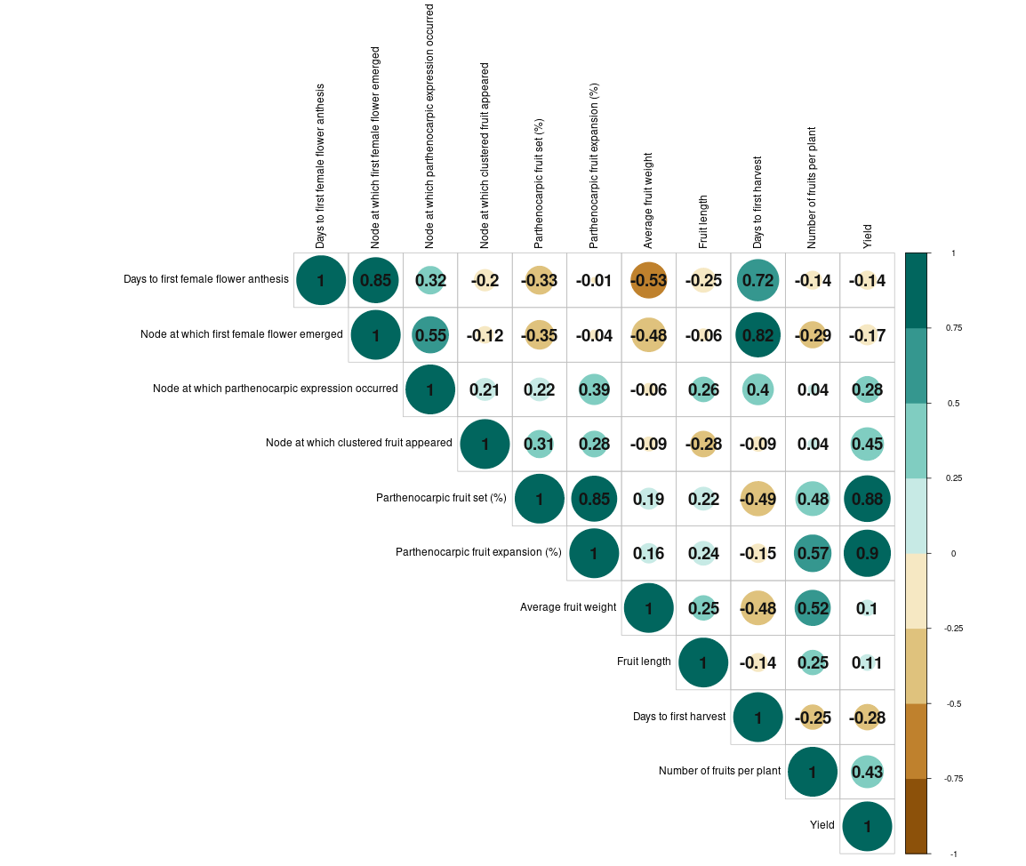

**Fig 1: Estimates of the correlation coefficient among different pairs of characters in salad cucumber**

|  |  |  |  |  |
| --- | --- | --- | --- | --- |
| **Traits** | **PCV (%)** | **GCV (%)** | **h2 bs** | **Genetic advance**  **(%) (i=5%)** |
| Days to 1st female flower anthesis | 8.78 | 8.21 | 87.4 | 15.82 |
| Node at which 1st female flower emerged | 26.32 | 22.52 | 73.2 | 39.69 |
| Node at which parthenocarpic expression occurred | 29.67 | 24.98 | 70.9 | 43.32 |
| Node at which clustered fruit appeared | 22.74 | 18.12 | 63.5 | 29.74 |
| Parthenocarpic fruit set percentage | 27.05 | 26.38 | 95.1 | 53.00 |
| Parthenocarpic fruit expansion percentage | 21.75 | 21.49 | 97.7 | 43.76 |
| Average fruit weight | 14.17 | 11.90 | 70.5 | 20.59 |
| Fruit length | 16.16 | 15.70 | 94.5 | 31.43 |
| Days to 1st harvest | 10.45 | 10.02 | 92.0 | 19.79 |
| Number of fruits per plant | 40.84 | 29.41 | 51.8 | 43.62 |
| Yield per plant | 20.70 | 14.78 | 51.0 | 21.73 |

**Table 2: Estimates of phenotypic (PCV) and genotypic (GCV) coefficients of variation, heritability and genetic advance in percent of mean for different traits in salad cucumber**

PCV: “Phenotypic Coefficient of Variation {>20 % - High (H), 10 – 20 % - Moderate (M), <10% - Low (L)}

GCV: Genotypic Coefficient of Variation {>20 % - High (H), 10 – 20 % - Moderate (M), <10% - Low (L)}

h2bs(%): Heritability in broad sense { >70 % - High (H), 50 – 70 % - Moderate (M), <50% - Low (L)}

Genetic Advance (%) of mean {>25% - High (H), 15 – 25 % - Moderate (M), <15% - Low” (L)}

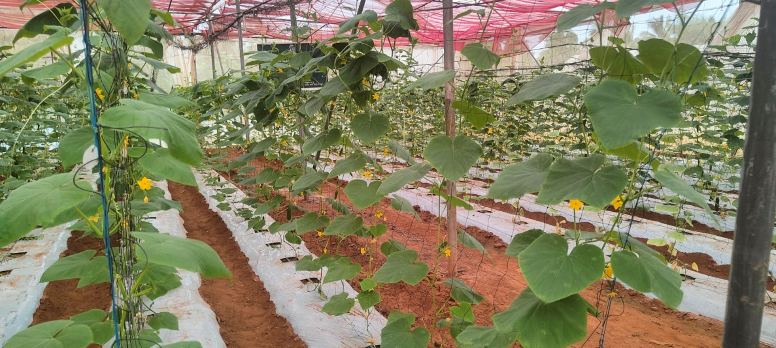

**A**

**Fig 2: A. General view of crop**

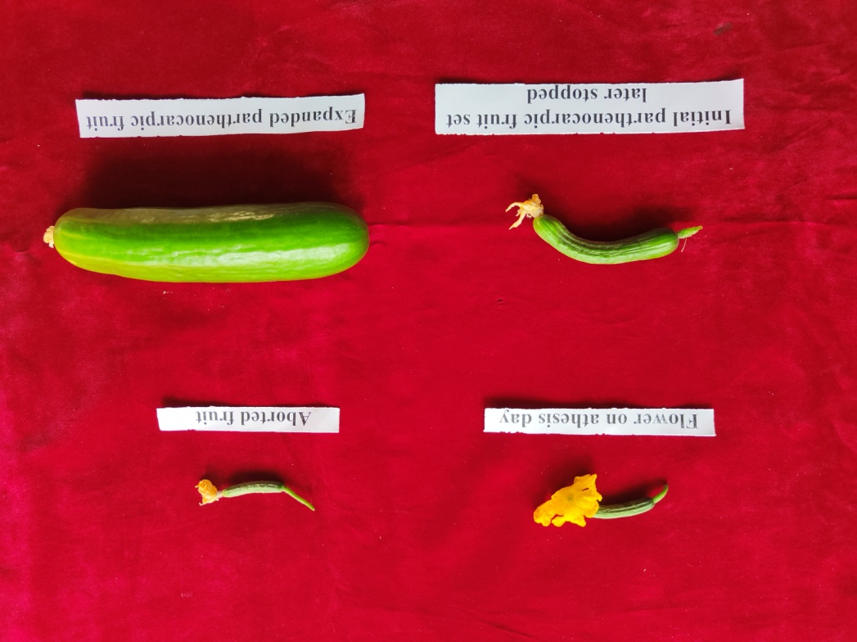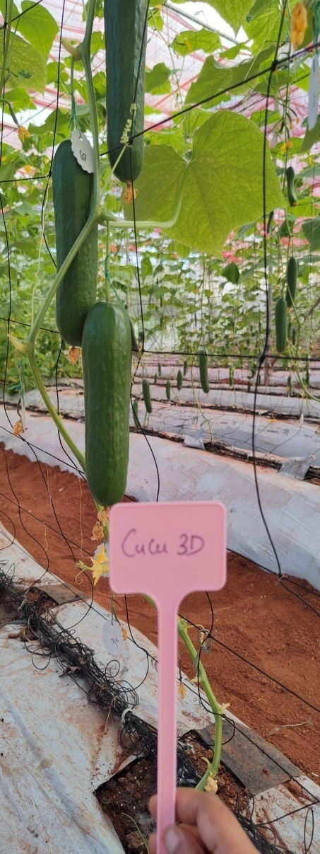

**B**

**C**

**Fig 2. B. Stages of parthenocarpy as well as non-parthenocarpy in cucumber C. High yielding line**

**CS 136**

**REFERENCES**

Ahirwar, C. S., & Singh, D. K. (2018). Assessment of genetic variability in cucumber (Cucumis sativus L.). International Journal of Current Microbiology and Applied Sciences, 7, 813–822.

Al-Jibouri, H. A., Muller, P. A., & Robinson, H. P. (1958). Genotypic and environmental variances and covariances in an upland crop of interspecific origin. Agronomy Journal, 30, 633–636.

Bhagwat, A., Srinivasa, V., Bhammanakati, S., & Shubh, A. S. (2018). Evaluation of cucumber (Cucumis sativus L.) genotypes under hill zone of Karnataka, India. International Journal of Current Microbiology and Applied Sciences, 7(9), 837–842.

Burton, G. W., & De Vane, E. W. (1953). Estimating heritability in tall fescue (Festuca arundinacea) from replicated clonal material. Agronomy Journal, 45, 478–481.

Chaudhary, V. I., Kumar, S., & Tank, R. V. (2016). Evaluation of greenhouse cucumbers for various horticultural traits under naturally ventilated polyhouse. Advances in Life Sciences, 5(8), 3320–3327.

Choudhary, S. (2022). Evaluation of parthenocarpic cucumber (Cucumis sativus L.) cultivars for summer cultivation under insect-proof net house in Indian hot arid region. Annals of Arid Zone, 61(1), 53–59.

Ene, C. O., Ogbonna, P. E., Agbo, C. U., & Chukwudi, U. P. (2016). Studies of phenotypic and genotypic variation in sixteen cucumber genotypes. Chilean Journal of Agricultural Research, 76, 307–313.

Gatti, I., Anido, F. L., Vanina, C., Asprelli, P., & Country, E. (2005). Heritability and expected selection response for yield traits in blanched asparagus. Genetics and Molecular Research, 4(1), 67–73.

Gopinath, P. P., Parsad, R., Joseph, B., & Adarsh, V. S. (2020). GRAPES: General R Shiny Based Analysis Platform Empowered by Statistics. https://www.kaugrapes.com/home. Version 1.0.0. DOI:10.5281/zenodo.492320

Gou, C., Zhu, P., Meng, Y., Yang, F., Xu, Y., Xia, P., Chen, J., & Li, J. (2022). Evaluation and genetic analysis of parthenocarpic germplasms in cucumber. Genes, 13(2), 225.

Johnson, H. W., Robinson, H. F., & Comstock, R. E. (1955). Estimates of genetic and environmental variability in soybean. Agronomy Journal, 47, 314–318.

Kaur, M., & Sharma, P. (2022). Performance of parthenocarpic cucumber (Cucumis sativus L.) genotypes for yield and quality characters under protected environment. Himachal Journal of Agricultural Research, 48(2), 220–224.

Kumar, A., Kumar, S., & Pal, A. K. (2008). Genetic variability and characters association for fruit yield and yield traits in cucumber. Indian Journal of Horticulture, 65(4), 423–428.

Kumar, P., Edelstein, M., Cardarelli, M., Ferri, E., & Colla, G. (2015). Grafting affects growth, yield, nutrient uptake, and partitioning under cadmium stress in tomato. Horticultural Science, 50, 1654–1661.

Kumar, P., Khapte, P. S., Saxena, A., & Kumar, P. (2019). Evaluation of gynoecious cucumber (Cucumis sativus L.) hybrids for early-summer greenhouse production in western Indian arid plains. Indian Journal of Agricultural Sciences, 89, 545–550.

Mehta, P. (2019). Genetic evaluation for fruit yield and related traits in parthenocarpic cucumber. Doctoral dissertation, CSKHPKV, Palampur.

Murthy, D. S., Prabhakar, B. S., Hebbar, S. S., Srinivas, V., & Prabhakar, M. (2009). Economic feasibility of vegetable production under polyhouse: A case study of capsicum and tomato. Journal of Horticultural Sciences, 4(2), 148–152.

Nagamani, G. V., Kumar, J. S. A., Reddy, T. B. M., Rajesh, A. M., Amarananjundeswara, H., Reddy, R. L. R., & Doddabasappa, B. (2019). Performance of different parthenocarpic cucumber (Cucumis sativus L.) hybrids for yield and yield attributing traits under shade net house. International Journal of Current Microbiology and Applied Sciences, 8, 978–982.

Nwofia, G. E., Amajuoyi, A. N., & Mbah, E. U. (2015). Response of three cucumber varieties (Cucumis sativus L.) to planting season and NPK fertilizer rates in lowland humid tropics: Sex expression, yield and inter-relationships between yield and associated traits. International Journal of Agriculture and Forestry, 5(1), 30–37.

Panse, V. G., & Sukhatme, P. V. (1957). Statistical Methods for Agricultural Workers. ICAR, New Delhi, pp. 359.

Patra, S., Singh, D. K., Singh, S. S., & Negi, M. (2023). Assessment of genetic diversity of parthenocarpic cucumber (Cucumis sativus L.) genotypes under polyhouse condition. The Pharma Innovation Journal, 12(7), 1532–1538.

Ranjan, P., Gangopadhyay, K. K., Bag, M. K., Roy, A., Srivastava, R., Bhardwaj, R., & Dutta, M. (2015). Evaluation of cucumber (Cucumis sativus L.) germplasm for agronomic traits and disease resistance and estimation of genetic variability. Indian Journal of Agricultural Sciences, 85(2), 234–239.

Sharma, P., Dhillon, N. S., Kumar, P., & Mehta, P. (2019). Evaluation of parthenocarpic cucumber genotypes for fruit yield and its contributing traits under protected environment of N-W Himalayas. International Journal of Chemistry Studies, 3, 4–6.

Singh, H. P., & Malhotra, S. K. (2012). Current scenario and policy issues for protected cultivation of horticultural crops in India. In Proceedings of National Seminar on Protected Cultivation of Vegetables and Flowers—A Value Chain Approach, CoA, GBPUA&T, Pantnagar, India, 11–12 January, pp. 9–20.

Singh, A. K., Chandra, P., Shrivastava, R., & Kumar, R. (2015). Influence of varieties and spacing on yield and economics during off-season cucumber production under protected condition in North Indian plains. Vegetable Science, 42(2), 71–75.

Singh, S. S., Yadav, G. C., & Kathayat, K. (2018). Study of genetic variability in cucumber. Journal of Hill Agriculture, 9(1), 39–43.

Thapliyal, V. (2017). Heterosis and combining ability for yield and yield attributing traits of parthenocarpic cucumber (Cucumis sativus L.) under poly-net house conditions. Doctoral dissertation, Punjab Agricultural University, Ludhiana.

Tripathi, V., Singh, V. K., Bhardwaj, A., Singh, R. S., Srinivasaraghavan, A., & Kumari, A. (2021). Mean performance and genetic variability of parthenocarpic gynoecious cucumber inbreds under protected conditions of Eastern India. Journal of Current Opinion in Crop Science, 2(2), 178–183.