Review Article

“Legacy and Interventions of Krishi Vigyan Kendra’s on Empowerment of Farming Communities”- A Review

Abstract
The foundation of India's agricultural extension system, Krishi Vigyan Kendra’s (KVKs), have greatly improved rural livelihoods through creative interventions in capacity building, technology distribution, and socioeconomic empowerment. To assess the effectiveness of important interventions, such as On-Farm Trials (OFTs), Frontline Demonstrations (FLDs), training initiatives, agroecological practices, and mobile advisory services, this document summarises the results of ten peer-reviewed research articles. According to the findings, these efforts have significantly increased the adoption of technology, with rates for gram crop technologies reaching 92.00 per cent and water quality monitoring technologies reaching 95.00 per cent. There were noticeable increases in productivity, including a 20.45 per cent increase in groundnut pod production and a 54.60 per cent increase in turmeric yield. Additionally, KVK programs improved socioeconomic results, increasing farmwomen's adoption of skills by 85.00 per cent and income by 20.00 to 25.00 per cent. Additionally, by maximising resource utilisation and preserving production, agro-ecological
techniques supported sustainable farming. The report emphasises how crucial KVKs are to closing the knowledge gap between field application and agricultural research. Particularly in isolated and tribal communities, their customised, region-specific approaches empower resource-poor farmers while simultaneously increasing production. It has proved that services provided to the farming community is vital for their livelihood and overall empowerment in their spheres of life.
Keywords: KVK Interventions, Impact of KVKs, Farmer’s Empowerment, Legacy of KVKs, Golden Jubilee of KVKs
Introduction
KVKs are integral part of the national agricultural research and extension system in India, aims at technology assessment, refinement, demonstration and dissemination in the field of agriculture and allied sectors (Kumari. et. al., 2020). They are considered as grassroots organisations designed to implement technology by evaluating, improving, and showcasing tested technologies in various district "micro-farming" scenarios (Das, 2007; Singh et al., 2023). It is also called as farm science centres, innovative institutions, agricultural extension centres mostly associated with local agricultural universities of the respective states under the different agricultural technology application and research institute zones of Indian Council of Agricultural Research System (ICAR). All the host institutes of KVKs are hundred percent funded by the ICAR Extension Division only. The country's leading agency for research on agriculture is the Indian Council of Agriculture and Research (ICAR). It has occasionally funded several first-line transfers of technology initiatives aimed at transferring cutting-edge technologies to farmers, such as the Lab to Land program (LLP), the All India Coordinated Project on National Demonstrations (AICPND), and the Operational Research Project (ORP) (Waman et al., 2011). Above mentioned all three projects were mobile in nature. So, those projects were merged to KVK in the year 1992 (Sahoo. et. al., 2021; Devi et al., 2023) for effective functioning as innovative institution with updated mandates and objectives. It has mainly emphasis on the functions of farm testing, preliminary exhibition, capacity building, multisectoral support and farm advisory services (Bhattacharyya et al., 2021; Harsha Vardhan et al., 2021).
In the year 1964-66, education commission formed for suggesting the imparting of vocational education in agriculture. Further planning commission & inter-ministerial committee stressed the importance of vocational education followed by in 1973, committee headed by Dr. Mohan Singh Mehta appointed by the ICAR for establishing KVKs as farm science centre because of that committee first KVK was established in the march 21st 1974 at Pondicherry under the administration of Tamil Nadu Agricultural University.
In 1967-77, the planning commission approved the proposal of the ICAR to establish 18 more KVKs during the fifth five-year plan (1974-1978). In 2005, then Prime Minister. Manmohan Singh announced that one KVK should be created in each rural district of the country by the end of 2007. In the 10th five-year plan 551 KVKs were drastically established in our nation and over a period it was gradually increasing the numbers. Currently in 2024, we have 731 KVKs in the nation under the eleven zones of ATARI, ICAR. (Gautam. et. al., 2024)
Mandates and objectives of KVKs (KVK Network Portal, 2024)
KVK's Mandate is to assess technology and demonstrate its application and capacity development.
Objectives are followed carefully to fulfil the mandate successfully
1. On-farm testing to evaluate agricultural technologies' location specificity under different farming systems.
2. Frontline demonstrations to determine the technologies' production potential on farmers' fields.
3. The enhancement of farmers' and extension workers' ability to stay current on the latest agricultural technologies.
4. To serve as an agricultural technology knowledge and resource centre to support public, private, and nonprofit sector initiatives aimed at enhancing the district's agricultural economy.
5. Use ICT and other media to deliver farm advisories on a range of topics that farmers must follow well for information receiving and dissemination.
KVKs produce high-quality technological products, including seeds, planting materials, bio-agents, livestock, and provide these to farmers. They also organise frontline extension activities, identify and document selected farm innovations, and align with ongoing schemes and programs within their mandate.
Vision and Mission of KVKs (Ministry of Agriculture and Farmers Welfare, 2024)
Vision: Growth driven by science and technology, resulting in improved productivity, profitability, and sustainability in agriculture.
Mission: Farmer-centric growth in agriculture and allied sectors through application of appropriate technologies in specific agro-ecosystem’s perspective
Goal of this review paper
To find out the different institutional interventions followed by the KVKs such as on farm trials, different kinds of demonstration, training programmes in impacting the farmer’s community or empowering them.
Rationale behind KVKs
KVKs are known as innovative institution and forming a major part of frontline extension system in India to mainly bridge the gap between consumer system and research system. They are really considered as extension system for technology assessment and dissemination of proven technologies on the farmers field itself.
Methodology
This review is based on the randomly selected research articles dealt with different interventions and impacts of KVKs on farmers and those articles were peer reviewed articles from various journals. I found more than 30 articles related to KVKs., out of it 10 articles are deeply discussed about the different interventions followed for technology assessment, refinement and demonstration to impact the farming communities were selected to analyse, to find major results to discuss upon it.
Distribution of KVKs in India
Table no.1. Distribution of KVKs under Different Host Organizations
S. No. | Organizations | No. of KVKs
01. | State Agricultural Universities | 487
02. | NGOs | 101
03. | ICAR Institutes | 66
04. | State Goverments | 38
05. | Central Agricultural Universities | 22
06. | Deemed Universities | 07
07. | Other Educational Institutes | 05
08. | Central University with Agriculture Faculties | 03
09. | Public Sector Undertaking | 02
Total |  | 731
(Ministry of Agriculture and Farmers Welfare, 2024)
Reviews
1. Singh. et. al., (2012) conducted study on Socio-economic Empowerment of Farmwomen in Madhya Pradesh Through Suitable Technological Interventions: A Krishi Vigyan Kendra (KVK) Approach, the study revealed after modifying the technological module accordance with Madhya Pradesh condition, a total number of 32 OFTs, 30 FLDs and 278 trainings were organized by KVK Home Scientists during the period of 2008-09. All these above-mentioned interventions gained importance and increased the adoption rates of technologies and skills thoroughly by 45.00%, 68.00% and 85.00% respectively with around quarter percentage hype in income (20-25%). Hence this module can be generalized further to other parts of the nation, and it has proved excellence in enhancing the socioeconomic status of farm women.
2. Behera. et. al., (2014) conducted a study called Transfer of Technology through Krishi Vigyan Kendra for the Tribal Farmers in Hilly Areas of Koraput District. The research results revealed that after conducted training programmes, the effects of technology on crop production were drastically improved and resulted in 26.20 percent increase in yield of HYV crop variety named Pratikhya compared to local race followed by increase in yield of Niger found boosted with 32.43 percent and even in turmeric it is 54.60 percent and groundnut yield increased by 28.00 percent. In terms of vegetables such as tomato, cabbage and brinjal, yield increased up to 25.00 percent. Those increased yield percentages of above crops resulted in increased B:C ratio also. Therefore KVK- Koraput played a significant role in impacting farmers through their interventions such as training programs and Dissemination of improved varieties.
3. Nath and De (2015) conducted study called Role of KVKs in Strengthening Livelihood Security of Resource Poor Farm Families of Rural India. The research results exhibited that farmers from adopted villages had good amount of social, economic, occupational, environmental development and as well as technology adoption. Based on all five table values there was huge gap (65.00 – 78.00%) between adopted and non-adopted villages of KVK in this region.
4. Sahoo. et. al., (2016) The study emphasises the function of Krishi Vigyan Kendra (KVK) in Khordha district of Odisha state in advancing composite fish culture through scientific management practices, respondents are those are regular beneficiaries benefitted from mandatory objectives of KVK. after KVK interventions such as training programs, advisory services, front line demonstrations the percentage of adopters boomed to 95.24 percent in practicing water quality test followed by proper stocking density (94.24%), use of extension agencies (92.85%) followed by lime application to pond (87.51%). It was notable that Front line demonstrations and On-farm trail were more effective changing the farmers attitude and mindset through the principle of ‘Seeing is Believing.’
5. Dobariya. et. al., (2017) conducted a study called Impact of KVK Activities in Adopted Villages of KVK-Dang. They had conducted research on gram crop to find out the impact and significance of KVK interventions, mainly focusing on FLDs, OFTs and training programmes. the study results revealed that in case of improved agricultural technologies majority (72.00%) of the beneficiary farmers had medium levels of knowledge compared to non-beneficiaries. In the section of adoption, greater majority (92.00%) of the beneficiary farmers had medium to high level compared to non-beneficiaries, which are medium to low levels only (82.00%). In case of yield, beneficiaries’ farmers got 37.00 per cent had medium level of yield followed by high level of yield (35.00%) and low level of yield (28.00%). In contrast, non-beneficiaries’, around sixty per centage (58.00%) had low levels of yield followed by medium (28.00%) and high levels of yield (14.00%). So KVKs intervention clearly influenced and convinced the farmers to get more knowledge and boosted the adoption rates of improved technologies on gram crop.
6. Bhatnagar. et.al., (2018) conducted a study on Impact of Kisan mobile advisory services in Tikamgarh district of Madhya Pradesh. It resulted that majority of the respondents (90.84%) showed that messages and short videos were needful followed by 87.50 per cent of respondents said that messages were saved time and money. When coming to the applicability of messages, partly to fully applicable for about 65.80 per cent to 26.66 per cent of respondents found useful. The findings about timely messages are about 51.66 per cent of respondents and finally the messages were partially to high understandable by 46.67 to 33.33 per cent of respondents. Finally, the overall impact of Kisan mobile advisory services said to be medium level in nature.
7. Kumar. et. al., (2020) conducted a study on Agro Ecological Approaches for Strengthening of Krishi Vigyan Kendra’s (KVKs) in India. The study revealed that Agro ecology offers a means of rethinking the various food systems that are currently in place, from the farm to the kitchen. Agro-ecology's goal is to accomplish sustainability of various food systems in terms of ecology, economy, and society. It connects science, practice, and social change-focused movements through multidisciplinary, participatory, change-oriented, and action-oriented research. At the farm level, the main social changes are to use various agricultural inputs more efficiently so that they can't have any unintended and detrimental effects on natural resources when used optimally. Farmers have maintained or increased production through the adoption of various agro-ecological management techniques and strategies, such as better seeds, optimal planting density, more effective fertiliser and pesticide application, and more accurate water use.
8. Venkataravana. et. al., (2020) carried a study on Impact assessment of frontline demonstrations on improved variety of groundnut: Chintamani-2 (KCG-2) in southern Karnataka. TMV2 Variety was used against this new variety as improved technology. The study revealed that improved variety (KCG-2) yielded higher mean pod of 2278.56 kg/ha which is 20.45 per cent increase in pod yield over the old farmer variety (1896.87kg/ha). Increased haulm yield (5.29t/ha) with 14.96 per cent compared to the farmers variety (4.60t/ha). With all increased yield and its attributive characteristics of the plant leads to the higher net income and B:C ratio (1:3.43) to the farmers because of the improved technology disseminated by the Frontline Demonstrations and training programmes of KVK.
9. Subbiah. (2023) in his study called Impact of KVK activities on farmers preparedness for agricultural operations in NTR district of Andhra Pradesh. The study summarized that more than one-third of the respondents thought that OFTs had a moderate (39.00%) impact, FLDs had a transformative (81.00%) impact, training programs had a high impact (78.00%), and mobile agro-advisories had a substantial (56.00%) impact. Publications were thought to have a moderate impact (36.00%). Mean scores on a five-point scale were used to evaluate the program's effectiveness. In comparison to non-participating farmers, participating farmers scored higher in important areas like seed selection (3.6), climate variability planning (3.8), adoption of recommended practices (3.7), mechanisation (4.1), adoption of communication systems (4.3), and technological integration for monitoring and response (3.3).
10. Bharath. et. al., (2023) conducted a study on Impact of KVK Training Programme on Knowledge and Adoption of Paddy Production Technology in Cuddalore District of Tamil Nadu., The study revealed that because of the KVK Training program, it was discovered that 58.00 percent of paddy growers possessed a high degree of knowledge. Likewise, it was noted that the number of high-level adopters rose from 20.00 percent to 63.33 percent, indicating an increase in adoption among farmers. Low-level adopters, on the other hand, dropped from 33.33 percent to 13.00 percent. The adoption of important agricultural practices by farmers was greatly increased by KVK training. The largest increase (73.40%) was in irrigation management, which was followed by seed treatment (70.00%), nutrient management (60.00%), and weed control (56.00%). These enhancements demonstrate how KVK interventions have a significant impact on improving sustainable farming methods. It has been determined that paddy farmers should periodically take advantage of the KVK training program to refresh their knowledge and abilities to better adopt paddy technologies to increase income and productivity.
Major Findings and Discussion
Table no.2. Major findings of the KVK’s Different Interventions for Positively Impacting the farmers empowerment
S. No. | KVK Study (Author, Year) | Interventions Used | Major Impacts
1 | Singh. et. al., (2012) | OFTs, FLDs, training programs | Adoption rates rose for technologies (45.00%), skills (85.00%), and income increased by 20.00–25.00 per cent. Significant socio-economic impact on farm women.
2 | Behera. et. al., (2014) | Training programs, technology dissemination | Yield increases: HYV Pratikhya (26.20%), Niger (32.43%), turmeric (54.60%), and groundnut (28.00%). Improved B:C ratio.
3 | Nath and De (2015) | FLDs, adoption programs, semi-structured interviews | Significant socio-economic and technological advancements. Gap of 65.00–78.00 per cent between adopted and non-adopted villages.
4 | Sahoo. et. al., (2016) | Training programs, FLDs, OFTs | Adoption of water quality tests rose to 95.24 per cent, proper stocking density 94.24 per cent, lime application 87.51 per cent. “Seeing is Believing” principle boosted adoption.
5 | Dobariya. et. al., (2017) | Training, FLDs, OFTs | Medium to high adoption (92.00%) of gram crop technologies among beneficiaries; yield levels also higher compared to non-beneficiaries.
6 | Bhatnagar. et. al., (2018) | Kisan mobile advisory services | Improved knowledge: 90.84 per cent found messages/videos useful, saving time and money for 87.50 per cent., Medium-level overall impact.
7 | Kumar. et. al., (2020) | Agroecological practices | Enhanced sustainable farming with better seeds, water use, and pesticide application. Increased efficiency and maintained production.
8 | Venkataravana. et. al., (2020) | Frontline demonstrations, training | Improved variety KCG-2 groundnut yielded 20.45 per cent higher pods and better B:C ratio (1:3.43). Positive rate of adoption among farmers.
9 | Subbiah (2023) | FLDs, OFTs, training programs, mobile advisories | High impact of training (78.00%) and FLDs (81.00%) on preparedness for seed selection, mechanization, and climate adaptation.
10 | Bharath. et. al., (2023) | KVK training programs | Increased adoption of irrigation (73.40%), seed treatment (70.00%), nutrient management (60.00%) and High knowledge improvement (58.00%).

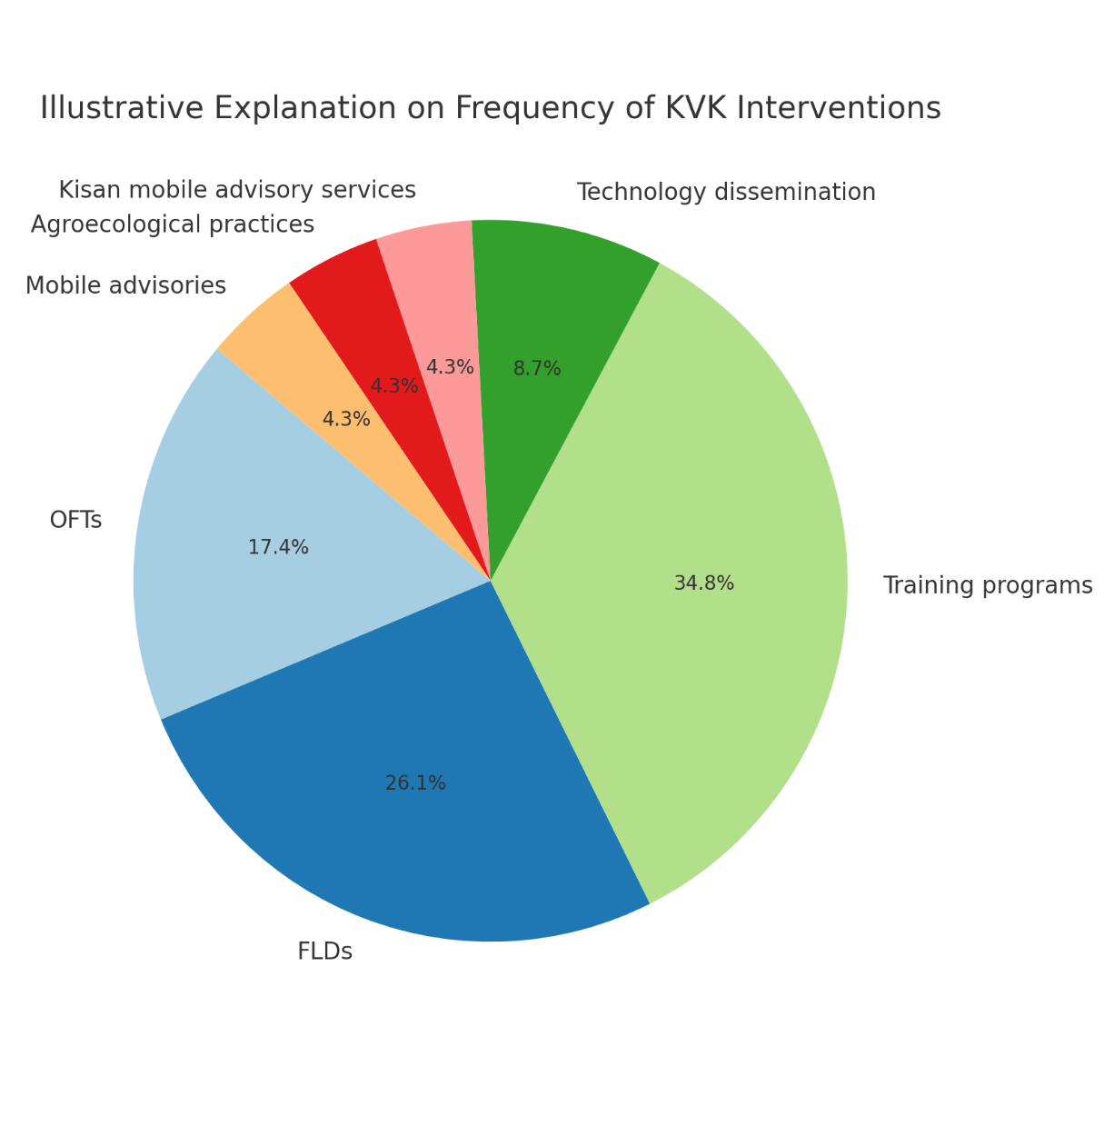
Fig. 1. Illustrating the repetition percentage of KVK interventions on selected articles

From the above table no.2 and fig.2. I could infer that over a period of five decades it has proved the excellence in the technology development and dissemination, since the inception of first KVK, the evolutionary journey was inevitable and unshakeable to provide different interventions to the farming community. Mainly to indicate that Frontline Demonstrations (FLDs), On Farm Trials (OFTs) through Assessment and Refinement (TAR), Human resources development through conducting Training programmes were the top three interventions because out of these research articles, eight were commonly shared and discussed about these for empowering farmers in those respective regions. Interventions helped to gain knowledge which resulted in elevated adoption of improved technologies to lead better yields and annual net income for empowerment of farmers.
Conclusion
It is evident from the literature and research mentioned above that KVKs have been instrumental in transforming the Indian agricultural and extension system and greatly improving the socioeconomic circumstances of the farming community. KVKs have successfully met the varied needs of farmers in a range of agricultural and related sectors, such as fisheries, livestock, poultry, and more, through important interventions like Frontline Demonstrations (FLDs), On-Farm Trials (OFTs), training programs, advisory services, and agroecological approaches. These programs have improved farmers' overall lives by empowering them and encouraging the adoption of novel technologies. As they continue to assist farmers' development and contribute to the expansion of Indian agriculture, KVKs, who have already celebrated their Golden Jubilee, now anticipate the Diamond Jubilee by focusing on the ongoing or upcoming farming problems such as digital literacy of farmers, aberrant weather situations, natural disasters, sustainability, global warming and climate resilience.
Importance of the work
"The review, 'Legacy and Interventions of Krishi Vigyan Kendra's (KVKs),' emphasises how they bridge the gap between field application and research in a revolutionary way. With initiatives like Frontline Demonstrations, On-Farm Trials, and training programs, it highlights the socioeconomic empowerment of rural communities. Increased adoption of technology (up to 95%), increased productivity (e.g., 54.6% in turmeric output), and improved socioeconomic indices for farmers—particularly in disadvantaged areas—are noteworthy effects. The paper highlights KVKs' crucial contributions to agricultural innovation and farmer welfare by tackling issues, arguing for its crucial relevance for agricultural extension frameworks and policymakers.

References
- Kumari, N., Singh, S. K., Singh, P., Mukherjee, S. and Singh, V. K., Role of Krishi Vigyan Kendra (KVK) in skill development of rural youth in Indian Agriculture. Annals of Horticulture, 2020, 13(1), 82-90.
- Das, P., Proceedings of the Meeting of DDG (AE), ICAR, with Officials of State Departments, ICAR Institutes and Agricultural Universities, NRC Mithun, Jharnapani on 5th October 2007, Zonal Coordinating Unit, Zone-III, Barapani, Meghalaya, India.
- Waman, G. K., Khule, R. P., and Sonawane, H. P., Constraints faced, and suggestions made by beneficiaries of KVKs, Asian J. Ext. Educ., 2011, 29, 77–82.
- Sahoo, A. K., Sahu, S., Meher, S. K., Begum, R., Panda, T. C. and Barik, N. C., The role of Krishi Vigyan Kendra’s (KVKs) in strengthening national agricultural research extension system in India, Insights into Eco. Mgt., 2021. 8(9), 43-45.
- Gautam, U. S., Singh, R. K., and Kumar, A., Krishi Vigyan Kendras Glorious Journey of Five Decades, Indian Farming, 2024, 74(3), 5–8.
- Singh, A., Gautam, U. S., and Singh, S. R. K., Socio-economic empowerment of farmwomen in Madhya Pradesh through suitable technological interventions: A Krishi Vigyan Kendra (KVK) Approach, Indian J. Ext. Educ., 2012, 48(1&2), 74–77.
- Behera, S. K., Maharana, J. R., and Acharya, P., Transfer of technology through Krishi Vigyan Kendra for the tribal farmers in hilly areas of Koraput District, Indian J. Hill Farming, 2014, 27(2), 34–37.
- Nath, S. K., and De, H. K., Role of KVKs in strengthening livelihood security of resource-poor farm families of rural India, Indian J. Ext. Educ., 2015, 51(3&4), 29–33.
- Sahoo, P. R., Ananth, P. N., Dash, A. K., Pati, B. K., Barik, N. K., and Jayasankar, P., Institution-based intervention on promoting composite fish culture in rural Odisha: A case of KVK-Khordha, Int. J. Fish. Aquat. Stud., 2016, 4(4), 190–195.
- Dobariya, J. B., Thesiya, N. M., and Desai, V. K., Impact of KVK activities in adopted villages of KVK-Dang, Educ., 2017, 25, 41–50.
- Bhatnagar, S., Bisht, K., Singh, S. P., and Raghuwanshi, S., Impact of Kisan mobile advisory services in Tikamgarh district of Madhya Pradesh, J. Pharmacogn. Phytochem., 2018, 7(6), 2493–2496.
- Venkataravana, P., Mahesh, M., and Priyadarshini, S. K., Impact assessment of frontline demonstrations on improved variety of groundnut: Chintamani-2 (KCG-2) in southern Karnataka, J. Entomol. Zool. Stud., 2020, 8(4), 1469–1472.
- Kumar, S., Singh, L., Singh, R., Thombare, P., and Devi, S. R., Agroecological approaches for strengthening of Krishi Vigyan Kendra’s (KVKs) in India, Andhra Agric. J., 2020, 67, 75–80.
- Kumar, R., Mishra, S., Kuswah, R. S., Jain, D. K., and Chauhan, S. V. S., Assessment and refinement of KMA in Tikamgarh district (MP), Indian Res. J. Ext. Educ., 2012, 2, 130–135.
- Subbaiah, P. V., Impact of KVK activities on farmers' preparedness for agricultural operations, Indian Res. J. Ext. Educ., 2023, 24(1), 78–84.
- Bharath, M., Sriram, N., Devi, M. N., Padma, S. R., and Selvi, R. G., Impact of KVK Training Programme on Knowledge and Adoption of Paddy Production Technology in Cuddalore District of Tamil Nadu, India, Asian J. Agric. Ext. Econ. Socio., 2023, 41(10), 44–49.
- Singh, P., Ghadei, K., & Roy, P. (2023). Krishi Vigyan Kendras (KVKs) in India: Empowering Farmers for a Sustainable Future. New Era Agriculture Magazine, 2(3), 54-59.
- Bhattacharyya, T., Wani, S. P., & Tiwary, P. (2021). Empowerment of stakeholders for scaling-up: digital technologies for agricultural extension. Scaling-up solutions for farmers: technology, partnerships and convergence, 121-147.
- Harsha Vardhan, P. N., Pal, P. K., & Roy, D. (2021). Influence of Krishi Vigyan Kendras and Socio-Economic Characteristics towards Adoption of Climate-Resilient Technologies. International Journal of Environment and Climate Change, 11(12), 38–43.
- Devi, S. R., Gopal, P. V. S., Vijayabhinandana, B., Srinivasulu, K., & Rao, V. S. (2023). Construction of Knowledge Test to Measure the Knowledge of KVK Beneficiary Farmers on Farming Practices. Journal of Experimental Agriculture International, 45(7), 9–17.

