***Review Article***

**Exploring Vertical Farming: A Modern Approach to Horticultural Crop Cultivation**

**Abstract**

Vertical farming has rapidly gained attention as a modern and sustainable method for cultivating horticultural crops, particularly in urban areas where space is limited. This technique utilizes vertically stacked layers or towers to grow crops, incorporating technologies such as hydroponics, aeroponics, and artificial lighting, which allow for year-round production. In recent years, vertical farming has demonstrated substantial potential to address the challenges of traditional agriculture, including land scarcity, water inefficiency, and pesticide use. According to recent data, vertical farming can reduce water usage by up to 90% compared to conventional farming methods, making it a highly efficient alternative in areas facing water scarcity. Additionally, studies have shown that vertical farms can produce up to 10 times more crops per square foot than traditional farming, significantly increasing yield per unit of land. For example, companies such as Aerofarms report yields of over 390 times more crops per acre annually compared to conventional field farming. Despite the promise, the high initial setup costs and energy consumption required for artificial lighting are key challenges. However, with ongoing advancements in renewable energy integration and automation, vertical farming holds significant potential to contribute to global food security, reduce the carbon footprint of agriculture, and promote sustainable urban food production. This paper reviews the latest trends, technological advancements, and data-driven outcomes in vertical farming for horticultural crops, alongside a discussion of its challenges and future potential in transforming the horticulture industry.

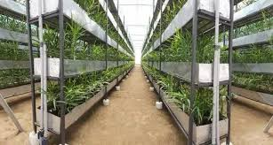**Keywords** — Hydroponics, Aeroponics, Aerofarms, Global food security.

Fig. 1 Vertical Farming

**INTRODUCTION**

Vertical farming is the practice of growing crops in vertically stacked layers or integrating them into other structures, such as abandoned warehouses or skyscrapers, while requiring less water and no soil. Indoor farming techniques and controlled-environment agriculture (CEA) technology are used in the latest vertical farming concepts. These technologies enable the artificial control of all environmental parameters, such as temperature, light, and humidity, as well as biofortification—the process of breeding crops to increase their nutritional value (Verapandi et al., 2014).

By applying nutritional supplements to feed the world’s growing population, vertical farming, particularly in urban areas, can help ensure food security. Some fruits and vegetables, vertical mushroom farming, hydroponically produced green manure, and even poultry and birds are either commonplace or highly developed. Green walls, living walls, bio walls, and vertical gardens are other terms for vertical gardens, a form of vertical farming in decorative horticulture (Jain & Jankiram, 2016). This area features spectacular flora, grown lushly in either an organic or inorganic medium—sometimes even soil—that covers all or part of the space. It could be part of a building or a stand-alone structure. Hydroponics and vertical farming meet the need for natural, nutrient-dense produce that is free from pesticides, acaricides, and insecticides, while being high in antioxidants and having a low carbon footprint (Pant et al., 2018; Merle H. Jensen, 2015).

Finally, the creative idea of vertical farming has been realized. Imagine living in a world where no drop of water or particle of light is wasted, and each town has its own locally grown food source produced in the most ecologically friendly way possible. In the twenty-first century, sustainable food production is greatly enhanced by intelligent farming practices. This is because plant development is directly influenced by environmental factors and water management strategies. It is projected that by 2050, a significant portion of the world’s population will be fed by cutting-edge techniques like vertical farming—farming located near the people it serves, conserving the planet’s finite natural resources, and offering more affordable, organic, and disease-free produce.

**HISTORY OF VERTICAL FARMING**

Vertical farms have only come to the forefront in agricultural discussions in the last decade. However, the concept behind this innovative farming technique is not new, as evidenced by the following historical examples:

**Pre-20th Century**

* **600 BC:** King Nebuchadnezzar II constructed the famous Hanging Gardens of Babylon, considered by many to be the first example of a "vertical farm." The gardens consisted of a sequence of terraces with arched ceilings, stacked one above the other, with flowerbeds and trees growing from them. At a height of twenty meters, the gardens were most likely irrigated by chain pumps, another early technological marvel. These pumps might have transferred water from the Euphrates River, flowing at the garden's base, to a pool at its summit via a network of buckets and pulleys.
* **1150 AD:** About a thousand years ago, the Aztecs used a form of hydroponic farming called *chinampas* to grow food in marshy areas near lakes. They built rafts out of reeds, stalks, and roots, which were covered with mud and clay from the lake bottom, creating fertile areas for farming in swampy regions. These rafts began to drift into the lakes, and their structural support allowed roots to spread downward into the water, enabling crops to grow higher. The rafts were often joined to create floating "fields."
* **1627:** The English statesman and philosopher Sir Francis Bacon's book *Sylva Sylvarum* contained the first theory on hydroponic gardening and farming. This led to the National Sir Bacon Academy of Agricultural Sciences developing and investigating the idea of cultivating land plants without soil.
* **1699:** John Woodward, an English scientist, refined the concept of hydroponic gardening by using spearmint in a series of water culture experiments. He discovered that plants developed more slowly in contaminated water compared to pure water. As a result, he made the significant finding that soil and other materials added to water solutions provide plants with essential nutrients.

**Twentieth Century and Beyond**

* **1909:** *Life Magazine* featured the first illustration of a "modern" vertical farm. The graphic depicted a farming landscape with open-air tiers of vertically stacked houses, all of which were producing food for human use.
* **1915:** The term "vertical farming" was first used by American geologist Gilbert Ellis Bailey in his book of the same name. Interestingly, Bailey emphasized "down" farming more than "up." He explored a type of underground farming where explosives were used to drill deeper, increasing the total cultivable area and allowing for the cultivation of crops over a larger area.
* **1929:** William F. Gericke, an agronomy professor at the University of California, Berkeley, is credited with creating modern hydroponics. In his article "Aquaculture: A Means of Crop Production," published in December 1929, Gericke explained how to grow plants without soil by adding nutrients to liquids, sand, or gravel.
* **1937:** According to an article in *Science* magazine, the term "hydroponics" is derived from the Greek words "hydro" (water) and "ponos" (labor). The term was suggested to Gericke by his colleague, botanist William Albert Setchell, as an alternative to "aquaculture," which was already used to refer to fish breeding practices.
* **1940:** The first large-scale agricultural use of hydroponic technology in modern history occurred during World War II. Over 8,000 tons of fresh vegetables were hydroponically grown to supply the Allied forces stationed in the South Pacific Islands (Kojai et al., 2015).
* **1964:** At the Vienna International Horticulture Exhibition, a vertical farm in the shape of a tall glass tower was displayed.
* **1989:** Ecologist and architect Kenneth Yeang developed a concept for growing plants outdoors in mixed-use structures that blend well with green areas. Yeang referred to this as "architecture made of plants." His concept, which focused on both individual and collective uses, set it apart from many previous approaches to vertical farming.
* **1999:** Drs. Despommier and Carter developed the concept of the modern vertical farm during a 2011 Environmental Health Sciences course at Columbia University. Despommier and his students proposed the idea of a multi-story skyscraper or contemporary vertical agricultural tower. To feed the residents of New York, layers of crops could be grown on each floor using urban rooftop agriculture. Since then, Despommier has become the world’s foremost expert and proponent of vertical farming. In his 2010 book, *The Vertical Farm: Feeding the World in the 21st Century*, he described the concepts and practices of modern vertical farming, which replaces horizontal expansion with vertical growth on Earth. Although his approach is not widely adopted worldwide, it has influenced the growth of hydroponic farming, including the cultivation of lettuce, leafy vegetables, strawberries, and herbs on a small scale in India during the 20th century.
* **Table 1. Comparison of traditional agriculture and vertical farming**

|  |  |  |
| --- | --- | --- |
| **Characteristic** | **Traditional Agriculture** | **Vertical Farming** |
| **Land Use** | Extensive | Intensive |
| **Water Consumption** | High | Low |
| **Pesticide Use** | Common | Minimal |
| **Crop Yield** | Moderate | High |
| **Labor Requirement** | High | Moderate |
| **Energy Efficiency** | Low | High |
| **Weather Dependency** | High | Low |
| **Transportation Costs** | High | Low |
| **Carbon Footprint** | High | Low |
| **Urban Accessibility** | Low | High |

**(Source:** Panotra *et al.,* 2024**)**

**IMPORTANT FEATURES OF VERTICAL FARMING**

* The producer may grow food on vertical farms
* continuously, all year round,
* and protect crops from erratic inclement weather.
* Using water acquired from indoor sources
* Provide employment
* opportunities to residents and communities.
* Minimise the use of pesticides, fertilisers, and herbicides.
* A major decrease in dependency on fossil fuels
* Prevent crop loss during storage, shipping, and long-distance transportation.
* Eliminate runoff from agriculture to conserve up to 90% of water.

The joy of creating food is a joyful feeling. instructing and getting students ready for food production

**Vertical Farming Concept**

Vertical farming is the process of growing crops in layers that are stacked vertically. It often comprises soilless farming techniques including hydroponics, aquaponics, and aeroponics as well as controlled environment agriculture, which aims to maximise plant development. Buildings, shipping containers, tunnels, and former mine shafts are common locations for vertical farming systems (Umashankar *et al.,* 2020).

**Importance of vertical farming**

Vertical farming is a transformative agricultural approach that offers several benefits to address the challenges of traditional farming. As urbanization and global food demand continue to rise, vertical farming presents a sustainable solution for food production in limited spaces. Below are the key reasons why vertical farming is becoming increasingly important:

**1. Efficient Land Use**

Vertical farming optimizes land use by growing crops in stacked layers, often within buildings or on rooftops, making it highly suitable for urban environments. This is especially significant as global urbanization continues to reduce the availability of arable land. For example, vertical farming can produce crops in areas where traditional farming would be impossible, such as densely populated cities or locations with poor soil quality.

**2. Water Conservation**

Traditional agriculture consumes significant amounts of water, often leading to the depletion of water resources. Vertical farming can use up to 90% less water than conventional farming methods, primarily because water is recirculated in a closed system. Techniques like hydroponics and aeroponics ensure efficient water use by minimizing waste, making vertical farming ideal for regions facing water scarcity.

**3.** **Reduced Carbon Footprint**

By growing crops closer to urban centers, vertical farming reduces the need for long-distance transportation, which is a major contributor to greenhouse gas emissions. Since vertical farms can be placed near major cities, the carbon footprint associated with food distribution is greatly reduced. Moreover, many vertical farming operations use renewable energy sources, such as solar or wind power, to further reduce their environmental impact.

**4. Year-Round Crop Production**

Vertical farming allows for year-round cultivation by creating controlled environments with artificial lighting, temperature regulation, and humidity control. This eliminates the dependency on seasonal weather patterns, ensuring a constant and reliable food supply. Crops such as leafy greens, herbs, and strawberries can be grown continuously, regardless of external climate conditions.

**5. Pesticide-Free Produce**

Vertical farms often utilize hydroponic or aeroponic systems that drastically reduce the need for pesticides, resulting in cleaner, healthier produce. The controlled environment minimizes pest and disease outbreaks, reducing the need for chemical interventions. This is particularly beneficial for growing organic crops and for health-conscious consumers seeking produce free from pesticides and harmful chemicals.

**6. Increased Yield per Square Foot**

Vertical farming can significantly increase crop yield compared to traditional farming methods. By growing crops in layers, vertical farms can produce 10 times more yield per square foot than conventional field farming. This makes vertical farming a highly efficient solution for growing more food in less space, which is crucial for meeting the needs of a growing global population.

**7. Local Food Production**

Vertical farms are typically located in or near urban centers, promoting local food production. This reduces the dependence on imports, supports local economies, and ensures that fresh produce is readily available to urban populations. By shortening the supply chain, vertical farming also helps reduce food waste, as it provides a more direct route from farm to table.

**8. Job Creation and Technological Innovation**

As vertical farming systems are increasingly automated and high-tech, they create new opportunities for innovation and job creation. Engineers, data scientists, agricultural technicians, and workers in urban farming operations can benefit from the growing sector. Furthermore, the development of vertical farming technologies stimulates advancements in artificial intelligence, robotics, and IoT (Internet of Things), which can be applied to other industries.

**9. Food Security and Resilience**

Vertical farming contributes to food security by providing a consistent and reliable source of food, regardless of external factors like climate change, soil degradation, or natural disasters. Urban vertical farms can help ensure that cities are less vulnerable to disruptions in the food supply chain, especially in areas where agricultural land is limited or unavailable.

**10. Sustainability and Environmental Stewardship**

Vertical farming offers a more sustainable method of growing food. It requires significantly less land, water, and energy compared to traditional farming practices, making it an environmentally friendly alternative. Additionally, it can be integrated with renewable energy sources, such as solar power, to further reduce its environmental footprint

**SCOPE AND POTENTIAL**

1. Land use and deforestation ought to decline. This leads to less flooding and erosion.
2. Properties that are unused or abandoned shall be put to good use.
3. Severe weather events like droughts, floods, and snow won't have an impact on the crops.
4. Because the produced foods are easily consumed, less cars are being used.
5. Use fewer products that burn coal to cut down on pollution and CO2 emissions.
6. Overall health as a result of agricultural structures having direct access to city waste.
7. Water is used more prudently.

**HOW DOES VERTICAL FARMING WORK**

There are four critical areas in understanding how vertical farming works:

1. Physical layout,
2. Lighting,
3. Growing medium, and
4. Sustainability features.

The primary goal of vertical farming is to increase food production per square metre, which is why crops are stacked vertically. Second, the right amount of artificial and natural lighting is used to maintain the space's optimal light level. One piece of technology that improves lighting efficiency is the rotating bed. Thirdly, we will substitute hydroponics (soaking the roots in a nutrient bath) or aeroponics (spraying the roots with water) for soil, together with aquaponic growing material. Peat moss, coconut husks, and other non-soil media are commonly utilized in vertical farming. Last but not least, the vertical farming method uses a number of sustainability features to balance the energy cost of farming. In fact, vertical farming uses 95% less water than conventional farming.

**Needs of vertical farming**

1. Better water efficiency (using less water than with conventional methods) It is simple to carry out occupational tasks like irrigation and other curable management.
2. Deforestation and land use are decreased as a result of vertical farming. As a result, erosion and flooding will be reduced.
3. Because drip systems are the primary instrument utilized, this method uses water more efficiently.
4. Crops will be protected from bad weather conditions like floods, droughts, and snowfall.
5. There is less requirement for vehicle transportation because the produced foods are quickly consumed.
6. Pollution and CO2 emissions are decreased by using fewer coal-burning products.
7. General well-being, since municipal waste will be directed.

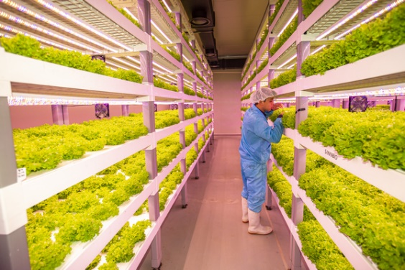

Figure 2. Vertical farm in Suwon, Republic of South Korea **(Source: Despommier D. 2014)**

**INNOVATIONS IN VERTICAL FARMING**

Existing agricultural methods and technology could be supported, enhanced, and supplemented by some of the following advancements in vertical farming.

1. Hydroponics: Soilless farming, or soilless plant growth.
2. Aeroponics: Plants cultivated without soil, in a mist or fog, with minimal water and fertiliser.
3. Aquaponics: An environment in which crops and fish are raised using essentially the same inputs (feed to the
4. Lokal: supplying just obtained food in its native environment.
5. Aero Farms: This ingenious vertical farming innovation grows greens in regulated conditions without the usage of sunlight.
6. Plants capers - A structure that provides food for its people.
7. The vertical crop is an urban farming method that is sustainable.
8. Modular farms allow you to grow fresh vegetables almost anywhere in the world.
9. Cubic farming systems, which use automated nutrient supply and conveyor rotation, are the next generation of sustainable agricultural systems.
10. Zip Grow: This vertical farming method for contemporary farmers uses LED illumination, automatic nutrient supply, and conveyor rotation.
11. Bowery: The world's most advanced commercial indoor farm in terms of technology. As the plants grow, the system gathers data and automatically creates the best circumstances for them. The information aids in precisely supplying the plants with water, nutrients, and light.
12. Sky Farm: A vertical farming tower driven by wind.
13. Sky Greens is the world's first vertical farm powered by hydraulics. The innovative vertical farming method developed by a Singaporean, Sky Greens is the world's first low-carbon farm powered by hydraulics. Throughout the day, vegetables are cultivated on rotating shelves.

The potential of space farming has been strengthened by global developments in vertical farming, which may find use even on worlds with temporary or permanent residents. Kheir Al-Kodmany (2018)

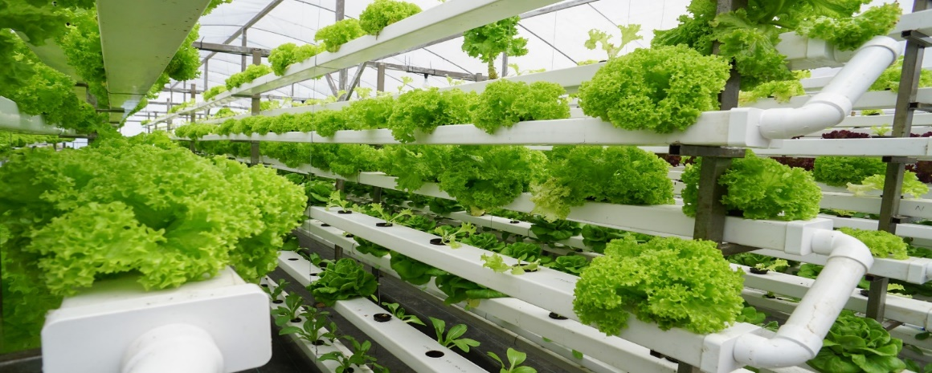

**Fig. 3** Model of Vertical Farming. (Source: Gupta and Ganapuram 2019)

**Techniques of vertical farming**

1. **Hydroponics:**

"Hydroponics" is the name given to a technique for growing plants without soil. Plant roots are submerged in liquid solutions containing macronutrients like nitrogen, phosphorus, sulphur, potassium, calcium, and magnesium, as well as trace elements like iron, chlorine, manganese, boron, zinc, copper, and molybdenum. In addition, inert (chemically inactive) mediums like sand, sawdust, and gravel are used as soil substitutes to provide support for the roots. Since hydroponic farms have strict certification regulations and regulated environments, they offer a practical solution for producing food in a more sustainable manner without the use of toxic chemicals. Hydroponic farming is currently included in sustainable agriculture to help meet the world's expanding food needs, so it's far from being a pipe dream (Debangshi, 2021).

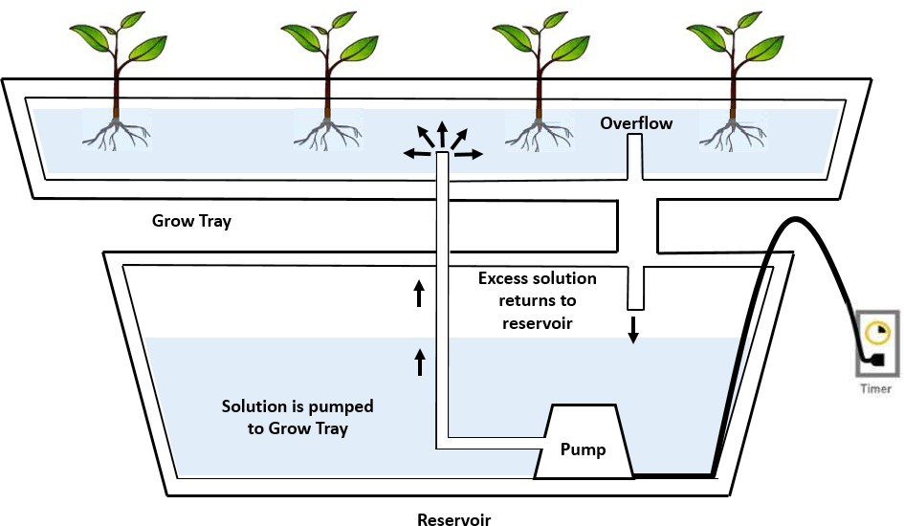

Fig. 4 Hydroponics (Source: Gupta and Ganapuram 2019)

Table. 2 System requirements (Royston *et al*., 2018)

|  |  |  |
| --- | --- | --- |
| 1 | pH control | 5 -7 or slightly acidic |
| 2 | Electrical conductivity | 1.2 -3.5 mho |
| 3 | Horticulture lighting | Direct sunlight or supplement lighting for 8-10 hrs. Per day |
| 4 | Temperature | 50 -70 degrees for fall plants and 60-80 degrees for spring plants. |
| 5 | Supplements | Nitrogen-phosphorus-potassium rich formula |
| 6 | Oxygen | Supplemental oxygen supply is required for optimal nutrient uptake |
| 7 | Structure & support | Stakes and strings are usually needed to support plants as they grow |

1. **Aquaponics**

Aquaponics is a type of hydroponics that grows both aquatic and terrestrial plants using a closed-loop system to mimic natural processes. The nutrient-rich effluent from the fish tanks is filtered by a particle removal unit before being sent to a biofilter, which converts toxic ammonia into nutrient-rich nitrate. The plants absorb nutrients and purify the effluent before returning it to the fish tanks. The greenhouse can maintain a constant temperature at night while using less electricity because the plants absorb the carbon dioxide that the fish emit and the water in the fish tanks absorbs heat. Most commercial vertical farming systems focus on growing a few rapidly growing vegetable crops, therefore aquaponics, which also includes an aquaculture component, is not as popular as it previously was.

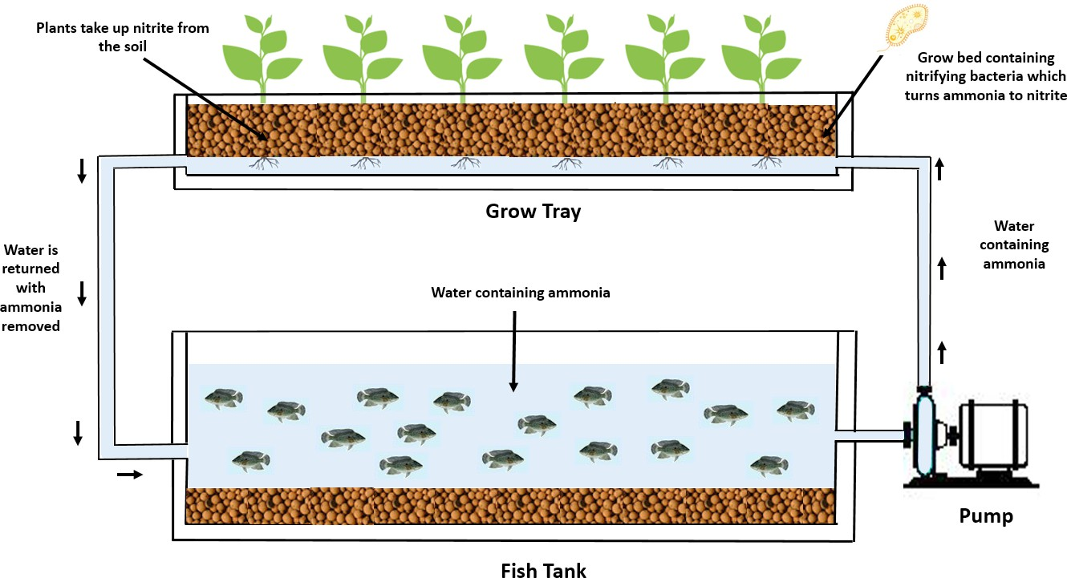

Fig. 5: A model of aquaponics (Source: Gupta and Ganapuram 2019)

**3. Aeroponics**

NASA (National Aeronautics and Space Administration) wanted to find a productive way to grow plants in space in the 1990s, which led to the development of aeroponics. Aeroponics develops plants without the need for a liquid or solid growing medium, in contrast to hydroponics and aquaponics. As an alternative, the plants are hung in air chambers that are misted with a liquid solution that is rich in nutrients. Aeroponics is by far the most eco-friendly soilless production technique; it doesn't require changing the growing media and uses up to 90% less water than even the most sophisticated conventional hydroponic systems. Because aeroponic systems may be set up vertically without a growing medium, they also use less energy. This is due to the fact that in hydroponic systems, surplus liquid is naturally drained away by gravity; however, in conventional hydroponic systems, water pumps are frequently used to control excess solution. Aeroponic systems are starting to garner a lot of interest, despite their limited use in vertical farming thus far.

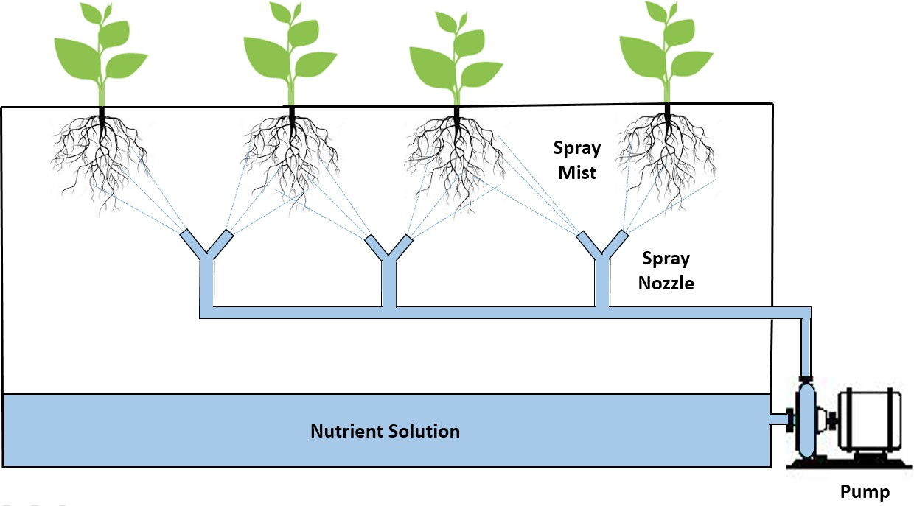

Fig. 6: A model of aeroponics (Source: Gupta and Ganapuram 2019)

1. **Controlled-environment agriculture**

Changing the natural environment to prolong the growing season or increase crop output is known as controlled-environment agriculture, or CEA. Environmental factors like air, temperature, light, water, humidity, carbon dioxide, and plant nutrition can be tracked in confined spaces like greenhouses or buildings. CEA systems are usually kept in this location. CEA is commonly employed in vertical farming systems in combination with soilless farming techniques such as hydroponics, aquaponics, and aeroponics.

**4 . Livestock production**

When included in vertical farming, pasture-based livestock provides certain social and environmental benefits, much like a fish farm. It gains from many different cultural influences. According to Times (Despommier, 2010), the cattle business in affluent countries has put human welfare, food security, environmental considerations, and animal health ahead of manufacturer quality. More research is required to ensure that the livestock division can satisfy the growing demand for products made from animals. They should consider the negative environmental impacts of livestock farming to ease concerns about food safety, the environment, and the morality of animal welfare. Poultry farming is another option; it takes up the least amount of space but produces the most meat in terms of kilograms.

**Table 3. Advantages and disadvantages of hydroponics, aeroponics, and aquaponics**

|  |  |  |
| --- | --- | --- |
| **System** | **Advantages** | **Disadvantages** |
| **Hydroponics** | Efficient water and nutrient use | Requires specialized knowledge and equipment |
| High crop yields | Dependence on electricity and pumps |
| Precise control over nutrient delivery | Risk of waterborne diseases |
| Suitable for a wide range of crops | Limited root space |
| **Aeroponics** | Minimal water and nutrient use | High initial setup costs |
| Excellent aeration for roots | Requires precise control and monitoring |
| Reduced risk of plant diseases | Vulnerable to power outages |
| Faster growth rates | Limited to certain crop types |
| **Aquaponics** | Sustainable and eco-friendly | Complex system design and management |
| Nutrient-rich water from fish waste | Balancing nutrient levels for fish and plants |
| Reduced need for fertilizers | Higher initial costs and maintenance |
| Dual production of fish and crops | Limited fish species suitable for the system |

**(Source: Panotra *et al.,* 2024)**

**Types of vertical farming**

1. **Building-based vertical farms**: Abandoned structures are frequently used for vertical farming. "The Plant," a Chicago farm that was converted from an abandoned meatpacking plant, is one such instance. However, recently built buildings are also commonly used to host vertical agricultural systems.
2. **Shipping-container vertical farms:** A growing number of vertical farming systems are being housed in repurposed shipping containers. The shipping containers serve as flexible, standardised spaces for a range of plant growth. Smart climate controls, vertically stacked hydroponics, LED lighting, and monitoring sensors are common features. Additionally, farmers may be able to boost their yield per square foot and save even more space by stacking the shipping containers.
3. **Deep farms:** A "deep farm" is a vertical farm constructed using underground passages or mine shafts that have been reused. Because the temperatures and humidity below the surface are frequently stable and moderate, deep farms consume less heating energy. Deep farms can reduce their water costs by using nearby groundwater. According to Saffa Riffat, head of Sustainable Energy at the University of Nottingham, deep farming can yield seven to nine times as much food on the same area of land as conventional above-ground production since it is inexpensive. These underground farms have the potential to become completely self-sufficient when combined with automated harvesting systems.

**REASONS TO SHIFT FROM CONVENTIONAL TO VERTICAL FARMING**

**2.1. Exponential Increase in Population**

India’s population is rapidly increasing, and it is predicted that it will soon surpass that of China. With natural resources such as water and arable land becoming scarce, these figures pose an even greater challenge. Vertical farming is, in fact, the most advantageous solution for this (Shubha *et al.,* 2019).

**2.2. Scope of Quality Food Production**

When compared to the refrigerated produce typically available at supermarkets, a vertical farm allows farming within the confines of a city, and the produce is quickly delivered and always fresh, when the farms are nearby [Banerjee, C. and Adenaeuer. L., 2014, Mok *et al*., 2014, Shubha *et al.,* 2019].

**2.3. Negligible Wastage of Water**

The agricultural industry is one of the most polluting industries on the planet, using up to 90 % of the world’s water. However, vertical farming has the potential to change that. Vertical farms use 95 % less water than conventional farms due to the regular circulation of water [Banerjee, C. and Adenaeuer. L. 2014, Shubha *et al.,* 2019].

**2.4. Optimum use of Energy**

Solar energy is used in vertical farms, which is renewable energy so saves energy [Shubha *et al.,* 2019].

**Table 4. Exploitation of vertical farming in the world**

|  |  |  |  |  |  |  |  |
| --- | --- | --- | --- | --- | --- | --- | --- |
| **S. No.** | **Name** | **Location** | **No. of Storey** | **Products** | **Area**  **(sq. ft.)** | **Technology** | **Reference** |
| 1. | Green Sense Farms | First farm in Portage, Indiana-Shenzhen, China |  | Micro Greens, Herbs and Lettuces are major crops | 20,000 | Automated computer controls system used, which provides the exact amount of water, nutrients, temperature, light and humidity for growth of the plant. Minimize the waste and recycle water technique | Colangelo, R. 2022). |
| 2. | The Plant Vertical Farm | Chicago, IL | 3 | Mushroom and Tilapia | 100,000 | Aquaponics and hydroponic systems, Waste is recycled into energy, Use of biogas from an anaerobic digester, Sunlight is used as natural energy. | (Kappes, 2023). |
| 3. | Plant lab VF | Den Bosch, Holland | 3 | Tomatoes, cucumbers in vegetables and strawberries in fruit crops |  | LEDs are used as an energy source. Hydroponic and Aeroponic system | (Muller, M. and Gelder, V. 2008). |
| 4. | Vertical Harvest plants | Jackson Wyoming, USA | 3 | Tomatoes, lettuce, micro greens and strawberry | 18,000 | Recirculating hydroponic methods LEDs are used as an energy source. | (Flug, 2022) |

**Waste management sub-system in vertical farming**

The plant culture rooms are anticipated to generate 2443 metric tonnes of bio-waste per year. The same amount is estimated to be about 517 tonnes in aquaculture systems. If tilapia are fed one tonne of plant waste per day, the leftover tonnage is around 7.11 tonnes per day on average. As a result of growing edible biomass, such as leaves, stems, fibrous roots, and damaged fruits and vegetables, vertical farms produce bio-waste, much like aquaculture systems do. Among other useful products, a closed-loop vertical farm is expected to generate biofuel and liquid fertiliser from garbage. In order to recover nutrients, wastewater is recycled and pushed through pipes filled with shattered volcanic rock fragments. When creating vertical farms, two floors are needed to manage the waste. The "SLURRYCARB" machine is one potential substitute power source (Royston and Pavithra, 2018).

**Smart devices used in vertical farming**

Since vertical farming is a completely automated process, it makes extensive use of sensors and actuators, sometimes known as "smart equipment," which can connect with other systems without requiring human intervention. To make vertical farming a reality as a technology, a complete computing system that continuously perceives its surroundings and assists in providing pertinent data and services is required (Banerjee and Adenaeuer, 2014). A database contains all of the information about the crops and any possible diseases. The ventilation system requires outdoor weather conditions even when crops are cultivated indoors. Weather forecasts offer current meteorological data so that appropriate decisions can be taken. Understanding the quantity of crops to be produced and the potential for infections has a significant impact on establishing a healthy environment for food production and disease prevention. Making the best supportive judgements is facilitated when a control agent is equipped with the necessary system knowledge. Context, devices, service, environment, network, location, and user are the main concepts.

**Table 5. Suitable crops for vertical farming**

|  |  |
| --- | --- |
| **Crop Category** | **Examples** |
| Leafy Greens | Lettuce, Spinach, Kale, Arugula, Swiss Chard |
| Herbs | Basil, Mint, Cilantro, Parsley, Rosemary |
| Microgreens | Radish, Broccoli, Sunflower, Pea Shoots, Wheatgrass |
| Fruiting Crops | Tomatoes, Peppers, Cucumbers, Strawberries, Eggplants |
| Root Crops | Carrots, Radishes, Beets, Turnips, Potatoes |

**(Source: Panotra *et al.,* 2024)**

**Vertical Rice Nursery**

* Fast recovery, consistent maturity, strong production of tillers, and
* higher yield gain are the characteristics of hydroponically produced seedlings.
* Earlier maturity of the crops results in earlier harvesting and better returns.
* 85% less water is used.
* Ideal for situations of a late or delayed monsoon.
* Nursery land can be utilized for several reasons.

**Advantages of vertical farming (Sonawane, 2018)**

By employing more hydroponic paddy nurseries, Indian rice growers can save a substantial quantity of water, land, labour, time, and other resources. The early phases of a rice crop have a significant impact on its performance and production. A 10% decrease in productivity may arise from using sick seedlings (Debangshi, 2022). Planting seedlings at the right time is also crucial for maximising production. Hydroponic farming has a number of advantages over traditional farming. The nursery is free of weeds and protected from insects because the crops are cultivated in a regulated atmosphere. The following are additional advantages of hydroponic paddy nursery cultivation over traditional nursery farming (Saxena and Upadhyay, 2019).

* High production per unit area: Vertical farming increases harvests per unit of land by more than 80%.
* Maintaining food production throughout the year without being susceptible to natural calamities like droughts, floods, heavy precipitation, snowfall, and outbreaks of pests and diseases, etc.
* It reduces the cost of transporting food from rural to urban areas.
* Furthermore, the amount of fossil fuel utilized to transport agricultural products from rural to urban regions has significantly decreased.
* Vertical farming uses 70–95% less water than conventional farming.
* Additionally, it requires little to no soil, preventing infestations of pests and diseases.
* Lastly, organic food is created since no pesticides are employed.
* For customers, fresh food maintains all of its original nutritious qualities.
* The greening of urban areas can help mitigate the effects of rising temperatures and urban air pollution.

**What to grow in vertical farm?**

Lettuce, kale, chard and collard greens, chives and mint, basil (sweet, lemon, cinnamon, etc.), oregano, parsley, tomatoes, strawberries, thyme, radish, iceberg, spinach, and other seasonal vegetables are being grown using vertical farming to meet the demands of primarily metropolitan areas. However, vertical farming is used to cultivate some indoor flowers and plants for aesthetic purposes. It is necessary to make inadequate use of the roof wall's vertical area. Vegetable shrubs and vines, such as tall tomato varieties, gourds, and beans, can be planted beside the walls and railings. Flowers will attract beneficial insects, such as native bees, to your food garden. Flowers like bougainvillea, jasmine, hibiscus, sunflower, tulips, lavender, rose, and oleander can be grown in planters (Debangshi and Mondal, 2021).

**Working principles of vertical farming**

There are four critical areas in understanding how vertical farming works:

* **Physical layout**: The crops are piled vertically to grow because the main objective of vertical farming is to produce more food per square metre.
* **Polymer:** The building's façade is made of ethylene tetrafluoroethylene (ETFE), a translucent, self-cleaning polymer. 95% of the light in the room may enter the building due to its transparency. The pressure differentials between the ETFE layers allow the screen to open and close in response to variations in the sun's power.
* **Lighting:** Lighting is a key factor in managing crop development in vertical farming. The perfect balance of artificial and natural lighting is employed to maintain the desired level of light in the room. One piece of technology that improves lighting efficiency is the rotating bed. LEDs or solar cells could be used for artificial lighting. A variety of light intensities are necessary to enhance crop growth (Saravanan et al., 2018).
* **Growing medium**: We'll use hydroponics, aeroponics, or aquaponics—which entail immersing the plant roots in a nutritional solution—instead of soil. Peat moss, coconut husks, and similar non-soil media are commonly utilized in vertical farming (Saravanan et al., 2018). It is crucial to keep in mind that the medium must provide adequate nutrients and have good moisture retention.

**Sustainability features of vertical farming**

A sustainable city is one that meets the needs of its present residents without endangering the resources available for future generations, claim Debangshi and Mandal (2021). By employing several sustainable components, the vertical farming method lowers the energy expenses associated with farming. In fact, vertical farming uses 95% less water than conventional farming.

***OPPORTUNITIES***

***3.1. Agricultural Productivity***

Agricultural cultivation has its limits, viz. the cultivable area is limited, and with the increasing population, it may not be apt for meeting the food requirements of future generations. In such a scenario, vertical farming can increase the yield up to more than ten times by utilizing the space component (Shubha et al. 2019). Currently, financial competency is analyzed for a period from 2019 to 2026 foreseeing the market analysis for a stronger performance of vertical farming [Banerjee, C. and Adenaeuer. L., 2014, O’Sullivan et al., 2020, Zeidler, C. and Schubert, D. 2014].

**3.2. Weather Resistance**

Agriculture is traditionally taken up as an outdoor activity which is highly prone to environmental conditions. Many times, these factors play a spoilsport and cause a lot of damage to the crops. Such concerns can be minimized by relying on vertical farming practices [*Shubha et al., 2019,* Avgoustaki, D.D., and Xydis, G. , 2020b].

**3.3. Constant Demand**

Profitability usually necessitates continuous operation, so the crop(s) grown must have sufficient year-round market demand. Horticulture makes it much easier to grow the same crop year after year, and it allows growing systems to be engineered and optimized specifically for that crop [Banerjee, C. and Adenaeuer. L. 2014, Shubha *et al.* 2019].

**3.4. Limited Labour**

Vertical farmers often report that one of the most common costs mentioned by vertical farmers is labour. Vertical farming lends itself to crops that can be “sown and grown” with little effort. Automation reduces labour inputs, but it usually comes at a high cost in terms of design, purchase, and installation [Shubha *et al.,* 2019, Avgoustaki, D.D., and Xydis, G. , 2020].

**3.5. High Harvestable Yield**

The portion of the crop that can be harvested and sold is referred to as this. In the case of lettuce, almost the entire plant can be sold, resulting in a high harvestable yield [Banerjee, C. and Adenaeuer. L., 2014, Mok *et al*., 2014, Shubha et al., 2019, Kumar *et al.,* 2020]. Throughout the year, produces large quantities of nutritious and high-quality fresh food [Avgoustaki, D.D., and Xydis, G, 2020, Kumar *et al.,* 2020].

**Socio-economic dimensions of vertical farming**

Vertical farming has the ability to significantly increase food production while reducing the environmental effect of the agricultural sector by using less land, water, fertilisers, and pesticides while increasing overall efficiency. Despite the proven environmental benefits of vertical farming, its economic feasibility remains a major obstacle. The financial benefits of greater production, reduced resource consumption, and enhanced sustainability far exceed the significant upfront costs associated with vertical farming:

* When compared to traditional agricultural production, vertical farms require less room and water to produce the same amount of food. Additionally,
* External environmental factors that increase farmers' expenses have minimal impact on vertical farms.
* Controlling ambient temperatures and nutrient levels can also maximise plant growth and nutritional value.
* Lower expenses result from less long-distance transit requirements.

In India, the cost of vertical farming varies based on the product. However, if you are not starting it professionally and are only using it for your own family, it only costs roughly Rs. 4 to 5 thousand, which you can boost to Rs. 8 to 10 thousand depending on your needs. However, women primarily contribute to urban agriculture in the areas of household food security and revenue generating. One source of income for female farmers is the sale of surplus products from their urban farming activities. Women can operate in vertical farming in a variety of capacities, such as controlling water levels, providing fertilisers, harvesting, and threshing—all of which are often done by women because of their accuracy.

**Future of vertical farming**

The 2020 World Population Data Sheet projects that by 2050, there will be 9.9 billion people on the planet, up from 7.8 billion in 2020. This sum is astounding. Furthermore, it is projected that by 2050, there will be over 6 billion people living in cities, 90% of whom would be in developing countries (UN, 2013). Megacities are expanding at a never-before-seen rate, which could be unsustainable and have detrimental environmental repercussions. Furthermore, global projections indicate that agricultural land can only be increased by 2% until 2040 (FAOSTAT, 2016). In order to feed a growing population, new technologies such as vertical farming provide a competitive alternative to conventional agricultural practices.

**Disadvantages of vertical farming**

1. The main problem is the upfront setup costs for the vertical farming method. Among other things, it covers the cost of software, remote control systems, climate control systems, and automated racking and stacking systems.
2. High energy costs because all artificial lighting is needed to grow plants; crop pollination could be an issue because vertical farming systems don't have any insects.
3. Excess fertilisers used in vertical farming could affect the main urban water supply.
4. A lot of garbage, plant residues, etc., can be generated around the structures when vertical farming is used.
5. They will need training because there won't be any skilled employees at first.

**MAJOR CHALLENGES IN ADOPTING VERTICAL FARMING**

The major challenges in vertical farming include

1. Considering vertical farming as an extra agricultural practice.
2. The relationship between plants and nature may be negligible or non existent.
3. Expensive farming methods.
4. Inadequate experience and infrastructure.
5. The development of suitable crop varieties and/or hybrids.
6. The technology eventually develops an unpleasant smell or odour, rendering it unsuitable for usage in an environmentally friendly way.

A number of obstacles need to be overcome before vertical farming can become a widely used agricultural method that can help alleviate the world's food need. Economies of scale are currently the main issue. At the moment, the vertical farming system lacks the necessary tools to take advantage of economies of scale as effectively as horizontal farming. Large sums of money are needed to set up and scale up infrastructure for vertical farming. Furthermore, taking production costs and ROI into account, vertical farming might be appropriate for growing fruits, herbs, medicinal plants, and green leafy vegetables like basil, cilantro, or chives (Banerjee and Adenaeuer, 2014).

Since each crop has unique environmental requirements and it is very difficult to modify a vertical farming facility's design to meet the needs of different crops, it is not possible to grow several crop kinds or different crops in a single vertical farming facility. Even if this is possible, it will come at a huge expense. According to Cox and Tassel (2010), vertical farms incur much higher operating expenses than horizontal farms for the same crop yield on open fields. These costs include labour, energy, and maintenance obligations. Cross pollination is one of the natural processes that must be manually carried out, which costs a lot of money and manpower (Cox and Tassel, 2010; Alter, 2010; Bax, 2015). The farming system uses a lot of energy. According to University of Utah experts, even the most efficient energy sources—assuming they operate at full capacity—also come with hefty expenses because of the plants' high energy needs. The total cost of cultivation rises as a result of these expenses. Another significant impediment at the moment is the cost of maintaining the structure and the machinery used to regulate the microclimate of the plants.

**CHALLENGES OF VERTICAL FARMING**

**6.1 Economic challenges**

Economically speaking, one of the main issues with vertical farming is that it requires a large financial investment. Building construction, growth media, growing platforms, a nutrient delivery system, labour, supplies, and the potential cost of renting or buying urban land are all significant expenses associated with implementing a vertical farm (Lubna *et al.,* 2022; Van Gerrewey *et al.,* 2021). The only major expense is construction: compared to a high-tech greenhouse, the starting expenses per square metre of growing space are ten times greater (Erekath *et al.,* 2024). In the same vein, operating vertical farms, for example, comes with significant expenses. They are costs that are incurred continuously like energy costs, labor costs, and expenses on maintenance and where energy is a significant operating cost. Lighting uses the most energy (65%), followed by cooling (20%) and dehumidification (10%) (Arabzadeh *et al.,* 2023). Since vertical farming must contend with traditional farming, which frequently receives government subsidies that lower the cost of their produce, the other economic hurdle is market competitiveness (Banerjee and Adenaeuer, 2014). This disparity in income makes it challenging to evaluate vertical farming's effectiveness as a less expensive option.

**6.2 Environmental challenges**

Despite all of its advantages, vertical farming has significant environmental issues, mostly related to energy use. A significant portion of greenhouse gas emissions are caused by the high electricity required to light the growing zones (Martin and Molin, 2018). According to Song *et al.* (2022), vertical farms have a high global warming impact of 2.51 kg CO2-eq for 1 kilogramme of lettuce and can use energy that is around 100 times greater than normal agricultural operations. Second, despite the vertical farm's optimised use of land and water, the farms' land usage is five to fourteen times that of the vertical farms due to the use of photovoltaic electricity for illumination. Recirculating and mechanical dehumidification are used to achieve these, but they are energy-intensive, which poses a significant environmental challenge (Stanghellini and Katzin, 2024). The main metropolitan water supply may become contaminated by nutrients used in vertical farming due to excessive use. As a result, there may be a significant buildup of waste in and around the buildings used for vertical farming, including plant debris and other tangible cluttering items (Barui *et al.,* 2022).

**6.3 Agronomic challenges**

Agronomic issues with vertical farming include crop species and pollination, as discussed below (Birkby, 2016). Moving pollen from a plant's male to female organs is done by hand in vertical farms due to the restricted availability of natural pollinators. This is a labour-intensive and time-consuming process (Barui *et al.,* 2022). Moreover, crop selectivity is another limitation of the existing vertical farming technologies. Particularly, these farms focus on short-generation plants like lettuce, basil, and other greens that are high-value, fast-growing, and require little space (Mir *et al.,* 2022). Crop variety options must be increased to make farming more effective and profitable in order to fully realize the potential of vertical farming (Birkby, 2016).

**6.4 Technological challenges**

There are several problems with vertical farming technologies, particularly with automation and illumination. In terms of planting and sowing, automated solutions are the best since they offer real-time monitoring and are ten to thirty times faster. However, compared to semi-automated technologies, these systems are two to three times more costly (Kabir *et al.,* 2023). Additionally, there are difficulties with the flexibility of vertical farming lighting spectrums, the use of LED illumination in vertical farming, and advancements in growth, colour, and flavour. The scheduling of light and light quality is not easily predictable depending on the type of crop, and even between varieties in the same type of crop; this makes it challenging to transfer results studied in one type of crop to the findings in another type (Wong *et al.,* 2020). Because vertical farming systems involve hydroponics or aeroponics, lighting, climate control systems, and data collection instruments, they are therefore quite complex. The various components must therefore be closely coordinated, which is not always simple to accomplish (Oh and Lu, 2023).

**6.5 Social and regulatory challenges**

Vertical farming's drawbacks also include social and legal concerns. People's views present a social dilemma, since some consumers may come to believe that produce from vertical farms is not naturally occurring. Since altering public opinion requires strategy, there are ongoing public education campaigns and information exchanges about the benefits and security of starting vertical farming (Benke and Tomkins, 2017). Additionally, implementing vertical farming as an urban agricultural practice necessitates addressing numerous legal frameworks. Therefore, even though there are good reasons for vertical farming, for it to be sustainable, better and more benevolent laws that address land rights, food safety, and environmental concerns must be in place. Some of the bureaucratic problems that farmers have when they enter the vertical farming sector can be resolved by a suitable legislative framework (Tooy *et al.,* 2023).

1. **FUTURE PROSPECTS OF VERTICAL FARMING**

As vertical farming develops further, a number of opportunities and fascinating areas of innovation emerge. Due to increased urbanization and population growth, there are an increasing number of new megacities. In pursuit of better jobs, education, healthcare, and living conditions, people relocate from rural to urban areas, which fuels city growth and the creation of megacities with extremely high population densities (Mir *et al.,* 2022). There is less land available per person as a result of the growing population, the expansion of towns and cities, the depletion of water supplies, and the constantly shifting climate (Satterthwaite *et al.,* 2010).

Vertical farming is anticipated to play a role in smart cities, where the utilization of data and smart technology is the foundation for urban progress. The idea of vertical farming is relatively new, and it is strongly related to smart city technology systems that gather data in real time, use artificial intelligence to analyze it, and connect it to the infrastructure of the smart city (Saad *et al.,* 2021). By using controlled indoor agriculture in city buildings that can be pictured as high rises, vertical farming seeks to increase output while mitigating the effects of climate change (Benke and Tomkins, 2017).

By incorporating technology and artificial intelligence into digital agricultural techniques and commodities, vertical agriculture has enormous potential to create sustainable solutions to meet future global food demands. Vertical farming has a number of prospects in smart agriculture, including explainable AI technologies for monitoring crop development, predicting plant nutritional needs, assessing plant health, and identifying pests and illnesses (Siregar *et al.,* 2022). Vertical farming will play important roles in the coming eras as new technologies like artificial intelligence, machine learning, and the networked world of the Internet of Things (IoT) emerge. Precision in farming resource usage is made possible by growing automation and robotics (Olabimpe Banke Akintuyi, 2024).

Due to the growing number of urban people, vertical farming complements conventional farming and improves food safety and security as fossil fuels are replaced by nuclear and renewable energy. At the moment, vertical farming reduces eutrophication and the need for water use and food transportation (Van Gerrewey *et al.,* 2022). The potential of vertical farming has increased dramatically with the integration of newer technologies like hydroponics, aeroponics, and aquaponics into greenhouses. This introduces fresh perspectives on farming, enlightening people and offering them workable ways to feed the world's urban population centres.

They are promising components for the development of urban farming since they can boost yields and require less upkeep (Al-Kodmany, 2018). The aforementioned soilless farming techniques—hydroponics, aeroponics, and aquaponics—have shown themselves to be among the most successful and may provide answers to future food shortages. Because these activities are effective, less expensive, and distinctive in today's environment, they are starting to gain appeal. They have a number of advantages over traditional agricultural methods, including effective aeration, water, time, and space conservation, seasonal flexibility, disease-free plant propagation, and mass production potential (Mir *et al.,* 2022). Because of the innovative ideas, fresh perspectives, and technological advancements, vertical farming has a bright future. However, the communities of practice must close the existing knowledge gaps and focus research on the priorities in order to ensure the long-term operation and economic viability of these systems. (Akintuyi Olahimpe Banke, 2024).

**Conclusion**

For the 21st-century green insurgency to succeed, a variety of tactics will be required. We may conclude that food security can be significantly improved with a little understanding of vertical farming. Aeroponic technology and pest-free plant growth have not only transformed the greenhouse industry but also made way for cutting-edge farming methods like rooftop farming. All of this has made it feasible to produce food locally in crowded places where there is a growing population and an unmet food need. Vertical farming has a lot of potential and offers alternatives for architectural and urban design in addition to flexibility and environmental benefits. If its use becomes widespread and normalized globally, the threat of famine will vanish and the negative effects of climate change will be lessened.

**References**

1. Pallvi Verma, Manish Bakshi, & Lakshya. (2023). Vertical Farming of Horticulture Crops: A Recent Trend. *Proceedings of the Pakistan Academy of Sciences: B. Life and Environmental Sciences*, *60*(3), 319–325.
2. Al-Kodmany, K. (2018). The Vertical Farm: A Review of Developments and Implications for the Vertical City. *Buildings*, *8*(2), 24.
3. Arabzadeh, V., Miettinen, P., Kotilainen, T., Herranen, P., Karakoc, A., Kummu, M., & Rautkari, L. (2023). Urban vertical farming with a large wind power share and optimised electricity costs. *Applied Energy*, *331*, 120416.
4. Banerjee, C., & Adenaeuer, L. (2014). Up, up and away! The economics of vertical farming. *Journal of Agricultural Studies*, *2*(1), 40-60.
5. Barui, P., Ghosh, P., & Debangshi, U. (2022). Vertical farming-an overview. *Plant Archives (09725210)*, *22*(2).
6. Gupta, M. K., & Ganapuram, S. (2019). Vertical farming using information and communication technologies. *White Paper, InfoSys*.
7. Beacham, A. M., Vickers, L. H., & Monaghan, J. M. (2019). Vertical farming: a summary of approaches to growing skywards. *The Journal of Horticultural Science and Biotechnology*, *94*(3), 277–283.
8. Benke, K., & Tomkins, B. (2017). Future food-production systems: vertical farming and controlled-environment agriculture. *Sustainability: Science, Practice and Policy*, *13*(1), 13–26.
9. Birkby, J., 2016a. Vertical farming. *ATTRA Sustainable Agriculture*, *2* (1), Pp.1–12.
10. C. Zeidler, and D. Schubert. From Bioregenerative Life Support Systems for Space to Vertical Farming on Earth–The 100% Spin-off (2014).
11. C.A. O’Sullivan, C.L. McIntyre, I.B. Dry, S.M. Hani, Z. Hochman, and G.D. Bonnett. Vertical farms bear fruit. Nature Biotechnology 38 (2), 160-162 (2020).
12. Cox S. and Tassel D (2010). Why Planting Farms in Skyscrapers Won’t Solve Our Food Problems. [Online] Available: [www.alternet.org.](http://www.alternet.org/)
13. D.D. Avgoustaki, and G. Xydis. How energy innovation in indoor vertical farming can improve food security, sustainability, and food safety? Elsevier. In Advances in Food Security and Sustainability 5: 1-51(2020).
14. Avgoustaki, D. D., & Xydis, G. (2020). Indoor Vertical Farming in the Urban Nexus Context: Business Growth and Resource Savings. *Sustainability*, *12*(5), 1965.
15. Debangshi, U. (2021). Hydroponics -An Overview. Chronicle of Bioresource Management, 5(2),110-114.
16. Debangshi, U. (2022). Hydroponics Rice Nursery: A Novel Approach to Rice Cultivation in India. *Journal of Research in Agriculture and Animal Science*, *9*(4), 60-63.
17. Debangshi, U. and Mondal, R. (2021). Rooftop Farming – An Overview. Chronicle of Bioresource Management, 5(2), 063-068
18. Despommier, D. (2010). The vertical farm: feeding the world in the 21st century. Macmillan, 12: 23-46.
19. Erekath, S., Seidlitz, H., Schreiner, M., & Dreyer, C. (2024). Food for future: Exploring cutting-edge technology and practices in vertical farm. *Sustainable Cities and Society*, 105357.
20. Mok, H. F., Williamson, V. G., Grove, J. R., Burry, K., Barker, S. F., & Hamilton, A. J. (2014). Strawberry fields forever? Urban agriculture in developed countries: a review. *Agronomy for sustainable development*, *34*, 21-43.
21. Jain, R., & Janakiram, T. (2016). Vertical gardening: A new concept of modern era. *Commercial horticulture*, 527-536.
22. Naskoori, K., Reddy, K. K., Reddy, M. V., & Devi, M. R. (2021). To study the scope of vertical farming in India: A review. *The Pharma Innovation Journal*, *10*(12), 158-162.
23. Shubha, K., Mukherjee, A., Tamata, M., Raju, N., & Koley, T. K. (2019). Vertical Farming of High Value Horticultural Crops. *ICAR Research Complex for Eastern Region*, *35*.
24. Kabir, M. S. N., Reza, M. N., Chowdhury, M., Ali, M., Samsuzzaman, Ali, M. R., ... & Chung, S. O. (2023). Technological trends and engineering issues on vertical farms: a review. *Horticulturae*, *9*(11), 1229.
25. Al-Kodmany, K. (2018). The vertical farm: A review of developments and implications for the vertical city. *Buildings*, *8*(2), 24.
26. Kozai, T., Niu, G., & Takagaki, M. (Eds.). (2019). *Plant factory: an indoor vertical farming system for efficient quality food production*. Academic press.
27. Gurung, L., Rawal, J. S., Puspa, R. C., Joshi, G. R., & Mandal, A. (2024). Vertical farming in urban agriculture: Opportunities, challenges, and future directions. *Big Data Agric*, *6*, 89-95.
28. Lubna, F. A., Lewus, D. C., Shelford, T. J., & Both, A. J. (2022). What you may not realize about vertical farming. *Horticulturae*, *8*(4), 322.
29. SharathKumar, M., Heuvelink, E., & Marcelis, L. F. (2020). Vertical farming: moving from genetic to environmental modification. *Trends in plant science*, *25*(8), 724-727.
30. Martin, M., & Molin, E. (2018). Assessing the energy and environmental performance of vertical hydroponic farming.
31. Mir, M. S., Naikoo, N. B., Kanth, R. H., Bahar, F. A., Bhat, M. A., Nazir, A., ... & Ahngar, T. A. (2022). Vertical farming: The future of agriculture: A review. *The Pharma Innovation Journal*, *11*(2), 1175-1195.
32. Oh, S., & Lu, C. (2023). Vertical farming-smart urban agriculture for enhancing resilience and sustainability in food security. *The Journal of Horticultural Science and Biotechnology*, *98*(2), 133-140.
33. Akintuyi, O. B. (2024). Vertical farming in urban environments: a review of architectural integration and food security. *Open Access Research Journal of Biology and Pharmacy*, *10*(2), 114-126.
34. Panotra, N., Belagalla, N., Mohanty, L. K., Ramesha, N. M., Tiwari, A. K., Abhishek, G. J., ... & Pandey, S. K. (2024). Vertical Farming: Addressing the Challenges of 21st Century Agriculture through Innovation. *International Journal of Environment and Climate Change*, *14*(4), 664-691.
35. Pant, T., Agarwal, A., Bhoj, A. S., Joshi, R. P., Prakash, O., & Dwivedi, S. K. (2018). Vegetable cultivation under hydroponics in Himalayas: Challenges and opportunities. *Def. Life Sci. J*, *3*, 111-119.
36. R. Colangelo.The Cea Wars! (2022). https://www.greensensefarms.com/new-blog/the-cea-wars/ (accessed 30 November 2022).
37. Royston, R.M. and Pavithra, M.P. (2018). Vertical farming: A concept. Int. J. Eng. Tech., 4(3), 500-506.
38. S. Flug. Welcome to the vertical harvest farms – Interview with new employees (2022). https://verticalharvestfarms.com/welcome-to-vertical-harvest-farms-interview-with-new-employees/ (accessed 22 July 2022).
39. Saad, M. H. M., Hamdan, N. M., & Sarker, M. R. (2021). State of the art of urban smart vertical farming automation system: Advanced topologies, issues and recommendations. *Electronics*, *10*(12), 1422..
40. Sarkar, A., & Majumder, M. (2015). Opportunities and challenges in sustainability of vertical eco-farming: A review. *Journal of Advanced Agricultural Technologies*, *2*(2).
41. Satterthwaite, D., McGranahan, G., & Tacoli, C. (2010). Urbanization and its implications for food and farming. *Philosophical transactions of the royal society B: biological sciences*, *365*(1554), 2809-2820.
42. Saxena, A., & Upadhyay, T. (2019). Hydroponics rice paddy nursery: An innovative twist on growing rice in India. *Rice today*, *2*(4), 56-66.
43. Siregar, R. R. A., Seminar, K. B., Wahjuni, S., & Santosa, E. (2022). Vertical farming perspectives in support of precision agriculture using artificial intelligence: A review. *Computers*, *11*(9), 135.
44. Sonawane, M. S. (2018). Status of vertical farming in India. *International Journal of Applied Science and Technology*, *9*(4), 122-125.
45. Song, S., Hou, Y., Lim, R. B., Gaw, L. Y., Richards, D. R., & Tan, H. T. (2022). Comparison of vegetable production, resource-use efficiency and environmental performance of high-technology and conventional farming systems for urban agriculture in the tropical city of Singapore. *Science of The Total Environment*, *807*, 150621.
46. Oh, S., & Lu, C. (2023). Vertical farming-smart urban agriculture for enhancing resilience and sustainability in food security. *The Journal of Horticultural Science and Biotechnology*, *98*(2), 133-140.
47. Stanghellini, C., & Katzin, D. (2024). The dark side of lighting: a critical analysis of vertical farms' environmental impact. *Journal of Cleaner Production*, 142359.
48. Tooy, D., Supriatna, E., Ma’ruf, M. I., Parang, L. M., & Barkim, K. (2023). Towards Global Food Security: Vertical Farming as an Innovative Solution. *J Intern. of Futures Studies*, *6*(3), 335-347.
49. Van Gerrewey, T., Boon, N., & Geelen, D. (2021). Vertical farming: The only way is up? *Agronomy*, *12*(1), 2.
50. Wong, C. E., Teo, Z. W. N., Shen, L., & Yu, H. (2020). Seeing the lights for leafy greens in indoor vertical farming. *Trends in Food Science & Technology*, *106*, 48-63.