**Effect of the operational parameters on spray discharge from an agricultural drone**

.

ABSTRACT

|  |
| --- |
| This study investigates the effect of various operational parameters of agricultural drones on spray discharge, specifically examining the effects of nozzle type, spraying height, and operating pressure on discharge rates. The study was carried out using specifically developed patternator of 8 m x 8 m. The spraying was performed using a multipurpose hexacopter drone equipped with flat fan and hollow cone nozzles, over the patternator under varying conditions. The study examined five different heights (0.5 m, 1 m, 1.5 m, 2 m, and 2.5 m) and three pressure levels (2 kg/cm2, 3 kg/cm2 and 5 kg/cm2). Each combination was replicated three times to ensure reliability. Statistical analysis conducted in RStudio included ANOVA and Tukey's post hoc tests to determine significant differences and interactions among the variables. The results indicated that the flat fan nozzle at a height of 0.5 m and maximum pressure of 5 kg/cm2 produced the highest discharge rates. It was observed that the discharge rate decreases as spray height increases. These findings provide valuable insights for optimizing drone spraying applications in agriculture, shows the importance of nozzle selection and operational parameters in enhancing efficacy and precision. |

*Keywords: Discharge; nozzle type; Height; Pressure; ANOVA*

**1. INTRODUCTION**

Developed countries already use UAVs in their precision agriculture (Zang et al., 2012). In agriculture, unmanned aerial vehicles (UAV) or drones are mostly utilized for soil analysis, crop monitoring, irrigation, etc. UAVs are being used in precision agriculture operations like crop monitoring (Bendig et al*.,* 2012), crop height estimations, pesticide spraying (Huang et al., 2009), and soil and field analysis (Primicerio et al., 2012). Drones can be operated manually or using GPS and autopilot to follow a predetermined path (Ahirwar et al., 2019).

Commercial pumps and nozzles are usually used in the spraying system in drones. The selection of appropriate nozzles for use in agricultural drones has been studied (Yu et al., 2020). The type of nozzle must be carefully determined for proper spraying application. The amount of liquid sprayed, the uniformity of application, and the degree of coverage attained on the target surface are all dependent on nozzles. Commonly used nozzles in agriculture drones are flat fan nozzles and air induction nozzles. These nozzles are preferred for their ability to reduce drift due to their larger droplet sizes, making them more effective for controlled spraying (Yu et al., 2023).

A patternator was used by Kailashkumar et al., 2022 to study the uniformity of the spray distribution pattern of the drone nozzle. A spray patternator was developed by Yellappa et al. (2023) to study the spray volume distribution of the hexacopter drone by collecting spray from the nozzles in many uniformly spaced channels.

A drone’s operational efficiency is greatly influenced by the discharge rate of its nozzle. This study aims to evaluate the discharge from different types of nozzles available for drone spraying such as flat fan and hollow cone nozzles, and to optimize the spraying parameters, such as height of spraying and operating pressure. A patternator was developed for taking observations for this study and the data collected was analysed using the R software.

**2. MATERIALS AND METHODS**

**2.1 Drone**

The UAV used for this study was a multipurpose agricultural drone manufactured by M/s Iotech World Avigation Pvt. Ltd (model AGRIBOT) (Fig. 1). This hexacopter has a tank with capacity of 10 liters and is equipped with terrain-following and collision-avoidance radars, allowing it to operate safely and precisely, even in hazardous situations or on uneven ground. Its onboard technologies increase the precision and efficacy of its applications by enabling it to avoid obstructions and maintain a constant height of operation.

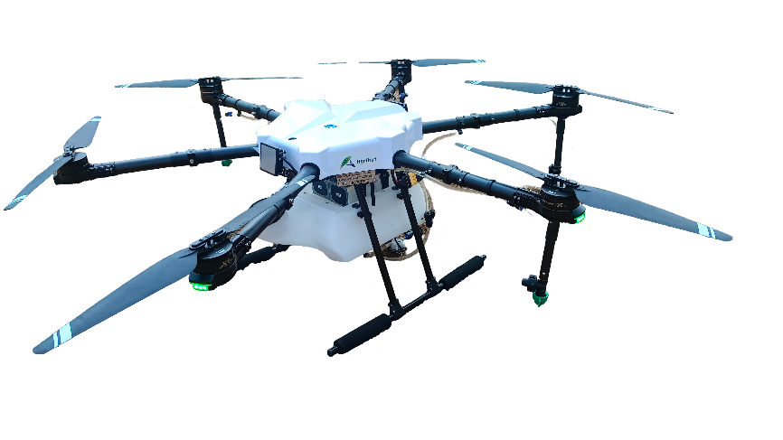

**Fig. 1. AGRIBOT**

**2.2 Patternator**

The patternator of size 8 m x 8 m was constructed using 39 numbers of 0.8 mm thick GI sheets. The V shaped troughs in the sheets direct the sprayed liquid towards the collection point. Water was used as spraying medium and drone was positioned at the centre of the patternator and spraying was carried out using flat fan and hollow cone nozzles. The collection bottles of 1 litre capacity were placed at the end of the V shaped troughs to collect the sprayed liquid from each channel, in order to evaluate the discharge from different nozzles during drone spraying.

**2.3 Experimental setup**

Two types of nozzles, N1 and N2 (flat fan nozzle and hollow cone nozzle), were tested under varying pressures and heights. The sprayer tank was filled with a known volume of water and the drone was flown over the patternator, maintaining a steady position at the center (Fig. 3). Trials were conducted for each nozzle using a combination of five height levels, H1, H2, H3, H4 and H5 (0.5 m, 1 m, 1.5 m, 2 m, and 2.5 m) from the surface of the patternator and three pressure levels, P1, P2 and P3 (2 kg/cm2, 3 kg/cm2 and 5 kg/cm2) of the spray pump. Each combination of height, pressure, and nozzle type was replicated three times to ensure reliability and accuracy of the results. The drone sprayed continuously over the patternator for a duration of 2 minutes and 30 seconds in each trial. Following the spraying operation, water collected in the bottles placed at the end of each channel was measured using a measuring cylinder. These measurements provided the data needed to calculate discharge rates for each combination of parameters.

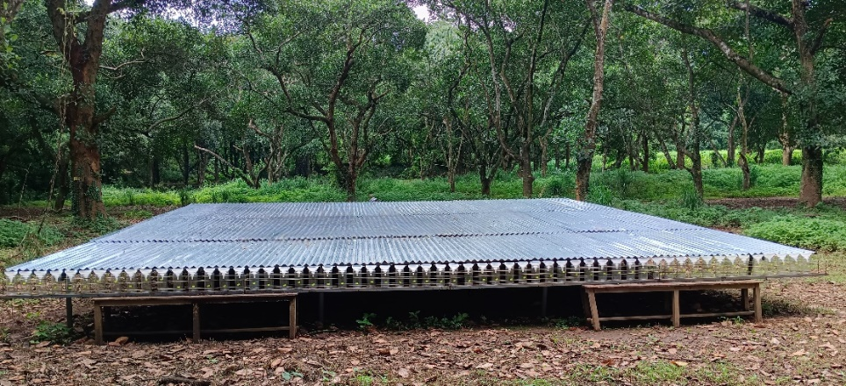

**Fig. 2. Patternator developed for the study**

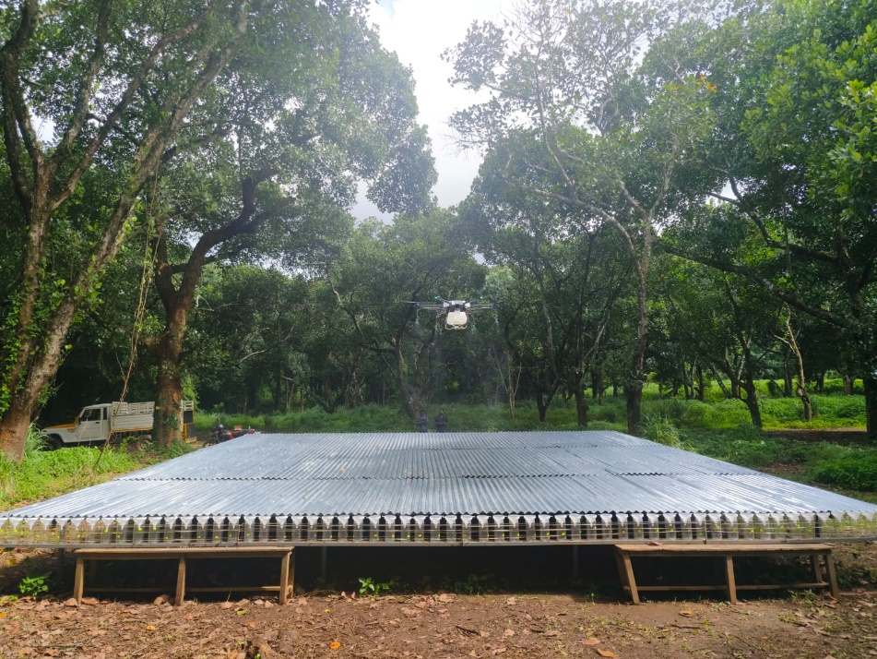

**Fig. 3. Spraying of water by drone on the developed patternator**

**2.4 Statistical analysis**

RStudio software was used to statistically analyze the discharge performance of the drone spraying. The software enabled precise processing and interpretation of data collected during the experiments, ensuring a strong and reliable understanding of performance characteristics. The primary objective of the analysis was to determine the influence of nozzle type, spraying height, and operating pressure on discharge performance.

Analysis of Variance (ANOVA) was used to identify significant differences among the variables and their interactions. The Tukey's Honest Significant Difference (HSD) post hoc test was applied to further analyze significant differences found in the ANOVA, providing pairwise mean comparisons to highlight the particular parameters (such as nozzle type, height, and pressure) that had a major impact on discharge performance. These findings are essential for optimizing drone operations and nozzle designs to accomplish precision spraying in agricultural activities.

**3. RESULTS AND DISCUSSIONS**

The data obtained from the experiment was statistically analyzed using RStudio software to explain the relationship between the combination of nozzle type, pressure, and height on discharge rates. The discharge values range from 0.6060 to 1.8150 L/min, with a median of 1.0255 L/min and a mean of 1.1374 L/min, indicating a slight positive skew. The interquartile range spans from 0.8888 to 1.4505 L/min, suggesting moderate variability in the data. Further analysis revealed significant differences in discharge rates among the selected heights.

Comparison between heights H1 and H5 showed a significant mean difference (mean difference = -0.09941, p = 0.0027866), indicating that the drone flying at a height of H5 has a lower discharge rate than that operating at a height of H1. These findings highlight the influence of height in discharge performance. No significant differences were observed between heights H3 vs H2 and H4 vs H3, indicating comparable discharge levels.

As illustrated in Fig. 4, the boxplot shows the discharge distribution by height, highlighting the distinct patterns that support the selection of height for further analysis.

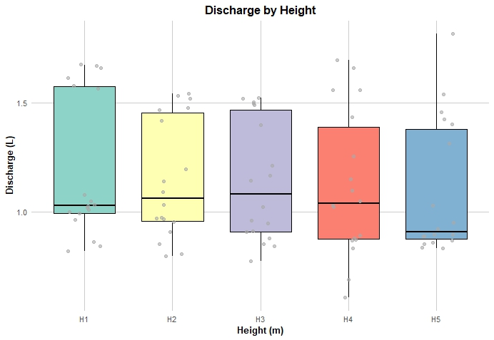

**Fig. 4. Boxplot showing discharge by height, with jittered points for individual measurements**

To ensure the robustness of the analysis, it is imperative that the samples exhibit independence, and the assumption of homogeneity of variances is met. Levene’s Test, performed using R software, yielded no significant violations (F=1.0747, p= 0.3966), suggesting the variances across the groups are homogeneously distributed. The ANOVA results (Table 1) indicated that nozzle type, height, and pressure significantly influence discharge, along with their interactions. The main effect of Nozzle Type (F = 739.672, p < 2e-16) is highly significant, indicating that nozzle Type has a highly significant effect on Discharge. The p-value is well below 0.05, indicating that the type of nozzle causes substantial differences in discharge levels. Height (F = 3.950, p = 0.00609) and Pressure (F = 172.653, p < 2e-16) also have significant effects, showing that variations in these factors meaningfully impact discharge. Similarly, the interaction between nozzle type and height, nozzle type and pressure, and height and pressure, indicate that the effects of one factor depend on the levels of the other. The three-way interaction between nozzle type, height, and pressure is statistically significant. The combined effects of these three factors on discharge are not additive, meaning the influence of one factor depends on the others. Residuals have a small mean square (0.006), representing the unexplained variability in Discharge after accounting for the main effects and interactions. The relatively small mean square for residuals indicates that the model explains a significant portion of the variance.

To substantiate the ANOVA findings, an effect size analysis was conducted, underscoring the importance of quantifying the magnitude of the observed effects. As shown in Table 2, the partial Eta Squared values and their corresponding 95% confidence intervals are reported for each main effect and interaction.

**Table 1. ANOVA Table**

|  |  |  |  |  |  |  |
| --- | --- | --- | --- | --- | --- | --- |
|  | **Df** | **Sum Sq** | **Mean Sq** | **F value** | **Pr(>F)** |  |
| **Nozzle_Type** | 1 | 4.554 | 4.554 | 926.645 | < 2e-16 | *** |
| **Height** | 4 | 0.097 | 0.024 | 4.965 | 0.00159 | ** |
| **Pressure** | 2 | 2.126 | 1.063 | 216.996 | < 2e-16 | *** |
| **Nozzle_Type : Height** | 4 | 0.099 | 0.025 | 5.066 | 0.00139 | ** |
| **Nozzle_Type: Pressure** | 2 | 0.589 | 0.294 | 60.073 | 4.74e-15 | *** |
| **Height: Presssure** | 8 | 0.112 | 0.014 | 2.852 | 0.00938 | ** |
| **Nozzle_Type : Height: Pressure** | 8 | 0.125 | 0.016 | 3.183 | 0.00449 | ** |
| **Residuals** | 60 | 0.294 | 0.005 |  |  |  |
| **Signif. Codes:** | 0 ‘***’ 0.001 ‘**’ 0.01 ‘*’ 0.05 ‘.’ 0.1 ‘ ‘ 1 | | | | | |

**Table 2. Effect Sizes (Partial Eta Squared) and 95% Confidence Intervals for the Factors and Interactions**

|  |  |  |
| --- | --- | --- |
| **Parameter** | **Eta2 (partial)** | **95% CI** |
| Nozzle_Type | 0.94 | [0.92, 1.00] |
| Height | 0.25 | [0.07, 1.00] |
| Pressure | 0.88 | [0.83, 1.00] |
| Nozzle_Type : Height | 0.25 | [0.08, 1.00] |
| Nozzle_Type: Pressure | 0.67 | [0.55, 1.00] |
| Height: Pressure | 0.28 | [0.05, 1.00] |
| Nozzle_Type:Height:Pressure | 0.30 | [0.07, 1.00] |

The results revealed that the nozzle type has the most pronounced effect on the outcome, with a substantial effect size of 0.94, followed by pressure at 0.88. Notably, both effect sizes are accompanied by confidence intervals that are close to 1, emphasizing the strength and significance of these factors and strongly explaining the variance. With wider confidence intervals signifying greater uncertainty, the interactions such as Nozzle Type: Height and Height: Pressure explain less variance (fig. 5). These findings agree with ANOVA results, confirming that nozzle type, height, and pressure have significant effects, with all two-way and three-way interactions being statistically significant, meaning the influence of one factor depends on the levels of the others.

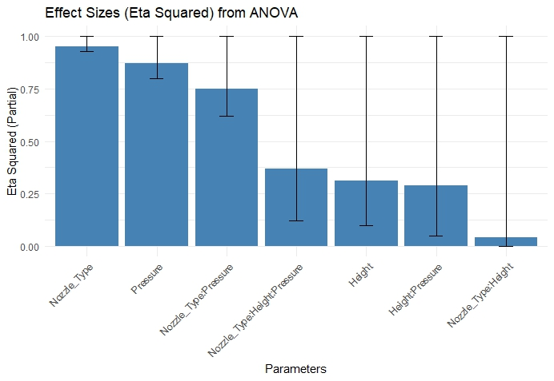

**Fig. 5. Effect sizes (Eta Squared) from ANOVA**

The effects of nozzle type, height, and pressure are not independent but interact with each other. Understanding these interactions can help in optimizing the discharge levels based on nozzle types, height variations, and pressure adjustments. The study of the interaction plot of nozzle type and height (Fig. 6) reveals a consistent pattern. N1 shows a consistent decrease in discharge rate with increase in height, suggesting that lower height enhances its performance. The N1 shows higher discharge rates at heights of H1, H2 and H3 m. This may be due to the increased effect of wind as height increases, causing the spray droplets to move away from the target area. The non-parallel lines in the interaction plot indicate that height's effect on discharge depends on nozzle type, further reinforcing the importance of considering these factors together.

A similar performance is also observed in the case of the N2. However, as the nozzle N1 consistently perform better than N2 at all heights, it is suitable for spray applications requiring higher discharge rates. However, when specific conditions requiring lower discharge rates are encountered, the nozzle N2 can be used at higher heights, especially at H3.

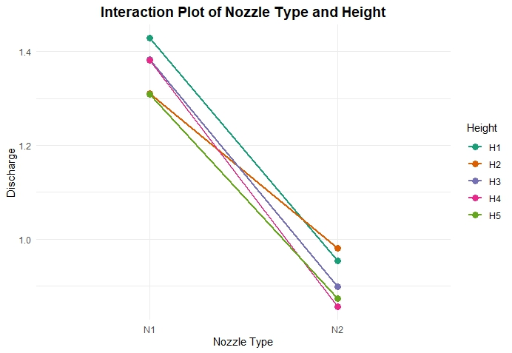 **Fig. 6. Interaction plot of nozzle type and height**

Considering the interaction plot of height and pressure (fig. 7), discharge slightly increases with pressure from heights H1 to H2. Both height and pressure have minimal effect on discharge in the case of both nozzles, showing that no significant interaction exists between height and pressure in determining discharge on the N1 and N2 nozzles.

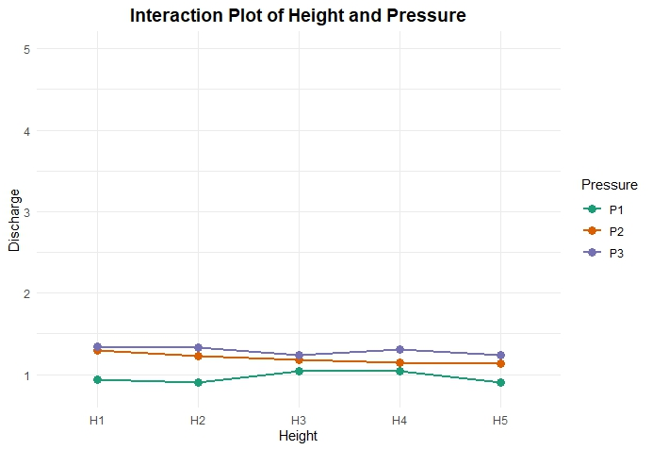

**Fig. 7. Interaction plot of height and pressure**

The interaction plot of nozzle type and pressure (figure 8) shows that the discharge increases with increasing pressure in the case of both nozzles. Higher discharge rate is obtained for N1 which is seems to be higher at 3 kg/cm2 and 5 kg/cm2 compared to 2 kg/cm2 pressure. Similar performance was observed in the case of N2 with lower discharge compare to N1 and discharge seems to increases with pressure.

Fig. 8 compares the discharge levels across two nozzle types (N1 and N2) under varying pressure levels (P1, P2, P3) using an interaction plot. N1 exhibit higher discharge with greater variation, while N2 show consistently lower discharge. Both nozzles show a noticeable increase in discharge when pressure is increased from P1 to P3. This suggests that nozzle type and pressure have a significant impact on discharge, with N2 being more effective, especially at higher pressure.

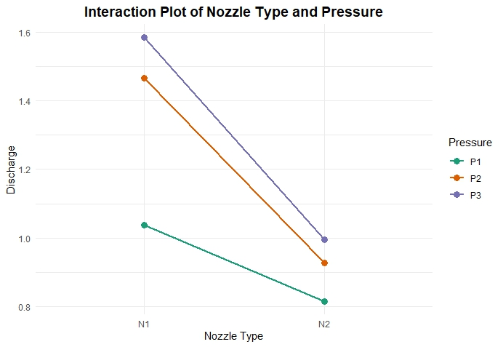

**Fig. 8. Interaction plot of nozzle type and pressure**

**3.1 Post hoc analysis**

Since ANOVA and effect size analysis shows significance differences, post hoc test is required. The post-hoc analysis revealed significant differences in discharge rates based on nozzle type, height, and pressure. For nozzle type, a significant difference was observed between N2 and N1, with N1 resulting in higher discharge rates (diff = -0.4499, p < 0.0001). In terms of height, significant differences were found between H1 and H4 (diff = -0.0724, p = 0.0236), and between H1 and H5 (diff = -0.0994, p = 0.0007), with H4 and H5 showing reduced discharge rates compared to H1. Other height combinations, such as H2-H1, H3-H1, and H3-H2, did not show statistically significant differences. For pressure, significant differences were observed between all pressure levels, with P2 showing higher discharge rates compared to P1 (diff = 0.2693, p < 0.0001) and P3 yielding even higher rates compared to both P1 and P2 (diff = 0.3625, p < 0.0001; diff = 0.0932, p < 0.0001, respectively). These findings were visually supported by the Tukey HSD plot (fig. 9) which clearly illustrated the significant pairwise differences in discharge rates across the nozzle types, heights, and pressures. Overall, the results suggest that nozzle type, height, and pressure significantly impact discharge rates, with pressure being a key factor influencing performance.

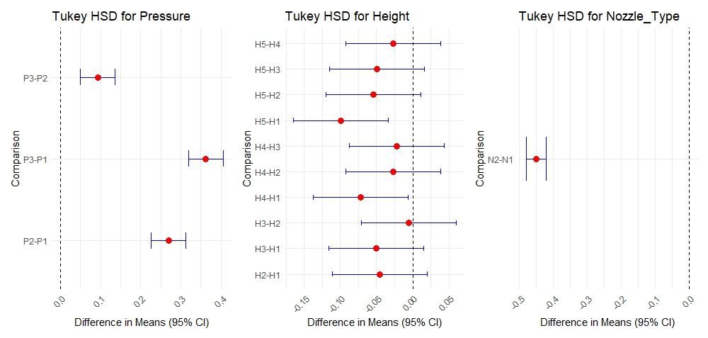

**Fig. 9. Tukeys HSD Plot**

As shown in Fig. 10, the post-hoc tests reveal significant differences in discharge rates between various nozzle, height and pressure combination

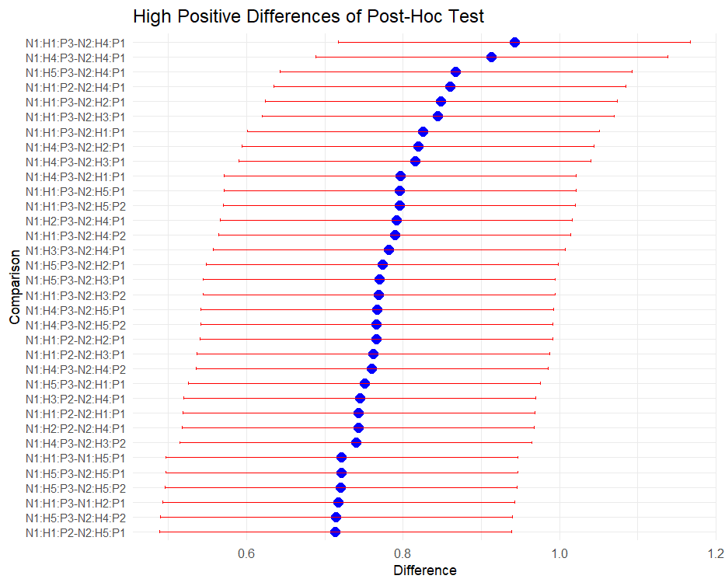

**Fig. 10. High Positive Differences in Post-Hoc Test Comparisons**

The optimal combination for maximizing discharge was Nozzle N1, Height H1, and Pressure P3, which demonstrated the highest discharge improvement (diff = 0.942) and a highly significant p-value (1.99e-11). This combination consistently performed better than all others, indicating that it was the most effective setting for increasing discharge, regardless of nozzle type or height. Other high-performing combinations included N1:H1:P3-N2:H2:P1 (diff = 0.848) and N1:H1:P3-N2:H3:P1 (diff = 0.844), both of which also showed significant discharge improvements compared to the alternative configurations. However, the combination of N1:H1:P3 provided the most reliable and statistically significant increase in discharge across all comparisons. Furthermore, the results indicated that P3 consistently better performance than P1 and P2, highlighting its critical role in optimizing discharge rates. In contrast, N1 and H1 appeared to be the most effective settings, reinforcing their importance in achieving optimal performance.

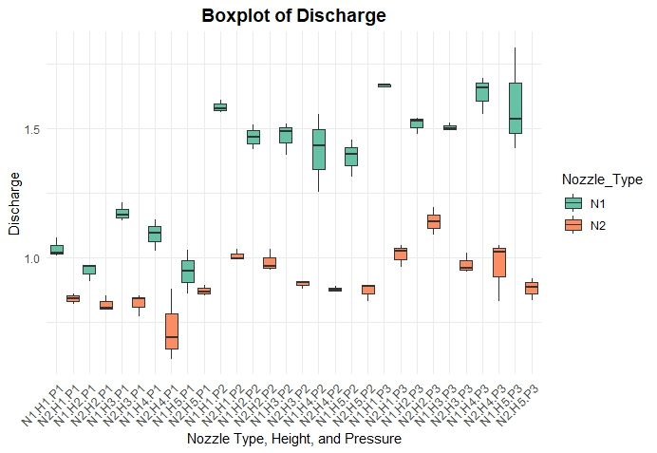

**Fig. 11. Boxplot of discharge**

The combination of N1:H1:P3 proved to be the most effective choice for maximizing discharge, offering the largest and most consistent improvement in performance. This finding suggests that adjusting for P3, coupled with N1 and H1, is key to optimizing discharge rates in practical applications. This conclusion is further supported by the discharge box plot presented in Fig. 11, which illustrates the enhanced performance of this combination.

**4. Conclusion**

This study evaluated the effect of discharge performance of a drone used for spraying. The best result was obtained for flat fan nozzle operating at 0.5 m height and at maximum pressure of 5 kg/cm2. It was found that discharge rate decreases with increasing height and increases with increasing pressure. These findings can be valuable for agricultural drone spraying operation to get an effective spraying in the field through drone spraying. Future research could explore additional factors, such as different spraying liquid type or environmental conditions, to further optimize discharge performance.

**5. References**

Ahirwar, S., Swarnkar, R., Bhukya, S., & Namwade, G. (2019). Application of drone in agriculture. *International Journal of Current Microbiology and Applied Sciences, 8*(1), 2500-2505.

Bendig, J., Bolten, A., & Bareth, G. (2012). Introducing a low-cost mini-UAV for thermal- and multispectral-imaging. *International Archives of the Photogrammetry, Remote Sensing and Spatial Information Sciences, 39*, 345-349.

Huang, Y., Hoffmann, W. C., Lan, Y., Wu, W., & Fritz, B. K. (2009). Development of a spray system for an unmanned aerial vehicle platform. *Applied Engineering in Agriculture, 25*(6), 803-809.

Kailashkumar, B., Sivakumar, S. S., John Gunasekar, J., Padmanathan, P. K., Alex Albert, V., & Ravikumar, R. (2022). Performance evaluation of NMD and NTM nozzle used for agricultural drone spraying. *International Journal of Mechanical Engineering, 7*(5), 1326-1334.

Primicerio, J., Gennaro, S. F. D., Fiorillo, E., Genesio, L., Lugato, E., & Matese, A. (2012). A flexible unmanned aerial vehicle for precision agriculture. *Precision Agriculture, 13*(4), 517-523.

Yallappa, D., Kavitha, R., Surendrakumar, A., Suthakar, B., Kumar, A. P. M., Kannan, B., & Kalarani, M. K. (2023). Influence of the downwash airflow in hexacopter drone on the spray distribution pattern of boom sprayer. *Journal of Applied and Natural Science, 15*(1), 391-400.

Yu, S. H., Kim, Y. K., Jun, H. J., Choi, I. S., Woo, J. K., Kim, Y. J., Yun, Y. T., Choi, Y., Alidoost, R., & Lee, J. K. (2020). Evaluation of spray characteristics of pesticide injection system in agricultural drones. *Journal of Biosystems Engineering, 45*, 272–280.

Yu, S. H., Kang, Y., & Lee, C. G. (2023). Comparison of the spray effects of air induction nozzles and flat fan nozzles installed on agricultural drones. *Applied Sciences, 13*(20), 11552.

Zhang, C., & Kovacs, J. M. (2012). The application of small unmanned aerial systems for precision agriculture: A review. *Precision Agriculture, 13*(6), 693-712.