“Evaluation of Decomposition Rates and Suitability of Various Crop Residues for Vermicompost Production”

ABSTRACT
Aims: Evaluation of Decomposition Rates and Suitability of Various Crop Residues for Vermicompost Production
Study Design: Randomized block design (RBD)
Place and Duration of Study: Centre for Organic Agriculture Research and Training Farm, Department of Agronomy, Dr. PDKV, Akola during experimental period of October 2018 to February 2019
Methodology: The experiment was laid out in randomized block design with eight treatments and replicated thrice. The treatments comprised various crop residues: soybean straw, rice straw, wheat straw, sunhemp stalk, foxtail millet straw, pigeonpea stalk, cotton stalk, and a mixture of available grasses and crop residues. The earthworm species Eisenia foetida was utilized for the study.
Result: The periodical observation is recorded to assess decomposition rate and production of quality compost from various crop residues revealed that initially the maximum temperature (45.4⁰C) was recorded in soybean straw (T1) followed by 45⁰C in cotton stalk (T7) and 44.8 0C in pigeonpea stalk (T6) at 7 DAF, further the temperature was steadily decreased towards maturity. The maximum final weight (11.0 kg) of vermicompost was obtained with soybean straw being at par (10.5 kg) with sunhemp straw and pigeonpea stalk. However, the lowest final weight (6.50 kg) was observed in rice straw vermicompost. The maximum percentage of vermicompost yield recovery was achieved using soybean straw vermicompost (55.0%), followed by sunhemp stalk vermicompost (51.2%) and vermicompost made using the conventional heap method (50.0%). The lowest yield recovery percentage recorded in cotton stalk vermicompost (40.9%). The highest reduction in the final volume of vermicompost was observed in rice straw (0.036 m³) being on par with soybean straw (0.039 m³), sunhemp stalk (0.043 m³) and wheat straw (0.044 m³) and minimum reduction in final volume was recorded with pigeonpea stalk (0.069 m³). Vermicompost maturity was significantly earlier in soybean straw (65 DAF) followed by foxtail millet straw (68 DAF) and traditional heap method (72 DAF). Vermicompost derived from soybean straw (T1) exhibited the lowest C:N ratio (17.24) at maturity, followed by vermicompost from sunhemp stalk (18.09) and the traditional heap method (18.41).
Conclusions: Soybean straw proved to be the most suitable substrate for producing high-quality vermicompost, followed by sunhemp and pigeonpea stalk. The C:N ratio at maturity straw is low, which positively affected the composting duration and quality.
Keywords: crop residue, earthworm, vermicompost, C:N ratio, Maturity and soil fertility
1.INTRODUCTION
Agricultural activities generate large amounts of crop residue, which is a key source of soil nutrients. Proper utilization, stabilization, and transformation of crop residue are crucial for enhancing soil fertility and prolonging nutrient availability. (Wei and Gui, 2017). Intensive agricultural practices, coupled with optimized nutrient and water management, can enhance crop biomass production and improve the efficiency of water and nutrient utilization, thereby increasing plant-derived carbon input to the soil and lower the rate of organic matter decomposition. (Das et al., 2023). Composting technology has as a successful management strategy for recycling and turning organic waste into a valuable "compost" product that is low in harmful microbes and high in nutrients. (Sanasam, et al, 2017). Crop residue has a high organic matter content, making it an ideal raw material for composting. The resulting compost can be used as a soil amendment to enhance soil structure and fertility, and to supply essential nutrients to plants. Composting is the most eco-friendly option for management of stubble by which the nutrients can be returned into the soil in readily available form. (Dutta, et al, 2022). Composting crop residue is an environmentally friendly and long-term waste reduction strategy. It has the potential to improve soil health by increasing organic carbon content and nutrient availability. (Sen, et al, 2024). The total amount of crop residues generated and burned for the year 2017–18 was estimated at 516 million tonnes and 116 million tonnes respectively. It is estimated that 116.3 Tg of crop residues burning released about 176.1 Tg of CO2, 10Tg of CO, 313.9Gg of CH4,8.14Gg of N2O, 151.14Gg of NH3, 813.8 Gg of NMVOC, 453.4 Gg of PM 2.5, and 935.9 Gg of PM10. The emission estimates can be used as a substitute for creating a national inventory of air pollutants caused by burning crop residue. (Venkatramanan et al, 2021). According to the Ministry of New and Renewable Energy, crop residue generation is greatest in Uttar Pradesh (60 Mt) followed by Punjab (51 Mt) and Maharashtra (46 Mt). Among different crops, cereals generate 352 Mt of residues followed by fibre crops (66 Mt), oilseeds (29 Mt), pulses (13 Mt) and sugarcane (Saccharum officinarum) (12 Mt). Rice (34%) and wheat (22%) are the dominant cereals contributing to crop residue generation. (NAAS, 2012). Direct application of fresh organic waste to soil is inadvisable due to potential nutrient imbalances, phytotoxicity, heavy metals, pathogens, and high salt content, which can hinder plant growth. Biochemical treatments help recover nutrients, making them safe for agricultural use (Wang et al., 2016). The composition and C/N ratio of CRs, pH, moisture, temperature, and aeration may affect the process of composting (Bhuvaneshwari et al. 2019). The main objective of vermicomposting is to develop a sustainable agriculture system, which conserves the environment, maintains soil fertility and ensures adequate food production. The earthworms accelerate decomposition of plant litter and organic matter and improve soil fertility by releasing mineral elements in the forms that are easily uptake by plants (Curry, 1987). The passage of soil through earthworm promotes growth of bacteria and actinomycetes, the latter thrive in presence of earthworm and their content in casts is more than 6 times that original soil. Earthworm casts are rich sources of micronutrient, enzyme, antibiotics and growth earthworm (Prasad, et al. 2014).
To prevent issues with agricultural residue burning, slow down the rate of organic matter breaks down, and impedes growth. Utilizing agricultural waste to prepare vermicomposting is a better option and has been thought of as a means of converting residues into compost that is beneficial for plants and soil while reducing its detrimental effects on the environment.
2. MATERIAL AND METHODS
The present investigation pertaining to “Effect of different crop residues on quality of vermicompost” was carried out during the year 2018-2019 at Centre for Organic Agriculture Research and Training (COART) Farm, Department of Agronomy, Dr. Panjabrao Deshmukh Krishi Vidyapeeth, Akola. The statistical analysis was carried out by applying randomized block design (RBD) with eight treatments and three replications
TABLE 1: TREATMENT DETAILS
Treatments | Crop residues
T₁ | Soybean straw
T₂ | Rice straw
T₃ | Wheat straw
T₄ | Sunhemp stalk
T₅ | Foxtail millet straw
T₆ | Pigeon pea stalk
T₇ | Cotton stalk
T₈ | Traditional heap method
The experimental duration was approximately 5 months, due to varying decomposition rates of the residues. Composting was conducted in a tank with dimensions of 0.90 x 0.45 x 0.30 m³, utilizing dung slurry (25%) as the decomposing culture. The crop residues were shredded into small pieces with a maximum length of 2 cm.

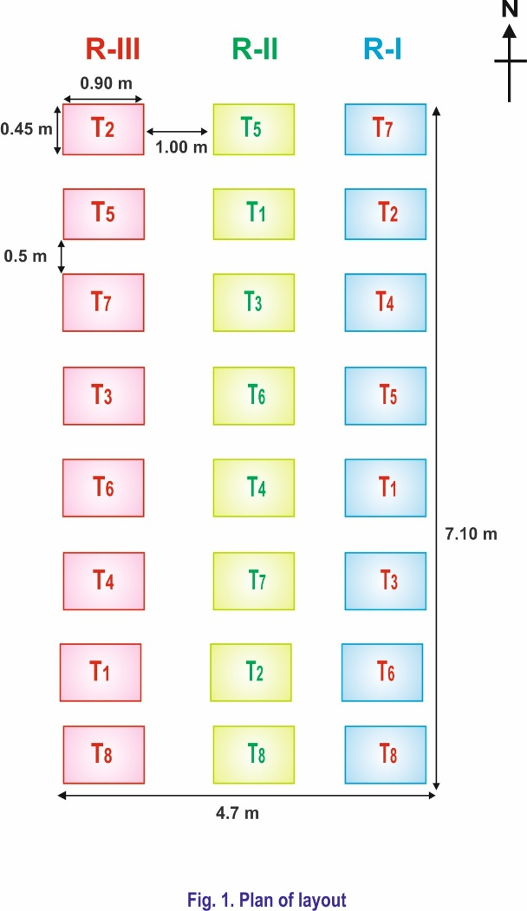
FLOW CHART OF VERMICOMPOST
The 0.9 x 0.45x 0.3 m³ of cement tanks were used
Dung slurry was made by thoroughly mixing of 5 kg dung in 20-liter water
Different crop residues were used
At bottom of tank 2 cm layer of soil was spread evenly
Crop residues as per the treatments were added upto 5 cm height
Dung slurry (25%) sprinkled to wet the desired layer
Likewise six layers were filled up to top level of tank

At final layer soil is mixed in slurry to plaster the layer to prevent heat and gaseous exchange
After partial decomposition (21days), the earthworms Eisenia foetida were released @ 100 worms per tank (0.1215 cu. m.)
Temperature was monitored at 7 days of interval
Final vermicompost is ready as per treatments

Figure1.Plan of layout

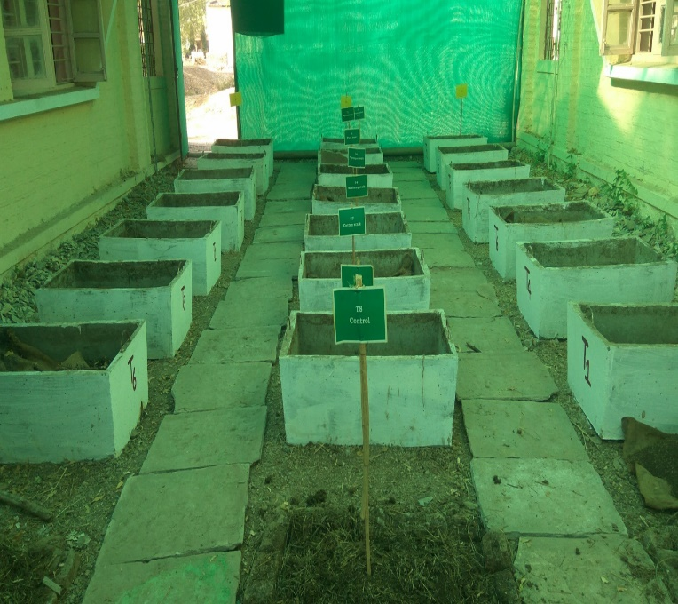
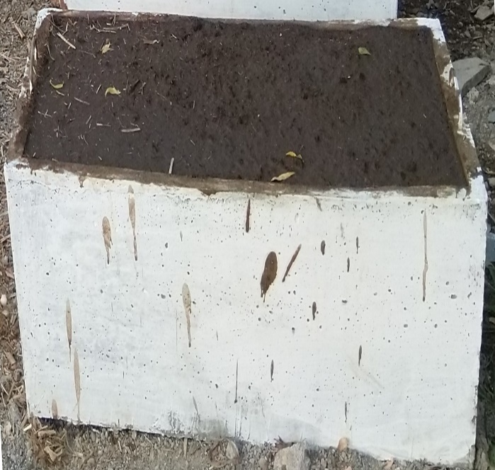
.
Plate 2. Filled tank for predecompostion
Plate 1. General view of experiment

2.2: TANK FILLING AND PRE-DECOMPOSITION:
The dung slurry was prepared by thoroughly mixing 5 kg of dung in 20 liters of water and was applied layer wise. Pre-decomposition was carried out to establish a conducive environment for earthworm inoculation. A 2 cm layer of soil was evenly spread at the bottom of the tank to retain moisture. A 5 cm layer of crop residue was subsequently added, followed by an adequate amount of dung slurry to sufficiently moisten the residue. This layering process was repeated until the tank was filled, requiring approximately six layers in total. Upon the addition of the final layer, one kg soil is added in dung slurry to plaster the layer to prevent heat and gaseous exchange. These tanks were left undisturbed for 21 days to allow for partial decomposition.
Eisenia Foetida SPECIES AND INOCULATION:
After the partial decomposition turning is given to partial decomposed material, water is sprinkled to remove excess heat for the convenience of earthworms. About 100 earthworms per tank were released and throughout the composting process, sufficient moisture was maintained at percent of maximum water holding capacity of a material.

3. RESULTS AND DISCUSSION
The investigational data have been arranged in sequential order starting from the initial temperature of vermicompost to till the mature vermicompost prepared.
Table 2. Periodical changes in mean temperature (⁰C) at 7 days interval as influenced by different crop residues

Treatments |  | Temperature ( ⁰C )
 |  | Days After Filling (DAF)
 |  | 7 | 14 | 21 | 28 | 35 | 42 | 49 | 56 | 63 | 70 | 77 | 84 | 91 | 98 | 105 | 112 | 119
T₁ | Soybean straw | 45.4 | 47.3 | 42 | 33.6 | 29.9 | 27.1 | 24.2 | 21.3 | 18 | - | - | - | - | - | - | - | -
T₂ | Rice straw | 44.2 | 45 | 39.5 | 32 | 30.1 | 26.2 | 23 | 22.2 | 17.3 | 18.1 | 19.3 | 23.1 | 22 | - | - | - | -
T₃ | Wheat straw | 44.1 | 45.8 | 41 | 34 | 30.3 | 25.8 | 24.3 | 21.5 | 17.9 | 18.2 | 18.4 | 22.5 | - | - | - | - | -
T₄ | Sunhemp stalk | 44.6 | 46 | 41.5 | 31 | 29.4 | 24.2 | 22.4 | 19.6 | 17.8 | 17.1 | 19.2 | - | - | - | - | - | -
T₅ | Foxtail straw | 44.3 | 46.9 | 40 | 33.2 | 29.9 | 25.4 | 22.6 | 19.9 | 17.3 | 17.6 | - | - | - | - | - | - | -
T₆ | Pigeonpea stalk | 44.8 | 46.4 | 41.8 | 34.1 | 30.8 | 26.1 | 24.8 | 21.8 | 18.1 | 18.3 | 18.1 | 22.8 | 23.5 | 23.9 | 24.4 | 25.3 | 25.9
T₇ | Cotton stalk | 45 | 47 | 42.1 | 32.2 | 31.2 | 26.9 | 24.9 | 22.4 | 19.1 | 19.5 | 19.2 | 23.8 | 24.3 | 25.8 | 26.1 | 26.3 | 26.6
T₈ | Traditional heap method | 44.6 | 46.7 | 39.9 | 30.2 | 30.6 | 26 | 25.3 | 23 | 19.9 | 20.1 | - | - | - | - | - | - | -

The temperature regime, generated by self-heating resulting from microbial activity, serves as an indicator of the efficacy of the composting process. (Hassan et al., 2023). The persual data is present in table 2. show that, After the inoculation of earthworms, the mean temperature of vermicomposting beds from 28 DAF to its maturity was in between 33.6 to 22.3 ⁰ C which was good for the earthworm activity. Singh, (2022) reported the ideal temperature range for earthworms, between 25°C and 37°C, supports their growth, activity, metabolism, reproduction, and cocoon formation, as well as benefiting associated microorganisms. Also, during predecomposition period (21 DAF) there was increase in temperature up to 14 DAF then it started decreasing. Initially at 7 DAF, the maximum temperature (45.4 ⁰C) was recorded in soybean straw tank (T₁) followed by cotton stalk (45⁰C) (T₇) and pigeonpea stalk (44.8 ⁰C) (T₆). The temperature increased at 14 DAF and the highest temperature (47.3 ⁰C) was recorded in soybean straw (T₁) followed by 47⁰C in cotton stalk (T₇) and least in wheat straw (T₃). A decreasing trend was found after 14 DAF of decomposition and temperature decreased from 45.4⁰C to 39.5⁰C. At 21 DAF, maximum temperature was observed in cotton stalk (42.1⁰C) followed by 42⁰C in soybean straw (T₁). Comparison of compost pit temperature with atmospheric temperature revealed erratic variation during the initial stages of composting (up to 15 days). The gradual decrease in temperature after the introduction of earthworms was due to the crawling action of earthworms and activity of microorganisms under ex-situ mode of composting. Similar results were reported by Mayadevi (2016), Nagarvallemma et al. (2004a), Hait and Tare (2011) and Vasanthi et al. (2013).
3.1: Change in weight (kg) during vermicomposting as influenced by different crop residues

Figure number 2 illustrated that significantly maximum final weight (11.0 kg) of vermicompost was obtained with soybean straw being at par (10.5 kg) with sunhemp straw and pigeonpea stalk each. However, lowest final weight (6.50 kg) was observed in rice straw vermicompost. Figure 3 depicts that the maximum percentage of vermicompost yield recovery was achieved using soybean straw vermicompost (55.0%), followed by sunhemp stalk vermicompost (51.2%) and vermicompost made using the conventional heap method (50.0%). However, using cotton stalk vermicompost resulted in the lowest yield recovery percentage (40.9%). Maximum change in weight was associated with the higher mineralization of organic matter. (Verma et, al, 2014). This might be due to crop residues having different palatability, digestibility, protein and crude fiber contents and even some concentration of special plant metabolites, i.e. polyphenols and related substances. Similarly, Manaig (2016) concluded that efficiency of vermicomposting is affected by bedding materials. Results were also in conformity with Suthar (2009a), Borang et al. (2016) and Viji and Neelanarayanan (2016).

3.2: Change in volume (m³) during vermicomposting as influenced by different crop residues

The application of this specific dosage of eco-enzyme resulted in a significant reduction in the volume of organic waste, indicating a faster composting process. Figure 4 revealed that significantly highest reduction in final volume of vermicompost was observed in rice straw (0.036 m³) being on par with soybean straw (0.039 m³), sunhemp stalk (0.043 m³) and wheat straw (0.044 m³). However, minimum reduction in final volume was recorded with pigeonpea stalk (0.069 m³) and also, it is observed that rice straw vermicompost (T₂) indicated maximum reduction in volume of about 0.086 m³ (70.7%) over initial volume added in vermicompost tank of 0.122 m³ at start of filling of tank. However, pigeonpea stalk vermicompost (T₆) recorded less reduction in volume of about 0.053 m³ (43.3%) over initial volume of material added in vermicompost tank and 8% more reduction were observed in rice straw compared to traditional heap method. Most of the scientists reported about loss in weight rather than loss in volume. In fact, when there is loss in weight of crop residue also affects loss in volume linearly. Maximum decrease in volume of rice straw might be due to its light weight with less density occupied in tank initially and due to the less consumption by the earthworms while in case of soybean volume reduction may be due to its feasibility and palatability therefore more readily accepted by earthworms. Nagavallemma et al. (2004b) also reported that earthworms consume various organic wastes and reduce the volume by 40–60%.

3.3 Time taken for maturity of vermicompost as influenced by different crop residues.

Time taken for vermicompost maturity (DAF) for different crop residues is given in Table 3. Vermicompost prepared from soybean straw was matured significantly earlier i.e. in 65 DAF followed by foxtail millet straw vermicompost in 68 DAF and traditional heap method in 72 DAF. However, vermicompost prepared from cotton stalk, pigeonpea stalk and rice straw was matured late i.e.at 120 DAF, 100 DAF and 90 DAF, respectively. Soybean straw took the least days for vermicomposting than paddy straw, cotton stalk and pigeonpea stalk. This might be due One of the key components of plant cell walls is lignin, which has a chemical composition that makes it extremely resistant to microbial deterioration. There are two consequences for lignin’s structure. One is that the bioavailability of the other cell-wall components is decreased by lignin, resulting in a lower real C:N ratio (i.e., ratio of biodegradable C to N) than the one typically reported. Similar findings are reported by Suthar (2009b)
3.4: Moisture content (%) at maturity of vermicompost as influenced by different crop residues
In present study moisture per cent at maturity in vermicompost prepared from different crop residues ranged between 18.6 to 29.5%. The significantly maximum moisture per cent in vermicompost was recorded in wheat straw vermicompost (29.5%) being at par with cotton stalk vermicompost (29.2%) and pigeonpea stalk vermicompost (27.6%). However, minimum moisture content (18.6%) was observed in vermicompost prepared by traditional heap method. Nagarvallemma et al. (2004c) also reported that moisture content of castings ranges between 32 and 66%.

Table 3. Periodical changes in C: N ratio during vermicomposting as influenced by different crop residues
Treatments |  | C:N ratio
 |  | Initial content | 30 DAF | 60 DAF | 90 DAF | At maturity
T₁ | Soybean straw | 48.25 | 35.78 | 20.18 | - | 17.24
T₂ | Rice straw | 60.87 | 41.56 | 31.26 | 31.26 | 20.52
T₃ | Wheat straw | 78.25 | 50.14 | 29.77 |  | 19.44
T₄ | Sunhemp stalk | 51.91 | 36.02 | 22.72 | - | 18.09
T₅ | Foxtail millet straw | 63.27 | 33.71 | 21.83 | - | 19.29
T₆ | Pigeonpea stalk | 53.06 | 35.52 | 27.42 | 22.42 | 20.58
T₇ | Cotton stalk | 77.11 | 44.25 | 31.47 | 25.70 | 20.29
T₈ | Traditional heap method | 60.79 | 39.53 | 21.66 |  | 18.41
GM |  |  | 39.22 | 25.38 |  | 18.92

The observed data from table 3 revealed that C:N ratio of vermicompost decreased at all the stages of vermicomposting. Decomposition rate can be predicted from the initial C:N ratio. (Chatterjee & Acharya, 2020). At the initial stage, the C:N ratio across different treatments ranged from 78.25 to 48.25, with a significant decrease to maturity, where the C:N ratio ranged between 20.58 and 17.24. The changes in the C:N ratio from the initial to the final stage, least observed in soybean straw T₁ (256.67%) and the highest in wheat straw (T3) (402.52%). The highest initial C:N ratio (78.25) was observed in wheat straw (T3), followed by cotton stalk (T7), whereas the lowest initial C:N ratio (48.25) was recorded in soybean straw (T1), likely due to its higher initial nitrogen content. Vermicompost derived from soybean straw (T1) exhibited the lowest C:N ratio (17.24) at maturity, followed by vermicompost from sunhemp stalk (18.09) and the traditional heap method (18.41).
The gaseous loss of carbon through microbial respiration and simultaneously addition of nitrogen by worms in the form of mucus and nitrogenous excretory material caused lowered the C:N ratio. Higher C:N ratio indicated slow degradation of substrate and the lower C:N ratio indicated the higher efficiency level of mineralization by the species. Similar results have also been reported by Gajbhiye and Satpute (2014).
4. CONCLUSIONS
Soybean straw was most feasible for production of quality vermicompost followed by sunhemp and pigeonpea stalk. Among all the crop residues, the rate of decomposition of soybean straw was faster followed by foxtail millet straw, traditional heap method and sunhemp stalk. Soybean straw exhibited the lowest C:N ratio at maturity, followed by vermicompost from sunhemp stalk and the traditional heap method.
5. DISCLAIMER (ARTIFICIAL INTELLIGENCE)
Author(s) hereby declare that NO generative AI technologies such as Large Language Models (ChatGPT, COPILOT, etc) and text-to-image generators have been used during writing or editing of this manuscript. 6.COMPETING INTERESTS
Authors have declared that no competing interests exist.
7. REFERENCES
Bhuvaneshwari S, Hettiarachchi H, Meegoda JN (2019) Crop residue burning in India: policy

Borang, B., Y.K. Sharma, S.K. Sharma, (2016). Effect of various substrates on performance of earthworm and quality of vermicompost. Annals of Plant and Soil Research, 18(1):37-42.
Chatterjee, A. and Acharya, U. (2020). Controls of carbon and nitrogen releases during crops’ residue decomposition in the Red River Valley, USA, Archives of Agronomy and Soil Science, 66:5, 614-624.
Curry, J. P. (1987). The invertebrate fauna of grassland and its influence on productivity. Grass For. Sci., 42: 103-120.
Das, B., Wani, S.P., Benbi, D.K., Muddu, S., Bhattacharyya, T., Mandal, B., Santra, P., Chakraborty, B., Bhattacharyya, R., Basak, N. and Reddy, N.N. (2023). Soil health and its relationship with food security and human health to meet the sustainable development goals in India. Soil Security 8:1-15.
Dutta, A., Patra, A., Hazra, K.K., Nath, C.P., Kumar, N., Rakshit, A. (2022). A state of the art review in crop residue burning in India: Previous knowledge, present circumstances and future strategies. Environmental Challenges 8:1-16.
Gajbhiye, B.R. and Satpute, U. M. (2014). Quality of vermicompost as influenced by earthworm species and legume crop residues. International Research Journal of Agricultural Science and Soil Science, 4(9): 172-179.
Hait, S. and Tare, V. (2011). Optimizing vermistabilzation of waste activated sludge using vermicompost as bulking material. Waste management, 31:502-511.
Hassa, N.Y.I., Badawi, E.M., Mostafa, D.E.S., Wahed, N.A.H., Smohamed, M., Abdelhamid, A.N.M., Ashry, H., Bassiony, D., Mohamed, O.M.A., Sayed, M.S., Mohammed, R.A., Mansour, A.M.A., Hassan, M.Y. and Mohamed, M.Y. 2023. Composting: an eco-friendly solution for organic waste management to mitigate the effects of climate change. Innovare Journal of Social Sciences, 11(4): 1-7.
Manaig, E.M. (2016). Vermicomposting efficiency and quality of vermicompost with different bedding materials and worm food sources as substrate. Research Journal of Agriculture and Forestry Sciences, 4(1): 1-13.
Mayadevi, M.R. and Sushama, P.K. (2016). Quality check- up of vermicompost by exotic (Eisenia foetida S.) and native ( Perionyx excavates P.) species of earthworms. Green farming, 7(5): 1224-1227.

NAAS 2012. “Management of Crop Residues in the Context of Conservation Agriculture”. Policy Paper No. 58, National Academy of Agricultural Sciences, New Delhi. 12 p.
Nagavalamma, K.P., Wani, S.P., Stephance, L., Padmja, W., Vineetha, C..,Rao, M.B. and Sahrawat, K.L. (2004). Vermicomposting: Recycling wastes into valuable organic fertilizer. Global Theme on Agri Eco Systems Report (8) Patancheru, A. P. ICRISAT.
Prasad R., D. Kumar, D. S. Rana, Y.S. Shivay and R. K. Tewatia. 2014. Textbook of plant nutrient management. Indian Society of Agronomy,New Delhi. pp: 31.
Sanasam, S.D.; Talukdar, N.C. Quality Compost Production from Municipality Biowaste in Mix with Rice Straw, Cow Dung, and Earthworm Eisenia fetida. Compos. Sci. Util. 2017, 25, 141–151.
Sen, M., Roy, A., Rani, K., Nalia, A., Das, T., Tigga, P., Rakshit, D., Atta, K., Mandal, S., Vishwanath, Das, A. (2024). Crop residue: Status, distribution, management, and agricultural sustainability. DOI: 10.1016/B978-0-443-18486-4.00017-8
Singh, A.P. (2022). An Analysis of Vermicomposting, International Journal of Food and Nutritional Sciences ,11 (7):3911-3916.

Suthar S., (2007). Bioconversion of post-harvest crop residues and cattle shed manure into value added products using earthworm Eudrilus eugeniae (king berg). Ecology Engineering, 32(3): 206-214.
Vasanthi, K., Senthilkumari, M., Chairman, K. and Singh, R. (2013). Influence of temperature on growth and reproduction of earthworm Eudrilus eugeniae. International Journal Current Microbiology and Applied Science, 2(7): 202-206.
Venkatramanan V, Shah S, Rai, A.K. and Prasad, R. (2021) Nexus Between Crop Residue Burning, Bioeconomy and Sustainable Development Goals Over North-Western India. Front. Energy Res. 8:1-14.
Verma, R., Badole, W. P., Deewan, P. and Meena, V.S. (2014). Carbon and weight loss during composting of wheat straw by different methods. Annals of Biology, 30 (2):354-357.
Viji J. and P. Neelanarayanan, (2016). Vermicomposting of sunflower (Helianthus annuus l.) Cob (pre-digested with Aspergillus niger) without cow dung by utilizing conventional composting earthworms. International journal of current science research, 2(5): 650-667.
Wang, Q., Wang, Z., Awasthi, M.K., Jiang, Y., Li, R., Ren, X., Zhao, J., Shen, F., Wang, M., Zhang, Z. (2016). Evaluation of medical stone amendment for the reduction of nitrogen loss and bioavailability of heavy metals during pig manure composting. Bioresour. Technol., 220:297–304.
Wei, F. and Gui, J.W. (2017). Crop Residue Application and Stabilization in Soil: A Review. Chinese Journal of Soil Science, 48(2): 501-506.

