DIETARY SUPPLEMENTS USED IN GERIATRICS DISEASES-AN OVERVIEW

**ABSTRACT:-**

Geriatrics is a medical practice that addresses the complex needs of older patients and emphasizes maintaining functional independence even in the presence of chronic disease. Treatment of geriatric patients requires a different strategy and is very complex. Geriatric medicines aim to promote health by preventing and treating diseases and disabilities in older adults. Development of effective dietary interventions for promoting healthy aging is an active but challenging area of research because aging is associated with an increased risk of chronic disease, disability, and death. Aging populations are a global phenomenon. The most widespread conditions affecting older people are hypertension, congestive heart failure, dementia, osteoporosis, breathing problems, cataract, and diabetes to name a few. Decreased immunity is also partially responsible for the increased morbidity and mortality resulting from infectious agents in the elderly. Nutritional status is one of the chief variables that explains differences in both the incidence and pathology of infection. Elderly people are at increased risk for micronutrient deficiencies due to a variety of factors including social, physical, economic, and emotional obstacles to eating. Thus there is an urgent need to shift priorities to increase our attention on ways to prevent chronic illnesses associated with aging. Individually, people must put increased efforts into establishing healthy lifestyle practices, including consuming a more healthful diet. The present review thus focuses on the phytochemicals of nutraceutical importance for the geriatric population.

**KEYWORDS**:-Aging, Frailty, Dementia (e.g., Alzheimer’s disease) ,Parkinson’s disease, Osteoporosis, Arthritis (e.g., osteoarthritis, rheumatoid arthritis), Hypertension, Diabetes mellitus, Cardiovascular disease (e.g., heart failure, coronary artery disease), Chronic kidney disease (CKD), Chronic obstructive pulmonary disease (COPD)

**INTRODUCTION**:-

Geriatrics refers to the medical care of the elderly people. Gerontology refers to the “study of physical and psychological changes which are incident to old age”. India Is currently facing a demographic transition with an ageing population. This transition consists of increasing elderly population, due to reduced mortality, reduced fertility and increased life expectancy. People above 60 years are included in elderly[1]. Geriatric population is usually neglected and brings with them a large number of medical, social, psychological and economic problems, creating a huge burden on the country. It is the need of hour to know about problems of geriatrics, for their timely detection and management in order to improve quality of life of the elderly and thus decreasing the burden on the country.

These geriatric syndromes are a group of symptoms or problems that are logically connected, associated with old age, and have a multifactorial etiology and a chronic course. They can interact with each other, generating a vicious circle that further impinges on functional and homeostatic reserves and paves the way for decline toward disability

**🡪Classification of elderly on basis of functional and cognitive status[2]:-**

1. **Group I elderly (functionally and cognitively fit**): They need health promotional activities including nutrition, physical activity, psychosocial support. The goal is to keep them physically and mentally active, to screen for common diseases like diabetes, hypertension, cancer, vision, hearing, promotion of bone health, and vaccination.
2. **Group II elderly (mild functional limitations or mild cognitive impairment):** These are usually in the age group of 70-80 years. They need assistance for living, special geriatric clinics for comprehensive assessment and rehabilitation, and constant medical help. Goal is to help them live independently with assistance.
3. **Group III elderly (severe functional limitations or cognitive limitations**): This group needs home surroundings.

**🡪Epidemiology of geriatrics**

The global and Indian demographic trend shows that, with passage of time, countries have experienced ageing of population with increase in proportion of older persons, thus creating a burden on the working age group. Census 2011, Sample Registration System, and other studies, have shown following demographic changes in India[3 ,4-6].

Proportion of elderly population-8.2%

Geriatric population growth rate-1.9%

Old age dependency ratio – 14.2

Physically disabled elderly-5177/1 lakh.

**🡪NUTRACEUTICAL:-**

Nutraceutical is a term given by Dr. Stephen De Felice in 1989 and came from two words “nutrition” and “pharmaceutical”. These are foods or a part of foods that are beneficial in providing various health benefits including the treatment and/or prevention of the disease. Science of nutrition has increasingly achieved new horizons, starting from the anticipation of deficiencies in nutrients to prominence on human health and prevention and treatment of chronic ailments. Terms ‘nutraceuticals’, ‘food supplements’, ‘dietary supplements’ have evolved after the concept was originated by Dr. De Felice. There is no sharp demarcation between food supplements and nutraceuticals given by regulatory authorities. Literature of recent years emphasizes on redefining the concept of nutraceuticals, taking into consideration the efficacy, safety and toxicity of these products. Food products are nourishing substances that are eaten, drunk or otherwise taken to sustain life, provide energy and promote growth. Currently, isolation of nutrients from these food products are well recognized and used. The starting point to differentiate food/dietary supplements and nutraceuticals is the identification of an epidemiological target, followed by safety and efficacy studies that understand the mechanism of action. One approach to differentiate these two types of formulations is describing ‘food supplements’ as agents to compensate deficiencies in micro- or macronutrients; in addition, the use of a “nutraceutical” in the treatment of a pathological disease must be supported by strong scientific evidence [7].

**Nutraceuticals may be classified as:**

**1. isoprenoid derivatives** (terpenoids, carotenoids, saponins, tocotrienols, tocopherols, terpenes)

**2.phenolic compounds** (couramines, tannins, lignins, anthocyanins, isoflavones, flavanones, flavanoids)

**3.carbohydrate derivatives** (ascorbic acid, oligosaccharides, nonstarch polysaccharides), fatty acid

**4.structural lipids** (n-3 polyunsaturated fatty acids, conjugated linoleic acid, monounsaturated fatty acids, sphingolipids, lecithins)

**5.amino acid derivatives** (amino acids, allyl-S compounds, capsaicinoids, isothiocyanates, indoles, folate, choline)

**6.microbes** (probiotics, prebiotics)

7.**minerals** (Ca, Zn, Cu, K, Se).

**🡪Registration of Nutraceuticals in India:**

**1.Classification of Nutraceuticals for Geriatric Diseases**

Before applying for FSSAI registration, it’s essential to classify your product under the correct category. Nutraceuticals in India fall into different segments:

Selecting the correct classification is crucial for regulatory approval and marketing.

Table 1 Classification of Nutraceuticals for Geriatric Diseases

|  |  |  |  |
| --- | --- | --- | --- |
| **Sno**. | **Category** | **Description** | **Examples** **of** **geriatric** **diseases** |
| **1** | Health Supplements | Products containing vitamins, minerals, plant extracts, amino acids, or bioactive substances | Omega-3 supplements for heart health, calcium supplements for osteoporosis. |
| **2** | Nutraceuticals | Bioactive compounds with functional health benefits | Curcumin capsules for arthritis, resveratrol for anti-aging |
| **3** | Food for Special Dietary Use | Designed for specific dietary needs, but not for disease treatment | Low-sodium diet products for hypertensive seniors. |
| **4** | Food for medical purposes | Managing medical conditions under medical supervision. | Protein-rich formulations for elderly muscle loss. |
| **5** | Probiotics and prebiotics | Products containing beneficial bacteria or fibers to support gut health. | Probiotic yogurt for elderly gut health. |

**2.FSSAI Registration & Licensing Process**

**A.Types of FSSAI Registrations**:- The type of registration depends on the scale of the business:

|  |  |  |  |
| --- | --- | --- | --- |
| **Sno.** | **Type of registration** | **Eligibility** | **Applicable business type** |
| 1 | FSSAI basic regeneration | Annual turnover ≤ 12 lakh | Small manufacturers, startups |
| **2** | FSSAI state license | Annual turnover 12 lakh - ₹20 crore | Mid-sized businesses operating in one state |
| **3** | FSSAI central licenses | Annual turnover > ₹20 crore OR businesses operating in multiple states | Large manufacturers, exporters, importers |

Table 2- FSSAI Registration & Licensing Process

**B.Steps to Apply for FSSAI License**

1. Visit the FSSAI FoSCoS Portal (<https://foscos.fssai.gov.in/>).
2. Register an account and log in.
3. Fill Form B with product details.
4. Upload Required Documents (see next section).
5. Pay Fees & Submit Application.
6. Inspection by FSSAI Officer (for state/central licenses).
7. Approval & License Issuance

**3.Product Approval for Novel Ingredients :-**If your nutraceutical contains new ingredients not listed by FSSAI, you must:

1. Submit a Product Approval Application via the FoSCoS portal.
2. Provide scientific studies, safety data, and clinical research to support efficacy.
3. The FSSAI Scientific Panel reviews and approves the request.
4. Approval typically takes 3-6 months.

**4.Testing & Stability Studies**

- FSSAI requires nutraceuticals to be tested for:

- Microbial contamination (bacteria, yeast, mold)

- Heavy metals (lead, mercury, arsenic)

- Nutrient stability (shelf-life validation)

- Testing should be done at an FSSAI-certified laboratory.

**🡪DISEASES IN GERIATRICS DISEASE:-**

●Rheumatoid Arthritis

●Delirium

●Alzheimer’s disease

●Hypertensive

●Parkinson’s disease

●COPD

**1.DELIRIUM:-**

 Delirium is a clinical syndrome that usually develops in the elderly. It is characterized by an alteration of attention, consciousness, and cognition, with a reduced ability to focus, sustain, or shift attention. It develops over a short period and fluctuates during the day. The clinical presentation can vary, usually with psychomotor behavioral disturbances such as hyperactivity or hypoactivity and with sleep duration and architecture impairment.[8] By definition, delirium is caused by an underlying medical condition and is not better explained by another preexisting, evolving, or established neurocognitive disorder. The underlying cause of delirium can vary widely and involve anything that stresses the baseline homeostasis of a vulnerable patient.

Fig 1- Delirium, a clinical syndrome

Examples include substance intoxication or withdrawal, medication side effects, infection, surgery, metabolic derangements, pain, or even simple conditions such as constipation or urinary retention. The diagnosis is often missed due to its subtle clinical manifestation, especially in the hypoactive type.[8] Delirium is dangerous, often preventable, and associated with a significant cost burden and increased morbidity and mortality .[9]

**\*Etiology:-**

Delirium is a manifestation of stress on the function of the central nervous system in a vulnerable patient. The pathophysiology is not fully understood, and there is likely no single etiology. Multiple theories describe the potential pathophysiologic causes of delirium, and any single case of delirium probably involves one or more of these theories in a complex and interconnected process. Multifactorial models have been accepted, describing delirium as an interaction of a vulnerable patient with predisposing factors exposed to noxious insults or precipitant factors.

There are 2 risk factors related to delirium: predisposing and precipitant factors. The most common predisposing factors are older age (older than 70 years), dementia (often not recognized clinically), functional disabilities, male gender, poor vision and hearing, and mild cognitive impairment. Alcohol use disorder and laboratory abnormalities have also been associated with an increased risk . [10]

**\*Pathophysiology**:- There is no single mechanism to explain the etiology of delirium. It is a complicated and multifactorial process. Several hypotheses describe different aspects of the pathophysiology of delirium, and multiple processes are likely to occur simultaneously to create the delirium syndrome.

**Increased Age:-** Changes associated with age lead to diminished physiologic reserve and increased vulnerability to physical stress and illness. Some changes associated with age include decreased brain blood perfusion, increased neuron loss, and changes in the proportion of stress-regulating neurotransmitters.

**Neuroinflammation:-** Peripheral inflammatory insults damage endothelial cell-cell adhesions at the blood-brain barrier. The increased endothelial permeability promotes inflammation in the central nervous system, causing further damage, ischemia, and neuronal death.

**Reactive Oxidation Species :-**Reactive oxygen species and reactive nitrogen species are mediators of cellular damage. The central nervous system is particularly vulnerable to reactive oxygen species due to its high lipid content and low antioxidant capacity. [10]

**TREATMENT AND PLANT BASED DRUG:-**

**1.Lemon Balm and Lavender**: Some evidence suggests that lemon balm and lavender can alleviate agitation in people with dementia, which can be a symptom of delirium.

**2.Sage**: Sage has been reviewed for its potential to enhance cognitive function and may be helpful in managing deliriums

**3.St. John’s Wort**: While St. John’s wort is known for its mood-boosting effects, it can also induce delirium, so caution is advised.

**Mechanism of action:**St John’s Wort is a xenobiotic or a plant-derived compound composed of five various forms of hypericin and other flavonoids. Many mechanisms of action have been proposed. One of the main mechanisms used in health care is the report that St. John’s Wort acts as a reuptake inhibitor of serotonin, dopamine, and norepinephrine. This works to reduce the uptake of serotonin at neuronal synapses, as well as dopamine and norepinephrine. Elevated levels of neurotransmitters are believed to be helpful when treating depression. The supplement works by activating pregnane-X-receptor (PXR) cytochromes, which induces the cytochrome P450 system, specifically the CYP3A4 enzyme and P-glycoprotein. P450s or monooxygenase enzymes act through hydroxylation reactions onto the xenobiotic or St. John’s Wort to make it more polar and thus increase its reactivity for conjugation into various polar groups.

In the monooxygenase reaction, molecular oxygen (O2) is broken into water and alcohol (R-OH); because of this, only one oxygen of the pair is given to the xenobiotic substrate.

[11,12 ,13]

**DRUG HISTORY AND DOSAGE**

**History**:st.john’s wort has been used since accident greek and Roman times for wound healing and mental health.

★**Dosage**: 300-900 mg/day in divided doses

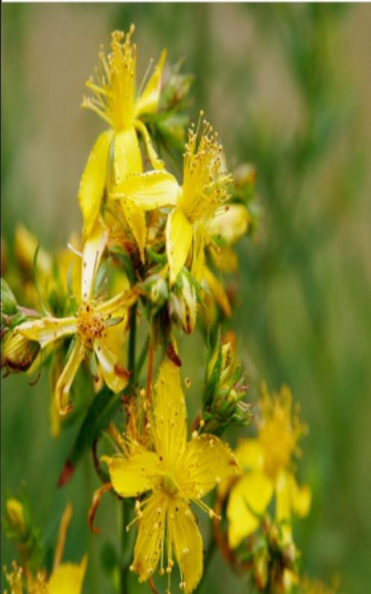★**Precautions**: Take before meals, avoid protein-rich foods.

Fig 2- Ashwagandha, an Ayurvedic herb

**4.Ashwagandha**: Ashwagandha, an Ayurvedic herb, is used for its adaptogenic and antistress properties and has shown promise in improving memory and cognition in some studies.

**5.Yokukansan**: This traditional Japanese herbal medicine may be effective against postoperative delirium.

**Dietary supplements used in delirium**

**Melatonin**:

Melatonin is a hormone produced by the brain that helps regulate sleep and circadian rhythms.

Recent clinical trials suggest melatonin and its receptor agonist ramelteon may be useful in preventing and managing delirium.

Melatonin levels are found to be altered in delirium subjects.

Melatonin is available over-the-counter in North America.

**Thiamine (Vitamin B1):**

Thiamine is an essential B vitamin involved in energy metabolism.

Thiamine deficiency has been associated with delirium, particularly in patients with critical illnesses.

Intravenous thiamine may prevent delirium in medically ill, hospitalized patients.

**2. ALZHEIMER’S DISEASES:-**

Alzheimer disease (AD) is the most prevalent type of dementia, accounting for at least two-thirds of cases in individuals aged 65 and older. AD is a neurodegenerative condition with insidious onset and progressive impairment of behavioral and cognitive functions. These functions include memory, comprehension, language, attention, reasoning, and judgment. While AD does not directly cause death, it substantially raises vulnerability to other complications, which can eventually lead to a person’s death. [14]

**Symptoms**:-

The first symptoms are often mistakenly attributed to aging or stress. Detailed neuropsychological testing can reveal mild cognitive difficulties up to eight years before a person fulfills the clinical criteria for diagnosis of Alzheimer’s disease. These early symptoms can affect the most complex activities of daily living.[15] The most noticeable deficit is short term memory loss, which shows up as difficulty in remembering recently learned facts and inability to acquire new information

**Pathophysiology :-**

Alzheimer’s disease is characterised by loss of neurons and synapses in the cerebral cortex and certain subcortical regions. This loss results in gross atrophy of the affected regions, including degeneration in the temporal lobe and parietal lobe, and parts of the frontal cortex and cingulate gyrus .[16]Degeneration is also present in brainstem nuclei particularly the locus coeruleus in the pons. [17]Studies using MRI and PET have documented reductions in the size of specific brain regions in people with Alzheimer’s disease as they progressed from mild cognitive impairment to Alzheimer’s disease, and in comparison with similar images from healthy older adults. [18]

Both Aβ plaques and neurofibrillary tangles are clearly visible by microscopy in brains of those with Alzheimer’s disease, especially in the hippocampus. However, Alzheimer’s disease may occur without neurofibrillary tangles in the neocortex. Plaques are dense, mostly insoluble deposits of amyloid beta peptide and cellular material outside and around neurons. Neurofibrillary tangles are aggregates of the microtubule-associated protein tau which has become hyper phosphorylated and accumulate inside the cells themselves. Although many older individuals develop some plaques and tangles as a consequence of aging, the brains of people with Alzheimer’s disease have a greater number of them in specific brain regions such as the temporal lobe. Lewy bodies are not rare in the brains of people with Alzheimer’s disease.**[19]**

**TREATMENT AND PLANT BASED DRUG:-**

**Treatment**: No cure, but medications manage symptoms.

**Plant-Based Drug**: ginkgo Biloba

Active Compound: flavonoids

**Mechanism**

1.Enhances Brain Circulation: Ginkgolides & Bilobalide improve blood flow, ensuring better oxygen And nutrient delivery.

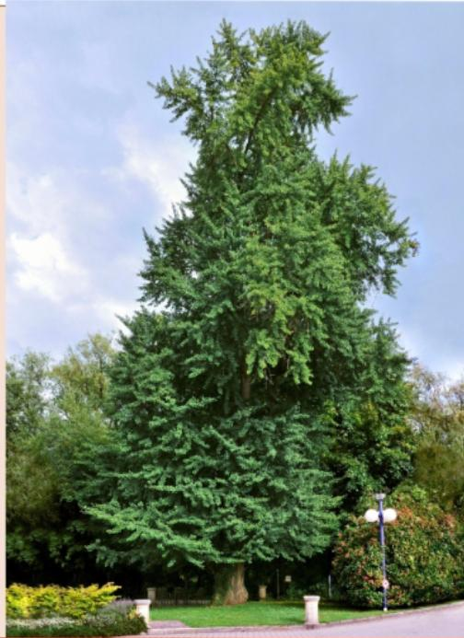

Fig 3- *Ginkgo biloba*

2. Antioxidant & Neuroprotection: Flavanoid reduce oxidative stress, protecting neurons from damage.

3. Prevents Beta-Amyloid Plaques: Inhibits beta-amyloid aggregation, a key factor in Alzheimer’s Progression . [20]

**DRUG HISTORY AND DOSAGE**

**History**: Ancient tree species from China, used in Traditional Chinese Medicine for brain function and circulation. Introduced to Europe in the 18th century and widely used today as a supplement.

**Dosage**: Typically 120-240 mg per day, divided into doses. Best taken with meals, and effects may take weeks.

**Precautions**: Avoid if on blood thinners, before surgery, or if pregnant. May interact with diabetes and epilepsy medications.

**Dietary supplements used in Alzheimer’s disease**

**Omega-3 Fatty Acids:**

Omega-3s, particularly DHA, are believed to be beneficial for brain health.

Some studies suggest a link between high omega-3 intake and a reduced risk of dementia or cognitive decline.

The MIND diet, a nutrition plan for dementia prevention, recommends consuming omega-3-rich foods like salmon weekly.

**Vitamin** E:

Vitamin E is an antioxidant that may help protect brain cells from damage.

Some studies suggest that vitamin E might slow functional decline in people with Alzheimer’s, but results have been mixed.

It’s important to note that studies on vitamin E supplementation have yielded mixed results.

**3.RHEUMATOID ARTHRITIS**:-

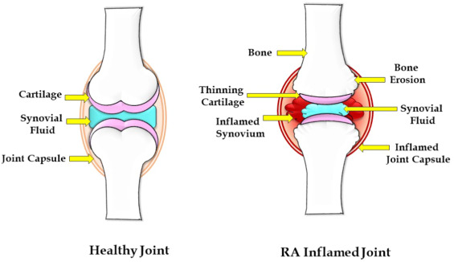Rheumatoid arthritis (RA) is a systemic autoimmune disease characterized by inflammatory arthritis and extra-articular involvement. It is a chronic inflammatory disorder caused in many cases by the interaction between genes and environmental factors, including tobacco, that

Fig 4- Rheumatoid arthritis, a systemic autoimmune disease

primarily involves synovial joint. [21] It typically starts in small peripheral joints, is usually symmetric, and progresses to involve proximal joints if left untreated. Joint inflammation over time leads to the destruction of the joint with loss of cartilage and bone erosions. RA with a symptom duration of fewer than six months is defined as early RA, and when the symptoms have been present for more than six months, it is defined as established RA. RA, if untreated, is a progressive disease with morbidity and increased mortality.

There is no pathognomonic laboratory test for rheumatoid arthritis, which makes the diagnosis of this disease challenging in the early stages. A comprehensive clinical approach is required to make the diagnosis and prevent debilitating joint damage. The treatment of patients with rheumatoid arthritis requires both pharmacological and non-pharmacological therapy. Today, the standard of care is early treatment with disease-modifying anti-rheumatic drugs. Despite treatment, many patients progress to disability and suffer significant morbidity over time. A comprehensive pharmacological and non-pharmacological treatment (physical therapy, counseling, and patient education) is required to improve clinical outcomes.[22]

**\*Etiology:-**

The etiology of RA has a significant hasis in genetics. It is thought to result from the interaction between patients genotypes and environmental factors. In a nationwide study of 91 monozygotic (MZ) and 112 dizygotic (DZ) twin pairs in the United Kingdom, the overall MZ concordance rate was 15%, and in dizygotic twins, 5% . The heritability of rheumatoid arthritis is approximately 40% to 65% for seropositive rheumatoid arthritis and 20% for seronegative rheumatoid arthritis. [23] The risk of developing rheumatoid arthritis has been associated with HLA-DRB1 alleles HLA-DRBI “04, HLA-DRB1 01, and HLA-DRB110. These HLA-DRB1 alleles contain a stretch of a conserved sequence of 5 amino acids referred to as the “shared epitope (SE) in the third hypervariable region of their DRB1 chain, which has been associated with the risk of developing RA.

Polymorphisms in other genes are associated with RA, including PAD14, PTPN22, CTLA4, IL-2RA, STAT4, TRAFI, CCR6, and IRFS Single nucleotide polymorphism (SNP) in PSORSICI, PTPN22, and MIR146A genes are associated with severe disease. Some genetic polymorphisms are associated with RA in different ethnic groups .[24]

**\*Pathophysiology:-**

RA, in some patients, is triggered by some sort of environmental factor in a genetically predisposed host. The best example is tobacco use in a patient with the HLA-DRB1 “shared epitope” gene and the development of ACPA-positive RA. RF and ACPA antibodies are the best known autoantibodies in RA, but several other autoantibodies are relatively specific for RA. The presence of antibodies in rheumatoid arthritis is referred to as seropositive RA. RF is an antibody of any isotype that binds to the Fc portion of IgG.

RA patients often have antibodies to citrullinated proteins. These antibodies have been identified in patients with RA since 1964 (antiperinuclear factor) . and were also described in 1979 (anti-keratin antibodies) . [25] In the 1990s, these antibodies were determined to be the same antibodies with high specificity for RA. The antibodies were found to have specificity for filaggrin, a citrullinated peptide. The epitope for these antibodies is citrullinated peptides. A cyclic citrullinated peptide (CCP) was synthesized, which could be used in an ELISA to test for these antibodies in patients in a clinical situation. These antibodies are called anti-cyclic citrullinated peptide antibodies (ACPA).

**TREATMENT AND PLANT BAED DRUG:**

**Treatment** :-There is no cure for rheumatoid arthritis. But clinical studies indicate that emission of symptoms is more likely when treatment begins early with medications known as disease-modifying ant rheumatic drugs (DMARDs).

**Surgery**:-If medications fail to prevent or slow joint damage, you and your doctor may consider surgery to repair damaged joints. Surgery may help restore your ability to use your joint. It can also reduce pain and improve function.

Rheumatoid arthritis surgery may involve one or more of the following procedures:

**Synovectomy**. Surgery to remove the inflamed lining of the joint (synovium) can help reduce pain and improve the joint’s flexibility.

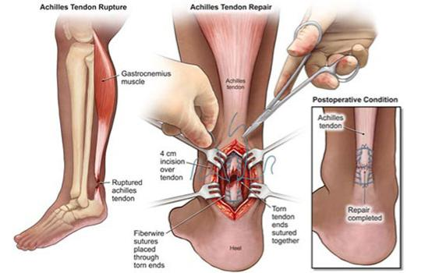Tendon repair. Inflammation and joint damage may cause tendons around your joint to loosen or rupture. Your surgeon may be able to repair the tendons around your joint.

Fig 5- Tendon repair

Joint fusion. Surgically fusing a joint may be recommended to stabilize or realign a joint and for pain relief when a joint replacement isn’t an option.

Total joint replacement. During joint replacement surgery, your surgeon removes the damaged parts of your joint and inserts a prosthesis made of metal and plastic.

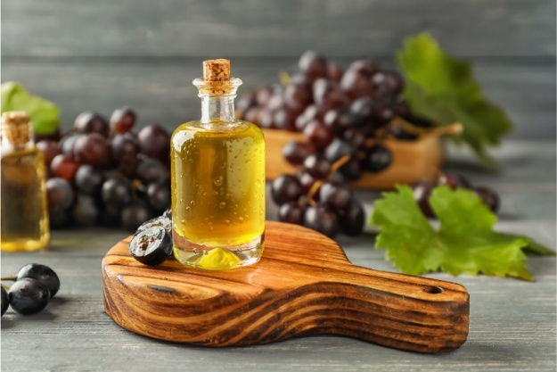**Plant-Based Drug**: Grape seed oil extracted from grape

**Fig 6-** **Plant-Based Drug**

**Mechanism of action**

**1. Antioxidant Activity** :Rich in proanthocyanidins (especially oligomeric proanthocyanidins or OPCs), which are powerful antioxidants.

These compounds help neutralize free radicals, which are elevated in RA and contribute to joint damage and chronic inflammation.

**2. Anti-Inflammatory Effects:** Grape seed oil contains linoleic acid (an omega-6 fatty acid) and vitamin E:Vitamin E reduces cytokine production (like TNF-α and IL-1β), which are major drivers of inflammation in RA.

The oil may modulate NF-κB signaling, a key inflammatory pathway activated in RA.

**3. Inhibition of Enzymes that Degrade Joint Tissue:** OPCs in grape seed extract (and oil to some extent) can inhibit matrix metalloproteinase (MMPs), which are enzymes involved in cartilage and bone degradation.

**4. Immunomodulatory Properties:** Grape seed compounds may down regulate T-cell activation and other immune responses, potentially reducing autoimmune activity.[26]

**DRUG HISTORY AND DOSAGE**

**History**: Most studies have been done using grape seed extract (GSE) rather than the oil. The extract is much more concentrated in proanthocyanidins, the key bioactive compounds.

Grape seed oil has also been explored in animal models of arthritis for its anti-inflammatory and antioxidant properties, but human clinical data is limited.

Combination therapies (e.g., grape seed extract with methotrexate or NSAIDs) have been studied in preclinical models and show synergistic effects in reducing inflammation and joint damage.

**Dosage**:

Grape Seed Extract (most commonly used):

Typical doses in human supplements: 100–300 mg/day (standardized to 95% proanthocyanidins).

**Precautions**: Allergy Risk: Rare, but individuals with grape allergies should avoid.

**\*Dietary supplements used rheumatoid arthritis** :-

1. **Omega-3 Fatty Acids (Fish Oil):**

Benefits: Omega-3s, particularly EPA and DHA found in fish oil, have anti-inflammatory properties that can help reduce joint pain and stiffness in RA patients.

Dosage: Around 1,000-3,000 mg of EPA and DHA combined per day.

1. **Turmeric (Curcumin):**

Benefits: Curcumin, the active compound in turmeric, has anti-inflammatory effects and may help reduce joint pain and swelling.

Dosage: Typically 500-1,000 mg of curcumin per day, with black pepper (piperine) for better absorption.

1. **Glucosamine and Chondroitin**:

Benefits: These supplements may help support cartilage health and reduce joint pain, although evidence for their effectiveness in RA is mixed.

Dosage: 1,500 mg of glucosamine and 1,200 mg of chondroitin per day.

1. **Vitamin D:**

Benefits: Vitamin D plays a role in immune function, and RA patients may be deficient in it. Supplementation may help support bone health and reduce inflammation.

Dosage: 1,000-2,000 IU per day, though higher doses may be recommended for those with deficiencies.

1. **Vitamin E:**

Benefits: Vitamin E is an antioxidant that may help reduce oxidative stress in the body, which is higher in people with RA.

Dosage: 100-400 IU per day.

4.**TYPE 2 DIABETIC MELLITUS :**

Type 2 Diabetes Mellitus (T2DM) is one of the most common metabolic disorders worldwide and its development is primarily caused by a combination of two main factors: defective insulin secretion by pancreatic β-cells and the inability of insulin-sensitive tissues to respond to insulin [27]

Causes: Aging, insulin resistance, obesity.

Symptoms: Frequent urination, fatigue, excessive thirst.

**TREATMENT AND PLANT BASED DRUG**

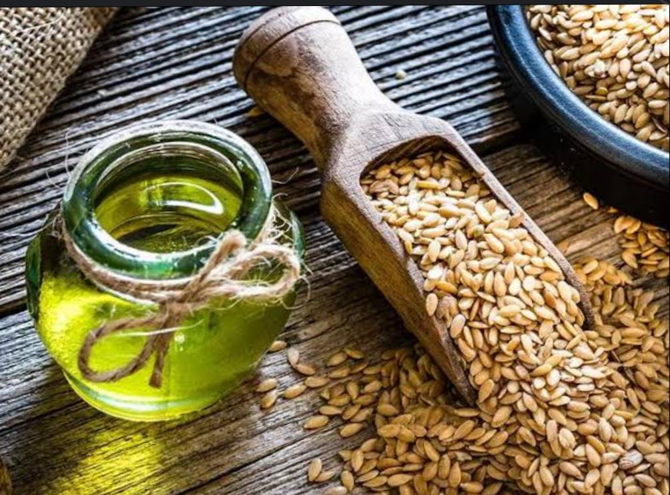**Treatment**: Diet control, exercise, oral medications.

**Fig 7- Dietic control**

**Plant based drug**: Flaxseed (also known as linseed) has several bioactive components that contribute to its health benefits. The primary mechanisms by which flaxseed exerts its effects are:

1. **Rich Source of Alpha-Linolenic Acid (ALA) – Omega-3 Fatty Acid**

Mechanism: ALA is converted (partially) in the body to EPA and DHA, the active omega-3 fatty acids.

Effect: Anti-inflammatory properties, cardiovascular protection, improved lipid profile.(27]

1. **High Lignan Content**

Mechanism: Lignans are phytoestrogens (plant estrogens) with antioxidant properties. They can modulate estrogen metabolism.

Effect: May reduce the risk of hormone-related cancers (like breast and prostate cancer), and have antioxidant and anti-inflammatory effects.[29]

1. **Dietary Fiber (Both Soluble and Insoluble)**

Mechanism: Fiber improves bowel regularity, slows glucose absorption, and binds bile acids (which can lower cholesterol).

Effect: Improves digestive health, lowers blood sugar and cholesterol levels, helps with satiety and weight management . [30]

1. **Antioxidant and Anti-inflammatory Effects**: Due to its ALA and lignans, flaxseed helps reduce oxidative stress and inflammation, which are underlying factors in many chronic diseases.
2. **Hormonal Regulation**: The lignans can bind to estrogen receptors and modulate estrogen activity, potentially balancing hormones in both men and women.

**DRUG HISTORY AND DOSAGE**

**History**:1.Traditional Use: Flaxseed has been used for centuries as a dietary supplement due to its high fiber and oil content.

**2.Modern Research (2000s–present**):

Numerous studies and clinical trials have evaluated flaxseed’s benefits in metabolic disorders, especially T2DM.

Research focuses on its ability to lower fasting blood glucose (FBG), HbA1c, insulin resistance, and lipid profiles.

Bioactive compounds studied: Alpha-linolenic acid (ALA), lignans (especially SDG), and dietary fiber.

**Dosage**:

Lignan extract (SDG): 300–600 mg/day in capsule or powder form in clinical trials.

**Precautions**: avoid alcohol

**Dietary supplements used in Type 2 diabetic mellitus**

**Magnesium**: Low magnesium levels are associated with increased risk of type 2 diabetes, and supplementation may improve insulin sensitivity and metabolic control in some individuals.

**Omega-3 Fatty Acids**:

Some studies suggest omega-3 fatty acids may have a positive effect on blood sugar control, but more research is needed.

**Vitamin D:**

Vitamin D deficiency is associated with increased risk of type 2 diabetes, and supplementation may improve insulin sensitivity and reduce the risk of diabetes.

**Zinc:**

Some studies suggest zinc supplementation may have a positive effect on blood sugar control, but more research is needed.

**4.CHRONIC OBSTRUCTIVE PULMONARY DISEASE**

Chronic obstructive pulmonary disease (COPD) is a common and treatable disease characterized by progressive airflow limitation and tissue destruction. It is associated with structural lung changes due to chronic inflammation from prolonged exposure to noxious particles or gases most commonly cigarette smoke. Chronic inflammation causes airway narrowing and decreased lung recoil. The disease often presents with symptoms of cough, dyspnea, and sputum production. Symptoms can range from being asymptomatic to respiratory failure.

**Etiology**: COPD is caused by prolonged exposure to harmful particles or gases. Cigarette smoking is the most common cause of COPD worldwide. Other causes may include second-hand smoke, environmental and occupational exposures, and alpha-1 antitrypsin deficiency (AATD). [31]

**Epidemiology:** COPD is primarily present in smokers and those greater than age 40. Prevalence increases with age and it is currently the third most common cause of morbidity and mortality worldwide. In 2015, the prevalence of COPD was 174 million and there were approximately 3.2 million deaths due to COPD worldwide. However, the prevalence is likely to be underestimated due to the under diagnosis of COPD.[31]

**Pathophysiology:** COPD is an inflammatory condition involving the airways, lung parenchyma, and pulmonary vasculature. The process is thought to involve oxidative stress and protease-antiprotease imbalances. Emphysema describes one of the structural changes seen in COPD where there is destruction of the alveolar air sacs (gas-exchanging surfaces of the lungs) leading to obstructive physiology. In emphysema, an irritant (e.g., smoking) causes an inflammatory response. Neutrophils and macrophages are recruited and release multiple inflammatory mediators. Oxidants and excess proteases leading to the destruction of the air sacs. The protease-mediated destruction of elastin leads to a loss of elastic recoil and results in airway collapse during exhalation.[32]

**PLANT BASED DRUG AND TREATMENT**

**Treatment:-**

Bronchodilators: SABA, LABA, SAMA, LAMA

Inhaled corticosteroids (ICS)

Combination inhalers: LABA+ICS, LABA+LAMA, Triple therapy

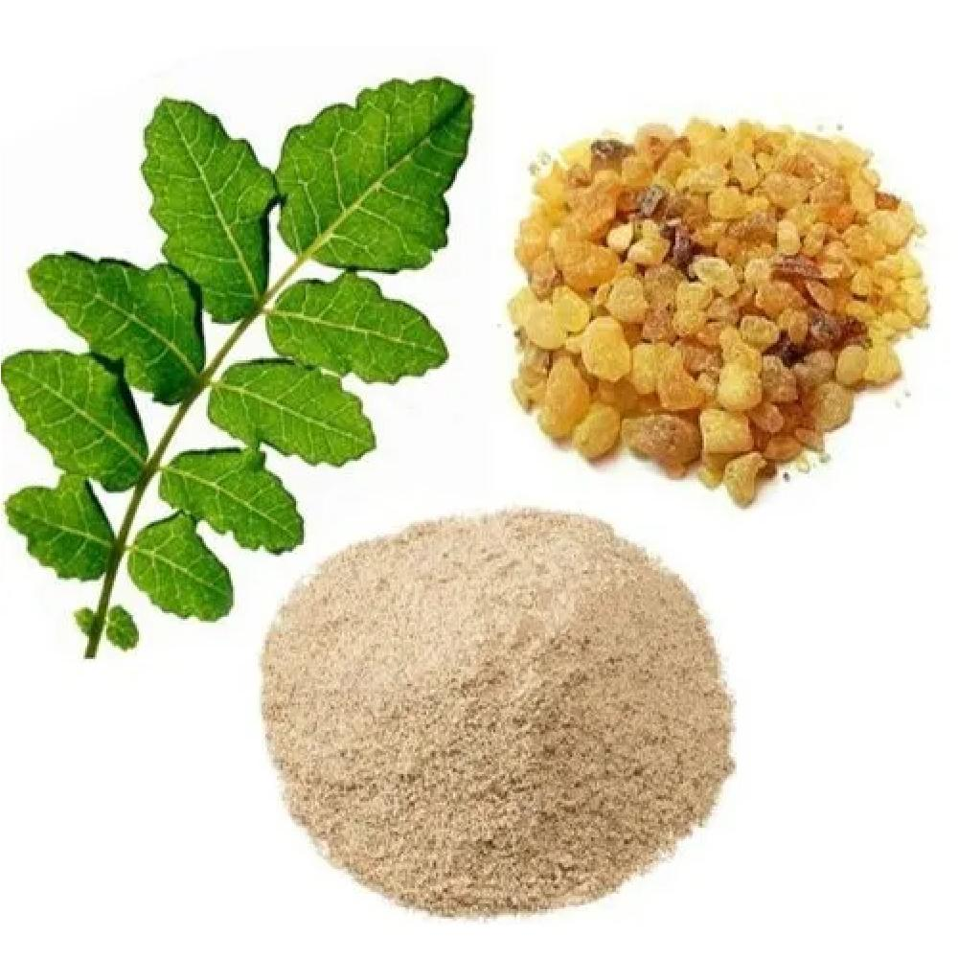**Plant based drug:-** Boswellia

**Fig 8-** Plant based drug *Boswellia*

**Mechanism of action:-**

1.Inhibition of 5-Lipoxygenase (5-LOX): Boswellia contains boswellic acids, particularly acetyl-11-keto-β-boswellic acid (AKBA), which selectively inhibit the 5-lipoxygenase enzyme.

5-LOX is involved in the synthesis of leukotrienes, which are potent inflammatory mediators in the lungs.

In COPD, leukotrienes contribute to bronchoconstriction, mucus production, and chronic inflammation.

By inhibiting 5-LOX, Boswellia reduces leukotriene levels, thereby reducing airway inflammation and bronchospasm.

2.Downregulation of NF-κB Pathway: Boswellic acids can also inhibit NF-κB, a transcription factor involved in the production of pro-inflammatory cytokines (like TNF-α, IL-1β, IL-6).

In COPD, NF-κB is chronically activated, leading to ongoing lung inflammation.

Suppressing NF-κB helps reduce this inflammation and may slow disease progression.

3.Antioxidant Effects : Boswellia has been shown to reduce oxidative stress, which is a major contributor to COPD pathology.

It helps neutralize free radicals in lung tissues, protecting against further damage to airway cells.

4.Immune Modulation: It modulates the immune response by affecting T-cell activity and suppressing autoimmune and hypersensitivity reactions that may worsen COPD .[33,34]

**DRUG HISTORY AND DOSAGE :**

**History :-**

Ancient use: Respiratory and inflammatory conditions in Ayurveda.

Modern research: Anti-inflammatory effects via 5-LOX inhibition; promising for COPD symptom management.

**Dosage:-**300–500 mg, 2 to 3 times per day

**Dietary supplements used in copd:**

**1. N-Acetyl cysteine (NAC):** Mucolytic and antioxidant Helps thin mucus and reduce exacerbations

Dose: 600–1200 mg/day

**2. Omega-3 Fatty Acids (Fish Oil**):Anti-inflammatory

May reduce airway inflammation and improve immune response

Dose: 1000–2000 mg/day of EPA + DHA

**3. Vitamin D:** Supports immune function and lung health **.**Deficiency is common in COPD and linked to worse outcomes

Dose: 1000–4000 IU/day, based on blood levels

**4.Vitamin C and E :**Antioxidants that protect lung tissue from oxidative stress

Often combined in lung-support formulas

**CONCLUSION**:-

dietary supplements can play a crucial role in managing health conditions and improving quality of life in geriatrics, provided they are used appropriately and in conjunction with a well-balanced diet. They may help address common nutritional deficiencies, support immune function, and aid in managing chronic diseases such as osteoporosis, heart disease, and diabetes. However, it is essential for healthcare professionals to assess the individual needs of elderly patients, considering potential interactions with medications and existing health conditions. Proper monitoring and personalized recommendations are key to ensuring the safety and efficacy of supplements in older adults.

Expanding further, dietary supplements can be particularly beneficial in older adults due to the physiological changes associated with aging, such as decreased nutrient absorption, changes in metabolism, and reduced dietary intake. Common supplements like vitamin D, calcium, omega-3 fatty acids, and B vitamins can help address deficiencies that are prevalent in geriatric populations and are associated with conditions like osteoporosis, cognitive decline, and cardiovascular disease.

For example, vitamin D and calcium supplements are essential for maintaining bone health, while omega-3 fatty acids can help reduce the risk of cardiovascular issues. B vitamins, especially B12, are crucial for cognitive function and preventing anemia, which is common in older adults.

However, the use of dietary supplements in geriatrics must be carefully managed. Older adults often take multiple medications, increasing the risk of drug-supplement interactions. Additionally, self-prescribing or indiscriminate use of supplements without medical guidance can lead to adverse effects, such as toxicity or interference with other treatments. Thus, individualized care plans developed by healthcare providers, with consideration for the patient’s medical history, existing medications, and overall nutritional needs, are essential.

Ultimately, while dietary supplements can support health and help manage or prevent chronic diseases in the elderly, they should complement—not replace—a balanced diet and regular medical care. Ensuring proper education on safe supplement use, as well as ongoing monitoring, is crucial to maximizing benefits and minimizing potential risks.

**REFERENCE**:--

1. Khan S, Itrat M. Current Issues in Geriatric Health Care in India-A Review. J Comm Med Health Care 2016; 1 (1): 1003-6.

2. Adhikari P. Geriatric health care in India – Unmet needs and the Way forward. Arch Med Health Sci 2017; 5: 112-4.

3.Census of India Website: Office of the Registrar General and Census Commissioner, India. Censusindia.gov.in. 2019. Available From: <http://www.censusindia.gov.in/2011-Common/> CensusData2011.html.

4. Census of India Website: Office of the Registrar General and Census Commissioner, India. Censusindia.gov.in. 2019. Available From: <http://www.censusindia.gov.in/2011-Common/> Sample_Registration_System.html.

5. Paul NS, Asirvatham M. Geriatric health policy in India: The need for Scaling-up implementation. J Fam Med Prim Care 2016; 5: 242-7.

6. Nath A, Ingle G. Geriatric health in India: Concerns and solutions. Ind J Comm Med 2008; 33 (4): 214-9.

7. Santini A., Novellino E. Nutraceuticals-Shedding Light on the Grey Area between Pharmaceuticals and Food. Expert Rev. Clin. Pharmacol. 2018;11:545-547. Doi: 10.1080/17512433.2018.1464911.

8. Mart MF, Williams Roberson S, Salas B, Pandharipande PP, Ely EW. Prevention and Management of Delirium in the Intensive Care Unit. Semin Respir Crit Care Med. 2021 Feb;42(1):112-126.

9.American Geriatrics Society Expert Panel on Postoperative Delirium in Older Adults. American Geriatrics Society abstracted clinical practice guideline for postoperative delirium in older adults. J Am Geriatr Soc. 2015 Jan;63(1):142-50.

10. Maldonado JR. Delirium pathophysiology: An updated hypothesis of the etiology of acute brain failure. Int J Geriatr Psychiatry. 2018 Nov;33(11):1428-1457.

11.Nicolussi S, Drewe J, Butterweck V, Meyer Zu Schwabedissen HE. Clinical relevance of St. John’s wort drug interactions revisited. Br J Pharmacol. 2020 Mar;177(6):11212-1226.

12. Mannel M. Drug interactions with St John’s wort : mechanisms and clinical implications. Drug Saf. 2004;27(11):773-97.

13.Barnes J, Arnason JT, Roufogalis BD. St John’s wort (Hypericum perforatum L.): botanical, chemical, pharmacological and clinical advances. J Pharm Pharmacol. 2019 Jan;71(1):1-3.

14.Mendez MF. Early-Onset Alzheimer Disease. Neurol Clin. 2017 May;35(2):263-281.

15.Bäckman L, Jones S, Berger AK, Laukka EJ, Small BJ (September 2004). “Multiple cognitive deficits during the transition to Alzheimer’s disease”. Journal of Internal Medicine. 256 (3): 195–204.

16.Wenk GL (2003). “Neuropathologic changes in Alzheimer’s disease”. The Journal of Clinical Psychiatry. 64 (Suppl 9): 7-10.

17. Braak H, Del Tredici K (December 2012). “Where, when, and in what form does sporadic Alzheimer’s disease begin?”. Current Opinion in Neurology. 25 (6): 708-714.

18. Desikan RS, Cabral HJ, Hess CP, Dillon WP, Glastonbury CM, Weiner MW, et al. (August 2009). “Automated MRI measures identify individuals with mild cognitive impairment and Alzheimer’s disease”. Brain. 132 (Pt 8): 2048-2057.

19. Kotzbauer PT, Trojanowsk JQ, Lee VM (October 2001). “Lewy body pathology in Alzheimer’s disease”. Journal of Molecular Neuroscience. 17 (2): 225-232.

20. Maclennan, K. M., Darlington, C. L., & Smith, P. F. (2002). The neuroprotective properties of the Ginkgo biloba leaf: a review of the possible relationship to platelet-activating factor (PAF). Journal of Ethnopharmacology, 72(1-2), 1–9.

21.Klareskog L, Rönnelid J, Saevarsdottir S, Padyukov L, Alfredsson L. The importance of differences; On environment and its interactions with genes and immunity in the causation of rheumatoid arthritis. J Intern Med. 2020 May;287(5):514-533.

22. Sparks JA. Rheumatoid Arthritis. Ann Intern Med. 2019 Jan 01;170(1):ITC1-ITC16.

23. Silman AJ, MacGregor AJ, Thomson W, Holligan S, Carthy D, Farhan A, Ollier WE. Twin concordance rates for rheumatoid arthritis: results from a nationwide study. Br J Rheumatol. 1993 Oct;32(10):903-7.

24.Dedmon LE. The genetics of rheumatoid arthritis. Rheumatology (Oxford). 2020 Oct 01;59(10):2661-2670.

25. Young BJ, Mallya RK, Leslie RD, Clark CJ, Hamblin TJ. Anti-keratin antibodies in rheumatoid arthritis. Br Med J. 1979 Jul 14;2(6182):97-9.

26. Bagchi, D., Bagchi, M., Stohs, S. J., Das, D. K., Ray, S. D., Kuszynski, C. A., ... & Pruess, H. G. (2000).

27. Roden M., Shulman G.I. The integrative biology of type 2 diabetes. Nature. 2019;576:51–60.

28. Goyal, A., Sharma, V., Upadhyay, N., Gill, S., & Sihag, M. (2014). Flax and flaxseed oil: an ancient medicine & modern functional food. Journal of Food Science and Technology, 51(9), 1633–1653.

29. Thompson, L. U., Chen, J. M., Li, T., Strasser-Weippl, K., & Goss, P. E. (2005). Dietary flaxseed alters tumor biological markers in postmenopausal breast cancer. Clinical Cancer Research, 11(10), 3828–3835.

30.Slavin, J. (2013). Fiber and Prebiotics: Mechanisms and Health Benefits. Nutrients, 5(4), 1417–1435.

31. Singh D, Agusti A, Anzueto A, Barnes PJ, Bourbeau J, Celli BR, Criner GJ, Frith P, Halpin DMG, Han M, López Varela MV, Martinez F, Montes de Oca M, Papi A, Pavord ID, Roche N, Sin DD, Stockley R, Vestbo J, Wedzicha JA, Vogelmeier C. Global Strategy for the Diagnosis, Management, and Prevention of Chronic Obstructive Lung Disease: the GOLD science committee report 2019. Eur Respir J. 2019 May;53(5)

32.Stockley RA. Neutrophils and protease/antiprotease imbalance. Am J Respir Crit Care Med. 1999 Nov;160(5 Pt 2):S49-52.

33.Ammon, H.P. (2010). Modulation of the immune system by Boswellia serrata extracts and boswellic acids. Phytomedicine, 17(11), 862–867.

34.Poeckel, D., & Werz, O. (2006). Boswellic acids: Biological actions and molecular targets. Current Medicinal Chemistry, 13(28), 3359–3369.