***Original Research Article***

**Influence of Coconut Shell Aggregate Size Variation on the Durability of Concrete**

**ABSTRACT**

Concrete is a widely used material globally. As demand grows, environmental concerns about its production have become more urgent. This study examines the effects of coconut shells as partial replacements for coarse aggregates in concrete on the durability of the concrete, focusing on abrasion resistance, magnesium sulphate attack resistance and sodium chloride attack resistance.

The study was conducted at the AAMUSTED condtruction Labouratory within 12 months. The west coast tall coconut specie was employed in the study. Sieved crushed coconut shell aggregates of various sizes:12.5-9.5mm, 19-12.5mm, 25-19mm, and 37.5-25 mm, were used, constituting 10% of the total coarse aggregate.

The aggregates were mixed with a 1:2:4 mix ratio. Three coconut shell aggregate size variation concrete mix and three samples each were cast and cured for 7,14,21 and 28 days before exposure to chemical attack.

The study found that 37.5 - 25mm coconut shell aggregate size replacement improved the concrete's resistance to abrasion by 1.7% compared to 1.32% for smaller size replacement (12.5mm – 9.5mm). Percentage reduction in Compressive strength after NaCl attack was 6.87% for 12.5mm – 9.5mm replacement and 15.70% for 37.5 – 25mm replacement. The study concludes that using coconut shell aggregate in concrete is a sustainable alternative to natural aggregates, supporting eco-friendly construction practices, especially in regions with a plentiful supply of coconut shells. This method reduces waste while improving concrete's surface durability and chemical resistance, making it ideal for specific applications. However, urability properties of concrete replaced with coconut shell size variation at 15%, 20% and 25% on a large scale are recommended for future research.

**Keywords**: Coconut shells (CS), Abrasion resistance, Magnesium sulphate attack, Sodium chloride attack.

**1. INTRODUCTION**

The demand for concrete has surged due to its ability to meet the requirements of various civil infrastructure and construction systems, along with the availability of its main components and strength characteristics (Olsson et al., 2023). Concrete ranks as the second most used material globally, after water, with an annual production of around 10 billion tons—equating to roughly one ton per person (Yerramala & Ramachandrudu, 2012). Coarse aggregate is a key element of concrete, historically available in sufficient quality and quantity for construction. However, concerns about the depletion of high-quality natural aggregates and environmental harm caused by extensive extraction have been raised (Kalyanapu et al., 2015; Wahab & Appiah-Kubi, 2024). Concrete consists of four main ingredients: water, cement, fine aggregate, and coarse aggregate. While water and cement act as binders, the aggregates provide structural strength, with variations in size and shape (de Brito & Kurda, 2021).

In Ghana, there is an increase in housing deficit to about one million, and 3.6 million additional houses will be required by 2025 to accommodate the population. The country’s housing and road sector is still experiencing significant development which will demand a lot of natural aggregate and millions of tons are used annually (Adinkra-Appiah et al., 2015). Also in the UK, natural aggregate use in construction grew from 110 million tonnes in 1960 to 275 million tonnes by 2006, while the U.S. produces about 2 billion tonnes of aggregates annually, expected to surpass 2.5 billion tonnes by 2020 (Reddy et al., 2014). Coarse aggregate, comprising 35% to 70% of concrete, is vital for construction, but environmental concerns from quarrying have led to site closures, prompting interest in alternative materials (Ibearugbulem & Igwilo, 2019). Transporting aggregates over long distances is expensive, so local alternatives like river stones are sometimes preferred (Steven et al., 2002). With rapid urbanisation causing shortages of traditional building materials (Arora et al., 2023), concrete technology is moving toward sustainable alternatives to reduce reliance on natural resources (Sujatha & Balakrishnan, 2021). To make concrete more affordable and environmentally friendly, researchers are exploring waste materials like wood chips, plastic, snail shells, and broken bricks as replacements for coarse aggregates (Murthy et al., 2020).

One such alternative is coconut shells, an agricultural waste product with similar chemical properties to wood. Coconut shells are durable, non-biodegradable, and could substitute natural aggregates in concrete production, maintaining many of its properties (Chin et al., 2021; Verma & Shrivastava, 2019). Classified as lightweight aggregates, coconut shells contain cellulose, lignin, and ash, and are considered suitable for concrete mixes, especially in low-income regions near coconut plantations (Kulkarni & Kumar, 2013; Gunasekaran et al., 2014).

Arora et al. (2023) and Danso & Appiah-Agyei (2021) found that concrete made with coconut and palm kernel shells has lower compressive strength than conventional concrete, though coconut shells outperform palm kernels. Using these materials can also reduce costs by 30% and 42%, respectively (Irham et al., 2024).

In this regard, coarse aggregate (granite stones) can be replaced with bio products like coconut shells. However, works on the durability of concrete made with coarse aggregate replaced with coconut shells, such as Abrasion resistance, Sulphate attack and Sodium Chloride attack, are essential but have not yet been done. This study aims to investigate the durability of concrete made with aggregate replaced with variations in the shell sizes of coconut shells.

**2. MATERIALS**

The study made use of various materials, including sand, coconut shells, crushed granite stones, and cement.

**2.1** **Sand**

The Sand was sourced from Kumasi in the Ashanti region of Ghana, and it was ensured to be free of organic matter by collecting it from 300mm below the surface.

**2.2 Granite Stones**

Crushed granite stones of sizes that passed through 14mm and retained on 12.5mm

**2.3 Coconut shells**

The coconut shells, as shown in Figures 1a and 1b, were procured from Roman Hill, Kumasi in the Ashanti Region, Ghana. These shells were from the west coast tall coconut variety, commonly found along Ghana’s coast. They were air-dried for 14 days to remove moisture before being manually crushed and sieved to different size variations. Crushed granite stones, sized between 12mm and 16mm, were obtained from Aboaso in the Ashanti region.

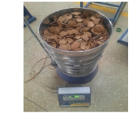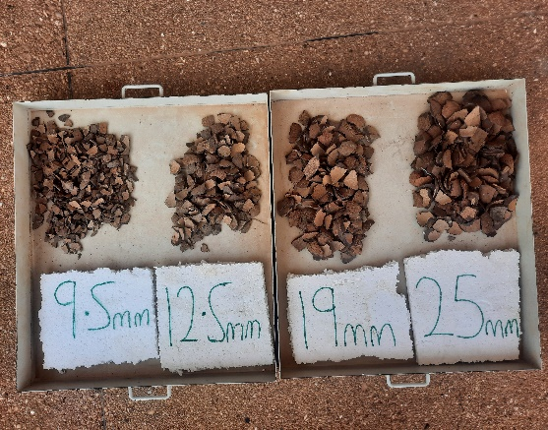

a

b

Figure 1 Crushed coconut shells in a sieve (a) and Sieved coconut shell Sizes (b)

**2.4 Cement**

Ordinary Portland cement, produced by CIMAF Ghana Cement Factory with a grade of 42.5R and conforming to BS EN 197-1 (2011), was also used.

**2.5 Water**

The water that was used for the study conformed to BS EN 1008 (2002). Potable water (tap water) from Ghana Water Company was employed in mixing concrete.

**3. METHODS**

The coconut shells (CS) were manually crushed with a maul hummer into smaller sizes and sieved. The materials were batched by weight and mixed mechanically. In the mixtures, 10% of the crushed coconut shell aggregate was used to partially replace the crushed granite stones (coarse aggregate), with various CCS size ranges: 12.5 - 9.5 mm, 19 - 12.5 mm, 25 - 19 mm, and 37.5 - 25 mm, as illustrated in Fig. 1b. The specimens were then mechanically moulded and cured by sun-drying for 28 days, following the procedures specified in BS 1881-111 (1983).

**3.1 Mixing**

10% of crushed and sieved sizes of coconut shells, that retained on the following sieves (37.5mm - 25mm, 25mm - 19mm, 19mm - 12.5mm and 12.5mm - 9.5mm) were presoaked 24hrs before being used in mixing. Shells were collected separately, and mixed separately with pit sand and crushed granite stones. In line with (BS EN 12620, 2002) Concrete materials were batched and mixed using the mechanical mix machine accordingly. The materials were mixed until a uniform mix was obtained with a 1:2:4 mix ratio. Water water-cement ratio of 0.769kg was then added and mixed thoroughly until a uniform mixture was obtained.

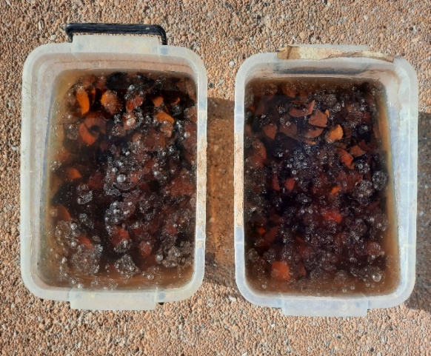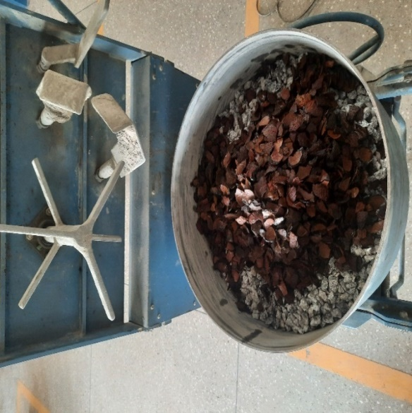

b

a

*Figure 2. Pre-soaking of coconut shell (a) and coconut shell aggregate in mixing machine (b)*

**3.2 Curing**

Specimens were cured by total immersion in potable water from Ghana Water Company for 28 days in accordance with BS 1881-111 (1983).

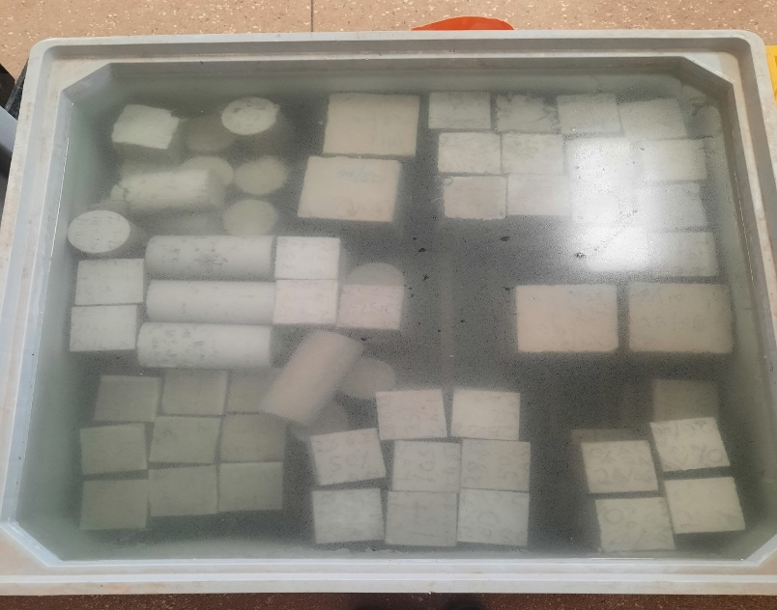

c

*Figure 3 curing of specimen (c).*

**4. TESTING PROCEDURES**

**4.1** **Abrasion resistance**

Following BS EN 12390-1 (2021), specimens underwent abrasion resistance testing after 28 days of curing using the surface wire brushing method with an iron brush as shown in Fig 2. This test was conducted to assess the surface hardness and wear resistance of the specimens. Initially, the specimens were weighed and their masses recorded as (M1), then placed securely on a table to prevent sliding. The top surface, intended as the facing surface, received 60 strokes per second with a wire brush in both forward and backward motions. Care was taken to ensure the brush width did not exceed the specimen's width by more than 2mm. After brushing, the specimens were reweighed and recorded as (M2). The abrasion resistance was then calculated as a percentage using the given formula;

$Ca =\frac{A }{M1-M2}$ X 100

Where,

Ca = Abrasion in percentage

A = Area of the brushed surface

M1= mass of concrete before brushing

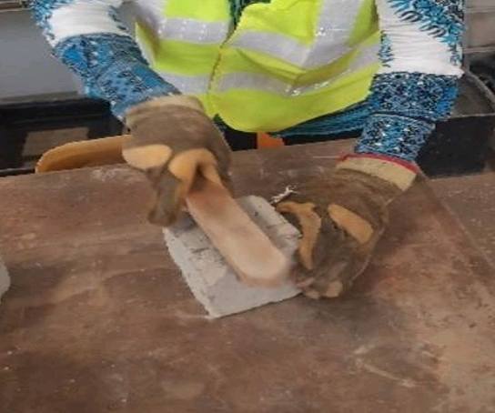M2 = mass of concrete after brushing.

4

*Figure 4:- Scrapping of the specimen with an iron brush to determine abrasion resistance.*

**4.2 Magnesium Sulphate (MgSO₄) attack**

Magnesium Sulphate (MgSO₄) attack occurs when MgSO₄ reacts with different phases of the hydrated cement paste, leading to the degradation of the concrete matrix through spalling, softening, and mass loss. This process can result in the expansion of the concrete and a reduction in its strength and elasticity (Shehata et al., 2008). A MgSO₄ resistance test was conducted on the specimens after 28 days, following the guidelines in BS EN 206-1. After 24 hours, the specimens were moulded for each size variation of coconut shell aggregate replacement, then submerged in a MgSO₄ solution, as shown in Figure 3 with a concentration of 30% by mass, and kept at room temperature for 28 days, similar to the method used by Zhutovsky & Hooton (2017). The physical MgSO₄ attack on the concrete specimens was evaluated by measuring mass loss before and after exposure to the MgSO₄ solution. The extent of the damage was expressed as a percentage using the formula provided;

$C =\frac{B-A }{A}$ X 100

Where,

C = Chemical attack

B = Compressive

A= magnesium sulphate

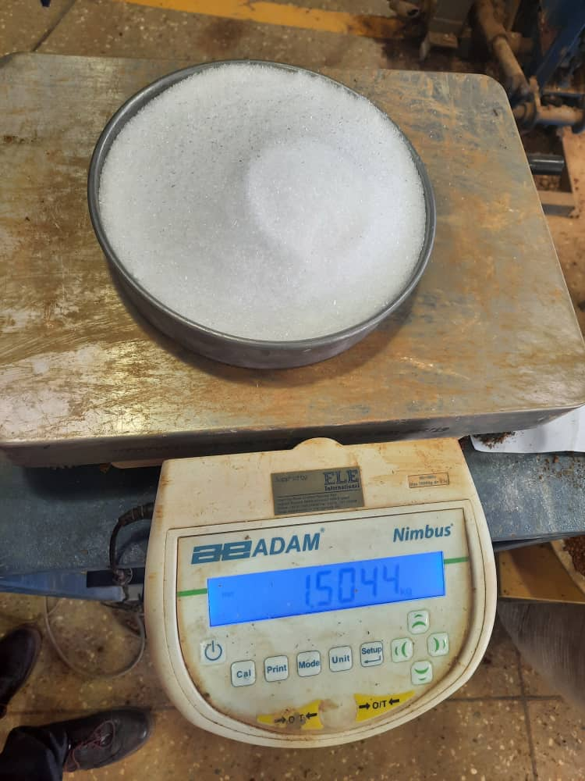

5

*Figure 5. Magnesium Sulphate (MgSO₄).*

**4.3 Sodium Chloride (NaCl) attack**

Following the guidelines of BS EN 206-1, CCS concrete specimens were tested for sodium chloride (NaCl) exposure. After 24 hours, the specimens were demolded for each variation in crushed coconut shell aggregate replacement and cured for a maximum of 28 days. The specimens were then submerged in a 30% by-mass NaCl solution shown in Fig 4, and maintained at room temperature for 28 days as done by Zhutovsky & Hooton (2017). The extent of damage from a physical sulphate attack on the concrete was evaluated by measuring the mass loss before and after exposure to the sulphate solution. The degree of attack on the specimens was then calculated as a percentage using the following formula;

$C =\frac{B-A }{A}$ X 100

Where,

C = Chemical attack

B = Compressive

A= magnesium sulphate

b

a

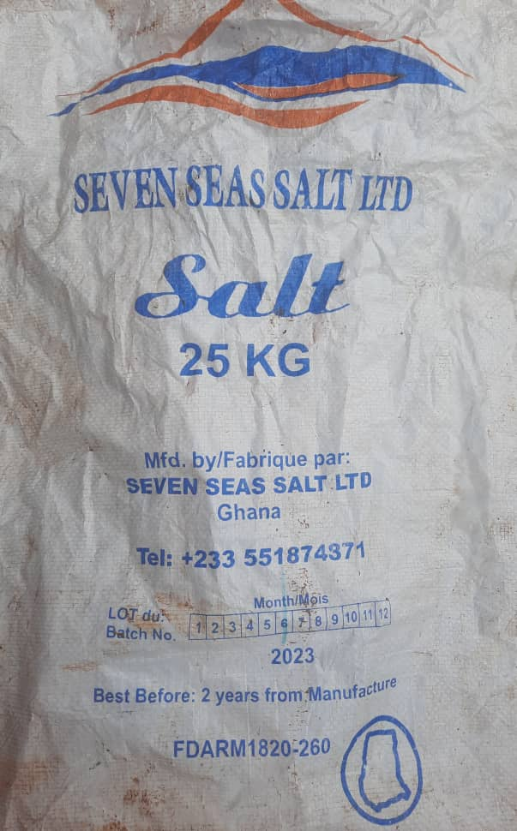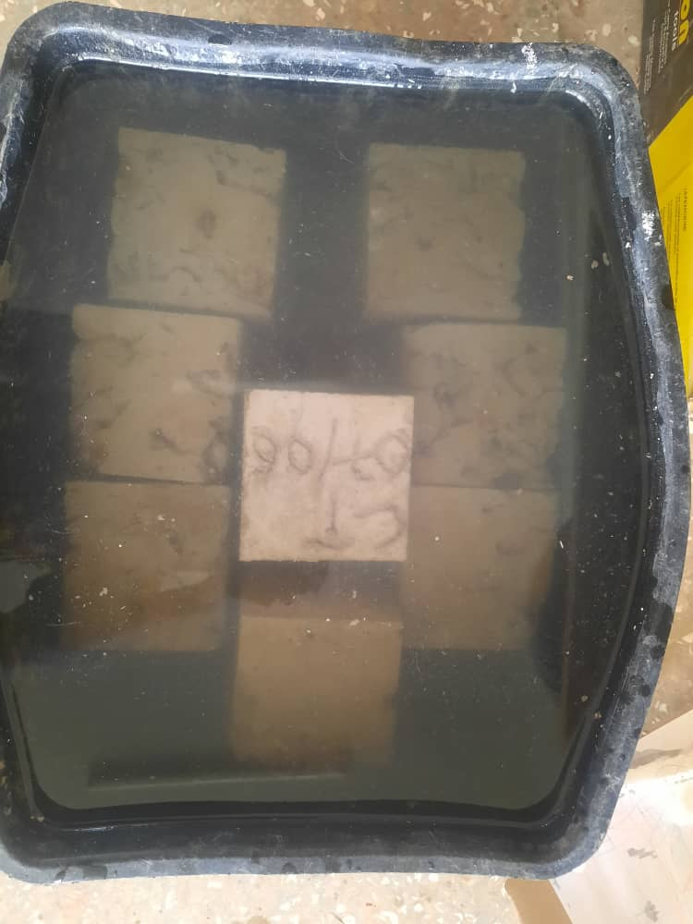

*Figure 6. Sodium Chloride (NaCl) (a) and (NaCl) Solution (b).*

**5. RESULTS AND DISCUSSIONS**

**5.1 Abrasion resistance test**

Figure 7 shows the results of the abrasion resistance test conducted on CCS concrete specimens. The results indicate that the abrasion resistance of CCS concrete improves with increasing strength. However, the study found that as the size variation of coconut shells in the concrete increased, the abrasion resistance increased. Among the tested sizes, the 37.5 - 25mm replacement exhibited the highest abrasion resistance, suggesting that this concrete can endure abrasive forces and resist erosion, abrasion, and surface degradation. The results also demonstrated that coconut shell concrete with higher compressive strength offered less resistance to abrasion compared to those with lower compressive strength, aligning with findings by Nadir and Sujatha (2018), who reported an average wear of less than 1.5% for all coconut shell concrete specimens. Additionally, Sujatha and Balakrishnan (2021) recorded a similar abrasion resistance value of 1.63%, which was consistent with this study. Figure 7 shows Average abrasion resistance (%)

*Figure 7. Average abrasion resistance (%)*

**5.2 Results of Compressive Strenght after Magnesium Sulphate (MgSO4) Attack**

Figure 7 illustrates the effects of magnesium sulphate on the CCS concrete specimen. The results show that exposure to magnesium sulphate weakens the concrete matrix through chemical reactions, leading to deterioration, cracking, and loss of structural integrity. Additionally, it was observed that increasing the size of coconut shell aggregates in the concrete mix reduces its strength. Concrete with 9.5mm coconut shell aggregate exhibited better resistance to MgSO₄ attack, likely due to the higher quantity of smaller coconut shell particles, which mitigated the destructive impact of ettringite formation compared to larger shell sizes. These findings align with previous research by Anon (2022) and Zhutovsky and Hooton (2017), which describe magnesium sulphate as a strength-reducing agent that causes internal cracking due to ettringite crystals. The study also supports Sharan and Raijiwala's (2017) conclusion that coconut shell aggregate concrete experiences a significant reduction in strength when exposed to MgSO₄ solution. Figure 8, shows Compressive strength before and after Magnesium Sulphate(MgSO4) Attack.

*Figure 8. Compressive strength before and after Magnesium Sulphate(MgSO4) Attack*

**5.3 Results of Sodium Chloride (NaCl) Attack**

Table 1 illustrates the compressive strength of concrete specimens after sodium chloride (NaCl) attack. The findings showed that as the size of the coconut shells in the concrete mix increased, the strength of the specimens decreased after being exposed to NaCl for 28 days. This reduction in strength is likely due to the deterioration caused by chemical reactions between the concrete and NaCl solution. Concrete containing 9.5mm coconut shell aggregate demonstrated better resistance to NaCl attack, possibly because the smaller coconut shells helped minimize the destructive effects of chemical ettringite, compared to mixes with larger shell sizes. Specimens with larger coconut shells were more vulnerable, likely due to the internal voids they created. This aligns with Ealias et al. (2014), who found that the presence of sufficient chloride ions in concrete affects compressive strength, depending on the rate of NaCl penetration and the pore structures. The study also reported a 19.9% chloride ion penetration in coconut shell concrete, which weakened the compressive strength, possibly due to the larger shell size. Prakash et al. (2020) similarly noted a 7.14% strength reduction after 28 days of NaCl exposure at a 28% chloride concentration, attributing the decline to the presence of quarry dust and the size variation of the coconut shells in the mix. Table 1 shows percentage reduction in compressive strength before and after sodium chloride (NaCl) attack.

|  |  |  |  |  |
| --- | --- | --- | --- | --- |
| **Sample sizes** | **Compressive strength after NaCl (A)** | **Compressive strength before NaCl (B)** | **C=(B-A)/(A)** | **D=(C*100) %** |
| Control | 13.26 | 14.4 | 0.079 | 7.92 |
| 12.5 -9.5mm Replacement | 12.48 | 13.40 | 0.069 | 6.87 |
| 19 - 12.5mm Replacement | 12.01 | 12.8 | 0.062 | 6.17 |
| 25 - 19mm Replacement | 10.85 | 12.20 | 0.111 | 11.07 |
| 37.5 - 25mm Replacement | 9.72 | 11.53 | 0.157 | 15.70 |

*Table 1. Percentage Reduction in Compressive Strength after Sodium Chloride (NaCl) Attack*

**5.4 Descriptive and one-way-ANOVA analysis for compressive strength after chemical attack (MgSO₄).**

Table 2. Shows descriptive and one-way-ANOVA analysis for compressive strength after (MgSO₄) attack.

|  |  |  |  |  |
| --- | --- | --- | --- | --- |
|  | | | | |
| Descriptive statistics | | | | |
| Treatment Name | N | Missing | Mean | Std Dev | SEM |
| Control | 3 | 0 | 13.933 | 0.0153 | 0.00882 |
| 9.5mm CS | 3 | 0 | 11.6 | 0.361 | 0.208 |
| 12.5mm CS | 3 | 0 | 10.767 | 0.473 | 0.273 |
| 19mm CS | 3 | 0 | 9.133 | 1.518 | 0.876 |
| 25mm CS | 3 | 0 | 8.567 | 1.721 | 0.994 |

|  |  |  |  |  |  |
| --- | --- | --- | --- | --- | --- |
| Table 3. One Way ANOVA | | | | | |
| Source of Variation | DF | SS | MS | F | P |
| Between Subjects | 2 | 3.362 | 1.681 |  |  |
| Between Treatments | 4 | 54.673 | 13.668 | 13.879 | 0.001 |
| Residual | 8 | 7.879 | 0.985 |  |  |
| Total | 14 | 65.914 | 4.708 |  |  |
|  |  |  |  |  |  |

|  |  |  |  |  |
| --- | --- | --- | --- | --- |
| Table 4: Pairwise comparisons between P-values | | | | |
| Comparison | Diff of Means | T | P | P<0.050 |
| Control vs. 25mm CS | 5.367 | 6.623 | 0.002 | Yes |
| Control vs. 19mm CS | 4.8 | 5.924 | 0.003 | Yes |
| Control vs. 12.5mm CS | 3.167 | 3.908 | 0.035 | Yes |
| 9.5mm Replace vs. 25mm CS | 3.033 | 3.744 | 0.039 | Yes |
| 9.5mm Replace vs. 19mm CS | 2.467 | 3.044 | 0.092 | No |
| Control vs. 9.5mm CS | 2.333 | 2.88 | 0.098 | No |
| 12.5mm Replace vs. 25mm CS | 2.2 | 2.715 | 0.102 | No |
| 12.5mm Replace vs. 19mm CS | 1.633 | 2.016 | 0.218 | No |
| 9.5mm Replace vs. 12.5mm CS | 0.833 | 1.028 | 0.556 | No |
| 19mm Replace vs. 25mm CS | 0.567 | 0.699 | 0.504 | No |

**5.5 CONCLUSION**

The study found that using crushed coconut shells aggregate (37.5-25 mm) in concrete enhances its resistance to abrasion. The study concluded that the size of the coconut shell aggregates affects the abrasion resistance, with 37.5 – 25mm size aggregates offering better protection as compared to 12.5 – 9.5mm aggregate. This indicates that concrete with bigger-sized coconut shells is more durable and suitable for applications where surface wear resistance is important. Additionally, the study revealed that concrete's resistance to magnesium sulfate (MgSO₄) decreases with larger coconut shell aggregates. Concrete made with smaller shells (12.5-9.5 mm) had better resistance to damage caused by MgSO₄, larger shells led to greater deterioration, likely due to the formation of harmful compounds like ettringite. This makes concrete with smaller coconut shells more durable in environments prone to sulfate exposure. Similarly, the size of coconut shell aggregates also affects the concrete's resistance to sodium chloride (NaCl). Smaller-sized shells (12.5-9.5 mm) showed better resistance to NaCl-induced degradation, while larger shells caused more strength reduction due to increased porosity, which allowed for more chemical reactions with NaCl. This makes concrete with 12.5 – 9.5mm shells more durable in salty or coastal environments. Overall, using coconut shells as a partial replacement for coarse aggregates in concrete offers a sustainable alternative by reducing waste and reliance on natural resources, making it a valuable option for promoting sustainable construction, especially in areas of abundant coconut shells.

**6.0 RECOMMENDATION**

This study contributes to the existing knowledge on sustainable concrete production by partial replacement of coarse aggregate (granite stones) with coconut shell size variation at 10%. The study investigated only the durability properties of concrete made with coconut shell size variations. Durability properties of concrete replaced with coconut shell size variation at 15%, 20% and 25% on a large scale are recommended for future research.

**REFERENCES**

Adinkra-Appiah, K., Adom-Asamoah, M., & Afrifa, O. R. (2015). *Reducing Environmental Degradation from Construction Activities: The Use of Recycled Aggregate for Construction in Ghana*. JCE. Architect. Res. 2(8), pp. 831-841.

Arora, R., Kumar. S., Dixit. S., Tipu. R. K., Kaul. P., Chauhan. S., Raju. Y. K., Nijhawan. G., & Haindavi., P. (2023). “ *Parametric Investigation of Coconut Shell as Partial Replacement of Coarse Aggregates in Sustainable Concrete*”. WoC 430, 01180.

Chin, M. Y., Rahman, M. R., Kuok, K. K. & Chiew, W. Y. (2021). “ *Characterization and Impact of Curing Duration on the Compressive Strength of Coconut Shell Coarse Aggregate in Concrete*. 16(3), 6057 – 6073.

Danso, H. & Appiah-Agyei, F. (2021). *A study on Size Variation of Palm Kernel Shells as a replacement of Coarse Aggregate for Lightweight Concrete Production*. Researchgate.net/publication/352714931.

de Brito, J., & Kurda, R. (2021). *The past and future of sustainable concrete: A critical review and new strategies on cement-based materials*. Journal of Cleaner Production, 281, 123558.

Ibearugbulem, O. M., & Igwilo, K. C. (2019). *Physical and mechanical properties of river stone as coarse aggregate for concrete production. Nigerian Journal of Technology*. 38(4), 856-862.

Irham, M. Z. M. A., Nurizaty, Z., Nadiah, S., Majedu, K. A., & Kado, B. (2024). “*Mechanical Properties of Concrete Containing Coconut Shell as Coarse Aggregate Replacement*”. 3(1), 69 – 80.

Kalyanapu, V. R., Swaroop, A. H. L., Kodanda, P. R., Bharath, C. N. (2015). “*Study on strength properties of coconut shell concrete*”. 6(3), pp.42-61.

Olsson, J. A., Miller, S. A. & Alexander, M. G. (2023). “*Near-term pathways for decarbonizing global concrete production*”. Doi.org/10.1038/s41467-023-40302-0.

Reddy, B.D., Jyothy, S.A. & Shaik, F. (2014). “*Experimental analysis of the use of coconut shell as coarse aggregate*”. IOSR J. Mech. Civil Eng., 10(6), 06-13.

Stephen, R.S., Gerry, G, C., Virmani, Y, P., Glen, E, S., Robert, G, K. (2002). *Electrochemical chloride extraction: Influence on Treatment.* DOT, F 1700.7 (8 - 72).

Verma, S. K., & Shrivastava, S. (2019, September). *Use of coconut shell as partial substitution of coarse aggregate experimental analysis. In AIP Conference Proceedings*. (Vol. 2158, No. 1). AIP Publishing.

Gunasekaran, K., Ramasubramani, R., Annadurai, R., & Chandar, S. P. (2014). *Study on reinforced lightweight coconut shell concrete beam behaviour under torsion.* Materials & Design, 57, 374-382.

Kulkarni, V, P., Kumar, S. (2013). *Comparative study on coconut shell aggregate with conventional concrete.* (Ijeit) 2(1). 9001: 2008.

Sujatha, A., & Balakrishnan, S. D. (2023). *Properties of high-strength lightweight concrete incorporating crushed shells as coarse aggregate*. Materials today. 2214 – 7853.

Murthy, A., A., Pukazhendhi, D., M., Vishnuvardhan, S., Saravanan, S. (2020). *Performance of concrete beams reinforced with GFRP bars under monotonic loading*. 27(3): 1274 – 1288.

Wahab, A., & Appiah-Kubi, E. (2024). *Characterization of Pulverized Palm Kernel Shells Block*. (JET), 15(1).

Yerramala, A. & Ramachandrudu, C. (2012). *Properties of concrete with coconut shells as aggregate replacement*. IJE, 1(6).