**Review Article**

**A Review on Mechanical and Vibrational Characteristics of Natural fibre based composite**

ABSTRACT

In the resent acknowledgement of nature’s demand and overuse of non-degradable engineering materials, the extent of use of the bio-degradable and its composites has to be raised. The natural fiber based composite is one of such novel materials now a day’s discussed most as probable alternatives. But the cause and reason for use of these alternate materials are limited by their durability and production techniques or variations of ingredients. The overwhelming advantages by using these in-house materials like the specific strength, density, ease of manufacturing and ultimate cost exceeds their limitations which are imposed by wet ability of fiber for matrix materials and temperature strength degradation. More over the standard method for production, cultivation and incapability of generalization of raw materials are some of the reasons which put limits for their use in engineering application. But overall strength to weight ratio, bio-degradability and carbon emission point of view these materials will fulfill the near future engineering expectation. The findings about the overall strength of composites are discussed by taking into account parameters, such as flexural modulus and strength and impact strength and the durability of the composite and reasoning behind such behavior of materials.

*Keywords: Natural Fiber Composites, Stiffness, Damping, Tensile strength*

1. **Introduction**

Nature is full of the examples of the composite materials and verities of design. Man has also started following the nature in term of their uses way back into ancient era. But as industrial revolution progressed, overuse of artificial material like plastics, glass fiber and carbon fiber lost an interest of these composite. In recent decades, as nature owes, human prospective in the term of degradability and renewability, natural composite gain an interest for use as structural materials. The fiber-composite material is made of basic two subsets namely matrix and fiber as shown in Figure: 1 which transfer load to matrix.

In case of natural degradable composite one or both fiber and matrix are made of naturally occurring derivatives. The most interested and suitable candidates as fibers are Coconut, Kenaf, Hemp, Sisa, Ramie, Flax and Bamboo. These are composed of cellulose, hemicelluloses and lignin as shown in figure: 2, with variation in composition (Table 1). Matrix can be chosen as per end use as epoxy-amine matrix, Polyvinyl chloride (PVC) or Polylactic acid (PLA). The brief summary of fibers and matrix materials properties are given in table: 2 and table: 3.

Fiber-disperse Phase

Matrix Phase

**Figure:1**- Fiber disperse – Matrix composite

The overall strength of composite is a function of individual strength of fiber, matrix, manufacturing method, pre-treatment of fibers and even it changes with the addition of the Nano-particles. Orientation of fibers and loading also play an important role in order to determine the overall strength of composite. Several studies suggest that even metal structure can have alternative from fiber composites. For rotary shaft, materials like glass-epoxy for low torque application like light motar vehicle shows promising. But the glass fiber due to its non-degradability finds some challenges as suitable materials.

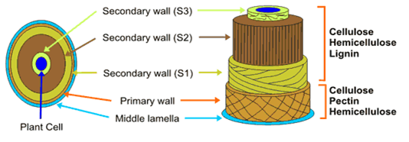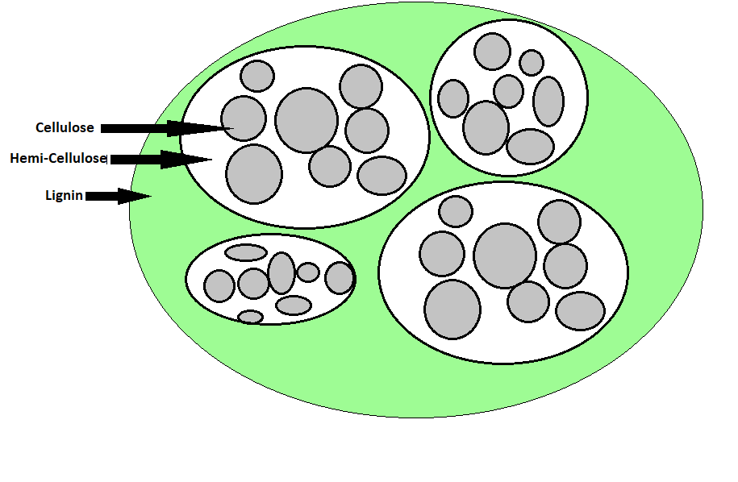

**Figure:2**- Plant Fiber section [http://bioenergy.ccrc.uga.edu/Background/background.htm]

**Table:1-** Composition of various fibers [1]

|  |  |  |  |
| --- | --- | --- | --- |
| **Fiber** | **Cellulose (wt%)** | **Hemi-cellulose (wt%)** | **Lignin (wt%)** |
| Bamboo | 26.0–43.0 | 30 | 21-31 |
| Banana | 50 | 5.10 | 17 |
| Coconut | 26.6 | 17.74 | 41.18 |
| Cotton | 80.0–95 .0 | 5.0–20.0 | 0 |
| Flax | 71.0 | 18.6–20.6 | 2.2 |
| Hemp | 68.0 | 15 | 10 |
| Jute | 61.0–71.0 | 14-20 | 12-13 |
| Kenaf | 72.0 | 20.3 | 9 |
| Ramie | 68.6–76.2 | 13.0–16.0 | 0.6-0.7 |
| Sisal | 65.0 | 12.0 | 9.6 |

**Table:2-** MechanicalProperties of various Fibers [1,23]

|  |  |  |  |  |
| --- | --- | --- | --- | --- |
| **Fiber** | **Density(gm/cm3)** | **% Elongation** | **Tensile Strength (MPa)** | **Youngs Modulus (GPa)** |
| Banana | 1.3-1.4 | 2.0-7.0 | 54-789 | 3.4-32 |
| Coconut | 1.4–3.8 | -- | 120.0–200.0 | 19.0–26.0 |
| Cotton | 1.5–1.6 | 3.0–10.0 | 287.0–597.0 | 5.5–12.6 |
| Flax | 1.4-1.5 | 1.2-3.2 | 345-1500 | 27.6-80 |
| Hemp | 1.4-1.5 | 1.6 | 550-900 | 70.0 |
| Jute | 1.3-1.5 | 1.5-1.8 | 393-800 | 10.0-30.0 |
| Kenaf | 1.2 | 2.7-6.9 | 295 | -- |
| Ramie | 1.5 | 2.0-3.8 | 220-938 | 44-128 |
| Sisal | 1.3-1.5 | 2.0-14.0 | 400-700 | 9.0-38.0 |
| Carbon | 1.4 | 1.4-1.8 | 1500-5500 | 230-240 |
| S-glass | 2.5 | 2.8 | 4570 | 86 |

**Table:3-** Properties of various Matrix Materials [3]

|  |  |  |  |  |  |
| --- | --- | --- | --- | --- | --- |
|  | **Polymer** | **Density(gm/cm3)** | **% Elongation** | **Tensile Strength (MPa)** | **Youngs Modulus (GPa)** |
| Thermoplastic | Polyvinyl chloride (PVC) | 1.3–1.5 | 50.0–80.0 | 52.0–90.0 | 3.0–4.0 |
| Nylon 6 (PA 6) | 1.1 | 60.0 | 81.4 | 2.8 |
| Rigid thermoplastic polyurethane (RTPU, PUR-RT) | 1.1 | 5.0 | 75.0 | 4.0 |
| Low-density polyethylene (LDPE) | 0.9 | 400.0 | 10.0-11.6 | 0.2-0.3 |
| Cross-linked polyethylene (PE) | 0.9 | 350.0 | 18.0 | 0.5 |
| Thermoset | Epoxy (EP) | 1.2–1.3 | 1.3 | 600.0 | 80.0 |
| Phenol formaldehyde (PF) | 1.2 | 1.2 | 45.0 | 6.5 |
| Rigid thermoset polyurethane (RPU) | 1.2 | 90.0 | 60.0 | 2.2 |
| Polyurethane rubber | 1.2–1.3 | 300.0–580.0 | 39.0 | 2.0–10.0 |
| Biopolymers | Polylactic acid (PLA) | 1.2–1.3 | 2.1–30.7 | 5.9–72.0 | 1.1–3.6 |
| Polycaprolactone (PCL) | 1.1 | 700.0 | 16.0–23.0 | 0.4 |
| Polyhydroxybutyrate (PHB) | 1.2 | 1.56–6.0 | 24.0–40.0 | 3.5–7.7 |

1. **Recent progress in Natural fiber composites with respect to Mechanical strength**

Kenaf fibres could potentially be used as an alternative for friction material. The study reveals by Weighted Decision Matrix approach and compared with other natural fibers, the kenaf fiber found a strong candidature on the scale of Toxicity, Price, Energy and CO2 footprint, Safe for disposal etc. and moderate on scale of Strength & Stiffness **[5]**. So it emphasis that traditional Asbestos impacting the environment and human health can have the alternative from plant based composite subjected to further improvement in mechanical properties of such alternatives.

The statistical approach for finding the mechanical properties of the vegetable sisal yarns conform that the variation of mechanical properties of plant based fibers are well connected to average values of Young's modulus with a linear prediction model and strength increases with decreases in Young's modulus [6] as shown in table 4. The reason behind this variation is that tested samples of sisal yarn are obtained from different geological regions with variation of climatic condition. Also the test conditions like grip type, or variety of fibers and measuring geometry also contributes to this dispersion.

**Table 4: Mechanical properties of sisal yarns tested under tensile quasi-static load.**

|  |  |  |  |  |  |  |  |  |  |
| --- | --- | --- | --- | --- | --- | --- | --- | --- | --- |
| GL | Strength (MPa) | | | Strain (%) | | | Modulus (MPa) | | |
| mean | SD | CoV(%) | mean | SD | CoV(%) | mean | SD | CoV(%) |
| 50 | 180.18 | 25.29 | 14.04 | 14.76 | 1.59 | 10.8 | 336.85 | 184.3 | 54.71 |
| 100 | 148.96 | 31.73 | 21.32 | 8.37 | 0.97 | 11.62 | 556.11 | 106.25 | 19.11 |
| 150 | 141.86 | 28.77 | 20.27 | 6.39 | 0.59 | 9.21 | 792.93 | 232.44 | 29.31 |
| 200 | 127.52 | 24.37 | 19.89 | 5.70 | 0.59 | 10.28 | 688.09 | 175.7 | 25.54 |
| 300 | 122.73 | 26.03 | 21.21 | 5.00 | 0.46 | 9.27 | 616.38 | 124.23 | 20.15 |

The load bearing capacity of composite varies as per the orientation of fibers using the finite element method. The fiber orientation of 0° and 90° showed the best result with minimum stressed conditions for tensile and flexural test and 45° for hardness test [7]. The impact toughness of hybrid composites was investigated and found that it is influenced by the fibre orientation [14]. Woven and unidirectional Kenaf and Kevlar- epoxy composite were tested under tensile test and impact test. The unidirectional sample shows best flexural strength while others are good in impact and tensile test.

The Tenax Reinforced Natural Rubber Composites for tensile and tear characteristics, hardness, and abrasion resistance tested and result shows that short fiber combination gives the best compromise between tensile and tear properties and hardness [table-5]. The resistance to abrasion is increasing with the amount of fibers in natural rubber. This is due to fact that at higher length of fiber, difficulty to maintain the straight alignment of fibers is more [8] against the irregular and variable surface grip in shorter fiber with effective stress transfer across the interface.

Table 5: Summary of the mechanical results (avg. values) of all rubber matrix composites [8]

|  |  |  |  |  |  |  |
| --- | --- | --- | --- | --- | --- | --- |
| **Properties** | **NR** | **P1** | **P2-6** | **P2-10** | **P2-14** | **P3** |
| Tensile strength (MPa) | 9.51 | 5.06 | 2.53 | 5.22 | 3.92 | 2.83 |
| Tensile strain (%) | 600 | 727 | 303 | 536 | 619 | 95 |
| 100% modulus (MPa) | 0.57 | 0.75 | 1.48 | 1.33 | 0.98 | - 1 |
| 200% modulus (MPa) | 0.98 | 0.78 | 1.54 | 1.24 | 1.13 | - 1 |
| 300% modulus (MPa) | 1.45 | 0.96 | 1.8 | 1.27 | 1.3 | - 1 |
| Tear strength (N/mm) | 29.2 | 27.5 | 37.2 | 26 | 24.4 | 41.2 |
| Shore A hardness | 37 | 46 | 55 | 49 | 49 | 62 |
| Abrasion loss (cc/h) | 0.5 | 0.36 | 0.35 | 0.42 | 0.45 | 0.26 |

**Note: P1 and P3 were all filled with 6-mm-long phormium fibers; whilst P2-6, P2-10, and P2-14 were filled with 6 mm, 10 mm, and 14 mm phormium fibers, respectively.**

The variation of mechanical performance of date palm and coir fibres reinforcement for polypropylene with temperature is evaluated. It is observe the heat treatment reduces strength and failure strain but not modulus. And also temperature should be limited to 200 0c [9] as it drastically reduces the fiber sections. The reason behind such reduction is nothing but the reduction in the water retention over the higher temperature.

The Non satisfactory services of plant based composite especially Natural fiber composite (NFC) does not conformed the criteria to replace the traditional material as their properties deteriorates due temperature exposure and as well hydro phobic- hydrophilic natures at boundary of fiber and matrix not ready adheres. In the following sub section, the adhesion between matrix and fiber is addressed which suggest that the pre-treatment of fiber enhances the bonding capacity to matrix. Several studies reported the natural fibers that were subjected to various chemical treatments such as alkali, maleated coupling agents, acetylation, silane, benzoylation, acrylation, isocyanates, and microwaves shows improved mechanical behaviors.

2.1 Alkali treatment

Literature suggest that pre-treatment of fiber with alkaline solution (10 percent NaOH ) for different time not only improves the locking tendency of matrix by  degrading the groups of hydroxyl present on the surface of the ﬁbre thereby expanding the surface roughness but extracts the oils, lignin, and wax that cover the cell wall's exterior surface of the fiber [10-13].

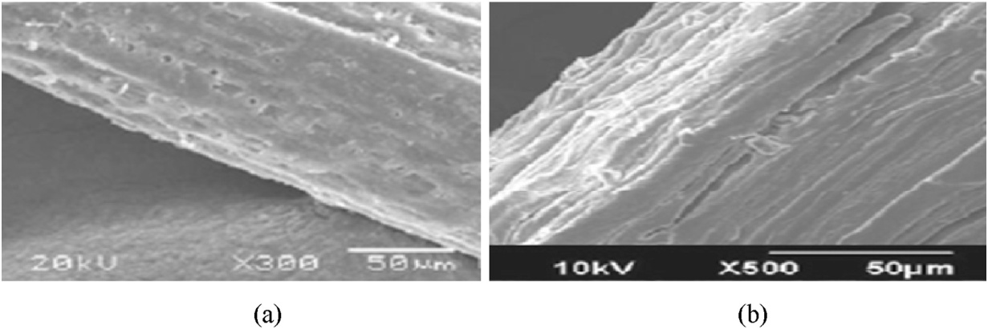

Fig. 3. SEM of coir fiber  (a) without alkali treatment (b) with alkali treatment.[10]

2.2 Microwave Treatments

Another and effective treatment is treating yarns of fibers with radio or microwaves. The structure of natural fiber is semi cylindrical non-uniform with reducing diameter of fiber towards the end. Fiber always presents as a bundle of 4-10 fibers sticks together [19]. The pretreatments are performed in order to degrade the non-fibrous tissues and strong bonds between carbon and hydrogen which requires 413 KJ/mol of energy which in turns loosen the fiber bundles as shown in figure 1. The microwaves radiations helps in breaking these bond by local heating by converting electromagnetic energy into mechanical and heat energy[19]. Main advantage of this treatment is that the entire materials get heated at once instead of conduction and convection means for the heat flow to spread. Microwave treatments are equally effective for changing properties, such as coloring and fiber-surface roughness.

Several experimental showed that after treating with microwaves, some properties like tenacity, elongation and energy uptakes as well as tensile strength, tensile modulus etc. can be altered. The study carried on jute yarns in un-fastened and fastened state results increase in the elongation by 70% after treatment for un-fastened state [21]. The reason for this is that for the un-fastened state, the resulting yarn thickness was thicker than for the yarn treated in the fastened state. The microwave treatment in water shows without any chemical treatment the tenacity of yarn can be increases but in certain conditions of states

Tensile strength and modulus of the sugar palm fiber with alkali and with microwave treatment at 70oc, 80oc and 90oc investigated and results are shown in the figure 4, 5 and 6 with the variation of tensile strain, strength and modulus respectively based on the experimental data for five samples [22].

As seen from the figure 4, tensile strain increases with temperature but this increase is no where comparable with samples of alkali treatment or untreated samples. Figure 5 and 6 shows the tensile strength and modulus which increases with temperature as decrease in strain at respective temperature and as compared to untreated samples the gain in strength and modulus is marginal. This experimental study reveals that after microwaves treatments surface of fibers not only improved by removing the wax but also enhances chemical interlock with the matrix as witness in figure 5.

|  |  |
| --- | --- |
| Untreated  **Tensile strain (%)** | Treated with 6% NaOH |
| 21.21 | 45.9 |
| 18.94 | 53.92 |
| 22.98 | 34.64 |
| 30.05 | 50.93 |
| 23.99 | 54.67 |

**Fig 4:** Tensile strain (%) for five samples

|  |  |  |
| --- | --- | --- |
|  | Untreated  **Tensile strength (MPa)** | Treated with 6% NaOH |
|  | 10.38 | 5.4 |
|  | 9.13 | 5.32 |
|  | 8.9 | 5.02 |
|  | 11.71 | 5.71 |
|  | 9.36 | 6 |
|  |  |  |

**Fig. 5 :** Tensile strength (MPa) for five samples

|  |  |  |
| --- | --- | --- |
|  | Untreated  **Tensile modulus (MPa)** | Treated with 6% NaOH |
|  | 105.53 | 30 |
|  | 96.32 | 30 |
|  | 90.37 | 30 |
|  | 95.84 | 30 |
|  | 88.48 | 30 |

**Fig. 6:** Tensile modulus (MPa) for five samples

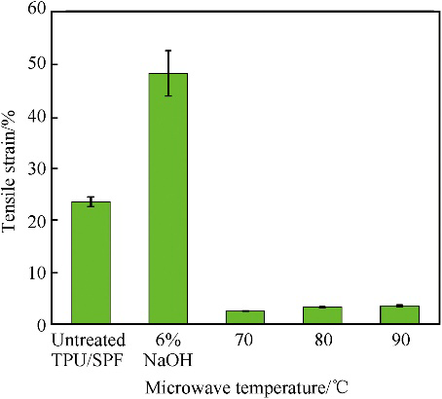 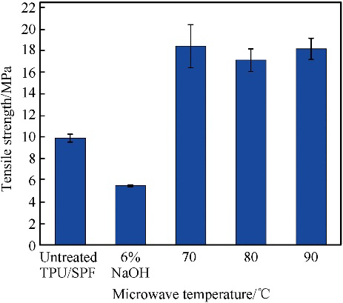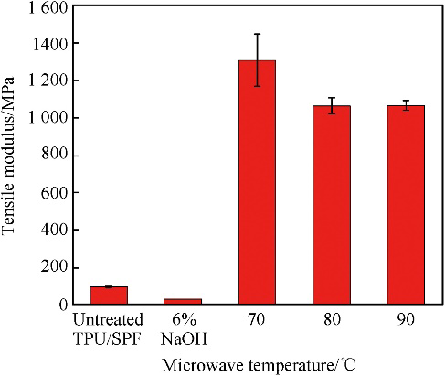

**Fig 7:** Tensile Stain, Strength and Modulus of composite of untreated and treated Samples,

The ability to replace the structural steel with composite is also examined [16]. The torsional strength, natural frequency, and critical speed of glass epoxy designed composite shaft investigated by have shown even better overall performance as compared to steel for light vehicle due to its low weight to strength ratios. Again the ease of manufacturing for required strength is the added advantage of the composite thus they even can replaces the conventional materials.

1. **Recent progress in Natural fiber composites with respect to vibrations**

Damping is the ability of the material to absorb the vibrations by dissipating or loosing the energy. These composite made of different natural fibers are tested under flexural vibration test and its time decay is measured and their vibrational characteristics like damping ratio, stiffness or product of stiffness and young modulus viz. loss modulus are analyzed.

Hybridizing natural fiber composites enhances their mechanical properties, and they typically offer higher damping capacity than metals, mainly due to the viscoelasticity of the polymer matrix and frictional sliding as the dissipation mechanism. [18], Nanocomposites offer higher damping capacity due to their larger interfacial area.

The study indicate that the best balance between stiffness and damping is achieved by maximizing the product of stiffness (E) and damping (η). By carefully selecting or treating fibers, further improvements can be made. Future development of modified plant fibers that enhance damping without sacrificing stiffness could be assessed using this model to create new hybrid composites. These composites would be ideal for applications where both stiffness and vibration damping are crucial

[17] The vibration aspect of the natural fiber based composite materials for automotive applications and finds jute fibres based composite performed better even as compared to the glass fiber in damping capacity and modal analysis. The table 6 gives the comparison of jute fiber advantages for more value of the loss factor over the glass fiber made bonnet for first five modes of vibration. The reason behind this is presence of lignocelluloses in jute which enhances the damping and make it more suitable in other noise suppression applications.

**Table 6: Modal parameters for Glass and Jute fiber bonnets**

|  |  |  |  |  |
| --- | --- | --- | --- | --- |
|  | Glass fibre bonnet | | Jute fibre bonnet | |
| Mode | Natural frequency [Hz] | Loss factor [%] | Natural frequency [Hz] | Loss factor [%] |
| 1 | 25.1 | 4.1 | 18.5 | 7.6 |
| 2 | 31.8 | 3.3 | 24.6 | 4.6 |
| 3 | 54.8 | 3.5 | 43.1 | 4.4 |
| 4 | 71.5 | 2.2 | 56.3 | 5.6 |
| 5 | 77.9 | 2.3 | 60.8 | 4 |

**Conclusion**

The next alternative as Natural fiber composite can be best suited for various applications in mechanical industries where the mechanical properties like strength and impact are important. These properties are the functions of individual members in composite and they vary as per the treatments of the fibers and plant source. These this review the various mechanical and vibrational aspect of the composites are studied and it is found that some of the natural composite has good mechanical but poor vibrational characteristics and vice a versa.

Some studies reveal impact of plant fibers on the mechanical properties of composites, particularly in terms of damping. Others studies quantified the damping coefficient of fiber-reinforced composites and hybrid composites. And reinforcement hybridization affects the damping coefficient, as well as the tensile and flexural elastic modulus and strength of the hybrid composites.

More over the standard method for production, cultivation and incapability of generalization of raw materials are some of the reasons which put limits for their use in engineering application. But overall strength to weight ratio, bio-degradability and carbon emission point of view these materials will fulfill the near future engineering expectation

**COMPETING INTERESTS DISCLAIMER:**

Authors have declared that they have no known competing financial interests OR non-financial interests OR personal relationships that could have appeared to influence the work reported in this paper.

**References**

1. Sathishkumar T, Navaneethakrishnan P, Shankar S, Rajasekar R, Rajini N. Characterization of natural fiber and composites – A review. Journal of Reinforced Plastics and Composites. 2013;32(19):1457-1476. doi:10.1177/0731684413495322
2. Thermoplastic vs Thermoset Plastic: Mechanical Properties Overview- An article; <https://www.fictiv.com/articles/thermoplastic-vs-thermoset-plastic-mechanical-properties-overview>
3. Rohan S. Dassanayake, Sanjit Acharya and Noureddine Abidi (November 5th 2018). Biopolymer-Based Materials from Polysaccharides: Properties, Processing, Characterization and Sorption Applications, Advanced Sorption Process Applications, Serpil Edebali, IntechOpen, DOI: 10.5772/intechopen.80898
4. Codispoti, R., Oliveira, D.V., Olivito, R.S., Lourenço, P.B. and Fangueiro, R., 2015. Mechanical performance of natural fiber-reinforced composites for the strengthening of masonry. *Composites Part B: Engineering*, *77*, pp.74-83.
5. Abdollah, M.F.B., Shuhimi, F.F., Ismail, N., Amiruddin, H. and Umehara, N., 2015. Selection and verification of kenaf fibres as an alternative friction material using Weighted Decision Matrix method. *Materials & Design*, *67*, pp.577-582.
6. Ahmed Belaadi, Mostefa Bourchak, Hamdi Aouici, Mechanical properties of vegetal yarn: Statistical approach,Composites Part B: Engineering,Volume 106,2016,Pages 139-153,
7. Upendra Sharan Gupta, Amit Dharkar, Mohit Dhamarikar, Arpit Choudhary, Dipanshu Wasnik, Pankaj Chouhan, Sudhir Tiwari, Rajeev Namdeo, Study on the effects of fiber orientation on the mechanical properties of natural fiber reinforced epoxy composite by finite element method,Materials Today: Proceedings,Volume 45, Part 9,2021, Pages 7885-7893,
8. Palanisamy, Sivasubramanian, Kalimuthu Mayandi, Murugesan Palaniappan, Azeez Alavudeen, Nagarajan Rajini, Felipe Vannucchi de Camargo, and Carlo Santulli. 2021. "Mechanical Properties of Phormium Tenax Reinforced Natural Rubber Composites" *Fibers* 9, no. 2: 11.
9. James L. Thomason, Jose L. Rudeiros-Fernández, Thermal degradation behaviour of natural fibres at thermoplastic composite processing temperatures, Polymer Degradation and Stability, Volume 188,2021,109594,
10. Yadvinder Singh, Jujhar Singh, Shubham Sharma, Thanh-Danh Lam, Duc-Nam Nguyen, Fabrication and characterization of coir/carbon-fiber reinforced epoxy based hybrid composite for helmet shells and sports-good applications: influence of fiber surface modifications on the mechanical, thermal and morphological properties, Journal of Materials Research and Technology,Volume 9, Issue 6,2020,Pages 15593-15603
11. N.H. Padmaraj, Laxmikant G. Keni, K.N. Chetan, Mayur Shetty, Mechanical Characterization of Areca husk-Coir fiber reinforced hybrid Composites, Materials Today: Proceedings,Volume 5, Issue 1, Part 1, 2018, Pages 1292-1297,
12. Potadar, O.V. and Kadam, G.S., 2018. Preparation and testing of composites using waste groundnut shells and coir fibres. *Procedia Manufacturing*, *20*, pp.91-96.
13. Mwaikambo, L.Y. and Ansell, M.P., 2002. Chemical modification of hemp, sisal, jute, and kapok fibers by alkalization. *Journal of applied polymer science*, *84*(12), pp.2222-2234.
14. Yahaya, R., Sapuan, S.M., Jawaid, M., Leman, Z. and Zainudin, E.S., 2016. Effect of fibre orientations on the mechanical properties of kenaf–aramid hybrid composites for spall-liner application. *Defence Technology*, *12*(1), pp.52-58.
15. Shinde, R.M. and Sawant, S.M., 2019. Investigation on glass-epoxy composite drive shaft for light motor vehicle. *International Journal of Design Engineering*, *9*(1), pp.22-35.
16. Furtado, S.C., Araújo, A.L., Silva, A., Alves, C. and Ribeiro, A.M.R., 2014. Natural fibre-reinforced composite parts for automotive applications. *International Journal of Automotive Composites*, *1*(1), pp.18-38.
17. Baley, C.. “Analysis of the flax fibres tensile behaviour and analysis of the tensile stiffness increase.” *Composites Part A-applied Science and Manufacturing* 33 (2002): 939-948.
18. Martone A, Giordano M, Antonucci V, Zarrelli M. Enhancing damping features of advanced polymer composites by micromechanical hybridization. Compos A Appl Sci Manuf 2011;42(11):1663e72
19. Nair, G.R., 2017. Role of microwave pre-treatment in the extraction of high quality natural fibers. *Journal of Textile Engineering & Fashion Technology*, *2*(2), p.53.
20. Kocak, Dilara, Nigar Merdan, and Oya Burcak Evren. "Research into the specifications of woven composites obtained from raffia fibers pretreated using the ecological method." *Textile Research Journal* 85, no. 3 (2015): 302-315.
21. Syrén, Felicia, Joel Peterson, and Nawar Kadi. 2021. "Effects of Microwave Treatment in Immersed Conditions on the Mechanical Properties of Jute Yarn" *Fibers* 9, no. 7: 40. <https://doi.org/10.3390/fib9070040>
22. A.A. Mohammed, D. Bachtiar, M.R.M. Rejab, J.P. Siregar, Effect of microwave treatment on tensile properties of sugar palm fibre reinforced thermoplastic polyurethane composites,Defence Technology,Volume 14, Issue 4,2018,Pages 287-290