**WATER RESOURCE MANAGEMENT STRUCTURES IN ANCIENT INDIA: A GEOGRAPHICAL PERSPECTIVE**

**ABSTRACT:**

Water scarcity is emerging as one of the most damaging issues of our time, conferring a slew of challenges that can no longer be ignored. Limited availability of water puts a chokehold on life as we know it, threatening the stability of fundamental fields, including, but not nearly limited to, public health, development, food security, sustainability, peace and sanitation. Addressing this crisis is essential for sustainable development and ensuring clean drinking water for future generations. Efficient water management practices like rainwater harvesting, conservation, and recharge should be adopted to reduce water waste and increase availability. The ancient Indian literature contains numerous references to hydrology and a reading of it suggests that those people knew the basic concepts of hydrological processes and measurements.

India has an age old tradition of water management system from more than 5000 years and over centuries. The ancient techniques of water management, including rainwater harvesting, groundwater recharge and canal systems, were developed based on a deep understanding of the local ecosystems and the water cycle. These practices were designed to promote the sustainable use of water resources and maintain a delicate balance between water availability and demand. In recent times, with the increasing global awareness of sustainability, there has been a renewed interest in these traditional practices which have been developed with a focus on reducing environmental impacts, conserving natural resources and promoting social and ecological equity which includes green technologies, and sustainable development goals and are rooted in the principles of sustainability that were ingrained in ancient India.

This study aims to explore the ancient water resources management practices and Geographically Appropriate techniques adopted to conserve, revive and expand this old wisdom for the benefit of all.

**KEY WORDS: Ancient, Traditional, Water, Conservation, Geographical**

**INTRODUCTION:**

About 97% of the water on the Earth is mainly salt water and only around 3% is fresh water; approximately around two thirds of this is frozen in glaciers and polar ice caps. The remaining unfrozen fresh water can be found mainly as groundwater; only a small fraction is present above the ground or in the air.( (U.S. Geological Survey, 1993).) Natural sources of fresh water comprise surface water, under river flow, groundwater and frozen water. Artificial sources of fresh water might include treated wastewater (reclaimed water) and also desalinated seawater.

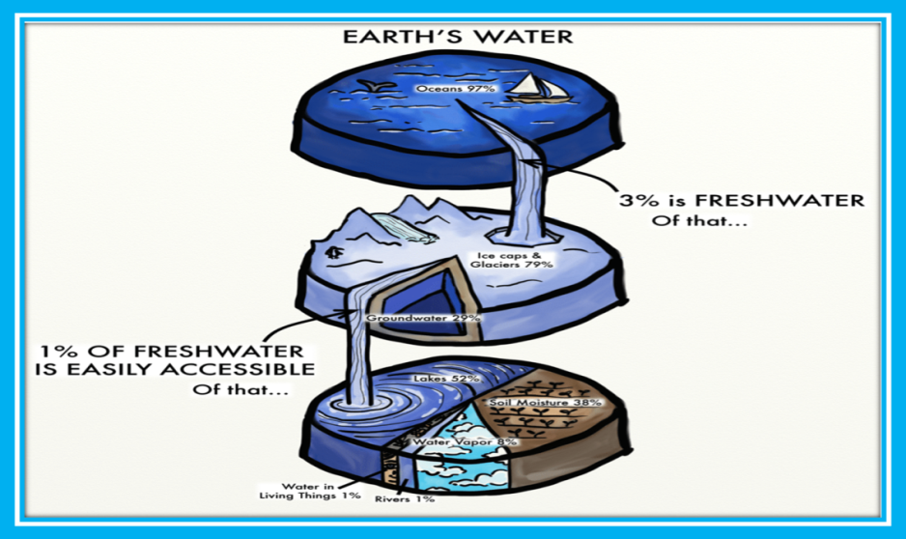

Fig 1. GLOBAL WATER DISTRIBUTION

**GLOBAL SCENARIO:**

Earth is the only plant, so far known to have water and this makes it fit for human living. However, with reckless abuse and increasing demand, due to growing population and unsustainable lifestyle, many countries are facing severe water crisis. In the absence of suitable corrective measures, many developing countries including India will have to face crisis of food and water security in the near future. Globally, 2 billion people (26% of the population) do not have safe drinking water and 3.6 billion (46%) lack access to safely managed sanitation, according to the report, published by UNESCO on behalf of UN-Water and released today at the UN 2023 Water Conference in New York. Over the next several years, experts estimate that half of the world’s population will live in water-stressed areas.

The United Nations predicts that by 2025, 1.8 billion people will be living in countries or regions with absolute water scarcity. With the existing climate change scenario, almost half the world’s population will be living in areas of high water stress by 2030. In addition, water scarcity in some arid and semi-arid places will displace between 24 million and 700 million people. By 2030, water scarcity could displace over 700 million people.

To achieve universal basic water coverage, the rates of progress would need to double by 2030. The UN suggests that each person needs approximately 20-50 liters of water daily to ensure their basic needs. Each person should drink at least four to seven liters of clean water per day.

Fig 2 . Global water consumption

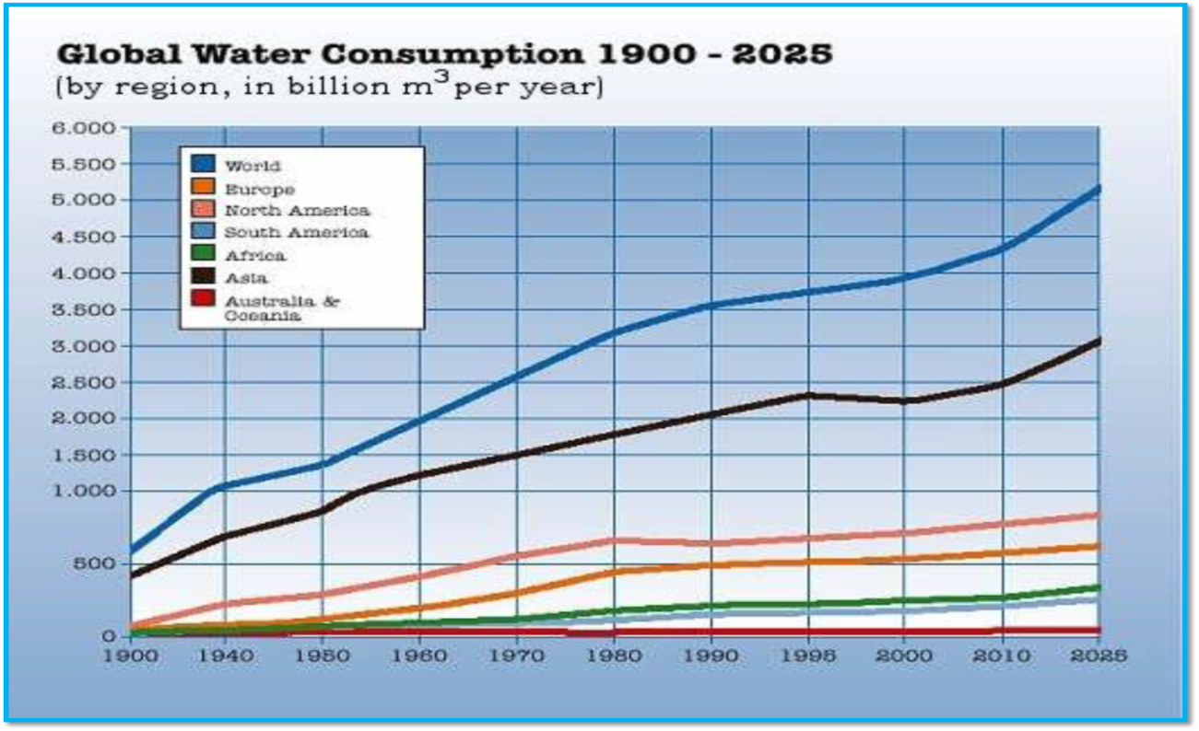

Source: Global water consumption prediction (Margaux, “Global water world resources sim centre,” Global Energy Network Institute)

**INDIAN SCENARIO:**

India faces a paradoxical situation of floods and droughts. From 1996 to 2015 nearly 19,000,007.5 million people annually were simultaneously affected by floods and droughts, respectively. Though, India is not a water poor country, due to growing human population, severe neglect and over­exploitation of this resource, water is becoming a scarce commodity. India is more vulnerable because of the growing population and undisciplined lifestyle. This calls for immediate attention by the stakeholders to make sustainable use of the available water resources.

Although India possesses only 4% of the world's renewable water resources, it is home to roughly 18% of the world's population. India has an average annual precipitation of 4,000 billion cubic meters (BCM), making it the country's primary source of freshwater. Surface water, subsurface river flow, groundwater, and frozen water are all-natural sources of freshwater. Out of the total available 1,126 BCM water resources, approximately 690 BCM is surface water, while the remaining 436 BCM is groundwater

**Demand for Water in India:** India uses more water than any other country. Indians are the largest freshwater users in the world. Around 65% of India’s total water demand is for groundwater, which plays an important role in shaping the nation’s economic and social development. Agriculture, domestic and industrial use, respectively, comprises India’s largest uses for water. Therefore with growing demand for water and depletion of the available water, assured supply of good quality water is becoming a growing concern. The requirement of water for various sectors has been assessed by the National Commission on Integrated Water Resources Development (NCIWRD) in the year 2010. On the basis NCIWARD major component of demand in India is irrigation, Drinking water, Industry etc. is shown in table

**Table 1 Water** **requirements** **for** **various** **sources**

|  |  |  |  |
| --- | --- | --- | --- |
| **Sector** | **Water** **Demand** **in** **Km3** **(** **or** **bcm)** | | |
| **2010** | **2025** | **2050** |
| Irrigation | 557 (78%) | 611 | 807 |
| Drinking | 43 | 62 | 111 |
| Industry | 37 | 67 | 81 |
| Energy | 19 | 33 | 70 |
| Others | 54 | 70 | 111 |
| **Total** | **710** | **843** | **1180** |

Source: National Commission on Integrated Water Resources Development

India’s water demand is increasing. Irrigation is by far the largest user of India’s water reserve, with usage of 78 per cent of total reserve, followed by the domestic sector (6 per cent) and the industrial sector (5 per cent). It is a major source of drinking water in urban and rural India and sustains 45 per cent of irrigation and 80 per cent of domestic water demands.

Water Requirements for various sources: (2010) National Commission on Integrated Water Resources Development (NCIWRD)

Fig 3. **Water availability in India**

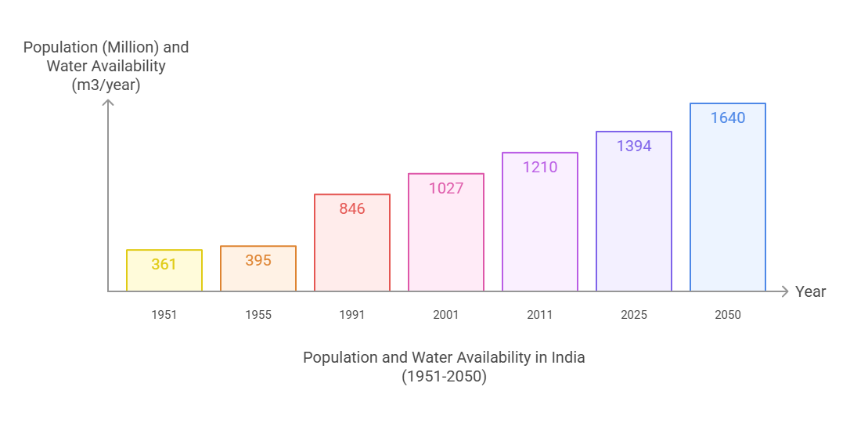

Source: National Commission on Integrated Water Resources Development

**Per Capita Water:**

National Commission for Integrated Water Resources Development (NCIWRD) has shown that the per capita availability of water varies widely in different regions of the country.

The amount of water consumed per person is one of the vital PIs that addresses each individual's water demand. Unit water demand refers to the individual user-level water requirements, which acts as a water consumption coefficient (Donkor et al., 2014). International Water Association (Alegre et al., 2016),

This per capita water availability is not same throughout India. It varies spatially and temporally in various regions of India depending upon the rain fall variability, utilisation patterns, evapotranspiration. However, per capita water availability disaggregated data for different uses, geographies and states is not available to comprehend it further. (Down To Earth, 2023) Serious efforts must to be made to combine water harvesting traditions with the insights of modern science and technology (Agarwal and Narain, 1997).

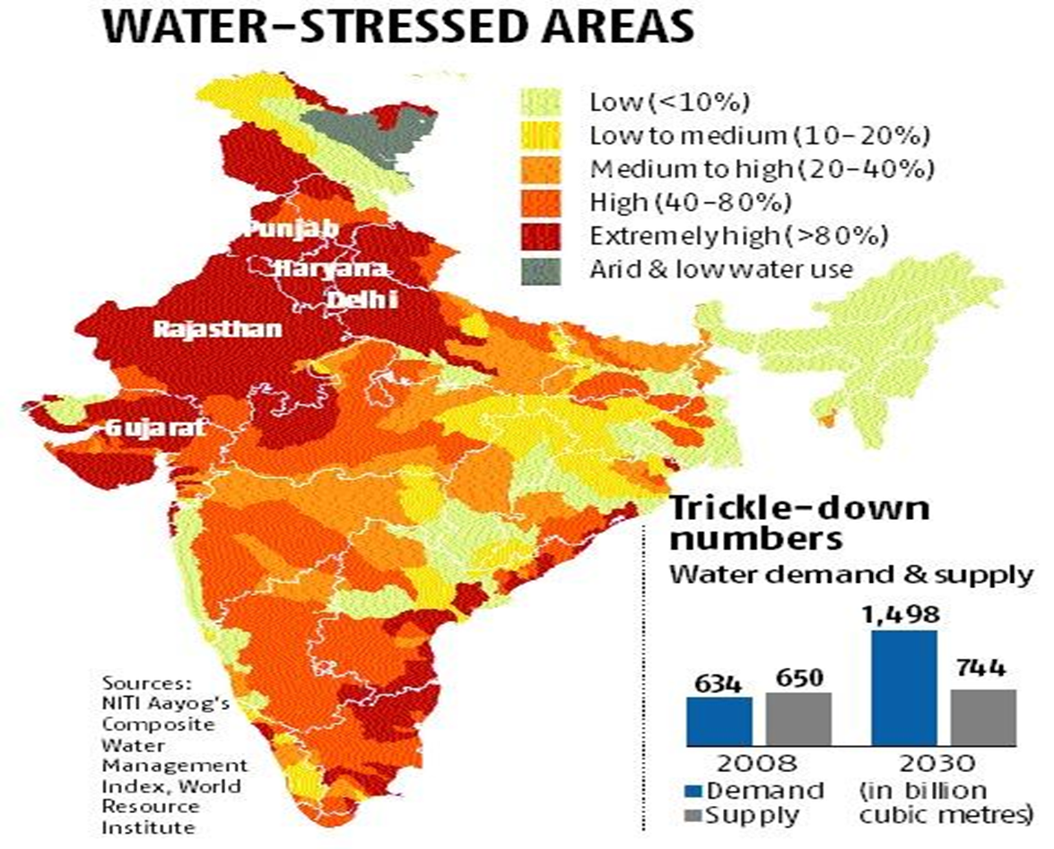

Fig 4. Water-stressed areas across India

According to NITI Aayog’s “Composite Water Management Index (CWMI)”, report India is undergoing the worst water crisis in its history. Nearly 600 million people were facing high to extreme water stress.

The Central Water Commission (CWC) in its study titled ‘Assessment of Water Resources of India 2024’ estimated that India’s average annual water availability, between 1985 and 2023, stood at 2,115.95 billion cubic meters (BCM). India’s annual per capita water availability was 1,486 cubic meters in 2021, which falls under the water stress category (less than 1,700 cubic meters). This is projected to reduce to 1,341 cubic meters by 2025 and 1,140 cubic meters by 2050. Due to rapid economic growth and demographic changes, water demands in all sectors are increasing. The Union Ministry of Water Resources has estimated that India’s water requirement which is 1,100 BCM per year (in 2017) will grow to 1,447 BCM in 2050.

In another estimate by the National Commission on Integrated Water Resources Development in 1999, water requirement of the country for the irrigation sector alone is going to need additional 200 BCM by 2050 compared to the demands of 2025.

**Table 2 Per Capita Availability of water**

|  |  |  |
| --- | --- | --- |
| **Year** | **Population**  **(Million)** | **Per** **capita** **water** a**vailability (m3/year)** |
| 1951 | 361 | 5177 |
| 1955 | 395 | 4732 |
| 1991 | 846 | 2209 |
| 2001 | 1027 | 1816 |
| 2011 | 1210 | 1545 |
| 2025 | 1394 | 1341 |
| 2050 | 1640 | 1140 |

**Source: Government of India, 2009**

The country currently uses only a small part of its water endowment - there is still huge potential for it to meet its water needs through developing water harvesting systems.

Released jointly by the Centre for Science and Environment (CSE) and National Mission for Clean Ganga (NMCG), it highlights the potential of wastewater treatment for water circularity and sustainability. It reveals that there is decline in India’s annual per capita freshwater availability: Currently below 1,700 cubic metres. Again, huge amount of untreated wastewater: Nearly 72% of India’s wastewater ends up in nearby rivers, lakes, etc.

At the same time it is that India presents a strong case for circular economy in water, as:20% of groundwater blocks are in critical condition or overexploited while 55% of households have open or no drains.

**NATURE BASED SOLUTIONS: A JOURNEY THROUGH PAST**

Water was worshipped in the past as a divine gift of Nature. Sages of the Vedic age provided the right guidance to people as to how to treat Mother Nature with respect. People looked to Nature, the provider of so many resources, with a sense of gratitude. Prayers to this effect can be seen in different Vedas. The Vedas also guide us as to what we must do to protect our environment. India is a water rich country with 4% of world’s water resources (India-WRIS wiki 2015). The rivers have been the heart and soul of the India’s growth as well as culture. Rapid urbanization and industrialization have worsened water quality in many regions, while agricultural over-reliance on groundwater has led to its depletion. Hindu texts like the Puranas, Mahabharata and Ramayana and various Vedic, Buddhist and Jain works contain

several references to canals, tanks, embankments and wells (Pande, 1997).

India has a long and rich history of rainwater conservation, deeply rooted in the practices of its ancestors. Since ancient times, people across the subcontinent have recognized the importance of harvesting and preserving water. They developed and refined techniques suited to the region’s diverse geography, creating a wide array of traditional water conservation systems. Though methods varied, the underlying goal was consistent: to capture and reuse rainwater, groundwater, stream and river flows, and even floodwaters, ensuring the efficient use of this precious resource.

Archaeological evidence supports the significance of water conservation in early Indian civilizations. The advanced water management systems of the Indus Valley Civilization, especially in sites like Lothal (Gujarat), and monumental structures such as the Grand Anicut (Kallanai Dam) built in the 2nd century CE by the Chola dynasty, stand as enduring examples. India’s traditional water architecture included step wells, tanks, canals, storage tanks, and innovative drainage and irrigation systems—all ingeniously designed to manage water sustainably.

Even the Vedas, India’s oldest sacred texts, emphasize the sacredness of water. They speak of its vital role in sustaining life, the importance of its purity, and the need for its careful preservation. This ancient wisdom reinforces the cultural and spiritual significance of water conservation in Indian tradition, reflecting a deep understanding of sustainable living that remains relevant even today.

Out of the five basic elements of nature, called the Panchamahabhuta, namely Ether or Space (Akash), Air (Vayu), Agni (Fire), Water (Aapah), and Earth (Prithvi), Water is seen as the foremost element and one that spawned the evolution of the Universe

In “Rigveda” mandala 7. Sukta 49. Shloka 2, says that water in the environment comes in five forms: divyah (rainwater), sravanthi (natural spring), khantrimah (wells and canals), shyamJah (lakes), nadi (rivers) and samudra (ocean). The Rig vedic hymns clearly describe the Dyava Prithivi (Heaven and Earth)as `full of water’, `decorated with ornaments of water’, `abundantly blessed with love of water’, `conservator of waters’, etc (Sharma, 2000).

Water conservation, use and management were given considerable importance in ancient India (Shadananan Nair, 2003).

India’s traditional water harvesting structures are a evidence to the creativity and practical wisdom of its people. Based on deep local knowledge and simple engineering skills, communities across the country have made a wide variety of new methods to collect and conserve water suitable to their particular environments. These practices reflect a deep understanding of nature and a commitment to sustainability.

The remains at Mohenjodaro and Harrapan have illuminated the reality that even in those prehistoric times; people valued having a sufficient quantity of water for irrigation, domestic use, and public baths. Each large house had its own well, and clusters of smaller dwellings were served by additional wells. With water channels running to and from it, the Great Bath was the most significant building in the city

The country’s immense ecological diversity—from the arid deserts of Rajasthan to the cold, high-altitude deserts of Ladakh; from the temperate Himalayan slopes to the lush tropical hills of the south—has given rise to region-specific water conservation techniques. The landscape includes mountain ranges, plateaus, and the fertile but flood-prone Indo-Gangetic plains, each requiring a tailored approach to water management. Whether it’s stepwells in Gujarat, tank systems in Tamil Nadu, or bamboo drip irrigation in the Northeast, India’s traditional water harvesting methods reveal a rich legacy of adaptive and sustainable resource use that remains highly relevant in addressing today’s water challenges.

Most of these devices and systems remained in use, with modifications, over theensuing centuries. These include the khadin-based cultivation, tankas, nadis etc ofRajasthan, bandharas and tals of Maharashtra, the bundhis common to Madhya Pradesh and Uttar Pradesh, and Bihar’s ahars and pynes.

These also include the kuhlsknown in Himachal Pradesh and the kuhals of Jammu & Kashmir, the ponds used in theKandi belt of Jammu, the eris of Tamil Nadu, surangams of Kerala, and the kattas of Karnataka, which are still in use today. (Agrawal & Narain Eds. Dying Wisdom, 1997). As many of these were the result of local community action, their management and maintenance often vested locally

Water conservation in India is not a new concept. One of the earliest sites of the Indus Valley civilisation, Dholavira in the Gujarat state has well documented storage reservoirs in the form of lakes to collect surface run offs during the rainy season . Not only that, there were intricate channels and check dams for various purposes. Such structures have also been found in other sites such as Harpapa and Mohenjodaro. Sringaverapura tank in modern day Uttar Pradesh was built sometime in the 1st BC and is a shining example of engineering during the early period of Indian civilisation. (Puskar Pande) The oldest step-well in India has been cut off natural rock on a high mountain range called Uparkot on Mount Girnar near Junagarh in Gujarat dating 2000 years old.

**TRADITIONAL METHODS:** **GEOGRAPHICALLY APPROPRIATE METHODS**

The designs of traditional RWH structures exhibited variations across states and regions in India, influenced by the specific monsoon pattern of each area. (Ummani and Mansi, 2013)

People still use old traditional water harvesting methods which were used by ancient civilizations. The archeological evidence shows that in the Indus valley civilization people used an excellent system of water harvesting and drainage. The stormwater channels of Dholavira settlement is a good example of water channeling and storing for dry seasons. Irrigation and water harvesting are mentioned in Chanakya’s Arthashashtra. A water harvesting system that uses the natural slope of the land to store floodwater is seen in Sringaverapura, near Allahabad. While king Bhoj of Bhopal made the largest artificial lake in India to conserve water. Jahaz mahal of Mandu, Madhya Pradesh is a water-saving structure on the top of a hill where the water table is very low. These are great examples that give us a better understanding of traditional techniques and their implementation.

Evidence dating back to 3000 B.C. reveals the presence of reservoirs to collect monsoon runoff, with approximately every third house having a well. Notably, sites such as Dholavira, Mohenjo-daro, and Harappa featured reservoirs for rainwater collection. Additionally, in regions like Lothal (Gujarat), Inamgaon (Maharashtra), and other parts of northern and western India, local communities constructed small bunds to store rainwater for drinking and irrigation purposes (Murthy et al., 2022) .Mohenjodaro, the largest city belonging to Harappa culture had over 700 open wells (Chandel andSharma, 2014) . Rainwater was collected directly in open wells (Ummani and Mansi, 2013)

The designs of traditional RWH structures exhibited variations across states and regions in India, influenced by the specific monsoon pattern of each area. (Ummani and Mansi, 2013)

Common in Jammu & Kashmir region and Ladakh, zings are small tanks that collect the water that melts from glaciers and can be used in other seasons. These are small tanks that collect melted glacier water through channels. Essential to the system is the network of guiding channels that brings the water from the glacier to the tank. As glaciers melt during the day, the channels fill up with a trickle that in the afternoon turns into flowing water. The water collects towards the evening, and is used the next day. A part of the land is dug to construct tanks that help to store water from melting glaciers. This is a freshwater source that is channelized to the tank with the help of a network of guiding channels. The collected water can be used for many purposes but is mainly used for irrigation. As this artificial glacier is at a lower altitude and much closer to the villages, they melt earlier at the start of the summer around April and provide water for the crops (Norphel et al, 2009).

In the eastern Himalayan states of Nagaland and Arunachal Pradesh, traditional water management practices reflect a deep ecological understanding and resourcefulness. In some villages, water diverted for irrigation is first channeled through cattle sheds, allowing it to absorb valuable nutrients from animal waste before reaching agricultural fields. The Angami Naga community goes a step further by protecting forests located upstream of water sources, ensuring that stream water remains rich in forest humus—natural fertilizer vital for soil health and crop productivity.

Zabo: Practised in Nagaland, Zabo is also known as the Ruza system. Rainwater that falls on forested hilltops is collected by channels that deposit the run-off water in pond-like structures created on the terraced hillsides. The channels also pass through cattle yards, collecting the dung and urine of animals, before ultimately meandering into paddy fields at the foot of the hill. Ponds created in the paddy field are then used to rear fish and foster the growth of medicinal plants.

Bamboo Drip: Among the most remarkable innovations are the bamboo-based water delivery systems developed by indigenous communities in the north-eastern hill regions. Utilizing their expertise in bamboo craft, these communities have built sophisticated pipelines that transport water from mountain springs across rugged terrain. Particularly in southern Meghalaya, intricate bamboo networks have been perfected to irrigate betel leaf plantations located on rocky, hard-to-access slopes where conventional irrigation methods fail. These systems mimic modern drip irrigation technology, delivering controlled amounts of water directly to plant roots. With an inflow of around 18–20 liters per minute, the water is gradually funneled through the bamboo channels and reduced to 20–80 drops per minute by the time it reaches the plants—demonstrating a fine balance between tradition and efficiency.

Kikruma, a rainshadow village in Nagaland’s Phek district, practises Ruza, a traditional water harvesting system, to overcome water scarcity and achieve good harvests for nearly a century.

According to the NRAA, rainfed areas in India are the most variable and unpredictable environments which renders rain-dependent agriculture a risky proposition. “Yet, there is enough evidence to show that traditionally, rural communities knew how to harness this variability to support their economies, societies and agro-ecosystems, carefully breeding livestock and varieties of crops that can thrive in these areas,” it states in a policy document. Ruza involves impounding run-off water in ponds, using gravity-based irrigation. The water harvesting ponds are located at a higher elevation and are connected to the fields at the lower elevations through narrow drains.(Barasha Das,2023)

Kuhls are surface water channels found in the mountainous regions of Himachal Pradesh. The channels carry glacial waters from rivers and streams into the fields

Meghalaya: Bamboo Drip irrigation System is an ingenious system of efficient water management that has been practised for over two centuries in northeast India.

The tribal farmers of the region have developed a system for irrigation in which water from perennial springs is diverted to the terrace fields using varying sizes and shapes of bamboo pipes

Uttarakhand: Many traditional systems like Naula (little depression aquifer), Dhara (springs), Gadhera (small river tributaries), Gul (traditional irrigation canals), Chal and Khal (artificial ponds on hilltops) to collect and supply water still persist in the villages of Uttarakhand.

Among these, Naula and Dhara are the most important and are still used as the prime source of drinking water in many hilly areas of Uttarakhand, especially in the Kumaon division.

**Indo- Gangetic plains**

Bihar:

Ahar Pynes: This traditional floodwater harvesting system is indigenous to south Bihar. Dating back to as early as 500 BCE, this indigenous system was tailored to the unique topography and climate of the region. These Pynes are artificial channels led off from nearby rivers that recharge the Ahars and the stored water can then be used during the dry summer season (Kaul et al.,2012). Of late, though, some villages in Bihar have taken up the initiative to re-build and re-use the system. One such village is Dihra

**Thar Desert :**

North western region of India consists of Rajasthan and Gujarat states that have a predominantly hot and dry climate. The annual average precipitation is low resulting in severe water scarcity in some parts of the states. Due to these many different water management systems, indigenous to this region can be found (Kumar et al, 2010).

Kuis / Beris: used to harvest rainwater in areas with meagre rainfall. The mouth of the pit is usually made very narrow. This prevents the collected water from evaporating

Nadis Jhalaras :were human-made tanks, found in Rajasthan and Gujarat, essentially meant for community use and for religious rites

Tankas (small tank): are underground tanks, found traditionally in most Bikaner houses. They are built in the main house or in the courtyard.

They were circular holes made in the ground, lined with fine polished lime, in which raiwater was collected. Tankas were often beautifully decorated with tiles, which helped to keep the water cool. The water was used only for drinking. Taankaas are considered as safe deposit lockers of water in Gujarat. They have been storing every drop of water that falls down and quenching the thirst of households for decades

Khadin: A khadin, also called a dhora, is an ingenious construction designed to harvest surface runoff water for agriculture

First designed by the Paliwal Brahmins of Jaisalmer, western Rajasthan in the 15th century, this system has great similarity with the irrigation methods of the people of Ur (present Iraq) around 4500 BC and later of the Nabateans in the Middle East. A similar system is also reported to have been practised 4,000 years ago in the Negev desert, and in southwestern Colorado 500 years ago.

Its main feature is a very long (100-300 m) earthen embankment built across the lower hill slopes lying below gravelly uplands. Sluices and spillways allow excess water to drain off. The khadin system is based on the principle of harvesting rainwater on farmland and subsequent use of this water-saturated land for crop production

Saza-Kuva An open well with multiple owners (saza = partner), sazakuva is the most important source of irrigation in the Aravalli hills in Mewar, eastern Rajasthan

Johad: are small earthen check dams that capture and conserve rainwater, improving percolation and groundwater recharge

**Gujarat:** Vav/ Rani ki vav the “Queen’s Stepwell”, is another impressive stepwell in India. Located in the town of Patan in the state of Gujarat, it is thought to have been built sometime in the 11th-century AD. Ancient Gujarat (part of the Indus Valley Civilization) had sophisticated water management systems, including reservoirs, wells, and rainwater harvesting techniques, demonstrating a deep understanding of local terrain, rainfall patterns, and groundwater tables

It is one of the finest examples in India and is designed as an inverted temple to the sanctity of water

The construction of stepwells date from four periods: Pre-Solanki period (8th to 11th century CE); Solanki period (11th to 12th century CE); Vaghela period (mid-13th to end-14th century CE); and the Sultanate period (mid-13th to end-15th century CE).Sculptures and inscriptions in stepwells demonstrate their importance to the traditional social and cultural lives of people.

Andalaj ni Vav stepwell near the city of Ahmedabad in Gujarat is yet another interesting step well. Not only is it exquisitely beautiful, but the story behind its construction is quite tragic

Talab / Bandhis Talabs are reservoirs of Tikamgarh in the Bundelkhand region

Pat Bhitada village, Jhabua district of Madhya Pradesh developed the unique pat system. Diversion bunds are made across a stream near the village by piling up stones and then lining them with teak leaves and mud to make them leak-proof

Kohli Tanks: The Kohlis, a small group of cultivators, built some 43,381 water tanks in the district of Bhandara, Maharashtra, some 250-300 years ago. It is still crucial for sugar and rice irrigation

Bhanadaras: These are check dams or diversion weirs built across rivers. A traditional system found in Maharashtra

A Phad: is a century old community-managed irrigation system. This Phad system is operated on three rivers in the Tapi basin – Panjhra, Mosam and Aram – in the Dhule and Nasik districts of Maharashtra. In modern India, this method is helpful in mitigating the risk of crop failure, especially in drought-prone suicide belts, like Vidarbha, Maharastra.

The Ramtek model: is named after the town in Maharashtra where the practice originated.

It is an elaborate network of channels with underground supply and the water is channelized through an extensive network of tanks, baolis that replenish the water supply. In this system, tanks connected by underground and surface canals form a chain that extends from the foothills to the plains. Once tanks located in the hills are filled to capacity, the water flows down to fill successive tanks, generally ending in a small waterhole. This system conserves about 60 to 70 % of the total runoff in the region (Gupta,et al 2014)

Kere: Tanks, called kere in Kannada, were the predominant traditional method of irrigation in the Central Karnataka Plateau, and were fed either by channels branching off from anicuts (chech dams) built across streams, or by streams in valleys. The outflow of one tank supplied the next all the way down the course of the stream; the tanks were built in a series, usually situated a few kilometres apart. This ensured a) no wastage through overflow, and b) the seepage of a tank higher up in the series would be collected in the next lower one.

Western Coastal plains : Virdas Virdas are shallow wells dug in low depressions called jheels (tanks). They are found all over the Banni grasslands, a part of the Great Rann of Kutch in Gujarat. They are systems built by the nomadic Maldharis, who used to roam these grasslands

The Eri (tank) system of Tamil Nadu is one of the oldest water management systems in India. Still widely used in the state, Eris act as flood-control systems, prevent soil erosion and wastage of runoff during periods of heavy rainfall, and also recharge the groundwater. Eris can either be a system Eri, which is fed by channels that divert river water, or a non-system Eri, that is fed solely by rain. The tanks were further interconnected to help extend the reach of the water source to far away villages and at the same time balance out the water levels in case of an excess in supply (Jalyatra, 2008).

In Tamilnadu: Ooranis, which go back to more than 2000 years, are structures formed in rural areas where ground water... is scarce or unfit for use, like the Ramanathapuram district of Tamilnadu.

Panam Keni: It is a type of well-constructed by a durable outer layer of Palm trees deeply immersed in groundwater springs within the forests and fields, mostly used by the Wayanad natives, Kerala, known as the Kuruma tribe. Because of such features, even during the hottest season of the year the water remains for domestic use

The Shompen tribe of the Great Nicobar Islands lives in a region of rugged topography that they make full use of to harvest water. In this system, the low-lying region of the island is covered with Jackwells (pits encircled by bunds made from logs of hard wood). A full-length bamboo is cut longitudinally and placed on a gentle slope with the lower end leading the water into the Jack-well. Often, these split bamboos are placed under trees to collect the runoff water from leaves. Big Jack-wells are interconnected with more bamboos so that the overflow from one Jack-well leads to the other, ultimately leading to the biggest Jack-well.

**Reasons for decline of Traditional water systems:**

i. Neglect of policy makers towards traditional existing structures, lack of innovative methods to deal with water related issues

ii. Growing use of subsidised energized system (subsidized electrical powers) to exploit deep aquifers

iii. Lack of interest on community in participation in preservation of traditional structures

iv. Some tanks have been encroached for farming, sand mining, expansion of city, waste dumping, industry etc

v. Pollution of water due to sewage and industrial waste

**CONCLUSION:**

It is important to understand that ‘water’ was not a scarce resource in the ancient times as compared to the scarcity challenges that we face in the current context. Unsustainable greed and overconsumption has pushed nature to its limits, and further. Nobody knows the full consequences of this decadence, but one thing is certain: unless the peoples of the world unite in the battle to restore the natural balance of the planet, the prospects of the future may end up being far less pleasant than the memories of the past. Harvesting water was an Indian way of life in the distant past. The traditional methods established in India are simple and cost effective, and are ingrained in the culture of the respective regions and thus can be specific solutions. The methods followed were environment friendly and have relevance even today. We must revive our traditional methods of water harvesting and also implement new methods. Solutions are within reach. But we need innovative thinking, greater political commitment and collaboration and increased financing so that when it comes to water, no one is left behind. The concept of a water-sensitive city is an urban water management approach that delivers benefits to enhance sustainability, liveability and resilience

**REFERENCES:**

1. Agrawal, Anil & Sunita Narain. (1997). Dying Wisdom: Rise, fall and potent ial of India's traditional waterharvesting systems. (State of India's Environment – A Citizens' Report, No. 4), Centre for Science &Environment (CSE), New Delhi

2. Alegre, H., J.M. Baptista, E. Cabrera, et al (2016 ) Performance Indicators for Water Supply Services (third ed.), International Water Association Publishing, London, UK (2016), 10.2166/9781780406336

3. Central Water Commission (2024) in its study titled ‘Assessment of Water Resources of India 2024’

4. Centre for Science and Environment (CSE) and National Mission for Clean Ganga (NMCG),2023

5. Chandel, R.S. and Sharma, M.R. (2014). Potential and limits of Domestic Rooftop Water

Harvesting in Una Area of Shiwalik Asian J. of Adv. Basic Sci.: 3(1), 28-35

5. Composite water management Index (2018)– A tool for water management, NITI Aayog, June 2018.

6. Donkor ,E.A., T.A. Mazzuchi, R. Soyer, J. Alan Roberson(2014) Urban water demand forecasting: review of methods and models J. Water Resour. Plann. Manag., 140 (2014), pp. 146-159, 10.1061/(ASCE)WR.1943-5452.0000314

7. Divy Ninad Kaul, Ganesh Neelam, Gopal Shukla, Swati Singh,(2012) ‘Traditional water management systems - An overview of the Ahar-Pyne system in the South Bihar plains in India and the need for its revival’, Indian Journal of Traditional Knowledge

8. Govt. of India. (2009). Background note for consultation meeting with Policy makers on review of National Water Policy. Ministry of Water Resources. .

9. Gupta, Anil & Nair, Sreeja & Singh, Swati,(2014) ‘Traditional Water Management Systems for Drought Mitigation in India’, *Water Digest*, 36-45, 2014.

10. Hooja Rima (2010) Channeling Nature: Hydraulics, Traditional Knowledge Systems, And Water Resource Management in India- A historical Perspective http://www.infinityfoundation.com/hooja_book.htm

*11. Kumar, Rajesh & Punia, M. et al (2010): ‘Sustainable development and management of water resources of Rajasthan’, Nava Gavesana, 2010*

*12. Nair Shadananan K, (2003), ‘Role of water in Developmen t of Civilization in India – a review of ancientliterature, traditional practices and beliefs’ ‘The Basis of Civilization – Water Science, Proceedings of theUNI-SCO/1 AI IS/I WI IA symposium held in Rome, December 2003.*

13 Murthy R.N.S., Srikonda, R., Kashinath, I.V. (2022) Traditional Water Management Systems of India, Journal of the International Society for the Study of Vernacular Settlements2(9), pp 61-77

14. NCIWRD (1999). Report of The National Commission for Integrated Water Resources Development. Ministry of Water Resources, Government of India, New Delhi, 1999

15.Nitya Jacob,(2008) ‘Jalyatra: A Journey Through India’s Water Wisdom’, *Penguin India*

16.. Norphel (2009)., ‘Artificial Glacier: A High-Altitude Cold Desert Water Conservation Technique’, *Leh Nutrition Project, Leh, Ladakh,* pp. 1- 5,

17.Pande, BM. (1997). A multi-millennial mission

18.Sharma K.N, (2000), Environmental Protection and Water Reverence in Ancient Indian Culture Secretary,International Commission on Irrigation and Drainage (ICID)

19.U.S. Geological Survey, (1993) The distribution of water on, in, and above the Earth | U.S. Geological Survey (usgs.gov0

20.Umamani, K.S. and Manasi, S. (2013). Rainwater Harvesting Initiative in Banglore City:

Problems and Prospects.