Urban land production and vulnerabilities to flood risks in the Niamey 5 municipal district

**Abstract**

The urban soil production process in Sahelian cities is often carried out without respecting the required urban planning standards. This is not without consequences for the lives of city dwellers. In the Niamey 5 municipal district, urban sprawl is taking place on informal plots. This situation creates urban problems for households. This article examines the vulnerabilities to flood risks arising from the urban soil production process. To achieve this objective, a quantitative data collection approach from households and the creation of thematic maps was used. This study shows a strong link between the type of subdivision and exposure to flood risks. Indeed, 60% of households living in informal subdivision areas are in marshy areas compared to 10.98% of households in formal subdivision areas. This finding calls on public decision-makers to take measures to comply with urban planning regulations in the urban soil production process.

**Keyword: urban land, land, subdivision**

1. **Introduction**

Cities are growing both spatially and demographically ( Kadjo et al.,2024, Zoma et al.2022, Derra and Podlunsek,2025). This growth of cities generates needs for housing and infrastructure (Simonneau and Adegbinni , 2024, Adam, 2024). These needs are difficult to meet in poor cities where municipal authorities do not always have the means to produce serviced land accessible to all (Jourdam-Boutin,2024, Adjayi , 2024, Ondoua and Peclard , 2020, Spire and Beier , 2024, Yenlide and Okey , 2024). The production of developed plots is only the preserve of the most affluent. A significant proportion of the citations resort to informal productions to build their housing. They turn to customary landowners or informal private developers to purchase their land. These plots without legal security, and do not respect any urban planning standards, are legion in the cities of sub-Saharan Africa. This exposes the inhabitants to a situation of vulnerability of all kinds. These vulnerabilities expose households to various risks, particularly those of flooding. This paper establishes the link between urban land production, exposure to vulnerabilities and the flood risks to which households are exposed in the Niamey 5 municipal district.

1. **Materials and methods**

Household surveys are conducted in villages and peri-urban neighborhoods. The stratified sampling method was adopted. This technique made it possible to consider the size of each of the spatial units by giving each element the chance to be surveyed according to the size of its parent population (Adam, 2024).

The selection of households to be surveyed is random. The sample was calculated using the standard formula for calculating the sample in statistics. The formula is as follows:

Sample size = [z2*p (1-p)] / e2 / 1 + [z2*p (1-p)] / e2*N] *deff*TNR.

Applying the formula cited and explained above, the sample size is 383 households for a parent population of 6502 households in 2012.

To determine the number of households to be interviewed per (neighborhood), the rule of three in proportion to the total number of households in the neighborhoods (N) of the sample (n) was applied. Thus, to determine the size of each neighborhood, the following procedure was followed: Nordiré (659 households): 659 x 388/6502 = 38.81 or 39 households to be interviewed Seno (262 households): 262 x 383 /6502 = 15 households to be interviewed. The results are recorded in the following table.

**Table 1 : Number of households surveyed by district**

|  |  |  |  |
| --- | --- | --- | --- |
| **Neighborhood** | **Number of Households** |  | **Number of respondents** |
| NORDIRE | 659 | 38.81 | 42 |
| SENO | 262 | 15.43 | 15 |
| NOGARE | 1009 | 59.43 | 61 |
| BANGA BANA | 4115 | 242.39 | 242 |
| SAGUIA | 457 | 26.91 | 28 |
| **Total** | **6502** | **382.97 = 383** | **388** |

Maps are the preferred tools of geographers. Given this proven usefulness, cartographic aspects occupy an important place in this work. This is why, given the absence of *shafiles* that concern this research subject, a specific spatial database was created for the development of maps. This database was created using satellite images from 2020, 2021, 2022 from the Google Satellite, Word Esri sites Imageri and Google Hybrid . These images were called into the Qgis software work interface and then digitized in a metric reference system, block by block, in the entire built-up area of the Niamey 5 municipal district. In addition to the blocks, all the elements of the urban framework were digitized.

In addition, topographic data were also developed using SRTM images of the Niamey 5 municipal district. These images enabled the creation of altimetric maps, slopes, and hydrographic networks using Argis.10 and Qgis software . Also, several maps were created by cross-referencing spatial maps and topographic maps.

1. **Results and discussion**
   1. **Location of the study area**

The Niamey 5 communal district (ACN V), the framework of this study, is located on the right bank of the Niger River and is connected to the left bank by three bridges (the Kennedy Bridge, the China-Niger Friendship Bridge and the Seyni Bridge Kountché ), built respectively in 1970, 2011 and 2021. It is bordered to the north by ACN1, 2, 3, 4 and the rural commune of Bintinkodji , to the east and south by the rural commune of Youri.

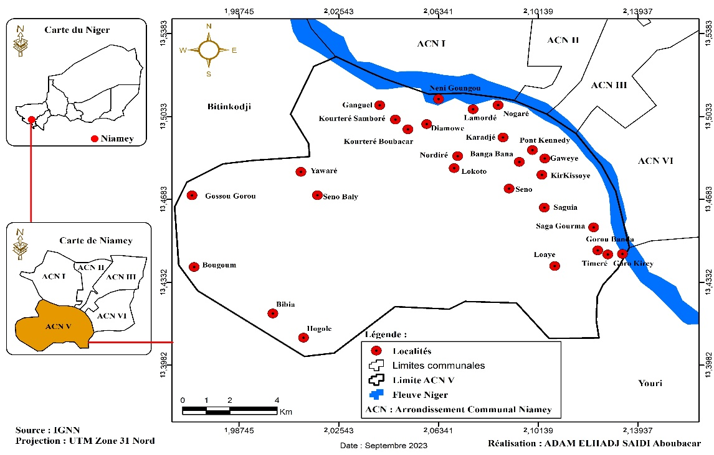

**Map 1: Location of the Study Area**

**3.2 Urban land production in the Niamey municipal district**

Indeed, any residential space must be the subject of a subdivision. However, to subdivide, it is necessary to follow the steps prescribed by law, in order to obtain authorization from the competent authorities, in particular the Ministry of Urban Planning. According to Decree No. 97-304 of August 8, 1997, establishing the creation, responsibilities, and organization of advisory bodies in matters of urban planning and housing, the steps to obtain subdivision authorization are:

* Preparation of a technical file containing the project presentation note, graphic documents and a subdivision request addressed to the ministry responsible for urban planning;
* Examination of the file at the municipal level by the local urban planning commission for an opinion (mandatory);
* Review and adoption of the project by the departmental commission for urban planning and housing. The project is then subject to a public inquiry;
* Sending of the file comprising all the deliberations and the conclusion of the public inquiry to the Ministry of Urban Planning and Housing, in particular to the technical committee for urban planning and housing;

If the file is technically and legally admissible, it is sent to the National Commission for Urban Planning and Housing for a final check of the subdivision project;

Finally, the file approved with the mention “favorable opinion” is returned to the community or the promoter for its execution.

Urban land that has not been subject to subdivision authorization is considered an informal settlement, and therefore illegal under the law. Informal subdivision areas, created by customary landowners and informal private developers, face undeniable legal vulnerability because they did not follow any urban planning standards before their subdivision.

Urban land production in Niger reveals the skills of public and private operators. The latter provide citizens with serviced plots for building and living. However, the conditions for accessing these plots produced according to standards are so difficult that poor urban households instead turn to informal operators who produce plots without respecting urban planning standards. We are witnessing a dual production of urban land. On the one hand, formal production inaccessible to the majority of city dwellers and on the other, informal production accessible to the poor whose conditions are precarious.

These are informal spaces for which the subdivision process has not been subject to any authorization. These so-called spontaneous spaces are commonplace in the outskirts of the right bank of Niamey. The dwellings built at this level only have a customary certificate generally issued by the village chiefs.map 2gives us the legal status of different built spaces in the Niamey 5 municipal district. It shows that informally developed spaces and squats constitute a significant portion of residential built spaces, up to 33.4% compared to 66.48% of formally developed spaces. The Niamey 5 municipal district is known to be the space par excellence where informal housing developments have taken on the greatest scale. In almost all the districts of the commune, there are informal fragments adjoining the officially developed part. This constitutes a significant problem in the context of improving the living conditions of households.

Indeed, in addition to land security issues, the vast majority of built-up areas in the Niamey 5 municipal district do not comply with current urban planning standards. These standards are, however, described in the various texts that frame the principles of urban planning in Niger.

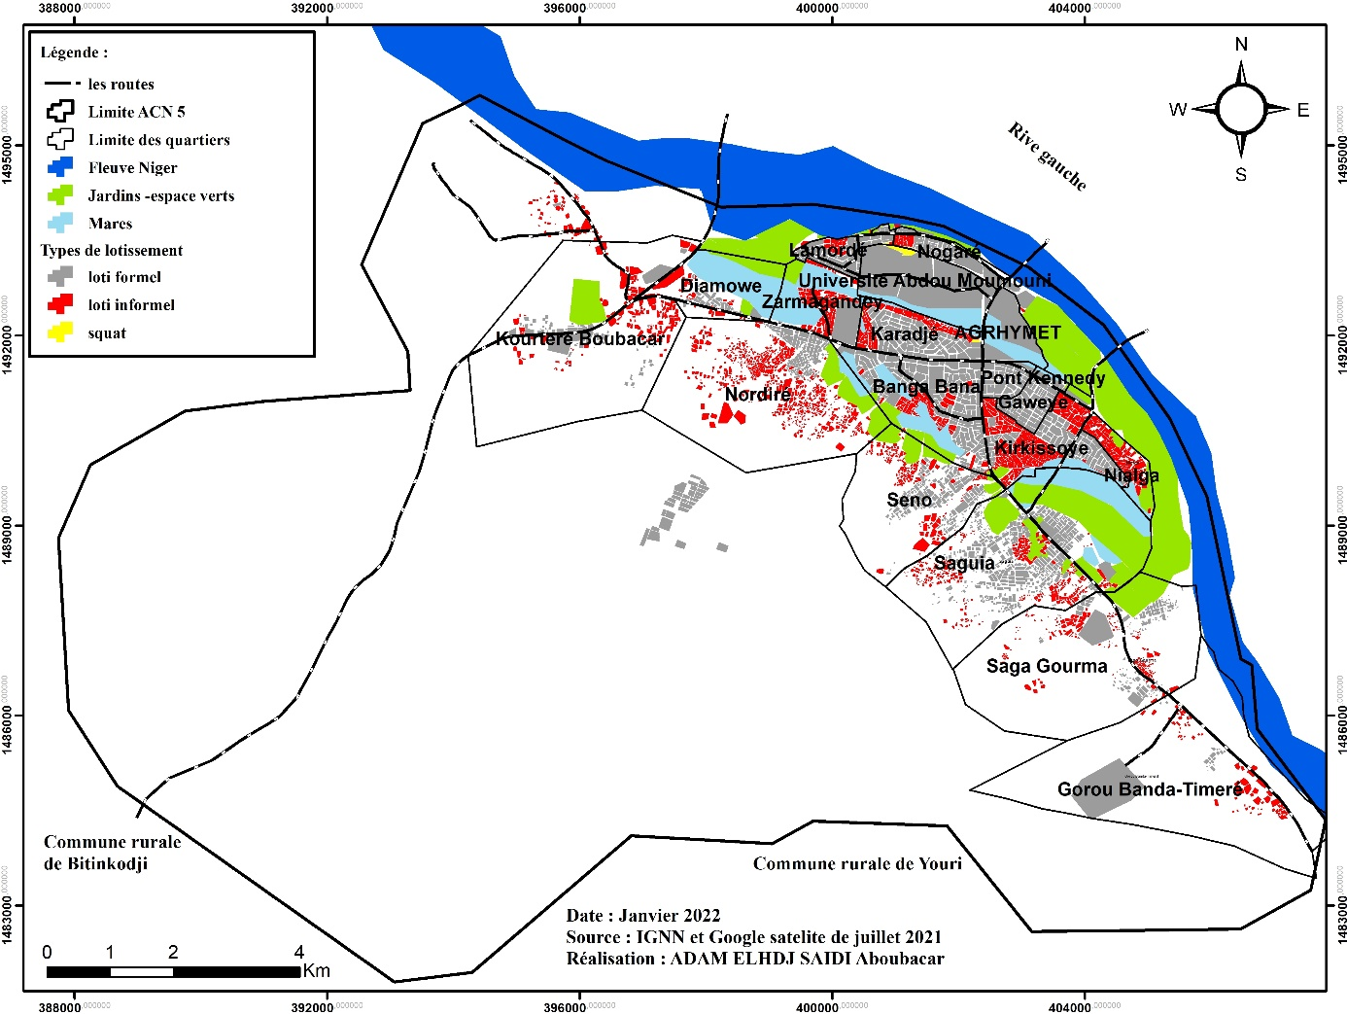

Map 2: Type of subdivision of built-up areas in ACN5

6.2.1 Site of the Niamey 5 municipal district

The Niamey 5 municipal district is an area that can be described as fragile, due to the rugged forms of its relief. The observation of the digital terrain model shows that the municipality has a very contrasting relief ranging from 172 to 272 m above sea level (map 3). The minimum values of the geomorphological sets are located in the valley of the Niger River and the maximum values are found in the south-eastern part of the municipality. The dense urban area, including the districts of Nogaré , Lamordé , Bangabana , Karadjé , Kirkissoye , is located in the low and medium altitudes 180-190 m. Indeed, it is known that vulnerability to flooding is very high in the part of the Niamey 5 municipal district located at an altitude of 182 m, because this is the part of the floodplain. Increasingly , we observe that the occupation of hillsides and summits by dwellings is increasing in the Nordiré , Seno and Lokoto districts .

To this topographical data, we must add a hydrographic network made up of seven large Koris which dissect a good part of the urbanized and urbanizing spaces. These include the Koris Gorou Kirey , Saga Gourma and Kourteré and Ganguel whose ultimate outlet is the Niger River passing through the different districts: Banga Bana Sud, Kirkissoye , Nordire , Karadjé , Kourteré . This important hydrographic network has its source in the high reliefs of the South-west, then spreads into the rest of the urban area.

These Koris create gullies and cause silting of the urban area. Increasingly, homes are being built in and around their banks. This poses a real risk of landslides and house collapse. By carefully observing theMap 3 **,** it is clear that the hydrographic network is quite dense, hence the abundance of areas at risk of flooding and/or landslides due to gullying. These koris cross the areas par excellence of the establishment of precarious housing on the right bank of the Niger River. H. K.Motcho rightly evokes this geographical reality in the following passage:

"There are close relationships between the site's shape and the various networks (communication routes, sanitation networks, etc.): for example, topography plays an important role in the layout of roads and in the choice of the types of crossing structures to be built; as far as the sanitation network is concerned, the slopes that can be given to the pipes are, to a large extent, linked to the relief. It also plays an important role in the location of the city's various watersheds, and therefore in the design of the networks." (KH Motcho , 2020, P: 228)

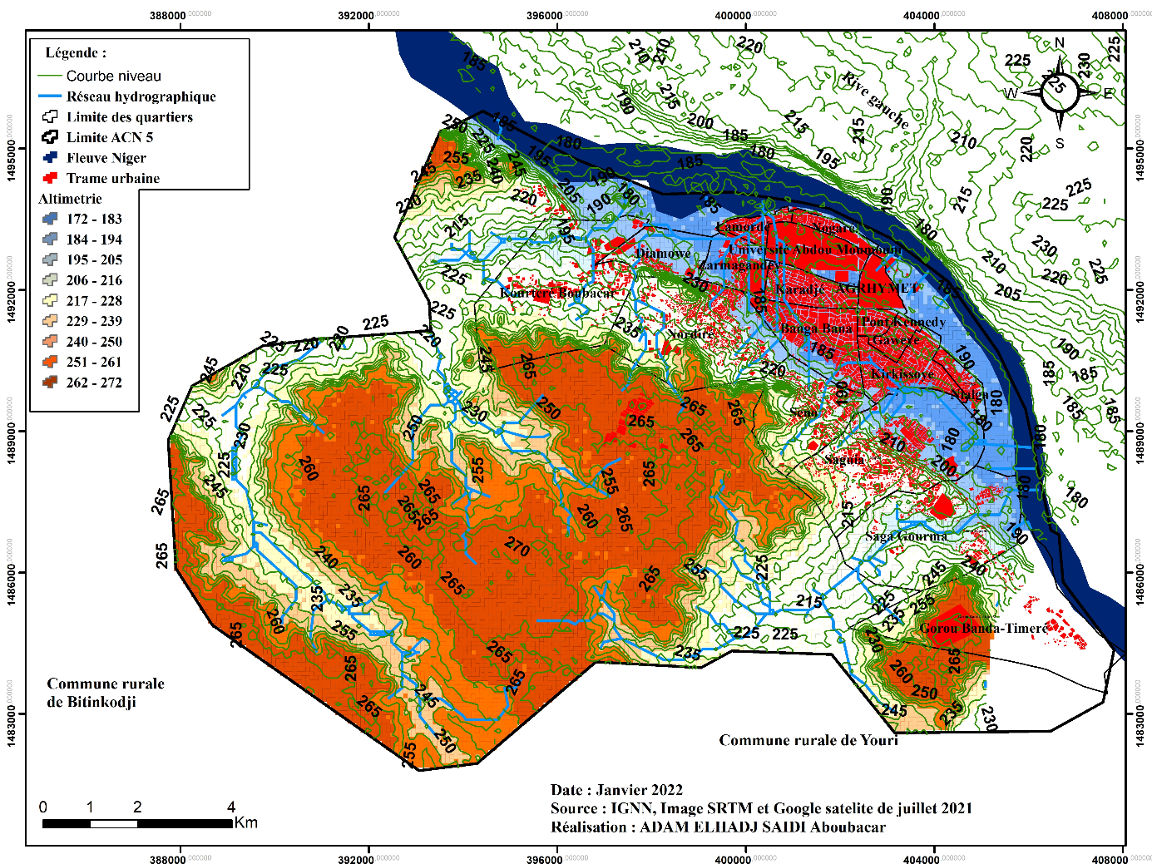

Map 3: Altimetry and hydrographic network of the Niamey 5 municipal district

The nature of the soil in the areas currently under urbanization is of the alluvial type composed of gravels and fluvial sands in the form of gravels (H. Issaka , 2012; KH Motcho , 2019). These types of soils are unsuitable for infiltration due to the presence of the water table less than 2 m deep in the Niger River valley (map 4).

As for the area located on the plateau, it is unsuitable for infiltration due to its lateritic cuirass cover. Indeed, with the urbanization of this area, the soil impermeability coefficient increases and the risks of rainwater flooding become high. According to the 2020 Sanitation Master Plan for the city of Niamey, the impermeability coefficient of the various basins on the right bank increased from 43% in 2015 to 48% in 2020. The low infiltration capacity also allows the development in depth and extent of ravines that drain water towards the main watercourses (the river and ponds). The peri-urban area of the Niamey district is also the site of the creation of gravel, sand and other construction material quarries. The excavations created during their exploitation accentuate the process of erosion and land degradation (IM Bahari et *al,* 2019).

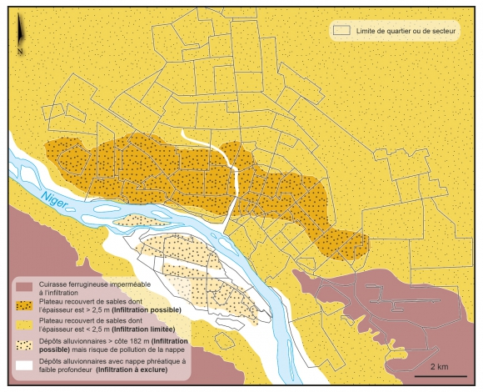

Map 4: Geology of the city of Niamey,

Source: Hamadou Issaka and D Badariotti , 2013

The analysis of the different slope classes is also a key element in assessing the level of vulnerability of areas. Taking slopes into account is justified by the fact that they have a direct relationship with the risk of flooding of housing and with that linked to sanitation (health). It is therefore a variable to be taken into account in a systemic analysis of risk in an urban environment. Indeed, observation of map 5 shows that most of the urbanized areas of the Niamey 5 municipal district are established on areas with a very low slope (less than 5%). These areas are sensitive to flooding and pollution of groundwater due to the low flow capacity. There are also human settlements on steep hillsides in the Nordiré , Lokoto and Kourteré sectors. Samboré .

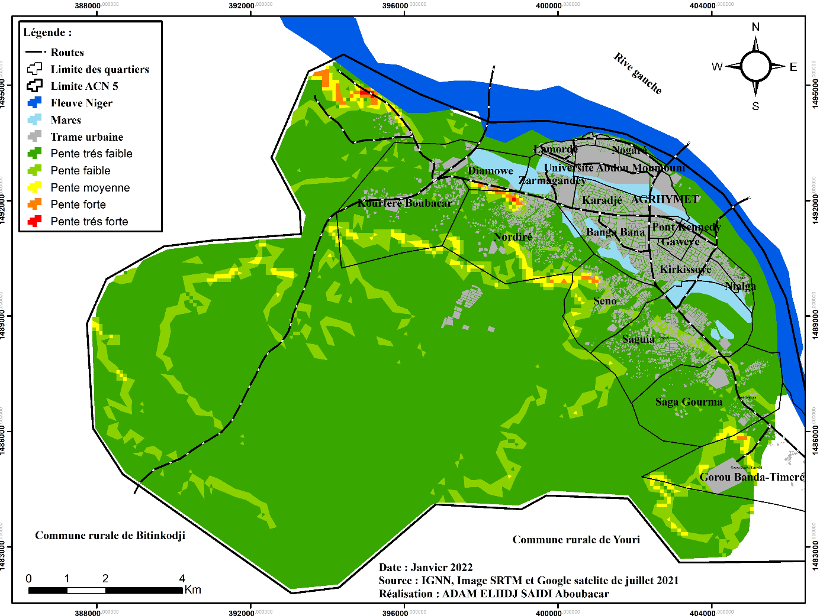

Niamey district

Map 5 : Urbanization in Niamey District

|  |  |
| --- | --- |
|  |  |
| Photo 1: Dwellings located on the hill of the “ three sisters” in Nordiré | Photo 2: Dwellings located in the ravine and on its edges in Seno . |
|  |  |
| Photo 3: Dwellings installed in a marshy area in Banga Bana . | Photo 4: Dwellings built on the side of one of the “ three sisters” in Nordiré |

According to the household survey data, human settlements took place in marshy areas, which are depressions or old river beds, spaces that are in principle not suitable for construction, at least not for residential purposes. (Photos 1 to 4).

The survey shows that 37.4% of households are located in marshy areas, lowlands or valleys and 7.2% of the households surveyed live on the slopes or sides of a hill (Table 2). Living on the side of a hill is a real residential constraint, if we know that the limit of the possibility of having a water and electricity network is 260 m above sea level ( Motcho , 2016).

In addition, the hilly site is a place subject to various forms of erosion and landslides due to steep slopes. As for the plateaus and plains, they are places prone to water stagnation due to the weakness of the slope and the undulating aspects of the relief. Their urbanization therefore requires the construction of a sanitation network.

Table 2: Types of sites occupied by households

|  |  |  |
| --- | --- | --- |
| Type of sites | Effective | Percentage |
| Flat area | 215 | 55.4 |
| Slope/side of a hill | 28 | 7.2 |
| Valley/lowland/marshy area | 145 | 37.4 |
| Total | 388 | 100.0 |

*Source: Field data in October and November 2020*

It also emerges that informal occupation areas constitute the majority of households living on the hillside and marshy areas with 60% of the households surveyed, as highlighted in Table 3 below. This indicates a close link between informal housing and the types of sites occupied.

Squatters occupy flat areas, as all the squatters encountered are located close to the main wall of Abdou Moumouni University in Niamey, which is in a non-flood zone. Squatters in the university grounds near the Karadjé neighborhood are in flood-prone areas because they are located in the dead arm of the Niger River.

As for households in the formal subdivision, 88.4% of them are located in flat areas. It should be noted that although in our sample we did not encounter formal subdivision areas in marshy areas or on hillsides, there are some on the right bank. This is the case of a plot that we visited in August 2020 and which is located in a private subdivision built in 2011 in the Saguia district . Today, it is located less than a meter from a large ravine that can measure more than a meter deep. Several plots that are upstream are already covered by this Kori . Therefore, the issue of occupation of marshy areas is not only the work of informal developers, but also that of formal private developers whose authorization has, in principle, followed all possible verifications as to the conformity of their project with the guiding principles of urban planning, as stipulated by law 2017-20 of April 20, 2017 on principles of urban planning and development.

Table 3: Type of sector surveyed

|  |  |  |  |  |
| --- | --- | --- | --- | --- |
|  | 2. Type of sector of the neighborhood surveyed | | | |
|  | Formal housing sector (%) | Informal housing (%) | Squatter sector (%) | Village core (%) |
| Flat area | 88.43 | 24.57 | 100 | 0 |
| Slope/side of a hill | 0.53 | 15.42 | 0 | 0 |
| Valley/lowland/marshy area | 10.98 | 60 | 0 | 100 |
| Total | 100 | 100 | 100 | 100 |

*Source: Field data in October and November 2020*

6.2.2 Predominance of self-construction

In Niger, the desire to ensure sustainable housing for all households has been a constant in the various regimes that have succeeded one another. However, this political will is marred by many contradictions and short-lived idealism, because all the measures announced to provide solutions have remained in most cases just declarations of intent. Indeed, projections in terms of housing are never realized, and even the few that are achieved are intended for a relatively well-off social class. For example, the achievements of the city of the Francophonie, the Fayçal cities and the achievements during the Renaissance regime only concern solvent city dwellers (national guards, senior civil servants, tax executives) ( Motcho, 1991; A. Adamou, 2014; Issaka , 2012; U. Meyer, 2016; Holding, 2017).

In any case, the housing supply has never been satisfactory, while the need is increasing overnight. For example, in the case of Niamey, the capital, the need is 5,000 housing units per year (SATU-SA, 2015).

The bank lending system excludes the overwhelming majority of households from accessing credit for the purchase or construction of a home. It remains the preserve of a minority made up of employees and remains inaccessible to the vast majority of populations with irregular incomes and whose savings capacity is low or almost non-existent. Only 22% of Nigerien employees can access this type of financing. This constitutes 1% of the total population of Niger (S. Aboubacar, 2019). The excessive indebtedness of some households limits their chances of easily accessing a mortgage loan capable of allowing them to build a home. Also, the interest rate is very high in some banks operating in Niger: 10% minimum interest rate. This limits a large part of the Nigerien population.

Households manage to build homes through their savings, willingly or unwillingly, at the cost of long years of deprivation. Table 3 shows that only 2.1% of households used bank loans to finance the construction of their homes, while 80.2% did so on the basis of personal income, 9.9% with family support and 2.1% through tontines.

Table 4: Method of financing construction by households

|  |  |  |  |
| --- | --- | --- | --- |
| **Construction financing** | **Effective** | **Relative percentage** |  |
| Bank loan | 5 | 2.1 | 2.4 |
| Personal income | 194 | 80.2 | 93.3 |
| Family help | 24 | 9.9 | 11.5 |
| Tontine | 5 | 2.1 | 2.4 |
| Others to be specified | 14 | 5.8 | 6.7 |
| **Total** | **242** | **100%** | **116.3%** |

*Source: Field data in October and November 2020*

6.2.3 Housing construction materials

The durability of building materials also determines the vulnerability of households to flooding in particular. In Table 5, we see a predominance of housing built from precarious materials. Thus, 42.5% of housing is built from mud, 6.2% from semi-hard and 5.8% from a mixture of straw, sheet metal and wood. Housing built from hard materials considered durable represents 42.5% of the households surveyed. These results confirm several studies carried out (H. Soumana , 2015; H. Issaka , 2010) in the neighborhoods of the right bank where there is a predominance of constructions from precarious materials despite the risks of flooding and the fragility of the environment of the spaces in this area. We note that constructions from precarious materials less resistant to flooding and other bad weather are proliferating; which exposes households to the threats of flooding and fire.

Table 5: Type of housing wall

|  |  |  |
| --- | --- | --- |
|  | Effective | Percentage |
| Hard | 178 | 45.9 |
| Semi-hard | 24 | 6.2 |
| Bank | 164 | 42.3 |
| Straw | 21 | 5.4 |
| Drink | 1 | 0.3 |
| Total | 388 | 100.0 |

*Source: Field data in October and November 2020*

The quality of building materials depends partly on the neighborhood sector. Indeed, in the informal sector, squatter areas and the village core, constructions made of non-durable, precarious materials seem to be the most dominant. Also, there is a strong correlation between building materials and the housing land situation ( Table 6). It emerged in this regard that 67.6% of households in formally subdivided areas have their homes built of solid material, while 78.9% of households in squatter areas and 49.1% in informally subdivided areas have mud brick buildings.

|  |  |  |  |  |  |
| --- | --- | --- | --- | --- | --- |
|  | Type of housing wall | | | | |
| Type of the area of the neighborhood surveyed | Hard | Semi-hard | Bank | Straw | Drink |
| Formally developed area | 67.6 (117) | 3.5(6) | 26.0(45) | 2 .9(5) | 0 |
| Informal housing estate | 32.6(57) | 10.3(18) | 49.1 (86) | 8(14) | 0 |
| Squatter sector | 10.5 (2) | 0 | (78.9) 15 | 10.5%2 | 0 |
| Village core | 9.5% (2) | 0 | 85.7 (18) | 0 | 4.8 (1) |
| Total | 178 | 24 | 164 | 21 | 1 |

Table 6: Type of construction materials and type of district sector

*Source: Field data in October and November 2020*

8.4 Flood risks

8.4.1 Causes and types of floods

The Niamey 5 municipal district is an area where the risks of river flooding are very high. In this area of the city of Niamey, it is the area most exposed to disasters and humanitarian crises linked to the extreme overflows of the Niger River. Local floods that occur in July, August and September are generally the cause of flooding in the neighborhoods on the right bank (H. Soumana , 2013).

These repeated floods are mainly due to the concentration of runoff due to the heavy rainfall that falls on the sub-watershed of the tributaries of the right bank, mainly on the Dargol , the Goroual and the Sirba. In addition to these massive and disastrous waters that flow into the Niger River, there is urban runoff that contributes to the overflowing of the river and therefore to flooding, just like the tributaries.

The phenomenon of repetitive flooding is amplified by the anarchic occupation of the dead arms of the river, ravines and the bed of the Niger River. In addition, to a certain extent, flooding is considered as a phenomenon that, in part, originates from the lack of an adequate rainwater drainage system due to blocked or non-existent gutters in some neighborhoods. In addition, the physical aspects of the relief of the ACN5, characterized by an alluvial plain occupied by dwellings and a gentle slope, are generators of flooding. Indeed, these characteristics of the relief favor the stagnation of water (Photo 5).

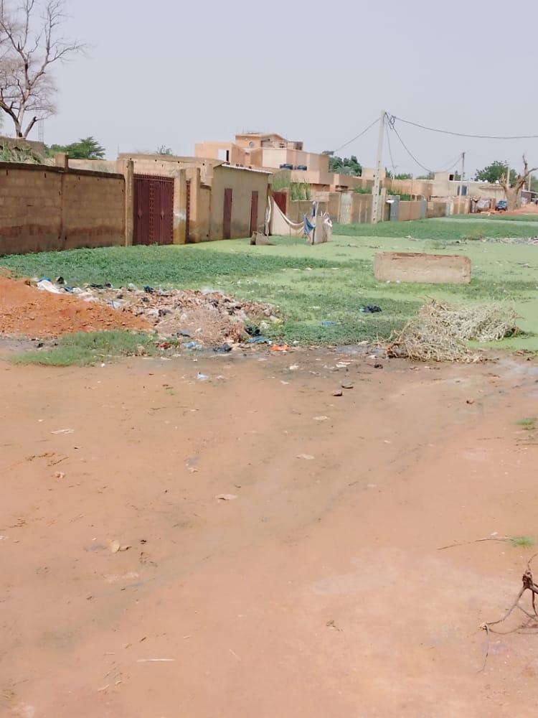

Photo 5: Dwellings in open water in Bangabana ,

August 2022

Map 6 shows the situation of the flooded areas during the floods of 2020. It shows that a good part of the districts of Lamordé , Nogaré , Karadjé , Bangabana , Kirkissoye , Saguia , were affected by the ravages of these floods. Indeed, it is well known that in these districts, informal and formal plots were produced and built on non-aedificandi spaces, that is to say, spaces that are not buildable according to the urban planning standards in force in Niger. These are spaces that are completely dead arms of the Niger River, the Niger River bed or ravines.

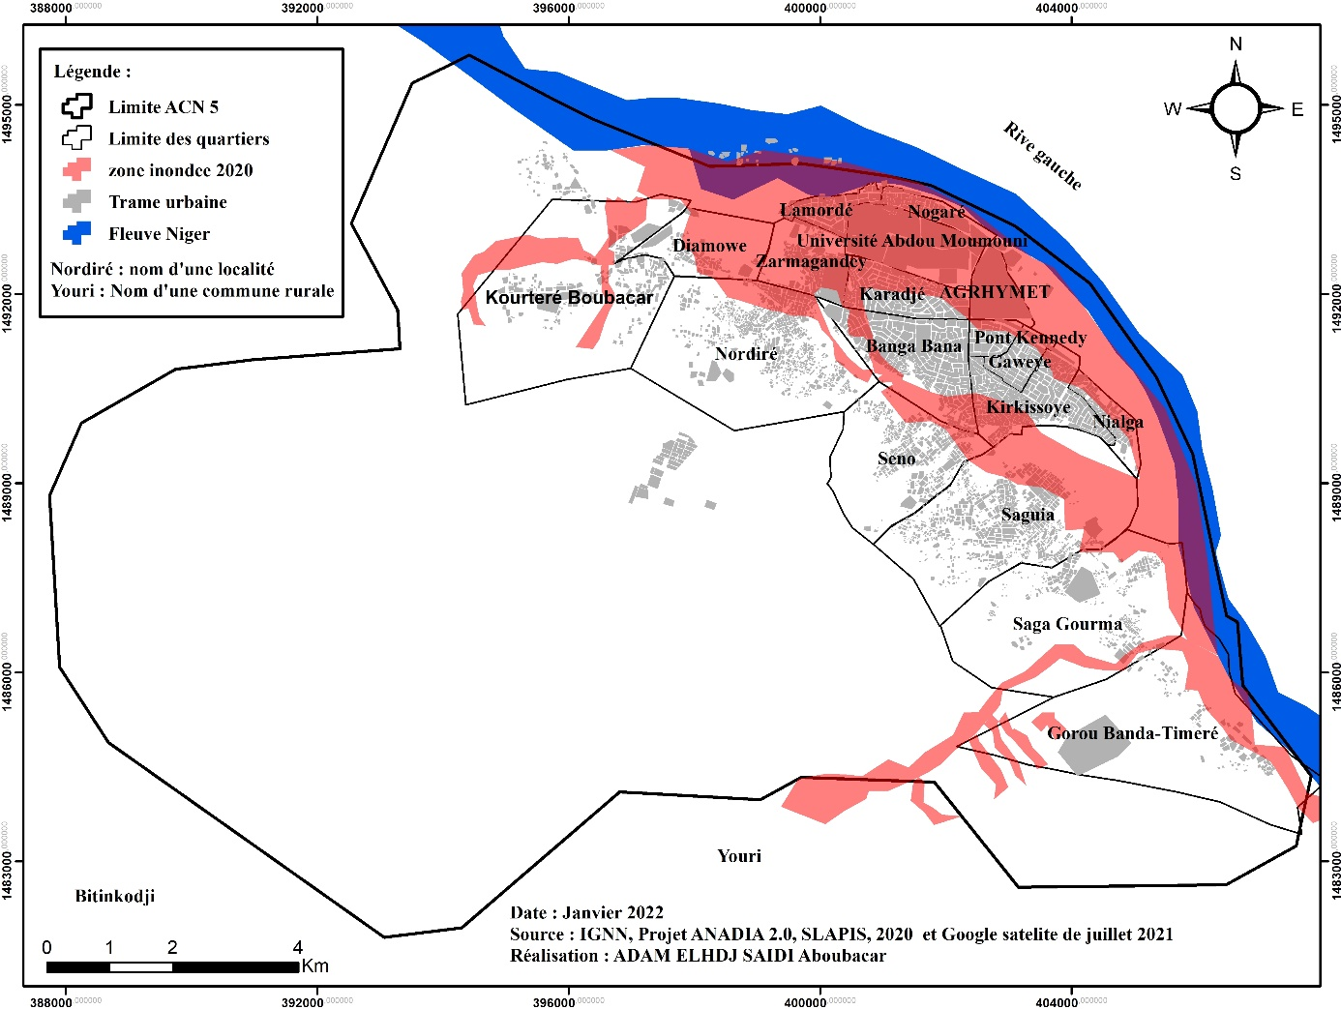

Map 6: Areas flooded between August and September 2020

Conclusion

This article has demonstrated that households in the Niamey 5 municipal district are faced with several vulnerabilities. These different forms of vulnerability are linked to the conditions in which land production was carried out. Land vulnerability is characterized by households settling in undeveloped urban spaces (45.10 % and 4.90% occupy undeveloped and squatted spaces respectively). These land and urban planning vulnerabilities are ultimately transformed into a residential vulnerability characterized by precarious housing conditions. Indeed, the homes of households in ACN5 are built, for the most part, in flood-prone and/or difficult-to-access areas (hillside, steep and gentle slopes) and constructed from non-durable materials (banco and semi-hard ).

**References**

Yenlide , T., & Okey , MKN (2024). Dynamics of household housing tenure in Togo: An analysis based on pseudo-panel data. *The International Review of French-Language Economists* , *9* (2), 255-274.

Spire, A., & Beier , R. (2024). Remaining urban despite everything. Thinking about cities through the experience of urban resettlement, based on two African cities. In *Annales de géographie* (Vol. 755, No. 1, pp. 75-98). Armand Colin.

ONDOUA, PDB, & PECLARD, D. Governing Discontent in Cameroon. Housing Policies and the Construction of Hegemony in Yaoundé, 2000-2020.

ADJAYI, KAF (2024). Kodjo Sena ATCHON. *Donni International Review* , *4* (1).

Jourdam -Boutin, M. (2024). *Neoliberalization of public housing policies in Cameroon* (Doctoral dissertation, University of Paris 1-Panthéon-Sorbonne).

KADJO, EE, ADABA, KA, BONI, H., & BARRY, H. (2024). Demography in West Africa : strengths and challenges.

Zoma , V., Kiemdé , A., & Sawadogo, Y. (2022). Main challenges of urban growth in Ouagadougou. *Regardsuds* , (2), 77-92.

Derra , S., & Podlunsek , C. (2025). In the shadow of urban sprawl. *Projet Review* , *405* (2), 60-63.

SANGARÉ, N., DIARRASSOUBA, B., & KOFFI, B. É. Access to decent housing in the cities of Bouaké and Korhogo (Ivory Coast ): from poor housing to household residential strategies.

Yenlide , T., & Okey , MKN (2024). Dynamics of household housing tenure in Togo: An analysis based on pseudo-panel data. *The International Review of French-Language Economists* , *9* (2), 255-274.

Fofana, M., & Kra, KW (2025). The occupation of flood risk areas in the district of Abidjan: between representations, frustrations and rhetoric. *VertigO - the electronic journal in environmental sciences* .

Motcho, 1991, 2016; A. Adamou, 2014; Issaka , 2012; U. Meyer, 2016; Holding,2017).