**ASSESSING THE IMPACT OF ROAD INSFRASTRUCTURAL DEVELOPMENT ON LAND USE SPATIAL PATTERNS IN SUBURBAN AREA – CASE STUDY FARKA/ADMINISTRATIVE UNIT 1, TIRANA, ALBANIA**

Abstract

The development of road infrastructure in suburban areas has historically been a key element in planning policies for the management and transformation of a country not only localy but at a regional and national level as well. This is beacuse the impacts of road constructions are observed in every aspect of a country's profile: economic, social and environmental. The development of roads and road infrastructure in these spaces has a direct impact on the way people and goods move, as well as on how these areas can be integrated with major cities. It has the potential to bring many benefits, but also requires careful planning to minimize negative environmental, social and economic impacts. Regard land use, road infrastructure often leads to the urbanization of suburban areas, increasing pressure on natural resources and causing urban sprawl into natural spaces. Consecuently often it can be observed a significant rising in property prices that leads to the closure of green spaces. Roadinfrastructure construction causes habitat fragmentarization, loss of agricultural land areas, alteration of the organic composition of soils etc. In this perspective, the analysis and assessment of the impacts of infrastructure developments on land use characteristics using GIS technology will be addressed in this study. The time span is between 2012-2018. Changes in land use types has been identified and visualized through maps.

Key words: road infrastructure, land use patterns, Geographic Information Systems, (GIS), spatial analysis,

**1. Introduction**

New road construction activities have always played a key role in planning policies, particularly in a developing country, as a way to sustain effective management of territories transformation at a local, regional or national level. This is due to the fact that infrastructural activities exert a direct impact on every aspect of a country's development: economic, social and environmental/natural. In economic terms, the road infrastructure provides positive support as it affects the growth and expansion of economic activities, especially in the service and production sectors, enables the establishment of new industrial areas and ensure the connection of remote areas to each-other. These newly created patterns of economic activities lead in turn to population growth in the affected area as a result of greater possibilities on employment offer.

However, despite these positive effects that road infrastructure brings in economic and social terms, the impact to land use may not always be in the same line. The construction activities in most of the cases are responsible for habitats alienation and fragmentation, loss of agricultural plots, destruction of organic soil composition, environmental pollution, etc. Various studies have shown that road infrastructure and land use are two different aspects but at the same time so closely related to each other. Initially, the development of transport infrastructure, especially road infrastructure, was focused and based on the residential areas and main centers of human economic activities. Whereas, nowadays it is the road infrastructure process that serves as a gravity point for the creation and development of new “to be” centers of almost all human activities[1].

Therefore, the characteristics of changing patterns in land use are crucial elements during the early stages of territory planning and management. As a result, these pattern have been always looked very carefully by policy-making authorities at all levels, especially those at local one. In order to ensure sustainable development of these territories they find it mandatory to monitor the timeline of land use and to thoroughly assess future demand in terms of infrastructure needs and potentials.

The above mentioned considerations were the impetus to address in this paper the impact on land use patterns caused by the road construction namely Outer Ring Road of Tirana. The work is done by making use of GIS technology which has been proven to be e very useful tool in creating, analyzing and visualizing spatio-temporal thematic data.

**2. Study area**

The study area includes the territories of Administrative Unit 1 and Farka Administrative Unit of Tirana Municipality, Albania.

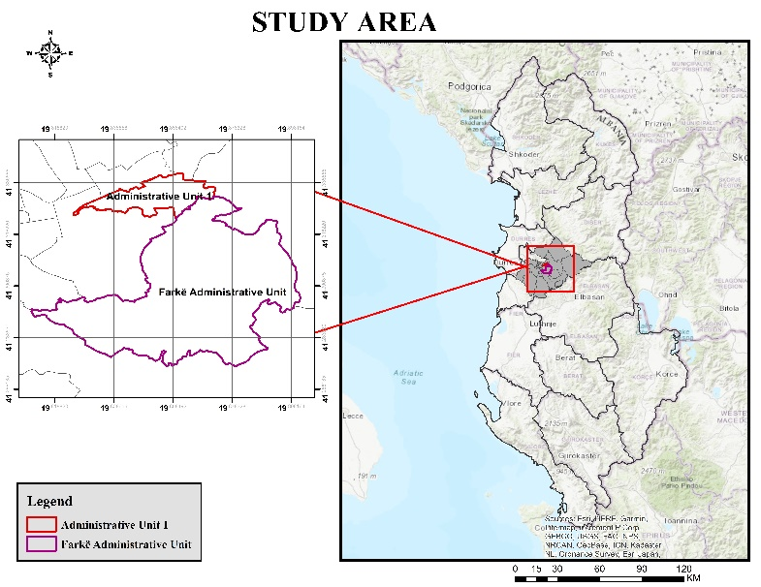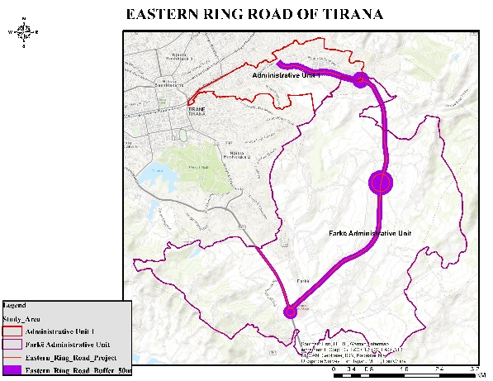

Figure 1. Study area Figure 2. Location of Outer Ring Road of Tirana

Source: World Base Map, Author’s design.

Administrative Unit 1 is an integral part of the administrative division of the Municipality of Tirana. This unit lies in the southeastern part of the city of Tirana and has an area of ​​412.7 ha, of which 100 ha is an urban area, while 312.7 ha is a rural one. The population of this Unit is mainly located on its outskirts and has increased in number over the years. Currently there reside 17,954 families with around 52,138 inhabitants as by December 2022.[2]

The territory of this unit has developed quickly after the interventions that have been made in the rehabilitation and construction of road infrastructure. There are approximately 1500 private businesses within this unit, such as family businesses, shops, bars, but also large businesses such as fashion, printing offices, etc. There are 15 educational institutions of all levels and 3 public health service units.

In the last two decades the investments that are made in Administrative Unit1 consist mainly in the requalification and rehabilitation of roads, the construction of social housing for the Roma and Egyptian community in Shkoza, reconstruction of kindergartens, nurseries and schools.

Based on the New General Plan of Tirana (TR30), the former Autotraktor Plant, Shkoze, is envisioned as a new epicenter of Tirana 2030, as well as an economic-industrial area. In the territory of this unit, the project of ``Outer Ring of Tirana, Lot III, Systemization of the Lana River bed and construction of parallel roads, segment from the new maternity center ``Koço Gliozheni-Outer Ring of Tirana'' has been implemented investment from ARRSH. Due to the impact of this project on the territory of this unit, this unit is part of the study for the assessment of the impact of the construction of this infrastructure on the change of land use.

The Farkë Administrative Unit is another territorial part of the administrative division of Tirana Municipality. Farka is located 7km southeast of the city of Tirana, lying along the national road Tirana-Elbasan. It is bordered to the east by the Dajti Administrative Unit, to the south by Petrela and to the west by Vaqarri.It has a generally autonomous population, but is not excluded from the relocation to this area of ​​a good part of the residential population. As by December 2022 the number of inhabitants of this unit is about 17894 inhabitants, about 5250 families are registered. The presence of the Farka lake, the parks around it, and the hilly relief have created an attractive panorama, increasing the interest of local and foreign tourists for swimming, cycling, etc.

The Tirana-Elbasan highway passes through the territory of Farka with a length of 3.5 km, contributing as such to the transformation of Farka in an important center of economic and architectural development. Along the territory of Farka passes as well the Outer Ring of Tirana, which serves as a connection point of this area with the rest of Tirana and beyond. Due to the strategic geographical position and favorable infrastructure, this area is turning into an attractive residential and economic area. Precisely starting from the impact that the infrastructural development had on the land use of this area, especially in the areas near the road segments, I chose it together with the Administrative Unit 1, as a study element for the assessment of the change in land use as a result of the development of road infrastructure.

The Great Ring of Tirana has been conceived since its beginnings as a highway (category A road). The initiation of this project for the realization of the Great Ring, as a project-idea that dates back to 1996. But mainly for financing reasons among others, this project was not fully accomplished, even though it was taken as a basis during the design of the Outer Ring of Tirana, which was on the other hand built in the footsteps of the previous project.10.

The construction of the Outer Ring Road of Tirana was conceived as a project and further implemented under the responsibility of the Albanian Road Authority (ARRSH), strating back at 2016. The project "Requalification of the road segment Eastern Ring Road of Tirana Lot 3", is the completed road segment, which connects the area of ​​Farka with Shkoza. While the project named as "Completion of works and connecting roads in the East Ring Lot 2", also completed and open for traffic, with a length of 4.14 km, and starts from the roundabout of the shopping center "TEG" (Tirana East Gate) and ends near the Department of Helicopters in Farka11. It is exactly this road segment and its construction that constitutes the area of ​​interest for the study and its impact on the new land use patterns formed in the territories of Farkë and Administrative Unit 1.

**3. Database and methods**

**3.1 Land Cover**

The database used to assess the land use change was downloaded from CORINE LAND COVER website. Two sets of digital vector data corresponding to period 2012-2018 were obtained for this purpose[3]. A total of 12 land use categories were evaluated: [Discontinuous urban fabric](https://land.copernicus.eu/content/corine-land-cover-nomenclature-guidelines/html/index-clc-112.html), Construction sites, Industrial or commercial units, Vineyards, Fruit trees and berry plantations, Olive groves, Pastures, Complex cultivation patterns, Land principally occupied by agriculture, with significant areas of natural vegetation, Broad-leaved forest, Sclerophyllous vegetation, Water bodies. These data were processed using ArcGIS Desktop 10.8 and respective maps were created (Figure 3). The land use categories, their corresponding codes and their percentages for years 2012 and 2018 are presented in the following Tables 1,2.

|  |  |
| --- | --- |
| Code LU | Description |
| 112 | [Discontinuous urban fabric](https://land.copernicus.eu/content/corine-land-cover-nomenclature-guidelines/html/index-clc-112.html) |
| 133 | Construction sites |
| 121 | Industrial or commercial units |
| 221 | Vineyards |
| 222 | Fruit trees and berry plantations |
| 223 | Olive groves |
| 231 | Pastures |
| 242 | Complex cultivation patterns |
| 243 | Land principally occupied by agriculture, with significant areas of natural vegetation |
| 311 | Broad-leaved forest |
| 323 | Sclerophyllous vegetation |
| 512 | Water bodies |

Table 1. Land use categories of the study area, CORINE 2012,2018

|  |  |  |  |
| --- | --- | --- | --- |
| **Code** | **LU categories in study area** | **2012%** | **2018%** |
| 112 | Discontinuous urban fabric | 24.1 | 23 |
| 133 | Construction sites | 1.1 | 1.1 |
| 121 | Industrial or commercial units | 1.1 | 1.1 |
| 221 | Vineyards | 9.1 | 9.2 |
| 222 | Fruit trees and berry plantations | 1.5 | 1.5 |
| 223 | Olive groves | 13.1 | 13.1 |
| 231 | Pastures | 4.3 | 4.3 |
| 242 | Complex cultivation patterns | 17.7 | 16.7 |
| 243 | Land principally occupied by agriculture, with significant areas of natural vegetation (Non cultivated agriculture land) | 16.1 | 16.2 |
| 311 | Broad-leaved forest | 8.4 | 8.5 |
| 323 | Sclerophyllous vegetation | 0.6 | 0.7 |
| 512 | Water bodies | 2.8 | 2.7 |

Table 2. Land use categories in % in the study area; Source: CORINE 2012,2018/Author’s calculation

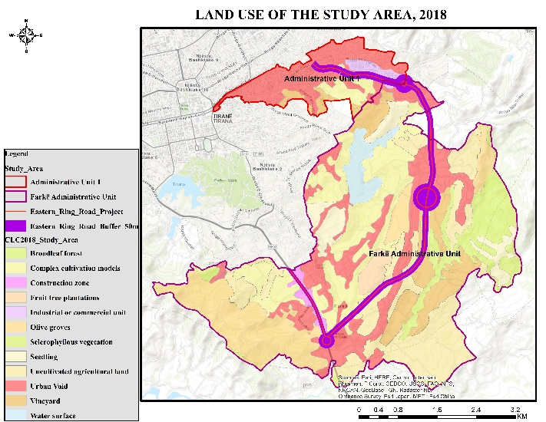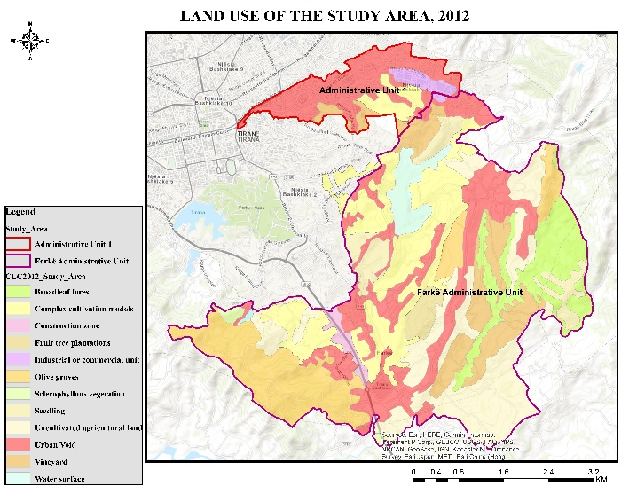Figure 3. Land use categories in 2012 and 2018

Land use categories as well as land use change processes were assessed at one level distance from roads, using the following distance ranges: 0–50 m.

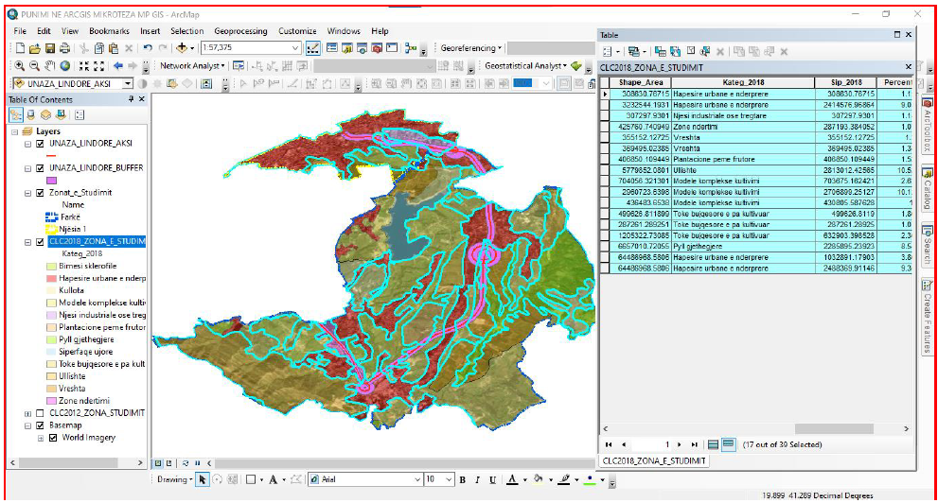

Figure 4. Land use categories at 50 m distance of Easte Ring Road construction; Source: Authors’ calculation

**4**. **Results**

**4.1 Patterns of land use changes**

To assess the level of land use changes in the time period between 2012-2018, six types of processes were distinguished: afforestation – the conversion of one of the land use categories into forest; grassing – conversion into permanent grassland; agricultural intensification – conversion into arable land, orchard, or vineyard and hop-field; the construction of water areas – conversion into water area; urbanization and other anthropogenic processes – conversion into built-up area, recreational area or other area; and stable areas – no change between the two time steps

Graphic 1. Land use categories affected by the construction of Eastern Ring Road,2018 Source: Author’s calculations

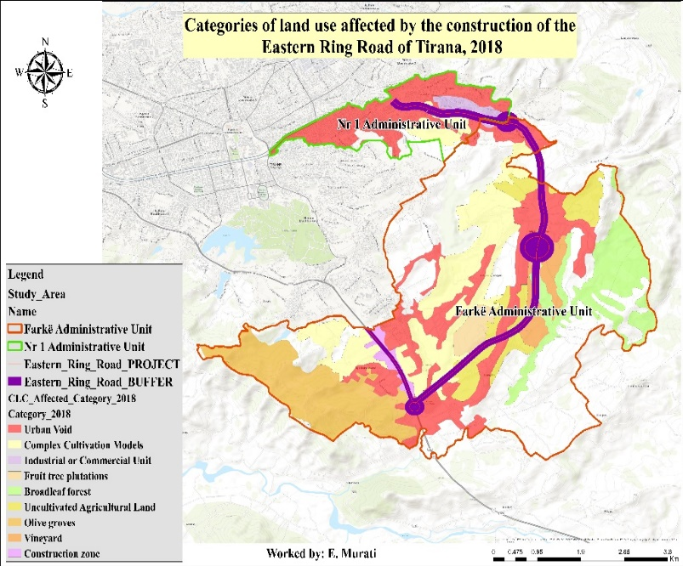

Figure 5. Spatial patterns of land use categories affected by the construction of Eastern Ring Road,2018

Looking at results according to the map and graph above, we notice that out of 12 (twelve) land use/cover categories, 9 (nine) of them have been affected by the construction of the Eastern Ring Road of Tirana. Among these 9 categories, it can be seen that the three categories were affected at most by the implementation of this project and they are: a) discontinous urban space (23%); b) complex cultivation patterns (16.7%) c) uncultivated agricultural land (18%).The reasons why these categories have been affected the most are because they have a greater extent in the territory of the area under study and secondly, because the Eastern Ring Road of Tirana is classified as ``Highway'' and `` Interurban'', and consequently the large width of the road has caused intersections and affect many surfaces of these land use categories. Among the three categories of land use most affected by the construction and implementation of the Eastern Ring Road of Tirana, according to the chart the most affected category is ``Disrupted Urban Space'', 23% of this category was affected by the construction of the Eastern Ring Road of Tirana. As mentioned above this category, which corresponds to residential spaces, has the widest extent in the territory of Administrative Unit no. 1, where as shown on the map in this unit this category is the most affected. This is also explained by the fact that the largest number of dwellings in this unit were demolished due to the construction of this road, also the highest number of expropriations for dwellings that were affected by the implementation of this project, were made in the territory of the Unit Administrative no. 1. In relation to this fact, it is also worth noting that part of the project of the Eastern ring road of Tirana was also the rehabilitation of the bed of the Lana River, thus influencing the width of the road body and the other consequences mentioned above.

The other categories of land use most affected by the construction of the Eastern Ring Road of Tirana, after the above category, are ``Complex cultivation patterns'', 17% of this category is affected by the project, and ``Agricultural land ``uncultivated'', (or agricultural land with significant natural vegetation), 18% of this category is affected by the project.Regarding these categories, based on the map with the corresponding symbols, most of them lie within the territory of the Farka Administrative Unit. As mentioned above the large extent of agricultural areas in this unit has made it known as one of the municipalities with a rural character, where the development or use of land for the cultivation of various agricultural crops has been relatively high.

The crossing and touching of these lands by the construction of the Eastern ring road of Tirana has reduced the area of ​​agricultural lands. In addition, since this road is frequented by a high number of vehicles, which cause a pollution of the air and the surrounding environment due to the fuels they discharge into the environment, we can say that the lands found along the road on both sides of it, have remained barren, so agricultural crops are no longer cultivated.

The construction of the Eastern ring road of Tirana in the territories of the study areas has had a positive effect in terms of the socio-economic aspect. The economic side is expressed in the increase of investments and businesses that have been established on both sides of the road. While the social effect is expressed in the increase in the employment of residents, mainly young people that inhabit these areas.

Both of these units in recent years have been introduced by local authorities as important socio-economic and urban development areas, referring to the Urban Plan of the Municipality of Tirana. Administrative unit no. 1 has absorbed a high number of investments that have consisted in the rehabilitation of existing roads, the opening of new roads (mainly neighborhood roads), the construction of residential complexes, etc.

The Farka Administrative Unit has also absorbed a high number of investments, causing its territory to undergo many transformations. The reason for these developments is also the change in the Local General Plan of the Municipality of Tirana (2023), according to which in most of the territory of Farka Administrative Unit is allowed to build, even if the land or property is agricultural.

However, the last two paragraphs constitute a separate topic of study importance after a certain period of time to see how the land use has changed in the territories of these units, which every day are more and more affected by various large investments.

**4.2 The impact of on the Eastern Ring Road on socioeconomic growth of the study area**

Developments in road infrastructure are always accompanied by significant socioeconomic improvements in the areas where they occur. The enhancement of the road network enables faster and more efficient movement of people and goods, which has facilitated traffic flow in the city of Tirana and its surrounding areas.

Moreover, improvements in infrastructure have created new opportunities for the economic development of the region. These developments have stimulated the creation of new residential areas and have been accompanied by increased private and public investments, leading to new opportunities for various businesses. Likewise, investments in sectors such as construction, tourism, and trade have also increased. All these changes have boosted economic activities and resulted in the creation of new job opportunities for local residents. This infrastructure development has also contributed to improving trade and the transportation of goods, enhancing the efficiency of the supply chain, especially for businesses involved in production and distribution, by reducing transportation costs.

Additionally, infrastructure growth has led to increased demand for real estate, driving up land and housing prices in some areas of Tirana. This phenomenon has benefited property owners but has also created challenges for those looking to buy or rent properties in these areas, as prices have risen significantly.

On the other hand, infrastructure development has had significant effects on urban planning and the environment. It has led to increased traffic in some peripheral areas and has heightened air and noise pollution, requiring better management strategies.

Furthermore, construction has affected certain neighborhoods and communities, causing concerns for residents who have been forced to relocate or have experienced negative impacts due to construction activities and increased traffic.

Conclusion

In conclusion*,* road infrastructure developments bring evident benefits in transportation, economic growth, and investment opportunities. However, they also present social and environmental challenges that require careful attention and appropriate measures for effective management in the future.

References

1.Effects of infrastructure on Land Use and Land Cover Change (LUCC): The Case of Hangzhou International Airport, China. Online: MDPI Journal

*https://www.mdpi.com/2071-1050/10/6/2013*

2. ResearchGate Journal: Terminology for Integrated Resources Planning and Management, Food and Agriculture Organization of the United Nations (FAO).

3. IOP Conference Serier: Earth and Environmental Science, Land use change due to road construction, 2021

4. Municipality of Tirana: Administrative Units

www.tirana.al

5. National Agency for Territorial Planning, Tirana PPV Review Document appendices I-III-IV, 2019

6. Sentinel Hub Public Collections, CORINE Land Cover

7. Copernicus`s Land Monitoring Service, Corine Land Cover 2012

https://land.copernicus.eu/en

8. Albanian Road Authority - Project for the Ring Road in full compliance with the law, 2018

9. Ministry of Infrastructure and Energy

https://www.infrastruktura.gov.al/unaza-e-madhe-e-tiranes-gjiknuri-perfundon-segmenti-nga-rrethrrotullimi-teg-deri-ne-farke

10. Albanian Road Authority: Terms of Reference for the object ``Study Design Requalification of the Eastern Ring Road for Lots 4,5,6``, Year of publication 2020.

11. OPEN DATA TIRANA- https://opendata.tirana.al

12. Open Street Map - https://www.openstreetmap.org

1. IOP Conference Serier: Earth and Environmental Science, Land use change due to road construction, 2021
2. https://www.tirana.al/njesite-administrative
3. Reference 12 Copernicus`s Land Monitoring Service, Corine Land Cover 2012.13 Sentinel Hub Public Collections, CORINE Land Cover https://land.copernicus.eu