Qualitative Interpretation of Seismic Attributes for Reservoir Characterization of A-Field, Central Depobelt Sedimentary Basin of Niger Delta Area.

**ABSTRACT**

A qualitative seismic attributes analysis was carried out for the evaluation of subsurface geological features and hydrocarbon potential of an oil field in Niger Delta Basin. The Interpretation using geophysical software on the 3D seismic data presents a great opportunity for reservoir characterization, enhanced with attributes from seismic signal processing, complex seismic trace attributes, structural attributes, stratigraphic attributes and surface attributes. Seismic attributes such as reflection intensity, RMS amplitude, Time gain, Trace AGC, Sweetness, Envelope, Instantaneous Frequency, Instantaneous Phase, Quadrature amplitude, Ant tracking, Dip deviation, Gradient Magnitude, Local Structural dip, Chaos, Iso-Frequency, Local flatness were used for the interpretation of the 3D seismic cube, time and depth surface maps generated. The result shows moderate to high sweetness region (sweet spots) within the zone of interest, Envelope attribute results show acoustic impedance contrasts indicating discontinuities, lithology changes, possible presence of hydrocarbon (bright spots), Variance, Dip deviation, Gradient magnitude and Ant tracking attributes enhanced the signals to map out discontinuities caused by faults and fractures signature which enabled the delineation of the zone of interest. This study on the qualitative interpretation of seismic attribute validate the lithology discrimination using elastic rock properties from well logs and shows the effectiveness of the use of seismic attributes for the optimizing, understanding, improving, identifying, and unmasking hidden features of the reservoirs in the field.

Keywords: *Seismic Attribute, Structural Mapping, Cross Plot, Prospects, Exploration Risk*

1. **INTRODUCTION**

Since the inception of the oil and gas industry, the need to explore for the natural resources from inside the ground and bring them to the surface by man using various methods has been a major priority, the never-ending increase in the demand for energy has also triggered a widespread for research globally which seek to reduce the cost of exploration and production. The recent decline in the prices of oil and gas has also increased exploration cost and even halted exploration activities in many oil and gas producing nations including Nigeria which has resulted to the current challenge of companies reducing production and personnel.

Against this ordeal, for oil and gas giants to survive this global crisis, very careful and thorough evaluation of information retrieved from the subsurface is imperative. Such information has grown beyond the use of only well logs but also the integrated analysis of conventional 2D and 3D seismic. Information extracted using various attributes from seismic data has proven to be a very useful tool for exploration and development of prospects developed in oil fields.

A seismic attribute is any measure of seismic data that helps us better visualize or quantify features of interpretation interest. It could be described as a powerful aid to improve accuracy of interpretations and predictions in hydrocarbon exploration and development. Seismic attributes allow the geoscientists to interpret faults and channels, recognize depositional environments, and unravel structural deformation history more rapidly. They are also useful in checking the quality of seismic data for artifacts delineation, seismic facies mapping, prospects identification, risk analysis and reservoir characterization. Seismic attributes provide a link between rock properties and seismic data, they are directly or indirectly related to rock properties and are directly measured from the seismic data (Thapar, 2004).

Seismic attribute analysis involves analysis of subtle changes in properties of reflections to determine rock properties, including fluid content (Taner *et al*., 1979) which present the possibility of creating different geological models in a faster and reliable way. They emerged to transform subjective and experienced based interpretation process into something less tedious and more objective. New generation software solutions have large attributes libraries that can compute and display seismic data. The use of seismic attributes has passed through periods of great proliferation and enthusiasm contrasting with moments of disuse and loss in credibility (Azevedo *et al*., 2012). To effectively answer the needs of the exploration and production industry, intensive studies in attributes have been carried out, mainly due to their potential for hydrocarbon reservoir prediction, characterization and monitoring (Chen and Sidney, 1997).

Seismic attribute has been increasingly used in both exploration and reservoir characterization studies and routinely integrated in the seismic interpretation processes (Partyka *et al*., 1999). Amongst the first attribute developed relative to the 1D complex seismic trace include envelop amplitude, instantaneous phase, instantaneous frequency, apparent polarity and acoustic impedance obtained from seismic inversion. Other attributes commonly used are coherence, azimuth, dip, instantaneous amplitude, instantaneous bandwidth, response amplitude, response phase, AVO and spectral decomposition et cetera.

For effective seismic attributes analyses, several attributes should be correlated to validate the end results of the feature of interest where the amplitude content within the seismic data effectively provides physical parameters about the subsurface such as acoustic impedance, reflection coefficients, velocities, and absorption effects which supply structural and stratigraphic details or act as direct hydrocarbon indicator (DHIs) (Taner, 2001; Barnes, 2001). The advantage of using well and seismic data rather than well data only, is that the seismic data can be used to interpolate and extrapolate between and beyond well control (Cooke and Muryanto, 1999). Reservoir models constructed from log data alone display an excellent vertical resolution and a poor areal resolution (Haas and Dubrule, 1994), which is a direct reflection of the resolution characteristics of the log data (high vertical resolution and limited depth of investigation). Seismic data possess the opposite resolution characteristics of a high areal resolution (bin size of the 3D survey) and poor vertical resolution (function of the seismic frequency content and velocity of the reservoir). In areas where well-log data is unavailable, real and effective estimate of facies distribution and prediction of hydrocarbon reservoir properties can be made based on seismic patterns recognition and correlation (Barnes, 2001; Chen and Sidney, 1997).

Seismic attributes fall into two broad categories, which are those that quantify the morphological component of seismic data and those that quantify the reflectivity component of seismic data. The morphological attributes are applied to extract information on reflector dip and azimuth, which can in turn be related to faults, channels, fractures, diapirs, and carbonate buildups. The reflectivity attributes extract information on reflector amplitude, waveform, and variation with illumination angle, which can in turn be related to lithology, reservoir thickness, and the presence of hydrocarbon. While in the reconnaissance mode, 3D seismic attributes could be applied to rapidly delineate structural features and depositional environments. Whereas in reservoir characterization mode, 3D seismic attributes are calibrated against real and simulated well data to evaluate hydrocarbon accumulations and reservoir compartmentalization.

1. **GEOLOGY OF THE STUDY AREA**

The Niger Delta Basin is situated at the apex of the Gulf of Guinea on the West Coast of Africa, in the southern end of Nigeria boarding the Atlantic Ocean which is one of the most prolific deltaic hydrocarbons provinces in the World. The Niger Delta is located between latitude 4° and 6°N and between longitudes 3° and 9°N. The Niger Delta is flanked on the northwest by a thick outcrop of uppermost Cretaceous sedimentary rocks, which in turn rest unconformably on an extensive Precambrian Basement Complex. The building of the Niger Delta over the edge of the African continent began in the middle-late Eocene (Hospers, 1965). Evidence from geophysical investigations indicates that the Oligocene and younger sediments progressively towards the continental shelf and that they average 26000 feet (7924 m). The accumulation of these sediments was rather fast and hence gravitational movements within them became pronounced, resulting in contemporaneous faulting with deposition (growth faults). Stratigraphically, the Tertiary Niger Delta is divided into three formations, namely Akata Formation, Agbada Formation, and Benin Formation (Evamy et al, 1978; Etu-Efeotor, 1997; Tuttle et al, 1999). The Akata Formation at the base of the delta is predominantly undercompacted, overpressured sequence of thick marine shales, clays and siltstones (potential source rock) with turbidite sandstones (potential reservoirs in deep water). It is estimated that the formation is up to 7,000 meters thick (Bouvier et al, 1989; Doust and Omatsola, 1990). The Agbada Formation, the major petroleum-bearing unit about 3700m thick, is an alternation sequence of paralic sandstones, clays and siltstone and it is reported to show a two-fold division. (Evamy et al, 1978; Etu-Efeotor, 1997; Tuttle et al, 1999). The upper Benin Formation overlying Agbada Formation consists of massive, unconsolidated continental sandstones.

There are 11 proven plays in the Niger Delta Basin, the Agbada group amongst the plays being the main contributors of reserves. The Agbada Stratigraphic-structural Play accounts for 58% of the basin recoverable oil reserves (34,603 MMb) and 55% of the basin recoverable gas reserves (114,925 Bcf) while the Agbada Structural Play accounts for another 40% of hydrocarbon reserves (Tuttle et al, 1999). Among the structural features are anticlinal traps (folds and diapirs); roll-over anticlines; and faults (growth faults).

* 1. **STRUCTURAL SETTINGS**

The structures for both plays are best developed at the proximal margin of each successive depobelts, and at points of major growth faults and associated roll-over anticlines. Stratigraphic features/traps include pinch-out, beach and barrier sands, salt domes, onlaps, and reefs; and they prevent migration of the hydrocarbon within the reservoir beds due to changes in permeability and porosity arising from changes in lithology, nature of strata or depositional pattern (Evamy et al, 1978; Doust and Omatsola, 1990; Stacher, 1995; Etu-Efeotor, 1997; Tuttle et al, 1999). These traps developed during syn-sedimentary deformation of the Agbada paralic sequence, they increase from the earlier formed depobelts in the North to the later formed depobelts in the South, responding to increasing instability of the under-compacted, over-pressure shale. On the flanks of the delta, common traps in the province are structural although stratigraphic traps are not uncommon because they are likely as important as structural traps. In this region, pockets of sandstone occur between diapiric structures. Towards the delta toe (base of distal slope), this alternating sequence of sandstone and shale gradually grades to essentially sandstone. The interbedded shale within the Agbada Formation form the primary seal rock in the Niger Delta. According to Doust and Omatsola, (1990)the shale recognized provides three types of seals; clay smears along faults, interbedded sealing units against which reservoir sands are juxtaposed due to faulting, and vertical seals. Major erosional events of early to middle Miocene age on the flanks of the Delta formed canyons that are now clay-filled. These clays form the top seals for some important offshore fields within Niger Delta.

* 1. **LOCATION OF STUDY AREA**

The field is located within the Central Swamp Depobelt, Onshore Niger Delta which extends between latitude 4°37"27'N and longitudes 6°17"55'E. (Fig. 1).

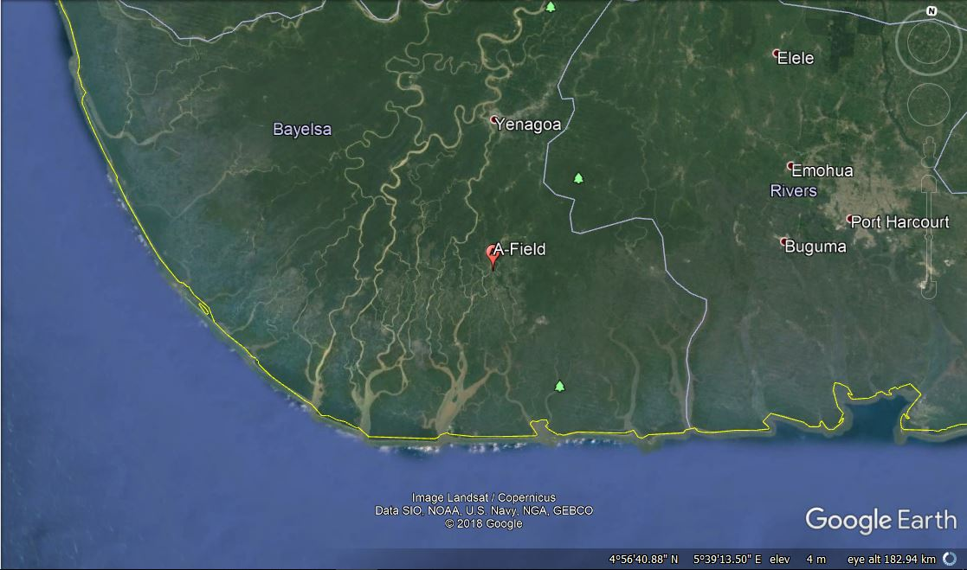

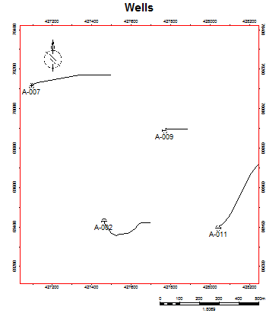

**Figure 1: A map showing the location of the A-Field, Central Swamp Depobelt, Onshore Niger Delta (Source: Google Earth 2018) and the Base map for A-Field showing the distribution of wells within the area.**

* 1. **SEISMIC ATTRIBUTES**

Marfurt (2005) defined seismic attribute as any measure of seismic data that helps in visualization or quantification of features of interpretation of interest. Chambers and Yarus (2002) considered seismic attribute as any seismically derived parameter computed from pre-stack or post-stack data before or after migration. For seismic attributes to have geological significance, they should have a physical basis for their correlation with properties measured at the wells. Sheriff (1980) identified amplitude, phase, frequency, polarity, and velocity as attributes useful as hydrocarbon indicators whereas acoustic impedance, reflectivity and transmissivity are useful for boundary conditions, hardness, and nature of surfaces. Anomalies due to variation in seismic attributes often appear in sections as *bright spots, flat spots*, and *velocity sags.* Sheriff (1980), Chambers and Yarus (2002), and Schlumberger (2009) highlighted the geological significance of seismic attributes as useful in defining lithological contrast, bedding continuity, bed spacing and thickness, depositional environment, geologic structures, gross porosity, fluid content, abnormal pressure, temperature, and polarity of seismic. While the structural attributes can help in picking horizons and faults, seismic attributes relating to log and rock properties help in defining a better petrophysical and facies model, thus reducing uncertainty.

Different authors introduced various kinds of attributes and their uses. The first attribute were single instantaneous attributes introduced Taner et al. (1979), Barnes (1996) extended these attributes to 2D and 3D. From 1995-1999, Amoco researchers introduced two new types of spatial attributes; Spectral decomposition, based on the Fourier transform and Coherency, based on trace-to-trace correlation. Roberts (2001) introduced curvature attributes and Marfurt et al. (2006) then showed the relationship between instantaneous attributes and dip and curvature.

**Classification of Seismic Attributes**

In classifying seismic attributes, Walls et al (2002) grouped them into their computational characteristics as:

***Physical Attributes-*** Those computed from complex traces, and which are related to wave propagation, lithology, and other parameters. These physical attributes can further be classified as pre-stack and post-stack attributes, with each having sub-classes as instantaneous and wavelet attributes. Instantaneous attributes are computed sample by sample and indicate continuous change of attributes along the time and space axis. The wavelet attributes, on the other hand, represent characteristics of wavelet and their amplitude spectrum.

***Geometric Attributes-*** Those computed from reflection configuration and continuity properties of the subsurface such as dip, azimuth, and discontinuity.

**Attributes Properties**

* **Seismic Signal Processing**

In the Seismic Signal Processing methods, a single seismic trace is operated at the line within the 2D or 3D seismic cube volume. The Signal processing runs through a collection of traces and each of the traces are operated on separately. They are classified as follows:

**Reflection Intensity:**

The Reflection Intensity of attributes are related to the energy in the seismic trace and are computed within a moving window. The formula for Reflection Intensity is:

$A_{RD }\left(t\right)=\sqrt{\frac{1}{N}}\sum_{t=-N/2}^{N/2}{\left|f(t+k)\right|}$ 2.1

It is useful for delineation of amplitude features while retaining the frequency appearance of the original seismic data. Reflection Intensity is also useful for AVO calculations

[Near-Far] / Near 2.2

**RMS Amplitude**

The root means square of the input data trace *f(t).* This attribute relates to the energy in the trace and can be computed within a moving window.

$A_{RMS}\left(t\right)=\sqrt{\frac{1}{N}}\sum_{t=-N/2}^{N/2}{{f\left(t+k\right)}^{2}}$ 2.3

**Time Gain**

The Time gain attribute can be used to compensate for the time dependent weakness in the seismic amplitudes. These may be a result of poor seismic data processing in correcting for spreading or attenuation losses, and because of poor acquisition conditions or equipment resulting in a weak amplitude s with depth. The Time Gain attribute may also be valuable in improving the balance of amplitudes as a function of time.

A simple gain correction can be applied using the equation:

**Time Gain** = *f(t)\** tα 2.4

If α is greater than 1.0, the amplitude will increase with time. If α is less than 1.0, the amplitudes will decrease with time.

**Trace AGC**

Trace AGC is an automatic gain control for the output trace by balancing the RMS (root mean square) level on a sliding window.

**Trace AGC** = *f(t)\** [1.5–ARMS(t)/Smax] 2.5

Where Smax is the maximum value in the entire survey. This attribute is useful for boosting weak events for improved interpretability. It will also have the effect of boosting noise, which could be eliminated using the structural smoothing attribute.

* **Complex Trace Attributes**

Complex trace attributes evolved from the work of Taner and Sheriff (1976). They demonstrated the benefit of thinking of the seismic trace as an analytic signal containing real and imaginary parts, of which only the real parts is detected.

**Sweetness**

Sweetness is a composite seismic attribute used to highlight thick, clean reservoirs, along with hydrocarbons contained within. Mathematically, sweetness is derived by dividing reflection strength (also known as “instantaneous amplitude” or “amplitude envelope”) by the square root of instantaneous frequency.

**Envelope**

Envelope, which is also known as reflection strength, instantaneous energy, and magnitude, is commonly define as the total energy of the seismic trace. In other words, it is the modulus of the seismic trace, which is the real part, and the imaginary part. Mathematically, given as:

$Envlope= {\left[\left(f^{2}\left(t\right)+ g^{2}(t)\right)\right]}^{1/2}$ 2.6

The real part *f(t)* is our original trace; the imaginary part *g(t),* is also the Quadrature Amplitude. The Envelope attribute is independent of phase, and it is always positive up to the maximum amplitude of the trace. The attribute is of importance detecting bright spots caused by gas accumulation, detecting major lithological changes that are caused by strong energy reflections and sequence boundaries. The attribute clearly shows subtle lithological changes that may not be apparent on the seismic data.

**Instantaneous Frequency**

Instantaneous Frequency ωc(t) is the rate of change of instantaneous phase. Mathematically expressed as:

$ω_{c}\left(t\right)=δ\left\{φ\left(t\right)\right\}/δt$ 2.7

The result of the computation of this attribute is instantaneous center frequency or mean frequency of the spectrum. Instantaneous frequency is independent of phase and amplitude and is useful in indicating reservoir rock properties such as hydrocarbon, fractures zones detection, and changes in thickness and lateral changes in lithology. Instantaneous frequency has an apparent higher resolution on the input data which is useful for mapping subtle changes.

**Instantaneous Phase**

The Instantaneous phase is the argument of the complex function, and it reveals weak and strong events with equal strength. Mathematically, the Instantaneous phase is given as:

$φ\left(t\right)=\tan^{-1}\left[\frac{g(t)}{f(t)}\right]$ 2.8

**Quadrature Amplitude**

The Quadrature attribute is used to compute other complex trace attributes in combination with the real trace.

The attribute strongly correlates to the coherency energy in the seismic.

The original Amplitude, *f(t)* is the real part of the complex seismic trace *x(t).* The Quadrature Amplitude, *g(t),* is the imaginary part of the complex seismic trace *x(t).*

*x(t) = f(t) + ig(t)* 2.9

* **Structural Attributes**

The structural attribute comprises a collection of attributes that isolate structural variation in the seismic reflection pattern. Ant Tracking, Dip Deviation, and Variance are primarily fault or edge detection methods, while Gradient Magnitude, Local Structural Azimuth and local Structural Dip are attributes to capture the local orientation of the formations.

**Ant Tracking**

Ant tracking performs edge enhancement for the identification of faults, fractures, and other linear anomalies within the seismic data volume (Pedersen et.al., 2002).

**Dip Deviation**

Dip deviation is one of the edge detection methods which discriminate rapid changes in the local orientation of the seismic horizon. The attribute is effective for softer rocks in passive margins, where the downthrown side of a fault typically shows significant dip into the fault.

**Gradient Magnitude**

The Gradient Magnitude attribute is length of the 3-component gradient. The gradient magnitude is computed using the algorithm for the 1st Derivative, but computed for the in-line direction, crossline direction, and vertical direction. The magnitude is the square-root of the sum of the squared for these derivatives.

$Gradient Magnitude= \sqrt{\left(f{(x)}^{2}+f{\left(y\right)}^{2}+f{\left(z\right)}^{2}\right)}$ 2.10

The Gradient Magnitude is amplitude sensitive thus can be used to discriminate regions from those with significant reflectivity and signal strength.

**Local Structural Dip**

The Local Structural Dip is the angle of inclination of the seismic event as measured from a horizontal plane (0 to 90 degrees for event and principal component, -90 to 90 for Gradient Dip).

**Structural Smoothing**

This attribute reduces noise without degradation to the fault expression contained in the original data.

The structural smoothing can also be used to illuminate flat spots within the seismic volume, by running smoothing operation without Dip guiding horizontal features such as fluid contacts can be emphasized.

The smoothing operator is Gaussian having expression:

$h_{G}\left(k\right)=\frac{1}{\sqrt{2πσ}}exp\left(-\frac{1}{2}\frac{k^{2}}{σ^{2}}\right)$ 2.11

Where the parameter σ determines the width of the smoothing filter and thus the degree of the smoothing (Iske and Randen, 2005)

**Variance**

The Variance attribute is a patented method (Van Bemmel et al., 2000) which can be used to isolate edges from the input data set. Variance is also a great stratigraphic attribute, it can really bring out depositional features including reefs, channels, splays etc. The normalized variance algorithm is computed as:

$σ_{I}^{2}=\frac{\sum_{j=I-j/2}^{j=I+j/2}{w_{j-2}\sum_{i=1}^{l}{{\left(x_{ij}-x_{j}\right)}^{2}}}}{\sum_{j=I-j/2}^{j=I+j/2}{w_{j-2}\sum_{i=1}^{l}{{\left(x_{ij}\right)}^{2}}}}$ 2.12

Where xij is the sample value at horizontal position, I, and vertical sample, j, wj-t is the vertical smoothing term over a window of length, L.

* **Stratigraphic Attributes**

Stratigraphic attribute attempts to isolate seismic textures visible in the data. These include structural orientation measurements (chaos and flatness), frequency decompositions (Iso-frequency) et cetera.

**Chaos**

The Chaos attribute maps the “chaoticness” of the local seismic signal within a 3D window (Iske and Randen, 2005). This chaotic-ness means how consistent is the orientation estimates based on the principal component method. An area with low consistency corresponds to regions of chaotic signal patterns and can be related to local geologic features, e.g. Faults/discontinuities, reef textures, channel infill et cetera.

**Iso-Frequency**

Iso-Frequency component is a patented seismic decomposition method and generates an attribute volume at user defined frequencies (Pepper and Bemmel, 2011).

With the cosine correlation transform (CCT) method, the resulting frequency value is a measure of the contribution for each user-defined frequency within window based on a cross-correlation between a cosine wave of that frequency and the autocorrelation of the windowed input seismic data. Thus, the CCT output value is a correlation coefficient measuring the similarity of the auto-correlated seismic data to a known cosine wave signature of a specific frequency. The correlation value range is -1.0 to 1.0, where 1.0 would mean an identical signal, 0.0 means uncorrelated, and a negative value means a polarity difference. The cross-correlation algorithm is defined as:

$∅_{GH}\left(τ\right)=\frac{\sum_{i=-N}^{N}{G\left(k\right)H(k+τ)}}{{\left|\sum_{k=-N}^{N}{G^{2}\left(k\right)\sum_{k=-N}^{N}{H^{2}}}(k)\right|}^{1/2}}$ 2.13

Where G(k) and H(k) are the signal being cross-correlated, either the windowed seismic trace with itself to generate the autocorrelation, to the cosine function and the windowed seismic auto-correction.

**Local Flatness**

The Local Flatness attribute maps to the flatness of the local seismic signal within a 3D window (Iske and Randen, 2005). Flatness does not refer to horizontal, non-dipping events; rather flatness is the degree to which the local orientation is planar. The local orientation is measured using the principal component method described in local structural azimuth attribute.

The Local Flatness can be computed on an amplitude invariant input volume by using the cosine of phase attribute volume as an initial step.

1. **METHODOLOGY**

**3.1 Materials**

Two types of data set were used for the work, well log and seismic data. The use of these sets of data is for proper well-log analysis and seismic attributes interpretation. The SEG-Y format of the seismic data consists of inlines 5577-5850 and crosslines 1495-1750, with line spacing of 25 meters. For this study four wells were identified A-002, A-007, A-009 and A-011 containing suites of log data which include Gamma ray logs, Caliper logs, Resistivity logs (Shallow and Deep), Density logs, Neutron logs, Sonic logs and Check shot for one well (table 1)

|  |  |  |  |  |  |  |  |  |
| --- | --- | --- | --- | --- | --- | --- | --- | --- |
| **Wells** | **Well logs** | | | | | | **Check**  **shot** | **Directional**  **Survey** |
| GR | Cali | Res | Den | Neu | Sonic |
| A-002 | + | + | + | + | + | + | - | + |
| A-007 | + | + | + | + | + | + | - | + |
| A-009 | + | + | + | + | + | + | - | + |
| A-011 | + | + | + | + | + | + | + | + |

**Table 1: Well Log Data Base containing well information.**

**3.2 Methods**

The Data set were quality checked properly, sorted into formats compatible with Schlumberger PETRELTM 2014 while Hampson Russell was used to derive the cross plot for lithology and fluid discrimation from well data. The Petrel software was used for both well logs (well correlation) and seismic attributes extraction. The seismic 3D cube data was investigated for potential structural and stratigraphic controls within the study area, with surface attributes. Generated for attribute maps to gain full understanding of the target features in terms of porosity, permeability and direct hydrocarbon indicators (DHI) for hydrocarbon exploration in the study area.The flow chat for the methos used is given in Fig 2.

Data Loading and QC

Checkshot

Well Logs

Seismic Data

Fault Mapping

Seismic Well Tie

Horizon Mapping

Time Surface

Reservoir Correlation

Velocity Models and Depth Conversion

Seismic Attribute Generation

Prospect Evaluation

**Figure 2: Workflow diagram used for the analysis of A-Field**

1. **RESULTS AND OBSERVATION**

The results of this study are presented in the following order: well log evaluation of the selected wells, well correlation and seismic attribute analysis.

* 1. **Well Log Evaluation**

Based on the gamma ray logs, two lithologies were identified, namely sand and shale. From the gamma ray log, the interval coloured yellow is sand, while the Gray yellow coloured is for shale (Fig 3). The gamma log signatures indicate areas with sand and shale. The resistivity log signatures indicate a higher value at a point where the gamma ray logs reading is low (where there is sand) and the high resistivity indicates brine sand. The Facies log signatures conform to the gamma ray log readings indicating areas of shale, sand, silt, and fine silt for different intervals.

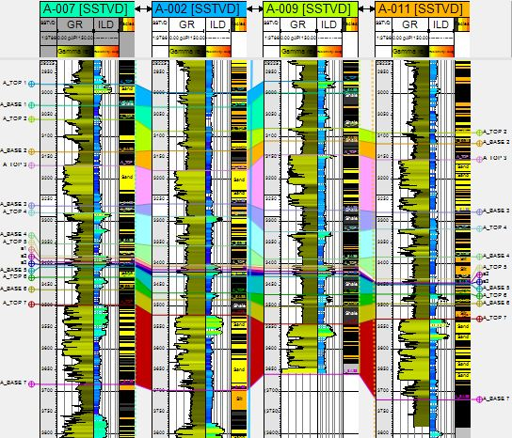

**Figure 3: Correlated Well Logs**

**4.2 Seismic Attribute Analysis**

The results of the extracted volume attributes such as Reflection Intensity, RMS Amplitude, Time gain, Trace AGC, Sweetness, Envelope, Instantaneous Frequency, Instantaneous Phase, Quadrature Amplitude, Ant Tracking, Dip deviation, Gradient Magnitude, Local Structural Dip, Chaos Iso Frequency, and Local Flatness in the 3D seismic data from the study area alongside with the mapped faults, horizons, synthetic seismogram generated to utilize seismic-to-well ties on well A-011, time surface and depth surface for reservoir A-5, velocity model used for depth conversion and cross plots for lithology and fluid discrimination using Vp/Vs against AI, Lambda-rho against Vp/Vs, Mui-rho against Density and Lambda-rho against Mui-rho for well 11 are shown in Fig 4 – Fig 13.

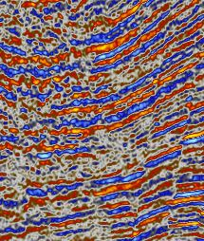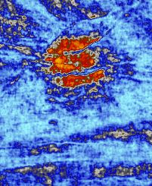

Anomalous High

Amplitude

**Figure 4: Time Slice of Reflection Intensity (Right) extracted from Original Seismic**

1. 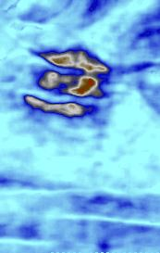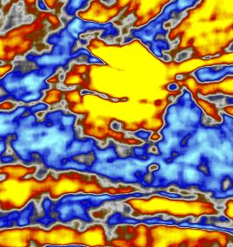 (b)

Anomalous High

Amplitude

**Figure 5: (a) RMS Amplitude and (b) Sweetness on Time Slice 2468ms**

1. 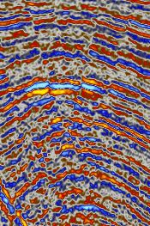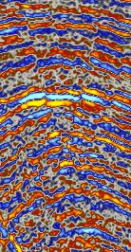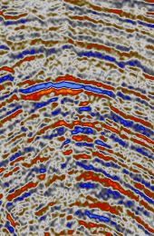 (b) (c)

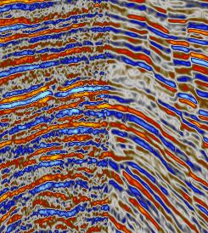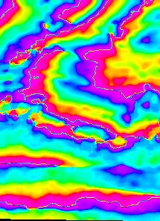

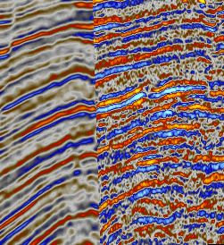(d) (e) (f)

**Figure 6: Volume attribute extracted from original Seismic (a) Trace AGC at 1000 (b) Time Gain at 0.2 (c) Time Gain at 0.5 (d) Structural Smoothing (e) Quadrature amplitude (f) Instantaneous Phase.**

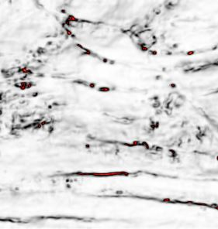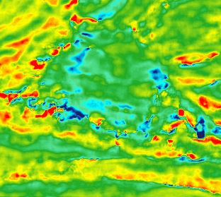**(a) (b)**

Probable Channel

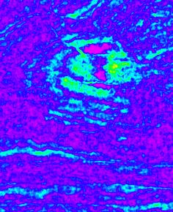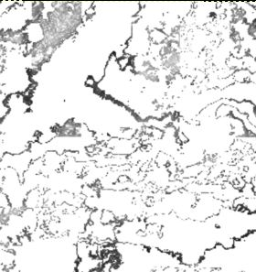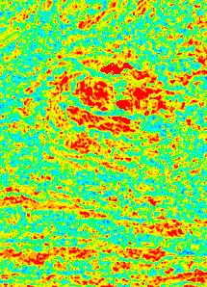**(c) (d) (e)**

**Figure 7: Volume attribute extracted from original Seismic at time slice 2468ms (a) Instantaneous Frequency (b) Variance (c) Dip Deviation (d) Local Structural Dip (e) Gradient Magnitude.**

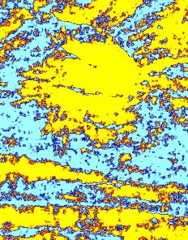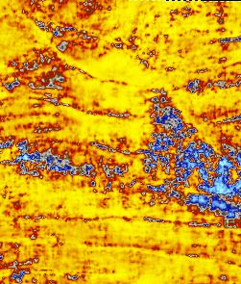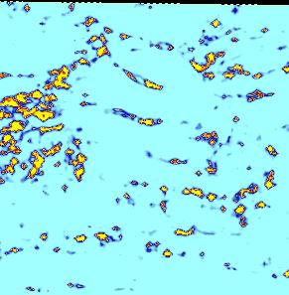**(a) (b) (c)**

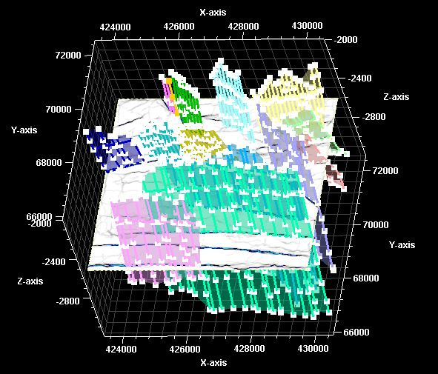**Figure 8: Volume attribute extracted from original Seismic at time slice 2468ms (a) Local Flatness (b) Iso-Frequency (c) Envelope**

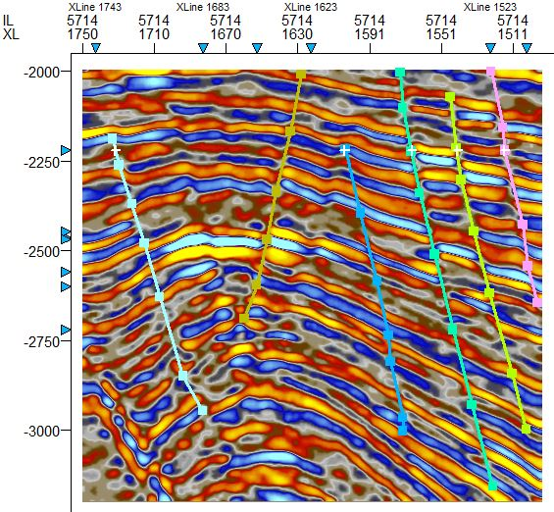

**Figure 9: Structural interpretation of faults mapped on ant tracking (left) and median Filter (right) on seismic data.**

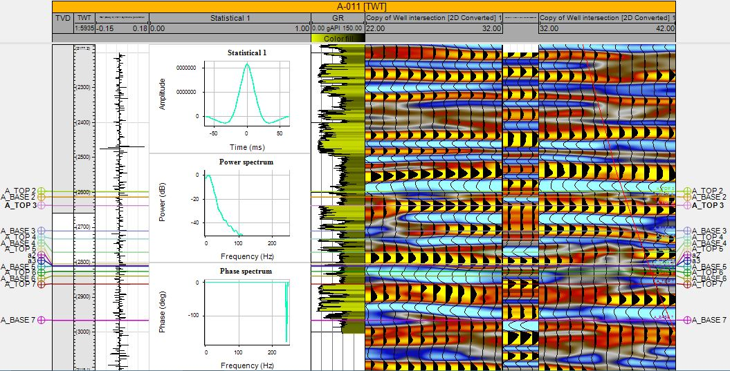

**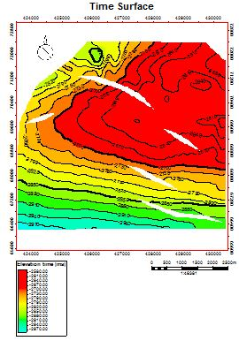****Figure 10: Synthetic Seismogram generated and utilized for seismic well tie in well A-011**

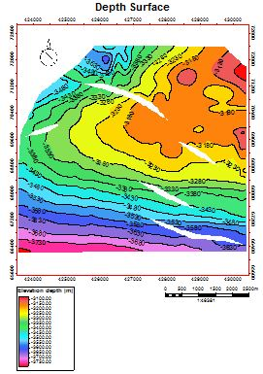

F1

F1

F5

F5

F2

F2

Prospect Area

F3

F3

Prospect Area

F4

F4

**Figure 11: Time and Depth surfaces generated from mapped horizons**

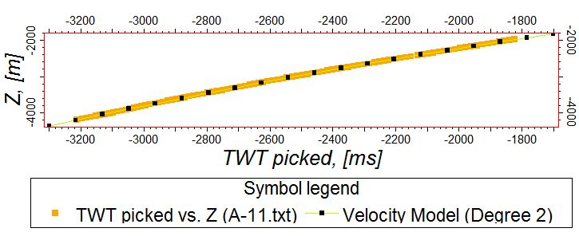

**Figure 12: Velocity Model utilized for depth conversion for well A-011**

(a) (b)

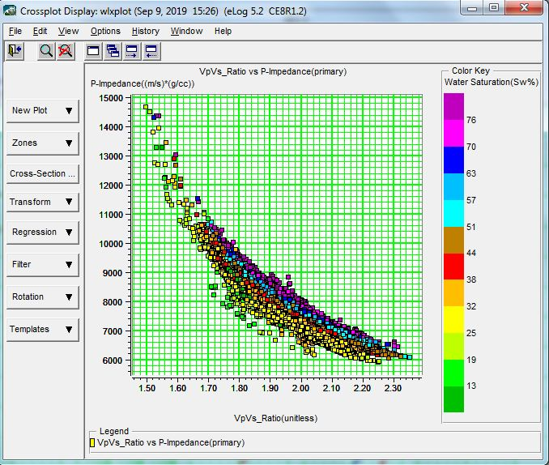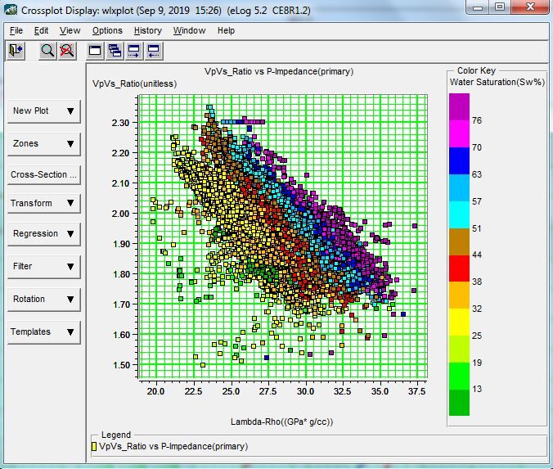

(c) (d)

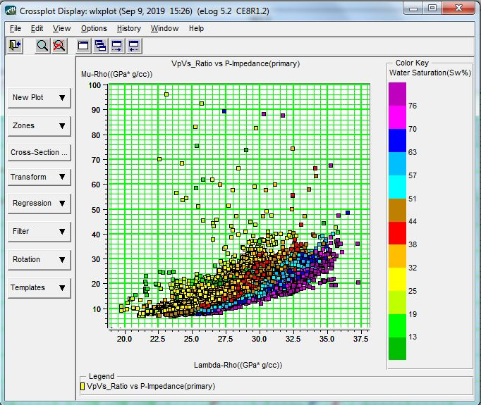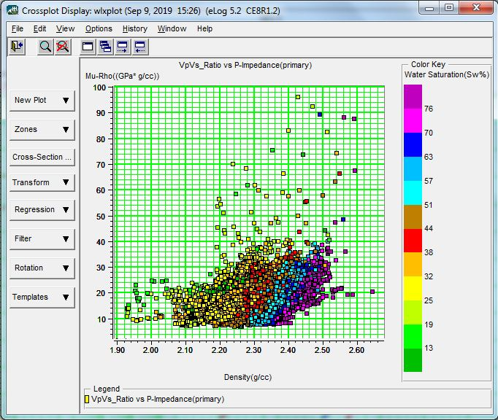

**Figure 13: Cross Plots of Lithology and Fluid discrimination for Well A-011; (a) Vp/Vs against Lambda-Rho (b) Acoustic Impedance against Vp/Vs (c) Mui-Rho against Density (d) Mui-Rho against Lambda-Rho**

1. **DISCUSSION**

The result shows moderate to high sweetness region (sweet spots) within the zone of interest, Envelope attribute results show acoustic impedance contrasts indicating discontinuities, lithology changes, possible presence of hydrocarbon (bright spots), Variance, Dip deviation, Gradient magnitude and Ant tracking attributes enhanced the signals to map out discontinuities caused by faults and fractures signature which enabled the delineation of the zone of interest. The predominant structural features within the area concave upward faults with downdip planes. Two major faults, and three minor faults cutting through the reservoir sand units were identified and mapped with the help of interpreted structures on seismic attributes. The probable hydrocarbon prospects in the field consist of the anticlinal structure and roll over structure assisted by faults. Fault closure against down to south crescentic growth fault derived from a roll over anticline, is seeing localized southeastern section of the mapped horizon. The minor faults (F3, F4 and F5) cutting through the horizon surfaces are predominantly synthetic and antithetic faults.

Cross plotting of some selected rock properties and rock attributes were conducted and the following results were obtained. First, Vp/Vs ratio against Acoustic impedance distinguishes the A-011 reservoir into hydrocarbon zone, brine zone and shale zone. Second, lambda rho (incompressibility) against Vp/Vs discriminates the reservoir of interest in sand and shale/sand/shale sequences. Next was the Mu rho against density. It was observed that both mu rho and density are lithology discriminators, with density also being a fluid discriminator. Mu rho values are high for sand and low for shale. Conversely, the density of shale is higher than that of sand. Finally, cross plots of lambda-rho (λρ) against mu-rho (μρ) shows separation into four zones that can be inferred to be probable shale, brine and gas zone confirmed by lowest density values. The cross plot of Vp/Vs ratio against Acoustic impedance (Zp) (Figure 13b), distinguishes the A-011 reservoir into three zones namely, hydrocarbon zone (red ellipse), brine zone (yellow ellipse) and shale zone (blue ellipse). This cross plot shows better fluid as well as lithology discrimination along the acoustic impedance axis, indicating that acoustic impedance attribute will better describe the A-011 reservoir conditions in terms of lithology and fluid content than Vp/Vs ratio. Figure 13(a) shows the variation of lambda-Rho (incompressibility) against Vp/Vs for sands and shale/sand/shale sequences. The plots are better aligned towards the lambda rho axis, thus making lambda rho a better lithology discrimination tool. The black ellipse describes shale zone, the yellow describes brine sand, the red ellipse describes hydrocarbon sand, and the blue describes gas zone.In the cross plot of Mui-rho against density (Figure 13c), both mui-rho and density are lithology discriminators, with density also being a fluid discriminator. Mui-rho values are high for sand and low for shale. Conversely, the density of shale is higher than that of sand. Furthermore, brine is denser than hydrocarbon (oil and gas). Thus, the blue ellipse in figure 13c indicates hydrocarbon bearing sand, the yellow ellipse shows the brine saturated region, while the black section describes the shale region. Cross plots of lambda-rho (λρ) against mui-rho (μρ) in figure 13d, shows separation into four zones that can be inferred to be probable shale (black eclipse), brine (yellow eclipse), oil (red eclipse) and gas zone (blue eclipse) confirmed by lowest density values. The plot indicates that λρ is more robust than μρ in the analysis of fluids in the field of study, and that μρ values are relatively low for the reservoir sand. The Acoustic impedance (Zp), Lambda-rho (λρ), Mu-rho (μρ), and Poisson impedance (PI) attributes were found to be most robust in lithology and fluid discrimination within the reservoir in the cross-plot analysis. The λ-μ-ρ technique was able to identify gas sands, because of the separation in responses of both the λρ and μρ sections to gas sands versus shale. Many different lithologies could also be identified by the cross plot of λρ versus μρ. This is possible because each lithology has a different rock properties response subject to fluid content and mineral properties.

1. **CONCLUSION**

Seismic attributes can help the interpreter to extract more information from conventional seismic data, which can support the structural and stratigraphic interpretation. The main types of fluvial system elements are major channels are well displayed with envelope, rms amplitude, sweetness, and chaos attribute. Structures such as faults and fractures are displayed well with structural dip and variance attribute. Seismic attributes within the framework of this research have been used to provide valuable information about the mapped reservoirs and identified structural traps towards better delineation of hydrocarbon prospects and improved reservoir characterization. The study has further demonstrated that seismic attributes are complementary to the information derived through traditional methods of seismic interpretation. Extraction of seismic attributes from seismic data can provide added information and insights into strati-graphic and structural interpretations. The outputs from seismic attributes extraction and analysis will help in reducing exploration and development risk. Therefore, for successful exploration and production of hydrocarbons, it is imperative to characterize the hydrocarbon reservoir accurately in terms of its fluid properties and lithology using attributes extracted from seismic.

**COMPETING INTERESTS DISCLAIMER:**

Authors have declared that they have no known competing financial interests OR non-financial interests OR personal relationships that could have appeared to influence the work reported in this paper.

**REFERENCES**

Adel, A. A. (2013). Seismic Attributes Techniques to delinate channel complex inpliocene age, North Abu Qir, Nile Delta; . *Eygpt Journal of applied science Research 10 (2)*, 4255-4270.

Aizebeokhai, K. D. (December, 2015). SEISMIC ATTRIBUTES ANALYSIS FOR RESERVOIR CHARACTERIZATION; OFFSHORE NIGER DELTA. *Petroleum & Coal 57(6)*, 619-628.

Ajisafe, Y. A. (2013). 3-D Seismic Attributes for Reservoir Characterization of “Y” Field Niger Delta, Nigeria. *Journal of applied Geology and Geophysics (IOSR-JAGG)*, PP 23-31.

Andrew, B. (2013). 3D seismic attributes analysis in Reservoir Characterization. *Journal of Geology, 2 (3),*, 112-117.

BELLO, R., IGWENAGU, C. L., & ONIFADE, Y. (2005). Cross plotting of Rock Properties for Fluid and Lithology Discrimination using Well. *Journal of Applied Science, Environnment and Manage*, 539-546.

Chambers, R. L. (2002). Quantitative Use of Seismic Attributes for Reservoir Characterization. . *CSEG Recorder,*, pp. 14 - 25, June Issue.

Chopra, S. a. (2005). Seismic Attribute for prospect identification and reservoir characterization. *SEG Geophysical Development Series No. 11*, 464 p.

Chopra, S. a. (2005). Seismic Attributes; A Histoical Perspective. *Geophysics 70 (5)*, 3-28.

Daukoru, C. M. (1994). Northern delta Depobelt portion of the Akata-Agbada Petroleum system, Niger Delta, Nigeria, Petroleum Association System, AAPG memoir 60. *American Association of Petroleum Geologists, Tulsa (AAPG),*, 598-616.

Ekweozor C. M, and. D. (1984). Petroleum source-bed evaluation of Tertiary Niger Delta; discussion and reply,. *AAPG Bulletin, Vol. 68,*, p. 387-394.

Evamy BD, H. J. (1978). Hydrocarbon habitat of Tertiary Niger Delta. *APG Bulletin*, Vol 62, p. 1-39.

Hampson, D. R. (199,). Multiattribute seismic analysis:. *The Leading Edge, 16*, 1439-1443.

Hart, B. S. (2008). Channel detection in 3-D seismic data using sweetness. . *AAPG Bulletin, 92(6),*, 733-742.

K. C. Chiadikobi et al. (2012). Seismic Attributes of BETTA Field, Onshore Niger Delta, Southern Nigeria. *International Journal of Science and Emerging Technologies*, 71-81.

Koson et al. (2014). Seismic attributes and seismic geomorphology. *Bulletin of Earth Sciences of Thailand Vol. 6,*, No. 1, 1-9.

Raef, A. E. (2015). Application of 3D Seismic Attributes in hydrocarbon prospect identification and evaluation, . *Marine and Petroleum Geology, 73 (14)*, 21-35.

Ralph Daber et al. (2009). *Interpreter's Guide to Seismic Attributes.* Schlumberger.

Sanhasuk Koson, P. C. (2014). Seismic Attributes and Their Applications in Seismic Geomorphology . *Bulletin of Earth Sciences of Thailand ol. 6*, No. 1,1-9.

Stewart, D. G. (1996). 3D Seismic Attribute. *CREWES Research Report-Volume 8*, 45-1 - 45-30.