APPLICATION OF WATER ALTERNATING GAS INJECTION (WAG) FOR OIL RECOVERY IN THE NIGER DELTA

.

ABSTRACT

|  |
| --- |
| It is widely known that after using the primary and secondary recovery methods, a sizable volume of oil called residual oil saturation (Sor) is often left in the reservoir. Consequently, several efforts are made by oil companies to device better means of extracting these reserves. One of the options of optimally reducing the residual oil saturation is the water-alternating gas injection due to its capacity to increase both oil displacement and sweep efficiency by combining the effects of waterflooding and gas injection techniques. This study seeks to investigate the effectiveness of Water-Alternating-Gas injection in comparison with Waterflooding or Gas injection methods for optimal oil recovery in the Niger Delta. The Eclipse Simulator was used to simulate the Field oil efficiency (FOE), Field oil production total (FOPT) and the field water cut (FWCT) for WAG injection and compared with that of Waterflooding and Gas injection. From the results, WAG injection had an FOE (recovery factor of 34%), FOPT of 76.46 MMSTB and a FWCT of 26% while waterflooding alone has an FOE of 26.65%, FOPT of 57.62MMSTB and a FWCT of 47.58% respectively. The FOE , FOPT and FWCT of gas injected were estimated to be 21.35%, 47.89MMSTB, and 9.2% respectively. From the results, it could be inferred that WAG injection technique proved to be the most effective recovery technique in maximizing oil recovery, based on its recovery performance, having the highest recovery factor and a minimal water cut, compared to waterflooding and gas injection as standalone technique. |

*Keywords: Enhanced oil recovery, Water-Alternating-Gas Injection (WAG), waterflooding, gas injection, residual oil saturation, recovery efficiency*

1. INTRODUCTION

Within the Niger Delta province are three main lithostratigraphic units that make up the thick sedimentary succession namely; Benin formation, Agbada formation and Akata formation, with majority of the hydrocarbon found in the Agbada formation’s sandstone reservoir (Oluwajana, et al 2017, Etimita and Beka, 2018). As global energy demand continues to increase, optimizing oil production becomes crucial. Crude oil production can be achieved through different levels of recovery: primary, secondary and tertiary recovery respectively.

Primary recovery basically uses the natural energy of the reservoir to produce the trapped hydrocarbon from the subsurface (Hussein, 2023). However, due to insufficiency of this natural drive in most reservoirs, the drive is aided by supplemental energy sources to sustain production through the use of artificial lift methods like gas-lifting and pumps (Speight and El-Gendy, 2018). However, to prevent drastic drop in production and particularly, to sustain production during the plateau phase for a relatively longer time, pressure maintenance is carried out which involves primarily gas or water injection (Farahbod, 2024). The injection of water or gas for pressure maintenance is what is termed secondary recovery. It is a technique that supplements the natural reservoir energy by injection of fluids (water or gas) through injection wells using different patterns, primarily for pressure maintenance. When the volumetric rate of production is equal to the volumetric rate of fluid replacement in the reservoir, pressure maintenance is achieved in oil production, keeping the average reservoir pressure constant (Archer and Wall, 1986).

The requirement for tertiary oil recovery techniques arises from the fact that the mobility of crude oil has decreased in such a way that both standard artificial lift techniques and pressure maintenance methods have failed to achieve reasonable recovery and thus, so much crude oil is left underground and the reservoir energy is fast depleted. Tertiary recovery, also known as enhanced oil recovery (EOR), entails injecting fluids into the reservoir while applying methods for improvement other than only providing external energy to sweep and enhance crude oil recovery (Lake et al, 2014).

A typical tertiary oil recovery technology known as the Water-Alternating Gas (WAG) Injection process is used to increase the displacement efficiency through mobility control and prevention of viscous fingering of the leftover oil that cannot be recovered during the primary and secondary recovery procedures (Afzali et al, 2018). Gas fingering during gas injection could lead to unfavourable mobility ratio that reduces the sweep efficiency (Afzali et al, 2018,Holm, 1972, Moffitt and Zorn, 1992, Watts et al 1982). Gas fingering and gas breakthrough could be exacerbated by reservoir heterogeneities, resulting from fractures and high permeable layers Birarda et al 1990, Cuesta and Merritt, 1982). WAG is an enhanced oil recovery (EOR) technique that increases oil recovery effectiveness by combining gas injection with water flooding (Kumar and Mandal, 2017). The method was developed to improve the oil displacement of gas injection and the sweep efficiency in waterflooding procedures (Abdullah and Hasan, 2021). To improve recovery and control gas mobility, WAG optimization is one of the best schems to deploy(Chen et al 2010).

Different types of WAG techniques have been studies over the years to improve the reduction of the residual oil saturation. Typical example is the study by Kulkarni and Rao (2004), where they carried out an experimental investigation through core flooding to compare gas injection and WAG and observed that WAG is superior to gas injection in reducing the residual oil saturation. In this study, the Water-Alternating-Gas Injection (WAG) recovery method is used to determine the recovery performance of a selected oil field in the Niger Delta in comparison to waterflooding and gas injection recovery methods.

2. methodology

ECLIPSE Compositional Simulator” was used to model and simulate the hydrocarbon flow of WAG injection technique in comparison with water flooding and gas injection for an oil field in the Niger Delta. Eclipse is a compositional software used for modelling and simulating multicomponent hydrocarbon flow in reservoirs.

The field of study is an oil field located in the Niger Delta. The predicted dominant drive mechanism of the oil field is the depletion drive and the reservoir pressure was found to be initially above the bubble point pressure. Depletion drive reservoirs have low ultimate recovery and are known to experience rapid decline in reservoir pressure and increase in the gas-oil ratio, the justification for the application of water-alternating gas injection (Ahmed and Meehan, 2012). Table 1 shows the input data used for the simulation. Simulating the reservoir was first carried out under natural depletion, after which optimization was carried done using waterflooding, gas injection and finally, water alternating gas injections.

3. results and discussion

There are a total of 10 wells; 6 producer wells (N2, N3, A4, E2, E3 & E4) and 4 injector wells (INJ1, INJ2, INJ3 & INJ4). To compare optimization performance, the field oil production total (FOE), the field oil production rate (FOPR), field oil production total (FOPT) and the field wate-rcut was determined for all three recovery methods. Figure 1 shows the 3D simulation models for the different recovery methods with the producers and injectors. Figures 1a is the 3D model for the natural depletion, 1b is the 3D model for waterflooding, 1c is the 3D model for gas injection and 1d is for the water-alternating gas injection model respectively.

**Table 1: Summary of Input data used for the simulation**

|  |  |  |
| --- | --- | --- |
| **S/N** | **Field Data** | |
| 1 | Original Oil in Place (OOIP) (STB) | 35,665,294 |
| 2 | API | 39 |
| 3 | Recovery Factor (%) | 14.305 |
| 4 | Oil Formation Volume Factor (Bo) | 1.6629 |
| 5 | FVF Initial Reservoir Pressure (Rbbl/stb) | 1.6024 |
| 6 | Oil Viscosity (cp) | 0.3942 |
| 7 | Water Viscosity (cp) | 0.27 |
| 8 | Rock Compressibility (1/Psi) | 5.00 * 10-5 |
| 9 | Water Compressibility (1/Psi) | 5.00 * 10-5 |
| 10 | Oil Saturation (%) | 0.85 |
| 11 | Initial Water Saturation (%) | 0.39 |
| 12 | Saturation Pressure (Psi) | 300 |
| 13 | Oil Density (Ib/ft3) | 829.7675 |
| 14 | Gas Density (Ib/ft3) | 1.0449 |
| 15 | Water Density (Ib/ft3) | 1020 |

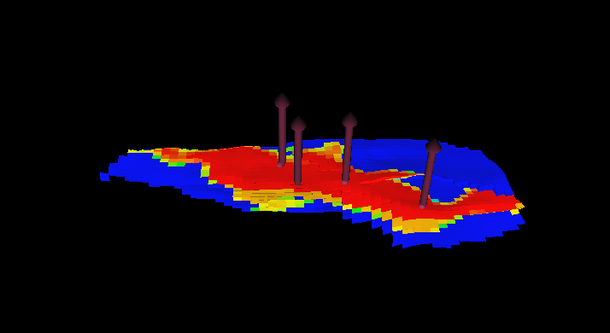 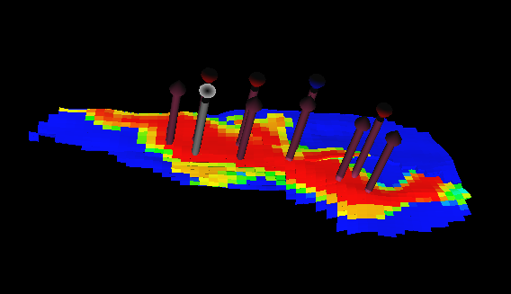

1. (b)

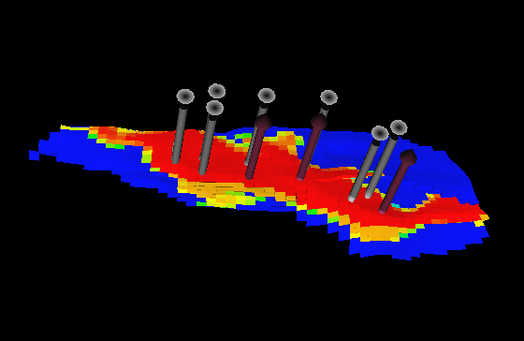 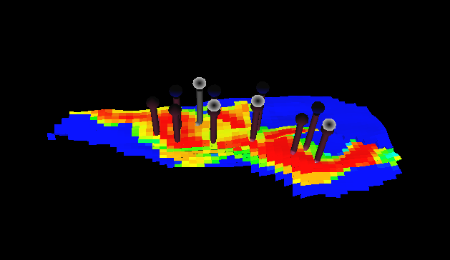

(c) (d)

Figure 1: 3D Model of different scenarious investigated. 1(a) is the is the 3D model for the natural depletion, 1(b) 3D model for waterflooding, 1(c) 3D model for gas injection and 1(d) is for the water-alternating gas injection model respectively.

Production from each of the scenario were plotted and the field oil efficiency, field oil production total and field water-cut were monitored over time for each case. Figure 2 is the result of field oil efficiency (FOE) over time. As can be seen, WAG FOE is the highest followed by waterflooding and then gas injection. The field oil production rate (FOPR) exhibited similar trend with WAG having a longer plateau followed by waterflooding and then gas injection as shown in Figure 3. Figure 4 shows the total filed oil production (FOPT) with WAG having a total of 76.46MM stb compared to waterflooding that has 59.62MM stb and the least from gas injection with 47.89MM stb after 4.5 years of production. As expected, the field water cut is highest with waterflooding, followed by WAG and the least water cut was observed in gas injection as shown in Figure 5. These results are similar to results from a study by Inaloo et al (2014). A summary of the performance of each method is shown in Table 2.

.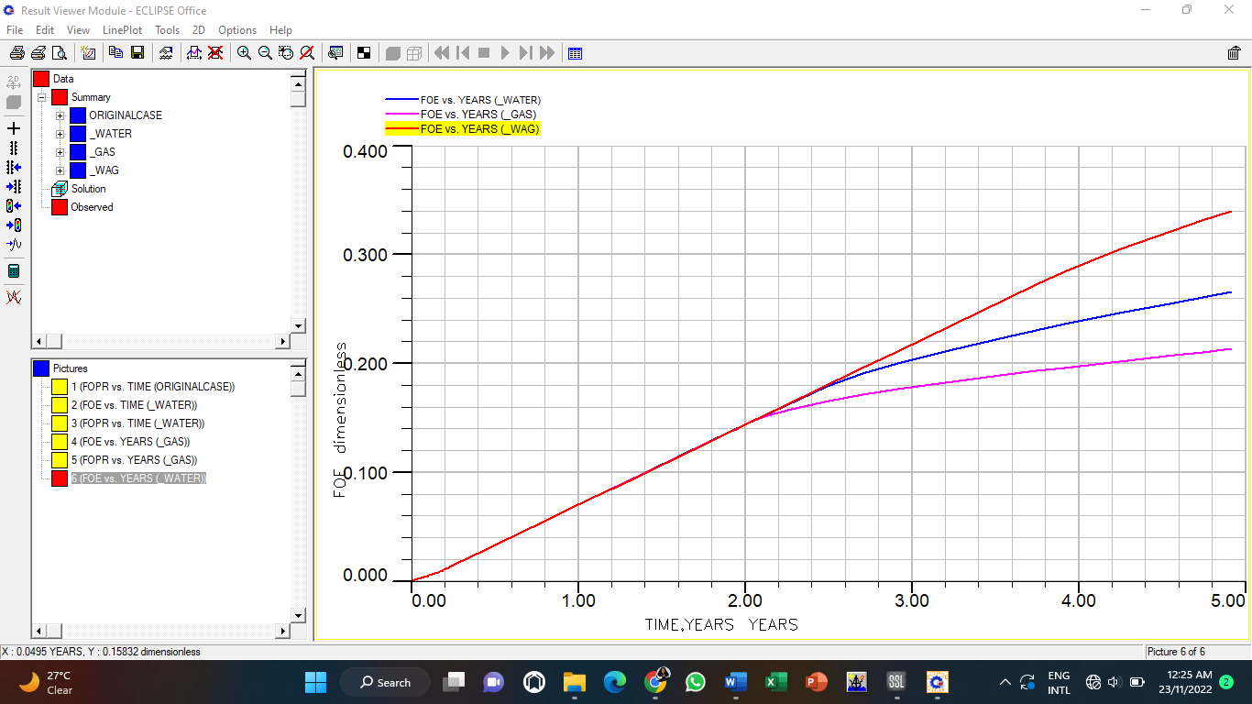

Fig.2: Plot of FOE vs TIME (yrs) – Waterflooding, Gas and WAG Injection

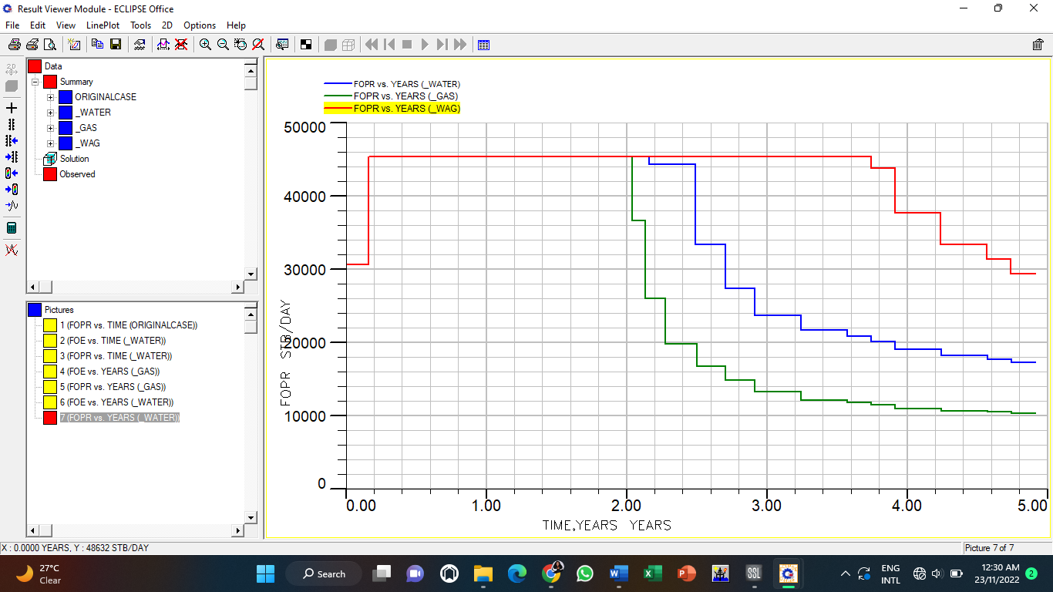

Fig.3: Plot of FOPR vs TIME (yrs) – Waterflooding, Gas and WAG Injection

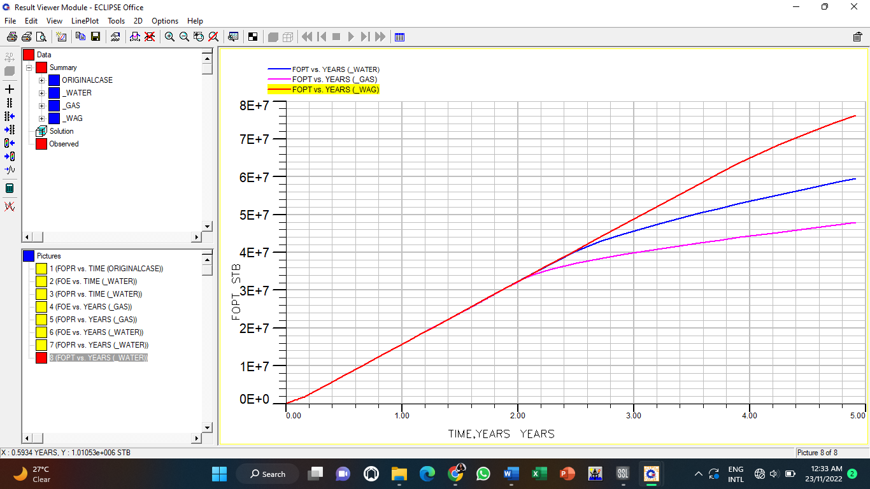

Fig.4: Plot of FOPT vs TIME (yrs) – Waterflooding, Gas and WAG Injection

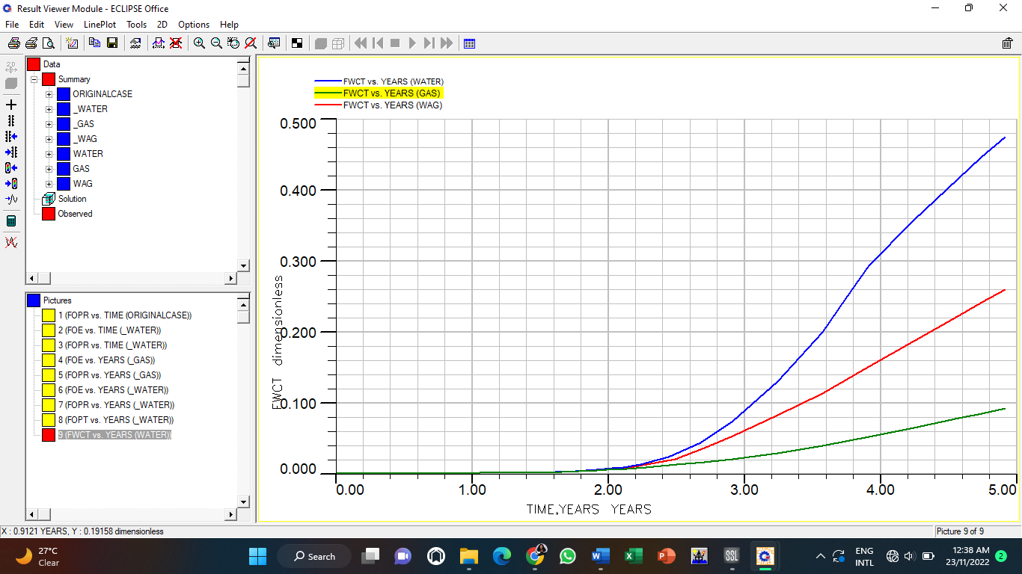

Fig.5: Plot of FWCT vs TIME (yrs) – Waterflooding, Gas and WAG Injections

**Table.2: FOE Results for Waterflooding, Gas and WAG Injection**

|  |  |  |  |
| --- | --- | --- | --- |
| Parameter | Waterflooding | Gas Injection | WAG |
| FOE (Recovery Factor, %) | 0.2665 | 0.2135 | 0.34 |
| FOPR (Plateau) (yrs) | 2.2 | 2.0 | 3.7 |
| FOPT (MMSTB) | 59.62 | 47.89 | 76.46 |
| FWCT (%) | 0.4758 | 0.092 | 0.2611 |

4. Conclusion

The following key conclusions were drawn from this investigation:

1. WAG injection had a maximum field oil efficiency (FOE) of 34%, a field oil production total (FOPT) of 76.46 MMSTB, a plateau time of 3.7years and a field water cut (FWCT) of 26.11%.
2. Waterflooding had a FOE of 26.65%, a FOPT of 59.62 MMSTB, a plateau time of 2.2years and FWCT of 47.58%. Whereas gas injection had an FOE of 21.35%, a FOPT of 47.89 MMSTB, a plateau time of 2 years, and FWCT of 9.2%.
3. From comparative analysis of the three recovery methods, WAG injection outperformed both waterflooding and gas injection with the highest FOE and minimal water cut after 4.5 years of production. Therefore, in comparison to waterflooding and gas injection methods, WAG technique has thus far demonstrated to be the most effective recovery method for optimal oil recovery for the selected oil field in the Niger Delta.

Consent (where ever applicable)

No consent whatsoever is needed to publish this article

Ethical approval (where ever applicable)

he content of this work does not require any ethical approval from any body

References

References must be listed at the end of the manuscript and numbered in the order that they appear in the text. Every reference referred in the text must also present in the reference list and vice versa. In the text, citations should be indicated as **(Author name, year).**

Oluwajana, O. A., Ehinola, O. A., Okeugo, C. G. Adegoke, O. (2017). Modeling hydrocarbon generation potentials of Eocene source rocks in the Agbada Formation, Northern Delta Depobelt, Niger Delta Basin, Nigeria. Journal of Petroleum Exploration and Production Technology, 7(2):379-388. <https://doi.org/10.1007/s13202-016-0286-y>

Etimita, O. O., and Beka, F. T. (2019). Structural to stratigraphic framework of “Banghan” field, onshore Niger Delta, southern Nigeria. Geology, Ecology, and Landscapes, 4(3), 216–221. <https://doi.org/10.1080/24749508.2019.1616154>

Hussein, A. (2023). Chapter 1 - Oil and Gas Production Operations and Production Fluids, Essentials of Flow Assurance Solids in Oil and Gas Operations, Gulf Professional Publishing,1-52, https://doi.org/10.1016/B978-0-323-99118-6.00012-5.

Speight, J.G. and El-Gendy, N. S. (2018): Chapter 4 - Microbial Enhanced Oil Recovery, Introduction to Petroleum Biotechnology, Gulf Professional Publishing, p. 103-130, <https://doi.org/10.1016/B978-0-12-805151-1.00004-7.>

Farahbod F. (2024). Simulation study of water and gas injection process into the Azadegan reservoir for enhanced oil recovery. Engineering Reports. 6(2):e12709. doi: [10.1002/eng2.12709](https://doi.org/10.1002/eng2.12709)

Archer, J.S. and Wall, C.G. (1986) Petroleum Engineering Principles and Practice. Graham and Trotman.

Lake, L., Johns, R. T. Rossen, W.R. and Pope, G. A. (2014). Defining Enhanced Oil Recovery", Fundamentals of Enhanced Oil Recovery, Society of Petroleum Engineers DOI: <https://doi.org/10.2118/9781613993286>

Birarda, G. S., Dilger, C.,& McIntosh I. (1990). Re-evaluation of the miscible WAG flood in the Caroline Field, Alberta. SPE Reservoir Eng 5(04):453–8.

Cuesta J, Merritt G.(1982). Caroline wag project, injectivity and interference test-a field example. J Canad Petrol Technol. Canadian Inst Mining Metallurgy Petroleum 101 6th Ave Sw, Ste 320, Calgary Ab Tzp 3p4, Canada; 1982:33

Kumar, S. and Mandal, A. (2017). A comprehensive review on chemically enhanced water alternating gas/CO2 (CEWAG) injection for enhanced oil recovery, Journal of Petroleum Science and Engineering, 157: 696-715. <https://doi.org/10.1016/j.petrol.2017.07.066.>

Afzali, S., Rezaei, N and Zendehboudi, S. (2018). A comprehensive review on Enhanced Oil Recovery by Water Alternating Gas (WAG) injection, Fuel, 227: 218-246, <https://doi.org/10.1016/j.fuel.2018.04.015.>

Holm L.(1972). Propane-gas-water miscible floods in watered-out areas of the adena field, Colorado. J Petrol Technol 24(10). 1264–170.

Moffitt P., & Zornes D. (1992). Postmortem analysis: lick creek meakin sand unit immiscible CO2 waterflood project. SPE Annual technical conference and exhibition. Society of Petroleum Engineer.

Watts, R. J., Conner, W. D., Wasson. J. A. & Yost, A. B. (1982). CO2 injection for tertiary oil recovery, Granny's Creek Field, Clay County, West Virginia. SPE enhanced oil recovery symposium. Society of Petroleum Engineers

Abdullah, N., Hasan, N. (2021). The implementation of Water Alternating (WAG) injection to obtain optimum recovery in Cornea Field, Australia. J Petrol Explor Prod Technol 11, 1475–1485. <https://doi.org/10.1007/s13202-021-01103-7>

Chen S, Li H, Yang D, Tontiwachwuthikul P. (2010). Optimal parametric design for water alternating-gas (WAG) process in a CO2-miscible flooding reservoir. J Can Pet.Techno,49(10):75–82.

Kulkarni M & Rao D. (2004): Experimental investigation of various methods of tertiary gas injection. SPE annual technical conference and exhibition. Society of Petroleum Engineers; 2004.

Ahmed, T. and Meehan, D. N (2012). Chapter 4 - Performance of Oil Reservoirs, Advanced Reservoir Management and Engineering (Second Edition), Gulf Professional Publishing, 433-483, <https://doi.org/10.1016/B978-0-12-385548-0.00004-X>

Inaloo, M.B., Jafari, F. & Helalizadeh, A. (2014). Comparison of water flooding, gas injection and WAG injection scenarios performance in a five spot pattern. World Applied Sciences Journal. 31: 96-103. 10.5829/idosi.wasj.2014.31.01.1881.