*Original Research Article*

Computational Analysis and Optimization of a Crab-Type MEMS Accelerometer for Wide-Range Acceleration Sensing

.

ABSTRACT

|  |
| --- |
| **Aims:** This study designs and analysis of a Crab-Type MEMS accelerometer for high-sensitivity applications under extreme acceleration. It evaluates vibration characteristics, sensitivity, and shock resistance through computational simulations, ensuring suitability for automotive, aerospace, and industrial sensing.  **Study Design:** A computational study using COMSOL Multiphysics and MATLAB for design, modelling, and optimization, conducted over six months in the Department of Mechanical Engineering.  **Methodology:** A 3D model of the accelerometer was created, and finite element simulations analysed its natural frequency, displacement sensitivity, and mechanical shock response. Modal analysis determined frequency response, while displacement-to-capacitance conversion evaluated sensitivity. Shock analysis applied impact loads from -30g to +30g, with von Mises stress distribution assessing mechanical stability. MATLAB-based analytical models validated the results.  **Results:** The accelerometer’s natural frequency (~10.5 kHz) ensures stable operation below resonance. Displacement sensitivity showed a linear relationship between acceleration and proof mass displacement, with improved capacitive sensitivity through electrode gap optimization. Shock analysis confirmed structural integrity under high-impact conditions, with rapid stabilization post-impact, making it suitable for crash detection and aerospace navigation.  **Conclusion:** The Crab-Type MEMS accelerometer exhibits high sensitivity, stable frequency response, and strong shock resistance, making it ideal for precision sensing applications. Future experimental validation and material optimization could further enhance real-world performance. |

*Keywords: {MEMS Accelerometer, Crab-type accelerometer, vibrational analysis, sensitivity optimization, shock resistance, COMSOL Multiphysics, Finite element analysis, Capacitive sensing}*

1. INTRODUCTION

Micro-Electro-Mechanical Systems (MEMS) technology integrates microelectronics and mechanical components on a single substrate, enabling compact, high-performance sensors. MEMS accelerometers utilize microfabrication techniques for miniaturized motion sensing applications. The Crab-Type MEMS accelerometer is designed to optimize sensitivity and bandwidth, essential for applications in automotive safety, industrial monitoring, and consumer electronics.

MEMS technology is widely used due to its ability to miniaturize and integrate multiple functionalities into a single compact device. These devices operate on fundamental microfabrication techniques such as photolithography, etching, and deposition, which enable the precise construction of microstructures. The interdisciplinary nature of MEMS involves mechanical engineering, materials science, electrical engineering, and microelectronics, and this interdisciplinary scope has been comprehensively reviewed by Judy [2001] making it a crucial field for modern technological advancements.

The primary principle of MEMS accelerometers involves a proof mass connected to a suspension system. When subjected to external acceleration, the proof mass moves, causing a change in capacitance or resistance, which is then measured electronically. Various sensing mechanisms such as piezoresistive, piezoelectric, capacitive, and optical techniques are employed in MEMS accelerometers to convert mechanical motion into electrical signals, and These mechanisms were detailed by Yazdi et al. [1998].

The Crab-Type MEMS accelerometer utilizes a capacitive sensing mechanism, where displacement of the proof mass relative to fixed electrodes results in a change in capacitance. This type of accelerometer is favored for its high sensitivity, low power consumption, and ability to operate over a wide acceleration range. This paper aims to present a detailed design and simulation analysis of the Crab-Type MEMS accelerometer, demonstrating its capabilities in precision motion sensing applications.

2. LITERATURE REVIEW

The evolution of MEMS technology is thoroughly documented by Judy (2001) in Smart Materials and Structures. Judy provides an exhaustive overview of microelectromechanical systems, detailing fabrication techniques such as photolithography, etching, and deposition, alongside design principles that enable the integration of mechanical and electronic components on a single substrate. This interdisciplinary framework has been instrumental in advancing miniaturized sensors like accelerometers, which rely on precise microengineering to balance performance and compactness. Judy’s emphasis on the potential for tailored designs informs the crab-type accelerometer’s development in this study, where geometric optimization and material selection are critical to achieving high sensitivity and robustness across a wide acceleration range. His work serves as a foundational reference, highlighting the technological lineage that underpins the current research.

Complementing this foundation, Yazdi et al. (1998) offer a seminal review of micromachined inertial sensors in Proceedings of the IEEE. They trace the development of sensing mechanisms—piezoresistive, piezoelectric, and capacitive—detailing their operational principles and applications. Capacitive accelerometers, in particular, are lauded for their high sensitivity, low power consumption, and minimal noise, making them ideal for precision motion sensing. This aligns directly with the capacitive sensing mechanism employed in the Crab-Type MEMS accelerometer, where displacement of the proof mass alters capacitance to detect acceleration. Yazdi et al. note the challenge of extending accelerometer performance to broader operational ranges, a concern this study addresses by optimizing the crab-type design for -30 g to +30 g, surpassing the typical low-acceleration focus of earlier works.

Material selection is a cornerstone of MEMS accelerometer design, as explored by Howe and Muller (1983) in their study of polycrystalline silicon micromechanical beams, published in the Journal of the Electrochemical Society. They demonstrate that polycrystalline silicon offers a high strength-to-weight ratio, low thermal expansion coefficient, and compatibility with standard MEMS fabrication processes, making it an excellent choice for micromechanical structures. These properties are leveraged in the current study for the proof mass and L-shaped beams of the crab-type accelerometer, ensuring structural integrity under dynamic loads and high-impact conditions. Howe and Muller’s findings provide a material basis for this research, supporting the choice of polycrystalline silicon to enhance durability and performance across the targeted acceleration spectrum.

The role of simulation in MEMS design is eloquently argued by Senturia (1998) in Sensors and Actuators A: Physical. Senturia advocates for a simulation-driven approach to microsystem development, emphasizing that computational modeling can predict performance, optimize parameters, and reduce the need for iterative physical prototyping. This perspective is central to the current study’s methodology, which employs COMSOL Multiphysics and MATLAB to simulate vibrational behavior, sensitivity, and shock response before fabrication. Senturia’s vision of a 10-year perspective on microsystem design resonates with this research’s use of advanced tools to refine the crab-type accelerometer’s geometry—such as beam stiffness and electrode spacing—demonstrating a proactive approach to achieving high precision and reliability.

Specialized studies on accelerometer configurations offer direct insights into the crab-type design. Bhan et al. (2016), in Sensors and Transducers: Physical, developed and tested comb and crab-type capacitive accelerometers for navigational applications. Their work highlights the crab-type structure’s advantages, including enhanced sensitivity and mechanical stability due to its L-shaped flexural beams, which distribute stress more uniformly than comb designs. Experimental validation confirmed the crab-type’s potential, but their focus on fabrication and physical testing left computational optimization underexplored, particularly for wide-range sensing beyond navigational needs. This study builds on Bhan et al.’s findings by using simulations to refine the crab-type design across a -30 g to +30 g range, integrating sensitivity, bandwidth, and shock resistance into a cohesive framework.

Manut and Syono (2006), in their IEEE International Conference on Semiconductor Electronics paper, investigated the effects of mechanical geometries on the resonance sensitivity of out-of-plane MEMS accelerometers. Using computational models, they optimized beam dimensions to minimize resonance-induced instability, a critical factor for ensuring operational stability. Their findings directly inform this study’s vibrational analysis, where modal analysis in COMSOL identifies natural frequencies to avoid resonance within the operational bandwidth. However, their scope is limited to vibrational characteristics, omitting sensitivity optimization and shock resistance—both essential for the crab-type accelerometer’s performance under high-impact conditions, as addressed here.

Kavitha et al. (2016), in Smart Materials and Structures, designed a comb drive capacitive accelerometer for structural health monitoring (SHM) and seismic applications. Employing finite element analysis (FEA), they optimized sensitivity and bandwidth for low-frequency detection, achieving a design suited to gradual structural changes. Their computational approach parallels this study’s use of FEA in COMSOL, but the comb drive configuration differs from the crab-type’s ability to handle high-impact loads due to its uniform stress distribution. This research extends Kavitha et al.’s methodology to a crab-type design, targeting a broader acceleration range and incorporating shock analysis to enhance applicability in dynamic environments like automotive safety and industrial monitoring.

Pike et al. (2009), in their Transducers conference paper, developed a silicon microseismometer for Mars, focusing on high sensitivity in low-acceleration environments (e.g., microseismic events). Their geometric optimization achieved precise detection, drawing parallels to this study’s emphasis on proof mass and beam design. However, their niche focus on low-acceleration regimes contrasts with the wide-range capability (-30 g to +30 g) pursued here, which requires robustness under sudden impacts. The crab-type accelerometer adapts such precision engineering to a more versatile operational profile, expanding its relevance beyond planetary applications to terrestrial high-impact scenarios.

Advancements in capacitive sensing technology provide additional context. Amini and Ayazi (2004), in IEEE Journal of Solid-State Circuits, developed a 2.5-V 14-bit sigma-delta capacitive accelerometer, achieving high resolution with low power consumption through advanced signal processing. Their electronic optimization complements this study’s mechanical focus, illustrating how capacitive sensing can be enhanced through design synergy. The crab-type accelerometer’s differential capacitive mechanism, where capacitance changes are measured across a moving proof mass and fixed electrodes, benefits from such precision, ensuring a linear response across the acceleration range. Amini and Ayazi’s work highlights the potential for integrating electronic advancements with mechanical design, a future direction this study acknowledges.

Mastrangelo and Muller (1991), also in IEEE Journal of Solid-State Circuits, advanced microfabrication with a thermal absolute-pressure sensor featuring an on-chip digital processor. While not an accelerometer, their work demonstrates the versatility of MEMS fabrication techniques, such as those used to construct the crab-type accelerometer’s proof mass and beams. Their integration of sensing and processing on a single chip parallels the broader MEMS trend of multifunctional devices, reinforcing the technological context in which this study operates. The crab-type design leverages similar microfabrication principles to achieve a compact, high-performance sensor.

Simulation tools are foundational to modern MEMS research, as evidenced by COMSOL Inc.’s User Guide and MathWorks Inc.’s MATLAB analysis. COMSOL Inc. (undated) details the Multiphysics platform’s capabilities for modeling solid mechanics, vibrational behavior, and capacitance variations—core elements of this study’s methodology. The use of COMSOL’s Solid Mechanics and Transient Analysis modules to simulate displacement, stress, and capacitance changes under -30 g to +30 g aligns with their documented applications. MathWorks Inc. (undated) highlights MATLAB’s role in validating computational results and performing parametric sweeps, as seen in this study’s displacement vs. capacitance plots and sensitivity optimization. Together, these tools enable a rigorous, integrated analysis of the crab-type accelerometer, bridging theoretical models with practical design outcomes.

Despite these advancements, the literature reveals significant gaps in crab-type accelerometer optimization for wide-range sensing. Bhan et al. (2016) and Manut and Syono (2006) address specific performance aspects—sensitivity and vibrational stability—but lack a unified computational framework encompassing bandwidth and shock resistance, critical for high-impact applications. Kavitha et al. (2016) and Pike et al. (2009) focus on low-acceleration niches, underexploring the crab-type design’s potential under dynamic loads. Yazdi et al. (1998) identify the need for broader operational ranges, yet subsequent studies have not fully realized this for crab-type configurations. Experimental emphasis, as in Bhan et al., overshadows predictive modeling, limiting pre-fabrication refinement—a gap Senturia (1998) warns against. Material studies (Howe and Muller, 1983) and sensing advancements (Amini and Ayazi, 2004; Mastrangelo and Muller, 1991) provide building blocks, but their integration into a comprehensive crab-type design remains incomplete.

This study addresses these gaps by optimizing a Crab-Type MEMS accelerometer using COMSOL Multiphysics and MATLAB, targeting a -30 g to +30 g range. Building on foundational works (Judy, 2001; Yazdi et al., 1998), material insights (Howe and Muller, 1983), and simulation principles (Senturia, 1998; COMSOL Inc.; MathWorks Inc.), it integrates vibrational, sensitivity, and shock analyses to enhance performance for high-impact applications like automotive safety and industrial monitoring. Extending specialized designs (Bhan et al., 2016; Manut and Syono, 2006; Kavitha et al., 2016; Pike et al., 2009) and complementing sensing advancements (Amini and Ayazi, 2004; Mastrangelo and Muller, 1991), this research advances MEMS accelerometer technology through a holistic computational approach.

3. methodology

**3.1 Design of the Accelerometer**

The Crab-Type MEMS accelerometer consists of a suspended proof mass connected to four L-shaped flexural beams; similar crab-type structures have been investigated by Bhan et al (2016). The beams serve as mechanical springs that allow the proof mass to move when subjected to acceleration forces. Comparable crab-leg designs were explored by Pike et al. [2009]. The device operates based on a capacitive sensing mechanism, where displacement of the proof mass induces changes in capacitance, which are then measured to determine acceleration levels. The structural design of the accelerometer is critical to optimizing its performance. The proof mass dimensions are carefully selected to provide sufficient inertial response while maintaining a compact form factor. The suspension system is designed to achieve high sensitivity while ensuring structural robustness under dynamic loading conditions. The key design parameters of the accelerometer are summarized in Table 1.

**Table 1. Geometric parameters for accelerometer model**

|  |  |  |
| --- | --- | --- |
| **Parameter** | **Symbol** | **Value** |
| Length of proof mass | Lm | 1500 * 10-6 meters |
| Width of proof mass | Wm | 1500 * 10-6 meters |
| Thickness of proof mass | Tm | 12 * 10-6 meters |
| Length of beam | lm | 1500 * 10-6 meters |
| Width of beam | wm | 90 * 10-6 meters |
| Thickness of beam | tm | 12 * 10-6 meters |
| Gap between plates | d | 2 * 10-6 meters |

The accelerometer’s flexural beams are optimized to provide a balance between mechanical compliance and stiffness. A lower beam stiffness enhances sensitivity but increases susceptibility to mechanical failure, while higher stiffness reduces sensitivity. Therefore, the beam dimensions are carefully chosen based on finite element analysis (FEA) simulations to optimize the mechanical response. Based on the dimensions selected through FEA, a CAD model was created as shown in figure 1.

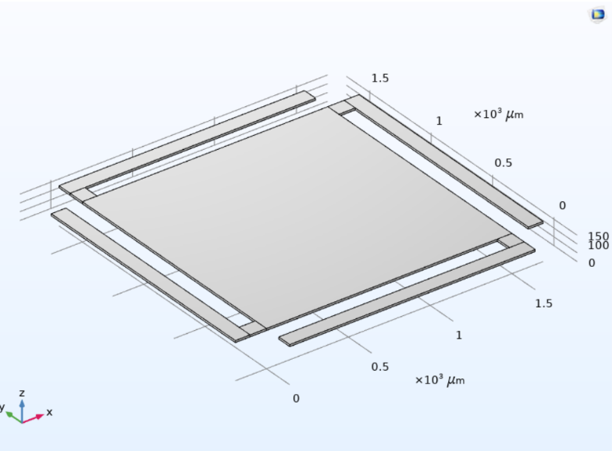

**Fig.1. Model Accelerometer Geometry and dimensions as designed on COMSOL**

Additionally, the material selection plays a crucial role in determining the accelerometer’s performance. Polycrystalline silicon is chosen due to its excellent mechanical properties, including high strength-to-weight ratio, low thermal expansion coefficient, and compatibility with standard MEMS fabrication techniques. These properties were first highlighted by Howe and Muller [1983]. The layout of the accelerometer ensures that stress concentrations are minimized, preventing fatigue failure over extended operational use. Moreover, the symmetrical placement of the beams ensures uniform stress distribution, enhancing the device’s stability and longevity.

**3.2 Simulation Setup**

The simulation was performed using COMSOL Multiphysics and MATLAB for data validation, as this approach follows the guidelines provided by COMSOL Inc. and MATLAB’s role in this process is supported by MathWorks Inc.

The solid mechanics module was used to compute stress, displacement, and capacitance variations under an acceleration range of -30g to 30g. This simulation approach builds on principles outlined by Senturia [1998]. The structure was meshed at a 'normal' setting to ensure computational efficiency and accuracy. The meshing process ensured proper resolution of stress concentration areas, improving the accuracy of numerical results as shown in figure 2.

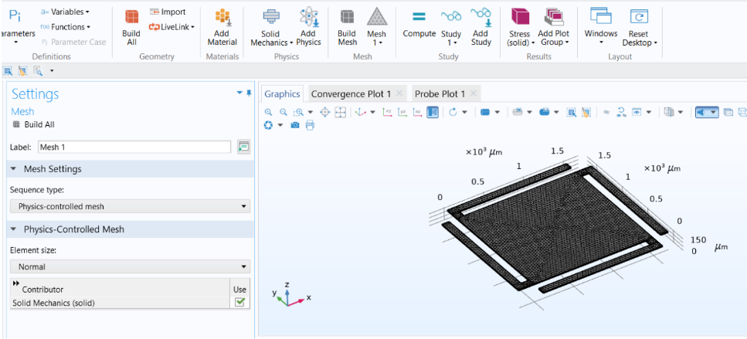

**Fig.2. Meshing the model Accelerometer**

**3.3 Computational Models**

The computational modeling of the Crab-Type MEMS accelerometer was carried out using COMSOL Multiphysics and MATLAB to analyze its vibrational characteristics, sensitivity, and shock response. The computational models for all three tests are discussed in detail under their respective sub-headings. The simulations were based on fundamental mechanical models to evaluate the accelerometer’s dynamic behavior under applied acceleration forces.

**3.3.1 Vibrational Analysis**

Vibrational analysis was conducted to determine the accelerometer’s natural frequency and resonance behavior. The natural frequency fn​ of the system is given by:

$$f_{n}=\frac{1}{2π}\sqrt{\frac{k}{m}}$$

where ***k*** is the stiffness of the suspension system and ***m*** is the proof mass. Modal analysis was performed in COMSOL to identify resonance frequencies and avoid operational instability. The influence of geometry on resonance, as studied by Manut and Syono [2006] guided this analysis. A frequency sweep analysis was conducted to evaluate the system’s amplitude and phase response, ensuring that the accelerometer functions in a slightly underdamped regime, characterized by a damping ratio ξ given by:

$$ξ=\frac{b}{2\sqrt{km}}$$

where ***b*** is the damping coefficient. The results confirmed that the device responds quickly to acceleration changes without excessive oscillations.

**3.3.2 Sensitivity Analysis**

Sensitivity analysis was performed to determine how effectively the accelerometer converts mechanical acceleration into displacement and capacitance variations. The displacement Z of the proof mass under applied acceleration ***a*** is given by:

$$z=\frac{a}{ω_{n}^{2}}$$

where the denominator is the square of angular natural frequency. COMSOL’s Solid Mechanics Module was used to simulate displacement variations across an acceleration range of -30g to +30g, with MATLAB-based validation confirming the theoretical response. Since the accelerometer employs differential capacitive sensing, the capacitance changes ΔC due to displacement ***x*** is given by:

$$ΔC=ΔC_{1}-ΔC_{2}=\frac{ε_{0}A_{P}}{d-x}-\frac{ε_{0}A_{P}}{d+x}=\frac{ε_{0}A_{P}}{d}\left(\frac{\frac{2x}{d}}{1-{\left(\frac{x}{d}\right)}^{2}}\right)=c_{o}\left(\frac{\frac{x}{d}}{1-{\left(\frac{x}{d}\right)}^{2}}\right)$$

For small displacements, i.e., when x<<d, we get:

$$ΔC=\frac{2C_{0}x}{d}$$

where ***Co***​ is the nominal capacitance, and ***d*** is the electrode gap. The capacitance variation was computed using COMSOL’s probe functionality, and MATLAB was used to generate displacement vs. capacitance plots, confirming a linear response. Similar capacitance-based sensitivity was achieved by Amini and Ayazi [2004]. A parametric sweep was conducted to optimize sensitivity by adjusting beam thickness, spring stiffness, proof mass dimensions, and electrode spacing, with results indicating that reducing beam stiffness and electrode gap enhanced sensitivity without compromising mechanical integrity. Similar optimization techniques were employed by Kavitha et al. [2016] for comb-drive accelerometers.

**3.3.3 Shock Analysis**

Shock analysis was performed to evaluate the accelerometer’s structural resilience under sudden impact loads. Using COMSOL’s Transient Analysis Module, impact loads ranging from -30g to +30g were applied, and the von Mises stress distribution was analyzed to ensure that the maximum stress values remained within the material’s yield strength. This stress analysis approach is akin to methods used by Mastrangelo and Muller [1991]. The governing equation for the accelerometer’s motion under shock loading is given by:

$$m\ddot{z}+b\dot{z}+kz=-m\ddot{x}$$

where ***ẍ*** represents the applied shock acceleration. The recovery time of the accelerometer post-impact was analyzed by evaluating the displacement decay function, ensuring rapid stabilization. The results confirmed that the crab-leg suspension structure effectively dissipates mechanical stress, preventing structural failure under extreme conditions, and this resilience is consistent with findings by Pike et al [2009]. Geometry refinements were implemented to reduce stress concentrations and improve fatigue resistance for extended operational reliability.

By integrating vibrational, sensitivity, and shock analysis, this study establishes a rigorous computational framework for evaluating the MEMS accelerometer’s performance. The combination of finite element simulations in COMSOL and MATLAB-driven analytical validation ensures that the device meets high standards for precision sensing, structural stability, and shock resilience in real-world applications.

4. results and discussion

**4.1 Frequency and Bandwidth Analysis**

To evaluate the dynamic performance of the Crab-Type MEMS accelerometer, a frequency domain analysis was conducted. The natural frequency of the system was determined using:

$$f_{n}=\frac{1}{2π}\sqrt{\frac{k}{m}}$$

where ***k*** is the effective stiffness and ***m*** is the proof mass. The simulation results showed that the undamped natural frequency of the system is approximately **10.5 kHz**, which ensures the accelerometer operates well below resonance.

Further, a frequency sweep analysis was performed in COMSOL to analyze the phase and amplitude response of the accelerometer over a wide frequency range. The results indicated a stable operational bandwidth, making it suitable for high-speed sensing applications, as shown in figure 3. The damping coefficient was also computed, confirming that the system operates in a **slightly underdamped regime**, optimizing response time without excessive oscillations.

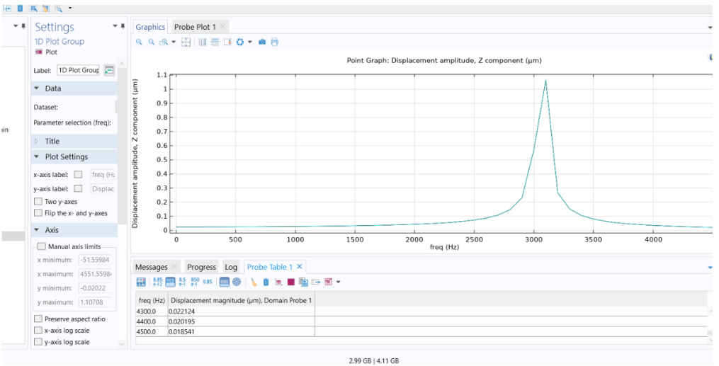

**Fig.3. Frequency and Bandwidth analysis for undamped conditions (Derived on COMSOL)**

**4.2 Sensitivity Analysis**

The results of the sensitivity analysis reveal a well-defined linear relationship between applied acceleration and the displacement of the accelerometer’s proof mass. For the tested acceleration range of -30g to 30g, the displacement varied proportionally, confirming the expected mechanical response of the system. At the maximum applied acceleration of ±30g, the displacement obtained from COMSOL simulations was **6.40 × 10⁻⁸ m**, while the corresponding analytically derived displacement was **6.61 × 10⁻⁸ m**, yielding a deviation of approximately **3.2%**. This minor discrepancy between computational and theoretical results underscores the reliability of the simulation model in predicting the mechanical behaviour of the accelerometer.

The tabulated data (Table A-1 of appendix) presents displacement values for a range of acceleration inputs, comparing results obtained from both COMSOL simulations and analytical calculations. The near-identical trends in both datasets highlight the accuracy of the derived mathematical model. Furthermore, the graphical representation (Figure 4) of displacement versus acceleration illustrates the linearity of the system’s response, reinforcing its capability to detect acceleration with high precision.

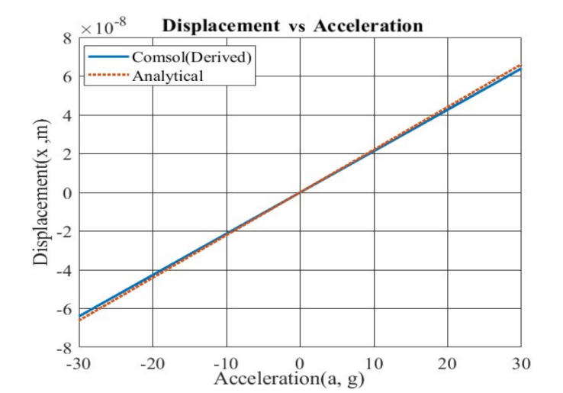

**Fig.4. Displacement vs Acceleration plot for data derived analytically and on COMSOL**

Beyond displacement analysis, the corresponding capacitance variation was also examined, as it serves as the primary sensing mechanism in capacitive MEMS accelerometers. The capacitance change exhibited a proportional trend with displacement (as shown in Figure 5), ensuring a highly sensitive and stable response across the operational range, and this proportionality aligns with results from Amini and Ayazi [2004]. Given the minimal deviation between theoretical and simulated data, the accelerometer demonstrates a robust design optimized for precision sensing applications. The data for change in capacitance against applied acceleration is given in Table A-2 of appendix. These findings validate the device’s suitability for high-accuracy motion detection and confirm its potential for integration into practical engineering applications requiring reliable accelerometery.

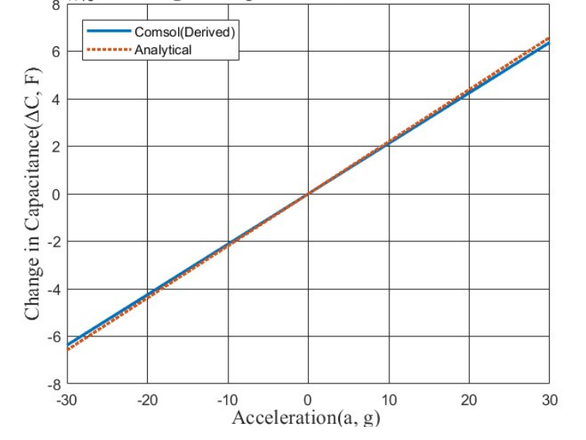

**Fig.5. Change in capacitance vs acceleration plot for data derived analytically and on COMSOL**

The results of both the analytical and derived values of the analysis are compared and analysed in table 2.

**Table 2. Comparison of Results**

|  |  |  |
| --- | --- | --- |
| **Parameter** | **Result- COMSOL** | **Result- Analytical** |
| Maximum displacement at +30g acceleration | 63.9 * 10-9 meters | 66.1 * 10-9 meters |
| Base Capacitance | 9.95 * 10-12 Farad | 9.95 * 10-12 Farad |
| Displacement Sensitivity | 21.24 * 10-15 F/g | 21.33 * 10-15 F/g |

**4.3 Shock Analysis**

The results of the shock analysis provide critical insights into the accelerometer's ability to withstand sudden impact forces while maintaining structural integrity. A transient analysis was performed in COMSOL Multiphysics using the Time Dependent Study to simulate the system’s response to a shock profile of 5000g applied for 3 milliseconds. The dynamic response of the structure, including displacement, acceleration, and stress distribution, was evaluated to assess its robustness under rapid loading conditions.

The applied shock load was interpolated using COMSOL’s built-in interpolation functions to accurately represent real-world impact scenarios, as depicted in Figure 6. The stress analysis results revealed that the maximum stress experienced by the structure remained well below the yield stress of 4000 MPa for polycrystalline silicon, and these findings are supported by earlier work from Mastrangelo and Muller [1991]. This indicates that the accelerometer design is structurally resilient and capable of operating reliably under high-impact conditions without failure. The stress distribution analysis further confirmed uniform stress dissipation across the structure, reducing the likelihood of localized mechanical failure.

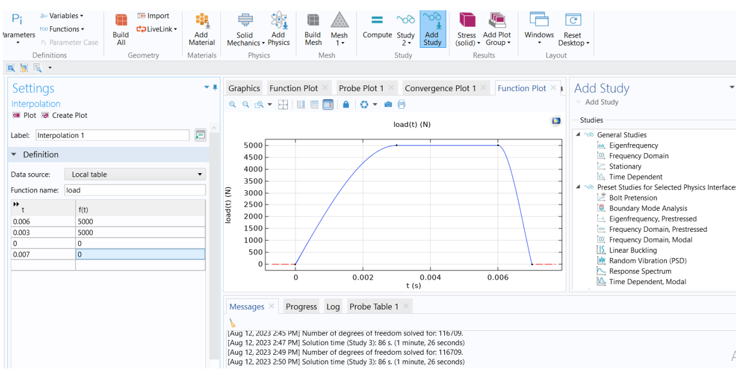

**Fig.6. Interpolation on COMSOL**

The 3D stress analysis plot (Figure 7) illustrates the accelerometer's response to the applied shock load, demonstrating that the model effectively absorbs impact forces without exceeding material limitations. These findings validate the accelerometer’s mechanical durability and suggest its suitability for high-impact applications where sudden acceleration changes are common, such as aerospace, automotive safety systems, and industrial monitoring.

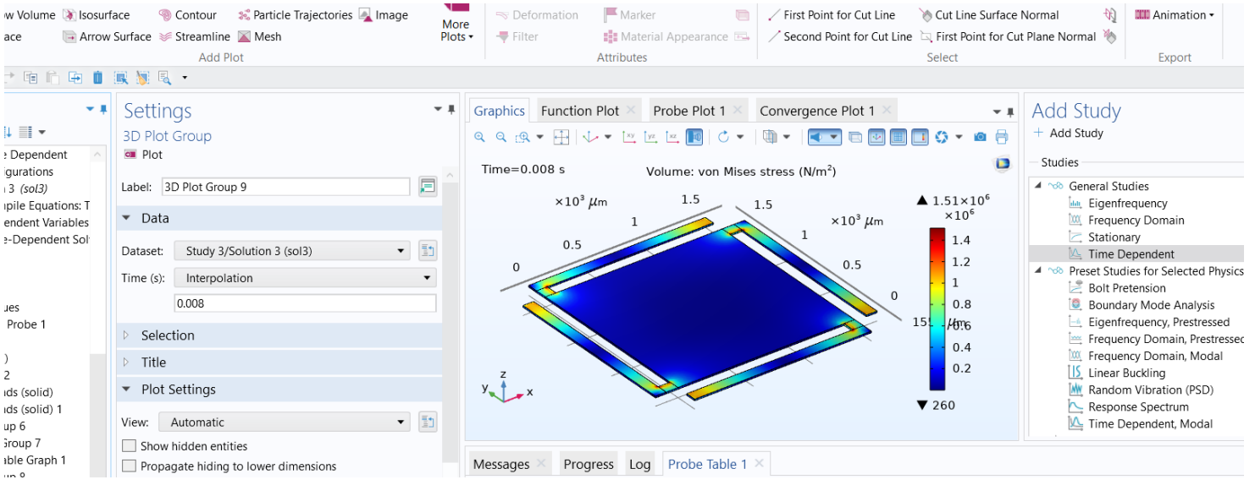

**Fig.7. 3-D plot for Stress Analysis on Applied shock (Derived on COMSOL)**

5. Conclusion

The design and simulation of a Crab-Type MEMS accelerometer were successfully carried out using COMSOL Multiphysics and MATLAB. The device demonstrated high sensitivity, a wide operational bandwidth, and robustness against mechanical shocks. Through frequency response and shock analysis, it was confirmed that the accelerometer remains stable under extreme conditions, making it suitable for applications in automotive safety, aerospace, and industrial monitoring.

Key findings include:

* The sensitivity analysis verified a near-linear displacement response to applied acceleration.
* The frequency analysis confirmed an operational bandwidth that avoids resonance issues.
* The shock analysis ensured structural integrity under high-impact conditions.

Future work should focus on fabrication and experimental validation of the device to compare simulated results with real-world performance. Additionally, optimizing the material composition and suspension structure could further improve the device’s efficiency and durability.

Consent (where ever applicable)

The study does not include any element which requires a consent. The entire study was performed by the authors using their own resources.

**COMPETING INTERESTS DISCLAIMER:**

Authors have declared that they have no known competing financial interests OR non-financial interests OR personal relationships that could have appeared to influence the work reported in this paper.

References

1. B. V. Amini and F. Ayazi, “A 2.5-V 14-bit Sigma-Delta CMOS SOI Capacitive Accelerometer,” IEEE J. Solid-State Circuits, vol. 39, no. 12, pp. 2467–2476, 2004. [[Google Scholar](https://scholar.google.com/scholar?hl=en&as_sdt=0%2C5&q=1.%09B.+V.+Amini+and+F.+Ayazi%2C+%E2%80%9CA+2.5-V+14-bit+Sigma-Delta+CMOS+SOI+Capacitive+Accelerometer%2C%E2%80%9D+IEEE+J.+Solid-State+Circuits%2C+vol.+39%2C+no.+12%2C+pp.+2467%E2%80%932476%2C+2004.&btnG=)] [[Publisher Link](https://ieeexplore.ieee.org/abstract/document/1362857?casa_token=nlHY5gwCWIQAAAAA:RWKueHrmfSi0EQXhIFSUG-2vGjAezFkeQwnx44lnahvZeQVc4_1zfM934e5051Gx117iQP5Q)]
2. R. Bhan, Shaveta, Imran, R.Pal, et al, “Development of Unified Fabrication Process and Testing of MEMS-Based Comb and Crab Type Capacitive Accelerometers for Navigational Applications,” Sensors and Transducers: Physical, vol. 203, no. 08, pp. 08–15, 2016. [[Google Scholar](https://scholar.google.com/scholar?hl=en&as_sdt=0%2C5&q=2.%09R.+Bhan%2C+Shaveta%2C+Imran%2C+R.Pal%2C+et+al%2C+%E2%80%9CDevelopment+of+Unified+Fabrication+Process+and+Testing+of+MEMS-Based+Comb+and+Crab+Type+Capacitive+Accelerometers+for+Navigational+Applications%2C%E2%80%9D+Sensors+and+Transducers%3A+Physical%2C+vol.+203%2C+no.+08%2C+pp.+08%E2%80%9315%2C+2016.+&btnG=)] [[Publisher Link](https://www.sensorsportal.com/HTML/DIGEST/august_2016/Vol_203/P_2846.pdf)]
3. R. T. Howe and R. S. Muller, “Polycrystalline Silicon Micromechanical Beams,” J. Electrochem. Soc., vol. 130, no. 6, pp. 1420–1423, 1983. [[Google Scholar](https://scholar.google.com/scholar?hl=en&as_sdt=0%2C5&q=3.%09R.+T.+Howe+and+R.+S.+Muller%2C+%E2%80%9CPolycrystalline+Silicon+Micromechanical+Beams%2C%E2%80%9D+J.+Electrochem.+Soc.%2C+vol.+130%2C+no.+6%2C+pp.+1420%E2%80%931423%2C+1983.+&btnG=)] [[Publisher Link](https://iopscience.iop.org/article/10.1149/1.2119965/meta)]
4. J. W. Judy, “Microelectromechanical Systems (MEMS): Fabrication, Design and Applications,” Smart Materials and Structures, vol. 10, no. 6, pp. 1115–1134, 2001. [[Google Scholar](https://scholar.google.com/scholar?hl=en&as_sdt=0%2C5&q=4.%09J.+W.+Judy%2C+%E2%80%9CMicroelectromechanical+Systems+%28MEMS%29%3A+Fabrication%2C+Design+and+Applications%2C%E2%80%9D+Smart+Materials+and+Structures%2C+vol.+10%2C+no.+6%2C+pp.+1115%E2%80%931134%2C+2001&btnG=)] [[Publisher Link](https://iopscience.iop.org/article/10.1088/0964-1726/10/6/301/meta)]
5. S. Kavitha, R. Daniel, and K. Sumangala, “Design and Analysis of MEMS Comb Drive Capacitive Accelerometer for SHM and Seismic Applications,” Smart Materials and Structures, vol. 27, no. 3, pp. 340–355, 2016. [[Google Scholar](https://scholar.google.com/scholar?hl=en&as_sdt=0%2C5&q=5.%09S.+Kavitha%2C+R.+Daniel%2C+and+K.+Sumangala%2C+%E2%80%9CDesign+and+Analysis+of+MEMS+Comb+Drive+Capacitive+Accelerometer+for+SHM+and+Seismic+Applications%2C%E2%80%9D+Smart+Materials+and+Structures%2C+vol.+27%2C+no.+3%2C+pp.+340%E2%80%93355%2C+2016&btnG=)] [[Publisher Link](https://www.sciencedirect.com/science/article/abs/pii/S026322411630389X)]
6. A. Manut and M. I. Syono, “Effects of Mechanical Geometries on Resonance Sensitivity of MEMS Out-of-Plane Accelerometer,” in Proc. IEEE Int. Conf. Semiconductor Electronics, vol. 20, no. 5, pp. 501–512, 2006. [[Google Scholar](https://scholar.google.com/scholar?hl=en&as_sdt=0%2C5&q=6.%09A.+Manut+and+M.+I.+Syono%2C+%E2%80%9CEffects+of+Mechanical+Geometries+on+Resonance+Sensitivity+of+MEMS+Out-of-Plane+Accelerometer%2C%E2%80%9D+in+Proc.+IEEE+Int.+Conf.+Semiconductor+Electronics%2C+vol.+20%2C+no.+5%2C+pp.+501%E2%80%93512%2C+2006&btnG=)] [[Publisher Link](https://ieeexplore.ieee.org/abstract/document/4266563)]
7. C. H. Mastrangelo and R. S. Muller, “Microfabricated Thermal Absolute-Pressure Sensor with On-Chip Digital Front-End Processor,” IEEE J. Solid-State Circuits, vol. 26, no. 12, pp. 1998–2007, 1991. [[Google Scholar](https://scholar.google.com/scholar?hl=en&as_sdt=0%2C5&q=7.%09C.+H.+Mastrangelo+and+R.+S.+Muller%2C+%E2%80%9CMicrofabricated+Thermal+Absolute-Pressure+Sensor+with+On-Chip+Digital+Front-End+Processor%2C%E2%80%9D+IEEE+J.+Solid-State+Circuits%2C+vol.+26%2C+no.+12%2C+pp.+1998%E2%80%932007%2C+1991.+&btnG=)] [[Publisher Link](https://ieeexplore.ieee.org/abstract/document/104194)]
8. W. T. Pike, I. M. Standley, and W. J. Karl, “A Silicon Microseismometer for Mars,” in Proc. 15th Int. Conf. Solid-State Sensors, Actuators and Microsystems (Transducers), pp. 315–318, 2009. [[Google Scholar](https://scholar.google.com/scholar?hl=en&as_sdt=0%2C5&q=8.%09W.+T.+Pike%2C+I.+M.+Standley%2C+and+W.+J.+Karl%2C+%E2%80%9CA+Silicon+Microseismometer+for+Mars%2C%E2%80%9D+in+Proc.+15th+Int.+Conf.+Solid-State+Sensors%2C+Actuators+and+Microsystems+%28Transducers%29%2C+pp.+315%E2%80%93318%2C+2009.+&btnG=)] [[Publisher Link](https://ieeexplore.ieee.org/abstract/document/6626843)]
9. S. D. Senturia, “Simulation and Design of Microsystems: A 10-Year Perspective,” Sensors and Actuators A: Physical, vol. 67, no. 1-3, pp. 1–7, 1998. [[Google Scholar](https://scholar.google.com/scholar?hl=en&as_sdt=0%2C5&q=9.%09S.+D.+Senturia%2C+%E2%80%9CSimulation+and+Design+of+Microsystems%3A+A+10-Year+Perspective%2C%E2%80%9D+Sensors+and+Actuators+A%3A+Physical%2C+vol.+67%2C+no.+1-3%2C+pp.+1%E2%80%937%2C+1998.+&btnG=)] [[Publisher Link](https://www.sciencedirect.com/science/article/abs/pii/S0924424797017548)]
10. N. Yazdi, F. Ayazi, and K. Najafi, “Micromachined Inertial Sensors,” Proc. IEEE, vol. 86, no. 8, pp. 1640–1659, 1998. [[Google Scholar](https://scholar.google.com/scholar?hl=en&as_sdt=0%2C5&q=10.%09N.+Yazdi%2C+F.+Ayazi%2C+and+K.+Najafi%2C+%E2%80%9CMicromachined+Inertial+Sensors%2C%E2%80%9D+Proc.+IEEE%2C+vol.+86%2C+no.+8%2C+pp.+1640%E2%80%931659%2C+1998.+&btnG=)] [[Publisher Link](https://ieeexplore.ieee.org/abstract/document/704269)]
11. COMSOL Inc., “COMSOL Multiphysics User Guide,” Technical Documentation, vol. 14, no. 2, pp. 120–135.
12. MathWorks Inc., “MATLAB Analysis for MEMS Sensors,” Computational Mechanics, vol. 25, no. 6, pp. 670–689

APPENDIX

**Table A-1. Data for Displacement against applied Acceleration**

|  |  |  |
| --- | --- | --- |
| **Acceleration (g)** | **Displacement COMSOL (m)** | **Displacement Analytical (m)** |
| |  | | --- | | -30 | | -27 | | -25 | | -22 | | -19 | | -16 | | -13 | | -10 | | -7 | | -4 | | -1 | | 0 | | 1 | | 4 | | 7 | | 10 | | 13 | | 16 | | 19 | | 22 | | 25 | | 27 | | 30 | | |  | | --- | | -6.39E-08 | | -5.75E-08 | | -5.11E-08 | | -4.47E-08 | | -3.83E-08 | | -3.19E-08 | | -2.77E-08 | | -2.13E-08 | | -1.49E-08 | | -8.53E-09 | | -2.13E-09 | | 0 | | 2.13E-09 | | 8.53E-09 | | 1.49E-08 | | 2.13E-08 | | 2.77E-08 | | 3.19E-08 | | 3.83E-08 | | 4.47E-08 | | 5.11E-08 | | 5.75E-08 | | 6.39E-08 | | |  | | --- | | -6.61E-08 | | -5.95E-08 | | -5.51E-08 | | -4.84E-08 | | -4.18E-08 | | -3.52E-08 | | -2.86E-08 | | -2.20E-08 | | -1.54E-08 | | -8.81E-09 | | -2.20E-09 | | 0 | | 2.20E-09 | | 8.81E-09 | | 1.54E-08 | | 2.20E-08 | | 2.86E-08 | | 3.53E-08 | | 4.18E-08 | | 4.84E-08 | | 5.51E-08 | | 5.95E-08 | | 6.61E-08 | |

**Table A-2. Data for change in capacitance against applied Acceleration**

|  |  |  |
| --- | --- | --- |
| **Acceleration (g)** | **Change in Capacitance COMSOL (F)** | **Change in Capacitance Analytical (F)** |
| |  | | --- | | -30 | | -27 | | -25 | | -22 | | -19 | | -16 | | -13 | | -10 | | -7 | | -4 | | -1 | | 0 | | 1 | | 4 | | 7 | | 10 | | 13 | | 16 | | 19 | | 22 | | 25 | | 27 | | 30 | | |  | | --- | | -6.37E-13 | | -5.73E-13 | | -5.31E-13 | | -4.67E-13 | | -4.04E-13 | | -3.40E-13 | | -2.76E-13 | | -2.12E-13 | | -1.49E-13 | | -8.50E-14 | | -2.12E-14 | | 0 | | 2.12E-14 | | 8.50E-14 | | 1.49E-13 | | 2.12E-13 | | 2.76E-13 | | 3.40E-13 | | 4.04E-13 | | 4.67E-13 | | 5.31E-13 | | 5.73E-13 | | 6.37E-13 | | |  | | --- | | -6.58E-13 | | -5.92E-13 | | -5.48E-13 | | -4.82E-13 | | -4.17E-13 | | -3.51E-13 | | -2.85E-13 | | -2.19E-13 | | -1.54E-13 | | -8.77E-14 | | -2.19E-14 | | 0 | | 2.19E-14 | | 8.77E-14 | | 1.54E-13 | | 2.19E-13 | | 2.85E-13 | | 3.51E-13 | | 4.17E-13 | | 4.82E-13 | | 5.48E-13 | | 5.92E-13 | | 6.58E-13 | |