***Original Research Article***

**Investigating the Synergistic Influence of**

**Textile Additive on Thermal Behaviour**

**of Recycled Plastic Materials**

ABSTRACT

|  |
| --- |
| **Aims:** This study aimed to investigate the thermal behavior and combustibility of plastic-textile composites, utilizing elemental and thermogravimetric analyses.  **Study design:** An experimental design was employed, incorporating both elemental analysis and thermogravimetric analysis (TGA and DTG).  **Place and Duration of Study:** The research was conducted in Nigeria, specifically at the Federal University of Technology, Minna, and the National Geosciences Research Laboratory, Kaduna between February to November 2022.  **Methodology:** The procedure involved analyzing composite samples with varying ratios of plastic (PL) and textile (TE): PL25/TE75 (Sample A), PL50/TE50 (Sample B), PL75/TE25 (Sample C), pure plastic PL100 (Sample D), and pure textile TE100 (Sample E). Elemental analysis determined the composition of carbon, hydrogen, oxygen, sulfur, and nitrogen. TGA and DTG were used to evaluate thermal stability and combustibility. Additionally, residual unburned materials and organic matter generation were quantified.  **Results:** The experimental outcomes showed that increasing textile content led to a decrease in carbon and hydrogen, with a slight increase in oxygen, sulfur, and nitrogen. TGA revealed varying thermal stabilities: Samples A, D, and E exhibited higher onset temperatures, indicating greater thermal stability. Sample B displayed the least stability, while Sample C showed moderate stability. Combustibility patterns displayed multiple peaks in Samples B, C, D, and E, suggesting diverse component compositions, unlike Sample A. Residual unburned material ranked from highest to lowest: Sample C, Sample B, and Sample A. Sample E produced the highest organic matter, likely due to lignocellulosic and cellulosic fibers. Distinct decomposition processes and combustibility patterns suggested diverse compositions related to synthetic fibers and specific polymers.  **Conclusion:** The thermal and combustibility characteristics of these composites are significantly influenced by their composition ratios. The findings highlight potential applications of these composites as renewable fuel and in waste mitigation, aligning with SDGs 7 and 12. This research provides valuable insights into the thermal properties of plastic-textile composites, contributing to improved waste management practices. |

*Keywords: Plastic-textile composites, elemental analysis, thermogravimetric analysis, peak temperature, briquettes, SDGs*

1. INTRODUCTION

The global surge in plastic waste presents an acute challenge to municipal solid waste (MSW) management, a predicament particularly pronounced in regions like Nigeria, where approximately 32 million tonnes of waste are generated annually, with 2.5 million tonnes being plastic [1]. This accumulation of non-biodegradable material contributes significantly to environmental degradation, notably through microplastic contamination, posing substantial risks to both ecological stability and human health [2]. Developing nations often grapple with inadequate waste management infrastructure, characterized by outdated protocols, insufficient data on waste generation rates, and constrained landfill capacity [3]. In urban centers such as Abuja, the complexity of waste composition, encompassing plastics and textiles, is further influenced by socioeconomic factors and population density [4]. The escalating volume of textile waste, driven by rapid fashion cycles, exacerbates this problem, with approximately 75% ending up in landfills or being incinerated [5,6,7,8]. Conversely, only a marginal 23-25% is recycled or reused, with less than 1% of recovered fibers reintegrated into clothing production, failing to establish a closed-loop system [9,10]. This disparity underscores the critical need for sustainable recycling alternatives and the exploration of energy recovery potential within these waste streams [11].

The environmental consequences of poor waste management, including blocked drainage systems and improper landfilling, lead to leachate formation and groundwater contamination, amplifying environmental concerns. These challenges have prompted intensified research into the energy recovery potential of textile waste, despite the complexities associated with sorting and recycling diverse fiber blends [12]. Consequently, various waste disposal methods are being investigated to mitigate environmental damage and safeguard public health [13]. This research, titled "Investigating the Synergistic Influence of Textile Additives on the Thermal Behaviour of Recycled Plastic Materials," specifically focuses on the pivotal role of textile additives in modifying the thermal properties of recycled plastics. The incorporation of these additives can significantly alter thermal conductivity, degradation resistance, and overall performance under various environmental conditions, thereby enhancing the suitability of recycled plastics for diverse applications. For instance, the inclusion of recycled textile fibers, such as polyamide and polyester, has been shown to modify the thermal conductivity of polyethylene (PE), with polyester effectively reducing thermal diffusivity at elevated temperatures [14].

Furthermore, additives like calcium carbonate and graphene improve temperature uniformity during processing, crucial for applications requiring consistent thermal properties [15]. Antioxidants and carbon black are known to delay thermal degradation, enhancing the oxidative induction time (OIT) and durability of recycled polyethylene blends [16] However, the potential environmental impact of these additives, particularly the leaching of pollutants, necessitates the development of effective remediation strategies [17]. This research therefore, emphasizes the importance of understanding the synergistic interactions between textile found in MSWs, and the thermal behavior of recycled plastics, to optimize their applications.

Incineration, is a common method for textile waste disposal, but poses significant environmental challenges due to the release of substantial CO2 emissions [18]. Notably, the incineration of cotton results in CO2 emissions that surpass even those of fossil fuels, with cotton producing approximately 102.84 kg CO2/GJ [19]. Different textile types exhibit varying combustion characteristics, with woolen fabrics demonstrating the highest combustion propensity and consequently, increased emissions [20].While incineration offers immediate waste disposal solutions, its environmental repercussions necessitate a transition towards more sustainable practices that prioritize recycling and resource recovery. Chemical recycling has been identified as the most energy-efficient method, while mechanical recycling emits the least CO2 [21]. The revitalization of textile waste into composite fibers presents a sustainable solution, promoting a circular economy and reducing reliance on virgin resources [22].This approach aligns with sustainable development goals (SDGs) 7 and 12 by fostering clean energy use and mitigating plastic waste pollution [23,24,25,26].

To achieve sustainable MSW management, a shift towards alternative strategies is imperative. Thermal treatment, biological treatment, landfilling with energy recovery, and recycling are considered viable options [27]. The reuse of plastic and textile waste for energy recovery can address waste management challenges in Nigeria. Incineration with energy recovery, such as refuse-derived fuel (RDF) production, can significantly reduce the solid mass of waste by 80-85% [28]. Waste-to-energy (WtE) technologies like incineration and gasification also offer potential solutions to energy poverty [29]. **Among these options, briquette production presents a particularly promising avenue for Nigeria. Briquettes, formed from compacted waste materials, offer several advantages. Firstly, they provide a densified fuel source, facilitating easier storage and transportation compared to loose waste. This is especially relevant in regions with logistical challenges. Secondly, briquettes offer a more controlled and consistent combustion process compared to the direct burning of heterogeneous waste, leading to improved energy efficiency and reduced emissions. Thirdly, utilizing briquettes can reduce the volume of waste sent to landfills, extending their lifespan and mitigating the associated environmental risks. Furthermore, in the Nigerian context, where access to reliable and affordable energy is a significant challenge, briquettes produced from locally sourced waste can contribute to decentralized energy generation, reducing dependence on fossil fuels and promoting energy security. The potential for briquettes to be produced from a blend of recycled plastics and textile waste, enhanced by the synergistic effects of textile additives on thermal behavior, makes this approach particularly attractive for addressing both waste management and energy needs.**

Hence, this research seeks to understand how adding textile waste materials changes the way recycled plastic materials, obtained from household trash, break down under heat. The study also aims to determine if these plastic and textile waste mixtures are suitable for making briquettes, a process that converts waste into energy. This directly aligns with the research's main objective, which is to explore waste-to-energy recovery options.

2. material and methods

### 2.1 Sample Collection and Preparation

Samples were collected manually from four locations within a 1 km radius in the Maitama District of Abuja, Nigeria. Samples were taken from the top, middle, and bottom of the material at each location. The samples were pre-dried under sunlight to reduce moisture content in accordance with BS EN 15442:2011 [30]. Following this, the samples were manually sorted into sub-fractions, including plastics, textiles, wood, and paper, based on BS EN 15440:2011 [30]. Refer to plates 1, 2, 3, and 4 respectively for plastic and paper samples.

|  |  |
| --- | --- |
| **Description: C:\Users\ENGR. M. M. GAJI\AppData\Local\Microsoft\Windows\Temporary Internet Files\Content.Word\IMG_20200716_174105_9.jpg**  **Plate 1. Plastic sample** | **Description: C:\Users\ENGR. M. M. GAJI\AppData\Local\Microsoft\Windows\Temporary Internet Files\Content.Word\IMG_20200716_174121_3.jpg**  **Plate 2. Textile samples** |

### 2.2 Preparation of Plastic-Textile Composites

Plastic-textile solid waste materials were pulverized to a particle size of 0.2 mm using a a Model 44 Series Circ-U-Flow Schutte Buffalo Hammermill. The mixtures were homogenized according to the weight ratios presented in Table 1, where textile fabrics served as a binder for briquette compaction.

**Table 1: Plastic- Textile composite samples used.**

|  |  |
| --- | --- |
| Samples | Percentage by Weight |
| PL 25 + TE 75 | Plastic 25% by weight and Textile 75% by weight |
| PL 50 + TE 50 | Plastic 50% by weight and Textile 50% by weight |
| PL 75 + TE 25 | Plastic 75% by weight and Textile 25% by weight |
| PL 100 | Plastic 100% by weight |
| TE 100 | Textile 100% by weight. |

### 2.3 Production of Waste-to-Energy Briquettes

The raw materials were extruded into briquettes with an inner diameter of 14.0 mm and a height of 95.0 mm. The briquettes included a central hole designed to enhance porosity and oxygen supply during combustion. The mold was filled with the plastic-textile mixture and compacted using a 5-tonne Budenberg Steel Tube hydraulic pressure machine under controlled conditions (temperature: 36-37°C, pressure: 40 kPa). A total of 35 briquettes were produced for each sample and air-dried for 35 days before testing.

|  |  |
| --- | --- |
| **Description: C:\Users\ENGR. M. M. GAJI\AppData\Local\Microsoft\Windows\Temporary Internet Files\Content.Word\IMG_20200716_173517_4.jpg**  **Plate 3. Plastic briquettes** | **Description: C:\Users\ENGR. M. M. GAJI\AppData\Local\Microsoft\Windows\Temporary Internet Files\Content.Word\IMG_20200716_173348_2.jpg**  **Plate 4. Plastic and textile briquettes** |

## 2.4 Material characterization

## 2.4.1 The ultimate analysis of test samples

The ultimate analysis determined the content of carbon (C), hydrogen (H), nitrogen (N), sulfur (S), and oxygen (O) using an element analyzer (Perkin Elmer model 2400 CHNS/O Series II) at the Geoscience Laboratory in Kaduna, following ASTM D3176-15 [31] and BS EN standards [30]. All values obtained from both the proximate and ultimate analyses are reported in this paper on a dry basis (d.b.).

2.4.2 Thermogravimetric analysis of test samples.

Thermogravimetric analysis (TGA) was performed in line with ASTM procedure using a STA 6000 TGA (Perkin Elmer) in an oxygen atmosphere. Samples were subjected to a heating rate of 10 °C/min from ambient temperature to 850 °C [32]. Accurate measurements were ensured, and experiments were repeated twice for reliability. Refer to Figure 1 for a schematic representation of the TG analyzer. TGA is a powerful analytical technique that examines the decomposition behaviour of solid samples. It provides data on the sample's weight and decomposition rate under controlled conditions of temperature, time, or both. The decomposition profile was assessed by subjecting the samples to a heating rate of 10 °C/min from ambient temperature to 850 °C. Three different heating rates were employed. A sample size of approximately 10.0 mg with a particle size of 0.2 mm was utilized. To ensure reproducibility, the experiment was performed twice [33]. During the tests, the sample's weight loss and derivative weight loss with temperature were simultaneously recorded. These data were used to generate thermogravimetry (TG) and derivative thermogravimetry (DTG) combustion curves, respectively [34].

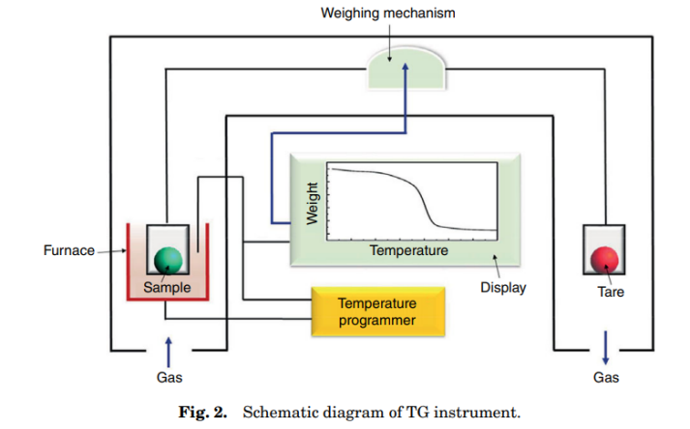

**Fig 1. Schematic diagram of a TGA.** Source: [32]

3. results and discussion

### 3.1 Elemental Analysis.

Elemental analysis (refer to table 2 and figure 2) reveals significant compositional disparities between plastic and textile materials, particularly concerning carbon, hydrogen, oxygen, sulfur, and nitrogen content. A notable trend is the inverse relationship between textile proportion and carbon content: as textile content increases, carbon levels decrease, while oxygen, sulfur, and nitrogen levels concurrently rise [35]. This difference in elemental composition has critical implications for both energy recovery and material recycling. Specifically, plastic samples exhibit a higher carbon content (47.41%) compared to textiles (30.83%), and their elevated hydrogen content further supports their suitability for energy recovery through incineration due to its longer carbon chains and higher energy density [36]. Conversely, oxygen content increases from 28.61% in plastics to 40.30% in textiles [35], with corresponding increases in sulfur and nitrogen levels [37]. These trends suggest a compositional shift that impacts combustion properties and emissions during energy recovery. While plastics offer advantages for energy recovery, the potential release of pollutants during incineration necessitates a balanced approach that integrates energy recovery with sustainable waste management.

Table 2. Ultimate analysis of plastic, and textile samples.

|  |  |  |  |  |  |
| --- | --- | --- | --- | --- | --- |
| Sample | Carbon (%) | Hydrogen (%) | Oxygen (%) | Sulfur (%) | Nitrogen (%) |
| PL 100 | 47.41 | 5.56 | 28.61 | 0.14 | 0.73 |
| TE 100 | 30.83 | 3.85 | 40.30 | 0.29 | 1.03 |

**Fig 2: Elemental composition of plastic and textile sample blends**

Further analysis of the relationship between plastic content and elemental composition in textile materials highlights specific trends in oxygen, sulfur, and nitrogen levels. As plastic content decreases, oxygen levels increase, likely due to oxygen-intensive processes in textile production, such as delignification and ozone bleaching [38]. Similarly, the chemistry of pulping and bleaching processes strongly suggests that the use of sulfur-containing chemicals can lead to increased sulfur content in recycled pulp [39]. The gradual increase in nitrogen composition is attributed to its role in dye production for textiles [40], thus reflecting the chemical complexity of textile coloration. These observed trends underscore the distinct chemical characteristics of textile materials compared to plastics. However, the environmental implications associated with the chemical processes contributing to the increased oxygen, sulfur, and nitrogen content raise concerns about pollution and sustainability in textile manufacturing, necessitating careful consideration of these factors in waste management and recycling strategies.

The ultimate analysis, as presented, reinforces these observations. Carbon composition, ranging from 47.41% in plastic-rich samples to 30.83% in textile-rich samples, shows a clear decrease with increasing textile content. This confirms that plastics contain more elemental carbon than textiles, contributing to their suitability for energy recovery due to longer carbon chains and higher energy content [41,42]. Similarly, hydrogen content is highest in plastic-rich samples, further supporting this conclusion. Conversely, oxygen content increases as plastic content decreases, indicating higher oxygen levels in textiles, likely due to oxygen-intensive processes like delignification and ozone bleaching [43,44]. Sulfur content also increases with decreasing plastic content, attributed to the use of sulfur-containing chemicals in pulp recycling post-bleaching [45]. Finally, nitrogen content shows a gradual increase, linked to its use in textile dye production.

### 3.2 Thermogravimetric Analysis

The TGA and DTG findings, summarized in Table 3, reveal insights into the thermal stability of the composites. The analysis indicates that Samples A, D, and E exhibit high thermal

**Table 3: Information from TGA and DTG analysis for both plastic and textile materials.**

|  |  |  |  |  |  |  |
| --- | --- | --- | --- | --- | --- | --- |
| **Samples** | **Composite mix** | **Onset temperature** | **Degradation temp. range** | **TGA step** | **DTG peak** | **% Organic matter** |
| A | PL25 + TE75 | 314.89 (89.81 %) | 314.89-520.50 | 3 | 369.47 446.38 | 6.80 |
| B | PL50 + TE50 | 251.23 (96 %) | 251.23-613.10 | 4 | 319.00, 373.70, 552.65, 675.11 | 9.52 |
| C | PL75 + TE25 | 275.82 (93.25 %) | 275.82-519.98 | 3 | 417.11, 458.52 | 19.64 |
| D | PL100 | 329.34 (90.39 %) | 329.34-546.60 | 2 | 417.08, 474.62 | 6.15 |
| E | TE 100 | 331.68 (94.43 %) | 331.68-529.26 | 2 | 395.77, 468.93 | 21.45 |
|  |  |  |  |  |  |  |

stability, while Sample B demonstrates the least stability. The presence of multiple DTG peaks across samples suggests diverse components, with Sample C indicating a higher potential for combustion due to its organic matter content.

The thermogravimetric analysis (TGA) and derivative thermogravimetry (DTG) of plastic-textile composite samples, as presented in Table 3 and Figure 3, reveal distinct thermal stability profiles across the various compositions. Sample A (PL25 + TE75) exhibits the highest thermal stability, characterized by a high onset temperature of 314.89°C and a narrow degradation range of 314.89-520.50°C. This suggests a dominant decomposition process, likely due to specific polymer types or synthetic fibers, as supported by a single DTG peak within 369.47-446.38°C. The low organic matter content (6.8%) indicates a significant presence of inorganic fillers or substantial char formation [46]. Conversely, Sample B (PL50 + TE50) displays the least thermal stability, with the lowest onset temperature of 251.23°C and a broad degradation range of 251.23-613.10°C, implying multiple decomposition events at varied temperatures, as confirmed by multiple DTG peaks (319.00, 373.70, 552.65, 675.11°C). The moderate organic matter content (9.52%) suggests a balance between organic and inorganic components [47]. Sample C (PL75 + TE55) shows intermediate thermal stability, with an onset temperature of 275.82°C and a degradation range of 275.82-519.98°C. Two DTG peaks (417.11, 458.52°C) indicate two dominant decomposition processes, and the highest organic matter content (19.64%) suggests a substantial fraction of combustible material [48].

Samples D (PL100) and E (TE100) exhibit high thermal stability, with onset temperatures of 329.34°C and 331.68°C, respectively, and moderate degradation ranges. Sample D's degradation occurs between 329.34-546.60°C, and Sample E's between 331.68-529.26°C. Both samples show two DTG peaks, indicating different thermal degradation pathways, with Sample D exhibiting peaks at 417.08°C and 474.62°C, and Sample E at 395.77°C and 468.93°C. Sample D has a low organic matter content (6.15%), suggesting high inorganic filler or char formation, while Sample E has the highest organic matter content (21.45%), indicating a significant fraction of combustible material. These differences in organic content and DTG peaks suggest varying degradation mechanisms, which could influence their applications in high-temperature environments [48,49].

The thermal degradation of polymeric materials, as analyzed through TGA and DTG, involves complex processes. Overlapping peaks in TGA data often indicate multiple decomposition processes, particularly in heterogeneous samples with various polymers, which is crucial for understanding material combustibility and degradation kinetics. Overlapping peaks signify different polymer types decomposing at varying temperatures, typically above 350°C for plastics [50]. High-resolution TGA can separate these overlapping processes for accurate analysis [51]. The oxidation process during thermal degradation involves four stages: water evaporation, oxygen chemisorption, significant decomposition reactions, and direct burn-off reactions. Mass loss is primarily driven by water evaporation, outweighing oxygen adsorption [50]. Combustibility is evaluated based on the peak temperature in the DTG plot, reflecting the highest weight loss rate, with different samples exhibiting varying combustibility profiles [52].

While overlapping peaks complicate analysis, they provide valuable insights into material composition and degradation mechanisms. Advanced analytical techniques are essential for fully understanding these processes. However, the findings highlight the importance of considering the complex thermal behavior of plastic-textile composites in waste management and energy recovery applications.

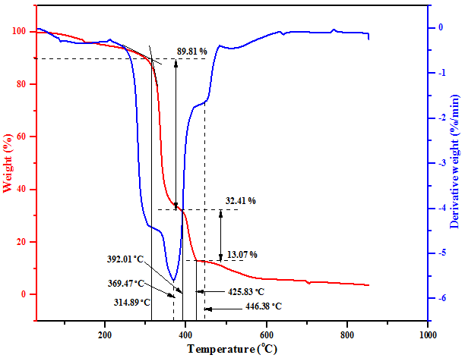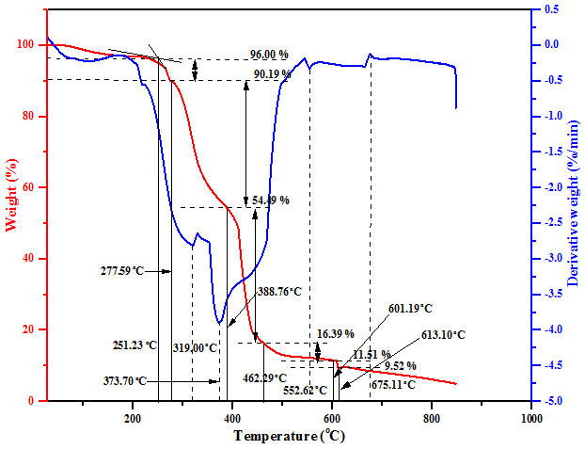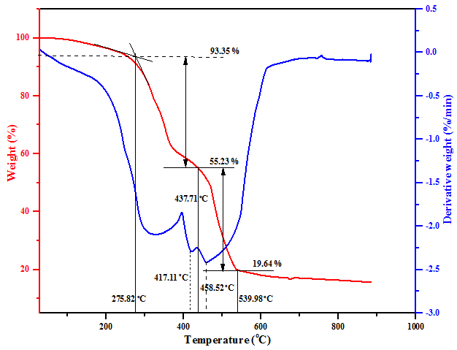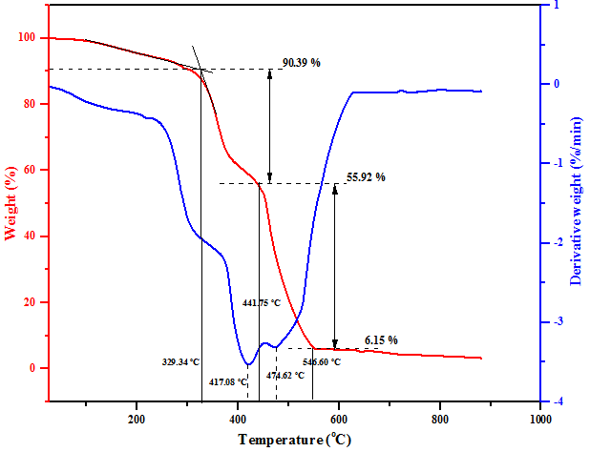

(e)

(d)

(c)

(b)

(a)

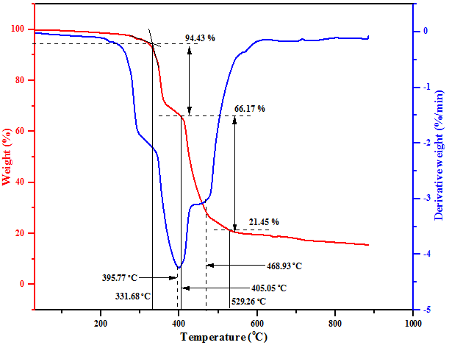

**Fig 3: TGA and DTG curves for Sample A, Sample B, Sample C, Sample D, and Sample E at the same heating temperature and time.**

The thermal degradation of polymeric materials, is a complex process effectively analyzed by thermogravimetric analysis (TGA), and mass spectrometry. It often presents overlapping peaks or shoulders in TGA data, indicating simultaneous decomposition processes in heterogeneous samples. These overlapping peaks manifest when distinct components decompose concurrently, with DTG peaks associated with plastic components typically exceeding 350°C, reflecting polymer chain breakdown, unlike textiles [50]. Multiple peaks within this range suggest diverse polymer types in the plastic. This complexity is crucial for understanding material thermal behavior, especially concerning combustibility and degradation kinetics. The oxidation process involves four stages: water evaporation, oxygen chemisorption, significant decomposition reactions, and direct burn-off reactions [50]. The TGA curve decreases due to mass loss from water evaporation outweighing oxygen adsorption, highlighting water evaporation's prominent role [53]. Peaks or plateaus in the mass loss curve signify specific thermal events. Combustibility, evaluated by the peak DTG temperature corresponding to the highest weight loss rate, varies among samples [52]. The temperature regions in the TGA plot correspond to moisture removal, organic component degradation, phase transitions, and combustion reactions [53]. High-resolution TGA can separate these overlapping processes, enabling accurate analysis of individual component thermal behavior [51].

Peak DTG temperatures for Samples B (319.00 - 675.11°C), C (417.11 - 458.52°C), and D (417.08-474.62°C) indicate heightened combustibility compared to Samples E (395.77-468.93°C) and A (369.47-446.38°C) [53]. This reduced thermal behavior of textile materials is attributed to flame-retardant finishes enhancing thermal stability, slowing combustion and reducing heat transfer rates [54]. Individual textile materials exhibit distinct thermal stability characteristics influenced by fiber composition, fabric structure, and applied treatments. Materials with higher stability are less prone to rapid combustion, exhibiting low reactivity, high ignition temperature, and limited combustible gas release when exposed to heat [54, 55, 56]. Different fibers exhibit varying thermal behaviors; for instance, blends of cotton and synthetic fibers alter combustion properties [57]. The application of flame retardants can shift DTG peak temperatures to lower values, indicating reduced combustibility [58]. The arrangement of fibers affects heat transfer and combustion rates, with tightly woven fabrics providing better protection [59].

Flame-retardant treatments, while enhancing thermal stability also introduces some complexities into material performance, such as potential degradation over time, affecting long-term safety and efficacy. Flame-retardant treatments, though they improve a material's ability to withstand heat, but also create certain challenges. Specifically, these treatments can cause the material to break down or deteriorate over time. This breakdown can negatively impact how well the material continues to resist fire, thus reducing its long-term safety and effectiveness. These complexities necessitate careful material selection and treatment processes to ensure optimal performance. Analysis of thermal degradation via TGA and DTG provides critical insights into the behavior of polymers and textiles at high temperatures, aiding in the development of safer and more efficient materials. Notably, Samples A, D, and E exhibit similar thermal stability due to high onset temperatures, Sample B shows the poorest thermal stability, Sample C has the highest organic matter content suggesting high combustion potential, and multiple DTG peaks in Samples B, C, D, and E suggest diverse components compared to Sample A. This research examined how the ratios of composite materials affect degradation temperature, revealing that lower plastic proportions are associated with reduced organic matter levels. The amount of unburned material residue followed this trend: Sample C had the most, followed by Sample B, and then Sample A. Sample E yielded a higher amount of organic matter, likely due to the carbonization of lignocellulosic and cellulosic fibers. The composition of carbon residue is influenced by combustion conditions and impurities. For accurate interpretation of Thermogravimetric Analysis (TGA) and Derivative Thermogravimetric Analysis (DTG) data, the specific material compositions, heating rates, and atmospheric conditions used during the analysis must be taken into account.

The regression analysis, as presented in Table 4, showed a high R-squared of 0.771, suggesting a significant portion of the variation in organic matter could be explained by the model. However, the adjusted R-squared of 0.155 and a statistically insignificant F-statistic (p=0.612) indicated a poor overall model fit. Furthermore, all p-values for the individual coefficients were not available, making them statistically insignificant. Consequently, this model should not be used for predictive purposes due to the small sample size (n=5), which produced unreliable results and potential multicollinearity issues

**Table 4. Ordinary Least Squares (OLS) Linear Regression Results**

|  |  |  |  |
| --- | --- | --- | --- |
| **Dep. Variable:**  **Model:**  **Method:**  **No. Observations:**  **Df Residuals:**  **Df Model:**  **Covariance Type:** | % Organic Matter  OLS  Least Squares  5  0  4  nonrobust | **R-squared:**  **R-squared:**  **F-statistic:**  **Prob (F-statistic):**  **Log-Likelihood:**  **AIC:**  **BIC:** | 0.771  0.155  1.248  0.612  7.8540  25.71  23.75 |

In summary, the interplay between material composition, processing, and thermal behavior is essential for understanding and optimizing polymer and textile performance in heat-related applications. Advanced analytical techniques are crucial for deciphering the complex degradation processes and ensuring material reliability and safety.

4. Conclusion

In conclusion, this study has demonstrated that the composition of plastic-textile composites significantly impacts their thermal behavior. As was observed, with increasing textile content, the elemental composition and combustion properties were altered. While these composites show potential as combustible fuel, particularly as briquettes, optimizing their use for energy recovery requires careful consideration of environmental impacts and further research into mixture ratios and emissions control.

COMPETING INTERESTS DISCLAIMER:

Authors have declared that they have no known competing financial interests OR non-financial interests OR personal relationships that could have appeared to influence the work reported in this paper.

References

1. Nwafor, J. Fighting plastic waste: a double-edged sword. 26/07/21. (2021). Bringing science & development together through news & analysis. https://www.scidev.net/sub-saharan-africa/multimedia/fighting-plastic-waste-a-double-edged sword/#~:text=Seun%2C.

2. Praveenkumar. T.R., Manigand, S., Raghavendra, R. P., B., Gavurová,. Kumar, G. A., & Kumar, M. V. (2024). Current technologies for plastic waste treatment for energy recovery, its effects on poly aromatic hydrocarbons emission and recycling strategies, Fuel, Volume. 2024.357, Part A, 129379, ISSN 0016-2361,<https://doi.org/10.1016/j.fuel.2023.129379>. (<https://www.sciencedirect.com/science/article/pii/S0016236123019932>)

3. Ayuba, K. A., Latifah, A.M., Abdullah, H. S., & Sulaiman W.A. (2013). Current Status of Municipal Solid Waste Management Practice in FCT Abuja Research Journal of Environmental and Earth Sciences, 5(6): 295-304, <http://dx.doi.org/10.19026/rjees.5.5704>  ISSN: 2041-0484; e-ISSN: 2041-0492

4. Federal Ministry of Environment Report. Integrated Waste Management Facility Study for Abuja. 2004

5. [Ajila](https://www.scirp.org/journal/articles.aspx?searchcode=K.+O.++Ajila&searchfield=authors&page=1), K.O. (2019). Analysis of Post-Consumer Solid Textile Waste Management among Households in Oyo State of Nigeria. [Journal of Environmental Protection](https://www.scirp.org/journal/journalarticles.aspx?journalid=144) > [*Vol.10 No.11, November 2019*](https://www.scirp.org/journal/home.aspx?issueid=13147#96169)*. DOI:*[*10.4236/jep.2019.1011084*](https://doi.org/10.4236/jep.2019.1011084)

6. Ibrahim, H.D. & Ogunwusi, A.A. (2017). Prospects for Kenaf Textile Production in Nigeria. Journal of Natural Sciences Research, 7, 22-28.<http://www.iiste.org>

7. Juanga-Labayen, J.P., Labayen, I.V. & Yuan, Q. (2022). A Review on Textile Recycling Practices and Challenges. Textiles, 2, 174–188. https://doi.org/10.3390/textiles2010010 https://www.mdpi.com/journal/textiles

8. Hole, G., & Hole, A. S. (2019). Recycling as the way to greener production: A mini-review. Journal of Cleaner Production, 2019; 212, 910-915.

9. United States Environmental Protection Agency (1996). Best Management Practices for Pollution Prevention in Textile Industry. U.S. Environmental Protection Agency Document, No. EPA/625/R-96/004, 1996; 53-78,

10. Ellen MacArthur Foundation. Fashion and the Circular Economy <https://ellenmacarthurfoundation.org/topics/fashion/overview>2018, accessed 20 February 2022.

11. Baloyi, R.B., Gbadeyan, O.J., Sithole, B., & Chunilall, V. (2023). Recent advances in recycling technologies for waste textile fabrics: a review. Textile Research Journal. 2023; doi:[10.1177/00405175231210239](https://doi.org/10.1177/00405175231210239)

12. Xu, C. Ke, Cheng, H., Liao, Z., & Hu, H. (2019). An Account of the Textile Waste Policy in China (1991–2017). Journal of Cleaner Production, Vol. 234, pp. 1459–1470. <http://doi.org/10.1016/j.jclepro.2019.06.283>

13. Ozuysal, A., & Akinci, G. (2019). The Assessment of Refuse Derived Fuel (RDF) Production from Textile Waste. Eurasian Journal of Environmental Research EJERE, Vol. 3, Issue 2, pp. 27-32, December. ISSN 2602-2990, TURKEY

14. Gasselin, M., Kalantar Mehrjerdi, A., Karlsson, S., Leisner, P., Skrifvars, M., & Khalili, P. (2024). Extrusion and Injection Molding of Polyethylene Loaded with Recycled Textiles: Mechanical Performance and Thermal Conductivity. *Journal of Composites Science*, *8*(10), 399. <https://doi.org/10.3390/jcs8100399>

15. Garapati, N., & Gupta, R. K. (2022). Role of additives in influencing heating and melting of polymers during thermoforming. Journal of Vinyl & Additive Technology, 29, 685. <https://doi.org/10.1002/vnl.21957>

16. Kharmoudi, H., Lamtai, A., Elkoun, S., Robert, M., & Diez, C. (2024). Effect of Additives on Thermal Degradation and Crack Propagation Properties of Recycled Polyethylene Blends. Polymers, 16(14), 2060. <https://doi.org/10.3390/polym16142060>

17.Zhang, L., He, Y., Jiang, L., Shi, Y., Hao, L., Huang, L., Lyu, M., & Wang, S. (2024). Plastic additives as a new threat to the global environment: research status, remediation strategies and perspectives. Environmental Research, 120007. <https://doi.org/10.1016/j.envres.2024.120007>

18. Tkachenko, Т., Mileikovskyi, V., & Tkachenko, Т. (2021). Incineration problems for the heat supply using garbage from the overproduction of fast fashion clothing. Ventilâcìâ, Osvìtlennâ Ta Teplogazopostačannâ, 39, 47–52. <https://doi.org/10.32347/2409-2606.2021.39.47-52>

19. Wang, T., Li, B., Xue, Y., Wang, W., & Chen, S. (2024). Effect of textile waste on incineration behavior of dyeing sludge: Combustion characteristics, gas emissions, kinetics. Journal of Cleaner Production. <https://doi.org/10.1016/j.jclepro.2024.140619>

20. Khan, M. I., Islam, M. T., Wang, L., & Padhye, R. (2024). Comparative energy demand and carbon footprint analysis of textile waste management systems in Australia. 2024. <https://doi.org/10.21203/rs.3.rs-3970086/v1>

21. Putra, A., Karim, F., & Abdel Hamid, M. (2024). Revitalisasi limbah tekstil: Pengembangan serat komposit berkelanjutan dari baju bekas. 2024; 1(1), 28–31. <https://doi.org/10.70310/0tq81d23>

22. UNDESA (2023a). Sustainable Development. Goal 12. Ensure sustainable consumption and production patterns. United Nations Department of Economic and Social Affairs online publication. <https://sdgs.un.org/goals/goal12>. Retrieved 23/01/2024.

23. UNO (2023). Sustainable Development Goal 7. Ensure access to affordable, reliable, sustainable, and modern energy. United Nations organization online publication.  <https://www.un.org/sustainabledevelopment/energy/>. UNO. 2023. Retrieved 23/01/2024.

24. UNDESA (2023a). Sustainable Development Goal 13. Take urgent action to combat climate change and its impacts. United Nations Department of Economic and Social Affairs online publication. [https://sdgs.un.org/goals/goal1](https://sdgs.un.org/goals/goal12)3. Retrieved 23/01/2024.

25. Global Goal 15. Life on Land. The Global Goal online publication.  <https://globalgoals.org/goals/15-life-on-land/>. Retrieved 23/01/2024.

26. Shekdar, A. V. (2009). Sustainable solid waste management: an integrated approach for Asian countries. Waste Management, vol. 29, no. 4, pp. 1438–1448.

27. Ramboll Natura, A. (2006). Strategic Environmental Assessment–Processes, Concepts & Cases, Introduction for Practitioners (brochure). Ramboll Natura, Stockholm. 2006.

28. Heron, K., & Dalager, S. (2004). [100 Years of Waste Incineration in Denmark](http://www.ramboll.com/services-and-sectors/energy/%7E/media/8CBA6EE8466246A88E51FE0BA8F9B19F.ashx) (PDF Document). 2004.

29. BSI Standards Publications for BS EN 15407:2011; BS EN 15408:2011; BS EN 15440:2011; BS EN 15442:2011. The British Standards Institution. Published by BSI Standards Limited. The UK.

30. ASTM D3176-15. Standard Practice for Ultimate Analysis of Coal and Coke; ASTM International: West Conshohocken, PA, USA, 2015.

31. Gmelin Handbook of Inorganic and Organometallic Chemistry. Compiled by the Gmelin Institute, part of the Max Planck Institute. Publisher by Springer-Verlag. 8th Edition.1995

32. Fan, Y.S., Zou, Z., Cao, Z., Xu, Y., & Jiang, X. (2008). Ignition characteristics of pulverized coal under high oxygen concentrations. Energy & Fuels, 2008; 22(2), 892-897

33. Baeyens, J., Brems, A., & Dewil, R. (2010). Recovery and Recycling of Post-Consumer Waste Materials. Part 2. Target Wastes (Glass Beverage Bottles, Plastics, Scrap Metal and Steel Cans, End-of-Life Tyres, Batteries and Household Hazardous Waste). International Journal of Sustainable Engineering, 2010, 3(4), 232-245.

34. Zhang, Z. (2022). Data for figures and results. <https://doi.org/10.6084/m9.figshare.21064123>

35. Sandoval, A. (2016). *Results*. 2016. <https://doi.org/10.6084/m9.figshare.4505648>

36. Uenzelmann‐Neben, G., Bohaty, S. M., Childress, L. B., Archontikis, O. A., Batenburg, S. J., Bijl, P. K., Burkett, A. M., Cawthra, H. C., Chanda, P., Coenen, J. J., Dallanave, E., Davidson, P. A., Doiron, K. E., Geldmacher, J., Guo, P., Haynes, S. J., Herrle, J. O., Ichiyama, Y., Jana, D. K., … Westerhold, T. (2023). IODP Expedition 392 Elemental analysis (CHNS). 2023 <https://doi.org/10.5281/zenodo.8277560>

37. Körlü, A. (2018). (2024). Use of Ozone in the Textile Industry. Intech Open.2018 <https://doi.org/10.5772/INTECHOPEN.81774>

38. Douglas A., Keith M. B., Sergio F. G., Robert J. O., Gail A. S., and Jonathan R.

Smith Jr. (1998). The Pulp and Paper Industry: The Ecology of Industry, National Academies of Sciences, Engineering, and Medicine. Washington, DC: The National Academies Press. 1998. https://doi.org/10.17226/5793. https://nap.nationalacademies.org/read/5793/chapter/7#110

39. Kaur, G., & Dandautiya, R. (n.d.). Microplastics in Synthetic Textile Industries: Origin, Occurrence, Routes and Their Fates on Environment and Human. E3S Web of Conferences. <https://doi.org/10.1051/e3sconf/202450901010>

40. Ng, [H.M.](https://www.researchgate.net/profile/Hm-Ng) , [Saidi](https://www.researchgate.net/profile/Norshahirah-Mohamad-Saidi), N.M.[, Omar](https://www.researchgate.net/profile/Fatin-Saiha-Omar), F.S., [Kasi](https://www.researchgate.net/profile/Rameshkasi-Kasi-2), [R., Subramaniam](https://www.researchgate.net/profile/Ramesh-T-Subramaniam-2), R.T., [& Baig](https://www.researchgate.net/profile/Shahid-Baig), S.B. (2018). (2024). Thermogravimetric Analysis of Polymers. 2018. <https://www.researchgate.net/publication/>

32895955. DOI:[10.1002/0471440264.pst667](http://dx.doi.org/10.1002/0471440264.pst667)

41. Ejilah, I.R., Gaji, M.M. and Mohammed, I. Y. (2024) (2022). An Elemental and Thermogravimetric Approach to Analyzing the Energy Generation Potentials of Recycled Plastic -Paper Composites. Nigerian Journal of Tropical Engineering. Accepted for publication. Publication date (Electronic preprint): 12 September 2022. https://www.scienceopen.com/hosted-document?doi=10.14293/S2199-1006.1.SOR-.PPC7NDH.v1

42. Danielewicz, D., & Surma-Slusarska, B. (2006). Oxygen delignification of High-kappa Number pine Kraft pulp. Fibers and Textile in Eastern Europe. 2006. Vol14(2):56

43. Danielewicz, D., & Surma-Slusarska, B. (2011). Oxygen delignification and bleaching of industrial hemp pulp. Fibers and Textile in Eastern Europe. 2011. Vol 84(1)

44. Nicholas P. Cheremisinoff; Paul E. Rosenfeld. (2010). Handbook of Pollution Prevention and Cleaner Production, Best Practices in the wood and paper industries. ISBN 978-0-08-096446. DOI <http://doi.org/10.1016/C2009-0-20361-8>. Copyright 2010 Elsevier Inc.

45. Luyt, A. S. (2015). Editorial: Using thermogravimetric analysis to determine polymer thermal stability: Relevance of changes in onset temperature of mass loss. Express Polymer Letters, 2015; 9(9), 756. <https://doi.org/10.3144/EXPRESSPOLYMLETT.2015.70>

46. Ellerstein, S. M. (1968). The Use of Dynamic Differential Calorimetry for Ascertaining the Thermal Stability of Polymers 1968; (pp. 279–287). Springer, Boston, MA. <https://doi.org/10.1007/978-1-4757-0001-5_34>

47. Thermo‐Analytical Techniques and Characterizations for Textile Fibers. 2022; 623–636. <https://doi.org/10.1002/9783527828692.ch19>

48. Thermal degradation of high temperature-resistant polymers (pp. 187–211). 2023. Elsevier eBooks. https://doi.org/10.1016/b978-0-12-823023-7.00003-4

49. Aniśko, J., Sałasińska, K., & Barczewski, M. (2023). Thermal stability and degradation kinetics of bio-based low-density polyethylenes. Polimery. <https://doi.org/10.14314/polimery.2023.9.1>

50. Wilson, D. E., & Hamaker, F. M. (1969). Thermal degradation analysis of polymeric materials by combined mass spectrometric and thermogravimetric analysis (pp. 517–538). Academic Press, INC. 1969. https://doi.org/10.1016/B978-0-12-395733-7.50041-1

51. Artiaga, R., Cao, R., Naya, S., González-Martin, B., Mier, J. L., & García, A. (2005). Separation of Overlapping Processes from TGA Data and Verification by EGA. Journal of Astm International, 2005; 2(4), 1–12. <https://doi.org/10.1520/JAI12795>

52. Venger, A. E., & Fraitnan, Yu. E. (1981). Thermogravimetric analysis of the kinetics of thermal decomposition processes in polymer materials. Journal of Engineering Physics, 40(2), 168–174. <https://doi.org/10.1007/BF00826026>

53. Chukwu, M., Folayan, C.O., Pam, G.Y. & Obada, D.O. (2016). Characterization of Some Nigerian Coals for Power Generation. Hindawi Publishing Corporation. Journal of Combustion. Volume Article ID 9728278, 11 pages. <http://dx.doi.org/10.1155/2016/9728278>

54. Wakelyn, P.J. (2008). 8 - Environmentally friendly flame-resistant textiles. [Advances in Fire Retardant Materials](https://www.sciencedirect.com/science/book/9781845692629). Woodhead Publishing Series in Textiles, Pages 188-212. <https://doi.org/10.1533/9781845694701.1.188>

55. Horrocks, A.R. (2022). Chapter 1 - Fundamentals: Flammability, ignition, and fire spread in polymers. [Analysis of Flame Retardancy in Polymer Science](https://www.sciencedirect.com/science/book/9780128240458). Pages 1-72. <https://doi.org/10.1016/B978-0-12-824045-8.00001-0>

# 56. [Saddiq, M.M., Sabee](https://sciprofiles.com/profile/2310168), M., [Itam](https://sciprofiles.com/profile/1191662),Z., [Beddu](https://sciprofiles.com/profile/1033988), S., [Zahari](https://sciprofiles.com/profile/author/NFB6SkNxQkVSY3NuNjZCMzN3N0Vhb1luUDNsaVhwVTk4OXA4dGJHWDVsbz0=), N.M., [Mohd Kamal](https://sciprofiles.com/profile/1753412),N.L., [Mohamad](https://sciprofiles.com/profile/1958054), D., [Zulkepli](https://sciprofiles.com/profile/author/cE54WXJ2bVVndWE5RG94d2ozQ0dFZU5OVnZuZUN4a3VVanFKOGdGWDdwST0=), N.A., [Shafiq](https://sciprofiles.com/profile/1905968), M.D., & [Abdul Hamid](https://sciprofiles.com/profile/1518824), Z.A. (2022). Flame Retardant Coatings: Additives, Binders, and Fillers. Polymers, 14(14), 2911; <https://doi.org/10.3390/polym14142911>

57. Gottlieb, I. M., & Beck, L. R. (2006). Thermal stability, flammability, and melting characteristics of textile substrates\*. Annals of the New York Academy of Sciences, 82(3), 724–743. <https://doi.org/10.1111/J.1749-6632.1959.TB44953.X>

58. Bakirtzis, D., Tsapara, V., Kolovos, K. G., & Liodakis, S. (2015). Assessment of the impact of fire retardants on the combustion of natural polymers employing DTG and LOI. Fire and Materials, 39(2), 109–118. <https://doi.org/10.1002/FAM.2232>

59. Gorji, M., & Jeddi, A. A. (2018). The Study of Burning Behavior of Cotton/Glass Woven Fabrics. 3(5), 1–6. <https://doi.org/10.31031/TTEFT.2018.03.000571>