Experimental Study of a Glazed Transpired Solar Collector with Chimney in Natural Convection Mode

ABSTRACT
Transpired solar collectors require adequate pressure difference across them for enhanced performance and electric fans are usually employed to produce the required pressure difference in forced convection mode. In natural convection mode a chimney replaces the fan and buoyancy forces in the chimney and collector produce the required pressure difference across the collector. An experimental rig was set up in the field to study a glazed transpired solar collector (GTC) with chimney in natural convection mode. The study considered the influence of absorber hole diameter, collector air velocity and chimney height on the performance of the GTC. The results of the study showed that heat exchange effectiveness decreased from 0.97 at absorber hole diameter of 1.0mm to 0.78 at absorber hole diameter of 3.0mm. Thermal efficiency increased from 6% at absorber hole diameter of 1.0mm to 75.4% at absorber hole diameter of 3.0mm. The efficiency also increased from 16.5% at a pressure difference of 6.81 N/m² corresponding to a chimney height of 4.04m to 75.2% at a pressure difference of 14.11 N/m² corresponding to a chimney height of 8.04m for the absorber with hole diameter of 3.0mm. The collector outlet velocity increased from 0.045m/s at a chimney dimensionless height of 11.74 to 0.075m/s at a chimney dimensionless height of 23.44 for an absorber hole diameter of 3.0mm. Finally, the pressure difference across the absorber increased from 6.81 N/m² at a chimney dimensionless height of 11.74 to 14.11 N/m² at a chimney dimensionless height of 24.31. The thermal efficiency and heat exchange effectiveness obtained in this study show that the GTC with chimney has promise for application in the areas of space heating and crop drying in natural convection mode.
Keywords: Glazed transpired solar collector, Natural convection, Chimney height, Collector air velocity, Pressure difference, Efficiency, Heat exchange effectiveness.

- INTRODUCTION
Flat plate solar energy collectors are commonly used for crop drying and space heating and their usage does not adversely impact the environment. The collector receives solar energy from the sun and transfers the energy in the form of heat to ambient air drawn into it. The heated air is then moved into a chamber or space for crop drying or space heating in a forced convection mode or in a natural convection mode.
Flat plate solar energy air-heating collectors can be classified broadly into unglazed and glazed solar collectors. The absorber plate of the collector may be transpired (perforated) or it may be non-transpired. The typical cover for flat plate collectors is glazing. A typical flat plate glazed non transpired collector (GNTC) is shown in Fig. 1. The glazing of the collector prevents convective heat loss from the absorber due to wind effect and minimizes long wave radiation heat loss from the absorber to the surrounding. However, there are factors that affect the performance of glazed solar collectors. Dust may accumulate on the glazing of the collector and this will reduce the transmission of solar radiation to the absorber of the collector and consequently reduce the efficiency of the collector [1-3]. The orientation of the collector which depends on geographic location also affects the performance of solar collectors. The vertical collector orientation is used in the extreme Northern Hemisphere where the sun is never vertically overhead but near horizontal. However, it is not possible to generate airflow in natural convection mode in the tropics with this configuration where the sun is near vertical overhead. For tropical regions, the collector is usually near horizontal to be able to intercept maximum solar radiation. The optimal tilt angle of a collector is also determined by geographic location and weather conditions [4,5]. In the northern hemisphere near the equator collectors are tilted at certain angles and face the south for enhanced insolation on the collector. For solar collectors that do not track the sun, shading of the sun’s rays from the collector glazing may occur and this affects the performance of the collector [3]. Shading of the sun’s rays from the collector may occur due to cloud cover or by the interception of the sun’s rays by tall structures at certain periods due to the position of the sun relative to the collector installation.
Fig. 1. A Section through a convectional glazed non-transpired collector.

Aluminum is the typical collector absorber plate material owing to its high thermal conductivity. However, studies have shown that non-metallic materials may be used as absorber plates without a significant reduction in the thermal performance of the solar collector [6].
Several studies have been carried out on modified forms of the conventional GNTC to improve the performance of the collector. It has been reported that the thermal performance of solar collectors used as air heaters was improved by causing the ambient air to pass through perforations in the absorber of the collector rather than passing the air over or under the absorber [7,8]. It is obvious that the size of the perforation in the absorber plate and the spacing between perforations (pitch) will influence the performance of the solar collector. Kutscher [7] has shown that for circular perforations an absorber plate having triangular patterns formed by adjacent holes enhanced air suction better than square patterns formed by adjacent holes on the same absorber plate.
Studies have been carried out on different types of solar collectors having perforated absorber plates. In recent works the absorber plate was replaced by packed wire mesh beds to improve heat transfer coefficients [9,10]. Several studies have been done on the glazed transpired collector (GTC). The performance of glazed flat plate, glazed transpired flat plate, glazed corrugated plate, and glazed transpired corrugated plate have been compared and the results showed that the glazed transpired flat plate had the best performance, Rhee and Edwards [11]. Similarly, an experiment has been performed to compare the performance of a perforated glazed solar air heater with that of a perforated unglazed solar air heater. The two air heaters had perforations of 3mm diameter and pitch of 30mm. The perforated glazed air heater had no conventional absorber material, rather the inside of the collector casing was painted and used as absorber. A higher efficiency was reported for the glazed transpired air heater than that of the unglazed collector [12]. Meng et al [13] studied the thermal performance of a GTC having a corrugated absorber with non-uniform distribution of holes in it. The authors reported that the non-uniform hole distribution increased the collector’s heat collection efficiency. They also reported that the collector of their study had a much higher heat exchange efficiency than the UTC and recommended its use in cold climates. The thermal characteristics of a glazed transpired collector (with a transpired corrugated absorber plate) has been studied. The corrugated plate had perforations of 4mm diameter and a porosity of about 10%. Mathematical models were built to predict the performance of the collector. The authors reported that the collector of their study had a higher efficiency than collectors having slit perforated corrugated plate, perforated flat metal plate, and unglazed transpired collector for large collector areas and heat exchange areas in cold regions [14]. A glazed perforated collector (with circular perforations in the corrugated absorber plate), a glazed perforated collector (with slit perforations in the corrugated absorber plate) and a glazed collector (with packing in the corrugated absorber plate) have been studied experimentally. The glazed corrugated plate with circular perforation had 4mm diameter holes and a porosity of 10%. The glazed perforated corrugated air heater having circular perforations was reported to have the highest efficiency and more suitable for use in cold and extreme cold temperatures [15]. The performance of a glazed transpired collector at different air flow rates has been studied numerically and experimentally. The perforations were square holes of 50mm by 50mm. The authors reported that the glazed transpired collector had the best efficiency at a flow rate of 300m³/h [16]. A comparative study of the performance of a novel triangular glazed solar air heater (having corrugated absorber plate) and a tilted glazed transpired collector (having flat absorber plate) has been carried out. The authors reported that the novel triangular glazed solar air heater (having corrugated absorber plate) performed better than the tilted glazed transpired collector (having flat absorber plate) [17]. Afaq [18] studied the performance of a glazed solar air heater in which a bed of wire mesh was used instead of an absorber plate. The porosity of the wire mesh was 0.98 and a blower of 0.62 kW provided air flow through the system. The author reported that using wire mesh instead of absorber plate improved the convective heat transfer coefficient. Although using a bed of packed wire mesh instead of an absorber plate improved the thermal performance of a glazed solar air heater, the performance of a collector which used wire mesh instead of a regular absorber plate decreased with increase in the bed height and decrease in the air flowrate [19]. In recent works on glazed solar air heaters photovoltaic modules were combined with the air heaters to produce a photovoltaic/thermal (PV/T) system to obtain higher energy yield per unit surface area at reduced cost compared to installing separate photovoltaic system side by side with a glazed solar air heater [20]. An Earth Air Heat Exchanger (EAHE) has also been coupled to a PV/T to improve the performance of the EAHE. The result showed that the air temperature was significantly raised for application in winter in arid regions [21]. It should be noted that all of the studies on glazed transpired collector cited so far were carried out in the forced convection mode. In the forced convection mode, a fan of adequate capacity provided the required pressure difference across the collector. However, the operation of a fan will require electric power supply with a cost implication. A solar collector which operates in natural convection mode eliminates the fan and the cost of operating the fan as well. In natural convection solar systems chimneys are used to provide the required pressure difference for the operation of the collectors. Also buoyancy forces in the collector and chimney were responsible for the pressure difference across the collector. The height of a chimney affects the performance of a solar collector in natural convection mode. Pritam and Chandramohan [22] have reported that air velocity in a solar updraft tower (SUT) increased with increase in chimney height resulting in the enhanced performance of the SUT. Marwa et al [23] numerically studied a transparent insulation material-parallel slats (TIM-PS) flat plate solar air heater in natural convection mode. The collector was inclined and the TIM-PS which was attached to the glazing and located between the glazing and collector absorber improved air velocity through the collector. The authors reported that the collector tilt had significant influence on the thermal efficiency of the air heater. While an adequate air flow can easily be obtained for efficient application of transpired collectors in a forced convection mode, achieving adequate air flow for efficient application of transpired collectors poses a challenge in natural convection mode. Furthermore, most of the authors studied glazed perforated collectors with the perforated absorbers having porosity values greater than 2% and these values are higher than the porosities of transpired collectors which are typically less than 2% [24].
In summary, although flat plate glazed non transpired collector (GNTC) and unglazed transpired collector (UTC) used as solar air heaters for crop drying and space heating exist they have major disadvantages. A major disadvantage of the UTC which is usually operated in forced convection mode by using an electrically powered fan is high convection heat losses due to wind effects, if pressure difference across the absorber is insufficient. By implication, the UTC is of no practical use in natural convection mode where no fan is used. Furthermore, employing an electrically powered fan in a UTC operation limits its usefulness to places that have reliable and adequate electricity supply. A major disadvantage of the GNTC is that its absorber is non-transpired and air transpiration affects the performance of solar collectors. A glazed transpired collector with chimney is therefore studied experimentally to provide a solution to the disadvantages of GNTC and UTC in natural convection mode. Studies on flat plate solar collectors having perforated absorbers and glass covers have been reported in the literature. However, the studies were done in forced convection mode also. In addition to being studied in forced convection mode their perforations have porosity exceeding the value for transpired absorbers.

A theory of the glazed transpired solar collector (GTC) with chimney in natural convection mode has been developed [25]. The theory presented formulation for several performance parameters in terms of the variables which influence their magnitudes. The present experimental study is based on the formulations of the developed theory of the GTC. A sketch of the collector of this study is shown in Fig. 2.

Fig. 2. Sketch of the collector for this study (Ekoja et al [25]).

2. Materials and methods
2.1. Materials
2.1.1. The experimental rig
The experimental rig used for the study is shown in Figure 3. Solar radiation was transmitted through the glass cover 2 unto the transpired navy blue Aluminium absorber test plate. The test plate absorbed the energy and got heated up. The air above the collector absorber plate got heated and rose creating a partial vacuum. Ambient air was drawn into the collector through the inlet duct 1 to fill the voids. The ambient air entered the collector in the space below the transpired Aluminium absorber. The hot Aluminium absorber then heated the ambient air as the air came into contact with it and got sucked through the holes in the absorber due to the pressure difference across the absorber produced by the chimney 5. The heated air rose through the collector outlet and flowed through the duct 3 into a chamber 4 by buoyancy.

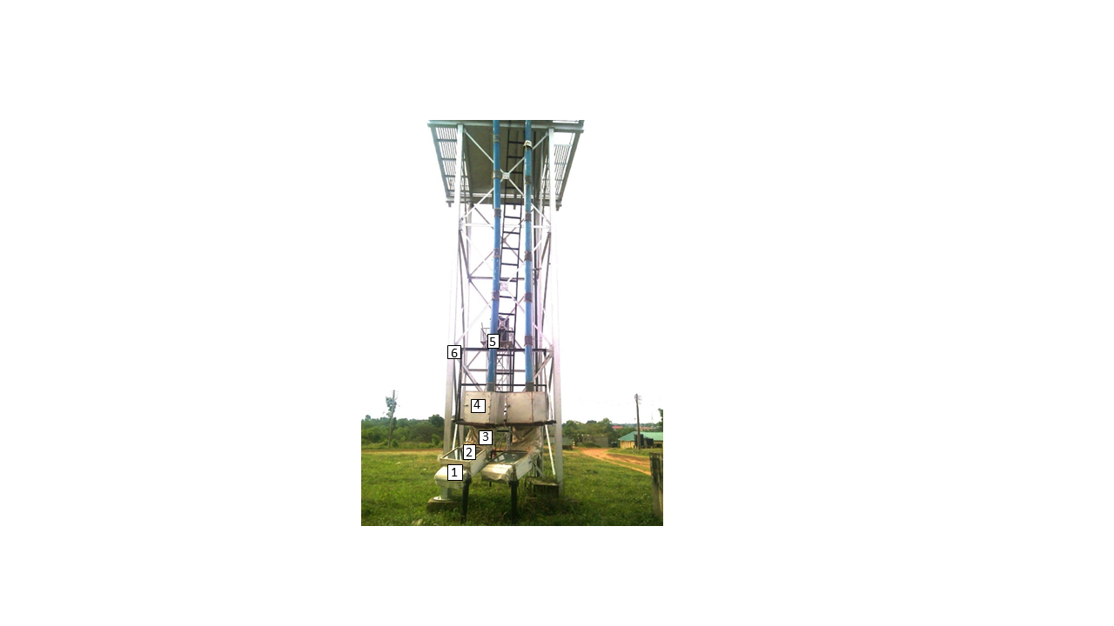
1. Air inlet hood; 2. Transpired glazed collector; 3. Duct; 4. Chamber; 5. Chimney;
6. Chimney Support.
Fig. 3. General features of the experimental rig
The difference in density between the warm air in the chimney 5 and the colder ambient air provided a buoyant pressure difference across the transpired plate that drove the process on. Thereafter the heated air flowed through the chimney pipe to the surrounding. The chamber was placed on steel bracket and the bracket and chimney pipe were supported by steel structure 6 of an existing overhead water reservoir. Fig 3 shows a second collector set up for comparing the performance of a GTC with a GNTC in a future study. The collector casing was constructed from 1mm thick mild steel sheets. The casing inner wall dimensions were 600 mm long by 600 mm wide by 250 mm high. The double walled casing had 25 mm gaps between the walls which were packed with insulation materials made of glass wool. The casing had a slot on one side which permitted the measurement of the surface temperature of the absorber test plate.
The cover glass which was acquired from the open market had a thickness of 5 mm. The optical transmittance of the glass was determined using a solar meter. This was done by first measuring the insolation without glazing and then measuring the insolation through the glazing and obtaining the ratio of insolation with glazing to insolation without glazing. The procedure was repeated three times and the average value of the transmittance of the glass was found to be 82% and the uncertainty of the transmittance is ± 1%.
A typical navy blue coloured transpired Aluminium test plate is shown in Fig. 4. The 0.55 mm thick Aluminium sheets that were used for production of the test plates were obtained from the open market. The test plates were 550 mm by 550 mm square. The solar absorption for navy blue colour was found to be 85% in the literature. The dimensions of transpired absorber test plates can be chosen for convenience [11].
The chimney was opaque and cylindrical in shape having an inner diameter of 150 mm and a thickness of 3mm. It was made of Unplasticized Polyvinyl Chloride (UPVC) and was obtained from the open market. The chimney material was chosen to minimize heat loss to the surrounding by conduction across its walls and also prevent transmission of solar radiation through its walls. The chimney was made up of seven sections of 1000 mm effective length per section to permit a study of the effect of the variation of chimney height on the performance of the GTC. A section of the chimney is shown in Fig. 5.
Fig. 4. Transpired Aluminium absorber test plate.

1
2
1. Section of upvc chimney
2. connection socket

Fig. 5 A section of the chimney used for the study
2.1.2. Instrumentation
Fig. 6 is a sketch of the experimental glazed transpired collector showing the positions of instruments used for measurement of various variables. The variables were solar radiation incident on the glass cover, absorber plate temperature, inlet air temperature, outlet air temperature and collector air velocity. The air inlet hood was installed to minimize the effect of wind on the performance of the air heater in natural convection mode. Prior to the installation of the hood, high wind speeds through the collector inlet resulted in the sudden cooling of the absorber plate. Consequently, low absorber plate temperatures were measured at such moments which did not reflect the measured high solar radiation values at such times.

Fig. 6. Sketch of the solar collector showing locations of instruments
Solar radiation data were collected with a solar radiation meter PCM-SPM 1(manufactured by PCE-Deutschland GmbH & Co. KG) made for measurement of solar radiation in the field and it is cosine corrected. It measured solar power in W/m² and has data logging capability. The meter has a sampling rate of 4 times per second. The instrument was placed on the glazing and measured the global radiation.
The surface temperatures of the absorber test plates were measured with 472A-1 Dual input Thermocouple Thermometer manufactured by Dwyer. A K-Type thermocouple having an L-bend probe suitable for solid surface temperature measurement was installed on the meter for the temperature measurements. The temperature and velocity of the heated air were measured with a hot wire anemometer made by Alnor TSI. The instrument has data logging capability.
Ambient temperatures were measured with AM4201A THERMO ANEMOMETER manufactured by Lutron. The optimal tilt angle for harnessing solar energy has been shown to range from 0º- 42º throughout the year in Nigeria [4]. The optimum angle was found to be 0º during rainy seasons (April to August) in all locations while the optimum angle increased in the range of 5º-42º during the dry season (September-March), reaching the maximum value in the month of December in all locations. This study was done from January to June with the January to March falling within dry season with optimum tilt angle range of 5º to 42º and the study period also fell partly within rainy season (April to June) with optimum tilt angle of Oº, so the optimum tilt angle for the entire study period was expected to be between Oº to 42º. A general practice has been to use the location latitude as the optimum collector tilt angle and it has been reported that a deviation from optimum collector tilt angle of up to 20º does not significantly affect solar irradiation on the collector [26]. The location of the study was Makurdi, Benue State, Nigeria, West Africa on Latitude 7.7ºN and a collector tilt angle of 17.7º was chosen as the tilt angle. The chosen collector tilt angle for this study met the optimum collector tilt angle requirement for dry season and was less than 20º deviation from the optimum tilt angle for rainy season. The angle of tilt was achieved using Wixey Digital Angle Gauge and the adjustment mechanism of the collector stand. Finally, a compass was used to align the GTC in a North South direction for optimum solar energy collection. The collector and instrument specifications are summarized in Table 1.
Table 1 Collector and Instrument Specifications
Parameter | Value
Location of collector | Makurdi, Benue State, Nigeria, West Africa
Collector tilt/location | 17.7º /(7.7ºN, 8.5ºE)
Collector orientation | South facing
Experiment period | January to June 2017
Length of collector | 0.65m
Width of collector | 0.65m
Air inlet entrance | 0.1m x 0.52m
Air outlet exit | 0.1m x 0.52m
Glass thickness | 5mm
Glass transmittance | 82%
Solar meter | PCM-SPM1(accuracy ± 10% and resolution of 0.1)
Hotwire Anemometer | Alnor TSI AVM440(accuracy: air velocity ±0.015m/s, resolution of ; air temperature ±0.3ºC and resolution of )
Thermocouple thermometer | Dwyer 472A-1(accuracy ±0.1% and resolution of )
Chimney pipe height | 8.04m (maximum)
Chimney pipe diameter | 0.15m (inner diameter)
Chimney pipe thickness | 0.003m
Chimney pipe material | UPVC
Aluminiun absorber thickness | 0.55mm
Absorber colour/Absorptivity | Navy blue/85%
Absorber dimension | 0.55m X 0.55m

2.2. Methods
To study the influence of the absorber hole diameter on the performance of the GTC a dimensionless ratio of Pitch(mm) to hole diameter D(mm), P/D was used. The pitch P and the diameter D of the absorber plate are as shown in Fig 7.
D
P
P
P: Pitch
D: Hole diameter
P
Fig. 7. A transpired absorber plate with circular holes on triangular pitch
The pitch (P) of the absorber plates was fixed at 25 mm while the diameter (D) of the plates were 1.0 mm, 1.5 mm, 2.0 mm, 2.5 mm and 3.0 mm respectively. The performance was measured in terms of collector thermal efficiency, η and heat exchange effectiveness ε, which are dimensionless quantities. Note that the efficiency and heat exchange effectiveness are expected to be constant for a given absorber plate geometry and pressure difference across the Absorber. The pressure difference will determine the air velocity and hence the air mass flow rate through Absorber holes. The averages of heat exchange effectiveness and thermal efficiencies obtained from the period of study for the absorber plates having hole diameters of 1.0mm, 1.5mm, 2.0mm, 2.5mm and 3.0mm were plotted against P/D of the plates as shown in Fig 8 section 4.1 and Fig 9 section 4.2 respectively. The trendline that gave the highest R² value was used to fit the data points for each plot in this study. Having adequate air velocity through the collector is necessary for the performance of the GTC in natural convection mode. A sufficient air flow rate ensured adequate mass flow of the air and hence greater energy transfer for application. The chimney heights used for the study on the influence of chimney height on the collector air outlet velocity were 4.04 m, 5.04 m, 6.04 m, 7.04 m and 8.04 m respectively while the absorber plate used in the test had 3.0 mm diameter holes with hole pitch of 25 mm. The absorber plate which had 3.0mm diameter holes and 25mm pitch was chosen for this test because it had the best thermal efficiency [25]. The averages of the collector air velocities were plotted against the various dimensionless chimney heights where the chimney height H was divided by the Absorber effective length L to obtain the dimensionless height. The pressure differences were computed from Equation (5) [25]. The Absorber effective length was measured along its length from the center of the first row of holes to the center of the last row of holes and had a numerical value of 0.343m. The result of this test is shown in Fig . 10 section 4.3.
The absorber plate which had 3.0mm diameter holes and 25mm pitch was also used for the study on the influence of chimney heights on the pressure difference across the collector. The pressure differences across the collector were plotted against chimney heights of 4.04m, 5.04m, 6.04m, 7.04m and 8.04m (Fig 11 section 4.4). The influence of the pressure difference across the Absorber on the thermal efficiency of the collector was also studied. The pressure differences were plotted against efficiencies of the Absorber using the absorber with the 3.0mm diameter holes and 25mm pitch for the test. The result of this test is shown in Fig. 12 of section 4.5.
2.2.1 Uncertainty Analysis
The average values of the various variables required to evaluate the performance of the GTC are given by Table 2. Performance parameters which includes heat exchange effectiveness ε, and solar to thermal energy conversion efficiency η, were computed from Equations 1 and 2, Ekoja et al.[25].
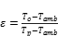 (1)
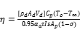 (2)
The authors gave the following values for the constants in Equation 2: density of air at collector exit(or duct inlet) ; area of cross section of collector exit(or duct inlet) ; specific heat capacity of air ; thermal absorptivity of navy blue absorber plate ; transmissivity of the glass ; the area of the absorber plate . These constants were used in this work since the absorber plates of this work have the same specifications as the ones used in [25]. Putting these constants in Equation 2 and simplifying yields Equation 3.
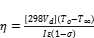 (3)
Where the porosity of the absorber plate, was defined in terms of the absorber hole diameter and the pitch of the holes given by Equation 4.
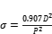 (4)
The absolute uncertainties of the variables required for determining the performance of the collector for various absorber plate diameters and the absolute uncertainties of the performance parameters are given by Table 3. The uncertainties of the performance parameters were calculated from Equations 6 and 7. The fractional uncertainties of the variables and of the heat exchange effectiveness and efficiencies are given by Table 4. Note that the magnitude of air velocities through the collector have the greatest influence on the efficiency of the collector. Note also that the fractional uncertainties of the measured velocities through the collector with absorber plates having hole diameters of 1.0 mm and 1.5 mm were and respectively ( see Table 4), which are much higher than values of less than which is the acceptable practice in Engineering. These high values of uncertainties were as a result of the inability of the instrument to measure the very low velocities through the 1.0 mm and 1.5 mm diameter holes accurately due to the high resistance to air flow through them. [25].
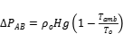 (5)
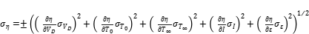 (6)
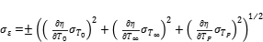 (7)

Table 2 Average values of variables for various diameters of absorber test plates
Absorber plate  Hole diameter (mm) |  |  |  |  | ε | η
1.0  1.5  2.0  2.5  3.0 | 33.3  34.0  33.3  33.0  34.8 | 56.4  54.7  47.8  46.5  46.6 | 0.005  0.011  0.052  0.065  0.083 | 957  853  630  618  503 | 0.97  0.93  0.90  0.83  0.78 | 0.037  0.086  0.399  0.514  0.754

Table 3 Absolute uncertainties of variables for various diameters of absorber plates
Absorber plate
Hole diameter (mm)
1.0  1.5  2.0  2.5  3.0 | 0.05  0.05  0.05  0.05  0.05 | 0.05  0.05  0.05  0.05  0.05 | 0.002  0.002  0.002  0.002  0.002 | 0.05  0.05  0.05  0.05  0.05 | 0.003  0.003  0.004  0.004  0.004 | 0.037  0.039  0.038  0.040  0.046

Table 4 Fractional uncertainties of variables for various diameters of absorber plates
Absorber plate  Hole diameter (mm) | 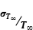 | 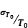 | 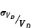
1.0  1.5  2.0  2.5  3.0 | 0.00150  0.00147  0.00150  0.00152  0.00144 | 0.000887  0.000914  0.00105  0.00108  0.00107 | 1.000  0.455  0.096  0.077  0.060 | 0.0000522  0.0000586  0.0000794  0.0000809  0.0000994 | 0.0031  0.0032  0.0044  0.0048  0.0051 | 1.000  0.453  0.095  0.078  0.061

- RESULTS AND DISCUSSION
4.1. Influence of Absorber Hole Diameter on Heat Exchange Effectiveness
The results showed that the heat exchange effectiveness decreased with decrease in P/D as shown by Fig. 8. A decrease in absorber plate hole pitch to diameter ratio implies an increase in absorber plate hole diameter since the pitch was kept constant. It follows that the heat exchange effectiveness decreased with increase in the absorber hole diameter [27]. The heat exchange effectiveness is a ratio of the difference between the air outlet temperature and ambient temperature to the difference between absorber plate temperature and the ambient temperature. Larger absorber plate hole diameters result in reduced resistance to induced air flow and enhance large mass flow of air through the absorber. The increased mass flow of air through the absorber will result in decrease in the air outlet temperature at a given insolation on the absorber. This leads to reduction in the difference between air outlet temperature and ambient air temperature which in turn reduces the heat exchange effectiveness.
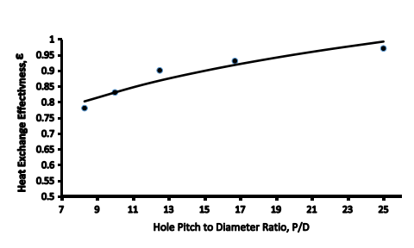
Fig. 8. Plot of Heat Exchange Effectiveness against Hole Pitch to Diameter Ratio.

4.2. Influence of Absorber Hole Diameter on Collector Thermal Efficiency

The results showed that the thermal efficiencies decreased with increase in P/D as shown by Fig. 9. As stated earlier, an increase in P/D implies a reduction in absorber plate hole diameter. It follows that the efficiencies decreased with decrease in the absorber hole diameter [14,27]. It has been earlier stated that a reduction in absorber plate hole diameters would result in increased resistance to induced air flow and consequently a reduction of mass flow of heated air through the air heater. The reduction in mass flow of heated air would in turn affect the heat transfer rate by the air since the heat transfer rate is a function of the mass flow rate of the heated air. This implies that a decrease in absorber plate hole diameter results in lower mass flowrates and consequently smaller quantities of useful energy transfer by the heated air. Note that low rates of useful energy transfer results in lower thermal efficiencies of the collector. Conversely, larger absorber plate hole diameters result in increased mass flow rates through the absorber plate and air heater. This in turn yields higher useful energy transfer rates by the air heater giving higher thermal efficiencies. This explains why thermal efficiencies decreased with decrease in absorber plate hole diameters.

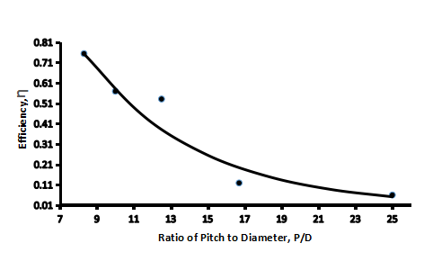
Fig. 9 Plot of Efficiency against Hole to Diameter Ratio.
4.3. Influence of Chimney Height on Collector air Velocity
The results showed that the collector air velocities increased with increase in chimney height as shown by Fig. 10. As stated previously, buoyancy pressure depends directly on chimney height and an increase in chimney height leads to increased pressure across the absorber plate which results in increased air velocity through the collector [22]. It has been stated earlier that the air velocity through the collector has a significant influence on the thermal performance of solar air heater.
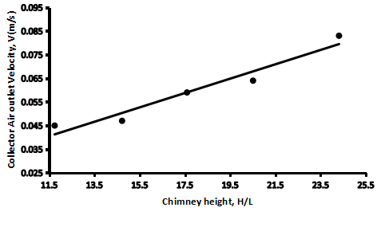
Fig. 10 Plot of Air Velocity against Dimensionless Chimney Height
4.4. Influence of Chimney Height on Pressure Difference across Collector

The results showed that the pressure difference across the collector increased with increase in chimney height as shown by Fig. 11. As already stated, buoyancy pressure depends directly on chimney height and an increase in chimney height leads to increased pressure across the absorber plate, [22]. The linear relationship between chimney height and the resulting pressure produced across the absorber plate is in agreement with what is in the literature.
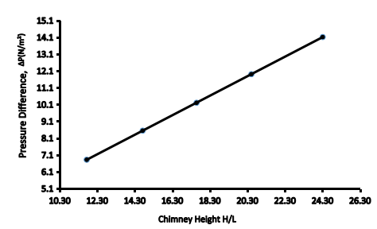,
Fig. 11 Plot of Pressure Difference against Dimensionless Chimney Height
4.5. Influence of Pressure Difference across Collector on the Thermal Efficiency of the Collector
The results showed that the thermal efficiencies of the absorber test plates increased with increase in pressure difference across the test plates as shown by Fig. 12. As stated before, an increase in pressure across the absorber plate results in increased air suction velocity through the absorber plate. It has also been stated that the air suction velocity and by implication, the mass transfer rate has a significant influence on the thermal efficiency of solar air heaters. High mass flow rates yield increase in useful energy gain by the air that flows through the absorber plate which in turn yields high thermal efficiencies. It therefore follows that increase in pressure across the absorber plate gave high air suction velocities leading to increased useful energy gain and also thermal efficiencies. This explains the result shown by Fig. 12.
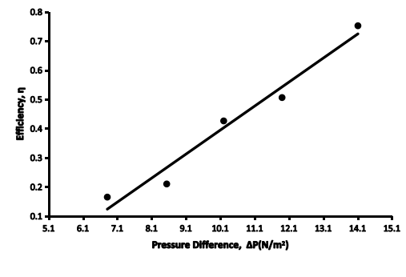
Fig. 12 Plot of Pressure Difference against Efficiency.

5. CONCLUSION
The experimental study on a glazed transpired solar collector with chimney in natural convection mode has been carried out. The results of the study showed heat exchange effectiveness decreased with increase in absorber hole diameter. Thermal efficiency increased with increase in absorber hole diameter. Thermal efficiency also increased with increase in velocity of air through the collector and pressure difference across the absorber. The pressure difference across the collector and air velocity through the collector increased with increase in chimney height. The study showed that the GTC with chimney has a promise for application in the areas of space heating and crop drying in natural convection mode. The GTC with absorber plate having 3.0 mm diameter holes provided the best performance with thermal conversion efficiency of 75.4%. The chimney height of 8.04 m provided the highest pressure difference and induced air velocity through the collector corresponding to the best performance. A study on the comparison of the GTC and GNTC for drying of crops in natural convection mode has been carried out and will be reported subsequently.

Nomenclature
A_{coll} = total frontal area of collector (including holes)(m²)
= specific heat capacity of air at constant pressure (kJ/kgK)
D= Absorber Plate hole diameter (m)
g = acceleration of gravity (m/s²)
I= solar radiation incident on collector (W/m²)
L or P = pitch (m)
P = pitch of holes in the absorber plate (m)
T_{out,air} or T_{o} =Temperature of heated air exiting the collector (K)
= absorber plate temperature (K)
= ambient air temperature (K)
= Collector air velocity (m/s)
Greek
= collector tilt angle
= absorber plate absorptivity
σ = porosity
= uncertainty of the value of thermal efficiency
= uncertainty of the value of heat exchange effectiveness
= pressure difference between points A and B (N/m²)
ε = collector heat exchange effectiveness
η = collector efficiency
ρ = density (kg/m³)
= transmittance of the glazing

References

[1] Li, X., Zhang, X., Wang, Z., Wang, C., Yao, W., Xu, X., Zheng, S.: Dust accumulation effect of glazing cover inner surface on the performance of transpired solar air collector. Renewable Energy (2022). https://doi.org/10.1016/j.renene.2022.06.084
[2] Li, X., Qin H., Zhang, Y., Yao, W., Li, Y., Liu, H.: Dust effect on the optical-thermal properties of absorber plate in a transpired solar air collector. Energy Conversion and Management (2018). https://doi.org/10.1016/j.enconman.2018.05.023
[3] Duffie, J.A., Beckman, W.A.: Solar Engineering of Thermal Processes. John Wiley & Sons, Inc., New York(1980)., 10-11.
[4] Temitope, R.A., Ayodeji, S.O., Samuel, O.: Determination of optical tilt angles in some selected cities of Nigeria for maximum extractable solar energy. Int. J. Renewable Energy Technology, 9(4): 453-483(2018). DOI:10.1504/IJRET.2018.095800.
[5] Myhan, R., Bieranowski, J., Kowski, Z.S., Sitnik, E.: The effect of local meteorological conditions on the optimal tilt angle of a solar energy collector - A case study in Poland. ASME J. Sol. Energy Eng 139(4): 044501(2017). DOI:10.1115/1.4036637.
[6] Gawlik, K.M., Christensen, C., and Kutscher, C.: A numerical and experimental investigation of low-conductivity unglazed transpired solar air heater. ASME J. Sol. Energy Eng 127, 153-155(2005).
[7] Kutscher, C.F.: Transpired solar collector system: A major advance in solar heating. Proceeding of the World Energy Engineering Congress, November 6-8, Atlanta, Georgia, 1-9(1996).
[8] Walker, A., Renne, D., Bilo, S., Kutscher, C., Burch, J., Balcomb, D., Judkoff, R., Warner, C., King, R.J., Eiffert, P.: Advances in solar buildings. ASME J. of Solar Energy Eng 125, 236-244(2003).
[9] Jasim Mahmood, A.: Experimental study of a solar air heater with a new arrangement of transverse longitudinal baffles. ASME J. Sol. Energy Eng 139(3), 031004(2017).
[10] Nowzari, R., Saygin, H., Aldabbagh, L.B.Y.: Evaluating the performance of a modified solar air heater with cover and packed mesh layers. ASME J. Sol. Energy Eng 143(1), 011006(2021)
[11] Rhee, S.J., Edwards, D.K.: Comparison of test results for flat plate, transpired flat plate, corrugated, and transpired corrugated solar air heaters. ASME J. of Sol. Energy Eng 105, 231-236(1983).
[12] Roozbeh, V., Ilkan, M., Egelioglu, F.: Experimental performance of glazed solar air heater and unglazed transpired solar air heater. Solar Energy 119, 251-260(2015).
[13] Meng, G., Dengjia, W., Yangfeng, L., Yingying, W., Yong, Z.: A study on the performance of a novel glazed transpired solar collector with perforating corrugated plate. Journal of Cleaner Production (2020). https://doi.org/10.1016/j.jclepro.2020.120443
[14] Wandong, Z., Bojia, L., Huan, Z., Shijun, Y., Ying, L., Tian, Z.Y.: Thermal characteristics of a glazed transpired solar collector with perforating corrugated plate in cold regions. Energy 109, 781-790(2016).
[15]. Wandong, Z., Huan, Z., Shijun, Y., Yindan, F.: Experimental investigation of the transpired solar air collector and metal corrugated packing solar air collector. Energies 10, 302(2017). doi: 10.3390/en10030302.
[16] Sima, C., Teodosiu C., Croitoru, C., Bode, F.: Analysis of numerical and experimental results of a solar glazed air collector configuration in Romania climate. 7th Conference of sustainable solutions for energy and environment, Bucharest, Romania, Oct. 21-24, IOP Conf. Ser. Earth and Environmental Science(2021). doi:10.1088/1755-1315/664/1/012085
[17] Yan, J., Huan, Z., Yaran, W., Shijun, Y., Zhangxiang., W., Man, F., Liwen, W., Shen, W.: A comparative study on the performance of a novel triangular solar air collector with tilted transparent cover plate. Solar Energy 227, 224-235(2021).
[18] Afaq, J.M.: Experimental study of a solar air heater with a new arrangement of transverse longitudinal baffles. J. of Sol. Energy Eng. 139, 031004(2017). Doi:10.1115/1.4035756.
[19] Nowzari, R., Saygin, H., Aldabbagh, L.B.Y.: Evaluating the performance of a modified solar air heater with cover and packed mesh layers”, ASME J. Sol. Energy Eng. 143(1), 011006(2021).
[20] Khaki, M., Shahsavar, A., Khanmohammadi, S.: Scenario-based multi-objective optimization of an air-based building-integrated photovoltaic/thermal system. ASME J. Sol. Energy Eng. 140(1), 011003(2018).
[21] Jakhar, S., Soni, M., Boehm, R.F.: Thermal modelling of a rooftop photovoltaic/thermal system with earth air heat exchanger for combined power and space heating ASME. J. Sol. Energy Eng. 140(3), 031001(2018).
[22] Pritam D., Chandramohan, V.P.: Effect of chimney height and collector roof angle on flow parameters of solar updraft tower (SUT) plant. Journal of Thermal Analysis and Calorimetry (2019). https://doi.org/10.1007/s10973-018-7749-y
[23] Marwa, A., Ameni, M., Hatem, M., Philippe B.: Parametric investigation on the performance of natural convection flat plate solar air collector with additional transparent insulation material parallel slats(TIM-PS). Solar Energy 231, 379-401(2022). https://doi.org/10.1016/j.solener.2021.11.053
[24] Kutscher, C. F.: Heat exchange effectiveness and pressure drop for air flow through perforated plates with and without crosswind. J. of Heat Transfer 116, 391-236(1994).
[25] Ekoja, M., Onyegegbu, S.O., Ekechukwu, O.V.: Theory of a glazed transpired solar collector in natural convection mode. Journal of Sol. Energy Eng. 145, 021012(2022).
DOI:10.1115/1.4055300.
- Kokouvi, E.N.: Effect of orientation and tilt angles of solar collectors on their performance: Analysis of the relevance of general recommendations in West and Central African context. Journal of Scientific African 15, e01069(2022).
https://doi.org/10.1016/j.sciaf.2021.e01069

[27] Dengjia, W., Qian, G., Yanfeng, L., Yingying, W., Yaowen, C., Yuan, L., Jiapin, L.: Experimental study on heating characteristics and parameter optimization of transpired solar collectors. Applied Energy 238, 534-546(2019). https://doi.org/10.1016/j.apenergy.2019.01.004.
https://doi.org/10.1016/j.energy.2019.02.168.

