**INFLUENCE OF CONFLICT MANAGEMENT ON EMPLOYEES’ PERFORMANCE OF ONDO STATE WATER CORPORATION**

**ABSTRACT**

*This study evaluated the influence of conflict management on employees’ performance of Ondo state water corporation in Ondo state Water Corporation. The study employed survey research design* *in order to utilize a structured questionnaire in the collection of data for* *analysis. The sample size for the study was one hundred and seventy two (172). The hypothesis was tested and* *analyzed using a simple linear regression analysis model applying a* *statistical package for social sciences (SPSS) version 26. The study* *found that there are positive effects of conflict avoidance strategy on* *employees’ performance of the Ondo state Water Corporation. There is a significant effect of conflict collaboration* *strategy on employees’ commitment to goals achievement. There is a* *significant relationship between conflict accommodation strategy and* *employees’ motivation. There is also a significant conflict mediation* *strategy on employees’ involvement in the Ondo state Water Corporation. Based on the findings, the study* *recommended that management of organizations or institutions should* *monitor and intervene on issues that can lead to conflicts in order to* *enhance employees’ performance by adopting avoidance strategies.* *Management should employ a collaboration strategy or approach of* *win-win method of conflict resolution in order to enhance employees’* *commitment. Management should also attend to conflicting situations as* *urgently as possible in order to avoid those factors that can hinder* *employees’ motivation and commitment to goal achievement.* *Management should also use a mediator in resolving conflicts on a* *continuous basis*

**INTRODUCTION**

Businesses environment are dynamic, constantly changing and turbulent. Organizations strife to survive, maintain competitiveness and improve performance despite the unfriendly situations (Dodd, 2003). Conflict is anticipated where people of different characters, attitudes, opinions, perceptions coexist (Fareo & Mohammed, 2018). Conflicts cannot be prevented in any human eadeavour but can be effectively managed depending on the handlers. Dahrendorf, (1979), posited that conflicts are inevitable and a common phenomenon in social interactions. In support of the above position, conflicts do arise any human gathering be it family, association or organizations and when it occur, resolution mechanism is raised to resolve it for organization health and progress. Obisi (1996) stressed the fact that peace forms one of the basic factors that increased productivity with resultant benefits to both employees and employers as well as economic development. Most of the time, conflicts are sustainable instrument to implement a significant change in the workplace. Consequently, the rift between employers and employees often produce mutual understanding, industrial harmony, and positively improve workers welfare. Esquivel and Kleiner (1997) concluded in their study that incompatible interest of individual or groups result in discord and frustrations in the workplace. The inevitability of conflicts in organizational life is premised on the incompatible of the stakeholders’ interests, goals and aspirations (Jones et al, 2000). It is expedient that two individuals may differ in their views, aspirations, value addition, perceptions, attitudes and character, these indexes increases the likelihood of conflict in social gatherings. This assertion, is supported by the view of Loomis and Loomis (1965) argue that in human relations, conflict is believed to be a continuous process. Conflict could arise because of the employee quest to maximise profit while workers representatives are out to ensure continuous improvement on the condition of work and standard of living for their members. In a bid to contend for jobs, scarce resources, power pursuit, self-recognition, security and social status, which made conflict sacrosanct organization life (Rain., Lane, & Steiner, 1991). Management of conflict entails strategy implementation to improve the positive aspects of conflict and reduce the negative aspect of conflict. In the study of Farace, Monge, & Russel, (1997), agreed that conflict management identify and handle conflict sensibly, fair, equitable, and efficient manner. Truly, conflict management increase learning and enhance group outcomes. Employee performance, It is about how the workers can be able to achieve organizational objectives basing on agreed measures, skills, competency requirements, when there is a direct and quantifiable links between customer service variables such as satisfaction, loyalty and employee variables like enthusiasm, commitment, capability, and internal service quality to deliver results and to create a high performance workforce, Frederick Reichheld's (1996). According to Olu and Abolade (2014), concluded that effective conflict management, conducive working environment, and efficient communication greatly increase employees’ performance and also reduce conflicting issues in the workplace. In recent time, inability to retain qualified, trained and experienced workers has been a major challenge facing most organization (Zayed et. al, 2022; Kundu & Gahlawat, 2016). Performance is the behaviour and results displayed by an individual in getting his work done (Ayat, 2019). Employees’ performance is major determinant of firm’s survival and well performing employee enhances organisation’s success and efficiency (Baranga & Maende, 2019). Employees in any organization, particularly in Ondo State Water Corporation are the brain behind the success of the nation as well as the anchor to find its bearing in the dynamic world. Among the factors influencing employees’ performance in the workplace were organization culture, employees’ empowerment, and knowledge management (Mohand, 2020). According to Kuruppu *et al*., (2021) concluded that the most valuable asset of an organization is the human resources which determine its success and survival. Thus, the performance of any going concern solely depend on its human resources on which the entire organization performance is anchored. In the study of Adeyefa, et al (2023), employees are the workforce or appointees of an organization that drive and sustain organization’s success and success. Employees are acknowledged in both profit and non-profit making organizations as the major driver of high performance and quality delivery.

**Statement of the Problem**

Conflict is inevitable in industrial relations, mostly it arises from poor communication, inadequate planning, scarce and poor allocation of resources, poor interpersonal relationships, poor working conditions, work hazards, poor remuneration and the likes. Many times agreements are reached as a means of resolution but inability to keep and follow the agreement to the letter continue to worsen the situations in the workplace especially in the water corporation in Ondo State. More often than not conflicts well managed with good commitment will bring progress and lasting solution. Employees and employers in most cases in the workplace, have poorly managed conflicts and neglected the part of commitment. This has led to poor decision making, poor commitment of workers, decline performance, low morale and unsatisfied workforce. Ondo State Water Corporation is not immune from conflict because conflict is anticipated where people of different characters, attitudes, opinions, and perception co-exit. Edeh et al, (2021) posited that more productive organizations in terms of customer service and societal orientation most likely retain satisfied and trained workers. According to Chatzoudes and Prodomos (2022), identified proper workers’ retention enhance performance, increase efficiency and greatly improve social responsibility.

**Research Questions**

The following questions are pertinent to the research:

1. What have been the consequences of conflict to Ondo State Water Corporation?
2. What are the strategic measures for managing conflict in Ondo State Water Corporation?

**Research Objectives**

1. To investigate the consequences of conflict on employees’ performance in Ondo State Water Corporation.
2. To assess strategic measures for managing conflict in Ondo State Water Corporation.

**Research Hypotheses**

1. Consequences of conflict have no significant effects on employees’ performance in Ondo State Water Corporation.
2. There is no strategic measure for managing conflict in Ondo State Water Corporation

**LITERATURE REVIEW**

**Conceptual Review**

Conflict Management according to Mary Parker Follett (1868-1933) hypothesized that conflict is neither good nor bad and managers could resolve it by, one side giving in, compromise, or integration. Dissatisfaction and frustrations in the workplace are major causes of conflicts which invariably hinder the achievement of organizational objectives. Conflict is disagreement between two individuals or groups having incompatible concerns. Conflict is a reality, in as much as people are of diverse opinions, views and goals opposing each other. Omene (2021) defined conflict as any disagreement between individuals in the same or different organizations. Conflict occurs when an action by one party is perceived as preventing or interfering with goals, needs or actions of another party. Mullins (2005) sees conflict as behaviour intended to obstruct the achievement of some other person’s goals. This indicates that, conflict is based on the incompatibility of goals and arises from opposing behaviours. Also, it can be view at individual level, group level, and organizational level. Conflict can arise over a multiple of organizational experiences, namely incompatible goals, differences in the interpretation of facts, negative feelings, differences of values and philosophies, or disputes over shared resources. Conflict is present in every organization, so organization must develop strategies to combat there when the need arise. Conflicts have given rise to distrust and hostility among professionals, thus hindering smooth, effective and efficient administration in the workplace. Many scholars suggest that conflict can be constructive (functional) or destructive (dysfunctional). Functional conflict is challenging of ideas, beliefs, and assumptions, and respect for others’ viewpoints even when parties disagree (Massey & Dawes: 2017). Dysfunctional conflict is thought to increase dissatisfaction and decrease the affective wellbeing of the employees and decline the organizational efficiency (Rahim, 2020).

**2.1.2 Employees’ Performance**

It is sacrosanct to say that a satisfied workforce will definitely be happy which is instrumental to the survival, growth and the success of the organization. Properly managed conflicts in the workplace couple with good communication enhance greater commitment improve employees’ performance. According to Meir Liraz (2018) opined that poor planning, poor working conditions, unfair treatment of employees ‘complaints, poor allocation of the resources can result in conflicts in the workplace.

Nwinami, (2014) posited that knowledge, skills, and attitudes were major determinants of employees’ performance in the workplace. Employees in Ondo State Water Corporation are the backbone and sustainable instruments quality service delivery. According to Adubasim *et al*., (2018), every organisation whether profit or non-profit oriented, take the issue of employees’ performance very crucial because it determines the continued existence and survival of an organisation.

Scholars such as (Oyewunmi, 2017) concluded in their studies that employees’ performance was declining due to low morale, lack of cooperation, and poor attitudinal pattern among the workers. The diminishing trend was alarming as observed by Gallup State of Workplace Report (2022), and this is having a serious implication on employees’ performance. Organizations in the digital age are striving to build a well-motivated and highly satisfied workforce to be able to achieve their stated objectives and compete better while sustaining a competitive edge over orders. Dunmade *et al*., (2021) submitted that unsatisfied workforce would rather engage in social vices than investing quality time to achieve organizational objectives. But satisfied workforce will be instrumental to quality service delivery, efficiency, effectiveness and increased productivity in the workplace.

The performance of employees in Ondo State Water Corporation is experiencing decline and this more challenging in present economic situation. Employees’ morale is very low, poor training, poor payment salary below expectation and more challenging because government pays salaries based on percentage with backlog of unpaid wages, which have been lowering the spirit of commitment to work (Dunmade *et al.*, 2021). Most importantly, when employees’ morale is low, their commitment, performance and outputs will decrease drastically. Employees’ performance is viewed as the major and key driver of organisation’s survival and success.

According to Kaplan and Norton (1992), Employees’ performance in the workplace can be assessed through some measures such as customer measures (delivery time, service/ product quality; innovation and learning perspective (ability to innovate, improve); financial measures (sales growth, profits, cash flow, increase market share); and internal business measure (cycle time, productivity, labour turn).

**Causes of Workplace Conflict**

Employer and employee conflict in any industrial set up is a common phenomenon. Conflict arises due to the differences in our perceptions, view, values, and priorities in life. Poor communication between employers and managers is one of the causes of conflict. Should the problem remain unsolved, productivity will decrease and employees’ morale will be low. Employees’ personality differences is another source of conflicts in the workplace. Employees’ background and experiences are not similar, failure to raise these facts of life fast track conflicts in the workplace. Turner and Weed (1983), opined that competition among employees especially when salary is tied productivity. When competition is not properly managed in the workplace, may result in sabotage, quarrels thereby creating unpalatable work environment and poor teamwork. Poor planning as a result of faulty structural design will cause conflicts in the industrial set up. Scarce resources namely money, materials, space, time, and other facilities will naturally lead to interpersonal conflicts (Deutsch, 1991). Different perspectives among employees and stress breed disagreement and motivate conflicts in the workplace. Conflicts are intensified by personality differences, perspective differences, pressure, and pursuance of personal goals at the detriments of organizational goals. Responsibility not clearly defined, inadequate resources and goal incompatibility trigger conflicts in the workplace.

**Consequences of Conflict on Employees’ Performance**

Conflicts sometimes bring peace, conducive atmosphere for creativity and innovation. Facts can be clarifies, mutually acceptable way of living may sorted out, and cooperation may be built through conflict resolution process. Conflicts resolution may result into new policy formulation and birth worthy creative ideas that will enhance productivity and interrelationship in the workplace. Many times conflicts result in great damage to the property of the organization.

Employees’ unrest and dissatisfaction with the job are resultant of conflicts (Anderson, et al, 2002). Conflicts lead to strikes and other practices such as theft during protest and destructive damages in a system. The negative aspect of conflicts lead to low productivity, poor commitment on the part of employees. Conflicts must not be allowed to linger for the sake of organizational achievement of the objectives. (Brahm, Eric 2017) posited that inability to communicate direction leads to conflicts. Unresolved conflict breeds tension, rivalries and inability to create new ideas that will sustain lasting progress in the workplace. The quality of job, product quality and outputs are badly affected by prolong conflict. This can jeopardize workers’ welfare, safety and productivity of the organization. Conflict may linger because both parties are claiming rights and this will frustrate production thereby unable to meet the deadline for supplies. When management sleeps over conflicts leaving it unresolved, hostility increase, misconceptions abound leading to labour turnover, low morale and lack of trust among employees. Schmidt (1974), posited that the outcomes of conflict are both positive and negative. The positive outcomes of conflict are production of better ideas, search for new approvals, resolution of long standing problems, clarifications of views and perceptions, enhanced creativity and innovation, and chance to prove ones capabilities. While the negative outcomes of conflict were defeats, poor relationship, increase distance between people, suspicion and lack of trust, lack of cooperation among people in a team or department, pursuance of personal interest, and workers turnover.

**Conflict Resolution Process in Nigeria**

Conflict can be prevented by effective management of issues, making productive efforts to prevent the occurrences of conflict in the workplace. Other methods of conflict resolution include (i) joint consultation (meeting between the aggrieved parties may be employee and employer, discussing the joint benefits to be derived from such meeting that makes joint consultation suitable for discussing industrial disputes); (ii) mediation (section 3 of the amended Trade Dispute Act (1977), provides a comprehensive process of dispute settlement aside the internal procedure); (iii) collective bargaining (this method explore the principle of voluntarism); (iv) conciliation ( appointment of conciliator who looks into the cases and circumstances of the dispute, negotiating between employee and employer, to bring about a settlement); and (v) arbitration (arbitration procedure is employed though is time consuming).

**Theoretical Framework**

**Abraham Maslow Theory of Needs:** The theory was propounded by Abraham Maslow (1908-1970), it suggests that human needs are fundamental to conflicts in an organization. There is a link between human needs and performance, fulfilling the needs improve the chances of survival and motivation for individual to perform well. He posited that the denial of these essential needs underlie social conflicts in the workplace, and that whosoever falls a victim definitely will fight until the attainment of the goal. This applies to all employees across the globe. Key findings revealed that there is a relationship that exits between employees’ satisfaction and organizational performance. When employees are satisfied, performance at individual and organizational level increase indefinitely. The motivation to do more is embedded in fulfilment of the basic needs (physiological, safety, love, esteem, and self-actualization).

**Process Theory:** This theory was proposed by Goldman (1996), it states that conflicts in organization is a reliable developmental tendencies (Alade, 1998). This is to say that innovations and creativity are products of non-destructive conflicts in organizations and most of the time leads to better conflict resolution procedures. The importance of the theory to this study is that good conflicts resolution has direct link to individual and organizational performance.

The theory that underpin this study is Abraham Maslow theory of needs, which proposed that the satisfaction of human basic needs motivate them to more, achieve their goals and in improve tremendously organizational performance.

**Empirical Review**

Frequent conflicts in universities and colleges of education in Nigeria is at alarming rate (Adeyemi & Ademilua, (2012), Olaleye & Arogundade, (2013). The study further revealed that poor communication between workers and management as the major cause of conflict in the institutions. Akhtar and Hassan (2021) investigated the effect of conflict management styles on organization commitment in Pakistan and found that integrating style predicted the commitment of workers compare to other conflict management styles. Dialoke and Edeh (2017) examined conflict resolution strategies and workers’ commitment in Rivers State, Nigeria and found that conflict resolution strategies such as integrating, collaborating and compromising strategy have significant positive relationship with workers’ commitment. Osabiya (2015) examined the best practice in resolving conflict in Nigeria public sector and found that compromising can be used to settle conflict between an employee and management. Omene (2021) explored conflict management strategies as a prerequisite for effective organizational performance and found that resolution strategy enhances good relationships with other stakeholders in the organization. Many scholars have identified different conflict management strategies being used in the workplace. In the study of Oyebade, (2000); Adeyemi, (2010); Adeyemi and Olumilua, (2012); and Olaleye and Arogundade, (2013) indicated that dialogue has been the most effective strategy in resolving conflict between two parties. Similarly, effective communication was identified in the study of Meyer, (1994) as the best instrument that can be employed in conflict management.

Wonah, Oluo, Ake and Benjamin (2020) conducted a study on conflict management strategies and organizational performance of River State civil service. The survey design was adopted in the study. The population of the study was three hundred and eighty (380) respondents (RSCS, 2018). A sample of 200 respondents was drawn out of the population of Rivers State Civil Service. The data used for this study was obtained from primarily sourced, and secondary data was also used and it was drawn from literature. A structured questionnaire was used to collect primary data in the study. The study showed that mediation is a predictor of organizational performance. The regression equation for predicted organizational performance, and negotiation is also a predictor of organizational performance. The study recommended that organizations should focus on increasing the utilization of conflict management strategies like negotiation and third party intervention to increase organizational performance, and that management should be sensitive to conflicts and set up effective communication channels to facilitate an improvement in conflict management.

Saidu (2021) conducted a study on the effect of conflict management styles on employees’ performance in selected institutions of higher learning in Nigeria. The study adopted survey research design. Primary and secondary data were used for the study primary data were collected using a structured questionnaire. The population of the study was 687. Smart-PLS software was used to analyze the data and test the hypotheses. The study revealed that the most common sources of conflict were needs, roles, pressures, goals, perception and styles, violation of agreement reached between the government, management and the labor unions, denial of promotion when due and non-payment of promotion arrears. The study recommended that management of the institutions should ensure that employees are promoted based on merit and not on sentiments because it will not only encourage the hard working ones, but it will also reduce the waves of industrial disputes in the institution. The management of the institutions and government should also ensure the sanctity of all agreements signed with the unions at all times to avoid frictions and some compelling costs especially on the students and the entire community as a whole.

Wabi (2021) had a study on the effect of conflict management on employee performance of selected banks in Abuja, Nigeria. The study adopted survey and quantitative research designs. The population was 187 respondents. The sample size was 124 respondents, using simple random sampling techniques. Primary data was collected using a structured questionnaire. Simple linear regression and Pearson Product Moment Correlation Coefficient was used to test the hypotheses. The study revealed that conflict management strategies such as avoidance, accommodation, competition, compromise, collaboration, mediation, counseling, team resolution has a significant effect on employees’ performance as well as organizational performance. The study recommended that management should ensure that there is effective communication between the management team and subordinates to ensure that all are aware of management policies. Organizations should embark on training and retraining of its employees in the area of conflict management so as to create a conducive working environment for the employees. There should be effective interpersonal relationships among management and employees of the organization in order to create democratic management style of leadership to address employees’ problems.

**METHODOLOGY**

**Research Design**

This study employed survey research design, data were collected from employees of Ondo State Water Corporation to ascertain the relationship between conflict management (independent variable) and employees’ performance (dependent variable).

**Study Population**

The study explored the staff of Ondo State Water Corporation as the target population. About 150 employees constitute the study population. A sample size of 250 was selected from target population (workers and management staff) to help collect information about the study. The study used simple random sampling technique for respondents’ selection. This gives every employee the best opportunity and equal chance of being selected.

**Data Analysis**

The study employed frequencies tables and descriptive statistics to present the findings and data collected were analysed through the use of tables and graph.

**DISCUSSION OF FINDING**

**Presentation of Data**

|  |  |  |  |  |  |
| --- | --- | --- | --- | --- | --- |
| **Table 1: Academic Qualification of Respondents** | | | | | |
|  | | **Frequency** | **Percent** | **Valid Percent** | **Cumulative Percent** |
| Valid | HND | 59 | 34.3 | 34.3 | 34.3 |
| BSc | 47 | 27.3 | 27.3 | 61.6 |
| MSc | 66 | 38.4 | 38.4 | 100.0 |
| **Total** | **172** | **100.0** | **100.0** |  |

**Source**: Fieldwork, 2024

Thepresent position showed the academic level of staff at Ondo state Water Corporate response that were captured in the table above; 59 of them were Higher National Diploma (HND) knowledge representing (34.3%), 47 of them were Bachelor (BSc) representing (27.3%), 66 of them were others (i.e. Master of Sciences level) representing (38.4%). The table showed that most of staff captured had educational background to the research work, this is captured below.

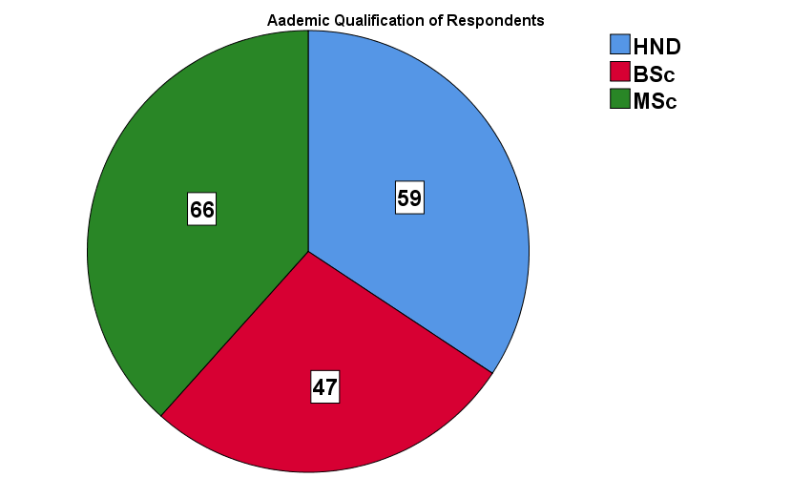

|  |  |  |  |  |  |
| --- | --- | --- | --- | --- | --- |
| **Table 2: Age of Respondents** | | | | | |
|  | | **Frequency** | **Percent** | **Valid Percent** | **Cumulative Percent** |
| Valid | 21-30 | 41 | 23.8 | 23.8 | 23.8 |
| 31-40 | 51 | 29.7 | 29.7 | 53.5 |
| 41-50 | 80 | 46.5 | 46.5 | 100.0 |
| **Total** | **172** | **100.0** | **100.0** |  |

**Source**: Fieldwork, 2024

The table 2 above, showed that 41 respondents representing (23.8%) ranged between 21-30years, 51, (29.7%) of the staff captured were young. within 31-40years, 80, (46.5%) of them being within 41-50years. This implies that the most of staff were range between 41-50 years on the bases of their experience concerning staff issues. The structure is below.

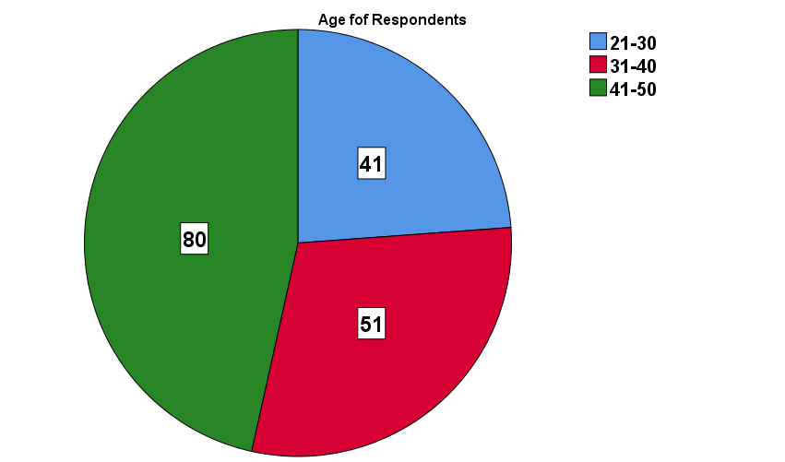

|  |  |  |  |  |  |
| --- | --- | --- | --- | --- | --- |
| **Table 3: Gender of Respondents** | | | | | |
|  | | **Frequency** | **Percent** | **Valid Percent** | **Cumulative Percent** |
| Valid | Male | 88 | 51.2 | 51.2 | 51.2 |
| Female | 84 | 48.8 | 48.8 | 100.0 |
| **Total** | **172** | **100.0** | **100.0** |  |

**Source**: Fieldwork, 2024

Out of 172 respondents captured among staff structure, 88 respondents representing (51.2%) of captured males, while 84, (48.8%) were female. This indicates that all most of response came from male fossil, because of their experience concerning matter. This is shown in the presentation below.

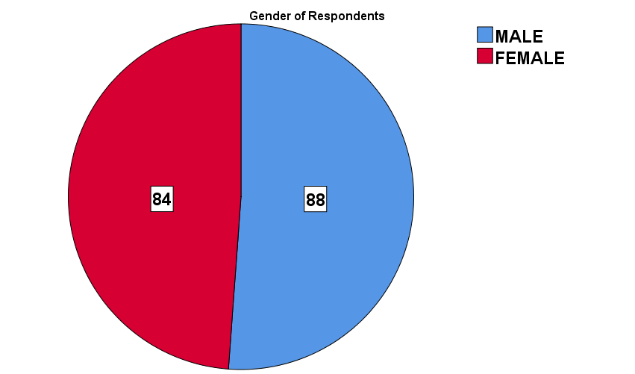

|  |  |  |  |  |  |
| --- | --- | --- | --- | --- | --- |
| **Table 4: Status/Cadre of Respondents** | | | | | |
|  | | Frequency | Percent | Valid Percent | Cumulative Percent |
| Valid | Administrative | 59 | 34.3 | 34.3 | 34.3 |
| Operational | 45 | 26.2 | 26.2 | 60.5 |
| Management | 68 | 39.5 | 39.5 | 100.0 |
| **Total** | **172** | **100.0** | **100.0** |  |

**Source**: Fieldwork, 2024

The department and unit of staff in Ondo state Water Corporation are in the table 4 above, 59 (34.3%) are in Administrative unit, 45 (26.2%) were in Operational unit of the corporation, while 68 (39.5%) of staff are in management unit.

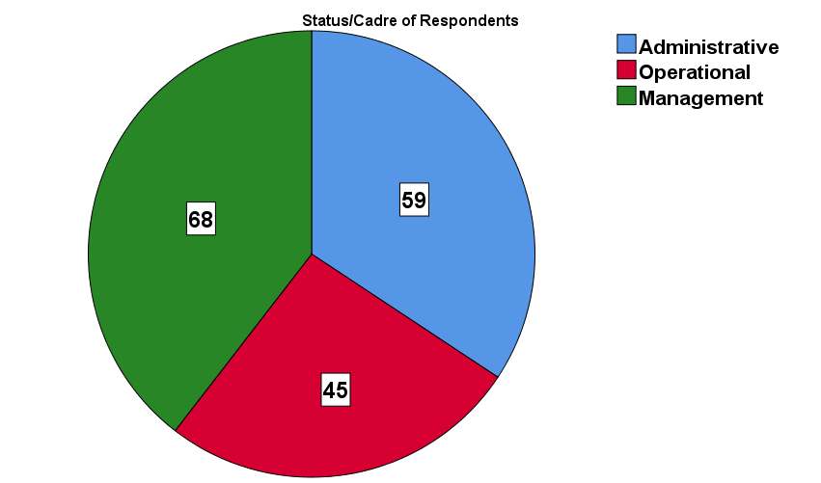

|  |  |  |  |  |  |
| --- | --- | --- | --- | --- | --- |
| **Table 5: Length of Service of Respondents** | | | | | |
|  | | **Frequency** | **Percent** | **Valid Percent** | **Cumulative Percent** |
| Valid | 5 – 10 years | 71 | 41.3 | 41.3 | 41.3 |
| 11 – 15 years | 72 | 41.9 | 41.9 | 83.1 |
| 16 – 20 years | 29 | 16.9 | 16.9 | 100.0 |
| **Total** | **172** | **100.0** | **100.0** |  |

**Source**: Fieldwork, 2024

The length of service of staff so far are show in table 5 above, 71 (41.3%) have spent 5-10 years as staff, 72 (41.9%) have spent 11-15 years as staff while 29 (16.9%) have spent 16-20 years as staff at Ondo state water corporation.

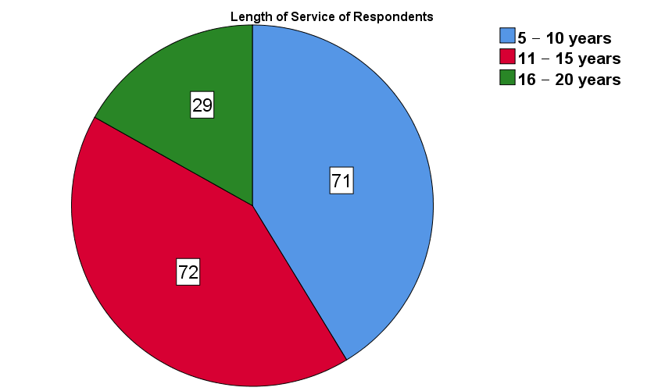

**Table 6: Causes of Conflicts in Ondo State Water Corporation**

|  |  |  |  |  |  |
| --- | --- | --- | --- | --- | --- |
| **S/N** | **Responses** | **Yes** | **No** | **Mean (X)** | **SD** |
| **1** | Non-Payment of Salaries | 137 (79.7%) | 35 (20.3%) | .80 | .404 |
| **2** | Communication Gap | 129 (75.0%) | 43 (25%) | .75 | .434 |
| **3** | Inadequate Provisions | 83 (48.3%) | 89 (51.7%) | .48 | .501 |
| **4** | Differences in Perceptions | 148 (86.0%) | 24 (14%) | .86 | .348 |
| **5** | Allegation of corruptions | 156 (90.7%) | 16 (9.3%) | .91 | .291 |
| **6** | Competition & Rivalry | 140 (81.4%) | 32 (18.6) | .81 | .390 |
| **7** | Position of Decisions | 170 (98.8%) | 2 (1.2%) | .99 | .108 |
| **8** | Miscomprehension of Duties | 172 (100%) | - | 1.0 | .000 |
| **9** | Refusal to Honour Agreements | 172 (100%) | - | 1.0 | .000 |
| **10** | Denial of Right and Privileges | 162 (94.2%) | 10 (5.8%) | .94 | .235 |

**Source**: Fieldwork, 2024

The cause of conflict in Ondo state Water Corporation has been stated above alongside with responses from staff with mean (X) and standard deviation (SD). 137 (79.7%) agreed that Non-payment of salaries is one of reason why conflict occurred at Ondo state Water Corporation, 129 (75.0%) agreed that communication gap usually surface in as a result of needed gap to be filled along the channel of information network in that corporation. 83 (48.3%) of staff agreed that inadequate provisions of staff and facilities spring up conflict in that organisation while, 89 (51.7%) disagreed with the statement of inadequate provisions of staff and facilities at the organisation. 148 (86.0%) of staff agreed that differences in perceptions cause conflict in that corporation while 24 (14%) said disagreed with the statement. 156 (90.7%) of staff agreed that allegation of corruptions among staff is the cause of conflict in that organisation and 16 (9.3%) disagreed with that. 140 (81.4%) agreed that competition & rivalry is the cause of conflict at Ondo state Water Corporation and 170 (98.8%) agreed that position of decisions making is the cause of conflict at that corporation. 172 (100%) of staff totally agreed that miscomprehension of duties and refusal to honour agreements cause conflict and finally, 162 (94.2%) of staff totally agreed that denial of right and privileges cause conflict at Ondo state Water Corporation. Upon this responses from respondents, much needed to be resolved in the organisation in under to meet up with the demand of citizen and masses.

**Table 7: Consequences of Conflict in Ondo State Water Corporation**

|  |  |  |  |  |  |
| --- | --- | --- | --- | --- | --- |
| **S/N** | **Responses** | **Yes** | **No** | **Mean (X)** | **SD** |
| 1 | Enhanced Cooperation & Efficiency | 155 (90.1)) | 17 (9.9%) | 0.90 | .299 |
| 2 | Low Employees’ Morale | 142 (82.6%) | 30 (17.4%) | 0.83 | .831 |
| 3 | Delay in Salaries | 172 (100%) | - | 1.00 | .000 |
| 4 | Improves Quality Decision Making | 172 (100%) | - | 1.00 | .000 |
| 5 | Innovation and Creativity | 172 (100%) | - | 1.00 | .000 |
| 6 | Disruption of Operations | 172 (100%) | - | 1.00 | .000 |
| 7 | Delay in Promotion of Staff | 172 (100%) | - | 1.00 | .000 |
| 8 | Leads to Poor Teamwork | 172 (100%) | - | 1.00 | .000 |
| 9 | Resources Wastage | 147 (85.5%) | 25 (14.5%) | 085 | .353 |
| 10 | Low Employees’ Performance | 142 (82.6%) | 30 (17.4%) | .83 | .831 |

**Source**: Fieldwork, 2024

The consequence of conflict in Ondo state Water Corporation has been state above alongside with responses from staff. 155 (90.1%) agreed that enhanced cooperation & efficiency while 17 (9.9%), 142 (82.0%) agreed that low employees’ morale serve as consequence of conflict while 30 (17.4%) disagreed with the statement. 172 (100%) agreed that delay in salaries, improves quality decision making, innovation and creativity, disruption of operations, delay in promotion of staff and leads to poor teamwork are consequence of conflict in Ondo state Water Corporation. 147 (85.5%) agreed that resources wastage at consequence of conflict in Ondo state Water Corporation while 25 (14.5%) disagreed with the statement, lastly, 142 (82.6%) agreed that consequence of conflict in Ondo state Water corporation is low employees’ performance and 30 (17.4%) disagreed with the assertion.

**Table 8: Strategic Measures for Managing Conflict Ondo State Water Corporation**

|  |  |  |  |  |  |
| --- | --- | --- | --- | --- | --- |
| **S/N** | **Responses** | **Yes** | **No** | **Mean (X)** | **SD** |
| 1 | Dialogue Strategy | 159 (92.4%) | 13 (7.6%) | 0.92 | .265 |
| 2 | Compromise Strategy | 159 (92.4%) | 13 (7.6%) | 0.92 | .265 |
| 3 | Collaboration Strategy | 151 (87.8%) | 21 (12.2%) | 0.88 | .328 |
| 4 | Avoidance Strategy | 152 (88.4%) | 20 (11.6%) | 0.88 | .321 |
| 5 | Negotiation Strategy | 151 (78.8%) | 21 (12.2%) | 0.88 | .328 |
| 6 | Mediation Strategy | 153 (89.0%) | 19 (11.0%) | 0.89 | 314 |
| 7 | Accommodation Strategy | 147 (85.5%) | 25 (14.5%) | 0.85 | .363 |
| 8 | Conciliation Strategy | 156 (85.5%) | 16 (9.3%) | 0.91 | .291 |
| 9 | Prevention Strategy | 152 (88.4%) | 20 (11.6%) | 0.88 | .321 |
| 10 | Emergency Strategy | 123 (71.5%) | 49 (28.5%) | 0.72 | .453 |

**Source**: Fieldwork, 2024

Strategic measures for managing conflict in Ondo state Water Corporation has been state in table 8 above alongside with responses from staff. 159 (92.4%) believed that dialogue strategy is the best way to settle dispute and conflict at Ondo state Water Corporation while 13 (7.6%) disagreed that conflict cannot be settle through dialogue strategy in Ondo state Water Corporation. 159 (92.4%) believed that compromise strategy is the best way to settle dispute and conflict at Ondo state Water Corporation while 13 (7.6%) disagreed that conflict cannot be settle through dialogue strategy in Ondo state Water Corporation. 151 (87.8%) concurred that collaboration strategy can resolve conflict while 21 (12.2%) disagreed with the statement. 152 (88.4%) agreed that avoidance strategy can resolve conflict at all level of an organisation while 20 (11.6%) said no that strategy. 151 (87.8%) concurred that negotiation strategy can resolve dispute and conflict at Ondo state water corporation and 21 (12.2%) disagreed that conflict can be resolved through negotiation strategy. 153 (89.0%) agreed that mediation strategy can solve conflict at Ondo state Water corporation while 19 (11.0%) disagreed that mediation strategy can solve conflict. 147 (85.5%) agreed that accommodation strategy can solve conflict issues at Ondo state water corporation and 25 (14.5%) disagreed that the statement cannot stand to resolve conflict. 156 (85.5%) agreed that conciliation strategy is best way to solve conflict in Nigeria. 152 (88.4%) agreed that prevention strategy is good for conflict solving and lastly, 123 (7.5%) agreed that emergency strategy is the best strategy of problem solving.

**Discussion of Finding**

From the hypothesis one; table six has justified that, cause of conflict in Ondo state Water Corporation usually occurred based on responses from staff. 83 (48.3%) of staff agreed that inadequate provisions of staff and facilities spring up conflict in that organisation while, 89 (51.7%) disagreed with the statement of inadequate provisions of staff and facilities at the organisation. 148 (86.0%) of staff agreed that differences in perceptions cause conflict in that corporation while 24 (14%) said disagreed with the statement. 156 (90.7%) of staff agreed that allegation of corruptions among staff is the cause of conflict in that organisation and 16 (9.3%) disagreed with that. 140 (81.4%) agreed that competition & rivalry is the cause of conflict at Ondo state Water Corporation and 170 (98.8%) agreed that position of decisions making is the cause of conflict at that corporation. 172 (100%) of staff totally agreed that miscomprehension of duties and refusal to honour agreements cause conflict and finally, 162 (94.2%) of staff totally agreed that denial of right and privileges cause conflict at Ondo state Water Corporation. Upon this responses from respondents, much needed to be resolved in the organisation in under to meet up with the demand of citizen and masses. From this responses, null hypothesis one was rejected. Causes of conflict in Ondo State Water Corporation usually occurred.

From the hypothesis two; table seven has justified that, conflict has significant effects on employees’ performance in Ondo State Water Corporation. The consequence of conflict in Ondo state Water Corporation has been state above alongside with responses from staff. 155 (90.1%) agreed that enhanced cooperation & efficiency while 17 (9.9%), 142 (82.0%) agreed that low employees’ morale serve as consequence of conflict while 30 (17.4%) disagreed with the statement. 172 (100%) agreed that delay in salaries, improves quality decision making, innovation and creativity, disruption of operations, delay in promotion of staff and leads to poor teamwork are consequence of conflict in Ondo state Water Corporation. 147 (85.5%) agreed that resources wastage at consequence of conflict in Ondo state Water Corporation while 25 (14.5%) disagreed with the statement, lastly, 142 (82.6%) agreed that consequence of conflict in Ondo state Water corporation is low employees’ performance and 30 (17.4%) disagreed with the assertion. From hypothesis two conflict has significant effects on employees’ performance in Ondo State Water Corporation. From the hypothesis two; table eight has justified that consequences of conflict have significant effects on employees’ performance in Ondo State Water Corporation.

Table eight has justified that there is strategic measure for managing conflict in Ondo State Water Corporation. Strategic measures for managing conflict in Ondo state Water Corporation has been state in table 8 above alongside with responses from staff. 159 (92.4%) believed that dialogue strategy is the best way to settle dispute and conflict at Ondo state Water Corporation while 13 (7.6%) disagreed that conflict cannot be settle through dialogue strategy in Ondo state Water Corporation. 159 (92.4%) believed that compromise strategy is the best way to settle dispute and conflict at Ondo state Water Corporation while 13 (7.6%) disagreed that conflict cannot be settle through dialogue strategy in Ondo state Water Corporation. 151 (87.8%) concurred that collaboration strategy can resolve conflict while 21 (12.2%) disagreed with the statement. 152 (88.4%) agreed that avoidance strategy can resolve conflict at all level of an organisation while 20 (11.6%) said no that strategy. 151 (87.8%) concurred that negotiation strategy can resolve dispute and conflict at Ondo state water corporation and 21 (12.2%) disagreed that conflict can be resolved through negotiation strategy. 153 (89.0%) agreed that mediation strategy can solve conflict at Ondo state Water corporation while 19 (11.0%) disagreed that mediation strategy can solve conflict. 147 (85.5%) agreed that accommodation strategy can solve conflict issues at Ondo state water corporation and 25 (14.5%) disagreed that the statement cannot stand to resolve conflict. 156 (85.5%) agreed that conciliation strategy is best way to solve conflict in Nigeria. 152 (88.4%) agreed that prevention strategy is good for conflict solving and lastly, 123 (7.5%) agreed that emergency strategy is the best strategy of problem solving. From hypothesis three, null hypothesis can be rejected on strategic measures for managing conflict Ondo state water corporation.

**Conclusion**

For an organisation to grow effectively and efficiently it depends on the way it manages the conflict within its organisation. Having studied the opinions of the various stakeholders as far as this research is concerned, it should be noted that the employee’s should be flexible and should direct their energy towards the achievement of organisational goals and objectives. It should be more than a target, against which performance is routinely assessed, in viable and vibrant plan for success of the organisation. This research work has effectively addressed the effect of conflict management on employee performance in a public sector organisation like Ondo state Water Corporation. That the existence of the organisation can be threatened by conflict among the different level of management in the organisation. This research work analysis the clear picture of important role which conflict management play on employee performance and the entire organisation in the public sector Ondo state Water Corporation. In view of this, the researchers rightly conclude that if the organisation can effectively and efficiently manage conflict within its operation, this will lead to high level of organisational performance which will result into achievement of the organisational goals and objectives. Successfully managing conflict has a domino effect, allowing managers to create a workplace where employees can thrive.

**Recommendations**

1. Management of organizations should monitor and intervene on issues that can lead to conflicts in order to enhance employees’ performance by adopting avoidance strategies.
2. Management should employ a collaboration strategy or approach of win-win method of conflict resolution in order to enhance employees’ commitment.
3. Management should also attend to conflicting situations as urgently as possible in order to avoid those factors that can hinder employees’ motivation and commitment to goal achievement.
4. Management of organizations should invite a third party (neutral mediator) to assist conflict management strategy in order to induce employees’ motivation and performance.
5. The organisation should embark on training and retraining of its employees in area of conflict management so as to create a conductive working environment for the employees.

**REFERENCES**

Abdullah, A. S. A. (2015). The impact of conflict management on organizational effectiveness: A case study of ministry of higher education of Jordan. European Journal of Business and Management, 7 (36), 75-79.

Abraham Maslow, H. Motivation and Personality. 2nd ed. New York: Harper and Row, 1970.

Adedeji, A.O., & Obianuju, C.U. (2018). Factors motivating employee loyalty and employee retention in deposit money banks in Nigeria. International Journal of Human Resource Studies, 8, 300-13. http://www.macrothink.org/ioumal/index.php/ijhrs/article/view/13555

Adeyemi J., & Ademilua, W. (2012). Conflict management strategies and administrative effectiveness in public universities in Nigeria. Journal of Emerging Trends in Education Research Policy Studies, 3, 368-375. https://hdl.handle.net/10520/EJC140929

Adeyemi, T.O & Ademilua, S. O. (2012). Conflict management strategies and administrative effectiveness in Nigerian universities. *Journal of Emerging Trends in Educational Research and Policy Studies,* 3 (3), 368-375.

Adeyemi, T.O. (2010). Principals' management of conflicts in public secondary schools in Ondo State, Nigeria: A critical survey. *African Journal of Interdisciplinary Studies.*

Adilo, J.N. (2019). Conflict management and organizational performance: A study of selected breweries in the south east Nigeria. International Journal of Management and Entrepreneurship, 1(1), 1-22.

Adomi, E.E. and S.O. Anie, 2005. Conflict management in Nigerian University libraries. J. Library Manage, 27: 520-530.

Aja S. N. (2014). Conflict management approaches that principals adopt for effective administration in Ebonyi State, Nigeria. International Journal of Science and Research, 92, 2319-2321.

Akhtar, N., & Hassan, S.S. (2021). Conflict management styles as predictors of organizational commitment in university teachers. Journal of Behavioural Sciences, 31(1), 99-123.

Alper, S., Tjosvold, D., & Law, K. S. (2000) Conflict management, efficacy, and  
performance in organizational teams. Personnel Psychology, 53, 625-642.

Amason, A. C. (1996). Distinguishing the effects of functional and dysfunctional conflict on strategic decision making: Resolving a paradox for top management  
teams. Academy of Management Journal, 39, 123-1

Amason, A.C., 1996. Distinguishing the effects of functional and dysfunctional conflict on strategic decision making: Resolving a paradox for top management teams. J. Acad. Manage., 39: 123-148.

Baron, R. A. (1997). Positive effects of conflict: Insights from social cognition. In C. K.W. DeDreu & E. Van de Vliert (Eds.), Using conflict in organizations (pp.177-191). London: Sage.

Baron, R.A., 1991. Positive effects of conflict: A cognitive perspective. J. Employee Responsibilities Rights, 4: 25-36.

Batcheldor, M. (2000). The Elusive Intangible Intelligence: Conflict Management and Emotional Intelligence in the Workplace. The Western Scholar, Fall, 7-9

Behfar, K. J., Peterson, R. S., Mannis, E. A., &Trochim, W. M. K. (2008). The critical role of conflict resolution in teams: A close look at the links between conflict type, conflict management strategies, and team outcomes. Journal of Applied Psychology, 93, 170-188.

Biason, R.S. (2020). The effect of job satisfaction on employee retention. International Journal of Economics, Commerce and Management, 3, 405-13.

Boateng, I.A. (2014). Conflict resolution in organizations-an analysis. European Journal of Business and Innovation Research, 2(6), 1-8.

Boulding, K.E., 1962. Conflict and Defense a General Theory. Harper Torchbooks,  
Harper and Row, Publishers, New YorkDe Bono, E. 1985.33

Chatzoudes, D., & Prodromos, C. (2022). Factors affecting employee retention: Proposing an original conceptual framework. International Journal of Economics and Business Administration, 10,49- 76.

Chris Argyris, Personality and Organization (New York: Harper Torchbooks, 1957), Chapters III and VII.

Danish, R.Q., Shahid, F., Bano, S., Ali, H.F., & Humayon, A.A. (2019). Supervision support and turnover intention: Impact of employee's training in banking sector of Pakistan. European Online Journal of Natural and Social Sciences, 8(1), 121-132.

Dialoke, I., & Edeh, P.O. (2017). Conflict resolution strategies and workers' commitment in selected oil companies in Rivers State. International Journal of Business Ethics in Developing Economies,6(2), 9-17. https://ssrn.com/abstract=3480587

Douglas McGregor, The Human Side of Enterprise (New York: McGraw-Hill, 1960).  
De Bono, E. 1985. Conflicts: A Better Way to Resolve Them. London: Harrap.

Edeh, P.O., & Udensi, C.E. (2017). Human resource management practices and lecturers' retention in Nigerian universities. International Journal of Management and Marketing Systems, 13, 1-15. https://ssrn.com/abstract=3480824

Edeh, P.O., Edeoga, G., Chukwu, A.U., Adama, L., Chiamaka, E.G., & Ngozi, U.A. (2021). Organisational justice and human resource retention: Role of leadership consideration. Gusau International Journal of Management and Social Sciences, 4, 32^15.https://giimss.com.ng/index.php/giimss/article/view/48

Ezekiel, A.O., & Abdulraheem, I. (2022). Traditional methods of conflict management and resolutions: The case of the old Oyo empire. European Journal of Management and Marketing Studies, 7(4), 126-139. <http://dx.doi.org/l0.46827/ejmms.v7i4..1303>

Fukui, S., Wu, W.,' & Salyers, M.P. (2019). Impact of supervisory support on turnover intention: The mediating role of burnout and job satisfaction in a longitudinal study. Administration and Policy in Mental Health and Mental Health Services Research, 46, 488-97. https://doi.org/l0.1007/s 10488-01900927-0

Gwanyo, Y.E., Dickson, C.N., & Talatu, M. (2020). Conflict management as an instrument for organizational effectiveness: A conceptual perspective. International Journal of Management, Social Sciences, Peace and Conflict Studies, 3(4), 165 174.

Homans, G.C. (1958). Social behavior as exchange. American Journal of Sociology, 63(6), 597606. https://doi.org/10.1086/222355

Ivancevich, J.M., Szilagyi, A.D., Jr., & Wallace, M.J., Jr. 1977. Organizational Behavior and Performance. California, CA: Goodyear Publishing.

Kirchoff, N., & Adams, J.R. 1982. Conflict Management for Project Managers.  
Drexel Hill: Project Management Institute.

Mayowa, S.O. (2015). Industrial conflict and its management in selected Nigerian manufacturing companies. International Journal of Organizational Leadership, 4, 430-439. https://ssrn.com/abstract=3330488

Mba, O. A. (2013). Conflict management and employees performance in Julius Berger Nigeria PLC, Bonny Island. International Journal of Academic Research in Management, 3(4) 125 - 139. h tt ps ://ssrn .com/abstract=23 71540

Ogbonna, H.O., & Mbah, C.S. (2022). Examining social exchange theory and social change in the works of George Caspar Homans - Implications for the state and global inequalities in the world economic order. Mediterranean Journal of Social Sciences, 13(1), 90-104. https://doi.org/l 0.3694 l/mjss-2022-0009

Ohunakin, F., Adenike, A.A., Olumuyiwa, A.O., Adewale, O.O., & Oluseyi, O.O. (2019). Employees' retention in Nigeria's hospitality industry: The role of transformational leadership style and job satisfaction. Journal of Human Resources in Hospitality & Tourism, 18, 441-70. <https://doi.org/IQ.l> 080/15332845.2019.1626795

Olukayode, L. (2015). Impact of workplace conflict management on organizational performance: A case of Nigerian manufacturing firm. Journal of Management and Strategy, 6(2) 83 -92.

Omene, G.R. (2021). Conflict management strategies as a prerequisite for effective organizational performance: An exploratory analysis. International Journal of Business & Law Research, 9(4), 187-199.

Osabiya, B.J. (2015). Conflict management and resolution in Nigeria public sector. Review of Public Administration and Management, 4(8), 107-120.

Owsiak, A.P. (2021). Conflict management trajectories: Theory and evidence. International Interactions, 47(1), 23-55, https://doi.org/l 0.1080/03050629.2020.1814767

Ozyildirim, G., & Kayik9i, K. (2017). The conflict management strategies of school administrators while conflicting with their supervisors. European Journal of Education Studies, 3(8), 1-20. http://dx.doi.org/10.46827/ejes.vOiO.834

Uchendu, C., Anijaobi, F., & Odigwe, F. (2013). Conflict management and organizational performance in secondary schools in cross Rivers State. Nigeria Research Journal in Organisational Psychology and Educational Studies, 2(2), 67-71.

Wainaina, R.N., Magoma, C., & Mange, D. (2020). Influence of principals' conflict management strategies on conflict resolutions in secondary schools in Murang'a County, Kenya. European Journal of Education Studies. 7(4). 99-112. http://dx.doi.org/10.46827/ejes.vOiO.304Q