Original Research Article

Comparison of Aridity Indices in Mahi River Basin under climate change scenarios

**ABSTRACT**

Climate change poses a significant global challenge, driven by both natural climatic variability and anthropogenic activities, with its effects increasingly evident worldwide. Since the onset of the Industrial Revolution, substantial emissions of greenhouse gases have amplified global warming by trapping long-wave radiation within the atmosphere. This warming has been exacerbated by unsustainable land and water resource exploitation, intensifying environmental degradation. Developing nations, often equipped with limited adaptive capacity, are particularly vulnerable to these changes. India, characterized by rapid population growth and development, faces pronounced risks, especially in critical sectors such as water resources. This study investigates shifts in aridity within the Mahi River Basin, a semi-arid, water-scarce region in western India with a catchment area of 34,842 km², under the influence of climate change. Historical (baseline: 1961–1990; present: 1991–2005) and future (2006–2040) dynamically downscaled climate datasets of precipitation and temperature were analyzed. Key parameters—rainfall, temperature, potential evapotranspiration (PET), and aridity—were evaluated across these periods. Results indicate a projected decline in rainfall, a rise in mean temperature, and an associated increase in PET, collectively contributing to heightened aridity and drier conditions in the basin over time. Evidence of climate change impacts is already discernible in the baseline and present periods, with future scenarios suggesting intensified water scarcity due to reduced precipitation and elevated PET. Strategic water management, including optimized utilization and conservation of limited water resources, is proposed as a vital approach to mitigate anticipated water shortages in the Mahi Basin.

***Keywords;*** Aridity, Aridity Index, Climate change, Global warming, Potential Evapotranspiration

**1. INTRODUCTION**

**1.1 Weather and climate**

Weather refers to the short-term atmospheric conditions of a region, which can change within minutes to weeks. In contrast, climate represents the long-term average of weather patterns observed over a period typically exceeding 30 years [1,2]. It is determined by several meteorological variables such as temperature, precipitation, atmospheric pressure, wind speed, humidity, and sunshine duration. Climate plays a vital role in shaping human activities, particularly in sectors like agriculture, water resources, and health [3,4,5]. Climate change refers to significant and long-term shifts in average climatic conditions. [6] The United Nations Framework Convention on Climate Change (UNFCCC) defines it as “a change in climate attributed directly or indirectly to human activity that alters the composition of the global atmosphere, and which is in addition to natural climate variability observed over comparable time periods.” This phenomenon is primarily driven by the increase in greenhouse gases (GHGs) such as carbon dioxide (CO₂), methane (CH₄), nitrous oxide (N₂O), and ozone (O₃), which trap heat in the atmosphere by absorbing long-wave radiation [7,8]. Changes in aerosols, solar radiation, and land surface properties also contribute to the disturbance of Earth’s energy balance, a process described through radiative forcing [9,10]. According to the Fourth Assessment Report (AR4) of the Intergovernmental Panel on Climate Change (IPCC, 2007), the global mean surface temperature has increased by 0.74°C over the last century, with a rate of approximately 0.13°C per decade. Projections indicate that global temperatures may rise by 1.1°C to 6.4°C by the end of the 21st century. This rising global temperature affects the hydrological cycle, leading to changes in water availability and distribution. Such shifts impact not only water resources but also public health, agricultural productivity, and industrial and municipal water demands [11,12]. Due to the close link between climate and hydrology, variations in temperature and precipitation are expected to alter hydrological variables and increase the occurrence of extreme events such as droughts and floods. Monitoring these changes and implementing effective water resource management and climate adaptation strategies are essential for ensuring food and livelihood security in the face of future climate uncertainty [13,14,15].

**1.2 Aridity**

Aridity typically conjures images of dry, desert-like landscapes with minimal surface water, scarce rainfall, and sparse vegetation. In simple terms, aridity refers to a deficiency of water, primarily as a result of climatic conditions [16,17]. It is defined by a persistent lack of moisture, making it essentially a climatic phenomenon determined by long-term average weather conditions over a region [18]. According to Thornthwaite (1948), whether a climate is considered ‘moist’ or ‘dry’ depends not only on the total amount of precipitation but also on its adequacy in meeting the atmospheric demand for moisture, known as evapotranspiration—which includes both evaporation and plant transpiration [19]. Thornthwaite (1948) introduced the concept of potential evapotranspiration (PET), describing it as the maximum possible water loss to the atmosphere under ideal moisture conditions. Penman (1948, 1956) further refined this definition, characterizing PET as the water loss from a well-watered, short green crop completely covering the ground [19,20,21]. Hence, aridity is fundamentally influenced by both precipitation and PET. Temperature and the seasonal distribution of rainfall are additional critical factors [22]. For instance, precipitation occurring during cooler months in warmer regions can enhance plant growth, as lower temperatures reduce direct evapotranspiration losses [23]. Aridity represents an extended period of below-average rainfall, leading to significant hydrological imbalances. These conditions can result in reduced stream flows, groundwater depletion, crop failure, and widespread water scarcity [24,25]. A key challenge in arid environments is the disparity between PET and actual evapotranspiration (AET), which depends on the availability of moisture. In many arid regions, AET remains low due to limited water availability, while surface water bodies may experience high AET rates that approach PET, causing substantial water loss. The severity and impact of aridity differ from region to region, depending on the total rainfall, its variability, and local water demand. Both natural variability and anthropogenic activities can influence changes in aridity [26,27]. Investigating these changes is particularly important in arid and semi-arid regions, where climate change is projected to significantly alter precipitation patterns and temperature regimes, thereby affecting the regional water balance and increasing vulnerability to drought [28,29].

**1.2 Aridity Index**

The Aridity Index (AI) is a quantitative measure used to evaluate the degree of dryness or moisture deficiency in a particular region based on climatic variables. It is a key indicator in climate and hydrological studies, especially in assessing the impact of climate variability and change on water availability [30]. The concept of aridity index provides a standardized way to classify climatic zones ranging from humid to arid and hyper-arid, which is essential for understanding regional water balance and ecosystem sustainability [31]. Aridity indices are typically derived from the relationship between precipitation and potential evapotranspiration (PET), where a lower ratio indicates drier conditions. One of the earliest and most widely used indices was proposed by Thornthwaite (1948), which compares precipitation to PET to classify climates. Penman (1948, 1956) later refined the estimation of PET using both energy and aerodynamic factors. Several other indices, including the De Martonne Index, the UNEP Aridity Index, and the Palmer Drought Severity Index, have been developed to suit specific climatic and regional contexts. The AI plays a crucial role in environmental planning, water resource management, agricultural decision-making, and drought monitoring. It also serves as a critical tool in climate change studies, as shifts in precipitation and temperature patterns directly influence the classification of regions based on aridity levels [32]. In arid and semi-arid areas, such as the Mahi River Basin, evaluating aridity through various indices helps identify trends, assess vulnerability, and guide adaptive strategies for sustainable development under changing climatic conditions [33].

1. **STUDY AREA**

The Mahi River Basin spans parts of Madhya Pradesh, Rajasthan, and Gujarat, covering a total catchment area of approximately 34,842 square kilometers. The basin stretches nearly 330 kilometers in length and about 250 kilometers in width. Geographically, it is located between latitudes 21°46′N to 24°30′N and longitudes 72°21′E to 75°19′E. It is bordered by the Aravalli hills to the north and northwest, the Chambal basin to the east, the Vindhya ranges to the south, and the Gulf of Khambhat to the west [34]. An index map illustrating the geographical extent of the Mahi River Basin is provided in Figure 1.

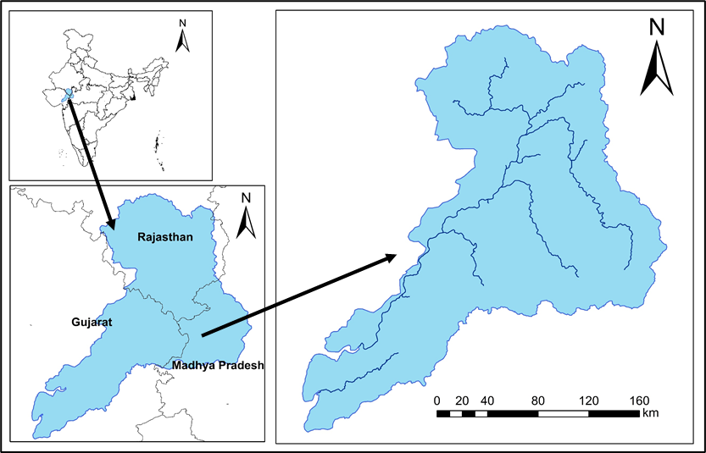

**Figure 1: Index Map of the Mahi Basin**

**2.1 Climatic characteristics**

The Mahi River Basin experiences three distinct seasons: summer (March to May), monsoon (June to September), and winter (October to February). Climatically, the basin is divided into two primary zones. The northern portion exhibits a subtropical wet climate, while the larger part of the basin is characterized by a tropical wet climate, largely influenced by the higher elevations and forested areas. Near the river’s origin, the region tends to have a relatively cooler climate with moderate rainfall [35]. As the river flows northward into Rajasthan, the climate transitions into a warmer and drier type. Upon curving southwest and entering Gujarat, the climatic conditions gradually revert to a tropical wet pattern.

**2.2 Rainfall**

The Mahi River Basin receives an average annual rainfall of approximately 785 mm, the majority of which is influenced by the southwest monsoon The monsoon typically begins around mid-June and retreats by early October. Nearly 90% of the total annual rainfall occurs during the monsoon period, with July and August alone contributing around 50% of the total precipitation [35,36].

* 1. **Temperature Profile of the Mahi River Basin**

May is typically the hottest month in the Mahi River Basin, with an average maximum temperature of 39.8 °C, while January is the coldest, recording an average minimum temperature of 11.1 °C. Based on data from 1969 to 2004, the basin’s average annual minimum temperature is 19.36 °C, and the average annual maximum temperature is 32.82 °C. The overall mean annual temperature for this period stands at 26.09 °C [35].

**2.4 Data Collection**

To assess the climatic variables of the Mahi River Basin, a minimum of 30 years of data was considered essential for reliable analysis. Daily rainfall and temperature data spanning the period from 1951 to 2022 were sourced from the Indian Meteorological Department (IMD) [37]. Additionally, future climate projections were obtained using data from the CORDEX (Coordinated Regional Climate Downscaling Experiment) framework [38].

**3. MATERIALS AND METHODS**

* 1. **Rainfall**

Daily rainfall data were utilized to calculate both monthly and annual rainfall totals by aggregating the values over the corresponding time periods [39]. The equation used for computing monthly rainfall is provided in Equation 1, while the formula for determining annual rainfall is presented in Equation 2.

$P_{mon}=\sum_{i=1}^{i=n days}{P_{daily}}$…………… (1)

Pmon =Monthly rainfall (mm)

Pdaily =Daily rainfall (mm)

i = No. of days

n days = No. of days in a month i.e. 31 days for: January, March, July, August and 30 days for: April, June, September, Number and 28 or 29 days for February for non-leap and leap year respectively

$P_{annual}=\sum_{i=1}^{i=12}{P_{mon}}$……………… (2)

**3.2 Temperature**

The mean temperature is the average of the Tmax and Tmin which is calculated by the following formula:

$T_{mean}=\frac{T_{max+T_{min}}}{2}$……….… (3)

$T_{max}=\frac{Sum of all T_{max} values during the month}{Number of days of the month}$………… (4)

$T_{min}=\frac{Sum of all Tmin values during the month }{Number of days of the month}$………… (5)

**3.3 Potential Evapotranspiration**

Potential evapotranspiration (PET) is the potential water requirement for vegetation growth under no scarcity of water. The principal factors influencing evapotranspiration are temperature, wind velocity, humidity, and sunshine. In India, evapotranspiration varies with season. The rates of evapotranspiration reach peak during the summer months of April and May. The following methods have been used for the computation of PET.

**3.3.1** **Thornthwaite** **Equation**

Thornthwaite proposed an exponential relationship between mean monthly temperature and mean monthly potential evapotranspiration (PET), based primarily on climatological observations from the central and eastern regions of the United States. The original method did not account for variations in crop type or land use. It was initially designed to support a systematic classification of global climatic zones. To enhance the accuracy of crop evapotranspiration estimates, region-specific adjustment coefficients have since been introduced. The first step in this method involves calculating the monthly Thornthwaite Heat Index (i), as shown in Equation-6.

$i={\left(\frac{t}{5}\right)}^{1.514}$…………… (6)

where, tis the mean monthly temperature.

The Annual Heat Index (I) is then calculated as the sum of the monthly heat indices using Equation 7,

$I=\sum_{i=1}^{12}{i}$…………… (7)

The PET is estimated for each month, considering a month of 30 days with 12 theoretical sunshine hours per day. The PET has been estimated using Equation 8,

${PET}_{non-corrected}=16{\left(\frac{10.t}{I}\right)}^{α}$…………… (8)

where α is given by Equation 9,

α=675*10-9*I3-771*10-7*I2+1792*10-5I+0.49239 …………… (9)

These estimated PET values are subsequently adjusted based on the actual number of days in each month and the theoretical sunshine duration for the given latitude (or actual sunshine hours, if available), as calculated using Equation 10.

$PET={PET}_{non-corrected}\left(\frac{N}{12}.\frac{d}{30}\right)$…………… (10)

where, Nis the theoretical sunshine hours for each month and *d* number of days for each month.

**3.4 Aridity indices**

**3.4.1 UNEP Aridity Index (AI)**

The United Nation Environmental Program [40]. aridity index (AI) is based on the ratio of annual precipitation (P) and annual potential evapotranspiration (PET) calculated using Equation 11

$AI=\frac{P}{PET}$…………… (11)

In this study, potential evapotranspiration (PET) was calculated using the method outlined by [15], which provides a reliable estimation based on temperature and other climatic variables. Building upon this, [38] proposed a widely accepted classification system for climate zones based on the Aridity Index (AI). According to this classification, regions with an AI value below 0.20 are categorized as arid. The complete UNEP (United Nations Environment Programme) classification of climatic zones based on AI values is presented in Table 1.

**Table 1: UNEP based climate classification**

|  |  |
| --- | --- |
| Aridity Index (AI) | Climate Type |
| 0.050 ≤ AI < 0.20 | Arid |
| 0.20 ≤ AI < 0.50 | Semi-Arid |
| 0.50 ≤ AI < 0.65 | Dry Sub- Humid |

**3.4.2 The De Martonne Aridity index (IDM)**

The De Martonne Aridity Index is one of the most recognized and widely applied indices in the field of applied climatology. It plays a significant role in distinguishing between arid and humid climatic conditions. Although it is one of the earliest developed indices, it continues to be effectively used across various regions worldwide to assess moisture availability and classify climate zones. The index is calculated using the formula presented in Equation 12.

$I_{DM }= \frac{P}{T+10}$…………… (12)

where IDM is the De Martonne aridity index, P and T are the annual amount of precipitation and mean annual surface temperature in mm and in oC respectively.

De Martonne proposed a climate classification system based on the Aridity Index. According to this classification, regions with an IDM value below 24 are considered to have a dry climate, while those with values above 24 are categorized as humid [41]. The detailed classification criteria are presented in Table 2.

**Table 2: De Martonne climate classification**

|  |  |
| --- | --- |
| **Aridity Index (IDM)** | **Climate Type** |
| IDM < 10 | Arid |
| 10 $≤$ IDM < 20 | Semi-Arid |
| 20 $≤$ IDM < 24 | Mediterranean |
| 24 $≤$ IDM < 28 | Semi- Humid |
| 28 $≤$ IDM < 35 | Humid |
| 35 $≤$ IDM < 55 | Very- Humid |
| IDM > 55 | Extremely Humid |

**3.4.3 The Pinna Combinative Index (IP)**

Pinna Combinative Index is a direct method to find out the Aridity Index. The Pinna Combinative Aridity Index is calculated using Equation 13,

$I_{P}=\left(\frac{P_{ma}}{T_{ma+10}}+\frac{12P^{'}d}{T^{'}d+10}\right)$…………… (13)

where Pma, Tma, P′d, and T′d are the annual amount of precipitation, mean annual surface temperature, the amount of precipitation, and mean surface temperature of the driest month, respectively [42].

When the IP is less than 20 then climate is defined as the dry, whereas when IP is greater than 20 the climate is defined as humid. The Pinna classification is given in Table 3.

**Table 3: Pinna climate classification**

|  |  |
| --- | --- |
| **Aridity index IP** | **Climate type** |
| IP < 10 | Arid |
| 10 ≤ IP < 20 | Semi-Arid |
| IP > 20 | Humid |

1. **RESULTS AND DISCUSSION**

**4.1 Rainfall Variation in Mahi Basin**

Rainfall in the Mahi River Basin varies significantly across regions and seasons. The basin receives an average annual rainfall of around 785 mm, predominantly during the southwest monsoon (June to September). Spatial variation is notable, with higher rainfall in the southern parts near the river’s origin and decreasing amounts as the river flows northward into drier regions of Rajasthan.

**4.1.1 Rainfall distribution during baseline period (1961-90)**

The average annual rainfall has been computed based on the five grids falling in and around the basin. The average annual rainfall during the baseline period varies between 478.2 mm during 1964 to 1602.0 mm during 1973. The mean rainfall during the baseline period is 866.9 mm. The temporal variation of the annual rainfall is given in Figure 2. It can be observed that the variability of the annual rainfall is very high. The coefficient of variability is 0.30 and this might be one of the reasons for the water stress being faced in the basin.

**Figure 2: Temporal variation of annual rainfall in Mahi basin during the baseline period**

Figure 3 illustrates the spatial distribution of average rainfall across the Mahi River Basin during the baseline period. Rainfall in the basin ranges between 600 mm and 1000 mm annually. In the western parts of Udaipur district, average rainfall falls between 600–700 mm and 700–800 mm. The northwestern areas, covering parts of Dungarpur, Neemuch, and Pratapgarh districts, receive between 800–900 mm. Similarly, the western regions encompassing parts of Jhabua, Dhar, and Dahod districts also fall within this range. The central and coastal parts of the basin receive the highest rainfall, ranging from 900 mm to 1000 mm.

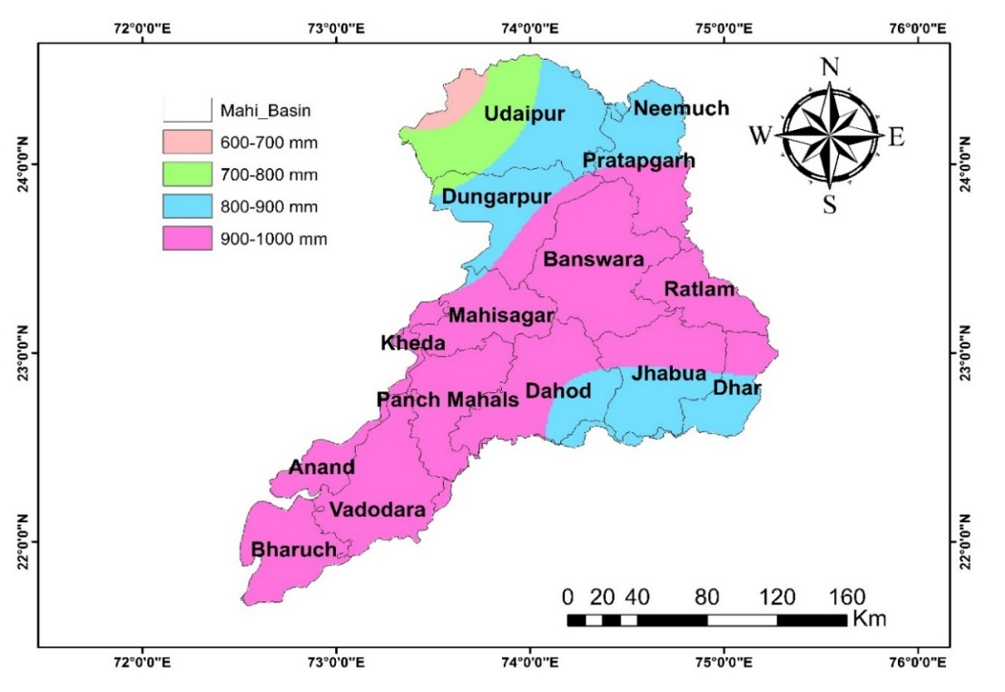

**Figure 3: Rainfall distribution during baseline period**

The area under the various rainfall classes during baseline period is given in Table 4 and it can be observed that about 66% of the area receives rainfall in the range of 900 mm to 1000 mm. It will be interesting to study how the average rainfall is varying spatially and temporally during the present period as well as during the future time period. The average annual rainfall during the present period varies between 446.3 mm during 2000 to 1327.4 mm during 1994. The mean rainfall during the present period is 772.1 mm which is about 11% less than the baseline period.

**Table 4: Area under various rainfall classes during baseline period**

|  |  |  |
| --- | --- | --- |
| **S. No.** | **Rainfall (1961-90)** | **Area (%)** |
| 1 | 600-700 mm | 1.53 |
| 2 | 700-800 mm | 6.81 |
| 3 | 800-900 mm | 25.98 |
| 4 | 900-1000 mm | 65.67 |

**4.1.2 Rainfall distribution during present period (1991-2005)**

The annual rainfall peak during the present period has also decreased by 17% during the present period as compared to the base line period. The temporal variation of the annual rainfall is given in Figure 4. It can be observed that the variability of the annual rainfall is very high. The coefficient of variability is 0.28 during the present period which is again quite high.

**Figure 4: Temporal variation of annual rainfall in Mahi basin during the present period**

The spatial distribution of average rainfall during the baseline period across the Mahi River Basin is illustrated in Figure 5. Rainfall in the basin ranges from 500 mm to 1000 mm. The central and western parts of Udaipur district receive between 500–600 mm and 600–700 mm, respectively. Districts such as Dungarpur, Pratapgarh, and Neemuch in the west, along with Jhabua and Dhar in the east, recorded lower rainfall, ranging from 700–800 mm, compared to the baseline. Similarly, reduced rainfall was observed in Banswara, Ratlam, Mahisagar, Kheda, and Dahod districts, falling between 800–900 mm. In contrast, no significant changes were noted in the coastal districts of Panchmahal, Anand, and Vadodara. However, Bharuch district, located near the coast, experienced a decrease in rainfall within the 800–900 mm range. Overall, most parts of the basin, excluding the lower central zones, experienced a decline in rainfall compared to the baseline. The average annual rainfall for the basin declined from 866.9 mm during the baseline period to 772.1 mm in the current period, indicating a substantial reduction of approximately 11%.

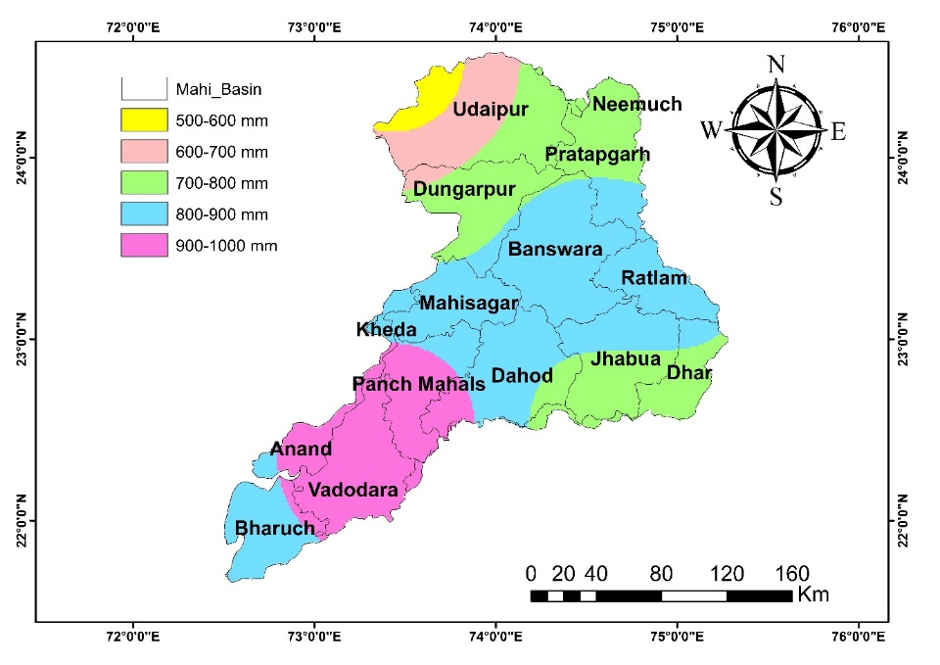

**Figure 5: Rainfall distribution during present period (1991-05)**

Table 5 presents the distribution of area under different rainfall classes for the current period. It is evident that the region receiving 900–1000 mm of rainfall has significantly declined—from 66% during the baseline period to just 18.7% in the present period. Currently, the largest portion of the basin (approximately 44%) falls within the 800–900 mm rainfall range.

**Table 5: Area under various rainfall classes during present period (1991-05)**

|  |  |  |
| --- | --- | --- |
| **S. No.** | **Rainfall (1991-05)** | **Area (%)** |
| 1 | 500-600 mm | 2.17 |
| 2 | 600-700 mm | 7.63 |
| 3 | 700-800 mm | 27.41 |
| 4 | 800-900 mm | 44.08 |
| 5 | 900-1000 mm | 18.67 |

**4.1.3 Rainfall Distribution During the Future Period (2006–2040)**

Future climate projections for the Mahi River Basin have been analyzed using CORDEX South Asia data, based on the widely adopted Regional Climate Model (RCM) CCSM4. This analysis assesses expected changes in rainfall and temperature and their impact on aridity within the basin. The projected average annual rainfall for the period 2006–2040 ranges from 220.4 mm to 889.2 mm. The mean annual rainfall is estimated at 479.8 mm—approximately 44% lower than the baseline period. Additionally, the peak annual rainfall during this future period is also projected to decline by 44% in comparison to the baseline. Figure 6 illustrates the temporal variation in annual rainfall, revealing considerable fluctuations. The coefficient of variability has increased notably, from 0.28 in the present period to 0.34 for 2006–2040, indicating a significant rise in rainfall variability.

**Figure 6: Temporal variation of annual rainfall in Mahi basin during 2006-2040**

The spatial distribution of the projected average annual rainfall (Fig. 7 ) depicts the spatial variation in projected average annual rainfall across the Mahi River Basin for the period 2006 to 2040. Rainfall in the basin is expected to decrease significantly, ranging between 300 mm and 600 mm. Districts such as Udaipur, Neemuch, Pratapgarh, Dungarpur, and portions of Banswara and Mahisagar are likely to receive 400–500 mm of rainfall. The remaining districts—Ratlam, Dhar, Jhabua, Dahod, Kheda, Panchmahal, Anand, Vadodara, and Bharuch—are projected to receive slightly higher rainfall, ranging from 500–600 mm annually.

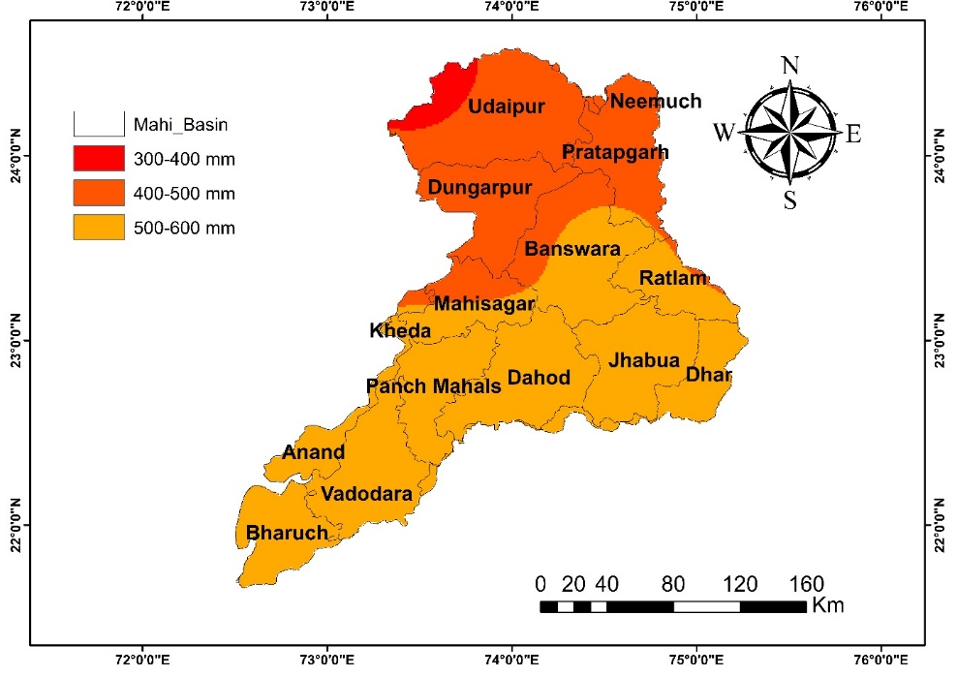

**Figure 7: Rainfall distribution during future period (2006-40)**

The area under the various rainfall classes during 2006-40 is given in Table 6. The majority areas in the basin (63.5%) fall in the class of 500-600 mm whereas during the baseline period, majority area (66%) was falling in the class of 900-1000 mm. Therefore, the average annual rainfall for Mahi basin has projected to reduce from 866.9 mm during the baseline period to 479.8 mm during 2006-40. This is a drastic shift and suggests towards water stress in future in the basin.

**Table 6: Area under various rainfall classes during future period (2006-40)**

|  |  |  |
| --- | --- | --- |
| **S. No.** | **Rainfall (2006-40)** | **Area (%)** |
| 1 | 300-400 mm | 2.18 |
| 2 | 400-500 mm | 34.31 |
| 3 | 500-600 mm | 63.49 |

**4.2 Temperature Variation in Mahi Basin**

The annual mean temperature across the Mahi River Basin has shown a gradual upward trend (Fig.8) during the baseline period (1961–1990). Analysis reveals that this warming trend continues consistently through subsequent time periods, with a more noticeable increase projected for the future period (2006–2040). This is evident from the steeper gradients of the trend lines representing each time frame.

**Figure 8: Temporal variation of annual temperature during the baseline period (1960-90)**

**Figure 9: Temporal variation of annual temperature during the present period (1991-2005)**

**Figure 10: Temporal variation of annual temperature during the future period (2006-40)**

* 1. **Potential Evapotranspiration**

Potential Evapotranspiration (PET) refers to the amount of water that would evaporate and transpire from a surface if sufficient moisture were available. It represents the atmospheric demand for moisture and is influenced by climatic variables such as temperature, solar radiation, wind speed, and relative humidity. PET is a key component in understanding the hydrological cycle, particularly in water resource management and agricultural planning. It is commonly used to assess water deficits in a region by comparing it with actual precipitation. Various empirical and physically based methods, such as the Thornthwaite and Penman-Monteith equations, are employed to estimate PET, each requiring different levels of climatic input data. PET plays a crucial role in identifying arid and semi-arid conditions and is often integrated into aridity index calculations to evaluate climate classification and monitor the impacts of climate change.

**4.3.1 Potential Evapotranspiration** **during (1961-90)**

The Potential Evapotranspiration estimated using the Thornthwaite method (PET<sub>TH</sub>) is highly sensitive to mean temperature and exhibits a direct proportionality with it. The spatial distribution of PET across the Mahi River Basin during the baseline period is presented in Figure 11. The PET values range between 1600 mm and 2000 mm across the basin. In the upper reaches, PET generally falls within the range of 1600–1800 mm, while in the lower reaches near the coastal areas, higher PET values are observed, ranging from 1800–2000 mm.

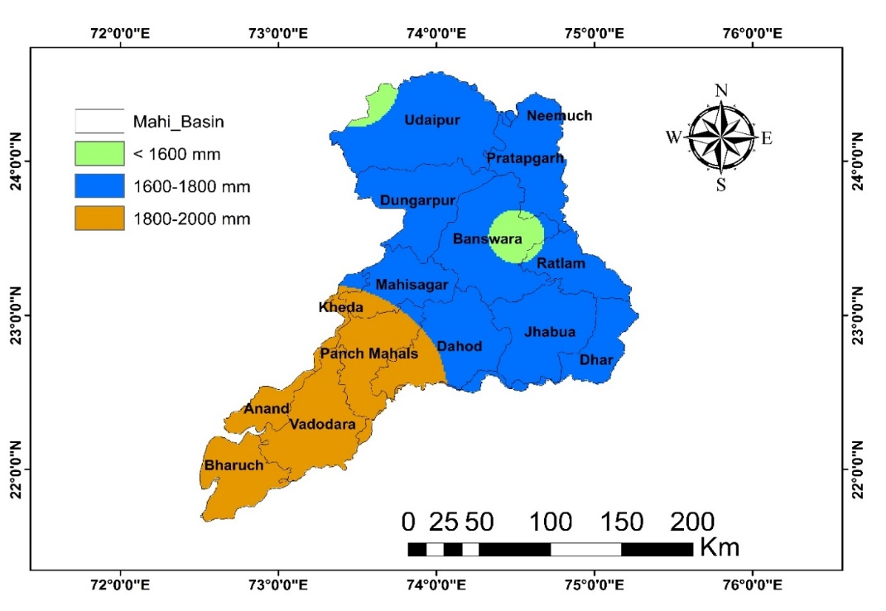

**Figure 11: Distribution of PETTH during baseline period (1961-90)**

During the baseline period, the classification of Potential Evapotranspiration (PET) across the Mahi River Basin is summarized in Table 7. The majority of the basin, accounting for approximately 67.3%, experiences PET values between 1600 mm and 1800 mm. In contrast, about 28.9% of the area falls within the higher PET category of 1800–2000 mm. A minimal portion, located mainly in the western regions of Udaipur and parts of Banswara, records PET values below 1600 mm.

**Table 7: Area under various PETTH classes during baseline period (1961-90)**

|  |  |  |
| --- | --- | --- |
| **Sl. No.** | **PET (1961-90)** | **Area (%)** |
| 1 | < 1600 mm | 3.80 |
| 2 | 1600-1800 mm | 67.33 |
| 3 | 1800-2000 mm | 28.85 |

**4.3.2 Potential Evapotranspiration** **during (1991-05)**

The spatial variation of the PET in Mahi basin during the present period as evaluated by the Thornthwaite method is shown in Figure 12. It can be observed that the PET varies between 1600-2000 mm in the basin. The PET in the upper reaches of the basin falls in the range of 1600-1800 mm whereas the PET in the lower reaches of the basin near the sea coast is having Higher PET in the range of 1800-2000 mm.

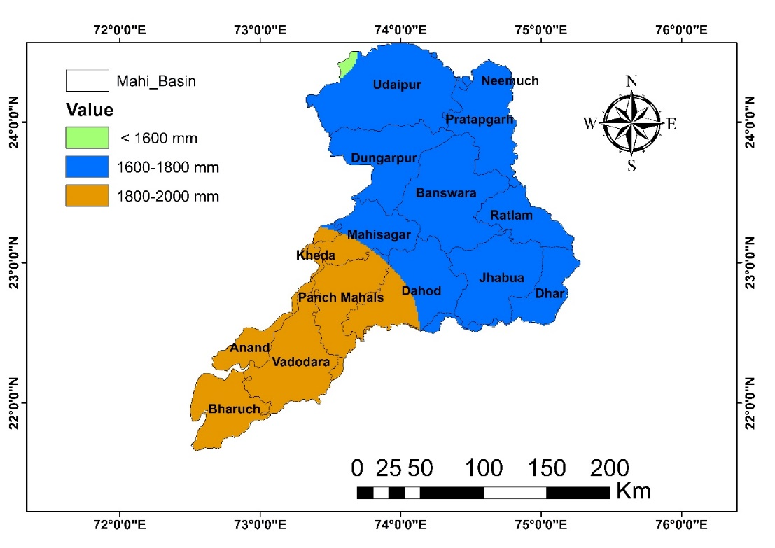

**Figure 12: Distribution of PET during present period (1991-05)**

The area under various PET classes during baseline period is given in Table 8. The PET in the major portion of the basin (68.9%) is under the 1600-1800 mm class whereas the remaining area (30.7%) is under 1800-2000 mm class with very less areas near the western part of Udaipur under less than 1600 mm class.

**Table 8: Area under various PETTH classes during present period (1991-05)**

|  |  |  |
| --- | --- | --- |
| **Sl. No.** | **PET (1991-05)** | **Area (%)** |
| 1 | < 1600 mm | 0.36 |
| 2 | 1600-1800 mm | 68.91 |
| 3 | 1800-2000 mm | 30.71 |

**4.3.3 Potential Evapotranspiration** **during (2006-40)**

The spatial variation of the PET in Mahi basin during 2006-40 as evaluated by the Thornthwaite method is shown in Figure 13. It can be observed that the PET varies between 2000-2600 mm in the basin. The PET in the northern parts of the basin in the districts of Udaipur and Neemuch falls in the range of 2000-2200 mm whereas the PET in the central parts of the basin falls in the range of 2200-2400 mm. The lower reaches of the basin near located the sea coast is having highest PET in the range of 2400-2600 mm. It can be observed that there is a considerable increase in all the PET classes during (2006-40) as compared to the baseline period due to the increases in the mean temperature projected during (2006-40).

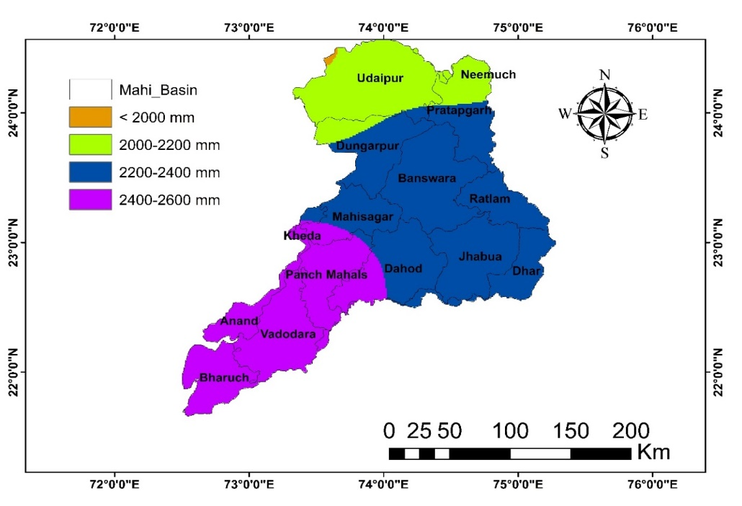

**Figure 13: Distribution of PETTH during future period (2006-40)**

The area under various PET classes during (2006-40) is given in Table 9. The PET in the major portion of the basin (52.1%) is under the 2200-2400 mm class followed by about 28.8% area falling in the PET range of 2400-2600 mm; 18.8% area falling in the 2000-2000 mm class and very less areas (0.15%) near the western part of Udaipur under less than 2000 mm class.

**Table 9: Area under various PET classes during future period (2006-40)**

|  |  |  |
| --- | --- | --- |
| **Sl. No.** | **PET (2006-40)** | **Area (%)** |
| 1 | < 2000 mm | 0.15 |
| 2 | 2000-2200 mm | 18.81 |
| 3 | 2200-2400 mm | 52.19 |
| 4 | 2400-2600 mm | 28.83 |

* 1. **Aridity Estimates for Mahi Basin**

Aridity estimates for the Mahi Basin reveal spatial and temporal variations influenced by rainfall and evapotranspiration patterns. Based on various aridity indices, the basin exhibits semi-arid to dry sub-humid conditions. Increasing temperatures and declining rainfall in future projections suggest a potential intensification of aridity, highlighting the need for sustainable water resource planning and climate-resilient strategies.

**4.4.1. Aridity** **during baseline period (1961-90)**

During the baseline period (1961–1990), the Mahi River Basin predominantly exhibited semi-arid to dry sub-humid climatic conditions. Aridity Index values calculated using standard methods indicated a moderate moisture deficit across the basin, with higher aridity observed in the northern and central regions. These conditions were primarily driven by low annual rainfall and high potential evapotranspiration, particularly during the summer months.

**4.4.1.1 UNEP Aridity index**

The spatial variation of the UNEP Aridity index based on the Thornthwaite method of PET estimation during the baseline period is shown in Figure 14 and the area under the various aridity classes is given in Table 10.

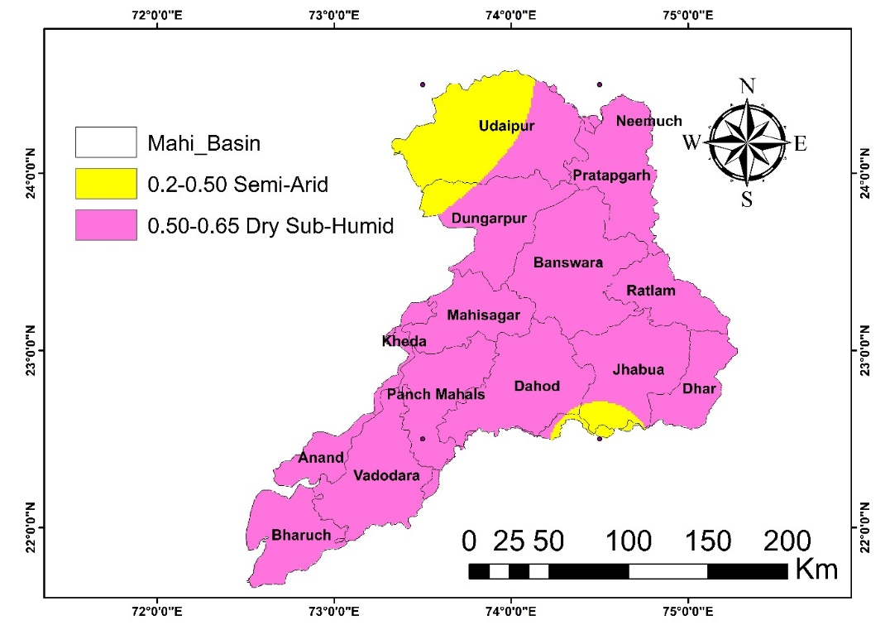

**Figure 14: Area under various AI classes during (1961-90) using PETTH**

It can be observed that the north western part of the basin located in Udaipur and small part of Jhabua district is under the semi-arid class whereas the remaining districts in the basin are mostly dry sub-humid.

**Table 10: Area under various AI classes during (1961-90) using PETTH**

|  |  |  |  |
| --- | --- | --- | --- |
| **Sl. No.** | **AI (1961-90)** | **Aridity class** | **Area (%)** |
| 1 | 0.2-0.50 | Semi-Arid | 9.71 |
| 2 | 0.50-0.65 | Dry Sub-Humid | 90.27 |

**4.4.1.2 De Martonne Aridity Index**

The spatial variation of the De Martonne Aridity index (IDM) during the baseline period is shown in Figure 15 and the area under the various aridity classes is given in Table 11. It can be observed that the aridity in Mahi basin varies between semi-arid to humid.

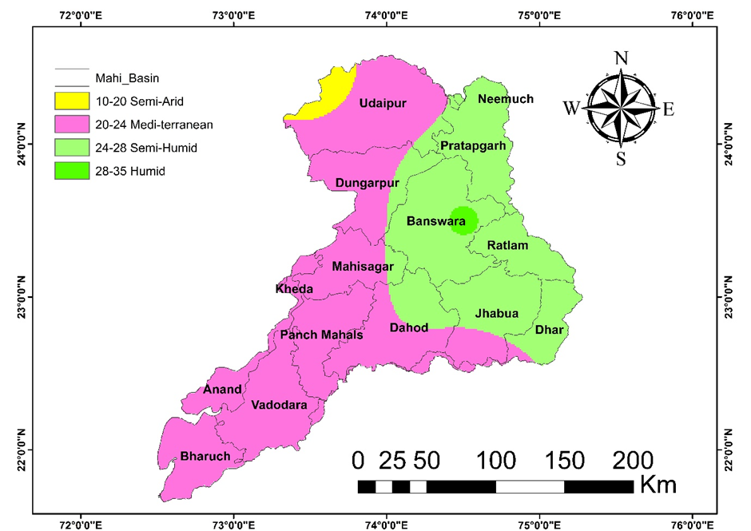

**Figure 15: Area under various De Martonne Aridity index classes during (1961-90)**

The semi-arid zones are located in the western parts of Udaipur district whereas the majority of the basin is under Mediterranean climate which resembles the dry sub-humid class as per the UNEP Climate Classification. Some of the districts in the upper reaches including Neemuch, Pratapgarh, Banswara, Ratlam, Jhabua and Dhar have semi-humid climate. About 57.5% of the study area is under mediterranean (dry sub-humid) climate followed by 39.8% under semi-humid climate.

**Table 11: Area under various De Martonne Aridity index classes during (1961-90)**

|  |  |  |  |
| --- | --- | --- | --- |
| **Sl. No.** | **AI (1961-90)** | **Aridity class** | **Area (%)** |
| 1 | 10-20 | Semi-Arid | 1.91 |
| 2 | 20-24 | Mediterranean | 57.53 |
| 3 | 24-28 | Semi-Humid | 39.75 |
| 4 | 28-35 | Humid | 0.79 |

**4.4.1.3 Pinna Combinative Index**

The spatial variation of the Pinna Combinative Index (IP) during the baseline period is shown in Figure 16. It can be observed that the aridity in Mahi basin varies between semi-arid to arid.

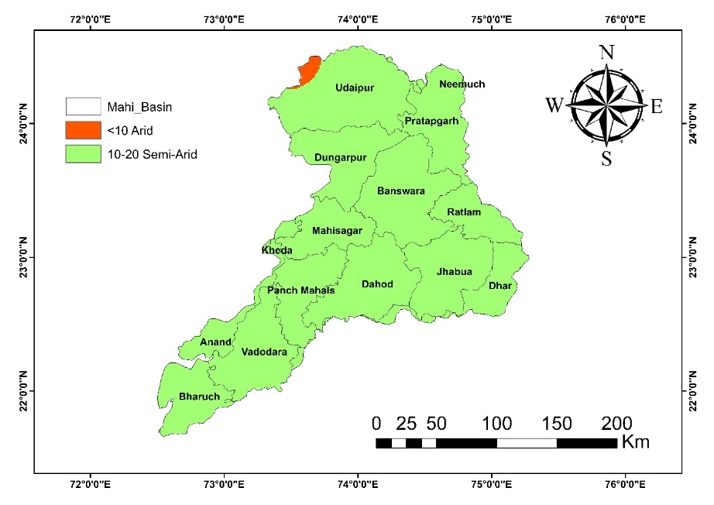

**Figure 16: Area under various Pinna Combinative Index classes during (1961-90)**

The area under the various aridity classes is given in Table 12. The arid zones are located in the western parts of Udaipur district whereas the majority of the basin is under semi-arid climate (99.33%).

**Table 12: Area under various Pinna Combinative Index classes during (1961-90)**

|  |  |  |  |
| --- | --- | --- | --- |
| **Sl. No.** | **AI (1961-90)** | **Aridity class** | **Area (%)** |
| 1 | < 10 | Arid | 0.66 |
| 2 | 10-20 | Semi-Arid | 99.33 |

**4.4.2 Aridity** **during present period (1991-2005)**

**4.4.2.1 UNEP Aridity index**

The spatial variation of the UNEP Aridity index based on the Thornthwaite method of PET (PETTH) estimation during the present period is shown in Figure 17 and the area under the various aridity classes is given in Table 13.

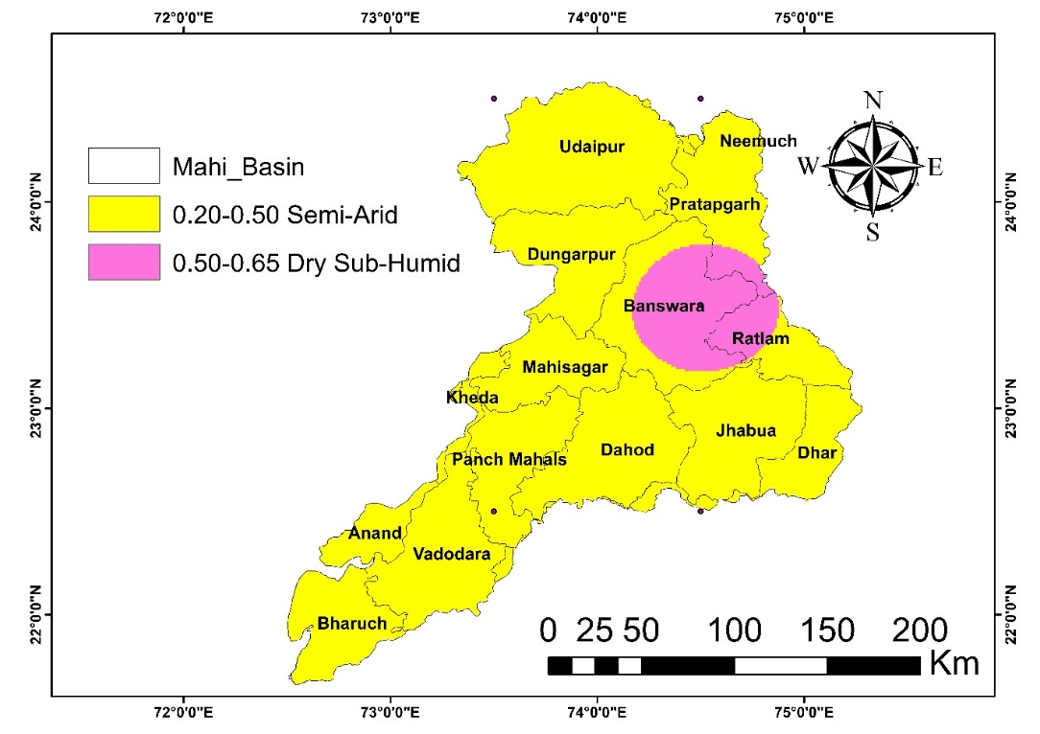

**Figure 17: Area under various AI classes during (1991-05) using PETTH**

It can be observed that most parts of the basin are under the semi-arid climate (90%) except for some areas with dry sub-humid climate located mostly in the districts of Banswara and Ratlam.

**Table 13: Area under various AI classes during (1991-05) using PETTH**

|  |  |  |  |
| --- | --- | --- | --- |
| **Sl. No.** | **AI (1991-05)** | **Aridity class** | **Area (%)** |
| 1 | 0.20-0.50 | Semi-Arid | 90.01 |
| 2 | 0.50-0.65 | Dry Sub-Humid | 9.97 |

**4.4.2.2 De Martonne Aridity Index**

The spatial pattern of the De Martonne Aridity Index (IDM) during the present period is depicted in Figure 18, and the classification of area under different aridity zones is summarized in Table 14. The analysis indicates that the Mahi Basin currently exhibits a range of aridity conditions, predominantly falling between semi-arid and semi-humid zones.

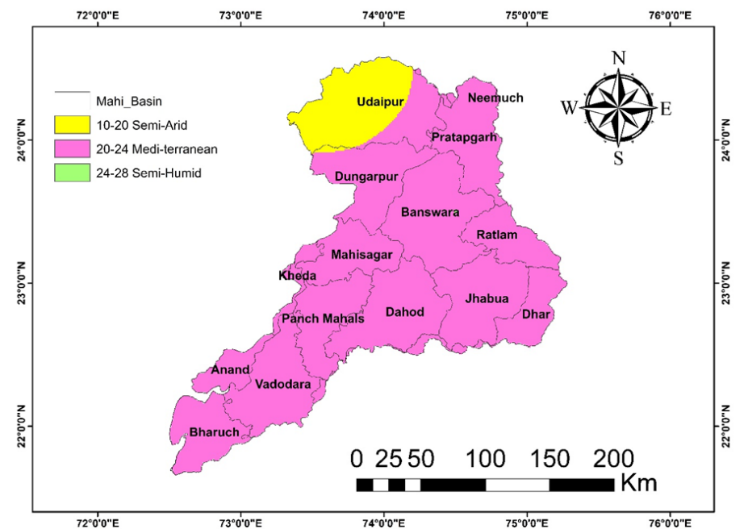

**Figure 18: Area under various De Martonne Aridity index classes during (1991-05)**

Semi-arid conditions are primarily observed in the western regions of Udaipur district. The majority of the Mahi Basin, however, falls under a Mediterranean-type climate, which aligns with the dry sub-humid category based on the UNEP Climate Classification. Approximately 89.6% of the basin lies within the dry sub-humid zone, while the remaining area falls under the semi-arid category.

**Table 14: Area under various De Martonne Aridity index classes during (1991-05)**

|  |  |  |  |
| --- | --- | --- | --- |
| **Sl. No.** | **AI (1991-05)** | **Aridity class** | **Area (%)** |
| 1 | 10-20 | Semi-Arid | 10.36 |
| 2 | 20-24 | Mediterranean | 89.62 |
| 3 | 24-28 | Semi-Humid | 0.01 |

**4.4.2.3 Pinna Combinative Index**

The spatial variation of the Pinna Combinative Index (IP) during the present period is shown in Figure 19 and the area under the various aridity classes is given in Table 15.

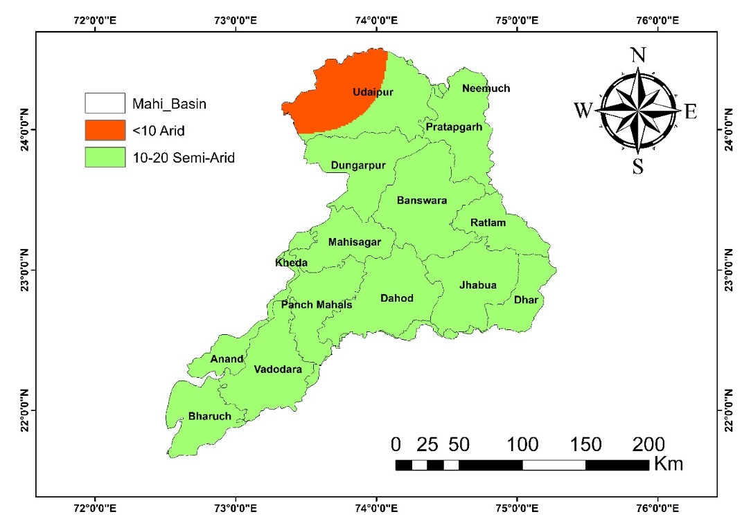

**Figure 19: Area under various Pinna Combinative Index classes during (1991-05)**

It can be observed that the aridity in Mahi basin has increased. The area under the arid zones located in the western parts of Udaipur district has increased from 0.66% to 7.58%. However, the majority area of the basin is under semi-arid climate (92.4%).

**Table 15 Area under various Pinna Combinative Index classes during (1991-05)**

|  |  |  |  |
| --- | --- | --- | --- |
| **Sl. No.** | **AI (1991-05)** | **Aridity class** | **Area (%)** |
| 1 | < 10 | Arid | 7.58 |
| 2 | 10-20 | Semi-Arid | 92.42 |

**4.4.3 Aridity future period** **during (2006-40)**

Projections for the period 2006–2040 indicate an increase in aridity across the Mahi River Basin, primarily driven by declining rainfall and rising temperatures. The De Martonne Aridity Index values suggest a shift from dry sub-humid to more semi-arid conditions, especially in the central and western regions. This trend reflects the impact of climate change on moisture availability, highlighting the need for adaptive water resource management to mitigate the risks associated with increasing aridity in the basin.

**4.4.3.1 UNEP Aridity index**

The spatial variation of the UNEP Aridity index based on the Thornthwaite method of PET estimation during 2006-40 time period is shown in Figure 20 and the area under the various aridity classes is given in Table 16.

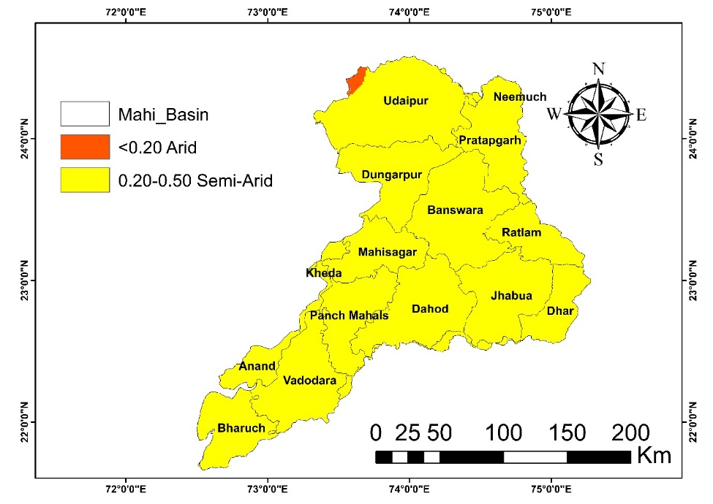

**Figure 20: Area under various AI classes during (2006-40) using PETTH**

It can be observed that the a very small part of the basin located in the north west in Udaipur district is projected to fall in the arid climate whereas the remaining districts in the basin are mostly semi-arid. This depicts a considerable change in the climate in Mahi basin which is projected to change form dry sub-humid to semi-arid in major portions of the study area. 99.52% of the basin is projected to have a semi-arid climate during (2006-40).

**Table 16: Area under various AI classes during (2006-40) using PETTH**

|  |  |  |  |  |
| --- | --- | --- | --- | --- |
| **Sl. No.** | **AI (2006-40)** | **Aridity class** | **Area (%)** | |
| 1 | < 0.20 | Arid | | 0.40 |
| 2 | 0.20-0.50 | Semi-Arid | | 99.52 |

**4.4.3.2 De Martonne Aridity Index**

The spatial variation of the De Martonne Aridity index (IDM) during 2006-40 is shown in Figure 21 and the area under the various aridity classes is given in Table 17.

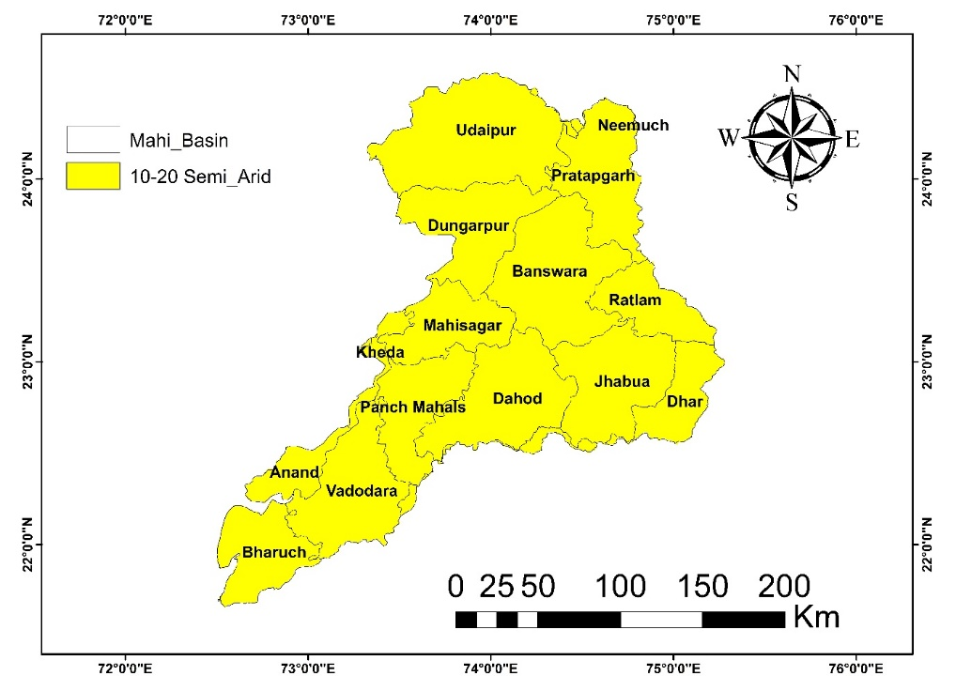

**Figure 21: Area under various De Martonne Aridity index classes during (2006-40)**

It can be observed that Mahi basin is projected to experience a semi-arid climate in the complete basin. A shift in the climate is therefore projected from mediterrean climate during present period to semi-arid climate during 2006-40.

**Table 17: Area under various De Martonne Aridity index classes during (2006-40)**

|  |  |  |  |
| --- | --- | --- | --- |
| **Sl. No.** | **AI (2006-40)** | **Aridity class** | **Area (%)** |
| 1 | 10-20 | Semi-Arid | 100 |

**4.4.3.3 Pinna Combinative Index**

The spatial variation of the Pinna Combinative Index (IP) during 2006-40 is shown in Figure 22 and the area under the various aridity classes is given in Table 18.

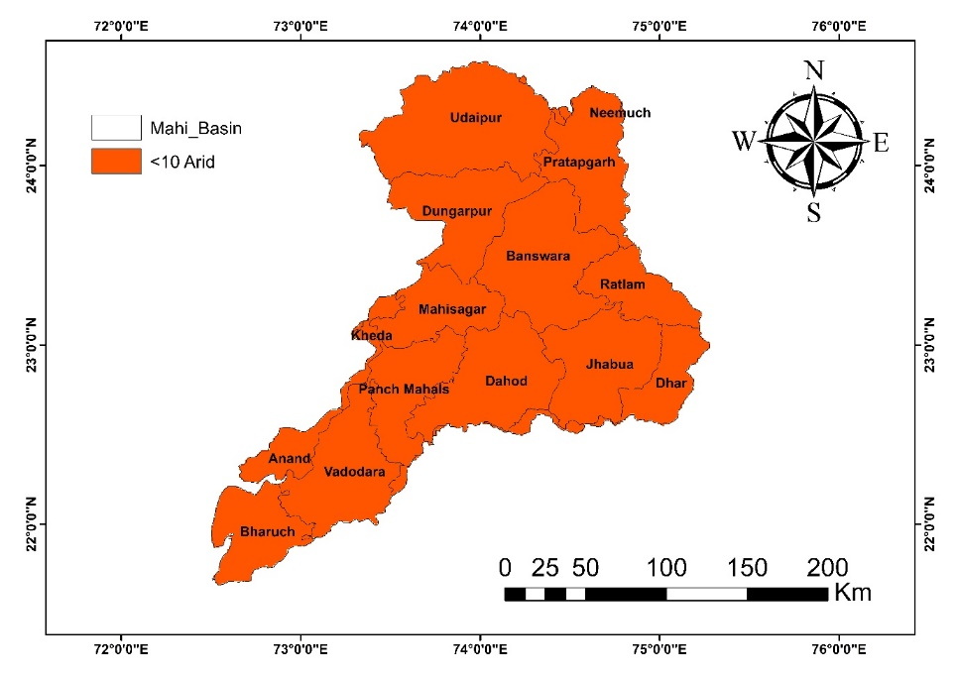

**Figure 22: Area under various Pinna Combinative Index classes during (2006-40)**

It can be observed that the aridity in Mahi basin is projected to be completely under the arid climate during 2006-40. The climate is expected to change substantially and become arid during 2006-40 from the semi-arid climate in major portions of the watersheds during the baseline period.

**Table 18: Area under various Pinna Combinative Index classes during (2006-40)**

|  |  |  |  |
| --- | --- | --- | --- |
| **Sl. No.** | **AI (2006-40)** | **Aridity class** | **Area (%)** |
| 1 | < 10 | Arid | 100 |

The climate classification derived from the three methods discussed earlier has been compiled for comparison in Table 19. A detailed examination reveals that aridity levels within the Mahi basin are undergoing a shift. According to the UNEP climate classification, which utilizes the Thornthwaite method for estimating potential evapotranspiration (PET), the basin's climate transitions from dry sub-humid in the baseline period to semi-arid during both the current period and the 2006–2040 timeframe. This suggests that the aridity index calculated through this method shows limited sensitivity to variations in climate parameters across the region. Furthermore, the influence of rising temperatures appears to have a minimal impact on PET, aridity levels, and consequently on the overall climate classification. On the other hand, the Martonne climate classification indicates a clearer transition—from a mix of dry sub-humid and semi-arid conditions during the baseline period to dry sub-humid in the present, eventually evolving to semi-arid conditions in the projected future.

**Table 19: Comparison of climate based on various climate classification schemes**

|  |  |  |  |  |  |
| --- | --- | --- | --- | --- | --- |
|  |  | **Climate classification method** | | | |
| S. No. | Time period | UNEP Climate Classification | De Martanne Climate  Classification | Pinna Climate Classification | |
|  |  |  |  | |
| 1 | Baseline | Dry-sub-humid | Partly Dry sub-humid and partly Semi-humid | | Semi-arid |
| 2 | Present | Semi-arid | Dry sub-humid | | Semi-arid |
| 3 | Future time  2006-40 | Semi-arid | Semi-arid | | Arid |

This indicates that the climate is projected to become drier in future time period. This climate classification also closely resembles the UNEP climate classification system based on Thornthwaite PET. Although the Pinna climate classification scheme suggests drier climate in future time period, but the estimation of the climate is always on the higher side. The final climate classification based on the majority of the climate suggested by all the three methods is given in Table 20.

**Table 20: Final climate for baseline, present and future time period**

|  |  |  |
| --- | --- | --- |
| **S. No.** | **Time period** | **Climate** |
| 1 | Baseline period | Dry sub-humid |
| 2 | Present period | Semi-arid |
| 3 | 2006-40 | Semi-arid |

It can be observed from above Table 19 that the aridity in the basin is projected to increase with the basin become drier in future time period. The dry sub-humid climate during the baseline period has already changed to semi-arid climate and is projected to remain the same during 2006-40.

Looking into the prospects of decreased rainfall and higher PET in the future time period, appropriate water resources management mechanisms should be devised considering the future water stress in the basin. The higher variability of rainfall suggests recurrent droughts in the future time period in the basin.

1. **CONCLUSION**

The present study evaluates the spatio-temporal variation in aridity across the Mahi River Basin using various aridity indices in the context of climate change. Historical climatic data from 1961–1990 and future projections for 2006–2040 were analyzed to understand the shifting climatic patterns, particularly focusing on rainfall, temperature, potential evapotranspiration (PET), and aridity index values.

Results from the baseline period revealed that the Mahi Basin was predominantly characterized by dry sub-humid conditions, with semi-arid zones mainly observed in the western parts of Udaipur district. Approximately 89.6% of the basin fell under the dry sub-humid category based on the UNEP classification, indicating moderate water availability under historical climatic conditions.

However, future climate projections indicate a notable decline in annual rainfall and a consistent rise in mean temperatures, resulting in increased PET values. This shift leads to a gradual transformation of the basin's climate from dry sub-humid to semi-arid, particularly in central and western regions. The De Martonne Aridity Index shows significant reductions in moisture availability, highlighting the growing influence of climate change on regional hydrological balance.

These findings emphasize the urgency of incorporating climate resilience into water resource planning and agricultural practices. Adaptive strategies, such as efficient irrigation systems, crop diversification, and improved watershed management, are essential to address the increasing aridity and ensure sustainable development in the region. Continued monitoring and modelling of climate variables will further support long-term planning and help mitigate the adverse effects of climate variability on the Mahi River Basin.

**Conflicts of Interest**

The authors declare no conflicts of interest.

**Disclaimer (Artificial intelligence)**

Author(s) hereby declare that NO generative AI technologies such as Large Language Models (ChatGPT, COPILOT, etc.) and text-to-image generators have been used during the writing or editing of this manuscript.

1. **REFERENCES**
2. Seneviratne, S., Nicholls, N., Easterling, D., Goodess, C., Kanae, S., Kossin, J., ... and Zwiers, F. W. (2012). Changes in climate extremes and their impacts on the natural physical environment.
3. McIlveen, R. (1998). *Fundamentals of weather and climate*. Psychology Press.
4. GUIDE, A. (2007). *Understanding weather and climate*.
5. Mulla, S., Ahmed, R., Singh, K. K., Singh, S. K., Deshmukh, N., and Inamdar, F. K. (2023). Climate change effect on-climate parameters like temperature, rainfall and water resources sectors in India. In *Climate change impacts in India* (pp. 9-59). Cham: Springer International Publishing.
6. Liu, J., Zhang, Q., Singh, V. P., and Shi, P. (2017). Contribution of multiple climatic variables and human activities to streamflow changes across China. *Journal of Hydrology*, *545*, 145-162.
7. Corfee-Morlot, J., and Höhne, N. (2003). Climate change: long-term targets and short-term commitments. *Global environmental change*, *13*(4), 277-293.
8. Jain, N., Bhatia, A., Pathak, H., Gupta, N., Sharma, D. K., and Kaushik, R. (2015). Greenhouse gas emission and global warming. *Introduction to environmental sciences*, 379-411.
9. Ussiri, D., and Lal, R. (2012). *Soil emission of nitrous oxide and its mitigation*. Springer Science and Business Media.
10. Liu, S., Chen, M., and Zhuang, Q. (2014). Aerosol effects on global land surface energy fluxes during 2003–2010. *Geophysical Research Letters*, *41*(22), 7875-7881.
11. National Research Council, Division on Earth, Life Studies, Board on Atmospheric Sciences, Climate Research Committee, and Committee on Radiative Forcing Effects on Climate. (2005). *Radiative forcing of climate change: Expanding the concept and addressing uncertainties*. National Academies Press.
12. Bano, I., and Arshad, M. (2017). Climatic changes impact on water availability. In *Perspectives on water usage for biofuels production: aquatic contamination and climate change* (pp. 39-54). Cham: Springer International Publishing.
13. Yadav, Vijay Shankar, R. V. Galkate, V.K. Chandola, Samikshya Panda, and Ankit Patel. 2024. “Trend Analysis and Change Point Detection of Climatic Parameters in Ambedkar Nagar District of Uttar Pradesh, India”. International Journal of Environment and Climate Change 14 (9):578-605.
14. Panda, S., Tripathi, V. K., and Yadav, V. S. (2025). A synergetic approach for multidimensional drought assessment in the Indian agro-climatic zone using coherency, propagation and AHP techniques. Environmental Science and Pollution Research, 1-18.
15. Garrote, L. (2017). Managing water resources to adapt to climate change: facing uncertainty and scarcity in a changing context. *Water Resources Management*, *31*(10), 2951-2963.
16. Sadoff, C., and Muller, M. (2009). *Water management, water security and climate change adaptation: early impacts and essential responses*. Stockholm: Global Water Partnership.
17. Mainguet, M., and Mainguet, M. (1999). The Spatial Framework, the Concepts of Aridity and Drought: the Soils and the Vegetation. *Aridity: Droughts and Human Development*, 5-78.
18. Mainguet, M. (1999). *Aridity: droughts and human development*. Springer Science and Business Media.
19. Agnew, R. (1992). Foundation for a general strain theory of crime and delinquency. *Criminology*, *30*(1), 47-88.
20. Thornthwaite, C. W. (1948). An approach toward a rational classification of climate. *Geographical review*, *38*(1), 55-94.
21. Penman, H. L. (1948). Natural evaporation from open water, bare soil and grass. *Proceedings of the Royal Society of London. Series A. Mathematical and Physical Sciences*, *193*(1032), 120-145.
22. Penman, H. L. (1956). Evaporation: an introductory survey. *Netherlands Journal of Agricultural Science*, *4*(1), 9-29.
23. Feng, X., Porporato, A., and Rodriguez-Iturbe, I. (2013). Changes in rainfall seasonality in the tropics. *Nature Climate Change*, *3*(9), 811-815.
24. Walton, R. E., and Dutton, J. M. (1969). The management of interdepartmental conflict: A model and review. *Administrative science quarterly*, 73-84.
25. Nairizi, S. (2017). Drought and Water Scarcity. *International Commission on Irrigation and Drainage: New Delhi, India*.
26. Pereira, L. S., Cordery, I., and Iacovides, I. (2009). *Coping with water scarcity: Addressing the challenges*. Springer Science and Business Media.
27. Zarch, M. A. A., Sivakumar, B., and Sharma, A. (2015). Assessment of global aridity change. *Journal of Hydrology*, *520*, 300-313.
28. Wang, Y. J., and Qin, D. H. (2017). Influence of climate change and human activity on water resources in arid region of Northwest China: An overview. *Advances in Climate Change Research*, *8*(4), 268-278.
29. Abdulla, F., Eshtawi, T., and Assaf, H. (2009). Assessment of the impact of potential climate change on the water balance of a semi-arid watershed. *Water resources management*, *23*, 2051-2068.
30. El-Rawy, M., Batelaan, O., Al-Arifi, N., Alotaibi, A., Abdalla, F., and Gabr, M. E. (2023). Climate change impacts on water resources in arid and semi-arid regions: a case study in Saudi Arabia. *Water*, *15*(3), 606.
31. Ullah, S., You, Q., Sachindra, D. A., Nowosad, M., Ullah, W., Bhatti, A. S., ... and Ali, A. (2022). Spatiotemporal changes in global aridity in terms of multiple aridity indices: An assessment based on the CRU data. *Atmospheric Research*, *268*, 105998.
32. Haider, S., and Adnan, S. (2014). Classification and assessment of aridity over Pakistan provinces (1960-2009). *International journal of environment*, *3*(4), 24-35.
33. Sharma, A., Sharma, D., and Panda, S. K. (2022). Assessment of spatiotemporal trend of precipitation indices and meteorological drought characteristics in the Mahi River basin, India. *Journal of Hydrology*, *605*, 127314.
34. Pedro-Monzonís, M., Solera, A., Ferrer, J., Estrela, T., and Paredes-Arquiola, J. (2015). A review of water scarcity and drought indexes in water resources planning and management. *Journal of Hydrology*, *527*, 482-493.
35. Jain, S. K., Agarwal, P. K., Singh, V. P., Jain, S. K., Agarwal, P. K., and Singh, V. P. (2007). Tapi, sabarmati and mahi basins. *Hydrology and water resources of India*, 561-595.
36. Pawar, U., Hire, P., Gunathilake, M. B., and Rathnayake, U. (2023). Spatiotemporal rainfall variability and trends over the Mahi basin, India. *Climate*, *11*(8), 163.
37. Das, S., and Scaringi, G. (2021). River flooding in a changing climate: rainfall-discharge trends, controlling factors, and susceptibility mapping for the Mahi catchment, Western India. *Natural Hazards*, *109*(3), 2439-2459.
38. Laskar, S. I. "India meteorological department." (2016): 1021-1037.
39. CORDEX, W. (2023). *Cordex–Coordinated Regional Climate Downscaling Experiment*.
40. Geng, S., de Vries, F. W. P., and Supit, I. (1986). A simple method for generating daily rainfall data. *Agricultural and Forest meteorology*, *36*(4), 363-376.
41. Ivanova, M. (2007). Designing the United Nations Environment Programme: a story of compromise and confrontation. *International Environmental Agreements: Politics, Law and Economics*, *7*, 337-361.
42. Rahimi, J., Ebrahimpour, M., and Khalili, A. (2013). Spatial changes of extended De Martonne climatic zones affected by climate change in Iran. *Theoretical and applied climatology*, *112*, 409-418.
43. Jahangir, M. H., and Danehkar, S. (2022). A comparative drought assessment in Gilan, Iran using Pálfai drought index, de Martonne aridity index, and Pinna combinative index. *Arabian Journal of Geosciences*, *15*(1), 90.