**Original Research Article**

**Spatiotemporal Evaluation of Rainfall Variability and Meteorological Drought in Bundelkhand Region**

ABSTRACT

Rainfall variability significantly impacts the hydrological and agricultural systems of Bundelkhand, a region frequently experiencing drought and water scarcity. This study analyzes rainfall trends, homogeneity, randomness, and autocorrelation across 14 districts of Bundelkhand from 1984 to 2023. Pettitt’s test confirmed homogeneity in most districts except Mahoba, which exhibited a significant shift in rainfall patterns. The Durbin-Watson test indicated negative autocorrelation in most districts, with Chitrakoot as the only exception showing positive autocorrelation. Spatial and temporal analyses revealed considerable variation in annual and monsoon rainfall, with southern districts (Sagar, Tikamgarh, and Panna) receiving higher rainfall than northern districts (Jalaun, Hamirpur, and Banda). The coefficient of variation showed that Jalaun had the highest rainfall variability, whereas Chhatarpur exhibited more stability. Drought assessment using rainfall departure methods highlighted that northern Bundelkhand, particularly Hamirpur and Jalaun, faces frequent droughts every 4–5 years. The results provide crucial insights that can assist policymakers in formulating effective drought mitigation measures and improving water security in Bundelkhand.

*Keywords: Rainfall variability, Drought assessment, Autocorrelation, Homogeneity test, Rainfall departure.*

# INTRODUCTION

Rainfall variability in India is a critical factor affecting agricultural productivity, water resources, and overall socio-economic stability. The Indian subcontinent experiences a highly variable monsoon season, which accounts for nearly 70% of the annual rainfall. This variability is influenced by a range of factors, including the El Niño Southern Oscillation (ENSO), Indian Ocean Dipole (IOD), as well as by local factors including topography and land use changes [1]. In recent decades, climate change has further intensified this variability, leading to increased occurrences of extreme weather events such as intense rainfall, floods, and prolonged droughts. These changes pose significant risks to agricultural productivity, particularly in rain-fed areas, which constitute nearly 60% of India's cultivated land [2]. Research have shown that the monsoon is starting to arrive on earlier dates, that seasons are getting shorter, and that there are more intense rainfall events. All of these factors combine to create a complicated pattern of wet and dry spells in different parts of the world [3,4,5]. Concern over the regional differences in rainfall distribution is also developing, as some regions see a noticeable drop in yearly rainfall while others have heavy and erratic downpour events. For example, throughout the past few decades, the north-eastern region of India has experienced a considerable decline in monsoon rainfall, which has had a negative impact on agriculture and water resources [6,7,8,9,10]. In the meantime, there is an increase in heavy rainfall events in several parts of India, which is causing catastrophic floods and soil erosion [11,12]. Research showed that the harmful effects on agriculture, infrastructure, and livelihoods in India must be mitigated by adopting adaptive solutions for crop planning, water resource management, and disaster preparedness due to the compounding effects of these changes [13,14].

Recent years have seen an increase in the difficulties brought on by rainfall variability due to the effects of climate change. Extreme weather occurrences, such as protracted dry periods that result in droughts and heavy rainfall that causes floods, have become more frequent and intense [15]. Due to its heavy reliance on monsoon rains, India's agriculture is especially disturbed about these changes, exclusively in areas lacking adequate irrigation infrastructure [16]. Additionally, there has been an increase in extreme rainfall events in certain places and a decrease in overall rainfall in others in the spatial distribution of rainfall. For instance, there has been a rise in severe rainfall events in some areas of the Eastern Ghats and the Eastern Coastal Regions, resulting in a regular occurrence of flooding and landslides [17]. However, there has been a decrease in seasonal rainfall in the Indo-Gangetic plains, which has led to worries about water scarcity and how it may affect food security [18].

Drought is a prolonged period of abnormally low precipitation that leads to a shortage of water, impacting agriculture, ecosystems, and human activities [19]. It is important to distinguish between drought, aridity and water scarcity [20]. Aridity is a constant aspect of the climate in some places, but water scarcity occurs when there is not enough water to meet typical demand. A recurring and unavoidable aspect of the climate is drought. Drought intensity is correlated with low precipitation, low soil moisture content, and decreased groundwater or stream flow relative to average levels. A region which receives more rainfall they can also got drought event e.g. in North-East India generally they received more rainfall but we cannot say surly that there were no drought events occurs.

According to report of Indian Meteorological Department [21]. North-East India has been facing increasing instances of drought in recent years. A significant decline in monsoon rainfall has been observed, leading to drought-like conditions in several states. According to this report, some parts of Assam and Meghalaya experienced rainfall deficits of over 20% during the monsoon season, which severely impacted agriculture and water resources in the region. These changes in rainfall patterns are contributing to the growing vulnerability of the region to droughts, a phenomenon that was once rare in this part of India [22], so the drought is nothing but it is the condition when the rainfall is below till a certain level of average rainfall at that area in a particular time. Bundelkhand region is one of the areas which is most susceptible to drought, where drought frequently occur and have a major negative impact on both the economy and agriculture [23] In light of this, the present research study visualizes a comprehensive analysis of statistical aspect of rainfall in 14 districts of Bundelkhand region. The aims to assess of the rainfall variability using standard statistical indicator and quantification of droughts using rainfall departure analysis, in order to obtain a better knowledge of drought frequency, drought prone districts and probability distribution analysis of drought in the Bundelkhand region

# STUDY AREA

The Bundelkhand region is spread in the 14 districts of Uttar Pradesh and Madhya Pradesh. It lies at the center of India and is located below the Indo-Gangetic plain to the north of the undulating Vindhyan mountain range which are spread across the northwest to the south. Out of the 14 districts of Bundelkhand region seven lies in Uttar Pradesh - Jhansi, Jalaun, Lalitpur, Hamirpur, Mahoba, Banda and Chitrakoot and seven in Madhya Pradesh - Datia, Tikamgarh, Chhatarpur, Damoh, Sagar, Panna and Niwari. The region lies between 23008ʹ N to 26030ʹ N latitude and 78011ʹ E to 81030ʹ E longitude with a total area of 71,619 sq. km. Most of the agriculture is rain-fed and the main occupation of the local population is agriculture.

### Climate

The average annual rainfall varies between 514 mm and 1260 mm and about 90% of it occurs during the south-west monsoon. The rainfall pattern is erratic and uncertain with very high variability. Maximum temperature of 470 C is recorded in Banda district and minimum temperature of 60 C is recorded in Banda and Chhatarpur district. The map showing the study area is given in Fig. 1.

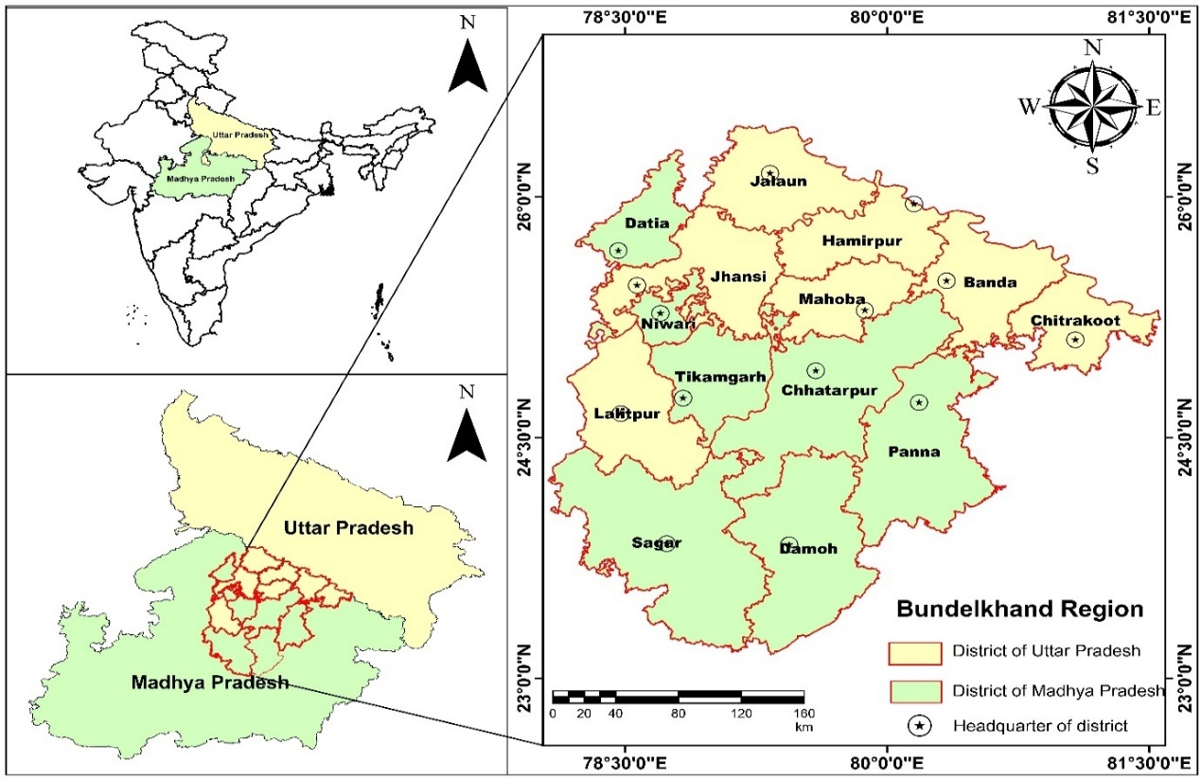

**Fig. 1. Map of Bundelkhand Region**

### Geography and Topography

Bundelkhand is known for its varied topography, which ranges in altitude from low plains to hilly mountains. The northern Vindhya Range, which passes across the area, contains the highest point in the area, which is around 600 meters above sea level. Usually located in the plains and river basins, the lowest height is about 150 meters above sea level. The Bundelkhand region's steep terrain is mostly due to the presence of the Vindhya Range. These hills are widespread but not extremely tall, creating a rough landscape that affects the climate, hydrology, and agriculture of the area.

### Data collection

Daily meteorological data (rainfall and temperature) for 14 districts of Bundelkhand region was collected by India meteorological department, Pune. At a resolution of 0.25*0.25, the rainfall gridded data was downloaded in grd format for the years 1901–2023 [24]. On the other hand, the analysis for the years 1984 to 2023 in this study was done using the grd format. IMD grid extractor software was used to extract the data. The Bundelkhand region comprises 14 districts with a total of 182 grid stations. Since there are more grid stations per district, the weighted average of rainfall for each station was determined using the Theisen polygon. Additionally, daily temperature data for the Bundelkhand region was collected by the India Meteorological Department, Pune. The temperature data (maximum and minimum) does not fluctuate as much as rainfall [25]. Maximum and minimum temperature grid data for each district was collected by the India Meteorological Department at its headquarters.

### Thiessen polygon Method

Thiessen polygon technique is the popular approach for figuring out average area rainfall. It is used in rainfall analysis to give rise to a way of spatially interpolating rainfall data over an area when measurements are limited to certain locations, such weather stations. Using Thiessen polygons, the region is divided into discrete regions, each linked to a single station, and the total area of each polygon is assigned the station's rainfall measurement. The main foundation of this strategy is proximal mapping, or locating the closest distant neighbour [26,27]. When predicting regional rainfall averages, Thiessen polygons outperform the arithmetic mean technique [28]. If P1,P2,P3….Pn are the rainfall magnitudes recorded by the stations 1,2,3,…,n respectively and A1,A2,A3….,An are the respective areas of the Thiessen polygons which has been shown in Fig. 2. The average rainfall P can be computed by the following Equation (1).

$$P= \frac{\sum_{i=1}^{n}{P_{i}A_{i}}}{\sum_{i=1}^{n}{A_{i}}} …(1)$$

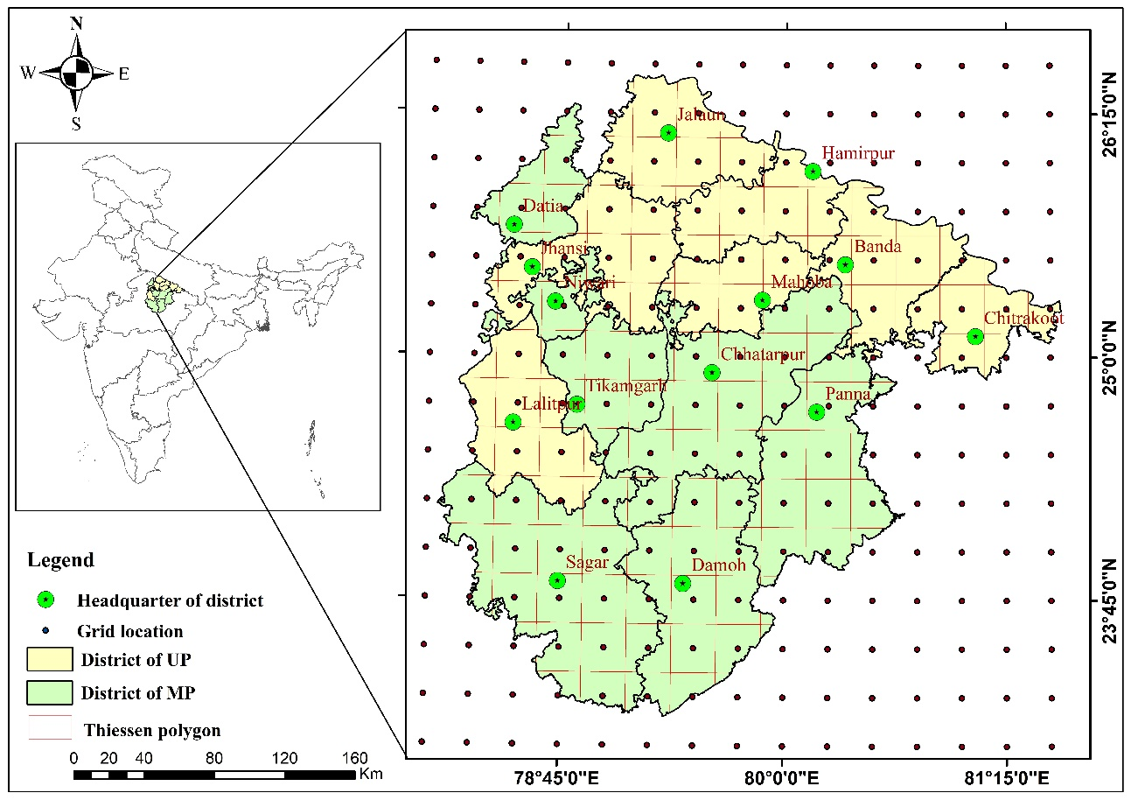

**Fig. 2. Thiessen Polygon of study area**

# METHODOLOGY

This section includes the description about the study area, collection of required data, statistical analysis of data and methods used to achieve research objective. The study involves the examination of rainfall variability using statistical tests, coefficient of variation, standard deviation, estimation of meteorological drought by rainfall departure analysis its characteristics as per their classification, at the end of the chapter, Drought frequency and severity analysed and the spatial representation of these analysis in the study area have done in this chapter.

### Homogeneity, Randomness and Autocorrelation Test

A homogeneity test for rainfall data is essential in hydrological and climatological investigations to confirm the data's dependability and consistency throughout time. Rainfall data, which is commonly collected over extended periods of time, can be influenced by a variety of factors, including changes in measuring techniques, the relocation of weather stations, and environmental changes. These factors might cause non-climatic movements or trends in the data, leading to incorrect conclusions if not discovered and corrected. In the present study non-parametric Pettitt’s test was carried out at 95% level of significance (alpha=0.05) to test the homogeneity in the annual rainfall time series of 14 district of Bundelkhand region. Assume that the null hypothesis at the time of applying this test is homogenous data over the entire period. If the computed "p" value is larger than the significance level alpha=0.05, the null hypothesis (H0) cannot be rejected. The alternative hypothesis (Ha) should be accepted and the null hypothesis (H0) should be rejected if the computed p-value is less than the significance level alpha = 0.05. The formulas involved in the Pettitt test are as follows.

* **Rank the data:**

Rank the data point X1, X2,……,Xn in the time series.

* **Calculate the rank sum Rt :**

For the data point t, calculate the rank sum of the first t data points,

$R_{t}=\sum_{i=1}^{t}{R(X_{i})} …(2)$

where R(Xi) is the rank of the ith observation in the entire series.

* **Compute the Test Statistic Ut :**

For each time point t, compute the Pettitt test statistic.

$$U_{t}=2R_{t}-t\left(n+1\right) …(3)$$

where n is the total number of observations

* **Identify the Change Point (k):**

The test statistic k is defined as the maximum absolute value of Ut​.

The Durbin-Watson test is a widely used statistical test to detect the presence of autocorrelation in the residuals from a regression analysis. Autocorrelation, particularly in time series data like rainfall, can indicate that the residuals (errors) are not independent, which violates one of the key assumptions of ordinary least squares regression. In the present study, the Durbin-Watson autocorrelation test was used to test the presence of autocorrelation or randomness in the data set. The autocorrelations near-zero or zero indicates the presence of randomness in the data set and when the autocorrelations are significantly non-zero indicate the non-random or autocorrelated data set. The Durbin-Watson statistic ranges from 0 to 4, where a value near 2 suggests no autocorrelation, a value close to 0 indicates positive autocorrelation, and a value approaching 4 indicates negative autocorrelation. A thumb rule is that test statistic values in the range of 1.5 to 2.5 are relatively normal. A normally auto correlated rainfall data was found more suitable for the analysis as it reduces the variability and improve predictive power of the results. A negative correlation may lead to bias in trend analysis, misleading statistical significance, and greater variability during statistical analysis which may be taken care during interpretation of results. The Durbin-Watson statistic‘d’ is calculated using the following Equation (5)

$$d= \frac{\sum_{t=2}^{n}{{\left(e_{t}-e_{t-1}\right)}^{2}}}{\sum_{t=1}^{n}{e_{t}^{2}}} …(5)$$

Where,

et is the residual (difference between observed and predicted values) at time t

n is the number of observations.

### Rainfall Variability Assessment

Rainfall variability refers to the inconsistencies in rainfall patterns observed over different timescales, ranging from short-term fluctuations (such as daily or monthly changes) to long-term trends (annual or decadal variations). These variations include differences in the quantity, intensity, duration, and timing of rainfall. Factors like geographic location, atmospheric conditions, and climate change significantly influence rainfall variability [29]. Understanding and managing rainfall variability is crucial for ensuring sustainable development in this vulnerable area. The area has seen enormous variations in precipitation in recent years, from severe droughts to flooding. As per study [30], the growing fluctuations in rainfall have intensified the scarcity of water and decreased crop production, impacting the means of subsistence for smallholder farmers, who make up the bulk of the populace in Bundelkhand. To assess the spatial and temporal variability associated with the rainfall in 14 districts of Bundelkhand region, the statistical analysis of annual, pre-monsoon, monsoon, post-monsoon, and winter rainfall as well as rainy days were carried out to compute the mean, standard deviation, coefficient of variation.

### Statistical Mean

The average or mean used to determine the central tendency of the data is called the statistical mean. Equation (6) is used to compute it by adding up all of the data points in a population and dividing the result by the total number of data points.

$$\overline{X}=\frac{\sum_{i=1}^{N}{X_{i}}}{N} …(6)$$

where,

$\overline{X}$ is the mean value of observations

Xi is the ith data value

N is the total number of data

### Standard Deviation

The standard deviation, which expresses the dispersion of the dataset with relation to its mean, is the square root of the variance.A low standard deviation suggests values are close to the sample mean, while a high standard deviation shows values are spread out over a larger range. The variance and standard deviation have been calculated using Equations (7 and 8)

$$S^{2}= \frac{\sum_{i=1}^{n}{{\left(x_{i}-\overline{x}\right)}^{2}}}{\left(n-1\right)} …(7)$$

$$SD=\sqrt{\frac{\sum_{i=1}^{n}{{\left(x_{i}-\overline{x}\right)}^{2}}}{\left(n-1\right)}} …(8)$$

where,

S2 is the sample Variance

SD is the Standard Deviation

xi is the observation value

$\overline{x}$ is the mean value of observations

n is the number of observations

### Coefficient of Variation (CV)

A standardized measurement of the dispersion of a probability or frequency distribution is the coefficient of variation, sometimes referred to as the relative standard deviation. The standard deviation to mean ratio is used to express it. The coefficient of variation is a dimensionless quantity that is computed using Equation (9) and is commonly given as a percentage. By comparing two data sets according to the degree of variance, it is possible to comprehend the intricate picture of rainfall variability throughout location and time.

$$CV=\frac{SD}{\overline{X}}×100 …(9)$$

where,

CV is the coefficient of variation

SD is the Standard Deviation

$\overline{X}$ is the mean of the observation value

### Extreme values of climatic parameters

To evaluate the features linked to rainfall and temperature extremes, statisticians must determine sample maximum and minimum values of climatic variables that differ from location to location and season to season. The maximum and minimum values of various temperature and rainfall statistics from every station were used in the analysis for this study.

### Rainfall Departure Analysis

The measurement of actual rainfall variations from long-term averages is a critical process in rainfall departure analysis, which is useful for planning agricultural impacts, managing water resources, and comprehending hydrological patterns. In this research work drought frequency, return period, and severity have all been assessed using the rainfall departure analysis of yearly rainfall. If the annual rainfall shortfall is more than or equal to 25% of the long-term norm, the year is deemed to be in a drought [31,32]. Droughts are further categorized based on how severe they are: a moderate drought occurs when the annual rainfall shortfall falls between 25% and 50%, while a severe drought occurs when the rainfall deficit exceeds 50%. The researcher [33,34,23,35], have carried out an analysis to identify droughts, their frequency and magnitudes in selected areas of Bundelkhand region and India. To diagnose meteorological drought, it's important to include region-specific atmospheric conditions, as precipitation deficits vary greatly among regions (NDMC). In this study, drought years were identified using at more than 25% deficiency of annual and seasonal rainfall departure (D) which have been calculated using Equation (10). The frequency and return period of droughts were calculated for further analysis using Equations (11 and 12).

$$Rainfall Departure \left(D\right)=\left(\frac{X_{i}-X_{m}}{X_{m}}\right)*100 …(10)$$

where Xi and Xm are annual rainfall and mean annual rainfall respectively.

$$Frequency \left(F\right)= \frac{Total No. of drought in the period}{Total No. of year} …(11)$$

$$Return period=\frac{Total No. of year}{Total No. of drought in the period } …(12)$$

### Probability distribution analysis

The probability distribution analysis of rainfall is very important for the investigation of extreme events occurrence. An area can be considered drought-prone if the probability of exceedance 75% of normal rainfall is less than 80% [36]. Researcher [23,35] have carried out studies to identify drought-prone areas in Madhya Pradesh at 75% of average annual rainfall and in Bundelkhand region, [37] has carried out study to identify drought prone area at 80% of average annual rainfall to assessment of drought proneness. For computing the probability of exceedance (P), Weibull’s distribution was fitted to the ranked annual rainfall data using Equation (13).

$$P= \left(\frac{M}{N+1}\right)*100 …(13)$$

Where, M is the rank and N is the number of years of data used.

# RESULTS AND DISCUSSION

The analysis has been carried out to assess rainfall variability and drought characteristics of 14 district of Bundelkhand region using long-term rainfall data with the help of statistical tests, rainfall departure analysis and probability distribution analysis.

### Homogeneity, Randomness and Autocorrelation Test of rainfall data

Climate data homogenization is crucial because non-climatic variables that are included in the data collecting process during monitoring could lead to data that is not reflective of the real climate, which could have an impact on the findings of hydrological and climatic studies. The Pettitt’s test has been applied for assessment of homogeneity and Durbin-Watson test statistics has been applied for assessment of randomness and autocorrelation in the data set of 14 stations of Bundelkhand region and results are shown in Table 1.

**Table 1. Pettitt’s test and Durbin-Watson test statistics of rainfall in Bundelkhand region**

|  |  |  |  |  |
| --- | --- | --- | --- | --- |
| District  Name | Homogeneity | | Randomness and Autocorrelation | |
| **Pettitt’s test statistics** | **Interpretation** | **D-W Test statistic** | **Interpretation** |
| Banda | 0.816 | H | 2.099 | NA |
| Chitrakoot | 1.000 | H | 1.641 | PA |
| Hamirpur | 0.242 | H | 2.269 | NA |
| Jalaun | 0.187 | H | 2.330 | NA |
| Jhansi | 0.055 | H | 2.413 | NA |
| Lalitpur | 0.730 | H | 2.553 | NA |
| Mahoba | 0.044 | NH | 2.397 | NA |
| Chhatarpur | 0.513 | H | 2.725 | NA |
| Damoh | 1.000 | H | 2.704 | NA |
| Datia | 0.609 | H | 2.406 | NA |
| Niwari | 0.447 | H | 2.375 | NA |
| Panna | 0.142 | H | 2.376 | NA |
| Sagar | 1.000 | H | 2.703 | NA |
| Tikamgarh | 0.204 | H | 2.416 | NA |

*H= Homogeneous, NH = Non-Homogeneous, PA = Positive Autocorrelated, NA = Negative Autocorrelated*

From the analysis of results shown in Table 1, it was observed that the annual rainfall data from 1984 to 2023 was homogeneous at all station except at Mahoba, where the *p*-values were lower than the significance level alpha=0.05. The annual rainfall time series data was found to be relatively normal for most of the districts where the Durbin-Watson (D-W) statistic was found lying between 1.5 to 2.5. All stations have shown negative autocorrelation in the data set as the D-W test statistic was found higher than 2 except Chitrakoot, where the D-W test statics was observed lower than 2. A normally autocorrelated rainfall data was found more suiTable for the analysis as it reduces the variability and improve predictive power of the results. A negative correlation may lead to bias in trend analysis, misleading statistical significance, and greater variability during statistical analysis which may be taken care during interpretation of results.

### Variability Analysis of rainfall

Rainfall variability refers to the inconsistencies in rainfall patterns observed over different timescales, ranging from short-term fluctuations (such as daily or monthly changes) to long-term trends (annual or decadal variations). These variations include differences in the quantity, intensity, duration, and timing of rainfall. Factors like geographic location, atmospheric conditions, and climate change significantly influence rainfall variability.Rainfall variability in the Bundelkhand region of India has significant implications for agriculture, water resource management, and socio-economic stability. Rainfall variability has been carried out using statistical analysis of 14 districts of Bundelkhand region for 40 years of rainfall data. This statistical study was carried out to assess the mean, standard deviation, and coefficient of variation of the temporal and spatial variation in rainy days and rainfall of the monsoon, post-monsoon, winter rainfall, pre-monsoon, and annual, as shown in Table 2 and its variances have been described by spatial maps, as shown in the Fig. 3 to Fig. 5.

**Table 2. Statistical analysis of rainfall in Bundelkhand region for the period of 19984 to 2023.**

|  |  |  |  |  |  |  |  |  |  |  |  |  |  |  |  |  |  |  |
| --- | --- | --- | --- | --- | --- | --- | --- | --- | --- | --- | --- | --- | --- | --- | --- | --- | --- | --- |
| District | Annual | | | Pre-Monsoon | | | Monsoon | | | Post Monsoon | | | Winter Rain | | | Rainy Days | | |
| **Mean** | **Std Dev** | **CV** | **Mean** | **Std Dev** | **CV** | **Mean** | **Std Dev** | **CV** | **Mean** | **Std Dev** | **CV** | **Mean** | **Std Dev** | **CV** | **Mean** | **Std Dev** | **CV** |
| Banda | 798.9 | 191.9 | 24.0 | 22.4 | 20.2 | 90.2 | 713.7 | 190.5 | 26.7 | 36.5 | 42.8 | 117.2 | 26.3 | 26.3 | 100.0 | 59.3 | 10.6 | 17.9 |
| Chitrakoot | 837.1 | 204.9 | 24.5 | 23.4 | 27.2 | 116.3 | 745.8 | 199.6 | 26.8 | 38.8 | 45.2 | 116.3 | 29.2 | 31.0 | 106.2 | 59.0 | 9.3 | 15.8 |
| Hamirpur | 758.1 | 195.6 | 25.8 | 21.1 | 16.3 | 77.4 | 671.1 | 187.6 | 27.9 | 40.0 | 44.6 | 111.5 | 25.9 | 27.6 | 106.8 | 55.5 | 8.4 | 15.2 |
| Jalaun | 639.8 | 202.2 | 31.6 | 16.7 | 12.9 | 77.6 | 559.5 | 177.9 | 31.8 | 40.2 | 47.9 | 119.2 | 23.5 | 28.4 | 121.1 | 51.1 | 10.6 | 20.7 |
| Jhansi | 778.5 | 208.2 | 26.7 | 19.7 | 17.4 | 88.2 | 697.6 | 189.9 | 27.2 | 38.1 | 47.9 | 125.8 | 23.2 | 27.2 | 117.2 | 59.4 | 8.9 | 15.0 |
| Lalitpur | 908.5 | 218.5 | 24.1 | 15.4 | 15.9 | 103.5 | 835.9 | 204.9 | 24.5 | 34.9 | 53.0 | 151.9 | 22.3 | 27.7 | 124.2 | 59.9 | 9.1 | 15.1 |
| Mahoba | 829.4 | 207.0 | 25.0 | 20.8 | 17.0 | 81.5 | 742.2 | 208.6 | 28.1 | 39.6 | 46.1 | 116.3 | 26.8 | 27.0 | 101.0 | 58.1 | 8.1 | 14.0 |
| Chhatarpur | 991.3 | 230.7 | 23.3 | 23.1 | 23.6 | 102.1 | 896.9 | 232.5 | 25.9 | 42.4 | 55.6 | 131.1 | 28.9 | 28.7 | 99.5 | 68.4 | 9.7 | 14.2 |
| Damoh | 1103.0 | 271.3 | 24.6 | 24.0 | 27.6 | 114.9 | 1012.8 | 272.7 | 26.9 | 38.3 | 50.2 | 131.1 | 27.9 | 29.1 | 104.3 | 73.3 | 11.6 | 15.9 |
| Datia | 763.5 | 187.8 | 24.6 | 19.5 | 19.2 | 98.2 | 682.7 | 169.1 | 24.8 | 39.4 | 51.5 | 130.5 | 21.8 | 25.9 | 119.0 | 56.6 | 10.2 | 18.1 |
| Niwari | 845.1 | 244.4 | 28.9 | 20.2 | 27.8 | 138.0 | 764.9 | 228.0 | 29.8 | 36.7 | 51.6 | 140.8 | 23.4 | 30.4 | 130.1 | 52.5 | 8.6 | 16.4 |
| Panna | 1042.6 | 254.1 | 24.4 | 20.7 | 27.1 | 131.3 | 953.0 | 256.5 | 26.9 | 39.1 | 47.0 | 120.1 | 29.8 | 33.3 | 111.7 | 69.2 | 9.7 | 14.0 |
| Sagar | 1118.7 | 277.8 | 24.8 | 24.0 | 26.0 | 108.4 | 1032.3 | 271.7 | 26.3 | 38.0 | 55.4 | 145.5 | 24.3 | 27.9 | 115.0 | 72.9 | 11.1 | 15.2 |
| Tikamgarh | 901.2 | 241.6 | 26.8 | 19.6 | 19.3 | 98.7 | 815.9 | 228.8 | 28.0 | 40.1 | 62.1 | 154.7 | 25.6 | 29.6 | 115.7 | 60.8 | 10.4 | 17.1 |

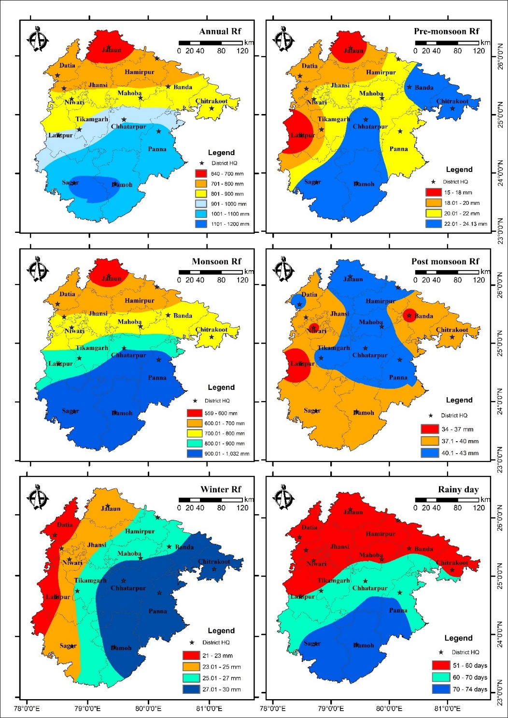Table 2 gives an overview of the amount of rainfall in each of the 14 districts in the Bundelkhand region. To aid in understanding, the entire region of Bundelkhand has been divided into two sections: North and South. Madhya Pradesh's states are situated in the bottom, or south portion, While Uttar Pradesh's states are primarily located in the upper section, or north. The statistical analysis has been shown in Table 2 Owing to the existence of a Vindhya range subcategory (Bander Chains), the Sagar district of Bundelkhand region had the most rainfall. The average pre-monsoon, monsoon, and annual rainfall were found to be similar; they were found to be highest in Sagar and lowest in Jalaun district, with magnitudes ranging from 24 to 16 mm, 1033 to 559 mm and 1119 to 639 mm, respectively. The post-monsoon rainfall average was found to be highest (43 mm) in Chhatarpur and lowest (34 mm) in Lalitpur. Panna and Lalitpur districts experienced the highest and lowest average winter rainfall 30 mm and 22 mm, respectively. The average number of rainy days was found to be highest in Damoh (73 days), and lowest in Niwari district (52 days).

**Fig. 3. Average rainfall distribution in Bundelkhand region for the period of 1984-2023**

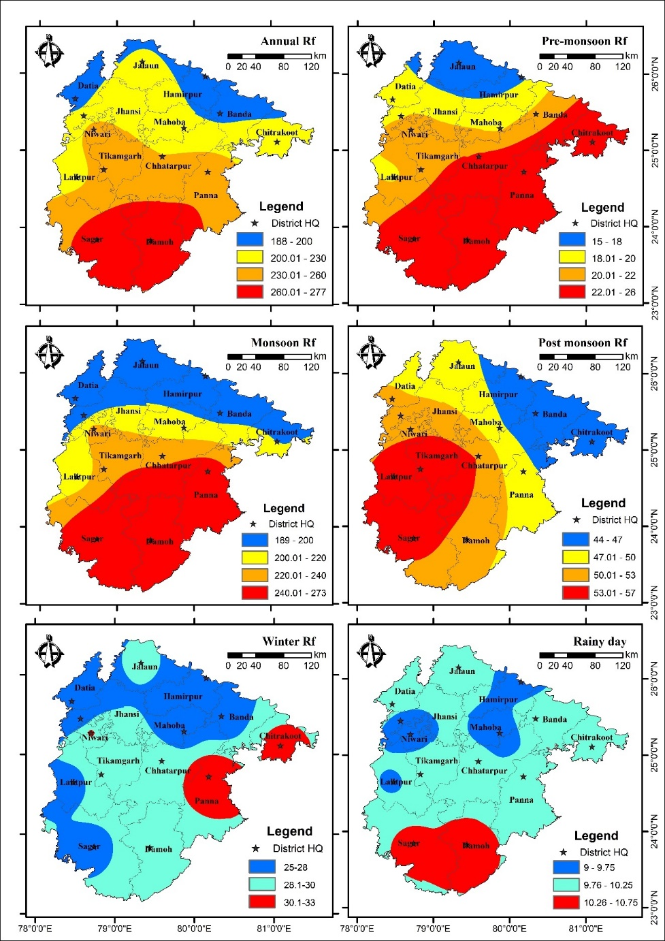From the Fig. 3 it was observed that southern part of the Bundelkhand region were received more average rainfall in annual, pre-monsoon and monsoon and least rainfall received at Northern part. Higher Post-monsoon rainfall received at north part whereas least at south. Winter rainfall was observed lowest in west portion of Bundelkhand e.g. Datia and Lalitpur whereas highest in east portion e.g. Chitrakoot, Panna, Damoh, Chhatarpur and some area of Banda district. North portion of Bundelkhand region was received less rainy days while south portion which is lies in Madhya Pradesh vice-versa.

**Fig. 4. Average standard deviation distribution in Bundelkhand region for the period of 1984-2023**

Important statistical indicators that can provide a complex picture of rainfall on both a spatial and temporal scale are the Standard Deviation (SD), which measures a dispersion in the dataset and the Coefficient of Variation (CV), which depends on inter-annual rainfall variation. These are described in detail in Table 2 and spatial distribution displayed in Fig. 4 and Fig. 5 the SD of average annual rainfall was observed highest at Sagar (277 mm) and lowest at Datia (187 mm) and CV for average annual rainfall was observed highest for Jalaun (32%) and lowest for Chhatarpur district with 24%. It was observed that SD of pre-monsoon rainfall is highest at Niwari (28 mm) with 138% of CV and lowest SD was found at Jalaun (13 mm), the lowest CV was observed at Hamirpur district which was 77.4% for pre-monsoon rainfall. For the monsoon rainfall highest SD was observed for Damoh district which was 272.7 mm, highest CV was found 31.8% for Jalaun and lowest SD was observed at Datia (169.1 mm), 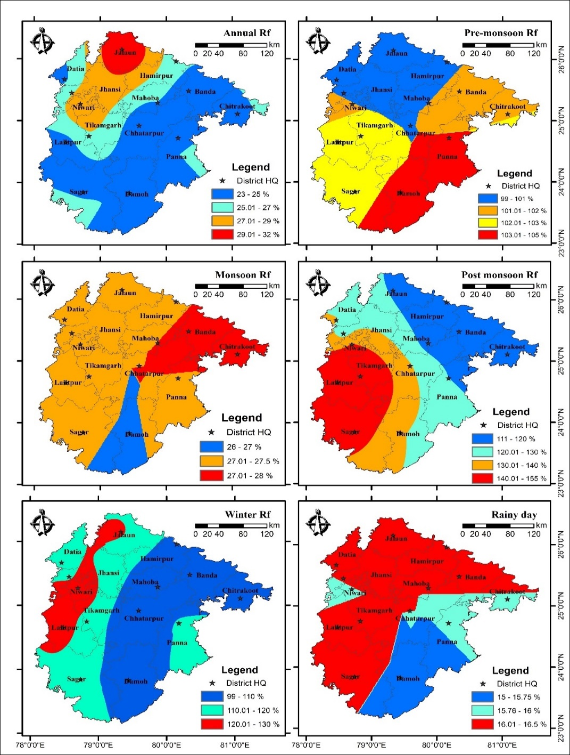lowest CV was found 24.5% at Lalitpur. For the post-monsoon rainfall, the maximum SD was observed at

**Fig. 5. Average coefficient of variance distribution in Bundelkhand region for the period of 1984-2023**

Tikamgarh district (62.1 mm) with 154.7% CV and the lowest SD was observed at Banda district which was 42.8 mm and the lowest CV was found 111.5% at Hamirpur district. Winter rainfall was observed that, the highest SD and CV were found at Panna district (33.3 mm) and Niwari (130.1%) respectively, and the lowest SD and CV were found at Datia (25.9 mm) and Chhatarpur (99.5%) respectively. In Bundelkhand region it was observed that the lowest SD and CV were found at Mahoba district which was 8.1 days with 14% variance and the highest SD was found at Damoh district (11.6 days) and highest CV was found at 20.7% for Jalaun district.

According to the Fig. 4 It has been shown that the south of the Bundelkhand region has the highest standard deviation, meaning that there is a greater chance of rainfall variance in this area. On the other hand, the north of the Bundelkhand region experiences lower rainfall due to its topography, as there are no hills or other obstructions that could cause orographic precipitation. The north of the Bundelkhand region has the lowest rainfall, as indicated by the Fig. 3, and the lowest standard deviation and coefficient of variance. Accordingly, the south of Bundelkhand had a relatively high coefficient of variance, whereas the north had a low value. The SD of rainy days was found to be highest in the south and to decrease in value as one moves northward.

### Drought assessment

In this study, the drought assessment has been carried out using rainfall departure analysis at 75% and the probability distribution analysis approach in 14 districts of Bundelkhand region which is discussed in details in this section.

### Rainfall Departure Analysis

The departure analysis of annual and monsoon rainfall has been carried out of 14 districts of Bundelkhand region to evaluate drought frequency, return period and drought severity, although all these characteristics are further estimated by drought indices. The district wise drought frequency analysis based on annual and monsoon rainfall departure analysis at 75% has been shown below in Tabular format. By the rainfall departure analysis, it was observed that the U.P. part (North part) of the Bundelkhand region experienced highly rainfall deficit as compare to M.P. part (South part) of the Bundelkhand region because presence of Vindhyan hill’s sub division. The rainfall departure at typical stations from different district is shown in Fig. 6 to Fig. 8. From these Fig.s it has been shown that the highest annual rainfall departure in Hamirpur district was observed -45.53% in year 2017 and highest monsoon rainfall departure -48.93% in 2014. Highest Annual rainfall departure and monsoon rainfall departure at Jalaun district was observed -60.67% and -58.23% in 2012. It was observed that the highest annual and monsoon rainfall departure -49.17 and -49.98% in 2007 at Lalitpur district.

**Fig. 6. Annual and monsoon rainfall departure at Hamirpur district**

**Fig. 7. Annual and monsoon rainfall departure at Jalaun district**

**Fig. 8. Annual and monsoon rainfall departure at Lalitpur district**

### Analysis of drought characteristics for annual and monsoon season

The India Meteorological Department states that when the annual or seasonal rainfall deficit exceeds 25% of the long-term normal rainfall, the year can be classified as a drought year. The drought frequencies evaluated using annual and monsoon rainfall at all districts of Bundelkhand region has been shown in Table 3 and the spatial representation has been shown in Fig. 10.

Table 3. Annual and monsoon drought return period and frequency

|  |  |  |  |  |  |  |
| --- | --- | --- | --- | --- | --- | --- |
| District | Annual | | | Monsoon | | |
| **No. of Drought year** | **Return period** | **Frequency** | **No. of Drought year** | **Return period** | **Frequency** |
| Banda | 5 | 1 in 8 year | 12.5 | 6 | 1 in 6 -7 year | 15 |
| Chitrakoot | 5 | 1 in 8 year | 12.5 | 8 | 1 in 5 year | 20 |
| Hamirpur | 9 | 1 in 4-5 year | 22.5 | 9 | 1 in 4-5 year | 22.5 |
| Jalaun | 8 | 1 in 5 year | 20 | 10 | 1 in 4 year | 25 |
| Jhansi | 6 | 1 in 6 -7 year | 15 | 6 | 1 in 6 -7 year | 15 |
| Lalitpur | 4 | 1 in 10 year | 10 | 6 | 1 in 6 -7 year | 15 |
| Mahoba | 7 | 1 in 5-6 year | 17.5 | 7 | 1 in 5-6 year | 17.5 |
| Chhatarpur | 5 | 1 in 8 year | 12.5 | 6 | 1 in 6 -7 year | 15 |
| Damoh | 6 | 1 in 6 -7 year | 15 | 7 | 1 in 5-6 year | 17.5 |
| Datia | 5 | 1 in 8 year | 12.5 | 6 | 1 in 6 -7 year | 15 |
| Niwari | 6 | 1 in 6 -7 year | 15 | 7 | 1 in 5-6 year | 17.5 |
| Panna | 4 | 1 in 10 year | 10 | 7 | 1 in 5-6 year | 17.5 |
| Sagar | 4 | 1 in 10 year | 10 | 6 | 1 in 6 -7 year | 15 |
| Tikamgarh | 6 | 1 in 6 -7 year | 15 | 8 | 1 in 5 year | 20 |

From the analysis, it was observed that drought return period for annual rainfall found least at Hamirpur district as one drought year in 4-5 year which means that the chances of drought occurrence in Hamirpur district is every 4 to 5-year. The highest drought frequency was observed at Hamirpur district with the value of 22.5%. from the Table 3. It has been observed that district Lalitpur, Panna and Sagar experience one drought event every 10 year. When we consider the monsoon rainfall, we found that the Jalaun district had the shortest drought return period, with chance of one drought occurring every four years and drought frequency was 25%. Banda, Jhansi, Lalitpur, Chhatarpur, Datia, and Panna districts had the longest drought return period, with the chance of one drought occurring every six to seven years, and the drought frequency was observed 15% for all these districts.

The severity of the drought was examined to determine whether districts are vulnerable to drought or not. There are two classifications based on the severity of the drought: normal and drought-prone. A district falls into the drought prone category if its rainfall deficit exceeds 25%, whereas it is considered to be normal if it receives more than 75% of its average rainfall. Table 4 shows the analysis of the drought severity for both annual and monsoon rainfall.

**Table 4. Drought severity of Bundelkhand region**

|  |  |  |  |  |  |  |
| --- | --- | --- | --- | --- | --- | --- |
| District (Station name) | Annual rainfall Based Analysis | | | Monsoon rainfall Based Analysis | | |
| 75% of annual rainfall | Probability of exceedance of 75% annual RF | Station Characteristic | 75% of monsoon RF | Probability of exceedance of 75% monsoon RF | Station Characteristic |
| Banda | 599.2 | 85 | Normal | 535.3 | 83 | Normal |
| Chitrakoot | 627.9 | 86 | Normal | 559.3 | 79 | Drought Prone |
| Hamirpur | 568.6 | 78 | Drought Prone | 503.4 | 77 | Drought Prone |
| Jalaun | 479.9 | 80 | Normal | 419.6 | 74 | Drought Prone |
| Jhansi | 583.9 | 85 | Normal | 523.2 | 84 | Normal |
| Lalitpur | 681.3 | 89 | Normal | 626.9 | 84 | Normal |
| Mahoba | 622.0 | 84 | Normal | 556.6 | 82 | Normal |
| Chhatarpur | 743.4 | 86 | Normal | 672.7 | 84 | Normal |
| Damoh | 827.2 | 84 | Normal | 759.6 | 80 | Normal |
| Datia | 572.6 | 87 | Normal | 512.1 | 84 | Normal |
| Niwari | 633.8 | 84 | Normal | 573.6 | 82 | Normal |
| Panna | 781.9 | 89 | Normal | 714.7 | 81 | Normal |
| Sagar | 839.0 | 89 | Normal | 774.3 | 84 | Normal |
| Tikamgarh | 675.9 | 84 | Normal | 611.9 | 79 | Drought Prone |

From the Table 4. It was observed that Hamirpur was the only district to be identified as drought prone, all the other districts were deemed to be normal. Four districts Hamirpur, Jalaun, Tikamgarh, and Chitrakoot were identified as drought-prone upon examination of the monsoon rainfall, other 10 districts were found to be normal condition. A typical annual and monsoon rainfall probability distribution graph for Banda district has been shown in Fig. 9 (a & b) and a spatial representation of the probability distribution of rainfall in Bundelkhand region has been shown in Fig. 10.

**Fig. 9 (a). Annual Rainfall probability distribution graph at Banda district**

**Fig. 9(b). Monsoon Rainfall probability distribution graph at Banda district**

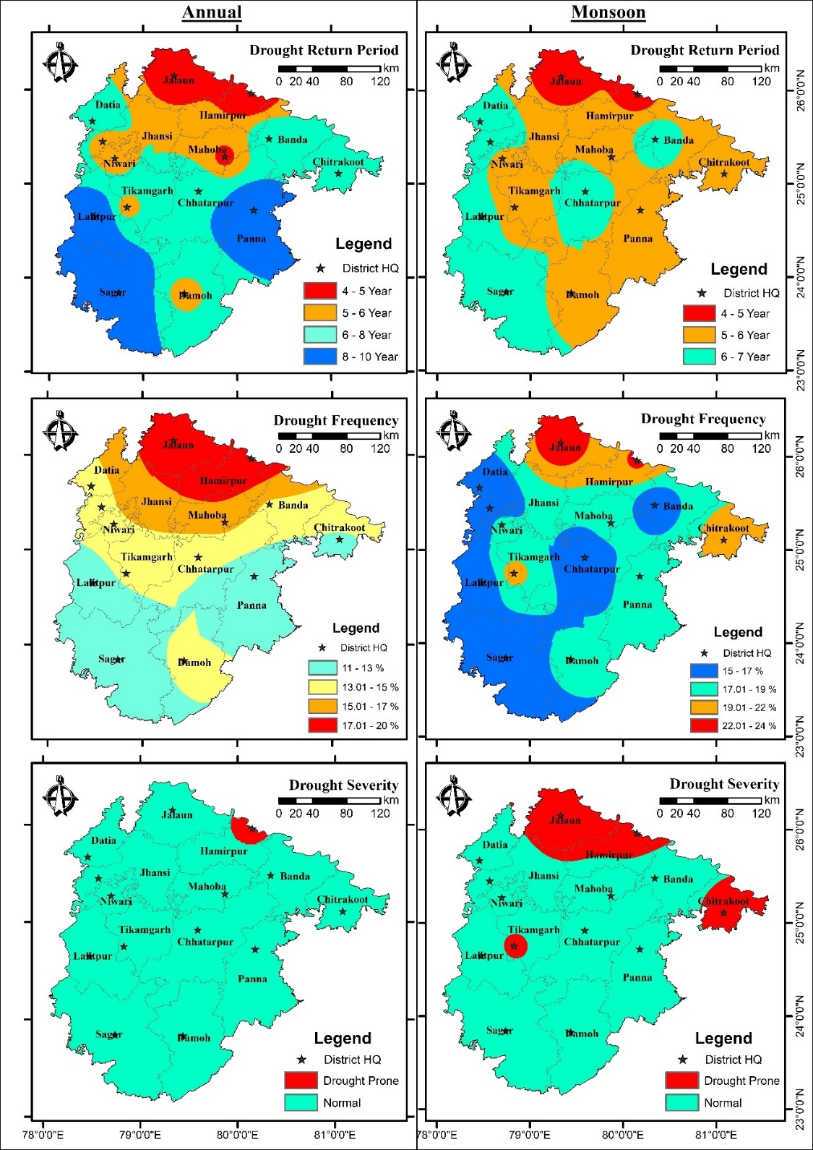

**Fig. 10. Spatial distribution of annual and monsoon drought characteristics**

According to the Fig. 10, The northern part of the Bundelkhand region is recognized as the quickest drought return period because of its plain landscape and absence of mountains, which resulted in less rainfall there, while south portion of Bundelkhand region experience longest drought return period because the presence of subdivision of Vindhyan region. This indicates that the districts which located in Uttar Pradesh, experiences more drought events as compare to districts that are located in Madhya Pradesh. Drought frequency was found to be lowest in the bottom half of the Bundelkhand region and higher in the top. Severity of drought was observed that drought prone district was found only north part of Bundelkhand region which has been shown in Fig. 10.

# SUMMARY AND CONCLUSION

The study assesses rainfall variability and drought characteristics in 14 districts of the Bundelkhand region using long-term rainfall data from 1984 to 2023. The analysis incorporates statistical tests, rainfall departure analysis, and probability distribution analysis to evaluate homogeneity, randomness, autocorrelation, and variability in rainfall patterns. The Pettitt’s test confirms homogeneity at most stations except Mahoba, while the Durbin-Watson test identifies negative autocorrelation in most cases, except in Chitrakoot. Rainfall variability is examined through statistical measures such as mean, standard deviation, and coefficient of variation for different rainfall seasons. The findings indicate that the southern part of Bundelkhand, particularly in Madhya Pradesh, receives higher annual, pre-monsoon, and monsoon rainfall compared to the northern part in Uttar Pradesh. Sagar district records the highest annual rainfall, while Jalaun experiences the lowest. The standard deviation and coefficient of variation maps suggest that rainfall is more variable in the southern region, whereas the northern region has more consistent but lower rainfall.

Drought assessment was analysed by using rainfall departure analysis and probability distribution analysis. The results indicate that the northern Bundelkhand region has a higher frequency of droughts compared to the southern region, primarily due to the absence of orographic barriers. Hamirpur, Jalaun, and Lalitpur districts have recorded severe drought conditions, with Jalaun experiencing the highest annual and monsoon rainfall departures. The frequency analysis highlights that droughts occur once every 4 to 10 years, depending on the district and season. The analysis highlights significant spatial and temporal variability in rainfall across the Bundelkhand region, with southern districts receiving higher and more variable rainfall than northern districts. The negative autocorrelation observed in most stations suggests potential biases in trend analysis, which should be considered in future studies. The findings emphasize the importance of considering regional disparities when planning water resource management and agricultural strategies. Drought frequency analysis reveals that northern districts, particularly in Uttar Pradesh, experience more frequent and severe droughts compared to the southern districts in Madhya Pradesh. Overall, the study provides valuable insights into rainfall variability and drought patterns in Bundelkhand, which can aid policymakers in developing effective strategies for water resource management and climate resilience in the region.

**Conflicts of Interest**

The authors declare no conflicts of interest.

**Declaration of using AI**

The Author, hereby declare that NO generative AI technologies have been used during writing or editing of manuscript.

# REFERENCES

1. Gadgil, S., & Srinivasan, J. (2021). *Monsoon variability and climate change in India*. Current Science, 120(3), 449-457.
2. Kumar, M., Tripathi, S. K., & Singh, A. (2022). *Socio-economic implications of drought and rainfall variability in Bundelkhand region*. Journal of Climate Change, 8(2), 15-28.
3. Pai, D. S., & Rajeevan, M. (2020). *Observed changes in the Indian summer monsoon rainfall patterns*. Theoretical and Applied Climatology, 141(3-4), 1297-1308.
4. Saha, S. K., Nair, A. R., & Goswami, B. N. (2023). *Regional disparities in Indian monsoon rainfall and implications for agriculture*. Climate Dynamics, 60(1), 29-43.
5. Yadav, Vijay Shankar, R. V. Galkate, V.K. Chandola, Samikshya Panda, and Ankit Patel. 2024. “Trend Analysis and Change Point Detection of Climatic Parameters in Ambedkar Nagar District of Uttar Pradesh, India”. International Journal of Environment and Climate Change 14 (9):578-605.
6. Jaiswal, R. K., Lohani, A. K., & Tiwari, H. L. (2015). Statistical analysis for change detection and trend assessment in climatological parameters. Environmental Processes, 2, 729-749.
7. Kumari, P., Jaiswal, R. K., & Singh, H. P. (2024). Assessing climate change impacts on irrigation water requirements in the Lower Mahanadi Basin: A CMIP6-based spatiotemporal analysis and future projections. Journal of Water and Climate Change, jwc2024152.
8. Galkate, R. V., Yadav, S., Jaiswal, R. K., & Yadava, R. N. (2020). Trend analysis of river flow and groundwater level for Shipra river basin in India. Arabian Journal of Geosciences, 13(3), 1-9.
9. Jaiswal, R. K., Tiwari, H. L., & Lohani, A. K. (2017). Assessment of climate change impact on rainfall for studying water availability in upper Mahanadi catchment, India. Journal of Water and Climate Change, 8(4), 755-770.
10. Galkate, R. V., Pandey, R. P., & Yadava, S. (2022, December). Assessment of Rainfall Variability and Drought Features in Bundelkhand Region of Madhya Pradesh, India. In 5th World Congress on Disaster Management: Volume II (pp. 278-289). Routledge.
11. Dhruw, G., Agrawal, N., & Jaiswal, R. K. (2024). Rainfall-runoff Modelling Using MIKE11 NAM Model for Ravishankar Sagar Catchment, Chhattisgarh, India. *International Journal of Environment and Climate Change*, 14(4), 719-738.
12. Dhankar, Bhupendra, Jitendra Sinha, and Rahul Kumar Jaiswal. 2025. “Assessment of Rainfall-Runoff Using HEC-HMS in Ravishankar Sagar Reservoir, Dhamtari, Chhattisgarh, India”. *International Journal of Environment and Climate Change* 15 (4):1-15.
13. Singh, A., Kumar, R., & Das, S. (2021). *Climate change and its impact on rainfall patterns in North-East India*. Journal of Climatology and Weather Forecasting, 9(2), 45-53.
14. Chowdary, V. M., Rao, V. U. M., & Sikka, A. K. (2023). *Strategies for managing climate-induced rainfall variability in Indian agriculture*. Agricultural Systems, 205, 103556.
15. Mishra, V., Tiwari, A. D., & Shah, R. D. (2022). *Extreme weather events and rainfall variability in India under climate change*. Weather and Climate Extremes, 35, 100384.
16. Mall, R. K., Srivastava, R. K., & Banerjee, T. (2022). *Climate change, extreme events and agriculture: Adaptation perspectives from India*. Regional Environmental Change, 22(1), 12.
17. Joseph, S., Sahai, A. K., & Goswami, B. N. (2021). *Increasing trend of extreme rainfall events over the Western Ghats of India*. International Journal of Climatology, 41(4), 2315-2330.
18. Krishna Kumar, K., Rajagopalan, B., & Cane, M. A. (2021). *Climate change and the weakening of the Indian summer monsoon rainfall*. Science, 347(6227), 728-731.
19. World Meteorological Organization. (2023). The State of Climate Services 2023: Drought (No. 1382). WMO. <https://library.wmo.int/doc_num.php?explnum_id=11104>
20. Wilhite, D. A. (Ed.). (2012). *Drought assessment, management, and planning: theory and case studies: theory and case studies* (Vol. 2). Springer Science & Business Media.
21. Indian Meteorological Department. (2022). *Monsoon report: Rainfall patterns and impacts in North-East India*. IMD.
22. Singh, D., Swain, D. L., & Horton, D. E. (2021). *Rising extreme rainfall events over central India and their association with climate change*. Geophysical Research Letters, 48(7), e2020GL090902
23. Galkate, R. V., Pandey, R. P., Thomas, T., Jaiswal, R. K., & Nayak, T. R. (2015). Meteorological and hydrological aspects of drought in central Indiapreparedness and management of water related disasters’, 3rd India Water Week 2015, water Management for Sustainable Development, 13–17 January 2015. New Delhi.
24. Pai, D. S., Rajeevan, M., Sreejith, O. P., Mukhopadhyay, B., & Satbha, N. S. (2014). Development of a new high spatial resolution (0.25× 0.25) long period (1901-2010) daily gridded rainfall data set over India and its comparison with existing data sets over the region. Mausam, 65(1), 1-18.
25. Srivastava, A. K., Rajeevan, M., & Kshirsagar, S. R. (2009). Development of a high resolution daily gridded temperature data set (1969–2005) for the Indian region. Atmospheric Science Letters, 10(4), 249-254.
26. Basistha, A., Arya, D. S., & Goel, N. K. (2008). Spatial distribution of rainfall in Indian Himalayas–a case study of Uttarakhand region. Water Resources Management, 22, 1325-1346.
27. Tabios III, G. Q., & Salas, J. D. (1985). A comparative analysis of techniques for spatial interpolation of precipitation 1. JAWRA Journal of the American Water Resources Association, 21(3), 365-380.
28. Thiessen, A. H. (1911). Precipitation averages for large areas. Monthly weather review, 39(7), 1082-1089.
29. Doe, J., & Smith, A. (2024). Understanding rainfall variability and its implications. *Climate Research Journal, 35*(4), 215-230.
30. Singh, R., Kumar, M., & Tripathi, S. (2020). Rainfall variability and its impact on agriculture in Bundelkhand. Climate Change Journal, 15(2), 157-172.
31. Ray, K. S., & Shewale, M. P. (2001). Probability of occurrence of drought in various sub-divisions of India. Mausam, 52(3), 541-546.
32. India Meteorological Department. (2002). End of season report [Online]. Southwest monsoon. Available: 〈http://www.imd.gov.in/section/nhac/dynamic/mid1.htm〉; 4 October 2002 Accessed February 2013
33. Yaseen, K., AL-Timimi & AL-Jiboori. (2013). Assessment of spatial and temporal drought in Iraq during the period 1980-2010. International Journal of Energy and Environment, 4(2): 291-302.
34. Ramaraj, A. P., Kokilavani, S., Manikandan, N., Arthirani, B., & Rajalakshmi, D. (2015). Rainfall stability and drought valuation (using SPI) over southern zone of Tamil Nadu. Current World Environment, 10(3), 928.
35. Jaiswal, S., Galkate, R., Chandola, V. K., Singh, P., & Thakur, A. (2019). Assessment of drought in Shipra River Basin, Madhya Pradesh. Journal of Soil and Water Conservation, 18(2), 188.
36. Central Water Commission. (1982). Report on identification of drought prone areas of 99- Districts, New Delhi.
37. Gupta, A. K., Nair, S. S., Ghosh, O., Singh, A., & Dey, S. (2014). Bundelkhand drought: retrospective analysis and way ahead. *National Institute of Disaster Management, New Delhi*, *148*.