***In vitro* evaluation of different plant extracts against *Fusarium oxysporum* f. sp. *vasinfectum* (FOV) causing wilt disease of cotton under South Gujarat**

**Abstract**

Cotton (*Gossypium hirsutum* L.) is a major fiber crop that contributes significantly to global economic and social development. It is often referred to as "The White Gold" or "The King of Fibers". Cotton is a major cash crop in our country and belongs to the family Malvaceae. Cotton is a historically important commercial commodity, next to food grains, and serves as the primary raw material for the thriving textile industry. Cotton production, processing, textiles, and allied industries employ approximately 42 million people and sustain their livelihoods. In this present study, six different plant extracts at 10 per cent concentration were evaluated under *in vitro* condition against the *Fusarium oxysporum* f. sp. *vasinfectum* causing wilt disease of cotton. When compared to control, all the plant extracts showed a significant suppression of the pathogen's mycelial growth. The lowest mycelial growth with the maximum per cent inhibition was found in Garlic bulb extract (*A. sativum*) while, the highest mycelial growth with the minimum per cent growth inhibition was found in onion bulb extract (*A. cepa*).

**Keywords**: Cotton, *Fusarium,* Extract, Inhibition

**Introduction**

Cotton (*Gossypium hirsutum* L.) is a major fiber crop that contributes significantly to global economic and social development. It is often referred to as "The White Gold" or "The King of Fibers". Cotton is a major cash crop in our country and belongs to the family Malvaceae (Anonymous, 2017). Cotton is a historically important commercial commodity, next to food grains, and serves as the primary raw material for the thriving textile industry. Cotton production, processing, textiles, and allied industries employ approximately 42 million people and sustain their livelihoods (Manickam and Sankaranarayanan, 2013).

India is the leading country in terms of area under cotton, which cultivates cotton in around 125 lakh hectares, which is around 39 per cent of the world cotton area. At the global level, though India occupies 39 per cent of the area, but able to produce just 22 per cent of the global cotton production (Anonymous, 2024a).

Indian cotton scenario has been highly fluctuating due to biotic as well as abiotic stresses and competition from other crops in recent years. The cotton production in India during 2023-24 estimated to produce 323.11 lakh bales of 170 kg from 124.69 lakh hectares with a productivity of 441 kg lint/ha as estimated by the Directorate of Economics and Statistics, Ministry of Agriculture and Farmers Welfare, New Delhi. The area under cotton in the current year in the country decreased by 3.67 per cent and cotton production decreased by 4.18 per cent compared to last year. In Gujarat, cotton is cultivated in an area of 26.83 lakh ha and the production of 89.65 lakh bales with the productivity of 568 kg/ha. (Anonymous, 2024b).

Biological control has been considered to be a more environmentally friendly option than the existing chemical treatment techniques for managing soil-borne pathogenic fungi that cause wilt (Otadoh *et al*., 2011). Natural solutions, including plant extracts or botanical supplements, are being used instead of synthetic fungicides to treat fungal diseases in plants because they pose fewer risks to human health and the environment. This could be utilized to express novel, environmentally friendly, and safer fungicides (Ramaiah and Garampall 2015). Biopesticides made from natural resources are a better choice, even though chemical pesticides are occasionally more appropriate. The different botanicals have recently gained more attention in the field of plant protection. Because they are less expensive and safer than synthetic pesticides, plant-derived (botanical) protectants (PDPs) provide a competitive advantage (Arora *et al*., 2022). Therefore, the purpose of this experiment was to investigate the effectiveness of plant extracts in controlling the wilt disease in cotton under *in vitro* condition.

**Materials and methods**

Fresh plant parts were collected and washed first in tap water and then in distilled water. Hundred grams of fresh sample was chopped and then crushed in surface sterilized pestle and mortar by adding 100ml sterile water (1:1 w/v). The extract was filtered through two layers of muslin cloth and then centrifuged at 10,000 rpm. Finally filtrate thus obtained was used as stock solution (Sindhan *et al*., 1999).

To study the antifungal mechanism of plant extracts, poisoned food technique was used (Nene and Thapliyal, 1973). 10ml of stock solution was mixed with 90ml of sterilized molten PDA medium, so as to get 10 per cent concentration. The media was thoroughly shaken for uniform mixing of the extract. To avoid the bacterial contamination, a little amount of streptomycin was added in each flask before plating (Hiremath *et al*., 2020).

Each plate was inoculated with 5mm disc of seven days old culture of *F. oxysporum* f. sp. *vasinfectum* with the help of sterilized cork borer. The inoculated Petri plates were incubated at 27±2°C for seven days. A control was also maintained where, the media was not supplemented with any of the plant extracts. The experiment was conducted in completely randomized design with three repetitions. The colony diameter was measured after seven days of incubation.

The efficacy of botanicals was expressed as the per cent inhibition of mycelial over control which was calculated by using the formula given by Asalmol *et al*. (1990).

$$I=\frac{C-T}{C}×100$$

Where,

I = Inhibition of mycelial growth (%)

C = Radial growth of mycelial in control (mm)

T = Radial growth of mycelial in treatment (mm)

**Table 1: List of Plant extracts to be used for the experiment**

|  |  |  |  |
| --- | --- | --- | --- |
| **Tr. No.** | **Treatments** | **Plant part used** | **Concentration (%)** |
| T1 | Neem extract (*Azadirachta indica* A. Juss.) | Leaves | 10 |
| T2 | Datura extract (*Datura stramonium* L.) | Leaves | 10 |
| T3 | Ginger (*Zingiber officinale* Roscoe) | Rhizome | 10 |
| T4 | Onion extract (*Allium cepa* L.) | Bulb | 10 |
| T5 | Turmeric (*Curcuma longa* L.) | Rhizome | 10 |
| T6 | Garlic extract (*Allium sativum* L.) | Bulb | 10 |
| T7 | Absolute control (without treatment) | **-** | **-** |

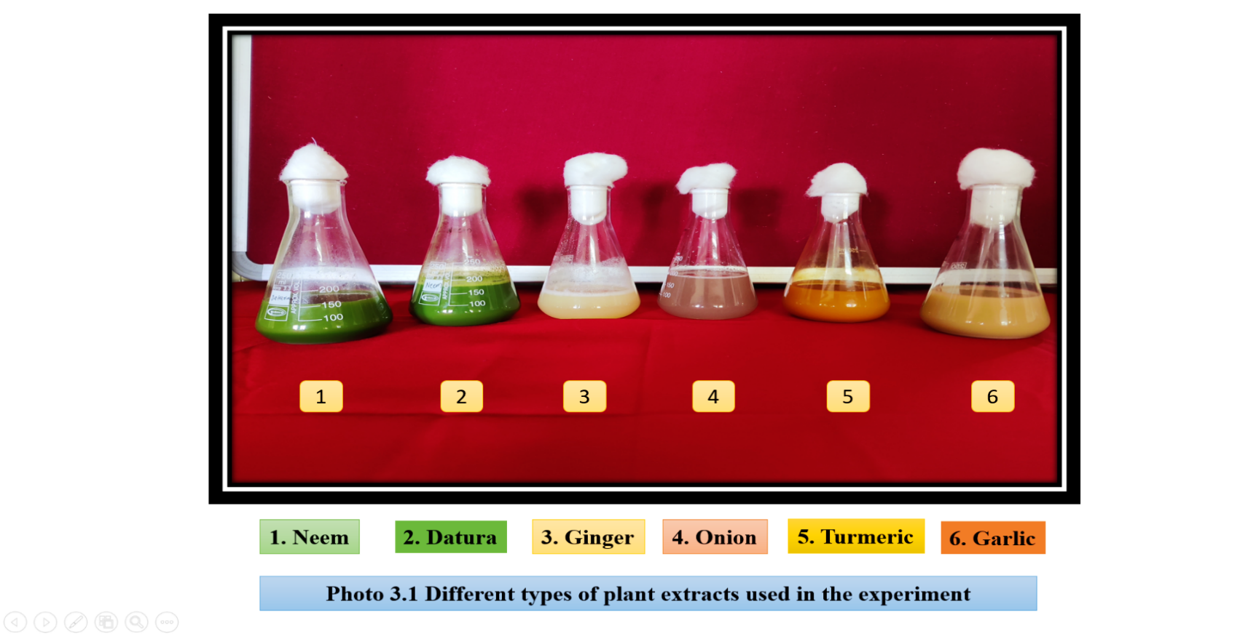

**Photo 1: Different types of plant extracts used in the experiment**

**Design**: Completely Randomized Design

**Treatments**: 7

**Repetitions**: 3

**Location**: Department of Plant Pathology, Post Graduate Laboratory, N. A. U.,

Navsari, Gujarat.

**Result and discussion**

In order to find out the inhibitory effect on the development of *Fusarium oxysporum* f. sp. *vasinfectum*, six different plant parts were screened by the poisoned food technique *in vitro* at a 10 per cent concentration with a control. Table: 2 describes the results related to its colony diameter and mycelial growth suppression. In comparison to the untreated control, the results demonstrated that all six of the plant extracts tested was fungistatic or antifungal against *F. oxysporum* f. sp. *vasinfectum*, leading to a significant reduction in colony diameter and an increase in inhibition. In accordance with the identified plant extract concentrations, the colony diameter reduced and its inhibition increased.

The colony diameter of *F. oxysporum* f. sp. *vasinfectum* at a 10 per cent concentration ranged from 35.42mm in extract from garlic bulbs (*Allium sativum*) to 67.58mm in onion bulbs (*Allium cepa*).The minimum colony diameter was observed in the Garlic bulb extract with 35.42mm which, was statistically superior over the rest of phytoextracts and it was at par with Turmeric (*Curcuma longa*) 38.36mm, the next best phytoextract was Ginger rhizome (*Zingiber officinale*) 55.06mm and Datura leaf extract (*Datura stramonium*) 57.31mm. However, the maximum colony diameter was observed in Onion bulb extract (*Allium cepa*) 67.58mm, which was followed by Neem leaf extract (*Azadirachta indica*) 62.10mm.

At 10 per cent concentration, the highest mycelial growth inhibition was observed in Garlic bulb extract with 60.64 per cent followed by Turmeric rhizome with 57.38 per cent, Ginger rhizome with 38.82 per cent and Datura leaf extract with 36.32 per cent. The least inhibition was observed in Onion bulb extract with 24.91 per cent, which was followed by Neem leaf extract with 31.00 per cent (Table: 2, Fig.:1).

The present findings are in agreement with the earlier research workers of Choudhary *et al.* (2017) studied the effect of different plant species *viz.*, Garlic, Ginger, Onion, Turmeric, Amla, Castor, Calotropis, Tobacco, Betel, Fennel and Neem at three different concentration 10, 15 and 30 per cent against *Fusarium oxysporum* f. sp. *vigni*. The growth inhibition increases with the increase of concentration of all the plant extracts. Highest mycelial growth inhibition was recorded with garlic extract at 30 percent concentration 100 per cent followed by 91.80 per cent and 80.52 per cent at concentration 10 per cent and 15 per cent, respectively.

Singh *et al.* (2017) studied the antifungal activity of twelve botanicals at 1, 2, 5 and 10 per cent concentrations were tested against *Fusarium oxysporum* (*i.e*., Isolate Fo8) under *in vitro* condition. Among the botanicals, Neem oil formulation (Nemazal) and Garlic oil exhibited significant effect on the test fungus. The Neem oil (Nemazal) and Garlic oil at 10 per cent concentration completely inhibited the mycelial growth that was followed by Mustard oil 69.26 per cent, Datura 46.67 per cent, *Withania somnifera* L. 34.44 per cent, whereas, the effectiveness of rest of the leaf extracts *viz*., *Chrysanthemum* 30.37 per cent inhibition was recorded followed by *Duranta erecta* 28.15 per cent, *Bougainvillea* 26.30 per cent, *Clerodendron enerme* 24.44 per cent, *Parthenium* 20.37 per cent, *Cannabis sativa* 18.52 per cent and *Eucalyptus* 16.30 per cent thereby indicating less effectiveness. Garlic oil was highly effective 100 per cent even at 5 per cent concentration, whereas Neem oil was comparatively less effective 59.63 per cent.

Bammidi and Dandnayak (2018) observed suppression of the growth of *Fusarium oxysporum* f. sp. *coriandrii* was significantly higher with *Allium sativum* with significantly less mycelial growth (0.00mm) and highest mycelial growth inhibition 100 per cent of the test pathogen. This was followed by Neem oil with mycelial growth of (8.00mm) and inhibition of 82.22 per cent. The treatment with the extracts of *Zingiber officinalis*, *Mentha arvensis*, *Allium cepa* showed the mycelial growth of (27.66mm), (32.00mm), (33.00mm) and inhibition per cent of 38.53, 28.88, 26.66 respectively. The highest colony growth and lowest per cent inhibition was observed with NSKE (37.33mm) and 17.04 per cent, respectively.

Chandra *et al.* (2020) conducted an experiment on comparison among botanicals, bio-agents and chemical control against *Fusarium oxysporum* f. sp. *ciceris in vitro*. They observed that the minimum radial growth was obtained at 10 per cent concentration in Garlic bulb extract (4.51mm) followed by Neem leaf extract (7.72mm), Zinger rhizome extract (8.28mm), Onion bulb extract (10.63mm) and Tulsi leaf extract (11.84mm). The maximum radial growth was recorded in control (25mm). The maximum per cent inhibition was recorded in Garlic bulb extract 80.61 per cent followed by Neem leaf extract 68.62 per cent, Zinger rhizome extract 66.54 per cent, Onion bulb extract 56.83 per cent and Tulsi leaf extract 52.26 per cent at 10 per cent concentration.

Rao *et al.* (2020) tested antifungal property of locally available botanicals namely, Garlic (*Allium sativa*), Turmeric (*Curcuma longa*) and Ginger (*Zingiber officinale*) again *Fusarium oxysporum* f. sp. *lycopersici* under *in vitro* condition. They found that the best result by Garlic at 10 per cent concentration with colony growth (2.06cm) and 73.75 per cent inhibition followed by Ginger at 10 per cent concentration showed (3.03cm) colony growth and 61.48 per cent inhibition and Garlic at 5 per cent concentration showed (3.1cm) colony growth and 60.63 per cent inhibition and Ginger at 5 per cent concentration showed (3.33cm) colony growth and 57.67 per cent inhibition. Deshpande (2024) conducted *in vitro* test of three plant extract at 10 per cent concentration against Fusarium wilt disease in lentil plant and revealed that garlic show an antifungal activity against Fusarium wilt disease.

**Table: 2 *In vitro* efficacy of different plant extracts against the colony diameter and mycelial growth inhibition of *Fusarium oxysporum* f*.* sp. *vasinfectum***

|  |  |  |  |  |
| --- | --- | --- | --- | --- |
| **Tr. No.** | **Name of Phytoextract** | **Plant Part**  **used** | **Colony Diameter (mm)** | **Mycelial growth inhibition (%)** |
| T1 | Neem leaf extracts (*Azadirachta indica* A. Juss.) | Leaves | 62.10 | 33.80  (31.00) |
| T2 | Datura leaf extracts (*Datura stramonium* L.) | Leaves | 57.31 | 37.04  (36.32) |
| T3 | Ginger rhizome (*Zingiber officinale* Roscoe) | Rhizome | 55.06 | 38.52  (38.82) |
| T4 | Onion bulb extracts (*Allium cepa* L*.*) | Bulb | 67.58 | 29.92  (24.91) |
| T5 | Turmeric rhizome (*Curcuma longa L.)* | Rhizome | 38.36 | 49.23  (57.38) |
| T6 | Garlic bulb extract (*Allium sativum* L.) | Bulb | 35.42 | 51.12  (60.64) |
| T7 | Absolute control (without treatment) | - | 90.00 | 0.00  (0.00) |
|  | SEm± | | 1.13 | 0.75 |
|  | CD at 5% | | 3.46 | 2.29 |
|  | CV% | | 3.37 | 3.79 |

**Photo2:*In vitro* efficacy of 10 per cent plant extract on the growth of *Fusarium oxysporum* f. sp*. vasinfectum***

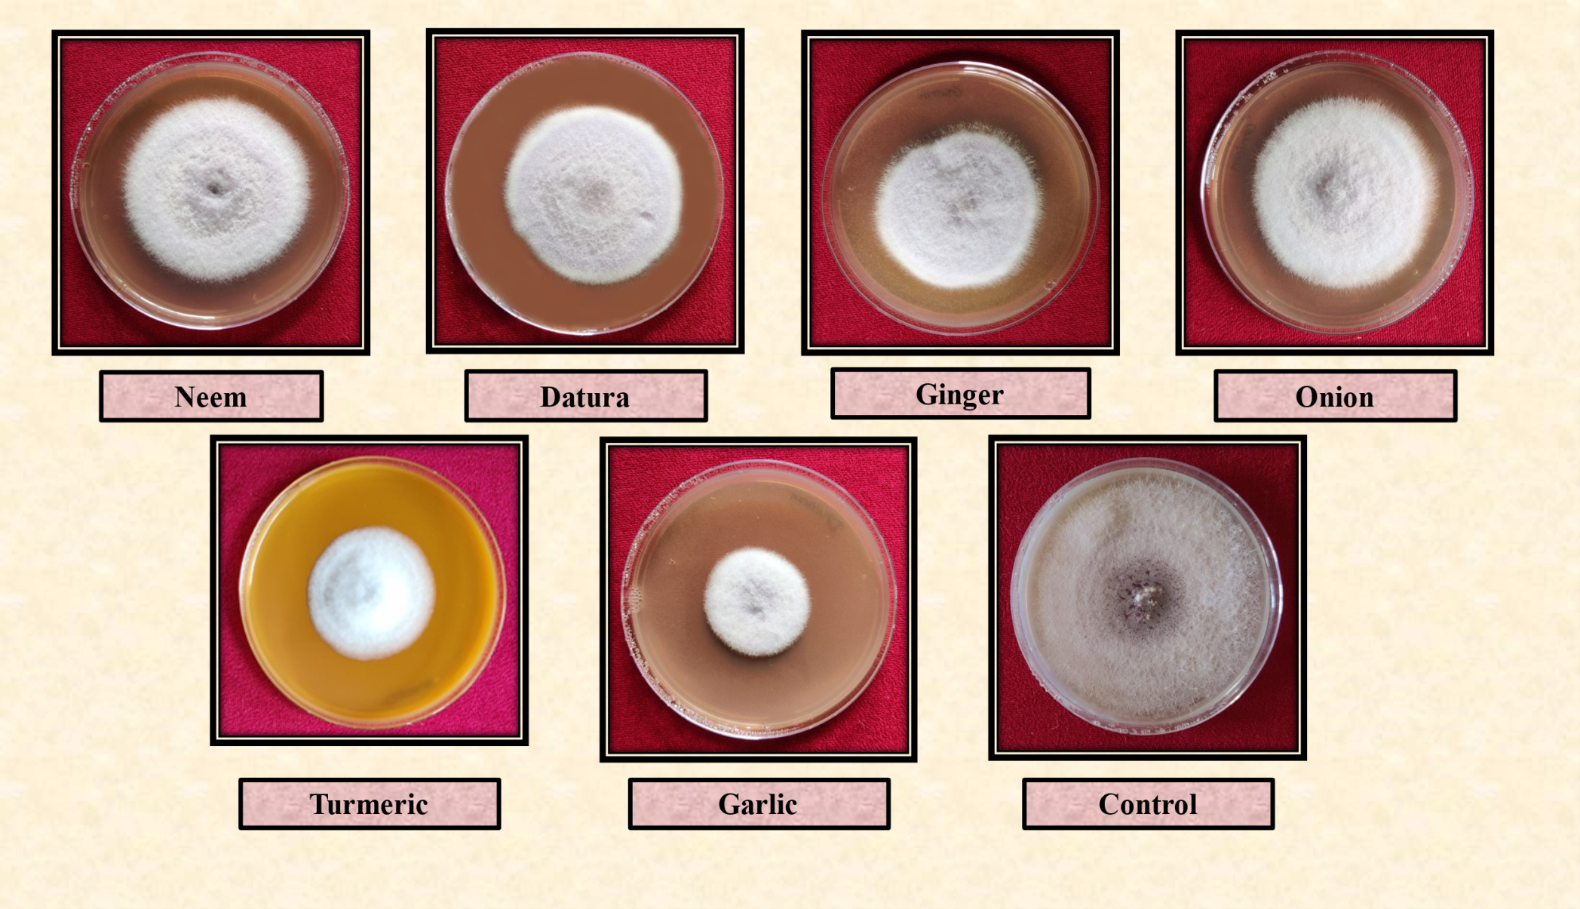

**Fig.:1Effect of plant extracts on the mycelial growth inhibition of *Fusarium oxysporum* f. sp*. vasinfectum***

**Conclusion**

In present experiment bio-efficacy of six different plant extracts at 10 per cent concentration were screened by poisoned food technique *in vitro* to know their inhibitory effect on the growth of *F. oxysporum* f. sp. *vasinfectum.* All the six plant extracts were found to have inhibitory effect on the pathogen. The lowest mycelial growth with the maximum per cent growth inhibition at 10 per cent was recorded in Garlic bulb extract (*Allium sativum*) while, the maximum mycelial growth with minimum per cent inhibition was recorded in Onion bulb extract (*Allium cepa).*

**COMPETING INTERESTS DISCLAIMER:**

Authors have declared that they have no known competing financial interests OR non-financial interests OR personal relationships that could have appeared to influence the work reported in this paper.

**References**

Anonymous (2017). <http://en.wikipedia.org/wiki/Cotton>

Anonymous (2024a). All India Coordinated Research Project on Cotton – Annual Report., A3-4.

Anonymous (2024b). All India Coordinated Research Project on Cotton – Annual Report., A1-2.

Arora, H.; Sharma, A.; Poczai, P.; Sharma, S.; Haron, F. F.; Gafur, A. and Sayyed, R. Z. (2022). Plant-derived protectants in combating soil-borne fungal infections in tomato and chilli. *Journal of fungi*, **8**(2): 213.

Asalmol, M. N.; Sen, B. and Awasthi, J. (1990). Role of temperature and pH in antagonisum of *Aspergillus niger* and *Trichoderma viride* against *Furarium solani*. *Indian Phytopathological Society (WZ) on Biocontrol of Plant Pathogen*., Pune. pp. 11-13.

Bammidi, K. and Dandnayak, B. (2018). *In vitro* evaluation of botanicals against Fusarium wilt of coriander caused by *Fusarium oxysporum* f. sp. *coriandrii* (L.). *International Journal of Plant and Soil Science*, **23**(4): 1-6.

Chandra, S.; Kumar, M.; Kumar, N.; Rajvanshi and Chaudhary, V. P. (2020). Comparison among botanicals, bio-agents and chemical control against *Fusarium oxysporum* f. sp. *ciceris in vitro. The Pharma Innovation Journal*, **9**(3): 321-324.

Choudhary, A.; Ashraf, S. and Musheer, N. (2017). Screening of phytoextracts to control of *Fusarium oxysporum* f. sp. *vigni* incitant of mung bean (*Vigna radiata*) wilt. *International Journal of Academic Research and Development*, **2**(6): 1181-1184.

Deshpande, S. A. (2024). Management of fusarium wilt disease by phytoextract. *International Journal of Research and Analytical Reviews*, **11**(1); 331-334.

Hiremath, I. G.; Huilgol, S. N.; Hegde, Y. R.; Basavaraja, G. T. and Kullalli, K. G. (2020). *In vitro* bio-efficacy of botanicals against *Corynespora cassiicola* (Berk. and Curt.) Wei causing target leaf spot of soybean. *Journal of Pharmacognocy and Phytochemistry*, **9**(5): 1013-1016.

Manickam, S. and Sankaranarayanan, K. (2013). Relevance and techniques of organic cotton production. In: *Cotton Technical Assistance Programme for Africa*, January, 21-25, Central Institute for Cotton Research, Coimbatore, India, **p.1**

Nene, Y. L. and Thapliyal, P. N. (1973). Fungicides in plant disease control. Oxford and IBH publishing Co. Pvt. Ltd., New Delhi, 325.

Otadoh, J.A.; Okoth, S.A.; Ochanda, J. and Kahindi, J.P. (2011). Assessment of Trichoderma isolates for virulence efficacy on *Fusarium oxysporum* f. sp. *phaseoli*. *Tropical and Subtropical Agroecosystems*, **13**:99-107.

Ramaiah, A.K. and Garampall, R.K.H. (2015). *In vitro* antifungal activity of some plant extracts against *Fusarium oxysporum* f. sp. *lycopersici*. *Asian Journal of Plant Science and Research*, **5**(1):22-27.

Rao, Y. H.; Devi, P. S. and Vardhani, V. (2020). Effect of media andpH on mycelial growth of *Fusarium oxysporum* f. sp*. lycopersici* causing fusarium wilt of tomato in Manipur under *in vitro* condition and effect of native *Trichoderma* spp*.* one chemical fungicide (Mancozeb) on growth. *International Journal of Chemical Studies*, **8**(5): 2120-2123.

Sindhan, G. S.; Hooda, I. and Parashar, R. D. (1999). Effect of some plant extracts on vegetative growth of root rot causing fungi. *Indian Journal of Mycology and Plant Pathology*, **29**: 110- 111.

Singh, H. B. (2014). Management of plant pathogens with microorganisms. In *Proc. Indian National Science Academy* ,**80**(2): 443-454.

Singh, J. K.; Kumar, M.; Kumar, S.; Kumar, A. and Mehta, N. (2017). Inhibitory effect of botanicals on growth and sporulation of *Fusarium oxysporum* inciting wilt of chilli (*Capsicum annuum* L.). *Journal of Pharmacognosy and Phytochemistry*, **6**(5): 2199-2204.