**Evaluation of Biofertilizers, Micronutrients and Biostimulant on Fruit quality of Strawberry *Cv.* Nabila**

**ABSTRACT**

Strawberry (Fragaria × ananassa) is a high-value fruit crop with substantial economic and nutritional benefits. This study assesses how nutrient and biostimulant management influences the quality of strawberry cv. 'Nabila' grown in the Nilgiris of TamilNadu. A factorial experiment was carried out to evaluate the effect of combinations of biofertilizers, micronutrients, and biostimulants on fruit quality parameters of strawberry. The findings revealed that treatments including Arbuscular Micorhizal Fungi (AMF) and potassium-solubilizing bacteria (KSB), as well as a micronutrient mix (0.6%) with humic acid (1%) and seaweed extract (1%), greatly increased fruit production and quality. This combination resulted in higher total soluble solids, total phenols, and titratable acidity. An **integrated nutrient management strategy,** incorporating **AMF and KSB** in combination with **micronutrients and biostimulants such as humic acid and seaweed extract,** presents a promising approach to improving both the **quality and post-harvest attributes of strawberries.** Additionally, the adoption of such a **bio-enhanced fertilization approach** promotes **soil health, reduces reliance on synthetic inputs, and aligns with environmentally sustainable agricultural practices.**

**Keywords:** Strawberry, biostimulant, micronutrient, biofertilizer, Fruit quality

**INTRODUCTION**

Strawberry (*Fragaria × ananassa* Duch*.)* is a popular and delicious fruit belonging to the Rosaceae family. The fleshy thalamus, which has several achenes, is the edible portion of this aggregate fruit. Temperatures between 22 and 23°C during the day and 7 to 13°C at night are ideal for growth of strawberry. Plant growth and development are best supported by sandy loam soil that has a pH between 5.5 and 6.5 (Chandrakar *et al.,* 2019). Due to their excellent flavor and high nutritional value, strawberries are in high demand in both the fresh market and processing sectors. According to Jain *et al.* (2017), fresh, ripe strawberries have modest levels of vitamin A (60 IU) and vitamin C (30–120 mg per 100 gm of the edible portion). About 5000 metric tons of strawberries are produced annually on 1000 ha of cultivation in India (Anonymous, 2016). Strawberry farming was initially limited to temperate regions such as Himachal Pradesh and Jammu Kashmir, but advancements in varietal development and agro-techniques have expanded cultivation in non-traditional regions across India (Sharma and Sharma, 2004). Currently, strawberries are grown on 600 hectares in India, producing approximately 4300 metric tons for both domestic and export markets (Anonymous, 2018).

Micronutrients play a vital role in plant growth, acting as catalysts in various physiological and biochemical processes. Deficiencies of these nutrients often limit fruit crop production. The application of zinc sulfate and boric acid has been shown to increase fruit yield, while molybdenum enhances fruit quality. While higher concentrations of zinc sulfate can result in an extended shelf life of fruits at ambient temperatures, excessive boric acid can be toxic, hindering growth, yield, and overall quality. Traditionally, micronutrients were not considered essential as soil naturally supplied these trace elements. However, many of these nutrients are unavailable to plants, though present in the soil, as a result of intensive farming practices, along with increase in soil pH and salinity (Ahmad *et al*., 2010). Plant growth and development depends on micronutrients like copper and zinc. Their deficiencies can result in stunted growth from a lack of copper and chlorosis from a lack of zinc (Zewail *et al*., 2020). Furthermore, by lowering nutrient losses and increasing nutrient efficiency, foliar feeding of micronutrients has been demonstrated to dramatically improve plant growth, production, and fruit quality (Sangeeta *et al*., 2019). In particular, the application of iron and zinc has been shown to enhance both the quantity and quality of fruit crops (Shanker *et al.,* 2019).

Foliar application of biostimulants, such as humic acid (HA) and seaweed extract (SWE), can be an efficient long-term approach for increasing crop productivity while maintaining fruit quality. Humic acid is a significant source of organic carbon on the soil surface. It is created by the chemical and biological decomposition of plant and animal matter, which are fuelled by microbial activity. Humic acid is known to stimulate plant development by controlling carbon and nitrogen cycle in the soil. It also contributes significantly to soil structure development (Canellas *et al.,* 2015). Seaweed extract includes complex polysaccharides, fatty acids, phytohormones, vitamins, and vital minerals like phosphorus (P), potassium (K), calcium (Ca), magnesium (Mg), copper (Cu), iron (Fe), manganese (Mn), and zinc (Zn) (Battacharyya *et al*., 2015). Humic acid and SWE both improve crop production and quality, therefore they are commonly utilized in horticulture, particularly for application in fruit crops. These biostimulants can be applied to plant leaves as well as the soil. Biofertilizers are natural products containing live microorganisms that have no detrimental impact on plants, soil health, or the environment (Kumar *et al.,* 2015). These microorganisms can dwell freely in the soil or create symbiotic relationships with plants, thereby contributing directly or indirectly to plant nitrogen and phosphorus nutrition. Biofertilizers improve the development and output of horticultural crops. Studies conducted by Singh et *al.* (2015) revealed that biofertilizers can enhance crop yields by 15 to 30%. According to research, combining biofertilizers such as AMF and KSB with micronutrients and biostimulants can significantly improve strawberry growth, production, and quality under a variety of agro-climatic situations (Kumar *et al.,*2019)

**MATERIALS AND METHODS**

**Experimental Site and Planting Material**

The study was conducted at a strawberry farm in Masakal, Nilgiris, Tamil Nadu. The farm is situated at an elevation of 1,000–2,600 meters above MSL, experiencing temperatures between 10–25°C in summer and 0–20°C in winter, with rainfall from both the Southwest and Northeast monsoons. Runner plants of Strawberry cv. Nabila was procured from Kotagiri, Nilgiris, from an experimental location.

The site was cleaned and levelled by removing stones and rubbish, and raised beds (45 cm high and 60 cm wide) were prepared. A drip irrigation system was set up at 30 cm intervals, delivering water at a rate of 3 L/h. The experiment used a Factorial Completely Randomised Design (FCRD) with three replications. 4 weeks old seedling of Nabila were planted in nursery beds at a spacing of 30 x 30 cm. NPK was applied at recommended dose of with 100:100:80 kg/ha basal dose and top dressing was given at 30 days interval.

Total soluble solids (TSS) were measured using a hand refractometer to determine biochemical parameters. The research also assessed ascorbic acid (AA), total sugars (TS), and titratable acidity (TA) using AOAC procedures. The Folin-Ciocalteu reagent procedure (Bray and Thrope, 1954) was used to calculate total phenol. The data was checked for variance, and the least significant differences were arranged to compare significant effects at the 5% level (Snedecor and Cochran, 1967).

**Nutrient Solution Preparation:**

* Humic Acid (2%): 35 ml HA dissolved in 965 ml water.
* Seaweed Extract (2%): 66 ml SWE in 934 ml water.
* Micronutrient Solution (0.3%): 0.75 g each of boron, zinc, iron, and copper in 1 L water.
* Micronutrient Solution (0.6%): 1.5 g each of boron, zinc, iron, and copper in 1 L water.

**Table 1. Treatment combinations of biofertilizers, micronutrient blends, and biostimulants used in the study**

|  |  |  |
| --- | --- | --- |
| **S. No.** | **Treatment** | **Combination** |
| 1 | A1B1C1 | No Biofertlizer, Micronutrient blend (0.4%), No Biostimulant |
| 2 | A1B1C2 | No Biofertilizer, Micronutrient blend (0.4%), Humic acid (2%) |
| 3 | A1B1C3 | No Biofertlizer, Micronutrient blend (0.4%), Seaweed extract (2%) |
| 4 | A1B1C4 | No Biofertlizer, Micronutrient blend (0.4%), Humic acid (1%) + Seaweed extract (1%) |
| 5 | A1B2C1 | No Biofertlizer, Micronutrient blend (0.6%), No Biostimulant |
| 6 | A1B2C2 | No Biofertlizer, Micronutrient blend (0.6%), Humic acid (2%) |
| 7 | A1B2C3 | No Biofertlizer, Micronutrient blend (0.6%), Seaweed extract (2%) |
| 8 | A1B2C4 | No Biofertlizer, Micronutrient blend (0.6%), Humic acid (1%) + Seaweed extract (1%) |
| 9 | A2B1C1 | AMF+KSB, Micronutrient blend (0.4%), No Biostimulant |
| 10 | A2B1C2 | AMF+KSB, Micronutrient blend (0.4%), Humic acid (2%) |
| 11 | A2B1C3 | AMF+KSB, Micronutrient blend (0.4%), Seaweed extract (2%) |
| 12 | A2B1C4 | AMF+KSB, Micronutrient blend (0.4%), Humic acid (1%) + Seaweed extract (1%) |
| 13 | A2B2C1 | AMF+KSB, Micronutrient blend (0.6%), No Biostimulant |
| 14 | A2B2C2 | AMF+KSB, Micronutrient blend (0.6%), Humic acid (2%) |
| 15 | A2B2C3 | AMF+KSB, Micronutrient blend (0.6%), Seaweed extract (2%) |
| 16 | A2B2C4 | AMF+KSB, Micronutrient blend (0.6%), Humic acid (1%) + Seaweed extract (1%) |

**RESULTS AND DISCUSSION**

**Ascorbic Acid (AA)**

The effect of biofertilizers, micronutrients, and biostimulant on ascorbic acid concentration of the fruit was not statistically significant at 5% level as presented in Table 2. This showed that intrinsic plant metabolism, environmental conditions, and genetic features may have a greater effect on ascorbic acid accumulation in strawberries than a combination of these inputs. Overall Treatments with micronutrient concentration (B2 0.6%) and biostimulant treatment (C4) humic acid + seaweed extract, produced somewhat higher ascorbic acid levels. This might be linked to the role of micronutrients in increasing enzymatic activity involved with antioxidant synthesis, resulting in improved ascorbic acid retention. Treatments without biostimulants, on the other hand, showed lower levels of ascorbic acid as shown in fig1, demonstrating that while individual components may contribute, their interplay does not play a significant role in ascorbic acid production.

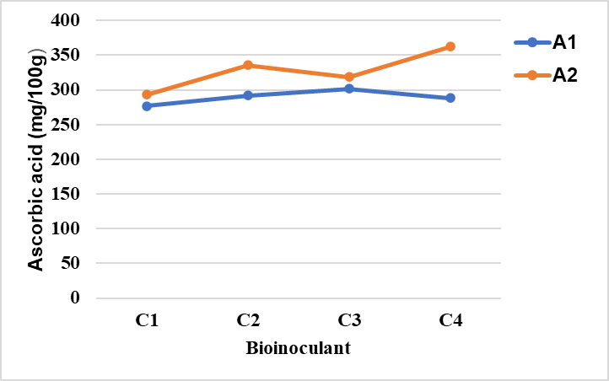

**Fig. 1. Interaction effect of Factor A (Biofertilizer) and Factor C(Biostimulant) on Ascorbic Acid**

**Total Soluble Solids (TSS)**

The three-factor interaction had a considerable impact on TSS levels. The greatest TSS (10.87 °Brix) was reported in A2B1C4 (AMF + KSB, micronutrient mix 0.4%, humic acid 1%, and seaweed extract 1%), followed by A2B2C4. The lowest TSS (7.63 °Brix) was found in A1B2C1 (no AMF + KSB, micronutrient mix 0.6%, no biostimulant). These findings indicate that the combined action of biofertilizer and biostimulants increased sugar metabolism, resulting in higher TSS levels. The findings are consistent with prior research, which found that biofertilizers boost nutrient absorption and carbohydrate buildup, raising TSS content in crops such as strawberries (Shanker *et al.,* 2019). TSS enhancement might be attributed to increased photosynthetic efficiency and improved sugar translocation from leaves to growing fruits, which are aided by biostimulant and micronutrients.

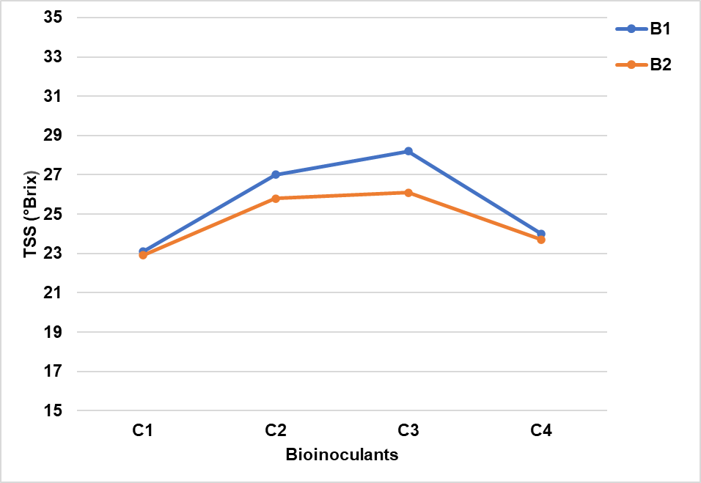 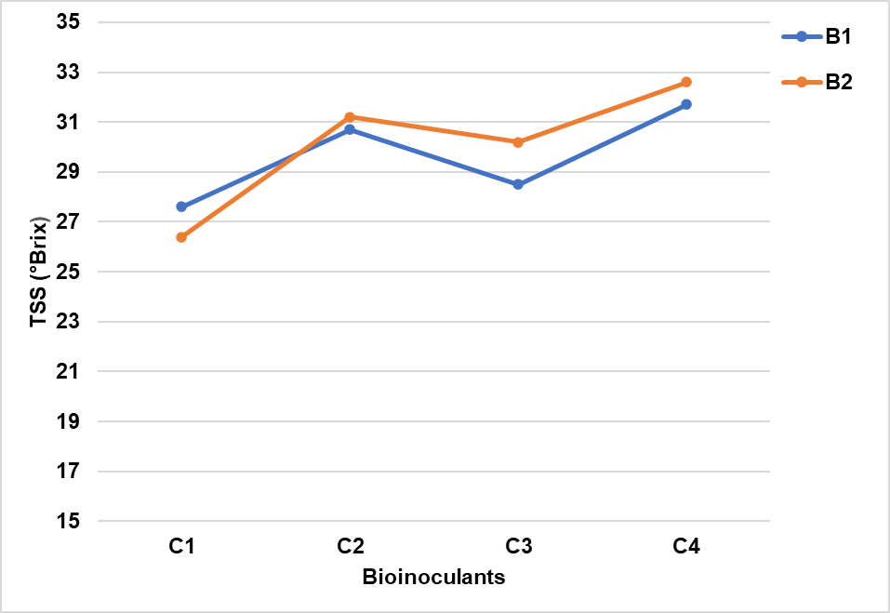

**Fig. 2b. Interaction effect of factor A2 x (B x C) on TSS**

**Fig. 2a. Interaction effect of factor A1 x (B x C) on TSS**

**Total Phenols (TP)**

A significant interaction effect was observed with regard to total phenolic content, as represented in Table 2. Highest concentration of total phenols was recorded in the treatment combination A2B2C4, (AMF+KSB, Micronutrient blend (0.6%), Humic acid (1%) + Seaweed extract (1%)), measuring 352.12 mg per 100g, followed by A2B2C3 (AMF+KSB, Micronutrient blend (0.6%), Seaweed extract (2%)) at 322.72 mg per 100g indicating that the combination of AMF and KSB along with a higher micronutrient concentration of 0.6%, and the application of seaweed extract, significantly enhanced the synthesis of phenolic compounds. These findings align with Zewail *et al*. (2020), who reported that foliar applications of micronutrients and biofertilizers increase phenolic content by stimulating the enzymatic activity that drives the production of secondary metabolites. The increased phenolic content may also enhance antioxidant properties, thereby improving the shelf life and nutritional quality of the fruits. Among the treatment combinations, lower phenol content was found in A2B1C3 (AMF+KSB, Micronutrient blend (0.4%), Seaweed extract (2%)), which had 99.60 mg per 100g although this treatment used a combination of all three.

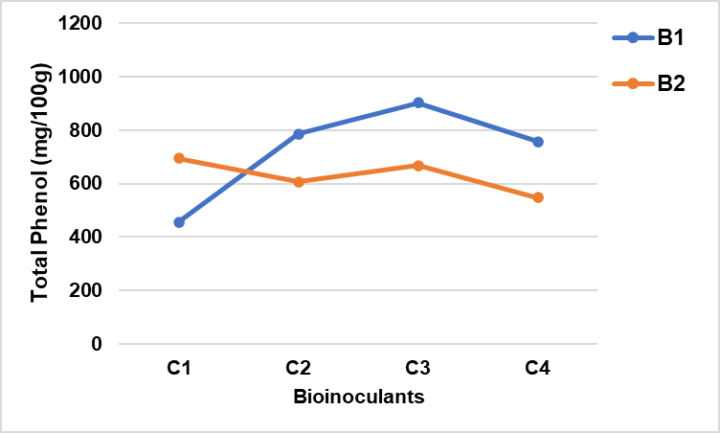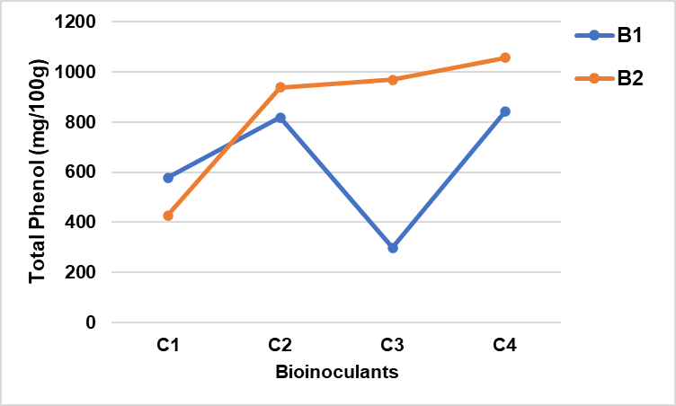

**Fig. 3b. Interaction effect of factor A2 x (B x C) on TP**

**Fig. 3a. Interaction effect of factor A1 x (B x C) on TP**

**Titratable Acidity (TA)**

Titratable acidity is a crucial factor that affects both the flavor and shelf life of fruits. Significant differences in acidity levels were observed among the different treatments (Table 2). The highest acidity level, at 0.867%, was recorded in treatment A2B2C4, (AMF+KSB, Micronutrient blend (0.6%), Humic acid (1%) + Seaweed extract (1%)) followed by A1B2C1 (No AMF+KSB, Micronutrient blend (0.6%), No biostimulant) with a level of 0.860%. The lowest acidity, measured at 0.593%, was found in treatment A1B1C1 (No AMF+KSB, Micronutrient blend (0.4%), No biostimulant). These findings indicate that nutrient availability and the usage of biostimulants are critical in sustaining organic acid levels, which are required for improved fruit flavor and post-harvest lifespan. Ahmad *et al.* (2010) found comparable results, indicating that micronutrient administration enhances pH balance and acid metabolism in fruit crops. The presence of organic acids adds to strawberries' distinctive tartness, which may be regulated by the proper nutritional balance and stress tolerance provided by biostimulant and seaweed extracts.

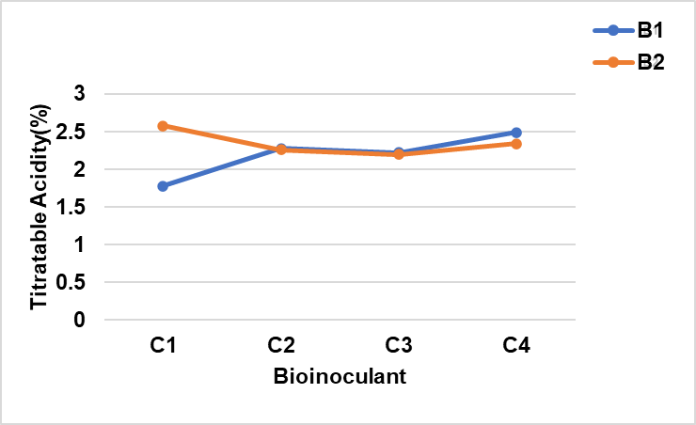 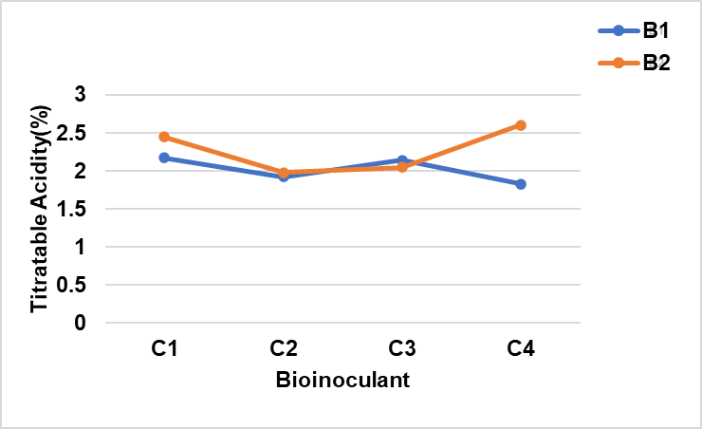

**Fig. 4b. Interaction effect of factor A2 x (B x C) on TA**

**Fig. 4a. Interaction effect of factor A1 x (B x C) on TA**

**Total sugars (TS)**

The three-way interaction of total sugar content was not statistically significant, indicating that the combined effects of biofertilizers, micronutrients, and biostimulant did not significantly influence sugar accumulation (Table 2). However, treatments utilizing a micronutrient blend (0.6%) and biostimulants, such as humic acid and seaweed extract, achieved slightly higher sugar levels. These findings suggest that while individual factors may contribute to sugar synthesis, their combined effects are limited. In fact, sugar accumulation is more reliant on photosynthesis, genetic regulation, and the ripening processes. The minor variations in total sugar levels observed in some treatments may be related to enhanced enzymatic activities that regulate carbohydrate metabolism, which in turn indirectly affects sugar accumulation in the fruit. 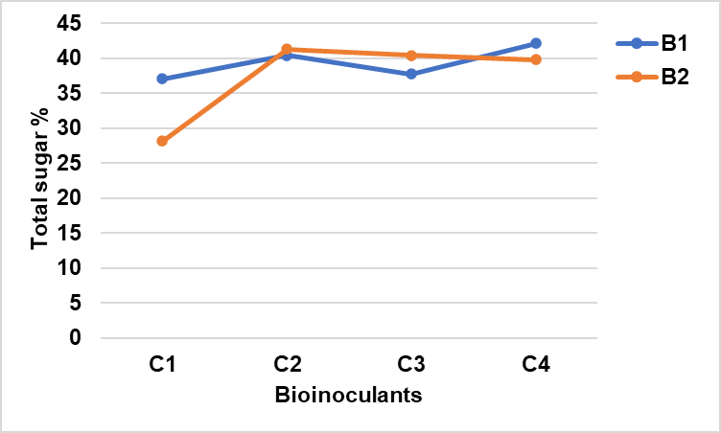 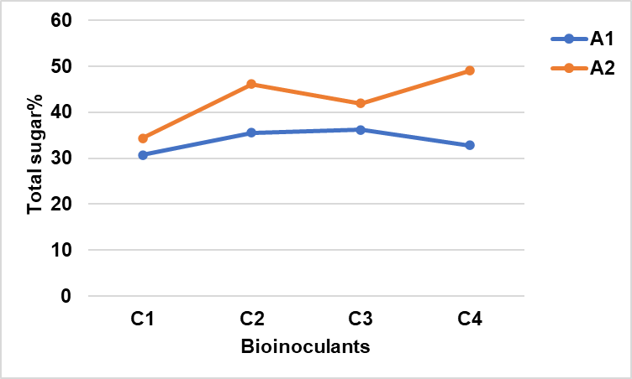

**Fig. 6. Interaction effect of Factor A (Biofertilizer) and Factor C(Biostimulant)**

**Fig. 5. Combined influence of Factor B (Micronutreint) and Factor C(Biostimulant)**

**Table 2. Evaluation of fruit quality parameters of strawberry for the various treatment combinations**

|  |  |  |  |  |  |
| --- | --- | --- | --- | --- | --- |
| Treatment | Ascorbic Acid (mg/100g) | TSS (°Brix) | Phenol (mg/100g) | Titratable Acidity (%) | Total Sugar (%) |
| Factor A (Biofertilizers) | | | | | |
| A1 | 48.27 b | 9.81a | 225.63b | 0.76a | 7.09a |
| A2 | 54.59a | 8.50b | 246.89a | 0.71b | 5.77b |
| SE(d) | 0.709 | 0.066 | 1.21 | 0.005 | 0.13 |
| CD @5% | 1.44 | 0.134 | 2.464 | 0.01 | 0.265 |
| Factor B (Micronutrients) | | | | | |
| B1 | 52.28a | 9.37a | 246.02a | 0.70b | 6.68a |
| B2 | 50.45b | 8.94b | 226.51b | 0.76a | 6.18b |
| SE(d) | 0.709 | 0.066 | 1.21 | 0.008 | 0.13 |
| CD @5% | 1.443 | 0.134 | 2.462 | 0.016 | 0.265 |
| Factor C (Biostimulants) | | | | | |
| C1 | 47.98c | 9.55a | 179.73d | 0.74b | 6.80a |
| C2 | 52.29ab | 9.41ab | 262.32b | 0.70c | 6.72a |
| C3 | 51.69b | 9.33b | 236.24c | 0.71c | 6.50a |
| C4 | 54.22a | 8.33c | 266.75a | 0.77a | 5.69b |
| SE(d) | 0.98 | 0.093 | 1.711 | 0.011 | 0.184 |
| CD @5% | 1.998 | 0.189 | 3.485 | 0.023 | 0.374 |
| Interaction A x B (Biofertilizers x Micronutrients) | | | | | |
| SE(d) | NS | 0.093 | 1.711 | 0.011 | NS |
| CD @5% | NS | 0.189 | 3.485 | 0.023 | NS |
| Interaction B x C (Micronutrients x Biostimulants) | | | | | |
| SE(d) | NS | 0.131 | 2.419 | 0.016 | 0.26 |
| CD @5% | NS | 0.267 | 4.928 | 0.032 | 0.529 |
| Interaction C x A (Biostimulants x Biofertilizers) | | | | | |
| SE(d) | 1.417 | 0.131 | 2.419 | 0.016 | 0.26 |
| CD @5% | 2.887 | 0.267 | 4.928 | 0.032 | 0.529 |
| Interaction A x B x C (Biofertilizers x Micronutrients x Biostimulants) | | | | | |
| SE(d) | NS | 0.186 | 3.422 | 0.022 | NS |
| CD @5% | NS | 0.378 | 6.97 | 0.045 | NS |

*NS – Not Significant at 0.05 level*

*Treatment combinations with same letters are non - significantly different*

*LSD (Least Significant Difference) is performed only for those effect which are significant*

**Conclusion**

This study found that the combined effect of biofertilizers (AMF + KSB), micronutrients, and biostimulant had a substantial influence on several quality metrics in the strawberry *Cv* 'Nabila.' While the combined treatments enhanced TSS, total phenolic content, and titratable acidity, there was no significant effect on ascorbic acid or total sugar content. The results further revealed that while administering AMF + KSB, a higher dosage of micronutrient mix @ 0.6%, and biostimulant combination of humic acid and seaweed extract might improve the quality of strawberry fruit and its post-harvest properties. This encourages the use of biofertilizers and biostimulant for sustainable nutrient management to improve quality of strawberries grown in Tamil Nadu. Furthermore, the findings indicate that future research into enzyme activity, nutrient mobility, and stress responses might bring new insights into improving strawberry quality through integrated nutrient management techniques.

**REFERENCE**

Ahmad, I., Khan, M. A., Qasim, M., Ahmad, R., & Randhawa, A. M. (2010). Growth, yield, and quality of *Rosa hybrid L.* as influenced by various micronutrients. *Pakistan Journal of Agricultural Sciences, 47(1), 5–12.*

AOAC (1980) Official Method of Analysis. Association of Official Analytical Chemist, AOAC, Benjaminn Franklin Station, Washinton DC.

Anonymous. 2018. Area and Production of Horticulture Crops - All India: 2017-18 (3rd Advance Est.). Indian Horticulture Database 2018, NHB, MoA, GoI, Gurgaon, Haryana, pp. 1.

Battacharyya, D., Babgohari, M.Z., Rathor, P. and Prithiviraj, B. (2015). Seaweed extracts as biostimulants in horticulture. SciHortic. 196: 39-48.

Bray, H. G., & Thorpe, W. V. (1954). Analysis of phenolic compounds of interest in metabolism. *Methods of Biochemical Analysis, 1*, 27–52.

Canellas, L.P., Olivares, F.L., Aguiar, N.O., Jones, D.L., Nebbioso, A., Mazzei, P. and Piccolo, A. (2015). Humic and fulvic acids as biostimulants in horticulture. Sci Hortic., 196: 15-27.

Chandrakar, S., Singh, P., Panigrahi, H. K., & Kumar, P. A. (2019). Response of foliar application of micro-nutrients on number of flowers, fruits and yield per plant of strawberry (Fragaria x ananassa Duch.) cv. Nabila under net tunnel condition. *The Journal of Pharmaceutical Innovation*, *8*(4), 531-3.

Jain, N., Mani, A., Kumari, S., Kasera, S., & Bahadur, V. (2017). Influence of INM on yield, quality, shelf life, and economics of strawberry (*Fragaria × ananassa Duch.*) cv. Sweet Charlie. *Journal of Pharmacognosy and Phytochemistry, 6(5), 1178–1181.*

Kumar N, Singh HK and Mishra PK. 2015. Impact of organic manure and bio-fertilizers on growth and quality parameters of strawberry Cv. Chandler. Indian Journal of Science and Technology, 8(15): 1-6.

Kumar, S., Sharma, S., & Mishra, S. (2019). Effect of biofertilizers and micronutrients on growth and yield of strawberry (*Fragaria × ananassa*). *International Journal of Current Microbiology and Applied Sciences, 8*(3), 1524-1533.

Sangeeta, P., Choudhary, D. R., Meena, R. S., & Rathore, D. K. (2019). Effect of micronutrient application on yield and fruit quality of strawberry (*Fragaria × ananassa Duch.*). *International Journal of Chemical Studies, 7(5), 3158–3162.*

Shanker, K., Misra, S., Topwal, M. and Singh, V.K. (2019). A research review on use of micronutrient in fruit crops. International Journal of Current Microbiology and Applied Sciences, 8(8): 3014-3025.

Sharma, V.P. and Sharma, R.R. 2004. The Strawberry, ICAR, New Delhi, India. pp. 106-109.

Singh KA, Beer K, Pal AK. 2015. Effect of vermicompost and bio-fertilizers on strawberry growth, flowering and yield. Annals of Plant and Soil Research, 17(2): 196-99.

Snedecor, G.W. and Cochran, W.G. (1967) Statistical methods (6thEdn.)Oxford and IBH Publ. Co., New Delhi, India 593.

Zewail, R. M. Y., El-Gmal, I. S., Khaitov, B., & El-Desouky, H. S. (2020). Micronutrients through foliar application enhance growth, yield, and quality of sugar beet (*Beta vulgaris L.*). *Journal of Plant Nutrition, 43(15), 2275–2285.*