**Estimation of Post-Harvest Losses in Tamarind: A Study on Sampling Structure and Market Dynamics**

**Abstract**

Tamarind is a vital crop with economic and nutritional significance. However, significant post-harvest losses occur due to inefficient handling, transportation, and storage. and is a significant concern in agricultural supply chains, affecting food security and farmers' economic stability.This study aims to estimate PHL at different market levels and identify key areas for improvement. This research investigates post-harvest losses (PHL) in tamarind at different levels—farm, wholesale, and retail—through a structured sampling approach. The study was conducted in Anantapur district, covering multiple villages, wholesale markets, and retail outlets. The findings reveal significant losses, particularly at the farm level, necessitating interventions for loss reduction.

**Keywords:** Post-harvest losses, Tamarind, Supply chain, Anantapur, Agricultural losses

**Introduction:**

Tamarind (*Tamarindus indica L.*) is a widely cultivated tropical fruit tree known for its versatile uses in food, pharmaceuticals, and industrial applications. It is an important source of income for farmers in regions such as India, Thailand, and Africa (El-Siddig et al., 2006). Despite its economic significance, tamarind faces substantial post-harvest losses due to inadequate handling, storage, and processing techniques. These losses not only reduce the quantity of marketable produce but also affect the overall quality and shelf-life of tamarind products (Prasad & Mali, 2018). Post-harvest losses (PHL) in agricultural products significantly impact food security and farmer profitability. Tamarind, a widely cultivated crop in India, suffers from losses due to inefficient harvesting, sorting, and storage methods. This study aims to quantify these losses and propose mitigation strategies based on empirical data collected from Anantapur district, where tamarind is a key agricultural commodity.

This research aims to analyze the key factors contributing to post-harvest losses in tamarind, assess the economic implications of these losses, and explore potential strategies for mitigation. By reviewing existing studies and conducting field-based investigations, this study seeks to provide practical recommendations for reducing losses and improving the sustainability of tamarind production and trade.

**Literature Review**

Several studies have examined PHL in various crops. For instance, Hodges et al. (2011) highlighted that post-harvest losses in perishable commodities often exceed 30%, emphasizing the need for improved handling and storage. Similarly, Parfitt et al. (2010) discussed the impact of inefficient supply chains on food wastage. Studies on tamarind suggest that inadequate drying and improper packaging contribute significantly to losses (Kumar & Patel, 2019). This paper builds upon these findings by analyzing losses at different stages of tamarind supply chains.

Post-harvest losses in tamarind occur at different stages, including harvesting, drying, storage, and transportation. Improper harvesting practices can lead to early or late picking, affecting pulp quality and yield (Reddy et al., 2015). Additionally, high moisture content and inadequate drying methods contribute to fungal contamination and spoilage (Kumar & Sharma, 2020). Storage pests such as *Lasioderma serricorne* and *Ectomyelois ceratoniae* also cause significant damage, leading to weight loss and decreased market value (Singh & Yadav, 2017).

Several studies have highlighted the impact of improved post-harvest management practices in minimizing these losses. Proper drying, the use of airtight packaging, and pest management techniques have been found effective in enhancing the storage life of tamarind (Mishra et al., 2021). However, despite advancements in storage and processing technologies, small-scale farmers and traders continue to face challenges due to limited access to infrastructure and knowledge (Patel & Rao, 2019).

This research aims to analyze the key factors contributing to post-harvest losses in tamarind, assess the economic implications of these losses, and explore potential strategies for mitigation. By reviewing existing studies and conducting field-based investigations, this study seeks to provide practical recommendations for reducing losses and improving the sustainability of tamarind production and trade.

**Methodology**

The study was conducted in Anantapur district, covering farm, wholesale, and retail markets. This study follows a structured sampling approach, collecting data from five farmers, five wholesalers, and five retailers in the Anantapur district. The study areas include villages such as Dasappapalyam, Gantalapalli, and Kadiri. Data were gathered through field observations and farmer interviews to estimate losses at each stage of the supply chain.

**Results & discussion** :

**Table 1: Sampling structure for estimation of Post Harvest Losses in tamarind**

|  |  |  |  |
| --- | --- | --- | --- |
| **Level** | **Study area** | **Village/Mandal** | **Sample size** |
| Farm level | Anantapur district | Dasappapalyam | Five farmers |
| Gantalapalli |
| Kadiri |
| Kallumarri |
| Gudduguriki |
| Wholesale market/Mandi | Anantapur district | Hindupur | Five wholesalers |
| Kadiri |
| Kadiri |
| Madakasira |
| Rayadurgam |
| Retail market | Anantapur district | Anantapuramu | Five retailers |
| Anantapuramu |
| Anantapuramu |
| Kadiri |
| Madakasira |

**Table 2: Farmer’s Details**

|  |  |  |  |  |
| --- | --- | --- | --- | --- |
| **S. S. No** | **Name of the farmer** | **Village** | **Mandal** | **Area**  **G grown (in acres)** |
| 1. | K. Chandrappa | Dasappapalyam | Rolla | 2.5 |
| 2. | C. Lakshmi Devamma | Gantalapalli | Madakasira | 2.0 |
| 3. | S. Hussain Basha | Kadiri | Kadiri | 3.0 |
| 4. | K. Nabi Rasool | Kallumarri | Madakasira | 4.0 |
| 5. | G. Krishnappa | Gudduguriki | Rolla | 1.5 |

**Table 3: Harvesting, packing and transportation practices in tamarind**

|  |  |  |  |
| --- | --- | --- | --- |
| **Method of harvesting** | **Sorting & Grading** | **Packing** | **Transportation** |
| Manual-by using bamboo pole | Manual | Plastic bags | Mini trucks, Tempo vans, auto-rickshaws, bullock carts, tractors |

|  |  |
| --- | --- |
|  |  |

**Fig 1 : Deshelling of tamarind pods at farm level**

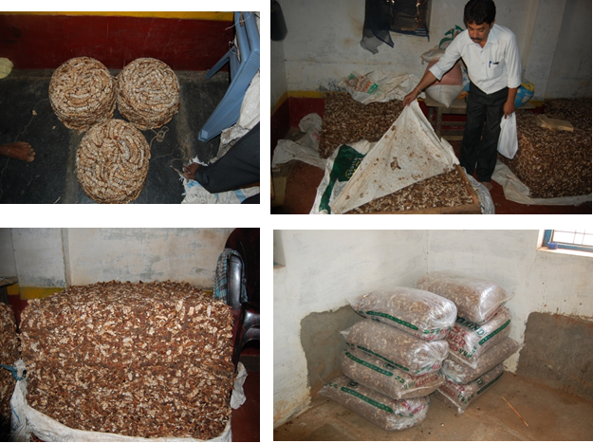

**Fig 2 : Tamarind pulp stacked and packed in gunny bags and poly bags**

**Table 4: Post Harvest Losses of tamarind at farm level**

|  |  |  |  |  |
| --- | --- | --- | --- | --- |
| **S. No.** | **Particulars** | **Qty. handled (kg)** | **Qty. lost (kg)** | **Percentage** |
| 1. | Harvesting/picking | 7168.00 | 1558.40 | 21.7 |
| 2. | Sorting & grading | 5609.60 | 173.40 | 3.1 |
| 3. | Cleaning/curing | 5435.80 | 165.80 | 3.1 |
| 4. | Drying | -- | -- | -- |
| 5. | Packaging | -- | -- | -- |
|  | Salable produce | 5270.00 kg |  |  |

Farm-level losses represent the most significant portion of total food losses, with 27.9% attributed to harvesting, sorting, and grading inefficiencies. Among these, harvesting losses account for the highest proportion at 21.7%, equating to 1,558.4 kg out of 7,168 kg of produce. Sorting and grading contribute an additional 3.1% loss (173.4 kg from 5,609.6 kg), while cleaning and curing result in another 3.1% loss (165.8 kg from 5,435.8 kg). The primary factors driving these losses include traditional manual harvesting techniques, particularly the use of bamboo poles, which can cause physical damage to produce. Additionally, inadequate sorting methods lead to the rejection of edible yet cosmetically imperfect products, further increasing waste. Moreover, the absence of proper drying and curing facilities exacerbates spoilage, reducing overall yield and market value. These inefficiencies highlight the urgent need for improved harvesting tools, enhanced sorting standards, and better post-harvest infrastructure to minimize farm-level losses and enhance food security (Gustavsson et al., 2011; FAO, 2019).

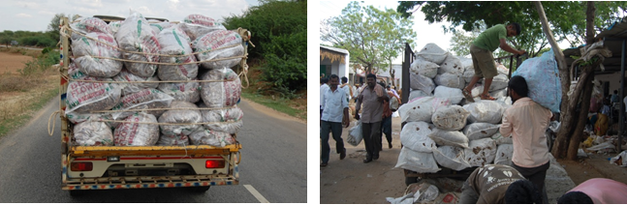

**Fig 3 : Packed Tamarind transported by mini trucks and tempo vehicles**

**Table 5: Post Harvest Losses of tamarind at wholesale market (Mandi’s)**

|  |  |  |  |
| --- | --- | --- | --- |
| **S. No.** | **Name of the wholesalers/ Mandi** | **Qty. handled (kg)** | **Percentage** |
| 1. | R.M.C. mandi (Hindupur) | 36000 | -- |
| 2. | Thanveer mandi (Kadiri) | 45000 | -- |
| 3. | Minuaddin mandi (Kadiri) | 28000 | -- |
| 4. | Ramesh mandi (Madakasira) | 32000 | -- |
| 5. | Venkteswara mandi (Rayadurgam) | 48000 | -- |

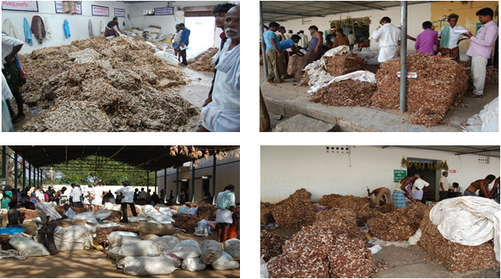

**Fig 4 : Tamarind trade in Hindupur market yard**

Wholesalers in markets such as Hindupur and Kadiri handle substantial volumes of produce, ranging between 28,000 and 48,000 kg. Although exact loss percentages have not been formally recorded, observational data indicate that market-level losses arise primarily from spoilage due to moisture retention and transportation-related issues. Moisture retention in perishable goods accelerates microbial growth and enzymatic degradation, leading to reduced quality, discoloration, and eventual spoilage. Inadequate ventilation during transportation and improper packaging can exacerbate these problems by creating humid conditions that favor fungal and bacterial proliferation (Kitinoja & Kader, 2002). Additionally, delays in transit and rough handling contribute to physical damage, bruising, and contamination, further increasing losses. Studies suggest that implementing improved packaging solutions, such as perforated crates, moisture-absorbing materials, and climate-controlled transportation, can significantly mitigate spoilage at this stage of the supply chain (Hodges et al., 2011). Moreover, cold chain logistics and better storage infrastructure at wholesale markets could further reduce deterioration and extend shelf life, enhancing overall market efficiency and profitability (FAO, 2019). Addressing these challenges is crucial for minimizing post-harvest losses, ensuring higher economic returns for wholesalers, and improving food availability for consumers.

**Table 6: Post Harvest Losses of tamarind at retail market**

|  |  |  |  |
| --- | --- | --- | --- |
| **S. No.** | **Name of the retailers** | **Qty. handled (tonnes)** | **Percentage** |
| 1. | Kareem | 7000 | -- |
| 2. | Maruthi | 12000 | -- |
| 3. | Thirumala Rao | 9000 | -- |
| 4. | Chennakesava | 6000 | -- |
| 5. | Maheswari | 8000 | -- |

Retailers managing tamarind stocks between 6,000 and 12,000 kg often face significant losses due to improper storage conditions and environmental exposure. While exact loss figures were not documented in the dataset, existing literature highlights key factors that contribute to spoilage at the retail level. One primary concern is moisture absorption, as tamarind is highly hygroscopic, meaning it readily absorbs moisture from the air. High humidity levels can lead to fungal contamination, fermentation, and degradation of quality, reducing both edibility and market value (Kader, 2005). Inadequate storage infrastructure, such as the absence of moisture-proof packaging or climate-controlled environments, exacerbates these issues. Additionally, exposure to direct sunlight and fluctuating temperatures accelerates biochemical changes, causing texture hardening, discoloration, and loss of essential organic acids (Kitinoja & Kader, 2002). Physical handling during retail transactions, including frequent opening of storage containers, further exposes tamarind to microbial contamination and oxidative spoilage. Research suggests that employing airtight packaging, controlled-humidity storage, and periodic quality checks can significantly reduce spoilage at this stage (Hodges et al., 2011). Moreover, improved inventory management techniques, such as first-in, first-out (FIFO) systems, can help minimize prolonged storage durations and associated deterioration. Addressing these post-harvest challenges is critical for reducing economic losses for retailers and maintaining consistent product quality for consumers.

**Table 7: Aggregate Post Harvest Losses in tamarind**

|  |  |  |
| --- | --- | --- |
| **Particulars** | **Qty. (kg)** | **Percentage** |
| Farm level | 1897.6 | 27.9 |
| Wholesale market level | -- | -- |
| Retail market | -- | -- |
| Total loss | 1897.6 | 27.9 |

### The aggregate post-harvest losses (PHL) in tamarind indicate that the most significant losses occur at the farm level, totaling 1,897.6 kg, which accounts for 27.9% of total production. These losses primarily stem from inefficiencies in harvesting, sorting, grading, and inadequate drying practices. However, data on losses at the wholesale and retail market levels remain undocumented in the dataset. Literature suggests that losses at these stages arise due to moisture retention, microbial spoilage, improper packaging, and inadequate storage conditions (Hodges et al., 2011; Kader, 2005). The absence of reliable loss estimates beyond the farm level underscores the need for comprehensive post-harvest assessments to quantify spoilage at different points in the supply chain. Implementing improved drying methods, optimized storage facilities, and better transportation infrastructure could significantly mitigate these losses and enhance the overall efficiency of tamarind supply chains. Furthermore, monitoring losses at wholesale and retail levels would provide a clearer understanding of total post-harvest waste, guiding targeted interventions to improve food security and reduce economic losses for stakeholders (FAO, 2019).

### **Conclusion**

The study on post-harvest losses (PHL) in tamarind highlights significant inefficiencies in handling, transportation, and storage across different levels of the supply chain. The findings reveal that the highest losses occur at the farm level, amounting to 1,897.6 kg (27.9% of total production). These losses are primarily due to inefficient manual harvesting using bamboo poles, improper sorting and grading, and inadequate drying and storage facilities. Although losses at the wholesale and retail levels were not explicitly quantified, observational data and literature suggest that factors such as moisture retention, microbial spoilage, inadequate packaging, and poor transportation conditions contribute to additional losses. The absence of comprehensive loss estimation beyond the farm level indicates a critical gap in data collection and monitoring within the tamarind supply chain. Addressing these inefficiencies is essential to improving overall productivity, ensuring food security, and enhancing the profitability of farmers, wholesalers, and retailers alike. Post-harvest losses in tamarind can be significantly reduced, leading to improved economic outcomes for farmers and traders while ensuring sustainable agricultural practices. Future studies should focus on quantifying losses at the wholesale and retail levels and evaluating the effectiveness of various interventions in mitigating post-harvest wastage in tamarind and other agricultural commodities.

### **References:**

### El-Siddig, K., Gunasena, H.P.M., Prasad, B.A., Pushpakumara, D.K.N.G., Ramana, K.V.R., Vijayanand, P., Williams, J.T., Smith, R.W., Haq, N., & Dunsiger, Z. (2006). *Tamarind, Tamarindus indica*. Southampton Centre for Underutilised Crops, Southampton, UK. ISBN: 0854328599.

### FAO (Food and Agriculture Organization). (2019). *The State of Food and Agriculture: Moving Forward on Food Loss and Waste Reduction.*

* Gustavsson, J., Cederberg, C., Sonesson, U., Van Otterdijk, R., & Meybeck, A. (2011). *Global food losses and food waste*. FAO.
* Hodges, R. J., Buzby, J. C., & Bennett, B. (2011). *Postharvest losses and waste in developed and less developed countries: Opportunities to improve resource use.* Journal of Agricultural Science, 149(S1), 37-45.

### Kader, A. A. (2005). *Increasing food availability by reducing postharvest losses of fresh produce.* Acta Horticulturae, 682, 2169-2176.

* Kumar, S., & Patel, A. (2019). An assessment of post-harvest losses in tamarind production: Challenges and solutions. *Indian Journal of Agricultural Economics*.
* Kitinoja, L., & Kader, A. A. (2002). *Small-scale postharvest handling practices: A manual for horticultural crops.* University of California, Davis.

### Kumar, V., & Sharma, H.K. (2020). *Post-harvest management and processing of tamarind (Tamarindus indica L.)*. Journal of Food Science and Technology, 57(1), 1-12.

### Mishra, P., Mishra, S., & Singh, A. (2021). *Effect of different drying methods on quality and shelf life of tamarind pulp*. Journal of Food Processing and Preservation, 45(2), e15123.

### Prasad, B.A., & Mali, P.C. (2018). *Value addition of tamarind: An option for livelihood of tribal people of Panchmahal*. Indian Journal of Arid Horticulture, 13(1&2), 91-93.

### Patel, S., & Rao, M.S. (2019). *Challenges in post-harvest management of tamarind in India*. International Journal of Agriculture Sciences, 11(5), 8224-8228.

* Parfitt, J., Barthel, M., & Macnaughton, S. (2010). Food waste within food supply chains: Quantification and potential for change. *Philosophical Transactions of the Royal Society B*.

### Reddy, B.M.C., Swamy, G.S.K., & Reddy, Y.T.N. (2015). *Standardization of harvesting indices for tamarind (Tamarindus indica L.)*. Journal of Horticultural Sciences, 10(2), 216-219.

### Singh, S., & Yadav, A.K. (2017). *Storage pests of tamarind and their management: A review*. Journal of Entomology and Zoology Studies, 5(6), 1234-1240.