**DISEASE SITUATION OF SESAME IN MAJOR SESAME GROWING REGIONS OF NORTHERN KARNATAKA**

-------------------------------------------------------------------------------------------------------------------------------------

**Abstract:** The survey was conducted in major sesame growing districts of North Karnataka such as Vijayapura, Belgaum, Bagalkote, Gadag and Dharwad to record the incidence of different foliar diseases such as Cercospora leafspot, Alternaria leaf blight, Powdery mildew and Phyllody for two year 2023-24 and 2024-25 of *Kharif* season. The average per cent disease incidence of different districts surveyed during *Kharif* 2023 and 2024. Maximum average severity of Cercospora leaf spot was recorded in Vijaypur district (25.3%) and Belgaum (25.3%) district, whereas lowest per cent disease severity was noticed in Bagalkote district (21.3%). The maximum average disease severity of Alternaria blight was noticed in Vijaypur district (28.2%) and lowest average disease severity was recorded in Gadag district (21.8%). The highest severity of Powdery mildew disease was recorded in Gadag district (25.7%) and lowest disease severity was noticed in Dharwad district (21.8%). The maximum average per cent disease incidence of Phyllody was noticed in Belgaum district (26.9%) and average lowest disease incidence was recorded in Gadag district (19.4%). From the study recommended that appropriate control methods should be identified and recommended to prevent sesame yield loss and increases productivity.

**INTRODUCTION**

Sesame (*Sesamum indicum* L.) is one of the important oilseeds belonging to family Pedaliaceae which is having the longest history of cultivation in India. This crop is mentioned as tila in Atharva Veda, Asthadviaji, Manusmriti and Puranas, indicating its presence since the pre-Christian era in India. Asia is having maximum area and production in the world where the crop is cultivated in tropical and subtropical areas. The origin of this crop is believed to be Africa.

Sesame is known as the "Queen of oilseeds" because seeds have high quality poly-unsaturated stable fatty acids which offer resistance to rancidity. Sesame seeds are rich source of edible oil (48-55 %) and protein (20-28 %) consisting of methionine, tryptophan, vitamin (niacin) and minerals. Seeds also contain sesamin and sesamolin. Sesamolin on hydrolysis yields sesamol which has pronounced antioxidative activity and there by longer shelf life and hence sesame is called as "seeds of immortality" (Bashir, 2017).

Seeds of sesame are used in food industries like baking, candy making etc. sesame oil contains about 47 per cent oleic and 39 per cent linoleic acid. Because of presence of antioxidant sesamol, the fried foods from sesame oil have more shelf life. The oil is used in manufacture of perfumes, soaps, pharmaceuticals, insecticides and paints. Sesame meal is having high protein content of about 20 to 28 per cent which is used for feed for livestock and poultry.

Sesame is the sixth most important oil seed crop in the world with an area of 7.4 million ha and a total production of 3.9 million tonnes and an average yield of 535 kg/ha. Sesame is extensively cultivated in India, China, Myanmar, Sudan, Nigeria, Mexico, and to a small extent in Ethiopia, Uganda, Venezuela and Turkey. In India, it is cultivated over an area of 16.66 lakh ha with annual production of 7.47 lakh tonnes with a productivity of 448 kg/ha, whereas, in Karnataka sesame is mainly grown under rainfed situations over an area of 0.35 lakh ha with annual production of 0.22 lakh tonnes with an average productivity of 629 kg/ha (Anon., 2017).

The acreage and production of sesame is declining in the traditional sesame growing areas due to several yield limiting factors like biotic and abiotic stresses. Among the biotic factors, the diseases constitute a major constraint in decreasing the yield level of sesame crop. Sesame is known to be a vulnerable crop for a number of diseases like Alternaria leaf spot, bacterial blight, stem and root rot, powdery mildew, Cercospora leaf spot and phytoplasma.

To know about the disease incidence survey was carried out in major sesame growing districts of Karnataka. Survey mainly based on topography and geography of soil, soil characterization like colour, texture and irrigation situation.

Out of all these constraints, disease prevalence is most important. To critically investigate the disease prevalence, this survey work was carried out in parts of North Karnataka.

**Materials and Methods**

**Survey to assess the severity of major diseases of sesame in parts of North Karnataka**

A roving survey was undertaken to know the severity or incidence of major foliar diseases of sesame during 2023 and 2024 in different districts of North Karnataka region *viz.,* Vijaypur, Belgaum, Bagalkote, Gadag and Dharwad. The survey was carried during 45 to 90 days old crop stage. In each district 2-3 taluks were selected and at each taluk, minimum of two villages, in each village, two sesame plots were selected, where from each plot a 5 m2 subplot was chosen and ten plants were selected to and from each plant five leaves were selected to assess the severity or incidence of disease *viz*. Cercospora leaf spot, *Alternaria* leaf blight, powdery mildew and phyllody. Fields were selected randomly in a village and in each field, plants were selected at random and the incidence or severity of the diseases was recorded.

Observations on different diseases of sesame such as Cercospora leaf spot *Alternaria* blight, powdery mildew and phyllody were recorded by using standard disease rating scale as described below. The disease severity of *Alternaria* leaf blight was recorded by following the disease assessment key (0-9 scale) developed by Mayee and Datar (1986) which is described below.

Table 1: Disease rating scale for Cercospora and Alternaria leaf spot

|  |  |  |
| --- | --- | --- |
| Rating scale | Disease severity (%) | Disease reaction |
| 0 | Healthy | Immune |
| 1 | < 1% leaf area covered with spots | Resistant |
| 3 | 1-10% leaf area covered with spots | Moderately resistant |
| 5 | 11-25% leaf area covered with spots | Moderately susceptible |
| 7 | 25-50% leaf area covered with spots | Susceptible |
| 9 | >50% leaf area covered with spots | Highly susceptible |

Observations on Powdery mildew were done by using 0-9 disease rating scale (Mayee and Datar, 1986) as described below.

Table 2: Disease rating scale for powdery mildew

|  |  |
| --- | --- |
| Grade | Description |
| 0 | No symptoms on the leaf |
| 1 | Small powdery speck on the leaves covering 1% or less area |
| 3 | Powdery lesion small, scattered covering 1-10% of the leaf area |
| 5 | Powdery patches big, scattered covering 11-25% of the leaf area |
| 7 | Powdery patches big, coalescing covering 26-50% of the leaf area |
| 9 | Powdery growth covering 51% or more of leaf area, leaves turn yellow dry up |

Observation on phyllody was recorded by using standard 0- 4 grade (Vanishree *et al*., 2013) disease rating scale as described below.

Table 3: Disease rating scale for phyllody

|  |  |  |
| --- | --- | --- |
| Rating scale | Per cent disease incidence | Disease severity |
| 0 | 0 | Immune(I) |
| 1 | 1-10 | Resistance |
| 2 | 10.1-25 | Moderately resistant |
| 3 | 25.1 to 50 | Moderately susceptible |
| 4 | >50 | Susceptible |

The per cent disease index is calculated by using formula given by Wheeler (1969).

Per cent disease index =Sum of numerical ratings

Total no. of leaves scored ×Maximum scale × 100

The per cent disease incidence of phyllody of sesame is calculated by using the formula

Per cent disease incidence =Number of plants infected

Total number of plants examined× 100

**Results and Discussion**

The roving survey was conducted in the major Sesame growing districts such as Belagavi, Dharwad,Bagalkote, Gadag and Vijayapura during *Kharif* 2023-24 and 2024-25 to assess the severity of foliar diseases such Cercospora leafspot, *Alternaria* leafspot, Powdery mildew and phyllody of Sesame. In each district various taluks along with villages were surveyed and the results obtained are presented in the Fig 1 and 2 (Table 1 and 2).

**Survey conducted in sesame growing regions of North Karnataka during 2023-24 for *Kharif* season**

**Vijaypura:** In Vijaypura district, the survey was conducted in Bagewadi, Jumnal and Nandihalli cross. Among these, the highest disaease severity of Cercospora leafspot was recorded in Bagewadi (28.2%) and lowest disease severity was noticed in Nandihal cross village (22.1%). The highest severity of Alternaria blight was noticed in Nandihal cross village (27.1%), whereas lowest was recorded in Jumnal village (23.1%). The highest per cent severity of powdery mildew was noticed in Jumnal village (31.2) and lowest disease severity was recorded in Nandihal cross (23.1%). The highest per cent disease incidence of sesame phyllody was observed in Nandihal cross village (28.1 %) and lowest was noticed in Jumnal Bagewadi taluk (23.1%). (Table 1& Fig 1).

**Gadag district:** In Gadag district, the survey was conducted in four villages such as Shyagoti, Laxmishwar, Hombal and Kalkeri. Among these, the highest disaease severity of Cercospora leaf spot was recorded in Kalkeri village (30.1%) and lowest disease severity was noticed in Laxmishwar village (23.1%). The highest severity of Alternaria blight was noticed in Laxmishwar village (28.3%), whereas lowest was recorded in Shyagoti village (23.8%). The highest per cent severity of powdery mildew was noticed in Laxmishwar village (31.1) and lowest disease severity was recorded in Kalkeri (23.1%). The highest per cent disease incidence of sesame phyllody was observed in Hombal village (30.1 %) and lowest was noticed in Shyagoti (18.5%). (Table 1& Fig 1).

**Belgaum District:** In Belgaum district, the survey was conducted in four villages such as Bailhongal, Inchal. Muthwad and Sankeshwar to record different diseases such as Cercospora leaf spot, Alternaria blight, Powdery mildew and Phyllody diseases. Among these, the highest severity of Cercospora leaf spot was recorded in Sankeshwar (30.6%) and lowest disease severity was noticed in Inchal village (18.3%). The highest severity of Alternaria blight was noticed in Muthwad (31.1%), whereas lowest was recorded in Sankeshwar (24.9%). The highest per cent severity of powdery mildew was noticed in Sankeshwar (32.1%) and lowest disease severity was recorded in Bailhongal (21.3%). The highest per cent disease incidence of sesame phyllody was observed in Inchal village (30.1 %) and lowest was noticed in Sankeshwar (22.7%). (Table 1& Fig 1).

**Bagalkote district:** In Bagalkote district, the survey was conducted in two villages such as Annadinni and Anagwadi, to record different diseases such as Cercospora leaf spot, Alternaria blight, Powdery mildew and Phyllody diseases. Among these, the disease severity of Cercospora leafspot was ranged from 11.4% to 23.6, whereas Alternaria blight was ranged from 18.3% to 26.1%, Powdery mildew ranged from 15.5% to 18.9% and phyllody ranged from 20.1% to 25.2%. (Table 1& Fig 1).

**Dharwad district:** In Dharwad district, the survey was conducted in four villages such as Narendra, Amargol, Garag and Koratti to record different diseases such as Cercospora leaf spot, Alternaria blight, Powdery mildew and Phyllody diseases. Among these, the highest severity of Cercospora leafspot was recorded in Narendra (27.3%) and lowest disease severity was noticed in Amargol village (21.8%). The highest severity of Alternaria blight was noticed in Koratti (23.9%), whereas lowest was recorded in Garag (15.9%). The highest per cent severity of powdery mildew was noticed in Koratti (28.2) and lowest disease severity was recorded in Garag (11.4%). The highest per cent disease incidence of sesame phyllody was observed in Koratti village (31.6 %) and lowest was noticed in Narendra (15.3%) (Table 1& Fig 1).

**Table 1. Survey for sesame diseases in major sesame growing areas of North Karnataka during 2023-24**

|  |  |  |  |  |  |  |
| --- | --- | --- | --- | --- | --- | --- |
| **Sl no** | **District** | **Taluk/ district** | **Cercospora leaf spot**  **(Per cent disease index)** | **Alternaria leaf spot**  **(Per cent disease index)** | **Powdery mildew**  **(Per cent disease index)** | **Phyllody**  **(Per cent disease incidence)** |
| 1 | Vijapur | Jumnal | 22.6 | 25.2 | 30.1 | 22.1 |
|  |  | Bagewadi | 28.2 | 25.2 | 29.1 | 21.8 |
|  |  | Nanadihal cross | 22.1 | 23.1 | 23.1 | 28.1 |
|  | Mean |  | 24.3 | 24.5 | 27.4 | 24.0 |
| 2 | Gadag | Shyagoti | 29.1 | 21.8 | 28.2 | 15.4 |
|  |  | Laxshmishwar | 23.1 | 28.1 | 31.1 | 18.5 |
|  |  | Hombal | 21.8 | 28.2 | 25.2 | 30.1 |
|  |  | Kalkeri | 30.1 | 22.1 | 23.1 | 28.1 |
|  | Mean |  | 26.0 | 25.0 | 26.9 | 23.0 |
| 3 | Belgaum | Bailhongal | 22.5 | 25.2 | 21.3 | 22.3 |
|  |  | Inchal | 21.8 | 28.2 | 25.2 | 30.1 |
|  |  | Muthwad | 28.1 | 31.1 | 22.6 | 25.2 |
|  |  | Sankeshwar | 31.6 | 24.9 | 32.1 | 21.7 |
|  | Mean |  | 26.0 | 27.3 | 25.3 | 24.8 |
| 4 | Bagalkot | Annadinni | 23.6 | 26.2 | 18.9 | 25.4 |
|  |  | Anagwadi | 11.4 | 18.3 | 15.5 | 18.4 |
|  | Mean |  | 17.5 | 22.2 | 17.2 | 21.9 |
| 5 | Dharwad | Narendra | 27.3 | 21.3 | 19.4 | 15.3 |
|  |  | Amargol | 26.2 | 18.9 | 23.6 | 26.2 |
|  |  | Garag | 18.3 | 15.5 | 11.4 | 18.3 |
|  |  | Koratti | 18.6 | 23.9 | 28.2 | 31.6 |
|  | Mean |  | 22.6 | 19.9 | 20.6 | 22.9 |

**Survey conducted in sesame growing regions of North Karnataka during 2024-25 for *Kharif* season**

**Vijaypura:** In Vijaypura district, the survey was conducted in Bagewadi, Jumnal and Nandihalli cross. Among these, the highest disaease severity of Cercospora leafspot was recorded in Jumnal village (32.6 %) and lowest disease severity was noticed in Bagewadi (18.2%). The highest severity of Alternaria blight was noticed in Bagewadi (35.2%), whereas lowest was recorded in Jumnal village (27.2%). The highest per cent severity of powdery mildew was noticed in Jumnal village (20.1%) and lowest disease severity was recorded in Nandihal cross (13.1%). The highest per cent disease incidence of sesame phyllody was observed in Jumnal village (32.1 %) and lowest was noticed in Bagewadi taluk (11.8%) (Table 2& Fig 2).

**Gadag district:** In Gadag district, the survey was conducted in four villages such as Shyagoti, Laxmishwar, Hombal and Kalkeri villages. Among these, the highest disaease severity of Cercospora leafspot was recorded in Shyagoti village (26.1%) and lowest disease severity was noticed in Hombal village (11.8 %). The highest severity of Alternaria blight was noticed in Laxmishwar village (26.1%), whereas lowest was recorded in Kalkeri village (12.1%). The highest per cent severity of powdery mildew was noticed in Kalkeri village (33.1) and lowest disease severity was recorded in Hombal (15.2%). The highest per cent disease incidence of sesame phyllody was observed in Shyagoti village (19.4%) and lowest was noticed in Hombal (10.1%) (Table 2& Fig 2).

**Belgaum District:** In Belgaum district, the survey was conducted in two villages such as Bailhongal, Inchal. Muthwad and Sankeshwar to record different diseases such as Cercospora leaf spot, Alternaria blight, Powdery mildew and Phyllody diseases. Among these, the highest severity of Cercospora leafspot was recorded in Bailhongal (27.5%) and lowest disease severity was noticed in Muthwad village (25.1%). The highest severity of Alternaria blight was noticed in Sankeshwar (34.9%), whereas lowest was recorded in Inchal (18.2%). The highest per cent severity of powdery mildew was noticed in Sankeshwar (32.1%) and lowest disease severity was recorded in Bailhongal (11.3%). The highest per cent disease incidence of sesame phyllody was observed in Muthwad village (35.2 %) and lowest was noticed in Inchal (20.1%). (Table 2& Fig 2).

**Bagalkote district:** In Bagalkote district, the survey was conducted in four villages such as Annadinni and Anagwadi, Inchal to record different diseases such as Cercospora leaf spot, Alternaria blight, Powdery mildew and Phyllody diseases. Among these, the disease severity of Cercospora leafspot was ranged from 21.4% to 28.6%, whereas Alternaria blight was ranged from 16.2% to 28.3%, Powdery mildew ranged from 27.5% to 28.9% and phyllody ranged from 20.4% to 25.4%. (Table. 2 & Fig 2).

**Dharwad district:** In Dharwad district, the survey was conducted in four villages such as Narendra, Amargol, Garag and Koratti to record different diseases such as Cercospora leaf spot, Alternaria blight, Powdery mildew and Phyllody diseases. Among these, the highest severity of Cercospora leafspot was recorded in Amargol (31.2%) and lowest disease severity was noticed in Koratti village (11.6%). The highest severity of Alternaria blight was noticed in Amargol (28.9%), whereas lowest was recorded in Koratti (13.9%). The highest per cent severity of powdery mildew was noticed in Koratti (28.3) and lowest disease severity was recorded in Garag (11.4%). The highest per cent disease incidence of sesame phyllody was observed in Koratti village (31.6 %) and lowest was noticed in Narendra (15.3%). (Table 2& Fig 2).

**Table 2: Survey for sesame diseases in major sesame growing areas of North Karnataka during 2024-25**

|  |  |  |  |  |  |  |
| --- | --- | --- | --- | --- | --- | --- |
| **Sl no** | **District** | **Village/Taluk** | **Cercospora leafspot**  **(Per cent disease index)** | **Alternaria blight (Per cent disease index)** | **Powdery mildew**  **(Per cent disease index)** | **Phyllody (Per cent disease incidence)** |
| 1. | Vijaypur | Jumnal | 32.6 | 27.2 | 20.1 | 32.1 |
|  |  | Bagewadi | 18.2 | 35.2 | 19.1 | 11.8 |
|  |  | Nanadihal cross | 28.1 | 33.1 | 13.1 | 21.1 |
|  | Mean |  | 26.3 | 31.8 | 17.4 | 21.7 |
| 2. | Gadag | Shyagoti | 26.1 | 11.8 | 27.2 | 19.4 |
|  |  | Laxshmishwar | 23.1 | 26.1 | 23.1 | 15.5 |
|  |  | Hombal | 11.8 | 23.2 | 15.2 | 10.1 |
|  |  | Kalkeri | 20.1 | 12.1 | 33.1 | 18.1 |
|  | Mean |  | 20.3 | 18.3 | 24.7 | 15.8 |
| 3. | Belgaum | Bailhongal | 27.5 | 23.2 | 11.3 | 32.3 |
|  |  | Inchal | 26.8 | 18.2 | 29.2 | 20.1 |
|  |  | Muthwad | 25.1 | 21.1 | 12.6 | 35.2 |
|  |  | Sankeshwar | 19.6 | 34.9 | 32.1 | 28.7 |
|  | Mean |  | 24.8 | 24.4 | 21.3 | 29.1 |
| 4. | Bagalkot | Annadinni | 28.6 | 16.2 | 28.9 | 20.4 |
|  |  | Anagwadi | 21.4 | 28.3 | 27.5 | 25.4 |
|  | Mean |  | 25.0 | 22.3 | 28.2 | 22.9 |
| 5. | Dharwad | Narendra | 29.3 | 26.3 | 16.4 | 19.3 |
|  |  | Amargol | 31.2 | 28.9 | 33.6 | 36.2 |
|  |  | Garag | 28.3 | 25.5 | 21.4 | 28.3 |
|  |  | Koratti | 11.6 | 13.9 | 18.2 | 11.6 |
|  | Mean |  | 25.1 | 23.7 | 22.4 | 23.9 |

**The average per cent disease incidence of different districts surveyed for different diseases during *Kharif* 2023 and 2024**

The survey was conducted in major sesame growing districts of North Karnataka such as vijayapura, Belgaum, Bagalkote, Gadag and Dharwad to record the incidence of different foliar diseases such as Cercospora leafspot, Alternaria leaf blight, Powdery mildew and Phyllody for two year 2023-24 and 2024-25 for *Kharif* season. The average per cent disease incidence of different districts surveyed during *Kharif* 2023 and 2024 was calculated and presented in Table 3, Figure 3 and Plate 1. Maximum average severity of Cercospora leaf spot was recorded in Vijaypur (25.3%) and Belgaum (25.3%) district, whereas lowest per cent disease severity was noticed in Bagalkote district (21.3%). The maximum average disease severity of Alternaria blight was noticed in Vijaypur district (28.2%) and lowest average disease severity was recorded in Gadag district (21.8%). The highest severity of Powdery mildew disease was reorded in Gadag district (25.7%) and lowest disease severity was noticed in Dharwad district (21.8%). The maximum average per cent disease incidence of Phyllody was noticed in Belgaum district (26.9%) and average lowest disease incidence was recorded in Gadag district (19.4%). The survey results revealed that the age of the plant could influence the extent and intensity of damage by *A. sesami*. The disease severity was less in young and vigorous plants, whereas in old, senescing plants the disease severity was more. Similarly Kolte (1985) reported that amount of damage to sesame plants by *A. sesami* was dependent on the growth stage of the host. The data on survey revealed that the *Alternaria* leaf blight severity varied from locality to locality, due to varied agro-climatological situations, cropping patterns, varieties grown and cultural practices.

It was also evident from the survey that, there was no considerable difference in respect of the disease incidence recorded on different local varieties of sesame. However varieties with late maturing type recorded high phyllody incidence. Similar observations were also recorded by Gopal *et al*. (2003). The high incidence of phyllody was recorded in late maturing varieties, while early maturity types exhibited least incidence of phyllody.

The infected plants showed different symptoms like phyllody, cracking of capsule, Ovivivipary, twisting of stem, early drying of plant and ratoon crop also showed phyllody. Invariably leafhoppers were found feeding on the sesame in most of the field surveyed and aphids in some fields. Similar observations were recorded by Salehi and Izadpanah (1992) and Akhtar *et al*. (2009).

Sridhar and Patil (2013) conducted a survey on sesame phyllody in Northern Karnataka, finding that the phyllody incidence was highest in Raichur district (52.3%), followed by Kalaburgi district (50.5%), and Gadag district (50.55%) (39.5%). Least incidence was noticed in Dharwad district (3.46%). Similarly Min *et al.* (2019) reported that the disease incidence ranged from 5.00 percent to 30.00 percent. The varied incidence of disease can be attributed to climatic conditions (Murugesan *et al.,* 1973), cultivars grown (Gopal *et al*., 2003; Selvanarayanan and Selvamuthukumaran, 2000), insect-vector composition (Sundaraju and Jayaraju, 1977) *etc*. such variations in incidence has been observed in different parts of sesame growing areas.

**Conclusion**

Survey for major foliar diseases of sesame in North Karnataka observed that the Maximum average severity of Cercospora leaf spot was recorded in Vijaypur (25.3%) and Belgaum (25.3%) district, whereas lowest per cent disease severity was noticed in Bagalkote district (21.3%). The maximum average disease severity of Alternaria blight was noticed in Vijaypur district (28.2%) and lowest average disease severity was recorded in Gadag district (21.8%). The highest severity of Powdery mildew disease was reorded in Gadag district (25.7%) and lowest disease severity was noticed in Dharwad district (21.8%). The maximum average per cent disease incidence of Phyllody was noticed in Belgaum district (26.9%) and average lowest disease incidence was recorded in Gadag district (19.4%) respectively.The study indicated that those diseases occurred at all sesame crop growth stages are the major diseases. From this study we recommended that periodization of different diseases appropriate control methods should be identified and recommended to prevent sesame yield loss and increases productivity. Field diseases assessment and inspection diseases control must be from emergence to capsule formation and maturity. Farmers and investors should be given continuous training how to assess, identify and control sesame diseases.

**COMPETING INTERESTS DISCLAIMER:**

Authors have declared that they have no known competing financial interests OR non-financial interests OR personal relationships that could have appeared to influence the work reported in this paper.

**Table 3.Survey conducted for sesame diseases in sesame growing areas of North Karnataka during 2023 and 2024**

|  |  |  |  |  |  |  |  |  |  |  |  |  |  |  |
| --- | --- | --- | --- | --- | --- | --- | --- | --- | --- | --- | --- | --- | --- | --- |
|  | **District** | **Village/Taluk** | **Cercospora leaf spot**  **(Per cent disease index)** | | | **Alternaria blight**  **(Per cent disease index)** | | | **Powdery mildew**  **(Per cent disease index)** | | | **Phyllody**  **(Per cent disease incidence)** | | |
| **2023** | **2024** | **Mean** | **2023** | **2024** | **Mean** | **2023** | **2024** | **Mean** | **2023** | **2024** | **Mean** |
| 1 | Vijapur | Jumnal | 22.6 | 32.6 | 27.6 | 25.2 | 27.2 | 26.2 | 30.1 | 20.1 | 25.10 | 22.10 | 32.1 | 27.1 |
|  |  | Bagewadi | 28.2 | 18.2 | 23.2 | 25.2 | 35.2 | 30.2 | 29.1 | 19.1 | 24.10 | 21.8 | 11.8 | 16.8 |
|  |  | Nanadihal cross | 22.1 | 28.1 | 25.1 | 23.1 | 33.1 | 28.1 | 23.1 | 13.1 | 18.10 | 28.1 | 21.1 | 24.6 |
|  | Mean |  | 24.3 | 26.3 | 25.3 | 24.5 | 31.8 | 28.2 | 27.4 | 17.4 | 22.43 | 24.0 | 21.7 | 22.8 |
| 2 | Gadag | Shyagoti | 29.1 | 26.1 | 27.6 | 21.8 | 11.8 | 16.8 | 28.2 | 27.2 | 27.7 | 15.4 | 19.4 | 17.4 |
|  |  | Laxshmishwar | 23.1 | 23.1 | 23.1 | 28.1 | 26.1 | 27.1 | 31.1 | 23.1 | 27.1 | 18.5 | 15.5 | 17.0 |
|  |  | Hombal | 21.8 | 11.8 | 16.8 | 28.2 | 23.2 | 25.7 | 25.2 | 15.2 | 20.2 | 30.1 | 10.1 | 20.1 |
|  |  | Kalkeri | 30.1 | 20.1 | 25.1 | 22.1 | 12.1 | 17.1 | 23.1 | 33.1 | 28.1 | 28.1 | 18.1 | 23.1 |
|  | Mean |  | 26.0 | 20.2 | 23.1 | 25.0 | 18.3 | 21.7 | 26.9 | 24.6 | 25.7 | 23.0 | 15.8 | 19.4 |
| 3 | Belgaum | Bailhongal | 22.5 | 27.5 | 25 | 25.2 | 23.2 | 24.2 | 21.3 | 11.3 | 16.3 | 22.3 | 32.3 | 27.3 |
|  |  | Inchal | 21.8 | 26.8 | 24.3 | 28.2 | 18.2 | 23.2 | 25.2 | 29.2 | 27.2 | 30.1 | 20.1 | 25.1 |
|  |  | Muthwad | 28.1 | 25.1 | 26.6 | 31.1 | 21.1 | 26.1 | 22.6 | 12.6 | 17.6 | 25.2 | 35.2 | 30.2 |
|  |  | Sankeshwar | 31.6 | 19.6 | 25.6 | 24.9 | 34.9 | 29.9 | 32.1 | 32.1 | 32.1 | 21.7 | 28.7 | 25.2 |
|  | Mean |  | 26.0 | 24.7 | 25.3 | 27.3 | 24.4 | 25.9 | 25.3 | 21.3 | 23.3 | 24.8 | 29.1 | 26.9 |
| 4 | Bagalkot | Annadinni | 23.6 | 28.6 | 26.1 | 26.2 | 16.2 | 21.2 | 18.9 | 28.9 | 23.9 | 25.4 | 20.4 | 22.9 |
|  |  | Anagwadi | 11.4 | 21.4 | 16.4 | 18.3 | 28.3 | 23.3 | 15.5 | 27.5 | 21.5 | 18.4 | 25.4 | 21.9 |
|  | Mean |  | 17.5 | 25.0 | 21.2 | 22.2 | 22.3 | 22.3 | 17.2 | 28.2 | 22.7 | 21.9 | 22.9 | 22.4 |
| 5 | Dharwad | Narendra | 27.3 | 29.3 | 28.3 | 21.3 | 26.3 | 23.8 | 19.4 | 16.4 | 17.9 | 15.3 | 19.3 | 17.3 |
|  |  | Amargol | 26.2 | 31.2 | 28.7 | 18.9 | 28.9 | 23.9 | 23.6 | 33.6 | 28.6 | 26.2 | 36.2 | 31.2 |
|  |  | Garag | 18.3 | 28.3 | 23.3 | 15.5 | 25.5 | 20.5 | 11.4 | 21.4 | 16.4 | 18.3 | 28.3 | 23.3 |
|  |  | Koratti | 18.6 | 11.6 | 15.1 | 23.9 | 13.9 | 18.9 | 28.2 | 18.2 | 23.2 | 31.6 | 11.6 | 21.6 |
|  | Mean |  | 22.6 | 25.1 | 23.8 | 19.9 | 23.7 | 21.8 | 20.6 | 22.4 | 21.5 | 22.8 | 23.9 | 23.3 |

**Fig.1 Survey for major diseases of sesame in North Karnataka during 2023-24 *Kharif***

**Fig.2 Survey for major diseases of sesame in North Karnataka during 2024-25 *Kharif***

**Fig.3 Survey for major diseases of sesame in North Karnataka during 2023 and 2024 *Khari***

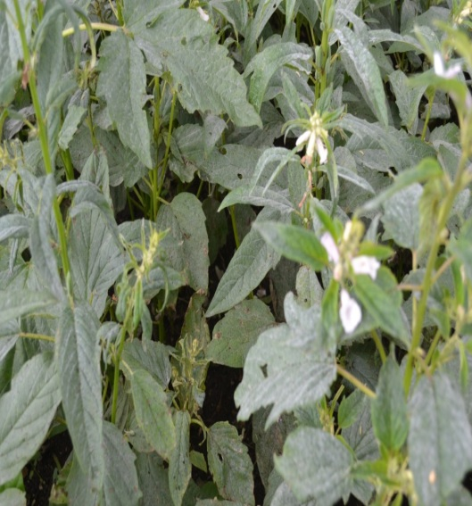 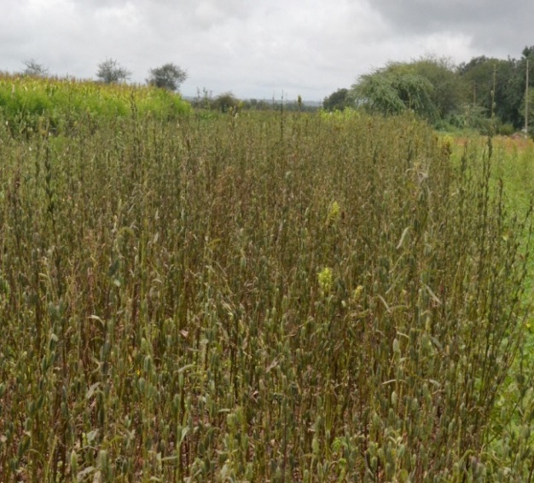

**Dharwad Bagalkote**

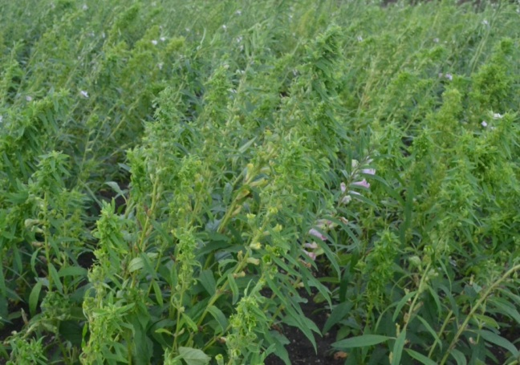 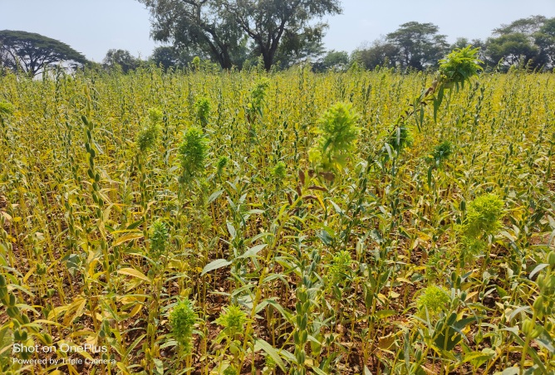

**Gadag Vijaypur**

**Plate 1: Field view of major fields infested with foliar diseases of sesame**

**References**

Akhtar, K., Sarwar, G., Dickson, M., Ahmad, M., Ahsanul Haq, M., Hameed and Javeed Iqbal, M., 2009, Sesame phyllody disease: Its symptomatology, etiology and transmission in Pakistan. *Turk. J. Agric*., 33: 477- 486.

Anonymous, 2017, Status paper on oilseeds, Department of agriculture and cooperation, Ministry of Agriculture, Govt. of India, New Delhi.

Bashir M R, 2017, Impact of global climate change on charcoal rot of sesame caused by *Macrophomina phaseolina*. *Journal of Hort*iculture, 4(1): 100-106.

Gopal K, Jagadeswar R, Prasad babu G. Evaluation of sesame (*Sesamum indicum*) genotypes for their reactions to powdery mildew and phyllody diseases. *Pl Dis Res.* 2003; 20(2):126-130.

Kolte SJ. Disease of annual edible oilseed crops. Vol II: Rapeseed, mustard, safflower and sesame diseases.Boca Raton, Florida: CRC Press Inc; 1985. p. 135.

Mayee CD, Datar VV. Phytopathometry, Technical Bulletin-I (Special Bulletin-3). Marathwada Agricultural Univ., Parabhani. 1986. p. 950.

Min YY, Toyota K. Occurrence of different kinds of diseases in sesame cultivation in Myanmar and their impact to sesame yield. *J Exp Agric Int.* 2019;38:1-9.

Murugesan S, Rap'mmshnan C, Kandaswamy TK, Murugesan M. Forecasting phyllody disease of sesamum. *Madras Agric J.* 1973;60(7):492-495.

Selvanarayanan V, Selvamuthukumaran T. Field resistance of sesame cultivars against phyllody disease transmitted by *Orosius albicinctus* Distant. Sesame and Safflower News Lett. 2000;15:71-74.

Sridhar D, Patil MS. Survey for Sesamum phyllody disease in Northern Karnataka. *Karnataka J Agric Sci*. 2013; 26(2):320-321.

Sundraraju D, Jayaraj S. The biology and the host range of *Orosius albicinctus* dist. (Hemoptera, Cicadellidae), the vector of sesame phyllody disease. *Madras Agric J.* 1977;64(7):442-446.

Vanishree LR, Banakar CN, Goudappagoudar R. Inheritance of phyllody resistance in sesame (*Sesamum* *indicum* L.). *Bioinf Lett.* 2013;10 (1b):177-179.