Agricultural valorisation of organic wastes from market in Korhogo city (Côte d’Ivoire)

Abstract
The objective of this study is to assess the fertilization potential of solid waste derived from specific activities, particularly organic waste from the municipal markets of Korhogo city (Market of Sinistré). The study began with the collection and characterization of this waste. Subsequently, thermophilic aerobic composting was conducted using the Berkley method. Two compost piles were prepared for the experiment. The first pile consisted solely of dried organic waste, while the second pile was structured with a base layer of 0.5 m³ of dried organic waste, topped with a layer of fresh organic waste.
The resulting compost was analyzed in the laboratory using the Mehlich 3 method with an infrared spectrometer to determine its nutrient composition. Finally, the effect of this compost on plant growth and productivity was evaluated through cucumber cultivation (Poinsett variety).
The findings revealed that an average of 56.57 kg of organic waste was collected daily from the market. The resulting compost contained average NPK (Nitrogen, Phosphorus, Potassium) concentrations of 7, 4, and 32 g/kg, respectively, with low levels of trace metals (less than 0.007 g/kg). When applied as fertilizer in cucumber cultivation, the compost promoted rapid plant growth within four weeks, with an average height ranging between 70 and 98 cm using compost doses of 50 g and 75 g per plant. Additionally, the first mature cucumbers were harvested on the 55th day in plots treated with compost, whereas cucumbers in untreated plots were still developing.
Over a two-week period, the highest yield was observed in the plot amended with wet compost, producing 6.18 kg of cucumbers, followed by the plot with dry compost (4.2 kg) and the plot treated with NPK mineral fertilizer (3.15 kg).

Keywords: Korhogo, organic waste, municipal markets, compost, agriculture

- Introduction
In Africa, municipal waste management remains a significant challenge. Large amounts of household waste, often left uncollected, accumulate in streets and public spaces, leading to serious environmental and public health concerns. This waste serves as a major source of pollution and facilitates the spread of disease vectors such as rats and flies. Furthermore, its uncontrolled accumulation can contaminate soil and water resources (Sy et al., 2011; Dongo et al., 2008; WHO, 2007).
A substantial portion of this waste originates from municipal markets, a problem exacerbated by the global production of approximately 230 million tons of food waste annually (FAO, 2018). The issue is further aggravated by inadequate waste management practices, as emphasized by the World Health Organization (WHO, 2018). Given these challenges, improving food waste management is essential. This requires enhanced collection systems and the development of a circular economy to recover and repurpose these residual materials.
In Korhogo, a northern city, rapid population growth has led to a sharp increase in municipal solid waste (Tshala et al., 2017). However, waste management remains largely insufficient, limiting recovery opportunities and intensifying environmental and health risks. In this context, the hypothesis that agricultural valorization of plant-based waste could provide a sustainable solution warrants particular attention. This approach would not only enhance waste management but also contribute to food security by utilizing compost as an agricultural fertilizer.
The main objective of this study is to assess the fertilization potential of food waste from Korhogo’s municipal markets in agriculture. To achieve this, three specific objectives have been defined: (i) characterize the organic waste generated in municipal markets, (ii) evaluate the fertilizing potential of compost derived from this waste, and (iii) analyze the impact of its application on crop growth cycles and yields.

2- Material and methods
2.1 Material
The biological material used for composting consisted of various organic waste collected (Figure 1) from Sinistré market of Korhogo. Trays were essentially used as collecting containers. The Poinsett variety of cucumber (Cucumis sativus) was selected for the study (Figure 2).

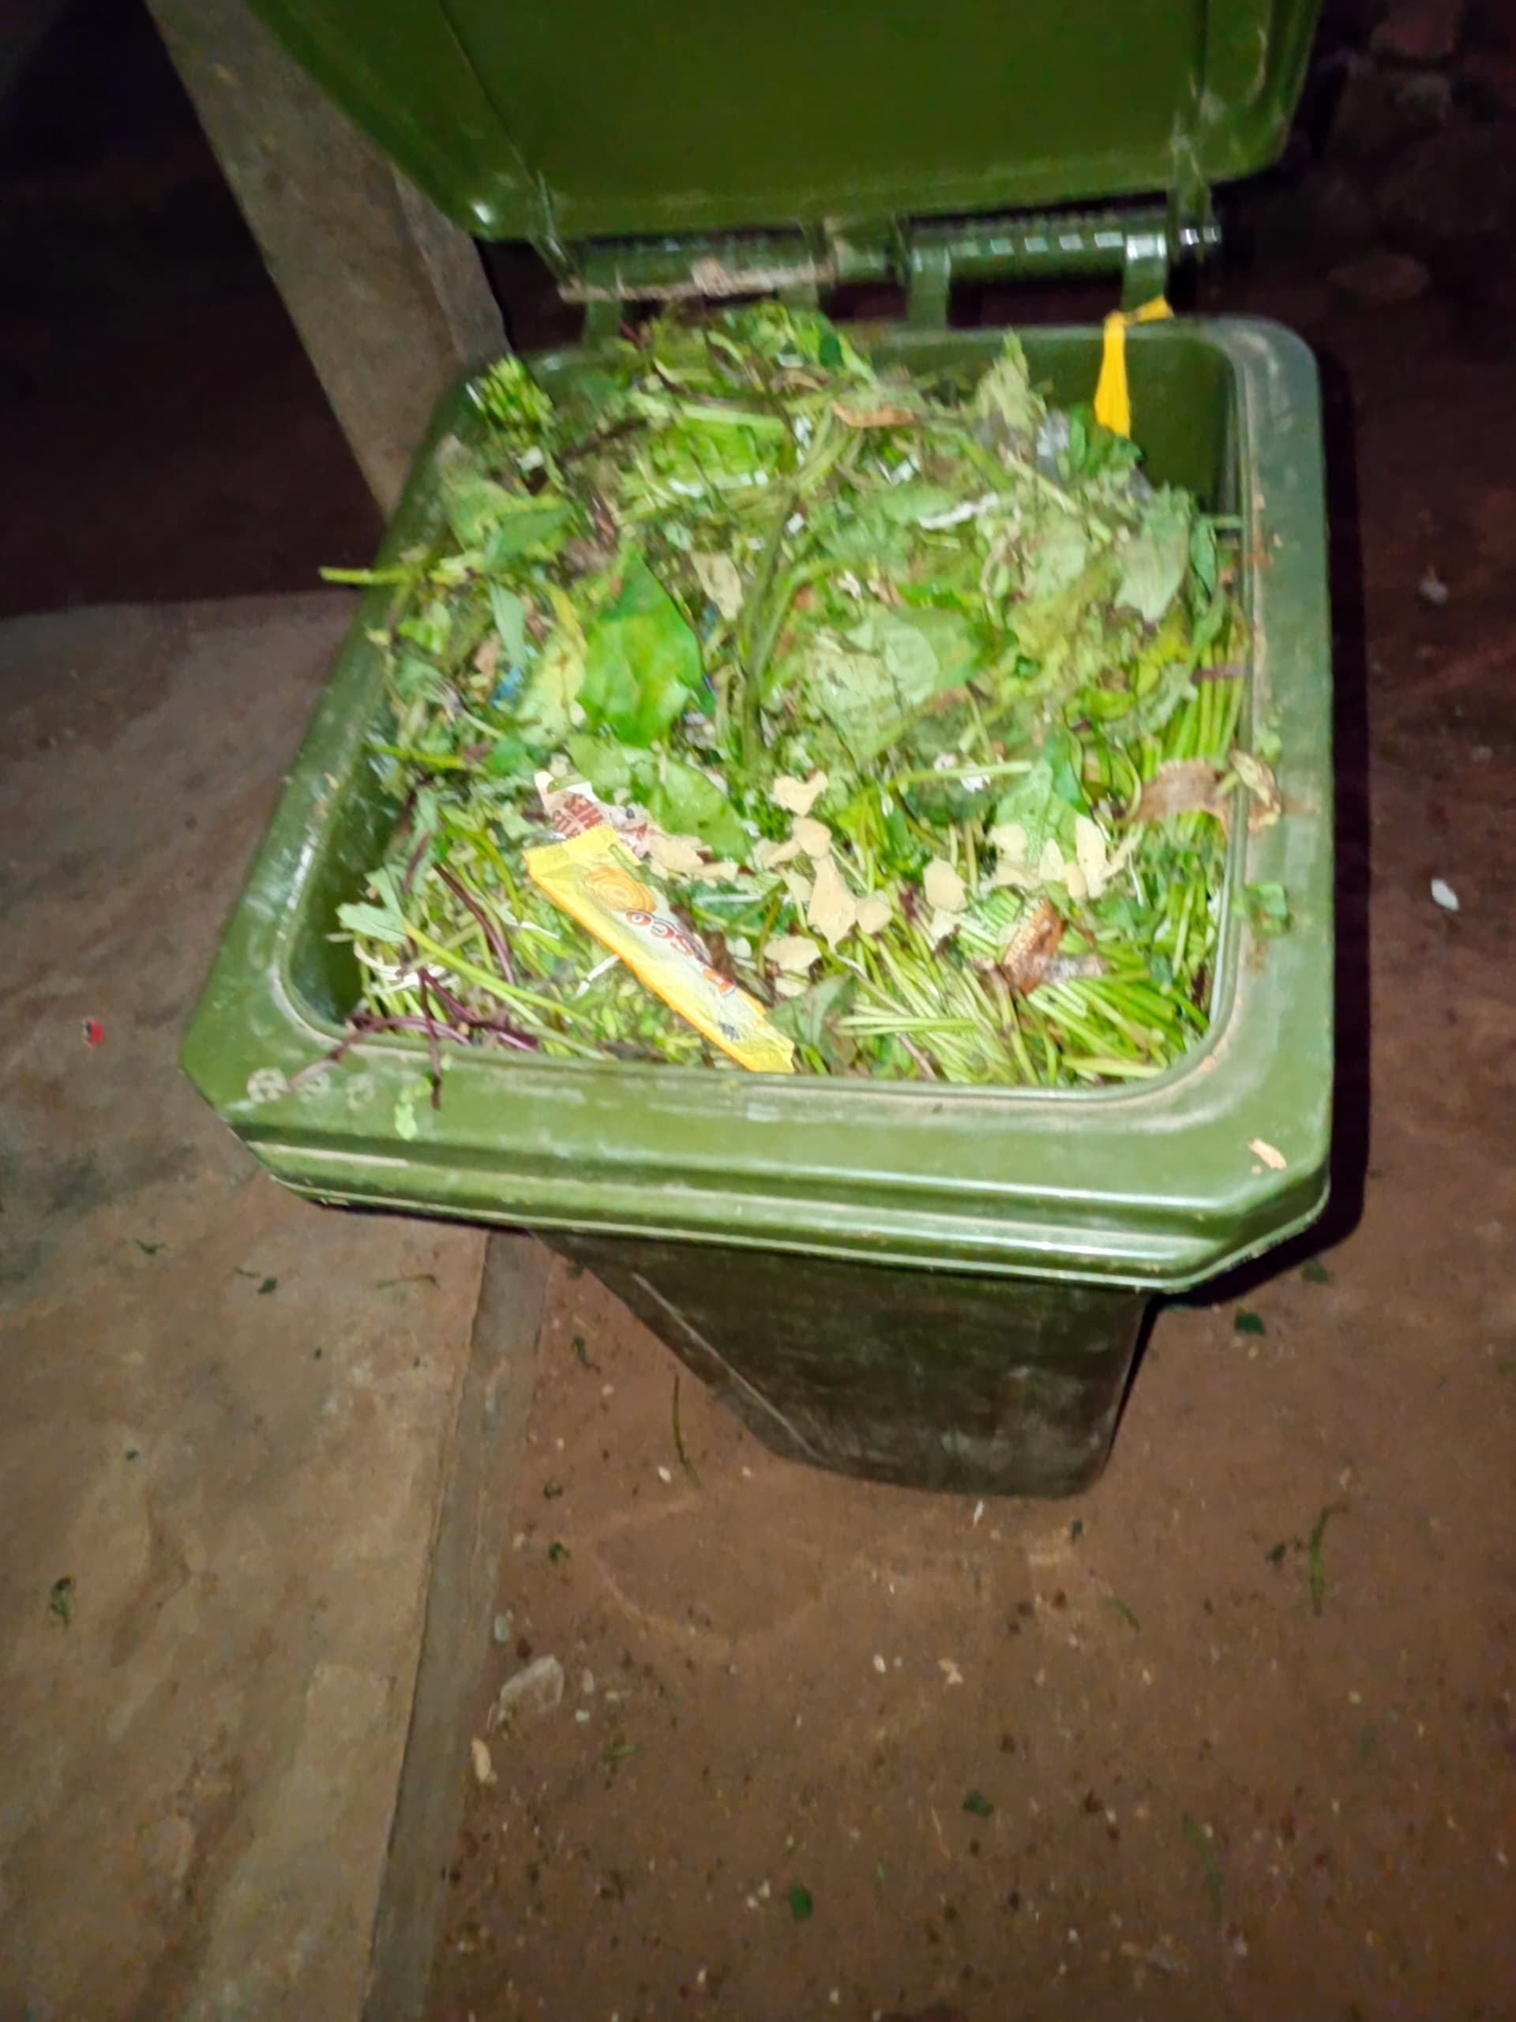
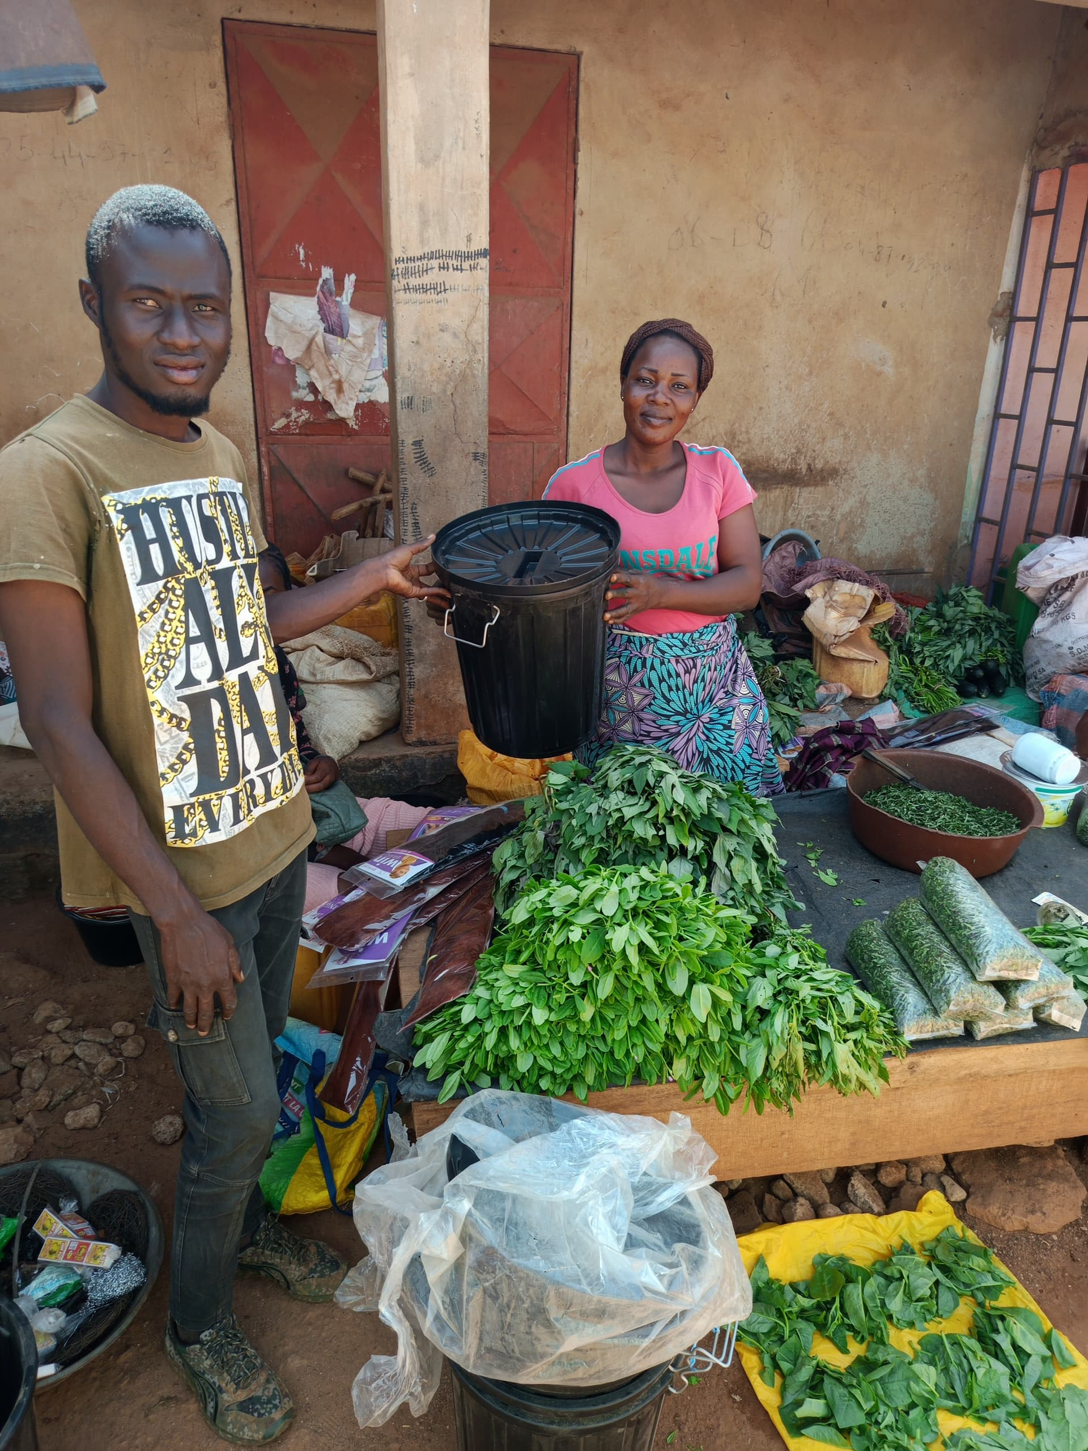

Figure 1: Organics market waste collection

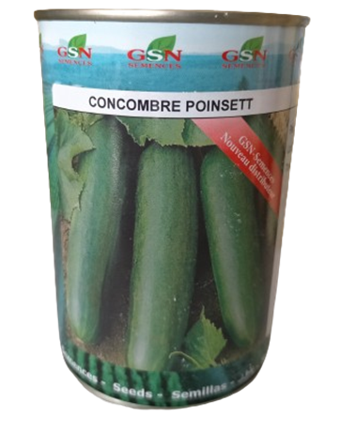

Figure 2: Variety of cucumber used for the experimentations

2.2 Method
2.2.1 Characterization of Organic Waste from Municipal Markets

Organic waste was collected daily over a three-week period from the market in the Sinistré neighborhood. Waste was gathered using trays with capacities of 30 and 120 liters. The 30-liter bins were used to collect residual organic waste from individual vendors’ sales activities. The contents of these bins were then transferred to 120-liter containers. After collection, the organic waste was spread on plastic sheets and dried for 18 days. This drying process aimed to reduce moisture and fat content while partially eliminating pathogenic microorganisms. The waste was weighed before and after drying to measure mass loss due to evaporation and partial degradation of organic matter. A representative 1 kg sample of the dried waste was taken for laboratory analysis using the Melhich 3 method with an infrared spectrometer to determine its chemical composition, including carbon, nitrogen, phosphorus, and potassium content.

2.2.2 Assessment of the Fertilizing Potential of Compost from Municipal Market Organic Waste

Thermophilic aerobic composting was conducted using the Berkley method (Raabe, 2001). Two compost piles were prepared for the study:
Pile 1: Composed solely of dried organic waste.
Pile 2: Consisting of a base layer of 0.5 m³ of dried organic waste, topped with a layer of fresh organic waste.

The piles were arranged in a pyramidal shape with a minimum volume of 0.90 m³ and were periodically turned to ensure proper aeration. At the end of the composting process, a 1 kg sample was taken from each pile and analyzed in the laboratory using the Melhich 3 method with an infrared spectrometer. The analysis aimed to evaluate the compost’s fertilizing properties, particularly its content of essential nutrients and organic matter.

2.2.3 Assessment of the Impact of Compost Use on Crop Growth and Yield

The fertilizing effect of the produced compost was tested on experimental plots dedicated to cucumber cultivation. The experimental design included four treatments:
Plot 1 (Control): No compost or fertilizer applied.
Plot 2: Compost derived exclusively from dried organic waste.
Plot 3: Compost made from a mixture of dried and fresh organic waste.
Plot 4: Chemical NPK fertilizer applied at a rate of 100 kg/ha, administered at the beginning of the third week after cucumber seed germination.

The control plot (Plot 1) consisted of a single row of 10 planting pockets. Plots 2 and 3 each contained four rows, corresponding to increasing compost doses (25 g, 50 g, 75 g, and 100 g per pocket). Plot 4 received a standard dose of 4 g NPK per pocket.
Vegetative parameter (plant height) and crop yields were measured over a four-week period. Fruits harvested during multiple passes over two weeks were weighed to determine total yield per plot and compare the effectiveness of the different treatments

3. Results and Discussion

3.1 Physico-Chemical Characteristics of Collected Organic Waste
The table presents the daily quantities of organic waste collected from the markets in the Disaster district. The amounts ranged from 30 to 75 kg per day, with an average of 56.57 kg/day. Over the three-week collection period, a total of 1,244.43 kg of organic waste was gathered. After the drying process, the weight of the waste was reduced to 396.5 kg, representing 31.86% of the initial fresh material (Table 1). The collected waste comprised a variety of agricultural by-products, including onion peels, peanut shells, potato and cabbage leaves, orange pulp, eggplant scraps, chili peppers, carrots, tomatoes, and other similar materials.
Table 1: Quantity of organic wastes collected
Total quantity of collected Fresh waste in 22 days (Kg) | Average quantity of collected Fresh waste per day (Kg) | Standard deviation | Total dry waste obtained (Kg)
1244.43 | 56.57 | 13.85 | 396
The physico-chemical characteristics of the dried organic waste (DOS) are summarized in the table. For every 1 kg of the analyzed DOS sample, a significant presence of mineral nutrients essential for plant growth was observed. These include primary macronutrients (Nitrogen (N), Phosphorus (P), and Potassium (K) with respectively values of 0.683% (6.83 g/kg), 0.311% (3.11 g/kg) and 3.218% (32.18 g/kg)), secondary macronutrients (Calcium (Ca), Magnesium (Mg), Sulfur (S) with respectively values of 1.7365% (17.37 g/kg), 0.1323% (1.32 g/kg) and 0.2891% (2.89 g/kg)), and trace elements (Manganese (Mn), Iron (Fe), Copper (Cu), Zinc (Zn) and Molybdenum (Mo) with respectively values of 0.14 g/kg, 5.01 g/kg, 0.03 g/kg, 0.06 g/kg, less than 0.01 g/kg. Additionally, the analysis revealed the presence of Titanium (Ti): 0.0091% (0.09 g/kg), Arsenic (As) and lead (Pb) with contents below 0.005 g/kg, which are within normal and non-hazardous levels for both plants and humans. The sample also contained a notable amount of carbon, measured at 71.5 g/kg with C/N value of 10.472.

Table 2 - Physico-Chemical Composition of Dried Organic Waste
Parameters | Dry waste (%) (1% = 10g/kg)
C | 7,155
N | 0,683
Mg | 0,1323
Al | 0,57935
P | 0,31115
S | 0,2891
K | 3,2181
Ca | 1,7365
Ti | 0,0091
Mn | 0,01395
Fe | 0,50065
Co | 0,0004
Ni | 0,00065
Cu | 0,00275
Zn | 0,00615
As | 0,0001
Mo | 0,0006
Pb | 0,0004
The characterization of organic waste from municipal markets revealed a significant reduction in mass after 18 days of drying. From an initial quantity of 1,244.43 kg, only 396.5 kg (±32%) remained. This reduction is attributed to the loss of water and fat due to heat exposure, as well as the partial degradation of organic matter. Furthermore, physico-chemical analysis confirmed the presence of essential minerals for plant growth, particularly macronutrients with concentrations exceeding 1 g/kg, and a carbon content of 71 g/kg, which is crucial for effective composting. These findings highlight the potential of organic waste to produce high-quality compost, as shown in the study of Soudi (2001), which related that the quality of compost produced from urban solid waste depends on its initial composition. The compost yields, representing 26% to 28% of the initial mass of each heap, are consistent with the volume reduction reported by Misra et al. (2005), resulting from the decomposition of organic matter by microbial activity. The use of compost significantly improved key vegetative parameters in cucumber cultivation, including germination, plant growth, and yield, outperforming the use of chemical fertilizers.

3.2 Assessment of the Fertilizing Potential of Compost from Organic Waste in Municipal Markets
For each 1 kg of compost analyzed, a notable presence of mineral nutrients essential for plant growth was observed. The compost with wet components has approximatively values of 6 g/kg, 3 g/kg and 37.4 g/kg respectively for Nitrogen, Phosphorus and Potassium. Secondary Macronutrients have contents of 23.2 g/kg, 3.9 g/kg and 3.9 g/kg respectively for Calcium, Magnesium and Sulfur. The compost with wet components has slight high values compared to the compost with dry components as shown on Figure 3. According to Carbon content, C/N ratio of compost with dry components (11.96) was slight higher than compost with wet components (11.25).

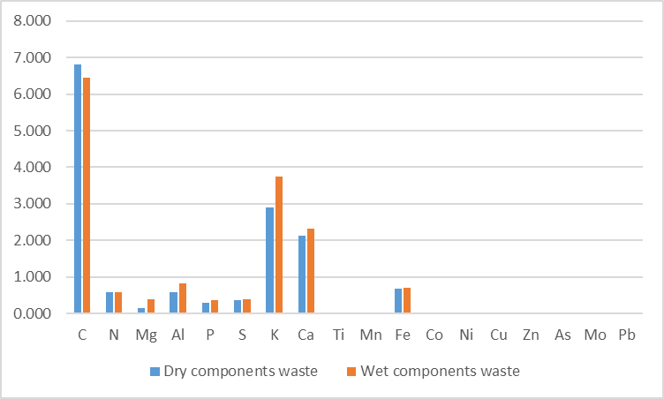

Figure 3: Physico-chemical characteristics of composts with dry and wet components
Analysis of the physico-chemical properties of the composts revealed slight higher concentrations of macronutrients and micronutrients in wet compost. This is attributed to the composting method, which involved mixing dry organic waste with fresh organic waste, thereby enhancing the chemical diversity of the substrate. The C/N ratios of the composts, approximately 11, align with values reported by Compaoré et al. (2010), ranging from 10.5 to 13.8, indicating near-complete mineralization. The C/N ratio is a widely used indicator for assessing organic matter mineralization and compost maturity (Larbi, 2006).

3.3 Assessment of the Impact of Compost Use on Crop Growth Cycle and Yield
The vegetative cycle parameters examined in this study include germination and plant growth. The germination rate on the control plot (without compost) was 60%. Average germination rate for dry components compost was 75 % compared 65 % for wet components compost. For plots amended with dry components compost, the germination rates were 80%, 90% and 50% respectively for 25 g and 50 g, 75 g 100 g, as fertilization doses. For plots amended with wet components compost (applied as basal manure), the germination rates were: 90%, 60% and 50% respectively for 25 g, 50 g and 75 g, and 100 g applied as basal manure. Figure 4 illustrate the germination rates for each plot amended with dry and wet components compost.

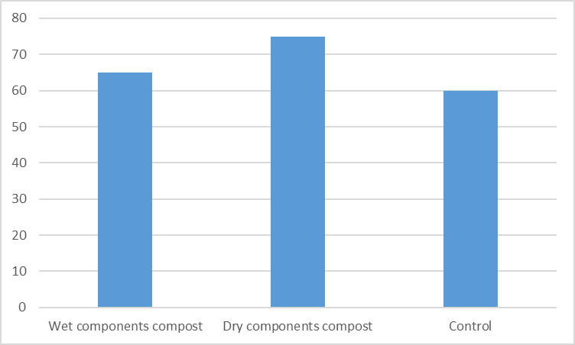
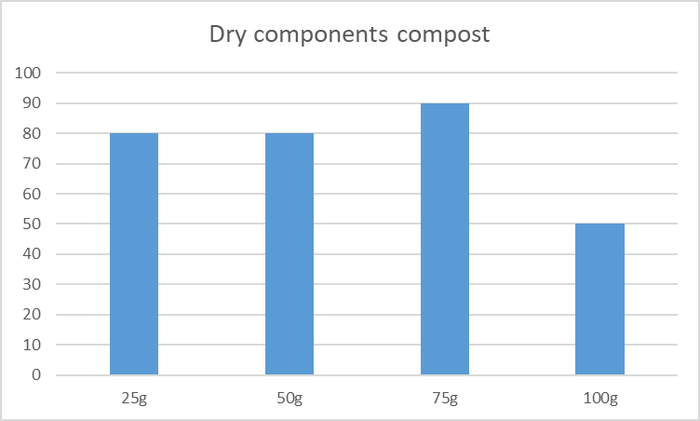
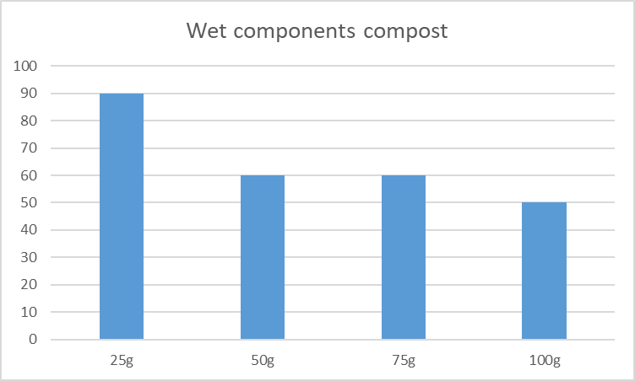
Figure 4: Germination rate
These results show the agricultural value of the use of composts produced from market organics wastes enhance. Phytotoxicity tests on cucumbers showed that composts incorporation improved germination rates, reaching 75% for dry compost and 65% for wet compost, compared to 60% for the control. These findings are consistent with those of Chennaoui et al. (2016), who observed germination rates of up to 85% (vs. 70% for the control) for wheat and 67% (vs. 58% for the control) for tomatoes with 25% compost incorporation. In terms of cost-effectiveness, low doses of compost, such as 25 g of wet compost or 25 g, 50 g, and 75 g of dry compost, proved particularly advantageous. These results are in line with the recommendations of Kitabala et al. (2016) and M’zée (2008), who advocate for the use of small amounts of compost for various crops, including lettuce, wheat, cabbage, corn, and potatoes. However, germination rates may vary depending on the compost dose and crop type (Compaoré et al., 2010). Chennaoui et al. (2016) consider compost non-toxic when its germination index exceeds 50%, explaining the reduced germination observed at higher doses (e.g., 100 g).

Plant Growth
Figures 5 and 6 show the height of plants measured over a four-week period after germination. On the control plot (without compost), plants showed an average growth ranging from 1.7 cm in week 1 to 26.31 cm by week 4. On the plot amended with dry compost, plants treated with 75 g per plot exhibited significantly higher growth starting from week 3, reaching a maximum average height of 84.43 cm by the end of week 4 (Figure 5). On the plot amended with wet compost (applied as basal manure), plants treated with 25 g per plot showed markedly higher growth from week 3, achieving a maximum average height of 98 cm by the end of week 4 (Figure 6).

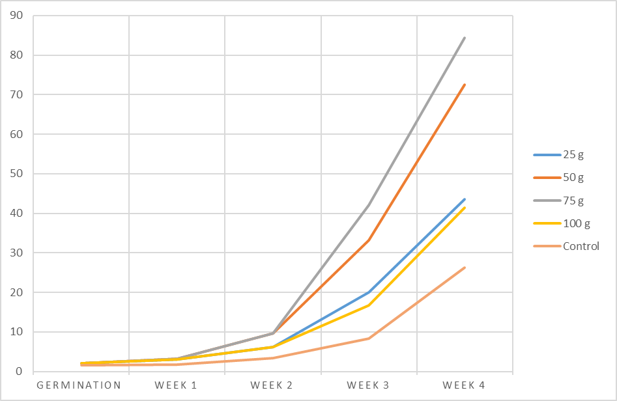
Figure 5: Plants growth with dry components compost

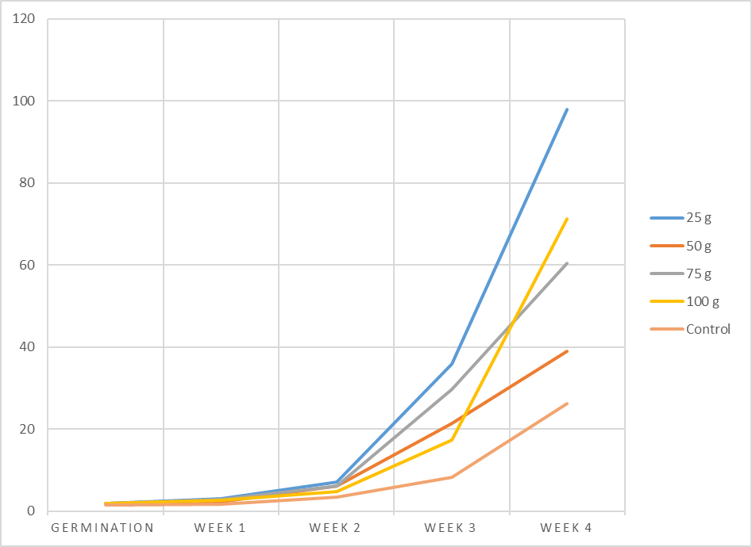
Figure 6: Plants growth with wet components compost
Regarding cucumber plants growth, results indicate that wet components compost gives a large amount of larger higher plants, while the control treatment recorded the smallest values, demonstrating a significant positive effect on growth. The rapid growth observed with 50 g and 75 g of dry components compost and 25 g of wet components compost can be attributed to improved substrate quality. Increased soil organic matter enhances nutrient retention and availability by boosting the Cation Exchange Capacity (CEC), which reached 14.35 in this study. Organic matter also contributes to soil aggregation, improving soil structure and nutrient availability. The average number of flowers, approximately 13, remained relatively consistent, corroborating the findings of Baboy Longanza et al. (2015), who also observed similar results based on different treatments (control, compost, NPK) and time.

Yield
Harvesting over a two-week period yielded significant results. From day 55, the first ripe cucumbers were harvested from plots 2 and 3 (amended with compost), while cucumbers on plots 1 (control) and 4 (amended with NPK) were still developing. Cucumbers from plot 3 (25 g wet compost) were notable for their large size and elongated shape, similar to those from plot 4. In contrast, cucumbers from plot 1 were smaller and had a rounded shape with a pointed end (Figure 7). In terms of quantity, plot 2 (75 g dry compost) produced 1.6 kg of cucumbers, plot 3 (50 g wet compost) produced 1.65 kg, comparable to plot 4 (NPK-amended), which also yielded 1.65 kg, while plot 3 (50 g wet compost) recorded the highest cucumber yield at 2.75 kg, significantly exceeding the yield of plot 4 (1.65 kg). These results are illustrated in Figure 8, which shows the quantities of cucumbers harvested from each plot during the two-week period. In terms of yield, results highlight the fertilizing potential of compost derived from organic waste and its positive impact on cucumber production. The first fruits were harvested from compost-amended plots, with an average yield of 2.75 kg (30.6 t/ha) for wet compost, surpassing that of NPK-amended plots (1.65 kg, or 18.3 t/ha) and the control (1.5 kg, or 16.7 t/ha). These yields are in the typical production range for tropical regions (5–20 t/ha) without chemical fertilizers (De Lannoy, 2001).
This performance is attributed to the heterogeneous nutrient composition of the compost, particularly its phosphorus, potassium, and other mineral content, which are released gradually over the crop cycle. These findings are similar to the observations of Serémé and Phal (2007), Mulaji (2011), and Tahraoui (2013), who also demonstrated that household compost significantly improves crop yields compared to controls.
The variations in fruit shape and size may be due to insufficient nutrient availability, particularly nitrogen, which could explain the pointed apex of some fruits and the pale green coloration of leaves. Overall, compost quality and application rates directly influence crop yields, as documented by Charland et al. (2001).

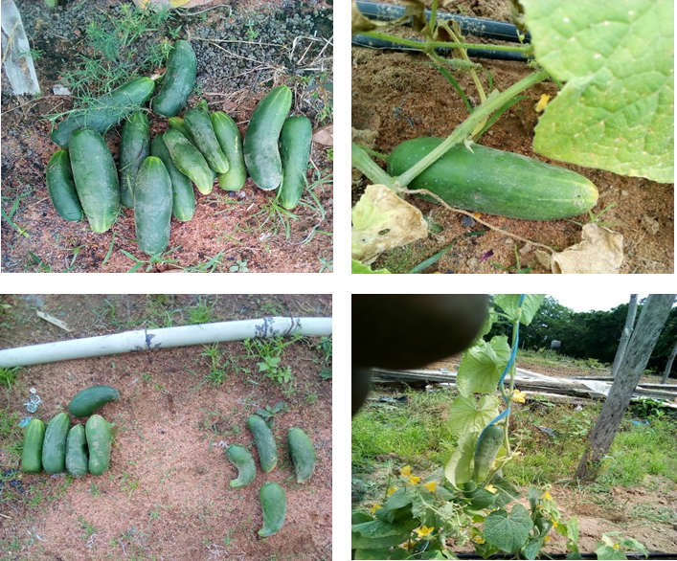

Figure 7: Shape of yields with composts and control

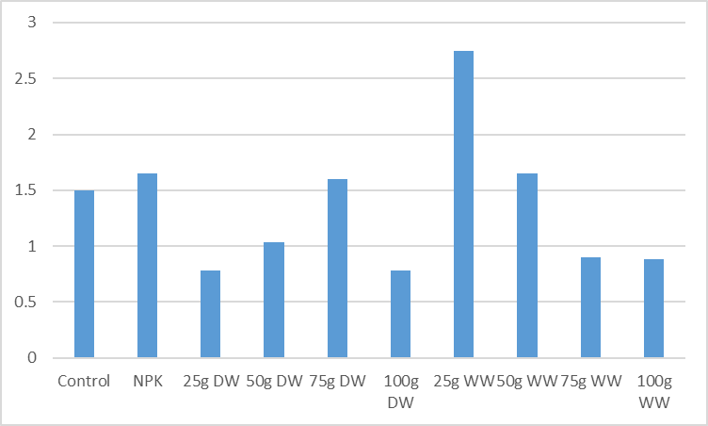

Figure 8: Plots yields with composts and control

Conclusion
In conclusion, this study aimed to demonstrate the fertilizing potential of organic waste from municipal markets in Korhogo. The results confirmed that organic waste and compost are valuable sources of nutrients capable of meeting the needs of vegetable crops. This is particularly relevant in the context of local soils with low mineral content, as evidenced by the low yields from the unamended control plot (1.5 kg). While the use of NPK chemical fertilizers at a dose of 4 g per plot (100 kg/ha) achieved a yield of 18.3 t/ha, the study highlighted the promising potential of composting. This approach not only reduces the environmental impact of pollutants but also offers a cost-effective alternative for farmers, who often supplement chemical fertilizers with organic amendments to improve yields. The application of a low dose of wet compost (25 g per plot, or 625 kg/ha) achieved a significant yield of 30.6 t/ha while reducing production costs. This is particularly important in a context where many farmers seek sufficient profitability to support their families.
For future research, it is recommended to evaluate the effectiveness of compost on crops other than cucumbers to better understand and optimize its potential. Additionally, further exploration of strategies to enhance compost performance could provide valuable insights for sustainable agriculture. Energy production through biogas from those waste could be a double beneficial way of valorisation.

REFERENCES
- Chennaoui, M., Salama, Y., Makan, A., & Mountadar, M. (2016). Agricultural recovery of compost produced from in-tank composting of municipal waste. European Scientific Journal, 12(35), 247. DOI: 10.19044/esj.2016.v12n35p247
- Compaore, E., Nanema, L. S., Bonkoungou, S., & Sedogo, M. P. (2010). Quality assessment of solid urban waste compost from Bobo-Dioulasso, Burkina Faso for efficient use in agriculture. Journal of Applied Biosciences, 33, 2076–2083.
- Kitabala, M., Alain, T. U. J., Kalenda, M. A., Tshijika, I. M., & Mufind, K. M. (2016). Effects of different doses of compost on the production and profitability of tomato (Lycopersicon esculentum Mill) in Kolwezi City, Lualaba Province, Congo. Journal of Applied Biosciences, 102, 9669–9679. DOI: https://doi.org/10.4314/jab.v102i1.1
- Larbi, M. (2006). Influence of the quality of composts and their extracts on the protection of plants against fungal diseases (Thesis). University of Neuchâtel, Institute of Botany (Laboratory of Soil and Vegetation), Neuchâtel.
- Baboy Longanza, L., Kidinda, K. L., Tshipama Tamina, D., Tombo, J. A., & Tshijika Ikatolo, M. (2015). Agricultural waste recovery as an alternative to waste management in cities in sub-Saharan Africa: Characterization of urban waste in Lubumbashi and assessment of its effects on food crop growth. Africa SCIENCE, 11(2), 76–84.
- M’zée, S. P. (2008). Influence of organic matter inputs on biological activity and phosphorus availability in two soils in the Great Lakes region of Africa (Doctoral thesis). Faculty of Agronomic Sciences of Gembloux.
- Charland, M., Cantin, S., St. Pierre, M. A., & Côté, L. (2001). Research on the advantages of using compost (CRIQ File 640-PE27158 (R1), Final Report. Recyc-Québec.
- Misra, R. V., Roy, R. N., & Hiraoka, H. (2005). Composting methods at farm level. Food and Agriculture Organization of the United Nations (FAO), Rome.
- Mulaji, K. C. (2011). Use of household bio-waste composts to improve the fertility of acidic soils in Kinshasa province (Democratic Republic of Congo) (Doctoral thesis). University of Liège-Gembloux Agro-Biotech.
- Raabe, R. D. (2001). The rapid composting method. University of California, Cooperative Extension, Division of Agricultural and Natural Resources.
- Serémé, A., & Phal, M. (2007). Agricultural recovery of household waste in the Sudano-Sahelian zone: The case of the town of Bobo-Dioulasso. CAMES-Series A, 5, 47–54.
- Soudi, B. (2001). Composting of household waste and recovery of compost: The case of small and medium-sized municipalities in Morocco. Actes Editions.
- Tahraoui, D. N. (2013). Composting of solid urban waste from the commune of Chlef, Algeria (Doctoral thesis). University of Limoges in co-tutelage with the University of Blida, Department of Science and Technology, Algeria.
- Tshala, U. J., Kitabala, M. A., Tunda, M. J. P., Mufind, K. M., Kalenda, M. A., Kapele, K. G., & Nyembo, K. L. (2017). Towards a recovery of household waste in urban agriculture (peri) in Kolwezi: Characterization and influence of seasonality. International Journal of Biological and Chemical Sciences, 11(2), 11072–11079. DOI: http://dx.doi.org/10.4314/jab.v112i

