*Review Article*

Farmers' perception of midge impact on sorghum grains production in Burkina Faso

.

ABSTRACT

|  |
| --- |
| Sorghum midge, Stenodiplosis sorghicola (Coquillet, 1898) (Diptera: Cecido-myiidae) is one of the most dangerous insect pests reducing the crop yield over the world. The present study was carried out to bring out a better understanding of farmers' perceptions of sorghum midge and the endogenously methods used to control it. Surveys were carried out in seven (7) regions, including ten (10) provinces of Burkina Faso. These surveys were carried out using scorecards on the incidence of the insect and other agricultural aspects during the period October and November 2023. The results show that most growers are illiterate and mostly use local varieties for sorghum production. The results also revealed that only 6% of growers surveyed are able to identify the insect and its damage to the crop, and among them, only 3% apply methods to control the insect. Similarly, the survey revealed that all the localities visited were infested by the midge. These results represent an important step towards managing sorghum midge populations and improving production, especially in areas with high levels of infestation. |

*Keywords: sorghum midge, farmer perception, insects, damage, production, Burkina Faso*

1. INTRODUCTION

Sorghum is the leading cereal produced in Burkina Faso [1]. It is grown in all over different climatic zones and regions of the country due to its high adaptability and tolerance to water stress [2]. Its production was about 2,100,036 tons, representing 39% of national cereal production, on an average area of 2,007,650 ha, which accounts for 45.6% of the national cereal-growing area. It constitutes with millet the basis of food crop for rural population [3].

However, its production remains low due to climate change and variability [4,5]; along with biotics constraints (diseases, weeds, and pest pressure), including insect pests that particularly has a negative impact on its yields [6]. All these combined factors lead surely to either poor quality of the grains, affecting the quality of derived dishes [7], or considerable losses in expected production [8]. Among these pests, the sorghum midge, Stenodiplosis sorghicola (Coquillet, 1898) (Diptera: Cecidomyiidae), is reported as the most important pest of sorghum cultivation [8, 9]. In fact, this very small insect, measuring about 1.5 to 2.0 mm, is classified among those with highly devastating effects [10]. As such, the larva develops in the spikelets where it feeds on the ovary or the forming grain, causing grain loss [11, 12]. As a result, the panicle remains empty and appears shattered [13,14], especially when planting is done late [9]. To address these concerns, the development of insect-tolerant varieties could be an alternative [15,16,10], along with suitable management practices. Thus, at the national level, some promising tolerant lines to the insect had been identified [8,17].

However, better management of the pest requires a diagnostic and participatory approach involving various stakeholders in the sorghum value chain, especially the farmers. This will promote integrated pest management methods to effectively address the damage caused by this pest. The study was then initiated through a survey to gather information on the sorghum midge in seven (7) regions of Burkina Faso and to determine indigenous knowledge used for managing the pest in these different regions of the country.

2. material and methods

**2.1. Study area**

Burkina Faso is a landlocked country with three main climatic zones, which are further subdivided [18,19]. The Sahelian zone is located in the extreme north, the sub-Sudanian zone in the extreme south, and the sub-Sahelian, north-Sudanian, and south-Sudanian zones in the middle. From north to south, the vegetation varies from steppes with very irregular and short rainfall during the rainy season, to clear forests and wooded savannahs in the south with more abundant rainfall during the rainy season [20]. Over the past few decades, a general decline in rainfall has been observed [21], with a decrease in rainfall exceeding 40 mm per year across the entire country, with nearly 65% of the country falling between the isohyets of 500 mm and 800 mm, and 13.3% of the land being cultivated [22. The main food crops, including sorghum, millet, rice, maize, and peanuts, are cultivated on leached ferruginous soils in the south, eroded soils in the north, and eutrophic brown soils throughout the territory [20].

**2.2. Collection zones**

The survey was conducted in regions located between the north-Sudanian agro-climatic zone (isohyet 700-900 mm) and the south-Sudanian agro-climatic zone (isohyet 1100 mm and above) [23,24]. These regions cover almost different agro-ecological zones where sorghum is grown in Burkina Faso.

* **North-Sudanian zone:** in this area, four regions in which five provinces were explored for the survey: the Central-Eastern region (Boulgou and Kouritenga provinces), the Central Plateau region (Ganzourgou province), the Central region (Kadiogo province), and the Central-Western region (Boulkiemdé province).
* **South-sudanian zone:** in this area, three regions involving the Boucle du Mouhoun region (Balés province), the Hauts-Bassins region (Tuy and Houet provinces), and the Cascades region (Comoé and Léraba provinces) were explored.

The figure (Figure 1) below shows the various zones explored with the collection sites colored in green points across all seven regions of Burkina Faso. Each green point represents a village or a town where data were collected across the national territory (Figure 1).

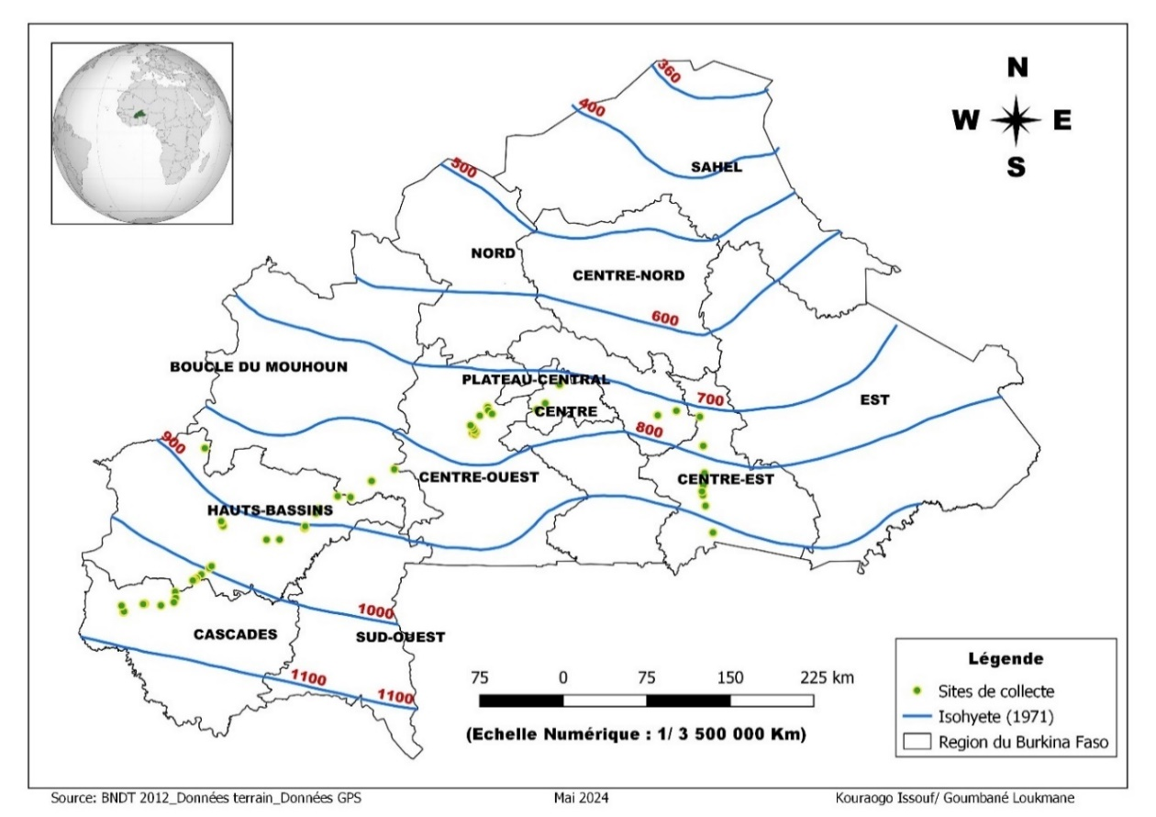

Figure 1: Map showing the data collection sites

**2.3. Conducting the surveys**

The surveys were conducted during the 2023 rainy season with farmers through semi-structured interviews and the completion of a survey form. Villages were retained based on two mains factors. Firstly, villages should be located in regions with high sorghum production potential (61% of the total national area and 54% of the total national production). Secondly, villages should be located in midge hotspot regions, i.e that, regions/areas with a high infestation rate of sorghum midge (Dakouo *et al*., 2005 [8]),

During the survey, information was gathered on the farmer's experience with sorghum cultivation, the criteria used by the farmer to recognize the insect, the presence of the insect on the site, the period of its appearance, the severity of the insect infestation, the farmer's ability to identify the damage caused by the insect, and the endogenous control methods developed by farmers against the insect.

A total of 90 farmers were interviewed regarding their understanding of the sorghum midge. These farmers were spread across 10 provinces from 7 regions (Cascades, Hauts-Bassins, Boucle du Mouhoun, Centre-Ouest, Centre, Plateau Central, Centre-Est). These 10 provinces were distributed in 27 communes of 48 villages across Burkina Faso. The selection of farmers was based on the size of their sorghum cultivated areas and the number of years of experience with sorghum cultivation, as well as the accessibility of their fields.

**2.4. Method for identifying the insect and its damage on sorghum**

The identification of the sorghum midge can be done through visual observation on sorghum panicles, but very early in the morning before 7 a.m. It can be recognized by its small size, around 1.5 mm, and its red-orange color on the sorghum panicles, either for egg-laying or waiting for the male for mating. Farmers are thus asked to describe the different insects they encounter on the sorghum panicles and their intervention methods on the panicle. This is confirmed if the description provided by the farmer matches with midge morphology and if the observation is done at the right time i.e early in the morning before 7 a.m.

As for the damage caused by the insect on the plant, it consists of the grain abortion in the spikelet, leading to an empty panicle. Each spikelet hosting a developing midge larva becomes empty of its content. Farmers are questioned about the appearance of the panicle at maturity. In case the farmers response aligned with following statement: panicle with glume but no grain" or "panicle without grain," then it is confirmed midge effect on sorghum.

**2.5. Statistical analysis**

Data collected during the study were managed using Excel Spreadsheet version 2016. The spreadsheet was also used to conduct different analysis and create graphs. Circular diagrams were made to structure the education level of all interviewed farmers. Likewise, histograms were created based on farmers’ gender and areas planted with sorghum according to collection areas. Moreover, graphs were created to present the types of varieties used, sowing dates, and level of insect’ identification and damage on the crop, as well as the control methods practiced by the farmers

**III. RESULT**

3.1. **Sorghum production and total area in percentage for the 7 visited regions**

A breakdown of sorghum planted areas in each of the studied regions was made to highlight the importance of this cereal crop in these different sites. Indeed, these 7 regions alone account for 61% of the national area planted with sorghum and contributed to 54% of the total national production [1]. Figure 2 below is a summary of this breakdown. It shows that the Boucle du Mouhoun and Centre-Ouest regions occupy the largest areas of sorghum cultivation, with 18% and 22% of the national area, respectively, and this account a total of 40% for these two regions [1]. As for production, these two regions account for 16.1% and 16.6% of the national total, respectively, for the Boucle du Mouhoun and Centre-Ouest regions. In opposite, the regions with the smallest sorghum planted areas were the Centre and Cascades regions, with 1% and 2% of the national area, respectively [1]. The production rates are similarly low, with 0.8% for the Centre region and 1.8% for the Cascades region. For the remaining three regions, the proportions range from 6% to 7% for the areas planted and from 4.7% to 6.9% for grain production rates (Figure 2).

Figure 2: Proportion of sorghum areas and production by region

**3.2. Types of varieties used by producers**

Discussions about different varieties grown by producers in the studied sites showed a low use of improved varieties. Thus, out of 90 producers interviewed regarding the crops they grow, only 10% use improved varieties, while 90% use local varieties. These varieties often struggle to complete their growth cycle due to the generalized irregular rainfall patterns across the country. Figure 3 presents the results showing the proportion of producers using local or improved varieties.

Figure 3: Proportion of variety types used by producers

**3.3. Distribution of producers by gender according to the visited regions**

A total of 90 producers from 48 villages across 27 municipalities were involved in this study. These 27 municipalities are distributed as follows: 4 municipalities in the Cascades region (Sindou, Douna, Wolonkoto, Banfora); 7 municipalities in the Hauts-Bassins region (Toussiana, Peni, Bobo-Dioulasso, Bama, Koumbia, Houndé, and Boni); 2 municipalities in the Boucle du Mouhoun region (Pâ, Boromo); 5 municipalities in the Centre-Ouest region (Sourghou, Sabou, Koudougou, Poa, Villy); 2 municipalities in the Centre region (Tanghin Dassouri and Ouagadougou); 2 municipalities in the Plateau Central region (Boudry and Zorgho); and finally, 5 municipalities in the Centre-Est region (Dialgaye, Koupela, Tenkodogo, Bitou, and Bané). Thus, the number of producers varied by region, with the highest numbers found in the Hauts-Bassins, Centre-Ouest, and Centre-Est regions, with 22, 27, and 16 producers respectively. In the other regions, the number of producers ranged from 5 to 9 people. The study revealed a low participation rate of women, with the largest number of women interviewed in the Centre-Est region (only 6 female producers). As for men, their numbers ranged from 4 in the Plateau Central and Centre regions to 23 in the Centre-Ouest region. Figure 4 below presents the number of interviewees by gender in the different regions.

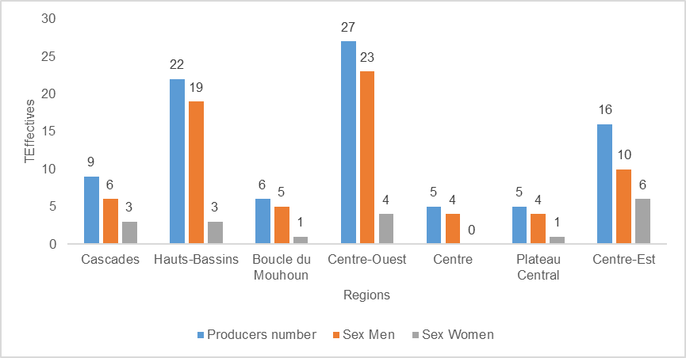

Figure 4: Number of producers surveyed by region and gender

**3.4. Distribution of producers according to their education level**

The education level of producers, which is one of the key factors in the management and success of agricultural activities, was examined in this study. The analysis revealed that majority of farmers has low education level. In fact, it appears that 71.71% of the producers are uneducated. However, 14.15% have attended primary school, and 11.11% have completed secondary education. Concerning higher education, only 3.33% of producers have reached this level (Figure5).

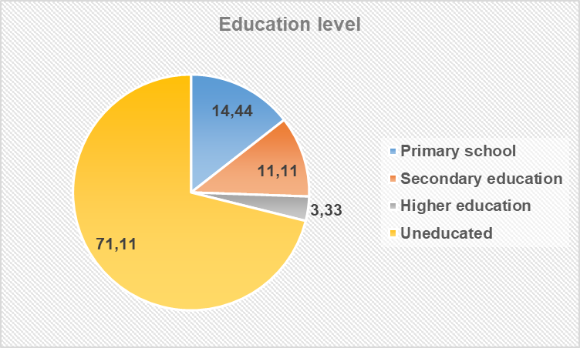

Figure 5: Education level of producers

**3.5. Planting dates of crops by producers**

According to the analysis, majority (> 50%) of farmers plants sorghum seeds in mid-July, while 32% of producers’ plants sorghum seeds at the end of July. However, 18% of producers manage to plant at the beginning of July.

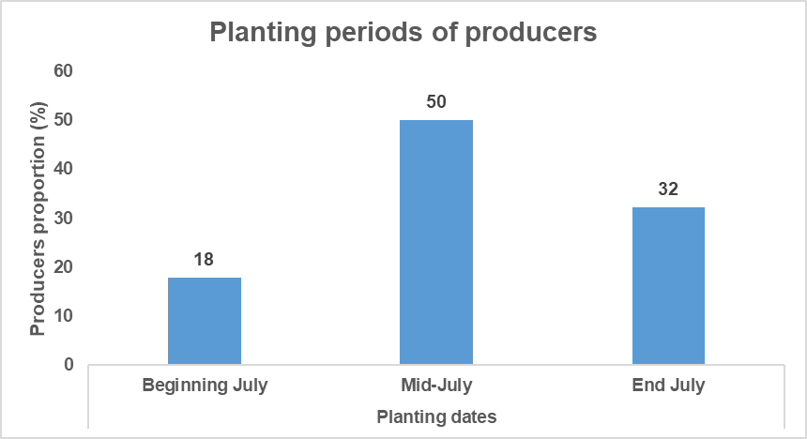

Figure 6: Illustration of planting periods by producers

**3.6. Producers’ knowledge on the insect and damage on sorghum**

Concerning midge knowledge, agronomic practices or protectives measures adopted to lessen midge effect, the analysis revealed that producers were grouped as follow. Ninety-four per cent (94%) of producers did not recognize the insect and consequently did adopt any protectives measure or agronomic practices to lessen its effect. In opposite, only 6% among them confirmed to recognize midge insect and its damage over panicles (Figure 7).

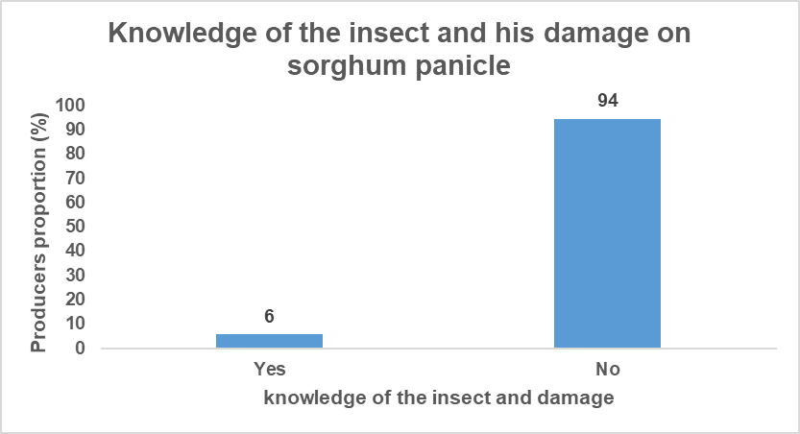

Figure 7: Proportion of producers' knowledge of the insect and damage on sorghum panicle

**3.7. Midge control’ methods**

After recognition of the insect and its damage, it was necessary to discuss with farmers about midge control methods. The analysis showed that only 3% of the producers use some agronomic practices or measures to lessen midge effect. However, majority (97%) of the respondents do not apply any control methods against the damage caused by the insect (Figure 8).

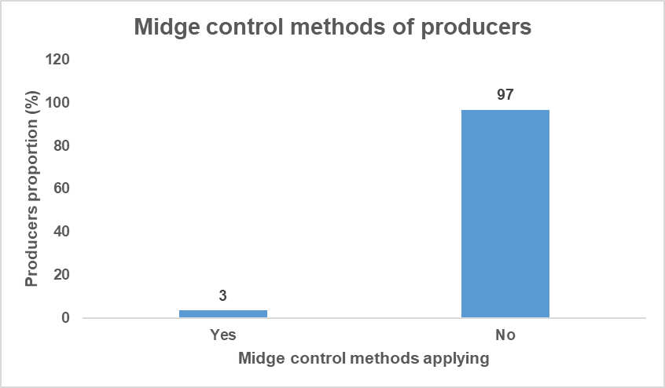

**Figure 8: Proportion of producers using control methods**

**3.2. DISCUSSION**

Farmers’ perception on sorghum midge is influenced by several factors, notably the knowledge of the insect and the type of damage caused to the crop. First of all, the study was conducted in areas with high incidence of the insect and in localities with high sorghum production potential. Overall, different studied sites were located in agroecological areas where sorghum is widely grown in the country [2]. Some previous studies conducted on sorghum midge by Dakouo *et al* [8], Ouedraogo *et al* [25] confirmed the presence of sorghum midge in studied sites (eastern region, central region, southern region and central south region of the country) along with damage ranging from 33% to 100% yield loss. Concerning the second parameter, data from DSS/DGESS/MAAH [1] showed clearly that studied regions effectively potential sorghum growing areas and important sorghum production areas. As an example, some regions such as Boucle du Mouhoun and Central-western regions alone account for 40% of sorghum cultivated areas and 32.7% of the national sorghum grain production [1].

Concerning sorghum cultivated areas and grain production in studied sites, the analysis exhibited q slide mismatch. In majority of survey’ sites, cultivated areas was more important than sorghum grain production inducing a low yield of sorghum. This result may be attributed to poor agricultural practices used by farmers in one hand and in other hand to a large use of traditional varieties to ensure sorghum production [26,2,27]. Previous studies also revealed that sorghum production is limited in semi-arid country due to abiotic constraint such as water shortage and biotic constraints such disease (anthracnose), weed (striga) and insect pest such as midge [27]. This result is also aligned with the finding revealed during that study through the investigation about varietal type used for sorghum production. In fact, the result showed that 90% of producers in these areas use traditional varieties in their fields while only 10% are using improved varieties for sorghum cultivation.

Among the respondents, very few were females and majority were men. In Burkina Faso, men are generally land owners and also responsible of major crop such as sorghum, maize and millet cultivation while women are not land owners and are mostly in charge of minor crop such as groundnut, cowpea, Bambara nut, okra cultivation. Overall, women contribute as labors in carrying out agricultural tasks but not as decision-makers [28]. This explains the low participation of women in the interviews. In rural areas, women are often subject to socio-cultural pressures that position them as passive agents in local development. This low participation of women further confirms the exclusion of women from management and responsibility of tasks, especially at the farmer level and in the localities chosen for this study. One of the reasons for this situation may be the lack of awareness among producers, partly due to the high illiteracy rate early July, those among them.

Through the examination of planting date, the study revealed three groups of farmers. Among them, majority (50%) plant around mid-July and the second important group (32%), plant at the end of July. Only few (18%) among farmers plant at the beginning of July. This result is in agreement with INERA recommended practices which stated that suitable period for sorghum planting is comprised from mid-June to mid-July. In fact, planting dates are crucial for completing a crop cycle depending in in a given agroclimatic zone. Planting dates represent a limitation for producers, as they are heavily dependent on rainfall in the region. In Burkina Faso, the onset of rainy season, marking the beginning of the agricultural season, is often irregular or delayed which affects the planting of crops [5]. Concerning midge, planting at the same time varieties with synchronized flowering in the same agroecological zone are important factors and contribute to lessen midge damage on sorghum [29]. In opposite, having different planting dates in the same locality may contribute to proliferate the insect and therefore contribute to enhance damage on panicle and sorghum production.

An important aspect of this study was the ability of farmers to recognize the insect and its damage to sorghum. Morphologically, the insect is very small size and difficult to be identify by common farmers. The analysis showed that only 6% of producers were able to recognize the insect and its damage caused on sorghum panicle. In contrast, 94% of farmers did not recognize the insect and consequently, have no solution to lessen its effects on sorghum grain production. This result is in agreement with Chantereau and Nicou [11] statement who reported that the insect is very inferior physically and exhibit small size characteristics that its development cycle goes unnoticed by growers. This ignorance of the sorghum midge and its effects on the sorghum plant reinforces the argument of some authors who claim that the sorghum midge is a myth for farmers [8].

At the end of the investigation, farmers’ knowledge about midge control method was assessed. Unfortunately, only 3% among producers use control methods against midge. The suitable midge control method adopted is the use of tolerant varieties that according to them contribute to lessen midge damage on sorghum grains. In accordance with midge recognition and its damage, it appears clearly that majority (97%) of farmers remain indifferent to the insect's and it damage and therefore, did not take any protective or defensive measure to cope with the insect attack. However, this attitude towards the insect contributes to increase its population, which represents a short or medium-term threat to sorghum cultivation in hotspot areas. So, regarding the importance of the crop across the country, is essential to pave the way for suitable integrated management practices.

**4. CONCLUSION AND RECOMMANDATION**

This study provided an overview of farmers’ perception on midge in seven regions of Burkina Faso where sorghum is mostly grown. The investigation highlighted knowledge of farmers about sorghum midge, its effects on panicle and also different agricultural practices or control measures use to lessen its damage on sorghum production. The study revealed that majority of farmers ignore the insect and could not even describe it. This is why midge and its damage was considered as a myth by farmers. In opposite, very few among farmers were able to recognize the insect and consequently, adopted a control method. Particularly, those farmers used improved varieties to lessen midge effect on grain production. It appears clearly that having almost the same planting date could be benefic for farmers growing in order to avoid the insect pullulation. So, regarding farmers knowledge about the insect, urgent measures must be taken to address this concern. Therefore, it is necessary for agricultural authorities to develop suitable strategies for awareness-raising, training and technical support that will strengthen farmers' knowledge about the insect and also to develop their capacity to manage the pest in order to reduce its damage on sorghum grain production across infested hotspot in the country.

Consent (where ever applicable)

Not applicable in this study

Ethical approval (where ever applicable)

Not applicable in this study

References

1. DSS/DGESS/MAAH. General report on the final results of the 2018/2019 agricultural campaign and the outlook for the food and nutrition situation, Ministry of Agriculture and Hydraulic Development, General Directorate of Sector Studies and Statistics. Ouagadougou, Burkina Faso, 2022. 115 p.

2. Barro/Kondombo C P. Agromorphological and genetic diversity of local sorghum varieties (Sorghum bicolor [L.] Moench) in Burkina Faso. Elements for the valorization of local genetic resources. Doctoral thesis, University of Ouagadougou, Burkina Faso. 2010. 112 p.

3. Bal AB. Entomofauna of sorghum panicles and the effect of sowing dates and varieties on Stenodiplosis sorghicola (Diptera: Cecidomyiidae) and Eurystylus oldi (Hemiptera: Miridae) populations and yield losses. Tropicultura, 2005. 23 (3): 177–182.

4. Sharma HC, Venkateswarulu G. Effect of environmental factors on the expression of resistance to sorghum midge, Stenodiplosis sorghicola. Ann Appl Biol, 1999, 124: 495–507.

5. Ratnadass A, Fernandes P, Avelino J, Habib R. 2012. Plant species diversity for sustainable management of crop pests and diseases in agroecosystems: a review. Agronomy for Sustainable Development, 2012. 32, 273-303.

6. Bal AB. Sustainable Protection of Food Crops against Insect Pests for Food Security: What Strategies for the Sahel? Doctoral Thesis. Senegal, Dakar. 2015. 90p.

7. Dakouo D, Trouche G, Ratnadass A, Ba M, Da S. New Sources of Resistance to Sorghum Midge in Burkina Faso. International Sorghum and Millet Newsletter, 2000. Vol. 41 p. 34-37.

8. Dakouo D, Trouche G, Bâ NM, Neya A, Kaboré KB. Genetic Control of the Sorghum Midge, Stenodiplosis sorghicola: A Major Constraint to Sorghum Production in Burkina Faso. Cahiers Agricultures, 2005, 14 (2): 201-208.

9. Elamein AAM. Screening of some sorghum Genotypes for resistance to sorghum Midge, Stenodiplosis sorghicola (Coq), under Rain-Fed conditions, Sudan. International journal of agricultural innovations and research, 2014. 2 (6): 1144-1146.

10. Kadi Kadi HA. Bio-ecology of sorghum midge, Stenodiplosis sorghicola populations on sorghum plants at ICRISAT India; Department of Science and Technology (DST); International Fellowship for African Researchers, 2011, 28p.

11. Chantereau J, Nicou R. Sorghum. Maisonneuve and Larose, Paris, 1991, 159 p.

12. Magallanes-Cedeno R, Teetes GL. Sorghum midge distribution in sorghum florets. Sorghum-Newsletter, 1991, 32: 51.

13. Sharma HC, Franzmann BA. Orientation of sorghum midge, Stenodiplosis sorghicola females (Diptera, Cecidimyiidae) to color and host odor stimuli. Journal of Agricultural and Urban Entomology, 2001, 18 (4): 237-248.

14. Sharma HC, Nwanze KF. Insect pests of sorghum: biology, extent of losses, and economic thresholds. Pages 9-23 in Plant resistance to insects in sorghum (Sharma, H.C., Faujdar Singh, and Nwanze. K.E., eds.). Patancheru 502 324, Andhra Pradesh, India: International Crops Research Institute for the Semi-Arid Tropics, 1997.

15. Sharma HC, Franzmann BA. Orientation of sorghum midge, Stenodiplosis sorghicola females (Diptera, Cecidimyiidae) to color and host odor stimuli. Journal of Agricultural and Urban Entomology, 2001, 18 (4): 237-248.

16. Kadi Kadi AH, Kapran I, Pendleton BB (2005). Identification of sorghum genotypes resistant to sorghum midge in Niger. International Sorghum and Millets Newsletter, vol. 46, pp. 57-59.

17. Ouattara D, Simdé R, Latevi K, Yameogo IS, Bama H, Nacro S, Ouattara B, Dakouo D. Evaluation of advanced sorghum lines for their resistance/tolerance to the sorghum midge, their agromorphological characteristics, and the taste quality of their seeds in the central-western and eastern regions of Burkina Faso. Sciences Naturelles et Appliquées. 2023, 42 (1): 57-86.

18. Fontès J. Vegetation mapping trials using remote sensing. Some examples from Upper Volta. Doctoral thesis, Paul Sabatier University, Toulouse, France. 1983. 179 p.

19. Zoungrana I. Research on grazing areas in Burkina Faso. State thesis, University of Bordeaux III, Department of Planning and Natural Resources, France. 1991, 277 p.

20. Fontes J, Guinko S. Vegetation and soil map of Burkina Faso. Explanatory note. French Ministry of Cooperation. Campus project. 1995, 67 p.

21. Somé L. Agroclimatic diagnosis of drought risk in Burkina Faso. Study of some agronomic techniques to improve resistance in sorghum, millet, and maize crops. Doctoral thesis, University of Montpellier II, France. 1989, 312 p.

22. MRA. Action plan and investment program for the livestock sector in Burkina Faso. Diagnosis, areas of intervention, and priority programs. 2000, 192 p.

23. Monod F, Powaud B, Sechet S. The Volta River Basin. Hydrological Monographs, ORSTOM, 1977, No. 5, 1 vol., 513 p.

24. Guinko S. Vegetation of Upper Volta. Doctoral Dissertation in Science, University of Bordeaux III, Volumes 1 and 2, France. 1984, 394 p.

25. Ouédraogo N, Thio IG, Drabo I, Kouraogo I, Sawadogo WPA, Vernon G, and Nebie B. Impact of midge damage on new sorghum lines performance in eastern Burkina Faso, 2022. Agricultural Science Research Journal, 12 (5), pp. 84-92.

26. Zongo JD. Genetic resources of sorghums [Sorghum bicolor (L.) Moench] in Burkina Faso: Agro-morphological and genetic evaluation. State thesis, University of Abidjan, Ivory Coast, 1991. 175p.

27. Ouedraogo N, Sanou J, Kam H, Traore H, Myriam A, Vernon G, and Danquah EY. Farmers’ perception on the impact of drought and their preference for sorghum cultivars in Burkina Faso. Agricultural Science Research, 2017, 7(9): 277-284,

28. Thiombiano BG. Gender and decision-making within the household in Burkina Faso. Cahiers québécois demographie, 2015. 43 (2): 249 -278

29. Sama K, Nacro S, Dakouo D. Effect of transplanting period on the population dynamics, parasitism and damage of lepidopteran rice stem borers in irrigated rice scheme of Kou Valley, Burkina Faso. International Journal of Tropical Insect Science, 2015, 35 (1): 11–16.

Definitions, Acronyms, Abbreviations

INERA : Institut de l’Environnement et de Recherches Agricoles

GGE :