**PERFORMANCE EVALUATION OF SUGARCANE SINGLE BUD CUTTER**

**ABSTRACT**

Sugarcane single bud cutting machine was developed in the Farm Machinery Power Engineering Lab, DRPCAU, Pusa. The developed machine consists of a frame, cutting blade, electric motor, sitting arrangement etc. This machine will save the time and effort by traditional methods of farmers. Field experiments were conducted for 5 varieties of sugarcane to determine the time taken for cutting different type of varieties by machine and manually by khurpi. The machine cuts the sugarcane single buds. The results of preliminary tests revealed that the machine achieved the skipping, percentage of damaged, cutting efficiency, and productivity was (1.41,3.17,4.1,0.69,3.39%), (1.46,3.35,4.33,0.71,3.62%),(98.59,96.83,95.90,99.31,96.61%), (1626,1960,1824,2253,1662 bud/hr.) of the variety R1, R2, R3, R4, and R6 respectively. The total costs for operating the machine is44.66 Rs/h.

Introduction

Sugarcane is an important commercial crop cultivated in many parts of the world for its high sugar content, which is used for the production of sugar, ethanol, and other industrial products. Here is an overview of the sugarcane production yield and area of the world. According to the Food and Agriculture Organization (FAO) of the United Nations, the global average sugarcane yield in 2020 was 71.3 tonnes per hectare. Brazil, the world's largest producer of sugarcane, had an average yield of 77.4 tonnes per hectare, followed by India, the average yield of sugarcane in India is around 73 tons per hectare.In year 2020, the global sugarcane production area was estimated to be around 26.5 million hectares, with Brazil having the largest area of sugarcane cultivation at 10.4 million hectares. Other major sugarcane producing countries include India with 5.2 million hectares, China with 1.9 million hectares, Thailand with 1.1 million hectares, and Pakistan with 1 million hectares.

Overall, sugarcane production is a significant contributor to the economies of many countries, providing income to farmers and employment to workers in the sugar, ethanol, and related industries. However, sugarcane cultivation also has some environmental impacts, such as soil degradation, water depletion, and greenhouse gas emissions, which need to be addressed to ensure sustainable sugarcane production.

List 1-The top 10 sugarcane producing countries in the world (based on latest available data)-

|  |  |  |
| --- | --- | --- |
| 1. Brazil | 1. Thailand | 1. Colombia |
| 1. India | 1. Pakistan | 1. Indonesia |
| 1. China | 1. Mexico | 1. Philippines |
| 1. Australia |  |  |

**Source: United Nations Food and Agriculture Organization**

India is the second-largest producer of sugarcane in the world after Brazil. Sugarcane is an important cash crop in India, contributing significantly to the country's economy.According to the latest available data from the Indian Ministry of Agriculture and Farmers Welfare (2019-2020), the total area under sugarcane cultivation in India is around 5.2 million hectares, with an estimated production of 354 million metric tons.

The average yield of sugarcane in India is around 70-75 tons per hectare. However, this can vary depending on factors such as weather conditions, soil quality, irrigation, and the use of fertilizers and pesticides.Uttar Pradesh is the largest sugarcane producing state in India, accounting for around 40% of the country's total sugarcane production.

List-2 The rank list of the top sugarcane producing states in India (based on the latest available data)-

|  |  |  |
| --- | --- | --- |
| 1. Uttar Pradesh | 1. Maharashtra | 1. Karnataka |
| 1. Tamil Nadu | 1. Gujarat | 1. Andhra Pradesh |
| 1. Telangana | 1. Bihar | 1. Haryana |
| 1. Punjab |  |  |

**Source: Indian Ministry of Agriculture and Farmers Welfare**

Sugarcane is an important agricultural crop in Bihar, one of the eastern states of India. According to the latest available data from the Indian Ministry of Agriculture and Farmers Welfare (2019-2020), the total area under sugarcane cultivation in Bihar is around 215,000 hectares, with an estimated production of 14.4 million metric tons.

The average yield of sugarcane in Bihar is around 67 tons per hectare, which is slightly lower than the national average of 70-75 tons per hectare. However, the yield can vary depending on factors such as weather conditions, soil quality, irrigation, and the use of fertilizers and pesticides.

The sugarcane industry in Bihar provides employment to thousands of people, both directly and indirectly. The state government has been taking steps to promote sugarcane cultivation in the state and to increase productivity through the adoption of modern farming techniques and the use of high-yielding varieties of sugarcane.

List 3-The rank list of the top sugarcane producing districts in Bihar (based on the latest available data):

|  |  |  |
| --- | --- | --- |
| 1. West Champaran | 1. Gopalganj | 1. Siwan |
| 1. Saran | 1. East Champaran | 1. Muzaffarpur |
| 1. Sitamarhi | 1. Samastipur | 1. Vaishali |
| 1. Madhubani |  |  |

**Source: Indian Ministry of Agriculture and Farmers Welfare**

A single bud cutter is a tool used in the propagation of sugarcane, which is an important agricultural crop in many parts of the world. The tool is used to cut the sugarcane stalk into small sections, each containing a single bud or "node," which can then be planted to grow into a new sugarcane plant.

The use of single bud cuttings is an important technique in the production of high-quality sugarcane. By using single bud cuttings, farmers can ensure that each new plant is genetically identical to the parent plant, which can help to maintain desirable traits such as high sugar content, disease resistance, and high yields.

Single bud cutters can be manual or automated, and are typically designed to make precise cuts to the sugarcane stalks. The tool works by clamping onto the sugarcane stalk and cutting it into small sections, with each section containing a single bud. The cuttings are then planted in the ground or in a propagation tray, where they can grow into new sugarcane plants.

Overall, the use of single bud cuttings is an important technique in sugarcane cultivation, as it allows farmers to propagate high-quality sugarcane plants with desirable traits.

So a single bud chipping machine was developed under the department of Farm Machinery and Power Engineering department, College of Agricultural Engineering and Technology Department, DRPCAU, Pusa and needs to assess its performance with the following objectives-

* To test the efficiency of cutting.
* To reduce the human effort to cut the single nodes from sugarcane for sowing.
* To testthe efficiency of germination of single node.

**REVIEW OF LITERATURE**

**Ugle et al. (2015**) conducted an experimental study on a semi-automatic sugarcane bud cutting machine. The study aimed to evaluate the performance of the machine and compare it with manual bud cutting. The results showed that the machine could cut sugarcane buds with a higher accuracy than manual cutting, with a reduction in labour requirement.

**Jadhav et al. (2016)** developed a semi-automatic sugarcane bud cutter machine with the aim of reducing labour costs and increasing productivity. The machine was evaluated in the field, and the results showed that it was efficient and could save labour costs.

**Magdum et al. (2016)**developed a bud cutter using a platform, hemi sphere chipping knife of G.I pipe and roller follower with a simple harmonic motion belt drive used for speed reduction. It was used to chip out the node from sugarcane for sowing purpose. In this project using two hemisphere chipping knifes which provided gentle cutting of node without extra loss of sugarcane during sowing. G I cutting blades were using to cut the buds. The cam and roller follower transmitted the rotary motion of gear shaft in to a reciprocating motion of the cutter. The machine was powered by electric motor. Cutting speed was calculated as per the motor and reduction gear boxes. Large number of buds was easily chipped off in this way in a short period of time.

**Bhandare et al. (2017)**developed a food pedal bud cutter. the unit removed the node from the node of the sugarcane whichwas then used for planting. It was hampered by lack of availability of samplings in large numbers. The device consists of platform, hemi sphere chipping knife, sphere chipping knife, linkage system and handle, it was used to chip out the node from sugarcane for sowing purpose. The radius of the hemispherical blade was 2.5 cm.

**Prasad et al. (2017)**developed a semi-automated sugarcane node chipping machinewhich was fabricated and assembled as per the proposed design. Through the development of sugarcane node cutting machine, slicing the inter-node was possible, so that nearly 1.8 tons of sugarcane stalk was utilized which was considered as wastage in traditional method. The sugarcane node cutting machine based on the required consideration and objective was ready with all the required connection and support on the mild steel frame. The outcome of the fabricated machine was to separate the buds from the sugarcane stalk. In the traditional way of plantation, nearly 3 tons of sugarcane was used for plantation per acre. The sugarcane with 2 to 3 buds known as seed was planted continuously. In this traditional method, nearly 1.5 tons of useful sugarcane stalk was being wasted per Acre for plantation.

**Jadhav et al. (2017)**developed a machine where the sugarcane was placed on the conveyor system and camera sensor took the image of sugarcane and actuator with the cutter at its end to cut sugarcane node. The conveyor was powered with the help of stepper motor. For controlling the stepper motor and to actuate the actuator the different controllers like Arduino board and raspberry pie were used and the motion was controlled with the help of the program. This system had proposed the new system for sugarcane node cutting using machine vision system. It reduced the danger of causing injury which generally happens in a hydraulic cutter.

**Abarna et al. (2017)** developed a sugarcane bud cutting machine for small scale farmers. The machine can handle various sugarcane sizes and diameters. Traditional method for cutting sugarcane node caused wastage of sugarcane and time. Also, time was saved by this process as compare to the traditional system of sugarcane node cutting. Extra piece of sugarcane bud waste in small scale farm that was saved by using sugarcane bud cutting machine that can be used as a fodder for animals.

**Ragupathi et al. (2017)** developed a machine for the field of small scale industries related to agricultural activities. It was very useful for the workers work in the lathe and small scale industries. This project reduced the cost of the labour. The speed of the cutting and releasing stroke was varied by the timer control unit circuit.

**Ndiwa et al. (2018)** conducted a study on the development of a sugarcane bud cutting machine using a power hacksaw. The machine was evaluated in terms of its cutting accuracy and efficiency. The study concluded that the machine was efficient and could be used to cut sugarcane buds with a high degree of accuracy.

**Makwana et al. (2019)** developed an automated sugarcane bud cutter machine**.** The machine was designed to cut sugarcane buds with high accuracy and efficiency. The study concluded that the machine was effective in cutting sugarcane buds, with reduced labour costs and increased productivity.

**Adhapure et al. (2019)** developed a simple pedal operated sugar cane node cutter. Itreduced the mass and improved the quality of seed for sugarcane to plant node chips. These node chips were less bulky, easily portable and more economical material. Through the development of sugarcane node cutting machine, slicing the inter-node was made possible, sugarcane stalk can be utilized which was considered as wastage in traditional method. The literature on sugarcane bud cutting machinery shows that the use of machinery can improve the accuracy and efficiency of bud cutting while reducing labour costs. Further research is required to evaluate the effectiveness of different types of sugarcane bud cutting machines and their suitability for different farming systems.

**MATERIALS AND METHODS**

**3.1EXPERIMENTAL SITE**

The field experiment was conducted at Sugarcane research institute DRPCAU, Pusa ,Bihar. Whose latitude is 25.52o N and 85.32o E longitudes 48 m above the mean sea level. And also planted at Sugarcane research institute DRPCAU, Pusa ,Bihar. The cutting bud machine was developed in the workshop of the Farm Machinery and Power Engineering Lab,Dr. Rajendra Prasad Central Agricultural University, Pusa, Bihar.

The source of the sugarcane stalks used in this research was from the Sugarcane Research Institute(SRI), RPCAU. The samples were selected, cleaned, and shelled manually. The test was carried out in SRI and measurements were taken in Farm Machinery and Power Engineering Lab.

**3.2** V**ARIETIES USED IN EXPERIMENT**

In the SRI, we got 5 following verities of sugarcane samples for testing:

1. Rajendra Ganna 1(R-1),
2. Rajendra Ganna 2(R-2),
3. Rajendra Ganna 3(R-3),
4. Rajendra Ganna 4(R-4),
5. Rajendra Ganna 6(R-6).

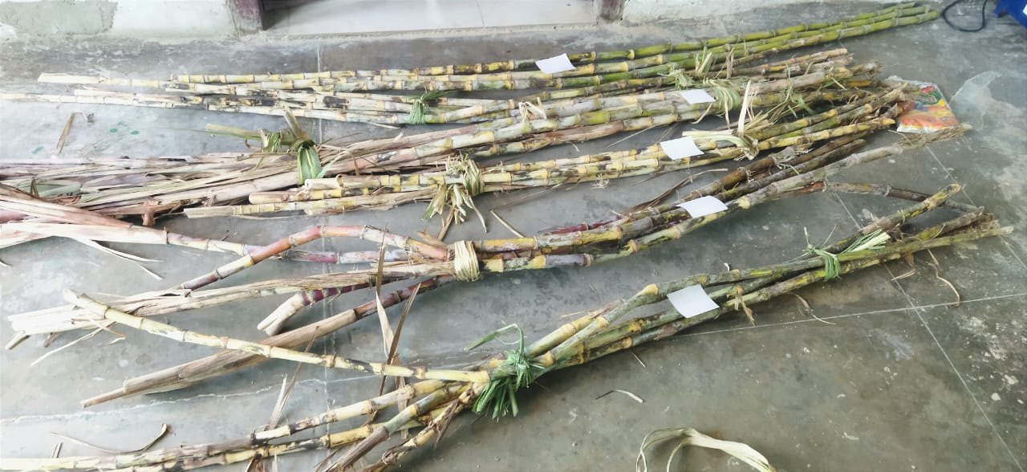

**Fig 1: 5 varieties of sugarcane**

**3.3 SUGARCANE BUD CUTTING MACHINE**

**3.3.1 Frame of the machine:**

The frame was fabricated from angle iron and sheet, thickness 2 mm. The frame shapeis rectangularwith certain dimensions 1020 mm length,260 mm width, 430 mm height and weight of the machine is approx 9 kg.

**3.3.2 Operator seating arrangement:**

A suitable seating arrangement is provided along with the machine for the operator. The dimension of the seat is 260 mm length, 200 mm width and 140 mm height.

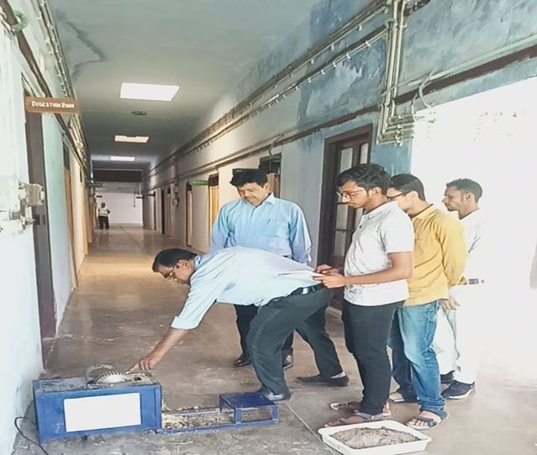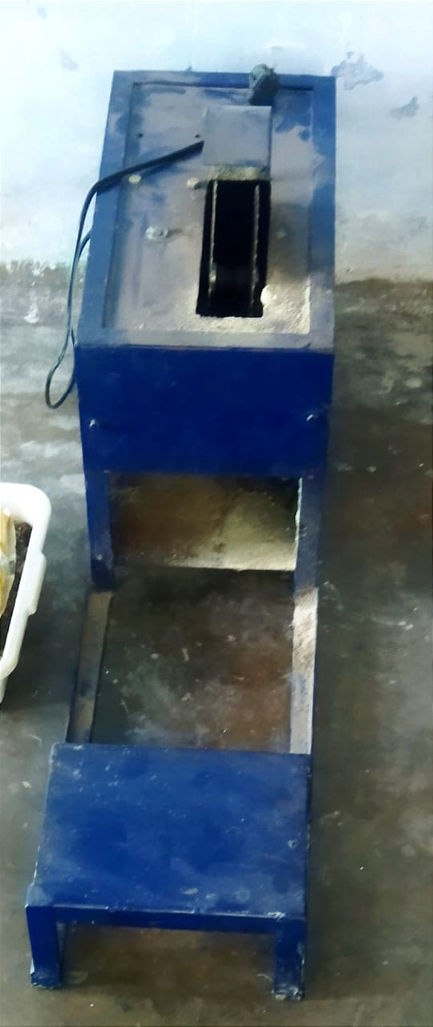

**Fig 2: Sugarcane Single Bud Cutting Machine**

**3.3.3 Cutting Blade:**

The cutting 2 no blade with 100 mm diameter of each. The speed of each blade is 1100 revolution per minute (rpm).

**3.3.4 Power supply:**

The experimental sugarcane seed cutting machine is powered by a 3-phase electrical AC motor.

**3.4 METHODS OF OPERATION**

The working idea of the developed prototype of the cutting buds machine is based on cutting buds of sugarcane stalks through the clearance between the two cutting blades, which revolves at 1100 rpm. Consequently, cut shoots can fall off through the blank under the cutting unit. The bud chips or short sets that include one bud by cutting machine were developed, which used to establish the sugarcane seedlings nursery were prepared where each bud chip includes a healthy bud and root band.

The cutting buds machine was tested considering the measurements related to performance to realize the purpose of this research. Measurements as following:

**3.4.1. Actual number of buds per minutes (Nbactual).**

The actual number of buds that can be cut during feeding by the operator compared to the number of cuts calculated by the theoretical cutting rate (Nbtheo).

**3.4.2. Skipping rate (Sr, %).**

Skip rate refers to the number of cuts of the cutting knife without feeding by the operator which usually results from increasing the reciprocating speed of the cutting knife. Skip rate is useful for determining the optimum reciprocating speed of the cutting knife it can be calculated as a percentage of the number of skipped cuts divided by the theoretical number of cutting knife frequencies with each speed.

$Sr, \%=\frac{Nb_{theo}-Nb_{actu}}{Nb_{theo}}$ ×100

Where:

𝑁𝑏tℎ𝑒𝑜= Number of theoretical cutting rate (bud/min).

𝑁𝑏𝑎𝑐𝑡𝑢= Number of actual cutting buds (bud/min).

**3.4.3. The percentage of damaged buds (Nbd, %).**

The damaged bud means mechanical damage to the bud scar due to the cutting process. decrease in the number of damaged buds indicates an increase in the percentage of cutting efficiency. The percentage of the damage was calculated by counting the damaged buds and relative to the actual number of buds that had been cut.

$$Nbd,\%=\frac{Nbd}{Nb_{actu}}×100$$

Where, = Number of damaged buds.

**3.4.4. Cutting efficiency *(ηc, %).***

Cutting efficiency refers to the number of healthy cut buds relative to the total actual number of cut buds.

$$ηc, \%=\frac{{Nb}_{actu}}{Nb_{theo}}$$

Where, η*c =* Cutting efficiency.

**3.4.5MACHINE PRODUCTIVITY**:

The machine was operated by laborers. The nodes and timed consumed were estimated for each whole stalk, then the machine productivity (Q) was computed as no. nodes /h,

$$Q=\frac{Nb_{actu}}{t}$$

Where,Nbactual = Actual number of buds per minutes at time t.

**3.5 MEASURE DIAMETER AND LENGTH:**

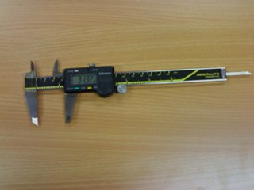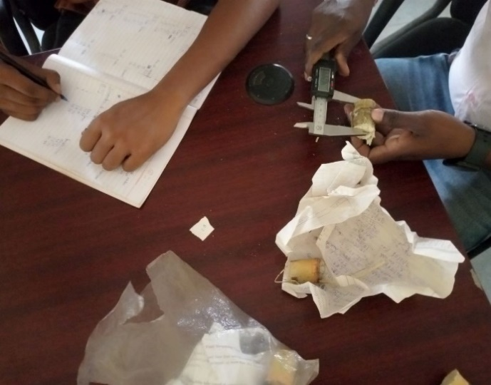The diameter and length of 5 buds for each variety were taken by digital Vernier Caliper in Farm Machinery and Power Engineering Lab. The average of each variety was calculated to compare them.

**Fig 3: Measuring the Diameter and Length of Each Bud**

* 1. **GERMINATION EFFICIENCY:**

The germination of efficiency of plant in tray can be calculated by

* 1. **COST ESTIMATION OF OWNING AND OPERATING THE PROPOSED MACHINE:**

Cost of operation per hour was calculated in the following form:

Fixed cost + Operating cost

= (Depreciation cost + Interest + Taxes) + (Electric Cost + Wages of operator)

= [(C-S) / (L×H) + {(C+S) / 2} × {I / H} + t] + (w.E + W)

Where,

C = capital cost, Rs

S = salvage value = C/10, Rs

L = life expectancy of the machine (10 year),

H = yearly working hours,

I = interest rate/year, %

t = taxes, %

w = electrical power consumed, kW/hr

E = electrical price, Rs/kw,

W = hourly wages rate, Rs.

**RESULTS AND DISCUSSION**

We have taken 5 samples for machine cutting and 5 samples for manually cutting for each sugarcane variety. The sugarcanes were cut manually by Khurpi. The time taken by every sugarcane of each variety and also the number of nodes per sugarcane were noted down. And we have plotted these data in graph so that we can compare how much extra time taken by manually cutting w.r.t machine cutting. These are given below: -

**Table 1: Cutting time vs number of Nodes by developed Machine vs manual [Rajendra Ganna 1 (R- 1)]**

|  |  |  |  |  |
| --- | --- | --- | --- | --- |
| S. No. | Developed sugarcane single bud cutter | | Manually by khurpi(general practice) | |
| Time (sec) | No. of nodes | Time (sec) | No. of nodes |
| 1 | 60 | 27 | 117 | 25 |
| 2 | 35 | 18 | 126 | 28 |
| 3 | 67 | 30 | 121 | 26 |
| 4 | 62 | 28 | 75 | 17 |
| 5 | 61 | 26 | 139 | 29 |

Above table shows the time taken for cutting of nodes of the variety Rajendra Ganna 1 (R- 1) in second. The maximum number of cutting nodes in a single piecewere 30 in 67 secand minimum number of cutting nodes were 18 in 35 sec. Average time taken for cutting one node of variety Rajendra Ganna 1 (R- 1) was found 2.2 sec by the developed machine and manually by khurpi it was 4.6 sec.

**Table 2: Cutting time vs number of Nodes by developed Machine vs manual [Rajendra Ganna 2 (R- 2)]**

|  |  |  |  |  |
| --- | --- | --- | --- | --- |
| S. No. | Developed sugarcane single bud cutter | | Manually by khurpi(general practice) | |
| Time (sec) | No. of nodes | Time (sec) | No. of nodes |
| 1 | 33 | 19 | 71 | 18 |
| 2 | 27 | 19 | 93 | 21 |
| 3 | 43 | 23 | 65 | 14 |
| 4 | 32 | 16 | 73 | 18 |
| 5 | 30 | 15 | 106 | 25 |

Above table shows the time taken for cutting of nodes of the variety Rajendra Ganna 2 (R- 2) in second. The maximum number of cutting nodes in a single piece were 23 in 43 sec and minimum number of cutting nodes were 16 in 32 sec. Average time taken for cutting one node of variety Rajendra Ganna 2 (R- 2) was found 1.8 sec by the developed machine and manually by khurpi it was 4.25 sec.

**Table 3: Cutting time vs number of Nodes by developed Machine vs manual [Rajendra Ganna 3 (R- 3)]**

|  |  |  |  |  |
| --- | --- | --- | --- | --- |
| S. No. | Developed sugarcane single bud cutter | | Manually by khurpi(general practice) | |
| Time (sec) | No. of nodes | Time (sec) | No. of nodes |
| 1 | 46 | 24 | 101 | 22 |
| 2 | 51 | 28 | 112 | 27 |
| 3 | 43 | 24 | 95 | 17 |
| 4 | 40 | 21 | 101 | 19 |
| 5 | 41 | 20 | 134 | 29 |

Above table shows the time taken for cutting of nodes of the variety Rajendra Ganna 3 (R- 3) in second. The maximum number of cutting nodes in a single piece were 28 in 51 sec and minimum number of cutting nodes were 20 in 41 sec. Average time taken for cutting one node of variety Rajendra Ganna 3 (R- 3) was found 1.89sec by the developed machine and manually by khurpi it was 4.7 sec.

**Table 4:Cutting time vs number of Nodes by developed Machine vs manual [Rajendra Ganna 4 (R- 4)]**

|  |  |  |  |  |
| --- | --- | --- | --- | --- |
| S. No. | Developed sugarcane single bud cutter | | Manually by khurpi(general practice) | |
| Time (sec) | No. of nodes | Time (sec) | No. of nodes |
| 1 | 30 | 20 | 65 | 18 |
| 2 | 65 | 29 | 69 | 21 |
| 3 | 32 | 22 | 139 | 30 |
| 4 | 31 | 21 | 84 | 24 |
| 5 | 31 | 20 | 63 | 17 |

Above table shows the time taken for cutting of nodes of the variety Rajendra Ganna 4 (R- 4) in second. The maximum number of cutting nodes in a single piece were 29 in 65 sec and minimum number of cutting nodes were 20 in 31 sec. Average time taken for cutting one node of variety Rajendra Ganna 4 (R- 4) was found 1.68 sec by the developed machine and manually by khurpi it was 3.8sec.

**Table 5: Cutting time vs number of Nodes by developed Machine vs manual [Rajendra Ganna 6 (R- 6)]**

|  |  |  |  |  |
| --- | --- | --- | --- | --- |
| S. No. | Developed sugarcane single bud cutter | | Manually by khurpi(general practice) | |
| Time (sec) | No. of nodes | Time (sec) | No. of nodes |
| 1 | 40 | 18 | 96 | 19 |
| 2 | 45 | 21 | 116 | 24 |
| 3 | 54 | 26 | 80 | 21 |
| 4 | 45 | 23 | 121 | 25 |
| 5 | 37 | 24 | 96 | 20 |

Above table shows the time taken for cutting of nodes of the variety Rajendra Ganna 6 (R- 6) in second. The maximum number of cutting nodes in a single piece were 26 in 54 sec and minimum number of cutting nodes were 18 in 40 sec. Average time taken for cutting one node of variety Rajendra Ganna 6 (R- 6) was found 1.9sec by the developed machine and manually by khurpi it was 4.7 sec



**Fig4: Cutting all varieties by developed Machine vs manual**

After the cutting process, we have taken the diameter and length of 5 buds for each variety by Vernier Calliper in Farm Machinery and Power Engineering Lab.

**Table 6: Sugarcane variety vs average length, mm & average Dia, mm**

|  |  |  |
| --- | --- | --- |
| **Variety** | **Average length, mm** | **Average Dia, mm** |
| Rajendra Ganna 1 (R- 1) | **22.6** | **40.8** |
| Rajendra Ganna 2 (R- 2) | **27.3** | **39.5** |
| Rajendra Ganna 3 (R- 3) | **27.2** | **43.2** |
| Rajendra Ganna 4 (R- 4) | **23.6** | **48.1** |
| Rajendra Ganna 5 (R- 5) | **23.7** | **41.7** |

The maximum average diameter is 48.1 mm of R-4 variety and minimum average diameter is 39.5 mm of R-2 variety. And the maximum average length is 27.3 mm of R-2 variety and minimum average diameter is 22.6 mm of R-1 variety.

**Table 7:Effect of cutting rate on the skipping rate (Sr, %)**

|  |  |  |  |  |  |  |
| --- | --- | --- | --- | --- | --- | --- |
| **Variety** | **Cutting Rate( per mint)** | | **Skipping rate( Sr , %)** | **% damage buds( NBD %)** | **Efficiency %** | **Machine Productive Q=N/ h** |
| **N-Theoritical per min** | **N- Actucal- per mint** |
| **R1** | 27 | 27.10 | 1.41 | 1.46 | 98.59 | 1626 |
| **R2** | 34 | 32.67 | 3.17 | 3.35 | 96.83 | 1960.2 |
| **R3** | 32 | 30.40 | 4.10 | 4.33 | 95.90 | 1824 |
| **R4** | 38 | 37.55 | 0.69 | 0.71 | 99.31 | 2253 |
| **R6** | 29 | 27.70 | 3.39 | 3.62 | 96.61 | 1662 |

**4.1 EFFECT OF CUTTING RATE ON THE SKIPPING RATE (Sr, %):**

It was observed that during the initial stages, the theoretical rate of cutting buds was R1 = 27 buds per minute and it was found through experiments that there the skipping rate was 1.41 %. While the percentage of skipping rate was 3.17% at the theoretical rate of cutting buds R2 = 34 buds per minute, when R3 = 32 buds per minute and it was found through experiments that there the skipping rate was 4.10 %. and the percentage of skipping rate was 3.39% at the theoretical rate of cutting buds R6 = 29 buds per minute as shown in following Table.

**Fig 5: Effect of cutting rate on skipping rate**

**4.2 EFFECT OF CUTTING RATE ON THE PERCENTAGE OF DAMAGED BUDS (NBD, %)**Mechanical damage to the buds may occur by the cutting blades due to the wrong feeding from the labourer. The skipping rates and theoretical per minute values for the given varieties (R1, R2, R3, R4, and R6) have been analysed. The results indicate that R1 and R2 have relatively low skipping rates, resulting in higher theoretical per minute values. R3 and R4 have slightly higher skipping rates but still maintain reasonable processing capacities. R6, with the highest skipping rate, has a slightlyower processing capacity compared to the other varieties. These findings can be useful in understanding the efficiency and performance of the respective processes and assist in making informed decisions regarding resource allocation and process improvement.

**Fig 6: Effect of cutting rate on damage buds**

**4.3 EFFECT OF CUTTING RATE ON THE PERCENTAGE OF CUTTING EFFICIENCY(ηc, %):**

During experiment it was observed that decreasing of the cutting efficiency with increasing of the theoretical cutting rate. The highest of cutting efficiency was 99.31% when the theoretical cutting rate 38 buds/min., and lowest of cutting efficiency was 95.90% when the theoretical cutting rate 32 buds/min.

**Fig 7: Effect of cutting rate on the cutting efficiency**

**4.4 EFFECT OF CUTTING RATE ON PRODUCTIVITY**

The critically observed during the cutting of sugarcane by developed machine effect of cutting rate on the productivity (Q, Nb/h) Shown that the lowest productivity was 1626 Nb/h when using a cutting rate 1.41, while the highest productivity was 2253 Nb/h when using a cutting rate 0.69 .it is presented in fig. 8.

**Fig 8: Effect of cutting rate on productivity**

**4.5GERMINATION EFFICIENCY:**

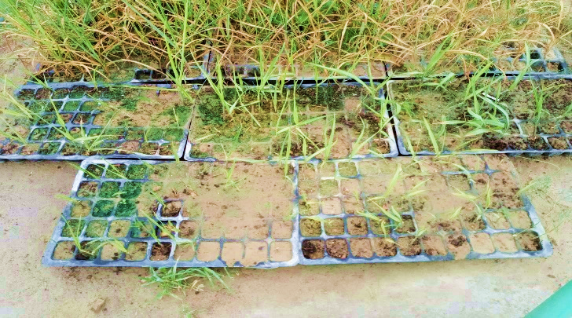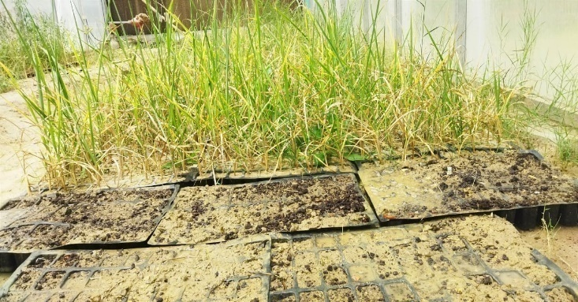

Fig 9: Germination of Sugarcane Single Buds

After cutting of single bud at the sugarcane Research Institute, DRPCAU, Pusa, the instituteprovided 5 coco pit and accordingly vermin compost for germination of single bud. We irrigate the seed regularly in the morning and in the afternoon. After 8 days the sprouts were coming. After 16days all buds were fully germinated and then it was transferred to main field. There was no mortality of the buds.

The germination of efficiency of plant in tray (after eliminating the damaged cutting buds) can be calculated by

(η,%) = (Number of nodes germinated / Number of nodes on the tray) X 100

= (250/250) x 100 %

= 100 %

**4.6COST ESTIMATION OF OWNING AND OPERATING THE PROPOSED MACHINE:**

Cost of operation per hour was calculated in the following form:

Fixed cost + Operating cost

= (Depreciation cost + Interest + Taxes) + (Electric Cost + Wages of operator)

= [(C-S) / (L×H) + {(C+S) / 2} × {I / H} + t] + (w.E + W)

Where,

C = capital cost = 3000Rs

S = salvage value = C/10 = 3000/10 = 300Rs

L = life expectancy of the machine = 10 years,

H = yearly working hours = 200 hours

I = interest rate/year = 10% = 0.1

t = taxes, % = 1% = 3000 × 1 / (100 × 200) = 0.15

w = electrical power consumed = (710 × 1) / 1000 = 0.71kW/hr

E = electrical price, = 8Rs/kw,

W = hourly wages rate, = 300/8 = 37.5Rs.

So, the cost of the machine

= [(C-S) / (L×H) + {(C+S) / 2} × {I / H} + t] + (w×E + W)

= [(3000-300) / (10×200) + {(3000+300) / 2} × {0.1 / 200} + 0.15] + (0.71×8 + 37.5)

= 44.66 Rs/hr.

**SUMMARY AND CONCLUSION**

Sugarcane single bud cutting machine was developed in the Farm Machinery Power Engineering Lab, DRPCAU, Pusa. The developed machine consists of a frame, cutting blade, electric motor, sitting arrangement etc. This machine will save the time and effort by traditional methods of farmers. Field experiments were conducted for 5 varieties of sugarcane to determine the time taken for cutting different type of varieties by machine and manually by khurpi. The machine cuts the sugarcane single buds. The results of preliminary tests revealed that the machine achieved the skipping, percentage of damaged, cutting efficiency, and productivity was (1.41,3.17,4.1,0.69,3.39%), (1.46,3.35,4.33,0.71,3.62%),(98.59,96.83,95.90,99.31,96.61%), (1626,1960,1824,2253,1662 bud/hr.) of the variety R1, R2, R3, R4, and R6 respectively. The total costs for operating the machine is44.66 Rs/h.

**5.2. CONCLUSION:**

The overall results of the project could be concluded as follows –

1. The highest skipping rate was 4.10 % of R-3 variety at the theoretical rate of 32 buds per minutes and the lowest skipping rate was 0.69 % of R-4 variety at the theoretical rate of 38 buds per minutes.
2. The highest damage was 4.33 % of R-3 variety at the theoretical rate of 32 buds per minutes and the lowest damage was 0.71 % of R-4 variety at the theoretical rate of 38 buds per minutes.
3. The highest cutting efficiency was 99.31% of R-4 variety at the theoretical rate of 38 buds per minutes and the lowest cutting efficiency was 95.90 % of R-3 variety at the theoretical rate of 32 buds per minutes.
4. The maximum machine productivity was 2253 buds/hrof R-4 and minimum machine productivity was 1626 buds/hr of R-1.
5. The efficiency of germination is 100 % after eliminating the damaged buds which were in small amount.
6. The total costs for the machine operation are 44.66Rs/h.

**REFERENCES**

1. Dipak U Adhapure, Kolekar, Navnath, Gadhave (2019). “Design Development& Fabrication of Sugarcane Bud Cutting Machine”, IJSRD, Volume 6, Issue 12.
2. G Ragupathi, A Ramesh Kumar, V Selva Prakash, G Sivaprakasam, E Thirumoorthi (June 2017). “Design and Fabrication of Pneumatic Sugarcane Bud Cutting Machine”, IJASER, Volume 2, Issue 1.
3. Jadhav, S. S., Patil, P. G., & Pawar, N. J. (2016). Design and development of semi-automatic sugarcane bud cutter machine. International Journal of Engineering Research and Technology, 5(9), 63-66.
4. Krishna Prasad, Harish Kumar H, Harsha B Harshith, Kishan Kumar (July 2017). “Design and Fabrication of Sugarcane Bud Cutting Machine”, IJESC, Volume 7, Issue 7.
5. Mahesh Bhandare, Chavan Akshay, Dhaigude Rajkumar, Gaikwad Ganesh, Jadhav Sunil (2017). “Sugarcane bud cutting machine”, IERJ, Volume 2, Issue 8, pp. 2814−2816.
6. Makwana, G. K., Mehta, R. K., & Patel, D. V. (2019). Development and evaluation of an automated sugarcane bud cutter machine. International Journal of Recent Technology and Engineering, 8(3S3), 448-452.
7. Ndiwa, M. N., Mbuthia, S. K., &Mwaniki, J. M. (2018). Design, construction and performance testing of a sugarcane bud cutting machine. International Journal of Scientific & Engineering Research, 9(5), 1669-1675.
8. R Abarna, M Dhayanethi, AS Elango, M Elango, R Hari Prasanth (May 2017). “Fabrication of Sugarcane Bud Removal Machine with Advancements”, IJISR, Volume 30, Issue 3.
9. Sham A Jadhav, Aniket S Dunde, Anil B Bhosale, VH Borkar (September 2017). “Proposed Design of Sugarcane Node Cutting by using Machine Vision Technique”, VJER, Volume 1, Issue 3.
10. Suraj S Magdum, Shubham Pawar, Pankaj B Gavali (Oct. 2016). “Sugarcane bud cutting machine”, IJIRSE, Volume 2, Issue 10.
11. Ugle, M. B., Khot, S. P., & Kadam, D. P. (2015). Design, development, and performance evaluation of semi-automatic sugarcane bud cutter machine. Journal of AgriSearch, 2(1), 40-46.

***

**APPENDIX**

**CUTTING TIME VS NUMBER OF NODES**

**Appendix-1: Cutting time vs number of Nodes by developed Machine vs manual [Rajendra Ganna 1 (R- 1)]**

|  |  |  |  |  |
| --- | --- | --- | --- | --- |
| S. No. | Developed sugarcane single bud cutter | | Manually by khurpi(general practice) | |
| Time (sec) | No. of nodes | Time (sec) | No. of nodes |
| 1 | 60 | 27 | 117 | 25 |
| 2 | 35 | 18 | 126 | 28 |
| 3 | 67 | 30 | 121 | 26 |
| 4 | 62 | 28 | 75 | 17 |
| 5 | 61 | 26 | 139 | 29 |

**Appendix-2:Cutting time vs number of Nodes by developed Machine vs manual [Rajendra Ganna 2 (R- 2)]**

|  |  |  |  |  |
| --- | --- | --- | --- | --- |
| S. No. | Developed sugarcane single bud cutter | | Manually by khurpi(general practice) | |
| Time (sec) | No. of nodes | Time (sec) | No. of nodes |
| 1 | 33 | 19 | 71 | 18 |
| 2 | 27 | 19 | 93 | 21 |
| 3 | 43 | 23 | 65 | 14 |
| 4 | 32 | 16 | 73 | 18 |
| 5 | 30 | 15 | 106 | 25 |

**Appendix-3: Cutting time vs number of Nodes by developed Machine vs manual [Rajendra Ganna 3 (R- 3)]**

|  |  |  |  |  |
| --- | --- | --- | --- | --- |
| S. No. | Developed sugarcane single bud cutter | | Manually by khurpi(general practice) | |
| Time (sec) | No. of nodes | Time (sec) | No. of nodes |
| 1 | 46 | 24 | 101 | 22 |
| 2 | 51 | 28 | 112 | 27 |
| 3 | 43 | 24 | 95 | 17 |
| 4 | 40 | 21 | 101 | 19 |
| 5 | 41 | 20 | 134 | 29 |

**Appendix-4:Cutting time vs number of Nodes by developed Machine vs manual [Rajendra Ganna 4 (R- 4)]**

|  |  |  |  |  |
| --- | --- | --- | --- | --- |
| S. No. | Developed sugarcane single bud cutter | | Manually by khurpi(general practice) | |
| Time (sec) | No. of nodes | Time (sec) | No. of nodes |
| 1 | 30 | 20 | 65 | 18 |
| 2 | 65 | 29 | 69 | 21 |
| 3 | 32 | 22 | 139 | 30 |
| 4 | 31 | 21 | 84 | 24 |
| 5 | 31 | 20 | 63 | 17 |

**Appendix-5:Cutting time vs number of Nodes by developed Machine vs manual [Rajendra Ganna 6 (R- 6)]**

|  |  |  |  |  |
| --- | --- | --- | --- | --- |
| S. No. | Developed sugarcane single bud cutter | | Manually by khurpi(general practice) | |
| Time (sec) | No. of nodes | Time (sec) | No. of nodes |
| 1 | 40 | 18 | 96 | 19 |
| 2 | 45 | 21 | 116 | 24 |
| 3 | 54 | 26 | 80 | 21 |
| 4 | 45 | 23 | 121 | 25 |
| 5 | 37 | 24 | 96 | 20 |

**THE DIAMETER AND LENGTH OF 5 NODES OF EACH SUGARCANE VARIETY AND THEIR AVERAGE:**

|  |  |  |  |
| --- | --- | --- | --- |
| **Appendix-6: Diameter &Length (R-1)** | | |  |
| S. No. | Dia (mm) | Length (mm) |  |
| 1 | 21.2 | 40.8 |  |
| 2 | 23.2 | 42.5 |  |
| 3 | 23.9 | 39.7 |  |
| 4 | 22.8 | 40.1 |  |
| 5 | 22.1 | 40.9 |  |
| Average | 22.6 | 40.8 |  |

|  |  |  |  |
| --- | --- | --- | --- |
| **Appendix-7: Diameter &Length (R-2)** | | |  |
| S. No. | Dia (mm) | Length (mm) |  |
| 1 | 27.9 | 41.3 |  |
| 2 | 28.4 | 40.4 |  |
| 3 | 25.0 | 35.3 |  |
| 4 | 28.4 | 40.4 |  |
| 5 | 26.7 | 40.2 |  |
| Average | 27.3 | 39.5 |  |

|  |  |  |  |
| --- | --- | --- | --- |
| **Appendix-8: Diameter &Length (R-3)** | | |  |
| S. No. | Dia (mm) | Length (mm) |  |
| 1 | 29.4 | 42.0 |  |
| 2 | 25.5 | 40.1 |  |
| 3 | 22.3 | 40.6 |  |
| 4 | 32.8 | 30.8 |  |
| 5 | 25.9 | 62.3 |  |
| Average | 27.2 | 43.2 |  |

|  |  |  |  |
| --- | --- | --- | --- |
| **Appendix-9: Diameter &Length (R-4)** | | |  |
| S. No. | Dia (mm) | Length (mm) |  |
| 1 | 26.6 | 44.4 |  |
| 2 | 22.4 | 40.8 |  |
| 3 | 22.1 | 40.1 |  |
| 4 | 24.5 | 75.5 |  |
| 5 | 22.2 | 40.0 |  |
| Average | 23.6 | 48.1 |  |

|  |  |  |  |
| --- | --- | --- | --- |
| **Appendix-10: Diameter &Length (R-6)** | | |  |
| S. No. | Dia (mm) | Length (mm) |  |
| 1 | 22.3 | 42.0 |  |
| 2 | 24.5 | 40.5 |  |
| 3 | 23.6 | 42.7 |  |
| 4 | 26.2 | 40.9 |  |
| 5 | 22.1 | 42.4 |  |
| Average | 23.7 | 41.7 |  |

|  |  |  |  |
| --- | --- | --- | --- |
| **Appendix-11: Diameter &Length (Avg)** | | |  |
| Variety | Dia (mm) | Length (mm) |  |
| R1 | 22.6 | 40.8 |  |
| R2 | 27.3 | 39.5 |  |
| R3 | 27.2 | 43.2 |  |
| R4 | 23.6 | 48.1 |  |