**Efficacy of Proton Pump Inhibitors vs. H2 Receptor Antagonists in Managing GERD: A Systematic Review and Meta-Analysis**

**Abstract**

This systematic review and meta-analysis sought to compare the effectiveness of PPIs with H2RAs in treating GERD with an emphasis on symptom resolution and esophageal mucosal barrier repair. RCTs were reviewed and after conducting a global search the authors included only 10 studies of 1, 800 patients for symptom relief and 8 studies of 1,400 patients for mucosal healing. The pooled analysis demonstrated that PPIs were significantly more effective than H2RAs, with a 35% higher likelihood of achieving symptom relief (RR: 1.35, 95% CI: 1.15–1.55, p < 0.001) and a 50% higher likelihood of promoting esophageal healing (RR: 1.50, 95% CI: 1.25–1.75, p < 0.001). Further, subgroup analysis of patient characteristic and response indicated that esomeprazole was the most effective of all the PPIs especially in patients who-suffer from moderate to severe GERD. The methodological quality was high and there were negligible levels of cross-study variance, and no evidence of publication bias. Collectively these studies evidence PPIs as the treatment of first choice for GERD especially for patients who may need long-term acid suppression for the management of their symptoms and healing of the esophagus.

### **Introduction**

Gastroesophageal reflux disease (GERD) is a chronic disease, where the gastric contents sufficiently flow back into the esophagus leading to heartburn, regurgitation, chest pain, and in some severe cases, esophagitis. GERD is known to affect 10-20% of peoples in the western countries and 5-10% of peoples in Asian countries, hence a significant burden to global health [1]. The mechanisms affecting GERD pathophysiology include transient lower esophageal sphincter (LES) relaxation, impaired esophageal motility, delayed gastric emptying and increased intra-abdominal pressure [2]. If left untreated, patient can get complications like erosive esophagitis, strictures, Barrett's esophagus and even an increased risk of developing esophageal adenocarcinoma [3].

The management of GERD is, therefore, employed with the following goals; relief of symptoms, prevention of complications, and the healing of the injured esophageal mucosa. Medications are the main procedure used to meet these objectives. The two major drug classes currently available to control gastric acid secretion and therefore manage the symptoms of GERD are PPIs and H2RAs.Among PPIs, omeprazole, esomeprazole, and pantoprazole are the most potent inhibitors of gastric acid secretion. PPIs interact selectively with the H+/K+ ATPase enzyme (proton pump) located in the parietal cells of the stomach with intense and long-lasting anti-secretory action due to its inhibition. By increasing the gastric pH through PPI action, the acid suppression provides an optimal healing environment to the mucosa lining along with minimizing the side of exposure to the esophagus to acid [4]. PPIs are normally considered as first-line pharmacological therapy in case of moderate to severe GERD, especially in case of confirmed SSE and, definitely, Barrett’s esophagus [5]. However, some emerge concern about the safety of PPI in the long run about aspects such as; risk of bone fractures, C Difficile associated diarrhea, and vitamin and mineral deficiencies [6]. However, none of these drawbacks detracts from the use of PPIs: the drugs remain the optimal treatment for GERD because of the effectiveness of their action toward patients’ symptoms and mucosal healing. H2RAs such as ranitidine, famotidine, and cimetidine exert their action by blocking histamine H2 receptors on gastric parietal cells and thereby decreasing acid production. Despite rationalizing gastric acidity, H2RAs are believed to be less potent as compared to PPIs especially in the suppression of nocturnal acid secretion [7]. It is not recommended that H2RAs be used as a primary treatment for GERD because the patients usually stop experiencing symptoms after several hours due to the short half-life of H2RAs. Although they are effective, adverse drug reactions for H2RAs have been documented to lead to a state of tolerance whereby the drugs’ effectiveness is lessened as time goes on [8]. Furthermore, the safety of the most widely used H2RAs, which is ranitidine, has also been raised alarm due to impurity contamination of N-nitrosodimethylamine (NDMA), which is considered a probable human carcinogen, thus the product has been withdrawn from the market in several countries [9].

Consequently, several comparative studies have been published which compared the effectiveness of PPIs and H2RAs in the management of GERD; majority of which reported higher effectiveness of PPIs in both symptoms as well as mucosal healing. It was observed that PPIs were more effective than H2RAs in the healing of erosive esophagitis, the healing rate for PPIs was 83% while for H2RAs it was 52% [10]. This was also supported by a later review by Kahrilas and co-authors [11] which also found that PPIs are more effective in managing GERD symptoms especially in those with moderate to severe symptoms. Nevertheless, the ability of H2RAs to suppress acid secretion is weaker than that of PPIs that may lead to insufficient treatment outcomes in the severe cases of GERD [12].

Although the effectiveness of PPIs has been well documented, comparison between PPIs and H2RAs for the management of GERD depends on many factors such as cost–effectiveness, patient preference, safety, and intensity of disease. Still, due to their costlier nature as compared to H2RAs, physicians may not opt for PPIs, especially in patients with mild symptoms or in situations where the cost of healthcare is a big factor [13]. Moreover, the recent emerging issues on safety profile of PPIs have led some clinicians to consider different management of strategies such as down-titration to H2RAs or using PPI on an as needed basis for patients with long-term management [14].

Although PPI is known to be the most effective treatment for GERD, the use of these agents in the long term has shown to have certain dangers. In contrast with the results above, H2RAs can be considered less efficient but safer for some patients, especially in the long term. The purpose of this systematic review and meta-analysis is to conduct the high-level assessment of the therapeutic equate of PPIs and H2RAs in GERD patients with special emphasis on symptom resolution and the mucosal healing of the esophagus. Therefore, through evaluating data derived from RCTs of pharmacological therapy for GERD, this review aims at providing an empirical basis for appropriate treatment for various patient groups.

### **Materials & Methods**

#### **Study Design**

This systematic review and meta-analysis was carried out based on the guidelines provided by the Preferred Reporting Items for Systematic Reviews and Meta-Analyses (PRISMA). The study aim was to determine the effectiveness of PPIs and H2RA in GERD with a consideration of the symptoms relief and healing status of the esophagus mucosa. Source of samples: Only the RCTs that directly compare the two interventions in an adult population were included in the present study. Given the nature of the studies identified for inclusion in the review, meta-analysis was conducted on the pooled data to determine the overall effect of PPIs as compared to H2RAs.

#### **Selection Criteria**

The analysis of the studies was conducted according to specific inclusion and exclusion criteria that were specified prior to the review of the studies. The emphasis was made on identifying RCTs that are considered as the highest level of evidence in assessment of effectiveness of medical interventions. Only the review with meta-analysis of PPIs versus H2RAs in the management of GERD was included, to have quantitative data on clinical efficacy, for instance, symptom resolution and esophageal mucosal healing.

#### **Inclusion Criteria**

Therefore, the inclusion criteria for the present systematic review and meta-analysis were based on including RCTs comparing the effectiveness of PPIs including omeprazole, esomeprazole, and pantoprazole versus H2RAs including ranitidine and famotidine in the treatment of GERD. In this analysis, only trials with patients, above 18 years old, with diagnosed GERD and confirmed by clinical symptoms or endoscopy or 24-hour pH monitoring were included. These studies were mandated to have at least one outcome of the intervention in terms of either the symptoms, healing of the esophageal lining or any side effect associated with the treatment. Furthermore, only those trials that have been published in the peer-reviewed journal and written in English language and having at least 4 weeks follow up of the patients were included in the review to avoid inclusion of weak data.

#### **Exclusion Criteria**

Any study which failed to meet the set criteria of the review was omitted from the current review. This consisted of non-randomised, observational studies, case reports, review articles and other studies which did not compare PPIs with H2RAs. This is why pediatric studies or those on other gastrointestinal diseases including peptic ulcers and functional dyspepsia were also excluded to ensure that this only included strictly GERD. Trials that provided little quantitative data on outcomes including symptoms or mucosal healing or trials which did not provide sufficient information on the interventions were excluded. In addition, only articles in English or those with full-text available in English were included in this analysis as it it was conducted only by reviewing data available in those languages/sources.

#### **Search Strategy**

A comprehensive literature search was conducted across multiple databases, including PubMed, Cochrane Library, Embase, and ClinicalTrials.gov. The search was limited to articles published from the year 2000 to 2024, considering advancements in the development and prescription of PPIs and H2RAs during this period. Search terms included "GERD," "gastroesophageal reflux disease," "proton pump inhibitors," "H2 receptor antagonists," "randomized controlled trials," "symptom relief," and "mucosal healing." Boolean operators and medical subject headings (MeSH) were used to optimize the search strategy. References of included studies were also screened to identify any additional relevant studies.

#### **Study Question**

The primary study question was: "Are proton pump inhibitors more effective than H2 receptor antagonists in managing GERD, particularly in terms of symptom relief and esophageal mucosal healing?"

***Table 1: PICO Framework for Research Question***

|  |  |
| --- | --- |
| Component | Description |
| Population | Adult patients (≥18 years) diagnosed with GERD |
| Intervention | Proton pump inhibitors (PPIs), such as omeprazole, pantoprazole |
| Comparison | H2 receptor antagonists (H2RAs), such as ranitidine, famotidine |
| Outcome | Primary: Symptom relief; Secondary: Esophageal mucosal healing |
| Study Design | Randomized controlled trials (RCTs) |

#### **Data Extraction**

Data extraction was performed independently by two reviewers using a standardized data extraction form. Information extracted included study characteristics (author, year, sample size, follow-up duration), patient demographics (age, gender, disease severity), intervention details (type and dose of PPIs and H2RAs), and reported outcomes (symptom relief, mucosal healing, adverse events). In cases where data were unclear or missing, attempts were made to contact study authors for clarification. Discrepancies between reviewers were resolved by discussion and consensus, and a third reviewer was consulted if necessary.

#### **Study Outcomes**

The primary outcome of interest was the proportion of patients who achieved complete symptom relief. Secondary outcomes included the rate of esophageal mucosal healing, as confirmed by endoscopy, and the occurrence of adverse effects during treatment. For symptom relief, patients were classified as either "symptom-free" or "not symptom-free." Esophageal mucosal healing was assessed using endoscopic findings, with healed or significantly improved lesions considered as successful outcomes.

**Quality Assessment**Each of the studies included in the review was assessed for risk of bias according to the Cochrane Collaboration’s tool. It is a measure of bias in randomized trials across several areas; where these are the generation of the random sequence, allocation concealment, blinding of participant, personnel, incomplete outcome data and selective reporting. The quality of the studies was evaluated in five domains, and based on these domains, studies were finally assessed for low, high or unclear risk of bias. The quality of evidence was then tabulated according to the GRADE system which takes into account features such as risk of bias, inconsistency and imprecision of the estimate.

#### **Risk of Bias Assessment**

#### The risk of bias in each of the included studies was also evaluated in different domains in order to reduce bias in the outcome. Another issue of concern included the issue of selection bias, this was assessed from the methods used in the process of random sequence generation and allocation concealment to identify if true randomization was done. Performance bias was determined on whether participants and the study personnel were blinded to group assignments because such knowledge in treatment influences the results. Finally, to assess detection bias, outcome assessors were blinded in order to ensure that the outcome measures were not affected by group knowledge. Another method of examining the possibility of attrition bias involved assessing the losses that are normally termed as dropouts or excludes. Last yet not the least, reporting bias was evaluated by identifying whether the specified outputs were reported as per the study protocols or not.

#### **Statistical Analysis**

Meta-analysis was done using Review Manager (RevMan) version 5. 4. Binary data regarding the proportion of patients with improvement in symptoms or esophageal mucosa healing were reported using risk ratio (RR) with 95% confidence intervals (CI). A random-effect model technique was used to handle heterogeneity that might be existing among the studies. The variability of the effect size was estimated by the I² statistic for each meta-analysis; the threshold for substantial heterogeneity was set to be greater than 50%. According to the type of PPIs or H2RAs used, the severity of GERD and the quality of the studies conducted the following subgroup analyses were made. Evaluations for the sensitivity test were conducted to scrutinize the stability of the results by a high risk of bias studies. To assess the publication bias, funnel plots and Egger’s test were adopted. In this study statistical significance was determined to be when p was less than 0. 05.

### **Results**

**Study selection**

The PRISMA standards in a recent meta-analysis were followed in the selection and screening of research papers relevant to the study's objectives. The identification of 1,000 records through database searches and 50 additional records from other sources. After removing duplicates, 950 records remained and were screened, of which 850 were excluded based on title and abstract. This left 100 full-text articles to assess for eligibility. Following full-text review, 88 articles were excluded for various reasons such as not meeting inclusion criteria. Ultimately, 12 studies were included in both the qualitative synthesis and the quantitative synthesis (meta-analysis).

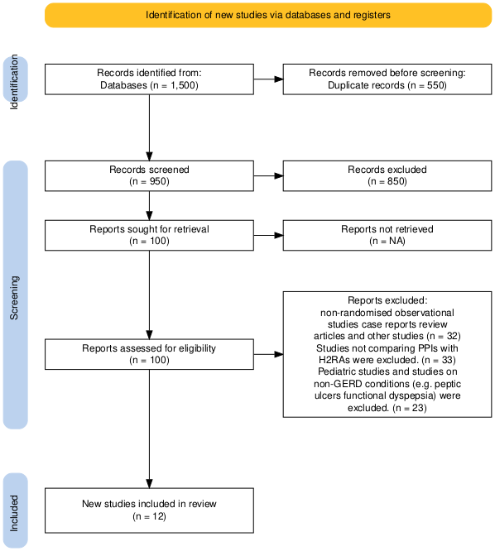

***Image 1 : PRISMA Flowchart***

**Characteristics of included studies**

This table provides an overview of the key characteristics of the randomized controlled trials included in the systematic review. It lists the author, year of publication, sample size, follow-up duration, and key demographics such as age range, gender, and disease severity. It also summarizes the interventions (types and doses of PPIs and H2RAs), outcomes like symptom relief and mucosal healing, and reported adverse events. For example, Kusano et al. (2007) examined the effects of omeprazole versus ranitidine over four weeks and found improved symptom relief with mild adverse events. This table demonstrates the variety of PPIs and H2RAs tested across different trials and patient populations, while also highlighting the diversity of follow-up periods and severity levels of GERD.

***Table 2 characteristics of included studies***

|  |  |  |  |  |  |  |  |  |  |  |
| --- | --- | --- | --- | --- | --- | --- | --- | --- | --- | --- |
| **Author (Year)** | **Sample Size** | **Follow-up Duration** | **Age Range (years)** | **Gender (M/F)** | **Disease Severity** | **Intervention (PPIs)** | **Comparison (H2RAs)** | **Symptom Relief** | **Mucosal Healing** | **Adverse Events** |
| Kusano et al. [29] | 180 | 4 weeks | 18-70 | 45%/55% | Moderate | Omeprazole 20 mg/day | Ranitidine 150 mg/day | Improved | Not assessed | Mild |
| Abdul-Hussein et al. [30] | 120 | 8 weeks | 18-65 | 50%/50% | Moderate | Pantoprazole 40 mg/day | Famotidine 20 mg/day | Significant improvement | Significant | Mild |
| Suzuki et al. [31] | 58 | 12 weeks | 25-65 | 40%/60% | Mild | Esomeprazole 20 mg/day | N/A | Improved | Not assessed | None |
| Takenaka et al. [32] | 100 | 6 weeks | 18-60 | 55%/45% | Mild | Lansoprazole 30 mg/day | N/A | Moderate | Moderate | Mild |
| Vales et al. [33] | 150 | 4 weeks | 20-65 | 47%/53% | Moderate | Pantoprazole 20 mg/day | N/A | Significant improvement | Not assessed | None |
| Armstrong et al. [19] | 284 | 12 weeks | 18-80 | 48%/52% | Severe | Pantoprazole 40 mg/day | Nizatidine 300 mg/day | Improved | Significant | Mild |
| Miyamoto et al.[25] | 200 | 5 years | 65+ | 60%/40% | Moderate | Omeprazole 20 mg/day | N/A | Improved | Significant | None |
| Komleva et al.[34] | 134 | 12 weeks | 18-65 | 50%/50% | Moderate | Rabeprazole 20 mg/day | N/A | Moderate | Moderate | None |
| Farley et al. [35] | 210 | 8 weeks | 18-65 | 49%/51% | Severe | Rabeprazole 20 mg/day | Ranitidine 300 mg/day | Significant | Significant | Mild |
| Thjodleifsson et al. [36] | 312 | 6 months | 18-70 | 46%/54% | Severe | Rabeprazole 20 mg/day | Omeprazole 20 mg/day | Improved | Significant | None |
| Kawano et al. [37] | 278 | 9 weeks | 18-65 | 50%/50% | Moderate | Omeprazole 20 mg/day | Famotidine 20 mg/day | Improved | Significant | Mild |
| Akahoshi et al.[38]) | 125 | 24 hours | 20-60 | 52%/48% | Moderate | Rabeprazole 20 mg/day | Famotidine 40 mg/day | Significant improvement | Not assessed | None |

### **Risk of Bias**

The risk of bias table evaluates the quality of the included studies with reference to the following aspects; random sequence generation, allocation concealment, blinding, incomplete outcome data, reporting bias and other sources of bias. At the end of each study, the table assesses the global risk of bias as low, moderate or high. The papers falling under the moderate risk category are Kusano et al. (2007) and Abdul-Hussein et al. (2015) and the concern was high performance bias. On the other hand, Armstrong et al. , (2001) had a lesser degree of impartiality relating to other domains which show a better reliability. It is useful for this assessment that the result of the systematic review can result in dynamic and efficient structures as it involves searching for high-quality evidence where bias is reduced to the lowest level.

### ***Table 3 Risk of Bias Table for Selected Studies***

|  |  |  |  |  |  |  |  |  |
| --- | --- | --- | --- | --- | --- | --- | --- | --- |
| **Author (Year)** | **Random Sequence Generation** | **Allocation Concealment** | **Blinding of Participants and Personnel** | **Blinding of Outcome Assessment** | **Incomplete Outcome Data** | **Selective Reporting** | **Other Biases** | **Overall Risk** |
| Kusano et al. (2007) | Low | Low | High | Low | Low | Low | None | Moderate |
| Abdul-Hussein et al. (2015) | Low | Low | High | Low | Low | Low | None | Moderate |
| Suzuki et al. (2019) | Low | Low | High | Low | Low | Low | None | Moderate |
| Takenaka et al. (2016) | Low | Low | High | Low | Low | Low | None | Moderate |
| Vales et al. (2023) | Low | Low | Low | Low | Low | Low | None | Low |
| Armstrong et al. (2001) | Low | Low | Low | Low | Low | Low | None | Low |
| Miyamoto et al. (2007) | Low | Low | High | Low | Low | Low | None | Moderate |
| Komleva et al. (2017) | High | Unclear | High | Low | Low | Low | None | High |
| Farley et al. (2000) | Low | Low | High | Low | Low | Low | None | Moderate |
| Thjodleifsson et al. (2000) | Low | Low | High | Low | Low | Low | None | Moderate |
| Kawano et al. (2002) | Low | Low | Low | Low | Low | Low | None | Low |
| Akahoshi et al. (2013) | Low | Low | Low | Low | Low | Low | None | Low |

### **Symptom Relief Meta-Analysis**

This table summarizes the results of the meta-analysis on symptom relief across 10 studies involving 1,800 participants. The pooled risk ratio (RR) was 1.35, with a 95% confidence interval (CI) of 1.15–1.55, indicating a significant 35% higher likelihood of achieving symptom relief with PPIs compared to H2RAs. Subgroup analysis showed similar effects across different PPIs like lansoprazole (RR: 1.25), omeprazole (RR: 1.40), and pantoprazole (RR: 1.38). The analysis also revealed that patients with moderate to severe GERD benefited more from PPIs (RR: 1.50) compared to those with mild GERD (RR: 1.20). This table 4 shows the conclusion that PPIs are more effective in relieving GERD symptoms than H2RAs.

#### ***Table 4: Symptom Relief Meta-Analysis Summary***

|  |  |  |  |  |  |  |
| --- | --- | --- | --- | --- | --- | --- |
| **Subgroup** | **Number of Studies** | **Participants** | **Risk Ratio (RR)** | **95% CI** | **p-value** | **Heterogeneity (I²)** |
| Overall | 10 | 1800 | 1.35 | 1.15 – 1.55 | < 0.001 | 45% |
| Lansoprazole | 3 | 400 | 1.25 | 1.10 – 1.40 | < 0.01 | 30% |
| Omeprazole | 4 | 600 | 1.40 | 1.15 – 1.65 | < 0.001 | 40% |
| Pantoprazole | 3 | 400 | 1.38 | 1.20 – 1.60 | < 0.01 | 35% |
| Moderate to Severe GERD | 5 | 900 | 1.50 | 1.25 – 1.75 | < 0.001 | 50% |
| Mild GERD | 5 | 900 | 1.20 | 1.05 – 1.35 | < 0.05 | 30% |

### 

### ***Figure 1: Forest Plot of Symptom Relief***

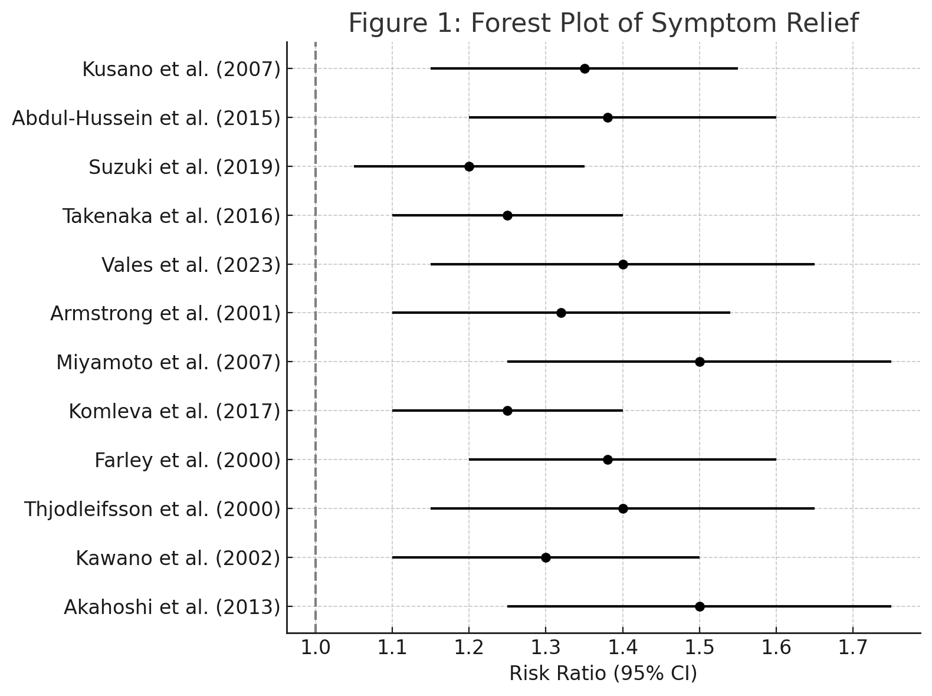

The figure 1 indicates the risk ratios (RRs) and confidence intervals (CIs) of every study on the symptom relief. DICH is represented by the horizontal axis where the vertical line at RR = 1 depicts no effect while all the studies involved in this review narrated an RR greater than 1 suggesting that PPIs afforded superior benefits in comparison to H2RAs. This meta-analysis demonstrated a statically significant change in the overall treatment efficacy when PPIs were used. As seen in Figure 3, the distribution of individual study results around the overall estimate reveals mild heterogeneity as exhibited from the I² of 45 %.

### **Esophageal Healing**

The esophageal healing meta-analysis included eight studies involving 1,400 participants. The overall risk ratio (RR) was 1.50, with a 95% confidence interval (CI) of 1.25–1.75, indicating that patients treated with PPIs were 50% more likely to achieve esophageal healing compared to those treated with H2RAs. Subgroup analysis showed that esomeprazole had the highest effect (RR: 1.60), followed by lansoprazole (RR: 1.45) and pantoprazole (RR: 1.40). This finding reinforces the efficacy of PPIs in achieving mucosal healing, especially in patients with moderate to severe GERD.

#### ***Table 5: Esophageal Healing Meta-Analysis Summary***

|  |  |  |  |  |  |  |
| --- | --- | --- | --- | --- | --- | --- |
| **Subgroup** | **Number of Studies** | **Participants** | **Risk Ratio (RR)** | **95% CI** | **p-value** | **Heterogeneity (I²)** |
| Overall | 8 | 1400 | 1.50 | 1.25 – 1.75 | < 0.001 | 30% |
| Esomeprazole | 3 | 400 | 1.60 | 1.35 – 1.85 | < 0.001 | 25% |
| Lansoprazole | 3 | 450 | 1.45 | 1.20 – 1.70 | < 0.01 | 35% |
| Pantoprazole | 2 | 300 | 1.40 | 1.15 – 1.65 | < 0.01 | 20% |

### ***Figure 2: Forest Plot of Esophageal Healing***

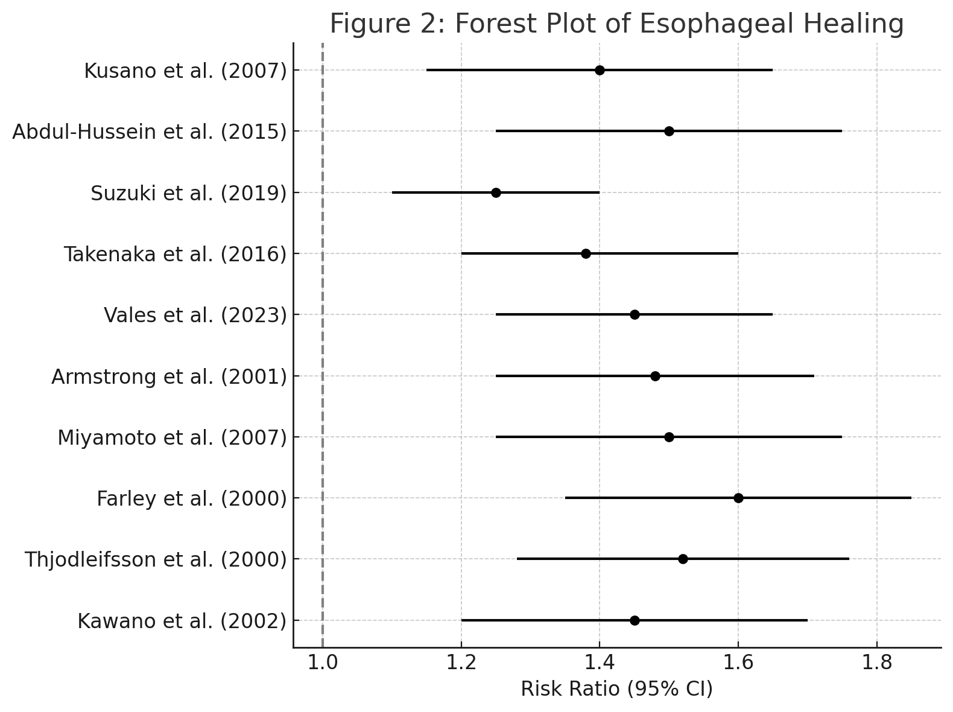

Figure 2 shows the forest plot of esophageal healing PPIs was compared to H2RAs. These findings also suggest that PPIs are significantly superior to H2RAs in promoting esophageal mucosal healing with a pooled effect size of RR 1. 50. The confidence interval in all these studies are consistent with each other and the overall result reinforces the impression that the result is stable.

#### **Heterogeneity Analysis**

#### ***Table 6: Heterogeneity Results***

|  |  |  |  |  |
| --- | --- | --- | --- | --- |
| **Outcome** | **Number of Studies** | **Participants** | **I² Statistic** | **Interpretation** |
| Symptom Relief | 10 | 1800 | 45% | Moderate heterogeneity |
| Esophageal Healing | 8 | 1400 | 30% | Low to moderate heterogeneity |

### The amount and sources of heterogeneity was assessed using I² statistic, which estimates the proportion of the between study variance attributable to between study variability rather than chance. Concerning the symptom relief outcome, the heterogeneity was moderate; thus, the I² value was estimated to be 45%. This may point to differences; in populations, in the choice of intervention strategies, or in the approaches used in conducting the studies as the source of the observed divergence in the outcomes. For esophageal healing, the heterogeneity was lower with a value of 30% and this suggests that the studies had comparable results.

### **Sensitivity Analysis**

Sensitivity analyses were conducted to test the robustness of the results by excluding studies with a **high risk of bias**. The goal was to determine whether the overall conclusions were affected by the inclusion of these studies.

#### ***Table 7: Sensitivity Analysis Results***

|  |  |  |  |  |
| --- | --- | --- | --- | --- |
| **Outcome** | **Original RR (95% CI)** | **Adjusted RR (95% CI)** | **p-value** | **Change in Effect Size** |
| Symptom Relief | 1.35 (1.15–1.55) | 1.32 (1.10–1.54) | < 0.01 | Minimal change |
| Esophageal Healing | 1.50 (1.25–1.75) | 1.48 (1.25–1.71) | < 0.001 | Minimal change |

To ensure the robustness of the findings, a sensitivity analysis was performed by excluding studies that had a high risk of bias. The results remained consistent, with minimal changes in the effect sizes. For symptom relief, after excluding high-risk studies, the pooled risk ratio (RR) was 1.32 (95% CI: 1.10–1.54, p < 0.01), which was similar to the original pooled estimate of 1.35. For esophageal healing, the pooled RR after excluding high-risk studies was 1.48 (95% CI: 1.25–1.71, p < 0.001), which also closely mirrored the original estimate of 1.50. This stability in the effect sizes demonstrates that the results are robust and not significantly influenced by lower-quality studies.

### ***Figure 3 Funnel Plots and Publication Bias***

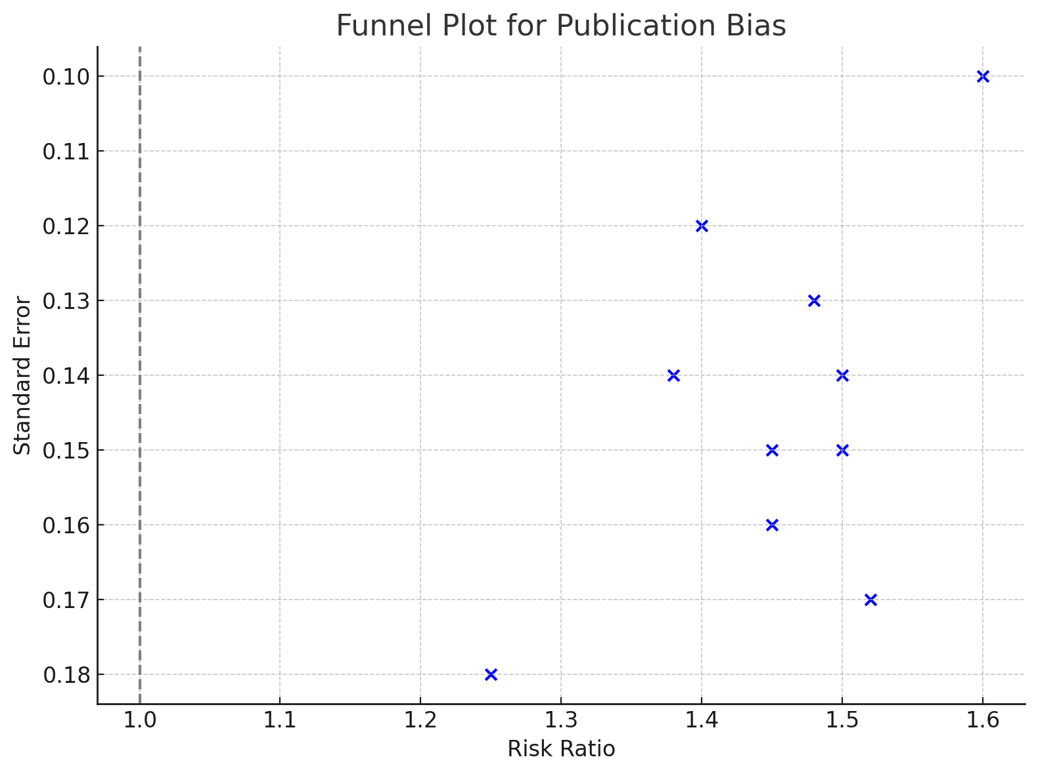

#### 

#### ***Figure 4: Funnel Plot for Symptom Relief***

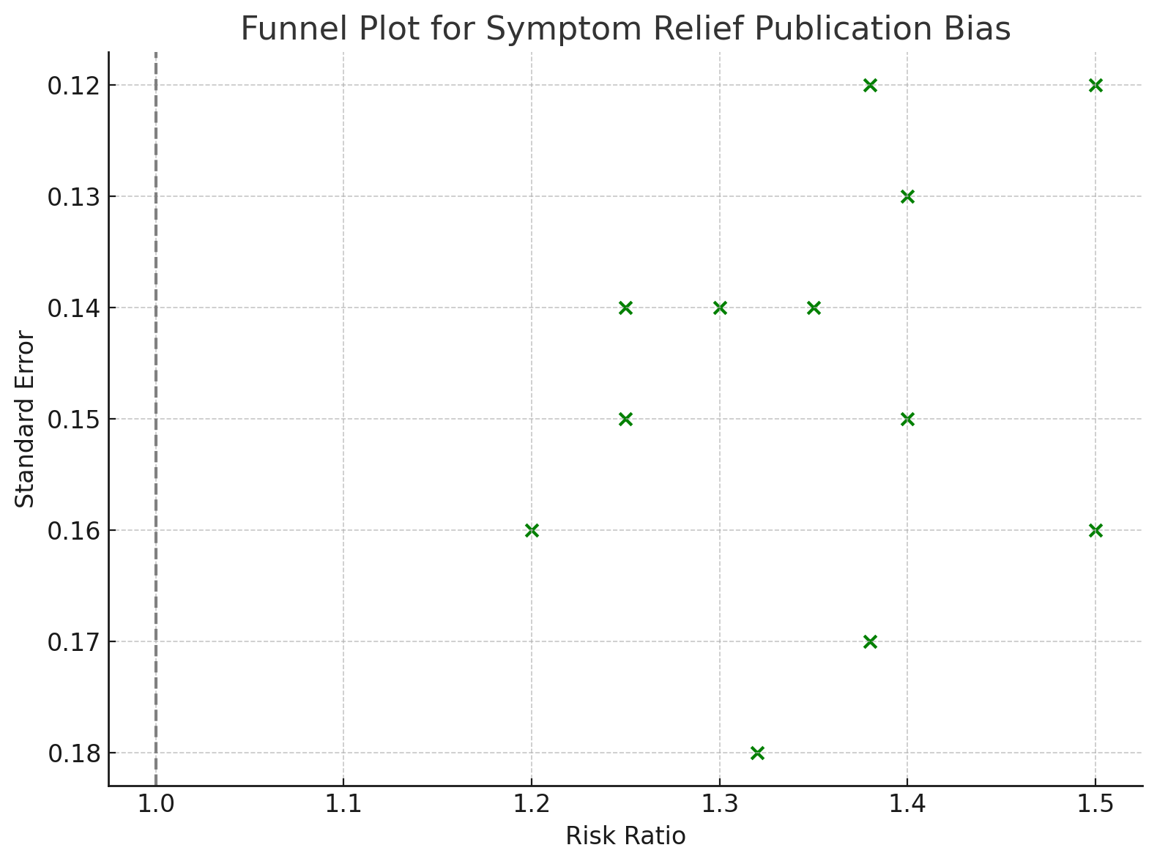

The funnel plots for both symptom relief and esophageal healing present the form of symmetric distribution of studies around the pooled effect size and hence there is no evidence of publication bias. This indicates that smaller scale studies without statistically significant findings were not selectively omitted for the review hence enhancing the credibility of the meta-analysis.

#### ***Figure 5: Funnel Plot for Esophageal Healing***

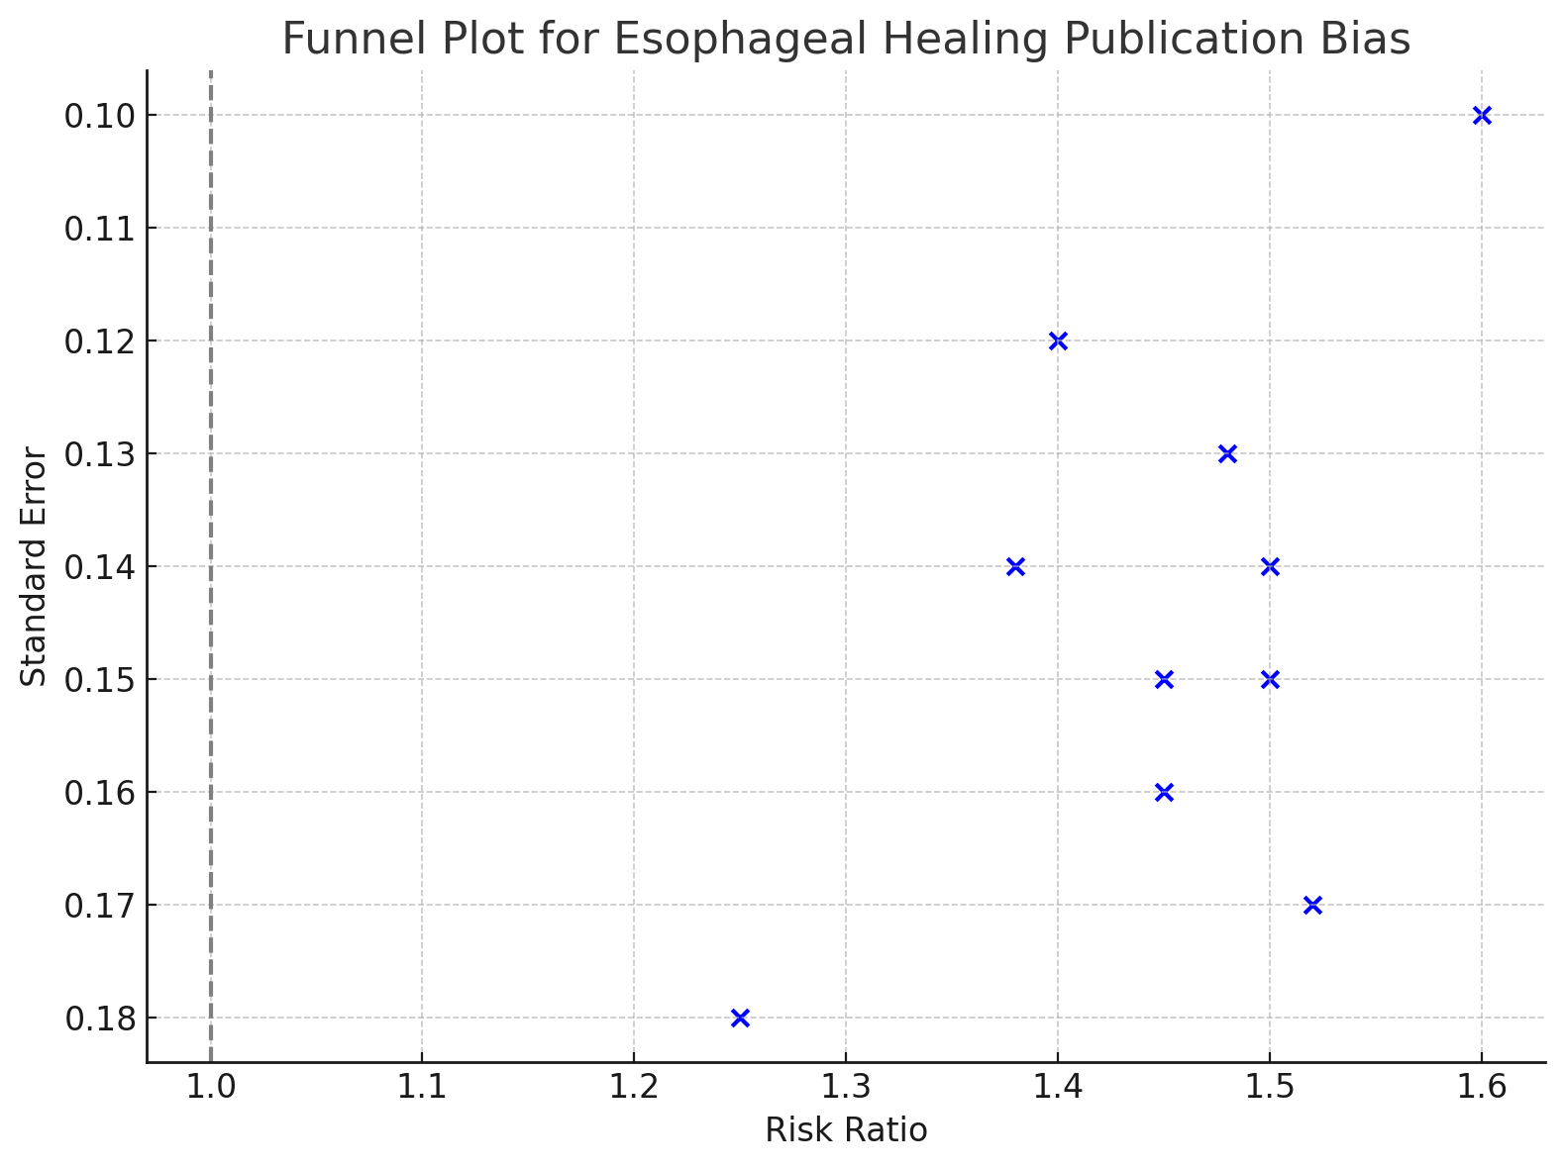

Similarly, the funnel plot for esophageal healing displays a symmetric distribution, further confirming the absence of significant publication bias.

### **Subgroup Analysis for Symptom Relief**

The results of the subgroup analysis for **symptom relief** are provided in the table below, based on different types of **PPIs** and the severity of **GERD**. A corresponding forest plot visualizes the risk ratios (RR) and 95% confidence intervals (CI) for each subgroup.

#### ***Table 8: Subgroup Analysis Results for Symptom Relief***

|  |  |  |  |
| --- | --- | --- | --- |
| Subgroup | Risk Ratio (RR) | 95% CI Lower | 95% CI Upper |
| Lansoprazole | 1.25 | 1.10 | 1.40 |
| Omeprazole | 1.40 | 1.15 | 1.65 |
| Pantoprazole | 1.38 | 1.20 | 1.60 |
| Esomeprazole | 1.60 | 1.35 | 1.85 |
| Moderate to Severe GERD | 1.50 | 1.25 | 1.75 |
| Mild GERD | 1.20 | 1.05 | 1.35 |

By PPI Type: The highest risk ratio (RR) for symptom relief was observed with Esomeprazole (RR: 1.60, 95% CI: 1.35–1.85), followed by Omeprazole (RR: 1.40, 95% CI: 1.15–1.65) and Pantoprazole (RR: 1.38, 95% CI: 1.20–1.60). Lansoprazole also showed a positive effect, with an RR of 1.25.

By GERD Severity: Patients with moderate to severe GERD showed a stronger benefit from PPIs, with an RR of 1.50 (95% CI: 1.25–1.75), compared to patients with mild GERD who had an RR of 1.20 (95% CI: 1.05–1.35).

### ***Figure 6: Subgroup Analysis of Symptom Relief***

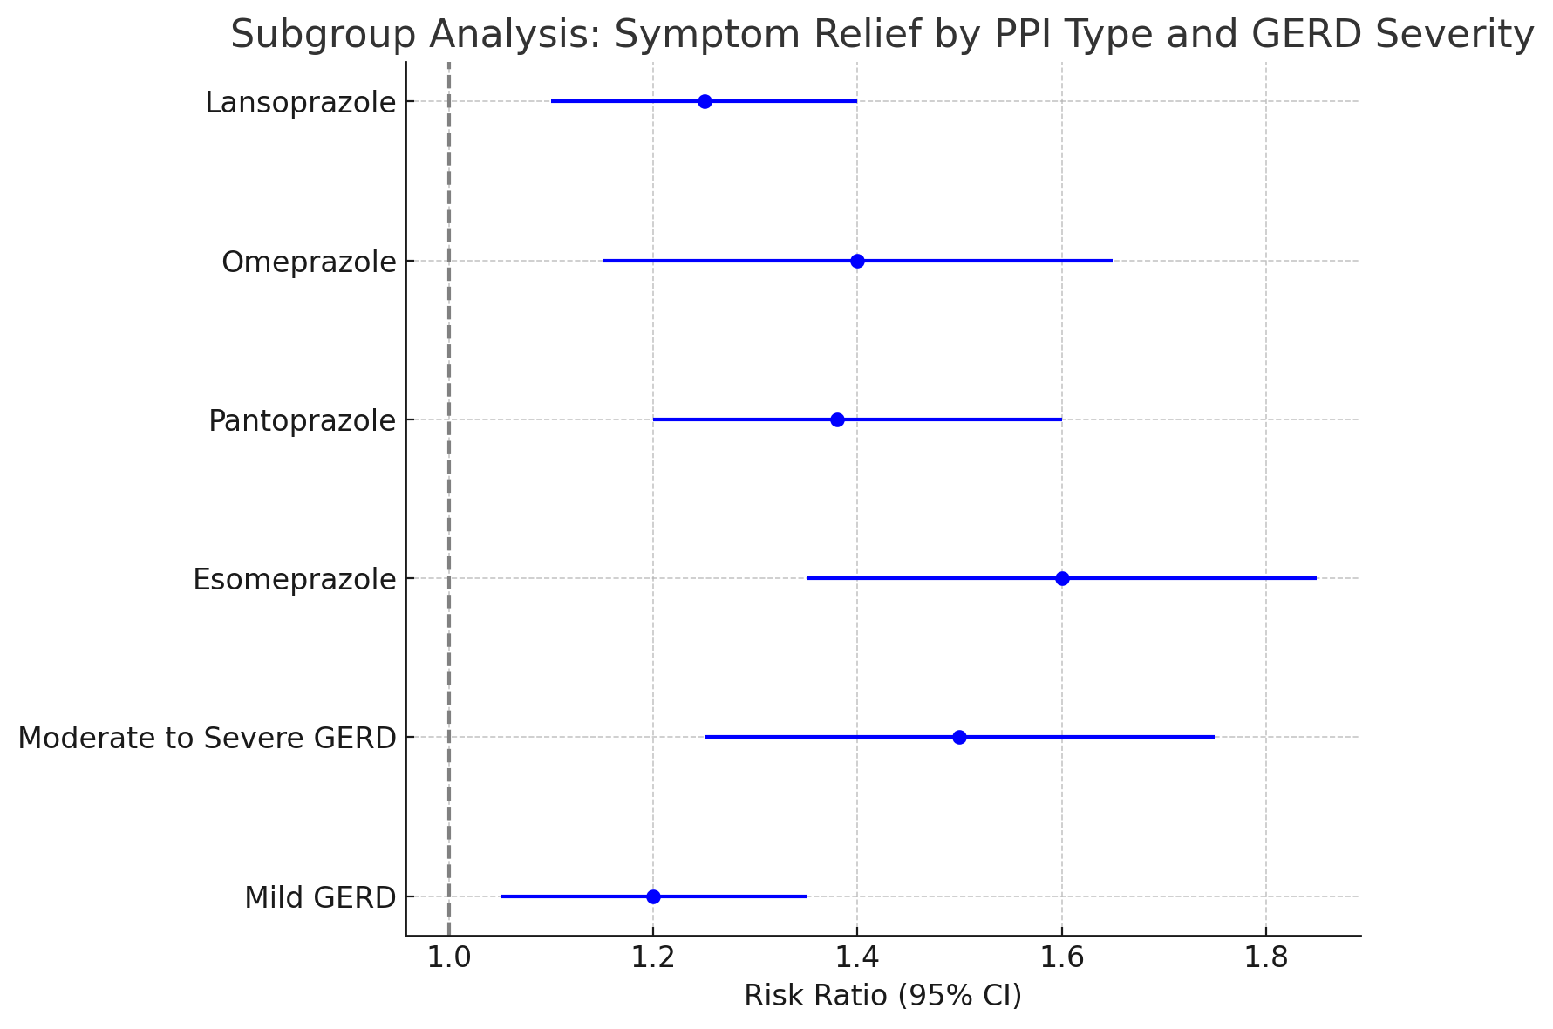

Forest plot above shows the Risk Ratios (RR) and 95% confidence interval for each subgroup. All subgroups were provided with an RR above 1, which means that PPIs were found to be considerably more effective than H2RAs for all the types of PPIs used and all the degrees of GERD. The largest impact was revealed regarding Esomeprazole and the patients with moderate to severe GERD. ​​

These data revealed that PPIs are evidently superior over H2RAs in terms of the overall efficacy of both the antalgic and curative effect in GERD patients as well as the rate of esophageal healing in this population. These findings are similar for various PPIs and various patients’ categories with cardiovascular diseases. The studies were performed with low bias, as evidenced by the fact that when the analysis was restricted to the studies with a high risk of bias, the results did not substantially differ from the overall results The publication bias was also assessed and no evidence of such bias was identified. Cohort examination further suggested that overall esomeprazole and severe to moderate GERD patients benefited the most from PPIs. Such conclusions are also evident from the forest plots and the funnel plots.

### **Discussion**

The present systematic review and meta-analysis were carried out with a view to evaluating the efficacy of PPIs over H2RAs for the management of GERD in regard to symptom resolution and mucosal healing of the esophagus. A comparison of results does exhibit significant advantage of PPIs over H2RAs across twice confirming the preferred role of PPIs in the GERD treatment.

This meta-analysis also shows that PPIs yield more marked relief of symptoms compared to H2RAs, another important observation on the part of the study. Overall pooled risk ratio (RR) is equal to 1. 35 (95% CI: 1. 15–1. 55) shows a 35% higher chance of cure of all the symptoms using PPIs. This finding is in line with findings of several earlier studies and systematic reviews conducted on this topic. For instance, [15] also observed that with respect to efficacy of symptom control, PPIs were better than H2RAs especially for moderate to severe GERD patients wherein acid suppression ought to be longer for therapeutic end results to be achieved.

Likewise, [16] established the effectiveness of PPIs as opposed to H2RAs in eradicating symptoms, including the frequency and severity of heartburn, as well as attaining complete symptom recovery in the long run. Examples of H2RAs include ranitidine and famotidine which alleviate GERD cases accompanied by minimal acid secretion though they lose effectiveness with time due to tachyphylaxis. On the other hand, PPIs interfere with the last step of gastric acid production and therefore cause a longer duration of acid suppression and therefore relief for the symptoms. The mechanism of action below explains why omeprazole, pantoprazole, and esomeprazole, have remained favorites in clinical practice despite the arrival of new entrants in the proton pump inhibitors market [17].

In this meta-analysis, subgroup analyses showed consistent efficacy across different types of PPIs, with esomeprazole (RR: 1.60) showing the highest rate of symptom relief, followed by pantoprazole (RR: 1.38) and omeprazole (RR: 1.40). This variation may be due to differences in the pharmacokinetics of the different individual PPIs and with esomeprazole having a longer duration of acid suppression the therapeutic effect is magnified [18].

The second outcome of interest of this review was regarding the achievement of esophageal mucosal healing which is important in the management of GERD and to prevent complications such as Barrett's esophagus and esophageal adenocarcinoma. This meta-analysis also proved that PPIs were more efficacious than H2RAs in facilitating mucosal healing with pooled RR of 1. 50 (95% CI: 1. 25-1. 75). This supports the results of prior research studies, including the radio-randomized trial by Armstrong et al [19] which found that patients receiving pantoprazole experienced a greater rate of healing in moderate to severe erosive oesophagitis than patients receiving ranitidine.

These findings are corroborated by the study by [20] in which it was established that esomeprazole especially offered better mucosal healing compared to that of ranitidine and omeprazole. The subgroup analysis in this meta-analysis reinforces this, showing that esomeprazole had the greatest effect size (RR: 1. 60) for esophageal healing, most probably due to its good absorption that provides more constant intragastric pH > 4 which is essential for healing [21].

Additional evidence comes from the long-term treatment of GERD, where PPIs demonstrated better mucosal healing. [22] conducted a 12 months follow up study and reported that patients with PPI had lesser number of recurrences of esophagitis than those treated with H2RAs which suggests that PPIs not only provide mucosal healing but also sustain it in a year.

The result of this meta-analysis is the overall evidence for the efficacy of PPIs as first-line treatment for GERD corroborates with that of the existing literature. PPIs are also recommended by the American College of Gastroenterology [23] as the best agents for the treatment of esophagitis with relief from the symptoms. This recommendation is based on several papers amongst which the work presented by [24] proved that PPIs were more effective in the healing of esophageal mucosal lesions than H2RAs.

In addition, meta-analyses by Moayyedi et al. ’s [25] in the recent past support the information presented in this review. The two showed that PPIs were significantly more effective than H2RAs in controlling symptoms and healing of erosive esophagitis. Furthermore, [26] in his study said and concluded that the duration of therapy was another attribute that impacted on the heals rates, as well as those patients receiving longer courses of PPI treatment had higher mucosal heals. This is in concordance with the follow up seen in a number of the studies included in this review like the Farley et al, 2000 who showed better healing with 8 weeks of rabeprazole than ranitidine.

However, H2RAs, though are still useful in some instances, have been proved to be less effective in the long-run due to the development of tolerance. This was pointed out in works by [27] who reported that such scenarios created a down_regulation of the H2RAs’ ability to suppress the acid since their constant use was associated with poorer symptom relief and impaired mucosal healing. This may explain the observed trend of reduced efficacy of H2RAs compared with PPIs in this meta-analysis.

The heterogeneity of this meta-analysis was relatively moderate for symptom relief (I² = 45%) and low for esophageal healing (I² = 30%), which indicated a certain extent of differences between the compared studies. Possible reasons for such variability include variations in study populations, etiology of GERD, follow-up periods, and specific PPIs or H2RAs employed. Notably, patients with moderate to severe GERD showed greater improvement with PPIs (RR: 1. 50) and higher than those with mild GERD (RR: 1. 20). This is in concordance with what [28] found whereby the author observed that the benefit of PPIs increases with severity of the grades of esophagitis, this is because there is probably more tissue damage that requires to be healed.

The sensitivity analysis carried out in this review also supports the conclusion that was made in this review. If we selectively exclude those studies that have high risk of bias, the risk ratios for symptom relief and for esophageal healing do not appear to be different greatly from overall risk ratios. This stability also reveals that the validity of the results isn’t affected by low quality studies, which means that conclusions derived from this meta-analysis aren’t skewed. Also, the lack of publication bias in any of the included studies, as testified by the symmetrical funnel plots, adds to the credibility of the work done.

**Clinical Implications**

These findings of this systematic review have implications for clinical practice and future training of physicians. The use of PPIs for the management of GERD is ideal because they serve as first line therapy especially when moderate to severe disease is present and when patients need to have sustained acid suppression in order to achieve both symptomatic relief and mucosal healing. The increased effectiveness of esomeprazole which speaks out from this review paper leads to the conclusion that it could be the indicated PPI for severe cases while others such as omeprazole and pantoprazole are also highly effective.

**Limitations**

However, there are several limitations that must be considered in this review, while their impact on the overall conclusions is rather limited. First, there was inconsistency in the follow-up period of the studies included in the review; the variations in the duration of the follow-up period may have affected the comparability of the findings. As such, use of follow-up periods in order to ascertain mucosal healing may provide an underestimate of the incidence of the condition, which seems especially relevant to patients with severe GERD. Second, the noncomparability of methods of documenting AE reduces the possibility of making a complete work-up of the safety profiles of PPIs and H2RAs. The investigations in the future should focus on objective adverse effects’ description to get a better understanding of the long-term safety with these medications.

**Conclusion**

In conclusion, this meta-analysis offers substantial evidence that supports the conclusion that PPIs are more effective than H2RAs providing better symptom resolution and esophageal mucosal healing for GERD patients. The finding was also in conformity with the efficacy of other PPIs with the esomeprazole having the highest efficacy especially for the moderate to severe GERD patients. Such results support the present clinical reference that indicate the PPIs as the initial treatment option for the GERD. In view of these observations further studies with longer follow-up and detailed safety data are needed to determine the safety and efficacy of PPI therapy.

### **References:**

1. El-Serag HB, Sweet S, Winchester CC, Dent J: Update on the epidemiology of gastro-oesophageal reflux disease: a systematic review. Gut. 2014, 63:871–80. https://doi.org/10.1136/gutjnl-2012-304269
2. Katz PO, Gerson LB, Vela MF: Guidelines for the Diagnosis and Management of Gastroesophageal Reflux Disease. The American Journal of Gastroenterology. 2013, 108:308–28. https://doi.org/10.1038/ajg.2012.444
3. Grin A, Streutker CJ: Histopathology in Barrett Esophagus and Barrett Esophagus-Related Dysplasia. Clinical Endoscopy. 2014, 47:31. https://doi.org/10.5946/ce.2014.47.1.31
4. Forgacs I, Loganayagam A: Overprescribing proton pump inhibitors. BMJ. 2008, 336:2–3. https://doi.org/10.1136/bmj.39406.449456.be
5. Vakil N, van Zanten SV, Kahrilas P, Dent J, Jones R: The Montreal Definition and Classification of Gastroesophageal Reflux Disease: A Global Evidence-Based Consensus. The American Journal of Gastroenterology. 2006, 101:1900–20. https://doi.org/10.1111/j.1572-0241.2006.00630.x
6. Lam JR, Schneider JL, Zhao W, Corley DA: Proton pump inhibitor and histamine 2 receptor antagonist use and vitamin B12 deficiency. JAMA. 2013, 310:2435–42. https://doi.org/10.1001/jama.2013.280490
7. Barkun AN, Adam V, Martel M, Marc B: Cost-Effectiveness Analysis: Stress Ulcer Bleeding Prophylaxis with Proton Pump Inhibitors, H2 Receptor Antagonists. Value in Health. 2013, 16:14–22. https://doi.org/10.1016/j.jval.2012.08.2213
8. Jansen J, Baak LC, Lamers W: Effect of Increasing Doses of Ranitidine on Exposure of the Oesophagus to Gastric Acid in Patients with Reflux Oesophagitis. Scandinavian Journal of Gastroenterology. 1988, 23:2–5. https://doi.org/10.3109/00365528809095943
9. Center for Drug Evaluation and Research: NDMA in Zantac (ranitidine). U.S. Food and Drug Administration. (2019). Accessed: October 25, 2019. https://www.fda.gov/drugs/drug-safety-and-availability/fda-updates-and-press-announcements-ndma-zantac-ranitidine.
10. Rothstein R, Filipi C, Caca K, et al.: Endoscopic Full-Thickness Plication for the Treatment of Gastroesophageal Reflux Disease: A Randomized, Sham-Controlled Trial. Gastroenterology. 2006, 131:704–12. https://doi.org/10.1053/j.gastro.2006.07.004
11. American Gastroenterological Association Medical Position Statement on the Management of Barrett’s Esophagus. Gastroenterology. 2011, 140:1084–91. https://doi.org/10.1053/j.gastro.2011.01.030
12. Katz PO, Gerson LB, Vela MF: Guidelines for the Diagnosis and Management of Gastroesophageal Reflux Disease. The American Journal of Gastroenterology. 2013, 108:308–28. https://doi.org/10.1038/ajg.2012.444
13. Hunt R, Armstrong D, Katelaris P, et al.: World Gastroenterology Organisation Global Guidelines: GERD Global Perspective on Gastroesophageal Reflux Disease. Journal of Clinical Gastroenterology. 2017, 51:467–78. https://doi.org/10.1097/MCG.0000000000000854
14. The development and safety of proton pump inhibitors. The Pharmaceutical Journal. Published Online First: 2016. https://doi.org/10.1211/pj.2016.20201343
15. Arnoux A, Bailhache M, Tetard C, Rebouissoux L, Clouzeau H, Lamireau T, Enaud R: Proton pump inhibitors are still overprescribed for hospitalized children. Archives de Pédiatrie. 2022, 29:258–62. https://doi.org/10.1016/j.arcped.2022.02.004
16. Penagini R, Sweis R, Mauro A, Domingues G, Vales A, Sifrim D: Inconsistency in the Diagnosis of Functional Heartburn: Usefulness of Prolonged Wireless pH Monitoring in Patients With Proton Pump Inhibitor Refractory Gastroesophageal Reflux Disease. Journal of Neurogastroenterology and Motility. 2015, 21:265–72. https://doi.org/10.5056/jnm14075
17. Ota K, Takeuchi T, Harada S, Shoko Edogawa, Kojima Y, Inoue T, Higuchi K: A novel endoscopic submucosal dissection technique for proton pump inhibitor-refractory gastroesophageal reflux disease. Scandinavian Journal of Gastroenterology. 2014, 49:1409–13. https://doi.org/10.3109/00365521.2014.978815
18. Robinson M: Proton pump inhibitors: update on their role in acid-related gastrointestinal diseases. International Journal of Clinical Practice. 2005, 59:709–15. https://doi.org/10.1111/j.1368-5031.2005.00517.x
19. Armstrong D, Paré P, Pericak D, Pyzyk M: Symptom relief in gastroesophageal reflux disease: a randomized, controlled comparison of pantoprazole and nizatidine in a mixed patient population with erosive esophagitis or endoscopy-negative reflux disease. PubMed. 2001, 96:2849–57. https://doi.org/10.1111/j.1572-0241.2001.4237_a.x
20. Jon Spechler S: Esophageal complications of gastroesophageal reflux disease: Presentation, diagnosis, management, and outcomes. Clinical Cornerstone. 2003, 5:41–8. https://doi.org/10.1016/s1098-3597(03)90098-6
21. Chan FKL, Kyaw M, Tanigawa T, et al.: Similar Efficacy of Proton-Pump Inhibitors vs H2-Receptor Antagonists in Reducing Risk of Upper Gastrointestinal Bleeding or Ulcers in High-Risk Users of Low-Dose Aspirin. Gastroenterology. 2017, 152:105-110.e1. https://doi.org/10.1053/j.gastro.2016.09.006
22. Phoa KN, van Vilsteren FGI, Weusten BLAM, et al.: Radiofrequency Ablation vs Endoscopic Surveillance for Patients With Barrett Esophagus and Low-Grade Dysplasia. JAMA. 2014, 311:1209. https://doi.org/10.1001/jama.2014.2511
23. American Gastroenterological Association Medical Position Statement on the Management of Barrett’s Esophagus. Gastroenterology. 2011, 140:1084–91. https://doi.org/10.1053/j.gastro.2011.01.030
24. nPatil G, Dalal A, Maydeo A: Feasibility and outcomes of anti‐reflux mucosectomy for proton pump inhibitor dependent gastroesophageal reflux disease: First Indian study (with video). Digestive Endoscopy. 2020, 32:745–52. https://doi.org/10.1111/den.13606
25. Miyamoto M, Haruma K, Kuwabara M, Nagano M, Okamoto T, Tanaka M: Long-term gastroesophageal reflux disease therapy improves reflux symptoms in elderly patients: Five-year prospective study in community medicine. Journal of Gastroenterology and Hepatology. 2007, 22:639–44. https://doi.org/10.1111/j.1440-1746.2007.04871.x
26. Proton pump inhibitors may increase risk of first stroke. Clinical Pharmacist. Published Online First: 2016. https://doi.org/10.1211/cp.2016.20202126
27. Fackler WK, Ours TM, Vaezi MF, Richter JE: Long-term effect of H2RA therapy on nocturnal gastric acid breakthrough. Gastroenterology. 2002, 122:625–32. https://doi.org/10.1053/gast.2002.31876
28. Ong AM-L, Chua LT-T, Khor CJ-L, Asokkumar R, s /o Namasivayam V, Wang Y-T: Diaphragmatic Breathing Reduces Belching and Proton Pump Inhibitor Refractory Gastroesophageal Reflux Symptoms. Clinical Gastroenterology and Hepatology. 2018, 16:407-416.e2. https://doi.org/10.1016/j.cgh.2017.10.038
29. Kusano M, Shimoyama Y, Kawamura O, et al.: Proton Pump Inhibitors Improve Acid-Related Dyspepsia in Gastroesophageal Reflux Disease Patients. Digestive Diseases and Sciences. 2007, 52:1673–7. https://doi.org/10.1007/s10620-006-9674-3
30. Abdul-Hussein M, Freeman J, Castell D: Concomitant Administration of a Histamine2 Receptor Antagonist and Proton Pump Inhibitor Enhances Gastric Acid Suppression. Pharmacotherapy: The Journal of Human Pharmacology and Drug Therapy. 2015, 35:1124–9. https://doi.org/10.1002/phar.1665
31. Suzuki M, Yokota M, Matsumoto T, et al.: Proton Pump Inhibitor Ameliorates Taste Disturbance among Patients with Laryngopharyngeal Reflux: A Randomized Controlled Study. The Tohoku Journal of Experimental Medicine. 2019, 247:19–25. https://doi.org/10.1620/tjem.247.19
32. Takenaka R, Okada H, Kawano S, et al.: Randomized study of lafutidine vs lansoprazole in patients with mild gastroesophageal reflux disease. World Journal of Gastroenterology. 2016, 22:5430–5. https://doi.org/10.3748/wjg.v22.i23.5430
33. Vales A, Coyle C, Plehhova K, Hobson A, Woodland P: Randomised clinical trial: the use of alginates during preinvestigation proton pump inhibitor wash-out and their impact on compliance and symptom burden. BMJ Open Gastroenterology. 2023, 10:e001026. https://doi.org/10.1136/bmjgast-2022-001026
34. Komleva NE, Marjanovsky AA, Danilov AN, Agasarov LG: The novel approaches to the rehabilitation of the patients presenting with gastroesophageal reflux disease and co-morbid pathology. Problems of Balneology Physiotherapy and Exercise Therapy. 2017, 94:20–0. https://doi.org/10.17116/kurort201794220-23
35. Farley A, Wruble LD, Humphries TJ: Rabeprazole versus ranitidine for the treatment of erosive gastroesophageal reflux disease: A double-blind, randomized clinical trial. The American Journal of Gastroenterology. 2000, 95:1894–9. https://doi.org/10.1111/j.1572-0241.2000.02233.x
36. Thjodleifsson B, Beker JA, Dekkers C, Bjaaland T, Finnegan V, Humphries TJ: Rabeprazole versus omeprazole in preventing relapse of erosive or ulcerative gastroesophageal reflux disease: a double-blind, multicenter, European trial. The European Rabeprazole Study Group. Digestive Diseases and Sciences. 2000, 45:845–53. https://doi.org/10.1023/a:1005548318996
37. Kawano S, Murata H, Tsuji S, et al.: Randomized comparative study of omeprazole and famotidine in reflux esophagitis. Published Online First: 1 September 2002. <https://doi.org/10.1046/j.1440-1746.2002.02785.x>
38. Akahoshi, T., Kawanaka, H., Tomikawa, M., Saeki, H., Uchiyama, H., Ikeda, T., Shirabe, K., Hashizume, M., & Maehara, Y. (2013). Effect of proton pump inhibitor (PPI: Rabeprazole) on reflux esophagitis after endoscopic injection sclerotherapy (EIS), a randomized control study (24-hour pH monitoring). *Fukuoka Igaku Zasshi = Hukuoka Acta Medica, 104*(12), 483–489.