**Review Article**

**Block chain Technology in Healthcare: Assessing Its Impact on Pharmacovigilance and drug Tracking – A Review**

**ABSTARCT**

Blockchain technology is changing the face of several industries, but in health care, it is proving to be a critical tool to improve prescription drug tracking and pharmacovigilance. Prescription drug counterfeiting and safety monitoring pose significant global challenges that result in patient harm and economic losses. Blockchain offers enhanced transparency, traceability, and integrity through its decentralized, immutable ledger system,which is essential for secure drug tracking from manufacturing to end-user. This review considers whether blockchain can overcome the inadequacies of current pharmaceutical tracking systems and applications in pharmacovigilance, particularly in the context of real-time adverse event reporting. Blockchain will enable the safe sharing of patient and drug information among healthcare entities protected by privacy; this is a significant advantage for activities in pharmacovigilance. In blockchain, smart contracts may be used to automate compliance and reporting processes to ensure adherence to regulations. These are the standardization of data input, energy consumption, and legal and ethical issues in pharmaceutical supply chains. These barriers could be addressed through policy innovation and cross-sector collaboration to bring out the true potential of blockchain. The study shows that even with its limitations, the realistic solution in pharmaceutical tracking and safety monitoring is blockchain. It aggregates evidence from sundry studies that could interest healthcare policymakers, technology developers, and pharmaceutical stakeholders in leveraging blockchain technology to foster a safer and more efficient healthcare system.

Key words :

Blockchain technology,drug tracking, pharmacovigilance,healthcare,data security.

**1.INTRODUCTION**

Blockchain technologies will enable better monitoring and tracking of empty medication bottles and bolster the governance of the recycling processes. Blockchain technologies allow addressing these challenges, as well as resolving the issues with tracing the lifecycle of the medication bottles and making sure there is someone accountable for each recycling process. In the pharmaceutical sector, the role of blockchain has also enabled wiping out fake drugs, enhancing adherence to pharmaceutical regulations such as the Drug Supply Chain Security Act (DSCSA), and better overall supply chain management (13). Blockchain technology can provide a complete barrier against the entry of fake medications into the supply chain. Since all nodes in the system must confirm any changes, blockchain solutions are nearly impenetrable due to the fact that data cannot be altered after it has been made. Additionally, the technology makes it possible for every consumer to confirm the legitimacy of the medications they have purchased, for instance, by using an app to scan the code that is printed on the container. Every customer can quickly determine if their goods are authentic or not (5). Blockchain technology as a Cultural Security Sociotechnical Framework (CSSF)-based e-DP solution. The research showed a twelvefold increase between 2015 and 2023, with more growth observed in 2023. Blockchain technology was acknowledged for its dependability, transparency, and capacity to enhance data storage, patient safety, and security, and thirteen important variables associated with CSSF were found. Blockchain anonymizes and safeguards system data, but for the digital prescription to be implemented successfully, a new governance framework is required (27).Blockchain technology in the tracking of clinical medication trials: The study focuses on critically examining the issues with the traditional tracking, demystifying the broad principles of blockchain technology, and evaluating how it would improve the efficiency and reliability of monitoring of drug trials (9).The Internet of Medical Things [IoMT] is mainly associated with improving pharmacovigilance because it tracks the efficacy of drugs as long as they are in use. IoMT devices track the efficacy of a drug once it has been administered to a patient. Wearable technology allows doctors to monitor for initial signs of effectiveness of a medication in patients' bodies by tracking the key vital indicators of the body, such as blood pressure and heart rate. This makes it important in patient care due to its potential effects, which may result in a change of treatment or the dose. Information on how effective drugs are and whether they are safe can help patients and the larger society through the information-issuing ability of IoMT devices (18).

**2. DISCUSSION**

Blockchain technology is highly useful in many fields of human life, in particular, because of an immutable and secure database for data storage. Smart contracts are proving efficient, especially in the financial sector, by automating and securing transactions. However, the combination of blockchain and IoT is especially relevant to logistics, where the use of sensors and detectors to receive all the required information about the goods and then save it in the blockchain; such a procedure shall protect the data from deletion and falsification. This will enable better automation of the process of delivering goods, and, for end-users, it will provide the best quality available; insurance companies, with their help, will be able to make more well-grounded decisions based on more reliable data. Further developments in blockchain technology toward effectively integrating into the paradigm of IoT. Despite the great potential for the extensive use of blockchain in different industries, its applicability remains relatively low. In the future, such work could be directed to create prototypes or examples of implementation. This does not need to be a huge project; it might be a model or a basic project with basic functions that can serve as a foundation for a full system. The development of such projects will also allow easier understanding of problems and difficulties that may occur when introducing blockchain in real life. This also allows for implementing new ideas and developing new functions. In addition to everything stated above, this will certainly enhance further development of such technologies within the scientific environment (40).Blockchain in pharmaceutical supply With the enormous consequences that come with the use of counterfeit or gone-bad drugs came the need for a solution to keep track of and authenticate every step of the process that the supplies undergo before getting into the patient's hands. Another use case for blockchain technology in the medical sector is in the pharmaceutical supply chain. Below we can see the potential method of implementation of such a technology in the pharmaceutical supply chain infrastructure. First, the manufacturer of the drug generates a unique identification code (for example, a QR code) associating it with a node in the blockchain. Since each consecutive node carries its own hash value as well as the hash of the previous node, it is theoretically impossible to tamper with the validated nodes, thereby making every subsequent transaction involving a definite batch of drugs trustful (14).Blockchain in biomedical research In the recent past, biomedical research has undergone several administrative and fundamental changes. Especially after the high-speed broadband connectivity, cloud computing, remote data processing and data storage, artificial intelligence (AI), machine learning (ML), natural language processing (NLP), and the emergence of large language models, this shift has necessitated a paradigm shift in it. With the help of these tools, researchers are moving towards large "multi-centric studies'.Scale genomic data is also used in this study. Multi-centric studies mean data exchange and data sharing among different entities for facilitating the integration of multivariate data for the development of patient-centric therapies. Seamless integration and communication between different systems still present a huge challenge (1) .The blockchain technology has the potential to reduce the circulation of fake medications and improve traceability, as suggested by some research findings and case studies, but agreement from all the stakeholders, interoperability among different applications, and costs in the implementation of the system, as well as security vulnerabilities and regulatory considerations, need to be counterpointed for it to gain widespread acceptance (33).A relatively new development, the use of blockchain technology for medical data storage, is most often associated with the "digital" or "information age" generation that emerged at the close of the 20th century and continues to this day. Even though the technology behind blockchain was actually invented back in 2008 upon the launch of Bitcoin, its application in healthcare was first reported to be observed to gain momentum in the mid- to late-2010s. It coincides with a protracted digital revolution that has been unfolding across various sectors, such as health care. In medical data storage, blockchain technology presents a good number of advantages over conventional solutions, including integrity, security, and interoperability. Blockchain technology can further protect medical records while making them immutable and offering secure information transfer between patients and their care providers through decentralized and cryptographic approaches (20).

**2.1 BLOCKCHAIN FOR PRESCRIPTION DRUG TRACKING**

Blockchain technology has proven effective in enhancing transparency within the drug supply chain (36). For instance, decentralized systems allow stakeholders to verify drug origins and authenticity without compromising patient privacy (3). The secure and decentralized nature of blockchain makes it well-suited for mitigating the risks of counterfeit drugs, especially in regions lacking reliable verification methods (28). Projects such as MediLedger have demonstrated how blockchain can maintain drug authentication through immutable records of every transaction (11). Blockchain-based systems offer substantial improvements in supply chain transparency, allowing stakeholders to track the source and movement of drugs at all stages (24).

Blockchain can also streamline operations through smart contracts, which automatically enforce compliance with regulatory standards by monitoring drug movement at key checkpoints (2). Smart contracts improve efficiency by eliminating manual verification processes and ensuring that only compliant products proceed through the supply chain (32). This reduces operational costs associated with compliance checks, contributing to a more efficient drug distribution network (4). The data security inherent in blockchain further reinforces drug traceability, offering a valuable tool for maintaining quality standards and preventing fraudulent practices (19).

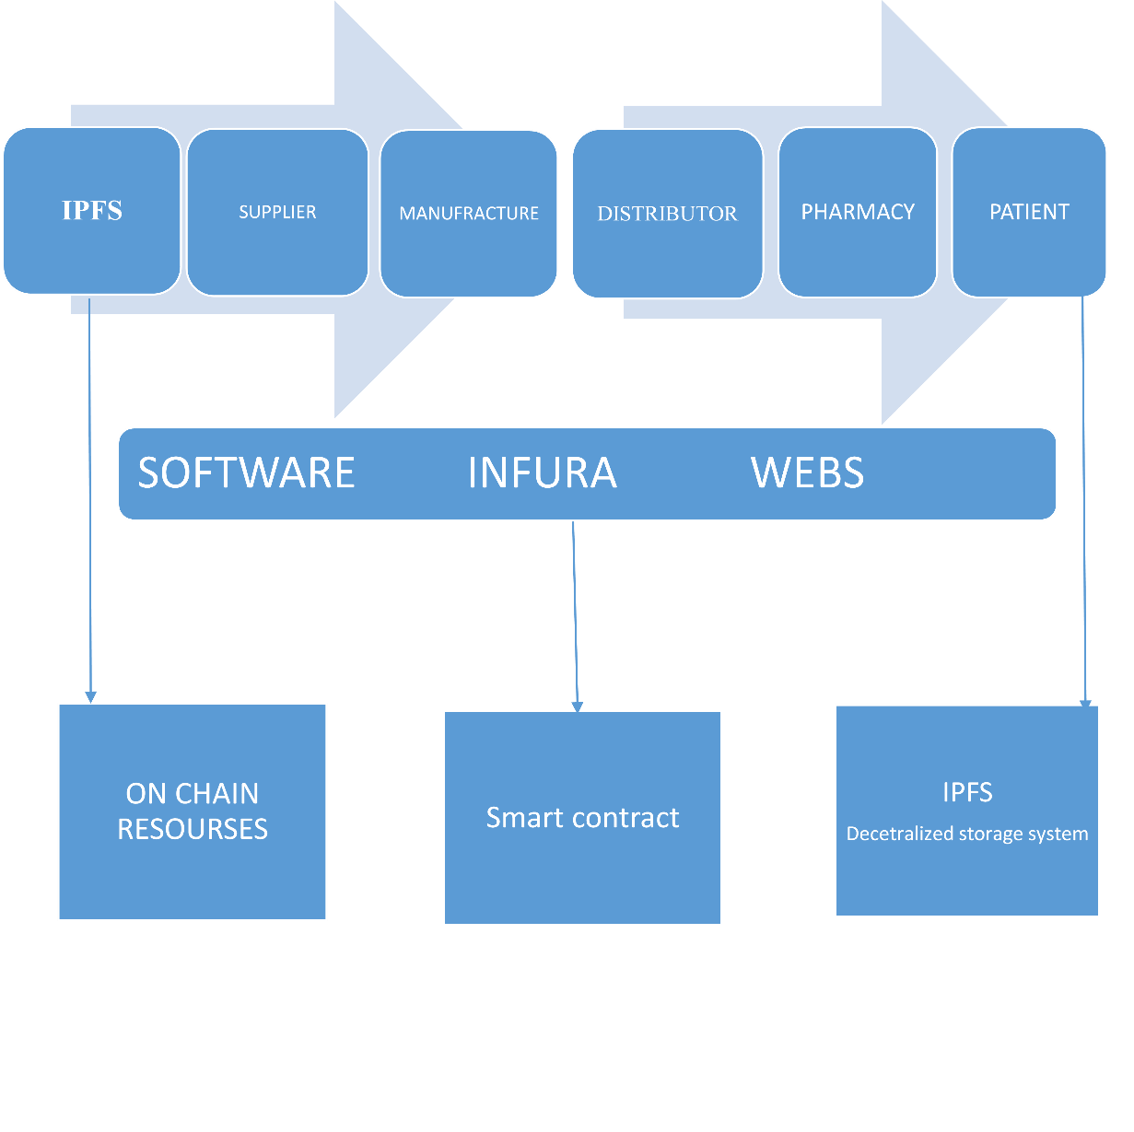

Figure1: Block chain in drug tracking

**2.2 BLOCKCHAIN IN PHARMACOVIGILANCE**

In pharmacovigilance, blockchain provides a secure platform for ADR reporting and data sharing among healthcare providers, patients, and regulators (7). Decentralized data systems allow for real-time ADR reporting, enabling faster responses to emerging drug safety issues (25). Additionally, blockchain’s transparency in data handling supports regulatory compliance by offering a clear, immutable record of each ADR reported (38). This prevents tampering and reduces errors that often occur in traditional data systems (16). By enabling real-time data sharing, blockchain helps address critical bottlenecks in drug safety surveillance, such as delayed reporting and data verification (12). Furthermore, the security of blockchain technology supports patient privacy, a vital requirement in healthcare data systems (8).

Blockchain’s decentralized architecture can significantly reduce operational costs by automating processes like ADR reporting, allowing healthcare providers to monitor patient safety with minimal administrative burden (30). By eliminating intermediaries, blockchain reduces the complexity and cost of drug safety monitoring while ensuring data accuracy and accessibility (6). The increased efficiency and reduced risk of data tampering in ADR reporting can have a transformative effect on pharmacovigilance systems worldwide (29). Additionally, blockchain can help standardize data collection and reporting practices across jurisdictions, which is essential for global pharmacovigilance efforts (39).

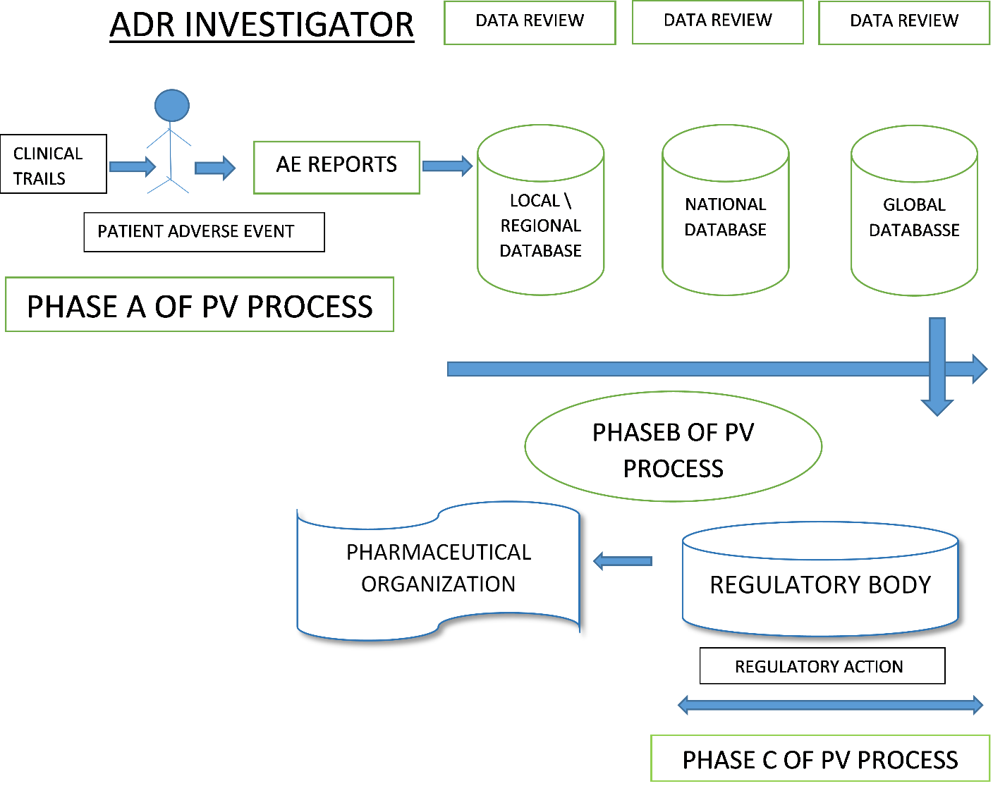

Figure 2: Block chain in pharmacovigilance

**3. RESULTS**

Research shows positive effects of blockchain technology on drug tracking; that blockchain reduces instances of counterfeit drugs and increases traceability along the medication supply chain (26). For instance, pilot projects are found to have led to reduced counterfeit drugs and increased transparency along drug supply chains in blockchain-based drug tracking programs (10). In addition, blockchain has sped up recalls by allowing the identification of affected batches, and thus, they cut down on response time significantly (35). The effectiveness of blockchain has also been seen in pharmacovigilance, offering a secure system to report ADRs whose data integrity is maintained and can be updated in real time (17). Studies of cases have shown that the implementation of blockchain diminishes the possibilities of tampering with the data, thus bringing trust among the healthcare provider and patients (21). In total, these findings show that blockchain exerts its disruptive potential in drug tracking management and in the management of patient safety (34).

Blockchain is a new and relatively current technology that has creative uses in the successful use of healthcare. The development of affordable cures and advanced treatments for a variety of ailments is aided by the seamless, effective exchange and transmission of data among all the major network participants and healthcare providers. In the upcoming years, this will hasten the expansion of the healthcare industry. It provides the healthcare sector with a number of significant and outstanding opportunities, ranging from research and logistics to practitioner-patient connections (41).

**Blockchain in Health Care: Challenges and Solutions:**

EHRs save patient health information digitally (44, 42). Without keeping medical records on the blockchain itself, blockchain solutions can provide a central hub—possibly on the cloud—to connect all patient records. Instead, a patient’s records would be located off-chain, with the blockchain infrastructure serving as a hub (46, 43, 45).

**4. CONCLUSION**

Blockchain technology holds immense promise for the transformation of prescription drug tracking and pharmacovigilance (31). It has a decentralized ledger system, ensuring that drugs are tracked securely and transparently, which improves the security of supply chains and decreases the probability of counterfeit drugs (23). Blockchain can serve as a tool in enhancing drug safety and regulatory compliance through the real-time reporting of ADRs (22). However, it is limited by barriers like technological costs and regulatory complexities in wide adoption (37). Further research and collaboration among stakeholders are needed to address these challenges and fully harness blockchain's capabilities for enhancing global healthcare and patient safety (15).

**5. REFERENCES:**

1. Khezr S, Moniruzzaman M, Yassine A, Benlamri R. Blockchain technology in healthcare: A comprehensive review and directions for future research. Applied sciences. 2019 Apr 26;9(9):1736.
2. Hung AH. How AI-Enabled Blockchain Technology Facilitates US Sanctions on Foreign Businesses: An Analysis Based on International Regulatory Harmonization. Int'l JL Ethics Tech.. 2024:151.
3. Panda SK, Satapathy SC. Drug traceability and transparency in medical supply chain using blockchain for easing the process and creating trust between stakeholders and consumers. Personal and Ubiquitous Computing. 2021 Jul 29:1-7.
4. BRADY AM, MALONE AM, Fleming S. A literature review of the individual and systems factors that contribute to medication errors in nursing practice. Journal of nursing management. 2009 Sep;17(6):679-97.
5. Akram W, Joshi R, Haider T, Sharma P, Jain V, Garud N, Singh N. Blockchain technology: A potential tool for the management of pharma supply chain. Research in Social and Administrative Pharmacy. 2024 Jun 1;20(6):156-64.
6. Akram W, Joshi R, Haider T, Sharma P, Jain V, Garud N, Singh N. Blockchain technology: A potential tool for the management of pharma supply chain. Research in Social and Administrative Pharmacy. 2024 Jun 1;20(6):156-64.
7. Praveen J. Catalyzing Drug Safety: Harnessing IoT and Block chain Technology and its Synergy in Pharmacovigilance. Journal of Innovations in Applied Pharmaceutical Science (JIAPS). 2023 Sep 17:13-7.
8. Wenhua Z, Qamar F, Abdali TA, Hassan R, Jafri ST, Nguyen QN. Blockchain technology: security issues, healthcare applications, challenges and future trends. Electronics. 2023 Jan 20;12(3):546.
9. Omar IA, Jayaraman R, Salah K, Yaqoob I, Ellahham S. Applications of blockchain technology in clinical trials: review and open challenges. Arabian Journal for Science and Engineering. 2021 Apr;46(4):3001-15.
10. Munyao SM. *A Blockchain-based Drug Traceability Solution: a Case of Drug Counterfeiting in the Pharmaceutical Industry* (Doctoral dissertation, university of nairobi).
11. Uddin M, Salah K, Jayaraman R, Pesic S, Ellahham S. Blockchain for drug traceability: Architectures and open challenges. Health informatics journal. 2021 Apr;27(2):14604582211011228.
12. Akram W, Joshi R, Haider T, Sharma P, Jain V, Garud N, Singh N. Blockchain technology: A potential tool for the management of pharma supply chain. Research in Social and Administrative Pharmacy. 2024 Jun 1;20(6):156-64.
13. Javaid M, Haleem A, Khan IH, Singh RP, Khan AA. Biomedical Analysis.
14. BÎSTRIȚCHI Ș. Blockchain use in healthcare: exploring opportunities and challenges.
15. Aparisi-Cerdá I, Ribó-Pérez D, García-Melón M, D’Este P, Poveda-Bautista R. Drivers and barriers to the adoption of decentralised renewable energy technologies: A multi-criteria decision analysis. Energy. 2024 Oct 1;305:132264
16. Kim GH, Spafford EH. The design and implementation of tripwire: A file system integrity checker. InProceedings of the 2nd ACM Conference on Computer and Communications Security 1994 Nov 2 (pp. 18-29).
17. Mackey TK, Kuo TT, Gummadi B, Clauson KA, Church G, Grishin D, Obbad K, Barkovich R, Palombini M. ‘Fit-for-purpose?’–challenges and opportunities for applications of blockchain technology in the future of healthcare. BMC medicine. 2019 Dec;17:1-7.
18. Marcos-Garcia MD, Ramos-Gonzalez MV. The safe administration of medication within the electromagnetic scenarios of the Internet of Things (IoT): looking towards the future.
19. Akram W, Joshi R, Haider T, Sharma P, Jain V, Garud N, Singh N. Blockchain technology: A potential tool for the management of pharma supply chain. Research in Social and Administrative Pharmacy. 2024 Jun 1;20(6):156-64.
20. Deepa N, Pham QV, Nguyen DC, Bhattacharya S, Prabadevi B, Gadekallu TR, Maddikunta PK, Fang F, Pathirana PN. A survey on blockchain for big data: Approaches, opportunities, and future directions. Future Generation Computer Systems. 2022 Jun 1;131:209-26.
21. Yaqoob I, Salah K, Jayaraman R, Al-Hammadi Y. Blockchain for healthcare data management: opportunities, challenges, and future recommendations. Neural Computing and Applications. 2022 Jul 1:1-6.
22. Uddin M. Blockchain Medledger: Hyperledger fabric enabled drug traceability system for counterfeit drugs in pharmaceutical industry. International Journal of Pharmaceutics. 2021 Mar 15;597:120235.
23. Uddin M. Blockchain Medledger: Hyperledger fabric enabled drug traceability system for counterfeit drugs in pharmaceutical industry. International Journal of Pharmaceutics. 2021 Mar 15;597:120235.
24. Liu X, Barenji AV, Li Z, Montreuil B, Huang GQ. Blockchain-based smart tracking and tracing platform for drug supply chain. Computers & Industrial Engineering. 2021 Nov 1;161:107669.
25. Geerthik S, Mohanakrishnan K. A Novel Pharmacovigilance Strategy for Detecting Adverse Drug Reactions in Healthcare Using Machine Learning and Blockchain. In2024 Second International Conference on Intelligent Cyber Physical Systems and Internet of Things (ICoICI) 2024 Aug 28 (pp. 763-767). IEEE.
26. Saindane P, Jethani Y, Mahtani P, Rohra C, Lund P. Blockchain: A solution for improved traceability with reduced counterfeits in supply chain of drugs. In2020 International Conference on Electrotechnical Complexes and Systems (ICOECS) 2020 Oct 27 (pp. 1-5). IEEE.
27. Surjandy S, Cassandra C, Rumangkit S. The Influence of Blockchain Technology on the Use of Electronic Drug Prescription Based on Cultural Safety Sociotechnical Framework. International Journal of Safety & Security Engineering. 2024 Aug 1;14(4).
28. Talwandi NS, Khare S, Thakur P. Revolutionizing Pharmaceuticals: Harnessing Blockchain for Industry Solutions. Blockchain‐Enabled Solutions for the Pharmaceutical Industry. 2025 Jan 8:19-40.
29. Khot A, Dakhale G. Perspective Chapter: Challenges and Possible Solutions of ADR Monitoring (Pharmacovigilance) in Low-and Middle-Income Countries.
30. Praveen J. Catalyzing Drug Safety: Harnessing IoT and Block chain Technology and its Synergy in Pharmacovigilance. Journal of Innovations in Applied Pharmaceutical Science (JIAPS). 2023 Sep 17:13-7.
31. Praveen J. Catalyzing Drug Safety: Harnessing IoT and Block chain Technology and its Synergy in Pharmacovigilance. Journal of Innovations in Applied Pharmaceutical Science (JIAPS). 2023 Sep 17:13-7.
32. Hasan H, AlHadhrami E, AlDhaheri A, Salah K, Jayaraman R. Smart contract-based approach for efficient shipment management. Computers & industrial engineering. 2019 Oct 1;136:149-59.
33. Akram W, Joshi R, Haider T, Sharma P, Jain V, Garud N, Singh N. Blockchain technology: A potential tool for the management of pharma supply chain. Research in Social and Administrative Pharmacy. 2024 Jun 1;20(6):156-64. -7.
34. Kushwaha P, Srivastava N, Kushwaha SP. Enhancing clinical drug trial monitoring with blockchain technology. Contemporary Clinical Trials. 2024 Sep 3:107684..
35. Kravenkit S, So-In C. Blockchain-based traceability system for product recall. IEEE Access. 2022 Sep 6;10:95132-50.
36. Akram W, Joshi R, Haider T, Sharma P, Jain V, Garud N, Singh N. Blockchain technology: A potential tool for the management of pharma supply chain. Research in Social and Administrative Pharmacy. 2024 Jun 1;20(6):156-64.
37. Aparisi-Cerdá I, Ribó-Pérez D, García-Melón M, D’Este P, Poveda-Bautista R. Drivers and barriers to the adoption of decentralised renewable energy technologies: A multi-criteria decision analysis. Energy. 2024 Oct 1;305:132264.
38. Bhatti HW. *ENHANCING CONSTRUCTION TRANSPARENCY AND DISPUTE RESOLUTION USING BLOCKCHAIN-BACKED BIM MODELS* (Doctoral dissertation, (SCEE), NUST).
39. Sharma P, Nandave M, Kumar A. Reporting of ADRs Across the Globe: India, USA, EU, and Non-EU. InPharmacovigilance Essentials: Advances, Challenges and Global Perspectives 2024 Apr 4 (pp. 127-146). Singapore: Springer Nature Singapore.
40. Laroiya C, Saxena D, Komalavalli C. Applications of blockchain technology. InHandbook of research on blockchain technology 2020 Jan 1 (pp. 213-243). Academic press.
41. Siyal AA, Junejo AZ, Zawish M, Ahmed K, Khalil A, Soursou G. Applications of blockchain technology in medicine and healthcare: Challenges and future perspectives. Cryptography. 2019 Jan 2;3(1):3.
42. Seymour T, Frantsvog D, Graeber T. Electronic health records (EHR). American Journal of Health Sciences. 2012;3(3):201.
43. Dubovitskaya A, Baig F, Xu Z, Shukla R, Zambani PS, Swaminathan A, Jahangir MM, Chowdhry K, Lachhani R, Idnani N, Schumacher M. ACTION-EHR: Patient-centric blockchain-based electronic health record data management for cancer care. Journal of medical Internet research. 2020 Aug 21;22(8):e13598.
44. Seymour T, Frantsvog D, Graeber T. Electronic health records (EHR). American Journal of Health Sciences. 2012;3(3):201.
45. Dubovitskaya A, Baig F, Xu Z, Shukla R, Zambani PS, Swaminathan A, Jahangir MM, Chowdhry K, Lachhani R, Idnani N, Schumacher M. ACTION-EHR: Patient-centric blockchain-based electronic health record data management for cancer care. Journal of medical Internet research. 2020 Aug 21;22(8):e13598.
46. Dubovitskaya A, Baig F, Xu Z, Shukla R, Zambani PS, Swaminathan A, Jahangir MM, Chowdhry K, Lachhani R, Idnani N, Schumacher M. ACTION-EHR: Patient-centric blockchain-based electronic health record data management for cancer care. Journal of medical Internet research. 2020 Aug 21;22(8):e13598.