Digital Microvascular Occlusion; a Manageable complication of essential thrombocythaemia - A Case Report and Literature review.

Abstract

Aim:
This case report aims to address the apparent lack of documented instances of digital microvascular occlusion secondary to essential thrombocythemia (ET) in the southwestern region of Nigeria, while also providing a review of the available literature.

Presentation of Case:
This report describes the case of a 75-year-old patient diagnosed with essential thrombocythemia, who experienced complications due to late presentation at Redeemers Health Village, a multi-specialist tertiary academic hospital in western Nigeria. The patient developed a microvascular arterial complication that resulted in gangrene in the left foot. The patient successfully underwent a below-the-knee amputation after cytoreduction. Postoperative management included rehabilitation, ambulation, and the use of a below-the-knee prosthesis.

Discussion:
Essential thrombocythemia (ET) is often asymptomatic and is therefore frequently detected incidentally, particularly in facilities equipped to recognize it. The limited availability of specialized care in many community and general hospitals may contribute to the perceived rarity of ET. As illustrated in this case report, if left untreated for extended periods, ET can lead to increased morbidity and mortality due to conditions that predispose patients to microvascular disease. These risks can be minimized by implementing measures to reduce the time to treatment.

Conclusion:
Essential thrombocythemia may not be as uncommon as previously suggested. Patients with this condition are often asymptomatic and may remain unaware of their diagnosis until they experience a sudden thrombotic event. Identifying this condition through routine laboratory tests requires the expertise of a haematologist. Early diagnosis is crucial for preventing complications associated with ET.

Keywords: essential thrombocythemia, digital ischemia, gangrene, cytoreduction, surgical intervention.

- Introduction

Essential thrombocythaemia (ET) is a type of myeloproliferative neoplasm (MPN) characterized by significant thrombocytosis and megakaryocytic hyperplasia. This category of BCR-ABL negative myeloproliferative neoplasm also include polycythaemia vera (PV) and primary myelofibrosis (PMF). [1,2]
ET is a rare chronic disorder with annual incidence rate of 1.2 to 3cases per 100,000 people. It affects twice as many females as males, [3,4] and typically impacting patients aged between 60 and 80 years. About 20% of all cases involve patients aged 40 and younger and it is rare in children. [5,6]
Essential thrombocythaemia develop due to genetic mutations, primarily in the Janus kinase 2 (JAK2 V617F) gene which occurs in approximately 55% of cases, Calreticulin gene mutations (CALR located at 19p13.2) are found in about 25% of cases, while mutations in the Myeloproliferative leukaemia virus (MPL) oncogene (thrombopoietin receptor gene. located at 1p34) occurs in 4% - 5% of cases. The JAK2 gene mutation associated with the V617F variant, leads to a gain of function, resulting in uncontrolled activation of JAK2 kinase and downstream signaling through the STAT pathway. The activated JAK2-STAT signaling promotes the proliferation and maturation of megakaryocytes which culminates in increased platelets production. The dysregulation of the JAK2-STAT pathway and the resulting elevated platelet count can predispose patients to thrombosis. [7,8]
The diagnosis of ET is made when there is a sustained platelet count exceeding 450 x 10⁹/L in the absence of a secondary cause. [4,9,10]
Primary thrombocythaemia can manifest in various ways, ranging from asymptomatic to symptomatic presentation. When symptoms do occur, they may include: thrombotic events (both arterial or venous), haemorrhagic complications, erythromelalgia, neurological consequences from microvascular disturbances, transient ischaemic attack, ocular disturbances, and an increased risk of first-trimester miscarriages. Microvascular symptoms account for the highest rate of morbidity and mortality in ET cases. [2,6] According to Papadonikolakis A et al., the major risk factors for thrombosis in essential thrombocythaemia are age greater than 60 years and a history of previous thrombotic episodes.
The significant morbidity and mortality associated with ET can be alleviated through early diagnosis, prompt treatment, and regular monitoring of patients. This publication is motivated by the case of a preventable gangrenous foot that ultimately led to a below-the-knee amputation. There is a significant gap in the literature regarding digital microvascular occlusion secondary to essential thrombocythaemia, particularly in Nigeria and more specifically, the Southwest region. This documented case report aims to address this paucity, while also providing a review of the available literature.

- Presentation of Case

The patient is a 75 year old male who was generally well until approximately one year before his presentation. He sustained an injury to his left foot, resulting in mild excoriation that progressively enlarged. Other developing symptoms included pain, induration, foul-smelling purulent discharge, and weight loss. Notably, he did not experience fever, drenching night sweats, bleeding diathesis, cough, polyuria or polydipsia.
The patient has a past medical history of a right hemispheric ishaemic stroke with left hemiparesis, which occurred about two years prior to his presentation. He was previously managed at a general hospital in Nigeria , but his symptoms did not resolve before he sought further care at the Redeemers Health Village (RHV). He is a known hypertensive and has not been diagnosed with diabetes mellitus. He is married and has four children.
On examination, the patient is an elderly man with adequate vital signs and no significant findings during the general and physical examination,except for the musculoskeletal system. The dorsal surfaces of both feet appeared dusky, congested, and hyerpigmented, with more pronounced features on the left foot. The hyperpigmentation extended from the big toe to the fourth toe. The left foot displayed an ulcer with an irregular outline, sloping edges, and necrotic tissue in the first dorsal interosseous. The plantar surface of the left foot exhibited cyanotic features, with bluish discoloration mixed with areas of necrotic tissue. Fig 1&2
The diagnosis of essential thrombocythaemia complicated by vascular disease and foot gangrene was made based on the clinical features, including the previous ischaemic stroke, and the WHO criteria, which include three major crieria: an elevated platelet count, megakaryocyte hyperplasia, and the absence of neutrophils granulopoiesis or erythropoiesis, no evidence of chronic myeloid leukaemia, polycythaemia vera or primary myelofibrosis. A minor criterion was the absence of a reactive cause.[11]
Preliminary investigation results revealed the following: White Blood Cell (WBC): 17.7 × 10⁹/L, Red Blood Cell (RBC): 2.8× 10⁹/L, Haemoglobin (Hb): 7.3g/dL, Haematocrit (PCV): 22.9%, Platelets: 809,000/µL. Fig 4. Additionally, a bilateral lower limb Doppler ultrasound (both arterial & venous) showed features of atherosclerotic arterial stenosis. Other laboratory findings included: JAK2 V617F: Negative, D-Dimer: 1.5mg/dL (reference range: 0-0.5mg/dL), and Glycosylated Haemoglobin (HBA1C): 5.3% (reference range: 4.0 - 6.5%).
Based on the clinical presentation, diagnosis, and elevated platelet count, the patient was \scheduled for a below- the- knee amputation (BKA) of the left foot. However, this surgical intervention was postponed until the target platelet count of less than 450,000µL was achieved.
The Patient was subsequently treated with a direct thrombin inhibitor, Dabigatran 150mg daily; anti-platelet agent, Clopidogrel 75mg daily; and for cytoreduction, Hydroxyurea 1g daily.[12] The patient’s platelet count was monitored regularly (fig 4), with the lowest recorded value being 198,000µL after about 12 weeks of antiplatelet and cytoreduction therapy.
The Patient underwent a successful below-the-knee amputation and was discharged home after satisfactory postoperative recovery and stable performance status. He is currently followed up in both the haematology and orthopaedic clinics.

Fig1:Left Foot dorsal surface with Dusky
congested Digital interosseous necrosis Fig.2: Left Foot plantar surface with digital ischaemia necrosis
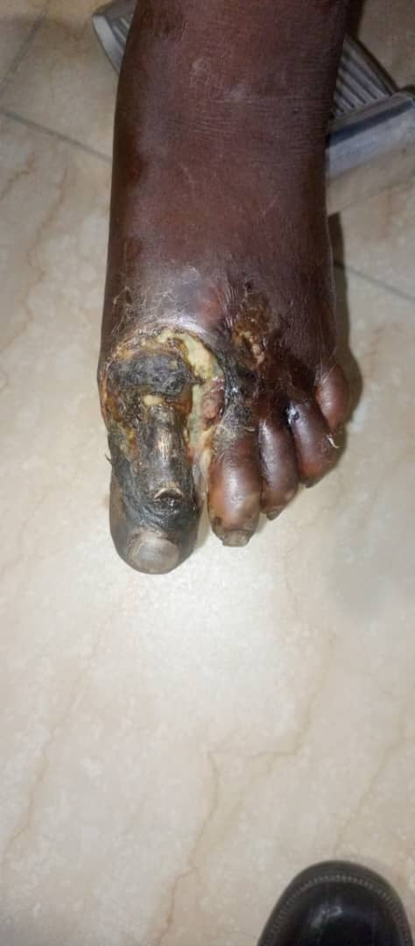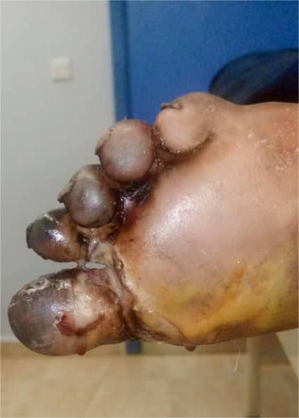

Fig 3: Below the left knee amputation
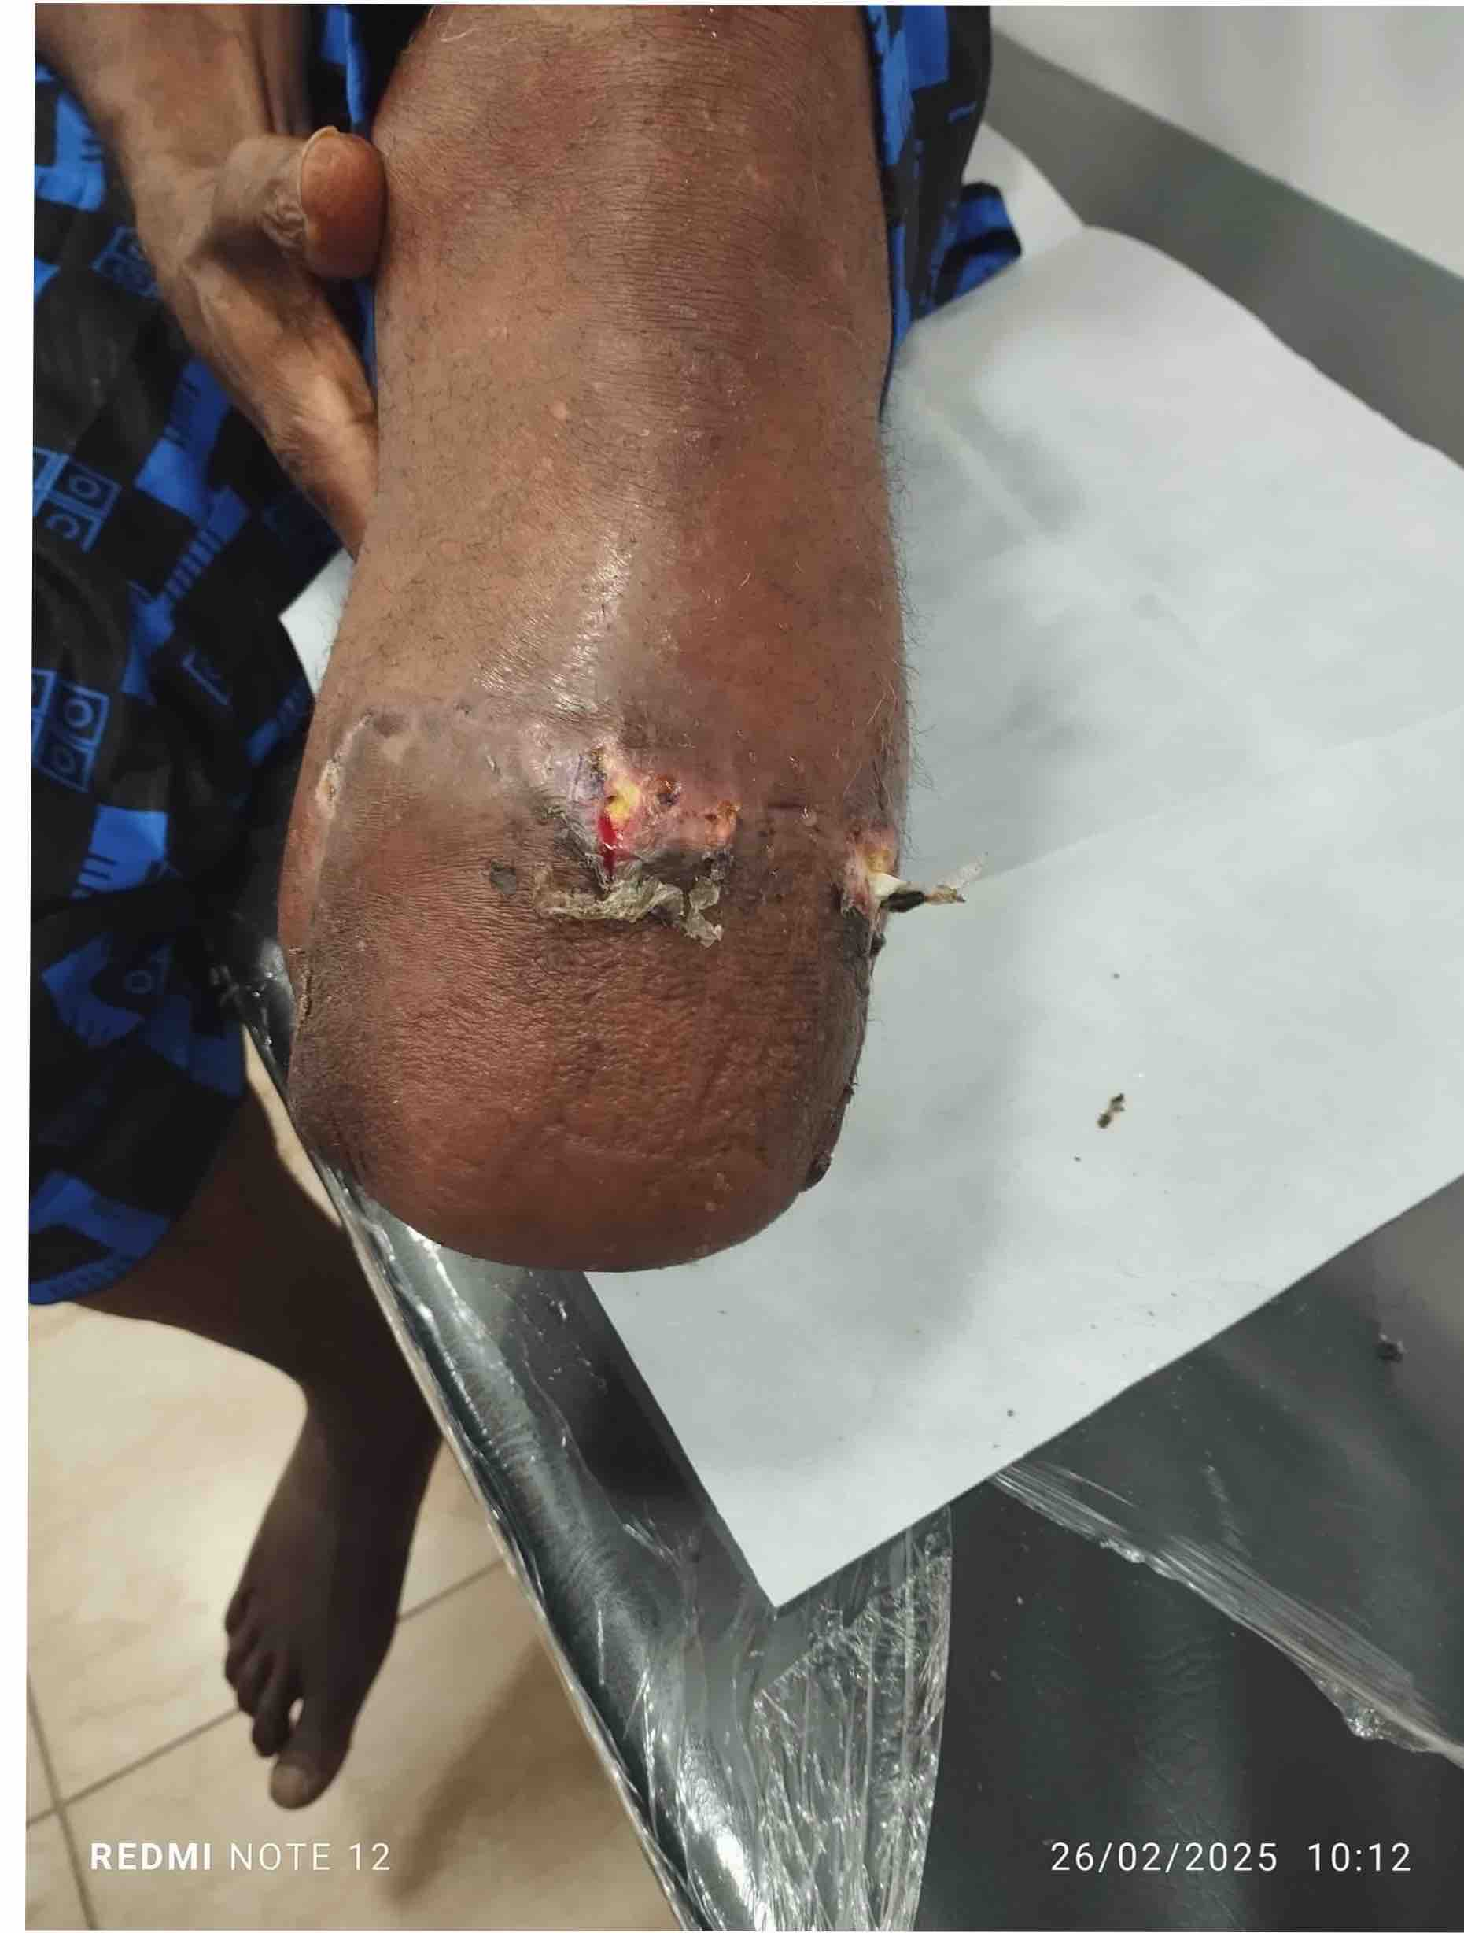

SHAPE \* MERGEFORMAT

Fig 4:Line graph showing pattern of platelet count
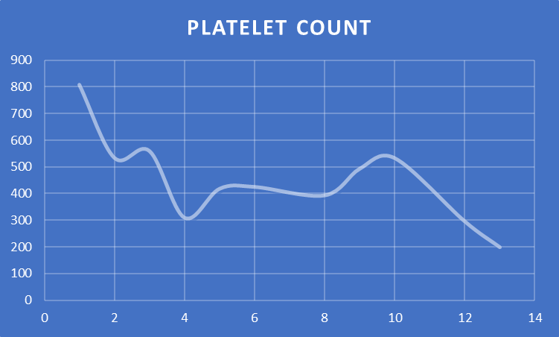
Platelet count
Weeks on antiplatelets and cytoreduction therapy

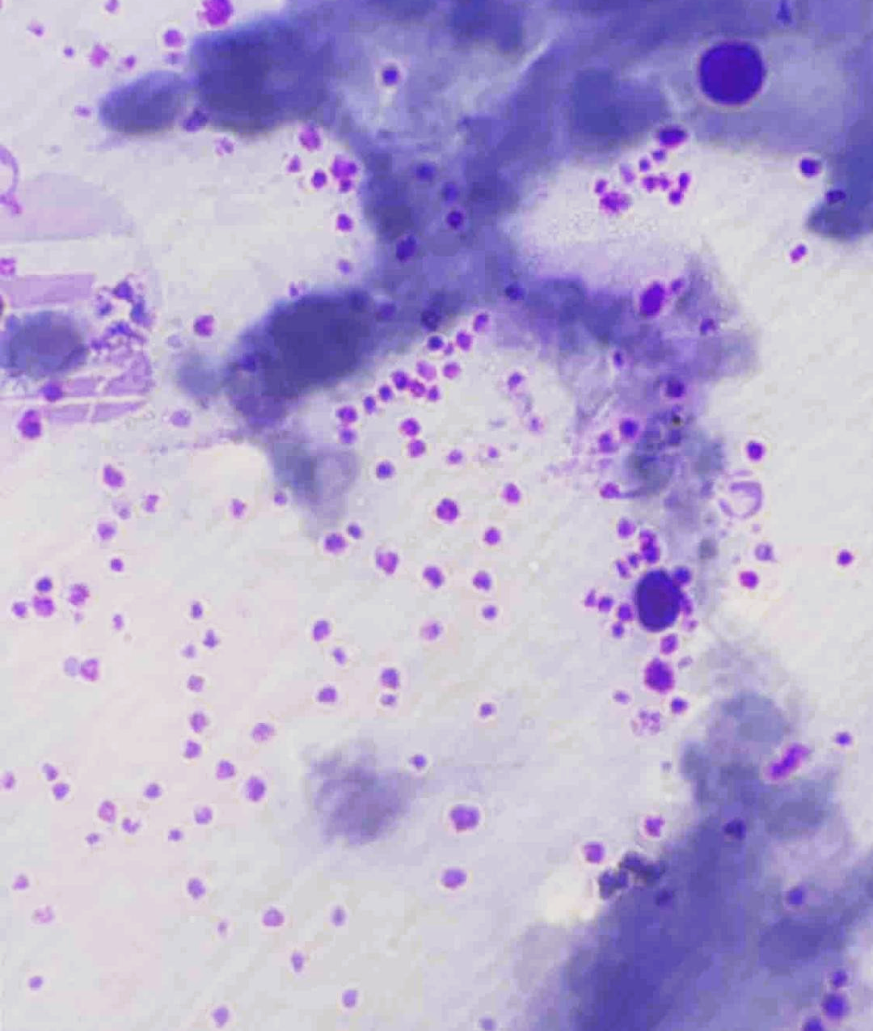
Fig 5: Peripheral Blood film

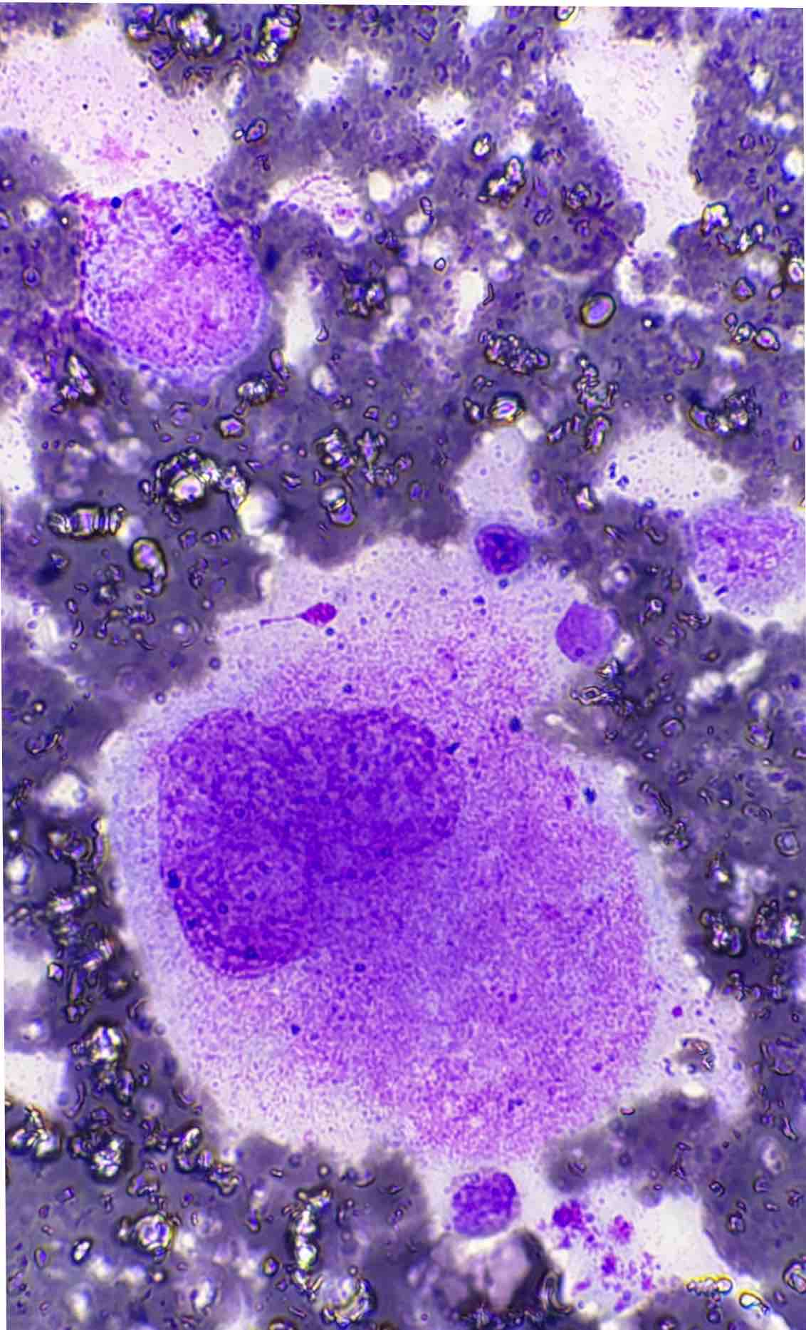

Fig 6: Bone Marrow Aspiration displaying clusters of megakaryocytes

- Discussion
Microvascular thrombosis occurs when small blood vessels (microvasculature) are blocked by blood clots (thrombi). This blockage is primarily the result of a complex interplay among endothelial cell dysfunction, platelet activation, and the coagulation cascade, often triggered by inflammatory processes. Such events can lead to tissue ischemia and potential damage to tissues or organs. [4, 11]

Essential thrombocythemia (ET) is often asymptomatic and is therefore frequently detected incidentally, particularly in facilities equipped to recognize it. The limited availability of specialized care in many community and general hospitals may contribute to the perceived rarity of ET. [11] As illustrated in this case report, if left untreated for extended periods, ET can lead to increased morbidity and mortality due to conditions that predispose patients to thromboembolic strokes, ischemic heart disease, and microvascular disease. These risks can be minimized by implementing measures to reduce the time to treatment. [4, 13, 14]
Several factors can negatively impact outcomes for patients being managed for ET or other chronic debilitating conditions. Key issues include a poor referral system, late presentation, and a lack of specialized expertise required to interpret routine hematological investigations, establish a diagnosis, and initiate prompt treatment.
In the case report, the patient presented to the hospital approximately twelve months after the onset of symptoms. A timely referral could have greatly benefited this patient if the primary medical condition had been identified earlier. According to the WHO's major and minor criteria for ET, the diagnosis was made based on the patient's clinical history, previous medical history of hemispheric ischemic stroke, and findings from the complete blood count, peripheral blood film, and bone marrow aspiration. Although the Janus Kinase 2 (JAK2) mutation—the major diagnostic criterion—was not detected in this patient, however, studies suggest that this mutation is only present in about 55% of ET cases.
Supportive laboratory findings for the index case diagnosis included elevated platelet counts of 809,000/uL, megakaryocyte hyperplasia, absence of causes for secondary thrombocytosis, and exclusion of features consistent with chronic myeloid leukemia. Furthermore, bilateral Doppler ultrasound revealed evidence of arterial stenosis, which could result from platelet aggregation or thrombus formation. Thrombocytosis and abnormal levels of D-Dimer of 1.5 mg/L, places this patient at high risk of arterial / venous thrombosis including acute ischaemic stoke. 14 D-Dimer is a soluble fibrin degradation product generated during the breakdown of cross-linked fibrin, and this often indicates coagulation activation and secondary fibrinolysis. [16]
The manifestation of occlusive vascular disease from ET in this patient is similar to findings from a study by Hussani et al., where out of ten patients analyzed, six presented with complaints ascribable to incipient gangrene of the toes, and several of these patients developed occlusions in the tibia and larger arteries while under observation. [17]
At the time of presentation, this patient exhibited signs of long-standing ET, including a dusky congested foot, numbness, erythromelalgia, cyanotic toes, and gangrene. The management plan put forward for this patient involved a multidisciplinary approach, incorporating an orthopedic surgeon, an internal medicine physician, and a haematologist. After all clinical consideration including ascending pathology, a below-the-knee amputation was opted as the appropriate surgical intervention, however, this intervention was delayed in order to have platelet reduced to less than 450,000/µL. The treatment plan included administering an anti-platelet agent (clopidogrel 75 mg daily) and cytoreduction therapy (hydroxyurea 1g daily).[12]
Elevated platelet counts, particularly those exceeding one million/uL, can lead to a disorder such as pseudo-Von Willebrand disease (pseudo-VWD), which can result in uncontrollable haemorrhage, especially during surgery. [18, 19] In such scenarios, therapeutic plateletpheresis is advised as an emergency measure to reduce platelet counts (Papadonikolakis A. et al.), however, this procedure was not indicated in this particular case.
The patient successfully underwent a below-the-knee amputation after extensive counselling, obtaining informed consent, and achieving satisfactory platelet reduction.
Notably, there was significant improvement in the reperfusion and overall health of the patient's right foot. The stump is being manged on an outpatient basis while discussions regarding rehabilitation and restoration of lost function are ongoing. To ensure comfortable ambulation, the patient is being guided on the option of obtaining a below-the-knee prosthesis.

- Conclusion:
Essential thrombocythaemia (ET) may not be as uncommon as previously suggested. [20] Patients with this condition often do not exhibit symptoms and may remain unaware of their diagnosis until they experience a sudden thrombotic event. Identifying this condition through routine laboratory tests requires the expertise of a haematologist, which is unfortunately lacking in many general hospitals in Nigeria. Early diagnosis is crucial for preventing complications associated with ET.

COMPETING INTERESTS DISCLAIMER:
Authors have declared that they have no known competing financial interests OR non-financial interests OR personal relationships that could have appeared to influence the work reported in this paper.

Reference
- Titilola Stella Akingbola, Olateni Asake Adeoye, Oluwafemi Akinyinka Akinwunmi. Management of Essential Thrombocythemia in a Resource-limited Country: A Nigerian Case Study. Annals of Tropical Pathology Journal / Annals of Tropical Pathology. 2018; 9: 2
- Rodrick B, Lucia M, Srdan V. A review of Essential Thrombocythaemia and its complications. Clinical Advances in Haematology & Oncology. 2023;23:2
- Essential Thrombocythemia - Blood Disorders - MSD Manual Consumer Version. Available at https://www.msdmanuals.com/home/blood-disorders/myeloproliferative-disorders/essential-thrombocythemia.
- Papadonikolakis A, Chloros G. D., Smith B. P. & Koman L. A.Digital Ischaemia Due to Essential Thrombocythemia. A case Report. The Journal of Hand Surgery. 2007; 32A.
- Cleveland Clinic. Available at https://my.clevelandclinic.org/health/diseases/24031-essential-thrombocythemia.
- Akingbola TS' and Aworanti OW. Essential Thrombocythaemia: A Phenotypic Spectrum with Polycythaemia Vera. Nigerian Medical Practitioner. 2018;74 (3-4):51-55
- Kelly J.M and Gilliland. A role for JAK2 mutations in myeloprolferative disease. Annu Rev Med. 2008. Available at http://pubmed.ncbi.nlm.nih.ng
- Marchetti A., Vignoli A., Balducci D.,Russo L., Guerini V., Barbui T. V617F JAK2 mutation in patients with essential thrombocythemia: related to platelet, granulocyte, and plasma hemostatic and inflammatory molecules. Experimental Hematology. 2007;35(1):1476.e1-147.e11.
- Damilola Ashorobi; Pouyan Gohari. Essential thrombocytosis. Statpearls publishings; 2023
- Patrick Olanrewaju Osho1, Maltida Adesuwa Ojo1, Evelyn Salewa Osho2. Profile of Polycythaemia Vera in South Western Nigeria. Nigerian Journal of Medicine. 2022; 31:4.
- Justyna K. Essential Thrombocytosis.Medscape. Ed: Emmanuel C.B.September 30, 2024. Available at https://emedicine.medscape.com
- Elisa Rumi, Mario Cazzola. How I treat essential thrombocythemia.
Blood. 2016; 128 (20): 2403–2414.
Available at https://doi.org/10.1182/blood-2016-05-643346

- Falanga A, Marchetti M, Vignoli A, Balducci D, Russo L, Guerini V, and Barbui T. V617F JAK-2 mutation in patients with essential thrombocythemia: relation to platelet, granulocyte, and plasma hemostatic and inflammatory molecules. Experimental Hematology. 2007;35:702-711
- Franchini M. Thromboembolic risk in hematological malignancies. Clin Chem Med 2015;53(8):1139-1147
- Liu Y, Li F, Sun H, Sun Y, Sun H, Zhai Y, Yang F, Wang J, Feng A, Zhao J, Tang Y. Combined prognostic significance of D-dimer level and platelet count in acute ischaemic stroke.Thrombosis Research. 2020;194:142-149
- Margaret C. Mudge. Hemostasis, Surgical Bleeding, and Transfusion. Chapter 4, 2012,Equine Surgery (Fourth Edition)
- Hussain S, Schwartz MJ, Friedman AS, and Chua NS. Arterial thrombosis in essential thrombocythemia. American Heart Journal. 1978;96(1):31-36
- Russell DS & Roth JG. Pseudo-von Willebrand Disease:A Mutation in the Platelet Glycoprotein 1bα Gene Associated With a Hyperactive Surface Receptor. Blood. 1993;81(7):1787-1791
- Weiss JH, Meyer D, Rabinowitz R, Pietu G, Girma PJ, Vicic JW and Rogers J. Pseudo-von Willebrand’s Disease- An Intrinsic Platelet Defect with Aggregation by Unmodified Human Factor VIII/von Willebrand Factor and Enhanced Adsorption of its High-Molecular-Weight Multimers. N Eng J Med 1982;306:326-333
- Johnson M, Gernsheimer T, Johansen K. Essential thrombocytosis: Underemphasized cause of large-vessel thrombosis. Journal of vascular surgery. 1995;22(4):443-449

