Original Research Article
A Dataset and A Dynamic Distributed Parallel Network for Identifying Divisors of Odd Composite Integers

Abstract: For a given odd integer N = pq , where p and q are prime factors satisfying 2 < p < q, we define a dataset that systematically accumulates multiples of p and q. This dataset is isomorphic to a rectangular lattice structure described in terms of rows and columns. We then design a dynamic distributed parallel network to search for a multiple of p or q, enabling the calculation of a divisor of N via the greatest common divisor (GCD) between the identified multiple and N. Experimental results demonstrate that the defined dataset provides a novel scenario for applying search algorithms to identify divisors of N and the designed dynamic distributed parallel network operates efficiently when paired with an appropriate search method.
Key words: Integer factorization, distributed parallel computing, randomized algorithm, lattice.

Introduction
The mathematical challenge of integer factorization has persisted as a fundamental research subject for centuries. Its cryptographic significance became particularly pronounced following the advent of the RSA cryptosystem, whose security framework is intrinsically predicated on the computational intractability of this problem. The theoretical foundation of RSA would be fundamentally compromised should an efficient polynomial-time factorization algorithm emerge for large integers. This critical dependency has driven sustained research efforts by cryptanalysts and number theorists to develop enhanced factorization methodologies.
As documented in foundational monographs [1-6] and comprehensive survey papers [7-17], the post-1970s era witnessed remarkable algorithmic evolution, yielding over a dozen distinct factorization approaches. These include: Pollard's rho method; Shanks' SQUFOF (SQUare FOrm Factorization); the Morrison-Brillhart CFRAC (Continued FRACtion method); Pomerance's Quadratic Sieve (QS); Lenstra's Elliptic Curve Method (ECM); the Number Field Sieve (NFS/GNFS); and quantum computing-based approaches. Despite this methodological proliferation, recent investigations [18-26] published within the past 5 years reveal persistent demands for improved factorization efficiency, particularly regarding cryptographically relevant integers, suggesting ongoing algorithmic innovation in this field.
A systematic review of factorization methodologies reveals that search mechanisms, randomization strategies, and parallel computation paradigms constitute three foundational pillars underlying both classical and modern integer factorization approaches.
The search component operates through systematic identification of integers sharing non-trivial divisors with the target composite number. This manifests through distinct implementations across algorithms: cycle detection in the Pollard-ρ method, square number exploration in SQUFOF, and elliptic curve point searching in ECM. Contemporary developments over the past two decades demonstrate accelerated integration of intelligent search heuristics, including Tabu search implementations (Sadiq A. T. [27], 2009; Candra A. [28], 2017), genetic algorithm-driven searches (Rutkowski E. [32], 2020; Mobin M. A. [33], 2024), Grover's algorithm of the quantum search (Dash A. [31], 2018), heuristic searches (Mishra M. [34], 2016; Fagin B.S. [35], 2021; Hittmeir M. [36], 2023), and Lévy flight-based divisor search and identification (Wang X. [37], 2024). Notably, the period 2015-2017 witnessed concentrated efforts in general search algorithm applications (Choudhury B. [29], 2015; Wang X. [30], 2017), highlighting sustained interest in search-space optimization techniques.
According to the Digital Library of Mathematical Functions (DLMF) assessment framework, randomized algorithms have revolutionized integer factorization research [38]. Classical factorization methods – including Pollard-ρ, SQUFOF, CFRAC, QS, ECM, and GNFS – fundamentally rely on randomization principles. Notably, even advanced intelligent search methodologies inherently incorporate stochastic components.
The evolution of parallel computing architectures has been instrumental in advancing factorization capabilities since R.P. Brent's seminal work [39]. Extensive adaptations of major algorithms (ECM, QS, SQUFOF, CFRAC, and GNFS) for parallel environments have been systematically demonstrated through [40–46], with subsequent extensions to distributed and grid computing paradigms [47,48]. Crucially, all successful factorizations of RSA numbers to date have leveraged parallel implementations. This establishes parallelism as an essential requirement for practical large integer factorization. An algorithm that lacks parallelizability would face substantial limitations in factoring large integers unless it exhibits exceptionally high speed.
It is evident that a high-quality dataset plays a crucial role in the application of search algorithms, regardless of whether the computing environment is sequential or parallel. Consequently, we have constructed an integer dataset focusing on multiples sharing divisors of a given composite odd integer, building upon our foundational research. This dataset is associated with a rectangular lattice region that can be easily searched using various algorithms in both sequential and parallel computing paradigms. We also propose a Distributed Dynamic Parallel Random Search (DDPRS) framework, which operates within this dataset as an example for identifying divisors of odd composite numbers. Our methodological innovations address the dual requirements of parallelizability and stochastic search efficiency, which are critical in addressing current factorization challenges.
This paper is organized as follows: Section 1 contextualizes the research landscape. Section 2 establishes formal definitions and notational conventions. Section 3 synthesizes relevant prior work from our research group. Section 4 details our technical contributions through theoretical analysis, algorithmic innovations, and empirical validation. Section 5 concludes with implications and future directions.

Terminologies, Symbols and Notations
This section contains the necessary symbols, notations, and definitions for further use.
Symbol means conclusion B can be derived from condition A. means both and . An integer interval means the set of all the integers bounded with integers a and b with ; for example, integer interval . If d is a divisor of integer h, h is called a host number of d , or a number hosting d, or simply a host of d, denoted by symbol . If an integer interval contains integer x, that integer interval is called a host interval of x. If a two-dimensioanl region (zone, area) contains integer point P, that region (zone, area) is called a host region (zone, area) of P. A finite set is called a computing cell if the set is used to compute something. A computational base, or simply a base, which originates from the concept of an artillery base, refers to the minimum number of computational tasks a processing unit is scheduled to complete within its designated time frame. The base of a multi-core computer is the multiplication of the number of its cores with the base of an individual core. A complete partition of a set S is to divide S into finite subsets, say ,..., and , such that and for, where . For positive integers a and b, integer is called the gap between a and b. Symbol means a gap taking value x. Symbols and are respectively the floor and ceil functions such that or , where is the fractional part of x.
For an odd composite integer N , 'a host of N's divisors' can sometimes be simply called 'a host' in the case that there is no misunderstanding, and likewise, 'the hosts of N's divisors' can be said to be 'the hosts'.

Our Previous Research Results
For an odd composite integer N=pq with as odd prime factors, the prime divisors p or q can be determined by computing the greatest common divisor (gcd) of N and any integer sharing a nontrivial factor with N. The central challenge lies in developing an efficient methodology for rapid identification of the hosts. Building upon this foundation, our prior investigations have systematically addressed four critical dimensions: distribution characteristics of the hosts, densification strategies for enhancing host integer concentration, optimized search protocols for host integer detection, and parallel computing architectures to accelerate the search process.
This section concisely summarizes these foundational results, which underpin the subsequent analytical developments presented in this work.

Distribution of the Hosts
Lemma 1[49]. Let q be a positive odd number, be a set composed of consecutive odd numbers; if is a host of q, then so it is with .
Lemma 2[50]. Given an odd integer with divisors p and q satisfying ; let . Then the integer interval contains hosts of N's divisors if ; otherwise it containshosts of N's divisors.
Lemma 3[50]. Given an odd integer with divisors p and q satisfying ; let . Assume is the probability of picking randomly a host of N's divisors in ; then
.
Lemma 4[51]. Let be an odd integer and integer interval , where p and q are odd integers with and ; then for each pair of and in satisfying , it holds
,
and there exists a pair, still say and satisfying.
Lemma 5[52]. Let p and q be odd integers with ; then there is not a host of q between and . There are at least two hosts of p between and ; particularly, and are exact two hosts of p between and if .
Lemma 6 [52] . Given an odd integer , where p and q are odd integers such that and with being an integer; let be an integer interval. Then in , each of , and symmetrically occurs twice between two adjacent hosts of N's divisors, whereas totally occurs times across p distinct subintervals in a symmetric manner. Furthermore, there exist exactly subintervals in each of which occurs times.

Distribution Trait of the Hosts In Their Hosting Interval
Let be an odd integer with divisors satisfying ; then from 1 to N−1 there are hosts of q and hosts of p, totally hosts in the integer interval . Let be the probability to pick randomly a host in ; then
. (1)
It surely follows
,
indicating one successful pick for a big p is like finding proverbial needle in the haystack.

Densification of the Hosts
Paper [53] proposed a method to make the hosts a denser distribution by Cartesian subtraction and obtained a sequence of the form
,
where is a lower bound of p, and g is the multiplicity of the terms.
By this means, a host accumulates together to g times every time it occurs and the its total number is increased by g times. Hence the densification increases the probability of a successful pick for a local search. Paper [54] investigated the case g=1 in detail. It demonstrated that taking and led to a pq-band Ξ that has a more concentrated distribution of the hosts, where Ξ is given by
.
Ξ is easily seen to have ridges (defined in paper [54]) each one identified with a unique integer in . Therefore, Ξ consists of host ridges and non-host ridges. Each term is a host on a host-ridge, whereas there is not a host on a non-host ridge. For example, with symbol 'o' to express a host and '.' to express a non-host, taking N=21 obtains the Ξ-zone as Figure 1 shows.
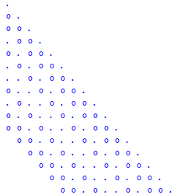
Figure 1: The Ξ-zone calculated by N=21

The Ω-Zone
Paper [55] constructs an Ω-zone of the following form.
.
By using X and Y to represent the indices of the row and column from top to bottom and from left to right, respectively, the term at row X and column Y is calculated by
, (2)
and the four borders of the zone are
line , line , line , and line .
The Ω-zone is easily to be computed, as exampled in Figure 2 for N=21 and g=2.
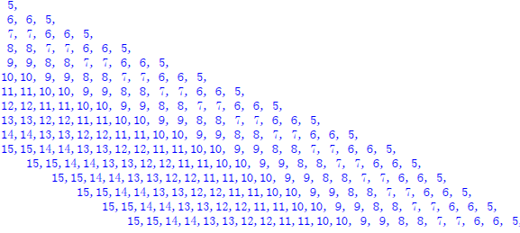
Figure 2: The Ω-zone calculated by N=21 and g=2.
In order to see the hosts and non-hosts, Figure 2 is alternatively depicted with Figure 3. It is seen that the hosts are accumulating by g times locally here and there, even though they are sparsely distributed globally. This is described to be a property of local accumulation in global sparse distribution of the Ω-zone, for convenience.
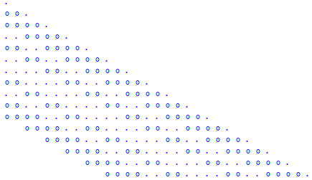
Figure 3: Hosts and non-hosts in the Ω-zone of N=21 and g=2

Search with Monte Carlo Method
Paper[56] proposes a deterministic-embedded Monte Carlo approach to find out a hidden host within an expected computing time (ECT) in a large interval I_{N} that contains n odd integers. By defining an odd integer of the form and expressing n to be an integer of the formwith , the large interval IN is subdivided into two parts by
wherecontains consecutive odd integers,contains R consecutive odd integers, and .
Since can be further subdivided intosubintervals, say ,,..., and , each containingodd integers, the Monte Carlo sampling method is applied to select a subinterval from the subintervals, where integer is a pseudorandom number generated by the linear congruential generator (LCG) . As a result,can be searched out within steps. It is evident that a host in can be found inevitably, and the more host subintervals there are, the greater probability a host is found.
It should be clarified that the LCG with , is utilized for generating pseudorandom numbers, is referred to as the Monte Carlo selector in this paper.

Search With Random Walk
According to the property of local accumulation in global sparse distribution of the Ω-zone, papers [53] and [55] have explored search with random walk.
Let and be identically distributed (iid) random variables, or alternatively random steps, a random walk is defined by
Each move (or step) of the random walk can be regarded to be a random selection of a host in the Ω-zone and the whole process is surely the Bernoulli trials. If the random steps are drawn from the uniform distribution, is a simple random walk (SRW), whereas, it is the Lévy flight (LF) in the case that the random steps are drawn from the isotropic symmetric Lévy stable distribution. The characteristic function of the LF is given by
where real α is a scale coefficient and real β is the Lévy index.
When , the LF turns to be the Brownian motion (BM) whose iid random steps are drawn from the Gaussian distribution [57][58].
With 'footprint', the three different random walks, the SRW, the BM, and the LF, are intuitively illustrated with Figure 4. Seen in the footprints, the SRW is nearly-uniformly distributed, the BM is more concentrated near a center, and the LF is alternated between frequent short-distance jumps and occasional long-distance jumps. Therefore, the LF is regarded to be suitable for search in an area in which the targets are distributed in the way of local accumulation in global sparse distribution, whereas, the SRW and the BM are suitable for local searches. The BM is particularly good for the case that there is some reference (clue) to locate searched target while SRW is more suitable for the local blind search.

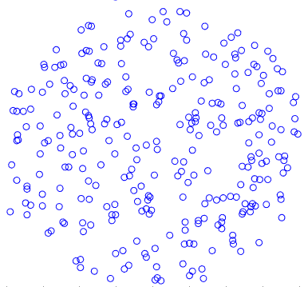 | 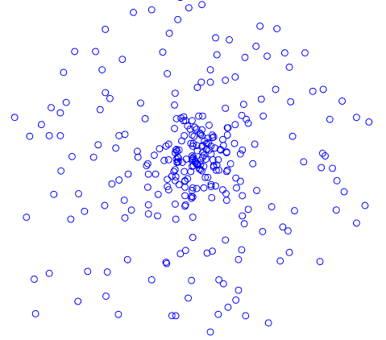 | 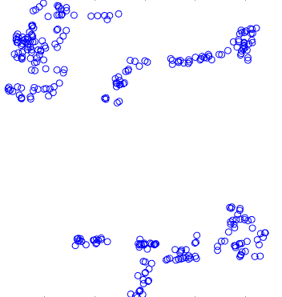
(a) The SRW | (b) The BM | (c) The LF
Figure 4: Footprints of the SRW, the BM, and the LF

Parallel Strategy
As overviewed in the introductory part, parallel computing is essential for factoring a large integer. We have naturally touched this topic. In the papers [59], parallel strategies are proposed to meet the different needs. The main work of this issue is to create independent computing subspaces so that a parallel computing thread can perform its computations in a specified subspace.

Challenges and Limitations Identified in Prior Studies
Two categories of challenges were encountered in previous research: systematic issues, referred to as hardness, and algorithmic issues, termed softness. Hardness primarily concerns computational environments, encompassing both hardware and software infrastructure. For instance, as noted in [55] and [60], there is an insufficient supply of multi-core computers for parallel computing applications and limitations in handling large integers and random number generation, among other constraints. Softness issues, on the other hand, pertain mainly to the determination of computational parameters within specific algorithms, such as the starting point, step size, and local region, when employing random walk (RW) search methods and the Monte Carlo-based ECT.

New Research Issues and Results in This Paper
Regarding the probability of randomly selecting a host, Corollary 13 of [54] defines a rectangular sub-zone within the Ω-zone and proves that the rectangular sub-zone is better than the entire Ω-zone. That rectangle is oriented at an angle relative to the horizontal line, complicating its formulation and analysis. Subsequently, we identified a horizontally aligned parallelogram sub-zone with equivalent probability to that rectangular sub-zone. Through an isomorphic mapping of this parallelogram sub-zone onto a new rectangular sub-zone, we developed a partitioning strategy to divide the new rectangular sub-zone into a series of independent sub-spaces (ISSs). We then established a dynamic distributed parallel system to conduct random searches for the hosts within these ISSs. This section summarizes our research findings.

A Rectangular Hosting Zone
A parallelogram sub-zone, denoted by , can be taken from the Ω-zone by
.
is made up of rows each having columns. It therefore has totally terms. Still use X and Y to denote the indices of the row and column, from top to bottom and from left to right, respectively; the term at row X and column Y is then calculated by
, (3)
and the four borders are given by
line , line , line , and line .
Or alternatively
, (3*)
with the four borders given by
line , line , line , and line
Take N=21 and g=2 for instance; then and , the Π-zone is calculated as Figure 5 shows.
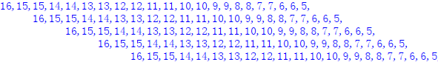
Figure 5: The Π-zone calculated by N = 21, g = 2, p_{b} = 4, and p_{u} = 16.
Being a parallelogram, Π can be isomorphically mapped onto a rectangle by
. (4)
This rectangle is referred to as the isomorphic rectangle of Π , and its elements are determined by
. (5)
For example, Figure 6 is the isomorphic rectangle of Π defined in Figure 5.
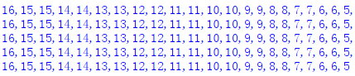
Figure 6: Isomorphic rectangle of Π
The isomorphic rectangle is significantly more straightforward than the parallelogram when it comes to computational tasks; therefore, it will serve as the primary object of computation hereafter and will continue to be denoted by the symbol Π unless otherwise specified.

Distribution Trait of the Hosts in Π
The original Π-zone inherits the distribution trait of the Ω-zone. That is, the hosts are accumulating locally here and there despite their sparse distribution globally. Figure 7 intuitively illustrates such a distribution.
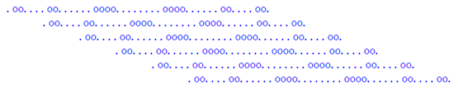
Figure 7: Hosts and non-hosts in the Π-zone of N = 35, g = 2, p_{b} = 5, and p_{u} = 29.
In the isomorphic rectangle, the hosts and non-hosts are laid out tidily in rows and columns, still keeping their local accumulation in global sparsity, as seen in Figure 8 generated by N=35, g=2, p_{b}=5, and p_{u}=29.
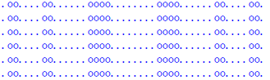
Figure 8: Hosts and non-hosts laid out tidily in the isomorphic rectangle

Probability of Randomly Selecting Hosts in Π
The hosts exhibit a distribution pattern of local accumulation within a global sparsity in Π. To assess the ease or difficulty of identifying a host, we have investigated the probability of randomly selecting a host across three scenarios: single-term, multi-term, and selection from a complete partition. Theoretical results indicate a higher probability appears in the selection from a complete partition.

Single-term Selection
Assume ; let , , and . By Lemmas 2, 4, and 5, each row of Π containshosts. Consider draw randomly an individual term in a row of Π. The probability that the selected term is a host is given by
. (6)
Given that Π comprises rows, the probability of randomly selecting a host via a single draw fromis calculated as
. (7)
It is evident that, holding
. (8)
From (6) and (7), it can be seen that,, and g are three critical factors that influence the probability. By Lemmas 4, 5, 6, and the fact, when taking and , each row changes the total number of the terms to and the number of the hosts to . Consequently it yields
. (9)
Comparing (8) with (9) knows that is better than if . Henceforth is regarded as the default case from now on unless otherwise specified. Furthermore, due to , either (8) or (9) yields when
, (10)
indicating that the minimal probability is around , which is a very small number.
Picking a host randomly is surely a Bernoulli process; hence the probability of selecting a host successfully after n times of picking is calculated by
, (11)
by which n is estimated by
. (12)
It is also known from (11) that can reach an appreciate value with the increase of n. For instance, Figure 9 exhibits the cases of and with . Observably, gradually approaches 1 with the increase of n.
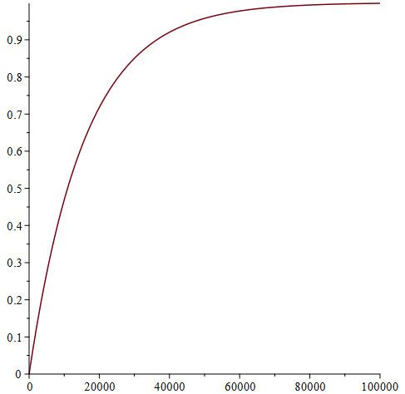 | 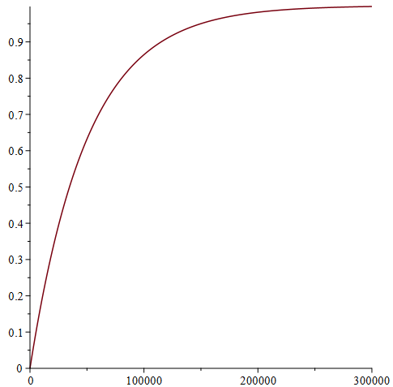
(a) N=10⁹ | (b) N=10¹⁰
Figure 9: Distribution of
On the other hand, it is also seen from (12) that a large N may lead to a very big n for an appreciate because , which means it will take a long time to find a host. From (12), it is evident that the only way to reduce n is to increase . This can be done by augmenting g in (8) and (9). Unfortunately, either (8) or (9) shows that it cannot be raised to a very large extent for a large N even with a considerable g. Consequently, an alternative approach is required for the random selection in Π.

Multi-term Selection
When selecting multiple terms simultaneously, imagine n terms are chosen in a single draw. The probability of having at least one host among the chosen n terms, denoted as , can be calculated by
, (13)
where is the combinational coefficient, represents the total number of the terms in Π, and denotes the total number of the hosts in Π.
Denote . In the case , it follows, , and , leading to
. (14)
In the case , it results in
. (15)
With (14), (15), (13), and (11), it is easy to obtain
. (16)
saying the multi-term selection is better than the single-term selection. Furthermore, (13) also indicates that a bigger n is better than a smaller one.

Selection on a Complete Partition of Π
The multi-term selection can be conceptualized as a single-term selection conducted on a set of subsets derived from Π, selecting one subset at a draw. This time, a complete partition of Π is necessary to ensure that all the hosts are accounted for and to prevent any leakage or overlap. Assume Σ is the required complete partition, which divides Π into m distinct sub-zones, say ,..., and , as illustrated with Figure 10.
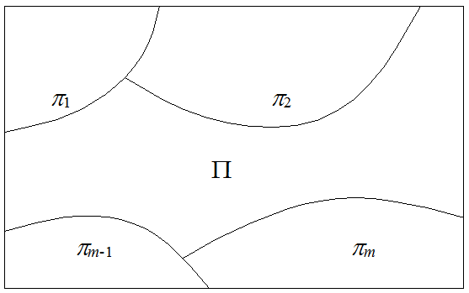
Figure 10: A complete partition of Π
Suppose is the probability of randomly selecting a host in sub-zone by the single-term selection; assume each sub-zone can be randomly chosen with an equal probability, namely, . Then, the total probability with respect to the partition Σ is calculated by
. (17)
This indicates that there must be at least a sub-zone such that because is the arithmetic mean of and . Since the total number of the terms in is less than that in Π, it takes less time to search in even with a brutal search. Therefore, a proper partition is mandatory for searching the hosts in a large region. Additionally, a complete partitioning approach offers an extra advantage: it enables the entire Π to be computed through parallel processing.

Distributed Parallel Random Searches on Π
Let L and W represent the number of columns and rows, respectively. Then , , and (when ). L and W are significantly large for a large N, resulting in a huge Π. This scenario frequently necessitates applying parallel searching techniques to find a host. We thereby have investigated methodologies for implementing distributed parallel techniques and developed two distinct systems: a dynamic distributed parallel system and an extended dynamic distributed parallel system. In the dynamic distributed parallel system, each individual computer (machine) functions as a single computing node, while the extended dynamic distributed parallel system regards a cluster of computers as a single computing node.
Both systems employ randomized algorithms for selection and search. The search process employs various algorithms, including Brutal Search (BS), Simple Random Walk (SRW), Brownian Motion (BM), Lévy Flight (LF), and even machine-learning-based approaches. For the sake of conciseness, these search algorithms are collectively denoted by the symbol X. Accordingly, the dynamic distributed parallel random search system is abbreviated as DDPRX or D²PRX, while the extended dynamic distributed parallel search system is represented as eDDPRX or eD²PRX.
Given that partitioning the large Π is essential for efficient distributed parallel computing, we propose a three-tiered partitioning strategy to meet the requirements of both D²PRX and eD²PRX. Additionally, we introduce an approach for creating computing cells within the partitioned sub-zones.
Parallel computing entails concurrently executing multiple processes across distinct cores within multi-core processors. Consequently, the term 'process' is frequently employed in parallel computing literature. Nonetheless, this section opts for the term 'core' to underscore the architectural foundation of the computer system.

Partition Strategy
Two critical factors are paramount in the design of a partition: the dimensions and configuration of the subspaces that constitute the entire computational space. The dimensions influence the probability of randomly selecting a host, while the configuration affects the complexity of the partitioning process. Various methodologies exist for partitioning a rectangular domain like Π; one of the simplest methods involves dividing Π into a series of uniformly sized smaller rectangles (or squares), as illustrated in Figure 11. This approach exemplifies a basic configuration, where the size of the subspaces becomes the primary determinant. However, given the hosts' distribution characterized by local accumulation amidst global sparsity, some smaller rectangles may remain devoid of hosts unless they are sufficiently large. Given that larger rectangles may reduce the probability of randomly selecting a host within them, this partitioning method exhibits certain limitations in practical applications unless the hosts are densely distributed everywhere.
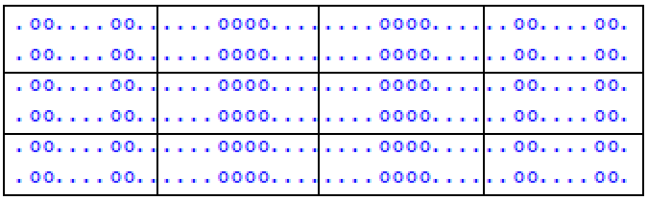
Figure 11: Partition the isomorphic rectangle with small rectangles
There are two other fundamental partitions with a simple configuration: row-based and column-based partitions. The row-based partition divides the whole space into a finite number of subspaces, called sub-zones later, each consisting of multiple rows, while the column-based partition segments the area into a finite number of sub-zones, each comprising multiple columns. These two distinct partitions are illustrated in Figure 12. Unlike the simplest partition, which features uniformly sized sub-zones, the sub-zones resulting from either of these two partitions may vary in size. Consequently, devising an appropriate sizing strategy is crucial for effectively utilizing these partitions.
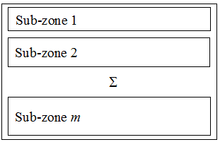 | 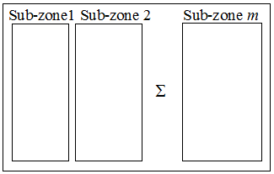
(a) Row-based partition | (b) Column-based partition
Figure 12: Row-based and column-based partitions
In light of the distribution characteristics of the hosts within , the column-based partitioning approach is more likely to generate some sub-zones that have higher probabilities of randomly selecting the hosts. Consequently, we employ the column-based partition.

A Three-tiered Partition
Assuming n distinct multi-core computers are involved in the computation, the three-tiered partition (TTP) first aims to allocate an ISS for every computer, thereby partitioning  into n ISSs, sayand , such that for and ,
,.
As a result, each computer is responsible for processing one ISS.
The TTP next targets allocating independent sub-zone (ISZ) for every core within a single computer. Assuming that ISS , where , is processed by a computer having cores, is further divided into ISZs, designated as and , such that for and
,.
Consequently, each core is available to handle one ISZ independently.
The TTP subsequently establishes on the ISZ independent computing cells (ICCs) from which the core can randomly select and search. Under this consideration, an ISZ, such as , is decomposed into a series of ICCs, represented as ,and , totally cells, such that for and
,.
Then each core randomly selects an ICC and performs necessary computations on the chosen cell.
The hierarchical structure of TTP is illustrated in Figure 13, where the topmost node represents Π, and each subsequent node corresponds to a specific partition.

Π
Independent
subspace H₁
Independent
subspace H₂
Independent
subspace H_{n}
Sub-zone S₁₁
Sub-zone S₁₂
Sub-zone S_{1m}
......
...
......
......
Sub-zone S_{ns}
......
Computing cell
Computing cell
Computing cell
......
Computing cell
Computing cell
Computing cell
......
......
......
......
......
......
......

Figure 13: Architecture of the three-tiered partition of Π
There are several critical issues in the three-tiered partition, as outlined below.
4.5.2.1. Columns contained in ISSs
Π contains columns that are broken up into a series of the ISSs. Because the ISSs are allocated to computers sequentially, the number of columns in an ISS is determined by the computational capability of the assigned computer. Typically, each core is designed to process a specific number of columns, which must align with the base B of that core. Consequently, a computer contributing m cores can process mB columns concurrently. Therefore, the number of columns in the ISS varies based on the computational contribution of the assigned computer.
4.5.2.2. Columns contained in ISZs
For ISS containing columns that are to be divided intoISZs, let , where ; then each of the first ISZs, and , comprises s columns while the last one consists of columns.
4.5.2.3. ICCs in ISZs
Consider dividing the ISZ containing columns into ICCs, where and , assuming that each of the first ICCs contains the same number of columns while the last one contains a different one. Given that the ICCs are intended to be randomly selected and searched, is proposed to be of the form so that the Monte Carlo selector can be utilized. This can be achieved by expressing in the form of
, (18)
where .
Consequently, comprises groups, each encompassing columns, along with one additional group including columns. These groups constitute ICCs, say, and .
For example, can be expressed by
resulting in , and .
In general, when expressed in binary form, an integer u can always be represented as
, (19)
where or 1, . Through this method, M,, andcan be easily derived.
4.5.2.4. Dimension of the ICCs
Because the rows of Π are identical, the ICC is proposed to be a square, meaning it comprises an equal number of rows and columns.
Note that the base B of a core is the minimum number of the columns the core searches; referring to the previous section, letting B be of the form can yield ICCs, each containing columns. This time the square principle results in that the dimension of an ICC is .

D²PRX
The D²PRX is analogous to grid computing; it operates within a network open to computers that voluntarily participate in computational processes. This section overviews the system's operational mechanism and underlying algorithms.
4.5.3.1 Working Mechanism
Regarding the multi-core computers participating in the computation as a computer queue, the D²PRX registers each computer with an unique integer identifier (ID), denoted by cID. It sequentially assigns an ISS from the unallocated portion of Π to each computer for computation according to FIFO principle of the queue. This allocation process continues until either the expected result is achieved or the entire Π is allocated. Figure 14 illustrates this scenario. In the figure, the arrowed curve represents the 'allocation' and the waved curves mean the omitted contents. The term 'dynamic' in the D²PRX signifies that computers can join the queue at any time, while 'distributed' indicates that each computer independently contributes its computational resources and executes computations (or searches) using its designated algorithm. Every computer divides its allocated ISS into ISZs according to the number and the base of its available cores , assigning each core a distinct ISZ for computation. Each core constructs its ICCs and performs searches on randomly selected ICCs.
The D²PRX designates a specific computer, referred to as the root-host, to handle communication and collection of system status information. The information is recorded in a resource configuration table, denoted as rgTable. The rgTable records the global parameters for the computation, the cID of the last computer that has been assigned an ISS, and the overall job status of the system. This information enables a newly joined computer to ascertain whether the task has been completed and, if not, where to obtain its ISS.
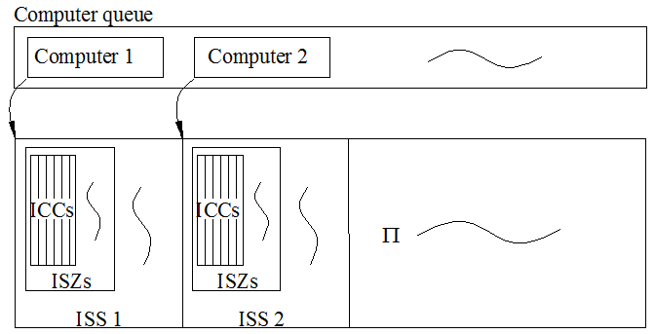
Figure 14: Illustration of D²PRX
Initially, the newly joined computer registers itself to the root-host with its own information and asks for the location of its ISS, provided that the entire task has not been completed. Following the retrieval of necessary information from the rgTable, it proceeds to execute computational tasks, which encompass calculating an ISS for itself, planning ISZs for its cores, and initializing the cores to establish their ICCs and conduct stochastic searches on the ICCs. Upon task completion, it records its results locally, reports them to the root-host for documentation, and then exits the system. If the task is completed successfully, ie. a host is identified, the root-host broadcasts a message to all other computers to cease their computations.
4.5.3.2 Algorithm Description
The D²PRX algorithm requires three input parameters: N, an odd composite integer one of whose divisor is to be found; m, the number of cores participating in the computation; and B, the core's base. The N-S chart of this algorithm is illustrated in Figure 15, described with pseudo-C language. As depicted, each computer initially verifies and updates its registration information, subsequently calculates the ISS for itself and the ISZs for its respective cores, and then initiates the cores to conduct searches on randomly selected ICCs. The subroutine designated as 'Search' in the algorithm refers to the search algorithms X described in earlier sections, and it returns the found divisor.

Key Issues
Seen from the algorithm's N-S chart, the multiplicity g, the base B, and the subroutine 'Search' are key issues. Here introduce their solutions, respectively.
4.5.5.1 The multiplicity g
Theoretically, the bigger g is, the more hosts are accumulated somewhere. Nevertheless, by , a large value of g also results in a proportionally large L, thereby increasing the search time. It is crucial to strike an appropriate balance between these two parameters. Referring to subsection 4.4.2-5 of [55], g is proposed to be
, (20)
where η is given by
. (21)
4.5.5.2 The base B
B is a metric that quantifies a computer's computational capability, which varies across different computers. For example, a processor core operating at 4.0 GHz generally exhibits superior processing performance compared to one at 3.0 GHz. Consequently, the computer owner or contributor must provide the base B as an input parameter. Given that the core serves as the fundamental unit in parallel computing, B typically denotes the processing capability of a single core. Any computer participating in computational tasks must specify its core base B.
In general, B can be estimated based on the clock speed of the core. Assuming the clock speed of a core is b GHz, and given that 1 GHz=2³⁰ Hz≈ 10⁹ Hz, the processing capability C of the core per hour can be approximated by
.
Suppose the contributor wants to contribute 100 hours' computation; then
.
Referring to subsection 4.5.2.4, B is proposed to be of the form
.
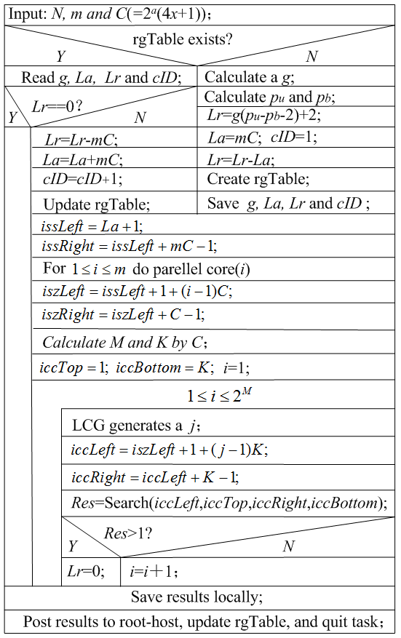
Figures 15 N-S chart of the general algorithm.
4.5.5.3 The search algorithm X
As aforementioned, each computer can choose its preferred search algorithm to execute the search on its ISS, including BS, SRW, BM, LF, and even machine-learning-based approaches. Considering that the partition possibly generates a certain number of ISSs contain an accumulation of hosts due to the characteristics of Π's structure, stochastic local search algorithms [20] are proposed to use in general.

Time Complexity and Space Complexity
The entire search process continuously computes the value of , where is defined in equation (3). Consequently, an individual computation's time complexity depends on N, X, and ISS, whereas the space complexity is solely dependent on N.
4.5.5.1 The time complexity
Let be the total number of the lattices in the ISS a computer randomly searches; then the best case of the search takes just one step, taking times, whereas the worst case takes times. Using and to denote the time complexity in the best and the worst cases, respectively; it follows
(22)
and
.
Since , it yields , saying
, (23)
where is a finite real constant.
4.5.5.2 The space complexity
It takes binary bits to store N, , and d. Along with other data, the space complexity of an individual computer is, where is a finite real constant.

eD²PRX
Let
be a queue of computer clusters such that
,
where s is a definite positive integer and with is a multi-core computer of base .
Then Q constitutes eD²PRX if the following conditions are met:
1). Q functions within a network environment.
2). Once established,remains unchangeable and is responsible for computing an ISS.
3). Each clusterappoints an agent or representative, denoted as , to manage both internal and external communications as well as the aggregation of system status information.
4). Computers within clustercan only communicate with.
5). Each computer is assigned an ISS to perform computations.
6). A designated computer within Q serves as the root-host, analogous to that in D²PRX.
7). The root-host of Q maintains communication with every representative.
The eD²PRX operates on the same principle as the D²PRX, treating a cluster as a single computer and an individual computer as a core. As a result, both the eD²PRX and D²PRX can be operated using the same algorithm, as illustrated by the N-S chart in Figure 15.

Numerical Experiments
Using 40 computers equipped with Intel(R) CoreCM i5-10500 CPU @ 3. 10GHz, 16GB memory, and Windows 10 OS, each one contributing a processing capability of 6×10¹² per hour. Taking experimental data from paper [33], we perform the numerical experiments via Python. In the experiment, we take a fixed g=30 and designate brutal search as the local search approach. A computer is assigned an initial cID to start its computation first, and automatically relays the computing as a new role after it completes its task without obtaining the expected result. The Python source codes can be accessed in where [62] shows, and the results are list in Tables 3-7 in the Appendix section. In the tables, Time A is the computing time with D²PRX and Time B is taken from [37], respectively.
Conclusions can be surely obtained from the experiment:
1. The region Π can be indeed available for a dataset to identify a divisor of an odd composite integer.
2. D²PRX works better than the method introduced in either [33] or [37] for a bigger N.
3. New better method is still in need to have a better efficiency than D²PRX.

Conclusion and Future Work
For the given odd integer N = pq, the dataset Π constructed in this paper can accumulate hosts of p and q locally here and there in a global sparse distribution. This characteristic provides a way to develop new searching algorithms to find a host and thus to calculate a divisor of N, helpful to solve the hard problem of integer factorization. The method of D²PRX designed in this paper indicates that there exist expected approaches worthy of our further attempts to reach the goals. We will continue to explore better method and hope more scholars to join us.
Disclaimer (Artificial Intelligence)
Author(s) hereby declare that NO generative AI technologies such as Large Language Models (ChatGPT, COPILOT, etc) and text-to-image generators have been used during writing or editing of this manuscript.

References
- Hans Riesel. (1994). Prime Numbers and Computer Methods for Factorization(2nd Edition), Birkhauser.
- Crandall R, Pomerance C. (2005). Prime Numbers: A Computational Perspective(2nd Edition). New York: Springer-Verlag.
- Shi Bai. (2006). Computer Methods for Integer Factorization and Discrete Logarithm: A Cryptographic Perspective. Mater Thesis, Australian National University.
- Yan S Y. (2013). Computational number theory and modern cryptography. Wiley & Higher Education Press.
- Alfred J Menezes, Paul C van Oorschot, Scott A Vanstone. (2018). Handbook of Applied Cryptography. CRC press. DOI:10.1201/9781439821916
- Joppe Bos, Martijn Stam . (2021). Computational Cryptography: Algorithmic Aspects of Cryptology. Cambridge University Press.
- Wunderlich M C. (1988). Computational methods for factoring large integers. Abacus, 5(2), 19-33.
- Peter L Montgomery. (1994). A Survey of Modern Integer Factorization Algorithms. CWI, 7(4), 337-365
- Pomerance C. (1996). A Tale of Two Sieves . Notice of The AMS,1996, 43(12), 1473–1485.
- Arjen K Lenstra. (2000). Integer Factoring . Designs, Codes and Cryptography, 19, 101-128.
- Kefa R. (2006). Review of Methods for Integer Factorization Applied to Cryptography. Journal of Applied Sciences, 6(2), 458-581.
- Wanambisi A W，Aywa S, Maende C，Muchiri Muketha G. (2013). Advances in Composite Integer Factorization, Methematical theory and Modeling, 13(2), 86-90.
- Sonal Sarnaik, Dinesh Gadekarand Umesh Gaikwad. (2014). An overview to Integer factorization and RSA in Cryptography . International Journal for Advance Research in Engineering and technoloy, 2(9):21-26
- Duta C L, Gheorghe L, Tapus N, (2016). Framework for evaluation and comparison of integer factorization algorithms, 2016 SAI Computing Conference (pp.1047-1053), London, UK,.
DOI: 10.1109/SAI.2016.7556107.
- Zhang X, Li M, Jiang Y, Sun Y. (2019). A Review of the Factorization Problem of Large Integers . In: Sun X, Pan Z, Bertino E (eds), Artificial Intelligence and Security. ICAIS 2019. Lecture Notes in Computer Science, 11635:202-213. DOI:10.1007/978-3-030 -24268-8 _19
- Majid Mumtaz, Luo Ping. (2019). Forty years of attacks on the RSA cryptosystem: A brief survey. Journal of Discrete Mathematical Sciences and Cryptography, 22(1),9-29. DOI: 10.1080/09720529.2018. 1564201
- Patro Subhasree, Alvaro Piedrafita. (2020). An Overview of Quantum Algorithms: From Quantum Supremacy to Shor Factorization. 2020 IEEE International Symposium on Circuits and Systems (ISCAS) (pp. 1-5). DOI:10.1109/ISCAS45731.2020.9180793
- Wu Liangshun, et al. (2019). The Integer Factorization Algorithm With Pisano Period. IEEE Access 7 (pp. 167250-167259). DOI:10.1109/ACCESS.2019.2953755
- Wang Baonan, He Feng, Yao Haonan, Wang Chao. (2020). Prime factorization algorithm based on parameter optimization of Ising model. Scientific Reports, 10:7106. DOI:10.1038/s41598-020-62802-5
- Kritsanapong Somsuk. (2020). The new integer factorization algorithm based on fermat's factorization algorithm and euler's theorem. International Journal of Electrical and Computer Engineering, 10(2), 1469-1476. DOI: 10.11591/ijece.v10i2.pp1469-1476
- Overmars Anthony, Sitalakshmi Venkatraman. (2021). New Semi-Prime Factorization and Application in Large RSA Key Attacks. Journal of Cybersecurity and Privacy. 1, 660-674. DOI:10.3390/jcp1040033
- Murthy D H R. (2022). A Comprehensive study on RSA Prime Factorization Algorithms, Journal of Engineering & Management, 6(1),101-104. DOI: 10.37314/JJEM.2022.060114
- Omollo Richard, Arnold Okoth. (2022). Large Semi Primes Factorization with Its Implications to RSA Cryptosystems. BOHR International Journal of Smart Computing and Information Technology (3),1-8. DOI:10.54646/bijscit.011
- Fabrice Boudot, Pierrick Gaudry, Aurore Guillevic, Nadia Heninger, Emmanuel Thomé, et al. (2022). The State of the Art in Integer Factoring and Breaking Public-Key Cryptography. IEEE Security and Privacy Magazine, 20 (2), 80-86. DOI: 10.1109/MSEC.2022.3141918.
- Ruslan Skuratovskii. (2022). Optimal Method of Integer Factorization. Wseas Transactions on Information Science and Applications,19,23-29. DOI: 10.37394/23209.2022.19.3
- Balasubramanian, Kannan and Mohana Priya Pitchai. (2023). A Survey of Fermat Factorization Algorithms for Factoring RSA Composite Numbers. Multidisciplinary Science Journal. 6, 2024ss0101 DOI:10.31893/multiscience.2024ss0101.
- Ahmed T Sadiq, Tayseer S Atia, Abd-alsattar S Awad. (2009). Integer Factorization Problem Solving Using Tabu Search. Journal of Wasit for Science and Medicine, (1),1-10. DOI:10.31185/jwsm.20
- Ade Candra, Mohammad Andri Budiman, Dian Rachmawati. (2017). On Factoring The RSA Modulus Using Tabu Search. Journal of Computing and Applied Informatics, 01(1),30-37. DOI:10.32734/ JOCAI.V1.I1-65
- Choudhury Bhargab, Sangita Neog. (2015). Particle Swarm Optimization Algorithm for Integer Factorization Problem (IFP). International Journal of Computer Applications, 117,14-17. DOI:10.5120/20613-3276
- Wang X. (2017). Factorization of Odd Integers as Lattice Search Procedure. International Symposium on Intelligence Computation and Applications(pp.7-22). DOI:10.1007/978-981-13-1651-7_22
- Dash, Avinash et al. (2018). Exact search algorithm to factorize large biprimes and a triprime on IBM quantum computer, Quantum Physics, arXiv:1805.10478v2.
- Rutkowski Emilia, Sheridan K Houghten. (2020). Cryptanalysis of RSA: Integer Prime Factorization Using Genetic Algorithms. 2020 IEEE Congress on Evolutionary Computation (CEC) (pp. 1-8).
DOI:10.1109/CEC48606.2020.918572
- Mahadee Al Mobin, Md Kamrujjaman. (2024). Cryptanalysis of RSA Cryptosystem: Prime Factorization using Genetic Algorithm. arXiv:2407.05944v1 [math.GM]
- Mohit Mishra, Utkarsh Chaturvedi, and Kaushal K Shukla. (2016). Heuristic algorithm based on molecules optimizing their geometry in a crystal to solve the problem of integer factorization. Soft Computing, 20(9),3363–3371. DOI: 10.1007/s00500-015-1772-8
- Fagin Barry S. (2021). Search Heuristics and Constructive Algorithms for Maximally Idempotent Integers. Information, 12, 305. DOI:10.3390/info12080305
- Hittmeir Markus. (2023). Smooth Subsum Search: A Heuristic for Practical Integer Factorization. International Journal of Foundations of Computer Science, arXiv:2301.10529v2. DOI:10.1142/s0129054123500296
- Wang X. (2024). Leveraging Lévy Flight for Efficient Divisor Identification in Odd Composite Integers. Journal of Advances in Mathematics and Computer Science 39 (11):116-39.
https://doi.org/10.9734/jamcs/2024/v39i111943.
- DLMF. NIST Digital Library of Mathematical Functions. http://dlmf.nist.gov/27.19
- Brent R P. (1990). Some Parallel Algorithms for Integer Factorisation[C] Number Theory and Cryptography (edited by J. H. Loxton), Cambridge University Press, pp 26–37.
- Wolski E, Filho J G S, Dantas M A R. (2001). Parallel Implementation of Elliptic Curve Method for Integer Factorization Using Message-Passing Interface (MPI). Available at: http://www.lbd.dcc.ufmg.br/colecoes/ sbac-pad/2001/007.pdf
- Brynielsson J. (2000). Factoring large integers using parallel Quadratic Sieve. Available at https://www.csc.kth.se/~joel/qs.pdf
- Mcmath S S. (2005). Parallel Integer Factorization Using Quadratic Forms.U.S.N.A-trident Scholar Project Report No.339.
- Mcmath S, Crabbe F, Joyner D. (2006). Continued fractions and Parallel SQUFOF. Mathematics, 2006,(1):19-38.
- Yang L T, Xu L, Lin M. (2005). Integer Factorization by a Parallel GNFS Algorithm for Public Key Cryptosystems, Embedded Software and Systems 2005, pp 683-695, Springer Berlin Heidelberg.
- Sameh Daoud, Ibrahim Gad. (2014). A parallel line sieve for the GNFS Algorithm. International Journal of Advanced Computer Science and Applications, 5(7):178-185
- Yeh Y S, Huang T Y, Lin H Y, et al. (2009). A Study on Parallel RSA Factorization. Journal of Computers, 4(2):112-118
- Robert D Silverman. (1991). Massively distributed computing and factoring large integers, Communication of the ACM, 34(11):95-103
DOI:10.1145/125490.125504
- Herman te Riele, Walter Lioen. (2001). Factoring Large Numbers on a Grid of Computers, ERCIM News, No.45. https://www.ercim.eu/publication/Ercim_News/enw45/te-riele.html
- Wang X. (2016). Valuated Binary Tree: A New Approach in Study of Integers. International Journal of Scientific and Innovative Mathematical Research (IJSIMR),4(3),63-67. DOI: DOI:10.20431/2347-3142. 0403008
- Wang X. (2024). Distribution of Divisors of an Integer in a Triangle Integer Sequence, JP Journal of Algebra, Number Theory and Applications, 63(2),185-208. DOI:10.17654/0972555524011
- Wang X. (2024). Minimal Gap among Integers having a Common Divisor with an Odd Semi-prime. Journal of Advances in Mathematics and Computer Science, 39(6), 1–7. DOI:10.9734/jamcs/2024/ v39i61896
- Wang X. (2025). Gaps Between Integers Having a Common Divisor With an Odd Semiprime. Asian Research Journal of Mathematics 21 (2):67-88. https://doi.org/10.9734/arjom/2025/v21i2894
- Wang X. (2023). Densification of Witnesses for Randomized Algorithm Design. Journal of Advances in Mathematics and Computer Science, 38(10):44-69. DOI: 10.9734/JAMCS/2023/v38i101823.
- Wang X. (2024). Distribution of Divisors of an Integer in a Triangle Integer Sequence, JP Journal of Algebra, Number Theory and Applications, 63(2):185-208. doi:10.17654/0972555524011
- Wang X. (2024). Leveraging Lévy Flight for Efficient Divisor Identification in Odd Composite Integers. Journal of Advances in Mathematics and Computer Science, 39 (11):116-139. DOI:10.9734/jamcs/2024/ v39i111943
- Wang X, Guo J. (2019). Deterministic-Embedded Monte Carlo Approach to Find out an Objective Item in a Large Number of Data Sets. International Journal of Applied Physics and Mathematics, 9(4):173-181. DOI: 10.17706/ijapm.2019.9.4.173-181
- Xin-She Yang, Xingshi He. (2019). Mathematical Foundations of Nature-Inspired Algorithms. Springer Briefs in Optimization. DOI:10.1007/978-3-030-16936-7
- Sajad Ahmad Rather, Aybike Özyüksel Çiftçioğlu, P Shanthi Bala, (2023). Lévy flight and Chaos theory based metaheuristics for grayscale image thresholding, Chapter 12 of Comprehensive Metaheuristics Algorithms and Applications edited by Seyedali Mirjalili and Amir H Gandomi, Academic Press. DOI: 10.1016/B978-0-323-91781-0.00012-0.
- Wang X. Strategy For Algorithm Design in Factoring RSA Numbers, IOSR Journal of Computer Engineering (IOSR-JCE),2017,19(3,ver.2):1-7.
- Wang X. Algorithm Available for Factoring Big Fermat Numbers, Journal of Software,2020,vol.15, no.3, pp86-97. DOI: 10.17706/jsw.15.3.86-97
- Hoos H H, Stützle T. (2015). Stochastic Local Search Algorithms: An Overview. In: Kacprzyk, J., Pedrycz, W. (eds) Springer Handbook of Computational Intelligence. Springer Handbooks. Springer, Berlin, Heidelberg. DOI:10.1007/978-3-662-43505-2_54
- Wang X. Source Code along with Experimental data of this paper.
https://python-forum.io/thread-44170.html
Copyright © 2021 by the authors. This is an open access article distributed under the Creative Commons Attribution License which permits unrestricted use, distribution, and reproduction in any medium, provided the original work is properly cited (CC BY 4.0)

Appendix
Computing results with D²PRX.
Table 1. Factorization Group 1
Integer N | Digits | Found Divisor | cID | ISS | ISZ | ICC | Time A | Time B
10909343 | 8 | 2693 | 1 | 1 | 2 | 59342 | 3.54 | 0.2817
29835457 | 8 | 4001 | 1 | 1 | 5 | 13048338 | 2.63 | 0.0900
392913607 | 9 | 21937 | 1 | 1 | 1 | 31682 | 3.59 | 0.4497
5325280633 | 10 | 57731 | 1 | 1 | 4 | 15104072 | 2.37 | 0.7980
42336478013 | 11 | 243077 | 1 | 1 | 4 | 15664562 | 2.38 | 1.1181
272903119607 | 12 | 374989 | 1 | 1 | 9 | 40522502 | 2.12 | 9.9060
11683458677563 | 14 | 4500737 | 1 | 1 | 7 | 32411282 | 5.15 | 202.3835
51790308404911 | 14 | 9278263 | 2 | 2 | 1 | 62436632 | 3.73 | 305.5239
115137038087959 | 15 | 11471099 | 1 | 1 | 5 | 22168262 | 3.65 | 490.4322
8335465900089539 | 16 | 91855193 | 1 | 1 | 4 | 16627532 | 3.30 | 2424.0374
10380088039872631 | 17 | 101858333 | 11 | 51 | 12 | 3055009202 | 13.04 | /
253422413591685001 | 18 | 501900991 | 31 | 251 | 3 | 15011688302 | 31.66 | /
1160633764479964633 | 19 | 1004922797 | 27 | 467 | 4 | 27975550232 | 52.60 | /
31625125947164338313 | 20 | 9010002107 | 14 | 1694 | 3 | 101591363582 | 192.09 | /
454367322351811534933 | 21 | 13545006127 | 8 | 2888 | 1 | 173223497702 | 329.11 | /
4500000514520012390279 | 22 | 50000003993 | 19 | 16459 | 12 | 987538886432 | 1875.85 | /
26785956134870280125273 | 23 | 113630636299 | 14 | 88614 | 11 | 5316832496312 | 10118.36 | /

Table 2. Factorization Group 2
Integer N | Digits | Found Divisor | cID | ISS | ISZ | ICC | Time A | Time B
12654529 | 8 | 1697 | 1 | 1 | 5 | 20001332 | 3.02 | /
369717133 | 9 | 25609 | 1 | 1 | 9 | 40070702 | 2.87 | /
1897440553 | 10 | 65099 | 1 | 1 | 5 | 20126972 | 2.57 | /
52739663177 | 11 | 111637 | 1 | 1 | 11 | 50022632 | 6.00 | /
130713369233 | 12 | 519733 | 1 | 1 | 5 | 20286002 | 2.14 | /
6748770789473 | 13 | 2090593 | 1 | 1 | 10 | 47461112 | 3.37 | /
11524840919477 | 14 | 1802261 | 2 | 2 | 1 | 6231362 | 2.58 | /
430485039573419 | 15 | 14567051 | 12 | 12 | 6 | 688514012 | 5.23 | /
1955733632904137 | 16 | 58510391 | 8 | 8 | 2 | 428558492 | 6.43 | /
30217484037846601 | 17 | 115447669 | 29 | 29 | 7 | 1711851932 | 5.79 | /
266941704466880371 | 18 | 267927329 | 10 | 10 | 8 | 575672102 | 4.87 | /
2166633888615295159 | 19 | 2027514317 | 38 | 278 | 10 | 16666917062 | 31.86 | /
22756653803671245041 | 20 | 6451727197 | 1 | 841 | 9 | 50440005962 | 97.06 | /
413222670126548323081 | 21 | 13504913321 | 21 | 3341 | 12 | 200458353212 | 397.38 | /
1503913043740073215127 | 22 | 53729287673 | 35 | 7475 | 6 | 448469041202 | 861.5 | /
23208481761499119809917 | 23 | 103222262531 | 11 | 27051 | 8 | 1623036622352 | 3054.51 | /

Table 3. Factorization Group 3
Integer N | Digits | Found Divisor | cID | ISS | ISZ | ICC | Time A | Time B
11157067 | 8 | 1663 | 1 | 1 | 3 | 10013702 | 2.21 | /
383910353 | 9 | 12391 | 1 | 1 | 4 | 15012392 | 3.37 | /
1438236853 | 10 | 29201 | 1 | 1 | 9 | 40017812 | 2.54 | /
59495473109 | 11 | 460217 | 1 | 1 | 5 | 20225852 | 2.37 | /
204338073419 | 12 | 244217 | 1 | 1 | 5 | 45025442 | 1.75 | /
4075254216277 | 13 | 3909233 | 1 | 1 | 12 | 56638832 | 3.17 | /
16522992841517 | 14 | 7906771 | 2 | 2 | 12 | 115206932 | 2.33 | /
415613171542577 | 15 | 13464553 | 4 | 4 | 4 | 196223612 | 3.40 | /
2130887677054559 | 16 | 65850437 | 10 | 10 | 11 | 590606882 | 19.12 | /
31043832317143097 | 17 | 251809561 | 38 | 38 | 10 | 2268434072 | 7.65 | /
209495243841913543 | 18 | 225880099 | 30 | 110 | 12 | 6597952172 | 14.38 | /
4082205679196499709 | 19 | 1023526193 | 14 | 14 | 4 | 798105692 | 6.14 | /
33019716065589397447 | 20 | 8290277077 | 18 | 5418 | 2 | 325028197982 | 597.08 | /
450574758051764161729 | 21 | 13581342847 | 8 | 2968 | 12 | 178078114472 | 397.38 | /
1878613353066239152189 | 22 | 33445347731 | 14 | 11774 | 11 | 706431649502 | 2069.93 | /
27913133719399938961837 | 23 | 129510556649 | 15 | 45975 | 6 | 2758466091962 | 7894.19 | /

Table 4. Factorization Group 4
Integer N | Digits | Found Divisor | cID | ISS | ISZ | ICC | Time | Time
13414967 | 8 | 1949 | 1 | 1 | 2 | 5017712 | 2.96 | /
331451893 | 9 | 26459 | 1 | 1 | 2 | 5005082 | 2.76 | /
1933146287 | 10 | 32633 | 1 | 1 | 7 | 30004292 | 3.28 | /
61376888039 | 11 | 119237 | 1 | 1 | 3 | 10421912 | 4.50 | /
221449201327 | 12 | 233663 | 1 | 1 | 5 | 20856572 | 2.93 | /
8356391888797 | 13 | 1993679 | 1 | 1 | 7 | 32894522 | 4.00 | /
10503658570897 | 14 | 1622449 | 1 | 1 | 1 | 98492 | 3.89 | /
530802693107327 | 15 | 16361099 | 5 | 5 | 11 | 290440922 | 3.66 | /
1571847149341363 | 16 | 52290587 | 7 | 7 | 4 | 379270232 | 5.63 | /
30266236030889197 | 17 | 262157671 | 5 | 45 | 2 | 2645520302 | 7.30 | /
227020160422765063 | 18 | 920927503 | 23 | 223 | 3 | 13333792622 | 28.62 | /
7632766872780422213 | 19 | 2067929597 | 7 | 687 | 74 | 41193373742 | 21.16 | /
28518585380150198561 | 20 | 8198690527 | 30 | 1430 | 3 | 85752258782 | 171.77 | /
549438783354451709261 | 21 | 32834112247 | 17 | 4697 | 12 | 281819986112 | 809.52 | /
1885102352659402618003 | 22 | 31356944219 | 9 | 9649 | 1 | 578883642362 | 1827.62 | /
21852468492088577490449 | 23 | 206686559659 | 31 | 29431 | 5 | 1765822576532 | 5153.08 | /

Table 5. Factorization Group 5
Integer N | Digits | Found Divisor | cID | ISS | ISZ | ICC | Time A | Time B
11427677 | 8 | 1583 | 1 | 1 | 2 | 20492 | 1.81 | /
405031259 | 9 | 14029 | 1 | 1 | 5 | 20009402 | 1.34 | /
1354177351 | 10 | 27241 | 1 | 1 | 6 | 25023662 | 2.03 | /
61111357501 | 11 | 123733 | 1 | 1 | 1 | 3842 | 2.14 | /
190838622707 | 12 | 819187 | 1 | 1 | 8 | 35991572 | 1.88 | /
3856534651811 | 13 | 1010897 | 2 | 2 | 1 | 62329502 | 2.98 | /
15286768369531 | 14 | 2045713 | 1 | 1 | 2 | 5380172 | 1.41 | /
450109181452867 | 15 | 13700527 | 31 | 31 | 6 | 1829576372 | 6.94 | /
1317487523002697 | 16 | 25232681 | 8 | 8 | 2 | 425022242 | 2.46 | /
31042285010899441 | 17 | 241950887 | 33 | 33 | 11 | 1972807322 | 4.01 | /
218532124445731211 | 18 | 238707713 | 5 | 5 | 12 | 298219982 | 3.53 | /
8202929148558584683 | 19 | 2111935009 | 40 | 680 | 11 | 40793790962 | 111.63 | /
24120674285926579159 | 20 | 7437872333 | 24 | 1264 | 4 | 75797708432 | 218.28 | /
464395777895275578169 | 21 | 29317776269 | 4 | 3884 | 12 | 233037889742 | 715.56 | /
1789550188834786401307 | 22 | 54178402379 | 27 | 33027 |  | 1981611838682 | 6229.76 | /
29891632748859892878863 | 23 | 130706538707 | 8 | 174968 | 2 | 10498025530262 | 30481.30 | /

