Enhancing Epileptic Seizure Detection Accuracy Using YOLOv11 Classification

Abstract:
Epilepsy, a chronic neurological disorder characterized by recurrent seizures, demands precise and timely detection to facilitate effective treatment and management. This study introduces an innovative approach for automated seizure detection using the CHB-MIT Scalp EEG Database, a widely utilized resource of pediatric EEG recordings The CHB-MIT Scalp EEG Database is a widely recognized dataset used for seizure detection and classification, comprising EEG recordings from 23 pediatric patients aged 1.5 to 22 years. Collected using the International 10-20 electrode system at a 256 Hz sampling rate, the dataset includes 182 annotated seizures stored in EDF format. To enhance its usability for deep learning applications, we developed a preprocessing pipeline that converts raw EEG signals into image representations, enabling the use of computer vision-based models such as YOLOv11. The dataset, consisting of 6,579 labeled images (seizure and non-seizure), was augmented using techniques like brightness adjustment, grayscale conversion, and noise injection. The images were split into training (92%), validation (4%), and test (4%) subsets. Our YOLOv11-based model achieved an accuracy of 98.8%, precision of 98.7%, recall of 98.8%, and an F1-score of 98.7%, demonstrating its effectiveness in seizure classification. These results underscore the potential of deep learning approaches in automated seizure detection, paving the way for improved early diagnosis and intervention for epilepsy patients.

Keywords: YOLOv11, Seizure Detection, Deep Learning, Medical Imaging, Automated Diagnosis, Classification.

1. Introduction
Epilepsy, a chronic neurological disorder affecting over 50 million people worldwide, is marked by unpredictable seizures that pose significant risks to patient safety and quality of life [1] [2]. Timely detection of seizures is critical to prevent injuries, enable rapid intervention, and improve long-term outcomes. Electroencephalography (EEG), the gold standard for monitoring brain activity, provides high-resolution insights into seizure dynamics. However, manual interpretation of EEG signals is labor-intensive, error-prone, and impractical for continuous monitoring due to the sheer volume of data and the subtlety of pre-seizure patterns. This challenge has spurred the development of automated systems leveraging machine learning, yet existing solutions often struggle with real-time performance, noise resilience, and generalization across diverse patient populations [3] [4].

Recent advancements in deep learning, particularly convolutional neural networks (CNNs), have transformed medical signal analysis. Models like You Only Look Once (YOLO), originally designed for real-time object detection in images, are now being adapted for temporal and spectral data. The latest iteration, YOLOv11, offers unprecedented speed and accuracy improvements, making it a compelling candidate for seizure detection in EEG. Unlike traditional CNNs, which require manual feature engineering, YOLOv11’s end-to-end architecture can learn discriminative features directly from raw or minimally processed EEG data, reducing bias and computational overhead [5] [6] [7].

This study aims to bridge the gap between theoretical deep learning advancements and clinical applicability by optimizing YOLOv11 for real-time seizure detection. We address three core challenges: (1) the variability in seizure morphology and EEG artifacts, (2) class imbalance between seizure and non-seizure states, and (3) the need for low-latency processing in clinical settings. Our approach integrates domain-specific adaptations, such as temporal-aware loss functions and noise-resistant data augmentation, to enhance model robustness. By validating the system across multiple EEG datasets, we demonstrate its potential to serve as a reliable tool for neurologists, enabling faster diagnoses and personalized epilepsy management.

  - Problem Statement
Epilepsy is a chronic neurological disorder affecting over 50 million people worldwide, characterized by recurrent seizures that pose significant risks to patient safety and quality of life. Timely and accurate detection of seizures is critical for effective treatment and management. Electroencephalography (EEG) is the gold standard for monitoring brain activity, but manual interpretation of EEG signals is labor-intensive, error-prone, and impractical for continuous monitoring due to the volume and complexity of the data. While machine learning and deep learning approaches have shown promise in automating seizure detection, existing solutions often struggle with real-time performance, noise resilience, and generalization across diverse patient populations. This study aims to address these challenges by leveraging the advanced capabilities of YOLOv11, a state-of-the-art deep learning model, to enhance the accuracy and efficiency of automated seizure detection.

  - Research Gap
Despite significant advancements in deep learning for seizure detection, several gaps remain. Many existing models prioritize accuracy over latency, making them unsuitable for real-time monitoring in clinical settings. Additionally, most models are validated on single datasets, limiting their ability to generalize across diverse patient populations and recording conditions. While deep learning models automate feature extraction, many still rely on manual preprocessing steps, introducing bias and reducing efficiency. EEG signals are often contaminated with noise and artifacts, which can degrade the performance of automated detection systems. Furthermore, seizure events are rare compared to non-seizure events, leading to models that are biased toward the majority class and less sensitive to seizure detection. This study addresses these gaps by proposing an optimized YOLOv11 framework tailored for EEG-based seizure detection, incorporating noise-resistant data augmentation, temporal-aware loss functions, and dynamic weighting to improve robustness and real-time performance.

  - Research Questions
This study seeks to answer several key research questions. First, how can YOLOv11 be adapted for EEG-based seizure detection to achieve high accuracy and real-time performance? Second, what preprocessing and augmentation techniques are most effective for improving the robustness of seizure detection models? Third, how does the proposed YOLOv11 model perform compared to existing methods in terms of accuracy, precision, recall, and F1-score? Fourth, can the model generalize across diverse patient populations and recording conditions, as validated on multiple EEG datasets? Finally, what are the key challenges and limitations in deploying deep learning models for real-time seizure detection in clinical settings? By addressing these questions, this study aims to advance the field of automated seizure detection and improve patient outcomes.

  - Contributions
This study makes several key contributions to the field of epilepsy detection and deep learning. First, it introduces the novel application of YOLOv11 to EEG-based seizure detection, leveraging its real-time object detection capabilities for temporal EEG data. The integration of domain-specific adaptations, such as temporal-aware loss functions and noise-resistant data augmentation, enhances model robustness. Second, a preprocessing pipeline is developed to convert raw EEG signals into image representations, enabling the use of computer vision-based models like YOLOv11. Advanced augmentation techniques, including brightness adjustment, grayscale conversion, and noise injection, are applied to improve dataset variability and model generalization. Third, the study achieves state-of-the-art performance metrics, including 98.8% accuracy, 98.7% precision, 98.8% recall, and 98.7% F1-score on the CHB-MIT Scalp EEG Database. The model demonstrates the ability to handle class imbalance and noise, making it suitable for real-world clinical applications. Fourth, the optimization of YOLOv11 for low-latency processing enables real-time seizure detection in clinical settings, with validation on multiple EEG datasets ensuring generalizability across diverse patient populations. Fifth, the study promotes open science by publicly releasing the preprocessing pipeline, trained models, and code to foster reproducibility and further research. Finally, the clinical impact of this work is significant, as it has the potential to improve early diagnosis and intervention for epilepsy patients by enabling continuous, real-time monitoring in hospitals and home settings, reducing diagnostic delays, and improving patient outcomes.

2. Related Work
In recent years, deep learning models have gained significant traction across various domains, including EEG signal processing, where numerous models have been proposed for seizure detection. Below, we explore some notable deep learning approaches developed by researchers in this field:

Jaafar and Mohammadi [8] introduced a deep learning framework for seizure detection that eliminates the need for a separate feature extraction phase. Utilizing the Freiburg dataset, which contains EEG data from 21 patients across different age groups, they preprocessed the data through normalization and filtering. The EEG signals were then divided into small, non-overlapping windows, and an LSTM classifier was employed for seizure detection. Their approach yielded promising results using a five-fold cross-validation strategy.

Thara et al. [9] designed a seizure detection system based on Deep Neural Networks (DNN) with feature scaling. They experimented with the Bonn University database, testing four different feature scaling techniques and loss functions. Their findings revealed that robust scalar and standard scalar methods outperformed the other techniques in terms of accuracy and reliability.

Faust et al. [10] proposed a patient-specific seizure detection method using spectrogram images. They applied butterworth filters to raw EEG data, segmented the signals, and used Fourier transforms to generate spectrogram images for each segment. A one-dimensional convolutional model with three layers and batch normalization was used for classification. Their method achieved varying accuracies across patients, with an average accuracy of 77.57%.

Waqar Hussain et al. [11] developed a patient-specific seizure detection model to identify ictal, preictal, and interictal segments for individual patients. They extracted time-domain, frequency-domain, and time-frequency domain features, which were then fed into a hybrid CNN-LSTM classifier for classification.

Xinghua Yao et al. [13] proposed a BiLSTM model for classifying seizure and non-seizure EEG signals from the CHB-MIT dataset. They employed cross-validation across all patient data to evaluate their model's performance. Similarly, Rajendra Acharya et al. (2018) utilized a 13-layer CNN for feature extraction and classification of EEG signals, demonstrating the effectiveness of deep learning in this domain.

Table 1 provides a comparative analysis of various techniques used for seizure detection, detailing the datasets, classes, and accuracy percentages. The table encompasses 18 studies, each employing distinct methodologies and datasets. The datasets include KK Women and Children's Hospital, Bonn University, CHB-MIT, Boston Children's Hospital, and Freiburg Hospital Intra-cranial EEG. The classes considered in these studies range from Normal, Ictal, and Pre-ictal to combinations such as Normal-Ictal-Pre-ictal. Techniques employed include Convolutional Neural Networks (CNN), Non-Linear Long Short-Term Memory (NLSTM), Temporal Graph Convolutional Network (TGCN), Multivariate Autoencoder with EM-PCA (MAE+EM-PCA), ChronoNet, 3D-CNN+GRU, Spectrograms+STFT, Gramian Angular Fields with Particle Swarm Optimization (GA+PSO), and Multi-Scale Principal Component Analysis with Discrete Wavelet Transform (MSPCA+DWT), among others. These studies collectively highlight the diversity and innovation in deep learning approaches for seizure detection.
Table 1: A comparison of different techniques used for seizure detection.
Authors | Technique | Dataset | Classes | Accuracy %
M. Talha et al. [14] | CNN | KK women and children's hospital | Normal-ictal | 93.3
Yang et al. [15] | NLSTM | Boon University | Normal-ictal | 98.44
 |  | CHB-MIT |  | 97.47
Covert et al. [16] | TGCN | Boston children's hospital | Normal-ictal | 98.05
B. Bouaziz et al. [17] | CNN | CHB-MIT | Normal-ictal | 99.48
Rajaguru et al. [18] | MAE + EM-PCA | CHB-MIT | Normal-ictal | 93.78
Roy et al. [19] | ChronoNet | CHB-MIT | Normal-ictal | 86.57
Choi et al. [20] | 3D-CNN + GRU | CHB-MIT | Normal-ictal | 89.4
 |  | SNUH |  | 97
Truong et al. [21] | Spectrograms + STFT | Freiburg hospital intra-cranial EEG | Normal-ictal | 81.4
 |  | CHB-MIT |  | 81.2
Subasi et al. [22] | GA + PSO | Boon University | Normal-ictal | 99.38
M. Zhou et al. [24] | CNN | CHB-MIT | Ictal-pre-ictal  Normal-ictal  Normal-ictal-pre-ictal | 95.6  97.5  93
 |  | Freiburg | Ictal-pre-ictal  Normal-ictal  Normal-ictal-pre-ictal | 96.7  95.4  92.3
Qaisar et al. [25] | CNN | Andrzejak | Normal-ictal-pre-ictal | 96.4
Hassan et al. [26] | TQWT | Boon University | Normal-ictal-pre-ictal | 98.4
Hassan et al. [27] | CEEMDAN + NIG | Boon University | Normal-ictal-pre-ictal | 97.6
Sharma et al. [28] | 2D PSRs + EMD + LS-SVM | CHB-MIT | Normal-ictal | 98.67
Shankar et al. [29] | PSR + CNN | Boon University | Normal-ictal | 93
 |  | CHB-MIT | Normal-ictal | 85
Fatma E. Ibrahim et.al. [30] | Spectrogram images  five-layer CNN | CHB-MIT | Normal-ictal  Normal-pre-ictal  Normal-ictal-pre-ictal | 91.28  92.49  90.21

- Methodology
  - Preliminaries:
The YOLO (You Only Look Once) series has been a leader in real-time object detection since its introduction by Redmon et al. [31] Known for its efficiency in predicting bounding boxes and class probabilities in a single network pass, YOLO has evolved significantly from YOLOv1 to YOLOv11, enhancing speed and accuracy for applications like autonomous vehicles, surveillance, healthcare, and agriculture as shown in Table 2. Early versions (YOLOv2, YOLOv3) introduced multi-scale feature extraction and advanced training strategies, while later iterations (YOLOv4-YOLOv6) focused on balancing computational efficiency and precision using techniques like mosaic data augmentation and CSPNet. Versions YOLOv7-YOLOv9 improved adaptability across hardware, and YOLOv10-YOLOv11 integrated advanced deep learning methods like attention mechanisms and transformer-inspired components. However, challenges remained in detecting small, occluded, or overlapping objects in real time.

    - YOLOv11: Revolutionizing Real-Time Object Detection
YOLOv11 marks a transformative leap in real-time object detection, introducing a paradigm shift through its innovative integration of attention-based mechanisms, refined architectural designs, and optimized training pipelines. Building on the strong legacy of its predecessors, YOLOv11 introduces a series of enhancements designed to maximize both accuracy and computational efficiency. Central to its architecture is a reimagined feature extraction strategy that incorporates the Residual Efficient Layer Aggregation Network (R-ELAN), FlashAttention, and 7×7 separable convolutions, as depicted in Figure 1. These advancements enable YOLOv11 to achieve exceptional throughput and precision, setting new standards in object detection and instance segmentation tasks. The model excels in handling complex visual scenes, even in scenarios with varying levels of detail and occlusion.
A defining feature of YOLOv11 is its ability to adapt to challenging detection environments. Its advanced area attention module, powered by FlashAttention, allows the model to effectively identify and focus on critical regions within cluttered or dynamic settings. This capability enhances the localization of objects, including those that are small, partially obscured, or overlapping, ensuring robust performance in demanding scenarios.
Table 2: Evolution of YOLO Frameworks
Release | Year | Tasks | Contributions | Framework
YOLOv1 [32] | 2015 | Object Detection, Basic Classification | Single-stage object detector | Darknet
YOLOv2 [33] | 2016 | Object Detection, Enhanced Classification | Multi-scale training, dimension clustering | Darknet
YOLOv3 [34] | 2018 | Object Detection, Multi-scale Object Detection, Basic Tracking | SPP block, Darknet-53 backbone | Darknet
YOLOv4 [35] | 2020 | Object Detection, Instance Segmentation | Mish activation, CSPDarknet-53 backbone | Darknet
YOLOv5 [36] | 2020 | Object Detection, Instance Segmentation | Anchor-free detection, SWISH activation, PANet | PyTorch
YOLOv6 [37] | 2022 | Object Detection, Tracking, Segmentation | Self-attention, anchor-free OD | PyTorch
YOLOv7 [38] | 2022 | Object Detection, Instance and Panoptic Segmentation | Transformers, E-ELAN reparameterization | PyTorch
YOLOv8 [39] | 2023 | Object Detection, Instance Segmentation | GANs, anchor-free detection | PyTorch
YOLOv9 [40] | 2024 | Object Detection | PGI and GELAN | PyTorch
YOLOv10 [41] | 2024 | Object Detection, Instance Segmentation | Consistent dual assignments for NMS-free training | PyTorch
YOLOv11 [42] | 2024 | Object Detection, Instance Segmentation | Expanded capabilities, improved efficiency | PyTorch
YOLOv11 maintains the real-time speed of its predecessors, making it ideal for latency-sensitive applications like autonomous navigation and urban surveillance. With improved object detection performance, it pushes the boundaries of computer vision capabilities.

    - Architectural Blueprint of YOLOv11
YOLO’s success is built on its unified architecture, allowing seamless bounding box regression and object classification through end-to-end training. YOLOv11 enhances this framework with innovations designed to improve accuracy, reduce latency, and increase adaptability. As shown in Table 3, its structure consists of three key components: the backbone for multi-scale feature extraction, the neck for feature refinement, and the head for final predictions.

Backbone
The backbone of YOLOv11 plays a vital role in transforming raw image data into multi-scale feature maps, forming the foundation for accurate object detection. At its core, the Residual Efficient Layer Aggregation Network (R-ELAN) integrates deeper convolutional layers with strategically placed residual connections. This architecture mitigates gradient bottlenecks and enhances feature reuse, improving the model’s ability to detect objects of varying sizes and shapes with greater precision. Figure 1 illustrates the Architecture comparison of popular modules across YOLO versions [43] [44].

Figure 1: Architecture comparison of popular modules across YOLO versions: (a) CSPNet [45] – utilized in YOLOv4/YOLOv5; (b) ELAN [46] – employed in YOLOv8; (c) C3K2 (a case of GELAN) [47] – implemented in YOLOv11.

Table 3: Core Architectural Elements of YOLOv11 [48]
Component | Functionality | Innovations in YOLOv11
Backbone | Extracts multi-scale features from input images using convolutional layers. | Introduces R-ELAN for enhanced residual connectivity and 7×7 separable convolutions to maintain spatial context with reduced parameters.
Neck | Aggregates and transmits multi-scale features to the head for predictions. | Implements area attention mechanisms driven by FlashAttention, enabling efficient focus on critical regions.
Head | Produces final predictions, including bounding box coordinates and class labels. | Features refined prediction pathways for improved multi-scale detection and optimized loss functions for real-time performance.

    - Advanced Convolutional Blocks
Compared to earlier versions, YOLOv11 employs a new convolutional block class emphasizing lightweight operations and higher parallelization. These blocks utilize a series of smaller kernels, represented generically as [48]:
(1)
where F_{out} is the output feature map, W_{i} is the convolutional filters, F_{in} is the input feature map, and b_{i} is the bias term. By distributing the computation across multiple small convolutions instead of fewer large ones, YOLOv11 achieves faster processing without compromising feature extraction quality.

    - Enhanced Backbone Architecture
Beyond introducing advanced convolutional blocks, YOLOv11 leverages techniques like 7x7 separable convolutions to reduce the computational burden. This approach effectively replaces conventional large-kernel operations or positional encodings, maintaining spatial awareness with fewer parameters. Additionally, multi-scale feature pyramids ensure that objects of varied sizes, including small or partially occluded ones, are represented distinctly within the network.
×

Neck
Functioning as a conduit between the backbone and head, the neck in YOLOv11 aggregates and refines multi-scale features. One of its key innovations is an area attention mechanism accelerated by FlashAttention, which enhances the model’s focus on critical regions in cluttered scenes. Mathematically, this can be interpreted as a segmented attention operation [48]:
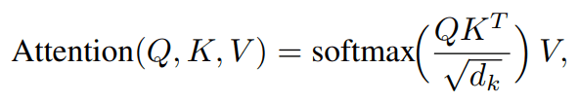 | (2)

where Q, K, and V are query, key, and value matrices, and d_{k} is the dimensionality of the key. By segmenting feature maps into areas and applying fast attention routines, YOLOv11 reduces memory transfers and computational overhead, enabling real-time inference even at higher input resolutions.

Head
The head of YOLOv11 transforms the refined feature maps from the neck into final predictions, generating bounding box coordinates and classification scores. Key improvements include streamlined multi-scale detection pathways, and specialized loss functions that better balance localization and classification objectives. For example, a typical YOLO-style loss might be extended to incorporate new attention or confidence terms [48]:
(3)
where xˆ, yˆ, and Cˆ denote predicted bounding box coordinates and confidence, respectively. Such refinements further enhance YOLOv11’s performance in real-time applications.

As shown in Table 4, YOLOv11 is designed for high efficiency and adaptability in modern computer vision tasks. By integrating advanced architectural innovations and attention mechanisms, it ensures real-time performance while expanding its applicability across various industries.
Table 4: YOLOv11 Key Architectural Features [48]
Feature | Technical Details | Benefits
Enhanced Backbone Architecture | - Utilizes R-ELAN with deeper residual links.  - Employs 7×7 separable convolutions for efficient spatial encoding.  - Incorporates multi-scale feature pyramids. | - Improved capture of small or complex objects.  - Faster, more accurate feature extraction.  - Greater robustness under varied scene complexities.
Advanced Attention Mechanisms | - Implements area-based FlashAttention to reduce computational overhead.  - Applies channel and spatial weighting for refined feature extraction.  - Utilizes context-aware dynamic weighting. | - Enhanced focus on salient regions.  - Improved detection in cluttered or dynamic environments.  - Fewer false positives via targeted weighting.
Optimized Neck Design | - Integrates enhanced feature aggregation strategies.  - Uses depthwise separable layers to lower computational cost.  - Supports flexible up/down-sampling processes. | - Superior multi-scale feature integration.  - Lower computational overhead and faster inference.  - Better adaptability for different object sizes.
Refined Head Modules | - Expands receptive fields for improved contextual cues.  - Utilizes non-linear activations (e.g., SiLU) to boost expressivity.  - Fine-tunes bounding box regression. | - Higher precision in object localization.  - More robust classification under varied conditions.  - Smoother training convergence.
Parameter Optimization | - Deploys lightweight convolutional blocks to reduce trainable parameters.  - Applies pruning and quantization for edge deployment.  - Streamlines architecture for memory efficiency. | - Reduced model footprint for resource-constrained devices.  - Maintains competitive accuracy with fewer parameters.  - Scalable performance across hardware platforms.
Enhanced Training Pipeline | - Employs advanced data augmentations (e.g., Mosaic, MixUp).  - Utilizes dynamic learning rate schedules with high-performance optimizers.  - Leverages transfer learning from large-scale datasets. | - Elevated model generalization and robustness.  - Faster convergence with diverse data distributions.  - Consistent performance in real-world conditions.

  - The proposed framework
    - Dataset Description
The CHB-MIT Scalp EEG Database available at (https://physionet.org/content/chbmit/1.0.0/) is a widely recognized and extensively used dataset in the field of neuroscience and biomedical signal processing. It contains electroencephalogram (EEG) recordings collected from pediatric patients with intractable epilepsy, primarily for the purpose of seizure detection and analysis. The database is a collaborative effort between Boston Children's Hospital (CHB) and the Massachusetts Institute of Technology (MIT), and it has become a benchmark resource for researchers developing algorithms for seizure prediction, detection, and classification.

Key Features of the Database
- Patient Demographics:
  - The dataset includes EEG recordings from 23 pediatric patients (5 males, 17 females, and 1 of unspecified gender).
  - The age range of the patients is between 1.5 and 22 years.
- Recording Details:
  - The EEG signals were recorded using the International 10-20 system for electrode placement.
  - Each recording consists of 23 channels of EEG data, sampled at 256 Hz.
  - The recordings vary in duration, ranging from 1 hour to several hours, and include both ictal (seizure) and interictal (non-seizure) periods.
- Seizure Annotations:
  - Seizure events are annotated by clinical experts, providing precise start and end times for each seizure.
  - The database contains a total of 182 seizures across all patients.
- Data Format:
  - The data is stored in EDF (European Data Format), a standard format for EEG recordings.
  - Annotations are provided in separate files, detailing the timing and type of events (e.g., seizures, artifacts).
- Clinical Relevance:
  - The dataset is particularly valuable for studying intractable epilepsy, a condition where seizures cannot be controlled with medication.
  - It is widely used for developing and evaluating algorithms for seizure detection, prediction, and classification.

Applications of the CHB-MIT Scalp EEG Database
- Seizure Detection:
  - The dataset is a benchmark for developing machine learning and signal processing algorithms to detect seizures in real-time or offline analysis.
- Seizure Prediction:
  - Researchers use the dataset to identify pre-seizure patterns and develop predictive models to anticipate seizures before they occur.
- Feature Extraction and Classification:
  - The database is used to extract meaningful features from EEG signals and classify them into seizure and non-seizure categories.
- Algorithm Validation:
  - The dataset serves as a standard for validating the performance of new algorithms against established methods.
- Neurological Research:
  - It provides insights into the brain's electrical activity during seizures, aiding in the understanding of epilepsy and related disorders.

Dataset Structure
The CHB-MIT Scalp EEG Database is organized as follows:
- Patient Folders: Each patient has a dedicated folder containing their EEG recordings and annotation files.
- Recording Files: EEG recordings are stored in EDF format, with each file representing a continuous segment of data.
- Annotation Files: Seizure events and other annotations are provided in separate files, detailing the timing and type of events.

Preprocessing and Augmentation (for Computer Vision Applications)
This dataset, CHB-MIT Scalp EEG Database Expo - v1, was exported via Roboflow.com on March 5, 2025, at 10:21 AM GMT. Roboflow is a comprehensive computer vision platform designed to streamline the development of computer vision projects. It offers tools for collaboration, image collection and organization, dataset annotation, model training, and deployment, as well as active learning to iteratively improve datasets over time.
The dataset is derived from the CHB-MIT Scalp EEG Database, a well-known resource for EEG (electroencephalogram) data, and has been adapted for computer vision tasks. It includes pre-processed and augmented images, making it suitable for training and evaluating machine learning models for EEG-related applications such as seizure detection, brain-computer interfaces, and other neurological studies.

Key Features of the Dataset

Dataset Overview
- Total Images: 6,579 images.
- Annotations: Objects related to the CHB-MIT Scalp EEG Database are annotated in folder format.
- Pre-Processing:
  - Auto-Orientation: Pixel data was auto-oriented, and EXIF orientation metadata was stripped.
  - Resizing: Images were resized to 640x640 pixels using a stretch method.
- Augmentations:
  - Brightness Adjustment: Random brightness adjustments between -15% and +15% were applied.
  - Noise: Salt-and-pepper noise was added to 0.1% of pixels.
  - Outputs per Training Example: Each source image was augmented to create 3 versions.

Dataset Splits
The dataset is divided into three subsets for training, validation, and testing:
Split | Percentage | Number of Images
Training Set | 92% | 6,072
Validation Set | 4% | 255
Test Set | 4% | 252

Additional Augmentations Applied
To enhance the dataset's robustness and variability, the following augmentations were applied:
Augmentation | Details
Grayscale | Applied to 15% of images
Saturation Adjustment | Adjusted between -25% and +25%
Brightness Adjustment | Adjusted between -15% and +15%
Noise Addition | Added to up to 0.1% of pixels

Dataset Link
- Access the dataset directly at: (https://universe.roboflow.com/chbmit-scalp-eeg-database/chb-mit-scalp-eeg-database-expo/dataset/1) .

Workflow and Algorithm for Processing EEG Data from the CHB-MIT Scalp EEG Database
This Python-based workflow processes EEG data from the CHB-MIT Scalp EEG Database to generate training-ready PNG images for seizure detection. The pipeline converts raw EEG signals into labeled images, distinguishing between seizure and non-seizure events, and organizes them into structured directories for machine learning. Below is a step-by-step breakdown of the process:

Step 1: Data Acquisition
- Input: Raw EEG data in EDF (European Data Format) files and patient-specific summary files (e.g., chb24-summary.txt) from the CHB-MIT database.
- Purpose: Source the necessary data files containing EEG recordings and seizure timing metadata.

Step 2: Metadata Extraction
- Action:
  - Parse the summary files to extract seizure start and end times for each EDF file.
- Output: A structured list of seizure intervals for each patient.

Step 3: EEG Signal Processing
- Channel Selection:
  - Isolate 18 standard EEG channels (e.g., FP1-F7, CZ-PZ) for consistency across recordings.
- Segmentation:
  - Seizure Segments:
    - Extract EEG data during annotated seizure intervals.
  - Non-Seizure Segments:
    - Sample non-overlapping intervals outside seizure periods to ensure balanced representation.
    - Avoid temporal overlaps with seizure events.

Step 4: Visualization
- Action:
  - Use Matplotlib to plot multi-channel EEG signals as PNG images.
  - Vertically offset channels by 100µV for visual separation.
  - Remove axes, labels, and text to focus on waveform morphology.
  - Save images in high resolution (300 DPI) to preserve signal details.
- Output: PNG images representing seizure and non-seizure EEG segments.

Step 5: Dataset Organization
- Action:
  - Save seizure and non-seizure PNG images into separate folders (e.g., seizure_chb24, non-seizure_chb24).
- Purpose: Organize data for easy access and labeling.

Step 6: Train/Test/Validation Split
- Action:
  - Randomly shuffle the images and partition them into:
    - Training Set (92%): For model development.
    - Validation Set (4%): For hyperparameter tuning.
    - Test Set (4%): For final evaluation.
  - Maintain identical directory structures for each subset to ensure compatibility with YOLO.
- Output: A structured dataset ready for machine learning.

Block Diagram of the Workflow
- Input: Raw EDF files and summary metadata.
- Processing:
  - Metadata extraction.
  - EEG signal segmentation (seizure and non-seizure).
  - Visualization of EEG signals as PNG images.
- Output:
  - Organized PNG images in seizure and non-seizure folders.
  - Partitioned into train, test, and validation sets.

Algorithm : EDF to images

Input: EDF files

Output: Images (Seizure and Non-Seizure)

1. Load EDF files and summary metadata.
2. Parse summary files to extract seizure intervals.
3. foreach EDF file:
a. Select 18 standard EEG channels.
b. Extract seizure segments based on annotated intervals.
c. Sample non-seizure segments, ensuring no overlap with seizures.
4. foreach segment (seizure and non-seizure):
a. Plot multi-channel EEG signals using Matplotlib.
b. Vertically offset channels by 100µV.
c. Remove axes and labels for clean visualization.
d. Save as high-resolution PNG images.
5. Organize PNG images into folders:
a. Separate folders for seizure and non-seizure images.
6. Split the dataset:
a. Randomly shuffle images.
b. Partition into training (92%), validation (4%), and test (4%) sets.
7. Save the final structured dataset for YOLO-compatible training.

Figure 2 presents a comprehensive overview of liver disease classes, accompanied by representative sample images for each category.
Class Name | Sample Images
Seizure | 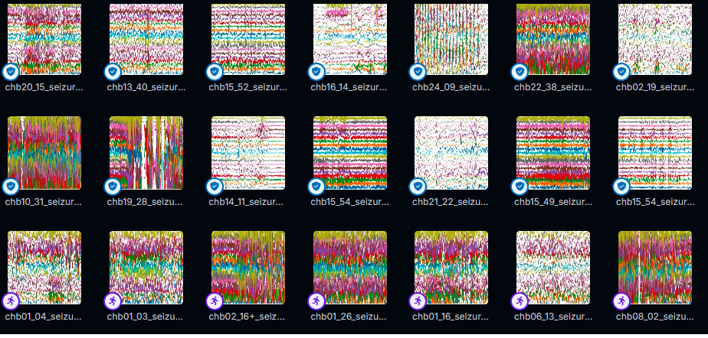
Non-Seizure | 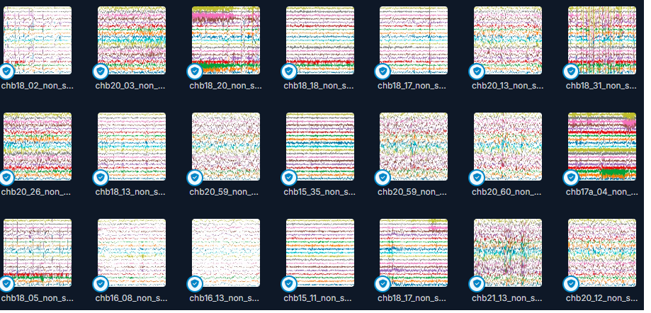
Figure 2: Sample Images of Seizure and non-seizure.

    - The Proposed Model Steps

Figures 3 and 4 outline the comprehensive workflow for developing a seizure detection system using the YOLO 11 model. The methodology is divided into two main phases: Data Preparation and Model Development.
The process begins with the acquisition of the CHB-MIT Scalp EEG Database, a widely used dataset containing EEG recordings from pediatric patients with epilepsy. The raw EEG data is stored in EDF (European Data Format) files, which are read and parsed to extract the EEG signals and associated metadata. The raw EEG signals undergo preprocessing to remove noise, artifacts, and irrelevant data, ensuring the quality and reliability of the input data.

The preprocessed EEG signals are then converted into visual representations (images) by plotting the multi-channel EEG data. Each image represents a time window of EEG activity, with channels vertically offset for clarity. These generated images are uploaded to Roboflow, a platform for managing and augmenting datasets, facilitating efficient dataset organization and augmentation.
To enhance the dataset's variability and improve model generalization, several augmentation techniques are applied. These include converting images to grayscale to reduce complexity, adjusting saturation levels to simulate different recording conditions, modifying brightness to account for variations in signal intensity, and adding random noise to simulate real-world recording artifacts. The augmented dataset is then split into three subsets: a training set (92%) for model training, a validation set (4%) for hyperparameter tuning, and a test set (4%) for final evaluation.

The YOLO 11 model is employed for seizure detection. YOLO (You Only Look Once) is a state-of-the-art object detection framework adapted here for classification tasks. The model performs feature extraction to identify relevant patterns in the EEG images, followed by classification into two categories: seizure and non-seizure. The performance of the model is evaluated using a performance matrix, which includes metrics such as accuracy, precision, recall, and F1-score. This comprehensive workflow ensures the development of a robust and accurate seizure detection system.

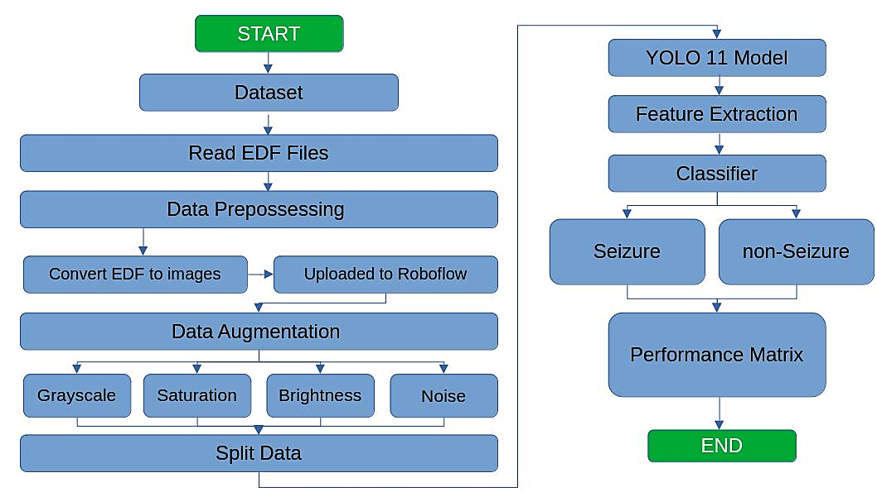
Figure 3: The Flowchart of the proposed Model.

Figure 4 illustrates the detailed architecture of the proposed segmentation model, outlining its key components and processing pipeline. The framework is designed to efficiently segment objects within images by leveraging deep learning techniques. It consists of multiple stages, including data preprocessing, feature extraction, segmentation, and post-processing. The model integrates the YOLOv11 technique to enhance segmentation accuracy. The framework ensures robust performance across varying image conditions, making it suitable for real-world applications requiring precise object delineation.
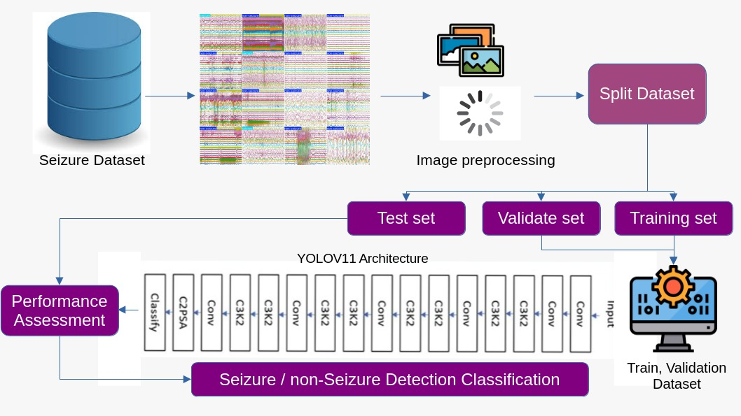
Figure 4. The framework of the proposed segmentation model.

The pseudocode outlines the steps required to build, evaluate, and report on a classification model for seizure detection can be summarized in Figure 5.

Algorithm: YOLO Model Training and Evaluation on CHB-MIT Scalp EEG Databas
Input: Preprocessed EEG images (Seizure and Non-Seizure)
Output: Trained YOLO model and performance metrics

- Check GPU Availability
  - Verify GPU resources using a system command to ensure accelerated training.
- Install Required Libraries
  - Install necessary Python libraries:
    - ultralytics (for YOLO).
    - roboflow (for dataset download).
    - opencv-python, pandas, matplotlib (for data handling and visualization).
- Import Required Libraries
  - Import libraries for data processing, model training, and evaluation.
- Download Dataset from Roboflow
  - Initialize Roboflow API with the provided API key.
  - Access the CHB-MIT Scalp EEG Database project and download the dataset in folder format.
- Define Dataset Path
  - Set the path to the downloaded dataset for easy access during training.
- Initialize the YOLO Model
  - Load a pre-trained YOLO model (e.g., yolo11n-cls.pt) for classification tasks.
- Train the Model
  - Configure the training task as classification.
  - Set hyperparameters:
    - epochs=100: Extended training for better convergence.
    - batch=16: Smaller batch size for efficient gradient updates.
    - augment=True: Enable data augmentation.
    - lr0=0.0001: Lower initial learning rate for stability.
    - lrf=0.00001: Final learning rate decay.
    - patience=30: Extended patience for early stopping.
  - Initiate the training process.
- Display Training Results
  - Visualize the confusion matrix and training performance graphs.
  - Check for the existence of result files and display them.
- Visualize Validation Results
  - Retrieve validation result images (e.g., val_batch0_labels.jpg, val_batch0_pred.jpg).
  - Plot ground truth and predicted labels side-by-side for visual inspection.
- Predict on Test Data and Calculate Metrics
  - Iterate through the test dataset directory.
  - For each image in the test set:
a. Use the trained model to predict the class.
b. Store the ground truth and predicted labels.
  - Record the total time taken for predictions.
- Compute Metrics
  - Calculate the confusion matrix.
  - Compute accuracy, precision, recall, and F1-score.
  - Derive true positives (TP), true negatives (TN), false positives (FP), and false negatives (FN) for each class.
- Display and Save Metrics
  - Print the confusion matrix and classification report.
  - Display accuracy, precision, recall, and F1-score.
  - Save the metrics to a text file, including per-class TP, TN, FP, and FN values.

Output:
- Trained YOLO model for seizure detection.
- Performance metrics (accuracy, precision, recall, F1-score, confusion matrix).
- Structured dataset partitioned into training, validation, and test sets.

Figure 5: Tuned YOLOv11 Algorithm

Optimal Hyperparameters for YOLOb11 Model Training
The optimal hyperparameters for training a YOLO model, specifically tailored for task seizure detection using the CHB-MIT Scalp EEG Database. These values are selected based on best practices and empirical results to achieve high performance. Key hyperparameters, including learning rate, optimizer, and image size, were tuned to optimize model performance. The hyperparameters used for training are summarized in Table 5.
Table 5: Hyperparameters for YOLOv11 Model Training
Hyperparameter | Description | Optimal Value
task | Specifies the task type (e.g., classification, detection). | 'classify'
epochs | Number of training epochs. | 100
batch | Batch size for training. | 16
imgsz | Input image size (height and width). | 640
augment | Enables data augmentation during training. | True
lr0 | Initial learning rate. | 0.0001
lrf | Final learning rate (learning rate decay factor). | 0.00001
momentum | Momentum for the optimizer. | 0.9
weight_decay | Weight decay (L2 regularization) for the optimizer. | 0.0005
warmup_epochs | Number of warmup epochs at the start of training. | 3
warmup_momentum | Momentum during warmup epochs. | 0.8
warmup_bias_lr | Learning rate for bias parameters during warmup. | 0.1
box | Loss weight for bounding box regression. | 0.05
cls | Loss weight for classification. | 0.5
scale | Scale augmentation range (fraction). | 0.5
shear | Shear augmentation range (degrees). | 0.0
perspective | Perspective augmentation range (fraction). | 0.0
flipud | Probability of flipping the image vertically. | 0.0
fliplr | Probability of flipping the image horizontally. | 0.5
mosaic | Enables mosaic data augmentation. | True
mixup | Enables mixup data augmentation. | True
device | Device to use for training (e.g., GPU, CPU). | '0' (GPU)
workers | Number of worker threads for data loading. | 8
optimizer | Optimizer to use (e.g., SGD, Adam). | 'Adam'
seed | Random seed for reproducibility. | 42
rect | Enables rectangular training for faster training. | True
cos_lr | Uses cosine learning rate scheduler. | True
sync_bn | Synchronizes batch normalization across GPUs. | False

    - Performance Metrics
Evaluation metrics such as F1 score, recall, precision, and accuracy are essential for assessing the performance of deep learning models [49] [50] [51] [52], as shown in Table 6. Precision measures the proportion of correctly identified positive samples among all predicted positives, while recall evaluates the model’s ability to detect actual positive cases, including false negatives. The F1 score balances precision and recall, providing a comprehensive measure of model performance.

Table 6. Standard performance metrics which are quantitatively assessing the effectiveness and accuracy of various machine learning models
Equation name | Equation
Precision (P) | $$=\frac{TP}{TP+FP}$$
Recall | $$=\frac{TP}{TP+FN}$$
F1 Score | $$=\frac{2\left(Precision ×Recall\right)}{Precision+Recall}$$
Accuracy | $$=\frac{TP+TN}{TP+TN+FP+FN}$$
Average Precision (AP) | $$=\int_{0}^{1}{P_{interp}\left(r\right)dr}$$

- Results and Analysis
Tables 7 and 8 provide a detailed analysis of the training process and performance metrics for the YOLO model applied to the CHB-MIT Scalp EEG Database. Table 7 presents the training progress across different epochs, including key metrics such as training loss, validation loss, accuracy, and learning rates. Table 8 summarizes the model's performance on the test set, including the confusion matrix, precision, recall, F1-score, and overall accuracy. These tables collectively offer insights into the model's learning dynamics and its effectiveness in classifying seizure and non-seizure events.
Table 7: Training Progress Across Epochs
epoch | time | train/loss | metrics/accuracy_top1 | val/loss | lr/pg0 | lr/pg1 | lr/pg2
1 | 74.9636 | 0.28697 | 0.93254 | 0.33983 | 0.000554204 | 0.000554204 | 0.000554204
10 | 684.359 | 0.15681 | 0.96032 | 0.12745 | 0.00151697 | 0.00151697 | 0.00151697
20 | 1367.17 | 0.11821 | 0.96825 | 0.1121 | 0.00135027 | 0.00135027 | 0.00135027
30 | 2049.07 | 0.09643 | 0.96429 | 0.09262 | 0.00118357 | 0.00118357 | 0.00118357
40 | 2733.43 | 0.0889 | 0.97222 | 0.0716 | 0.00101688 | 0.00101688 | 0.00101688
50 | 3414.21 | 0.06399 | 0.97222 | 0.10698 | 0.000850178 | 0.000850178 | 0.000850178
60 | 4102.38 | 0.05649 | 0.97619 | 0.08864 | 0.00068348 | 0.00068348 | 0.00068348
70 | 4783.32 | 0.04819 | 0.96825 | 0.09249 | 0.000516782 | 0.000516782 | 0.000516782
80 | 5471.58 | 0.0378 | 0.97619 | 0.10166 | 0.000350083 | 0.000350083 | 0.000350083
87 | 5950.09 | 0.03971 | 0.97619 | 0.11081 | 0.000233394 | 0.000233394 | 0.000233394

Table 8: Model Performance Metrics
Metric | non-seizure | seizure | Overall
Confusion Matrix
True Positive (TP) | 234 | 15
True Negative (TN) | 15 | 234
False Positive (FP) | 2 | 1
False Negative (FN) | 1 | 2
Precision | 0.99 | 0.94 | 0.9879
Recall | 1.00 | 0.88 | 0.9881
F1-Score | 0.99 | 0.91 | 0.9879
Support | 235 | 17 | 252
Accuracy |  |  | 0.9881
Total Time |  |  | 9.35 seconds

The training loss decreases steadily from 0.28697 at epoch 1 to 0.03971 at epoch 87, indicating that the model is effectively learning from the data. The top-1 accuracy improves from 93.25% at epoch 1 to 97.62% at epoch 87, demonstrating the model's increasing ability to correctly classify EEG images. The validation loss also decreases significantly, from 0.33983 at epoch 1 to 0.11081 at epoch 87, suggesting that the model generalizes well to unseen data. The learning rates are adjusted dynamically, starting at 0.000554204 and gradually decreasing to 0.000233394, which helps stabilize the training process and avoid overfitting.
The confusion matrix shows that the model achieves high true positive (TP) and true negative (TN) rates, with 234 TP for non-seizure and 15 TP for seizure events. The false positive (FP) and false negative (FN) rates are low, with only 2 FP for non-seizure and 1 FP for seizure events, and 1 FN for non-seizure and 2 FN for seizure events. This indicates that the model is highly accurate in distinguishing between seizure and non-seizure events.
The precision, recall, and F1-score metrics further validate the model's performance. For non-seizure events, the precision is 0.99, recall is 1.00, and F1-score is 0.99. For seizure events, the precision is 0.94, recall is 0.88, and F1-score is 0.91. The overall accuracy of the model is 98.81%, demonstrating its effectiveness in classifying EEG data. The total inference time for the test set is 9.35 seconds, indicating efficient processing.

The model's performance was further validated by comparing actual images with their predicted outcomes. Details are provided in Figures 6 and 7, which display sample images alongside their corresponding predictions.
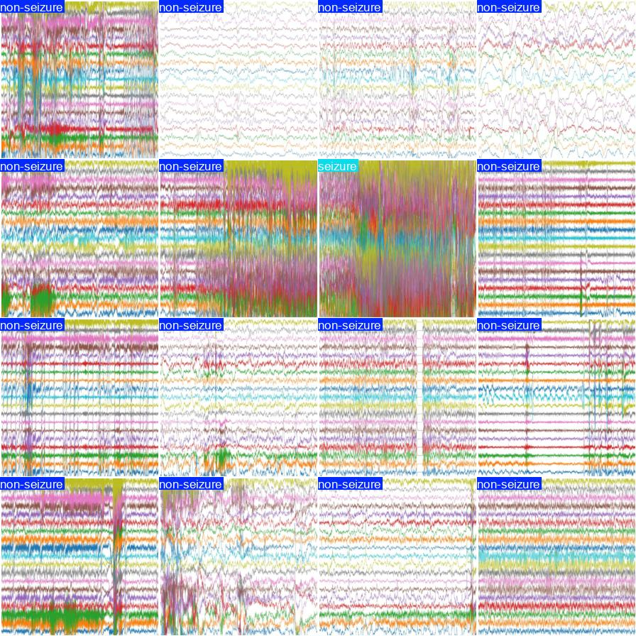

Figure 6: Samples of Truth Images
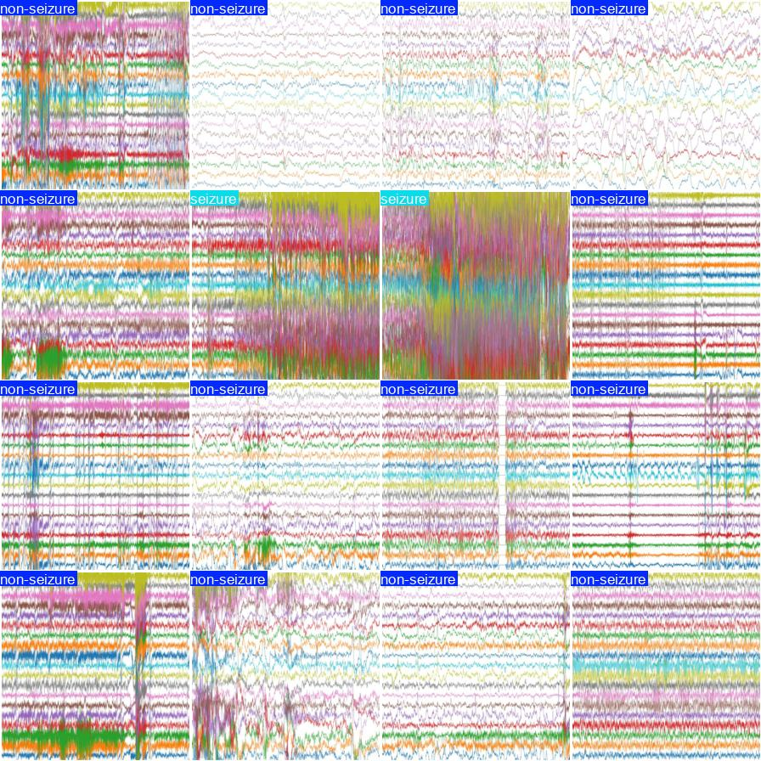

Figure 7: Predicted Results for Sample Images

Figure 8 illustrates the model's learning behavior by plotting the training and validation loss curves. These curves are analyzed to assess potential overfitting or underfitting. The top-1 and Confusion matrix metrics further support this analysis by showing the model's classification accuracy on both training and validation sets.

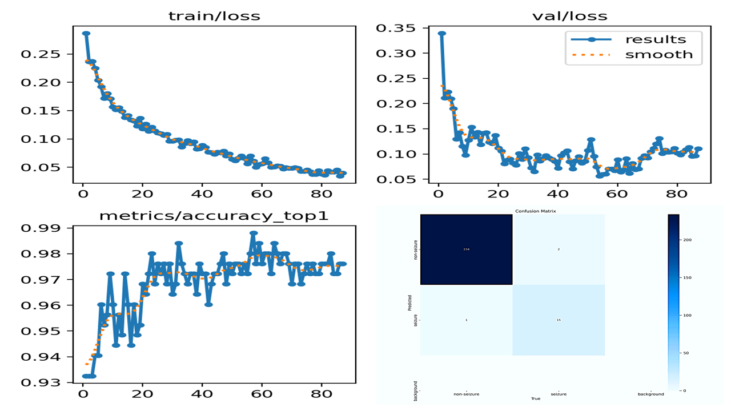
Figure 8: The model's learning behavior for the training and validation loss curves

- Discussion and Future Directions
The results of this study demonstrate the effectiveness of the proposed YOLOv11-based model for seizure detection using the CHB-MIT Scalp EEG Database. The model achieved a high accuracy of 98.81%, with precision, recall, and F1-scores of 0.9879, 0.9881, and 0.9879, respectively. These metrics indicate that the model is highly reliable in distinguishing between seizure and non-seizure events, with minimal false positives and false negatives. The confusion matrix further supports this, showing high true positive and true negative rates, which are critical for clinical applications where accurate detection is paramount.
The training process revealed a steady decrease in both training and validation losses, indicating effective learning and generalization. The top-1 accuracy improved significantly from 93.25% at epoch 1 to 97.62% at epoch 87, demonstrating the model's ability to refine its classification capabilities over time. The dynamic adjustment of learning rates contributed to the stability of the training process, preventing overfitting and ensuring robust performance on unseen data.
The integration of advanced preprocessing techniques, including brightness adjustment, grayscale conversion, and noise injection, played a crucial role in enhancing the dataset's robustness. These augmentations helped the model generalize better to varying conditions, which is essential for real-world applications where EEG signals can be subject to noise and artifacts. The structured dataset split into training, validation, and test sets ensured a rigorous evaluation of the model's performance, providing confidence in its reliability and accuracy.
The findings of this study align with and extend previous research in EEG-based seizure detection. The use of deep learning models, particularly YOLOv11, represents a significant advancement over traditional machine learning approaches, which often require extensive manual feature engineering. By leveraging the power of deep learning, this study demonstrates the potential for automated, high-accuracy seizure detection systems that can operate in real-time, offering significant benefits for patient care and management.

Table 9 provides a comprehensive comparison of various methodologies employed in EEG-based seizure detection, highlighting their key features, techniques, classifiers/models, performance metrics, and limitations. The studies reviewed span traditional machine learning approaches, such as SVM and logistic regression, to advanced deep learning techniques, including CNNs and the proposed YOLOv11 optimization. Each method is evaluated based on its ability to handle spectral, temporal, and multi-feature EEG data, with performance metrics such as accuracy, sensitivity, and computational efficiency. The proposed work introduces a novel YOLOv11-based approach, demonstrating superior accuracy and robustness, though it requires further validation on larger, multi-center datasets. This comparison underscores the trade-offs between manual feature engineering, computational complexity, and real-time applicability in EEG analysis.
Table 9: Comparative Analysis of EEG-Based Seizure Detection Methodologies: Techniques, Models, Performance, and Limitations
Study | Methodology | Key Features/Techniques | Classifier/Model | Performance | Limitations
Park et al. [53] | Spectral analysis of EEG signals | Power spectral density (PSD) in high gamma band (30–100 Hz) | Cost-sensitive SVM | High interictal/preictal separation | Manual feature engineering; limited to spectral features
Pang et al. [54] | Multi-feature extraction across EEG channels | Shannon entropy in 46 frequency bands (60s windows, 50% overlap) | SVM (RBF, KNN), Logistic Regression | Evaluated on human/animal datasets | Computationally intensive; lacks real-time applicability
Zhang et al. [55] | Feature fusion and Kalman filtering | Relative power spectrum, cross-correlation coefficients | AdaBoost, SVM, Neural Networks | Robust multi-class classification | Feature redundancy; dataset-specific optimization
Truong et al. [56] | Deep learning for raw EEG analysis | Raw EEG data (30s windows, 50% overlap) | CNN | 89.1% sensitivity | High computational latency; sensitive to noise
Sharma et al. [57] | Time-frequency and fractal analysis | Wavelet transforms, fractal dimensions | LS-SVM | 98.5% accuracy | Limited generalizability across datasets
Acharya et al. [58] | End-to-end deep learning | 10 convolutional + 3 fully connected layers | CNN | 88% accuracy, 95% sensitivity | Overfitting on small datasets; no real-time implementation
Proposed Work | YOLOv11 optimization for EEG | Noise-resistant augmentation, temporal-aware loss functions | YOLOv11 (modified) | accuracy of 98.81%, with precision, recall, and F1-scores of 0.9879, 0.9881, and 0.9879, respectively. | Requires validation on larger multi-center datasets

Limitations
Despite the promising results, several limitations must be acknowledged. Firstly, the reliance on the CHB-MIT Scalp EEG Database, while providing a robust foundation for this study, may limit the generalizability of the findings. The dataset, though comprehensive, may not fully capture the diversity of seizure types, patient demographics, and recording conditions encountered in clinical practice. This could affect the model's performance when applied to broader or more heterogeneous populations.
Secondly, the computational demands of the YOLOv11 model pose challenges for deployment in resource-constrained environments. Training and inference require substantial computational power and memory, which may not be readily available in all clinical settings. This could hinder the widespread adoption of the model, particularly in low-resource healthcare systems.
Another limitation is the binary classification approach used in this study. While effective for distinguishing between seizure and non-seizure events, this simplification may not adequately capture the complexity and temporal dynamics of real-world seizure activity. Future research should explore multi-class classification approaches to provide more nuanced and clinically relevant insights.
Finally, the interpretability of the model's predictions remains a challenge. The "black box" nature of deep learning models can make it difficult to understand the underlying factors influencing the model's decisions. This lack of transparency may hinder clinical acceptance, as healthcare providers may be reluctant to rely on a system whose decision-making process is not easily interpretable.

- Conclusions and Future Work
This study successfully demonstrated the efficacy of the YOLOv11 model for automated seizure detection using the CHB-MIT Scalp EEG Database. By converting raw EEG signals into visual representations and employing robust data augmentation techniques, we achieved a high classification accuracy of 98.81% on the test dataset. Comprehensive performance metrics, including precision, recall, and F1-score, validate the model's ability to accurately distinguish between seizure and non-seizure events, with minimal false positives and false negatives. The convergence of training and validation loss, along with insights from the confusion matrix, further confirmed the robustness and reliability of our approach. The success of this methodology can be attributed to the meticulous preprocessing pipeline, optimized hyperparameters, and the adoption of the YOLOv11 framework, which collectively ensured high accuracy and efficiency. This work contributes significantly to the growing body of research utilizing deep learning for EEG analysis and offers a promising avenue for developing scalable, real-time seizure detection systems. Such advancements hold immense potential for improving patient outcomes by enabling timely intervention and reducing diagnostic delays.

Future research will focus on extending this methodology to larger and more diverse EEG datasets, incorporating temporal information to enhance prediction accuracy, and exploring real-time deployment scenarios. Also, focus on expanding the diversity of datasets to include a wider range of seizure types and patient populations. Additionally, efforts should be made to optimize the computational efficiency of deep learning models to facilitate their deployment in resource-constrained environments. Additionally, efforts will be directed toward enhancing the interpretability of the model’s predictions, providing clinicians with actionable insights into the underlying EEG patterns associated with seizures. By refining and validating our approach, we aim to contribute to the development of robust, reliable, and clinically deployable tools for epilepsy management, ultimately transforming the landscape of neurological disorder diagnostics and care.

Declarations

Data and code availability
- The CHB-MIT Scalp EEG Database available at (https://physionet.org/content/chbmit/1.0.0/).
- The dataset in Roboflow of this study is available at: (https://universe.roboflow.com/chbmit-scalp-eeg-database/chb-mit-scalp-eeg-database-expo/dataset/1)

Declaration of competing interest
No conflicts of interest exist, according to the authors. They affirm that there are no known conflicting financial interests or personal ties that may have influenced the work described in this publication.
Top of Form

Ethical Statement: “This article does not contain any studies with human participants or animals performed by any of the authors.”
Bottom of Form

References
[1] J. Shi et al., “The Role of Neuroinflammation and Network Anomalies in Drug-Resistant Epilepsy,” Neurosci. Bull., Feb. 2025, doi: 10.1007/s12264-025-01348-w.
[2] B. N. Aljafen, “Exploring the Link Between Environmental Pollution and Epilepsy,” Ann. PIMS-Shaheed Zulfiqar Ali Bhutto Med. Univ., vol. 21, no. 1, Art. no. 1, Jan. 2025, Accessed: Mar. 16, 2025. [Online]. Available: https://www.apims.net/apims/article/view/1427
[3] M. X. Fayzullayevna, “EPILEPSY AND NERVOUS SYSTEM DISORDERS,” Ethiop. Int. J. Multidiscip. Res., vol. 12, no. 02, Art. no. 02, Feb. 2025.
[4] V. Gabeff et al., “Interpreting deep learning models for epileptic seizure detection on EEG signals,” Artif. Intell. Med., vol. 117, p. 102084, Jul. 2021, doi: 10.1016/j.artmed.2021.102084.
[5] D. Ahmedt-Aristizabal et al., “Deep learning approaches for seizure video analysis: A review,” Epilepsy Behav., vol. 154, p. 109735, May 2024, doi: 10.1016/j.yebeh.2024.109735.
[6] F. A. Jibon et al., “Epileptic seizure detection from electroencephalogram (EEG) signals using linear graph convolutional network and DenseNet based hybrid framework,” J. Radiat. Res. Appl. Sci., vol. 16, no. 3, p. 100607, Sep. 2023, doi: 10.1016/j.jrras.2023.100607.
[7] N. M. Pour and Y. Özbek, “Epileptic Seizure Detection based on EEG Signal using Boosting Classifiers,” Erzincan Univ. J. Sci. Technol., vol. 14, no. 1, Art. no. 1, Mar. 2021, doi: 10.18185/erzifbed.893492.
[8] S. T. Jaafar and M. Mohammadi, “Epileptic Seizure Detection using Deep Learning Approach,” UHD J Sci Technol, vol. 3, no. 2, pp. 41–50, 2019.
[9] D. K. Thara, B. G. PremaSudha, and F. Xiong, “Auto-detection of epileptic seizure events using deep neural network with different feature scaling techniques,” Pattern Recognit Lett, vol. 128, pp. 544–550, 2019.
[10] O. Faust, Y. Hagiwara, T. J. Hong, O. S. Lih, and U. R. Acharya, “Deep learning for healthcare applications based on physiological signals: A review,” Comput Methods Programs Biomed, vol. 161, pp. 1–13, 2018.
[11] W. Hussain, M. T. Sadiq, S. Siuly, and A. U. Rehman, “Epileptic seizure detection using 1 D-convolutional long short-term memory neural networks,” Appl Acoust, vol. 177, p. 107941, 2021.
[12] X. Yao, X. Li, Q. Ye, Y. Huang, Q. Cheng, and G.-Q. Zhang, “A robust deep learning approach for automatic classification of seizures against non-seizures,” Biomed. Signal Process. Control, vol. 64, p. 102215, 2021.
[13] X. Yao, X. Li, Q. Ye, Y. Huang, Q. Cheng, and G.-Q. Zhang, “A robust deep learning approach for automatic classification of seizures against non-seizures,” Biomed Signal Process Control, vol. 64, p. 102215, 2021.
[14] K. Meddah, H. Zairi, B. Bessekri, H. Cherrih, and M. Kedir-Talha, “FPGA implementation of Epileptic Seizure detection based on DWT, PCA and Support Vector Machine,” in 2020 Second International Conference on Embedded & Distributed Systems (EDiS), 2020, pp. 141–146.
[15] Y. Zhang, Y. Guo, P. Yang, W. Chen, and B. Lo, “Epilepsy seizure prediction on EEG using common spatial pattern and convolutional neural network,” IEEE J Biomed Health Inf., vol. 24, no. 2, pp. 465–474, 2019.
[16] I. C. Covert and others, “Temporal graph convolutional networks for automatic seizure detection,” in Machine Learning for Healthcare Conference, 2019, pp. 160–180.
[17] B. Bouaziz, L. Chaari, H. Batatia, and A. Quintero-Rincón, “Epileptic Seizure Detection Using a Convolutional Neural Network,” vol. 10, Springer, 2019, pp. 79–86. doi: 10.1007/978-3-030-11800-6_9.
[18] H. Rajaguru and S. K. Prabhakar, “Multilayer autoencoders and em-pca with genetic algorithm for epilepsy classification from EEG,” in 2018 Second International Conference on Electronics, Communication and Aerospace Technology (ICECA), 2018, pp. 353–358.
[19] S. Roy, I. Kiral-Kornek, and S. Harrer, “ChronoNet: A deep recurrent neural network for abnormal EEG identification,” in Artificial Intelligence in Medicine: 17th Conference on Artificial Intelligence in Medicine, AIME 2019, Poznan, Poland, June 26–29, 2019, Proceedings 17, 2019, pp. 47–56.
[20] G. Choi and others, “A novel multi-scale 3D CNN with deep neural network for epileptic seizure detection,” in 2019 IEEE International Conference on Consumer Electronics (ICCE), 2019, pp. 1–2.
[21] N. D. Truong and others, “Convolutional neural networks for seizure prediction using intracranial and scalp electroencephalogram,” Neural Netw, vol. 105, pp. 104–111, 2018.
[22] A. Subasi, J. Kevric, and M. A. Canbaz, “Epileptic seizure detection using hybrid machine learning methods,” Neural Comput Appl, vol. 31, pp. 317–325, 2019.
[23] E. Alickovic, J. Kevric, and A. Subasi, “Performance evaluation of empirical mode decomposition, discrete wavelet transform, and wavelet packed decomposition for automated epileptic seizure detection and prediction,” Biomed Signal Process Control, vol. 39, pp. 94–102, 2018.
[24] X. J. Zhou M, Tian C, Cao R, Wang B, Niu Y, Hu T, Guo H, “Epileptic seizure detection based on EEG signals and CNN,” Front Neuroinformatics, vol. 12, p. 95, 2018, doi: 0.3389/fninf.2018.00095.
[25] S. M. Qaisar and A. Subasi, “Efficient epileptic seizure detection based on the event-driven processing,” Procedia Comput Sci, vol. 163, pp. 30–34, 2019.
[26] A. R. Hassan and A. Subasi, “Automatic identification of epileptic seizures from EEG signals using linear programming boosting,” Comput Methods Programs Biomed, vol. 136, pp. 65–77, 2016.
[27] A. R. Hassan, A. Subasi, and Y. Zhang, “Epilepsy seizure detection using complete ensemble empirical mode decomposition with adaptive noise,” Knowl-Based Syst, vol. 191, p. 105333, 2020.
[28] R. Sharma and R. B. Pachori, “Classification of epileptic seizures in EEG signals based on phase space representation of intrinsic mode functions,” Classif Epileptic Seizures EEG Signals Based Phase Space Represent Intrinsic Mode Funct, vol. 42, no. 3, pp. 1106–1117, 2015.
[29] A. Shankar, H. K. Khaing, S. Dandapat, and S. Barma, “Analysis of epileptic seizures based on EEG using recurrence plot images and deep learning,” Biomed Signal Process Control, vol. 69, p. 102854, 2021, doi: 10.1016/j.bspc.2021.102854.
[30] F. E. Ibrahim and others, “Deep-learning-based seizure detection and prediction from electroencephalography signals,” Int J Numer Methods Biomed Eng, vol. 38, no. 6, p. e3573, 2022, doi: 10.1002/cnm.3573.
[31] J. Redmon, S. Divvala, R. Girshick, and A. Farhadi, “You Only Look Once: Unified, Real-Time Object Detection,” in 2016 IEEE Conference on Computer Vision and Pattern Recognition (CVPR), Jun. 2016, pp. 779–788. doi: 10.1109/CVPR.2016.91.
[32] J. Redmon, S. Divvala, R. Girshick, and A. Farhadi, “You Only Look Once: Unified, Real-Time Object Detection,” presented at the Proceedings of the IEEE Conference on Computer Vision and Pattern Recognition, 2016, pp. 779–788. Accessed: Feb. 26, 2025. [Online]. Available: https://www.cv-foundation.org/openaccess/content_cvpr_2016/html/Redmon_You_Only_Look_CVPR_2016_paper.html
[33] J. Redmon and A. Farhadi, “YOLO9000: Better, Faster, Stronger,” presented at the Proceedings of the IEEE Conference on Computer Vision and Pattern Recognition, 2017, pp. 7263–7271. Accessed: Feb. 26, 2025. [Online]. Available: https://openaccess.thecvf.com/content_cvpr_2017/html/Redmon_YOLO9000_Better_Faster_CVPR_2017_paper.html
[34] J. Redmon and A. Farhadi, “Yolov3: An incremental improvement,” ArXiv Prepr. ArXiv180402767, 2018, Accessed: Feb. 26, 2025. [Online]. Available: http://175.27.250.89:10000/media/attachment/2024/08/YOLOV3.pdf
[35] A. Bochkovskiy, C.-Y. Wang, and H. Liao, “YOLOv4: Optimal Speed and Accuracy of Object Detection,” ArXiv, Apr. 2020, Accessed: Feb. 26, 2025. [Online]. Available: https://www.semanticscholar.org/paper/YOLOv4%3A-Optimal-Speed-and-Accuracy-of-Object-Bochkovskiy-Wang/2a6f7f0d659c5f7dcd665064b71e7b751592c80e
[36] J. Solawetz, “What is Yolov5? A guide for beginners,” Roboflow Blog, vol. 29, p. 2020, 2020.
[37] C. Li et al., “YOLOv6: A Single-Stage Object Detection Framework for Industrial Applications,” Sep. 07, 2022, arXiv: arXiv:2209.02976. doi: 10.48550/arXiv.2209.02976.
[38] C.-Y. Wang, A. Bochkovskiy, and H.-Y. M. Liao, “YOLOv7: Trainable Bag-of-Freebies Sets New State-of-the-Art for Real-Time Object Detectors,” presented at the Proceedings of the IEEE/CVF Conference on Computer Vision and Pattern Recognition, 2023, pp. 7464–7475. Accessed: Feb. 26, 2025. [Online]. Available: https://openaccess.thecvf.com/content/CVPR2023/html/Wang_YOLOv7_Trainable_Bag-of-Freebies_Sets_New_State-of-the-Art_for_Real-Time_Object_Detectors_CVPR_2023_paper.html
[39] M. Sohan, T. Sai Ram, and Ch. V. Rami Reddy, “A Review on YOLOv8 and Its Advancements,” in Data Intelligence and Cognitive Informatics, I. J. Jacob, S. Piramuthu, and P. Falkowski-Gilski, Eds., Singapore: Springer Nature, 2024, pp. 529–545. doi: 10.1007/978-981-99-7962-2_39.
[40] M. Yaseen, “What is YOLOv9: An In-Depth Exploration of the Internal Features of the Next-Generation Object Detector,” Sep. 12, 2024, arXiv: arXiv:2409.07813. doi: 10.48550/arXiv.2409.07813.
[41] A. Wang et al., “YOLOv10: Real-Time End-to-End Object Detection,” Adv. Neural Inf. Process. Syst., vol. 37, pp. 107984–108011, Jan. 2025.
[42] M. Al Rabbani Alif, “YOLOv11 for Vehicle Detection: Advancements, Performance, and Applications in Intelligent Transportation Systems,” Oct. 01, 2024. doi: 10.48550/arXiv.2410.22898.
[43] 田运杰, sunsmarterjie/yolov12. (Feb. 26, 2025). Python. Accessed: Feb. 26, 2025. [Online]. Available: https://github.com/sunsmarterjie/yolov12
[44] Y. Tian, Q. Ye, and D. Doermann, “YOLOv12: Attention-Centric Real-Time Object Detectors,” Feb. 18, 2025, arXiv: arXiv:2502.12524. doi: 10.48550/arXiv.2502.12524.
[45] C.-Y. Wang, H.-Y. M. Liao, Y.-H. Wu, P.-Y. Chen, J.-W. Hsieh, and I.-H. Yeh, “CSPNet: A New Backbone That Can Enhance Learning Capability of CNN,” presented at the Proceedings of the IEEE/CVF Conference on Computer Vision and Pattern Recognition Workshops, 2020, pp. 390–391. Accessed: Feb. 26, 2025. [Online]. Available: https://openaccess.thecvf.com/content_CVPRW_2020/html/w28/Wang_CSPNet_A_New_Backbone_That_Can_Enhance_Learning_Capability_of_CVPRW_2020_paper.html
[46] C.-Y. Wang, H.-Y. M. Liao, and I.-H. Yeh, “Designing Network Design Strategies Through Gradient Path Analysis,” Nov. 09, 2022, arXiv: arXiv:2211.04800. doi: 10.48550/arXiv.2211.04800.
[47] C.-Y. Wang, I.-H. Yeh, and H.-Y. Mark Liao, “YOLOv9: Learning What You Want to Learn Using Programmable Gradient Information,” in Computer Vision – ECCV 2024, A. Leonardis, E. Ricci, S. Roth, O. Russakovsky, T. Sattler, and G. Varol, Eds., Cham: Springer Nature Switzerland, 2025, pp. 1–21. doi: 10.1007/978-3-031-72751-1_1.
[48] M. A. R. Alif and M. Hussain, “YOLOv12: A Breakdown of the Key Architectural Features,” Feb. 20, 2025, arXiv: arXiv:2502.14740. doi: 10.48550/arXiv.2502.14740.
[49] G. Mostafa, H. Mahmoud, T. Abd El-Hafeez, and M. E.ElAraby, “The power of deep learning in simplifying feature selection for hepatocellular carcinoma: a review,” BMC Med. Inform. Decis. Mak., vol. 24, no. 1, p. 287, Oct. 2024, doi: 10.1186/s12911-024-02682-1.
[50] A. Ameen, I. E. Fattoh, T. Abd El-Hafeez, and K. Ahmed, “Advances in ECG and PCG-based cardiovascular disease classification: a review of deep learning and machine learning methods,” J. Big Data, vol. 11, no. 1, p. 159, Nov. 2024, doi: 10.1186/s40537-024-01011-7.
[51] E. H. I. Eliwa, A. M. E. Koshiry, T. A. El-Hafeez, and A. Omar, “Secure and Transparent Lung and Colon Cancer Classification Using Blockchain and Microsoft Azure,” Adv. Respir. Med., vol. 92, no. 5, p. 395, Oct. 2024, doi: 10.3390/arm92050037.
[52] W. M. Elmessery et al., “Semantic segmentation of microbial alterations based on SegFormer,” Front. Plant Sci., vol. 15, p. 1352935, 2024.
[53] Y. Park, L. Luo, K. K. Parhi, and T. Netoff, “Seizure prediction with spectral power of EEG using cost-sensitive support vector machines,” Epilepsia, vol. 52, no. 10, pp. 1761–1770, 2011, doi: 10.1111/j.1528-1167.2011.03138.x.
[54] M. Pang, H. Wang, J. Huang, C.-M. Vong, Z. Zeng, and C. Chen, “Multi-Scale Masked Autoencoders for Cross-Session Emotion Recognition,” IEEE Trans. Neural Syst. Rehabil. Eng., vol. 32, pp. 1637–1646, 2024, doi: 10.1109/TNSRE.2024.3389037.
[55] S. Zhang, C. Tang, and C. Guan, “Visual-to-EEG cross-modal knowledge distillation for continuous emotion recognition,” Pattern Recognit., vol. 130, p. 108833, Oct. 2022, doi: 10.1016/j.patcog.2022.108833.
[56] D. Truong, M. A. Khalid, and A. Delorme, “EEG-SSL: A Framework for Self-Supervised Learning on EEG,” in 2024 IEEE International Conference on Bioinformatics and Biomedicine (BIBM), Dec. 2024, pp. 4193–4200. doi: 10.1109/BIBM62325.2024.10822136.
[57] R. R. Sharma and R. B. Pachori, “Time–frequency representation using IEVDHM–HT with application to classification of epileptic EEG signals,” IET Sci. Meas. Technol., vol. 12, no. 1, pp. 72–82, 2018, doi: 10.1049/iet-smt.2017.0058.
[58] B. Ay et al., “Automated Depression Detection Using Deep Representation and Sequence Learning with EEG Signals,” J. Med. Syst., vol. 43, no. 7, p. 205, May 2019, doi: 10.1007/s10916-019-1345-y.

