**Curcumin as a Differential Blood Stain: An Effective Alternative to Eosin in Field Diagnostics**

**Abstract**

*Curcuma longa* L., a medicinal herb from the Zingiberaceae family, is renowned for its antioxidant, anti-inflammatory, hepatoprotective, and antimicrobial properties. Beyond its therapeutic applications, *C. longa* has been investigated as a potential staining agent due to its inherent fluorescence and stability. This study evaluates the efficacy of *C. longa* extract as an alternative to eosin for staining blood smears. Our findings demonstrate that a 5% ethanol-based *C. longa* extract effectively stains red blood cells, producing distinct contrast and enhanced visualization. Compared to eosin, curcumin, as a natural, biodegradable, and non-toxic product, offers advantages such as eco-friendliness, cost-effectiveness, sustainability, and broader availability, making it a promising alternative for hematological staining in routine and field-based applications.

**Key words**: *C. longa*, stain, blood smear and ethanol

**Introduction**

*Curcuma longa* L., commonly known as turmeric, is widely recognized for its culinary, medicinal, and industrial applications. Traditionally used as a spice and natural food pigment, *C. longa* has also been an integral component of Ayurvedic and Chinese medicine for centuries, valued for its antioxidant, anti-inflammatory, hepatoprotective, and antimicrobial properties. This perennial herb from the Zingiberaceae family is cultivated extensively across India, China, and other tropical regions, with its rhizome serving as a key economic commodity (Kumar et al., 2014). Beyond its therapeutic benefits, *C. longa* has been employed as a natural dye in textiles, pharmaceuticals, and cosmetics, highlighting its diverse applicability.

Recent advancements have explored the potential of *C. longa* as an alternative staining agent for blood smears, offering a sustainable and cost-effective solution compared to conventional stains. Eosin, a widely used counterstain in hematological procedures, has notable limitations, including photobleaching upon prolonged light exposure, high cost, and supply chain dependencies. In contrast, curcumin, the bioactive compound in *C. longa*, exhibits inherent fluorescence, providing enhanced staining stability and durability. Additionally, curcumin is non-toxic and environmentally friendly, presenting a safer alternative to synthetic dyes.

This study aims to evaluate the staining efficacy of purified ethanolic *C. longa* extract for blood smears from various animal species, comparing its performance to eosin.

**Materials and Methods**

The experimental study was conducted in the Department of Veterinary Epidemiology and Preventive Medicine, College of Veterinary and Animal Sciences Pookode, Wayanad.

**Method employed for turmeric dye preparation**

The rhizomes of *Curcuma longa* were collected, cut into small pieces, and finely milled into powder. Precisely 2.5 g, 5 g, and 7.5 g of the powdered sample were weighed using an electronic balance and dissolved in 50 mL of 70% ethanol. The mixture was homogenized using a magnetic stirrer for 1 hour, followed by centrifugation at 3000 rpm for 5 minutes. The supernatant was carefully collected and filtered through Whatman No.1 filter paper. The resulting staining solutions are presented in Figures 1, 2, and 3.

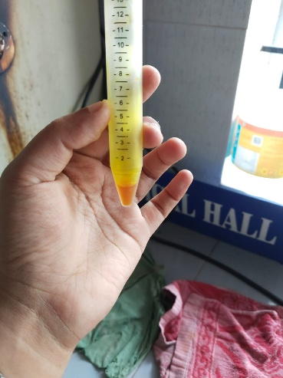 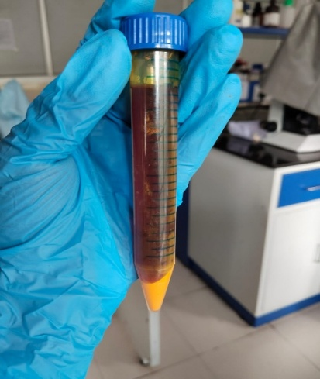 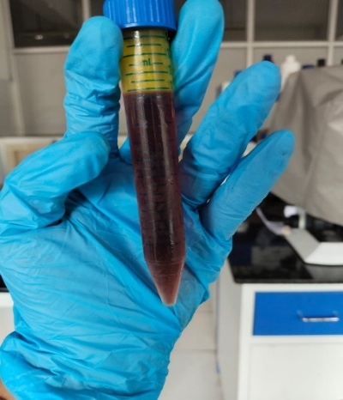

**Fig.1:** 5% curcumin stain prepared

**Fig.3**: 15% curcumin stain prepared

**Fig.2**: 10% curcumin stain prepared

**Staining Procedure**

Blood smears were obtained from clinically normal animals (n=10) and animals diagnosed with *Babesia gibsoni* infection (n=5) at the Teaching Veterinary Clinical Complex (TVCC), Pookode. The smears were initially fixed with methanol and subsequently stained using varying concentrations of *Curcuma longa* extract and different staining durations, as outlined in Table I. Following curcumin staining, the smears were counterstained with Field Stain A (methylene blue and azure dissolved in phosphate buffer), Loeffler’s Alkaline Methylene Blue (LAMB), and Methylene Blue Aqueous, as detailed in Table II. After washing, the smears were air-dried and examined under an oil immersion objective for microscopic evaluation.

**Results**

**Staining Performance of Different Curcumin Extract Concentrations and Counterstains**

The staining quality of blood smears varied depending on the concentration of *Curcuma longa* extract and staining duration (Table I). At 5% curcumin extract, optimal staining was observed at 5 minutes, whereas shorter durations (2 minutes) resulted in poor staining, and longer durations (10 minutes) led to overstaining. Higher concentrations (10% and 15%) consistently caused overstaining across all time points, suggesting that increased curcumin concentration reduces precision in stain differentiation.

Further evaluation of the 5% curcumin extract in combination with conventional counterstains (Table II) revealed that Loeffler’s Alkaline Methylene Blue (LAMB) and Methylene Blue Aqueous resulted in poor staining across all time points. In contrast, Field Stain A provided improved staining quality, with a 5-minute duration yielding fair staining, 10 minutes achieving optimal staining, and 15 minutes leading to overstaining. These findings highlight the potential of curcumin as a hematological staining agent while emphasizing the need for precise concentration and duration adjustments to achieve optimal staining quality.

**Table I.** staining qualities of different concentration of curcumin extract in different time

|  |  |  |  |
| --- | --- | --- | --- |
| **Time** | **5% Curcumin extract** | **10% Curcumin extrac**t | **15% Curcumin extract** |
| 2 min | Poor staining | Over stained | Over stained |
| 5 min | Good staining | Over stained | Over stained |
| 10 min | Over stained | Over stained | Over stained |

**Table II.** 5% Curcumin extract – Other stain combinations used

|  |  |  |  |
| --- | --- | --- | --- |
| **Stain used** | **5 min** | **10 min** | **15 min** |
| Loeffler’s Alkaline methylene blue (LAMB) | Poorly stained | Poorly stained | Poorly stained |
| Methylene Blue aqueous | Poorly stained | Poorly stained | Poorly stained |
| Field stain A | Fairly stained | Good | Over stained |

**Staining Characteristics of *Curcuma longa* Extract in Hematological Smears**

The staining efficiency of *Curcuma longa* extract varied with concentration, staining duration, and counterstaining method, significantly influencing the differentiation of blood cell components and hemoparasites. Optimal staining was achieved at 5% curcumin extract for 5 minutes. The red blood cells (RBCs) exhibit a greenish tint, indicating the influence of a specialised staining technique that differs from conventional eosin-based methods. *Babesia* organisms appear as distinct blue to purple structures, likely due to selective uptake of a methylene blue-based counterstain, enhancing their contrast against the RBC background. (Fig.11).

**Effect of Concentration and Staining Duration on Staining Efficacy**

Lower concentrations (5%) of *Curcuma longa* extract applied for shorter durations resulted in understaining, reducing the visibility of RBCs, white blood cells (WBCs), and *Babesia gibsoni*. Smears treated with 5% curcumin for 2 minutes followed by Loeffler’s Alkaline Methylene Blue (LAMB) for 5 minutes exhibited weak staining, limiting the differentiation of cellular structures (Figure 4). Similarly, 10% curcumin for 2 minutes followed by Field Stain A for 5 minutes produced lightly stained smears with poor contrast (Figure 10).

Conversely, higher curcumin concentrations (10%,15%) and prolonged staining durations (10 minutes) resulted in overstaining, leading to intense RBC coloration (yellowish-green) and reduced contrast between cellular components. Smears stained with 10% curcumin for 5 minutes and aqueous methylene blue for 10 minutes exhibited excessive RBC staining, whereas WBCs remained unstained (Figure 7). A similar trend was observed in smears treated with 15% curcumin for 10 minutes, where the intensified staining compromised hemoparasite visualization (Fig. 8).

**Evaluation of Counterstains**

The counterstaining method significantly influenced staining contrast and the ability to differentiate *Babesia gibsoni* from RBCs. Among the evaluated counterstains (Table II), Field Stain A at 10 minutes provided the most distinct staining contrast, where RBCs retained a greenish colour while *Babesia gibsoni* appeared dark bluish (Fig.11). In contrast, smears counterstained with LAMB or aqueous methylene blue exhibited poor contrast, with RBCs appearing faintly stained and hemoparasite morphology remaining indistinct.

**Optimal Staining Protocol for Hemoparasite Visualization**

The highest diagnostic clarity was achieved using 5% *Curcuma longa* extract for 5 minutes, followed by Field Stain A for 10 minutes (Figure 13). This staining combination produced well-differentiated RBCs, WBCs, and *Babesia gibsoni*, demonstrating its suitability as a diagnostic tool. A reference smear stained with Giemsa (Figure 14) exhibited standard staining characteristics, serving as a comparison for the curcumin-based protocol.

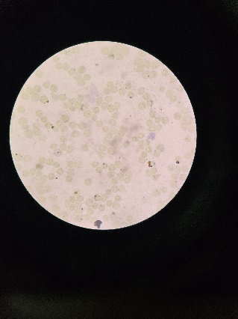 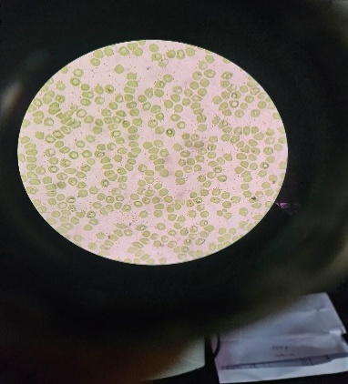 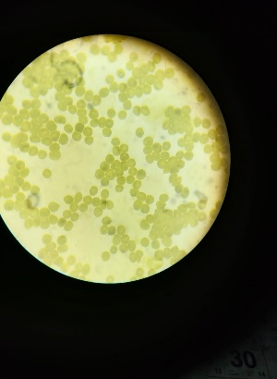

**Fig.4**: 5%curcumin for 2 min, LAMB for 5 min

**Fig.5**: 5% curcumin for 5 minutes and LAMB for 15 minutes

**Fig.6**: 15%curcumin for 10 minutes and LAMB for 10 minutes

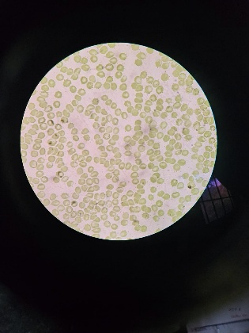 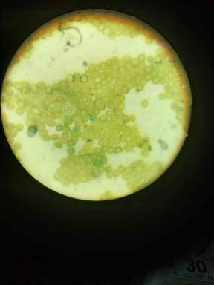 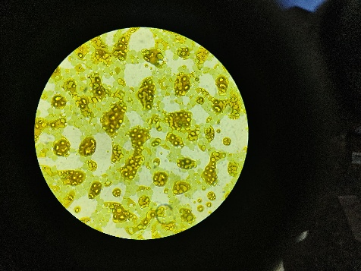

**Fig.7**: 10% curcumin for 5 minutes and aq. methylene blue for 10 minutes

Fig.6 5%curcumin for 15 minutes and aq. Methylene blue for 15 minutes

**Fig. 8**:15% curcumin for 5 minutes and aq. Methylene blue for 10 minutes

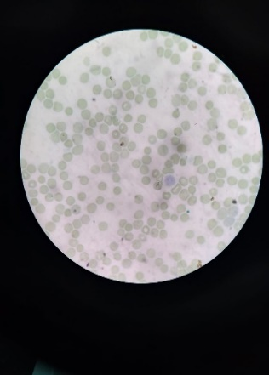 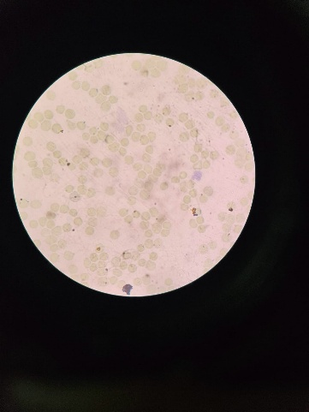

**Fig.9**: 5% curcumin for 2 minutes and field stain A for 5 minutes

**Fig.10**: 10% curcumin for 2 minutes and field stain A for 5 minutes

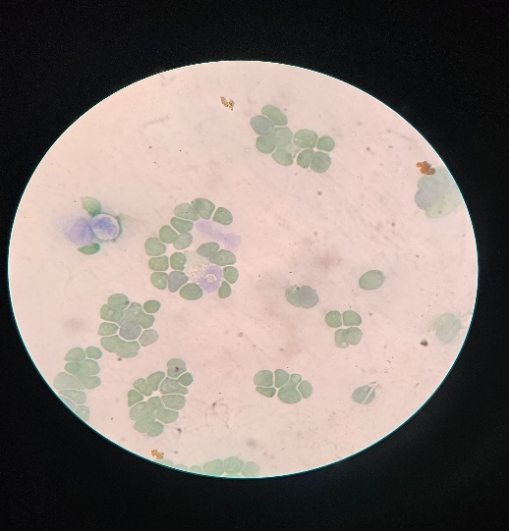 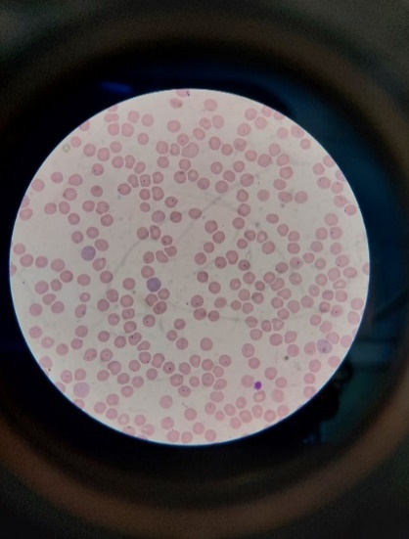

**Fig.11**: 5% curcumin for 5 minutes and field stain A for 10 minutes

**Fig.12**: staining of blood smear with Giemsa staining

**Discussion**

The present study evaluated the staining efficacy of *Curcuma longa* extract as a natural hematological stain for blood smears, particularly for the differentiation of blood cell components and *Babesia gibsoni*. Our findings indicate that a 5% curcumin extract applied for 5 minutes yielded optimal staining quality, balancing clarity and contrast. The observed greenish tint of red blood cells (RBCs) is a unique characteristic of curcumin staining, differing significantly from conventional eosin-based staining methods. This suggests curcumin’s potential applicability in hematological diagnostics, particularly as an alternative to synthetic stains.

**Comparative Analysis with Conventional Staining Methods**

Counterstaining played a crucial role in optimizing contrast and enhancing hemoparasite visualization. Among the tested counterstains, Field Stain A, applied for 10 minutes provided superior contrast, facilitating the distinct visualization of *Babesia gibsoni* as dark bluish structures against a greenish RBC background. In contrast, Loeffler’s Alkaline Methylene Blue (LAMB) and aqueous methylene blue resulted in poor contrast and inadequate hemoparasite differentiation. These findings align with previous studies demonstrating that counterstains significantly influence staining precision in diagnostic hematology (Grosset et al., 2019).

Compared to Giemsa staining, the gold standard for hemoparasite identification, curcumin-based staining showed comparable differentiation when paired with optimal counterstains. Prior research has highlighted the potential of natural stains in diagnostic microscopy, with curcumin exhibiting promising results due to its bioactive properties and selective staining ability (Kumar et al., 2021). However, further validation across a broader range of hemoparasites and hematological disorders is necessary to establish curcumin’s reliability as a routine diagnostic stain.

**Effect of Concentration and Staining Duration**

Our findings indicate that curcumin concentration and staining duration are critical determinants of staining quality. Lower concentrations (5%) with shorter durations (2 minutes) resulted in inadequate staining, leading to poor visualization of RBCs, white blood cells (WBCs), and *Babesia gibsoni*. Conversely, higher concentrations (10%, 15%) and extended durations (10 minutes) led to overstaining, where excessive RBC coloration reduced hemoparasite contrast. These findings are consistent with prior studies demonstrating the concentration-dependent staining properties of plant-derived dyes (Adeyemo et al., 2017;Mulla et al., 2023).

**Mechanism of Staining**

The staining specificity of *C. longa* extract is likely influenced by its acidic properties, as it selectively stains basic cellular structures. The bioactive component, curcumin (diferuloylmethane), exhibits polyphenolic characteristics, allowing effective interaction with cellular proteins (Hope-Roberts and Horobin, 2017). Previous studies have reported that natural phenolic compounds exhibit pH-insensitive staining mechanisms, further supporting curcumin’s potential as a stable alternative to eosin (Avwioro et al., 2007). Unlike eosin-stained smears, which may undergo photobleaching over time, curcumin’s inherent fluorescence confers long-term stability, making it advantageous for prolonged sample storage and analysis (Wittekind, 2003).

Despite the promising results, the study has several limitations. First, staining efficacy was evaluated only for *Babesia gibsoni*; further studies are required to assess its applicability in detecting other hemoparasites and hematological abnormalities. Second, the stability of curcumin-stained smears under varying storage conditions remains unknown and warrants further investigation. Additionally, inter-laboratory validation is necessary to confirm reproducibility across diverse diagnostic settings. Future research should also explore the molecular interactions of curcumin with blood cell components to elucidate the underlying staining mechanisms.

**Conclusion**

This study highlights the potential of *Curcuma longa* extract as a hematological stain, particularly when combined with Field Stain A as a counterstain. The optimized protocol (5% curcumin for 5 minutes, followed by Field Stain A for 10 minutes) demonstrated effective differentiation of *Babesia gibsoni* from RBCs, underscoring its applicability as an alternative diagnostic tool. However, further validation and standardization studies are essential before widespread implementation in clinical and veterinary hematology. The advantages of curcumin staining, including its non-toxic nature, environmental sustainability, and stability, support its potential integration into diagnostic laboratories. Nevertheless, optimization efforts should continue to refine its staining performance to match or surpass conventional eosin-based methods.

**References**

* Adeyemo,S.M., Akinloye,A.J., Adenkanmi,G.B. 2017. The Use of Plant Dyes for Microbial Staining and Identification: An Eco-friendly and Non-Toxic Alternative Method. *Journal of Advances in Biology and Biotechnology* ,16 (4)-1-10.

* Avwioro, O.G., Onwuka, S.K., Moody, J.O., Agbedahunsi, J.M., Oduola, T., Ekpo, O.E. and Oladele, A.A., 2007. Curcuma longa extract as a histological dye for collagen fibres and red blood cells. *Journal of anatomy*, **210(5)**:600-603.
* Grosset AA, Loayza-Vega K, Adam-Granger É, Birlea M, Gilks B, Nguyen B, Soucy G, Tran-Thanh D, Albadine R, Trudel D. Hematoxylin and Eosin Counterstaining Protocol for Immunohistochemistry Interpretation and Diagnosis. Appl Immunohistochem Mol Morphol. 2019 Aug;27(7):558-563. doi: 10.1097/PAI.0000000000000626. PMID: 29271792.
* Hope-Roberts, M. and Horobin, R.W., 2017. A review of curcumin as a biological stain and as a self-visualizing pharmaceutical agent. *Biotechnic & Histochemistry*, **92(5)**:315-323
* Kumar, S., Singh, N.N., Singh, A., Singh, N. and Sinha, R.K., 2014. Use of Curcuma longa L. extract to stain various tissue samples for histological studies. *AYU (An International Quarterly Journal of Research in Ayurveda)*, **35(4)**:447-451.
* Mulla SA, Bhattacharjee M, Shrivastava S, Panchmahalkar A. Natural staining-aided cytology: A potential ally of pathologists for early diagnosis of pathological lesions in remote and unequipped setups. J Oral Maxillofac Pathol. 2023 Oct-Dec;27(4):746-747. doi: 10.4103/jomfp.jomfp_348_23.
* Wittekind, D., 2003. Traditional staining for routine diagnostic pathology including the role of tannic acid. 1. Value and limitations of the hematoxylin-eosin stain. *Biotechnic & histochemistry*, **78(5)**:61-270.