*Original Research Article*

Assessing Fish Invasions in the Ganges: Molecular Detection and Surveillance of Juvenile Invasive Species Using DNA Barcoding

.

ABSTRACT

|  |
| --- |
| The Ganges River, the life line of India is facing ecological threats due to invasive fish species. Effective management and conservation of native biodiversity requires accurate identification of these non-native species especially at their early life stages. This study evaluates the potential of DNA barcoding as a molecular tool to detect and identify juvenile invasive fish in the Ganges ecosystem. The genetic analysis identified the invasive species namely *Oreochromis niloticus* (Nile tilapia) within the collected juvenile specimens. DNA barcoding proves essential for biodiversity preservation as well as controlling invasive species particularly when establishing identities of natural resources in their initial developmental phases. The identification process in traditional morpho-taxonomy needs entire developed specimens to achieve proper species determination because essential diagnostic traits appear fully during maturity. |

*Keywords: Molecular Surveillance, Fish Juveniles, Invasive species, DNA Barcoding, Ganges River*

1. INTRODUCTION

The introduction of invasive species creates multiple threats to native biodiversity and ecology which include resource competition, habitat destruction and functional process interference. These species cause native taxa populations to decrease or become extinct mostly in areas with high endemism levels such as islands and freshwater ecosystems which have low ecological resilience (Simberloff et al., 2013). The introduction of invasive plants results in changes to fire dynamics and nutrient processes whereas invasive predators along with herbivores tend to significantly diminish native fauna (Vilà et al., 2011). Invasive species management and associated damages from these species amount to billions of dollars every year worldwide according to Pimentel et al. (2005). Invasive species continue to expand because of global trade movements together with climate change effects and changes in land use which demand swift and sustained control measures (Ricciardi et al., 2017).

The Ganges River which supports millions of people and diverse aquatic biodiversity functions as a vital freshwater source yet faces growing ecological disturbances because non-native fish species continue to spread (Singh & Lakra, 2011). Non-native fishes seize valuable resources from native species while bringing negative effects on food webs which leads to decreasing native populations (Singh et al., 2010). Accurate detection of invasive species needs precise identification strategies particularly at their early developmental phase because morphological signs become unreliable for proper differentiation (Uh-Navarrete et al., 2021). Thus morpho-taxonomic examinations usually fall short when applied to juvenile specimens because key diagnostic traits have not yet fully developed. DNA barcoding represents an effective molecular identification system based on the COI gene region that provides swift and precise biological species recognition throughout developmental life stages (Ward et al., 2005). The identification of fish species diversity in Indian freshwater systems including the Ganges uses this method successfully for the detection of invasive species and makes decisions about management (Lakra et al., 2016).

Morphological identification techniques face challenges when determining species accurately because they work poorly with early life stages of organisms and cryptic species groups that show few morphological differences (Pfenninger & Schwenk, 2007). DNA barcoding represents a molecular identification method which uses the mitochondrial cytochrome c oxidase subunit I (COI) gene sequence at 655 base pairs for fast and accurate species recognition (Hebert et al., 2003). The identification approach of DNA barcoding serves as a vital tool for biodiversity assessment that helps discover unknown species and boosts species recognition in multiple organism groups (Hajibabaei et al., 2007). The identification of species and management of invasive species in the Ganges River requires DNA barcoding due to its high species diversity and dangerous invasive species threats. The study by Lakra et al (2016) used DNA barcoding to examine the fish diversity in the Ganges and identified both native and invasive species to enhance the observation of India's important river biodiversity and therefore early detection of such invasive species is crucial for implementing timely management strategies.

2. material and methods

Fish samples were collected from Gaighat, Patna, Bihar (25°39'11"N 85°05'43"E) on 24th November 2024 along the Ganges River using gill nets and cast nets. Specimens could not be morphologically identified up to species level due to its juvenile phase, hence preserved in 95% ethanol and stored at -20°C until DNA extraction, sequencing and molecular analysis. DNA was extracted using the Qiagen DNeasy Blood and Tissue Kit following the manufacturer’s protocol. The COI gene was amplified using universal primers LCO1490 and HCO2198 (Folmer et al., 1994). PCR products were sequenced using the Sanger sequencing method. The obtained sequences were compared with reference sequences in the GenBank for species confirmation (NCBI).

3. results and discussion

**3.1. DNA polymorphism analysis**

These sequences were aligned along with additional mitochondrial COI sequences retrieved from the NCBI, GenBank, and the sequence generated from the present study with latest Chromas version and MEGA (Koichiro Tamura, 2021). Based on similarity search the generated COI sequences showed similarity *Oreochromis niloticus* (Linnaeus, 1758) and were then deposited in NCBI GenBank database and accession number was obtained (PV202833). The identification of species was confirmed by using the BLAST program, NCBI (Zheng Zhang et al, 2000, 16. Aleksandr Morgulis et al 2008). The sequence was then used for polymorphism studies and further analysis with the COI sequences deposited from other countries etc., based on the geographical distribution and also as per available sequences from the NCBI nucleotide database.

The analysis of fish sequences used the Neighbor-Joining method to study the mitochondrial cytochrome c oxidase I (COI) gene which occurs frequently in DNA barcoding studies. Phylogenetic trees built using the Neighbor-Joining approach as one of the prevalent techniques allowed researchers to extract evolutionary relations from sequence genetic distances. The phylogenetic research demonstrated that *Oreochromis niloticus* belongs to the Cichlidae family with confirmed genetic proximity to other Oreochromis species. The phylogenetic tree obtained through this analysis displayed strong branches that exhibited proper clustering of sequences from *Oreochromis niloticus* together with their most related taxa. DNA barcoding studies supported by mitochondrial COI gene sequences proved effective in determining evolutionary relationships of Nile tilapia as well as taxonomic identification.

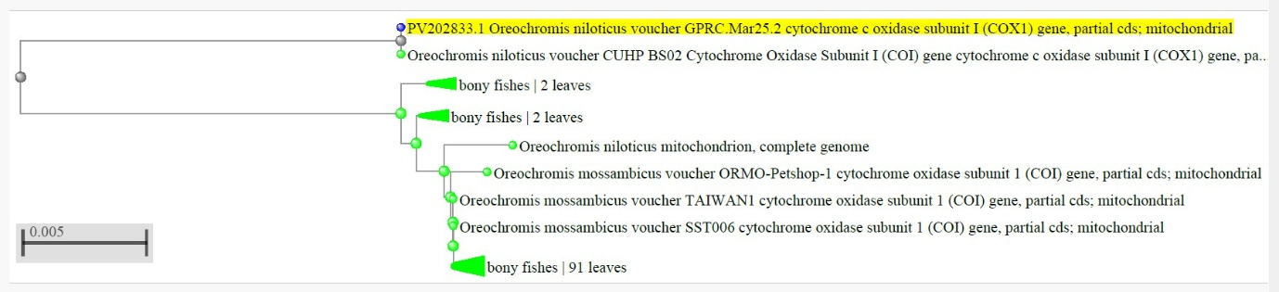

**Figure.1. Molecular Phylogenetic analysis by Neighbour Joining method using mitochondrial cytochrome c oxidase 1 gene of Nile tilapia (*Oreochromis niloticus* (Linnaeus, 1758) through DNA Barcoding using juvenile sample.**

Additionally, NCBI MSA Viewer 1.25.0 is a powerful tool for analyzing multiple sequence alignments, facilitating detailed comparative analysis of genetic sequences. In the present study, the Nile tilapiasequence was identified using the BLAST (Basic Local Alignment Search Tool) algorithm, which compares the queried sequence against a database of known sequences to find regions of similarity. The MSA Viewer was then employed to visualize and interpret the multiple sequence alignment results. This tool employes to align the query sequence of Nile tilapia through DNA Barcoding with those of other related species, highlighting conserved regions, identifying genetic variations, and inferring evolutionary relationships. The visual representation provided by the MSA Viewer aids in the clear identification of sequence homologies and differences, making it an essential resource for molecular biologists studying the genetic makeup and evolutionary history of the Nile tilapia.

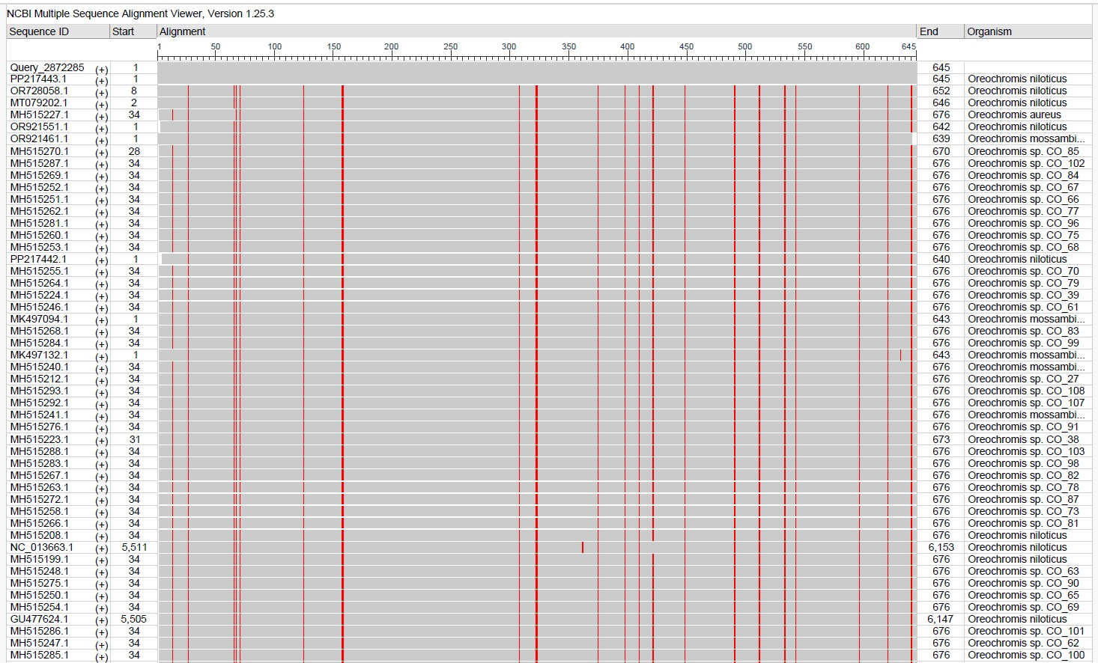

**Figure.2. NCBI Multiple Sequence Alignment Viewer 1.25.0 results showing query from the present study with the database of known sequences regions of similarity**

**3.2. Implications for Conservation and Management**

Nile tilapia (*Oreochromis niloticus*) originally from Africa introduced to India because of its quick growth rate and sturdy nature and high market value (FAO, 2020). The species continues to spread throughout Indian freshwater ecosystems through deliberate introductions and unintended escapes from aquaculture facilities which now affect sensitive ecological areas and biodiversity-rich zones (Kripal et al., 2021). Scientific research shows Nile tilapia invasions transform food chain dynamics through reduced ecological space for native herbivores and planktivores so these populations must change their feeding habits or experience population reductions (Canonico et al., 2005). The threat to native fish communities requires immediate monitoring and management strategies because Nile tilapia invasions damage native fish communities.

The introduction of Nile tilapia into other freshwater systems produces major threats to native and endemic fish species survival. The quick growth of Nile tilapia along with its adaptive behaviour leads to population competition which results in prey predation and habitat modifications that stress both broad-ranging fish species and those species with limited distribution areas. The species in Western Ghats biodiversity hotspot face high risk from these impacts because they occupy restricted ecological areas and possess poor dispersal abilities (Shuai F, Li J., 2022). Controlling aquaculture operations remains vital because it helps reduce these potential threats. A biosecurity framework with strict controls should be enforced to manage both non-native species movements and native fish farming of local-adapted species (Sugunan, 1995). The introduction of exotic species in aquaculture requires previous ecological risk assessments and local policies and monitoring systems to achieve balance between freshwater biodiversity conservation and aquaculture development (Gaupale, T. C., & Sontakke, G. K. (2023).

4. Conclusion

DNA barcoding tools enable early detection of invasive species which remains crucial for protecting native biodiversity and stabilizing ecosystems since biological invasions create significant threats. This research findings show the presence of juvenile invasive fish species within the Ganges. The combination of molecular tools and traditional ecological assessments enables policymakers to create effective methods which can protect the native aquatic biodiversity of the Ganges. Through DNA barcoding researchers can detect invasive species at their developmental stages before they become as an invader threat because of their resemblance to native species and lack of distinctions in early stages. Molecular identification systems provide faster and more exact species determinations compared to traditional morpho-taxonomic methods that need mature adult specimens for precise identification. The advancement helps conservationists together with decision-makers to cope with the effects of biological invasions while safeguarding the Ganges ecosystem.

References

1. Simberloff D, Martin JL, Genovesi P, Maris V, Wardle DA, Aronson J, Courchamp F, Galil B, García-Berthou E, Pascal M, Pyšek P, Sousa R, Tabacchi E, Vilà M. Impacts of biological invasions: what's what and the way forward. *Trends Ecol Evol*. (2013). Jan;28(1):58-66. doi: 10.1016/j.tree.2012.07.013. Epub 2012 Aug 10. PMID: 22889499.
2. Vilà M, Espinar JL, Hejda M, Hulme PE, Jarošík V, Maron JL, Pergl J, Schaffner U, Sun Y, Pyšek P. Ecological impacts of invasive alien plants: a meta-analysis of their effects on species, communities and ecosystems. *Ecol Lett.* (2011). Jul;14(7):702-8. doi: 10.1111/j.1461-0248.2011.01628.x. Epub 2011 May 19. PMID: 21592274.
3. David Pimentel, Rodolfo Zuniga, Doug Morrison, Update on the environmental and economic costs associated with alien-invasive species in the United States, *Ecological Economics*,Volume 52, Issue 3, (2005), Pages 273-288,ISSN 0921-8009, https://doi.org/10.1016/j.ecolecon.2004.10.002.
4. Ricciardi A, Blackburn TM, Carlton JT, Dick JTA, Hulme PE, Iacarella JC, Jeschke JM, Liebhold AM, Lockwood JL, MacIsaac HJ, Pyšek P, Richardson DM, Ruiz GM, Simberloff D, Sutherland WJ, Wardle DA, Aldridge DC. Invasion Science: A Horizon Scan of Emerging Challenges and Opportunities. *Trends Ecol Evol*. (2017) Jun;32(6):464-474. doi: 10.1016/j.tree.2017.03.007. Epub 2017 Apr 7. PMID: 28395941.
5. Singh, M., & Lakra, W. S. (2011). Risk and benefit assessment of alien fish species of the aquaculture and aquarium trade into India. *Reviews in Aquaculture*, 3(1), 3-18.
6. Singh, A.K., Pathak, A.K. and Lakra, W.S. (2010). Invasion of an Alien Invasive Fishes-Common Carp, Cyprinus carpio L. (Actinopterygii: Cypriniformes: Cyprinidae) in the Ganga River, India and Its Impacts*. Acta Ichthyologica Et Piscatoria*, 40, 11-19. http://dx.doi.org/10.3750/AIP2010.40.1.02.
7. Uh-Navarrete, Adrián Emmanuel, Carmen Amelia Villegas-Sánchez, José Angel Cohuo-Colli, Ángel Omar Ortíz-Moreno, and Martha Valdez-Moreno. (2021). Identifying Early Stages of Freshwater Fish with DNA Barcodes in Several Sinkholes and Lagoons from the East of Yucatan Peninsula, Mexico. *Diversity* 13, no. 11: 513. https://doi.org/10.3390/d13110513.
8. Ward, R. D., Zemlak, T. S., Innes, B. H., Last, P. R., & Hebert, P. D. (2005). DNA barcoding Australia's fish species. *Philosophical transactions of the Royal Society of London*. Series B, Biological sciences, 360(1462), 1847-1857. https://doi.org/10.1098/rstb.2005.1716.
9. Lakra, W. S., Singh, M., Goswami, M., Gopalakrishnan, A., Lal, K. K., Mohindra, V., Sarkar, U. K., Punia, P. P., Singh, K. V., Bhatt, J. P., & Ayyappan, S. (2016). DNA barcoding Indian freshwater fishes. *Mitochondrial DNA. Part A*, DNA mapping, sequencing, and analysis, 27(6), 4510-4517. https://doi.org/10.3109/19401736.2015.1101540.
10. Pfenninger, M., & Schwenk, K. (2007). Cryptic animal species are homogeneously distributed among taxa and biogeographical regions. *BMC Evolutionary Biology*, 7(1), 121.
11. Hebert, P. D. N., Cywinska, A., Ball, S. L., & deWaard, J. R. (2003). Biological identifications through DNA barcodes. *Proceedings of the Royal Society of London*. Series B: Biological Sciences, 270(1512), 313–321.
12. Hajibabaei, M., Singer, G. A. C., Hebert, P. D. N., & Hickey, D. A. (2007). DNA barcoding: how it complements taxonomy, molecular phylogenetics and population genetics. *Trends in Genetics*, 23(4), 167–172.
13. Lakra, W S and Singh, M and Goswami, Mukunda and Gopalakrishnan, A and Lal, Kuldeep Kumar and Mohindra, Vindhya and Sarkar, U K and Punia, P and Singh, K V and Bhatt, J P and Ayyappan, S. (2016). DNA barcoding Indian freshwater fishes. *Mitochondrial DNA Part A* DNA Mapping, Sequencing, and Analysis, 27 (6). pp. 4510-4517.
14. Folmer, O., Black, M., Hoeh, W., Lutz, R., & Vrijenhoek, R. (1994). DNA primers for amplification of mitochondrial cytochrome c oxidase subunit I from diverse metazoan invertebrates. *Molecular Marine Biology and Biotechnology*, 3(5), 294-299.
15. Koichiro Tamura, Glen Stecher, Sudhir Kumar (2021). MEGA11 Molecular Evolutionary Genetics Analysis Version 11*. Molecular Biology and Evolution*, 38(7), 3022–3027. https://doi.org/10.1093/molbev/msab120
16. Zheng Zhang, Scott Schwartz, Lukas Wagner, and Webb Miller (2000), A greedy algorithm for aligning DNA sequences, *J Comput Biol*. 7(1-2):203-14.
17. Aleksandr Morgulis, George Coulouris, Yan Raytselis, Thomas L. Madden, Richa Agarwala, Alejandro A. Schäffer (2008), Database Indexing for Production MegaBLAST Searches, *Bioinformatics* 24:1757-1764.
18. FAO. (2020). The State of World Fisheries and Aquaculture 2020: Sustainability in Action. Rome: Food and Agriculture Organization of the United Nations.
19. Kripal, Datt & Joshi, & Basheer, V S & Kumar, Aditya & Srivastava, Satyendra & Sahu, Vikash & Lal, Kuldeep. (2021). Alien fish species in open waters of India: Appearance, establishment and impacts. *The Indian journal of animal sciences*. 91. 167-173. 10.56093/ijans.v91i3.114139.
20. Canonico, G. C., Arthington, A., McCrary, J. K., & Thieme, M. L. (2005). The effects of introduced tilapias on native biodiversity*. Aquatic Conservation: Marine and Freshwater Ecosystems*, 15(5), 463-483.
21. Shuai F, Li J. (2022). Nile Tilapia (*Oreochromis niloticus* Linnaeus, 1758) Invasion Caused Trophic Structure Disruptions of Fish Communities in the South China River-Pearl *River. Biology* (Basel). Nov 15;11(11):1665. doi: 10.3390/biology11111665. PMID: 36421379; PMCID: PMC9687676.
22. Sugunan, V.V. (1995). Reservoir fisheries of India. FAO Fisheries Technical Paper. No. 345. Rome, FAO. 423 p.
23. Gaupale, T. C., & Sontakke, G. K. (2023). Impact of Exotic Fishes on Ecosystem, Economics and Management. *International Journal of Ecology and Environmental Sciences*, 50(1), 33-42. https://doi.org/10.55863/ijees.2024.3121.