***Original Research Article***

**"Studies on the extraction of DNA from human: Resourceful material for the identification"**

**ABSTRACT**

The extraction of DNA from human samples is a pivotal process in forensic science, medicine, and genetics, serving as a resourceful tool for identification purposes. This study explores various methods and techniques employed in DNA extraction from human tissues, focusing on their efficiency, reliability, and applicability in different contexts. We review the most used protocols, including organic solvent-based extraction, silica gel membrane-based extraction, and magnetic bead-based methods, examining their pros and cons. Additionally, the impact of sample quality, degradation, and contamination on DNA yield and integrity is discussed. The paper highlights the advancements in DNA extraction technologies and the significance of these methodologies in forensic investigations, genetic diagnostics, and anthropological studies. Through a comprehensive analysis, we aim to provide insights into optimizing DNA extraction for accurate human identification and explore emerging trends in the field.

1. **INTRODUCTION**

The extraction of DNA from human samples is a critical process in forensic science, medicine, and genetic research, as it provides a unique resource for human identification(Barash et al., 2024). DNA, as the genetic material of an individual, carries unique markers that can be used for a wide range of applications, including criminal investigations, paternity testing, and genetic diagnostics (*Forensic DNA Typing: Biology, Technology, and Genetics of STR Markers, Second Edition | Office of Justice Programs*, n.d.). The importance of accurate DNA extraction techniques cannot be overstated, as they form the foundation for subsequent analyses such as polymerase chain reaction (PCR) and sequencing, which are essential for human identification (Gupta, 2019).

Various methods have been developed for the isolation of DNA from human tissues, with protocols continually evolving to improve yield, purity, and reliability. Traditional methods, such as organic solvent-based extractions, have been widely used due to their simplicity and cost-effectiveness (Gupta, 2019). However, these methods can sometimes result in low yields or contamination, especially in challenging samples like degraded or ancient forensic evidence (Shah et al., 2017). To address these challenges, newer techniques, such as silica-based column extraction and magnetic bead-based methods, have been introduced, offering higher efficiency and reducing the likelihood of contamination (Haarkötter et al., 2023).

Despite the advances, challenges persist, particularly in forensic applications where evidence may be degraded, contaminated, or available in small quantities. The condition of the sample plays a crucial role in the success of DNA extraction, with factors such as DNA degradation, contamination from environmental sources, and inhibitor presence all affecting the quality and yield of extracted DNA (Bhoyar et al., 2024). Thus, the optimization of extraction methods, especially for compromised samples, remains a key area of research.

This paper explores the various DNA extraction methods from human samples, focusing on their relevance and effectiveness in human identification. By reviewing current techniques, comparing their advantages and limitations, and analyzing their applications in forensic and medical contexts, this research aims to contribute to the development of more efficient and reliable protocols for human identification. The paper also examines emerging trends in DNA extraction technology and its implications for the future of forensic investigations and genetic testing.

1. **MATERIAL AND METHOD**

**2.1 Sample Collection**

For forensic DNA related issues, the procedure consists of three major steps: extraction of DNA from the samples, PCR amplification of the target DNA sequences and lastly fragment analysis of PCR products using Gel electrophoresis. However, when the substrate for DNA profiling comprises fixed specimens, the isolation of DNA remained the most time consuming and tedious step of the analysis process. The first crucial step in DNA extraction starts with the collection of the sample followed by its appropriate storage. as shown in **Fig.1.** human saliva and cigarette butts of 7 persons were used as resource materials for the criminal identification in the current study.

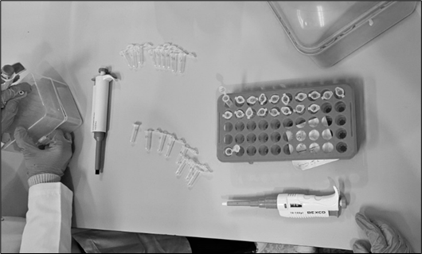

**Fig.1.** Pre-processing for DNA sample collection.

Initially the washed tissues were divided into 3 equal parts in order to subject them to 4 independent extraction protocols which include:

1. Phenol Chloroform extraction
2. Salting out extraction
3. Cetyl tri ammonium bromide (CTAB) extraction and

However, one protocol (CTAB) was abandoned due to the repeated failure in extracting any DNA from the tissues as no DNA was noticed on the gel material following gel electrophoresis. Excluding CTAB extraction protocol, other 3 extractions protocols were standardized for the liberation of DNA. Pertinently the standardized protocols that were followed during initial attempts/trials failed to give any positive results of DNA retrieval. While there has been a significant variation in the DNA recovery protocols of different laboratories, it is emphasized that one should optimize the protocols within the means of the individual laboratory (Hedman et al., 2021). Accordingly, a protocol was chosen after deciding the final conditions of proteinase K concentration, incubation temperature, incubation period and complete homogenization of the tissue (Meizarini et al., 2023). However, when standardized phenol chloroform extraction failed to give satisfactory results particularly for aged specimens, the technique was further modified for the liberation of DNA in all the circumstances irrespective of the duration of fixation (Liu et al., 2022). Accordingly, three versions of standardized phenol chloroform method of extraction were attempted and developed thereby making a total of five extraction methods (Shin, 2013). While the tissues were divided into equal parts, variations due to cellularity among some of the tissue sections cannot be excluded. Hence in all the later attempts, tissues were divided into 5 equal parts. Each tissue part was thereafter subjected to an independent extraction protocol after complete homogenization using different various set of reagents/chemicals.

* 1. **Materials required**

Chloroform (99.8%), iso-Propyl Alcohol (99.8%), Ammonium Acetate (98%), Acetone (99.8%), Dithiothreitol (DTT) (99%), Sodium Chloride (99.5%), Glycine (99.5%), Phenol (99.5%), Ethylene Diamine Tetra Acetic Acid (99.5%), Hydrochloric Acid (36.5%) were bought from Loba Chemie; Proteinase K, Sodium Acetate, Sodium Chloride, Tris, Sodium Dodecyl Sulphate, Phenol Chloroform isoamyl alcohol mixture, Isoamyl alcohol, Sodium hydroxide pellets, Potassium Chloride, Ammonium Acetate, Monopotassium phosphate, Sodium phosphate dibasic were procured from Hi Media; Ethanol was taken from Merck Germany; Sodium Lauryl Sulphate “Ultra Pure” was purchased from Otto; QIAamp® was acquired from Qiagen (Germany).

**2.3 Protocols used for DNA extraction**

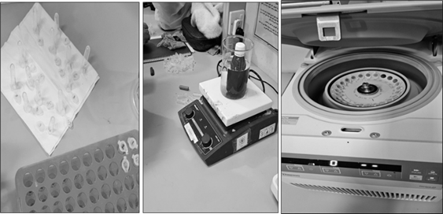

**Fig.2.** Tissue sections prepared for DNA extraction.

Each tissue section prepared at step is shown in **Fig.2.** was subjected to an independent DNA extraction protocol using various reagents. The DNA extraction methods employed in this investigation along with the usual steps followed in independent extraction protocols are as follows.

**2.3.1 Salting out DNA extraction protocol**

For salting out extraction method, the protocol of Rivero *et al*., 2006 and Funabashi *et al*., 2012 was followed but with some modifications. The steps followed were:

Prior to any addition, a tissue was finely chopped using a clean sterilized surgical blade. 2. Following this 1000µl of digestion buffer (10mM Tris-HCl, 1.0mM EDTA and 0.5% Tween 20 at a pH=8.0,) was added to this chopped tissue and was additionally subjected to homogenization using a tissue homogenizer. The homogenized tissue was transferred to a sterilized falcon tube and followed by adding 20mg/ml proteinase K to it. The tubes were then left for overnight incubation (up to 36 hours in some cases) at 56 oC. After the completion of this period, incubation temperature was extended to 95 oC for 10 -25 minutes (usually 15 minutes) for inactivating the proteinase K activity. 400 µl of Ammonium acetate was added to the tube and was again incubated for 10 minutes at 20oC . Following this, step, tubes were briefly vortexed and centrifuged for 12 minutes at maximum speed. The supernatant was then transferred to a new tube and 600 µl of isopropanol was added to this tube. Following this addition, the tube was briefly vortexed and centrifuged at maximum speed for 35 minutes. After the completion of centrifugation, the supernatant was discarded and 250 µl of 70% ethanol was added to the tube containing the pellet. The pellet was washed twice with 70% ethanol. The ethanol was discarded after being used for the washing of the pellet and consequently the pellet was left for air drying. Once the ethanol was completely evaporated, 80 µl of TE solution was added to the pellet and was briefly vortexed. The tube was again incubated at 56 oC for 15 minutes with a view to dissolve the DNA in the TE solution and was thereafter stored in -20 oC. A part of this diluted DNA was subjected to gel electrophoresis and spectrophotometric analysis.

**2.3.2 Phenol chloroform extraction protocol**

A single validated protocol for Phenol-Chloroform extraction was developed by modifying existing methods. The process involved adding TNE buffer to washed tissue, mincing it finely, and homogenizing it. Proteinase K was then added, followed by a 72-hour incubation at 60°C. After incubation, samples were vortexed, centrifuged, and processed for DNA extraction. When this method failed for aged specimens, three modified versions were developed.

The steps of Phenol chloroform method of DNA extraction in its three versions are:

*2.3.2.1 Phenol chloroform extraction (Version-I) protocol*

The DNA extraction process involved adding a phenol/chloroform/isoamyl alcohol mixture to the sample, followed by vortexing and centrifugation. The supernatant was transferred to a new tube while discarding protein debris. This step was repeated with another round of phenol/chloroform/isoamyl alcohol, followed by chloroform/isoamyl treatment twice. The final supernatant was collected for DNA precipitation using sodium acetate or sodium chloride along with cold ethanol, incubated at -80°C for 5 hours or -20°C overnight. After ethanol washes and drying, the DNA pellet was resuspended in TE buffer, incubated at 55°C, and analyzed using gel electrophoresis and spectrophotometry.

*2.3.2.2 Phenol-chloroform extraction (Version-II) protocol*

This modified DNA extraction method used only a phenol/chloroform mix (1:1) initially instead of phenol/chloroform/isoamyl alcohol. After vortexing and centrifugation, the supernatant was transferred to fresh tubes through multiple rounds of phenol/chloroform and phenol/chloroform/isoamyl treatments, followed by additional chloroform/isoamyl washes. DNA precipitation was carried out using 0.1M NaCl (1:5) or isopropanol, along with cold ethanol. After incubation at -80°C for 5 hours or -20°C overnight, ethanol washes were performed, and the DNA pellet was dried at room temperature. The DNA was resuspended in TE buffer, incubated at 55°C, and analyzed using gel electrophoresis and spectrophotometry.

*2.3.2.3 Phenol chloroform extraction (Version-III) protocol*

When formalin-preserved specimens were processed using the previous Phenol/Chloroform extraction methods, DNA recovery significantly declined or failed. To minimize DNA loss, instead of discarding the leftover bottom material (protein debris), it was collected in a fresh tube at each stage. After completing the standard extraction steps, 1000 µl of chloroform/isoamyl alcohol (1:1) was added, followed by vortexing and centrifugation. The supernatant was then transferred and treated again with 500 µl of chloroform/isoamyl alcohol. DNA was precipitated using isopropanol instead of NaCl. After centrifugation, the pellet was washed twice with 70% ethanol, air-dried, and resuspended in TE buffer. The DNA solution was incubated at 56°C for 15 minutes before storage at -20°C. The extracted DNA was analyzed using gel electrophoresis and spectrophotometry.

**2.4 Pre-processing of paraffin embedded tissues for DNA extraction**

For paraffin-embedded specimens, a tissue portion was excised with a sterile blade and placed on a cleaned microscope slide. The slide was heated on a hot plate to melt the paraffin, after which the tissue was carefully separated and transferred to a new slide. Further heating helped remove residual paraffin. The tissue was then washed in 70% alcohol, followed by 95% alcohol. Due to the small tissue size, only two DNA extraction methods were used: the Salting Out method and a commercial kit, following previously discussed protocols.

**2.5 DNA integrity**

**Agarose gel electrophoresis:** A 1% agarose gel was prepared by dissolving agarose in 1X TAE buffer, heating, and adding Ethidium Bromide (EtBr) before setting at room temperature. Once set, the gel was placed in a running tank with 1X TAE buffer. Extracted DNA was mixed with loading dye and loaded into wells, though DNA ladders were later omitted. Electrophoresis was run at 100V for 30-50 minutes. The DNA, bound to EtBr, fluoresced under UV light and was imaged. Only DNA verified through visualization was stored at -20°C for spectrophotometric analysis, while non-authenticated samples were discarded.

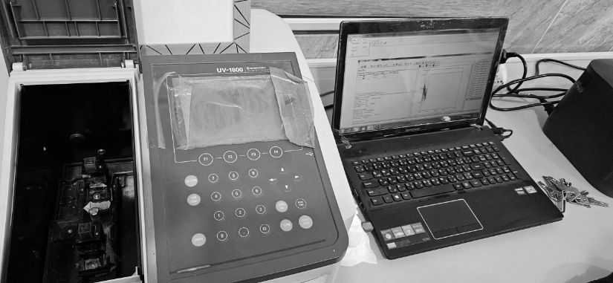**2.6 Quality control assessment using UV spectrophotometer**

**Fig.3.** UV Spectrophotometer.

Ultraviolet spectrophotometry (UV) (**Fig. 3**) was used for DNA quantification using the Evolution 60S Thermo Fisher Scientific spectrophotometer. DNA samples were placed in a quartz cuvette, and absorbance was measured at 260 nm (A260) for nucleic acid concentration and 280 nm (A280) for protein contamination. The DNA purity was determined by the A260/A280 ratio, with values ≥1.8 considered relatively pure. DNA concentration was calculated using the formula: **Concentration (µg/ml) = A260 × dilution factor × 50 µg/ml**.

While UV spectrophotometry is simple and requires minimal purified DNA, it has limitations, especially for low-yield samples from formalin-fixed tissues, where dilution is impractical due to degradation. Only DNA samples with an A260/A280 ratio between **1.8-2.0** were selected for PCR analysis.

**2.7 PCR Amplification**

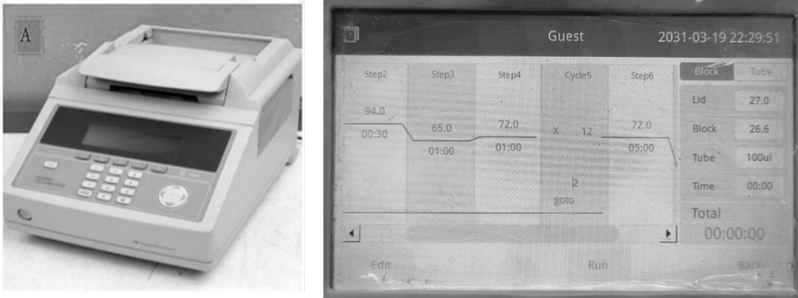

**Fig.4.** PCR thermal cycler and PCR programming.

Samples with an absorbance (A260/A280) ratio in between 1.2 - 1.8 were selected for the PCR amplifications. GlobalFiler® PCR Amplification Kit (Life Technologies) was used for the amplification of DNA extracted from fixed specimens. All PCR assays were conducted using 5 µl of DNA, 7.5 µl of Primer mix, 2.5 µl of Master Mix. The amplifications were performed as per the standardized protocol on a 9700 thermal cycler (**Fig. 4**) specific for degraded samples using up-to 40 PCR cycles (Life Technologies).

1. **REVIEW LITERATURE:**

The various methods used to extract DNA is explained as follows:

1. Chromatography-Based DNA Extraction: This method isolates DNA from various biological samples by separating molecules based on size, charge, or affinity (M. Carpi et al., 2011). It includes three subtypes: Size-Inclusion Chromatography: Separates DNA based on molecular size. Ion-Exchange Chromatography (IEC): DNA binds to a positively charged resin (diethylaminoethyl cellulose), which selectively isolates DNA (M. Carpi et al., 2011). Affinity Chromatography: Uses oligonucleotides that bind specifically to DNA sequences, separating them from other cellular components (M. Carpi et al., 2011). It is a simple, fast and produces high-quality nucleic acids as well are the advantages while its limitation is that it can be costly and time-consuming (Chockalingam et al., 2001).
2. EtBr-CsCl Gradient Centrifugation Method: Developed in 1957 by Meselson et al (Meselson et al., 1957), this method involves mixing DNA with cesium chloride (CsCl) and performing ultracentrifugation at 10,000–12,000 rpm for 10 hours. Ethidium bromide (EtBr) binds preferentially to non-supercoiled DNA, allowing separation under UV light. Advantage being effective for bacterial DNA extraction and limitations are that it requires large amounts of DNA, expensive and time-consuming and complex due to prolonged centrifugation.
3. Alkaline Extraction Method: Introduced by Birnboim and Doly in 1979 (Birnboim & Doly, 1979), this method is used for plasmid DNA extraction. The sample is treated with: Sodium hydroxide (NaOH) which breaks open cells. Sodium dodecyl sulfate (SDS) helps in denaturing proteins and lipids and Potassium acetate which Neutralizes the alkaline solution and causes precipitation of unwanted materials. Limitation can be the contamination of plasmid DNA with chromosomal DNA fragments.
4. Silica Matrices Method: Discovered by Vogelstein and Gillespie in 1979 (Höss & Pääbo, 1993), this method is based on the affinity between DNA and silica in the presence of positively charged ions. In the process DNA binds to the silica surface. Further the cellular contaminants are removed by washing with distilled water or Tris-EDTA buffer. Advantages are that its simple and cost-effective and fast DNA isolation while the limitation are Silica matrices cannot be reused.
5. Salting-Out Method: Introduced by Miller et al. in 1988 (Miller et al., 1988), this method is non-toxic and widely used. For rhe process the sample is mixed with lysis buffer, SDS, and proteinase K and incubated at 55–65°C overnight. Saturated NaCl solution is added to precipitate proteins and DNA is precipitated with ethanol (Peterson & Sober, 1956). Advantages comprises of high-quality DNA and non-toxic and cost-effective.
6. Cetyltrimethylammonium Bromide (CTAB) Method: Developed by Doyle et al. in 1990 (Green & Sambrook, 2017), this method is used for DNA isolation from plants. Process begins with sample mixed with 2% CTAB at alkaline pH. Low ionic strength buffer precipitates DNA and acidic polysaccharides. High salt concentration removes DNA from acidic polysaccharides. This method has limitations of time-consuming and using toxic reagents like phenol and chloroform (Budelier & Schorr, 1998).
7. Phenol-Chloroform Method: Introduced by Barker et al. in 1998 (Elkins, 2013), this is considered the gold standard for DNA extraction. In the process SDS lysis buffer breaks the cell membrane and nuclear envelope. Further the Phenol-Chloroform-Isoamyl Alcohol (25:24:1) (Peterson & Sober, 1956) is added which denature proteins and prevents emulsification. Further centrifugation separates sample into two layers which are DNA and proteins. In the last step DNA is precipitated using ethanol and sodium acetate. Advantages of this method are that it produces high-quality DNA and effective for extracting DNA from blood, tissue, and cells. Limitations are it uses toxic reagents (phenol, chloroform). (Peterson & Sober, 1956) and is time-consuming.
8. SDS-Proteinase K Method: Developed by Ebeling et al. in 1974 (Thomas et al., 1989), this method uses SDS and Proteinase K to lyse cells and digest proteins. Process consists of three simple steps in which SDS breaks the membrane and denatures proteins, Proteinase K degrades proteins and prevents DNA degradation and the DNA is extracted using the salting-out or phenol-chloroform method (Evans, 2001). Advantage is that it is efficient for extracting high-molecular-weight DNA.
9. Silica Column-Based DNA Extraction:A modern method using silica columns for DNA purification. In the process lysis buffer (SDS, proteinase K, Tris-EDTA buffer) is used to lyse cells. Then the sample is loaded onto a silica gel column in which DNA binds to silica, while proteins and contaminants are washed away. Purified DNA is eluted with Tris-EDTA buffer. Advantages of this method are that it increases DNA purity and Silica prevents direct contact with toxic chemicals.
10. Magnetic Beads Method: Patented by Trevor Hawkins in 1998 (Elkins, 2013), this method uses magnetic nanoparticles coated with DNA-binding molecules. Process consists of a magnetic field which pulls DNA-bound beads from solution and the DNA is eluted using ethanol precipitation (Peterson & Sober, 1956). Advantages are that it takes less than 15 minutes and highly pure DNA can be extracted.
11. Cellulose-Based Paper (FTA Cards):Developed by Whatman in 2000, these cards contain detergents, buffers, and chelating agents that facilitate DNA extraction (J Shetty, 2020). Process to be followed are sample is spotted on an FTA card. Further a small punch (1–2mm) is taken from the card and processed for DNA extraction. Advantages are it is a fast and convenient method and requires no need for laboratory expertise.
12. Chelex-100 Extraction Method: Patented by Xlonghui et al. in 2011 (J Shetty, 2020), this method chelates metal ions that act as cofactors for DNases, preventing DNA degradation. The process is sample incubated for overnight and 5% Chelex solution with Proteinase K is added and boiled to lyse membranes and denature proteins. Further the DNA is collected from the supernatant. Advantages are it reduces risk of contamination and uses a single test tube. The limitation being that the DNA can be unstable (J Shetty, 2020).
13. Filter Paper-Based DNA Extraction: Developed by Ruishi and Dilippanthe in 2017, this method is cost-effective and used for plant DNA. For the process sample is lysed and filtered through Whatman filter paper and DNA is collected using centrifugation. Advantage is that it is a Low cost method (Shi & Panthee, 2017).
14. **RESULT AND DISCUSSION:**

**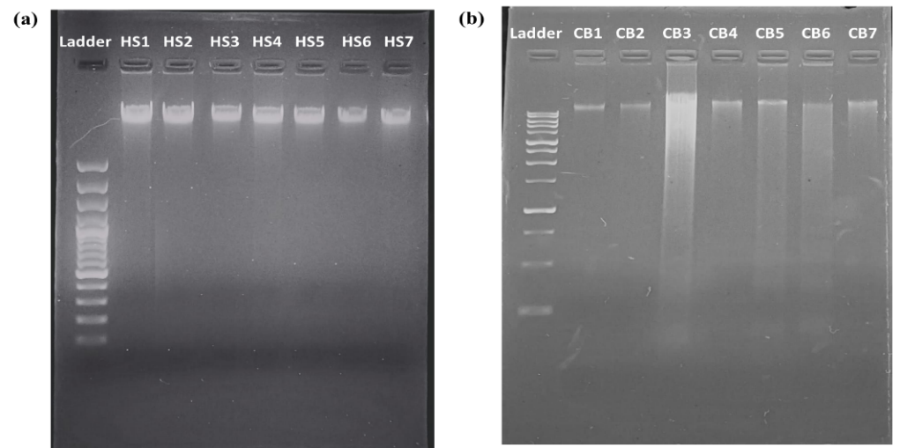  
Fig.5.** Gel electrophoresis of the DNA obtained (a) Human saliva samples (b) Cigarette bud samples.

The DNA bands visualized under UV transmitter chamber is shown in **Fig.5.** in which image (a) is of DNA from human saliva and (b) is DNA obtained from cigarette buds.

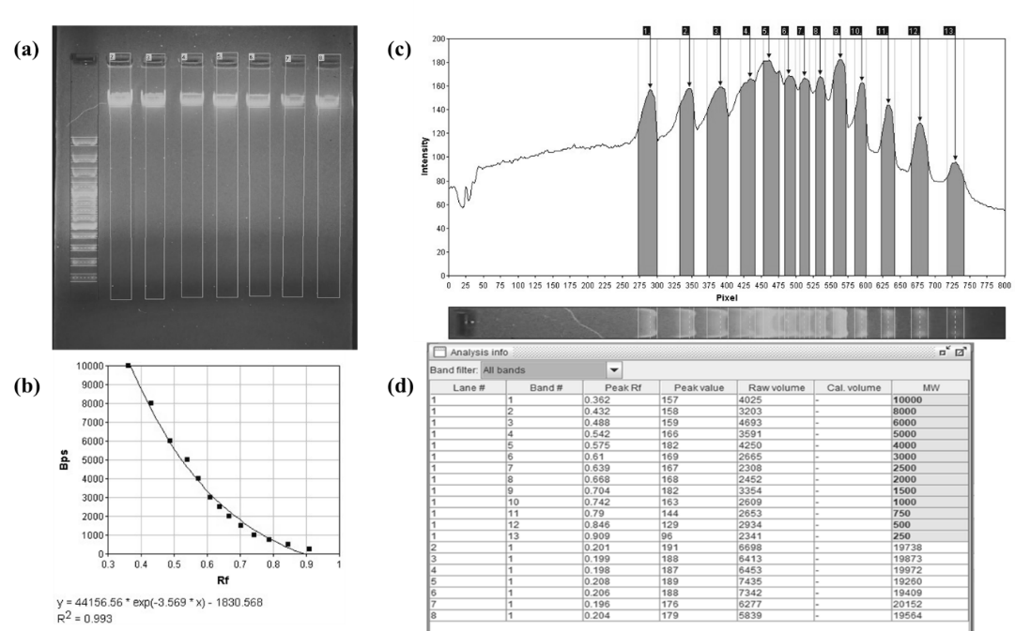

**Fig.6.** Gel analysis of DNA obtained from Human saliva samples.

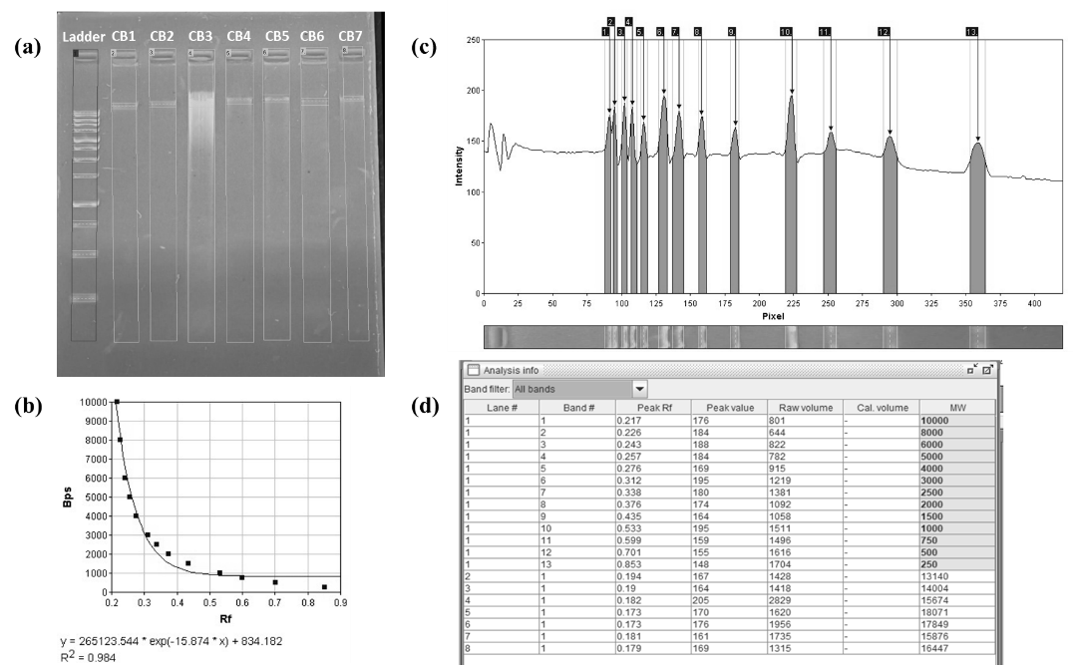

**Fig.7.** Gel analysis of DNA obtained from Cigarette bud samples.

**Fig.6 and Fig.7.** shows the gel analysis of DNA obtained from human saliva samples in which (a) represents the detection of lanes of the DNA run, (b) shows the calibration curve, (c) detection of bands in form of peaks; (d) is the analysis information which shows the result of size of band.

From the gel analysis information of both the gel, it can be easily concluded that the human genomic DNA band size is more than 10,000bp. Any human genomic DNA band falling below 10,000bp is a false result as it cannot be a genomic DNA band.

|  |  |  |  |  |
| --- | --- | --- | --- | --- |
| **Number** | **Human saliva** | **260/280Ab** | **Cigarette butts** | **DNA purity and concentration** |
| **1** | HS1 | 1.22 | CB1 | 1.65 |
| **2** | HS2 | 1.75 | CB2 | 1.77 |
| **3** | HS3 | 1.93 | CB3 | 1.79 |
| **4** | HS4 | 1.49 | CB4 | 1.66 |
| **5** | HS5 | 1.13 | CB5 | 1.65 |
| **6** | HS6 | 1.71 | CB6 | 1.14 |
| **7** | HS7 | 1.52 | CB7 | 1.77 |

**Table 1.** DNA purity and concentration under UV Spectrophotometer

1. **CONCLUSION:**

DNA extraction remains fundamental in forensic science, genetics, and medical diagnostics, playing a crucial role in human identification. This paper reviewed various extraction methods, including organic solvent-based, silica-based, and magnetic bead-based techniques, discussing their benefits and limitations. While advancements have improved DNA yield and purity, challenges persist, particularly with degraded or contaminated samples.

Future innovations, such as automated extraction systems and molecular biology advancements, will enhance forensic investigations, especially for challenging samples. As DNA-based identification grows in demand, continued research into improved methods is essential. Ultimately, refining DNA extraction techniques will strengthen forensic science, healthcare, and personal identification.

Consent (where ever applicable)

Not applicable.

Ethical approval (where ever applicable)

Not applicable.

**REFERENCES:**

Barash, M., McNevin, D., Fedorenko, V., & Giverts, P. (2024). Machine learning applications in forensic DNA profiling: A critical review. *Forensic Science International: Genetics*, *69*, 102994. https://doi.org/10.1016/j.fsigen.2023.102994

Bhoyar, L., Mehar, P., & Chavali, K. (2024). An overview of DNA degradation and its implications in forensic caseworks. *Egyptian Journal of Forensic Sciences*, *14*(1), 15. https://doi.org/10.1186/s41935-024-00389-y

Birnboim, H. C., & Doly, J. (1979). A rapid alkaline extraction procedure for screening recombinant plasmid DNA. *Nucleic Acids Research*, *7*(6), 1513–1523. https://doi.org/10.1093/nar/7.6.1513

Budelier, K., & Schorr, J. (1998). Purification of DNA by Anion‐Exchange Chromatography. *Current Protocols in Molecular Biology*, *42*(1). https://doi.org/10.1002/0471142727.mb0201bs42

Chockalingam, P. S., Jurado, L. A., & Jarrett, H. W. (2001). DNA Affinity Chromatography. *Molecular Biotechnology*, *19*(2), 189–200. https://doi.org/10.1385/MB:19:2:189

Elkins, K. M. (2013). *Forensic DNA biology: A laboratory manual*. Academic Press.

Evans, J. P. (2001). The complexities of predictive genetic testing. *BMJ*, *322*(7293), 1052–1056. https://doi.org/10.1136/bmj.322.7293.1052

*Forensic DNA Typing: Biology, Technology, and Genetics of STR Markers, Second Edition | Office of Justice Programs*. (n.d.). Retrieved March 6, 2025, from https://www.ojp.gov/ncjrs/virtual-library/abstracts/forensic-dna-typing-biology-technology-and-genetics-str-markers

Green, M. R., & Sambrook, J. (2017). Isolation of High-Molecular-Weight DNA Using Organic Solvents. *Cold Spring Harbor Protocols*, *2017*(4), pdb.prot093450. https://doi.org/10.1101/pdb.prot093450

Gupta, N. (2019). DNA extraction and polymerase chain reaction. *Journal of Cytology*, *36*(2), 116. https://doi.org/10.4103/JOC.JOC_110_18

Haarkötter, C., Gálvez, X., Vinueza-Espinosa, D. C., Medina-Lozano, M. I., Saiz, M., Lorente, J. A., & Álvarez, J. C. (2023). A comparison of five DNA extraction methods from degraded human skeletal remains. *Forensic Science International*, *348*, 111730. https://doi.org/10.1016/j.forsciint.2023.111730

Hedman, J., Akel, Y., Jansson, L., Hedell, R., Wallmark, N., Forsberg, C., & Ansell, R. (2021). Enhanced forensic DNA recovery with appropriate swabs and optimized swabbing technique. *Forensic Science International: Genetics*, *53*, 102491. https://doi.org/10.1016/j.fsigen.2021.102491

Höss, M., & Pääbo, S. (1993). DNA extraction from Pleistocene bones by a silica-based purification method. *Nucleic Acids Research*, *21*(16), 3913–3914. https://doi.org/10.1093/nar/21.16.3913

J Shetty, P. (2020). The Evolution of DNA Extraction Methods. *American Journal of Biomedical Science & Research*, *8*(1), 39–45. https://doi.org/10.34297/AJBSR.2020.08.001234

Liu, A. W., Villar-Briones, A., Luscombe, N. M., & Plessy, C. (2022). Automated phenol-chloroform extraction of high molecular weight genomic DNA for use in long-read single-molecule sequencing. *F1000Research*, *11*, 240. https://doi.org/10.12688/f1000research.109251.1

M. Carpi, F., Di Pietro, F., Vincenzetti, S., Mignini, F., & Napolioni, V. (2011). Human DNA Extraction Methods: Patents and Applications. *Recent Patents on DNA & Gene Sequences*, *5*(1), 1–7. https://doi.org/10.2174/187221511794839264

Meizarini, A., Puteri, A., Yasan, Y. D. R., & Hussaini, H. M. (2023). Optimization of proteinase K incubation protocol duration during DNA extraction from oral squamous cell carcinoma FFPE samples. *Dental Journal (Majalah Kedokteran Gigi)*, *56*(4), 233–237. https://doi.org/10.20473/j.djmkg.v56.i4.p233-237

Meselson, M., Stahl, F. W., & Vinograd, J. (1957). EQUILIBRIUM SEDIMENTATION OF MACROMOLECULES IN DENSITY GRADIENTS. *Proceedings of the National Academy of Sciences*, *43*(7), 581–588. https://doi.org/10.1073/pnas.43.7.581

Miller, S. A., Dykes, D. D., & Polesky, H. F. (1988). A simple salting out procedure for extracting DNA from human nucleated cells. *Nucleic Acids Research*, *16*(3), 1215–1215. https://doi.org/10.1093/nar/16.3.1215

Peterson, E. A., & Sober, H. A. (1956). Chromatography of Proteins. I. Cellulose Ion-exchange Adsorbents. *Journal of the American Chemical Society*, *78*(4), 751–755. https://doi.org/10.1021/ja01585a016

Shi, R., & Panthee, D. R. (2017). A novel plant DNA extraction method using filter paper-based 96-well spin plate. *Planta*, *246*(3), 579–584. https://doi.org/10.1007/s00425-017-2743-3

Shin, J. H. (2013). Nucleic Acid Extraction Techniques. In Y.-W. Tang & C. W. Stratton (Eds.), *Advanced Techniques in Diagnostic Microbiology* (pp. 209–225). Springer US. https://doi.org/10.1007/978-1-4614-3970-7_11

Thomas, S. M., Moreno, R. F., & Tilzer, L. L. (1989). DNA extraction with organic solvents in gel barrier tubes. *Nucleic Acids Research*, *17*(13), 5411–5411. https://doi.org/10.1093/nar/17.13.5411