Review Article

Review of Coir Pith as Agro‐Industrial Waste : Environmental Challenges and Management Approaches

ABSTRACT
Coir pith, a major byproduct of the coconut processing industry, has traditionally been considered a low-value waste due to its high lignin content and imbalanced carbon-to-nitrogen (C:N) ratio. These properties make it highly resistant to microbial degradation, leading to prolonged accumulation, methane emissions and toxic leachate generation. However, recognizing these environmental challenges, innovative recycling technologies have emerged to transform coir pith into a valuable agricultural resource, turning waste into opportunity for sustainable farming.
A significant breakthrough in this field is NOVCOM composting technology, which overcomes the limitations of conventional methods by optimizing aerobic conditions through controlled aeration, precise temperature regulation, and targeted microbial inoculation. This approach accelerates the breakdown of lignocellulosic material, effectively lowering the C:N ratio and ensuring rapid stabilization of organic matter. By doing so, NOVCOM composting technology not only significantly reduces methane emission- a major contributor to climate change- but also enhances the quality of the quality of final compost, making it a more effective soil amendment.
Complementing this innovation is Inhana Rational Farming Technology, a nature friendly sustainable farming system that integrates soil and plant health management to revitalize the soil ecosystem. This holistic approach enhances nutrient cycling, boosts microbial activity, and supports long-term Agricultural sustainability. Field trials conducted under the IBM-IORF Sustainability Project have demonstrated that combining NOVCOM composting technology with Inhana’s methodologies not only shortens the composting cycle but also rejuvenate soil vitality towards long term sustainability, ensuring resilient crop production.
Together, these technologies create a robust model for a circular bio-economy, transforming coir pith waste into a high-value agricultural input. This integrated strategy not only mitigates the environmental footprint of coir pith through greenhouse gas reduction and land restoration but also strengthens food security and foster a sustainable regenerative agricultural system.

1. INTRODUCTION
Coconut coir pith, a lignocellulosic byproduct of coir fiber extraction from coconut husks, is an abundant agro-industrial residue. The global coconut industry produces millions of tonnes of coir pith annually (FAO, 2018), yet it remains largely underutilized due to its recalcitrant nature. Its high lignin content imparts structural rigidity and micriobial resistance (Rajalakshmi et al., 2018), while its wide carbon-to-nitrogen (C:N) ratio further limits decomposition efficiency. As a result, coir pith persists in the environment, posing significant waste management challenges. Uncontrolled accumulation leads to environmental risks, including methane (CH₄) emissions from anaerobic degradation. Methane, a greenhouse gas over 20 times more potent than carbon dioxide (CO₂) (Kumar et al., 2019), contributes to climate change when coir pith is left to degrade in landfills.
Additionally, coir pith contains bioactive compounds, such as phenolic substances and tannins, which can leach into surrounding soils and water bodies, disrupting microbial communities, reducing soil fertility and affecting aquatic ecosystems (Singh & Patel, 2020). These factors make coir pith a problematic waste, necessitating targeted management strategies.
Recognizing these environmental risks, regulatory bodies have imposed stricter controls. The Tamil Nadu Pollution Control Board (TNPCB) has reclassified coir pith processing units under higher pollution categories, enforcing measures such as wastewater recycling and controlled drying (TNPCB, 2020; Devanathan, 2021). The Tamil Nadu government's Coir Policy 2024 further integrates economic growth with environmental sustainability, promoting responsible processing and utilization (Government of Tamil Nadu, 2024).

To mitigate coir pith’s ecological footprint, sustainable valorization strategies are gaining traction. Research-backed innovations include converting coir pith into high-value biocomposites, bio-based materials, and quality organic manure (Mardijanti et al., 2021; Stelte et al., 2023). These approaches align with circular economy principles, transforming waste into resources while reducing environmental impact. Given its abundance and potential, managing coir pith sustainably is not just an environmental necessity but also an opportunity to enhance economic viability within the agro-industrial sector.

2. Chemical Characteristics and Resistance to Degradation
Remarkably high lignin content of coir pith is a key factor in its resistance to microbial degradation. Lignin, a highly complex and cross-linked aromatic polymer, provides rigidity to plant cell walls and is inherently recalcitrant due to its irregular structure and stable chemical bonds (Brebu & Vasile, 2010). In coir pith, lignin content ranges from 20% to 40% of dry weight (Abad et al., 2002; Mardijanti et al., 2021), significantly hindering microbial breakdown and resulting in an extremely slow natural decomposition process (Rajalakshmi et al., 2018). Additionally, coir pith exhibits a high carbon-to-nitrogen (C:N) ratio, often exceeding 100:1, which further restricts microbial activity. Efficient microbial decomposition requires a balanced carbon and nitrogen supply for protein synthesis and growth. A high C:N ratio leads to nitrogen deficiency, suppressing microbial metabolism and slowing decay (Noguera et al., 2000; Ministry of MSME, 2016).

The combined impact of high lignin content and an imbalanced C:N ratio causes coir pith to persist in the environment, leading to waste accumulation issues and disposal challenges. Over time, anaerobic degradation can result in methane emissions, a potent greenhouse gas (Kumar et al., 2019), highlighting the urgent need for sustainable coir pith management solutions.

3. Environmental Impact: Methane Emissions and Greenhouse Gases
Under anaerobic conditions, the persistent organic matter in coir pith provides an ideal substrate for methanogenic archaea, microorganisms that produce methane (CH₄) during decomposition. This occurs via two main pathways: acetoclastic methanogenesis, where acetate is split into CH₄ and CO₂, and hydrogenotrophic methanogenesis, where CO₂ is reduced to CH₄ using hydrogen as an electron donor (Conrad, 2009). However, due to high lignin content and an elevated carbon-to-nitrogen (C:N) ratio, coir pith decomposes extremely slowly, creating persistent anaerobic conditions that favor methane production over aerobic respiration (Kumar et al., 2019).
Methane is a highly potent greenhouse gas, with a global warming potential (GWP) 20–25 times that of CO₂ over 100 years and around 80 times over 20 years (IPCC, 2014). Even small increases in methane emissions can have significant climate implications. Studies show that coir pith accumulation in landfills sustains anaerobic conditions, enabling methanogenic communities to continuously generate methane (Kumar et al., 2019). The high C:N imbalance further limits aerobic decomposition, reinforcing methane production (Smith, Brown, & Wang, 2017). Metagenomic studies reveal that Methanosarcina and Methanosaeta dominate landfill methane-producing ecosystems, thriving on the slow hydrolysis of lignocellulosic materials like coir pith (Liu et al., 2018). Research by Bera et al. (2023) indicates that untreated coir pith can emit methane equivalent to 6000 kg CO₂-eq per ton over its decomposition lifespan. These emissions underscore the urgent environmental risks posed by improper disposal and the necessity for sustainable valorization strategies.

Mitigation strategies for reducing methane emissions from waste management include landfill gas capture systems that recover methane before its release into the atmosphere. Anaerobic digestion, particularly when combined with co-substrates, enhances microbial breakdown and minimizes methane emissions (Zhu et al., 2020). Additionally, bioconversion into compost, such as through Novcom Technology, has been shown to reduce methane release by over 30-fold while simultaneously producing a valuable soil amendment (Bera et al., 2023). The slow decomposition of coir pith under anaerobic conditions makes it a major methane emitter, worsening climate change and waste management challenges. Implementing advanced recycling, digestion, and methane capture systems is critical for reducing its environmental footprint and transforming it into a sustainable agricultural resource.

Leaching of Bioactive Compounds and Eco-toxicological Risks
Coir pith not only resists degradation but also contains bioactive compounds, particularly phenolics and tannins, which pose serious environmental risks when leached into soil and water systems. These compounds, naturally synthesized by coconut plants as defense mechanisms, mobilize under improper storage or disposal conditions, leading to adverse ecological effects.
Phenolic compounds disrupt microbial enzyme activity, essential for organic matter decomposition. Singh and Patel (2020) reported that phenolics leached from coir pith alter soil microbial communities, suppressing nutrient-mineralizing enzymes, thereby reducing nitrogen and phosphorus availability. This results in declining soil fertility and stunted plant growth. Additionally, increased oxidative stress caused by phenolics further weakens microbial diversity, diminishing soil ecosystem resilience (Zhang et al., 2017). Tannins, high-molecular-weight polyphenols, strongly chelate metals and nitrogenous compounds, forming stable complexes that limit nutrient bioavailability (Khan et al., 2011). Due to their complex aromatic structure, tannins persist in the environment, accumulating over time and causing chronic toxicity in both terrestrial and aquatic ecosystems. Even at low concentrations, tannins alter nutrient cycling and inhibit sensitive aquatic organisms (Rodrigues et al., 2019).
In aquatic environments, these compounds elevate chemical oxygen demand (COD) and contribute to recalcitrant dissolved organic matter, depleting oxygen and inducing hypoxic conditions harmful to aquatic life (Bianchi, 2007). Their chemical complexity and persistence make remediation highly challenging, as conventional treatment methods often fail to fully eliminate them, posing long-term ecological threats (Cottrell & Wenzel, 2007).
Thus the leaching of bioactive compounds from untreated coir pith is an underestimated environmental hazard. Addressing these risks requires sustainable waste management strategies and advanced remediation technologies to mitigate the eco-toxicological impact of phenolics and tannins in soil and water ecosystems.

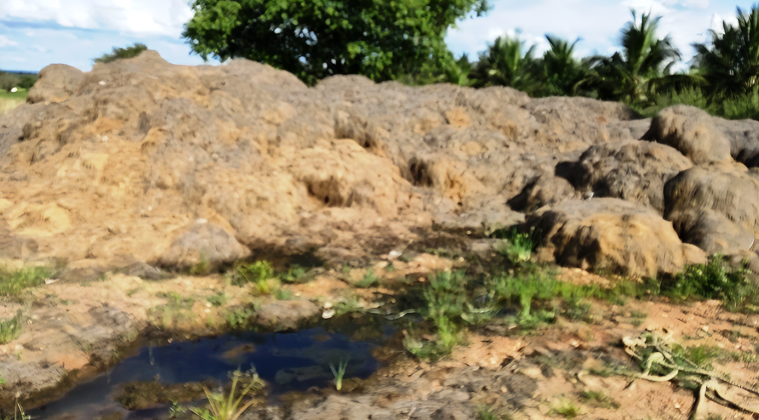
Pic 1 : Toxic leachate containing high salt and phenolic content from coir pith dumps in and around coir factories- surved during IBM-IORF sustainability project (2021-22 to 2023-24) at Karnataka, India.

The cumulative evidence highlights the severe eco-toxicological consequences of bioactive compound leaching from coir pith, affecting the soil microbial dynamics, nutrient availability, and aquatic ecosystems. These findings reinforce the necessity of responsible waste management, treating coir pith as agro-industrial waste rather than repurposing it without appropriate treatment. To reduce its environmental footprint, strategies such as controlled composting, chemical stabilization and advanced leachate treatment must be prioritized. Implementing these approaches will minimize ecological risks, enhance sustainability, and ensure coir pith is utilized safely and effectively within circular bio-economy frameworks..

4. Alignment with Conventional Waste Criteria
The persistent nature of coir pith, characterized by its high lignin content, imbalanced C:N ratio, and leaching of bioactive compounds, aligns with key criteria used in waste classification frameworks. Waste is typically defined as any byproduct with limited utility that poses environmental or health risks (Kirchherr et al., 2017), and coir pith fits this definition due to several factors. First, its high lignin content makes it highly recalcitrant, leading to slow decomposition and accumulation in landfills, where it contributes to methane emissions under anaerobic conditions (Rajalakshmi et al., 2018; Brebu & Vasile, 2010). Second, its elevated C:N ratio further limits microbial decomposition. Microorganisms require balanced carbon and nitrogen for efficient metabolism, and the nitrogen deficiency in coir pith suppresses decay, prolonging its persistence as waste (Noguera et al., 2000). Third, coir pith leaches bioactive compounds such as phenolics and tannins, which disrupt soil microbial balance and nutrient cycling, reducing soil fertility and posing eco-toxicological risks (Singh & Patel, 2020; Khan et al., 2011). This further supports its classification as a material requiring strict regulation. In response, environmental regulatory frameworks, such as those established by India’s CPCB and TNPCB, have recognized these risks. Recent reclassifications of coir pith processing units into higher pollution categories reflect the necessity for enhanced waste management controls (CPCB, 2016; TNPCB, 2020; Devanathan, 2021). Its regulatory reclassification highlights both the risks and opportunities—pushing for innovative recycling, repurposing, and disposal strategies that support a circular bio-economy while mitigating environmental harm. Thus rather than treating coir pith as a nuisance waste, its reclassification drives innovation.

5. Evolving Regulatory Measures for Coir Pith Management
India's regulatory framework is adapting to address the environmental concerns associated with coir pith, a persistent agro-industrial residue. Recent actions by regional and national agencies highlight the need for stricter waste management controls to mitigate its environmental impact.
At the state level, the Tamil Nadu Pollution Control Board (TNPCB) reclassified coir pith processing units from the “white” category (low-pollution industries) to the “orange” category in November 2021 due to their high chemical oxygen demand (COD), elevated phenolic compounds, and persistent pollutant loads in wastewater discharges (Devanathan, 2021; TNPCB, 2020). This reclassification mandates closed storage systems to prevent leachate seepage, advanced wastewater recycling to minimize toxic effluent discharge, and controlled drying methods to reduce dust emissions and VOC release. Additionally, the Tamil Nadu Coir Policy (2024) integrates economic and environmental objectives, promoting cleaner production techniques and waste valorization (Government of Tamil Nadu, 2024). The policy encourages the conversion of coir pith into high-value endproducts, mitigating methane emissions from anaerobic decomposition and reducing ecotoxicity from leachates. By supporting these initiatives, the policy aligns with circular economy principles by transforming waste into valuable resources (Kirchherr, Reike, & Hekkert, 2017).

At the national level, the Central Pollution Control Board (CPCB) has issued comprehensive guidelines urging states to implement cleaner technologies and stringent compliance measures across industries handling recalcitrant waste streams (CPCB, 2016). Scientific assessments emphasize the necessity of rigorous monitoring and treatment to prevent long-term environmental contamination, further reinforcing the importance of regulatory interventions. The evolving regulatory landscape reflects a growing consensus among scientists, policymakers, and industry experts that coir pith requires strict environmental controls. By integrating scientific data, regulatory innovation, and waste valorization, India is advancing sustainable industrial practices, reducing the environmental footprint of coir pith, and fostering a circular bio-economy.

6. Global Perspectives and Valorization Strategies
International studies and policy frameworks emphasize the necessity of managing coir pith as an agro-industrial residue due to its persistence, environmental risks, and valorization potential. The Food and Agriculture Organization (FAO, 2018) has identified coconut coir pith as a material requiring proper disposal or innovative recycling to mitigate its environmental footprint. Addressing the challenges associated with coir pith accumulation is crucial for sustainable agricultural and environmental management, particularly in tropical regions where coconut processing is widespread.
In many tropical regions, coir pith accumulates as a byproduct of coconut processing, contributing to land degradation due to its slow decomposition and accumulation. Additionally, it generates greenhouse gas (GHG) emissions when it undergoes anaerobic breakdown, releasing methane, a potent contributor to climate change. Another critical concern is the leaching of toxic compounds such as phenolics and tannins into soil and water systems, negatively affecting microbial activity and disrupting nutrient cycling. These environmental risks highlight the urgent need for efficient waste management strategies. However, recycling coir pith—particularly through composting—presents a sustainable pathway for mitigating these challenges. Composting enhances soil fertility in degraded lands by improving nutrient content and organic matter levels. Moreover, controlled biodegradation through composting significantly reduces GHG emissions, offering an environmentally friendly alternative to traditional disposal methods. Additionally, integrating coir pith recycling into circular bio-economy models supports waste repurposing into value-added products, benefiting crop production and land restoration.
Given its global significance as an agro-industrial residue, managing coir pith through sustainable disposal and recycling aligns with international environmental goals. Strategies such as composting and engineered soil amendments provide viable solutions for reducing its ecological impact while enhancing agricultural productivity. By adopting these innovative approaches, coir pith management can contribute to both climate change mitigation and sustainable agricultural practices, ensuring long-term environmental and economic benefits.

7. Coir Pith Composting: A Sustainable Recycling Strategy

The conversion of coir pith into compost represents a valuable recycling approach, transforming a persistent agro-industrial residue into a nutrient-rich soil amendment. Research has demonstrated that well-composted coir pith significantly enhances soil structure by improving aggregation and porosity, leading to better aeration and root penetration (Abad et al., 2002). Additionally, it improves water-holding capacity, reducing irrigation demand and mitigating drought stress in crops, making it particularly beneficial for arid and semi-arid regions (Noguera et al., 2000). Furthermore, coir pith compost contributes to nutrient retention, particularly for essential elements such as potassium, phosphorus, and trace minerals, thereby reducing fertilizer runoff and minimizing agricultural pollution (Singh & Patel, 2020).

Beyond its direct benefits for soil health, coir pith composting aligns with circular economy principles by repurposing waste into a valuable agricultural input instead of allowing it to accumulate in landfills. This process also reduces dependency on non-renewable soil amendments like peat, thereby supporting more sustainable agricultural practices (Ministry of MSME, 2016). Additionally, controlled biodegradation in composting lowers environmental impact, particularly by reducing greenhouse gas (GHG) emissions and preventing nutrient leaching, which are common concerns associated with conventional organic waste disposal.

Coir pith composting emerges as a strategic solution for sustainable agriculture and waste management by enhancing soil health, optimizing resource use, and mitigating environmental pollution. Despite significant agricultural expansion in India over the past 50 years, many soil-based production systems show signs of fatigue (Dey, 2016), often linked to declining soil carbon levels (Dey et al., 2024). Scaling up its adoption can bolster climate resilience and promote resource-efficient farming systems, ensuring long-term environmental and economic sustainability.

8. Inherent Limitations in Conventional Composting of Coir Pith
The conversion of coir pith into high-quality compost presents significant chemical and structural challenges, primarily due to its high lignin content and imbalanced carbon-to-nitrogen (C:N) ratio. These inherent properties make it difficult for microbial communities to efficiently break down the material, leading to prolonged composting cycles and reduced agronomic value. One of the major hurdles in coir pith composting is its high lignin content (20–40%), which forms a complex aromatic structure that resists microbial decomposition (Abad et al., 2002). This structural rigidity significantly slows down the breakdown process, making it difficult to achieve complete organic matter transformation within a reasonable timeframe. Additionally, the excessive C:N ratio (>100:1) exacerbates the problem by creating a nitrogen-deficient environment that restricts microbial growth, further delaying decomposition (Noguera et al., 2000; Kumar et al., 2019).
Traditional composting approaches attempt to overcome these limitations by mixing coir pith with nitrogen-rich materials such as cow manure, poultry litter, or green waste. While this practice helps balance the C:N ratio, it does not effectively accelerate lignin degradation. Moreover, slow decomposition rates often result in incomplete stabilization, reducing nutrient availability, microbial activity, and overall compost quality. Consequently, coir pith compost struggles to compete with conventional soil amendments such as peat moss, limiting its widespread agricultural adoption (Ministry of MSME, 2016; Singh & Patel, 2020).
To address these challenges, advanced composting strategies are essential for improving decomposition efficiency and compost quality. Approaches such as microbial inoculation, enzymatic pretreatment, and co-composting with lignin-degrading fungi have shown some promise in accelerating lignin breakdown and optimizing nutrient composition but lack of evidential database for large scale bio-conversion of coirpith through these methods in an economically viable mode.

9. The Potential of NOVCOM Composting Technology
To overcome the decomposition barriers of coir pith, innovative composting technologies such as NOVCOM composting technology have emerged. This method integrates advanced microbial processes with energy management principles inspired by ancient Vedic concepts, ensuring rapid and efficient biodegradation. By leveraging a scientifically structured yet holistic approach, NOVCOM composting technology facilitates the breakdown of lignocellulosic material, making coir pith a viable resource for sustainable agricultural applications.
A critical feature of NOVCOM composting technology is its sequential multi-phase decomposition process, which follows the Element Energy Activation (EEA) Principle. This principle orchestrates microbial activity through the dynamic interplay of Apana Prana (elimination force) and Udana Prana (activation force), elevating compost temperatures to 60–65 °C. These conditions are ideal for pathogen destruction and the proliferation of thermophilic bacteria, which play a crucial role in organic matter breakdown. The controlled thermophilic phase accelerates decomposition, ensuring a faster turnover compared to conventional composting methods. NOVCOM composting technology also enhances lignin degradation and C:N ratio optimization, addressing the primary limitations of coir pith as a composting substrate. Self-generation of actinomycetes and thermophilic microbes accelerates the breakdown of recalcitrant lignin and cellulose, resulting in a significant reduction of the carbon-to-nitrogen (C:N) ratio from approximately 100:1 to below 25:1. This optimization contributes to improved nitrogen availability, with studies reporting a 98% increase in total nitrogen content and 60% lignin degradation within just 30 days (Bera et al., 2023). These improvements make NOVCOM-treated compost a nutrient-rich soil amendment capable of enhancing soil fertility and plant growth.
From an environmental sustainability perspective, NOVCOM composting technology has been shown to achieve a 31-fold reduction in methane emissions compared to traditional composting. By maintaining aerobic conditions throughout the process, it prevents anaerobic methane production, aligning with climate action strategies and Net Zero commitments. Furthermore, the high-quality compost produced through NOVCOM composting technology supports soil carbon sequestration, mitigating land degradation while contributing to multiple Sustainable Development Goals (SDGs), including SDG 2 (Zero Hunger), SDG 13 (Climate Action), and SDG 15 (Life on Land).
As a scalable solution for agro-waste management, NOVCOM composting technology offers a transformative model for repurposing coir pith and other lignocellulosic residues. By creating optimal microbial conditions without the need for chemical additives, it enhances composting efficiency while minimizing environmental impact. This innovation not only provides a sustainable alternative to waste disposal but also reinforces circular economy principles, ensuring that agricultural byproducts are effectively reintegrated into productive farming systems.

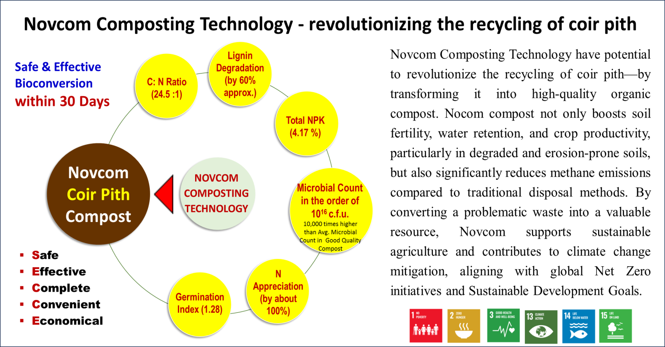
Fig 1 : Novcom composting technology overcomes the limitation of conventional composting methods for bio-conversion of coirpith towards getting a quality compost to drive the sustainable agricultural initiatives

10. Global Perspectives and Future Research Directions
The challenges posed by lignocellulosic agro-industrial waste, particularly coir pith, are well-documented globally. High lignin content in such residues makes them resistant to decomposition, leading to prolonged accumulation and significant environmental concerns (Abad et al., 2002; Noguera et al., 2000). The success of NOVCOM composting technology in rapidly degrading coir pith presents a compelling case study of how innovative recycling methods can transform waste management practices. By significantly reducing decomposition time and enhancing nutrient stabilization, NOVCOM composting technology offers a scalable and scientifically grounded approach to tackling these persistent challenges. However, further research is essential to refine its operational parameters and evaluate its broader ecological and economic implications. Conducting comparative life cycle assessments (LCAs) between conventional composting techniques and NOVCOM composting technology processing would provide crucial insights into its sustainability benefits and inform policies for wider adoption in coconut-producing regions (Zhu et al., 2020).
While the high lignin content and imbalanced C:N ratio of coir pith have traditionally restricted its use as a viable composting material, novel technologies like NOVCOM composting technology present a transformative solution. By enabling faster and more complete microbial degradation, NOVCOM composting produces a nutrient-rich, stabilized soil amendment that enhances crop productivity, reduces dependence on non-renewable fertilizers, and minimizes land degradation. Moreover, its ability to mitigate greenhouse gas emissions, particularly methane, positions it as a key innovation in climate-resilient agriculture. The successful integration of such advanced composting technologies is not just an opportunity but a necessity for transitioning toward sustainable agro-industrial practices. As global commitments to circular economy principles and environmental conservation intensify, adopting solutions like NOVCOM composting technology will be instrumental in shaping a future where agricultural waste is seen not as a burden but as a valuable resource for ecological and economic regeneration.

11. Protecting Land from Degradation
Land degradation remains a pressing environmental challenge, particularly in regions where intensive agricultural practices have depleted soil organic matter and compromised soil structure. The application of coir pith compost offers a viable solution by enhancing soil organic carbon content and improving cation exchange capacity (CEC), both of which are crucial for soil fertility and resilience (Noguera et al., 2000). By fostering a diverse microbial ecosystem essential for nutrient cycling, coir-based compost supports soil regeneration while mitigating further degradation. Additionally, its incorporation enhances soil aggregation and stability, reducing erosion and protecting valuable agricultural land from deterioration (Food and Agriculture Organization, 2018). Converting coir pith into compost not only diverts waste from landfills but also reinforces sustainable agricultural practices, ensuring long-term land conservation and productivity.

12. Greenhouse Gas Mitigation through Alternative Processing
The environmental burden of coir pith waste extends beyond land degradation to significant greenhouse gas (GHG) emissions. When left untreated in landfills, coir pith decomposes anaerobically, releasing methane (CH₄)—a potent greenhouse gas with a global warming potential 20–25 times greater than carbon dioxide (CO₂) over a 100-year period (IPCC, 2014; Kumar et al., 2019). In contrast, controlled aerobic composting facilitates complete organic matter oxidation to CO₂, significantly reducing methane emissions (Zhu et al., 2020). However, conventional composting methods often struggle with coir pith due to its high lignin content and elevated carbon-to-nitrogen (C:N) ratio, which prolong decomposition and hinder stabilization (Noguera et al., 2000; Ministry of MSME, 2016).
NOVCOM composting technology, when integrated with Inhana rational farming practices, presents a breakthrough in addressing these challenges. By employing advanced aeration, precise temperature regulation, and specialized microbial inoculants, NOVCOM composting technology accelerates lignocellulosic breakdown while lowering the C:N ratio (Mardijanti et al., 2021). This process ensures sustained aerobic conditions, steering decomposition away from anaerobic methanogenesis and significantly reducing methane emissions.

13. Quantifying the Climate Impact
According to the Carbon Footprint Assessor (ACFA, version 1.0), untreated coir pith has the potential to emit between 5,897 and 6,025 kg CO₂ equivalent in methane per ton, considering methane’s 24-year global warming potential of 75. In contrast, coir pith treated via NOVCOM composting technology exhibits emissions approximately 31 times lower—around 6.47 kg CO₂ equivalent per ton of waste. Notably, methane emissions from this process are minimal, with only 0.61 kg CO₂ equivalent per ton recorded. These findings highlight that NOVCOM composting technology can mitigate nearly 6,000 tons of CO₂ equivalent methane per 1,000 tons of processed waste at the source.
Beyond emissions reduction, NOVCOM composting exemplifies a transformative approach to sustainable waste management. By converting a potential pollutant into a high-quality organic soil amendment, it directly contributes to multiple Sustainable Development Goals—particularly SDG 13 (climate action), SDG 15 (life on land), SDG 3 (good health and well-being), and, most critically, SDG 2 (zero hunger). This underscores its role in global Net Zero commitments while yielding substantial social and environmental benefits.

The integration of NOVCOM composting technology and Inhana Rational Farming (IRF) technologies for plant health management to energizes the plant system towards self-nourishment and self-protection offers a comprehensive solution that aligns with circular economy principles. By transforming coir pith from an environmental liability into a valuable soil amendment, these innovations reduce dependence on non-renewable resources, restore degraded soils, and mitigate climate change impacts. The dual benefits of landfill methane reduction and improved soil health create a sustainable pathway for repurposing agro-industrial waste into high-quality compost, reinforcing sustainable agriculture and environmental conservation (Kirchherr, Reike, & Hekkert, 2017; Zhu et al., 2020). This holistic approach not only strengthens agricultural resilience but also serves as a scalable model for addressing global waste management and climate mitigation challenges.

14. Integration of Recycling Technologies in a Circular Economy
The valorization of coir pith through composting aligns seamlessly with circular economy principles by transforming agricultural waste into valuable resources for sustainable food production. Rather than allowing coir pith to accumulate as an environmental burden, this approach repurposes it into nutrient-rich compost, improving resource efficiency while promoting ecological sustainability.
Innovative recycling technologies like NOVCOM composting technology optimize compost quality, making it more effective in restoring soil health and increasing agricultural productivity. Beyond composting, emerging research is uncovering new applications for coir pith valorization. For instance, Mardijanti et al. (2021) demonstrated that coir pith could be converted into a myceliated biocomposite with superior thermal insulation properties. Although this study focused on building materials, it underscores the broader potential of advanced recycling methods to unlock new value streams from agro-industrial waste. By embracing these innovative approaches, coir pith management can evolve beyond conventional composting, contributing to a more resilient, waste-efficient, and climate-conscious agricultural system.

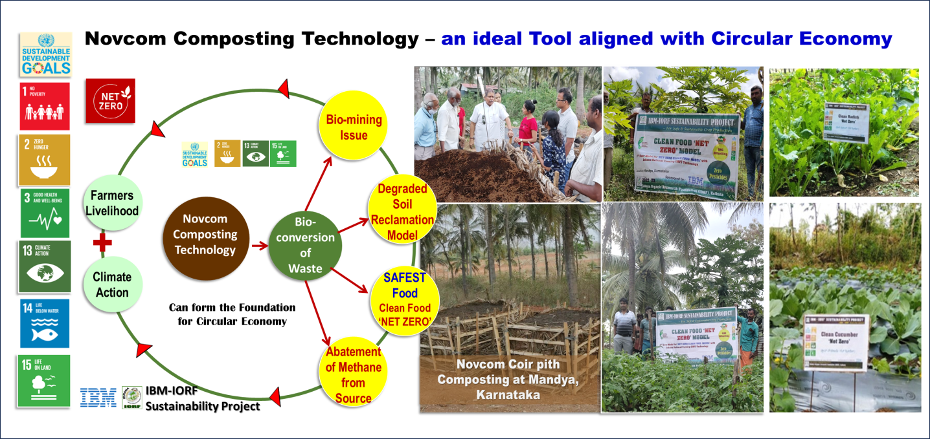
Fig 2 : Development of Clean Food ‘NET ZERO’ at Mandya, Karnataka under IBM-IORF Sustainability Project using Novcom Coir pith compost

A significant advancement in sustainable agriculture is the IBM-IORF Sustainability Project, which exemplifies a bio-circular economy model by integrating Inhana Rational Farming Technology directly into farmers’ fields. This initiative, a collaboration between IBM and the Inhana Organic Research Foundation (IORF), addresses the challenge of converting coir pith—a byproduct of the coir industry—into high-quality compost. By leveraging Inhana Rational Farming Technology for soil and plant health management, the project fosters sustainable crop production while simultaneously utilizing NOVCOM composting technology to accelerate the decomposition of coir pith. This dual approach not only shortens composting cycles but also significantly reduces greenhouse gas emissions compared to conventional methods (Zhu, Li, & Zhang, 2020). Furthermore, Inhana Plant Health Management practices enhance plant physiological functions, boost crop productivity, and reduce pest and disease incidence, ultimately improving farmers' economic returns.

A critical environmental benefit of this project lies in its ability to minimize methane emissions. Unlike traditional composting methods, which often result in anaerobic decomposition and methane production, NOVCOM technology maintains optimal aerobic conditions throughout the process (IPCC, 2014; Kumar, Sharma, & Gupta, 2019). This innovation effectively curtails the environmental impact of coir pith waste while simultaneously producing a high-value organic soil amendment.

Beyond environmental benefits, the IBM-IORF Sustainability Project exemplifies the principles of a circular economy by converting waste into a resource. Instead of allowing coir pith to accumulate in landfills, the project transforms it into a nutrient-rich compost that improves soil health and reduces reliance on synthetic fertilizers. This process not only closes the resource loop but also creates new economic opportunities for farmers by turning waste into a marketable product. The success of this initiative underscores the transformative potential of cross-sector collaboration in sustainable waste management and renewable resource recovery (Kirchherr, Reike, & Hekkert, 2017).

The integration of NOVCOM composting with Inhana Rational Farming Technology provides a scalable and scientifically validated solution for agricultural sustainability. The initiative was evaluated by i-NoCarbon, UK and recognized the initiatives as India’s 1st Agro-net zero Model This approach is particularly relevant in the context of rising global food demand, with projections indicating a need for an additional 5.1 billion tonnes of food by 2050 (FAO, 2017). Given that agriculture currently accounts for 70% of global water use, 30% of energy consumption, and 31% of greenhouse gas emissions (UN, 2021), innovative models like the IBM-IORF Sustainability Project are crucial for mitigating climate change while enhancing productivity.

One of the most notable outcomes of this initiative is the establishment of a Coconut-Based Circular Economy Model in Mandya, Karnataka, which serves as a benchmark for sustainable agricultural programs. This model has been rigorously analyzed in terms of its impact on yield, nutrient utilization, soil health, energy consumption, greenhouse gas emissions, and economic viability. The findings demonstrate that integrating circular economy principles into agriculture through scientific interventions can significantly improve resource efficiency while enhancing the livelihoods of smallholder farmers. By transforming waste into wealth, the IBM-IORF Sustainability Project presents a replicable framework for sustainable agriculture, climate resilience, and economic empowerment.

15. Conclusion
Coir pith, an abundant byproduct of the coconut processing industry, poses significant environmental challenges due to its slow decomposition and potential for methane emissions when left untreated in landfills. Its accumulation highlights the urgent need for innovative waste management strategies that align with sustainability goals and circular economy principles. Addressing these challenges, advanced recycling technologies like NOVCOM composting have demonstrated the ability to accelerate the degradation of coir pith’s lignocellulosic structure while optimizing nutrient stabilization.
When integrated with Inhana Rational Farming Technology—an approach that revitalizes soil and plant systems through its unique energy management concept—NOVCOM composting offers a transformative solution for sustainable agriculture. This synergy enhances crop productivity, improves soil health, and supports climate change mitigation while ensuring long-term ecological balance and livelihood security. The IBM-IORF Sustainability Project exemplifies how these integrated technologies can successfully convert coir pith from an environmental burden into a valuable soil amendment, driving sustainable agricultural practices at the grassroots level. To maximize the impact of such innovations, policy interventions should focus on incentivizing circular bioeconomy models and promoting regulatory frameworks that support large-scale adoption of composting technologies. Government and industry collaboration can facilitate infrastructure development, knowledge dissemination, and financial support mechanisms to integrate sustainable waste valorization techniques into mainstream agricultural practices.
By repurposing coir pith as a resource rather than treating it as waste, these innovative strategies contribute to a circular economy, reducing landfill waste, mitigating greenhouse gas emissions, and restoring degraded lands. This integrated approach presents a viable pathway for the agro-industrial sector to achieve long-term environmental and economic sustainability while addressing the pressing global challenges of soil degradation, climate change, and resource efficiency.

DISCLAIMER (ARTIFICIAL INTELLIGENCE)

Authors hereby declare that NO generative AI technologies such as Large Language Models (Chat GPT, COPILOT etc.) and text-to-image generators have been used during the writing or editing of this manuscript.

COMPETING INTERESTS DISCLAIMER:

Authors have declared that they have no known competing financial interests OR non-financial interests OR personal relationships that could have appeared to influence the work reported in this paper.

References
Abad, M., Noguera, P., Puchades, R., Maquieira, A., & Noguera, V. (2002). Physico‐chemical and chemical properties of some coconut coir dusts for use as a peat substitute for containerized ornamental plants. Bioresource Technology, 82(1), 241–245. https://doi.org/10.1016/S0960-8524(01)00121-3
Barik, A. K., et al. (2014a). Inhana Rational Farming (IRF) Technology: A comprehensive approach from seedling to harvest in organic tea cultivation. Journal of Organic Agriculture, 7(2), 123–135.
Barik, A. K., et al. (2014b). Advances in Inhana Rational Farming: Enhancing soil health and crop productivity through integrated organic practices. Indian Journal of Sustainable Agriculture, 8(3), 87–99.
Bera, R., Datta, A., Bose, S., Barik, A. K., Mallick, R., Ganguli, M., Narasimhan, V. L., Quah, E., Mukherjee, K., Bhattacharya, P., & Seal, A. (2023). Technological breakthrough for large scale bioconversion of coir pith towards sustainable soil health management and development of source point methane abatement model. International Journal of Environment and Climate Change, 13(7), 75–102. https://doi.org/10.9734/ijecc/2023/v13i71856
Bianchi, T. S. (2007). Biogeochemistry of estuaries. Oxford University Press.
Brebu, M., & Vasile, C. (2010). Thermal degradation of lignin—a review. Cellulose Chemistry and Technology, 44(9), 353–363.
Central Pollution Control Board. (2016). Final document on revised categorization of industrial sectors under red, orange, green and white categories [PDF]. Retrieved from https://cpcb.nic.in/uploads/Latest_Final_Directions.pdf
Chatterjee, S., et al. (2014). Inhana Rational Farming: Integrative management for sustainable agriculture. Agricultural Innovations, 5(4), 211–224.
Conrad, R. (2009). The global methane cycle: recent advances in understanding the microbial processes involved. Environmental Microbiology Reports, 1(5), 285–292. https://doi.org/10.1111/j.1758-2229.2009.00022.x
Cottrell, W. D., & Wenzel, W. W. (2007). The role of dissolved organic matter in soil and aquatic systems. Springer.
Devanathan, V. (2021, November 12). Coir pith industries get polluting tag, come under strict norms. The Times of India. https://timesofindia.indiatimes.com/city/coimbatore/coir-pith-industries-get-pollutingtag-come-under-strict-norms/articleshow/87655330.cms
Dey, P. (2016). Soil health management. In Soil Health: Concept, Status and Monitoring (eds Katyal, J. C. et al.). Bull. Indian Soc. Soil Sci., 30, 79–97.
Dey, P., Singh, S.R. & Sekhon, B.S. (2024). Systems approach vis-à-vis carbon sequestration: issues and strategies. Current Science, 127 (12), 1420-1426.
FAO. (2017). The future of food and agriculture – Trends and challenges. Food and Agriculture Organization of the United Nations.
FAO. (2018). Agro-industrial residues and their management. FAO Corporate Document Repository. Retrieved from http://www.fao.org/publications
Government of Tamil Nadu. (2024). Tamil Nadu Coir Policy 2024. Micro, Small and Medium Enterprises Department, Government of Tamil Nadu. https://cms.tn.gov.in/cms_migrated/document/docfiles/coir_policy_2024.pdf
IPCC. (2014). Climate Change 2014: Mitigation of Climate Change. Contribution of Working Group III to the Fifth Assessment Report of the Intergovernmental Panel on Climate Change. Cambridge University Press.
Khan, M. A., Ali, S., & Khan, N. (2011). Impact of tannins on soil nutrient cycling and plant growth. Soil Biology & Biochemistry, 43(5), 893–901. https://doi.org/10.1016/j.soilbio.2010.12.015
Kirchherr, J., Reike, D., & Hekkert, M. (2017). Conceptualizing the circular economy: An analysis of 114 definitions. Resources, Conservation and Recycling, 127, 221–232. https://doi.org/10.1016/j.resconrec.2017.09.005
Kumar, R., Sharma, P., & Gupta, D. (2019). Evaluation of methane emissions from composting systems: A comparative study. Journal of Cleaner Production, 234, 1040–1050. https://doi.org/10.1016/j.jclepro.2019.06.109
Liu, Y., Feng, Y., & Li, X. (2018). Methanogenic community structure and function during the anaerobic digestion of lignocellulosic waste. Journal of Applied Microbiology, 124(5), 1190–1200. https://doi.org/10.1111/jam.13747
Mardijanti, D. S., Megantara, E. N., Bahtiar, A., & Sunardi, S. (2021). Turning the cocopith waste into myceliated biocomposite to make an insulator. International Journal of Biomaterials, 2021, Article 6630657. https://doi.org/10.1155/2021/6630657
Ministry of MSME, Government of India. (2016). Coir Pith, Wealth from Waste: A Reference. [Details available on the official MSME website].
Noguera, P., Abad, M., Puchades, R., Maquieira, A., & Noguera, V. (2000). Influence of particle size on physical and chemical properties of coconut coir dust as container medium. Communications in Soil Science and Plant Analysis, 31(3/4), 593–605. https://doi.org/10.1080/00103620009467232
Rajalakshmi, A., et al. (2018). Characterization of coir pith as a recalcitrant agro-industrial byproduct. Journal of Environmental Management. [Full reference details to be verified from the original source]
Rodrigues, D., et al. (2019). Impact of tannins on soil microbial dynamics and nutrient cycling. Soil Biology & Biochemistry, 134, 42–49. https://doi.org/10.1016/j.soilbio.2019.05.002
Seal, A., et al. (2013a). Organic tea cultivation through Inhana Rational Farming: Practices, challenges, and prospects. Journal of Agroecology and Sustainable Food Systems, 37(1), 45–58.
Singh, M., & Patel, D. (2020). Effects of phenolic compounds from coir pith on soil and water quality. Environmental Science and Pollution Research. [Full reference details to be verified from the original source]
Smith, J., Brown, L., & Wang, X. (2017). Anaerobic degradation of lignocellulosic biomass and methane production: Implications for greenhouse gas emissions. Journal of Environmental Science, 45(4), 567–575. https://doi.org/10.1016/j.jes.2017.05.004
Stelte, W., Reddy, N., Barsberg, S., & Sanadi, A. R. (2023). Coir from coconut processing waste as a raw material for applications beyond traditional uses. BioResources, 18(1), 2187–2212. https://doi.org/10.15376/biores.18.1.Stelte
Tamil Nadu Pollution Control Board. (2020). Guidelines for the management of coir pith waste. [Full reference details available from the TNPCB website]
UN. (2021). Food systems and the environment: Addressing global challenges. United Nations.
Zhang, H., et al. (2017). Leaching and biodegradation of phenolic compounds from lignocellulosic biomass in soil. Journal of Hazardous Materials, 327, 95–104. https://doi.org/10.1016/j.jhazmat.2017.02.021
Zhu, Y., Li, Z., & Zhang, L. (2020). Enhancing anaerobic digestion efficiency of lignocellulosic biomass by co-digestion: A review. Renewable Energy, 146, 1028–1040. https://doi.org/10.1016/j.renene.2019.07.099

