Evaluating Organic Farming Practices on Physiological Dynamics and Soil Health in Tomato (Lycopersicon esculentum) Varieties VL-1 and VL-4

Abstract
This study explores the seed production of organic tomato varieties VL-1 and VL-4, sourced from Vivekananda Parvatiya Krishi Anusandhan Sansthan (VPKAS), Almora, Uttarakhand, India. The research at the Experimental Field in Rampur village, Tehri Garhwal, aims to produce high-nutritional-quality fruits, enhance long-term soil fertility, minimise pollution from agricultural practices, and utilise renewable resources within sustainable production systems. The experimental design employed a Randomized Block Design with 13 treatments and three replications over two cropping seasons. Tomato cultivation, particularly of Lycopersicon esculentum (now Solanum lycopersicum), is significant globally. Organic fertilisers, which activate beneficial soil microorganisms and improve nutrient uptake, can reduce reliance on chemical fertilisers and support agricultural sustainability, especially in developing countries like India. Field experiments revealed that vermicompost treatments significantly improved plant growth and yield parameters. For VL-1, the highest field emergence (33.33%), plant height (51.56 cm), and fruit yield (21.90 kg/plot) were recorded with 15 t/h vermicompost. Similarly, VL-4 showed notable results, with a maximum emergence of 20.99% and an average height of 36.09 cm under the same treatment. Biochemical analyses indicated that VL-1 outperformed VL-4 in most parameters, including seedling growth and vigour. The findings suggest that applying organic manures, particularly vermicompost, enhances both the growth and yield characteristics of these tomato varieties, highlighting the potential for sustainable organic farming practices to meet the increasing demand for organic produce.
Keywords: Organic farming, Tomato, Seed production, Sustainable agriculture

INTRODUCTION
The tomato (Lycopersicon esculentum Mill), also known as Solanum Lycopersicon L., is among the most widely cultivated vegetables globally, second only to potatoes in significance in various regions. Several factors contribute to its low yield, with insufficient fertiliser application being a key issue. Tomatoes have a high nutrient requirement, inadequate fertiliser use, and an imbalanced application of nitrogen, phosphorus, and potassium (N: P: K), which play a role in reduced productivity. Furthermore, solely relying on chemical fertilisers does not guarantee sustained high yields. There is a consistent demand for organic tomatoes in both local and wholesale markets, and with appropriate cultivation methods, they can provide a substantial return on investment. Numerous population studies have indicated that consuming tomatoes, rich in the antioxidant lycopene, is associated with a lower risk of cancer and cardiovascular diseases (Kanwar, 2011).
India holds the position of being the second-largest producer of vegetables in the world, following China. In the fiscal year 2021, the country's vegetable output was estimated at approximately 196.27 million metric tons (Horticultural Statistics Division, 2020-21). This includes vegetables like potatoes, tomatoes, onions, eggplants, and cabbage. While India is a significant exporter of low-cost fruits and vegetables, the per capita vegetable availability is merely around 160 grams, below the FAO's recommended daily intake of 300 grams.
Organic fertilisers, which are environmentally friendly and cost-effective, can significantly lessen reliance on chemical fertilisers. They stimulate beneficial soil microorganisms (Singh & Kalloo, 2000), facilitate the fixation of atmospheric nitrogen, and enhance the availability and absorption of nutrients. Additionally, they help solubilise essential soil nutrients, including phosphorus, zinc, copper, iron, and sulphur, into forms that plants can readily use. Since organic fertilisers are typically needed in smaller quantities, they are economical and can replace up to 25% of chemical fertilisers. This can be particularly beneficial in developing nations like India, addressing the challenges posed by high fertiliser costs and positively impacting the economy (Dubey, 1998).
Moreover, pesticides can harm earthworms, beneficial insects, and essential soil microorganisms, reducing mineral availability and fertility. These chemicals can persist in the soil for extended periods, diminishing its quality. In comparison, vermicompost supplies nutrients that plants can easily absorb, including nitrates, exchangeable phosphorus, and soluble forms of potassium, calcium, and magnesium (Edwards & Burrows, 1988).
To enhance the yield and quality of crops, it is essential to focus on the optimal and balanced application of nutrients through fertilisers. Tomatoes, in particular, require substantial amounts of both organic and inorganic nutrients to achieve economic yields. Fertilisers are vital for improving both the quantity and quality of tomato production. Proper fertilisation with key elements such as nitrogen, phosphorus, and potassium are crucial for tomato plants' growth and overall performance (Olaniyi et al., 2008).
In contrast, organic manures are more accessible to farmers and typically cost less than chemical fertilisers. Furthermore, organic fertilisers contribute to improved growth, yield, and quality of crops. They supply important macro and micronutrients, vitamins, growth enhancers, and beneficial microorganisms supporting plant health (Phonia et al., 2022).
Using efficient, environmentally friendly organic fertilisers in combination with inorganic fertilisers represents an ideal approach to integrated nutrient management. This strategy enhances crop yields while restoring soil health and maintaining long-term soil productivity and sustainability. Considering all the above factors, the present study aims to identify the best treatment combinations for organic manures and inorganic fertilisers in terms of growth, yield, quality, and economics of VL-1 and VL-4 varieties of tomatoes.
- MATERIAL AND METHODS

This study was conducted using a Randomized Block Design (RBD) with three replications. The research was carried out in an experimental field located in Rampur village, Tehri Garhwal district, near Kirtinagar, as well as at the Seed Testing Laboratory of the Department of Seed Science & Technology at HNB Garhwal University, Srinagar Garhwal, Uttarakhand. The experimental subjects included organic varieties, specifically VL Tamator-1 and VL Tamator-4, sourced from the Vivekananda Parvatiya Krishi Anushandhan Sansthan (VPKAS) at the Almora regional research station of the Indian Council of Agricultural Research (ICAR). The field experiments, conducted using a Randomized Block Design (RBD), consist of 13 treatments and 39 beds, each measuring 5 x 2 meters (10.00 m²). The net experimental area covers 390.00 m². The spacing between rows is 75 cm for planting, while the spacing between plants within each row is 60 cm. Each plot contains six rows, with three plants per row, resulting in 18 plants per plot. Additionally, the width of the irrigation channel is 1.2 meters. Standard cultural practices and plant protection measures were followed during the cultivation process. Tomato seeds of cultivars VL-1 and VL-4 were sown by hand at appropriate distances in experimental beds. The seeds, pre-treated with fungicide, were initially planted in nursery beds measuring 2 x 1 m, covered with dry mulch, and lightly irrigated after sowing. The mulch was removed after 15 days upon seedling emergence. Field preparation included manually constructed bunds according to a designated layout, utilising vermicompost and farmyard manure for organic treatments, while urea was used as the inorganic fertiliser. Seedlings aged 30 days were transplanted during the first and second growth seasons at a 75 x 60 cm density, ensuring uniform sizes across treatments (Table.1).

Table 1 The experiment comprised of the following treatments:
S. No. | Treatments | Notations
1. | 10t/h Vermicompost | T1
2. | 15t/h Vermicompost | T2
3. | 20t/h Vermicompost | T3
4. | 10t/h FYM | T4
5. | 15t/h FYM | T5
6. | 20t/h FYM | T6
7. | 10t/h Vermicompost + Recommended NPK (100:50:50) | T7
8. | 15t/h Vermicompost + Recommended NPK (100:50:50) | T8
9. | 20t/h Vermicompost + Recommended NPK (100:50:50) | T9
10. | 10t/h FYM + Recommended NPK (100:50:50) | T10
11. | 15t/h FYM + Recommended NPK (100:50:50) | T11
12. | 20t/h FYM + Recommended NPK (100:50:50) | T12
13. | Control | T13
Weeds were managed through hand weeding and two rounds of hoeing, and no chemical insecticides or fungicides were applied, although azadirachtin was used twice to control pests. Growth and yield parameters were recorded by tagging five plants from each treatment, measuring metrics such as field emergence percentage, plant height, leaf count, leaf area, stem thickness, root length, number of flowers per plant, and fruit yield.
Standard seed germination tests assessed seed vigour and seedling growth, with field emergence monitored at five-day intervals until no further germination occurred. The emergence percentage was calculated using the formula:
FE = (Total seeds sown / Number of seedlings emerged) × 100
Statistical analysis was conducted using a randomised block design with three replications, following the variance analysis method outlined by Fisher and Yates (1938) at 5% and 1% significance levels. Seed germination tests were carried out using four replicates of 50 seeds each, placed in a germination chamber at 20°C, and evaluated according to International Seed Testing Association (ISTA, 2008) guidelines for normal seedlings, with results expressed as percentages and dry weights measured after drying at 100°C for 24 hours.
The study selected various parameters to assess growth, yield, quality, and soil characteristics. For growth characters, the parameters included field emergence percentage, plant height, number of leaves per plant, leaf area per plant, stem thickness, and root length. Yield characters were measured through the number of flowers per plant, number of fruits per branch, number of seeds per fruit, fresh weight of fruit, yield per plot, and yield per hectare. Quality parameters encompassed a standard seed germination test and a seed vigour test, which included metrics such as speed of germination (SG), seedling growth rate (SGR), seedling length (SL), seedling dry weight (SDW), and field emergence (FE). Biochemical estimations focused on carbohydrates, specifically soluble sugars, starch, soluble proteins, and total free amino acids. Lastly, soil characteristics were evaluated through physical parameters, including soil moisture content and chemical parameters, such as soil pH, organic carbon, soil organic matter, total nitrogen, and exchangeable potassium.

RESULTS

The present investigation was conducted at the experimental fields of the Department of Seed Science & Technology, HNB Garhwal University, in Rampur village near Kirtinagar, District Tehri Garhwal (Uttarakhand), during the Kharif season. Data were recorded under field and laboratory conditions and analysed for means and variances.

Field Emergence: Both VL-1 and VL-4 varieties exhibited significant improvements in field emergence rates due to the application of vermicompost, particularly in the T2 treatment (15t/h vermicompost). VL-1 recorded maximum emergence rates of 32.10% in the first year and 33.33% in the second, while VL-4 showed 22.22% in the first year and 20.99% in the second (Table 2 and Table 3.). This trend highlights the effectiveness of vermicompost in enhancing seedling establishment, likely through improved soil structure and microbial activity.

Plant Height: The tallest plants were consistently associated with T2 treatment across both varieties. In the 1st year, VL-1 reached a height of 49.73, while VL-4 achieved 34.81 cm in the first year and in the 2nd year, VL-1 recorded 51.56 and VL- 4 36.09 cm in the second (Table 2 and Table 3.). The increased plant height over the two years indicates a cumulative benefit of nutrient availability from organic amendments that emphasise vermicompost’s role in promoting root and shoot development.

Number of Leaves per Plant: The number of leaves per plant, critical for photosynthesis, was maximised under T2 for both varieties. VL-1 recorded 55.86 leaves per plant in the first year, while VL-4 recorded 39.10. In the 2nd year. VL-1 recorded 57.56 leaves per plant, while VL-4 recorded 440.29 leaves per plant (Table 2 and Table 3.). Both showed significant leaf production in both years. This consistent increase supports the established correlation between organic amendments and enhanced plant vigour, as well as improving leaf production.

Thickness of Stem: Stem thickness, indicative of plant robustness, was highest in T2 treatments for both varieties, with VL-1 showing 5.53 cm² and VL-4 showing 3.47 cm² in the first year, while in the 2nd year, VL-1 recorded 6.13 cm² and Vl-4 recorded 4.29 cm² (Table 2 and Table 3.). The increased stem thickness suggests that organic amendments contribute to structural integrity, facilitating better nutrient and water transport.

Leaf Area: The highest leaf area was consistently observed in T2 treatments for both varieties, with VL-1 showing 9.67 cm² and VL-4 showing 6.76 cm² in the first year, while in the 2nd year, VL-1 recorded 11.12 cm² and Vl-4 recorded 7.78 cm² (Table 2and Table 3.). This shows that vermicompost application enhances fruit sets in crops.

Root Length: The highest root length was consistently observed in T2 treatments for both varieties, with VL-1 showing 20.88 cm and VL-4 showing 14.65 cm in the first year, while in the 2nd year, VL-1 recorded 24.63 cm and Vl-4 recorded 17.23 cm (Table 2 and Table 3.).
Table 2: Effect of different treatments on growth characters of Tomato varieties (VL-1 and VL-4) (1st year)
Treatments | Field emergence (%) |  | Height of plant (cm) |  | Number of leaves |  | Thickness of stem (cm²) |  | Leaf area (cm²) |  | Root length (cm)
Treatments | VL-1 | VL-4 | VL-1 | VL-4 | VL-1 | VL-4 | VL-1 | VL-4 | VL-1 | VL-4 | VL-1 | VL-4
T₁ | 30.25 | 20.99 | 43.73 | 30.74 | 38.53 | 26.97 | 4.33 | 3.13 | 5.52 | 3.87 | 18.88 | 13.02
T₂ | 32.10 | 22.22 | 49.73 | 34.81 | 55.86 | 39.10 | 5.53 | 3.47 | 9.67 | 6.76 | 20.88 | 14.65
T₃ | 29.63 | 20.99 | 43.26 | 30.28 | 49.66 | 34.76 | 5.13 | 3.59 | 7.11 | 4.98 | 18.44 | 12.88
T₄ | 30.86 | 21.60 | 41.86 | 29.30 | 52.20 | 36.54 | 5.33 | 3.73 | 6.68 | 4.68 | 18.33 | 12.81
T₅ | 28.40 | 21.60 | 43.40 | 30.38 | 48.80 | 34.16 | 4.83 | 4.28 | 9.26 | 6.48 | 13.88 | 14.44
T₆ | 25.31 | 17.28 | 39.06 | 27.04 | 38.00 | 26.60 | 5.13 | 3.59 | 6.25 | 4.38 | 16.88 | 11.78
T₇ | 19.14 | 12.96 | 26.76 | 18.64 | 10.13 | 7.09 | 4.43 | 3.08 | 5.28 | 3.70 | 15.32 | 10.72
T₈ | 18.52 | 16.67 | 30.66 | 21.46 | 12.33 | 8.61 | 4.56 | 3.20 | 7.35 | 5.15 | 17.21 | 11.78
T₉ | 18.52 | 13.58 | 28.46 | 19.92 | 14.32 | 10.01 | 4.63 | 3.24 | 7.16 | 5.00 | 14.66 | 10.26
T₁₀ | 19.14 | 17.28 | 23.43 | 16.31 | 12.16 | 8.51 | 4.06 | 2.85 | 6.57 | 5.02 | 13.67 | 9.56
T₁₁ | 19.75 | 14.81 | 23.11 | 16.38 | 11.33 | 7.93 | 3.92 | 2.73 | 6.29 | 4.41 | 14.88 | 10.37
T₁₂ | 14.20 | 11.11 | 20.13 | 14.07 | 12.96 | 9.07 | 3.53 | 2.45 | 5.82 | 4.08 | 12.33 | 8.63
T₀ | 11.11 | 8.64 | 18.13 | 12.69 | 11.66 | 10.96 | 3.30 | 2.31 | 4.58 | 3.21 | 11.16 | 7.91
SEm± | 2.00 | 1.29 | 3.08 | 2.16 | 5.44 | 3.75 | 0.20 | 0.16 | 0.42 | 0.29 | 0.82 | 0.61
CD at 5% | 1.94 | 1.67 | 7.95 | 5.54 | 14.09 | 9.86 | 0.33 | 0.33 | 0.58 | 0.41 | 1.52 | 1.05

Treatments | Field emergence (%) |  | Height of plant (cm) |  | Number of leaves |  | Thickness of stem (cm²) |  | Leaf area (cm²) |  | Root length (cm)
Treatments | VL-1 | VL-4 | VL-1 | VL-4 | VL-1 | VL-4 | VL-1 | VL-1 | VL-4 | VL-1 | VL-4 | VL-1
T₁ | 31.48 | 20.37 | 44.96 | 31.47 | 40.56 | 28.39 | 4.63 | 3.24 | 6.00 | 4.20 | 22.1 | 15.47
T₂ | 33.33 | 20.99 | 51.56 | 36.09 | 57.56 | 40.29 | 6.13 | 4.29 | 11.12 | 7.78 | 24.63 | 17.23
T₃ | 29.63 | 17.90 | 44.46 | 31.12 | 49.06 | 34.34 | 5.70 | 3.99 | 7.28 | 5.09 | 19.23 | 13.46
T₄ | 30.86 | 19.75 | 44.80 | 31.36 | 45.63 | 30.41 | 5.67 | 3.96 | 7.45 | 5.21 | 20.1 | 14.07
T₅ | 29.63 | 19.14 | 46.20 | 32.34 | 49.73 | 34.81 | 5.36 | 3.75 | 10.42 | 7.29 | 22.43 | 17.66
T₆ | 25.93 | 17.90 | 40.80 | 28.56 | 38.6 | 27.02 | 5.60 | 3.92 | 6.60 | 4.61 | 17.9 | 12.53
T₇ | 17.90 | 11.73 | 21.76 | 15.23 | 5.80 | 4.06 | 3.50 | 2.45 | 4.25 | 2.97 | 12.84 | 8.991
T₈ | 18.52 | 14.20 | 23.98 | 16.78 | 9.80 | 6.86 | 3.73 | 2.61 | 5.12 | 3.58 | 14.81 | 10.36
T₉ | 16.67 | 11.11 | 19.84 | 13.88 | 8.00 | 5.60 | 3.50 | 2.52 | 4.40 | 3.07 | 12.81 | 8.97
T₁₀ | 17.90 | 12.96 | 14.83 | 10.38 | 10.46 | 7.32 | 3.40 | 2.38 | 4.69 | 3.07 | 12.06 | 8.44
T₁₁ | 19.14 | 13.58 | 17.02 | 11.91 | 9.53 | 6.67 | 3.76 | 2.63 | 4.17 | 3.30 | 11.70 | 8.19
T₁₂ | 12.96 | 9.26 | 16.33 | 11.42 | 11.13 | 7.79 | 3.13 | 2.19 | 3.75 | 2.62 | 10.65 | 7.45
T₀ | 11.11 | 8.64 | 13.30 | 9.31 | 9.46 | 6.62 | 4.72 | 2.59 | 3.54 | 2.47 | 10.53 | 7.35
SEm± | 2.22 | 1.26 | 4.22 | 2.96 | 5.81 | 4.03 | 0.31 | 0.22 | 0.71 | 0.49 | 1.44 | 2.12
CD at 5% | 1.62 | 1.69 | 8.11 | 5.37 | 11.84 | 7.52 | 0.55 | 0.27 | 0.88 | 0.60 | 1.73 | 1.43
Table 3.: Effect of different treatments on growth characters of Tomato varieties (VL-1 and VL-4) (2nd year)

Flowers and Fruits: The highest flower and fruit counts were consistently observed in T2 treatments. In the 1st year, VL-1 achieved 18.13 fruits per plant, while VL-4 achieved 12.69 fruits per plant. In the 2nd year, VL-1 achieved 19.35 fruits per plant, while VL-4 achieved 13.54 fruits per plant (Table 4 and Table 5).

Seed Production: Variability in seed production was noted with treatment T₁₀ in VL-1, which recorded the highest number of seeds per fruit (17.83) in the first year, while VL-4 showed 16.06 seeds per fruit under T₄ treatment. In the 2nd year, treatment T9, followed by T10, performed well; VL-1 achieved 19.86 seeds per fruit, while VL-4 achieved 18.85 seeds per fruit (Table 4 and Table 5). These findings underscore the influence of nutrient combinations on reproductive success, suggesting further investigation is warranted for optimal treatment formulations.

Fresh Weight of Fruits and Plant Yield: Fruit weight was significantly enhanced in T2 for both varieties, with VL-1 achieving weights of 48.86 g and 51.07 g and VL-4 reaching 34.20 g in the 1st year, while in the 2nd year, VL-1 achieved weights of g and 51.07 g, and VL-4 reaching 35.75 g. The overall plant yield for VL-1 increased from 17.48 kg/plot to 21.90 kg/plot, while the yield of VL-4 increased from 13.48 kg/plot to 15.33 kg/plot. In the 1st year, VL-1 yielded 174.8 q/ha in T2, while Vl-4 showed 134.80 q/ha in T2. In the 2nd year, VL-1 yielded 219.90 q/ha in T2, while VL-4 showed 153.30 q/ha in T2 (Table 4 and Table 5) (Figure 1 and Figure 2). This increase in yield underscores the potential of vermicompost to enhance both the marketability and nutritional value of produce.

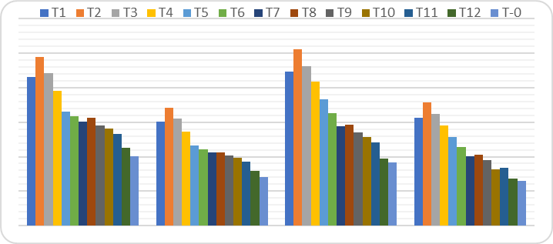
Fig.1: Effect of different treatments on fruit weight of VL-1 and VL-4 for 2 years
Table 4: Effect of different treatments on yield characters of Tomato varieties (VL-1 and VL-4) ((1st year)
Treatments | Number of flowers per plant |  | Number of fruits per plant |  | Number of seeds per fruit |  | Fresh weight of fruit (kg) |  | Yield per plot (kg) |  | Yield per hectare (Q)
Treatments | VL-1 | VL-4 | VL-1 | VL-4 | VL-1 | VL-4 | VL-1 | VL-4 | VL-1 | VL-4 | VL-1 | VL-4
T₁ | 21.13 | 14.79 | 14.23 | 9.963 | 11.73 | 13.04 | 43.12 | 30.16 | 15.63 | 10.94 | 156.3 | 109.4
T₂ | 34.6 | 17.20 | 18.13 | 12.69 | 11.26 | 12.50 | 48.86 | 34.20 | 17.48 | 13.48 | 174.8 | 134.8
T₃ | 25.4 | 12.33 | 13.13 | 9.193 | 14.08 | 14.86 | 44.21 | 30.94 | 15.73 | 10.95 | 157.3 | 109.5
T₄ | 31.11 | 10.83 | 12.34 | 8.638 | 14.50 | 16.06 | 38.97 | 27.27 | 13.40 | 9.311 | 134.0 | 93.11
T₅ | 28.93 | 10.23 | 14.15 | 9.905 | 14.35 | 15.66 | 33.08 | 23.16 | 13.16 | 10.37 | 131.6 | 103.7
T₆ | 19.13 | 10.69 | 12.75 | 8.925 | 15.00 | 15.90 | 31.64 | 22.14 | 12.17 | 8.75 | 121.7 | 87.55
T₇ | 6.86 | 3.45 | 6.23 | 4.363 | 14.58 | 15.56 | 30.23 | 21.16 | 5.00 | 3.50 | 50.00 | 35.00
T₈ | 7.46 | 5.14 | 7.56 | 5.226 | 14.26 | 14.25 | 31.33 | 21.19 | 10.3 | 4.42 | 103.0 | 44.21
T₉ | 6.96 | 4.99 | 6.56 | 4.596 | 15.32 | 15.01 | 29.01 | 20.30 | 4.95 | 3.46 | 49.5 | 34.60
T₁₀ | 6.97 | 5.01 | 7.034 | 4.93 | 17.83 | 15.49 | 28.14 | 19.73 | 3.68 | 2.57 | 36.8 | 25.78
T₁₁ | 6.86 | 4.26 | 6.43 | 4.503 | 17.69 | 14.91 | 26.50 | 18.55 | 4.53 | 3.17 | 45.3 | 31.73
T₁₂ | 5.46 | 4.07 | 5.46 | 3.826 | 17.46 | 15.50 | 22.67 | 15.87 | 4.633 | 5.71 | 46.33 | 57.13
T₀ | 5.80 | 4.06 | 4.23 | 2.963 | 12.73 | 13.30 | 20.01 | 14.00 | 1.67 | 1.172 | 16.7 | 11.72
SEm± | 3.21 | 2.44 | 1.27 | 0.89 | 0.60 | 0.33 | 2.48 | 1.74 | 1.58 | 1.16 | 15.85 | 11.60
CD at 5% | 1.08 | 0.72 | 0.54 | 0.38 | 1.22 | 1.18 | 1.94 | 1.35 | 1.75 | 1.84 | 17.47 | 18.44

Table 5: Effect of different treatments on yield characters of Tomato varieties (VL-1 and VL-4) ((2nd year)
Treatments | Number of flowers per plant |  | Number of fruits per plant |  | Number of seeds per plant |  | Fresh weight of fruit (kg) |  | Yield per plot  (kg) |  | Yield per hectare (Q)
Treatments | VL-1 | VL-4 | VL-1 | VL-4 | VL-1 | VL-4 | VL-1 | VL-4 | VL-1 | VL-4 | VL-1 | VL-4
T₁ | 23.13 | 16.19 | 15.56 | 7.26 | 10.50 | 15.13 | 44.64 | 31.24 | 17.84 | 12.49 | 178.46 | 124.9
T₂ | 25.36 | 17.75 | 19.35 | 13.54 | 10.36 | 14.66 | 51.07 | 35.75 | 21.90 | 15.33 | 219.06 | 153.3
T₃ | 23.60 | 13.33 | 14.34 | 10.04 | 14.26 | 15.50 | 46.11 | 32.27 | 16.61 | 11.68 | 166.10 | 116.23
T₄ | 21.68 | 15.17 | 13.34 | 9.33 | 13.40 | 16.96 | 41.62 | 29.13 | 14.36 | 10.05 | 143.67 | 100.53
T₅ | 26.67 | 18.67 | 14.85 | 10.39 | 13.83 | 16.16 | 36.57 | 25.60 | 15.49 | 10.84 | 154.93 | 108.43
T₆ | 20.34 | 14.23 | 13.49 | 9.44 | 14.18 | 16.23 | 32.67 | 22.86 | 13.51 | 9.46 | 135.16 | 94.61
T₇ | 4.23 | 2.96 | 5.36 | 3.75 | 17.46 | 17.43 | 28.80 | 20.11 | 5.12 | 3.58 | 51.20 | 35.80
T₈ | 4.50 | 3.15 | 5.50 | 3.85 | 14.26 | 15.83 | 29.21 | 20.45 | 6.35 | 3.74 | 63.50 | 37.49
T₉ | 3.96 | 2.98 | 4.67 | 3.54 | 19.86 | 18.85 | 27.10 | 18.97 | 5.82 | 3.609 | 58.23 | 36.09
T₁₀ | 5.16 | 2.77 | 4.80 | 3.59 | 19.66 | 18.40 | 25.67 | 16.41 | 3.64 | 2.548 | 36.40 | 25.48
T₁₁ | 4.76 | 3.33 | 4.96 | 3.61 | 19.86 | 17.49 | 24.01 | 16.80 | 4.77 | 3.343 | 47.76 | 33.43
T₁₂ | 4.23 | 2.96 | 4.23 | 2.96 | 18.40 | 18.17 | 19.47 | 13.62 | 4.02 | 2.818 | 40.26 | 28.18
T₀ | 4.90 | 3.43 | 3.83 | 3.33 | 12.46 | 13.76 | 18.41 | 13.05 | 2.13 | 1.694 | 21.38 | 16.94
SEm± | 2.87 | 2.10 | 1.62 | 0.21 | 0.99 | 0.22 | 3.03 | 0.13 | 1.92 | 1.36 | 19.18 | 13.55
CD at 5% | 2.97 | 1.97 | 0.45 | 0.30 | 1.43 | 1.26 | 2.26 | 1.55 | 2.08 | 1.49 | 29.67 | 125.38

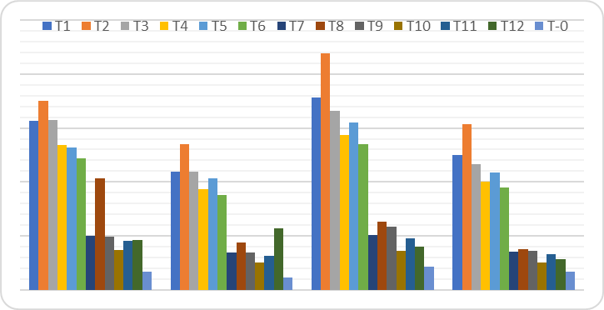
Fig. 2: Effect of different treatments on fruit weight of VL-1 and VL-4 for 2 years

Biochemical Estimation: The soluble protein content was highest in VL-1 vermicompost at 1.62 mg/g, followed by 1.49 mg/g in VL-1 with FYM. The lowest was 1.25 mg/g in VL-4 with FYM+NPK compared to the control. The maximum soluble sugar content was recorded at 12.30 mg/g in VL-1 vermicompost, with VL-4 vermicompost showing 11.69 mg/g, and the minimum at 6.34 mg/g in VL-4 with FYM+NPK. For starch content, the highest value was 3.14 mg/g in VL-1 vermicompost, followed closely by 3.09 mg/g in VL-4 vermicompost, while the lowest was 1.45 mg/g in VL-4 with FYM+NPK. The total free amino acid content reached a maximum of 0.19 mg/g in VL-1 vermicompost, followed by 0.17 mg/g in VL-4 vermicompost and a minimum of 0.07 mg/g in VL-4 with FYM+NPK. (Refer to Table 6 and Figure.3).

Soil Quality Parameters: The results of the soil chemical parameter analysis showed the following maximum values: soil pH was highest at 6.28 in VC+Soil; soil organic carbon was 2.39% in VC+Soil; soil organic matter reached 4.12% in VC+Soil; total nitrogen was highest at 0.61% in NPK+Soil; exchangeable potassium was maximised at 0.080% in VC+Soil; and moisture content was highest at 12.63% in VC+Soil. Improved soil quality indicators were observed, particularly in treatments involving vermicompost. The higher pH, organic carbon content, and moisture retention in these treatments suggest enhanced soil health and fertility (Table 7 and Figure 4).

Variance Analysis of Germination Percent, Speed of Germination, Seedling Length, Seedling Growth Rate and Seedling Dry Weight:

The results in (Table 8 and Figure 5) indicate significant differences in average germination percentage among tomato cultivars, with VL-1 achieving the highest at 13.5% and VL-4 the lowest at 9.75%. The average speed of germination was not statistically significant, with VL-1 at 25.73 and VL-4 at 20.42 (Plate 1 & Plate 2). Seedling length showed substantial differences, with VL-1 measuring 5.745 cm and VL-4 at 3.648 cm. The seedling growth rate also varied significantly, with VL-1 at 2.506 and VL-4 at 1.641. However, the differences in seedling dry weight were insignificant, with VL-1 at 0.004 gm and VL-4 at 0.002 gm.

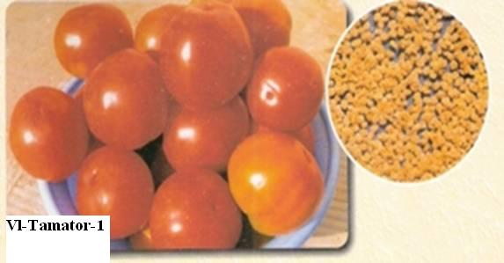
SEED
(A)

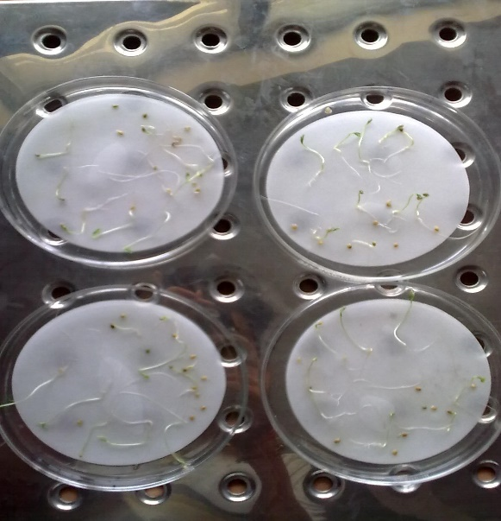
(B) (C)

Plate 1. VL-Tamater-1: (A) Seed extraction from fruit (B) Seed germination in laboratory (C) Seedling measurement

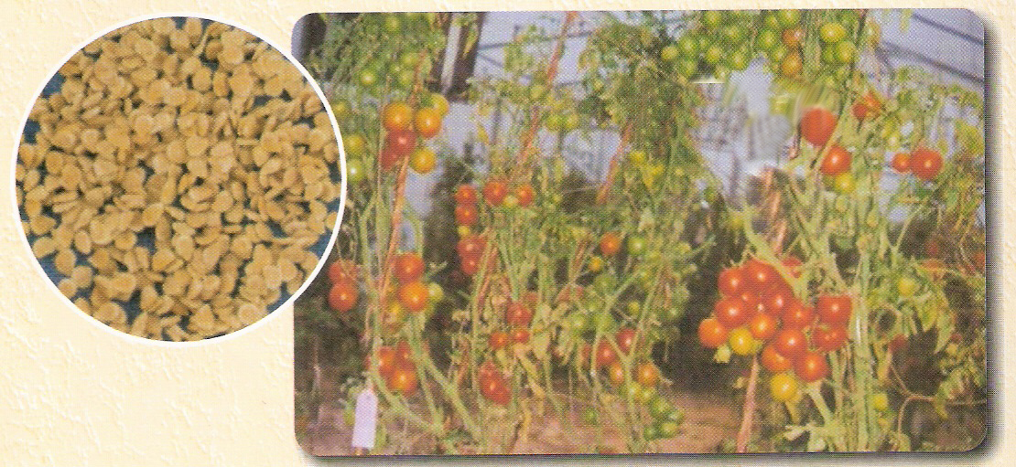
VL-Tamator- 4
SEED

(M)

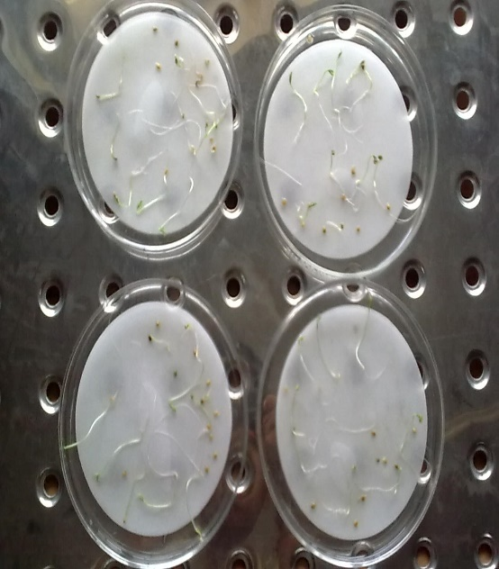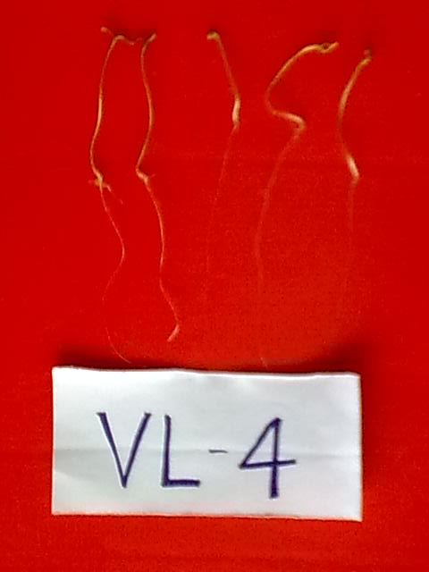
(N) (O)

Plate 2. VL-Tamator-3: (A ) Collection of fruit and extracted seed (B) Seed germination in laboratory (C) Measurement of seedlings.

Table 6. Biochemical variability in two varieties of L. esculentum (VL-1 and VL-4) provided organic and inorganic manure

Parameters | Soluble protein | Soluble sugar | Starch | Total free amino acid
Control | 1.32±0.13 | 8.41±0.50 | 2.58±0.28 | 0.18±0.04
VL-1 V C | 1.62±0.41 | 12.30±0.56 | 3.14±0.15 | 0.19±0.04
VL-4 V C | 1.43±0.35 | 11.69±0.87 | 3.09±0.15 | 0.17±0.04
VL-1 FYM | 1.49±0.12 | 8.01±0.27 | 2.10±0.16 | 0.15±0.04
VL-4 FYM | 1.33±0.09 | 7.95±0.20 | 2.05±0.15 | 0.13±0.04
VL-1 V C+NPK | 1.35±0.13 | 7.71±0.90 | 1.77±0.28 | 0.11±0.04
VL-4 V C+NPK | 1.33±0.11 | 7.09±0.56 | 1.73±0.10 | 0.09±0.04
VL-1 FYM+NPK | 1.29±0.08 | 6.75±0.37 | 1.48±0.07 | 0.09±0.03
VL-4 FYM+NPK | 1.25±0.11 | 6.34±0.76 | 1.45±0.16 | 0.07±0.03

Fig. 3: Biochemical variability in two varieties of L. esculentum (VL-1 and VL-4) provided organic and inorganic manure.

Table 7: Soil chemical and physical characteristics in different soil compositions
Parameters | Chemical parameters |  |  |  |  | Physical parameter
Parameters | Soil pH | 0rganic carbon (%) | Soil organic matter (%) | Total Nitrogen (%) | Exchangeable K (%) | Moisture content (%)
V C+Soil | 6.28±0.02 | 2.39±0.05 | 4.12±0.09 | 0.84±0.14 | 0.080±0.001 | 12.63±1.71
FYM+Soil | 6.07±0.02 | 0.93±0.07 | 1.60±0.11 | 0.15±0.08 | 0.051±0.001 | 12.13±2.72
NPK+Soil | 6.08±0.02 | 0.67±0.02 | 1.16±0.03 | 0.61±0.08 | 0.057±0.002 | 10.93±3.77
Control | 6.10±0.01 | 0.68±0.07 | 1.18±0.11 | 0.51±0.08 | 0.076±0.006 | 10.26±1.36

Fig. 4: Showing soil chemical and physical characteristics in different soil compositions

Cultivar | Germination % | Speed of germination | Seedling length (cm) | Seedling growth rate | Seedling dry weight (gm)
VL -1 | 13.5 | 25.73 | 5.745 | 2.506 | 0.004
VL -4 | 9.75 | 20.42 | 3.648 | 1.641 | 0.002
SEm± | 1.53 | 2.17 | 0.86 | 0.35 | 0.00
CD at 5% | 0.774 | 1.783 | 0.195 | 0.1224 | 0.759
Table 8: Variance analysis of germination %, speed of germination, seedling length, seedling growth rate and seedling dry weight.

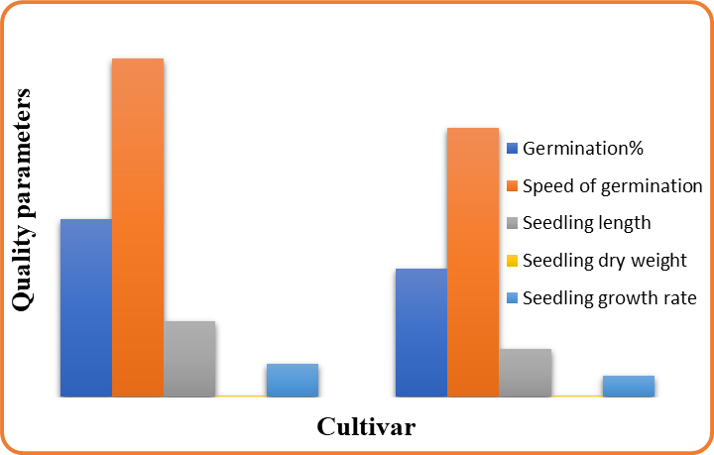
Fig 5. Effect of different quality parameters of tomato cultivar VL-1 and VL-4

4. DISCUSSIONS
4.1. Plant Growth, Yield, Physiology, and Nutritional Quality Attributes of Tomato Plant
In this study, the application of vermicompost significantly influenced the growth, yield, and physiological characteristics of tomato plants. Treatments incorporating vermicompost (T1 and T2) showed notable improvements in plant height, number of leaves per plant, root length, stem thickness, leaf area, and total biomass. These enhancements can be attributed to increased microbial activity, improved soil aeration, and gradual nutrient release associated with vermicompost application. These findings align with previous studies that demonstrated vermicompost’s ability to improve soil fertility and boost plant growth (Singh et al., 1997; Kumar, 2000; Arancon et al., 2003; Ilupeju et al., 2015; Hari & Sushma, 2005; Chapman & Pratt, 1982; Esringü et al., 2022).
The combined application of vermicompost and NPK fertilizers exhibited a synergistic effect on yield-related parameters. The highest fruit yield, fruit weight, and seed production were recorded in T2 (15 t/ha vermicompost), highlighting its potential as a sustainable amendment for optimizing crop productivity. Similar studies have reported that vermicompost enhances flowering, fruit set, and seed development in various crops, including tomatoes, cucumbers, and bell peppers (Arancon et al., 2003; Ansari & Sukhraj, 2010; Karagöz et al., 2019; Sanwal et al., 2000). These benefits are primarily attributed to the slow release of macro- and micronutrients, as well as increased microbial populations, which improve nutrient uptake efficiency (Naidu et al., 2001; Musa et al., 2018).
Regarding physiological attributes, the application of vermicompost significantly increased chlorophyll content, carotenoid levels, and SPAD values in tomato leaves. This aligns with findings by Togun et al. (2003), Aslam et al. (2023), and Raksun et al. (2022), who reported substantial increases in photosynthetic pigments in Phaseolus vulgaris following vermicompost treatment. The improvement in chlorophyll content can be linked to the high nitrogen content in vermicompost, as nitrogen is a key component of the chlorophyll molecule and plays a crucial role in photosynthesis (Raksun et al., 2022). Additionally, vermicompost contains plant growth-promoting rhizobacteria (PGPR), which stimulate the production of growth hormones and enzymes, further enhancing plant physiological attributes (Afandi et al., 2016).
Furthermore, our study revealed that vermicompost positively influenced biochemical parameters such as soluble protein, crude fiber, and fat content in tomato fruits. These findings are supported by Dominguez & Edwards (2011) and Rekha et al. (2018), who observed significant increases in nutrient composition in vermicompost-treated plants. The rise in protein content is likely due to higher nitrogen availability, which plays a crucial role in amino acid and protein synthesis (Mahmoud & Gad, 2020).
4.2. Effect of Vermicompost on Physico-Chemical Properties of Soil
The application of vermicompost significantly improved the physico-chemical properties of post-harvest soil. Notably, there was an increase in soil organic carbon (SOC), total porosity, and cation exchange capacity (CEC) in the vermicompost-treated plots. These findings align with previous studies that reported enhanced soil structure and fertility due to the high organic matter and humic acid content in vermicompost (Khosropour et al., 2022; Arancon et al., 2012). The presence of humic substances promotes soil microbial diversity and enzymatic activity, contributing to better nutrient cycling and soil aggregation (Aslam & Ahmad, 2020).
A key observation in this study was the improvement in soil moisture retention and hydraulic conductivity attributed to enhanced soil structure and porosity resulting from vermicompost application. These findings are consistent with reports by Prabha et al. (2007) and Emami & Astaraei (2012), who noted that vermicompost-treated soils exhibited higher water-holding capacity, making them more resilient to drought conditions. The ability of vermicompost to enhance soil water retention and aeration makes it a valuable amendment for improving soil quality, particularly in arid and semi-arid regions.
Additionally, vermicompost application significantly increased available nitrogen (N), phosphorus (P), and potassium (K) levels in the soil. This is due to the gradual decomposition of organic matter in vermicompost, which releases nutrients in forms readily available for plant uptake. Previous researchers reported similar trends and found that vermicompost application increased soil fertility and nutrient availability compared to chemical fertilizers alone (Conacher & Conacher, 1998; Yadav et al., 2019; Hafez et al., 2021). The increased exchangeable magnesium (Mg) and calcium (Ca) concentrations in vermicompost-treated soils further support its role in improving soil fertility (Beyk-Khormizi et al., 2022).
Finally, an increase in soil electrical conductivity (EC) was observed following vermicompost application, indicating a higher concentration of dissolved nutrients in the soil solution. This finding is consistent with reports by Ezzat et al. (2019), who demonstrated that organic amendments increase soil ion concentration, enhancing nutrient availability.
Our results indicate that vermicompost is an effective organic amendment that enhances soil fertility, improves plant growth and yield, and promotes sustainable agricultural practices.

CONCLUSION

The findings from our study on the VL-1 and VL-4 varieties highlight the transformative potential of vermicompost as a sustainable organic amendment, significantly enhancing plant growth, yield, and soil quality. With an optimal application rate of 15 tons per hectare, we observed impressive improvements in plant height, leaf vitality, fruit weight, and seed production, showcasing the power of organic practices. This research underscores the nutritional and economic benefits of organic farming and its crucial role in fostering a healthier planet by nurturing beneficial soil microorganisms and enhancing nutrient availability. As we face increasing demands for high-quality organic produce, embracing innovative organic techniques like vermicomposting is essential. Looking ahead, further exploration into the long-term impacts of diverse organic amendments across various tomato varieties can yield valuable insights, guiding us toward sustainable agricultural practices that harmonise productivity with ecological health.

Data availability: Data will be made available on request.

References
Afandi, A. M., Zulkifli, H., Khalid, H., Hasnol, O., Nur-Zuhaili, H., & Zuraidah, Y. (2016). Oil palm fertilizer recommendation for Sabah soils. Oil Palm Bulletin, 72, 1–24.
Ansari, A. A., & Sukhraj, K. (2010). Effect of vermiwash and vermicompost on soil parameters and productivity of Abelmoschus esculentus in Guyana. African Journal of Agricultural Research, 5, 1994–1998.
Arancon, N. Q., Pant, A., Radovich, T., Hue, N. V., Potter, J. K., & Converse, C. E. (2012). Seed germination and seedling growth of tomato and lettuce as affected by vermicompost water extracts (teas). HortScience, 47, 1722–1728. https://doi.org/10.21273/HORTSCI.47.12.1722
Arancon, NQ., Edwards, C.A., Bierman, P. & Metezger (2003). Effect of vermin-compost on growth and marketable fruits of field-grown tomatoes, peppers and strawberries. 7th International Symposium on Earthworm Ecology, Cardiff, Wales, 1-6 Sept. 2002. Pedobiologia, 47(5-6), 731-735. DOI: 10.1016/S0031-4056(04)70260-7
Arun Kumar, K.R. (2000). Organic Nutrition in Amaranths (Amaranthus tricolor). M.Sc. (Ag). Thesis Kerala Agricultural University. Thrischur.
Aslam, Z., & Ahmad, A. (2020). Effects of vermicompost, vermi-tea, and chemical fertilizer on morpho-physiological characteristics of maize (Zea mays L.) in Suleymanpasa District, Tekirdag of Turkey. Journal of Innovative Science, 6, 41–46. https://doi.org/10.36778/jis.v6i1.299
Aslam, Z., Ahmad, A., Bellitürk, K., Kanwal, H., Asif, M., & Ullah, E. (2023). Integrated use of simple compost, vermicompost, vermi-tea, and chemical fertilizers (NP) on the morpho-physiological, yield, and yield-related traits of tomato (Solanum lycopersicum L.). Journal of Innovative Science, 9, 1–12. https://doi.org/10.36778/jis.v9i1.456
Beyk-Khormizi, A., Hosseini Sarghein, S., Sarafraz-Ardakani, M. R., Moshtaghioun, S. M., Mousavi-Kouhi, S. M., & Ganjeali, A. (2022). Ameliorating effect of vermicompost on Foeniculum vulgare under saline condition. Journal of Plant Nutrition, 46, 1601–1615. https://doi.org/10.1080/01904167.2022.2143158
Chapman, H. D., & Pratt, F. P. (1982). Determination of minerals by titration method: Methods of analysis for soils, plants, and water. Agriculture Division, University of California.
Conacher, J., & Conacher, A. (1998). Organic farming and the environment, with particular reference to Australia: a review. Biological Agriculture & Horticulture, 16(2), 145-171. DOI: 10.1080/01448765.1998.9755229
Dominguez, J., & Edwards, C. A. (2011). Biology and ecology of earthworm species used for vermicomposting. In Vermiculture technology: Earthworms, organic waste and environmental management (pp. 27–40). CRC Press.
Dubey, R. C. (1998). A textbook of Biotechnology, Biofertilizer. Oxford and IBH Co. New Delhi, pp. 152-168
Edwards, C. A., & Burrows, I. (1988). Potential of earthworm composts as plant growth media. Earthworms in waste and environmental management/edited by Clive A. Edwards and Edward F. Neuhauser.
Emami, H., & Astaraei, A. R. (2012). Effect of organic and inorganic amendments on parameters of water retention curve, bulk density, and aggregate diameter of a saline-sodic soil. Journal of Agricultural Science and Technology, 14, 1625–1636.
Esringü, A., Turan, M., Sushkova, S., Minkina, T., Rajput, V. D., Glinushkin, A., & Kalinitchenko, V. (2022). Influence of vermicompost application on the growth of Vinca rosea valiant, Pelargonium peltatum L., and Pegasus patio rose. Horticulturae, 8(534). https://doi.org/10.3390/horticulturae8120534
Ezzat, A. S., Badway, A. S., & Abdelkader, A. E. (2019). Sequenced vermicompost, glycine betaine, and proline treatments elevate salinity tolerance in potatoes. Middle East Journal of Agricultural Research, 8, 126–138.
Fisher, R. A., & Yates, F. (1938). Statistical tables for biological, agricultural and medical research. Oliver & Boyd.
Hafez, E. M., Omara, A. E. D., & Alhumaydhi, F. A., & El-Esawi, M. A. (2021). Minimizing hazard impacts of soil salinity and water stress on wheat plants by soil application of vermicompost and biochar. Physiologia Plantarum, 172, 587–602. https://doi.org/10.1111/ppl.13349
Hari, T.K. & Sushama, P.K. (2005). Application of vermiculture Technology, Agrobios newsletter. June 2005. Vol iii 1, 27-28.
Horticultural statistics division, Second advance estimates (2020-2021)
Ilupeju, E. A. O., Akanbi, W. B., Olaniyi, J. O., Lawal, B. A., Ojo, M. A., & Akintokun, P. O. (2015). Impact of organic and inorganic fertilizers on growth, fruit yield, nutritional and lycopene contents of three varieties of tomato (Lycopersicon esculentum (L.) Mill) in Ogbomoso, Nigeria. African Journal of Biotechnology, 14(31), 2424-2433. DOI: 10.5897/AJB10.1902
International Seed Testing Association (ISTA) (2008). International Ruler for Seed Testing: The Germination Test. Seed Science and Technology.Zurich, Switzerland.
Kanwar, M. S. (2011). Performance of tomato under greenhouse and open field conditions in the trans-Himalayan region of India. Advances in Horticultural Science, 25(1), 65-68. DOI: 10.13128/ahs-12786
Karagöz, F. P., Dursun, A., Tekiner, N., Kul, R., & Kotan, R. (2019). Efficacy of vermicompost and/or plant growth-promoting bacteria on the plant growth and development in gladiolus. Ornamental Horticulture, 25, 180–188. https://doi.org/10.14295/oh.v25i2.1762
Khosropour, E., Weisany, W., Tahir, N. A., & Hakimi, L. (2022). Vermicompost and biochar can alleviate cadmium stress through minimizing its uptake and optimizing biochemical properties in Berberis integerrima Bunge. Environmental Science and Pollution Research, 29, 17476–17486. https://doi.org/10.1007/s11356-021-16998-2
Mahmoud, S. O., & Gad, D. A. M. (2020). Effect of vermicompost as fertilizer on growth, yield, and quality of bean plants (Phaseolus vulgaris L.). Middle East Journal of Agricultural Research, 9, 220–226.
Musa, S. I., Njoku, L. K., & Ndiribe, C. C. (2018). The effect of vermi-tea on the growth parameters of Spinacia oleracea L. (Spinach). Journal of Environmental Science and Pollution Research, 3, 236–238.
Naidu, A. K., Kushwah, S. S., Mehta, A. K., & Jain, P. K. (2001). Study of organic, inorganic, and biofertilizers in relation to growth and yield of tomato. JNKVV Research Journal, 35, 36–37.
Olaniyi JO, & Ajibola AT (2008). Effect of organic and organic fertilizers application on growth, fruit yield and quality of tomato (Solanum Lycopersicum L). Applied Biosciences. 8(1), 236-242.
Phonia, L., Bahadur, V., Thomas, T., & Prasad, V. M. (2022). Effect of organic manures and inorganic fertilizers on growth, fruit yield and quality of cherry tomato (Solanum lycopersicum var. cerasiforme) cv Pusa Cherry Tomato-1 under Naturally Ventilated Polyhouse Condition. International Journal of Plant & Soil Science, 34, 299-309. DOI:10.9734/IJPSS/2022/v34i2231380
Prabha, K.P., Y.L. Loretta & Usha, (2007). An experiment study of vermin-composting for agricultural soil improvement. Bioresource Technology., 99,1672-1681.
Raksun, A., Ilhamdi, M. L., Merta, I. W., & Mertha, I. G. (2022). Analysis of bean (Phaseolus vulgaris) growth due to treatment of vermicompost and different types of mulch. Journal of Biological Tropics, 22, 907–913. https://doi.org/10.1234/jbt.v22i3.789
Rao, T.S.S. & Sanker, C.R. (2001). Effect of organic manure on growth and yield of brinjal. South Indian Horticulture, 49, 288-291.
Rekha, G. S., Kaleena, P. K., Elumalai, D., Srikumaran, M. P., & Maheswari, V. N. (2018). Effects of vermicompost and plant growth enhancers on the exo-morphological features of Capsicum annum (Linn.) Hepper. International Journal of Recycling of Organic Waste in Agriculture, 7, 83–88. https://doi.org/10.1007/s40093-018-0204-9
Sanwal, S.K., Laxminarayan, K., Yadav, R.K., Rai, N., Yadav, D.S. & Bhuyan, M (2000). Effect of organic manures on soil fertility, growth, physiology, yield and quality of turmeric. Indian Journal of Horticulture, 64(4), 444-449.
Singh & Kalloo. (2000). Effect of Biofertilizer, organic fertilizer and foliar application of power 4 on the growth and yield of okra plants. Journal of Natural and applied Sciences, 7 (2), 25-35.
Singh, K., & Cheema, G. S. (1997). Veg. Symp. At Katrain, India Cited from Edw, K. (1976) Manurial requirements of Vegetables. ICAR, New Delhi
Togun, A.O., Akanbi, W.B., & Dris, R. (2003). Influence of compost and Nitrogen fertilizer on growth, nutrient uptake and fruit yield of tomato (Lycopersicon esculentum). Crop Research, 26(1), 98-105
Yadav, V., Karak, T., Singh, S., Singh, A. K., & Khare, P. (2019). Benefits of biochar over other organic amendments: Responses for plant productivity (Pelargonium graveolens L.) and nitrogen and phosphorus losses. Industrial Crops and Products, 131, 96–105. https://doi.org/10.1016/j.indcrop.2019.01.036

