Original Research Article
Community Structure of Litter Fauna in Rubber Plantations with Varying Age Strata

.
ABSTRACT

Forests serve as natural habitats for litter fauna, playing a crucial role in sustaining their survival. However, widespread forest conversion into plantations has become increasingly common, while information regarding litter fauna and their ecological roles particularly in Indonesia remains limited. This study aims to analyze and compare the community structure of litter fauna in rubber plantations of different age strata. The research locations were selected using a stratified sampling method based on the age of rubber trees, specifically 23-year-old and 11-year-old plantations. Data collection was conducted using the litterbag method and the Barlese-Tullgren funnel extraction technique. The Barlese-Tullgren funnel was employed to extract fauna from the litter samples. Data analysis included measurements of density, diversity index, evenness index, and dominance index. A total of 18 litter fauna species were identified across the two locations, with 16 species found in the 11-year-old rubber plantation and 9 species in the 23-year-old plantation. The 11-year-old plantation exhibited a higher total litter fauna density (4.02 individuals/litterbag) compared to the 23-year-old plantation (2.29 individuals/litterbag). However, the litter fauna diversity index in the 11-year-old plantation was relatively lower (H’ = 1.52) than in the 23-year-old plantation (H’ = 1.79). The dominance index was higher in the 11-year-old plantation (D = 0.45) than in the 23-year-old plantation (D = 0.18).

Keywords: Litter fauna, Rubber plantation, Litter

1. INTRODUCTION

Litter fauna is part of the soil fauna that carries out most of its activities on plant litter.. According to (Sulistyorini et al ., 2023) the arthropod phylum, especially the Insecta class, is the most numerous litter fauna compared to other animals. The phylum consists of 4 classes, namely Hexapoda, Chelicerata, Myriapoda, and Crustacea. Arthropods are known to be the type of animal with the most species on earth, it has been recorded that more than 800,000 insect species have been found.
Litter fauna plays an important role in the soil ecosystem. Some of the roles of litter fauna include improving litter fertility, namely playing a role in the decomposition process, especially in the process of humus formation (humification), mixing organic matter with litter particles and forming aggregate stability between organic matter and mineral litter. In addition, litter fauna also plays a role in carbon flow, nutrient redistribution, nutrient cycles, and soil structure formation (Ilhamdi et al. , 2022) . Litter is a source of organic matter for soil organisms including litter fauna, both directly and indirectly. Through the decomposition process, litter as organic material will be broken down by soil biota or litter into energy and simpler inorganic elements such as carbon, nitrogen, phosphorus, sulfur, and potassium (Aziz et al ., 2023) . In litter decomposition, there are three main factors that influence the litter decomposition process, namely climate, litter quality, and microbial and litter fauna communities. In addition, there are abiotic factors that are important supporters in the decomposition process, namely rainfall, temperature, organic content of litter and pH of litter. Rainfall is the most important factor in the occurrence of litter decomposition, so if rainfall increases, the rate of litter decomposition will also increase. In addition, rainfall is also closely related to temperature and soil humidity which are influential components in the litter decomposition process (Karina et al ., 2022) .
Research on the role of litter fauna on the rate of litter decomposition in rubber plantations is still very limited. The following explains several previous studies, including research by Younear et al ., ( 2023) regarding the diversity of litter macrofauna in rubber plantations ( Hevea brasiliensis ) in Labuhan Village, Batang Alai Selatan District, Hulu Sungai Tengah Regency showed the results of research and identification that identified 20 species of macrofauna from 14 families. The most dominant species is the fire ant ( Solenopsis invicta ) with the highest importance value index of 47.51%. Meanwhile, the diversity index of litter macrofauna species in rubber plantations is included in the moderate category with a value of 1.967. Furthermore, Melati's research et al ., ( 2021) on the diversity of litter macrofauna in the initial decomposition process of litter from secondary forests and candlenut stands on the slopes of the Gawalise Mountains, Central Sulawesi, showed that the production of secondary forest litter (2.20 tons/ha/month) was higher than that of candlenut stands (2.14 tons/ha/month). The rate of litter decomposition in secondary forests is moderate, with a percentage of 17%-19%, while the rate of decomposition in candlenut stands is slow, with a percentage of 10%-12%. This difference is due to the variation in the diversity of litter macrofauna species in the two types of forests. In addition, in the study of Karina et al ., ( 2022) regarding the rate of leaf litter decomposition in the Special Purpose Forest (KHDTK) area of Bengkulu University, North Bengkulu, it was found that the rate of decomposition increased along with the increasing percentage of dry weight loss of litter. The highest decomposition rate occurred in the 12th week, where rainfall tended to be higher compared to the previous week.

Based on several previous studies on litter fauna and decomposition rates in various locations, both forests and plantations, it is known that there is a correlation between litter fauna and decomposition rates. This difference occurs due to several factors, both biotic and abiotic factors. In addition, there is a change in forest function such as research conducted Melati et al ., (2021) , which states that the rate of decomposition of secondary forests is faster than candlenut stands and there are differences in fauna diversity in the two areas. The role of litter fauna in decomposing litter can certainly have an impact on litter fertility so that the presence of litter fauna in a location needs to be given more attention.
The existence of forest conversion causes changes in the structure of the existing litter fauna so that it can affect the rate of decomposition on the land. Changes in the rate of litter decomposition will result in a decrease in litter quality. Forest conversion can be in the form of opening agricultural land, plantations and settlements. (Hadryanti et al ., 2019) , Central Bengkulu is one of the districts in Bengkulu Province that has a large number of rubber plantations, namely 10,497 hectares (BPS Bengkulu Province, 2019). Paying attention to the presence of litter fauna in plantation land is very important in the management of sustainable plantation ecosystems. Therefore, research on "Community Structure of Litter Fauna in Rubber Plantations with Different Age Strata" needs to be conducted. This study aims to analyze the comparison of the community structure of litter fauna in rubber plantations with different age strata. It is hoped that the results This research can provide insight into the structure of litter fauna communities and serve as a reference in sustainable plantation land management.
2. material and methods

This study is a quantitative study conducted by sampling litter fauna in rubber plantations in Central Bengkulu Regency, Bengkulu Province, in the period January - April 2024. Determination of research stations or locations using the stratified sampling method , namely based on the age of the rubber plantation, which consists of two locations: an 11-year-old rubber plantation and a 23-year-old rubber plantation (Figure 1).

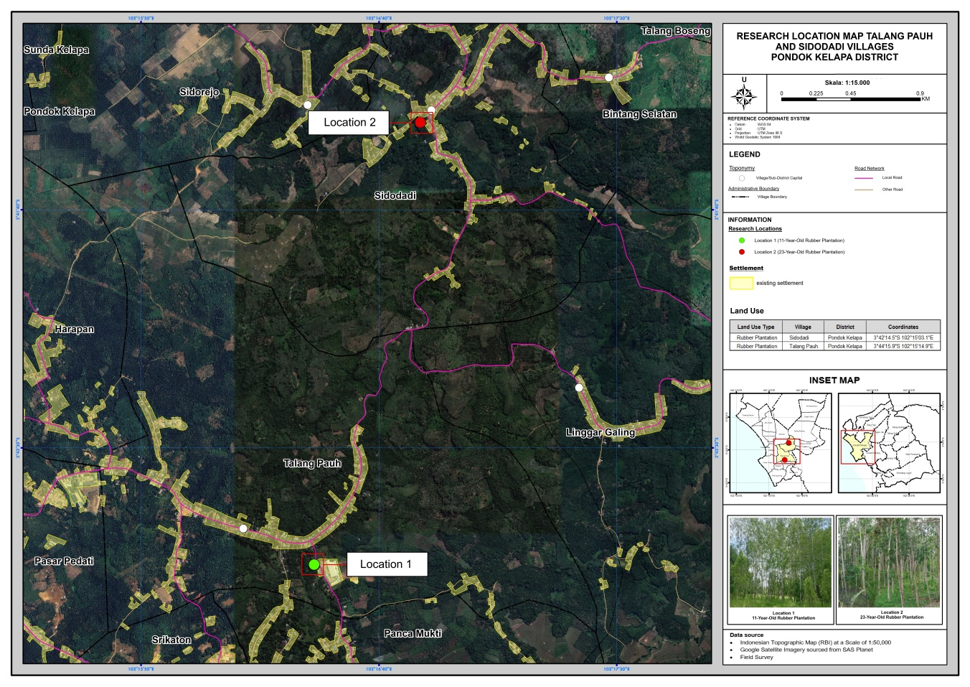
Fig 1. Map of research locations in the Rubber Plantation of the Regency Central Bengkulu, Bengkulu (Google Earth, 2024).
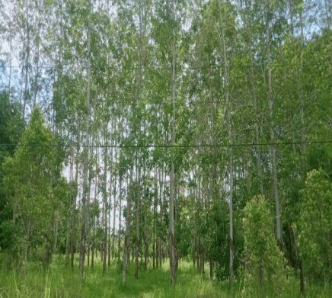  (a) | 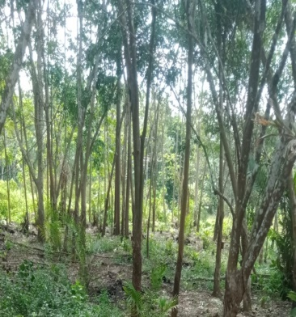  (b)

Fig 2. (a). Rubber plantation 11 years, (b). Rubber plantation 23 years
The litter to be used in the study was first collected using a 3 mx 3 m litter trap installed as many as 3 litter traps/location. Furthermore, the collected leaf litter was then dried in an oven at a temperature of 105ºC. Then the dried litter was weighed and put into a 14 cm x 14 cm litter bag with a litter weight of 15 gr/ litter bag . The 50 cm x 50 cm plot size litter bag that had been filled with litter was then placed on the surface of the rubber plantation soil with a distance between plots of 5 meters.
Litterbags that had previously been placed on the surface of the plantation soil were taken. Litterbags for the experiment on the rate of decomposition of litter that had been decomposed was taken to the laboratory to be dried in an oven at 105°C until it reached a constant weight. and weighing of litter weight after undergoing decomposition process. After obtaining litter weight data before and after decomposition process, the litter decomposition rate in the rubber plantation was calculated.
Litterbags for decomposed litter fauna extraction were taken to the laboratory for extraction using the Barlese-Tullgren funnel extraction method. The Barlese-Tullgren funnel used was given a 15 watt lamp, this was intended to generate heat in the funnel so that the litter fauna in the funnel contents would look for a cooler place, namely by going down to the bottom of the funnel and being trapped in the prepared collection bottle. The collection bottle containing picric acid was placed in the Barlese-Tullgren funnel. The process of extracting litter fauna using the Barlese-Tullgren funnel was carried out for 3 days or until the extracted litter had dried. Litter fauna collected in the collection bottle was sorted and identified using the identification book guide Borror et al . , ( 1996) , Lilies ( 1992) And Quigley, M & Madge ( 1988) . The parameters measured in this study include density, relative density, diversity index, evenness index, and dominance index, which are calculated using the following formula. (Soegianto, 1994) :
- Density

K =$\frac{The number of individuals of a species }{Area of ​​a square}$
- Relative density

K =$\frac{Density of species }{Density of all specie} x 100\%$
- Diversity index (H`)

H' = - ∑ pi ln pi
- Evenness index (J')

J' = $\frac{H}{\ln{(S)}}$
- Dominance Index (D)

D = 1- J'
3. results and discussion

3.1 Richness of Litter Fauna Species in Rubber
Plantations with Different Age Strata

Based on the research results at both rubber plantation locations, 18 types of litter fauna were obtained which were classified into 6 classes, namely Insecta (9 types), Arachnida (5 types), Hirudinea (1 type), Diplopoda (1 type), Chilopoda (1 type), and Oligochaeta (1 type) (Table 1).

Table 1. Types and Presence of Rubber Plantation Litter Fauna in Central Bengkulu Regency
No | Types of Litter Fauna | Class | 11 years rubber | Rubber 23 years
1 | Allonemobius sp | Insects | - | +
2 | Blatta sp | Insects | + | +
3 | Crematogaster sp | Insects | + | -
4 | Leptogenys sp | Insects | + | +
5 | Gymnochiromyi a sp | Insects | + | -
6 | Isotomiella sp | Insects | + | +
7 | Lachesilla sp | Insects | + | -
8 | Psytalla sp | Insects | + | -
9 | Solenopsis sp | Insects | + | +
10 | Attulus sp | Arachnida | + | +
11 | Diapterobates sp | Arachnida | + | -
12 | Gonatium sp | Arachnida | + | +
13 | Lycosa sp | Arachnida | - | +
14 | Oecobius sp | Arachnida | + | -
15 | Hirudo sp | Hirudinea | + | -
16 | Pseudoporatia sp | Diplopoda | + | -
17 | Scolopendra sp | Chilopoda | + | +
18 | Fridericia sp | Oligochaeta | + | -
Total |  |  | 16 | 9
Similarity index |  |  | 51.8%.

The results of this study indicate that the number of litter fauna species found is less compared to the study conducted by Younear et al ., (2023) which found 20 species of surface macrofauna on rubber plantations. The difference in the number of species found is due to the difference in focus of the research object and the methods applied. In the study of Younear et al ., (2023), the soil fauna focused on the macrofauna of the soil surface using the pitfall trap method so that the number of soil fauna species was greater because of the wider coverage of soil fauna. While in this study, the focus of soil fauna was limited to litter using the Litterbag method with a mesh size of 3 mm, so that the number of animal species obtained was smaller, even though the location was the same in a rubber plantation .
Comparison of the number of litter fauna species at both locations shows that the 11-year-old rubber plantation location is higher (16 species) compared to the 23-year-old rubber plantation (9 species). This shows that the diversity of species in the younger rubber plantation (11 years) is higher, because the environmental conditions are more supportive of the growth of more diverse basic vegetation, thus providing more diverse opportunities for litter fauna life. This is because the 11-year-old rubber plantation has a canopy that is not too dense, and allows sunlight to reach the ground surface and supports better growth of basic vegetation (Figure 2). The difference in communities between the two locations is also influenced by the large distance between the two locations, which is 2.9 km. This may also cause differences in the types of litter fauna found in the two rubber plantations.
The level of similarity of the types of litter fauna in both locations can also be seen from the similarity index value of 51.8% (Table 1). This shows that almost half of the types of fauna found in both locations are the same. Of the total 18 types of litter fauna obtained. This similarity may indicate that despite differences in the age of rubber plants, certain environmental factors still support the existence of similar litter fauna. In addition, Pariyanto & Destriani (2021) emphasized that the existence of soil fauna in rubber plantations is greatly influenced by environmental conditions, including factors such as humidity and type of vegetation. This supports the finding that despite differences in plant age, similar environmental conditions will also provide certain similarities in the types of litter fauna.
  - Density, Relative Density and Relative Frequency of Litter Fauna in Rubber Plantations of Different Age Strata

Based on the comparison of density data, there are differences in density and relative density of litter fauna in rubber plantations with different age strata. Litter fauna density is higher in 11-year-old rubber plantations compared to 23-year-old rubber plantations. This shows a tendency for decreasing density as the plantation age increases.

Table 2. K, KR, Litter Fauna in Rubber Plantations of Different Age Strata
No | Type | Location 11 years |  |  | Location 23 years
No | Type | K | KR | FR | K | KR | FR
1 | Allonemobius sp | 0.00 | 0.00 | 0.00 | 0.06 | 2.73 | 6.25
2 | Blatta sp | 0.96 | 23.83 | 39.58 | 0.67 | 29.09 | 27.08
3 | Crematogaster sp | 0.02 | 0.52 | 2.08 | 0.00 | 0.00 | 0.00
4 | Leptogenys sp | 0.38 | 9.33 | 20.83 | 0.29 | 12.73 | 12.50
5 | Gymnochiromyia sp | 0.02 | 0.52 | 2.08 | 0.00 | 0.00 | 0.00
6 | Isotomiella sp | 0.25 | 6.22 | 10.42 | 0.56 | 24.55 | 16.67
7 | Lachesilla sp | 0.02 | 0.52 | 2.08 | 0.00 | 0.00 | 0.00
8 | Psytalla sp | 0.02 | 0.52 | 2.08 | 0.00 | 0.00 | 0.00
9 | Solenopsis sp | 1.60 | 39.90 | 41.67 | 0.27 | 11.82 | 12.50
10 | Attulus sp | 0.02 | 0.52 | 2.08 | 0.02 | 0.91 | 2.08
11 | Diapterobates sp | 0.02 | 0.52 | 2.08 | 0.00 | 0.00 | 0.00
12 | Gonatium sp | 0.08 | 2.07 | 8.33 | 0.02 | 0.91 | 2.08
13 | Lycosa sp | 0.00 | 0.00 | 0.00 | 0.08 | 3.64 | 8.33
14 | Oecobius sp | 0.08 | 2.07 | 6.25 | 0.00 | 0.00 | 0.00
15 | Pseudoporatia sp | 0.02 | 0.52 | 2.08 | 0.00 | 0.00 | 0.00
16 | Scolopendra sp | 0.46 | 11.40 | 16.67 | 0.31 | 13.64 | 20.83
17 | Fridericia sp | 0.04 | 1.04 | 4.17 | 0.00 | 0.00 | 0.00
18 | Hirudo sp | 0.02 | 0.52 | 2.08 | 0.00 | 0.00 | 0.00
Total |  | 4.02 | 100.00 |  | 2.29 | 100.00

Based on Table 2, the 11-year-old Rubber Plantation shows a total litter fauna density of 4.02 individuals/ Litterbag , higher than the 23-year-old location (2.29 individuals/litterbag). This is also related to the environmental and abiotic conditions of the soil which tend to differ between the two locations. At the 11-year-old plantation location, the temperature and organic content of the soil tend to be higher and the soil moisture is lower compared to the 23-year-old rubber plantation location (Table 4). Species with relatively high densities at the 11-year-old location are Solenopsis sp. and Blatta sp. The Solenopsis sp. group has a density of 1.6 individuals/litterbag (KR= 39.90%). This indicates that the highest density of Solenopsis sp. is in the 11-year-old rubber plantation because the habitat is open, in accordance with the environmental conditions of the plantation which has a sparse canopy, so that more sunlight enters the soil surface. The results of the study by Darmi et al., (2015) also stated that Solenopsis sp. is abundant in population in 2-year-old oil palm plantations which are more open, compared to 10, 15, 19 and 23-year-old oil palm plantations.
The genus Blatta sp. has a density of 0.96 individuals/ litterbag (KR= 23.83%). This indicates that Blatta sp. is relatively common in 11-year-old rubber plantations because according to Abudin et al. (2023) , Blatta sp. likes warm, humid places with lots of food. 11-year-old rubber plantations have low canopies (J=sparse) allowing more sunlight to penetrate the soil surface, creating optimal microhabitat conditions for this species. In addition, the higher levels of soil organic matter in this location provide sufficient sources of nutrients and support the sustainability of litter fauna populations.
Other species such as Leptogenys sp. ( KR= 9.33%) and Scolopendra sp. ( KR= 11.40%) are classified as accidental or very rarely found in 11-year rubber plantations. Leptogenys sp. or black ants are active in the morning and evening to avoid high temperatures , while during the day they hide in their nests to avoid exposure to sunlight ( (Lilies, 1992 ; Aminudin et al ., 2021) ). Leptogenys sp . is a genus of ants with a low population and is rarely found in oil palm plantations. (Darmi et al ., 2015) . The low population of Scolopendra sp. is related to its nature of life. This animal is usually found on the ground surface and hides in rotten wood, rocks, or litter ( Aminudin et al ., 2021) .
In the 23-year Rubber Plantation, the litter fauna at this location has a lower total density, which is 2.29 individuals/litterbag compared to the 11-year rubber plantation location. Several genera that have relatively high densities at this location are Blatta sp., Isotomiella sp. and Scolopendra sp. Blatta sp. remains prominent at this location with ( KR= 29.09% ) which reflects its adaptability in various habitats. Isotomiella sp is the species with the highest density with ( KR = 24.55% .) The Collembola order (genus Isotomiella) is known to have tolerance to habitats with lower temperatures (Marcin et al ., 2021) , in accordance with the environment of this location which has a denser tree canopy and lower soil temperature compared to the 11-year location, and Isotomiella is a soil fauna that is a decomposer. While Scolopendra sp. has a KR of 13.64%. Syahfitri & Lestari (2022) in their study of soil macrofauna on the 44-year-old rubber plantation of PT. Agricinal, found Blatta sp. (99 individuals) and Scolopendra sp. (18 individuals). This shows that the litter fauna is higher in locations with denser canopies and lower temperatures compared to the 11-year-old rubber location.

Table 3. Abiotic Factors of Rubber Plantations at Different Age Strata
No | Abiotic factors | Rubber Plantation 11 Years | Rubber Plantation 23 Years
1 | soil pH | 6.41 ± 0.08 | 6.49 ± 0.13
2 | Soil temperature (°C) | 29.50 ± 2.74 | 29.33 ± 3.14
3 | Litter thickness (cm) | 0.36 ± 0.13 | 0.30 ± 0.13
4 | Soil water content (%) | 26.07 ± 1.85 | 26.36 ± 2.59
5 | Soil Organic Content (%) | 24.52 ± 1.14 | - 2.20

  - Diversity, Evenness and Dominance of Litter Fauna in Rubber Plantations of Different Age Strata

The diversity (H’), evenness (J), and dominance (D) of litter fauna were measured to compare the ecological conditions between rubber plantations of different ages. These indices provide insights into species distribution, relative abundance, and community composition across plantations of different age classes. The comparative values for the 11-year-old and 23-year-old rubber plantations are presented in Table 4.
Table 4. H', J and D Values of Litter Fauna in Rubber Plantations of Different Age Strata
Location | Diversity Index (H') | Evenness Index (J) | Dominance Index (D)
Rubber 11 years | 1.52 | 0.55 | 0.45
Rubber 23 years | 1.79 | 0.82 | 0.18

The diversity of litter fauna at the two research locations showed different results. The diversity index of litter fauna was higher in the 23-year-old rubber plantation (H'= 1.79) than in the 11-year-old rubber plantation (H'= 1.52), as was the evenness index value . Meanwhile, the dominance index had an inverse relationship with the diversity index value. Location 23 years dominance index value (D) = 0.18, while the 11-year location D = 0.45. The high dominance value at the 11-year rubber plantation location is indicated by the high density value of Solenopsis sp at that location (Table 2). The comparison shows that the 23-year-old rubber plantation has a litter fauna community that tends to be more balanced compared to the 11-year-old rubber plantation, because the dominance of the 11-year-old rubber plantation is stronger than that of the 23-year-old rubber plantation. Soegianto (1994) stated that the diversity index is an indication of the stability of an ecosystem. Ecosystems that have a high diversity index are more stable, conversely ecosystems that have a lower diversity index tend to be unstable. The value of the diversity index is directly proportional to the evenness index and inversely proportional to the dominance index.
Overall, both research locations have a diversity index that is also relatively the same as previous research. The results of Shelinda et al .'s research (2023) on the monoculture land of kayu bawang regarding insect diversity, it is known that the H' value of insects is 1.60. Meanwhile, when compared to a stable ecosystem such as in the forest ecosystem , the diversity index value of the two rubber plantation locations is lower. In his research, Tae et al. , (2023) stated that insects that live in the soil of the Rafae Forest area, Belu Regency, have a diversity index of 2.14. The low diversity index on monoculture land is due to relatively uniform vegetation. The existence of vegetation is closely related to the existence of fauna (heterotrophic organisms), because directly or indirectly the life of fauna depends on the existence of vegetation in a habitat.

4. Conclusion

The results of the study on the structure of litter fauna communities in rubber plantations with different age strata obtained 18 types of litter fauna classified into 2 locations, namely 11-year-old rubber plantations found 16 types of litter fauna and 23-year-old rubber plantations found 9 types of litter fauna. The 11-year-old Rubber Plantation showed a total litter fauna density of 4.02 individuals/litterbag , higher than the 23-year-old location (2.29 individuals/litterbag ). The diversity index of litter fauna in 11-year-old rubber plantations tended to be lower (H' = 1.52) than in 23-year-old rubber plantations (H' = 1.79). The dominance index of 11-year-old rubber was higher (D = 0.45) compared to 23-year-old rubber plantations (D = 0.18).

References

Abudin, S., Martini, M., & Nurjazuli, N. (2023). Factors That Trigger Cockroach Density: A Literature Review. Majalah Kesehatan Indonesia, 4(2), 71–76. https://doi.org/10.47679/makein.2023155
Aminudin, Y., Lestari, P., Prasetyo, E., & Utomo, S. (2021). Abundance of Soil Macrofauna in Post-Eruption Land of Mount Merapi in 2010 in Mount Merapi National Park Area. Gorontalo Journal of Forestry Research, 4(2), 98. https://doi.org/10.32662/gjfr.v4i2.1658
Aziz, H., Tito, D. H., & Annisa, R. (2023). Efforts to Accelerate the Decomposition Process of Rice Straw Through Various Methods: A Literature Study. Journal of Pertanian Agros, 25(1), 935–948.
Borror DJ. Triplehorn C.A & Johnson NF. (1996). Introduction to Insect Lessons, Sixth Edition. Translated by Partosoedjono S (Brotowidjoyo MD (ed.); 6th ed.). Gadjah Mada University Press.
Darmi, Budianta, D., Sabaruddin, & Rasyid Ridho, M. (2015). Communities of ants (Hymenoptera: Formicidae) in peatland planted with oil palm stands of different age strata. Journal of Advances in Environmental Biology, 9(3), 473–480.
Hadryanti, I., Suyanto, & Hafizianor. (2019). Analysis of Land Conversion of the Gunung Sebatung Protected Forest Area in Sasapit Hamlet, North Pulau Laut District, Kotabaru Regency. Journal of Sylva Scienteae, 02(3), 413–422.
Ilhamdi, M. L., Idrus, A. Al, & Syazali, M. (2022). Diversity of Soil Fauna in the Sesaot Nature Tourism Forest, West Lombok. Journal of Biologi Tropis, 22(3), 981–988. https://doi.org/10.29303/jbt.v22i3.4142
Karina, T. P., Arianto, W., & Wiryono. (2022). Leaf Litter Decomposition Rate in the Special Purpose Forest Area (KHDTK) of Bengkulu University, North Bengkulu. Journal of Global Forest and Environmental Science, 2(2), 106–112.
Lilies, C. S. (1992). Insect Determination Key. Jakarta: Kanisius.
Marcin, M., Raschmanová, N., Miklisová, D., & Kováč, Ľ. (2021). Microclimate and habitat heterogeneity as important drivers of soil Collembola in a karst collapse doline in the temperate zone. Journal of Invertebrate Biology, 140(2), 1–13. https://doi.org/10.1111/ivb.12315
Melati, Rima, Hasiani, Wardah, Y. (2021). Diversity of Soil Macrofauna in the Early Decomposition Process of Litter from Secondary Forests and Candlenut Stands on the Slopes of the Gawalise Mountains, Central Sulawesi. Journal of Mitra Sains, 9(1), 34–44. https://doi.org/10.22487/ms26866579.2021.v9.i1.pp.34-44
Pariyanto & Destriani. (2021). Diversity of Soil Macrofauna in Rubber Plantations in Talo District, Seluma Regency, Bengkulu Province. Journal of Kependidikan 1(2), 21–30.
Quigley, M & Madge, D. (1988). Blackwell Habitat Field Guides (Land Invertebrates). England: Basil Blackwell Ltd.
Shelinda, H., Putranto BAN, I., Enggar Apriyanto, D., Kehutanan, J., Pertanian, F., & Bengkulu, U. (2023). Diversity of Soil Insects in Agroforestry and Monoculture Lands of Kayu Bawang in Bengkulu Province. Journal of Global Forest and Environmental Science, 3(2), 46–56.
Soegianto, A. (1994). Quantitative Ecology: Population and Community Analysis Methods. Jakarta: Penerbit Usaha Nasional.
Sulistyorini, E., Laila, A., & Jiedny, Z. (2023). Identification of Soil Arthropods on Allium Fistulosum Fields. J. Il. Tan. Lingk, 25(April), 1–6.
Syahfitri, J., & Lestari, D. (2022). Diversity of Soil Macrofauna in Oil Palm Plantation Land of PT Agricinal North Bengkulu. Quagga: Journal of Pendidikan Dan Biologi, 14(1), 59–66. https://doi.org/10.25134/quagga.v14i1.5053
Tae, V. Y., Seran, Y. N., & Bani, P. W. (2023). Diversity and Ecological Role of Soil Insects in the Rafae Forest Area, Raimanuk District, Belu Regency. Journal Science of Biodiversity, 4(2), 51–60. https://doi.org/10.32938/jsb/vol4i2pp51-60
Younear, R., Pujawati, E. D., & Yamani, A. (2023). Soil Macrofauna Diversity in Rubber Plantations (Hevea brasiliensis) in Labuhan Village, South Batang Alai District, Central Hulu Sungai Regency. Journal of Sylva Scienteae, 6(3), 442. https://doi.org/10.20527/jss.v6i3.9223

