**Ethylene Absorbent Treatment: A Catalyst for Extending Shelf Life and Preserving Physicochemical Properties of Bitter Gourd Fruits**

**ABSTRACT**

Bitter gourd is a prominent vegetable of the cucurbitaceous family, recognized for its multifaceted nutritional composition and intricate phytochemical profile. The fruit is also integrated into traditional medical systems for its observed capacity to ameliorate a spectrum of ailments. However, fruit demonstrates a limited shelf life of 3-4 days post-harvest under ambient conditions, primarily due to its rapid ripening, sudden softening, and vulnerability to fungal proliferation. The present research endeavors to examine the influence of potassium permanganate (KMnO4) treatments on shelf life and diverse quality parameters of bitter gourd throughout its postharvest storage period at room temperature conditions. Bitter gourd was packed with potassium permanganate (KMnO4) soaked chalks at different concentrations viz., 3000 ppm, 2000 ppm, and 1000 ppm. The study explored the positive effects of using 3000ppm KMnO4-soaked chalks, resulting in lowering weight (15.42%) and decay loss (10.37%), preservation of skin chlorophyll levels (10.95%), and a limited rise in lipid peroxidation to 1.46 nmol/g FW. Furthermore, this treatment also exhibited maximal retention of ascorbic acid (50.13 mg/g FW), phenolics (521.25 µg GAE/g FW), and higher radical scavenging capacity (31.82%). Therefore, the application of postharvest ethylene absorbent treatment presents a scientifically viable strategy for elongating the market shelf life and retarding the progression of quality deterioration in bitter gourd fruits stored under ambient conditions.

**Keywords**: *Momordica charantia* L., Shelf life, Quality, Potassium permanganate.

**INTRODUCTION**

Bitter gourd is an important vegetable crop belonging to the cucurbitaceae family. It is commercially grown in most of the tropical and subtropical countries, with China and India being the primary contributors, accounting for over half of the total global production. In India, it is cultivated throughout the country but major bitter gourd producing states are Chhattisgarh, Telangana, Andhra Pradesh, Odisha, Madhya Pradesh, etc. Bitter gourd is the most nutritious among cucurbits, with high levels of iron and ascorbic acid. It has been used in traditional medicine for ages due to its many health benefits and possesses antidiabetic, antimicrobial, antiviral, antioxidant, and anti-inflammatory properties (Nerurkar *et al*., 13). Fruit possess anti-diabetic properties which are associated with bioactive compounds like charantin, polypeptide p (plant insulin) and alkaloid, which reduce the glucose level (Mohammady *et al*., 11). Due to the above-mentioned nutraceutical properties, the demand for bitter gourd has witnessed a significant upsurge in both domestic and international markets.

Bitter gourd fruits were harvested at immature tender green stage every 2-3 days due to rapid maturation, and thereafter undergo sequential changes. These encompass a shift in colour from green to yellow, a softening of its texture, the seed cavity of a bright red hue, and the arils within the fruit developing a deep red colouration, rendering the fruit unsuitable for both consumption and marketing purposes. Harvested bitter gourd fruits are extremely perishable, with a maximum storage time of 3-4 days under normal conditions owing to rapid respiration and ethylene production during maturation and ripening (Kays and Hayes, 9). Additionally, ethylene cause quick fruit softening during storage and the presence of a thin cuticle layer on the surface of fruit exacerbates moisture loss percentage. Moreover, the fruit's exterior lacks smoothness, resulting in peel breakdown and physical damage, thereby elevating the risk of microbial infections. The above-mentioned factors impede the transportation and marketing of bitter gourd over long distances.

Potassium permanganate (KMnO4), a stable chemical serves as an ethylene absorber by oxidizing ethylene into harmless carbon dioxide and water (Prasad and Kochhar, 14). Research has demonstrated that the utilization of KMnO4 leads to a delay in fruit ripening, and softening, and contributes to an extension of postharvest longevity. The perishable nature of bitter gourd fruits is characterized by the rapid increase in ethylene levels, necessitating a thorough investigation into the effects of ethylene absorbers on the postharvest quality and shelf life of the fruits. However, only a few researches have been performed to study the effects of ethylene absorber on the extension of postharvest shelf life and the consequential changes in the physiochemical properties of fruits (Belwal *et al*., 3; Bhattacharjee and Dhua, 4). Thus, the current investigation aims to assess the effect of packing bitter gourd fruits with potassium permanganate-soaked chalks on different physicochemical and functional quality parameters.

**MATERIALS AND METHODS**

The fruits of Bitter gourd cv. ‘USM-Prayag’ (*Momordica charantia* L.) were picked at the marketable stage and transported to the Postharvest Laboratory at the Horticulture department of Banaras Hindu University, Varanasi. Subsequently, fruits displaying consistent size, colour, and maturity, and showed no indications of pest infestation, disease, or physical damage, were selected for the experimental investigation. In the experiment, bitter gourd fruits were sorted and placed in three boxes along with chalks soaked in KMnO4 solutions at concentrations of 1000 ppm, 2000 ppm, and 3000 ppm. Meanwhile, the control group consisted of fruits packed without any KMnO4-soaked chalks. Afterwards, all the boxes were stored at room temperature (20°C), and the following physicochemical quality attributes were quantified every 2 days after storage (DAS).

The calculation of percent physiological weight loss involved determining the percentage by which the weight of fruits on each sampling day decreased from the weight of fruits recorded on the day of harvest. The decay loss percentage was determined by quantifying the percentage of spoiled fruits attributed to microorganisms. The total chlorophyll and carotenoid concentration in the fruit were measured using Arnon (1) and Roy (16) methods, respectively and articulated in units of milligrams per gram of fresh weight (mg/g FW). The determination of total soluble solids was done using a digital refractometer. The quantification of ascorbic acid was carried out utilizing the titration technique (Jones and Hughes, 7), with the results presented in milligrams per 100 grams of fresh weight (mg/100 g FW). Membrane lipid peroxidation was determined using trichloroacetic acid and thiobarbituric acid solutions (Zheng and Tian, 20) and denoted in terms of nanomoles per gram of fresh weight (nmol/g FW). The estimation of the phenolic content in bitter gourd fruit was executed by the methodology outlined by Singleton *et al*. (19) and findings were then represented as milligrams of gallic acid equivalent per 100 grams of fresh weight (mg GAE/100 g FW). The bitter gourd's ability to scavenge free radicals was evaluated using the DPPH (2, 2-diphenyl-1-picrylhydrazile) assay, with the results quantified as a percentage (Brand-Williams *et al*., 5).

A Complete Randomized Design (CRD) was employed for the experimental arrangement, involving four replications for each treatment. Subsequently, the data obtained through analytical determinations carried out during the postharvest storage phase underwent analysis of variance (ANOVA) and treatments mean was compared using the Duncan multiple range test. R software version 4.2.1 and agricolae statistical package was used to study statistical analysis.

**RESULTS AND DISCUSSION**

Within this research, regardless of treatments, bitter gourd fruits showed a significant decline in physiological weight loss, as the storage duration advanced (Fig. 1). However, the control fruits experienced a much higher weight loss on each sampling day compared to the treated fruits. The fruits treated with chalks soaked in 3000 ppm KMnO4 exhibited the least physiological weight loss (15.42%), whereas the control group displayed the highest weight loss (25.85%) on the 8th day of the sampling. In untreated bitter gourd fruits, the higher physiological weight loss (PLW) can be attributed to increased respiration, transpiration, and ethylene biosynthesis. On the other hand, incorporating an ethylene absorbent into the packaging of bitter gourd fruits during postharvest storage led to a decrease in postharvest weight loss (PLW), primarily attributed to the conversion of ethylene into carbon dioxide and water. In contrast, the presence of an ethylene absorbent in the packaging of bitter gourd fruits during postharvest storage reduced PLW, which is primarily due to the breakdown of ethylene into carbon dioxide and water (Prasad and Kochhar, 14).

The morphological characteristics of bitter gourd fruit (thin cuticle and irregular skin surface) make it susceptible to damage, leading to wounds that can allow pathogens in and cause decay. However, no decay loss was observed till the 2nd day of sampling in treated fruits (Fig. 2). Likewise, significantly less decay loss was recorded in fruits kept with 3000ppm KMnO4 soaked chalks (10.37 %) followed by 2000ppm KMnO4 soaked chalks (15.66%) compared to control fruits (27.34%) on the 8th day of storage. It was found that chalks soaked in a higher concentration of potassium permanganate significantly reduce the decay loss which might be attributed to the ethylene oxidizing property of the chemical leading to delayed softening and low penetration of pathogens.

Despite the treatments applied, the bitter gourd fruit skin experienced a reduction in total chlorophyll concentration as storage duration increased, whereas there was a contrasting increase in carotenoid concentration during the same storage period (Table 1). Following an 8-day storage period, the control fruits displayed the lowest chlorophyll concentration at 7.42 mg/g FW, whereas fruits packed with 3000 ppm KMnO4-soaked chalks exhibited the highest content at 10.95 mg/g FW. However, the increase was more significant in the control compared to the fruits treated with ethylene absorbent. It was found that untreated fruits exhibited the highest carotenoid concentration at 1.31 mg/g FW, whereas the fruits stored with 3000 ppm KMnO4 soaked chalks demonstrated the most effective reduction in the rate of carotenoid pigment increase at 1.05 mg/g FW. Bitter gourd's attractive green colour, mainly from chlorophyll, changes to yellow after harvest due to ripening, indicating chlorophyll breakdown and carotenoid synthesis. In climacteric fruits like bitter gourd, ethylene induces the production of enzymes viz., chlorophyllase, pheophorbidase, Mg-dechelatase, chlorophyll-degrading peroxidase and pheophytinase that break down chlorophyll (Kaewsuksaeng, 8). In this study, fruits treated with potassium permanganate displayed diminished chlorophyll degradation due to its ethylene-oxidizing attribute, which further reduces the activity of chlorophyllase enzyme and reduced yellowing (Bhattacharjee and Dhua, 4).

Total soluble solids (TSS) in bitter gourd fruits demonstrated a dynamic pattern of change. Initially, there was an overall increase in TSS, which was succeeded by a subsequent decrease, during the storage period (Fig. 3). TSS levels exhibited an increment within the initial 4-day storage period (5.33%), after which a decline was noticeable until the end of storage period (4.48%) in untreated fruits. Similarly, the fruits treated with an ethylene absorbent displayed an upward trend until the 6th day of post-harvest, followed by a subsequent decline by the 8th day. On the 8th day, fruits treated with 3000 ppm KMnO4-soaked chalks exhibited the highest TSS (5.13%), followed by those treated with 2000 ppm KMnO4-soaked chalks (5.10%). The elevation in bitter gourd fruit's total soluble solids content correlated with enzymatic conversion of cell wall starch to glucose, facilitated by sucrose phosphate synthetase enzyme. With the progression of storage duration, the subsequent reduction in soluble solids might be associated with the catabolism of sugars through respiratory pathways, signifying the commencement of ageing and senescence phenomena (Shalini *et al*., 18). Packaging of bitter gourd along with potassium permanganate-soaked chalks slowed down the increment in total soluble solids during storage by reducing ethylene production and inhibiting sucrose phosphate synthetase activity, meanwhile, respiratory activity of fruit also decreased.

The observation indicated that bitter gourd fruits underwent a rapid decline in ascorbic acid content starting from the initial day to the final day of storage when stored under ambient conditions (Fig. 4). The decline was more pronounced in untreated bitter gourd fruits in comparison to those stored with an ethylene absorbent, which exhibited a slower reduction in ascorbic acid. The lowest decline in ascorbic acid was recorded in fruits kept with chalks soaked with 3000 ppm KMnO4 (50.13 mg/g FW), followed by chalks soaked with 2000 ppm KMnO4 (45.56 mg/g FW). In contrast, untreated fruits displayed the highest reduction (41.03 mg/g FW) in ascorbic acid. The reduction in ascorbic acid during the storage phase is primarily because it donates electrons to reactive oxidizing agents, which further counteract the damaging effects of free radicals. It is also utilized as an energy source in the respiratory pathway. The declining intensity of ascorbic acid content intensifies when fruits become over-ripe, occurring simultaneously with the increased softening of the tissue. Enzymes like phenol oxidase and ascorbate oxidase cause degradation of ascorbic acid during the ripening process. The minimal ascorbic acid reduction in KMnO4-treated bitter gourd fruits is linked to suppressed ascorbate oxidase activity (Bal, 2).

In the current investigation, the gradual rise in malondialdehyde levels within the fruit pointed towards a progressive rise in membrane lipid peroxidation during the postharvest storage (Fig. 5). Starting from the second day of postharvest storage, the control fruit exhibited the highest malondialdehyde accumulation, starting at 0.69 nmol/g FW and gradually reaching 1.86 nmol/g FW by the eighth day of storage, indicating the 2.71 fold increase. The minimum decline in malondialdehyde was registered in fruits treated with chalks soaked in 3000 ppm KMnO4 (1.46 nmol/g FW). Malondialdehyde (MDA) is a byproduct of membrane lipid peroxidation, which is initiated by reactive oxygen species (ROS). ROS cause fatty acid peroxidation, creating free radicals that damage the cell membrane (Rosahl, 15). The diminished membrane lipid peroxidation observed in fruits kept with an ethylene absorber may be associated with delayed senescence, resulting from ethylene oxidation process.

A continual decline in secondary metabolites like total phenolics content was reported in bitter gourd fruits irrespective of treatment (Table 2). However, fruits kept with ethylene absorbent slow down the pace of decline. The phenolics content in the control fruit started at 645.0 µg GAE/g FW on the harvesting day and declined to 398.0 µg GAE/g FW by day 8. The fruits kept with 3000 ppm KMnO4 impregnated chalks were most successful in maintaining the maximum phenolics content (521.25 µg GAE/g FW), followed by 2000 ppm KMnO4 impregnated chalks treated fruits (480 µg GAE/g FW), on the 8th day. Bitter gourd contains various phenolic acids like gallic, caffeic, ferulic, chlorogenic, catechin, and p-coumaric acid, among which Gallic acid is prominent, succeeded by caffeic acid and catechin (Kubola and Siriamornpun, 10). Polyphenol oxidase (PPO) catalyzes phenolic conversion to quinones upon oxygen exposure. KMnO4 treatment slowed down ethylene production, leading to reduced PPO activity which in turn maintained higher phenolic compounds compared to the control group (Cerit and Demirkol, 6).

The efficacy of bitter gourd in scavenging DPPH radicals showed a step-by-step reduction as the storage period was prolonged. Throughout the storage period, the untreated bitter gourd displayed the least DPPH scavenging activity (24.11 %), while the fruit treated with 3000ppm KMnO4 soaked chalks showcased the highest radical scavenging activity (31.82 %). The antioxidant capacity of bitter gourd is due to various biochemical compounds viz., phenols, flavonoids, ascorbic acid etc. Antioxidants defend oxidative damage generated by reactive oxygen species during senescence, preventing cellular injuries by preventing fatty acid peroxidation. The findings suggested that fruit treated with KMnO4 retained greater antioxidant efficacy concerning untreated fruits. The observed rise in antioxidant capacity in KMnO4-treated fruit could be linked to the increased accumulation of phenolic compounds and the delay in the subsequent senescence post-storage. Our results are in accordance with Nath *et al*. (12) in tomato, Cerit and Demirkol (6) in sweet pepper, and Belwal *et al*. (3) and Bhattacharjee and Dhua (4) in bitter gourd. In the present investigation, it can be concluded that chalks soaked in a higher concentration of potassium permanganate (3000 ppm) significantly maintained physicochemical parameters and extended shelf life of bitter gourd fruits under ambient conditions.

**DECLARATION**

The authors declare that they have no potential competing and conflicting interests.

**REFERENCES**

1. Arnon, D.I. 1949. Copper enzymes in isolated chloroplasts. Polyphenoloxidase in Beta vulgaris. *Plant Physiol*. **24**: 1.
2. Bal, E. 2018. Extension of the postharvest life of nectarine using modified atmosphere packaging and potassium permanganate treatment. *Turkish Journal of Agriculture-Food Science and Technology.* **6**: 1362-69.
3. Belwal, P., Singh, A.K., Pal, A.K., Sharma, S. and Barman, K. 2023. Effect of potassium permanganate on postharvest quality attributes of bitter gourd fruits. *Veg. sci*. **50**: 39-45.
4. Bhattacharjee, D. and Dhua, R.S. 2017. Influence of ethylene absorbents on shelf life of bitter gourd (*Momordica charantia* L.) fruits during storage. *Int. j. curr. Microbial.* **6**: 1553-63.
5. Brand-Williams, W., Cuvelier, M.E. and Berset, C.L.W.T. 1995. Use of a free radical method to evaluate antioxidant activity. *LWT.* **28**: 25-30.
6. Cerit, I. and Demirkol, O. 2020. Effects of modified atmosphere packaging conditions and ethylene absorber on the quality of red bell pepper. *Food Nutr. Res.* **59**: 35-40.
7. Jones, E. and Hughes, R.E. 1983. Foliar ascorbic acid in some angiosperms. *Phytochemistry*. **22**: 2493-99.
8. Kaewsuksaeng, S. 2011. Chlorophyll degradation in horticultural crops. *Walailak J Sci Technol.*  **8**: 9-19.
9. Kays, S.J. and Hayes, M.J. 1978. Induction of ripening in the fruits of Momordica charantia L. by ethylene. *Trop. Agric.* **55**: 167-72.
10. Kubola, J. and Siriamornpun, S. 2008. Phenolic contents and antioxidant activities of bitter gourd (*Momordica charantia* L.) leaf, stem and fruit fraction extracts in vitro. *Food Chem.* **110**: 881-90.
11. Mohammady, I., Elattar, S., Mohammed, S. and Ewais, M. 2012. An evaluation of anti-diabetic and anti-lipidemic properties of *Momordica charantia* (Bitter Melon) fruit extract in experimentally induced diabetes. *Life Sci.* **9**: 363-74.
12. Nath, A., Bagchi, B., Verma, V.K., Rymbai, H., Jha, A.K. and Deka, B.C. 2015. Extension of shelf life of Tomato using KMnO4 as ethylene absorbent. *J. hill agric.* **28**.
13. Nerurkar, P.V., Lee, Y.K. and Nerurkar, V.R. 2010. *Momordica charantia* (bitter melon) inhibits primary human adipocyte differentiation by modulating adipogenic genes. *BMC Complement Altern. Med.* **10**: 34.
14. Prasad, P. and Kochhar, A. 2014. Active packaging in food industry: a review. *IOSR j. environ. sci., toxicol. food technol.* **8**: 1-7.
15. Rosahl, S. 1996. Lipoxygenases in plants- their role in development and stress response. *Z. Naturforsch., C, J. Biosci.* **51**: 123-38.
16. Roy, S.K. 1973. A simple and rapid method for estimation of total carotenoid pigments in mango. *J. Food Sci. Technol.* **10**: 38–42.
17. Shalini, K.S., Kumar, S. and Kumar, N. 2018. Effect of active packaging and refrigerated storage on quality attributes of kiwifruits (*Actinidia deliciosa* Chev). *Int. J. Pharmacogn. Phytochem. Res.* **7**: 1372-77.
18. Singleton, V.L., Orthofer, R. and Lamuela-Raventos, R.M. 1999. Analysis of total phenols and other oxidation substrates and antioxidants by means of folin-ciocalteu reagent. *Meth. Enzymol.* **299**: 152-78.
19. Zheng, X. and Tian, S. 2006. Effect of oxalic acid on control of postharvest browning of litchi fruit. **96**: 519-523.

Table 1. Effect of potassium permanganate on total chlorophyll and carotenoid concentration of bitter gourd fruit during storage.

|  |  |  |  |  |  |  |  |  |
| --- | --- | --- | --- | --- | --- | --- | --- | --- |
| Treatments | Total chlorophyll concentration (mg/g FW) | | | | Total carotenoid concentration (mg/g FW) | | | |
| 2 DAS | 4 DAS | 6 DAS | 8 DAS | 2 DAS | 4 DAS | 6 DAS | 8 DAS |
| Control | 14.16±0.38a | 12.39±0.44b | 9.29±0.38c | 7.42±0.34b | 0.80±0.02a | 0.98±0.02a | 1.13±0.02a | 1.31±0.01a |
| KMnO4 (1000 ppm) soaked chalks | 14.95±0.13a | 13.96±0.18a | 11.34±0.26b | 8.65±0.58b | 0.76±0.02ab | 0.85±0.03b | 1.02±0.03b | 1.20±0.02b |
| KMnO4 (2000 ppm) soaked chalks | 15.14±0.57a | 13.72±0.20a | 12.26±0.36ab | 10.22±0.35a | 0.72±0.01b | 0.85±0.01b | 0.97±0.03bc | 1.10±0.02c |
| KMnO4 (3000 ppm) soaked chalks | 15.26±0.24a | 14.38±0.57a | 12.91±0.39a | 10.95±0.35a | 0.65±0.02c | 0.76±0.02c | 0.93±0.02c | 1.05±0.03c |
|  | Initial reading (day 0): 16.05±0.54 mg/g FW | | | | Initial reading (day 0): 0.63±0.02 mg/g FW | | | |

*Treatment values followed by the different letters are significantly different at a 5 % level of significance

Table 2. Effect of potassium permanganate on total phenolics content and radical scavenging capacity (%) of bitter gourd fruit during storage.

|  |  |  |  |  |  |  |  |  |
| --- | --- | --- | --- | --- | --- | --- | --- | --- |
| Treatments | Total phenolics content (µg GAE/g FW) | | | | Radical scavenging capacity (%) | | | |
| 2 DAS | 4 DAS | 6 DAS | 8 DAS | 2 DAS | 4 DAS | 6 DAS | 8 DAS |
| Control | 590.50±5.11b | 530.00±4.56b | 471.50±4.44c | 398.00±5.15d | 46.44±1.41a | 37.14±1.68a | 32.11±1.28b | 24.11±1.37c |
| KMnO4 (1000 ppm) soaked chalks | 618.75  ±8.98a | 555.00±11.55ab | 505.00±9.35b | 433.75±4.27c | 49.48±1.48a | 39.90±1.22a | 35.29±1.46ab | 27.64±1.41bc |
| KMnO4 (2000 ppm) soaked chalks | 633.75±10.08a | 580±13.69a | 545.75±4.42a | 480.00±4.56b | 48.82±0.71a | 40.25±2.18a | 37.43±1.57a | 28.57±0.78ab |
| KMnO4 (3000 ppm) soaked chalks | 621.50±3.12a | 577.50±4.33a | 565.50±7.38a | 521.25±6.57a | 49.46±0.70a | 47.17±1.11a | 38.78±0.89a | 31.82±1.68a |
|  | Initial reading (day 0): 645.00±11.90 µg GAE/g FW | | | | Initial reading (day 0): 54.35±1.98 % | | | |

*Treatment values followed by the different letters are significantly different at a 5 % level of significance

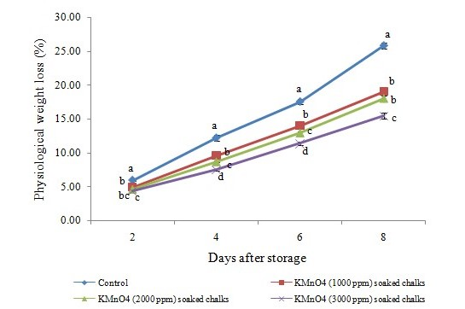

Fig. 1. Physiological weight loss (%) of the bitter gourd fruits as affected by postharvest treatment of ethylene absorber.

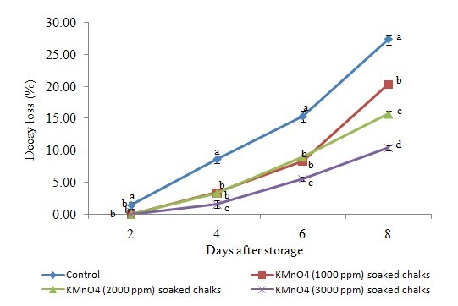

Fig. 2. Decay loss (%) of the bitter gourd fruits as affected by postharvest treatment of ethylene absorber.

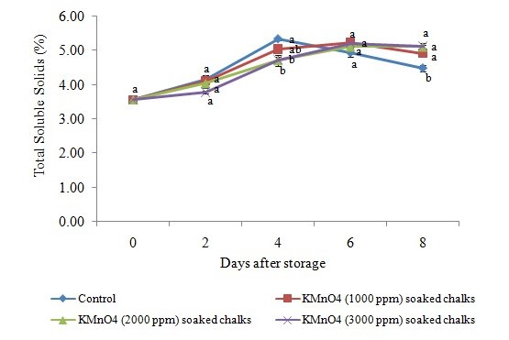

Fig. 3. Total soluble solids (%) of the bitter gourd fruits as affected by postharvest treatment of ethylene absorber.

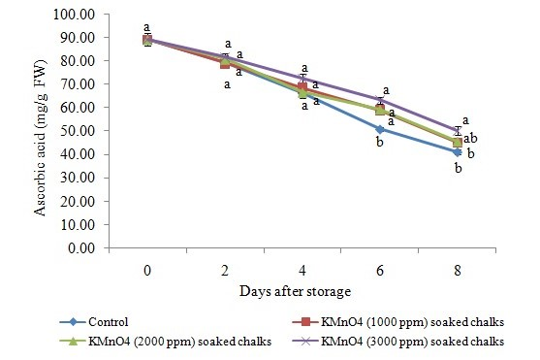

Fig. 4. Ascorbic acid (mg/g FW) of the bitter gourd fruits as affected by postharvest treatment of ethylene absorber.

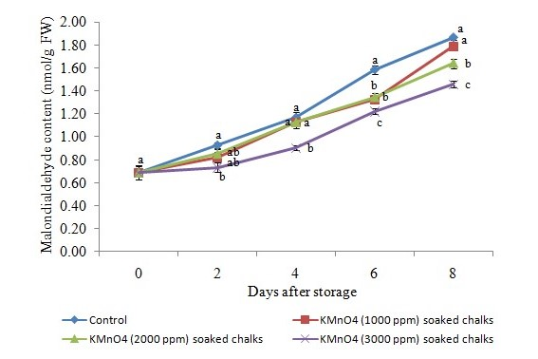

Fig. 5. Malondialdehyde content (nmol/g FW) of the bitter gourd fruits as affected by postharvest treatment of ethylene absorber.