HEALTH MAP OF TUBEROUS ROOT ROT OF CASSAVA (MANIHOT ESCULENTA CRANTZ) IN HIGH PRODUCTION AREAS COTE D'IVOIRE

ABSTRACT
Root rot of cassava tubers, Manihot esculenta Crantz, has become a scourge that devastates plantations and limits production in Côte d'Ivoire. The aim of this study was to investigate the distribution of cassava root rot on the one hand, and to assess the incidence and severity of varieties. The study was carried out in 13 localities where cassava is widely grown and 320 plots were observed and assessed. Symptoms were described by examining the above-ground and below-ground parts of the plants and described on the basis of existing information. In each plot visited, incidence and severity were noted. The disease is visible in the aerial part of the plant in two forms: leaf chlorosis and stem dieback. The disease is highly prevalent in the plots visited, with an incidence of between 25% and 100%, indicated by the colors pink, green and red. Analysis of the data collected showed that average incidence in the localities surveyed ranged from 10 to 56 %. In terms of disease severity, the results showed that all infected plots were severely attacked, with severity indices ranging from 2.50 to 4. Of the twenty-one cassava varieties found in the surveyed localities, the incidence recorded varied according to variety and type of varietal association. This threat is borne out by our results, which show that all cassava varieties encountered in the localities surveyed, more than 9 varieties are highly susceptible and attacked, with average incidences ranging from 40 to 100 %, regardless of the variety grown.
Key words : Manihot esculenta, Côte d'Ivoire, Root rot ; Health map

Introduction
Cassava is the second most important food crop after yam in terms of production volume. The cassava production area covers the whole country, with a predominance around major cities such as Abidjan, Bouaké, San-Pedro, Yamoussoukro, Gagnoa, Daloa and Man (Affery et al., 2017). It is an important crop for the Ivorian population, as it contributes to food security and the fight against poverty. However, yields, which fluctuate between 6 and 15 t/ha, are relatively low, especially in view of the spectacular results obtained in countries such as Nigeria, Brazil and Indonesia (N'Zué et al., 2013). This low productivity is due to low soil fertility, the harmful effects of weeds, and certain rudimentary cultivation practices that limit cassava production. In addition, numerous biological constraints tend to limit cassava production in Côte d'Ivoire, including viruses (CMV), vascular bacterial disease, mealybugs and mites. These pests cause losses ranging from 80 to 100% (Fargier, 2007, Bull et al., 2011). In addition, root rot of cassava is caused by telluric pathogens, notably fungi, bacteria and nematodes, but also by high soil humidity (Msikita et al., 2005; Bandyopadhyay et al., 2006; Kumulungui et al., 2012). Recently, stakeholders in several production zones have reported serious root rot on cassava. In view of the potential economic consequences of this disease, we need to anticipate its development through effective and sustainable control strategies in Côte d'Ivoire. This will guarantee sustained cassava production, which in turn will improve producers' incomes and the food security of the Ivorian population. The aim of this study was to investigate the distribution of cassava root rot on the one hand, and to assess the incidence and severity of varieties through an epidemiological study in Côte d'Ivoire on the other. Specifically, the aim will be to describe the symptoms and determine the prevalence of the disease; to assess the importance and extent of the disease in the regions affected by this phenomenon in Côte d'Ivoire; and to determine the incidence and severity of cassava root rot according to variety.
Materials and methods
Study site
Cassava production areas cover the whole country and extend around the major cities of Côte d'Ivoire. This study was carried out mainly in 13 surveyed localities. These were Aboisso, Abengourou, Adzopé, Agboville, Bouaké, Dabou, Toumodi, Yamoussoukro, Daloa, San Pédro, Man, Katiola and Ferkessédougou.
Plant material
The study covered several cassava varieties and cultivars grown in the areas visited. In all, more than 26 cassava cultivars were observed.
Sampling methods
Field survey
The survey took place in the main cassava-growing areas of Côte d'Ivoire, with the aim of visiting 320 plots in 13 departments. In each locality, producers were identified by ANADER on the basis of their capacity in terms of cassava production. The plots visited were well distributed around the target regions.
Description of cassava root rot symptoms
During the survey of the main cassava-growing areas, root rot symptoms were described. The aerial parts (leaves and stems), as well as the underground parts of the plants, were examined according to the methodology proposed by Msikita et al. (2000). Following the description of symptoms, root rot types were identified as described by Bandyopadhyay et al. (2006) and Kumulungui et al. (2012). In order to detect symptoms of a possible viral disease linked to root rot, notably CBSD, the PlantVillage NURU application was used during the surveys. This public application, supported and developed by Penn State University and in close collaboration with experts in the field at CGIAR centers, uses a digital assistant to help farmers diagnose crop diseases in the field, without an Internet connection.
Assessment of root rot incidence and severity
Incidence and severity were assessed according to indicators of disease presence in a given population. These indicators made it possible to determine the level of impact of root rot in the plantations, and also to identify tolerant or non-tolerant varieties. sensitive. In each cassava plantation, 5 plants were selected along the two diagonals to assess disease incidence and severity. The incidence of attack was calculated using the formula of Aigbe and Remison (2010): Incidence (%) I = ((Number of rotten roots) / (Total number of roots examined)) x 100
Root rot rates were determined on a 0 to 4 rating scale (Messiga et al., 2004). On this scale, 0= no root rot; 1= 1 to 10% of root volume rotted; 2= 11 to 25% of root volume rotted; 3= 26 to 50% of root volume rotted and 4= >50% of root volume rotted (Akrofi et al., 2016).
Severity (%) S = ((Sum of root rot rates) x 100) / ((Number of roots x 100))
Statistical analysis
The data collected were analyzed using Statistica 7.1 software. Data on rot incidence and severity were subjected to analysis of variance variance (ANOVA). Pearson correlation analysis was used to examine the relationship between disease incidence and severity. Where a significant difference was observed between the thirteen localities, Turkey's post hoc test was used to separate the means of rot incidence and severity. Health maps were produced using R software version 3.6.0 (R Core Team, 2019).
Results
Description of symptoms observed during surveys
Symptoms of root rot are visible in the aerial part of the plant in two forms: chlorosis or total yellowing of the leaves, and stem dieback and leaf wilting. In the case of chlorosis, the leaves of diseased plants show a generalized yellowing. This generalized yellowing progresses towards total defoliation of the plants (figure 1 a). In the case of stem dieback and leaf wilting, stems show dieback and slow growth. Dieback starts at the apex and reaches the whole plant. Secondary shoots then develop on the wilted apex. Leaves wither progressively, then wilting spreads throughout the aerial part, followed by browning and wilting of the plants (figure 1b and c).

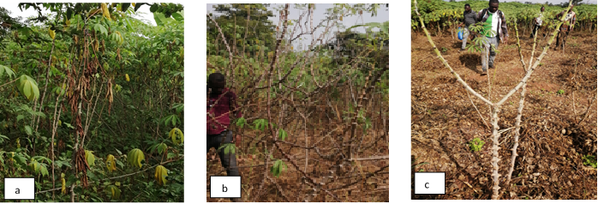
Figure 1 : symptoms on the aerial parts of infected plants
a) Chlorosis and wilting of leaves due to root rot; b et c) Defoliation of plants affected by root rot

Symptoms of stem collar and root rot in cassava
Symptoms of diseases present at the crown are characterized by two aspects. The first aspect concerns the collar, which has a whitish color, showing signs of pathogenic fungi on the swollen bark, which peels off easily. The second is browning of the bark at the collar. Several signs were noted (figure 2 a, b, c and d), namely the presence of brown mycelium at the stem collar; greyish or blackish mycelium at the collar; whitish mycelium at the collar; and yellow-orange or brown carpophores of macroscopic fungi at the collar. Observations during surveys revealed two types of root symptoms (figure 3). Firstly, rotting, characterized by necrotic lesions from the outside inwards, with swelling of the root epicarp before spreading to the whole tuberous root. The root affected by this type of rot retains its firmness and then becomes brittle. This is known as dry rot (figure 4 a and b). The second type of symptom is decomposition from the inside out. This type of symptom is marked by the release of a strong, nauseating odor. This rot has a soft consistency, and the decomposition of the roots is characterized by various colorations: white, black, gray, yellow and pink. This is soft rot (figure 4 c and d). These different colorations indicate the presence of a variety of pathogens responsible for these types of rot.

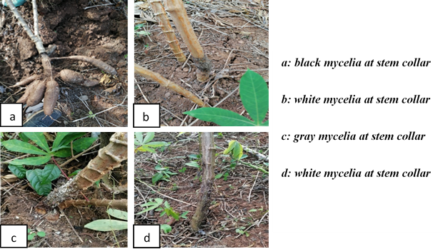
Figure 2: Early symptoms of root rot at the stem collar
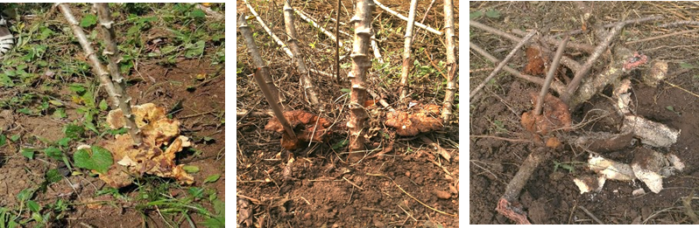
Figure 3: Cassava root rot caused by Rigidoporus microporus (Fomes lignosus)
a and b: presence of Fomes carpophores at the stem collar; c: presence of mycelial cords (rhizophores) on tuberous roots; d: roots totally destroyed (dry rot).
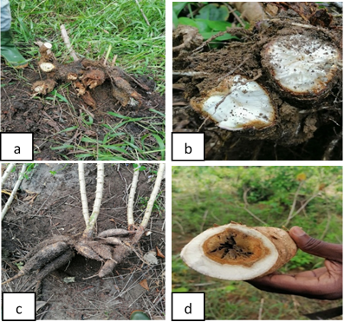
Figure 4: Types of cassava root rot
a and b: Dry rots; c and d: Soft rots

Spatial distribution of cassava root rot in the regions visited
The spatial distribution of the incidence of cassava root rot in the regions visited is illustrated in figure 5. The disease is present in all 14 localities surveyed.

Incidence levels are marked by different colors on the map. The disease is highly prevalent in the plots visited, with incidence levels of between 25% and 100%, shown in pink, green and red. In terms of severity, the map in figure 6 shows that the majority of plots surveyed in the 14 localities where the disease is rife showed a high level of root rot.

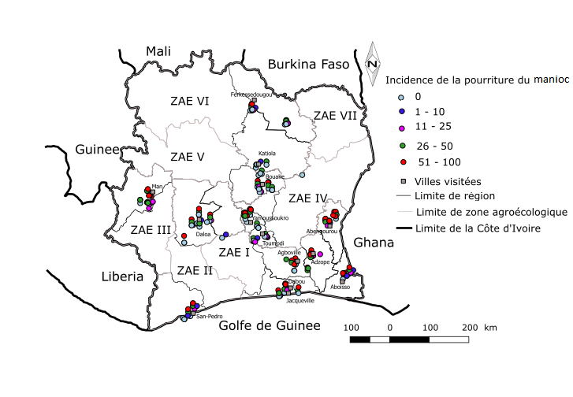
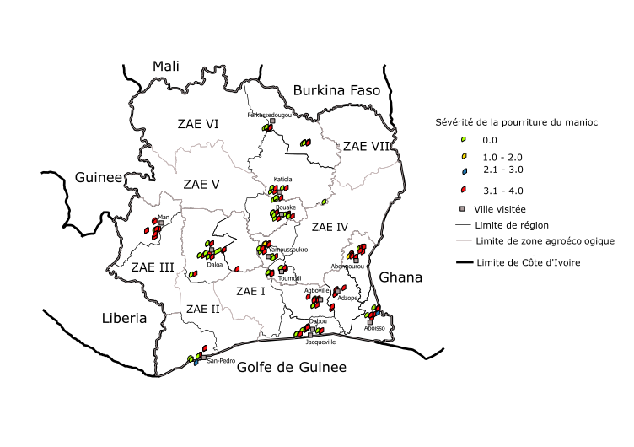

Figure 5: Map of cassava root rot incidence and severity in surveyed areas of Côte d'Ivoire

Average incidence and severity of rot in surveyed areas
Analysis of the data collected showed that average incidences in the localities surveyed ranged from 10 to 56% (Table III). Six (6) localities were surveyed: Adzopé (56.90%), Abengourou (53.91%), Dabou (53.69%), Man (48.33%), Yamoussoukro (47.87%) and Aboisso, (46.89%) recorded the highest incidence rates. Agboville (39.57%), Jacqueville (35.90%), San-pédro (31.14%), Bouaké (26.75%), Daloa (22.83%) and Ferkessédougou (21.83%) had high incidence rates of between 21 and 40%. On the other hand, the lowest incidence rates were observed in Toumodi and Katiola, at 11.13% and 10.55% respectively. As for disease severity, the results show that all infected plots are severely attacked, with severity indices ranging from 2.50 to 4. This means that in infected plots, 25% to 100% of the tuberous roots of diseased plants are completely rotted (Table I).

Table I: Average incidence and severity of cassava root rot by locality
Localities | Mean incidence (%) | Mean severity
Adzopé | 56,90±07,92a | 3,92±0,04a
Abengourou | 53,91±07,12a | 3,45±0,26a
Dabou | 53,69±13,34a | 3,53±0,39a
Man | 48,33±06,06b | 4,00±0,0a
Yamoussoukro | 47,87±07,20b | 3,29±0,45a
Aboisso | 46,89±09,60b | 3,22±0,37a
Agboville | 39,57±06,40b | 2,91±0,38b
Jacqueville | 35,90±11,30b | 2,80±0,61b
San-pédro | 31,14±08,47b | 2,72±0,44b
Bouaké | 26,75±07,27c | 2,85±0,67b
Daloa | 22,83±06,15c | 3,13±0,74a
Ferkessédougou | 21,83±05,42c | 4±0,0a
Toumodi | 11,13±03,81d | 4 ±0,0a
Katiola | 10,55±05,15d | 2,50±1,20b

Average disease incidence and severity in relation to cassava varieties and varietal associations
Twenty-one (21) cassava varieties were found in the localities surveyed. Incidences varied according to variety and type of varietal association (Table II). Nine (9) cassava varieties were heavily attacked, with average incidences ranging from 40% to 100%. These were Bondoukou (40.0%), Inconnue (56.71%), Yacé (45.36%), Bocou 5 (76.67%), Sapelle (56.71%), Zamaka (50.51%), Anader (100%), Manawa (53.02%) and Accra-Bantchi (66%). Varieties and varietal associations such as Foutou, Yavo, Diarrassouba, Bonoua+Yavo, Bonoua+Diarrassouba, Bonoua, Ahoua, Sika, Manioc Attiéké, Yacé+Yavo and Bonoua+Yacé showed incidences between 21.43 and 39.52%. On the other hand, varieties such as Agbablé and Bocou 1 or the varietal associations Agbablé+Yavo, Bonoua+Yacé+Yavo and Bocou5+Yacé showed low incidences of the disease, ranging from 0 to 20%. Irrespective of the variety grown, when attacked by the disease, tuberous roots are severely infected, with severity indices always ranging from 2 to 4 (Table II).

Table II: Average incidence and severity of root rot according to cassava varieties and varietal associations
 | Cassava agrosystems encountered | Incidence | Severity
1 | Bonoua+Yacé+Yavo | 0,00±0,00 | 0,00±0,00
2 | Bocou 5+Yacé | 0,00±00 | 0,00±00
3 | Bocou 1 | 0,00±00 | 0,00±00
4 | Agbablé | 14,89±5,89 | 3,22±1,09
5 | Agbablé+Yavo | 17,86±6,4 | 4±0,0
6 | Kaman | 19,68±0,32 | 4±0,0
7 | Manawa+Yacé | 20,83±3,45 | 3,40±1,4
8 | Bocou 2 | 21,43±5,1 | 4,00±0,0
9 | Foutou | 23,01±6,83 | 2,16±0,55
1 | Yavo | 27,73±7,71 | 3,39±0,83
0 | Diarrassouba | 28,26±6,32 | 4,00±0,0
12 | Bonoua+Yavo | 32,67±17,0 | 3,16±1,33
13 | Bonoua+Diarrassouba | 33,92±30,0 | 2,67±1,33
14 | Bonoua | 33,23±6,20 | 2,99±0,55
15 | Ahoua | 35,29±11,1 | 4,00±0,0
16 | SIKA | 39,09±11,7 | 4±0,0
17 | Manioc Attiéké | 39,13±10,1 | 3,67±1,1
18 | Yacé+Yavo | 39,23±9,48 | 2,85±0,66
19 | Bnoua+Yacé | 39,52±9,77 | 4±0,0
20 | Bondoukou | 40,00±40,0 | 2,13±2,13
21 | Sapelle | 43,15±15,98 | 3,87±0,13
22 | Yacé | 45,36±4,78 | 3,45±0,29
23 | Zamaka | 50,51±14,06 | 3,16±0,64
24 | Manawa | 53,02±14,67 | 4,00±0,00
25 | Tout-venant | 56,71±8,49 | 3,45±0,32
26 | Accra-Bantchi | 66,00±18,45 | 3,98±0,03
27 | Bocou 5 | 76,67±24,0 | 4,0±0,0
28 | Anader | 100±15,20 | 4,00±0,0

Incidence of rot in cassava varieties by locality
Analysis of the data showed differences between the average incidences for varieties grown in the Yamoussoukro locality. In this locality, six varieties were encountered with high incidences ranging from 39 to 77%. The Sika variety was the most attacked, with an incidence of 76.66%, compared with 39.33% for the Bonoua and Yacé combination (figure 7). In Bouaké, incidence ranged from 12% to 63%. The Bonoua+Yavo varietal association showed a high incidence of 63.33%, compared with a low incidence of 12.66% for the Agbablé variety (figure 7). High incidence was observed in the Man locality for the Bonoua, Yavo, Yacé and Bonoua+Yacé association varieties, with values of 62.85%, 67.77%, 32% and 47.33% respectively. The Sika variety, on the other hand, recorded a low incidence rate of 11.66%, probably due to the young age of the crop, which was only 3 months old, but the first roots were already beginning to be attacked (figure 7). In Dabou, the varieties Inconnue (Tout-venant), Sapelle, Yavo and Yacé had high incidence rates ranging from 39.32% to 64.24%. On the other hand, the Yavo+Yacé variety combination had zero incidence rates (figure 7). In Daloa, the most attacked varieties were Bocou 5 and Yacé, with incidences of 76.66% and 39.44% respectively. The Sika variety was moderately attacked, with an incidence of 21.66%. On the other hand, low incidences were observed on the Yavo variety and the Yacé+Yavo, Yavo+Agbagbé and Bocou5+Yacé combinations, with values ranging from 0 to 16.66% (figure 7). In Agboville, the varieties Yacé, Inconnue (Tout-venant) and the variety named “Foutou” by growers, showed variable incidences with values of 47.13%, 49.24% and 20.52% respectively (figure 7).Six varieties were recorded in Aboisso with different incidences. These varieties had high incidences, with values of 20%, 34.59%, 60.41% and 66% respectively for Yacé, Inconnue, Diarrassouba and Accra-Bantchi. The same applies to the Bonoua+Diarrassouba varietal association, with an incidence of 50.87%. Only the Bonoua variety showed zero incidence (figure 8). All the cassava varieties Sika, Anader, Yacé, Inconnue, Foutou and Zamaka in the Abengourou locality showed high incidences ranging from 35 to 100%. The variety referred to by growers as “Anader” stood out with an incidence rate of 100% (figure 8). In San-Pédro, the highest incidence was observed on the Yacé variety (60.58%), and the lowest on the Bocou 1 variety. As for the Agbaglé, Yacé, Foutou and Bocou 2 varieties, their incidence rates ranged from 21.42 to 30.58%. In Adzopé, six varieties were identified: Yacé, Inconnue, Manawa, Ahoua, Manioc attiéké and the Manawa+Yacé combination. High incidence rates were obtained on all these varieties, with values ranging from 20.83% to 76.57%. In Toumodi, the Yavo+Yacé combination was the most attacked variety, with an incidence of 50% (figure 8), while the Bonoua variety had no incidence at all. Three other varieties, Agbablé, Yavo, Kaman, and the Bonoua+Yacé association, had incidences of 7.04%, 13.33%, 6.66%, 6.67% and 19.67% respectively (figure 8). In Katiola, the Bonoua variety and the Bonoua+Yavo combination had incidences of 15% and 12.22% respectively. On the other hand, a high incidence was noted for the Bonoua+Diarrassouba and Bonoua+Yavo+Yacé combinations. Finally, in Ferkessédougou, the only variety grown had an incidence of 21.83%.

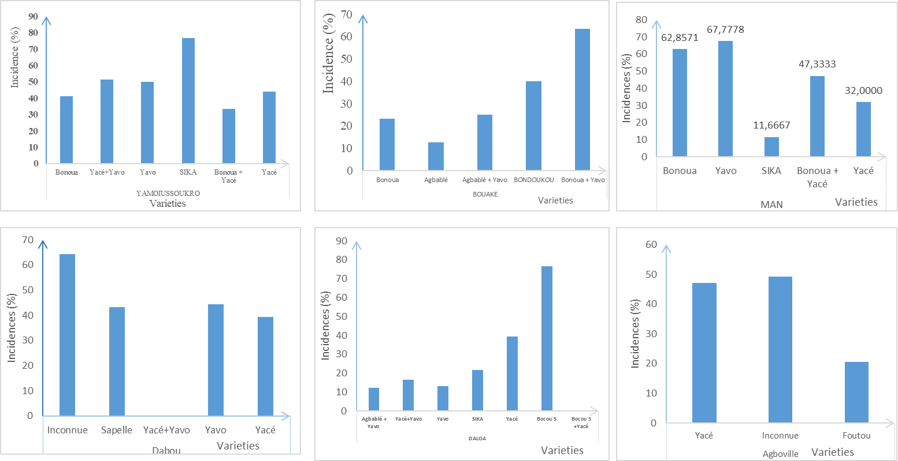
Figure 7: Incidence and severity of root rot on cassava varieties in Yamoussoukro, Bouaké, Man, Daloa, Dabou and Agboville

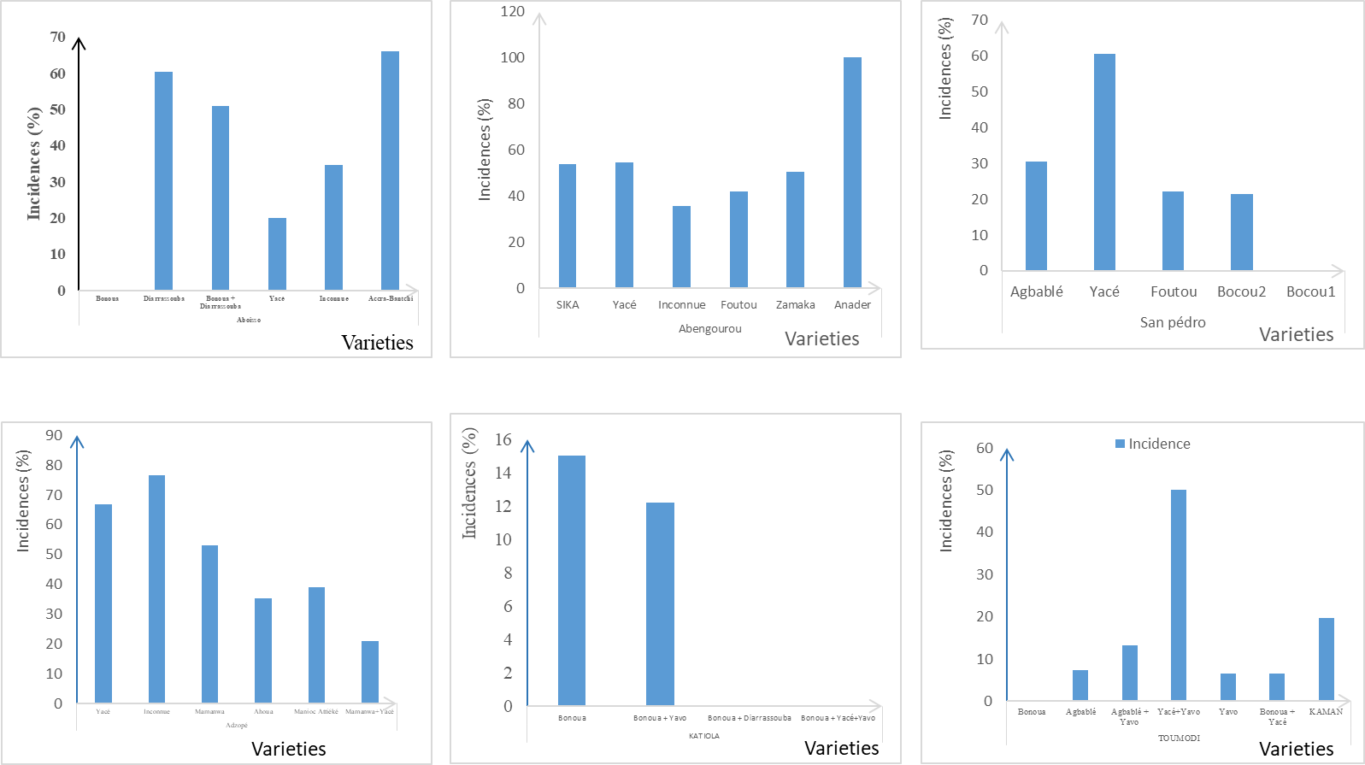
Figure 8: Incidence and severity of varieties according to localities in Aboisso, Abengourou, San-Pedro, Adzopé, Katiola and Toumodi

DISCUSSION
The studies revealed several types of symptoms of root rot disease. Symptoms of the disease are visible in the aerial part of the plant in two forms: leaf chlorosis and stem dieback and leaf wilting. Observations also revealed symptoms of collar disease, characterized by two aspects. The first aspect concerns the crown, which is whitish in color, showing signs of pathogenic fungi on the swollen bark that peels off easily. This diverse manifestation of the disease shows that it is due to several factors, in this case biotic and abiotic. This confirms the work of Bandyopadhyay et al. (2006) and Kumulungui et al. (2012), who showed that cassava root rot is caused by telluric pathogens, notably fungi, bacteria and nematodes, but also by high soil humidity, depending on the variety grown and the age of the crop. The presence of brown mycelium at the stem collar; greyish or blackish mycelium at the collar; whitish mycelium at the collar. A macroscopic fungus was also observed on affected plants, with signs such as white mycelial cords (rhizophores) on the root surface and yellow-orange carpophores at the crown, corresponding to the Rigidoporus microporus species previously known as Fomes lignosus. Several researchers have reported that P. manihotis is parasitic on the roots of several plant species, including conifers (Gilbertson & Ryvarden, 1987), and feeds on other plants. According to the work of Makambila (1994), all plants infected by P. manihotis showed severe dry rots in the tuberous roots. This type of rot was reported by Makambila and Koumouno (1986) in Congo-Brazzaville, who proved that Phytophtora sp., Armeriella sp. and Fomes lignosus are damaging to cassava in the DRC. The use of PlantVillage's NURU application revealed the absence of CBSD symptoms in the plantations surveyed. This disease, which is highly prevalent in East and Central Africa, is therefore not present in Côte d'Ivoire. Assessment of the disease's impact on the crop revealed that incidence levels vary from one locality to another and from one variety to another. The disease is highly prevalent in the plots visited, with incidence ranging from 25% to 100%, as indicated by the colors pink, green and red. Analysis of the data collected showed that average incidences in the locations surveyed ranged from 10 to 56%. As for disease severity, the results show that all infected plots are severely attacked, with severity indices ranging from 2.50 to 4. This means that in infected plots, 25% to 100% of the tuberous roots of diseased plants are completely rotted. These results demonstrate the alarming severity of the disease. Previous work on cassava root rot, notably by Afouda et al. (1995) and Bandyopadhyay et al. (2006) in Cameroon, Makambila (1994) in Congo and Mwangi et al. (2004) in the Democratic Republic of Congo, shows that cassava root rot is present in Central Africa. Of the twenty-one (21) cassava varieties encountered in the surveyed localities, the incidence recorded varied according to variety and type of varietal association. Nine (9) cassava varieties were heavily attacked, with average incidences ranging from 40% to 100%. This shows that the majority of cassava varieties are susceptible to factors that contribute to the development of root rot. Data analysis showed significant production losses due to the disease in different localities. This shows that the disease is a threat to food security. Indeed, the work of N'Zué et al (2013) pointed out that cassava cultivation is very important for the Ivorian population, as it contributes to food security and the fight against poverty. This threat is proven by our results demonstrating that all cassava varieties encountered in the localities surveyed, more than 9 varieties are highly susceptible and attacked with average incidences of 40 to 100% and that whatever the varieties grown, tuberous roots are severely attacked with severity indices always high. In addition, the variety typology shows that newly selected varieties such as “Sika” are heavily infected in Yamoussoukro, Abengourou and Daloa. This result also proves that the varieties grown are susceptible to the disease. The availability of resistant varieties will guarantee sustained cassava production, which in turn will improve producers' incomes and the food security of the Ivorian population. In view of the potential economic consequences of this disease, we need to anticipate its development through effective

Conclusion
Cassava root rot in Côte d'Ivoire is a threat. There are two types of rot, which manifest themselves through a variety of symptoms on both above-ground and below-ground parts. It causes numerous production losses and major damage in all localities and on all varieties. More than 9 varieties are highly susceptible and attacked, with average incidences ranging from 40% to 100%, whatever the variety grown. The availability of resistant varieties will make it possible to guarantee sustained cassava production, which will improve producers' incomes and the food security of the Ivorian population. In view of the potential economic consequences of this disease, we need to anticipate its development through effective and sustainable control strategies in Côte d'Ivoire. The aim of this project is to identify the microorganisms responsible for cassava tuberous root rot. The next step would be to determine, by biochemical tests, the actual involvement of each of the strains isolated and identified in the degradation process of tuberous cassava roots.

References
Affery AM., Abo K, Tuo S, N&#39;Zué B. and Koné D, (2017). Geographical distribution and incidence of cassava bacterial blight (Manihot esculenta Crantz) caused by Xanthomonas axonopodis pv. manihotis in two agro-ecological zones of Côte d&#39;Ivoire. Plant Pathol. J. 6 :1-11.
Afouda L., Wydra K. and K. Rudolph. 1995. Root and stem rot pathogens from cassava and theirs antagonists collected in Cameroon, Nigeria and Benin. European Journal of Plant Pathology. Abstract 573.
Aigbe, S.O. And Remison, S. U. (2010). The Influence Of Root Rot On Root Starch Content Of Cassava Planted In Different Ecological Environments Of Nigeria. Nigerian Annals Of Natural Sciences 10 (1): 60 – 70.
Akrofi, S., Moses, E., Akuoko, K. O., Bolfrey-Arku, G., Quansah, G. &amp; Larbikoranteng, S. (2016). Prevalence Of Cassava Root Rot Disease In The Brong-Ahafo Region, Ghana. Technical Report Csirpgrri Bunso E/R Ghana
Assanvo J. B., Agbo G. N., Behi Y. E. N. Coulin P. and Z. Farah. 2006. Microflora of traditional starter made from cassava for Attiéké production in Dabou (Côte d’Ivoire). Food Control 17 : 37 - 41.
Bandyopadhyay R., Aigbe S. O. and J. F. Leslie. (2006). Fusarium species from the Cassava root rot complex in West Africa. Pathology 59 : 673-676.
Bull SE, Ndunguru J, Gruissem W, Beeching JR. and Vanderschuren H, (2011). Cassava constraints to production and the transfer of biotechnology to Africanlaboratories. Plant Cell Rep. 30: 779– 787.
Fargier E, 2007. The study of the pathology of Xanthomonas campestris and the genetic structure of its pathovars allowed to improve the detection of the pathogen in seeds of Brassicaceae, Doctoral School of Angers. P : 236
Gilbertson, R.L. and Rywarden, l. 1987. North American polypores. Vol.27. Oslo.Pp 282. Makambila, C., 1994. The fungal diseases of cassava in the Republic of Congo, Central Africa. African Crop Science Journal, 2 (4): 511-517.
Kumulungui B., Ondo-Azi A., Madinda N. Et Mouaragadja I. (2012). Isolation of Microorganisms Involved in the Rot of Tuberous Roots of Cassava (Manihot Esculenta Crantz) in Gabon, African Agronomy 24 (3): 171-181
Makambila, C., and Koumouno, B.L., 1986. The rots in Armillaria sp. Sphaerostilbe repens and Phaeolus manihotis Heim on cassava (Manihot esculenta Crantz). Tropical Agronomy, 4: 258-264. Makambila and Koumouno, B.L., 1994. Cassava root rot in Congo: first evaluation of damage and identification of pathogenic agents. Acta Horticulturae, 380: 181 186.
Messiga, A. J. N. A., Mwangi, M., Bandyopadhyay, R. And Nolte, J. (2004). The Status Of Fungal Tuber Rots As A Constraint To Cassava Production In The Pouma District Of Cameroon. In: Proceedings Of The 9th Triennial Symposium Of The International Society For Tropical Root Crops-Africa Branch, 31 st October–5th November 2004,Whitesands Hotel, Mombasa, Kenya.Msikita et al. (2000
Msikita W., James B. D., Bissang B., Baimey H., Wilkinson H. T. et Ahounou M., R. (2005). Prevalence and Severity of Nattrassia mangiferae Root and Stem Rot Pathogen of Cassava in Bénin. Plant Dis, 89 : (1) 12-16.
Msikita W., James B. D., Nnondu E., Legg J., Wydra K. and F. Ogbe. 2000. Cassava Disease Control. Integrated Wrestling Practice Guide to the Use of Views
Mwangi M., Bandyopadhyay R., Dixon A. G. O. and K. Tata-Hangy. 2004. The status of fungal tuber rots as constraints to cassava production and utilization in eastern Democratic Republic of Congo. In : Book Abstracts of the 9th triennial Symposium of the International Society of Root and Tuber Crops. Mombasa Kenya 41.
N'Zué, B., Zohouri G. P., Djedji C. and. Tahouo O. (2013). Cassava is well grown in Côte d'Ivoire. Technical Sheet of the National Agronomic Research Center (CNRA), pp: 4
R Core Team. 2019. R: A Language and Environment for Statistical Computing. R Foundation for Statistical Computing, Vienna, Austria.
Roussari A., Busca D., Salles D., Dumont A., Carpy-Goulard F., 2013. Phytosanitary practices in agriculture and the environment. Irreducible tensions? Rural Economics, No. 333, pp. 67-80.

