**Effect of Storage Temperature on Physical and Functional Properties of Carambola Bagasse Powder**

**Abstract**

Carambola is rich in key phytochemicals such as alkaloids, flavonoids, and tannins. The bagasse, or pulp left over after juice extraction contains much higher antioxidant activity than the extracted juice. Carambola bagasse was collected after juice extraction and bagasse powder was freeze-dried at a temperature of -50OC. The bagasse powder was subjected to storage for 60 days under ambient conditions and was evaluated for physical and colour properties and bioactive potential. A significant decrease in water holding capacity, water solubility index and swelling index of bagasse powder were recorded with the advancement of the storage period. The bioactive potential of fruits significantly decreased in terms of total phenolic content however total carotenoid content, free radical scavenging activity and crude fibre content were not significantly affected.

**Key words: carambola bagasse, pomace powder, storage, water holding capacity, phenolic content**

**Introduction**

Carambola (*Averrhoa carambola*), often known as carambola or star fruit, is a fruit that is widely consumed in tropical and non-tropical regions (Lakmal *et al*., 2021; Ogochukwu *et al*., 2022). Major phytochemicals such as alkaloids, flavonoids, and tannins have been observed to be abundant in the fruit (Thomas, Patil, Patil, & Chandra, 2008). The major polyphenolic antioxidants present in star fruit contain L-ascorbic acid, (−) epicatechin, gallic acid gallotannin forms and proanthocyanidins (Shui & Leong, 2004). Star fruit is a great option for individuals who are watching their calories because it is low in calories and fat and high in soluble fibre and water. Vitamin B, B-complex, and C (Luan *et al*., 2021) as well as iron, salt, potassium, and a number of antioxidants, polyphenols, and flavonoids are all abundant in it. Significant antioxidant and antibacterial activity is found in star fruit (Ramadan *et al*., 2020). The byproduct, pomace or bagasse from star fruit left after juice extraction contains much higher antioxidant activity than the extracted juice (Shui & Leong, 2006). Turning this processing waste in form of powders or bioactive extracts and adding them to food as functional food components can be helpful in generating, nourishing and healthy meals ([Hussain et al., 2022](https://www.sciencedirect.com/science/article/pii/S2772753X23004197" \l "bib0030), [2023a](https://www.sciencedirect.com/science/article/pii/S2772753X23004197" \l "bib0031)).

Fruit powder products have been reported to be very sensitive to moisture content, which influences the physical, colour and antioxidant stability of the product, especially during long time storage. Studies on the consequence of storage on moisture content or water activity have allowed the development of mathematical models to predict the physicochemical changes of powder products over time (Venir, Munari, Tonizzo, & Maltini, 2007). Changes in moisture content indicate water mobility and the degree of plasticization of larger food molecules, which also affect the rates of chemical reactions (Labuza & Altunakar, 2007). Besides, the bioactive stability of fruit powder extracts is also affected throughout storage, especially under ambient storage conditions. This deterioration during storage may be due to the most common factors, such as temperature, humidity, oxygen, light and water activity. The food quality during storage may change to such an degree that it may be harmful to the consumer and may lose its acceptance.

Therefore, the present study was conducted to explore the effect of storage duration on the physical, colour and bioactive stability of carambola bagasse powder.

**Materials and methods**

**Preparation of bagasse powder**

Fresh and ripe carambola fruits was procured from the market, washed, blended for 10 min in a domestic blender and filtered with a stainless-steel sieve. After filtering, carambola juice and bagasse will be separated. Fresh pomace was washed 2-3 times in water and then dried in a hot air drier. The temperatures under different drying conditions as given in Table 1. Bagasse powder will be sealed in PP pouches and subjected to further analysis:

**Table 1. Drying Treatments for Preparation of Carambola Bagasse Powder**

|  |  |  |
| --- | --- | --- |
| **Treatment** | **Drying Conditions** | **Temperature** |
| CFBP0 | Room temperature (Control) | 25oC |
| CFBP1 | Oven drying | 40oC |
| CFBP2 | Oven drying | 45oC |
| CFBP3 | Oven drying | 50oC |
| CFBP4 | Freeze drying at -55oC | -50 oC |

**Physical Properties**

The samples were measured aW, using a water activity meter (Meter, Model: lab-Swift novasina). The analyser was calibrated before performing the analysis. According to Grabowski *et al*. (2006), 2.5 g of sample powder was added with 30 mL of distilled water and stirred for 30 minutes at 30° C to determine the solubility of the powders in water. The carambola bagasse powder samples' swelling index (SI) was calculated using a modified version of the procedure outlined by Abbey and Ibeh. According to Cai and Corke (2000), the sample powders' hygroscopicity was determined. The determination of carotenoid according to Ranganna, 1986.

**Bioactive Potential**

The Total Phenols in the different samples were determined with the Folin-Ciocalteu reagent according to the method of Bray and Thorpe (1954) using catechol as a standard. The crude fibre was determined by Maynard (1970) and analysed according to it. DPPH% inhibition measurement, The DPPH technique was used to assess the sample's antioxidant activity with minor changes (Babu et al., 2013). By measuring the 2, 2-Diphenyl-1-Picrylhydrazyl (DPPH) radical's ability to scavenge free radicals, the antioxidant capacity was investigated.

**Colour Properties**

L*, a*, b* values of prepared juice samples were determined by Hunter Lab Colour flex Ez Colorimeter (Hunter Associates Laboratory, Inc., Virginia, USA). The L* value shows brightness, a* denoted Redness/Greenness and b* value shows Yellowness/blueness.

**Result and Discussion**

**Effect of Storage on Physical Properties**

Data pertaining to the effect of storage on the physical properties of the carambola bagasse powder has been presented in table 2. A significant decrease in the WHC, WSI and SC was recorded after 60 days of storage under ambient conditions. WHC significantly decreased from a mean maximum value of 48.59% to 47.00% at the end of storage. Water holding capacity (WHC) is the ability of a material to hold water against gravity. The decrease in WHC may be due to higher protein oxidation, and degradation during storage (Li *et al*., 2024). WSI decreased significantly from a mean initial value of 46.78% to 45.35% at 60 days of ambient storage. Data indicated that SC significantly decreased from 45.74% (0 days) to 42.17% (30 days) followed by 39.21% (60 days). This decrease in swelling capacity (SC) may be due to significantly decrease in crude fibre concentration which has also been confirmed by our findings. Hygroscopicity of powders showed a gradual but non-significant decrease from a mean initial value of 42.10 per cent to 41.19 per cent at the end of 60 days of storage the similar results were found by Gomez-Mascaraque *et al*., 2018.

Table 2. Effect of storage on physical properties of carambola bagasse powder

|  |  |  |  |  |
| --- | --- | --- | --- | --- |
| **Storage Period** | **Water Holding Capacity (%)** | **Water Solubility Index (%)** | **Swelling Capacity (%)** | **Hygroscopicity (%)** |
|
| **0 Day** | 50.64 | 45.89 | 45.74 | 42.10 |
| **30 Days** | 45.78 | 43.25 | 42.17 | 44.24 |
| **60 Days** | 39.54 | 40.57 | 39.21 | 41.19 |
| **Mean** | 45.32 | 43.24 | 42.37 | 42.51 |
| **C.D.** | 3.727 | 2.470 | 3.090 | NS |
| **SE(m)** | 1.056 | 0.700 | 0.876 | 1.17 |
| **SE(d)** | 1.494 | 0.990 | 1.239 | 1.655 |
| **C.V.** | 4.067 | 2.805 | 3.580 | 4.769 |

Data showing the effect of storage on water activity (aW)of bagasse powder has been presented in table 2. It was recorded that aW of the powder increased significantly from an average initial value of 0.324 to 0.425 at the end of 60 days. A gradual but non-significant increase in moisture content was recorded during the storage of bagasse powder. The similar findings have been reported by Halim et al. (2024) in pumpkin-supplemented drinks powder. They also reported that moisture content of samples increased due to the absorption of moisture from the environment.

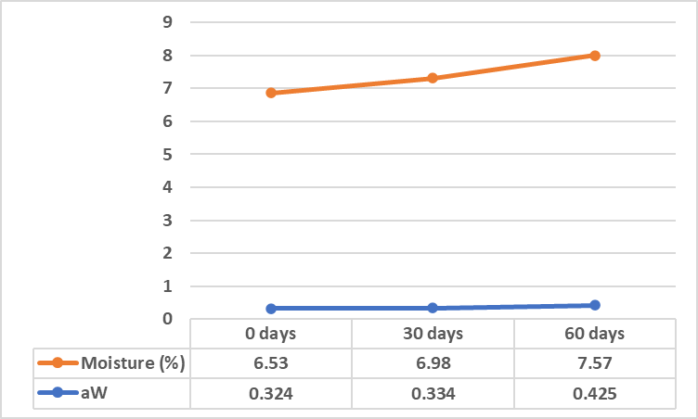

**CD(0.05)= aw=** **0.064; moisture= NS**

**Fig. 1 Effect of storage on water activity (aw) and moisture of carambola bagasse powder**

**Colour properties**

Figure 1 shows the impact of storage on the color characteristics of bagasse powder, which were quantified using L*, a*, and b* values. Data showed a significant decrease in the L* and b* values of the bagasse powder with the advancement of storage period. The L* value decreased from a mean initial value of 60.09 to 53.24 at the end of storage. The drop in the L value indicates that samples get less luminous as storage time increases. The positive b* value represents the degree of yellowness which decreased from an average value of 21.69 to 16.35 at 60 days. The decrease in lightness and yellowness of the samples may be attributed to non-enzymatic browning due to the reaction between amino acid and sugars in bagasse powder as these two components are mainly involved in the maillard reaction (Sagar and Suresh Kumar [2010](https://www.ncbi.nlm.nih.gov/pmc/articles/PMC4108651/#CR25)). No significant effect of storage was observed on a* value of bagasse powder.

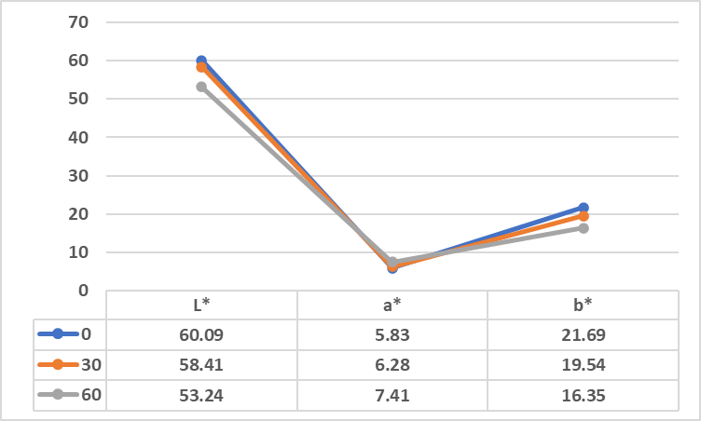

L*= Lightness; a*=greenness/redness (-a/+a); b*= blueness/yellowness (-b/+b)

**Fig. 2. Effect of storage on colour properties of carambola bagasse powder**

**Bioactive Potential**

The bioactive potential of carambola bagasse powder as affected by storage duration was evaluated in terms of TCC, TPC, CF and FRSA. Total Carotenoids Content (TCC) of bagasse powder exhibited a non-significant decrease gradually during the time of storage. A similar pattern was recorded in crude fibre content and FRSA of bagasse powder. The non-significant decrease in the total phenolics content (TPC) observed of carambola bagasse powder was recorded during the storage of 60 days under ambient conditions (table 3). It decreased from an average value of 1899.64 mg GAE/100g to 1798.33 mg GAE/ 100g at the end of storage.

Table 3: Effect of storage on functional properties of carambola bagasse powde

|  |  |  |  |  |
| --- | --- | --- | --- | --- |
| **Period** | **Total Carotenoids Content (mg/100g)** | **Crude Fibre (%)** | **Total Phenolics Content (mg GAE/100g)** | **Free Radical Scavenging Activity (%)** |
| **0 Day** | 5.79 | 26.32 | 1899.64 | 93.27 |
| **30 Days** | 5.75 | 26.14 | 1875.84 | 91.76 |
| **60 Days** | 5.71 | 25.97 | 1798.33 | 89.54 |
| Mean | 5.75 | 26.14 | 1857.94 | 91.52 |
| **C.D.** | NS | NS | NS | NS |
| **SE(m)** | 0.501 | 0.576 | 42.915 | 1.553 |
| **SE(d)** | 0.709 | 0.815 | 60.691 | 2.196 |
| **C.V.** | 15.098 | 3.817 | 4.001 | 2.938 |

Storage studies of bioactive compounds in bagasse powder have shown a significant decrease in total phenolic content (Halim et al., 2024). TPC may have decreased due to oxidation, phenolic compound degradation, and phenolic compound polymerization with proteins (Varela-Santos et al., 2012). According to Kim and Padilla-Zakour (2004), the reduction in TPC might be attributable to disruption in cell structure during processing. Zhou et al. (2014) reported that the observation of a decrease in antioxidant activity could potentially be attributed to the breakdown of total phenolic compounds during storage. Cell structure disruption during processing may be the cause of the decline in total phenolic, according to Kim and Padilla-Zakour (2004).

**Conclusion**:

Carambola bagasse powder can be successfully stored under ambient conditions for 60 days without compromising its bioactive potential. This fundamental exploration is beneficial to the industrial packaging and storage of spray-dried fruit, vegetable and bagasse powders. The carambola bagasse could also be utilized as a functional food ingredient in food products. However, nothing is known about its application as a functional food component in powdered mixed juice.

**References**:

Babu D, Borra GP, Cherian KM (2013) Antioxidant and free radical scavenging activity of triphala determined by using different in vitro models. *Journal of Medicinal Plant Research* 7: 2898-3905.

Bray HG and Thorpe WV (1954) In: Standard Methods of Biochemical Analysis. *(Thimmaiah S K (eds). Kalyani Publishers. New Delhi* 287-88

Cai YZ, and Corke H (2000) Production and properties of spray dried *amaranthus betacyanim* pigments. *Journal of Food Science* 65(6): 1248–1252.

Georgiev VG, Weber J, Kneschke EM, Denev PN, Bley T, Pavlov AI (2010) Antioxidant activity and phenolic content of betalain extracts from intact plants and hairy root cultures of the red beetroot Beta vulgaris cv. Detroit dark red. *Plant Foods for Human Nutrition* 65 (2): 105–111.

Halim A, Wazed A, Obaid S, Ansari J, Tahosin A, RahmanT, Noor F, Mozumder NHMR, Khatun AA (2024) Effect of storage on physicochemical properties, bioactive compounds and sensory attributes of drinks powder enriched with pumpkin (*Cucurbita moschata* L.). *Journal of Agriculture and Food Research* 18: 101337.

Kim DO and Padilla-Zakour OI (2004) Jam processing effect on total phenolics and anti-oxidant activity capacity in anthocyanin rich fruits: cherry, plum, and raspberry, sensory and nutritive qualities of food. *Journal of Food Science* 69: 395-400.

Lakmal K, Yasawardene P, Jayarajah U, Seneviratne SL (2021) Nutritional and medicinal properties of Star fruit (*Averrhoa carambola*): A review. *Food Science & Nutrition*. 9(3): 1810-1823.

Luan F, Peng L, Lei Z, Jia X, Zou J, Yang Y, He X, Zeng N (2021) Traditional uses, phytochemical constituents and pharmacological properties of *Averrhoa carambola* L.: *A Review. Frontiers in Pharmacology* 12: 699899.

Ogochukwu AP, Chigozie NG, Onyinye UC, Chukwuma UG, Loveth AC (2022) Antioxidants and Haematological Effects of Crude Extract of Star Friut (*Averrhoa carambola*) Leave in Alloxan-Induced Female Diabetic Albino Rats. *Asian Hematology Research Journal* *6*(3): 18-24.

Ramadan NS, Wessjohann LA, Mocan A, Vodnar DC, El-Sayed NH, El-Toumy SA, Mohamed, DA, Aziz ZA, Ehrlich A, Farag MA (2020) Nutrient and sensory metabolites profiling of *Averrhoa Carambola* L. (Starfruit) in the Context of its origin and ripening stage by GC/MS and chemometric analysis. *Molecules* 25(10): 2423.

Ranganna S (1986) Handbook of analysis and quality control for fruits and vegetables. *Tata Mc. Graw Hill Publishing Company Limited. New Delhi-110* *7*: 9-10.

Sagar VR, Suresh kumar P (2010) Recent advances in drying and dehydration of fruits and vegetables: a review. *Journal of Food Science and Technology*47: 15–26.

Varela-Santos E, Ochoa-Martinez A, Tabilo-Munizaga G, Reyes JE,Pérez-Won M, Briones-Labarca V, Morales-Castro J (2012) Effect of high hydrostatic pressure (HHP) processing on physicochemical properties, bioactive compounds and shelf-life of pomegranate juice. *Innovative Food Science & Emerging Technologies* 13: 13-22.

Zhou CL, Liu W, Zhao J, Yuan C, Song Y, Chen D, Li QH (2014) The effect of high hydrostatic pressure on the microbiological quality and physical–chemical characteristics of Pumpkin (*Cucurbita maxima* Duch.) during refrigerated storage. *Innovative Food Science and Emerging Technologies* 21: 24-34.