"Effect of Starch Source on the Microstructure of Extruded Feed Pellets Observed Through Scanning Electron Microscopy"

ABSTRACT
Scanning Electron Microscopy (SEM) is a powerful tool for analyzing the microstructure of extruded feed pellets. It offers high-resolution imaging to study surface topology, granule morphology, and textural changes, enabling a deeper understanding of how processing conditions affect feed quality. SEM has found extensive application in material sciences and biology, but its adaptation for food science, especially aquafeeds, has provided new insights into structural changes induced during extrusion.For extruded feed pellets, SEM aids in examining the binding properties of starch sources and how different ingredients contribute to the feed's uniformity and density. It is particularly valuable for detecting inconsistencies or defects in the pellet structure, which can affect durability and feed efficiency. Additionally, SEM reveals the effects of extrusion parameters, such as screw speed, temperature, and moisture content, on the final product.By offering detailed insights into the internal structure of extruded feeds, SEM supports innovations in feed formulation, ensuring the development of high-quality diets tailored for specific species. This application is indispensable in aquaculture, where the optimization of feed texture and composition is essential for sustainable production.

INTRODUCTION
Extruders act as high-temperature, short-duration bioreactors that transform raw components into modified intermediate or final products. These bioreactors facilitate several unit operations, including homogenization, cooking, kneading, shearing, molding, and texturing (Riaz, 2000; 2007).
Starch, a carbohydrate stored as a reserve in plants, is an essential component in food and feed production, with common sources including wheat, corn, potatoes, and rice (Kaushik et al., 2022). In human diets, carbohydrates are a primary energy source, contributing significantly to daily energy intake. However, farmed fish exhibit limited capacity to utilize dietary carbohydrates as an energy source due to factors such as feeding habits, anatomical and physiological features, and farming environments (Kamalam et al., 2017). Despite these limitations, optimizing starch utilization in aquafeeds is emphasized to reduce the reliance on proteins as an energy source.
The botanical origin of starch significantly influences its functionality during feed processing and its digestibility in fish. Key factors affecting starch functionality include the primary structure, granule morphology, size distribution, and the amylose-to-amylopectin ratio (Svihus et al., 2005). Starch granules exhibit diverse shapes, such as spherical, lenticular, polyhedral, and irregular forms, with sizes ranging from 1 to 100 μm. For instance, wheat starch granules typically measure about 22 μm, maize starch granules about 35 μm, and potato starch granules between 40 and 100 μm. These variations directly affect the digestibility of starch in fish, impacting nutrient assimilation and energy availability (Bergot, 1993).
In aquafeed formulation, starch plays a pivotal role, not only as an energy source but also as a binding agent that affects the physical properties of feed pellets. Starch is critical for producing both floating and sinking pellets, with optimal inclusion levels ranging from 18–22% for floating pellets and 5–11% for sinking pellets (Riaz, 1997). During extrusion, the combination of high shear forces and elevated temperatures disrupts the starch granules, leading to gelatinization and partial or complete breakdown of amylose and amylopectin. This process enhances the water solubility of starch, reduces viscosity, and improves nutrient bioavailability (Svihus et al., 2005).
Extrusion parameters, such as temperature, shear rate, and feed composition, directly impact the physicochemical properties of the final aquafeed product. Control of these parameters influences radial expansion, density, texture, pellet durability, sinkability, and water stability—factors critical for efficient nutrient utilization and minimizing feed wastage in aquaculture systems. Starch's hydrocolloid properties also improve pellet stability and nutrient retention, ensuring optimal feed performance for aquatic organisms (Rokey et al., 2010).
Scanning electron microscopy (SEM) serves as a vital analytical tool for studying the microstructural properties of extruded feed pellets. SEM produces high-resolution, three-dimensional images, providing detailed insights into the topology, morphology, and compositional changes occurring during feed extrusion. These microscopic evaluations are essential for assessing feed quality, optimizing processing parameters, and understanding starch's role in structural modifications of aquafeed pellets (Sharma & Vasudha, 2019).
By integrating the unique properties of starch and advanced imaging techniques such as SEM, feed manufacturers can develop optimized aquafeed formulations that enhance feed performance, reduce waste, and improve sustainability in aquaculture practices. The primary purpose of feed production is to efficiently fulfill both qualitative and quantitative levels of essential dietary nutrients, nutritional digestion, absorption, & processing practises (D'Abramo,. 2021). Superior aquaculture production method depends on a successful feeding strategy and high quality feed components.
MATERALS AND METHODS
Evaluation of Carbohydrate Sources on Extruded Tilapia Diets
Experimental Setup
The study was designed to assess the impact of different carbohydrate sources on the physical properties, engineering characteristics, starch gelatinization, and microstructure of extruded diets formulated for tilapia.
Location
Feed formulation, preparation, and analysis were conducted at the feed mill within the Department of Aquaculture, Kerala University of Fisheries and Ocean Studies (KUFOS), Panangad, Kochi. The biochemical analysis of the diets was carried out in the Nutrition and Feed Technology Laboratory, also within the Department of Aquaculture at KUFOS.
Feed Formulation and Preparation
Key ingredients included corn flour, rice flour, wheat flour, soybean meal, fishmeal, DDGS (Distillers Dried Grains with Solubles), groundnut oil cake (GNOC), a vitamin-mineral mix, and vegetable oil, all procured from local markets. Coarse materials were processed using a hammer mill, then sieved manually with a 250-micron mesh to achieve uniform particle size. Seven experimental diets were formulated, each with 25% crude protein and 4% crude lipid. The protein and lipid components (soybean meal, fish meal, DDGS, GNOC, vitamin-mineral mix, and vegetable oil) were constant across all diets, with the starch source being the variable factor.
The starch sources used were
1. Corn flour (CF)
2. Wheat flour (WF)
3. Rice flour (RF)
4. Corn and rice flour combination (CR)
5. Corn and wheat flour combination (CW)
6. Wheat and rice flour combination (WR)
7. Corn, wheat, and rice flour combination (CWR)
The diets were labelled CF, WF, RF, CRF, CWF, WRF, and CWRF, respectively.
Feed Manufacturing Process
The feed manufacturing process involved multiple stages:
1. Grinding: Raw materials were initially ground into coarse particles using a hammer mill with a 600 μm screen, followed by finer grinding with a 400 μm screen.
2. Mixing: Ingredients were weighed and mixed in a batch mixer, with hot water gradually added over a minute. The mixture was stirred for five minutes, with portions reintroduced into the mixer to ensure uniformity.
3. Pre-conditioning: Hot water (100°C) was added manually during ingredient homogenization, and moisture content was monitored using a moisture meter.
4. Extrusion: The twin-screw extruder (KK LIFESCIENCES Model DS 56-III) processed the feed at controlled temperatures (90°C and 120°C). Screw and feeder speeds were adjusted between 28–35Hz and 12–20Hz, respectively. The extruded material exited as noodles, which were cut into pellets using a cutter operating at 25Hz.
5. Drying: Pellets were dried using a hot-air drier at 60°C for 1–2 hours to lower moisture levels and prevent spoilage.
6. Coating: Pellets were coated with oil using a drum coater, ensuring uniform distribution through rotation facilitated by a central shaft and lever mechanism.
This systematic approach ensured the production of high-quality, consistent feed pellets optimized for tilapia aquaculture.
Scanning Electron Microscopy Evalution
The provided samples were placed on the sample holder (adhesive carbon tape fixed over brass stub) and were over-coated with gold using a JFC 1600 auto fine coater machine. The SEM measurements were performed at 100-1000 kV accelerating voltage (check SEM Image for Voltage and magnification). Different magnifications were used as indicated on the images. (Make/Model: JEOL, JSM—6390LV, Tokyo, Japan).
Result
In cross section SEM (Rice feed, Corn and Wheat feed & Wheat and Rice feed) grains clearly differ from the grains of aquafeeds and each feed surface starch granule has different size. The results related to pore and granule size are presented in are showing in table.
Table 1 Result of scanning electron microscopy Feed | Pore size (μm) | Granule size (μm)
CF | 174.77±15.34c | 7.03±2.37b
WF | 50.60±9.44a | 6.52±3.21b
RF | 123.56±18.54bc | 3.38±0.91a
CRF | 86.05±7.18a | 4.07±0.38a
CWF | 200.00±18.27d | 2.22±0.43a
WRF | 220.63±14.73d | 3.23±0.81a
CWRF | 130.12±10.89bc | 3.46±2.19a

There was significant difference among the feeds (P<0.05) in terms of pore size. The highest average pore size were recorded in WRF. The lowest average pore size was recorded in WF. There was significant difference among the feeds (P<0.05) in terms of granule size. The highest average granule size were recorded in CF. The lowest average pore size was recorded in CWF.

Discussion
There was little variation in the surface structure of extrudates where observed in scanning electron microscopy. However, a more detailed analysis of the cross-section revealed distinct differences in the internal microstructure of the pellets. In the current study, significant differences were found among the feeds in terms of pore size. The highest average pore size and granule size were observed in WRF and CF, respectively, while the lowest average pore size and granule size were found in WF and CWF, respectively. The shearing force and thermal temperature influences the extrusion process and starch gelatinization. The different pore size and granule size of the extruded pellets of present experiment could be due to the difference in the starch sources in the feed. Our results showed that extruded pellets of WF, CRF and RF has smaller pore which give higher expansion values while WRF, CWF, CF and CWRF bigger starch pore size. In comparision an earlier study conducted by Ishak et.al. (2020) reported that the smaller pores are obtained with corn, cassava and sago starch while showing higher expansion ratio but combination of these starch showed bigger size pore with lower expansion. According to Singh et al. (2007), the starches from different sources had different morphology, and different amylose to amylopectin ratio based on their botanical origins so that will causes different size starch granules and starch pore size in feed that have directly affects the rate of starch gelatinization an expansion ratio.

Conclusion
The study highlights the significant role of Scanning Electron Microscopy (SEM) in analyzing the microstructural characteristics of extruded feed pellets, particularly in terms of pore size and granule morphology. It was found that different carbohydrate sources, such as corn, wheat, rice, and their combinations, significantly influence the internal structure of extruded pellets, affecting properties such as expansion, granule size, and pore structure. Specifically, wheat and rice-based feeds exhibited larger pore sizes, while corn and wheat-based feeds had smaller granule sizes. These variations are directly linked to the starch characteristics, including the amylose-to-amylopectin ratio, which influences the gelatinization process during extrusion. The findings underscore the importance of selecting appropriate starch sources to optimize pellet texture, expandability, and nutrient bioavailability in aquafeeds, contributing to improved feed efficiency and sustainability in aquaculture. Thus, SEM serves as an invaluable tool for evaluating and enhancing the quality and performance of aquafeeds through precise adjustments in feed formulation and extrusion parameters.

Fig 1. CROSS SECTION VIEW OF FEED THROUGH SEM
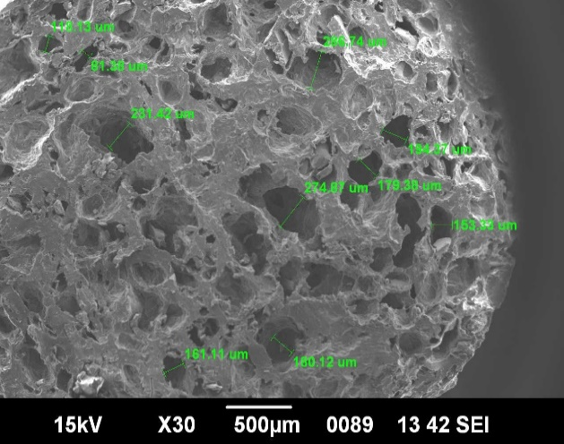  Corn pore size | 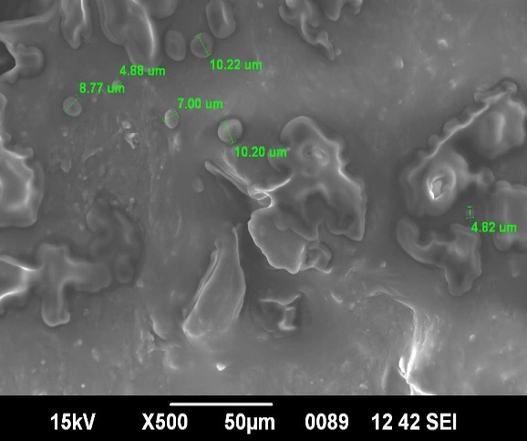  Corn granule size
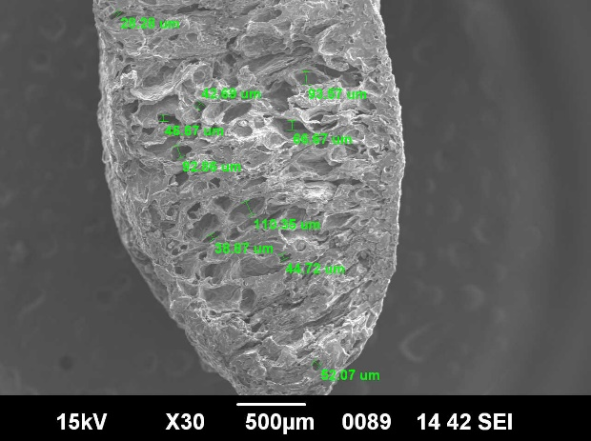  Wheat feed pore size | 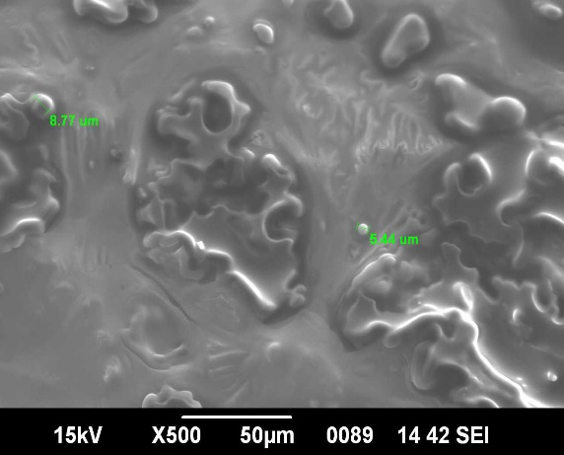  Wheat granule size
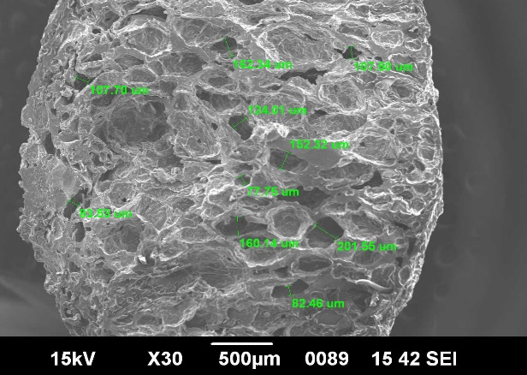  Rice feed pore size | 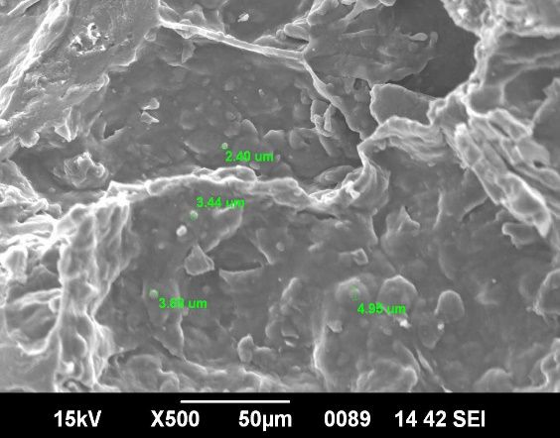  Rice granule size
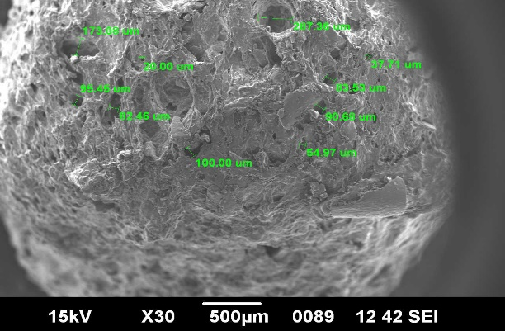  Corn and Rice feed pore size | 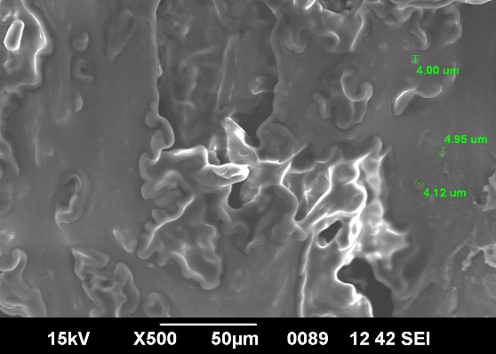  Corn and Rice granule size
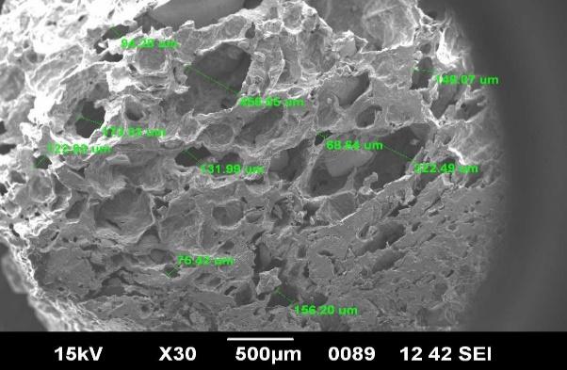  Corn and wheat feed pore size | 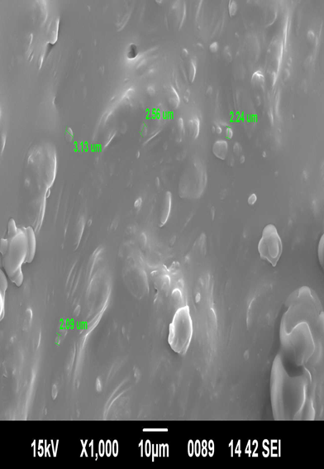  Corn and wheat granule size
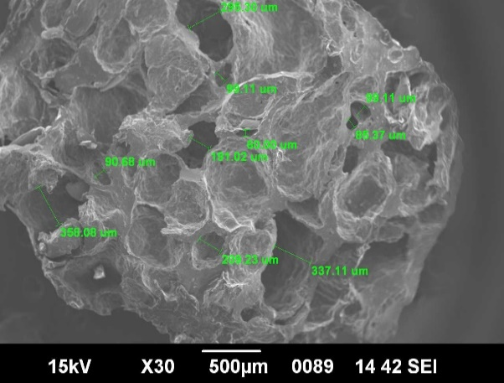  Wheat and rice feed pore size | 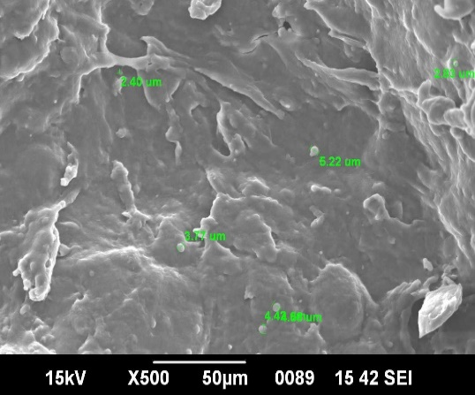  Wheat and rice granule size
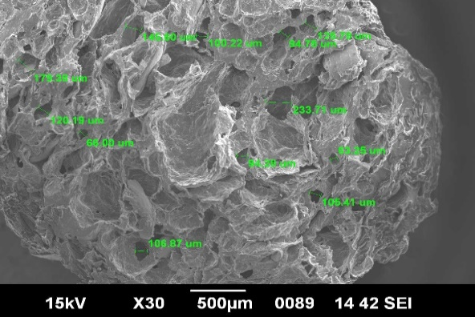  Corn, Wheat and Rice feed pore size | 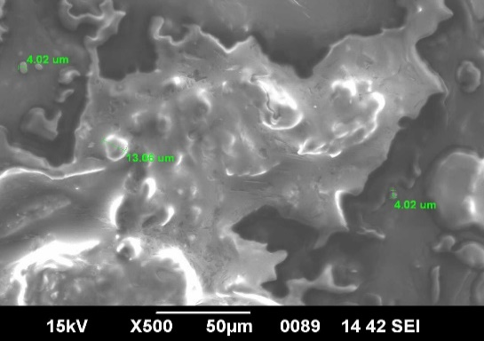  Corn, Wheat and Rice granule size

Reference
- Bergot, F. (1993). Digestibility of starch by rainbow trout: Effects of the physical state of starch and of the intake level. Aquaculture, 113(1–2), 83–92. https://doi.org/10.1016/0044-8486(93)90235-K
- D’Abramo, L. R. (2021). Nutritional requirements and feeding strategies in aquaculture. In C. C. Kohler & C. E. Lim (Eds.), Aquaculture: Farming aquatic animals and plants (3rd ed., pp. 442–459). Wiley-Blackwell.
- Ishak, W. I. W., Mat Hashim, D., Rahman, M. R. A., & Sazili, A. Q. (2020). Physical characteristics of aquafeed pellets produced with different starch sources using single screw extrusion. Journal of Applied Animal Research, 48(1), 240–247. https://doi.org/10.1080/09712119.2020.1775744
- Kamalam, B. S., Medale, F., & Panserat, S. (2017). Utilization of dietary carbohydrates in farmed fishes: New insights on influencing factors, biological limitations and future strategies. Aquaculture, 467, 3–27. https://doi.org/10.1016/j.aquaculture.2016.02.007
- Kaushik, S. J., Seiliez, I., & Panserat, S. (2022). Carbohydrate utilization in fish: The key role of nutritional regulation. Reviews in Aquaculture, 14(1), 303–324. https://doi.org/10.1111/raq.12614
- Riaz, M. N. (1997). Extruders and expanders in feed processing. Animal Feed Manufacturing Technology, 49, 225–236.
- Riaz, M. N. (2000). Extruders in food applications. CRC Press.
- Riaz, M. N. (2007). Extrusion problems solved: Food, pet food and feed. CRC Press.
- Rokey, G. J., Plattner, B., & Souza, E. M. (2010). Feed extrusion: Process description and product specifications. American Soybean Association.
- Sharma, M., & Vasudha, S. (2019). Role of scanning electron microscopy (SEM) in food science research: A review. International Journal of Current Microbiology and Applied Sciences, 8(1), 1284–1294. https://doi.org/10.20546/ijcmas.2019.801.137
- Singh, N., Singh, J., Kaur, L., Sodhi, N. S., & Gill, B. S. (2007). Morphological, thermal and rheological properties of starches from different botanical sources. Food Chemistry, 81(2), 219–231. https://doi.org/10.1016/S0308-8146(02)00416-8
- Svihus, B., Uhlen, A. K., & Harstad, O. M. (2005). Effect of starch granule structure, associated components and processing on nutritive value of cereal starch: A review. Animal Feed Science and Technology, 122(3–4), 303–320. https://doi.org/10.1016/j.anifeedsci.2005.02.025
- Svihus, B., Uhlen, A. K., & Harstad, O. M. (2005). Effect of starch granule structure, associated components and processing on nutritive value of cereal starch: A review. Animal Feed Science and Technology, 122(3–4), 303–320. https://doi.org/10.1016/j.anifeedsci.2005.02.025

