**Estimates of genetic variability and trait association among maize (*Zea mays* L.) inbred lines**

**Abstract:**

The present study aimed to evaluate the extent of genetic variability, trait associations in 133 maize inbred lines across eleven traits. The experiment was conducted during the *Kharif* 2022 using a randomized complete block design (RCBD) with two replications. Analysis of variance (ANOVA) revealed significant differences among the inbred lines for all traits, indicating substantial variability. Grain yield varied from 1.89 to 10.62 t/ha with an average mean value of 3.73 t/ha. Phenotypic variance was higher as compared to genotypic variance and highest plant height followed by ear height. However, the difference between phenotypic and genotypic variance was very narrow for majority of the traits. Similarly, phenotypic coefficient of variation (PCV) was marginally higher than the genotypic coefficient of variation (GCV) for all the traits and highest GCV and PCV was recorded for grain yield per hectare (38.97, 42.99) followed by hundred grain weight (27.81, 29.02) and ear height (23.29, 25.15) indicating that these characters are under genetic control and have high potential for selection. High amount of broad-sense heritability coupled with high genetic advance as a percent of mean (GAM) was observed for anthesis-silking interval (0.88, 143.60) followed by grain yield per hectare (0.82 and 72.77) indicating that phenotypic based selection for these traits would be successful. Grain yield per hectare had the highest genotypic correlation with cob girth (0.58) followed by kernel row number (0.53), hundred grain weight (0.50), number of kernels per row (0.48) and cob length (0.43) suggesting indirect selection of these traits helps in improving the grain yield.

**Key words:** Genetic variability, heritability, correlation, maize.

**Introduction**

Maize (*Zea mays* L.) is a versatile cereal crop cultivated across diverse seasons and ecosystems. It is often referred to as the "Queen of Cereals" due to its high genetic yield potential and broad industrial applications. In India, approximately 60% of maize is used as livestock and poultry feed, while it also serves as a staple food in many tropical and subtropical regions. Additionally, it is widely utilized in industries for producing ethanol, starch, and corn syrup. Maize is an economically significant crop, supporting global agriculture and industry. It is cultivated in 165 countries, with a production of 1,210 million tons and an average productivity of 5.92 t/ha (FAOSTAT, 2023). In India, it ranks third among cereals after rice and wheat, covering 10.04 million hectares with an average productivity of 3.349 t/ha (Agricoop, 2023-24). Although maize cultivation has expanded over the years, further productivity gains are essential to meet the increasing demand. Since expanding cultivation areas is often impractical, improving yield through genetic advancements, agronomic management, and breeding stress-resilient hybrids is the most viable approach. Given the rising population and increasing commercialization, there is a growing need to enhance maize productivity to meet food, feed, and industrial demands.

The primary goal of maize breeding programs worldwide is to enhance grain yield through systematic selection and hybrid development. Genetic variability plays a crucial role in crop improvement programs, enabling the selection of superior genotypes. Effective selection depends on sufficient variability within the germplasm, which can be assessed using genetic parameters such as the phenotypic coefficient of variation (PCV) and genotypic coefficient of variation (GCV). Despite the presence of variability, the efficiency of selection is influenced by heritability and selection intensity (Dudly and Moll, 1969). The estimates of broad sense heritability and genetic advance as a percent of mean (GAM) provides a reliable information about the heritable portion of the trait. High broad sense heritability along with high GAM also indicates the presence of additive gene action and hence selection could be effective (Nwangburuka *et al.* 2012) and when coupled with high genetic advance, it suggests strong potential for selection. Since grain yield in maize is a polygenic trait influenced by genotype-environment interactions, correlation helps to identify key traits contributing to yield improvement. Understanding these relationships enhances breeding efficiency by allowing targeted selection of desirable traits. By leveraging these genetic tools, maize breeders can develop improved hybrids with higher productivity and adaptability, ensuring sustainable production to meet future global demands.

**Material and methods**

The material for the present study comprised of 133 maize inbred lines, which include 13 inbreds (G1 - G13) from Maize Research Centre, Rajendranagar, 70 inbreds (G14 – G83) from CIMMYT and 50 inbreds (G84 – G133) from Indian Institute of Maize Research -Winter Nursery Centre. These lines were evaluated in randomized complete block design (RCBD) with two replications during *kharif*, 2022 at Maize Research Centre, Rajendranagar. Each entry was raised in two rows of four-meter length with a spacing of 60 cm × 20 cm and following all the recommended package of practice. The observations were recorded from each inbred lines for eleven quantitative traits *viz.,* days to 50 per cent tasseling (DTT), days to 50 per cent silking (DTS), anthesis-silking interval (ASI), plant height (PH) (cm), ear height (EH) (cm), cob length (CL) (cm), cob girth (CG) (cm), kernel row number (KRN), number of kernels per row (NKPR), hundred grain weight (TW) (g) and grain yield per hectare (GYPHA) (t/ha). The mean values of the data from these genotypes were subjected to analysis of variance (ANOVA) using variability package (Popat *et al.* 2020) in R-studio Rx643.6.2 and ANOVA was tested for significance. Genotypic and phenotypic variances were determined according to Singh and Chaudhary (1985) using MS-Excel programme. The genotypic coefficient of variation and phenotypic coefficient of variation were computed according to Burton and De vane (1953) using the following formula.

GCV = $\sqrt{σ2g}$/ X̅ × 100

PCV = $\sqrt{σ2p}$/ X̅ × 100

Where, σ2g = genotypic variance, σ2p = phenotypic variance and X̅ = sample mean. The GCV and PCV were classified according to Sivasubramanian and Menon (1973) as low (less than 10 %), moderate (10-20%) and high (more than 20%). Heritability in broad sense (h2bs) was computed for each character as the ratio of genotypic variance to the total variance as suggested by Hanson *et al.* (1956).

Heritability broad sense (h2bs) =

Where, σ2g = genotypic variance and σ2p = phenotypic variance. It was categorized by Robinson *et al.* (1951) as low (less than 0.30), moderate (0.31 – 0.60) and high (more than 0.60). Genetic advance and genetic advance as percent of mean were estimated according to Johnson *et al.* (1955) using the following formula,

GA = i × h2bs × σp,

Where, i = 2.06 (selection intensity at 5%), σp = Phenotypic standard deviation, h2bs = Heritability in broad sense.

Genetic advance as per cent of mean (GAM) = $\frac{Genetic advance}{X̅ }$ × 100

The GAM is grouped as low (less than 10%), moderate (10-20%) and high (more than 20%) respectively, according to Johnson *et al.* (1955). Karl Pearson’s simple correlation coefficients for all the eleven characters were worked out using variability package (Popat *et al.* 2020) and the heatmap of the correlation was made using function *corrplot* in R-studio Rx643.6.2.

**Results**

The analysis of variance for grain yield and yield contributing traits among the inbred lines is presented in Table 1. The mean sum of squares due to genotypes was found to be significant for all the eleven quantitative traits, indicating significant variation existed among the inbred lines chosen for the study. Hence from this, it is understood that the genotypes which were used in the study can be used for further breeding programme. The variability among the inbred lines was measured using mean, range, genotypic coefficient of variation (GCV) and phenotypic coefficient of variation (PCV) with regard to all the 11 characters, along with that broad sense heritability and genetic advance over mean was calculated and displayed in Table 2.

There was a wide range of variability exhibited for all the traits, among them grain yield per hectare varied from 1.89 to 10.62 t/ha with an average value of 3.73 t/ha (Table 2 and Fig 1). Similarly, there was a wide range of variability observed for flowering traits, plant height, ear height, number of kernels per row and hundred seed weight (Table 2 and Fig 1). Overall, the phenotypic variance (σ2p) was higher than genotypic variance (σ2g) for plant height (603.93 and 430.8) and ear height (157.98 and 135.48) indicating the influence of environmental factors in expression of these traits. However, the difference was very marginal for flowering traits, cob length, cob girth, kernel row number, number of kernels per row, hundred grain weight and grain yield per hectare indicating that environmental factors influencing the expression of these traits was very low, thereby whatever selections were made based on the genotypic performance for these traits will easily be expressed in the next generation. In general, PCV was marginally higher than GCV for majority of the traits but the difference was of very low magnitude except for plant height and grain yield per hectare indicating the environmental factors influenced the expression of these two traits (Table 2). Highest GCV and PCV was recorded for anthesis-silking interval (74.36, 79.33) followed by grain yield per hectare (38.97, 42.99), hundred grain weight (27.81, 29.02) and ear height (23.29, 25.15) indicating that these characters are under genetic control and have high potential for selection. Whereas moderate GCV and PCV were observed for cob length (15.64, 17.12), cob girth (10.07, 10.93) and kernel row number (13.61, 14.03). However, moderate GCV and high PCV were observed for plant height (17.42, 20.62) and number of kernels per row (19.32, 20.40). Low GCV and PCV was recorded for days to 50 per cent tasselling (7.24, 7.41) and days to 50 per cent silking (6.97, 7.17). For all the traits, the difference between GCV and PCV was very low, indicating environmental influence in the experiment is low. Moderate to high GCV and PCV for grain yield per hectare, hundred grain weight, ear height, plant height, number of kernels per row, cob length, cob girth and kernel row number excluding days to 50 per cent tasselling and days to 50 per cent silking suggested that there is ample of opportunity for selection in the present experimental material using these traits.

Even though the trait has high variability in terms of GCV and PCV, the effectiveness of the selection could be evaluated only based on the heritable portion of the character which could be identified based on heritability and genetic advance as a percent of mean (Rao and Rao, 2015). All the eleven traits exhibited high broad-sense heritability, days to 50 per cent tasselling had a maximum value of 0.95 followed by days to 50 per cent silking (0.94). The high amount of broad-sense heritability for all the quantitative traits indicated the least influence of the environment on these characters. GAM was high for anthesis-silking interval (143.60), grain yield per hectare (72.77), hundred grain weight (54.90), ear height (44.43), number of kernels per row (37.69), plant height (30.31), cob length (29.44) and kernel row number (27.20). Furthermore, cob girth, days to 50 per cent tasselling and days to 50 per cent silking had moderate GAM, even though all these traits had high heritability. Since, heritability does not always lead to high genetic gain, it is recommended to consider heritability and GAM together to predict the response of selection (Ogunniyan and Olakojo, 2014). Anthesis-silking interval, grain yield per hectare, hundred grain weight, ear height, number of kernels per row, plant height, cob length and kernel row number exhibited high broad-sense heritability along with high GAM.

The information about the direction and magnitude of association of various quantitative traits help in indirect selection for grain yield in the breeding programme, as the direct selection of a complex trait like grain yield is ineffective due to the influence of many genes and the environment (Grafius, 1956). The heat map representation of correlation coefficient among the eleven quantitative traits displayed in Fig. 1, where the intensity of blue and red colour depicts the magnitude of positive and negative correlation among the traits, respectively. Association of days to 50 per cent tasselling was positive and significant with days to 50 per cent silking (0.96). Days to 50 per cent silking (-0.27) and days to 50 per cent tasselling (-0.25) showed a significant negative correlation with grain yield per hectare. Plant height is significantly and positively associated with ear height (0.77). Among the yield contributing traits grain yield per hectare had highly significant and positive correlation with cob girth (0.58) followed by kernel row number (0.53), hundred grain weight (0.50), number of kernels per row (0.48) and cob length (0.43). The cob length was significantly associated in a positive direction with number of kernels per row (0.49), cob girth (0.39), plant height (0.31), hundred grain weight (0.28), ear height (0.25) and kernel row number (0.20). Cob girth showed a significant positive correlation with hundred grain weight (0.53), kernel row number (0.46), cob length (0.39), number of kernels per row (0.36), plant height (0.22) and ear height (0.18). Kernel row number is significantly and positively associated with cob girth (0.46), hundred grain weight (0.27) and cob length (0.20). Number of kernels per row exhibited positive and significant correlation with cob length (0.49) and cob girth (0.36). Hundred grain weight also showed significant and positive correlation with cob girth (0.53), plant height (0.52), ear height (0.48), cob length (0.28) and kernel row number (0.27). Thus, the cob characters and hundred grain weight are considered as important yield contributing traits indicating indirect selection for grain yield can be achieved by selection for these traits.

**Discussion**

The significant differences observed in analysis of variance (ANOVA) for all eleven quantitative traits confirm the presence of substantial genetic variation among the maize inbred lines evaluated, which is crucial for crop improvement efforts. The estimates of genotypic and phenotypic coefficients of variation (GCV and PCV) indicated that traits such as grain yield per hectare, hundred grain weight, and ear height exhibited high genetic control, making them suitable for selection. The narrow gap between GCV and PCV for most traits suggested a low environmental influence, reinforcing the reliability of genotype-based selection. Particularly, grain yield per hectare recorded the highest GCV (38.97) and PCV (42.99), indicating that it is a highly variable trait with a strong genetic basis. Earlier high GCV and PCV for grain yield and moderate GCV and PCV for cob characters were observed by Jilo *et al.* (2018) and Magar *et al.* (2021).

Heritability estimates are essential for understanding the extent to which traits are transmitted from parent to progeny. High broad-sense heritability was observed for all traits, with values ranging from 0.71 (plant height) to 0.95 (days to 50% tasselling). The high heritability coupled with high genetic advance as a per cent of mean (GAM) observed in traits *viz.,* anthesis-silking interval, grain yield per hectare, hundred grain weight, ear height, number of kernels per row, plant height, cob length and kernel row number suggest that these traits are predominantly controlled by additive gene action, making them highly responsive to selection (Wali *et al*., 2019). Wedwessen and Zeleke (2020) also observed high heritability with high GAM for grain yield, hundred grain weight, number of kernels per row and cob length supporting the findings of the present study.

Grain yield per hectare showed significant positive correlations with cob girth (0.58), kernel row number (0.53), hundred grain weight (0.50), number of kernels per row (0.48), and cob length (0.43). Pavan *et al*. (2011) reported a similar kind of association in their study. These associations indicate that selecting for these traits can lead to an indirect improvement in grain yield. The significant positive correlation between cob length and number of kernels per row (0.49) further suggests that longer cobs contribute to enhanced kernel set, ultimately increasing yield potential. Similar results were also noticed by Devasree *et al*. (2020). Conversely, a negative correlation between days to 50% tasseling and grain yield per hectare (-0.25) suggests that early maturing genotypes tend to produce higher yields, which is a desirable trait for breeding programs aimed at improving productivity under limited growing seasons.

The findings from this study align with previous researchers Magar *et al.* (2021), Suresh *et al.* (2021) and Antony *et al.* (2024) demonstrating that traits such as hundred grain weight, cob girth, and kernel row number play a critical role in determining grain yield in maize. The significant genetic variability and high heritability of these traits provide maize breeders with valuable information to develop superior inbred lines through selection and hybridization.

**Conclusion**

Overall, the study confirms the presence of significant genetic variability for yield and its component traits in maize, highlighting the effectiveness of selection based on phenotypic performance. High broad-sense heritability, coupled with high genetic advance as a percentage of the mean for grain yield per hectare, hundred grain weight, number of kernels per row, cob length, and kernel row number, suggests that selecting these traits would be effective for yield improvement. Additionally, cob girth, kernel row number, hundred grain weight, number of kernels per row, and cob length exhibit positive associations with grain yield, further reinforcing their importance in breeding programs. Prioritizing these high-heritability traits with strong genetic control can enhance maize productivity. Future research integrating molecular markers and genomic selection could complement these findings, accelerating the development of superior maize hybrids.

COMPETING INTERESTS DISCLAIMER:

Authors have declared that they have no known competing financial interests OR non-financial interests OR personal relationships that could have appeared to influence the work reported in this paper.

**References**

Anonymous. Annual Report, 2023–24. India Crop Coverage Report. Directorate of Economics and Statistics, Department of Agriculture and Farmer’s Welfare, Ministry of Agriculture and Farmers Welfare, Govt. of India, Krishi Bhavan, New Delhi. Available from: https://www.agricoop.nic.in.

Antony, B.J., Kachapur, R.M., Naidu, G.K., Talekar, S.C., Zerka, M. and Harlapur, S.I., 2024. Genetic variability and character association among maize (*Zea mays* L.) Inbred lines. *Bangladesh Journal of Botany*, *53*(1), pp.57-65.

Burton GW and Devane EM 1953. Estimating heritability in tall fescue from replicated clonal-material. Agron. J. 45: 478-481.

Devasree S, Ganesan KN, Ravikesavan R, Senthil N and Paranidharan V. 2020. Relationship between yield and its component traits for enhancing grain yield in single cross hybrids of maize (*Zea mays* L.). Electron. J. Plant Breed. 11: 796-802.

Dudly JW and Moll RH 1969. Interpretation and use of estimates of heritability and genetic variance in plant breeding. Crop Sci. 9: 257-267.

FAOSTAT. 2023. Crops and Livestock Products FAO, Rome. <https://www.fao.org/faostat/en/#data/QCL>

Grafius JE 1956. Components of yield in oats: A geometrical interpretation. J. Agron. 48: 419-423.

Hanson CH, Robinson HF and Comstock RE 1956. Biometrical studies of yield in segregating populations of Korean lespedera. Agron. J. 48: 268-272.

Jilo T, Tulu L, Birhan T and Beksisa L 2018. Genetic variability, heritability and genetic advance of maize (*Zea mays* L.) inbred lines for yield and yield related traits in southwestern Ethiopia. J. Plant Breed. Crop Sci. 10: 281-289.

Johnson HW, Robinson HF and Comstock RE 1955. Estimates of genetic and environmental variability in soybeans. J. Agron. 47: 314-318.

Magar BT, Acharya S, Gyawali B, Timilsena K, Upadhayaya J and Shrestha J 2021. Genetic variability and trait association in maize (*Zea mays* L.) varieties for growth and yield traits. Heliyon. 7: 07939.

Nwangburuka CC, Denton OA, Kehinde OB, Ojo DK, Popoola AR 2012. Genetic variability and heritability in cultivated okra (*Abelmoschus esculentus* (L.) Moench). Spanish. J. Agric. Res. 10:123-129.

Ogunniyan DJ and Olakojo SA 2014. Genetic variation, heritability, genetic advance and agronomic character association of yellow elite inbred lines of maize (*Zea mays* L.). Niger. J. Genet. 28: 24-28.

Pavan R, Lohithaswa HC, Wali MC, Prakash G and Shekara BG 2011. Correlation and path coefficient analysis of grain yield and yield contributing traits in single cross hybrids of maize (*Zea mays* L.). Electron. J. Plant Breed. 2: 253-257.

Popat R, Patel R and Parmer D 2020. Variability: genetic variability analysis for plant breeding research https://CRAN.R-project.org/package=variability.

Rao P and Rao VT 2015. Genetic analysis for yield and its components in pigeonpea (*Cajanus cajan* (L.) Mill Sp). Int. J. Appl. Biol. Pharmaceut. Technol. 6: 189-190.

Robinson HF, Comstock RE and Harvey PH 1951. Genotypic and phenotypic correlations in corn and their implications in selection. Agron. J. 43: 282-287.

Singh RK and Chaudhary BD 1985. Biometrical Methods in Quantitative Genetic Analysis. Kalayani Publishers, New Delhi, India. 318.

Sivasubramanian S and Menon M 1973. Heterosis and inbreeding depression in rice. Madras Agric. J. 60: 1139.

Suresh D, Kachapur RM, Talekar SC and Gurumurthy R 2021. Genetic variability and trait association studies in maize (*Zea mays* L.). J. Farm Sci. 34: 122-125.

Wali MC 2019. Genetic variability and divergence studies in maize (*Zea mays* L.). E. C Agric. 5: 2014-15.

Wedwessen T and Zeleke H 2020. Genetic variability, heritability and genetic advance estimates in maize (*Zea mays* L.) inbred lines. Int. J. Novel Res. Life Sci. 7: 10-16.

**Table 1. Analysis of variance for eleven quantitative traits in 133 maize (*Zea mays* L.) inbred lines.**

|  |  |  |  |  |  |  |  |  |  |  |  |
| --- | --- | --- | --- | --- | --- | --- | --- | --- | --- | --- | --- |
| **Parameters** | **Traits** | | | | | | | | | | |
| **DTT** | **DTS** | **ASI** | **PH** | **EH** | **CL** | **CG** | **KRN** | **NKPR** | **TW** | **GYPHA** |
| **Replication** | 1.25 | 0.31 | 0.31 | 61.40 | 22.09 | 0.22 | 0.00 | 0.01 | 1.18 | 13.28 | 0.04 |
| **Genotype** | 41.49** | 40.73** | 3.22** | 1034.81** | 293.45** | 6.85** | 0.28** | 6.08** | 36.19** | 92.80** | 4.67** |
| **Error** | 0.97 | 1.18 | 0.21 | 173.04 | 22.50 | 0.62 | 0.02 | 0.18 | 1.97 | 3.95 | 0.46 |
| **CV** | 1.58 | 1.70 | 27.62 | 11.04 | 9.49 | 6.95 | 4.26 | 3.41 | 6.56 | 8.29 | 18.15 |
| **CD 5%** | 1.95 | 2.15 | 0.90 | 26.02 | 9.38 | 1.55 | 0.30 | 0.85 | 2.78 | 3.93 | 1.34 |

* – Significant at 5 % and ** – Significant at 1 % level of probability.

**CV –** Coefficient of variance**, CD –** Critcal difference**, DTT** – Days to 50% tasseling, **DTS** – Days to 50% silking, **ASI** – Anthesis-silking interval, **PH** – Plant height (cm), **EH** – Ear height (cm)**CL** – Cob length (cm), **CG** – Cob girth (cm), **KRN** – Kernel rows per cob, **NKPR**- Number of kernels per row, **TW** – Test weight (g), **GYPHA** – Grain yield per hectare (t/ha).

**Table 2. Genetic variability parameters of eleven quantitative traits in 133 maize (*Zea mays* L.) inbred lines.**

|  |  |  |  |  |  |  |  |  |  |  |  |
| --- | --- | --- | --- | --- | --- | --- | --- | --- | --- | --- | --- |
|  | **DTT** | **DTS** | **ASI** | **PH** | **EH** | **CL** | **CG** | **KRN** | **NKPR** | **TW** | **GYPHA** |
| **Mean** | 62.17 | 63.82 | 1.65 | 119.16 | 49.97 | 11.29 | 3.54 | 12.61 | 21.41 | 23.97 | 3.73 |
| **Maximum** | 72.85 | 74.26 | 5.00 | 207.79 | 90.55 | 16.96 | 4.58 | 17.02 | 36.29 | 45.62 | 10.62 |
| **Minimum** | 46.86 | 47.93 | -2.00 | 66.14 | 21.08 | 6.00 | 2.61 | 4.74 | 10.06 | 9.14 | 1.89 |
| **Genotypic variance (**σg2**)** | 20.26 | 19.78 | 1.51 | 430.88 | 135.48 | 3.12 | 0.13 | 2.95 | 17.11 | 44.43 | 2.11 |
| **Phenotypic variance (**σp2**)** | 21.23 | 20.96 | 1.71 | 603.93 | 157.98 | 3.73 | 0.15 | 3.13 | 19.08 | 48.37 | 2.57 |
| **GCV (%)** | 7.24 | 6.97 | 74.36 | 17.42 | 23.29 | 15.64 | 10.07 | 13.61 | 19.32 | 27.81 | 38.97 |
| **PCV (%)** | 7.41 | 7.17 | 79.33 | 20.62 | 25.15 | 17.12 | 10.93 | 14.03 | 20.40 | 29.02 | 42.99 |
| **Heritability broad sense (h2bs)** | 0.95 | 0.94 | 0.88 | 0.71 | 0.86 | 0.84 | 0.85 | 0.94 | 0.90 | 0.92 | 0.82 |
| **Genetic Advance (GA)** | 9.06 | 8.90 | 2.37 | 36.12 | 22.20 | 3.32 | 0.68 | 3.43 | 8.07 | 13.16 | 2.71 |
| **GA as per cent of mean (GAM)** | 14.57 | 13.94 | 143.60 | 30.31 | 44.43 | 29.44 | 19.10 | 27.20 | 37.69 | 54.90 | 72.77 |

**GCV –** Genotypic coefficient of variance**, PCV –** Phenotypic coefficient of variance, **DTT** – Days to 50% tasseling, **DTS** – Days to 50% silking, **ASI** – Anthesis-silking interval, **PH** – Plant height (cm), **EH** – Ear height (cm)**CL** – Cob length (cm), **CG** – Cob girth (cm), **KRN** – Kernel rows per cob, **NKPR**- Number of kernels per row, **TW** – Test weight (g), **GYPHA** – Grain yield per hectare (t/ha).

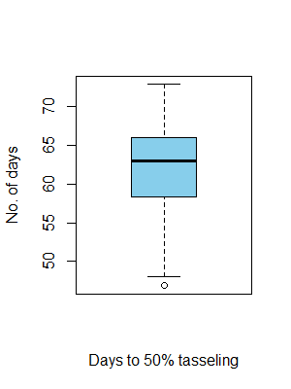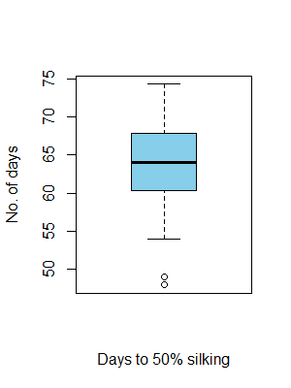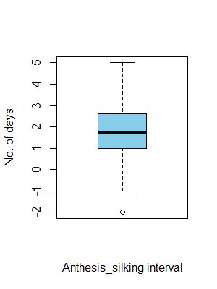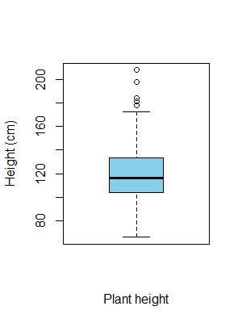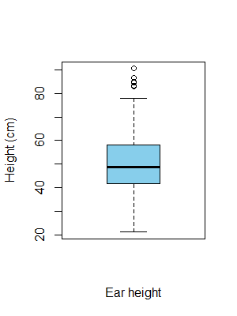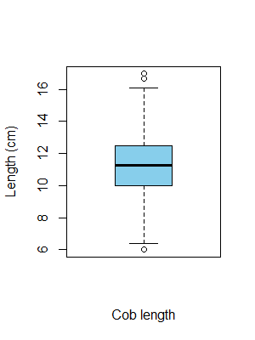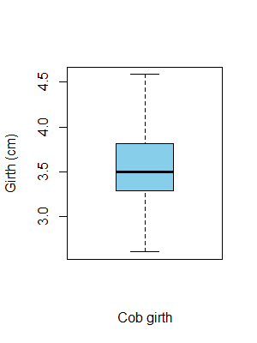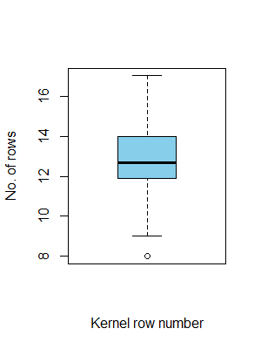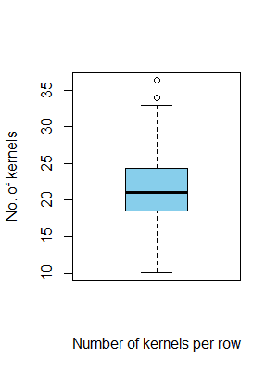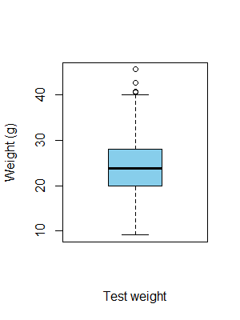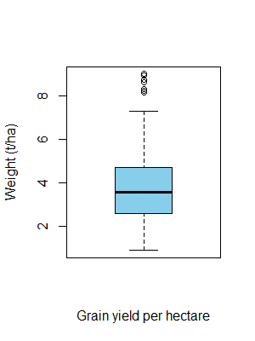

Fig. 1 **Box-plots showing variation in yield and its component traits in maize**

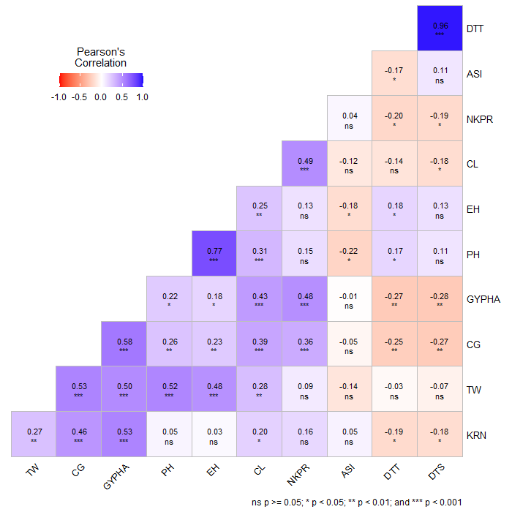

**Fig. 2 Association among the grain yield and its attributes in maize**

**DTT** – Days to 50% tasseling, **DTS** – Days to 50% silking, **ASI** – Anthesis-silking interval, **PH** – Plant height (cm), **EH** – Ear height (cm)**CL** – Cob length (cm), **CG** – Cob girth (cm), **KRN** – Kernel rows per cob, **NKPR**- Number of kernels per row, **TW** – Test weight (g), **GYPHA** – Grain yield per hectare (t/ha).