OPTIMIZING RAPESEED PRODUCTIVITY THROUGH SOWING DATE ADJUSTMENT AND AGRO-CLIMATIC INDICES MODERATION

ABSTRACT
Aims: To optimize rapeseed variety TS 67 yield and agroclimatic indices through sowing date adjustment in Assam condition.
Study design: Split plot design
Place and Duration of Study: Instructional cum Research Farm, Assam Agricultural University Jorhat, during kharif season of 2022.
Methodology: The treatments were laid out in a split plot design with three replications. The treatments comprised of three different sowing dates viz., D₁: 15th November, D₂: 30th November, D₃: 15th December in main plots and four Jasmonic acid concentration JA₁ (no JA), JA₂ (50 micromole per litre), JA₃ (100 micromole per litre), and JA₄ (150 micromole per litre). From the study, the growth, physiological parameters, yield attributes, yield and agroclimatic indices were recorded and analyzed.
Results: Results revealed that among the different sowing dates, the crop sown on 15th November (D₁) recorded significantly increased plant height, number of primary, secondary branches and dry matter production per plant, whereas, the crop sown on 15th December (D₃) recorded significantly higher root-shoot ratio and proline content. In case of physiological parameters also, 15th November sown crop (D₁) recorded significantly higher chlorophyll content, relative water content, leaf area and other growth indices viz., leaf area index, leaf area duration crop growth rate and relative growth rate. The crop sown on 15th November (D₁) required significantly higher number of days to flower initiation (28.50 days), 50% flowering (34.50 days), siliqua formation (34.58 days) and physiological maturity (87.08 days) along with significantly higher accumulated growing degree days (1199.77 ⁰C day), helio-thermal units (7567.22 ⁰C day hours) and photo-thermal units (12766.70 ⁰C day hours).
The yield attributing characters such as siliquae length (5.48 cm), number of siliquae per plant (58.65) and number of seeds per siliqua (12.03) were found to be maximum under the sowing of crop on 15th November (D₁). Significantly higher seed yield of 6.66 q ha^{-1,} stover yield of 14.11 q ha⁻¹ and oil yield of 243.62 kg ha⁻¹ were also obtained from the sowing of the crop on 15th November (D₁). On the other hand, the crop sown on 15th December (D₃) recorded lowest seed as well as stover yield of 4.99 q ha⁻¹ and 12.21q ha⁻¹ respectively.
Conclusion: Based on plant growth, physiological parameters, seed yield, oil yield and economics, the sowing of the crop on 15th November can be considered best for enhancing the production of rapeseed (Brassica campestris var. toria) under rainfed condition.

Keywords: Agroclimatic indices, accumulated growing degree days, accumulated helio-thermal unit, accumulated photothermal unit

1. INTRODUCTION
Rapeseed (Brassica campestris var. toria), commonly known as sarson or toria, is one of the major important oilseed crops containing 40–46% oil. India ranks third worldwide in production of rapeseed & mustard with an annual production of 11.10 metric tons per hectare (USDA, 2023). In north eastern part of the country, mainly in Assam, the crop is grown around 2.86 Lakh ha contributing annual production of 1.85 lakh tonnes with an annual average productivity of 6-7 q ha⁻¹ which is quite low as compared to the national average of 14.99 q ha⁻¹ (GoA, 2024). Every crop has an optimum range of sowing dates for the production of its potential yield. Sowing of crops at proper time resulted in efficient utilization of resources such as sunlight, water and air etc. which ultimately improved the uptake and distribution of nutrients, more crop growth and yield. The notable effect on yield of the crop mainly attributed to stress induced by delayed sowing as the crop is mainly grown under rain fed condition on residual soil moisture accompanied by poor nutrient management (Deka et al., 2018). Apart from these, many biotic and abiotic stresses that have a negative impact on crop growth is responsible for poor crop yield (Kumari et al., 2011). The critical stages viz., flowering and siliqua formation were severely hampered due to reduced soil moisture and shortened growing season under delayed rainfed conditions (Deka et al., 2018 and Singh et al., 2017). Rapeseed being a thermo and photosensitive plant (Ghosh and Chatterjee, 1988) is highly influenced by both biotic and abiotic factors grown under different micro-climatic regimes. Hence, microclimatic environment could be modified by altering the dates of sowing. (Pandey et al., 1981).
2. material and methods
The experimental site having humid subtropical climate with dry winters experiences annual average temperature of 78.21°F, an annual precipitation of approximately 96.46 mm over 66.44 rainy days. During the study, the weekly average maximum temperature ranged between 21.4°C and 29.3°C, while the minimum temperature recorded from 7.9°C to 15.7°C. The total rainfall measured throughout the experiment was 41.4 mm, distributed over four rainy days (Figure-1, 2).
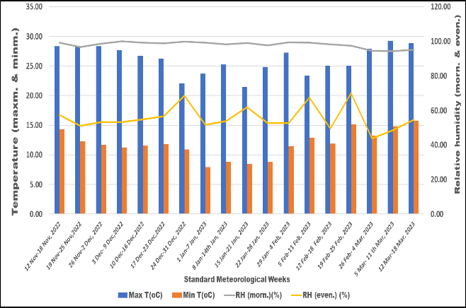 | 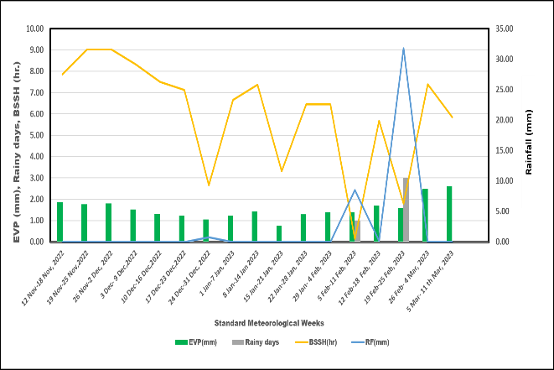
Figure-1: Weekly meteorological data of maximum temperature, minimum temperature and relative humidity (morning and evening), during the experimentation (2022-2023). | Figure-2: Weekly meteorological data of rainfall, evaporation, number of rainy days and bright sunshine hours during the experimentation (2022-2023).

The experiment followed in a split-plot design having three replications. The main plot involved three different sowing dates to create distinct microclimatic conditions: D₁ (15th November), D₂ (30th November), and D₃ (15th December). The sub-plots included four levels of jasmonic acid (JA) application: JA₁ (no JA), JA₂ (50 micromole per litre), JA₃ (100 micromole per litre), and JA₄ (150 micromole per litre).
Each individual plot measured 3.6 m × 2.4 m, with three replications. The TS-67 variety was cultivated during the rabi season of 2022-23, adhering to the recommended package of practices under rainfed conditions. The experimental soil was sandy loam, acidic (pH 5.62), medium in organic carbon (0.54%), and low in available nutrients N (239.54 kg/ha), P₂O₅ (22.40 kg/ha), K₂O (112.42 kg/ha), and S (6.61 kg/ha). Fertilizers were applied at a rate of 40-35-15 kg ha⁻¹ (N-P₂O₅-K₂O).

Growing degree days (⁰C day):
The growing degree days were the measure of accumulation of heat units, calculated in terms of maximum minimum and base temperature i.e., 5.0 ⁰ C (Nanda et al., 1996):
Growing degree days = | (T_{max} +T_{min})/2 - T_{t}

where, T_{max} = maximum temperature (⁰C)
T_{min} = minimum temperature (⁰C)
T_{t} = base or threshold temperature (⁰C)
Helio-thermal Unit (⁰C hours)
Helio-thermal units were measure by multiplying GDD and corresponding sunshine hours.
HTU = GDD x actual sunshine hours
Photo thermal Unit (⁰C hours)
The photo-thermal unit was measured in terms of day length and growing degree days.
PTU = GDD x Day length
Statistical analysis
The experimental findings for various parameters were statistically analysed following the standard procedures of analysis for split-plot design (Panse and Sukhatme, 1985). The critical difference (CD) at 5% probability level was calculated when the F value was found significant. The analysis of variance (ANOVA), S.Em. (±), CD, CV (%), means and S. Ed, were calculated using the software MS Excel and OP Stat. Duncan’s Multiple Range test (DMRT) was followed for multiple comparison, using the software OP Stat. The different letters viz., a, b and c indicated significant differences among treatments (P < 0.05).
For correlation and multiple regression analysis, computer software SPSS (version 21) was used.
CD = Sed (±) × √2 × × t value at 5% (2.447) for error (a) d.f.

3. results and discussion
3.1 Crop phenology:
The data on crop phenology due to different sowing condition has been presented in Table 1 and Figure 3. Results revealed that different sowing condition greatly influenced the crop phenology of rapeseed. The timely sown crop i.e. 15th November (D₁) reported to have maximum duration in flower initiation (28.50 days), 50% flowering, siliquae formation (34.50 days) and physiological maturity (87.08 days) followed by 15 days delay sowing from optimum (D₂). While, 30 days delayed sowing from optimum reported to have the shortest crop phenology in all the growing stages. However, the crop phenology remained unaffected due to the application of different concentrations of jasmonic acid.

Table 1: Effect of sowing date adjustment and growth hormone application on crop phenology (days) of toria
Treatments | Days to  emergence | Days to  flower  initiation |  | Days to  50%  flowering | Days to  siliqua  formation | Days to  physiological  maturity
Micro-climatic regimes (D)
D₁: 15th Nov | 6.42^{c} | 28.50ª | 34.50ª |  | 34.58ª | 87.08ª
D₂: 30th Nov | 7.67^{b} | 26.50^{b} | 30.75^{b} |  | 30.67^{b} | 83.28^{b}
D₃: 15th Dec | 8.50ª | 20.75^{c} | 27.17^{c} |  | 25.67^{c} | 77.18^{c}
S. Em (±) | 0.16 | 0.31 | 0.55 |  | 0.38 | 0.35
C.D (0.05) | 0.61 | 1.21 | 2.17 |  | 1.50 | 1.40
Here, different letters indicate significant differences among treatments (P < 0.05) according to Duncan’s Multiple Range test.

3.2 ACCUMULATED GROWING DEGREE DAYS (AGDD):
The accumulated growing degree days (AGDD) determined at different phenological stages i.e., emergence, flower initiation, 50% flowering, siliqua formation and physiological maturity were significantly influenced by different micro-climatic regimes (Figure 4). The result revealed that the crop sown on 15th November (D₁) availed significantly higher AGDD at flower initiation (435.35 ⁰C day), 50% flowering, (510.25 ⁰C day) siliqua formation (511.56 ⁰C day) and physiological maturity (1199.77 ⁰C day) which was significantly superior over the crop sown on 30th November (D₂) that availed 375.88 ⁰C day for flower initiation, 423.11 ⁰C day for 50% flowering, 422.59 ⁰C day for siliqua formation and 1132.59 ⁰C day for physiological maturity. Whereas, the lowest AGDD was availed by the crop sown on 15th December (D₃) at flower initiation (258.66 0C day), 50% flowering, (331.54 ⁰C day) siliqua formation (316.78 ⁰C day) and physiological maturity (1068.37 ⁰C day). In case of emergence, the crop sown on 15th December (D₃) (119.42 ⁰C day) availed significantly higher AGDD which was at par with the crop sown on 30th November (D₂) (114.56 ⁰C day) and both of them were significantly superior over the crop sown on 15th November (D₁) (100.46 ⁰C day).
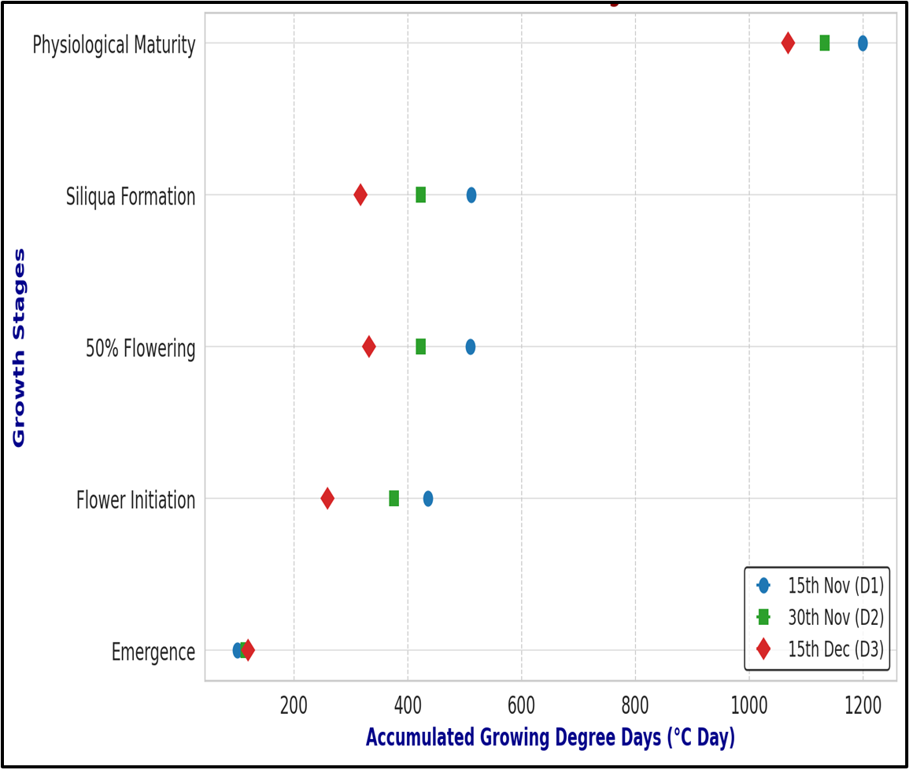
Figure4: Effect of sowing date adjustment on accumulated growing degree days of toria

3.2 ACCUMULATED HELIO-THERMAL UNIT (AHTU):
The accumulated helio-thermal unit (AHTU) at different crop growth stages viz., emergence, flower initiation, 50% flowering, siliqua formation and physiological maturity were significantly influenced due to different micro-climatic regimes (Figure 5). The micro-climatic regime created by sowing the crop on 15th November (D₁) availed significantly higher AHTU at flower initiation (3664.50 ⁰C day hours), 50% flowering (4604.76 ⁰C day hours), siliqua formation (4261.02 ⁰C day hours) and physiological maturity (7567.22 ⁰C day hours) which was significantly superior over the crop sown on 30th November (D₂) which availed comparatively lower AHTU of 2988.30 ⁰C day hours for flower initiation, 3354.31 ⁰C day hours at 50% flowering, 2895.79 ⁰C day hours at siliqua formation and 6209.52 ⁰C day hours at physiological maturity. Whereas, the lowest AHTU was availed by the crop sown on 15th December (D₃) at flower initiation (1368.65 ⁰C day hours), 50% flowering, (2414.94 ⁰C day hours), siliqua formation (1821.72 ⁰C day hours) and physiological maturity (5422.36 ⁰C day hours). On the other hand, at emergence, the crop sown on 30th November (D₂) availed significantly higher AHTU (980.88 ⁰C day hours) which was found to be significantly superior over the crop sown on 15th November (D₁) (841.90 ⁰C day hours). The lowest AHTU was recorded by crop sown on 15th December (D₃) (836.02 ⁰C day hours) which was statistically at par with crop sown on 15th November (D₁) (841.90 ⁰C day hours).
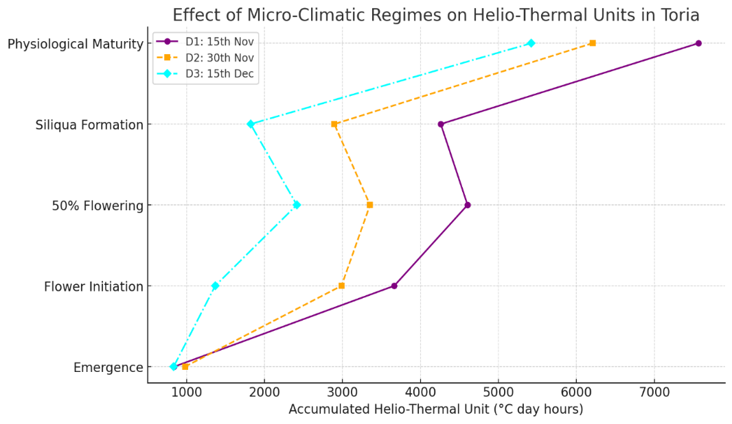
Fig-5: Effect of sowing date adjustment on accumulated helio-thermal unit of toria

3.3 ACCUMULATED PHOTO-THERMAL UNIT (APTU):
The micro-climatic regimes significantly influenced the accumulated photo-thermal unit (APTU) at different phenological stages (Figure 6). Among different micro climatic regimes, the crop sown on 15th November (D₁) availed significantly higher APTU at different growth stages viz., flower initiation (4528.28 ⁰C day hours), 50% flowering, (5413.43 ⁰C day hours), siliqua formation (5427.10 ⁰C day hours) and physiological maturity (12766.70 ⁰C day hours). Whereas, the crop sown on 30th November (D₂) availed comparatively lower APTU at flower initiation (3968.84 ⁰C day hours), 50% flowering (4442.26 ⁰C day hours), siliqua formation (4436.84 ⁰C day hours) and physiological maturity (12196.77 ⁰C day hours) followed by crop sown on 15th December (D₃) i.e., 2708.65 ⁰C day hours at flower initiation, 3477.34 ⁰C day hours at 50% flowering, 3290.36 ⁰C day hours at siliqua formation and 11629.53 ⁰C day hours at physiological maturity. On the other hand, at emergence, the crop sown on 15th December (D₃) availed significantly higher APTU (1249.58 ⁰C day hours) which was at par with 30th November (D₂) (1210.04 ⁰C day hours) and the lowest APTU was availed for the crop sown on 15th November (D₁) (1084.14 ⁰C day hours).
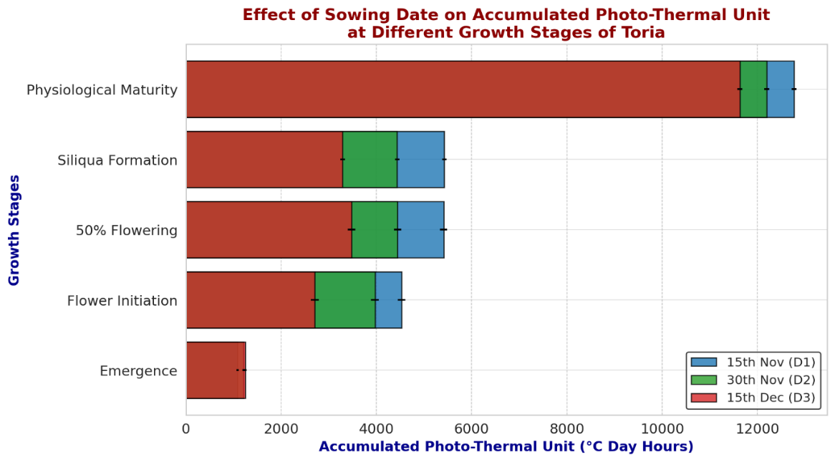
Fig-6: Effect of sowing date adjustment on accumulated photo-thermal unit of toria

4. CORRELATION STUDIES
4.1 CORRELATION STUDIES OF DRY MATTER PRODUCTION, YIELD ATTRIBUTING CHARACTERS AND YIELD WITH GDD (GROWING DEGREE DAYS) AT DIFFERENT STAGES OF TORIA

Table 2: Pearson correlation of dry matter production, yield attributing characters and yield with GDD (growing degree days) at different stages of toria
 | Dry matter 25 DAS | Dry matter 50 DAS | Dry matter 75 DAS | GDD E-FI | GDD FI-SF | GDD  SF-PM | No. of  Siliquae per plant | Seed per  siliqua | Seed yield | Oil yield | Oil  Content
Dry matter  25 DAS | 1 | 0.997** | 0.975** | 0.870** | 0.828** | 0.786** | 0.911** | 0.880** | 0.929** | 0.943** | 0.636*
Dry matter  50 DAS | 0.997** | 1 | 0.975** | 0.870** | 0.828** | 0.786** | 0.911** | 0.880** | 0.929** | 0.943** | 0.504
Dry matter  75 DAS | 0.975** | 0.975** | 1 | 0.948** | 0.918** | 0.878** | 0.932** | 0.811** | 0.919** | 0.969** | 0.527
GDD E-FI | 0.870** | 0.870** | 0.948** | 1 | 0.988** | 0.957** | 0.929** | 0.667* | 0.883** | 0.960** | 0.545
GDD FI_SF | 0.828** | 0.828** | 0.918** | 0.988** | 1 | 0.977** | 0.927** | 0.647* | 0.872** | 0.949** | 0.545
GDD SF_PM | 0.786** | 0.786** | 0.878** | 0.957** | 0.977** | 1 | 0.894** | 0.642* | 0.835** | 0.902** | 0.615*
No. of siliquae per plant | 0.911** | 0.911** | 0.932** | 0.929** | 0.927** | 0.894** | 1 | 0.823** | 0.931** | 0.971** | 0.719**
Seeds per  siliqua | 0.880** | 0.880** | 0.811** | 0.667* | 0.647* | 0.642* | 0.823** | 1 | 0.859** | 0.793** | 0.582*
Seed yield | 0.929** | 0.929** | 0.919** | 0.883** | 0.872** | 0.835** | 0.931** | 0.859** | 1 | 0.965** | 0.591*
Oil yield | 0.943** | 0.943** | 0.969** | 0.960** | 0.949** | 0.902** | 0.971** | 0.793** | 0.965** | 1 | 0.624*
Oil content | 0.636* | 0.504 | 0.527 | 0.545 | 0.545 | 0.615* | 0.719** | 0.582* | 0.591* | 0.624* | 1
** Correlation is significant at the 0.01 level (2-tailed), * Correlation is significant at the 0.05 level, E-FI: Emergence to flower initiation, FI-SF: Flower initiation to siliquae formation, SF-PM: Siliquae formation to physiological maturity
A perusal of data presented in Table 2 revealed that dry matter production at different stages viz., 25, 50 and 75 DAS was highly significant and positively correlated with accumulated growing degree (GDD) days at different phenological stages. The yield attributing parameters such as the number of siliquae per plant and number of seeds per siliqua was also, significantly and positively correlated with growing degree days at different crop growth stages. The number of siliquae per plant was highly significant and positively correlated (0.01 level) with GDD from emergence to flower initiation (r = 0.929 **), flower initiation to siliquae formation (r = 0.927**), and siliquae formation to physiological maturity (r = 0.894**). Significant (0.01 level) and positive correlation of seeds per siliqua was recorded with GDD from emergence to flower initiation (r = 0.667 **), flower initiation to siliquae formation (r = 0.647**), and siliquae formation to physiological maturity (r = 0.642**).
Similarly, the seed yield and oil yield were highly significant (0.01 level) and positively correlated with GDD from emergence to flower initiation (r = 0.883 ** and r = 0.960**, respectively), flower initiation to siliquae formation (r = 0.960** and r = 0.949**, respectively), and siliquae formation to physiological maturity (r = 0.835** and r = 0.902 **, respectively). Whereas, the oil content of toria was also significant (0.05 level) and positively correlated with GDD from siliqua formation to physiological maturity (r = 0.615*), but, non- significant with GDD from emergence to flower initiation (r = 0.545) and flower initiation to siliquae formation (r = 0.545).
4.2 CORRELATION STUDIES OF DRY MATTER PRODUCTION, YIELD ATTRIBUTING CHARACTERS AND YIELD WITH HTU (HELIO-THERMAL UNIT) AT DIFFERENT STAGES OF TORIA
Table 3: Pearson correlation of dry matter production, yield attributing characters and yield with HTU (helio-thermal unit) at different stages of toria
 | Dry matter 25 DAS | Dry matter 50 DAS | Dry matter 75 DAS | HTU EFI | HTU FISF | HTU SFPM | No. of  Siliquae per  plant | Seed per siliqua | Seed yield | Oil yield | Oil Content
Dry matter  25 DAS | 1 | 0.998** | 0.975** | 0.865** | 0.801** | 0.770** | 0.911** | 0.880** | 0.929** | 0.943** | 0.636*
Dry matter  50 DAS | 0.998** | 1 | 0.975** | 0.865** | 0.801** | 0.770** | 0.911** | 0.880** | 0.929** | 0.943** | 0.504
Dry matter  75 DAS | 0.975** | 0.975** | 1 | 0.943** | 0.887** | 0.856** | 0.932** | 0.811** | 0.919** | 0.969** | 0.527
HTU E-FI | 0.865** | 0.865** | 0.943** | 1 | 0.941** | 0.918** | 0.899** | 0.659* | 0.843** | 0.927** | 0.51
HTU FI-SF | 0.801** | 0.801** | 0.887** | 0.941** | 1 | 0.995** | 0.924** | 0.649* | 0.871** | 0.936** | 0.636*
HTU SF-PM | 0.770** | 0.770** | 0.856** | 0.918** | 0.995** | 1 | 0.907** | 0.637* | 0.852** | 0.912** | 0.622*
No. of  Siliquae per plant | 0.911** | 0.911** | 0.932** | 0.899** | 0.924** | 0.907** | 1 | 0.823** | 0.931** | 0.971** | 0.719**
Seed per siliqua | 0.880** | 0.880** | 0.811** | 0.659* | 0.649* | 0.637* | 0.823** | 1 | 0.859** | 0.793** | 0.582*
Seed yield | 0.929** | 0.929** | 0.919** | 0.843** | 0.871** | 0.852** | 0.931** | 0.859** | 1 | 0.965** | 0.591*
Oil yield | 0.943** | 0.943** | 0.969** | 0.927** | 0.936** | 0.912** | 0.971** | 0.793** | 0.965** | 1 | 0.624*
Oil content | 0.636* | 0.504 | 0.527 | 0.510 | 0.636* | 0.622* | 0.719** | 0.582* | 0.591* | 0.624* | 1
** Correlation is significant at the 0.01 level (2-tailed), * Correlation is significant at the 0.05 level, E-FI: Emergence to flower initiation, FI-SF: Flower initiation to siliquae formation, SF-PM: Siliquae formation to physiological maturity
The data regarding correlation studies of dry matter production, yield attributing character and yield with the helio-thermal unit (HTU) at different stages of toria are presented in Table 4 revealed that dry matter production at different stages viz., 25, 50 and 75 DAS was significantly and positively correlated with the accumulated helio-thermal unit at different crop
growth stages. The number of siliquae per plant was highly significant (0.01 level) and positively correlated with HTU from emergence to flower initiation (r = 0.899 **), flower initiation to siliquae formation (r = 0.924**), and siliquae formation to physiological maturity (r = 0.907**). Significant (0.05 level) and positive correlation of seeds per siliqua was recorded with HTU from emergence to flower initiation (r = 0.659 *), flower initiation to siliquae formation (r = 0.649*), and siliquae formation to physiological maturity (r = 0.637*).
Similarly, the seed yield and oil yield were highly significant (0.01 level) and positively correlated with HTU from emergence to flower initiation, flower initiation to siliquae formation, and siliquae formation to physiological maturity. Whereas, the oil content of toria was also significantly (0.05 level) and positively correlated with HTU from flower initiation and to siliquae formation (r = 0.636*) and siliqua formation to physiological maturity (r = 0.622*), but, non-significant with HTU from emergence to flower initiation (r = 0.510).

4.3 CORRELATION STUDIES OF DRY MATTER PRODUCTION, YIELD ATTRIBUTING CHARACTERS AND YIELD WITH PTU (PHOTO-THERMAL UNIT) AT DIFFERENT STAGES OF TORIA
Table 4: Pearson correlation of dry matter production, yield attributing characters and yield with PTU (photo-thermal unit) at different stages of toria
 | Dry matter 25  DAS | Dry matter 50 DAS | Dry matter 75 DAS | PTU E-FI | PTU FI-SF | PTU  SF-PM | Siliquae per plant | Seed per siliqua | Seed yield | Oil yield | Oil  Content
Dry matter 25  DAS | 1 | 0.997** | 0.975** | 0.877** | 0.828** | 0.788** | 0.911** | 0.880** | 0.929** | 0.943** | 0.636*
Dry matter 50  DAS | 0.997** | 1 | 0.975** | 0.877** | 0.828** | 0.788** | 0.911** | 0.880** | 0.929** | 0.943** | 0.504
Dry matter 75  DAS | 0.975** | 0.975** | 1 | 0.954** | 0.916** | 0.878** | 0.932** | 0.811** | 0.919** | 0.969** | 0.527
PTU E-FI | 0.877** | 0.877** | 0.954** | 1 | 0.982** | 0.942** | 0.925** | 0.673* | 0.881** | 0.959** | 0.545
PTU FI-SF | 0.828** | 0.828** | 0.916** | 0.982** | 1 | 0.973** | 0.929** | 0.654* | 0.877** | 0.949** | 0.601*
PTU SF-PM | 0.788** | 0.788** | 0.878** | 0.942** | 0.973** | 1 | 0.894** | 0.646* | 0.823** | 0.894** | 0.593*
No. of Siliquae per plant | 0.911** | 0.911** | 0.932** | 0.925** | 0.929** | 0.894** | 1 | 0.823** | 0.931** | 0.971** | 0.719**
Seed per siliqua | 0.880** | 0.880** | 0.811** | 0.673* | 0.654* | 0.646* | 0.823** | 1 | 0.859** | 0.793** | 0.582*
Seed yield | 0.929** | 0.929** | 0.919** | 0.881** | 0.877** | 0.823** | 0.931** | 0.859** | 1 | 0.965** | 0.591*
Oil yield | 0.943** | 0.943** | 0.969** | 0.959** | 0.949** | 0.894** | 0.971** | 0.793** | 0.965** | 1 | 0.624*
Oil content | 0.636* | 0.504 | 0.527 | 0.545 | 0.601* | 0.593* | 0.719** | 0.582* | 0.591* | 0.624* | 1
** Correlation is significant at the 0.01 level (2-tailed), * Correlation is significant at the 0.05 level, E-FI: Emergence to flower initiation, FI-SF: Flower initiation to siliquae formation, SF-PM: Siliquae formation to physiological maturity
A perusal of data presented in Table 3 revealed that dry matter production at different stages viz., 25, 50 and 75 DAS was significantly and positively correlated with the accumulated photo-thermal unit (APTU) at different phenological stages. The number of siliquae per plant was highly significant (0.01 level) and positively correlated with PTU from emergence to flower initiation (r = 0.925 **), flower initiation to siliquae formation (r = 0.929**), and siliquae formation to physiological maturity (r = 0.894**). Significant (0.05 level) and positive correlation of seeds per siliqua was recorded with PTU from emergence to flower initiation (r = 0.673*), flower initiation to siliquae formation (r = 0.654*), and siliquae formation to physiological maturity (r = 0.646*). Similarly, the seed yield and oil yield were also highly significant (0.01 level) and positively correlated with PTU from emergence to flower initiation (r = 0.881 ** and r = 0.959**, respectively), flower initiation to siliquae formation (r = 0.877** and r = 0.949**, respectively), and siliquae formation to physiological maturity (r = 0.823** and r = 0.894 **, respectively). Whereas, the oil content of toria was also significantly (0.05 level) and positively correlated with PTU from flower initiation to siliquae formation (r = 0.601*) and siliqua formation to physiological maturity (r = 0.593*), but, non- significant with PTU from emergence to flower initiation (r = 0.545).
5. REGRESSION STUDIES
Table 5: Predictive equation for seed yield of rapeseed as influenced by sowing date adjustments
Multiple regression equations | R²
Seed yield (kg ha⁻¹) = 352.448 + 0.178* GDD _{E-FI} (⁰C day) - 0.002 * HTU _{E-FI} (⁰C day hours) +0.068 * PTU _{E-FI} (⁰C day hours) | 0.894
Seed yield (kg ha⁻¹) = 1549.041 + 1.729 * GDD _{SF-PM} (⁰C day) – 0.076 * HTU_{SF-PM} (⁰C day hours) -0.251 * PTU _{SF-PM} (⁰C day hours) | 0.877
Seed yield (kg ha⁻¹) = -182.183 + 0.749 * AGDD (⁰C day) + 0.046 * AHTU (⁰C day hours) - 0.032 * APTU (⁰C day hours) | 0.822

The correlation studies among agro-meteorological indices with dry matter accumulation, yield attributes and yield indicated a significant and strong positive correlation between the parameters. Based on this, with the help of stepwise regression analysis three predictive models were framed, for the prediction of the yield (Table 5, Figure 7,8,9). The prediction of seed yield from the first equation can be carried out during the initial stage of the crop growth i.e., from emergence to flower initiation period by consideration of growing degree days, helio-thermal unit and photo-thermal unit as the independent variable, while seed yield as the dependent variable. While the second equation can predict the yield by considering of values of the independent variable from siliqua formation to the physiological maturity stage. The yield prediction with the third equation is mainly based on the accumulated growing degree days, helio-thermal unit and photo-thermal unit throughout the crop growing period. This model can be used as a short-term prediction model for succeeding years for estimation of yield component of the crop, in relation to various agrometeorological parameters.

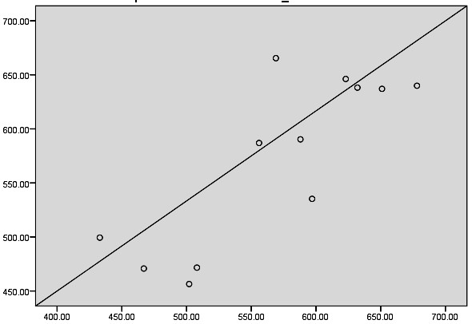
Predicted
Observed
Figure 7: Regression model for seed yield prediction based on GDD, HTU and PTU (from emergence to flower initiation).

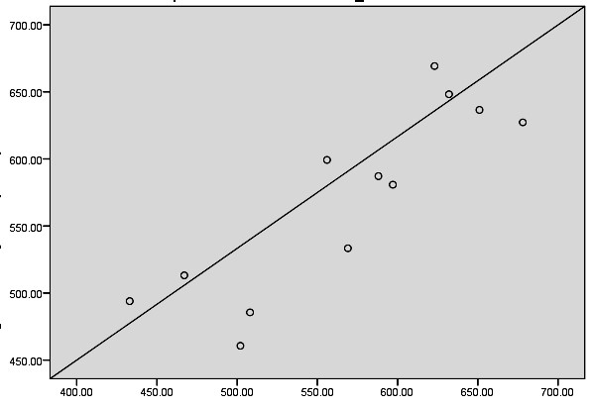

Observed

Predicted

Figure 8: Regression model for seed yield prediction based on GDD, HTU and PTU (from siliquae formation to physiological maturity).

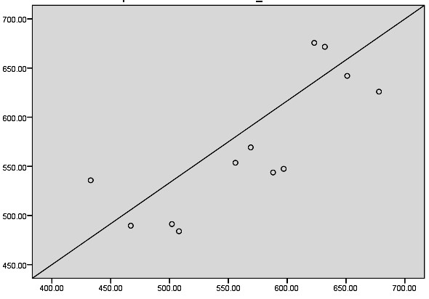
Predicted
Observed
Figure 9: Regression model for seed yield prediction based on AGDD, AHTU and APTU.

5. DISCUSSION
The micro-climatic regimes significantly influenced the crop phenology of toria. Among the different micro-climatic regimes, the crop sown on 15th November (D₁) required significantly higher number of days for the occurrence of different phenophase viz., flower initiation, 50% flowering, siliquae formation and physiological maturity followed by crop sown on 30th November (D₂) and 15th December (D₃). In case of agro-meteorological indices also, the crop sown on 15th November (D₁) availed significantly higher growing degree days, helio-thermal unit and photo-thermal unit as compared to the crop sown on 30th November (D₂) and 15th December (D₃). The significant variation in accumulated thermal units i.e., growing degree days, helio-thermal units and photo-thermal units might be responsible for the variation in crop phenology. The reduction in the number of days for the occurrence of various phenological events under the crop sown on 30th November (D₂) and 15th December (D₃) might be due to the lesser availability of thermal units which was in conformity with the results of Keerthi et al. (2016), Kumar et al. (2017) and Rana et al. (2017).
A positive and significant relationship between dry matter production, yield attributing characters and yield with GDD (growing degree days) at different stages of toria was observed. The growing degree days at different stages viz., emergence to flower initiation, flower initiation to siliquae formation and siliquae formation to physiological maturity were highly significant and positively correlated with dry matter accumulation, yield attributes and yield, which indicated that with increase in growing degree days, the other growth parameters also tend to increase. Similarly, in case of other agrometeorological indices such as helio-thermal unit and photo-thermal unit at different growth stages viz., emergence to flower initiation, flower initiation to siliquae formation and siliquae formation to physiological maturity was found to have positive correlation with dry matter production, yield attributing characters, yield. This indicated that with the increase in agrometeorological indices such as helio-thermal units, other related parameters also tend to increase. Further correlation was done to investigate the relationship among dry matter production at different growth stages i.e., 25, 50 and 75 DAS with crop phenology viz., days to emergence, days to 50% flowering, days to siliquae formation and days to physiological maturity. A significantly strong correlation was found between dry matter accumulation and crop phenology. This signifies that availing more crop duration under the crop sown on 15th November (D₁) resulted in better dry matter accumulation than the crop sown on 30th November (D₂) and 15th December (D₃).
The correlation studies among agro-meteorological indices with dry matter accumulation, yield attributes and yield indicated a significant and strong positive correlation between the parameters. Based on this, with the help of stepwise regression analysis three predictive models were framed, for the prediction of the yield. The micro-climatic parameters viz., growing degree days, helio-thermal unit and photo thermal unit at different stages such as emergence to flower initiation, flower initiation to siliquae formation and siliquae formation to physiological maturity significantly and 137 positively correlated with yield parameters. This relationship helped in the formulation of the multiple regression equations.
The prediction of seed yield from the first equation can be carried out during the initial stage of the crop growth i.e., from emergence to flower initiation period by consideration of growing degree days, helio-thermal unit and photo-thermal unit as the independent variable, while seed yield as the dependent variable. While the second equation can predict the yield by considering of values of the independent variable from siliqua formation to the physiological maturity stage.
The yield prediction with the third equation is mainly based on the accumulated growing degree days, helio-thermal unit and photo-thermal unit throughout the crop growing period. This model can be used as a short-term prediction model for succeeding years for estimation of yield component of the crop, in relation to various agrometeorological parameters.

7. CONCLUSION
In response to different micro-climatic regimes, the crop sown on 15th November (D₁) recorded significantly higher value of plant growth parameters viz., plant height, number of both primary and secondary branches and dry matter production at different growth stages. In case of physiological parameters also, the same micro-climatic regime (D₁) recorded significantly higher leaf area, leaf area index, leaf area duration, crop growth rate, relative growth rate, chlorophyll content and relative water content throughout the crop growing period. The overall crop growing period was found to be higher for the crop sown on 15th November (D₁), while delayed sowing reduces the crop duration. Marked variation on agrometeorological indices was recorded due to the effect of different micro-climatic regimes. Significantly higher accumulated growing degree days, helio-thermal unit and photo-thermal unit were recorded under the crop sown on 15th November (D₁) over 30th November (D₂) and 15th December (D₃). The crop sown on 15th November (D₁), registered better yield attributing characters over the crop sown on 30th November (D₂) and 15th December (D₃). Likewise, significantly higher seed yield, stover yield, harvest index and oil yield were documented in the crop sown on 15th November (D₁). Based on plant growth, physiological parameters, seed yield, oil yield and economics, the sowing of the crop on 15th November can be considered best for enhancing the production of rapeseed (Brassica campestris var. toria) under rainfed condition.

REFERENCES
Deka, P.; Pathak, K.; Begum, M.; Sarma, A. and Dutta, P. (2018). Seed yield and nutrient uptake in late sown toria as influenced by different irrigation and fertilizer levels. Agricultural Science Digest - A Research Journal. 8: 127-130.
Ghosh, R. K. and Chatterjee, B. N., (1988). Effect of dates of sowing on oil content and fatty acid profiles of Indian mustard. Indian J.Oilseed Res. 5 (2): 144-149.
Government of Assam, (2022). Directorate of Economics and Statistics of Assam. https://des.assam.gov.in/
Keerthi, P.; Pannu, R. K.; Singh, R. and Dhaka, A. K. (2016). Thermal requirements, heat use efficiency and plant responses of Indian mustard (Brassica juncea) for different levels of nitrogen under different environments. Journal of Agrometeorology.18: 201-205.
Kumar, Y.; Singh, R.; Kumar, A. and Dhaka, A. K. (2017). Phenological behaviour of Indian- mustard genotypes under different sowing environments at Hisar. Indian Journal of Ecology. 44 (3): 255-258.
Kumari, A.; Singh, R.P. and Yeshpal. (2011). Performance of mustard hybrids under different sowing dates and spacings. Pantnagar. Journal of Research. 9 (1): 16–19.
Nanda, R.; Bhargava S.C.; Tomar, D.P.S. and Rawson, H.M. (1996). Phenological development of Brassica campestris,B. juncea, B. napus and B. carinata grown in controlled environments and from 14 sowing dates in the field. Field Crops Res.46: 93-103.
Pandey, B. P.; Srivastava, S. K. and Lal, R. S. (1981). Genotype x environment interaction in lentil. LENS. 8: 14-17.
Panse V.G. and Sukhatme P.V. (1985). Statistical Methods for Agricultural Workers. Indian Council of Agricultural Research, New Delhi.
Rana, R. S.; Vaijinath, B. A.; Kumar, S. and Pathania, R. (2017). Forecasting phenology of mustard crop in North- western Himalayas. Journal of Applied and Natural Sciences. 9 (1): 230-236.
United states department of agriculture, foreign agricultural services, (2024). World agricultural production. Https://www.fas.usda.gov/data/world agricultural-production.

