**Evaluating the interaction of zinc and copper on biochemical activities of vegetatively grown *Bacopa monnieri* (L.)**

**Abstract:**

To find out the effect of foliar application of zinc and copper alone/combinations on biochemical activities of *Bacopa*, an experiment was conducted during two successive years (2019-2020) of field experiment at GBPUA&T, Pantnagar. The treatments of ZnSO4 and CuSO4 given as (BM0: CONTROL; BM1:1ppm Cu; BM2:2.5ppm Zn; BM3:5ppm Zn; BM4:0.5ppm Cu+5ppm Zn; BM5:1ppm Cu+2.5ppm Zn; BM6:1ppm Cu+5ppm Zn). Two foliar application was given in 30 days of interval and samples were collected and analysed after 10 days of each spray. The experimental results revealed that the biochemical traits shown significant increment mostly with 1ppm CuSO4 , 5ppm ZnSO4 and 2.5ppm ZnSO4 in photosynthetic pigments over control during 2019-2020. The plants response to 2.5ppm ZnSO4 significantly increased the NRA and protein content when compared with control in both year. The highest TPC noticed when plants subjected to 5ppm ZnSO4 than control during 2019. Whereas the highest values of phenols achieved at 1ppm CuSO4+5ppm ZnSO4 over control in 2020. The maximum value of TFC noticed when plants subjected to 1ppm CuSO4 and 5ppm ZnSO4 over control during 2019. While, maximum value of flavonoid content with 2.5ppm ZnSO4 when compared with control in 2020.Zn concentration increased significantly in BM6 treated plants while Cu content increased notably with both BM1 and BM6 treatments that of control plants in 2019 and 2020. The result also suggested 2.5ppm Zn treatment exhibit highest content of bacoside-A (0.31%). The finding underscores the efficacy of Zn and Cu in enhancing photosynthetic pigments, nitrogen assimilation activity and boosting antioxidant capacity in *Bacopa*, offering promising implications for further research in pharmaceutical and agriculture sectors.

**Keywords:** Photosynthetic pigment. Flavonoid. Phenol. Bacoside

**Abbreviation:** NRA: nitrate reductase activity TPC: total phenol content TFC: total flavonoid content

**INTRODUCTION**

Involvement of essential macro/micro nutrients in various enzymatic processes regulate production of secondary metabolites. Micronutrient such as Zn and Cu required in many structural and biochemical function in plants including plant growth, oxidation-reduction reactions, electron transport and many other metabolic processes. *Bacopa monnieri* (L.), a semi-aquatic non-aromatic herb. The presence of phenolic (total phenols, tannins, and flavonoids), and non-phenolics (alkaloids, sterol, resins, terpenoids, xanthoproteins, quinones, glycosides and saponins) compounds in *Bacopa* plant might be responsible for its therapeutic role and other pharmacological properties (**Fatima *et al. 2016***, **Shamiya *et.al* 2024, Tamta e*t al*. 2024).** Ancient Vedic scholars used this herb because of its pharmacological effects, particularly as a nerve booster and nootropic supporter **(Srivastava *et. al* 2024).** Hence,The objectives of this study was to detect the effect of different levels of Zn and Cu singly/combine to achieve the quality by examining its biochemical traits on *Bacopa monnieri* and the accumulation of the test metals.

**MATERIAL AND METHODS**

The stolons (5-7 cm length with uniform thickness) of *Bacopa monnieri* (variety CIM-Jagriti), were obtained from CSIR-CIMAP, Lalkuan, Uttarakhand and grown for two months in well-watered condition at the experimental site of Mango Garden Dept. of Plant physiology, GBPUA&T, Pantnagar during Monsoon and Winter season (2019-2020). This experiment was laid out in Randomized Block Design with three replications. After fully establishment of crop, plants were subjected to 16 different treatments of CuSO4 and ZnSO4 alone and combinations of both against control. Treatment details are as follows: [T0: (CONTROL); T1: (0.5ppm CuSO4); T2: (1ppm CuSO4), T3: (1.25ppm ZnSO4); T4: (2ppm CuSO4); T5: (2.5ppm ZnSO4); T6: (5ppm ZnSO4); T7: (0.5ppm CuSO4+1.25ppm ZnSO4); T8: (0.5ppm CuSO4+2.5ppm ZnSO4); T9: (0.5ppm CuSO4+5ppm ZnSO4); T10: (1ppm CuSO4+1.25ppm ZnSO4); T11: (1ppm CuSO4+2.5ppm ZnSO4); T12: (1ppm CuSO4+5ppm ZnSO4); T13: (2ppm CuSO4+1.25ppm ZnSO4); T14: (2ppm CuSO4+2.5ppm ZnSO4); T15: (2ppm CuSO4+5ppm ZnSO4)]. Harvesting was done after third and fourth months of planting. Two foliar sprays were applied 30 days before each harvest (90 and 120 days after sowing). All the morphological observations were recorded at the day of harvest. Biochemical parameters were analysed after 10 days of each spray. Based on morphological parameters that pronounced mostly, higher and lower values in growth pattern after each foliar treatments, six concentrations were selected including control for analysis as given: [BM0: (CONTROL); BM1: (1ppm CuSO4); BM2 (2.5ppm ZnSO4); BM3: (5ppm ZnSO4); BM4: (0.5ppm CuSO4+5ppm ZnSO4); BM5: (1ppm CuSO4+2.5ppm ZnSO4); BM6: (1ppm CuSO4+5ppm ZnSO4)].

**Chlorophyll and Carotenoid estimation**

Chlorophyll and carotenoid content was analysed by the method of (**Hiscox and Israelstam 1979).** Fresh mass of leaves (50 mg) was placed in a test tube containing 10 ml of dimethyl sulfoxide (DMSO) solution and incubated at 65oC for three hours. Reading measured at 480, 649.1 and 665.1 nm. Pure DMSO was used as blank. The chlorophyll a, chlorophyll b and carotenoid were calculated using the formula given by **(Wellburn 1994).**

**Chlorophyll ‘a’ (mg/g FW) =**



**Chlorophyll ‘b’ (mg/g FW) =**



**Total Chlorophyll (mg/g FW) =** Chlorophyll ‘a’ (mg/g FW) + Chlorophyll ‘b’ (mg/g FW)

**Carotenoid Content** (**mg/g FW)** **=**



where,

Wt.= weight of sample taken in grams

V= volume of DMSO used in ml

A480 = Absorbance at 480 nm

A 649.1 = Absorbance at 649.1 nm

A665.1 = Absorbance at 665.1 nm

**Nitrate reductase activity**

Nitrate reductase activity was determined according to (**Hageman and Huckles 1971).** Fresh plant leaves (0.5 g) were homogenized in 10 mL phosphate buffer (0.3 M) having pH 7.5. One set of the homogenate (1 ml) reacted with 1 ml of 0.4 M KNO3 and incubated in dark for 40 min and another set for 10 min at 30°C. After incubation, 0.5 mL of 1% sulphanilamide and 0.5 mL of 0.02% 1-naphthyl ethylene diamine dihydrochloride were added and placed for half an hour. Absorbance was measured at 540 nm.

The amount of nitrate reductase activity produced by g fresh weight of sample was calculated by the following formula,

µ mol NO2- /g fresh weight at 10 min **=**



µ mol NO2- /g fresh weight at 40 min =



NR enzyme activity (µ mol NO2-/g fresh weight h-1) = 2 (nitrate produced at 40 min – nitrate produced at 10 min)

**Estimation of protein**

Protein was determined in fresh leaves following the protocol of **(Lowry *et al*. 1951).** Fresh tissue (0.5 g) was macerated in 3.0 ml of 100 mM potassium phosphate buffer (pH 7.0) using mortar and pestle. The homogenate was then centrifuged at 15,000 g for 20 minutes. To 0.1 ml of supernatant, 5 ml of Reagent C at 50:1 ratio (50 ml of reagent A and 1.0 ml of reagent B) was added (Reagent C: mixture of reagent A and B at 50:1 ratio; Reagent A – 2.0 % sodium carbonate in 0.1N sodium hydroxide; Reagent B – 0.5% copper sulphate in 1.0 % potassium sodium tartrate). The tubes were allowed to stand in dark for 10 minutes at RT after Folin-ciocalteau reagent (0.5 ml) was added. The absorbance was read at 560 nm in a spectrophotometer. Bovin serum albumin was used as the standard.

**Total phenols estimation**

Total phenol content was determined according to the method of Folin Ciocalteu reaction **(Mundhe *et al.* 2011).** Fresh leaves (500 gm) were crushed and homogenized in 80% ethyl alcohol (v/v). It was then centrifuged at 10,000 rpm at 4°C for 20 min. Then 0.1 ml of supernatant was taken and 0.5 ml Folin – Ciocalteau reagent was then added, to it. After 3 min, 2 ml of 20% Sodium carbonate solution was mixed thoroughly and placed in warm water bath (580C) for 1 min then cooled to RT. Absorbance was read at 750 nm usingFolin ciocalteau reagent as blank. Phenolic content was evaluated using standard plot of catechol.

**Flavonoid estimation**

Flavonoid estimation was done according to **(Ordonez *et al.* 2006)** by using Quercitin as a standard. Fresh leaves (500 gm) were crushed and homogenized in 80% ethyl alcohol (v/v). It was then centrifuged at 10,000 rpm at 4°C for 20 min. The collected supernatants were dried by evaporation in a water bath at 68°C. The residue was dissolved in 10 ml of distilled water. The dry residue was dissolved in 5 ml of distilled water. 0.1 ml of supernatant was taken the final volume made upto 3 ml by adding 1.5 ml of 2% AlCl3 ethanol solution. The mixture was incubated for 1 h at room temperature till yellow colour appears. Blank was prepared by adding 1.5 ml water and 1.5 ml 2% AlCl3. The absorbance was measured at 420 nm.

**Micronutrient estimation**

Zinc and Copper were determined by **[4].** 0.5 g dried leaf sample was taken and 10 ml tri- acid mixture (10:1:4v/v) was added overnight. Next day, the flask was heated until brown fumes appear than 10 ml of TCA was added and heated until appeared transparent. Add 5 ml 6 N HCl solution. Filter it and makeup volume up to 50 ml with distilled water. The digested samples were analysed with the help of atomic absorption spectrometer (AAS). The respective elements were estimated in test sample by preparations standard curve.

**Bacoside content**

For Bacoside content three treatments were selected: (bm0: CONTROL; bm1:1ppm CuSO4 and bm2:2.5ppm ZnSO4) and one-gram dried leaf samples were sent to CSIR-CIMAP for HPLC analysis. *2.9.1. Sample preparation:* One gram of Bacopa leaves were powdered and 100 mg of each sample were extracted three times in 10 ml of methanol with sonication for 30 min at room temperature. The extract was filtered, and the filtrate was evaporated to dryness. Obtained residue was dissolved in 1 ml of HPLC grade methanol for analysis.

*HPLC analysis conditions:* The mobile phase was A- water, B- acetonitrile, 70: 30 (v/v) (A: B system) (Isocratic). The flow rate was 1.5 ml/min, Column: Chromolith Performance RP-18e (100 X 4.6 mm, 5 μm), 10 μL of Injection volume, run time of 30 min and detection was done at 205 nm.

**Statistical analysis:**

Experiments were performed in one-way Randomized block design (RBD) with three replications for each treatment. Collected data were analysed statistically by using statistic 10 software to analysis of variance (ANOVA) and the means compared by Duncan’s multiple range test (P < 0.05). The values are expressed as means ± S.D. of the three replicates, and *P* values ≤ 0.05 were considered to be significant.

**RESULT AND DISCUSSION:**

**Photosynthetic pigments:**

It was observed after each foliar application, BM1 treated plants brought about an increment of 48.20% and 38.39% on ‘chlorophyll a’ that of control during 2019. Exposure to BM2 showed rise up to 97.46% over control in ‘chlorophyll a’ during 2020. The highest ‘chlorophyll b’ was obtained with BM2, improvement upto 183.75% followed by BM5 by 182.17% rise in 2019 compared with the control after each foliar application. Among the various foliar treatments during 2020, BM2 showed enhanced ‘chlorophyll b’ upto 248.01% increment meanwhile BM4 recorded downfall about 26.05% that of control**.** During 2019 and 2020, the maximum average value of total chlorophyll recorded in BM2 that found to increase upto 72.12% and 96.64% while, there is a decline in total chlorophyll content with response to BM6 and BM4 but do not exhibit lower values than control. In case of carotenoid content, BM3 that rise up to 229.44% and 199.66% when compared with control, during 2019. It is found BM3 along with BM6 showed 240.63% and 228.13% rise in carotenoid content with control during 2020, data shown in **(Fig.1(A)).**

Cu is known for disturbing the photosynthetic apparatus by altering the structure of chloroplast and composition of thylakoid membrane **(Quartacci *et al.,*** [**2000**](https://www.tandfonline.com/doi/full/10.1080/23311932.2016.1276821)**).** At toxic levels, Cu replaces Mg2+ by inhibiting synthesis of aminolevulinic acid (precursor of chlorophylls) and protochlorophyllide reductase (enzyme to catalyze the reductive formation of chlorophyllide). Zn can also help increase the biosynthesis of chlorophylls and carotenoids and enhance the photosynthetic apparatus of the plant **(Aravind and Prasad 2004).** Carotenoids, especially [**β carotene**](https://www.sciencedirect.com/topics/agricultural-and-biological-sciences/beta-carotene), play an important role in the detoxification of reactive oxygen species and in protecting the photosystems from photooxidation **(**[**Di Toppi *et al.,* 2009**](https://www.sciencedirect.com/science/article/pii/S0098847217301922?casa_token=AwYhrTV1In4AAAAA:_PO1g7-fsfWqAl5oYGhFHNJugBepDr3vKUDcBkH8Phxux_ZqUUdHjzCncgpOor0RqL111CFvsw#bib0075)**).** Earlier study showed that the amounts of photosynthetic pigments decreased at high concentrations of zinc and copper so that the total chlorophyll content when applied with different level of ZnSO4 (0, 350 and 550 µM) and CuSO4 (0, 20 and 40 µM) in Basil (**Saljoughi and Ranjbar, 2019).** A study was investigated the effects of different concentrations of copper sulphate (0, 75, 125, and 175 ppm) on the morphological and biochemical features of *Spinacia oleracea* and *Avena sativa*. At this concentration, chlorophyll a & b levels increased significantly in *Spinacia oleracea*(462.9 and 249.8 𝜇𝑔/𝑔), and *Avena sativa* (404.7 and 437.63𝜇𝑔/𝑔). However, carotenoid content and sugar levels in Spinacia oleracea were negatively affected, while sugar content in *Avena sativa*increased at 125 ppm (941.6 µg/ml) **(Zeb *et al.,* 2024).**

**Nitrogen assimilation indicators**

During the study maximum plant subjected to BM2 reported increase in NRA by 101.33% elevation during 2019. Similar trend was found during 2020, plants exposed to BM2 showed NRA increased by 88.31% of control. Results of the experiment showed that plants response to BM2 significantly influenced the protein content that reached upto 57.59% and 53.96% during both years, represented in **[Fig.1(B) and (C)].**

Our results are in agreement with a study of 20 days old seedlings of tomato (cv. PKM-1) were dipped in double distilled water (control), 10, 50, 100 or 200 ppm of ZnO for 15, 30 or 45 min, respectively, noted maximum NRA were noted in the plants at 10 ppm of ZnO dipped in for 30 min which was 20%, 30%, 23% and 32% higher as compared to control respectively at 45 and 60 DAS (**Faizan *et al.,* 2020**).Data showed that three foliar sprays of 0.5% ZnSO4 (1st at 4-5 leaves stage 2nd and 3rd after one-week interval) in maize gave higher values of protein contents (10.02%) were recorded in treatment T7; whereas, significantly lower value (8.12%) of protein contents was observed without spray **(Tahir *et al.* 2016).** Similar results were found in maize **(Esmaeili *et al*. 2016)** indicated that foliar applications of ZnSO4 (0, 500 and 1000 mgl-1) showed maximum value of total protein content. Zn and Cu play a crucial role in various plant processes, including photosynthesis, respiration, protein and enzyme biosynthesis, cell division, carbohydrate and nitrogen metabolism, and cell wall lignification. They also participate in the structure of proteins, electron transfer reactions, protection against oxidative stress, ATP production, and hormone signaling **(Nekoukhou *et al.,* 2024)**

**Antioxidant compounds**

According to the experiment, the highest total phenolic content noticed when plants subjected to BM3 which is close to BM2 that reached upto 75.86 and 75.55% than control during 2019. Whereas in 2020 the highest values achieved at BM6 that gave 112.85% rise over control. Among the foliar treatments phenol content is more that of control**.** The same enhancing trend of flavonoid content in the leaves of *Bacopa* plants recorded maximum when plants subjected to BM1 and BM3 increased upto 78.07% and 68.74% over control in 2019. While in case of 2020, maximum value of flavonoid content in the leaves markedly increased with BM1, BM2 and BM3 about 86.47%, 95.68% and 88.57% increment after each foliar treatments when compared with control, data showed in **(Fig.1. (D) and (E)).**

Phenolics are mainly synthetized from cinnamic acid, which is formed from phenylalanine by the action of L-phenyloalanine ammonia-lyase PAL (EC 4.3.1.5), the branch point enzyme between primary (shikimate pathway) and secondary (phenylopropanoid) metabolism (**Dixon and Paiva, 1995**). Copper also plays an important role in the synthesis of phenolic compounds and its deficiency can decrease phenolic content in the plants **(Hejazi-mehrizi *et al.* 2012).** Zn influences the expression of phenolic biosynthesis pathway genes **(Song *et al.* 2015)**. Flavonoids have a key function as antioxidants in stressed plants, reducing ROS. The flavonoids, especially derivatives of quercetin, affect the auxin transport in the cells as well as in the apoplast **(Di Ferdinando *et al.***[**2012**](https://link.springer.com/article/10.1007/s10725-019-00527-w#ref-CR11)**).**

Zn had more efficient antioxidant system compared with Cu it might be due to Zn determines the tolerance of plants against Cu toxicity. Our results are in parallel with previous findings in *Brassica juncea* **(Ahmad *et al.,* 2017)** where Zn application protected plants from oxidative damage by stimulating the activities of antioxidant enzymes. This is in agreement with previous studies marigold, foliar applied with five different concentrations of zinc nitrate (control; 0.5, 1, 1.5 and 2 mgL−1) showed highest amount of phenol (46.78 mg GAE/g DW) was recorded in 2 mgL−1 treatments. The highest flavonoid content (8.84 mg quercetin/g DW) was observed in the 1 mgL−1 treatment and the lowest (6.07 mg quercetin/g DW) was in the 0.5 mgL−1 **(Sobati-Nasab *et al.,* 2021).** This work is aimed at relationships which govern zinc and copper uptake by four popular medicinal herbs: basil (*Ocimum basilicum* L.), borage (Borago officinalis L.), common nettle (*Urtica dioica* L.) and peppermint (*Mentha piperita* L.). The content of phenolic compounds in common nettle increased by 53% after copper supplementation and by 57% when the zinc treatment was applied. For basil, those values were 38% (copper supplementation) and 28% (zinc supplementation), respectively, while no significant differences were observed for peppermint and borage **(Adamczyk-Szabela 2024).**

**Micronutrient estimation:**

Compared with the control, Zn content increased after exposure to BM6 that recorded 136.17% more that of control in year 2019. Similar trend observed in the year 2020, after treatment with serial concentration, Zn content increased almost in BM6 and BM5 level rise at 187.17% and 144.91% as compared to control**.** Compared with the control, no differences were noticed in the content of Cu when exposed to different concentration during 2019 experimental trial. It is clearly showed that BM2 increased content of Cu by 32.78% when compared with control plants. During 2020, foliar spray of BM6 and BM1 recorded highest Cu content rise by 47.16% and 37.52% that of control represented in **(Fig.2. (A) and (B)).** Zn role on protein synthesis, cytochrome function, carbohydrate, nucleic acid and lipid metabolism. Cu is also an essential element and involved in photosynthesis, respiration, oxidative stress protection and cell wall synthesis **(Tamta *et.al,* 2021)**. A research was conducted in basil (*Ocimum basilicum*), the highest level of Cu (12.91 ± 2.38 µg/g) was observed in the treatment of Cu foliar spray, which was 83.64% higher compared to the control (water spray). The highest level of Zn (54.02 ± 4.75 µg/g) was observed in the zinc foliar spray treatment, which was 41.71% higher compared to the control treatment (water spray). The lowest level of Zn was obtained in the Cu foliar spray treatment **(Aghamirzaei *et al.* 2024**).

**Main Bioactive compounds:**

In this study, we quantified dried samples of treated with bm0, bm1 and bm2 (conc.). As shown in chromatogram fig…. of different constituents of bacoside-A, HPLC analysis indicated that bm2 led to lower (21.83%) peak area of Bacoside A3 as compared to bm1 and bm0 that recorded similar peak area (22.33%). A minor difference between bm0 and bm1 was noticed in Bacopaside II. The examination of bm2 have lesser peak area (26.97%) when compared with bm0 and bm1 i.e. (33.62%) and (34.00). For the jujubogenin isomer of Bacopasaponin C, it is noticed bm0 appeared highest peak area (19.84%) followed by bm1 and bm0 that received (18.22%) and (17.25%), respectively. Comparing the peak area Bacopasaponin C found more in b2 treated plants (31.37%) with respect to bm0 and bm1 peak area (26.55%) and (26.27%). Present findings result showed that bm2 treatment gave the highest content of bacoside-A (0.31%). However, bm0 and bm1 gave the same result of bacoside-A content (0.21%). The results indicating that Zn is more effective, increment of about 32.20% in Bacoside-A content than untreated and Cu treated plants, data represented Fig.3. In *Lavandula sublepiodata* Rech. F. foliar application of Cu-jujube and Cu-neem Cu–NCs at concentrations of 0, 10, 25, and 50 mgL−1 was applied results suggested that CuNCs demonstrate notably greater effectiveness, particularly at an ideal concentration of 25 mg L−1, in enhancing the production of essential oil and bioactive compounds **(Mazraeh, Ali, *et. al* 2024).** Elicitation of peppermint with MeJA at different Zn levels modified the EO composition. The highest menthol content (50.1%) was observed in the 1 mM MeJA and 0.025 mgL−1 Zn treatment groups **(Mehdizadeh, L., 2024).**

**Conclusion:**

Conclusively, our result suggests with an appropriate concentration of micronutrient application photosynthetic activities, NRA and protein content increases that give valuable information about the better functioning of plant. *Bacopa* crop a good source of antioxidant properties and available throughout the year, hence a clear understanding of Zn and Cu benefits boosting antioxidant activity and bioactive compounds is confirmed. However, treatment of medicinal plants such as with Cu and Zn or with their certain combination can be introduced as an efficient technique in order to produce more desired pharmaceutically active compounds for drug industries and medical supplies.

**References**

Fatima, A., Mehra, I., & Nishchal, N. K. (2016). Optical image encryption using equal modulus decomposition and multiple diffractive imaging. Journal of Optics, 18(8), 085701.

Tamta, R., Nayaka, S., & Kumar, B. (2024). Analysis of Antimicrobial Properties of Lichen Taxa Usnea eumitrioides Motyka against Plant Pathogens: Lichens. INTERNATIONAL JOURNAL OF PLANT AND ENVIRONMENT, 10(03), 198-202.

Shamiya, Y., Chakraborty, A., Zahid, A. A., Bainbridge, N., Guan, J., Feng, B., ... & Paul, A. (2024). Ascorbyl palmitate nanofiber-reinforced hydrogels for drug delivery in soft tissues. Communications Materials, 5(1), 197.

Srivastava, P., Yadav, D., Singh, S. K., Kim, S. H., Singh, S., Katiyar, S., & Song, M. (2024). Investigating Bacopa monnieri L. Therapeutic Potential for the Treatment of Neurological Diseases. Current Pharmaceutical Design, 30(13), 1016-1030.

Hiscox, J. D., & Israelstam, G. F. (1979). A method for the extraction of chlorophyll from leaf tissue without maceration. Canadian journal of botany, 57(12), 1332-1334.

Wellburn, A. R. (1994). The spectral determination of chlorophylls a and b, as well as total carotenoids, using various solvents with spectrophotometers of different resolution. Journal of plant physiology, 144(3), 307-313.

Mundhe, K. S., Kale, A. A., Gaikwad, S. A., Deshpande, N. R., & Kashalkar, R. V. (2011). Evaluation of phenol, flavonoid contents and antioxidant activity of Polyalthia longifolia. J Chem Pharm Res, 3(1), 764-9.

Ordonez, A. A. L., Gomez, J. D., & Vattuone, M. A. (2006). Antioxidant activities of Sechium edule (Jacq.) Swartz extracts. Food chemistry, 97(3), 452-458.

Quartacci, M. F., Pinzino, C., Sgherri, C. L., Dalla Vecchia, F., & Navari‐Izzo, F. (2000). Growth in excess copper induces changes in the lipid composition and fluidity of PSII‐enriched membranes in wheat. Physiologia Plantarum, 108(1), 87-93.

Aravind, P., & Prasad, M. N. V. (2004). Zinc protects chloroplasts and associated photochemical functions in cadmium exposed Ceratophyllum demersum L., a freshwater macrophyte. Plant Science, 166(5), 1321-1327.

**Fig. 1.** **Effect of Zn and Cu sole/combination treatments on fresh leaves (A) Photosynthetic pigments (mg g-1 FW) (B) Nitrate reductase activity (µM per min) (C) Total protein content (mg g-1 FW) (D) Total Phenol content (mg g-1 FW) (E) Total Flavonoid content (mg g-1 FW) during two successive years (2019-2020) and their change in relation to control plants. (Abbreviation: chl: chlorophyll TC: total chlorophyll CAR: carotenoid)**

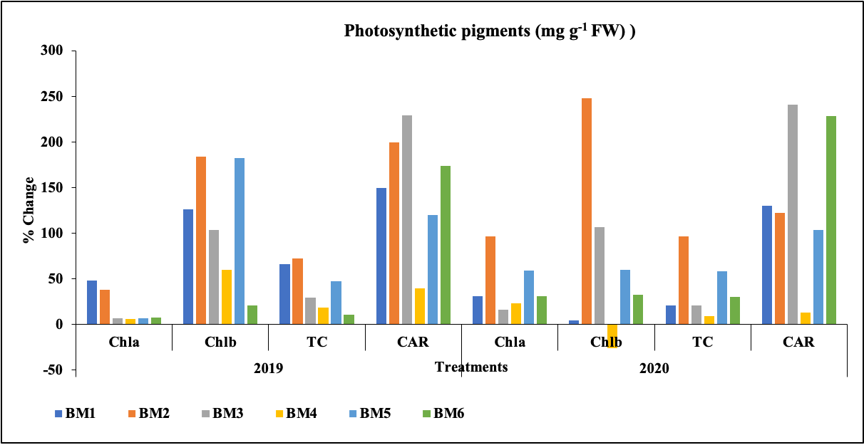

**(A)**

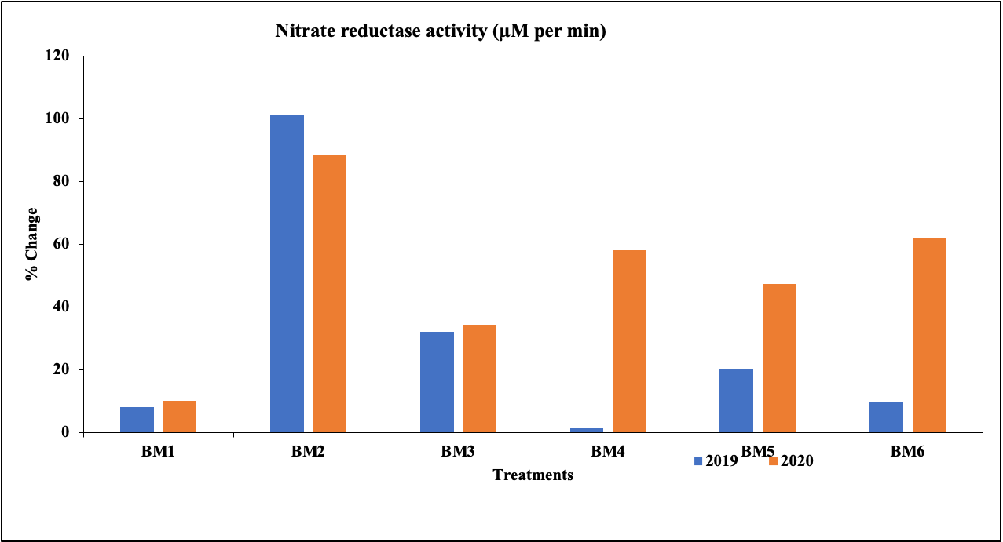

**(B)**

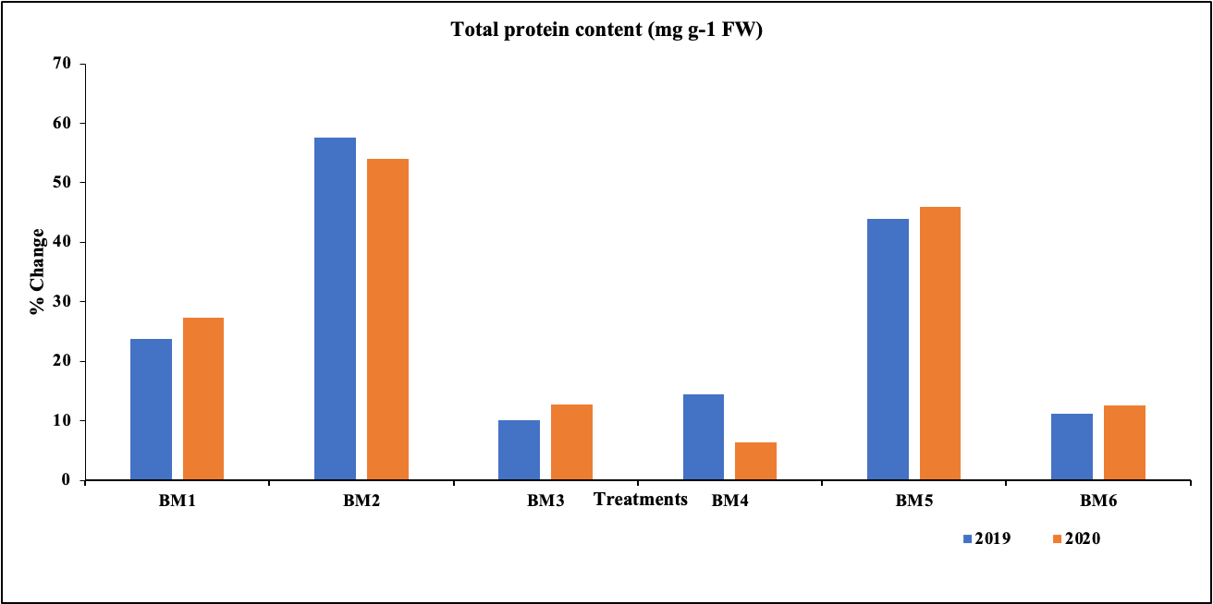

**(C)**

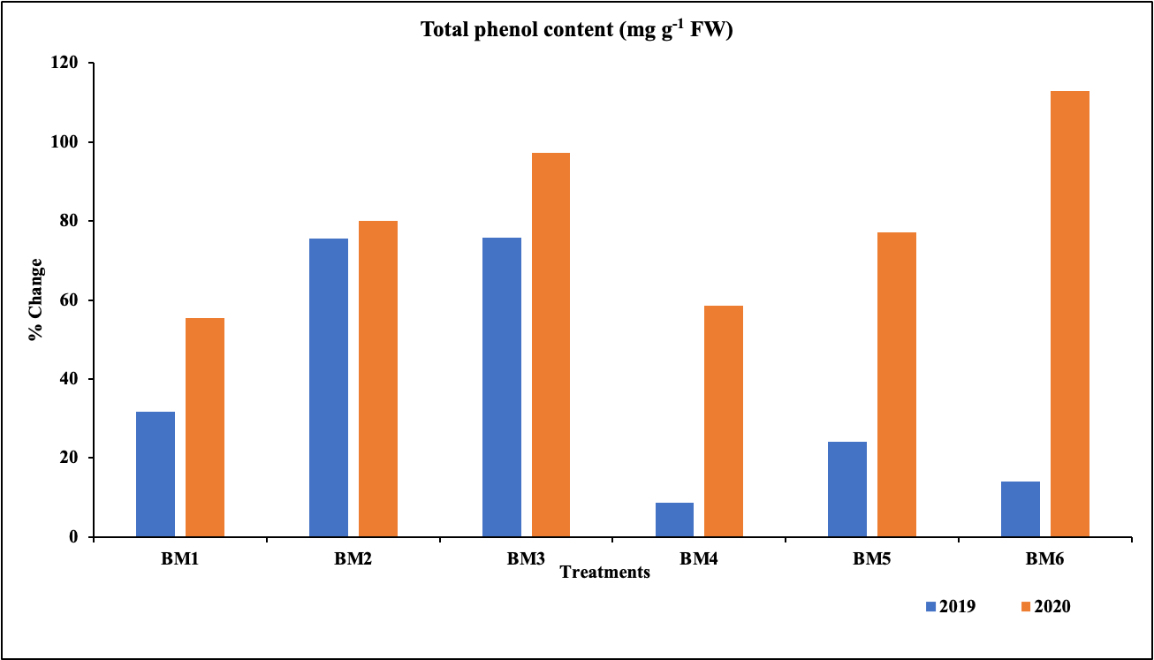

**(D)**

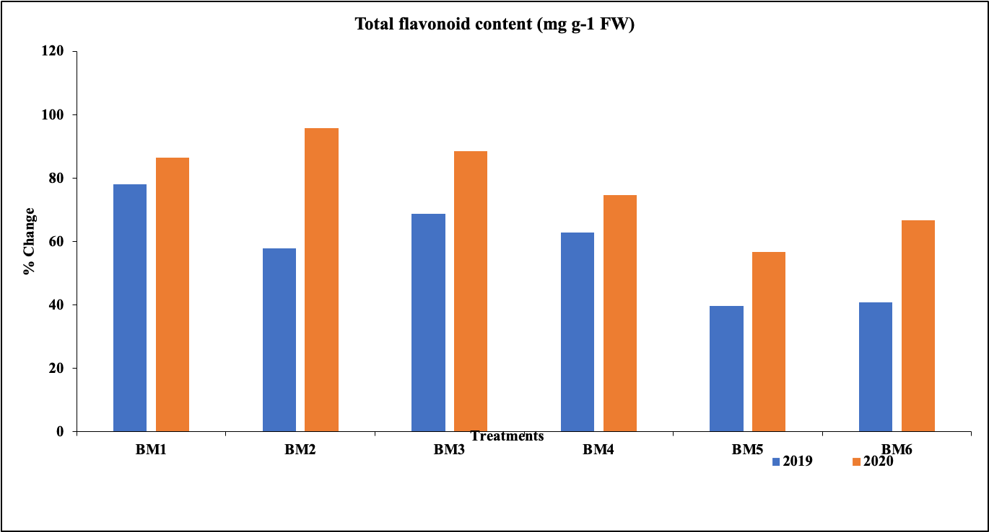

**(E)**

**Fig. 2.** **Effect of Zn and Cu sole/combination treatments in 0.5 g dried leaves of *Bacopa monnieri* (A) Zinc content (ppm) (B) Copper content (ppm) during two successive years (2019-2020) and their change in relation to control plants.**

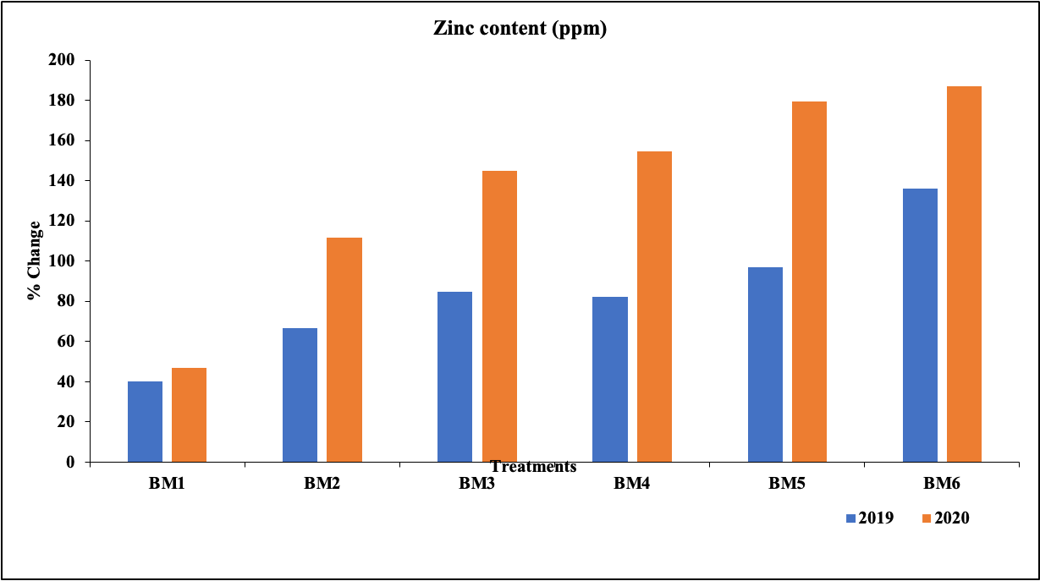

**(A)**

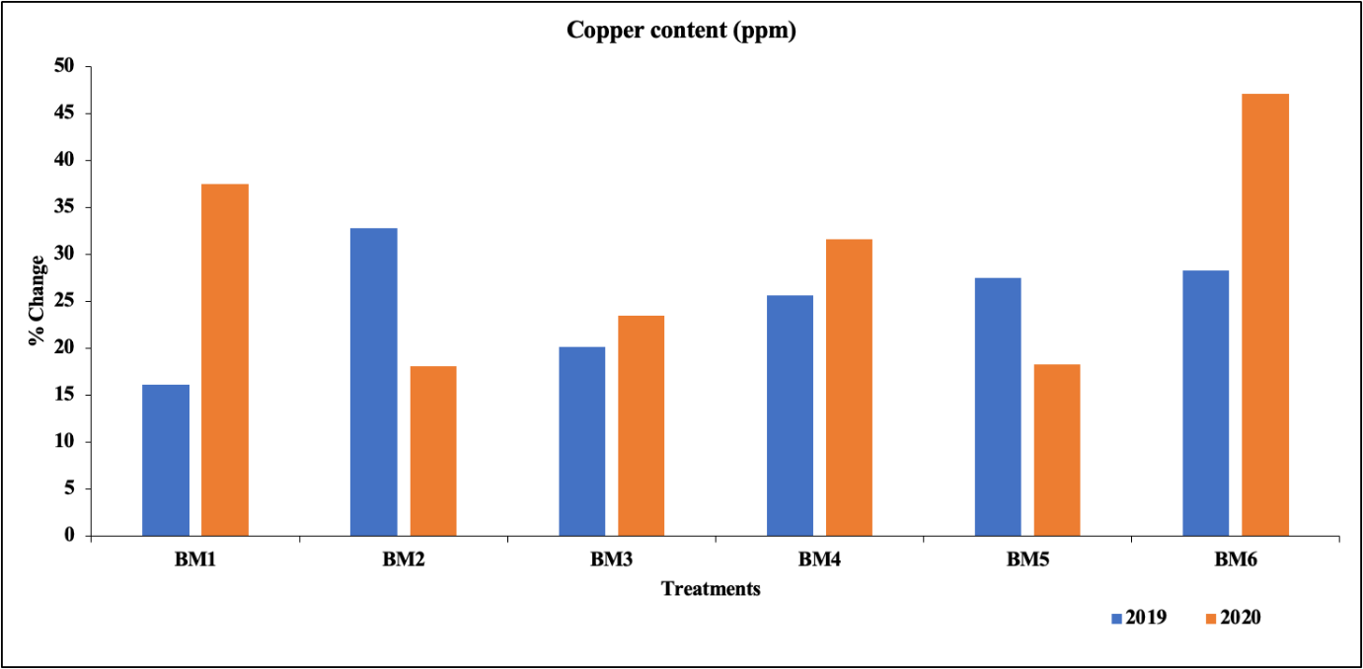

**(B)**

**Figure.3. HPLC chromatogram of *Bacopa monnieri***

