Enhancing Tomato Seed Vitality through Cold Plasma Treatment with Seed Flipping: A Path to Optimal Plant Growth
Abstract
This study investigates the effects of atmospheric pressure dielectric barrier discharge (DBD) cold plasma treatment on tomato seeds, focusing on the enhancement of seed vigor and germination rates. The research demonstrates that treatment duration of 24 seconds, combined with a seed flipping technique, significantly improves the hydrophilic properties of the seed surface, leading to increased water absorption and enhanced germination performance. The results indicate that plasma treatment not only elevates the germination percentage from 56% in the control group to 82% in treated seeds but also optimizes root and shoot lengths, thereby contributing to a higher vigor index. The study highlights the importance of uniform plasma exposure, as overexposure to a single side of the seed can adversely affect seed performance. These findings suggest that incorporating seed flipping in plasma treatment protocols can maximize the benefits of this innovative technology, paving the way for improved agricultural practices and seed treatment methodologies. Future research should focus on the mechanistic understanding of plasma-induced changes in seed physiology and the development of optimized treatment systems for commercial applications.
Keywords: Cold plasma seed treatment, eco-friendly agriculture, germination rate, seed Flipping, seed surface hydrophilicity, vigor index.
Introduction
Cold plasma seed treatment is a cutting-edge approach in eco-friendly agriculture that holds promise for boosting plant growth. Unlike techniques like space breeding or mutation breeding with particle beams, which can alter plant genes, this method uses non-ionizing, low-level radiation (cold plasma) to gently activate the seeds' vitality without causing mutations. This makes it a safe and potentially transformative technology for improving plant health and productivity.
Cold atmospheric non-thermal plasma (CANTP) has been a subject of intense research for years, leading to the development of various generator types. The most popular options include the Cold Atmospheric Plasma Jet (CAPJ), which offers a directed flow of plasma. Dielectric Barrier Discharge (DBD) reactors provide a more contained environment for plasma generation. Radio frequency (RF) reactors utilize radio waves to create plasma, while surface DBD sources offer a flat configuration for treating surfaces directly. This diversity of generator designs allows researchers and industrial users to tailor CANTP technology to specific applications.
Plasma seed treatment in tomatoes involves exposing tomato seeds to a low-temperature plasma, which consists of ionized gases that generate reactive oxygen and nitrogen species. This treatment is considered non-thermal, meaning it does not significantly raise the seed temperature, thereby preserving seed viability. The CANTP also enhances morphological and biochemical attributes of tomato seeds (Sultan et al., 2024). The primary goal of plasma seed treatment in tomatoes is to enhance seed germination, seedling vigor, and overall plant growth. The RONS generated by plasma treatment are can potentially stimulate various biochemical processes within the seed, including the activation of antioxidant enzymes, which can help seeds withstand stress conditions such as drought or disease pressure.
Research by Zivkovic et al. (2004) showed that treating Paulownia tomentosa seeds with non-thermal cold air plasma before planting significantly increased their germination rate. This suggests that cold air plasma could be a valuable tool for improving the germination success of this tree species. Building on the potential for improved germination, research has also found benefits for mature wheat plants. Studies have shown that cold plasma seed treatment can lead to increased growth and yield (Jiang et al., 2014). This suggests that cold plasma technology could not only improve germination rates but also contribute to a more productive wheat harvest. Early research explored the potential of microwave plasma (Chau et al., 1996), while non-thermal cold plasma as a seed sterilization studies showed that cold plasma treatment was effective in eliminating bacterial cells and spores, particularly those belonging to the Bacillus genus (Hury et al., 1998). This discovery suggests a promising application for cold plasma in reducing seed-borne diseases and improving overall crop health. One aspect almost all the researchers have not addressed in their research is the effect of flipping the seeds, this is more important for flat seeds as the bottom of the seeds tends to be exposed to fewer reactive species when compared to the exposed side of the seed. This aspect has been investigated in the present paper and will be elaborated in the subsequent sections.
Materials and Methods
About the device - Plasma reactor
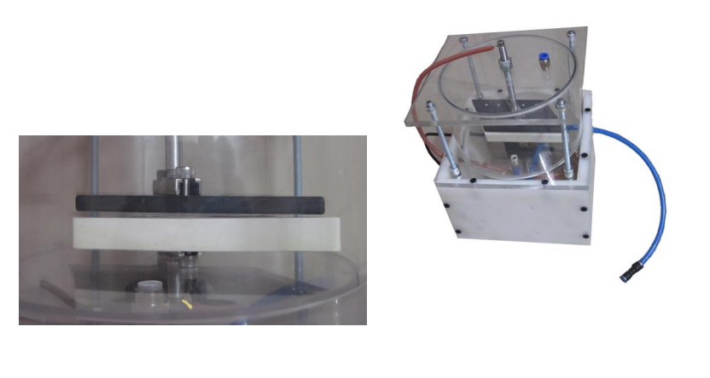
Figure 1 Plasma reactor with zoomed in view of the parallel plate arrangement
Figure 1 shows the parallel plate arrangement of the electrodes. The electrodes are separated by a 1mm thick alumina dielectric. The electrode gap is 3mm and the dielectric is 1mm thick, so the total electrode separation is 4mm. A high frequency 18kHz high voltage (variable up to 20kV peak to peak voltage) signal is applied to the electrodes, the power used is 40W. This setup generates dielectric barrier discharge (DBD) plasma. The tomato seeds are placed in between these electrodes with a spacing of 3mm and are then exposed to the plasma. The power rating during operation is 45W. Although the reactor can be used with different kinds of gases in an enclosed environment, the present set of experiments were conducted in air at standard temperature and pressure.
The seeds are exposed to plasma in a single side and in another set of experiments the seeds are flipped. To accomplish seed flipping, the top electrode is removed, and a carboard sheet 1 is placed on top of the seeds. When the dielectric and the cardboard sheet 1 are inverted, the seeds fall on to the surface of the cardboard. At this point a cardboard sheet 2 is used to cover the seeds after removing the dielectric cover. Once again, the arrangement with seeds is inverted and the seeds are now ready for the final flip. The dielectric is then used to perform the final flip and the seeds are now inverted. The second electrode is placed above the seeds and the plasma is initiated. The seeds are now exposed to the second half of the time of processing
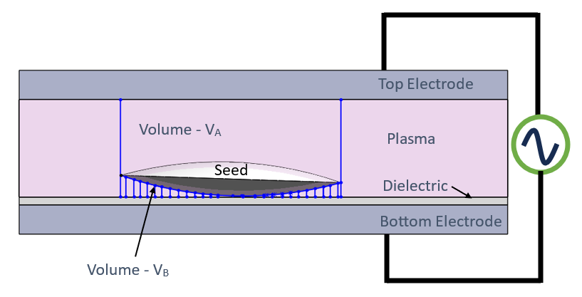
Figure 2 Schematic of the Electrode setup and the power supply connections. A single Seed is shown, placed over the dielectric and the volume above the seed is V_{A} and below the seed is V_{B}
Figure 2 shows the plasma that covers the seed in all directions. However, the volume of plasma above the seed is larger than the volume below the seed. The seed has a shadowing effect on the plasma. This difference is the number of reactive species (OH⁻, O⁻, O, O₃, H, H⁺ etc.) accessible to the seed surface causes a difference in the way the seed’s surface is processed. These reactive species can open the surface pores that allow the nutrients, and gases to enter the seed easily, thus causing the seed to germinate quickly and show a higher vigor index. However, prolonged plasma processing will cause these reactive species to reach the interior of the seed causing some detrimental damage there. Similarly, under processing the seed would also not have sufficient vigor altering effect.
Owing to this shadowing effect of the seed when placed on the surface of the dielectric (or electrode) a simple solution is proposed, wherein the seed can be flipped as illustrated in figure 3. This would help expose both sides of the seed to plasma uniformly, when flipped at equal intervals. In the subsequent section the effect of flipping the seed for uniform plasma processing of seeds is discussed.
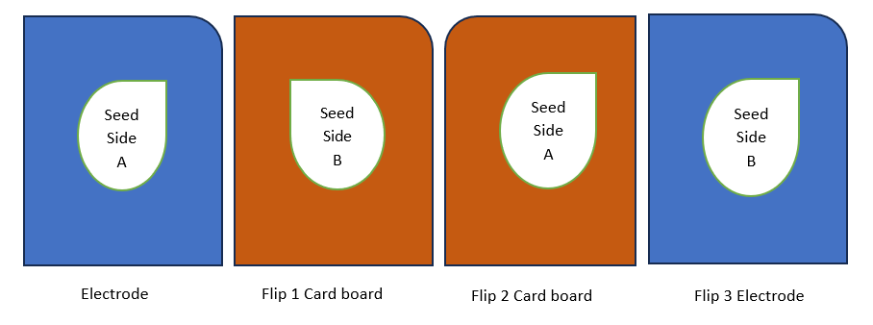
Figure 3. Seed with two sides A & B is flipped in three stages
Collision rate in the Dielectric Barrier Discharge Atmospheric Pressure Plasma
Atmospheric pressure dielectric barrier discharge (DBD) air plasma is a complex environment where frequent collisions occur between various species. Electrons, due to their low mass and high energy, experience the highest collision rate, primarily with neutral air molecules like nitrogen and oxygen. These collisions excite the molecules, leading to the generation of reactive oxygen and nitrogen species. The heavier charged particles, like ions, have a lower collision rate but can still interact with the neutrals and electrons, influencing the overall plasma chemistry. The collision rate for all species is dependent on factors like the applied electric field, gas composition, and plasma temperature. Understanding these collision dynamics is crucial for optimizing DBD plasma for various applications, such as surface modification and sterilization.
In this section we investigates the collision rates of particles with a surface in aCANTP. We derive separate expressions for neutral and ion collision rates due to their distinct behavior within the plasma. Such collisions result in surface modifications that cause macro property changes such as hydrophilicity of the seed surface.
Neutral Collisions
We derive a simple relationship for the collision rate (Z_{n}) of neutral particles with a surface based on the concept of particles sweeping a volume. The collision rate is estimated as Chen (1984).
where
is the collision rate of neutrals (particles hitting surface per unit area per unit time)
n is the density of neutral particles (particles per unit volume).
v is the average velocity of neutral particles
It is important to note that CANTP might introduce additional reactive species like neutral mono atomic species of oxygen, nitrogen and hydrogen. Although these species are not influenced by the ambient electric fields, the neutral collisions with the seed surface by these reactive species will still have an effect on the morphology and surface activation. The ion collision rates are governed by various other factors as explained in the next section.
Ion Collisions
For ions, the simple neutral collision rate formula significantly underestimates the actual value due to their interaction with electric fields within the CANTP. To account for this, we propose a simplified model considering sheath formation near the surface. The model estimates the effective collision rate of ions ()
where:
is the effective collision rate of ions
is the density of ions
E is the electric field strength within the sheath
is the mass of the dominant ion species
is the sheath thickness (estimated using the Debye length formula) [Error: Reference source not found]
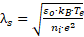 (3)
where:
ε₀ is the permittivity of free space (8.854 × 10⁻¹² F/m)
is the Boltzmann constant (1.381 × 10⁻²³ J/K)
is the electron temperature (in Kelvin)
is the density of ions (particles per unit volume)
e is the elementary charge (1.602 × 10⁻¹⁹ C)
This formula, based on the Debye length concept, provides an estimate of the sheath thickness where the electric field is strong and significantly accelerates ions towards the surface.
The presented simplified model elucidates the correlation between ion collision rate and key parameters such as electric field strength, sheath thickness, and ion mass. This foundational framework enables a preliminary understanding of the influence of CANTP plasma conditions on ion-surface interactions. Notably, the model does not account for the plasma volume (V_{A} and V_{B}, Figure 2), suggesting an initial independence from this factor. Nevertheless, given the seed's direct placement on the dielectric, the formation of plasma sheaths in this region induces varying ion energies, consequently impacting collision rates on the seed's top and bottom surfaces. This potential non-uniformity in surface modification by the impinging ions necessitates seed flipping for consistent seed surface treatment.
Measurement of Germination, root length, shoots length and dry matter
Sixteen replicates of twenty five seeds were sown using the between paper method (rolled towels) and kept under test conditions of 25 ± 1°C and 95 ± 2% relative humidity maintained in a germination room illuminated with fluorescent light. The number of normal seedlings was counted after 14 days and used for germination percentage calculation (ISTA, 2010). Vigour index (VI) was calculated for each replicate in the germination test by using the formula suggested by Abdul-Baki and Anderson (1973) and the mean expressed as the whole number.
VI = Germination (%) × [Root length (cm) + Shoot length (cm)]
Ten normal seedlings were selected at random from each of the 16 replications and measured for root length, from the point of attachment of seed to the tip of primary root, and shoot length, from the point of attachment of seed to tip of the primary leaf for vigour index calculation.
Seed Imbibition study
Hundred numbers of tomato seeds both control and treated seeds (24 seconds plasma treated with flipping) of four replicates were soaked in 10 ml of distilled water for the duration of 1, 5, 10, 20 and 40 minutes. The excess water was removed and the moisture present on the seeds was removed by using tissue paper and shade dried for 5 minutes. Initial weight and imbibed weight of the seeds were measured.
Results and Discussions
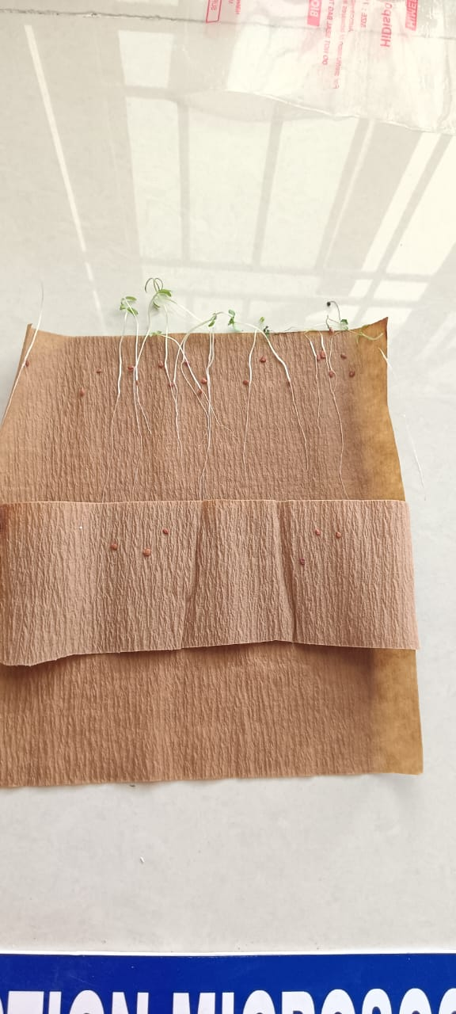 | 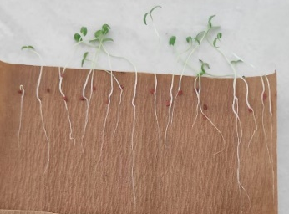 | 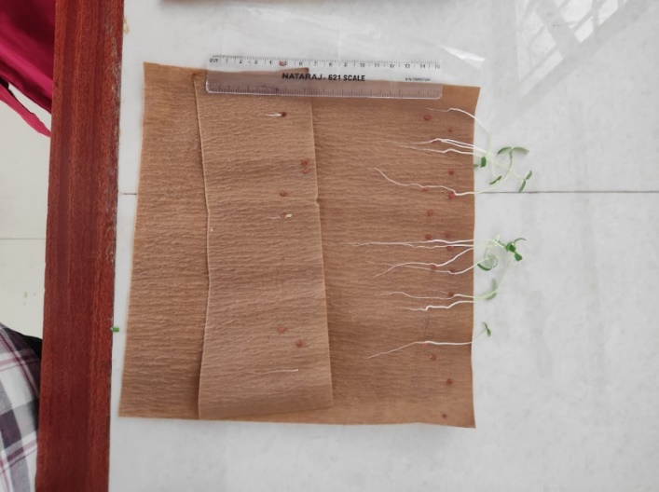
Control | 24 Seconds with flipping | 24 seconds without flipping

Figure 4. Sample Pictures of seeds germinating in paper for control and 24s only as a representation, all the other treatment appears similarly.
4s
Without flipping
24s
With flipping
24s
Without flipping

Figure 4 shows soak papers where 25 seeds were placed and then the paper was soaked in a bucket for a duration of 10days. After the seeds germinated, each of the seedlings were individually measured for their root length and shoot length. The number of seeds that successfully germinated were also measured. For instance, in table 1, one could observe that the germination percentage was only 56% for the control, while the germination percentage was 82% for the 24s plasma treated seeds (with flipping).
Table 1 Effect of Plasma Seed Treatment of Tomato Seeds
S.NO. | Treatment | Germination % | Root Length (cm) | Shoot Length (cm) | Vigor Index
 | Control | 56 | 6.20 | 5.40 | 650
 | 4 Seconds with flipping | 34 | 5.39 | 4.46 | 157
 | 4 Seconds without flipping | 40 | 4.71 | 5.12 | 393
 | 8 Seconds with flipping | 50 | 4.70 | 4.81 | 476
 | 8 Seconds without flipping | 62 | 4.88 | 4.97 | 611
 | 12 Seconds with flipping | 40 | 5.30 | 4.49 | 392
 | 12 Seconds without flipping | 16 | 4.39 | 4.71 | 146
 | 16 Seconds with flipping | 42 | 4.51 | 4.75 | 389
 | 16 Seconds without flipping | 46 | 4.89 | 5.07 | 458
 | 20 Seconds with flipping | 38 | 4.07 | 4.43 | 323
 | 20 Seconds without flipping | 42 | 3.55 | 4.15 | 323
 | 24 Seconds with flipping | 82 | 6.51 | 6.13 | 1036
 | 24 Seconds without flipping | 62 | 5.47 | 5.10 | 655
 | 28 Seconds with flipping | 44 | 3.98 | 3.96 | 349
 | 28 Seconds without flipping | 24 | 4.04 | 5.15 | 221
 | 32 Seconds with flipping | 82 | 4.64 | 4.75 | 770
 | 32 Seconds without flipping | 16 | 4.05 | 4.13 | 131
 | SEd | 2.000 | 0.260 | 0.140 | 7.500
 | CD (P= 0.05) | 0.112 | 0.406 | 0.593 | 0.009

Table 1 summarizes the observation of germination, root length and shoot length. One could observe that root length and shoot length are the highest for 24s plasma treatment, along with the germination percentage. This aspect is reflected in the overall vigor index as well, which is the highest for this duration of plasma treatment.
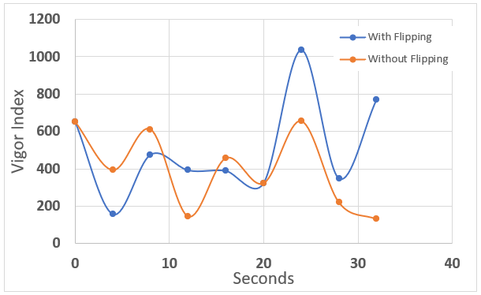
Figure 5 Plot of Vigor Index Vs number of seconds of plasma treatment (with and without flipping)
Figure 5 shows a plot of the vigor Index Vs number of seconds of treatment of the tomato seeds in the plasma reactor. One could observe that upto 20s of treatment the plasma seed flipping does not have significant effect on the vigor index and the results are alternatingly increasing and decreasing with flipping. However, after 20s, the flipping seems to have a marked effect on the seed vigor index. Especially at 24s, the vigor index variation between flipping and non-flipping seems to be over 58%. However, the percentage difference, although is higher for the 12s treatment (169%), the vigor index, individually, does not exceed the value of the control and is therefore not statistically significant. We may therefore conclude that the flipping of the seed at 50% time interval has a significant effect on its Vigor index and must be incorporated in the design of any future machines that aim at plasma treating the seeds. Furthermore, table 2 shows that the highest %difference in vigor index is observed for 32s treatment at this time, the true value of the vigor index has already decreased to 131 and that essentially brings the seed close to damaged levels. Hence this data cannot be used.

Vigour Index
S.No. | Seconds | With Flipping | Without Flipping | % difference
 | 0 | 650 | 650 | 0.0
 | 4 | 157 | 393 | -60.1
 | 8 | 476 | 611 | -22.1
 | 12 | 392 | 146 | 168.5
 | 16 | 389 | 458 | -15.1
 | 20 | 323 | 323 | 0.0
 | 24 | 1036 | 655 | 58.2
 | 28 | 349 | 221 | 57.9
 | 32 | 770 | 131 | 487.8
Table 2 Vigor Index values with and without flipping, long with the percentage change
Hydrophobic to Hydrophilic conversion of the seed surface
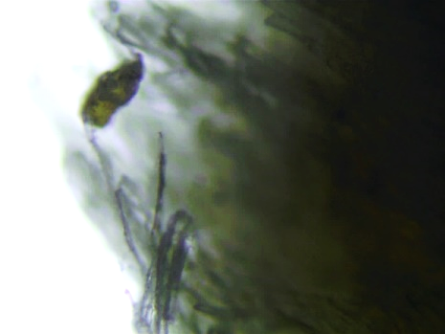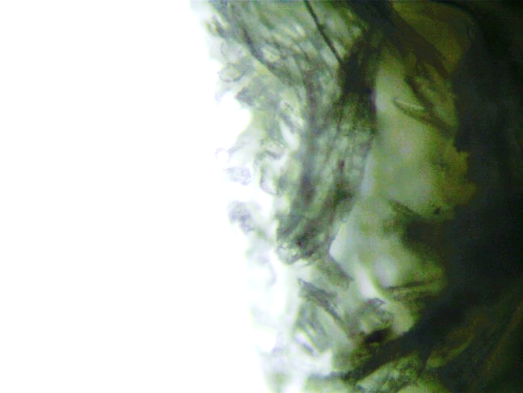
Figure 6 Seed surface morphology shows fibrous surface
Figure 6 shows the close up picture of the surface of tomato seed. Typically, it is not smooth and has fibrous structures over it. It is therefore difficult to analyze the hydrophobic or hydrophilic properties using a goniometer and then measuring the contact angle to determine the surface properties. Hence a simple technique was developed to accomplish this aspect. The seeds that showed the maximum vigor were soaked in water for various time periods as shown in the table 2 below. The seeds were then dried completely on both sides and then was weighed and compared with control seeds. The idea was to see if the surface turned out to be hydrophilic or hydrophobic by measuring the amount of water soaked in by the seeds.
The number of seeds used per water imbibing trial is 100. The comparison was done with 100 control seeds. The quantity of water added to soak the 100 seeds is 10 ml. The drying method used was such that the surface water firsts removed using a tissue paper and then shade dried for 5 mins under a ceiling fan.
From table 3 one could observe that the seeds are gaining a hydrophilic property when exposed to plasma. The amount of water imbibed is steadily increasing. The average value of the increase in weight is plotted in figure 7 below.
Table 3 Summary of Imbibition study in three Tomato seed samples (all measurements are in grams)
S.No. | Duration (mins) | Three samples of control seeds |  |  |  |  |  |  |  |  |  | Three samples of Plasma Treated seeds (24 Sec with Flipping)
S.No. | Duration (mins) | Initial Weight |  |  | After Imbibed Weight |  |  | Weight Increase |  |  | Average Weight Increase | Initial Weight |  |  | After Imbibed Weight |  |  | Weight Increase |  |  | Average Weight Increase | Percentage increase in weight
S.No. | Duration (mins) | S 1 | S 2 | S 3 | S 1 | S 2 | S 3 | S 1 | S 2 | S 3 | Average Weight Increase | S 1 | S 2 | S 3 | S 1 | S 2 | S 3 | S 1 | S 2 | S 3 | Average Weight Increase | Percentage increase in weight
1 | 1 | 0.210 | 0.240 | 0.250 | 0.210 | 0.260 | 0.260 | 0 | 0.02 | 0.01 | 0.010 | 0.250 | 0.220 | 0.270 | 0.280 | 0.240 | 0.280 | 0.03 | 0.02 | 0.01 | 0.020 | 100
2 | 5 | 0.230 | 0.210 | 0.260 | 0.240 | 0.240 | 0.270 | 0.01 | 0.03 | 0.01 | 0.017 | 0.250 | 0.210 | 0.290 | 0.290 | 0.230 | 0.310 | 0.04 | 0.02 | 0.02 | 0.027 | 58.8
3 | 10 | 0.220 | 0.230 | 0.260 | 0.240 | 0.270 | 0.290 | 0.02 | 0.04 | 0.03 | 0.030 | 0.260 | 0.220 | 0.250 | 0.310 | 0.250 | 0.290 | 0.05 | 0.03 | 0.04 | 0.040 | 33.3
4 | 20 | 0.230 | 0.220 | 0.250 | 0.290 | 0.260 | 0.290 | 0.06 | 0.04 | 0.04 | 0.047 | 0.250 | 0.220 | 0.230 | 0.310 | 0.260 | 0.280 | 0.06 | 0.04 | 0.05 | 0.050 | 6.4
5 | 40 | 0.250 | 0.220 | 0.240 | 0.300 | 0.270 | 0.290 | 0.05 | 0.05 | 0.05 | 0.050 | 0.230 | 0.260 | 0.250 | 0.330 | 0.320 | 0.310 | 0.1 | 0.06 | 0.06 | 0.073 | 46.0
SEd |  | 0.102 |  |  | 0.098 |  |  | 0.113 |  |  |  | 0.107 |  |  | 0.999 |  |  | 0.115
CD (P=0.05) |  | 0.971 |  |  | 1.000 |  |  | 1.000 |  |  |  | 0.998 |  |  | 0.976 |  |  | 0.999

Figure 7 clearly shows that the seeds have gained a hydrophilic nature when exposed to air plasma for a duration of 24s after flipping at 12s time duration. Although the amount of water imbibed is decreasing with time initially, it is once again increasing beyond 20s. What is interesting to observe is the fact that water imbibition remains high in plasma exposed seeds for every measured period. This is the first time that the change in surface properties of seeds with exposure to atmospheric pressure air plasma has been established macroscopically.
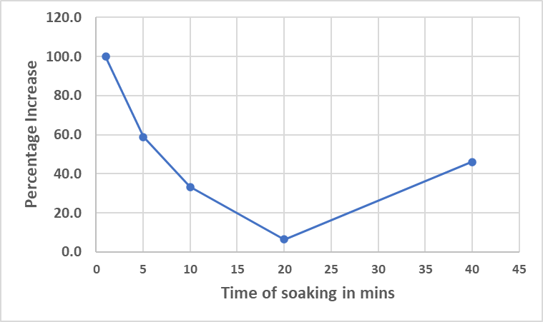
Figure 7. Percentage of water imbibed by the seeds vs the time duration of soaking
Conclusions
This study highlights the significant advantages of utilizing cold plasma treatment, particularly when paired with a seed flipping technique, to enhance the vitality of tomato seeds. The results demonstrate that a 24-second exposure to plasma (generated using 40W, 18kHz, 20kV peak to peak voltage), combined with systematic flipping, ensures uniform treatment across the seed surface, leading to optimal outcomes. This method not only improves germination rates but also positively affects root and shoot lengths, resulting in a higher vigor index compared to untreated seeds. The findings indicate that overexposure of a single side of the seed can be detrimental, underscoring the importance of even plasma exposure. Overall, the integration of seed flipping into plasma treatment protocols presents a promising advancement in agricultural practices, fostering healthier plant growth and potentially increasing crop productivity. Future research should focus on elucidating the mechanisms behind plasma-induced changes in seed physiology and refining treatment parameters for broader agricultural applications.
SReferences
Abdul-Baki, A.A. & Anderson, J.D. (1973). Vigour determination in soybean seed by multiple criteria. Crop Science, 13, 630-633.
Chau, TT., Kao, KC., Blank, G. & Madrid, F. (1996). Microwave plasmas for low temperature dry sterilization. Biomaterials. 17: 1273–1277.
Chen, F. F. (1984). Introduction to Plasma Physics and Controlled Fusion (2nd ed.). Vol. 1: Plasma Physics, Plenum Press New York.
Hury, S., Vidal, DR., Desor, F., Pelletier, J. & Lagarde, T. (1998). A parametric study of the destruction efficiency of Bacillus spores in low pressure oxygen-based plasmas. Lett. Appl. Microbiol. 26: 417–421.
ISTA (2010). International Rules for Seed Testing: edition 2010, International Seed Testing Association, Bassersdorf, Switzerland.
Jiang, JF., He, X., Li, L., Li, J.G., Shao, H.L., Xu, QL., Ye, RH & Dong, YH. (2014). Effect of cold plasma treatment on seed germination and growth of wheat. Plasma Sci. & Tech., 16: 54– 58.
Sultan, S.M.E, Ahmed Fathy Yousef, Waleed M. Ali, Amal A. A. Mohamed , Abdel-Raddy M. Ahmed, Mohamed. E. Shalaby , Islam I. Teiba , A. M. Hassan , Nabil A. Younes & E. F. Kotb. (2024). Cold atmospheric plasma enhances morphological and biochemical attributes of tomato seedlings. BMC Plant Biology, 24: 420.
Zivkovic, S., Puac, N., Giba, Z., Grubisic, D., & Petrovic, ZL. (2004). The stimulatory effect of non-equilibrium (low temperature) air plasma pretreatment on light induced germination of Paulownia tomentosa seeds. Seed Sci. & Tecnol. 32: 693– 701.

