***Review Article***

**SWEET Gene- Discovery, Structure and their role in Fruit crop improvement-A Review**

**Abstract**

The SWEET (Sugars Will Eventually be Exported Transporters) gene family plays a critical role in the transport of sugars across plant cells, influencing key physiological processes such as pholem loading, fruit development, ripening, and stress responses. Discovered through genome-wide analyses, SWEET genes are integral to sugar distribution in plants, enabling efficient transport of sucrose, glucose, and other monosaccharide’s. Structurally, SWEET transporters are characterized by a conserved sugar transporter domain and a characteristic 7-transmembrane helix configuration. These genes are classified into several subfamilies, each with specific roles in different tissues. In fruit crops, SWEETs regulate sugar accumulation, which directly impacts fruit quality, yield, and stress tolerance. This review highlights recent advances in the plant SWEET gene family, covering their discovery, protein structure characteristics, classification, and physiological functions. It emphasizes the pivotal role of SWEETs in regulating sugar transport and distribution, which directly influences fruit development and quality.

***Keywords-*** SWEET, Gene, Monosachharide, Genome.

**Introduction**

Sugars not only provide energy and metabolic substrates for growth and development but also serve as osmotic and signaling molecules in response to abiotic and biotic stresses in plants (Ruan 2014). In fresh fruit, the soluble sugars, including sucrose, fructose, and glucose, are also central to fruit quality because of their nutritional value and sweetness. The sugar profile (composition and concentration) and balance with organic acids largely determine fruit taste and flavour, which is a major quality indicator. The profile of sugars at fruit maturity mainly depends on their allocation during fruit development and understanding factors that affect this process will assist in the improvement of fruit quality (Li *et al*., 2018).

Sugar in plants is primarily synthesized by photosynthesis in leaves during the day or from the degradation of starch at night (Fettke *et al*., 2005). During the day, the triose phosphate synthesized in the chloroplast matrix is exported to the cytoplasm and used to synthesize sucrose. At night, the starch in the chloroplast is hydrolyzed into maltose and glucose, which are exported to the cytoplasm and continue to synthesize sucrose. Sucrose invertase and sucrose synthase can metabolize sucrose to monosaccharide’s (Stein and Granot 2019). The sugar synthesized in the source tissues needs to be transported and distributed to the sink tissues to maintain normal plant growth and development. The transportation and distribution of sucrose, glucose and fructose require the participation of sugar transporters (Chen *et al.,* 2015).

A variety of monosaccharide and sucrose transporters have been identified in plant plasma membranes or vacuolar membranes, including SUTs (sucrose transporters), MSTs (monosaccharide transporters) and SWEETs (sugars will eventually be exported transporters) (Lalonde *et al.,* 2004 and Chen *et al.,* 2012). Because the primary product of photosynthesis is sucrose, it is the main carbohydrate that is transported in plants. It is primarily transported and redistributed over long distances through the phloem (Ruiz-Medrano *et al.*, 2000 and Kuhn and Grof 2010). The loading and unloading of phloem sucrose and the transportation of sucrose across cell membranes and vacuolar membranes require the participation of SUTs (Kuhn and Grof 2010). The transport process that involves sucrose– proton symporters, SUTs and MSTs, requires energy to complete the transmembrane transport of sugars (Schneider *et al.,* 2012) SWEETs are a new type of sugar uniporters that can transport sugars in two directions and promote the diffusion of sugars along a concentration gradient (Baker *et al*., 2012). Studies have shown that SWEETs participate in important physiological processes of plant growth and development by regulating the transportation, distribution and storage of carbohydrates (Anjali *et al*., 2020). This review introduces the progress of research on the discovery, structural characteristics, physiological functions and regulation of stress by the SWEET gene family, which is of substantial significance to enhance plant breeding efforts in the future.

**Discovery of SWEET gene (Sugar Transporters)**

The fluorescent resonance energy transfer (FRET) sensor is a novel fluorescent signal label which is expressed in plants and animals and quantifies the intensity of fluorescence signal so that changes in the concentrations of substrates, such as sugars, amino acids and ions, at the cellular and subcellular levels, can be monitored in living tissues in real time (Looger *et al*., 2005). Chen *et al*., (2010) used the glucose FRET sensor to identify a new type of sugar transporter from *Arabidopsis thaliana*, designated as SWEET. SWEET proteins used the concentration gradient of intracellular and extracellular sugars to transport them across membranes instead of relying on the proton gradient (Chen *et al.,* 2015). Thus, ability of SWEET proteins to transport sugar does not depend on pH value of the environment. Moreover, SWEET proteins can transport sugar in both directions across the membrane along a concentration gradient driven by solute potential. In other words, SWEET proteins can transport sugar from within cells to the extracellular milieu or from extracellularly to intracellularly along the concentration gradient of sugar. While the MSTs and SUTs that have been identified require coupling with H+. They use H+ concentration gradient inside and outside of the cell to transport sugar in one direction across the membrane (Slewinski *et al.,* 2011).

It is hypothesized that, many important physiological processes of plants, such as phloem loading and nectar secretion, may require the participation of sugar efflux transporters (Ayre 2011). However, before the discovery of the SWEET gene family, such sugar transporters had not been isolated, resulting in an incomplete understanding of the molecular and physiological mechanisms of these important physiological processes in plants. The discovery of the sugar efflux transporter SWEET plays a pivotal role in understanding the molecular mechanisms of these important physiological processes in plants. However, before the discovery of the SWEET gene family, such sugar transporters had not been isolated, resulting in an incomplete understanding of the molecular and physiological mechanisms of these important physiological processes in plants. The discovery of the sugar efflux transporter SWEET plays a pivotal role in understanding the molecular mechanisms of these important physiological processes in plants.

They are widely present in plants, but their homologs are present in diverse species of prokaryotes and eukaryotes. However, compared with plants, there are fewer members of the SWEET gene family in prokaryotes and animals. For example, *Mycoplasma arthritidis, Prochlorococcus marinus,* mice (*Mus musculus*), olive baboon (*Papio anubis*) and humans all have only one SWEET gene (Yuan and wang 2013). A total of 17, 29, 105, 27, 18 and 17 SWEET genes have been identified from the vascular plants *A. thaliana*, Eggplant (*Solanum melongena*), Wheat (*Triticum aestivum*), Poplar (*Populus trichocarpa*), Pears (*Pyrus spp*.) and Grapes (*Vitis vinifera*), respectively (Chen *et al.,* 2010; Zhang *et al.,* 2021; Feng *et al.,* 2015 and Qin *et al*., 2020). Different members of the SWEET family from the same plant can transport different sugars. These results suggest that, SWEETs have a variety of important physiological functions in plants.

**Structural Characteristics of the SWEET Gene**

Before the discovery of SWEETs (Sugars Will Eventually be Exported Transporters), plant transporters known as MSTs (Monosaccharide Sugar Transporters) and SUTs (Sucrose Transporters) were part of the Major Facilitator Superfamily (MFS). SWEET proteins, also known as MtN3 family transporters, derive their name from the MtN3 domain, which was first identified in the legume Medicago truncatula (Gamas *et al.,* 1996). The discovery of the MtN3 domain in legumes has since paved the way for understanding its functional significance across diverse plant species. These proteins typically have 12 α-helical transmembrane domains (TMs), with both the N-terminal and C-terminal ends facing the inside of the cell. There is a large cytoplasmic loop in the middle that divides the protein into two domains, each containing six TMs. The structure of each domain is similar, arranged symmetrically in an anti-parallel manner (Sauer, 2003). This arrangement is known as the MFS fold (Forrest *et al.,* 2011).

In contrast, plant SWEETs belong to the MtN3/saliva family (PF03083) and have a different structure. Their N-terminus is on the outside, and the C-terminus is on the inside of the cell. Plant SWEETs typically have seven TMs. The fourth TM is less conserved and acts as a linker, splitting the protein into two MtN3/saliva domains, each containing three TMs in a “3-1-3” pattern. This structure forms a triple-helix bundle (THB), as shown in figure 1 (Chen *et al.,* 2012). The topological structure of SWEETs is different from MSTs and SUTs, which may explain why SWEETs can transport sugars from inside the cell to the outside.

Prokaryotic SWEETs only contain one MtN3/saliva domain with three TMs and are called Semi-SWEETs (Xuan *et al.,* 2013). It is thought that, a replication or horizontal gene transfer event led to the evolution of eukaryotic SWEETs with two MtN3/saliva domains. Research has shown that SWEETs need to oligomerize (form multimeric complexes) to function properly in sugar transport.

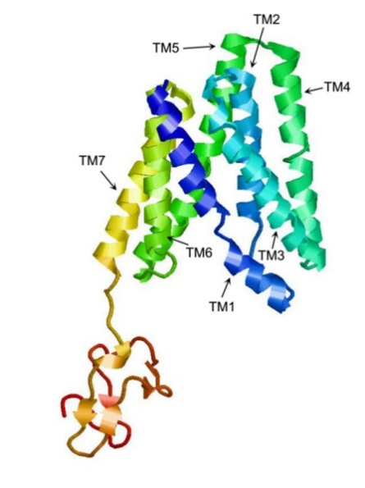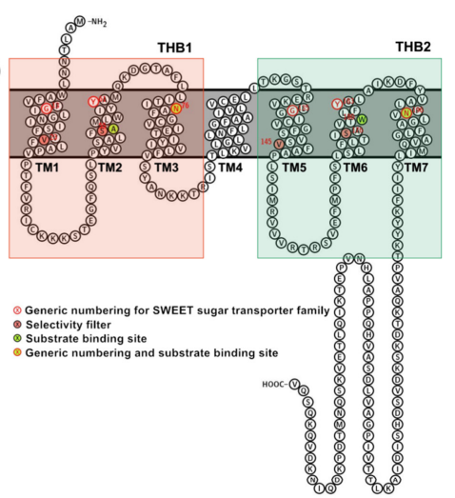

**Figure 1. Structural characteristics of SWEETs.**

The three-dimensional model of AtSWEET13 constructed with Phyre2.

Snake diagram of AtSWEET13 with key positions labeled. (Ji *et al.,* 2022)

**Classification/Evolution of SWEETs and their substrates**

Yuan and Wang (2021) used the Transporter Classification Database (TCDB) to identify and analyze SWEET proteins across various species. Their phylogenetic analysis revealed that, SWEET proteins are grouped into three evolutionary clades (Fig. 2). Clade I includes SWEET proteins from monocots and dicots, Clade II comprises those from metazoans and mammals and Clade III includes proteins from bacteria and archaea. Interestingly, some members of the MtN3/saliva family in Caenorhabditis elegans are also part of Clade III. Bacterial proteins in this clade possess a single MtN3/saliva domain with three transmembrane helices. The analysis suggests that the widely distributed MtN3/saliva SWEET protein likely originated from prokaryotic SemiSWEET proteins. During eukaryotic evolution, domain duplication resulted in SWEET proteins with two MtN3/saliva domains and seven transmembrane α-helices. Further phylogenetic studies on SWEET proteins in 16 types of angiosperms divided the family into four subfamilies (Clade I–IV). For example, in Arabidopsis thaliana, Clade I includes AtSWEET1–3, Clade II has AtSWEET4–8, Clade III includes AtSWEET9–15, and Clade IV contains AtSWEET16–17. Each subfamily shows distinct sugar transport preferences: Clades I and II transport hexose, Clade III specializes in sucrose, and Clade IV, located on the vacuolar membrane, primarily transports fructose.

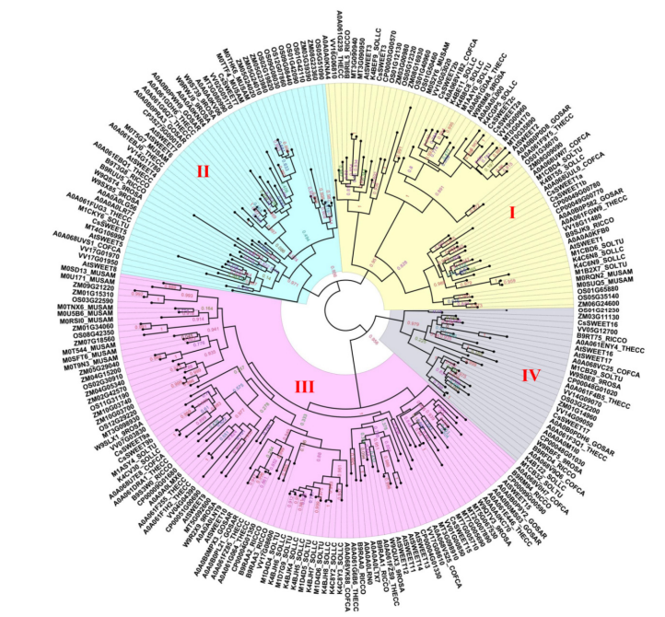

**Figure. 2. A phylogenetic tree of the SWEETs of 16 types of angiosperms**

**Diverse functional roles of SWEETs in plant mainly in Fruit crop**

1. **Phloem loading**

After the photosynthetic products are synthesized in leaves, SWEET transporters are the efflux proteins involved in the apoplasmic phloem loading (apoplastic pathway) of sucrose from the leaf mesophyll tissue, ultimately to the phloem elements for long-distance transport. Figure 3 represents the long-distance transport of sucrose from the source (leaves) to sink tissues (roots, fruits, flowers).

SWEET proteins act like "gates" in the cell membrane. Before the discovery of SWEETs, it was not clear wich type of transporter assisted the transport of sucrose from the phloem parenchyma cells through plasmodesmata and then transported to the apoplast near the sieve-element–companion-cell complex. This is a prerequisite for sucrose to complete phloem loading in the apoplast pathway Chen *et al.,* (2012) were the first to discover that two proteins, *AtSWEET11* and *AtSWEET12* located on the plasma membrane of phloem parenchyma cells, play a key role in this process. In fruit crops, SWEET genes are involved in sugar partitioning and accumulation, influencing fruit sweetness, ripening, and overall quality. Clade III efflux transporters such as *PpSWEET9a* and *PpSWEET14* are plasma membrane-localized proteins that mediate apoplasmic phloem loading in Peach (*Prunus persica*) (Luo *et al.,* 2024).

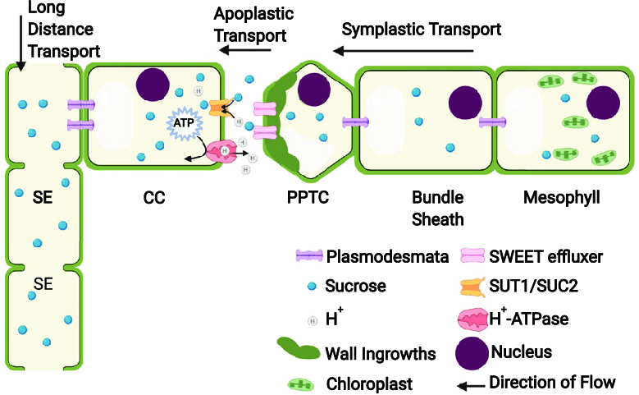

**Fig. 3. Diagram of phloem loading**

1. **Male Reproductive Development**

The SWEET gene family in plants plays a key role in pollen development and plant fertility. In Petunia, the gene NEC1 (*AtSWEET9*) is expressed in the nectaries and stamens, especially in the anther stomium cells and upper filaments. When the expression of NEC1 is inhibited, it causes premature anther dehiscence before the pollen is mature, resulting in male sterility (Gua *et al.,* 2008). Besides this gene, several other SWEET genes linked to male reproductive development have been identified. In sweet orange, five members of the SWEET gene family- *Cs7g02970, Cs3g14550, Cs3g20720, Cs9g04180* and *Cs2g28270* are strongly expressed in flowers (Zheng *et al.,* 2014). Similarly, in grapes, seven SWEET genes, including *VvSWEET3, -4, -5a, -5b, -7, -10*, and *-11,* show high expression in flowers (Chong *et al.,* 2015).

1. **Fruit Development**

SWEET genes are crucial for sugar transport and accumulation in fruits. Soluble sugars viz. sucrose, glucose, and fructose are key indicators of fruit quality. Zhen *et al.,* (2018) identified ***MdSWEET2e, MdSWEET15a*,** and ***MdSWEET9b*** as key contributors to sugar accumulation in apples, with ***MdSWEET15a*** and ***MdSWEET9b*** being efficient sucrose transporters during fruit development. In grapes, ***VvSWEET10*** was shown to enhance sugar levels during berry development (Zhang *et al.,* 2019). In strawberries, Liu *et al.,* (2019) reported that ***FvSWEET1****,* ***FvSWEET7*** and ***FvSWEET9c*** were active during the transition to maturity of fruit. In pineapple (Ananas comosus), ***AnmSWEET5*** and ***AnmSWEET11*** are highly expressed during early fruit development (Guo *et al.,* 2018). In orange (*Citrus sinensis*), 16 SWEET genes have been identified. Among them, *Cs2g28300, Cs3g14550, Cs7g02970, Cs3g14500, Cs3g20720,* *Cs2g04140*, and *orange1.1t02627* show high expression in the fruit (Zheng *et al.,* 2014). Similarly, the sugar transporters ***PpSWEET9a*** and ***PpSWEET14*** were identified as critical players in the allocation of sucrose from source leaves to peach fruits. SWEETS transporters work synergistically to ensure efficient sucrose mobilization, which is vital for fruit development and sugar accumulation in peaches (Luo *et al.,* 2024). In plum (*Prunus saliciana*) Fifteen PsSWEET genes were identified out of these *PsSWEE2, PsSWEET3, PsSWEET4, PsSWEET5, PsSWEET7, PsSWEET13,* and *PsSWEET14* exhibited a relatively higher expression at the fruit development stage (Jiang *et al.,* 2023). These findings underscore the role of SWEET genes in regulating sugar content in various fruit crops.

1. **Fruit Ripening**

The **SWEET (Sugars Will Eventually be Exported Transporter)** genes play a critical role in fruit ripening by regulating sugar transport and allocation. Sugars are not only essential for energy production and metabolic processes during ripening but also act as signaling molecules to trigger and regulate ripening-associated pathways. Here’s how SWEET genes contribute to fruit ripening. Researcher studied the expression patterns of SWEET genes during fruit ripening indifferent fruit crops. Liu *et al.,* (2019) reported that FvSWEET1, FvSWEET4, and FvSWEET9b were highly expressed in ripened strawberries. In carambola Ten ***AcSWEET*** genes were isolated and characterized with their structures, conserved motifs, and evolutionary relationships comprehensively analyzed. Expression pattern analysis during fruit ripening, alongside assessments of soluble sugar content and the titratable acid ratio, suggested that ***AcSWEET2a, AcSWEET2b,*** and ***AcSWEET16b*** are likely involved in sugar transport processes critical for fruit ripening (Lin *et al.,* 2021). Similarly, in Prunus sinensis (plum), two SWEET genes, ***PsSWEET1*** and ***PsSWEET9***, play crucial roles in fruit ripening by facilitating the transport and accumulation of sugars in the fruit (Jiang *et al.,* 2023).

1. **Plant Responses to Stress**

The SWEET (Sugars Will Eventually be Exported Transporters) gene family plays a crucial role in plant responses to both biotic and abiotic stresses. These genes are primarily involved in the transport of sugars, which are essential for various metabolic processes. In plants, the regulation of sugar transport is vital for growth, development, and stress adaptation (Chen *et al.,* 2010).

1. **Biotic stresses**

SWEET genes play a key role in plant responses to biotic stress, especially during attack of pathogen. They help regulate sugar distribution, supporting immune responses. Some SWEET genes are activated during infection, providing sugars that can either promote or inhibit pathogen growth depending on the interaction (Hu *et al.,* 2014). When bacterial or fungal pathogens invade plants, they secrete virulence proteins, described as transcription activator-like (TAL) effectors that can bind to the promoters of specific SWEET genes and activate their expression ((Nino *et al.,* 2006).*VsSWEET4* from *V. vinifera* was also reported to support the growth of *Botrytis cineria*, the causal agent of grey rot disease (Chong *et al.,* 2014). Its expression is induced by reactive oxygen species (ROS) and pathogen virulence factors during necrotrophic infections. Also in Citrus fruit crop the identification of susceptibility genes like LOB1 (Citrus canker susceptible gene) and the involvement of sugar transporters such as *CsSWEET-1* genes highlight the complex genetic and biochemical networks that govern disease resistance and susceptibility in citrus crops (Hu *et al.,* 2014). Fungal diseases significantly affect banana crops. *The MaSWEET7a* gene, involved in sugar transport, plays a key role in banana responses to fungal pathogens by regulating sugar allocation essential for both pathogen nutrition and plant defense (Miao et al., 2017).

1. **Abiotic stress**

These stresses often result in a disruption of metabolic balance and osmotic pressure within plant cells. The proper regulation of sugar transport by SWEET genes helps maintain cellular functions during stress. *In Citrus sinensis,* several SWEET genes are upregulated under drought conditions, indicating their involvement in drought tolerance mechanisms (Zheng *et al.,* 2014). Additionally, SWEET genes have been implicated in the regulation of osmotic pressure and stress-induced responses by modulating the distribution of sugars like sucrose and glucose. Two types of bananas, Fen Jiao (FJ, AAB group) and BaXi Jiao (BX, AAA group, Cavendish variety), showed different patterns of *MaSWEET* gene expression in their tissues during fruit development and responded differently to stresses like cold and drought *MaSWEET* genes in bananas show changes in activity under salt, osmotic, and cold stress(Miao *et al.,* 2017). These genes are highly active during salt and cold stress, with stronger activity in the FJ variety under cold conditions compared to the BX variety. This suggests that *MaSWEET* genes help bananas survive tough environmental conditions. The higher activity of these genes in the FJ variety may explain its better tolerance to cold, which can be used to develop improved banana varieties (Miao *et al.,* 2017). Jiang *et al.,* (2021) found 28 SWEET genes in C. sinensis with seven TM helices. Among them, *CsSWEET16* helps move sugars in and out of vacuoles, which improves cold resistance (Wang *et al.,* 2018). Similarly, *CsSWEET1a* and *CsSWEET17* transport sugars between the cytoplasm and apoplast, supporting growth and freezing tolerance (Yao *et al.,* 2020).

Aslo The sugar transporter ***MdSWEET17*** plays a pivotal role in abiotic stress responses in apple. Its ectopic expression in tomato enhanced drought tolerance by promoting the accumulation of soluble sugars, particularly fructose, under drought conditions. Additionally, ***MdSWEET17*** is highly responsive to abiotic stressors such as PEG, mannitol, and ABA, indicating its critical function in stress adaptation and sugar homeostasis (Lu *et al.,* 2019). A total of 15 SWEET genes have been identified in pomegranate, with PgSWEET13 showing differential expression under high salinity stress, highlighting its potential role in stress tolerance (Kumawat *et al.,* 2022).

**Conclusion**

In conclusion, sugar transport is essential for plant growth, development, and responses to biotic and abiotic stresses. SWEET transporters are characterized by their ability to distinguish between monosaccharides and disaccharides, transport hormones and metals, and form oligomers. While significant progress has been made in understanding the function of SWEET proteins, many aspects remain unclear, particularly regarding their three-dimensional conformations. The function of SWEET genes is closely tied to their structure, and current research has shown that SWEET transporters play key roles in vital processes such as phloem loading, pollen development, fruit development and ripening, as well as plant defense and stress responses. Further research is needed to fully elucidate the mechanisms by which SWEET proteins function and contribute to these processes.

**Future Perspective**

The mechanism of SWEET dimerization remains unclear, but structural analysis holds potential to clarify their function under varying environmental conditions. Further research on crystal structures of SWEET proteins, particularly those involved in different sugar transport functions, is crucial for understanding how they recognize substrates and transition between conformations. Moreover, the collaborative roles of SWEET genes, their regulation, and functional diversification require more in-depth investigation, especially in fruit species beyond those that have already been studied. Modulating the expression of SWEET genes to control carbohydrate flow presents significant potential for improving crop yield, quality, and stress resistance, positioning genetic engineering of SWEETs as a promising strategy for sustainable agriculture.

**References:**

Anjali, A., Fatima, U., Manu, M. S., Ramasamy, S., & Senthil-Kumar, M. (2020). Structure and regulation of SWEET transporters in plants: An update. *Plant Physiology and Biochemistry,* ***156***, 1–6.

Ayre, B. G. (2011). Membrane-transport systems for sucrose in relation to whole-plant carbon partitioning. *Molecular Plant,* ***4***, 377–394.

Baker, R. F., Leach, K. A., & Braun, D. M. (2012). SWEET as sugar: New sucrose effluxers in plants. *Molecular Plant,* ***5***, 766–768.

Chen, L. Q., Cheung, L. S., Feng, L., Tanner, W., & Frommer, W. B. (2015). Transport of sugars. *Annual Review of Biochemistry,* ***84***, 865–894.

Chen, L., Hou, B.H., Lalonde, S., Takanaga, H., Hartung, M.L., Quet, X.Q., Guo, W.-J., Kim, J.-G., Underwood, W., & Chaudhuri, B. (2010). Sugar transporters for intercellular exchange and nutrition of pathogens. Nature, 468(7327), 527–532.

Chen, L., Qu, X., Hou, B., Sosso, D., Osorio, S., Fernie, A. R., & Frommer, W. B. (2012). Sucrose efflux mediated by SWEET proteins as a key step for phloem transport. *Science,* ***335***, 207–211.

Chong, J., Piron, M.C., Meyer, S., Merdinoglu, D., Bertsch, C., & Mestre, P. (2014). The SWEET family of sugar transporters in grapevine: VvSWEET4 is involved in the interaction with Botrytis cinerea. Journal of Experimental Botany, 65(20), 6589–6601.

Feng, C., Han, J., Han, X., & Jiang, J. (2015). Genome-wide identification, phylogeny, and expression analysis of the SWEET gene family in tomato. Gene, 573(2), 261–272.

Fettke, J., Eckermann, N., Tiessen, A., Geigenberger, P., & Steup, M. (2005). Identification, subcellular localization and biochemical characterization of water-soluble heteroglycans (SHG) in leaves of *Arabidopsis thaliana* L.: Distinct SHG reside in the cytosol and in the apoplast. *Plant Journal,* ***43***, 568–585.

Forrest, L.R., Krämer, R., & Ziegler, C. (2011). The structural basis of secondary active transport mechanisms. Biochimica et Biophysica Acta - Bioenergetics, 1807(2), 167–188.

Gamas, P., Niebel, F., Lescure, N., & Cullimore, J. (1996). Use of a subtractive hybridization approach to identify new Medicago truncatula genes induced during root nodule development. Molecular Plant-Microbe Interactions, 9(3), 233–242.

Guo, C., Li, H., Xia, X., Liu, X., & Yang, L. (2018). Functional and evolution characterization of SWEET sugar transporters in Ananas comosus. Biochemical and Biophysical Research Communications, 496(2), 407–414.

Hu, Y., Zhang, J., Jia, H., Sosso, D., Li, T., Frommer, W.B., Yang, B., White, F.F., Wang, N., & Jones, J.B. (2014). Lateral organ boundaries 1 is a disease susceptibility gene for citrus bacterial canker disease. Proceedings of the National Academy of Sciences USA, 111(3), E521–E529.

Ji, J., Yang, L., Fang, Z., Zhang, Y., Zhuang, M., Lv, H., & Wang, Y. (2022). Plant SWEET family of sugar transporters: Structure, evolution and biological functions. Biomolecules, 12(2), 205.

Jiang, C., Zeng, S., Yang, J., & Wang, X. (2023). Genome-wide identification and expression profiling analysis of SWEET family genes involved in fruit development in plum (Prunus salicina Lindl). Genes, 14(9), 1679.

Kuhn, C., & Grof, C. P. (2010). Sucrose transporters of higher plants. *Current Opinion in Plant Biology,* ***13***(3), 288–298.

[Kumawat](https://link.springer.com/article/10.1007/s11033-021-06961-2#auth-Surbhi-Kumawat-Aff1-Aff2), S., [Sharma](https://link.springer.com/article/10.1007/s11033-021-06961-2#auth-Yogesh-Sharma-Aff1), Y., [Vats](https://link.springer.com/article/10.1007/s11033-021-06961-2#auth-Sanskriti-Vats-Aff1), S., [Sudhakaran](https://link.springer.com/article/10.1007/s11033-021-06961-2#auth-Sreeja-Sudhakaran-Aff1-Aff2), S., [Sharma](https://link.springer.com/article/10.1007/s11033-021-06961-2#auth-Shivani-Sharma-Aff1), S.,  [Mandlik](https://link.springer.com/article/10.1007/s11033-021-06961-2#auth-Rushil-Mandlik-Aff1-Aff2), R.,  [Raturi](https://link.springer.com/article/10.1007/s11033-021-06961-2#auth-Gaurav-Raturi-Aff1-Aff2), G.,  [Kumar](https://link.springer.com/article/10.1007/s11033-021-06961-2#auth-Virender-Kumar-Aff1), V.,  [Rana](https://link.springer.com/article/10.1007/s11033-021-06961-2#auth-Nitika-Rana-Aff1-Aff2), N., [Kumar](https://link.springer.com/article/10.1007/s11033-021-06961-2#auth-Amit-Kumar-Aff1), A., [Sonah](https://link.springer.com/article/10.1007/s11033-021-06961-2#auth-Humira-Sonah-Aff1), H. &  [Deshmukh](javascript:;), R. (2022). Understanding the role of SWEET genes in fruit development and abiotic stress in pomegranate (Punica granatum L.). Molecular Biology Reports, 49(2), 1329–1339.

Lalonde, S., Wipf, D., & Frommer, W. B. (2004). Transport mechanisms for organic forms of carbon and nitrogen between source and sink. *Annual Review of Plant Biology,* ***55***, 341–372.

Li, M., Li, P., Ma, F., Dandekar, A. M., & Cheng, L. (2018). Sugar metabolism and accumulation in the fruit of transgenic apple trees with decreased sorbitol synthesis. *Horticultural Research,* ***5***, 60.

Lin, Q., Zhong, Q., & Zhang, Z. (2021). Identification and functional analysis of SWEET gene family in Averrhoa carambola L. fruits during ripening. PeerJ, 9, e11404.

Liu, H.T., Lyu, W.Y., Tian, S.H., Zou, X.H., Zhang, L.Q., Gao, Q.H., Ni, D.A., & Duan, K. (2019). The SWEET family genes in strawberry: Identification and expression profiling during fruit development. South African Journal of Botany, 125, 176–187.

Looger, L. L., Lalonde, S., & Frommer, W. B. (2005). Genetically encoded FRET sensors for visualizing metabolites with subcellular resolution in living cells. *Plant Physiology,* ***138***, 555–557.

Lu, J., Sun, M.-H., Ma, Q.-J., Kang, H., Liu, Y.-J., Hao, Y.-J., & You, C.-X. (2019). MdSWEET17, a sugar transporter in apple, enhances drought tolerance in tomato. Journal of Integrative Agriculture, 18(9), 2041–2051.

Luo, M., Jia, M., Pan, L., Chen, W., Zhou, K., & Xi, W. (2024). Sugar transporters PpSWEET9a and PpSWEET14 synergistically mediate peach sucrose allocation from source leaves to fruit. Communications Biology, 7(1), 1068.

Miao, H., Sun, P., Liu, Q., Miao, Y., Liu, J., Zhang, K., Hu, W., Zhang, J., Wang, J., Wang, Z., et al. (2017). Genome-wide analyses of SWEET family proteins reveal involvement in fruit development and abiotic/biotic stress responses in banana. Scientific Reports, 7(1), 3536.

Nino-Liudo, R.P., & Bogdanove, A.J. (2006). Xanthomonas oryzae pathovars: Model pathogens of a model crop. Molecular Plant Pathology, 7(4), 303–324.

Qin, J., Jiang, Y., Lu, Y., Zhao, P., Wu, B., Li, H., Wang, Y., Xu, S., Sun, Q., & Liu, Z. (2020). Genome-wide identification and transcriptome profiling reveal great expansion of SWEET gene family and their wide-spread responses to abiotic stress in wheat (Triticum aestivum L.). Journal of Integrative Agriculture, **19**(8), 1704–1720.

Ruan, Y. L. (2014). Sucrose metabolism: gateway to diverse carbon use and sugar signaling. *Annual Review of Plant Biology,* ***65***, 33–67.

Ruiz-Medrano, R., Xoconostle-Cazares, B., & Lucas, W.J. (2001). The phloem as a conduit for inter-organ communication. Current Opinion in Plant Biology, **4**(2), 202–209.

Sauer, N. (2007). Molecular physiology of higher plant sucrose transporters. FEBS Letters, 581(12), 2309–2317.

Schneider, S., Hulpke, S., Schulz, A., Yaron, I., Holl, J., Imlau, A., Schmitt, B., Batz, S., Wolf, S., Hedrich, R., et al. (2012). Vacuoles release sucrose via tonoplast-localised SUC4-type transporters. *Plant Biology,* **14**, 325–336.

Slewinski, T. L. (2011). Diverse functional roles of monosaccharide transporters and their homologs in vascular plants: A physiological perspective. *Molecular Plant,* ***4***, 641–662.

Stein, O., & Granot, D. (2019). An overview of sucrose synthases in plants. *Frontiers in Plant Science,* ***10*,** 95.

Xuan, Y.H., Hu, Y.B., Chen, L.Q., Sosso, D., Ducat, D.C., Hou, B.H., & Frommer, W.B. (2013). Functional role of oligomerization for bacterial and plant SWEET sugar transporter family. Proceedings of the National Academy of Sciences USA, 110(45), E3685–E3694.

Yuan, M., & Wang, S. (2013). Rice MtN3/saliva/SWEET family genes and their homologs in cellular organisms. *Molecular Plant,* **6**, 665–674.

Zhang, L., Wang, L., Zhang, J., Song, C., Li, Y., Li, J., & Lu, M. (2021). Expression and localization of SWEETs in *Populus* and the effect of SWEET7 overexpression in secondary growth. *Tree Physiology,* ***41***, 882–899.

Zhang, Z., Zou, L., Ren, C., Ren, F., Wang, Y., Fan, P., Li, S., & Liang, Z. (2019). VvSWEET10 mediates sugar accumulation in grapes. Genes, 10(4), 255.

Zhen, Q., Fang, T., Peng, Q., Liao, L., Zhao, L., Owiti, A., & Han, Y. (2018). Developing gene-tagged molecular markers for evaluation of genetic association of apple SWEET genes with fruit sugar accumulation. Horticultural Research, 5(1), 14.

Zheng, Q., Tang, Z., Xu, Q., & Deng, X. (2014). Isolation, phylogenetic relationship and expression profiling of sugar transporter genes in sweet orange (Citrus sinensis). Plant Cell, Tissue and Organ Culture, 119(5), 609–624.

Lemoine, R., La Camera, S., Atanassova, R., Dédaldéchamp, F., Allario, T., Pourtau, N., Bonnemain, J. L., Laloi, M., Coutos-Thévenot, P., Maurousset, L., Faucher, M., Girousse, C., Lemonnier, P., Parrilla, J., & Durand, M. (2013). Source-to-sink transport of sugar and regulation by environmental factors. *Frontiers in plant science*, **4**, 272.

Smith, A. M., & Stitt, M. (2007). Coordination of carbon supply and plant growth. Plant, Cell & Environment, **30**(9), 1126–1149.

Smith, A. M., & Stitt, M. (2007). Coordination of carbon supply and plant growth. Plant, Cell & Environment, **i**(9), 1126–1149.

Li, J., Kim, Y. J., & Zhang, D. (2022). Source-To-Sink Transport of Sugar and Its Role in Male Reproductive Development. *Genes*, **13**(8), 1323.

Ji, J., Yang, L., Fang, Z., Zhang, Y., Zhuang, M., Lv, H., & Wang, Y. (2022). Plant SWEET Family of Sugar Transporters: Structure, Evolution and Biological Functions. *Biomolecules*, **12**(2), 205.