Original Research Article

Comparative Analysis of Titrimetric Methods for Quantifying Acetylsalicylic acid in Aspirin Tablets

.

ABSTRACT

This study compares two titrimetric methods for quantifying acetylsalicylic acid (ASA) in aspirin tablets stored under different environmental conditions. ASA stability can be influenced by factors such as temperature, humidity, and light exposure. The two titrimetric methods used are acid-base titration with hydrochloric acid (HCl) and sodium hydroxide (NaOH). Aspirin tablets were stored for 30 days under controlled conditions simulating varying environmental factors, and both methods were evaluated for accuracy, precision, and reliability. The results show a strong correlation between the two methods, with a Pearson correlation coefficient of 0.937 and a high Intraclass Correlation Coefficient (ICC), indicating consistency and reliability. However, the paired t-test revealed a statistically significant difference (r = 0.937, p = 0.001) between the methods, suggesting small but meaningful discrepancies in their results. The Bland-Altman analysis demonstrated that Method I consistently provided higher values than Method II, while the linear regression analysis indicated that Method II slightly underestimates values compared to Method I. Overall, both methods were found to be highly reliable and interchangeable within certain limits, but the small systematic differences between them should be considered when interpreting results. This study provides valuable insights into the performance of titrimetric methods for ASA quantification, contributing to the optimization of pharmaceutical analysis techniques.

Keywords: pharmaceutical analysis, acetylsalicylic acid, titrimetric methods, aspirin tablets

1. INTRODUCTION
Accurate and reliable quality control of pharmaceutical products is critical for ensuring their efficacy, safety, and overall quality (Narayan & Choudhary, 2017). In this context, it is essential to evaluate and compare different analytical methods used to assess key drug properties, such as dosage consistency and stability, particularly under varying environmental conditions. The present study aims to compare two analytical methods for determining the concentration of active pharmaceutical ingredient (API) in aspirin tablets subjected to different storage conditions.
Aspirin, a widely used non-steroidal anti-inflammatory drug (NSAID), contains acetylsalicylic acid (ASA) as its active component. Its pharmacological activity is primarily attributed to the irreversible inhibition of the cyclooxygenase (COX) enzyme, leading to reduced inflammation and pain (Shankar, 2024). The origins of aspirin can be traced back to salicin, a compound initially extracted from willow bark. Traditional medicine has utilized willow bark for over 3,500 years to alleviate pain, inflammation, and fever, even though ancient healers were unaware that salicin would later serve as the foundation for aspirin’s development (Desborough & Keeling, 2017). Historical accounts further suggest that willow bark was commonly chewed for its medicinal benefits (Oketch-Rabah et al., 2019). Its synthesis pathway involves acetylating salicylic acid, first achieved by Frédéric Gerhardt in 1853 (Rezabakhsh et al., 2021). Nowdays, acetylsalicylic acid is synthesized via esterification of salicylic acid with acetic anhydride in the presence of a catalyst, typically sulfuric or phosphoric acid, under mild heating. The reaction produces acetylsalicylic acid and acetic acid as a byproduct, followed by purification through recrystallization.
Aspirin is unstable molecule, particularly susceptible to environmental factors such as temperature, humidity, and light, all of which can significantly impact its stability and, consequently, its therapeutic effectiveness. Exposure to these conditions can lead to aspirin degradation, primarily resulting in the formation of salicylic acid and acetic acid, as illustrated in Fig. 1. Therefore, continuous monitoring and quantification of aspirin’s stability under different storage conditions are imperative. This study evaluates the performance of two acid-base titrimetric methods, comparing their reliability, accuracy, and suitability for quantifying aspirin under controlled conditions. Acid-base titration remains a widely used analytical technique due to its simplicity, rapidity, and cost-effectiveness, with well-documented precision and reproducibility (Alhamdany & Alfahad, 2021; Šljivić Husejnović et al., 2025).
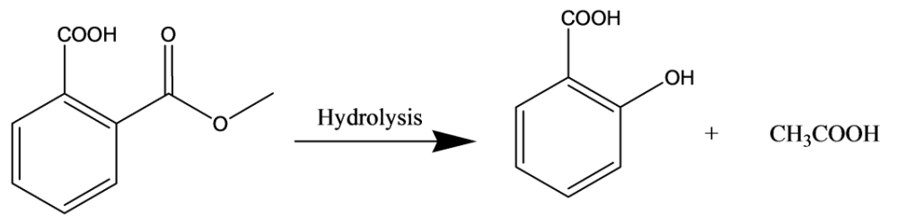
Fig. 1. The hydrolysis of acetylsalicylic acid into salicylic acid and acetic acid

2. material and methods

This study builds upon our previous research on drug stability under varying storage conditions (Šljivić Husejnović et al., 2025). The current study compares two acid-base titrimetric methods for determining the concentration of acetylsalicylic acid in aspirin tablets stored under different environmental conditions.

2.1 Materials
Aspirin tablets: Commercially available Aspirin Protect 100 mg tablets (Bayer, Germany) were obtained from a local pharmacy.
Reagents: Ethanol (C₂H₅OH) (Sigma Aldrich, USA), sodium hydroxide (NaOH) (Sigma Aldrich, USA), phenolphthalein indicator (Sigma Aldrich, USA), hydrochloric acid (HCl) (Sigma Aldrich, USA), chloroform (CH₃Cl) (Sigma Aldrich, USA), distilled water (for dilution and preparation of solutions).
Glassware: Burettes, pipettes, conical flasks, and volumetric flasks.
Instruments: Analytical balance AX120 (Shimadzu), magnetic stirrer, Sonorex ultrasonic bath (Bandelin electronic Gmbh & Co. KG), distillation water still (GFL Gesellschaft Fuer Labortec).
Storage Conditions
The aspirin tablets were stored under controlled conditions simulating common storage environments:
- temperature (<8°C, 15-25°C, >25°C);
- humidity (normal, increased);
- light exposure (direct light, darkness).
Samples were stored for 30 days, after which aspirin content was analyzed using both titration methods to assess degradation or stability over time.

  - Titration methods
Two acid-base titrimetric methods were used to quantify ASA in aspirin tablets. The procedures were adapted from our previous work (Šljivić Husejnović et al., 2025).
2.2.1. Titration with hydrochloric acid solution
ASA was dissolved in ethanol and titrated with 0.5 M HCl using phenolphthalein as an indicator. 1 mL of HCl consumption corresponded to 45.04 mg of acetylsalicylic acid.
2.2.2. Titration with sodium hydroxide solution
ASA was dissolved in chloroform and titrated with 0.1 M NaOH using phenolphthalein as an indicator. 1 mL of 0.1 M NaOH consumption corresponded to 0.02212 g of acetylsalicylic acid.
  - Statistical analysis
A comprehensive statistical analysis was performed to compare the accuracy and reliability of the two titrimetric methods.

Accuracy and Precision Assessment
- Recovery (%): Assessed method accuracy by comparing measured aspirin content to expected values in spiked samples.
- Descriptive Statistics: Minimum, maximum, mean values, and standard deviation (SD) were calculated.
- Coefficient of Variation (CV): Evaluated precision; a lower CV indicated higher precision.

Method Comparison and Agreement
- Mean Difference and 95% Confidence Interval (CI): Assessed systematic bias between the two methods.
- Kolmogorov-Smirnov & Shapiro-Wilk Tests: Tested data normality to determine appropriate statistical tests.
- Pearson Correlation: Quantified the linear relationship between the two methods.
- Intraclass Correlation Coefficient (ICC): Measured consistency and agreement (range: -1 to 1).
- Paired t-test: Determined significant differences in aspirin content measured by the two methods.

Graphical and Predictive Analysis
- Bland-Altman Plot: Visualized agreement and potential bias between methods.
- Linear Regression: Evaluated the predictive relationship between the two methods, estimating slope and intercept.
All statistical analyses were conducted using IBM SPSS v21 and Microsoft Excel, with significance set at p < 0.05.
3. results and discussion
Various sophisticated analytical techniques are developed and used in quality control of pharmaceuticals. Near-infrared chemical imaging (NIR-CI) has emerged as a valuable technique for analyzing acetylsalicylic acid (ASA) content in aspirin tablets. Studies have demonstrated its ability to determine ASA concentration and distribution without prior calibration, achieving results close to nominal values (Cruz & Blanco, 2011). Other analytical methods, including HPLC, UV-VIS spectrophotometry, and atomic absorption spectroscopy, have also been employed to quantify ASA and detect impurities in commercial tablets (Saeed et al., 2018). These methods have shown high reliability and reproducibility, with results generally aligning with label claims. However, acid-base titrations are still widely used in pharmaceutical analysis and quality control. The choice of solvent is crucial in nonaqueous titrations, with factors like promoting and differentiating effects influencing the analysis (Barcza & Buvári-barcza, 2003).
Comparative analysis of quantitative content of ASA in aspirin tablets was relied on two acid-base titration method. The first was performed by using 0.5M HCl, while the second by using 0.1M NaOH as solvent for titration. As can be seen from the results presented in Table 1, samples stored at different storing conditions have shown variations in ASA content, with some samples falling outside the acceptable range of 90-110% of stated amount. Sample S5, stored under increased humidity conditions, showed the largest deviations from the acceptable values. Despite these variations, most analyzed samples were found to meet pharmacopeia specification for content uniformity (Table 1).
Table 1. Quantitative content of ASA in aspirin tablets

Sample ID | ASA (mg) content ± SDª |  | Recovery percentage (%)
Sample ID | Method I | Method II | Method I | Method II
S1 | 572.00±0.02 | 159.40±0.12 | 114.40 | 106.20
S2 | 463.90±0.01 | 137.10±0.02 | 92.78 | 91.40
S3 | 477.40±0.03 | 143.78±0.02 | 95.54 | 95.85
S4 | 472.90±0.01 | 134.90±0.11 | 94.58 | 89.93
S5 | 426.90±0.07 | 121.60±0.14 | 85.38 | 81.07
S6 | 450.40±0.03 | 123.80±0.04 | 90.08 | 82.53
S7 | 486.40±0.07 | 137.10±0.01 | 97.28 | 91.40
U8 | 505.04±0.13 | 148.74±0.03 | 101.01 | 99.16
ª n=3, SD – standard deviation
The CV value for Method I (8.98%) and Method II (9.00%) indicates that both methods have similar precision, with acceptable variability below 10% (Table 2). This suggests that both methods provide consistent measurements.
The mean difference between the methods is 20.94, with a wide range (-1.56 to 41.00) and a high CV (72.24%), indicating significant variability in differences across samples. This suggests that Method I systematically produces higher values than Method II, but the inconsistency in differences requires further investigation. This indicates thar additional statistical analyses, such as Bland-Altman plots and paired t-tests, should be performed to determine whether the observed differences are systematic or random.
Table 2. Descriptive statistics

 | N | Minimum | Maximum | Mean | SD | CV (%)
Method I | 8 | 426.90 | 572.00 | 481.91 | 43.28 | 8.98
Method II | 8 | 405.33 | 531.00 | 460.96 | 41.47 | 9.00
Mean difference | 8 | -1.56 | 41.00 | 20.94 | 15.13 | 72.24
SD – standard deviation; CV – coefficient of variation
The Kolmogorov-Smirnov and Shapiro-Wilk tests showed no significant deviation from normality for Method I (p = 0.360) and Method II (p = 0.811), indicating that both datasets follow a normal distribution (Table 3). Therefore, parametric statistical tests are appropriate for comparing the two methods.
Table 3. Tests of normality
 | Kolmogorov-Smirnovª |  |  | Shapiro-Wilk
 | Statistic | df | Sig. | Statistic | df | Sig.
Method I | 0.209 | 8 | 0.200* | 0.911 | 8 | 0.360
Method II | 0.163 | 8 | 0.200* | 0.960 | 8 | 0.811
*. This is a lower bound of the true significance.
a. Lilliefors Significance Correction
Table 4 presents the results of the correlation analysis. The Pearson correlation coefficient (r = 0.937, p = 0.001) indicates a strong positive correlation between the two methods. A correlation close to 1 suggests a high degree of consistency in their measurements. This strong relationship implies that both methods yield comparable results, supporting their reliability and potential interchangeability in this context.
Table 4. Pearson Correlation analysis

 |  | Method I | Method II
Method I | Pearson Correlation | 1 | 0.937*
Method I | Sig. (2-tailed) |  | 0.001
Method I | N | 8 | 8
Method II | Pearson Correlation | 0.937* | 1
Method II | Sig. (2-tailed) | 0.001
Method II | N | 8 | 8
* Correlation is significant at the 0.01 level (2-tailed).
The paired t-test reveals a statistically significant difference between the two methods (p = 0.0058), indicating that while the methods are highly correlated, there is a small but significant difference in the values they produce (Table 5). The t-statistic of 3.92 reflects the magnitude of the difference between the means of the two methods in relation to the variability of the differences. Given the large t-statistic, this suggests a substantial and meaningful difference between the methods.
Table 5. Statistical significance between two methods
 |  | Paired Differences |  |  |  |  | t | df | p
 |  | Mean | SD | Std. Error Mean | 95% CI |  | t | df | p
 |  |  |  |  | Lower | Upper | t | df | p
Pair 1 | Method I - Method_II | 20.94 | 15.13 | 5.35 | 8.29 | 33.59 | 3.915 | 7 | 0.006
SD – standard deviation; CI – confidence of interval of the difference
The ICC and Pearson Correlation of 0.937 demonstrate a high degree of agreement between the two methods, indicating they are highly consistent. However, the results from the paired t-test reveal a statistically significant difference between the methods, suggesting that while the methods are very similar and reliable, their measurements are not identical, and the observed difference is meaningful.
The Bland-Altman analysis further supports these findings, showing that although the methods are generally in agreement, there are consistent differences, with Method I yielding higher values. The limits of agreement provide a range for these differences, and the majority of data points fall within this range, indicating that the methods can be used interchangeably within the defined limits.
As mentioned earlier, the mean difference between Method I and Method II is 20.94, indicating that, on average, Method I provides higher values than Method II. The standard deviation of differences is 14.15, which reflects the variability in the differences between the two methods. The Bland-Altman plot (Fig. 2) visually illustrates these differences, along with the limits of agreement (±1.96 standard deviations from the mean difference), which range from approximately -7.37 to 49.25. This range indicates that most of the differences between the two methods fall within these limits, suggesting that the methods are largely consistent but with some inherent variability.
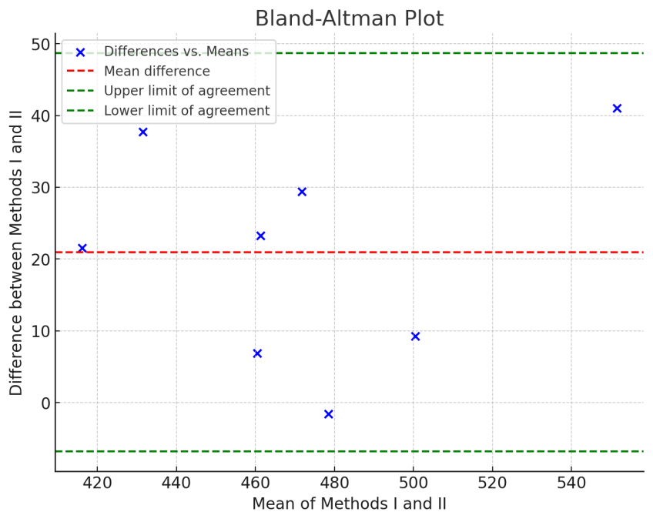
Fig. 2. Bland-Altman plot analysis
Linear regression further confirms the strong relationship between the two methods (Fig. 3). The slope of the regression line is 0.898, indicating that Method II tends to yield values approximately 0.9 times those of Method I, suggesting that Method II slightly underestimates measurements compared to Method I. The intercept of 28.21 implies that when the value of Method I is zero, Method II would still produce a value of around 28.21, indicating a constant offset between the two methods. The R-squared value of 0.878 shows that approximately 87.8% of the variation in Method II can be explained by the variation in Method I, indicating a strong predictive relationship between the two methods. While this suggests that Method I can be a good predictor for Method II, the slight systematic difference between the methods remains evident.
Titrimetric methods have long been employed in pharmaceutical analysis due to their simplicity, cost-effectiveness, and reliability. Unlike more complex instrumental techniques, such as HPLC and GC-MS, titrimetric assays offer a straightforward approach for the quantification of active pharmaceutical ingredients, making them particularly attractive for routine quality control in the pharmaceutical industry. While spectrophotometric and chromatographic methods, including HPLC, are known to demonstrate higher accuracy and precision (Ali et al., 2019; Anthony et al., 2017), the titrimetric approach remains a viable alternative, especially when factors such as cost, time, and available resources are considered (Watson, 2012). Chromatographic methods may provide high resolution and precision, but they often come with higher operational costs and require more time for analysis. In contrast, titrimetric methods offer an efficient and economical solution without compromising the accuracy required for effective pharmaceutical analysis. Therefore, depending on the specific analytical requirements and resources available, titrimetric methods can serve as a reliable and practical option for the quantification of active compounds in pharmaceutical formulations.
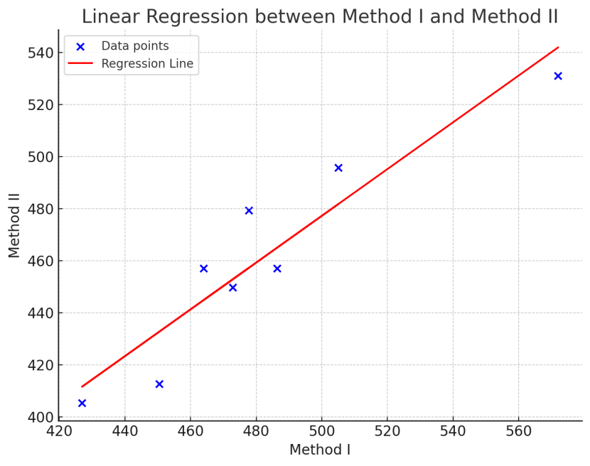
Fig. 3. Linear regression between the two methods

4. Conclusion
The results of this study highlight a strong correlation and agreement between the two titrimetric methods used for quantifying ASA in aspirin tablets. The Pearson correlation coefficient and ICC indicate that both methods are highly consistent, suggesting they are reliable and interchangeable. However, the paired t-test reveals a statistically significant difference between the methods, indicating that while they are similar, there is a small but meaningful discrepancy in their measurements.
The Bland-Altman analysis further underscores this difference, showing that Method I consistently provides higher values than Method II, with most data points falling within the calculated limits of agreement. The linear regression analysis supports this observation, indicating that Method II tends to slightly underestimate the values compared to Method I, with an intercept suggesting a constant offset between the two methods.
In summary, while both methods exhibit a high degree of agreement and can be used interchangeably within certain limits, the small systematic difference between them should be considered when interpreting the results. This study offers valuable insights into the performance of these titrimetric methods under varying storage conditions and provides guidance for their future use in pharmaceutical analysis.

References
Alhamdany, H., Alfahad, M. (2021). Stability evaluation of Acetylsalicylic acid in commercial Aspirin tablets available in the Iraqi market. J Adv Pharm Educ Res. 11(3):21.
Ali, L. M., Salih, M.A., Hayder, O.I. (2019). Determination of Acetyl Salicylic Acid in Aspirin tablets. Kurdistan Journal of Applied Research. 4(2):151-7.
Anthony, O., Moh’d, H. S., Mataka, M. A., Juma, A., Odalo, O. J. (2017). A Comparative Anaylsis of Aspirin from Various Analgesic Formulations Using Titrimetry, Spectroscopic and Hypenated Chromatographic Techniques. J Mol Imaging Dynamic. 7(134):2.
Barcza, L., Buvári-Barcza, Á. (2003). Acid-base titrations in nonaqueous solvents and solvent mixtures. Journal of chemical education. 80(7):822.
Cruz, J., Blanco, M. (2011). Content uniformity studies in tablets by NIR-CI. Journal of pharmaceutical and biomedical analysis. 56(2):408-12.
Desborough, M. J., Keeling, D. M. (2017). The aspirin story–from willow to wonder drug. British journal of haematology. 177(5):674-83.
Šljivić Husejnović, M., Suljić, A., Taletović, A., Džambić, A., Ibišević, M., Smajlagić, A., et al. (2025). Stability Evaluation of Acetylsalicylic Acid in Commercial Aspirin Tablets under Different Storage Conditions. J. Pharm. Res. Int.;37(2):66-74.
Narayan, S., Choudhary, M. (2017). A review on stability studies of pharmaceutical products. International journal of applied pharmaceutical and biological research. 2(3):67-75.
Oketch-Rabah, H. A., Marles, R. J., Jordan, S. A., Dog, T. L. (2019). United States pharmacopeia safety review of Willow Bark. Planta medica. 85(16):1192-202.
Rezabakhsh, A., Mahmoodpoor, A., Soleimanpour, H. (2021). Historical perspective of aspirin: A journey from discovery to clinical practice Ancient and modern history. Journal of Cardiovascular and Thoracic Research. 13(2):179.
Saeed, A.M., Hamzah, M.J., Ahmed, N.Q. (2018). Quantitative assay of aspirin and (salicylic acid and heavy metals as impuraties) in iraqi’s market aspirin tablets using different analytical methods. Int J App Pharm. 10(5):167-72.
Shankar, J. (2024). The Effect of pH on the Hydrolysis of Acetylsalicylic Acid (C9H8O4) to Salicylic Acid (C7H6O3) and Acetic Acid (C2H4O2) at 333.15 K (60° C): A Spectrophotometric Analysis. InChem. Proc Vol. 6.
Watson, D. G. (2012). Pharmaceutical analysis E-book: a textbook for pharmacy students and pharmaceutical chemists. Elsevier Health Sciences.

