*Original Research Article*

Optimizing Concrete mix design Using Response Surface Methodology and Artificial Neural Network (ANN)

**Abstract**

This research investigates the potential of applying Response Surface Methodology (RSM) and Artificial Neural Network (ANN) to optimize the mix design of concrete utilizing locally obtained raw materials. This study aimed to identify the optimal proportion of sand, cement, and coarse aggregate to produce the strongest and most resilient concrete mix. The RSM and ANN framework was applied using the Design of Experiments (DOE) approach, and three-level, three-factor experiments were conducted. The data gathered from laboratory trials was subjected to RSM and ANN. The predicted compressive strength of the concrete is 31.48 MPa, using 1016.85 g of cement, a fine/total aggregate ratio of 0.39, and 56 days of curing. The mixture of sand, cement, and coarse aggregate significantly improved strength and durability compared to control specimens, proving both cost-effective and suitable for local materials. The findings of this study can be utilized to create concrete mixes that are more effective and economical. This study also examined the response surface optimization findings through a validation test to demonstrate the efficacy of the RSM and ANN in optimizing the preparation of concrete.

**Graphical abstract**

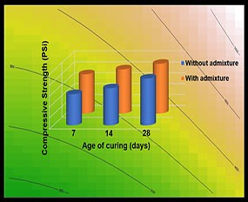

*Keywords*: Particle size distribution, Setting Time, Regression Coefficient, Response Surface Methodology, Concrete Mix Design, Artificial Neural Network.

**1. INTRODUCTION**

Concrete is a popular building material because it is readily available, durable, and easy to produce on-site. The process of determining the best proportions of concrete components to achieve the required quality is known as concrete mix design. This process is affected by factors like material specific gravity, cement type and strength, cement content limits, water-to-cement ratio, water needs, aggregate-to-cement ratio, aggregate type, shape, and size, grading, fine-to-total aggregate ratio, air content, exposure conditions, and fresh concrete properties. Many of these design factors are interrelated. For high-quality concrete, it is crucial to consider strength, durability, and workability. This is particularly important because conventional quality control methods for fresh Portland cement concrete do not provide a real-time assessment of workability during the mixing process. [1]. A mathematical model was developed to evaluate concrete workability based on the mixing power of concrete mixers. These mix design strategies are fundamental for achieving the desired results. The several known procedures for concrete mixes are not universal because design mixtures are unique to the area's temperature, exposure, and local materials. A concrete mix can be designed using various techniques depending on the environment, material, and workability requirements. Popular methods include the maximum density, fineness modulus, Bureau of Indian Standards (BIS), Road Research Laboratory (RRL), Design of Experiment (DOE), and American Concrete Institute (ACI) mix design techniques [2, 3].

The construction industry is rapidly expanding, leading to a high demand for concrete. To meet performance expectations, Consider focusing on concrete optimization instead. is essential to conserve natural resources and explore environmentally friendly alternatives. Concrete remains the most widely used building material globally. Most of the world’s basic ingredients can be found there, and making concrete does not require sophisticated or pricey machinery. However, because it is a widely used and in-demand building material, some of its components should have a source other than the usual one. Due to these financial issues, numerous engineering studies and research have focused on employing locally accessible materials for buildings [4, 5]. The two key factors driving daily innovations and ideas in the building sector are the economy and environmental sustainability. Several of these concepts have taken shape in various construction-related fields. Due to the non-biodegradable nature of This might not be relevant to the core of the study., their disposal has become a significant problem in most countries [6].

Optimizing a concrete mixture involves finding a balance of components that minimizes costs while meeting performance criteria like workability, strength, and durability. Concrete ingredients are divided into cement pastes and aggregates, with the water-to-cement ratio key to cement paste quality. Aggregate properties, such as surface area and void content, influence the required amount of cement paste. Shape and size affect surface area, while particle size distribution impacts void content. By increasing the aggregate-to-cement ratio and reducing voids, cement paste demand can be lowered. [7, 8, 9, 10, 11, 12]. A packing model helps select aggregates for minimal void content and maximum packing, which directly affects the cement paste requirement. Key parameters like water-to-cement ratio, coarse aggregate ratio, and cement content can be adjusted to optimize the design. [13,14,15,16,17,18].

Parameter optimization is one of the most crucial steps in creating an effective and affordable high-value product production process. It takes time and does not consider the interactions between independent variables when using the traditional "one-factor-at-a-time technique." With minimum experimental runs, Response Surface Methodology (RSM), a potent optimization approach, may uncover factors and their relationships [19]. This study aims to demonstrate the use of a statistical approach to optimize concrete mixture proportions, focusing on cementitious material content and the fine-to-total aggregate ratio. Polynomial regression was applied to model. concrete strength, water absorption, and slump based on the mixing components. Statistical analysis of the experimental data showed that the developed models for compressive strength, water absorption, and slump effectively optimize mixture designs while accounting for different alternatives.

This work uses the RSM to construct experiments to explore the relationship between concrete strength, water intake/absorption, slump, and different influence factors. The experimental findings create the regression model between the influence parameters and concrete strength. The primary drawback of the ACI approach is that the mix design does not account for cement strength and that fine aggregate cannot be modified to accommodate varying cement amounts. Additionally, this method has no set procedure for combining aggregates of various sizes [20].

ANN is an artificial tool of information processing inspired by biological neural network systems such as the human brain. ANN is made up of a group of three [21] layers: the input layer, the hidden layer, and the output layer, as illustrated in Figure 1(a) [22]. ANN develops the relationship between inputs and outputs by learning the mapping algorithm of data series [22].

In this study, optimization analysis is used to identify the precise best preparation parameters, and a verification test is used to confirm the accuracy of the optimization results. The parameters for making concrete mixes are optimized in a simple, useful, and efficient manner. To guarantee that the designed concrete's durability satisfies specified requirements while minimizing its cost, we can simultaneously optimize the durability and price of the concrete. This will allow us to obtain an ideal mix ratio and be a promising optimization tool for concrete design under complex working conditions.

**2. METHODOLOGY**

The materials used in this study were sand, Crushed Stone chips, cement and normal tap water. Crushed Stone chips were collected from the Panchagarh district, which is situated in the northern region of Bangladesh. The stone chips were used as coarse aggregate in the concrete mixture. This study, collected Cement (Grade: CEM-I 52.5 Ordinary Portland Cement (OPC) was collected from local manufacturer in Bangladesh named MI Crown Cement Ltd. The chemical analysis of Portland cement is given in Table 1.

**Table 1 Chemical analysis Report for Cement**

|  |  |  |
| --- | --- | --- |
| SL no. | Parameter | Result (wt %) |
| 1. | Silicon dioxide (SiO2) | 20.19 |
| 2. | Iron (iii) Oxide (Fe2O3) | 2.97 |
| 3. | Aluminum Oxide (Al2O3) | 6.91 |
| 4. | Calcium Oxide (CaO) | 64.43 |
| 5. | Magnesium Oxide (MgO) | 2.24 |
| 6. | Sulphur trioxide (SO3) | 2.43 |

The sand used as fine aggregate in the concrete mixture was collected from Habiganj, Sylhet, Bangladesh. The chemical analysis of sand used in this study is given in Table 2, where the higher percentage of SiO2 and lower impurities directly influence the quality, strength, and workability of the concrete.

**Table 2 Chemical analysis Report for Sand**

|  |  |  |
| --- | --- | --- |
| Sl No. | Name of Parameter | Result (Wt %) |
| 1. | Silicon dioxide (SiO2) | 98.20 |
| 2. | Aluminum Oxide (Al2O3) | 1.34 |
| 3. | Potassium Oxide (K2O) | 0.23 |

In this study, the crushed stone chips used as coarse aggregate in a concrete mixture were graded from 9 to 25 mm in size. The particle size distribution of crushed stone chips is given in Table 3 and Figure 1.

**Table 3 Particle Size Distribution of Crushed Stone Chips**

|  |  |
| --- | --- |
| Particle Size (mm) | Percentage (%) of passing |
| 2 | 15.12 |
| 4 | 24.26 |
| 8 | 30.56 |
| 16 | 17.36 |
| 18 | 10.68 |
| 20 | 1.71 |
| Pan | 0.31 |

**Figure 1** Particle Size Distribution: Sand and Stone

In this study, locally known as Sylhet sand, was used as fine aggregate in the concrete mixture and was graded from 0 to 2 mm in size. The particle size distribution of sand is given in Table 4 and Figure 1. The physical properties of the raw materials used in the concrete mixture are presented in Table 5.

**Table 4 Particle size distribution of sand**

|  |  |
| --- | --- |
| Particle Size (mm) | % Retained |
| 2.00 | 1.8 |
| 1.00 | 2.4 |
| 0.50 | 4.08 |
| 0.25 | 8.60 |
| 0.125 | 15.58 |
| 0.063 | 33.35 |
| 0.053 | 34.10 |

**Table 5 physical properties of raw materials**

|  |  |  |  |
| --- | --- | --- | --- |
| Raw materials | Parameter | | |
| Water to Cement Ratio | Fineness Modulus | Specific Gravity |
| Cement | 0.45 | 2.83 | 3.03 |
| Sand | 3.16 | 2.77 |
| Limestone | 2.93 | 2.81 |

The research employs composite designs to develop a complete quadratic model. These designs are particularly useful when the experimental plan requires sequential testing, as they can incorporate data from a well-structured factorial experiment. This approach is grounded in prior studies. Subsequently, the research applies Box-Behnken designs, which generally require fewer design points compared to central composite designs, making them more cost-effective to execute with an equivalent number of factors. The variables used in the concrete mix design experiment are cement content, aggregate ratio, and curing period (days). The strength of the concrete mix is also measured.

The study also includes RSM analysis procedure and various plots such as Residual vs Fitted plot, Normal Q-Q plot, Scale-Location plot, Residual vs Leverage plot, and Response Surface contour plots. The techniques outlined in the document rely on composite designs, commonly employed when sequential experimentation is required. These designs allow for the incorporation of data from a meticulously planned factorial experiment. Box-Behnken designs typically involve fewer design points compared to central composite designs, making them more cost-efficient to conduct with the same number of variables.

The study outlines the following steps:

1. Composite Designs: These designs are utilized to construct a complete quadratic model. They are frequently employed in scenarios where sequential experimentation is necessary, as they can incorporate data from a well-structured factorial experiment.

2. Box-Behnken Designs: These designs typically require fewer design points than central composite designs, making them more cost-effective to execute with an equivalent number of factors.

3. Variables: The variables considered in the experiment include cement content, aggregate ratio, and curing period (in days). The strength (in MPa) is the response variable 30.

4. Stationary Point: The stationary point is calculated as 1016.8458245 for cement content, 0.3852049 for aggregate ratio, and 56.0961292 for the curing period [23].

5. RSM Analysis Procedure: The document includes various plots for the RSM analysis procedure, including residual vs fitted plot, normal Q-Q plot, scale-location plot, residual vs leverage plot, and response surface contour plots.

**2.1. Experimental Program**

RSM Analysis Procedure: RSM is a set of statistical methods used to design experiments, develop models, assess factor effects, and identify optimal factor conditions for achieving desired outcomes. The procedure involves three general steps: experiment design, modeling, and optimization.

Polynomial Models: These models are often used to fit the empirical models to the data.

Experimental Matrix Design: This is the first step in the RSM process. It involves the selection of a suitable set of experiments to be conducted for adequate and reliable measurement of the response variable.

Justification: RSM is frequently utilized when numerous variables affect one or more performance attributes or reactions. It is used to meet a specific set of requirements or to optimize one or more responses (e.g., a minimum strength specification or an allowable range of slumps).

This study examined the effects of the standard mix proportion on compressive strength, water intake, and concrete slump. The curing times for all specimens were 7, 14, and 28 days. The typical concrete ingredients, cement, sand, gravel, and water were evaluated both with and without admixture. The experiment was conducted at the BCSIR, (IGCRT). To observe how the concrete reacted as it cured, 42 sets (age) were used (age).

Measurements were made of the cement's setting time with and without additives. The ACI mix design approach was used for the mix design procedure (ACI 211.1-91). The concrete's compressive strength after 28 days was assessed using a typical 4/8-inch cylinder-shaped sample. The statistical analysis was carried out using R, version 4.1.1. Data statistics, including the mean, standard deviation, and correlation coefficient between the variables, are provided in Tables 6 and Table S1.

**Table 6 Values of each factor per level**

| **Factors** | **Low Level** | **Middle Level** | **High Level** |
| --- | --- | --- | --- |
| Cement (gm) | 1575 | 2250 | 2925 |
| Curing Period (days) | 7 | 14 | 28 |
| Fine/total aggregate ratio (Rf/TA) by mass | 0.35 | 0.4 | 0.45 |

Cement, coarse aggregate, fine aggregate, and water were used to test the compressive strength of concrete [24]. The hydraulic press machine is the tool used to measure the compressive strength. It was used to test various cylinder-shaped concrete samples at various curing ages.

**2.2. Experimental Matrix Design**

A collection of statistical techniques known as the response surface methodology (RSM) can create, enhance, or optimize products [25]. When numerous variables affect one or more performance attributes or reactions, RSM is frequently utilized. (RSM) is used to meet a specific set of requirements or to optimize one or more replies (e.g., a minimum strength specification or an allowable range of slump values) [26]. (RSM) is made up of three general steps: experiment design, modelling, and optimization as shown in Figure 2.

**Figure 2** RSM analysis procedure

Multiple ingredients are mixed to create concrete. Basic concrete ingredients include water, Portland cement, fine, and coarse aggregates. Other substances, such as fibres and various chemical and mineral admixtures, may also be added. The response surface will fit most well if the design is chosen properly. Central composite is provided by R software [25]. Consider a concrete mixture with q component elements (where q is the number of component materials). The mathematically independent variable approach and mathematical model optimization are two methods that can be used for concrete mixtures.

**2.3. RSM analysis procedure**

Polynomial models, whether linear or quadratic, are often employed to fit empirical data. For instance, a full quadratic model with three independent variables is represented as:[25] y=b_0+b_1 x_1+b_2 x_2+b_3 x_3+b_11 x_1^2+b_22 x_2^2+b_33 x_3^2+b_12 x_1 x_2+b_13 x_1 x_3+b_23 x_2 x_3+e

………………………………………………………………………………………...……(1)

In (1), the bk stands in for the 10 coefficients, and e is a random error term that representing the combined effects of variables that are not part of the model. The interaction terms (xixj) and the quadratic terms (xi2) account for the response surface's curvature. In product optimization, the central composite design (CCD), an expanded factorial design, is frequently utilized [24]. The design consists of at least 3 center points with coded values of zero for each xk, 2k factorial points representing all combinations of coded values xk = 1, and 2*k axial points at from the origin [27]. Usually, the value is chosen to make the design rotatable, but occasionally, there are good reasons to choose different values. Central Composite designs can accommodate a full quadratic model and are frequently chosen when sequential experimentation is required, as they can incorporate data from a well-designed factorial experiment. In contrast, Box-Behnken designs generally involve fewer design points, making them more cost-effective to implement with the same number of factors. While they are efficient in estimating first- and second-order coefficients, they do not accommodate runs from a factorial experiment. Unlike Central Composite designs, which may include up to five levels per factor, Box-Behnken designs consistently use three levels per factor and do not include runs where all factors are at their extreme values, such as the lowest settings.

**2.4. Factors and Levels**

The study's structure was based on the Response Surface Methodology and Central Composite Design of the experiment. The numerical factors' low-level values are the lowest that can be achieved while still acceptable. For each concrete mixture, the maximum values were evaluated and found to be effective in achieving the necessary quality. Therefore, the compressive strength will be undesired if these values are exceeded.

**2.5 Development of ANN Prediction Model**

The ANN model to predict the compressive strength of concrete mix was developed by using R studio software. It was constructed by adopting feed forward neural network inbuilt in the software. Three (6) inputs were used to develop the model; these are cement (gm), curing period (days) and fine/total aggregate ratio (Rf/TA) by mass. Meanwhile, the compressive strength at 56th day was used as the output. The development of the model was carried out by dividing the datasets into three (3) groups: 60% for the model training, 20% for the model testing and 20% for the model validation. A linear activation function was used to solve the model. Meanwhile, the number of hidden neurons were decided based on paper in [28]. Several numbers were employed and tested in the software, and it was discovered that ten (10) hidden neurons were found to be suitable in this study. Then, the predicted results generated from the ANN model were compared with the experimental results.

**3. Results and Discussion**

The experiment design follows a Central Composite Design with 3 factors and 42 runs, as shown in Table 6 and Table S1, utilizing R Studio version 4.2.1 to implement the Response Surface Methodology (RSM). Table S1 presents the compressive strength of all 42 concrete mixtures after curing periods of 7, 14, and 28 days. To evaluate the significance of the mixture factors and build a regression model for compressive strength, the data in Table S2 were statistically analyzed using analysis of variance (ANOVA).

**3.1. Sampling Procedures and Runs**

Using R studio software for Response Surface Design, the effectiveness of the various components was assessed individually.

**3.2. Experimental Procedures**

The ideal slump height for all combinations was 2 inches to reduce the bleeding of the concrete during the experiment. To prevent contaminants, all batches were made in a pleasant climate and clean atmosphere. All specimen preparation and testing requirements follow ASTM and AASHTO guidelines. Following the mixing process, the produced concrete underwent curing and inspection. A Universal Testing Machine calculates each concrete mixture's final compressive strength. After each concrete mix's corresponding curing period, a compression test was conducted.

**3.3. Analysis**

42 concrete mixes with varying amounts of each of the three components were created during the experiment (Table S1). Surface Formula for Response

Formula = Yield (y) ~ SO (x1, x2, x3), data = concrete data................................................(2)

Equation (1) was applied to analyse the response surface model components. The curvature was quickly captured using the first-order response surface (FO), two-way interaction (TWI), and pure quadratic (PQ). Different analyses are done for each curing interval to determine how the cement content and aggregate ratio interact (Table S3).

**3.4. Analysis of Variance**

The three variables' effects on concrete strength are shown through the analysis of Variance (ANOVA). The study includes each concrete mix's first-order response surfaces (FO) and pure quadratic (PQ). Table 6 shows individual analyses of the strength of the concrete mix design. The strength F-value for the admixture quadratic model is 0.1841. This suggests that the lack of fit tests and with or without mixing is significant (values of Pr > F greater than 0.0500). This merely implies that the strength of the concrete is unaffected by analysing the outcome with or without admixture.

**3.5. Diagnostics plots of estimated response surfaces**

Diagnostic plots are essential for checking whether the assumptions of the model are satisfied. Figures 3-6 display the residual diagnostic plots. Since there is no significant deviation from the normal probability line, the normality assumption is confirmed. Figure 3 (Residuals vs. Fitted) shows a random distribution of residuals against fitted values, indicating a good fit. Figure 4 (Normal Q-Q) is a plot of residuals, where any deviations from the normal distribution appear away from the diagonal. Figure 5 (Scale-Location) assesses if residuals are evenly spread across the predictors, ensuring homoscedasticity.

They must also have an approximately random distribution, which is true. Figure 6 (Residuals vs Leverage) shows the points with the greatest influence (leverage) on the regression. In this case, they do not exceed the limits marked in red (Cook's distance), which would be influential cases that could alter the regression results which are excluded.

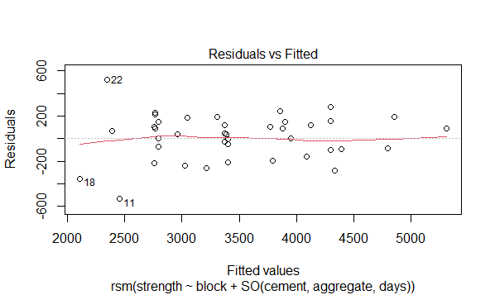

**Figure 3** Residual vs Fitted plot of the concrete experiment.

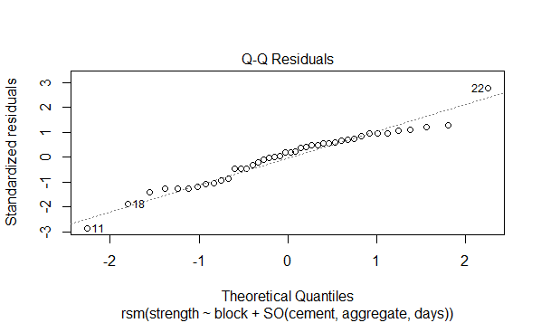

**Figure 4** Normal Q-Q plot of the concrete experiment.

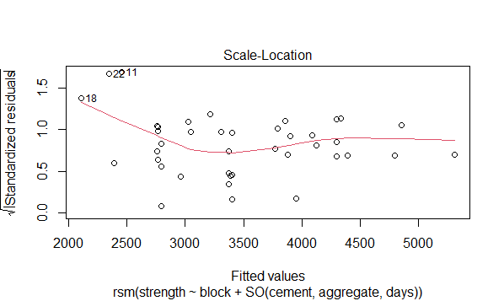

**Figure 5** Scale-Location plot of the concrete experiment.

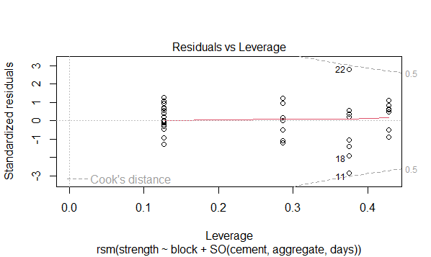

**Figure 6** Residual vs Leverage plot of the concrete experiment.

**3.6. Response Surface Model**

The ideal mix likely lies between the lower to middle range of curing duration and the middle to upper range for cement content, as ANOVA tables showed two significant factors with no significant interactions. R Studio software was used to pinpoint the optimal point on the response surface to maximize concrete compressive strength.

Numerical Optimization tool to provide a numerical example of this. The chosen values were placed where the highest compressive strengths could be seen. Figures 7 through 12 intuitively depict these findings. The degree of interaction can be inferred from the form of the 3D response surface, and contour graphs provide insight into how the cement content and cure time affect strength. A center point and star point extend the whole factorial design (cube points) in this pattern [29]. These numbers show how the three components interact in a reasonably substantial way. This result is in line with the Table S2 ANOVA results.

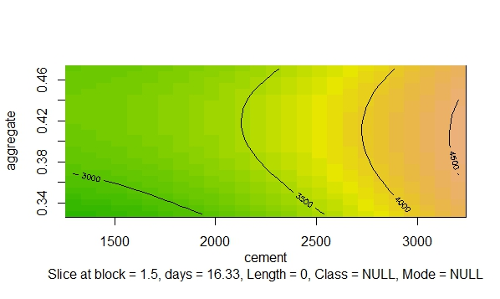

**Figure 7** Response Surface contour plot of cement vs aggregate in region of optimum combination.

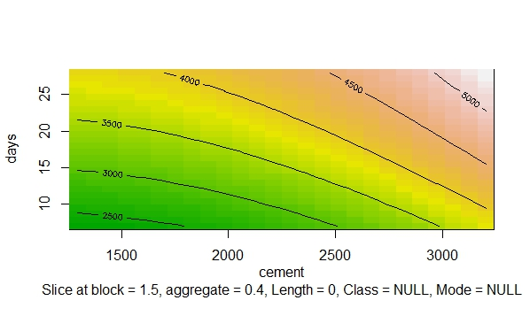

**Figure 8** Response Surface contour plot of cement vs days in region of optimum combination.

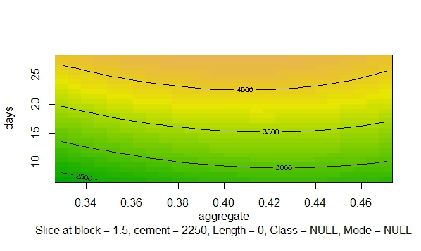

**Figure 9** Response Surface contour plot of days vs aggregate in region of optimum combination.

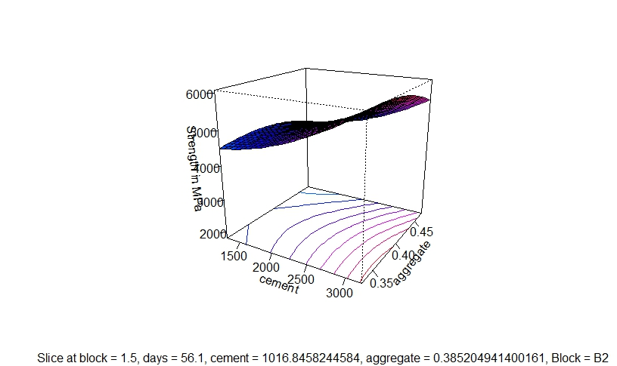

**Figure 10** 3D surface plot of cement vs aggregate in compressive strength for region of optimum combination.

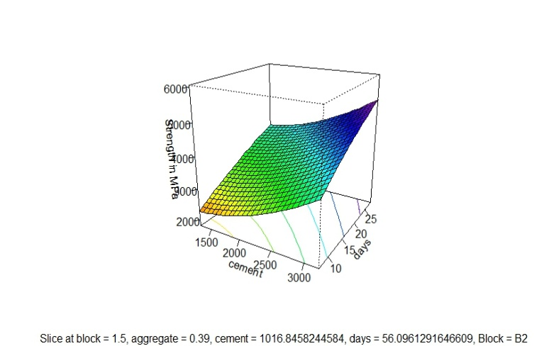

**Figure 11** 3D surface plot of days vs cement in compressive strength for region of optimum combination.

**Figure 12** 3D surface plot of days vs aggregate in compressive strength for region of optimum combination.

3.7 ANN architecture

Determining ANN architecture is the first important step in developing an ANN model that best suits the problem at hand. However, there is no guideline for selecting the optimum ANN architecture, thus it is open to investigation [21,22,28]. Consequently, after many trials and errors, the network architecture shown on Fig. 13 was selected.

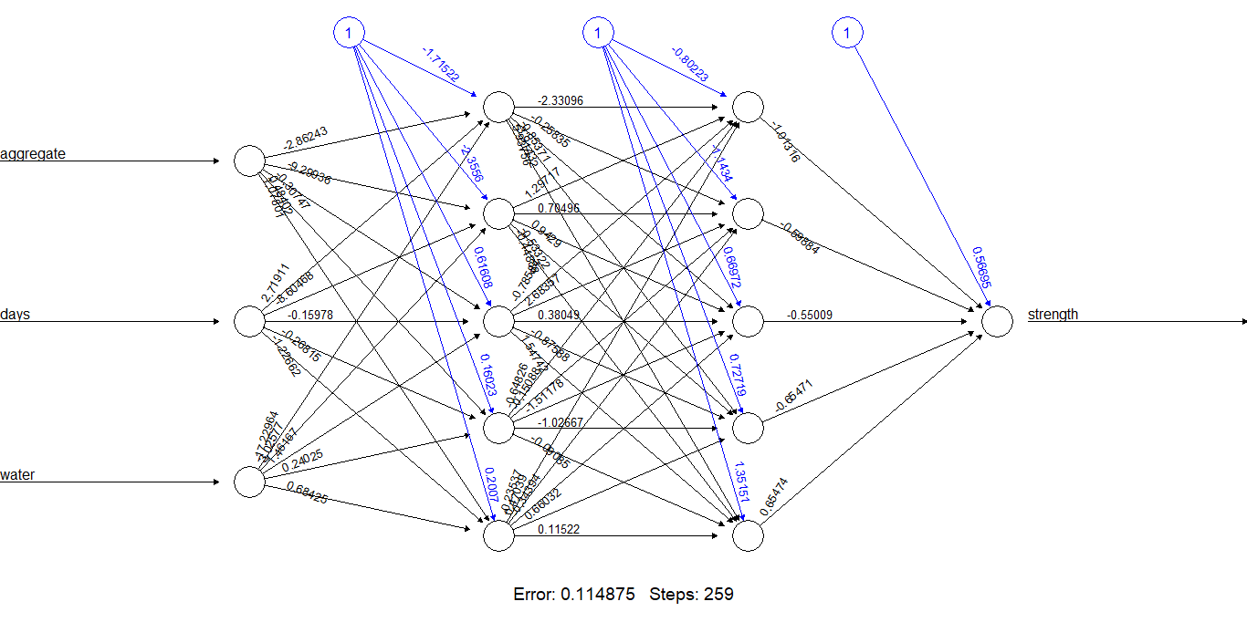

Fig. 13. Proposed artificial neural network architecture (3-10-1)

The Sum of Squared Errors (SSE) has reduced significantly by only 0.11 with few steps.

**3.7. Interpretation of Concrete Mix Design**

The equation gives the predicted strength.

*Strength = -7.8348e+03 + 4.2175e+04 aggregate + 1.5351e+02 time + 2.9974e-04 cement2 - 4.4972e+04 aggregate2*............................................................................(3)

The stationary point of the response surface corresponds to -1.8268951 for cement content, -0.2959012 for aggregate content, and 3.6758218 for curing days. When converted to the original units, these values are 1016.8458245 for cement content, 0.3852049 for aggregate ratio, and 56.0961292 for the curing period. Table S4 presents the Eigenvalues associated with the concrete mix design. Given that the Eigenvalue for cement content (3.086148e-04) is positive, while those for the aggregate ratio and curing period are negative (-9.096913e-01 and -4.497195e+04), the stationary point in the original units now represents the optimal combination for the concrete mix design experiment.

**3.8. Optimal experimental point**

The summary of our model includes the optimal experimental point, or the set of variables that will provide the best response. Finally, ensure that the experimental analysis matches the response predicted by the model given in Table XI, which will be the best possible combination of components in the concrete mixture for the best performance concrete production.

The optimization results in Table S5 show that the highest compressive strength occurs at cement concentrations of 1575 and 2925 gm/m³, exceeding the strength achieved at 1016.85 gm/m³. This suggests that improved aggregate packing increases compressive strength with lower cement content (i.e., a higher aggregate-to-cement ratio) when the optimal values of Rw/cm and RFA/TA are maintained, as observed by [12]. The maximum compressive strengths observed within the considered variation range in this study align with the minimum curing period of 56 days and the highest fine-to-to-to-total aggregate ratio (0.39) across all levels of cement material concentration.

**3.9. Limitations**

The main limitation of this method is its inability to adjust the fine aggregate based on changes in cement content and its lack of consideration for cement strength in the mix design. Moreover, it does not provide a specific procedure for blending various aggregate sizes.

**3.10. Significant Statement**

The RSM model's predicted features significantly support the experimental compressive strength values for the optimal process conditions. Statistical tools have advanced to reduce the number of trials and forecast the desired performance of mix-designed concrete products during large-scale preparation. The application of RSM is helpful in civil engineering, specifically in Investigating the conditions for building material preparation. This study will be expanded to include concrete products with altered mix designs for commercial use.

**4. Literature review**

Wong & Kwan used regular Portland cement following British Standard 12:1996, while Fennis and Walraven worked with both blast furnace slag cement and regular Portland cement. For mortar, Wong & Kwan used aggregate particles smaller than 1.2 mm, and for concrete mix, they used particles larger than 1.2 mm. Kwan and Wong utilized pulverized fly ash as a cementation material by BS 3892: Part 1: 1982. Kwan and Wong used ASTM C 1240-03 compliant condensed silica fume as the cementation material in their studies. In their research, Kwan and Wong employed two different kinds of superplasticizers: formaldehyde condensate based on naphthalene and polycarboxylate-based, cross-linked polymer.

1. The packing densities of cementation materials comprising condensed silica fume, fly ash that has been ground up, and regular Portland cement were measured by Kwan and Wong. The findings for non-blended materials showed that while adding a polycarboxylate-based superplasticizer could reduce the packing density of condensed silica fume, adding regular Portland cement and ground fly ash will invariably result in higher packing densities [30].
2. Concrete is among the most affordable and widely utilized building materials. Specific qualities for both the flexible and hardened concrete stages must be considered during design. Accurately distributing the components of concrete to maximize their qualities by site specifications is known as concrete mix design [31,22,33]. Put another way, it establishes the most cost-effective ratios between the various concrete components to produce the required strength and workability.
3. In 1988, Professor H. Okamura invented and released self-compacting concrete (SCC) to increase the longevity of structures built by unskilled laborers. The three characteristics of SCC—passing ability, filling ability, and segregation resistance—set it apart from conventional concrete. Professionals and researchers working in this field should take note of this information. By adding additives or custom mix designs, SCC can be further enhanced to identify the optimal option. Design approaches can be divided into six types according to various concepts and criteria: The strength-based design method, paste rheology method, Eco-SCC mix design method, statistical factorial design method, empirical design method, and particle packing method are some of the key approaches used in concrete mixture design [34].
4. The theory of particle packing has drawn the attention of numerous researchers in the domains of metallurgy, ceramics, and concrete technology in recent times. The theory is predicated on the idea of void minimization. Particle packing is utilized in the field of concrete technology to achieve a dense structure in concrete. It is an isolated, fully crowded virtual stage made of concrete. Combining aggregates, cementitious ingredients, and super plasticizers gives concrete workability, strength, and durability. Achieving the highest packing density of aggregate depends critically on the size, shape, and kind of parent rock. The method's foundation is provided by the packing properties of the aggregate and how they affect the packing of the aggregate mixture [35].
5. The study examines the strength efficiency of flash and rotary kiln metakaolin in concrete. An efficiency factor (k) is developed to assess strength efficiency based on pozzolan concentration and relative strength, utilizing the Smith and Bolomey modified model. The current investigation demonstrates that the effectiveness of metakaolin-modified concrete declines as the amount of metakaolin substitutions rises by up to 30%. After 14 days of curing, replacing ordinary Portland cement (OPC) with up to 30% rotary-calcined metakaolin (RMK) or flash-calcined metakaolin (FMK) in the mixtures resulted in improved strength properties compared to the control concrete. FMK-blended concrete demonstrated higher strength qualities and good k values than RMK-blended concrete [36].
6. Waste foundry sand (WFS) is a solid waste generated by the metal casting industry worldwide. The challenge of WFS utilization and disposal is becoming increasingly urgent across the globe. Because WFS contains both organic and inorganic components that have the potential to contaminate the environment and seriously harm human health, it is referred to as a hazardous material. The project's goal is to use WFS as a fine aggregate in concrete again in large quantities. The primary challenge in developing self-compacting concrete (SCC) is ensuring the robustness of the mixture. To study the impact of waste foundry sand (WFS) on SCC strength, six mixtures were created with WFS content up to 50%, and metakaolin was used as a cement substitute at a constant ratio. The mixtures were incrementally adjusted in 10% steps [37].
7. Self-compacting concrete is an engineering achievement due to its beneficial properties and lightweight aggregate concrete. However, its use in civil engineering is limited due to insufficient research. This review aims to provide a comprehensive analysis of lightweight, self-compacting concrete using various sustainable and natural lightweight aggregates. The lightweight aggregates play a key role in the material's bulk density and strength variations. The study shows that lightweight self-compacting concrete can achieve densities below 1000 kg/m³ by carefully assessing the impact of different aggregates and other factors on workability, strength, and durability [38].

**5. Summary of results**

- The traditional mix-design methods are not ideally suited for harsh environments, but they can serve as a foundation for developing a specialized design mix approach that better addresses the challenges of adverse exposure, climate, and material conditions.

- In demanding environments, a mix design that accounts for cement strength, air content, and aggregate grading with a broad range of aggregate sizes is ideal, producing dense and cost-effective concrete.

- To enhance concrete quality in harsh conditions, reducing cement concentration and incorporating low-cost materials and mineral admixtures is key. Additionally, setting limits on the water-to-cement ratio and specifying minimum cement content for various exposures is crucial.

- Durability factors like mix density and the fine-to-to-to-to-total aggregate ratio, along with quality indicators such as the fine aggregate-to-cement and total aggregate-to-cement ratios, should be adjusted for harsh conditions.

- Among the methods, the DOE approach is the most expensive, yielding the densest mix.

- The DOE method has the lowest aggregate-to-cement ratio, while the fineness modulus approach has the highest when unchanged.

- As the maximum aggregate size and concrete workability increases, so does the cost.

- The concrete mixed value is directly related to strength and inversely proportional to the water-to-cement ratio.

**6. Conclusions**

A simple step-by-step approach for optimizing concrete mixture design is proposed, based on data from a statistically structured experimental program. The method involves five key steps: first, conduct an experimental study with trial mixtures using a full factorial design to generate data for statistical modeling. Next, statistically analyze the data and fit a strength model. Finally, optimize the mixture proportions using the fitted model. The study found that cement quantity, aggregate ratio, and curing duration significantly affect compressive strength, while the admixture has minimal impact, mainly acting as a binder. The relationship between these factors and compressive strength is nonlinear, particularly between cement content and curing time, which means they do not have proportional effects at different levels. One cement type showed a saddle response, and it is recommended to conduct the same tests with canonical path analysis to find the optimal combination for maximum compressive strength.

**References**

1. Rong, X., Liu, H. and Li, C., 2022. A proposed method and monitoring system for evaluating workability of Portland cement concrete during mixing. *Heliyon*. 8(11): e11355.

[2] DeRousseau, M.A., Kasprzyk, J.R. and Srubar Iii, W.V., 2018. Computational design optimization of concrete mixtures: A review. *Cement and Concrete Research.* 109: 42-53.

[3] Ahmed, M., Islam, S., Nazar, S. and Khan, R., 2016. A Comparative Study of Popular Concrete Mix Design Methods from Qualitative and Cost-Effective Point of View for Extreme Environment. *Arabian Journal for Science & Engineering* 41(4).

[4] Behera, G.C., Mohanty, M., Bagh, S.R., Sarkar, I. and Singh, S., 2011. Slag as coarse aggregate and its effect on mechanical properties of concrete. *International Journal of Earth Sciences and Engineering. 4*: 899-902.

[5] Regulacion, R.E. and Oreta, A.W.C., 2014, March. Application of response surface methodology: optimum mix design of concrete with slag as coarse aggregate. *In DLSU Research Congress*, De La Salle University, Manila, Philippines.

[6] Raffoul, S., Garcia, R., Pilakoutas, K., Guadagnini, M. and Medina, N.F., 2016. Optimisation of rubberised concrete with high rubber content: An experimental investigation. *Construction and Building Materials*. 124: 391-404.

[7] Joshaghani, A., Ramezanianpour, A.A., Ataei, O. and Golroo, A., 2015. Optimizing pervious concrete pavement mixture design by using the Taguchi method. *Construction and Building Materials.* 101: 317-325.

[8] Harja, M., Barbuta, M. and Rusu, L., 2009. Obtaining and characterization of the polymer concrete with fly ash. *Journal of Applied Sciences.* *9*(1): 88-96.

[9] Glavind, M. and Munch-Petersen, C., 2000. ‘Green’concrete in Denmark. *Structural concrete.* 1(1): 19-25.

[10] Kumar, S.E.N.T.H.I.L. and Santhanam, M., 2003. Particle packing theories and their application in concrete mixture proportioning: A review. *Indian concrete journal*. 77(9): 1324-1331.

[11] He, H., Stroeven, P., Stroeven, M. and Sluys, L.J., 2012. Optimization of particle packing by analytical and computer simulation approaches. *Computers and Concrete, An International Journal*. 9(2): 119-131.

[12] Ishaq, M.S., Hussain, M.M., Siddique Afridi, M., Ali, G., Khattak, M., Ahmad, S. and Shakirullah, 2014. In vitro phytochemical, antibacterial, and antifungal activities of leaf, stem, and root extracts of Adiantum capillus veneris. *The Scientific World Journal*. 2014(1): 269793.

[13] Lensol, I., 2015. Investigation on reliability of particle packing models for aggregates.

[14] Pannem, R. and Kumar, P.P., 2019. Comparative study of self-compacting concrete containing lightweight and normal aggregates. *Slovak Journal of Civil Engineering*. 27(2): 1-8.

[15] Soudki, K.A., El-Salakawy, E.F. and Elkum, N.B., 2001. Full factorial optimization of concrete mix design for hot climates. *Journal of materials in civil engineering*. 13(6): 427-433.

[16] Li, Z., Lu, D. and Gao, X., 2021. Optimization of mixture proportions by statistical experimental design using response surface method-A review. *Journal of Building Engineering*. 36: 102101.

[17] Chang, P.K., 2004. An approach to optimizing mix design for properties of high-performance concrete. *Cement and Concrete Research.* 34(4): 623-629.

[18] Akalin, O., Akay, K.U. and Sennaroglu, B., 2010. Self-Consolidating High-Strength Concrete Optimization by Mixture Design Method. *ACI Materials journal.* 107(4).

[19] Rahman, S.H.A., Choudhury, J.P., Ahmad, A.L. and Kamaruddin, A.H., 2007. Optimization studies on acid hydrolysis of oil palm empty fruit bunch fiber for production of xylose. *Bioresource technology*. 98(3): 554-559.

[20] Hatem, M., Al-Gburi, M., Al-Ansari, N., Jonasson, J.E., Pusch, R. and Knutsson, S., 2012. Design of concrete mixes by systematic steps and ANN. *Journal of Advanced Science and Engineering Research.* 2(4): 232-251.

[21] Khademi F, Jamal SM, Deshpande N, Londhe S. Predicting strength of recycled aggregate concrete using artificial neural network, adaptive neuro-fuzzy inference system and multiple linear regression. Int J Sustain Built Environ. 2016;5(2):355–69.

[22] Rizalman AN, Lee CC. Comparison of Artificial Neural Network (ANN) and Response Surface Methodology (RSM) in predicting the compressive strength of POFA concrete. Appl Model Simul. 2020; 4:210–6.

[23] Pannem, R. and Kumar, P.P., 2019. Comparative study of self-compacting concrete containing lightweight and normal aggregates. *Slovak Journal of Civil Engineering*. 27(2): 1-8.

[24] Sayed-Ahmed, M., 2012. Statistical modelling and prediction of compressive strength of concrete. *Concrete Research Letters.* 3(2): 452-458.

[25] Soto-Pérez, L., López, V. and Hwang, S.S., 2015. Response Surface Methodology to optimize the cement paste mix design: Time-dependent contribution of fly ash and nano-iron oxide as admixtures. *Materials & Design.* 86: 22-29.

[26] Cihan, M.T., Güner, A. and Yüzer, N., 2013. Response surfaces for compressive strength of concrete. *Construction and Building Materials*. 40: 763-774.

[27] Alsanusi, S. and Bentaher, L., 2015. Prediction of compressive strength of concrete from early age test result using design of experiments (RSM). *Int Science Index, Civil and Environmental Engineering.* 9(12): 1559-1563.

[28] Golizadeh H, BANIHASHEMI S. Predicting Significant Characteristics of Concrete Containing Palm Oil Fuel Ash. J Constr Dev Ctries. 2015;20(1):85–98.

[29] Hetzner, H., Schmid, C., Tremmel, S., Durst, K. and Wartzack, S., 2014. Empirical-statistical study on the relationship between deposition parameters, process variables, deposition rate and mechanical properties of aC: H: W coatings. *Coatings.* *4*(4): 772-795.

[30] Tolmatti, S.S., Jadhav, S.J., Jadhav, S.S. and Maske, M.M., 2021. Concrete mix design using particle packing method: Literature review, analysis, and computation. *International Journal of Informatics, Information System and Computer Engineering (INJIISCOM).* 2(1): 83-102.

[31] Kumar, D., Kumar, A., Kumar, P., and Bains, N.S., 2017. Comparative Study of ACI and BIS Methods of Concrete Mix Design and Demonstration of Cracking Pattern of Concrete Specimens. *International Journal of Science and Research (IJSR).* 6(12): 543–546.

[32] Mishra, S., 2012. Comparison of IS, BS and ACI Methods of concrete mix design and proposing function equations-based design. *Research and Development (IJCSEIERD)*. 2(1): 20-56.

[33] Nwofor, T.C., Eme, D.B. and Eme, D.B., 2016. Comparative analysis of strength of concrete produced from different fine aggregates. *International Journal of Civil Engineering*. 3(1): 1-4.

[34] Ashish, D.K. and Verma, S.K., 2019. An overview on mixture design of self‐compacting concrete. *Structural Concrete*. *20*(1): 371-395.

[35] Ashish, D.K. and Verma, S.K., 2019. Determination of optimum mixture design method for self-compacting concrete: Validation of method with experimental results. *Construction and Building Materials*. 217: 664-678.

[36] Ashish, D.K. and Verma, S.K., 2019. Cementing efficiency of flash and rotary-calcined metakaolin in concrete. *Journal of Materials in Civil Engineering*. 31(12): 04019307.

[37] Ashish, D.K. and Verma, S.K., 2021. Robustness of self-compacting concrete containing waste foundry sand and metakaolin: A sustainable approach. *Journal of Hazardous Materials*. 401: 123329.

[38] Adhikary, S.K., Ashish, D.K., Sharma, H., Patel, J., Rudžionis, Ž., Al-Ajamee, M., Thomas, B.S. and Khatib, J.M., 2022. Lightweight self-compacting concrete: A review. *Resources, Conservation & Recycling Advances*. 15: 200107.

Supplementary

**Table S1** Results of the experimental and predicted Compressive strength

|  |  |  |  |  |  |  |  |
| --- | --- | --- | --- | --- | --- | --- | --- |
| Mix  number | Admixture | Mix proportion  (c:w:f:T) | Cement (gm in a concrete mixture) | Fine/total aggregate ratio (Rf/TA) by mass | Curing Period (days) | Compressive strength (MPa) | |
| Experimental | Predicted |
| 1 | 1 | 1:2.25:3 | 2925 | 0.45 | 28 | 32.48 | 22.72 |
| 2 | 1 | 1:2:3 | 2250 | 0.4 | 14 | 24.10 | 27.22 |
| 3 | 1 | 1:2.25:3 | 2925 | 0.45 | 14 | 27.30 | 24.02 |
| 4 | 1 | 1:1.75:3 | 2925 | 0.35 | 7 | 20.33 | 20.60 |
| 5 | 1 | 1:2:3 | 2250 | 0.4 | 28 | 30.75 | 24.08 |
| 6 | 1 | 1:2:3 | 2250 | 0.4 | 28 | 31.57 | 23.87 |
| 7 | 1 | 1:2:3 | 2250 | 0.4 | 28 | 28.95 | 24.80 |
| 8 | 1 | 1:2.25:3 | 1575 | 0.45 | 14 | 19.20 | 26.14 |
| 9 | 1 | 1:2.25:3 | 1575 | 0.45 | 28 | 27.35 | 24.70 |
| 10 | 1 | 1:2:3 | 2250 | 0.4 | 7 | 19.69 | 24.08 |
| 11 | 1 | 1:2.25:3 | 1575 | 0.45 | 7 | 13.23 | 22.72 |
| 12 | 1 | 1:2:3 | 2250 | 0.4 | 14 | 23.08 | 24.08 |
| 13 | 1 | 1:2:3 | 2250 | 0.4 | 14 | 23.61 | 23.731 |
| 14 | 1 | 1:1.75:3 | 1575 | 0.35 | 28 | 26.72 | 25.55 |
| 15 | 1 | 1:1.75:3 | 2925 | 0.35 | 28 | 34.82 | 27.43 |
| 16 | 1 | 1:2:3 | 2250 | 0.4 | 7 | 20.54 | 21.59 |
| 17 | 1 | 1:2:3 | 2250 | 0.4 | 7 | 20.68 | 22.72 |
| 18 | 1 | 1:1.75:3 | 1575 | 0.35 | 7 | 12.10 | 24.80 |
| 19 | 1 | 1:1.75:3 | 2925 | 0.35 | 14 | 28.26 | 22.24 |
| 20 | 1 | 1:2.25:3 | 2925 | 0.45 | 7 | 23.62 | 24.01 |
| 21 | 1 | 1:1.75:3 | 1575 | 0.35 | 14 | 17.51 | 24.80 |
| 22 | 2 | 1:2:3 | 1295.41 | 0.4 | 7 | 19.78 | 25.02 |
| 23 | 2 | 1:2.35:3 | 2250 | 0.47 | 14 | 24.13 | 26.31 |
| 24 | 2 | 1:2:3 | 3204.59 | 0.4 | 28 | 37.23 | 25.02 |
| 25 | 2 | 1:2:3 | 2250 | 0.4 | 28 | 27.93 | 25.77 |
| 26 | 2 | 1:2:3 | 2250 | 0.4 | 7 | 18.82 | 23.97 |
| 27 | 2 | 1:2:3 | 2250 | 0.4 | 14 | 22.06 | 20.61 |
| 28 | 2 | 1:1.65:3 | 2250 | 0.33 | 14 | 22.33 | 25.02 |
| 29 | 2 | 1:2:3 | 2250 | 0.4 | 28 | 27.93 | 22.93 |
| 30 | 2 | 1:2:3 | 2250 | 0.4 | 7 | 19.30 | 23.24 |
| 31 | 2 | 1:2.35:3 | 2250 | 0.47 | 7 | 19.71 | 23.15 |
| 32 | 2 | 1:2:3 | 2250 | 0.4 | 14 | 23.16 | 23.70 |
| 33 | 2 | 1:2:3 | 2250 | 0.4 | 14 | 23.44 | 22.93 |
| 34 | 2 | 1:2:3 | 3204.59 | 0.4 | 14 | 29.64 | 28.56 |
| 35 | 2 | 1:2:3 | 1295.41 | 0.4 | 14 | 20.68 | 24.77 |
| 36 | 2 | 1:2:3 | 3204.59 | 0.4 | 7 | 24.82 | 22.93 |
| 37 | 2 | 1:1.65:3 | 2250 | 0.33 | 28 | 27.12 | 25.42 |
| 38 | 2 | 1:2.35:3 | 2250 | 0.47 | 28 | 29.26 | 24.29 |
| 39 | 2 | 1:1.65:3 | 2250 | 0.33 | 7 | 16.92 | 22.52 |
| 40 | 2 | 1:2:3 | 2250 | 0.4 | 28 | 27.93 | 24.29 |
| 41 | 2 | 1:2:3 | 1295.41 | 0.4 | 28 | 27.93 | 25.67 |
| 42 | 2 | 1:2:3 | 2250 | 0.4 | 7 | 20.33 | 24.29 |

**Table S2** ANOVA Table of strength of concrete mix design.

|  |  |  |  |  |  |
| --- | --- | --- | --- | --- | --- |
| Source | Df | Sum Sq | Mean Sq | F value | Pr (>F) |
| admixture | 1 | 10277 | 10277 | 0.1841 | 0.6708554 |
| FO (cement, aggregate, time) | 3 | 22902404 | 7634135 | 136.7382 | < 2.2e-16 |
| TWI (cement, aggregate, time) | 3 | 78657 | 26219 | 0.4696 | 0.7056238 |
| PQ (cement, aggregate, time) | 3 | 832821 | 277607 | 4.9723 | 0.0062298 |
| Residuals | 31 | 1730739 | 55830 |  |  |
| Lack of fit | 17 | 1521295 | 89488 | 5.9817 | 0.0007815 |
| Pure error | 14 | 209444 | 14960 |  |  |

**Table S3** Regression Coefficient for the Model of compressive strength (MPa)

|  |  |  |  |  |  |
| --- | --- | --- | --- | --- | --- |
| **Factors** | **Estimate** | **Std. Error** | **t value** | **Pr (>|t|)** | **Remarks** |
| (Intercept) | -7.8348e+03 | 3.8509e+03 | -2.0345 | 0.05053 | Significant |
| admixture | 3.1287e+01 | 7.2919e+01 | 0.4291 | 0.67084 | Not Significant |
| cement | -8.8761e-02 | 9.6038e-01 | -0.0924 | 0.92696 | Not Significant |
| aggregate | 4.2175e+04 | 1.6820e+04 | 2.5074 | 0.01761 * | Significant |
| time | 1.5351e+02 | 5.6097e+01 | 2.7364 | 0.01019 * | Significant |
| cement: aggregate | -1.2494e+00 | 2.0210e+00 | -0.6182 | 0.54096 | Not Significant |
| cement: time | -7.0508e-04 | -0.0861 | -0.0861 | 0.93190 | Not Significant |
| aggregate: time | -1.1155e+02 | 1.1049e+02 | -1.0096 | 0.32051 | Not Significant |
| cement2 | 2.9974e-04 | 1.1018e-04 | 2.7205 | 0.01059 * | Significant |
| aggregate2 | -4.4972e+04 | 2.0080e+04 | -2.2396 | 0.03243 * | Significant |
| time2 | -9.7886e-01 | -9.7886e-01 | -1.2180 | 0.23243 | Not Significant |

Signif. codes: 0 ‘***’ 0.001 ‘**’ 0.01 ‘*’ 0.05 ‘.’ 0.1 ‘’ 1

**Table S4** Eigen Analysis for concrete mix design experiment

|  |  |  |  |  |
| --- | --- | --- | --- | --- |
| **Values** | [1] | 3.086148e-04 | -9.096913e-01 | -4.497195e+04 |
| **Vectors** |  | [,1] | [,2] | [,3] |
| **Cement** | 0.9999998923 | -0.0004639722 | -1.389069e-05 |
| **Aggregate** | -0.0000144661 | -9.999992e-01 | -9.999992e-01 |
| **Curing Period** | 0.0004639547 | 0.9999991233 | -1.240219e-03 |

**Table S5** The optimal experimental point of strength of concrete mix design experiment

|  |  |  |  |  |
| --- | --- | --- | --- | --- |
| **Variables** | **Cement content** | **Aggregate ratio** | **Curing period(days)** | **Strength (MPa)** |
| Stationary point | 1016.8458245 | 0.3852049 | 56.0961292 | **31.48 MPa** |