Case report
Subglottic Plasmacytoma as an Extramedullary Relapse of Multiple Myeloma: a case report

Abstract : Extramedullary plasmacytoma (EMP) is a rare plasma cell neoplasm arising outside the bone marrow and represents a minority of plasma cell disorders. EMP predominantly occurs in the head and neck region, with laryngeal involvement being exceedingly rare. Subglottic plasmacytoma is an uncommon manifestation and poses diagnostic and therapeutic challenges due to its potential for airway obstruction and frequent association with systemic plasma cell disorders such as multiple myeloma (MM).
This case study details the rare occurrence of a subglottic plasmacytoma in a 62-year-old male with a history of MM in remission. The patient was presented with progressive dyspnea, stridor, and hoarseness. Imaging revealed a subglottic mass causing airway narrowing, while biopsy confirmed the diagnosis of plasmacytoma with systemic dissemination of MM. The multidisciplinary management included tracheotomy, chemotherapy, and systemic monitoring.
Timely recognition and multidisciplinary intervention are essential for managing EMP, given its potential progression to MM. This report underscores the significance of imaging, histopathology, and systemic evaluation in EMP diagnosis and treatment. While radiotherapy remains the cornerstone for localized EMP, systemic therapies are crucial for cases associated with MM. Sharing rare presentations, such as subglottic plasmacytoma, contributes to improved understanding and management of this rare pathology
Keyword : case report, Extramedullary plasmocytoma, subglottic, multiple myeloma.

Introduction
Extramedullary plasmacytoma (EMP) is a rare plasma cell neoplasm that arises outside the bone marrow and accounts for a small fraction of all plasma cell disorders. The majority of EMP cases occur in the head and neck region, particularly in the upper aerodigestive tract, involving sites such as the nasal cavity, paranasal sinuses, oropharynx, and larynx. Among these, laryngeal involvement is exceedingly rare, comprising only 0.04% to 0.45% of all malignant tumors of the larynx (1,2).
Subglottic plasmacytoma is an especially uncommon presentation, with few cases reported in the literature. This rarity poses significant diagnostic and therapeutic challenges, particularly due to its potential to obstruct the airway and its frequent association with systemic plasma cell dyscrasias, such as multiple myeloma (MM). Given the clinical and therapeutic implications of EMP, timely recognition and multidisciplinary management are essential.
This case report describes a rare presentation of subglottic plasmacytoma in a patient with a history of MM in remission. The report emphasizes the diagnostic process, imaging findings, histopathological confirmation, and therapeutic strategy, along with a review of the relevant literature to enhance understanding this unusual pathology of an extramedullary recurrence of a multiple myeloma involving exclusively the larynx.
Case Report
A 62-year-old male, a former smoker with a history of multiple myeloma treated successfully with autologous bone marrow transplant, he had been in complete remission for three years. He complained of a gradually progressive dyspnea, stridor and hoarseness of voice for one month duration.
Indirect laryngoscopy revealed reduced mobility of the right vocal cord but no visible lesions in the glottic or supraglottic region (Figure.1 ). Bronchoscopy identified subglottic stenosis with regular edges and normal mucosa (Figure.2). A CT scan of the neck demonstrated a hemicircumferential soft tissue process in the glottic and subglottic regions, narrowing the airway. There was evidence of cartilage lysis involving the cricoid and arytenoid cartilages (Figures 3).
The patient underwent tracheostomy and a laryngotracheoscopy with targeted biopsies. Histopathological examination showed undifferentiated tumor proliferation with diffuse CD138 positivity and were conclusive for plasmacytoma. Other markers, including AE1/AE3, CD3, and CD56, were negative. PET-CT and biological evaluations revealed systemic dissemination of MM(F4). The patient’s history was discussed in the multidisciplinary head and neck oncology meeting, and he was additionally treated with chemotherapy associated bortezomib, thalidomide and dexamethasone. The patient died six months after diagnosis due to disease-related complications.
Discussion
According to the International Myeloma Working Group, among the major criteria for diagnosing multiple myeloma is the discovery of an extramedullary plasmacytoma is biopsy-proven bony or extramedullary plasmacytoma (Table 1). EMP can affect various sites of the larynx (in decreasing order of frequency): the epiglottis, vocal cords, ventricular bands, the arytenoids, and finally the subglottic region (3).The median age at diagnosis is 60 years, with a male predilection of 2:1 (4,5).Clinical symptoms are related to the location of the tumor and the degree of impairment of the laryngeal structure (6). The main symptom is hoarseness, often accompanied by dyspnea, dysphagia, and other symptoms (4).The laryngoscopic findings (of the three segments of the larynx) are nonspecific and may present various morphologic forms, ranging from a single, smooth polypoid mass to diffuse swelling of the tissue. In our case, it was a subglottic stenosis. Imaging examinations such as CT and MRI of the neck are used to identify the location of the tumor and cervical lymphadenopathy, evaluate the involvement of adjacent structures, and assess the curative effect. Computed tomography (CT) usually reveals a homogeneous laryngeal mass with well-defined margins, appearing with mild-to-moderate contrast enhancement [2]. calciﬁcation and areas with low densities in the thyroid cartilage and inﬁltrative growth pattern also can be fined [7, 8].
The diagnosis of an EMP is histological, based on the presence of plasma cells. Immunohistochemistry and immunophenotyping demonstrate monoclonality, pointing to its neoplastic nature. Most cells may test positive for CD138, CD38, CD79a, and negative for CD20, CD3 (6).
Differentiation between Solitary EMP and MM is important for the prognosis.so After defining the locoregional extent of the disease, additional hematological, biochemical, and radiological tests are performed to identify or exclude the presence of other plasmacytomas or systemic dissemination to multiple myeloma, like our case who describe an EMP as recurrence of MM (2). Therefore, histological diagnosis should be supported by hematological and radiological examination. The blood count in MM patients may reveal anemia and/or leukopenia and/or thrombocytopenia. In 95% of the MM cases, electrophoresis and immunofixation indicate the presence of an M component. A urine test is only useful for detecting light chains (Bence Jones protein). Bone marrow biopsy shows an excess of plasma cells (>10% of the total nucleated cell population), which may extend to total replacement of the normal myeloid parenchyma. Immunohistochemistry is crucial for determining positivity of B lymphocytes and plasma cells for the CD138 marker in the bone marrow as well as in extramedullary sites (9,10). For prognostic purposes, the determination of the serum concentration of b2-microglobulin is relevant (11). For initial workup, whole-body low-dose CT scan or whole-body fludeoxyglucose F 18 PET with CT is recommended to evaluate for lytic bone lesions (12), they have Superior detection rate for lytic bone lesions compared with conventional radiography/skeletal survey (12-15). Whole-body MRI scan may be useful if results from low-dose CT or PET-CT scans are negative because it can detect focal bone marrow lesions suggestive of myeloma even in the case of intact mineralized bone(16)
Treatment is complex and directed by a medical oncologist, along with specialists, to manage various aspects of the disease and its complications . Several treatment strategies may be adopted, including surgery, radiotherapy, and chemotherapy: Radiotherapy is the treatment of choice for solitary EMP, as it is highly radiosensitive. However, patients receiving radiotherapy for head and neck EMP have a higher risk of conversion to MM (17). Surgery should be avoided in head and neck EMP but may be combined with adjuvant radiotherapy for patients with involved surgical margins, as this approach can offer better survival outcomes compared to radiotherapy alone (18). Chemotherapy is indicated for patients with refractory disease or both therapies as in MM. Systemic therapy typically consists of a 2 to 4 drug combination, which may include the following: Proteasome inhibitors(Bortezomib, Carfilzomib, Ixazomib), Anti-CD38 monoclonal antibody(Daratumumab, Isatuximab). Immunomodulating agent(Thalidomide, Pomalidomide), Corticosteroid(Dexamethasone, Prednisone) and DNA-alkylating agents( Cyclophosphamide,Melphalan) . As there is to date no cure of MM, a life-long oncologic follow-up is essential [19]

Conclusion
This case highlights the importance of considering EMP in patients with laryngeal symptoms and a history of MM. Prompt diagnosis using imaging and histopathology is crucial for effective management. While EMPs have favorable outcomes with localized treatment, systemic surveillance remains essential due to the risk of progression to MM. Sharing such cases enriches the collective understanding and guides optimized management strategies for this rare pathology.

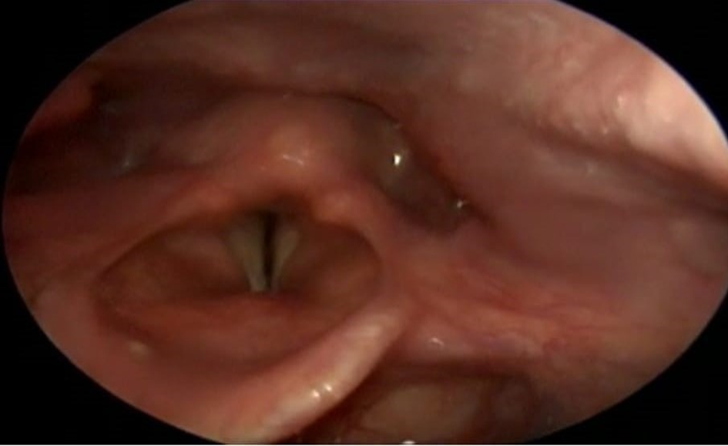
Figure 1 indirect laryngoscopy showing normal mucosa in glottic and supraglottic regions
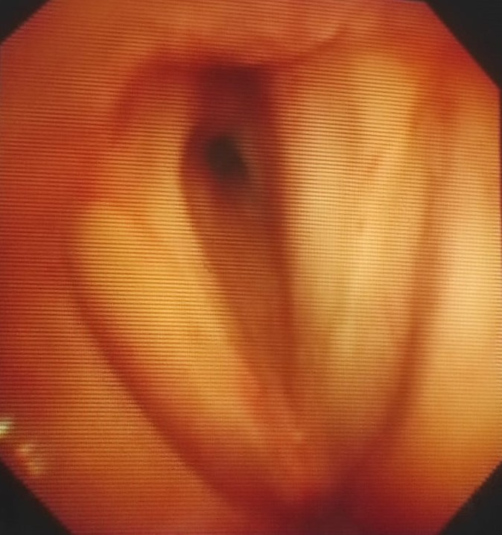
Figure 2 Bronchoscopy showing a stenosis of subglottic region, with regular edges and a normal mucosa

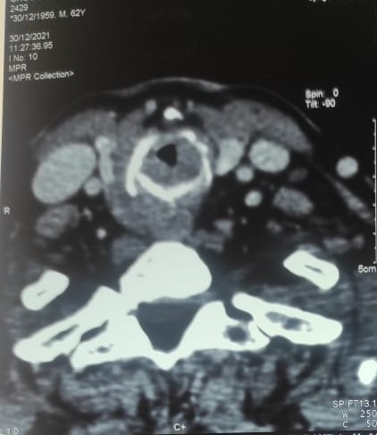
Figure 3 Computed tomography of the neck reveal a glottic and subglottic tissular process, hemicircumferentiel ,reduicing the lumen of the larynx
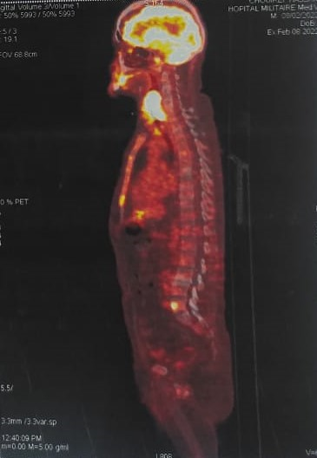
Figure 4 Pet scan showing metastatic localization in the skeleton

Table 1: Criteria symptomatic multiple myeloma, asymptomatic myeloma according to International Myeloma Working Group*

*International Myeloma Working Group (2003) Criteria for the classification of monoclonal gammopathies, multiple myeloma and related disorders: a report of the international myeloma work ing group. Br J Haematol 121:749–757

REFERENCES
- Ramírez-Anguiano J, Lara-Sánchez H, Martínez-Baños D, Martínez-Benítez B. "Extramedullary Plasmacytoma of the Larynx: A Case Report of Subglottic Localization."
- Lewis K, Thomas R, Grace R, Moffat C, Manjaly G, Howlett DC. "Extramedullary plasmacytomas of the larynx and parapharyngeal space: imaging and pathologic features." Ear, Nose and Throat Journal. 2007;86(9):567–569.
- Saad R, Raab S, Liu Y, Pollice P, Silverman JF. "Plasmacytoma of the larynx diagnosed by fine-needle aspiration cytology: a case report." Diagnostic Cytopathology. 2001;24(6):408–411.
- Pichi B, Terenzi V, Covello R, Spriano G. "Cricoid-Based Extramedullary Plasmocytoma." DOI: 10.1097/SCS.0b013e318231e56d.
- Wein OW, Topf P, Sham RL. "Subglottic plasmocytoma: a case report and review of the literature." American Journal of Otolaryngology. 2002;23:112–118.
- Ge S, Zhu G, Yi Y. "Extramedullary plasmacytoma of the larynx: Literature review and report of a case who subsequently developed acute myeloid leukemia." Oncology Letters. 2018; DOI: 10.3892/ol.2018.899.
- T. Shimada, M. Matsui, K. Ikebuchi et al., “Multiple myelomainvolving the thyroid cartilage,” Auris Nasus Larynx, vol. 34,no. 2, pp. 277–279, 2007.
- J. Hisa, B. S. Slasky, O. Paltiel, G. Pizov, and E. Libson,“Multiple myeloma involving the thyroid cartilage: case re-port,” American Journal of Neuroradiology (AJNR), vol. 23,no. 2, pp. 316–318, 2002.
- Mitchell HK, Garas G, Mazarakis N and McGlashan J: Extramedullary relapse of multiple myeloma in the thyroid cartilage. BMJ Case Rep 2013. pii. bcr2013200689. 2013.
- Grobman AB, Vivero RJ, Campuzano-Zuluaga G, Ganjei-Azar P and Rosow DE: Laryngeal involvement of multiple myeloma. Case Rep Oncol Med. 2012:2578142012.PubMed/NCBI
- McKenna RW, Kyle RA, Kuehl WM, Grogan TM, Harris NL and Coupland RW: Plasma cell neoplasmsWHO Classification of Tumours of Haematopoietic and Lymphoid Tissues. Swerdlow SH, Campo E, Harris NL, Jaffe ES, Pileri SA, Stein H, Thiele J and Vardiman JW: 2. IARC; Lyon: pp. 200–213. 2008
- Hillengass J et al: International Myeloma Working Group consensus recommendations on imaging in monoclonal plasma cell disorders. Lancet Oncol. 20(6):e302-12, 2019
- Princewill K et al: Multiple myeloma lesion detection with whole body CT versus radiographic skeletal survey. Cancer Invest. 31(3):206-11, 2013
- Dimopoulos MA et al: Multiple myeloma: EHA-ESMO clinical practice guidelines for diagnosis, treatment and follow-up. Ann Oncol. 32(3):309-22, 2021
- Wolf MB et al: Sensitivity of whole-body CT and MRI versus projection radiography in the detection of osteolyses in patients with monoclonal plasma cell disease. Eur J Radiol. 83(7):1222-30, 2014
- Mosebach J et al: Multiple myeloma guidelines and their recent updates: implications for imaging. Rofo. 191(11):998-1009, 2019
- Alexiou C, Kau RJ, Dietzfelbinger H, Kremer M, Spiess JC, Schratzenstaller B, Arnold W. "Extramedullary plasmacytoma: Tumor occurrence and therapeutic concepts." Cancer. 1999;85:2305–2314.
- Guidelines on the Diagnosis and Management of Solitary Plasmacytoma of Bone and Solitary Extramedullary Plasmacytoma. Clinical Oncology (Royal College of Radiologists). 2004 Sep;16(6):405–413. doi:10.1016/j.clon.2004.02.007
- . V. Ravo, M. G. Calvanese, R. Manzo et al., “Solitary plas-macytoma of the larynx treated with radiotherapy: a casereport,” Tumori, vol. 98, no. 2, pp. 35e–38e, 2012, http://www.tumorionline.it/articoli.php?archivio=yes&vol_id=1088&id=11945.

