***Original Research Article***

**Effect of alkaloid-rich fraction of *Dacryodes edulis* leaves on the microstructure of the hippocampus and blood glucose levels of STZ-induced diabetic Wistar rats.**

**Abstract**

**Aim:** the aim of this study was to elucidate the effect of alkaloid-rich fraction of *Dacryodes edulis* on the weight, blood glucose level and the microanatomy of the hipoocampus of STZ-induced Diabetic Wistar rats.

**Methodology:** 25 adult male Wistar rats were used for the experiment. These rats were randomly arrayed into 5 groups of rats each containing 5 rats designated A, B, C, D and E. Group A served as the normal control and were allowed access to drinking water and food *adlibitum.* Diabetes was induced to groups B to E through administration of 60mg/kg of STZ for 7 days. Group B was the untreated group; 1000mg/kg and 500mg/kg of alkaloid-rich fraction of *Dacryodes edulis* were given to groups C and D respectively while group E were given 50mg/kg of metformin.

**Results:** the results revealed increased body weight, increase glucose level and atrophied pyramidal cells in the pyramidal cell layer of the hippocampus as well as numerous vacuoles with lipid deposits in the untreated group. Compared to the control group. Groups C, D and E revealed potential ameliorative effects from the alkaloid-rich fraction of *Dacryodes edulis* and metformin though it was dose related compared to the normal control group.

**Conclusion:** Alkaloid-rich fraction of *Dacryodes edulis* is very potent in reducing glucose level, body weight and neurodegenerative nerve cells of the hippocampus of adult male Wistar rats in STZ-induced diabetic adult male Wistar rats.

**Keywords**: Alkaloid, *Dacryodes edulis*, Diabetes, Neurodegeneration, pyramidal cells

**1.0 INTRODUCTION**

Diabetes mellitus is a gradual incapacitating condition marked with prolonged excessive glucose level with disruption in the metabolism of starch, lipids and amino acids due to excessive production and inadequate utilization of glucose. This arises due to inadequate production or functioning of insulin in the pancreas (Inbaraj and Inbaraj, 2014; Gwarzo et al., 2014). The elevated blood glucose level in individual results to polyuria, polydipsia as well as polyphagia (Martin et al., 2012; wild et al., 2004). Patience with diabetes po**ssess** deficiencies in their antioxidant defense system in which may enhance their susceptibility to free radical-induced damage and the progression of diabetic sequalae (Gwarzo et al., 2014). Several corroborating factors imply that oxidative stress-induced harm is implicated in the etiology of a wide range of human disorders. Free radical-induced damage occurs when the generation of oxidative stressors surpasses the existing radical scavenging capacity. The stressors are bioactive compounds containing oxygen such as hydrogen peroxide, HCl and radical species like superoxide anion and hydroxyl radicals (Alhassan et al., 2009).

Global prevalence of diabetes among of diabetes among adults over 18 years has increase from 4.7% in 1980% to 8.5% in 2014. In 2016, WHO published 422 million adults with diabetes, 1.5 million deaths yearly (Global Report on Diabetes Geneva, 2016). The international Diabetes mellitus is expected to increase from 387 million people in 2014 to 592 million within the next 20 years. 316 million with impaired glucose tolerance are at increases risk from the disease with projection showing that more than 1 billion people will be living with diabetes in 2035 (daRocha et al., 2016). High blood sugar is a common effect of uncontrolled diabetes and may lead to serious damage to many body systems such as the nervous system and increase the risk of untimely death (Lallukka et al., 2016).

Nervous system transmits signals between the brain and the rest of the body including internal organs (Medlineplus, 2016). The basic unit of the nervous system is a nerve. The human brain contains about 100 billion nerves. The nervous system also contain non-neural cells called glia. This glia performs many important function that keep the nervous system working properly. The brain is made up of many pathways of communicating neurons and glia. These pathways allow different parts of the brain to communicate with each other and work together to control body functions, emotions, thinking, behavior and other activities (Medlineplus, 2016; Society for Neuroscience, 2012; National Institute of Neurological Disorders and Stroke, 2018). Neuroprotection refers to ways of defending the central nervous system against neural cell injury due to acute stroke or trauma including neurodegenerative disorders (Kummar et al., 2006) that may be caused by STZ. Recently, the use of herbal plants such as *Telfairia occidentalis, Talinium triangulare, Averrhoa carambola* and *Dacryodes edulis* ameliorates neurodegenerative disease such as Alzheimer’s type cognitive dysfunction Wistar rats has become paramount (Eru et al., 2024; 2022; 2021; 2020; Ifiok et al.,2024; Paulinus et al., 2024; Udoh et al., 2020).

*Dacryodes edulis* is highly nutritious, containing lipids, proteins and provitamins. Many health-enhancing chemical constituents such as alkaloids, tannins, flavonoids and saponin are present in parts the plant including its leaves. The bioconstituents obtained from the leaves are said to contain antioxidants, antisickle cell and antimicrobial activities (Ononamadu et al., 2019). Antioxidants in plants have been utilized for the treatment and management of diseases including neurological disorders (Sadhwani et al., 2021), hence the rationale to investigate the effect of alkaloids from *Dacryodes edulis* on the microstructure of the hippocampus, blood glucose levels and insulin status of STZ-induced diabetic Wistar rats.

**2.0 METHODOLOGY**

**2.1 Experimental animals**

With ethical approval number: FAREC-FBMS 042ANA3719, twenty-five adult male Wistar rats weighing140-190g were bought from the animal farm and kept in the animal room for two weeks. Before the experiment, the experimental animals were kept for acclimatization under standard conditions of temperature (27oC – 30oC); they were given rat chow and water *ad libitum*. After two weeks of adjustment, the rats were arbitrarily arrayed into five groups; each having five rats designated A, B, C, D and E.

**2.2 Plant extract preparation**

The mature fresh *Dacryodes edulis* leaves were plucked and washed in running tap water and thereafter rinsed properly in distilled water. It was air dried, powdered with a grinder and stored in an air tight plastic container till required for analysis. Crude alkaloid from *Dacryodes edulis* leaves was extracted by heating the powdered sample (500g) for 4hours at 55°C with 1200 ml of ethanol (20%). The extract was filtered and residue was re-extracted with 200 ml of ethanol (20%). The extract was concentrated on water bath till the volume reduced to 200 ml, which was mixed with 100 ml diethyl ether in a separating funnel. The mixture was vigorously shaken and then the separating funnel was fixed in a stand till the development of aqueous and diethyl layer. Aqueous portion was collected while the diethyl ether portion was discarded. To the aqueous layer n-butanol (80 ml) was added and properly mixed by vigorous shaking. The n-butanol extract was treated with 10 ml of 5% NaCl solution. The resultant solution was concentrated on a water bath and the crude alkaloid extract (Zeb *et al*., 2014).

**2.3 Induction of Hyperglycaemia**

Diabetes was induced after 14 hours of fasting by intraperitoneal injection of 60 mg/kg body weight (b.w.) of STZ for seven days. Following the induction, the tail vein blood was collected to determine fasting blood glucose level using Accu-Chek glucometer. Rats with fasting blood glucose over 250mg/dL were considered diabetic and included in the experiments.

**2.4 LD50 determination**

Using Lorke’s method (1983), LD50 of **alkaloids from *Dacryodes edulis***leaves were both established to be >5000 mg/kg and doses were determined using 10% and 5% of the established LD50.

**2.5 Administration of alkaloids from *Dacryodes edulis* leaves and metformin**

Group A served as the negative control and received animal feed and water *ad libitum*; group B served as the positive control and received 60mg/kg body weight of STZ only for seven days; group C received 60 mg/kg body weight of STZ and 1000mg/kg body weight of alkaloids from *Dacryodes edulis* leaves; group D received 60mg/kg body weight of STZ and 500mg/kg body weight of alkaloids from *Dacryodes edulis* leaves; and group E received 60mg/kg body weight of STZ and 50mg/kg body weight of metformin (bought from Bez Pharmacy, Etta Agbo Calabar-Nigeria). These extracts and drugs were administered for fourteen days.

**2.6 Histological tissue processing**

The animals were immolated with their brain tissues perfused and treated24 hours after the last administration. The whole brain was eviscerated, weighed and fixed in 10% buffered formal saline. This was done to maintain the morphological integrity of the tissue (Williams et al., 2006). The hippocampus of the rats was dissected out and used for histological studies using the haematoxylin and eosin (H & E) staining method and observed under light microscope (OMAX: 40X-2500X). During tissue processing, the hippocampal tissue was dehydrated through ascending percentage of alcohol for an hour each. The tissue was cleared in two changes of xylene for an hour each, infiltrated and embedded in molten paraffin wax. The solid tissue blocks in paraffin were mounted in the rotator microtome and sections were cut at six µm. The cut sections were floated in warm water bath, then picked and mount with an albumenized slide. Paraffin slides of the hippocampal tissue were de-waxed of paraffin through two changes of xylene for 5 minutes each, rehydrated through ascending percentage of alcohol and rinsed under ceaseless tap water. For 15 minutes, cut tissues were later dyed with haematoxylin and rinsed under ceaseless tap water for 5 minutes. For a minute, cut tissues were distinguished in acid alcohol, blued and counter stain with Eosin for another 1 minute. Sections were rinsed in tap water, dehydrate and cleared in xylene, allowed to dry with few drops of distyrene plasticizer xylene (DPX) kept on the slide and cover slipped (Avwioro, 2010).

**2.7 Statistical analysis**

Data were analyzed using a statistical package for social science version 21.0 The student t-test was used with data represented as mean ± standard error of the mean (SEM) and statistically significant at p < 0.05.

**3.0 RESULTS**

**3.1 Morphological observation**

The initial and final body weights of rats were monitored during the experimental period. Group A revealed 154.79±7.16 and 210.05±10.04; group B are 244.71±13.51 and 211.73±16.39; group C results are results are 184.24±1.82 and 197.24±6.01; group D results are 156.39±8.64 and 215.82±1.92 while group E results are 161.05±5.55 and 183.32±4.55 (figure 1). It was observed that there was significant decrease in body weight compared to the control group (p<0.05) as well as other groups. The result also showed a significant (p<0.05) increase in body weight of the rats in Group A compared to the rats in Group C and D. The initial weight, final weight, change in body weight and percentage change in body weight for all the groups are shown in figure 1.

**3.2 Blood sugar level**

The STZ-induced diabetic rats exhibited a significant increase in blood sugar level (P<0.05), similar to the treatment groups C to E before the initial treatment of alkaloids from *Dacryode edulis* and metformin. After administration of treatment, the results showed a significant (p>0.05) reduction in blood sugar level in the treatment groups (C-E) compared to the normal group A and diabetic control group B. There was also a significant (p<0.05) difference in the change in the blood sugar level of the rats in the High dose treatment group C compared to the drug treatment group E (figure 2).

**3.3 Histological observations**

Sections of the hippocampus stained with haematoxylin and eosin in the control group a normal pyramidal cells in the pyramidal layer with numerous neuropils. Neuroglial cells and blood capillaries are also present in other layers (granular and molecular). group B revealed atrophied pyramidal cells, numerous neuropils and capillaries are also present. Group C revealed distorted pyramidal cells with numerous vacuoles compared to the control group. Groups D and E revealed normal pyramidal cells compared to the control groups, neuroglial cells and neuropils are also present (plate).

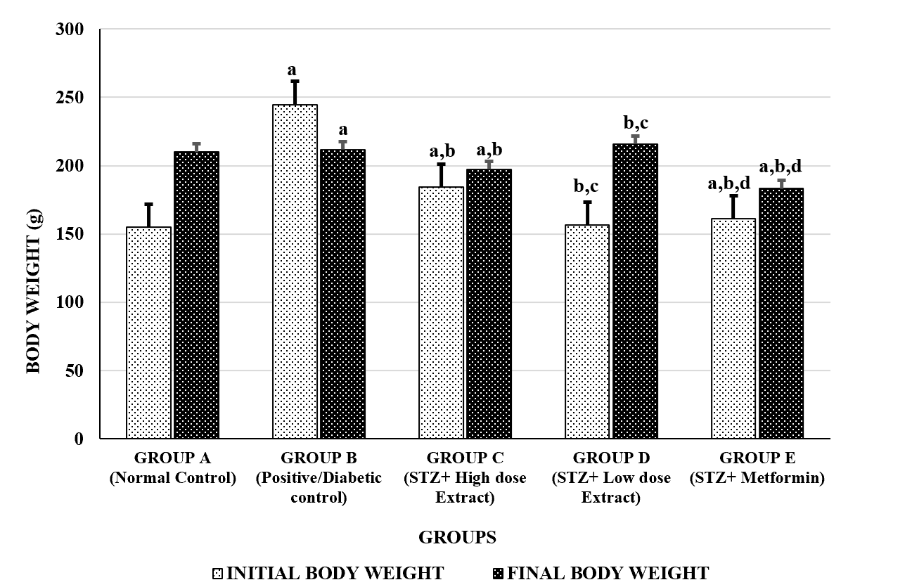

Figure 1: showing the initial and final body weight of the experimental animals

a = significantly different from Control group at p<0.05.

b = significantly different from Diabetic group at p<0.05.

c = significantly different from High dose treatment group at p<0.05.

= significantly different from Low dose treatment group at p<0.05.

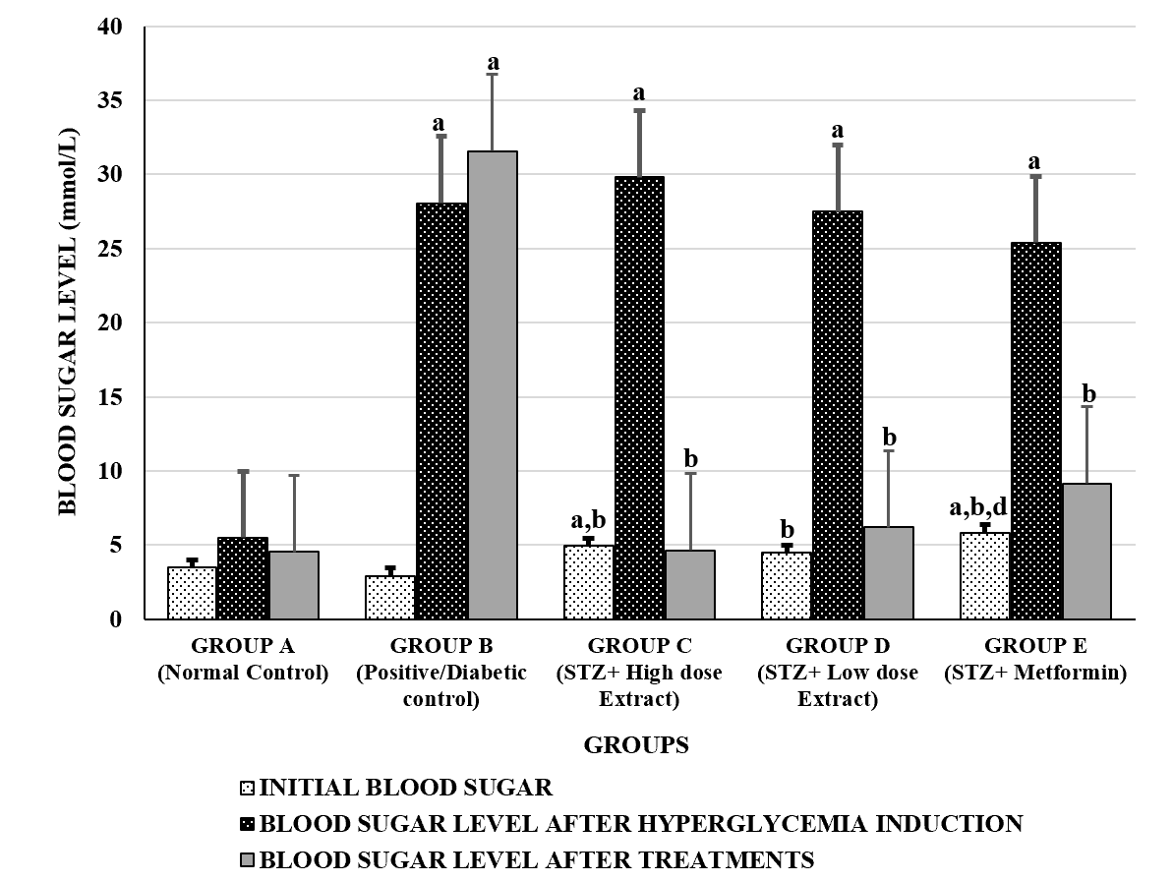

**Figure 2: Comparison of the blood sugar levels (mmol/L) in the different experimental groups.**

Values are expressed as mean + SEM, n =5.

a = significantly different from Control group at p<0.05.

b = significantly different from Diabetic group at p<0.05.

c = significantly different from High dose treatment group at p<0.05.

d = significantly different from Low dose treatment group at p<0.05

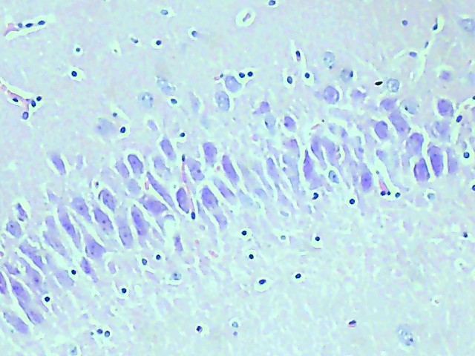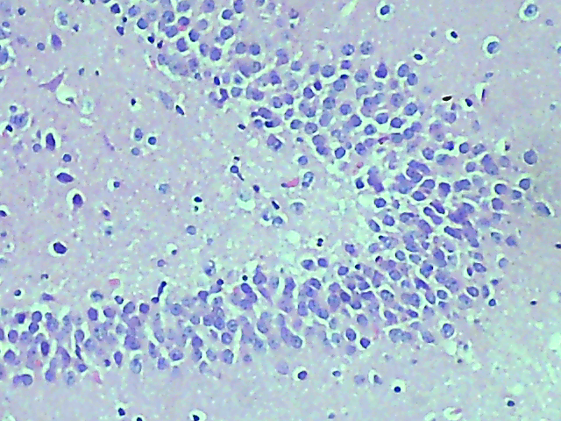

PCL

PCL

Plate 2 : Group B section of the hippocampus showing atrophied pyramidal cells in the pyramidal cell layer with numerous neuropils, neuroglial cells and vacuoles

Plate 1 : Group A section of the hippocampus showing the three layers with normal pyramidal cells in the pyramidal cell layer (PCL).

B

A

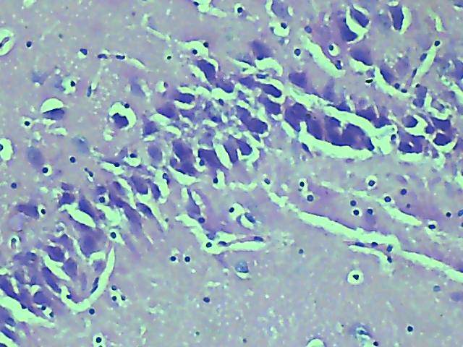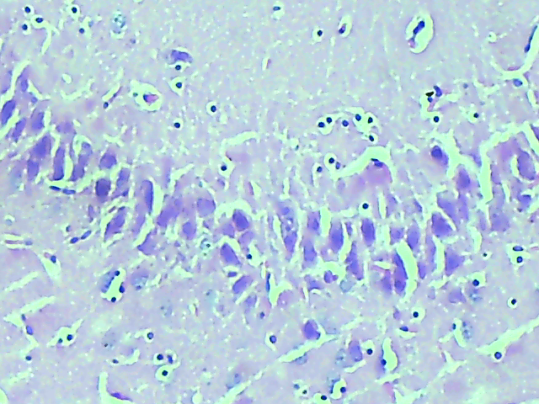

PCL

PCL

Plate 4 : Group D section of the hippocampus showing normal pyramidal cells with neuroglial cells and less vacuoles.

Plate 3 : Group C section of the hippocampus showing hypertrophied pyramidal cells in the pyramidal cell layer with numerous vacuoles.

D

C

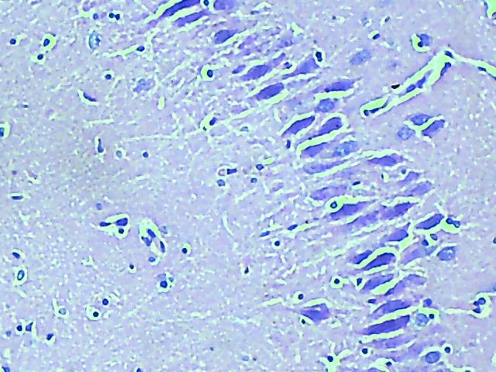

E

PCL

Plate 5 : Group E section of the hippocampus showing normal pyramidal cells, neuroglial cells, blood capillaries, neuropils and less vacuoles.

**4.0 Discussion**

Diabetes is a chronic disorder associated with many debilitating multi-systemic complications and are of many causes. The spectrum of the diabetic pathology is complex and thus would require beyond single therapy for management of such complications. The more acceptable approach should embrace alternatives to orthodox care, hence diabetes remains a public health concern with estimated 463 million cases worldwide according to Tuomi et al (2014). In 2017, diabetes resulted in approximately 4.2 million deaths. It is the 7th leading cause of death globally according to Boadu et al., (2017). The pooled prevalence of 5.77% in Nigeria suggests that about 11.2 million people are living with diabetes (Gabriel et al., 2015).

There are two main types of diabetes (type 1 and 2). Studies have it that type 2 diabetes can be a risk factor for Alzheimer’s disease (AD), vascular dementia and others. Studies have proved that similar to diabetes, glucose is not used properly in the brain of people with AD which may be caused by nerve death which reduces the brain’s ability to interpret messages in the case of vascular dementia, brain cells due to lack of oxygen preventing brain from communicating with each other. According to Alzheimer Society of Canada, recent studies suggests that the brains of people with AD are in a diabetic state partly due to the decrease in or insensitivity to insulin (Alzheimer Society of Canada, 2023).

In this study we investigated alkaloids rich fraction of *Dacryodes edulis* leaves on the microstructure of the hippocampus and blood glucose levels of STZ-induced diabetic Wistar rats. Morphologically, there was significant weight loss in group B that was given STZ alone compared to the negative control and the experimental group (figure 1). This effect is as a result of increased lipolysis within the adipose tissue and increased breakdown of protein (Buse et al., 2011). A study by Michelle (2013) also revealed that loss of glucose in urine may cause severe weight loss associated with lipolysis and protein breakdown. Significant increase in body weight was observed in the experimental groups mostly in group D with 38% increase. The increase in body weight in the treated group may be resulted from the reduced blood sugar statuses and normoglycemia stimulated by the alkaloids fraction of *Dacryodes edulis* administered post STZ induction. According to Holmann (2007), insulin influences increase cellular update of glucose resulting in weight gain by reducing metabolic rate and preventing glycosuria (Russel-Jones et al 2007). This is as a result of reduced glycosuria and increased caloric intake from ingestion of diets with high caloric contents.

Haematological observation of the rats in diabetic control group revealed that there was significant increase in the blood glucose compared to the normal control and the post treated groups with alkaloids from *Dacryodes edulis* and metformin (figure 2). This suggests the destruction of insulin producing cells in the diabetic control group B. This result is in line with the work of Lenzen (2008) who reported that STZ damage pancreatic beta cells causing hyperglycemia and hypoinsulinemia. The groups treated with alkaloid rich fraction of dacryodes edulis revealed significant decrease compared to the diabetic control groups at the end of the study. Herbal plants are mainly used to treat different kinds of ailments such as AD where Eru et al. (2024; 2022; 2020) demonstrated how *Talinum triangulare* and *Telfairia occidentalis* reduce the effect of neurotoxicity caused by scopolamine-induced Alzheimer’s type cognitive dysfunction rats due to its antioxidants components. Studies have it that fractionated components in plants such as flavonoids, saponin and glucoside of vernonia amydalina reduces blood glucose level and ameliorates pancreatic damage (Ugoanyanwu et al., 2015) as a result of their antioxidants free radical scavenging activities. The microanatomical study stained with haematoxylin and eosin using light microscope revealed atrophied pyramidal cells in the pyramidal cell layer of the hippocampus as well as numerous vacuoles filled with lipid depositions as compared to the negative control group and the posttreated groups. Study has it that normal cell death, gliosis, swollen or damage axons and myelin sheath are characteristics of chemically induced neurodegeneration (Cavanagh, 1984) This is true because the diabetic group caused by STZ in group B revealed atrophied pyramidal cells and numerous vacuoles with lipid deposits (plate 2). Normal nerves perform normal physiology but when abnormal or exposed to certain toxic substance which may result to injury on any part of the neurons, different degenerative changes may occur due to either obstruction in blood flow or causing the brain cells from not utilizing the glucose level in the brain by reducing metabolic rate and preventing glycosuria according to Russel-Jones et al., (2007).

The CA1 and CA3 subfields of the hippocampus are vulnerable to cell injury (George and Schneider*,* 1998) which is in line with the group that was given STZ alone and group C that received 1000mk/kg body weight of alkaloid-rich fraction of *Dacryodes edulis*. This study also confirm the involvement of pyramidal cells found in the pyramidal layer as degenerative changes observed in the hippocampus were predominantly evident in mostly the experimental groups treated with STZ. These degenerative changes may lead to dysfunction of the hippocampus characterized by inability to establish new long term memory. However, the distorted microanatomy of the hippocampus observed was mild in group D that received 500mg/kg body weight (plate 4) compared to the diabetic group B (plate 2). The observed microstructure showed dose related pattern of cellular repair with group D that received 5oomg/kg alkaloid-rich fraction exhibiting the most ameliorative potentials. The above results is in line with the work of Anani et al (2024) who reported that *Dacryodes edulis* ameliorates neurodegeneration in the hippocampus, reduce lipid peroxidation and increase glutathione level in rats caused by ketamine overdose. This alkaloid-rich fraction may had neutralized the excess free radicals, protect the cells against their toxic effect as well as providing enabling environment for cells and tissue survival.

**Conclusion**

The research study deduced that alkaloid-rich fraction of *Dacryode* *edulis* ameliorates cellular alterations, body weight as well as normalizing blood glucose level in STZ-induced diabetic Wistar rats.

**Consent**

Not applicable

**Competing interest**

Authors have declared that no competing interest exist.

REFERENCES

1. Alzheimer society of Canada. Reviewed in 2023. <https://alzheimer.ca/en/about-dementia/how-can-i-prevent-dementia/diabetes>.
2. Udoh BE, Erim AE, Paulinus SO, Eru EM, Ukpong EV, Efanga I, et al. (2020). Effects of *Cyperus esculentus* (Tiger Nut) Extract on the Irradiated Testes of Wistar Rats*. Trop J Nat Prod Res*, 4(11):966-969.
3. Anani SE, Eru EM, Okon DE, Uruakpa KC, Ugbem TI, Igiri AO. (2020). The Effect of *Averrhoa Carambola* (Star Fruit) Aqueous Fruit Extract on the Hippocampal Astrocyte Expression following Diazepam-Induced Neurotoxicity in Wistar Rats*. Trop J Nat Prod Res*, 4(12):1170-1173.
4. Eru EM, Paulinus SO, Igiri AO, Akpaso MI. (2020). Enhanced effect of aqueous extract of *Telfairia occidentalis* seed on the microstructure of the hippocampus of scopolamine hydrobromide-induced cognitive dysfunction rats*. Asian J of Res in Neuro*, 3(1): 5-10.
5. Eru EM, Anani SE, Paulinus SO, Mesembe OE, Uruakpa KC, Umoh NM, et al. (2022). Scopolamine-Induced Alzheimer’s Disease in Wistar Rats; Aqueous *Talinum Triangulare* Potency on the Hippocampal Nissl Bodies and Long-Term Learning and Memory. *Trop J Nat Prod Res*, 6(1):117-122.
6. Eru ME, Gabriel UU, Samson OP, Kelechi CU, Michael EO, Sadeyeng EA, et al.( 2021). Restorative Potentials of Aqueous *Telfairia occidentalis* Seeds Extract on the Hippocampal Nissl Granules and Short-Term Memory in Scopolamine Hydrobromide-Induced Alzheimer’s Type Cognitive Dysfunction Rats. *Trop J Nat Prod Res*, 5(1):182-187
7. Eru EM, Paulinus SO, Udo-Affah GU, Uruakpa KC, Oku ME, Anani SE et al. (2021). Hippocampal Astrogliotic Reduction in Scopolamine Hydrobromide-Induced Alzheimer’s Cognitive Dysfunction Wistar Rats Following Administration of Aqueous Extract of *Telfairia occidentalis* (Hook F.) Seeds. *Niger J Physiol Sci*, 36: 241 – 244
8. Eru EM, Paulinus SO, Gabriel UU, Kelechi CU, Michael EO, Edet UI, et al. (2020). Neurobehavioural enhancement in scopolamine hydrobromide-induced alzheimer type cognitive dysfunction in rats following administration of ethanol seedextractof *telfairia occidentalis* (hook.f.) cucurbitaceae. *Trop J Nat Prod Res*, 4(7):282-285
9. Eru EM, Gabriel UU, Ifiok FB, Kelechi CU, Samson OP, Michael EO et al. (2024). Efficacy of aqueous extract of *talinum triangulare* on the microanatomy of the hippocampus and short-term memory of scopolamine hydrobromide-induced alzheimer’s type cognitive dysfunction rats. *Niger. J. Physiol. Sci.* 39 (1):101-109
10. Ifiok FB, Eru EM, Mathias OA, Nsikak MU, Williams AN, Florence NO et al. (2024). Effect of *musa paradisiaca* stem juice on acute status epilepticus, hippocampal histology and behaviour in pentylenetetrazole – induced wistar rats. *Niger. J. Physiol. Sci.* 39: (in press).
11. Ifiok FB, Gabriel UU, Eru EM, Nsikak MU, Mathias OA, Williams AN et al. (2024). Histochemical study of Nissl substance and astrocytes in a pentylenetetrazole-induced model of epilepsy treated with *musa paradisiaca* stem juice. *Niger. J. Physiol. Sci.* 39: (in press).
12. Paulinus SO, Eru EM, Udo-Affah GU, Oku ME, Bassey IF, Uruakpa KC et al. (2024). Lipid peroxidation and glutathione level following scopolamine-induced cognitive dysfunction in rats: potentials of telfairia occidentalis seeds and talinium triangulare leaves aqueous extracts. Asian J. Res. Rep. Neurol. 7(1): 98-106.
13. Inbaraj, S.D.&Inbaraj, G.J. (2014). Comparative study of lipid and glycemic effects of pioglitazone, rosiglitazone with glibenclamide in patients with type 2 Diabetes and Dyslipidemia. *Global Journal of Pharmacology,8*(1): 107-113.
14. Gwarzo, M.Y., Ahmadu, J.H., Ahmad, M.B.&Dikko, A.U. (2014). Serum Glucose and Malondialdehyde levels in Alloxane Induced Diabetes Rats Supplemented with Methanolic Extract of Tacazzeaapiculata*. International Journal of Biomedical Sciences*, *10* (4): 236-242.
15. Martin, G., Henk, L. & Wilfried, M. (2012). Recent Advancements in the LC and GC Based Analysis of Malondialdehyde (MDA). *Chromatographia*, *75*(9-10): 433-440.
16. Wild, S., Roglic, G., Green, A., Sicree, R.&King, H. (2004). Global prevalence of diabetes: estimates for the year 2000 and projections for 2030. *Diabetes care*, *27*(5): 1047-1053.
17. Alhassan, A.J., Sule, M.S., Aliyu, S.A. & Aliyu, M.D. (2009). Ideal Hepatotoxicity in Rats Using Carbon Tetrachloride (CCL4*). Bayero Journal of Pure and Applied Science*, *2* (2): 185-187.
18. Kummar S, Gutierrez M, Doroshow JH, Murgo AJ. (2006). Drug development in oncology: classical cytotoxics and molecularly targeted agents. Brit J of Clin Phar. 1 (62):15-26.
19. Loorke D. (1983). a new approach to practical acute toxicity testing. Arch Toxicol., 54(4): 275-287.
20. Boadu, A. A.&Asase, A. (2017). Documentation of Herbal medicines used for the treatment and management of human diseases by some communities in southern Ghana. *Evidence Based complementary and Alternative Medicine: eCAM, 2017*, 3043061.
21. Tuomi, T., et al. (2014) The Many Faces of Diabetes: A Disease with Increasing Heterogeneity. The Lancet, 383, 1084-1094.
22. Pascal Iloh, Gabriel Uche, A. N. Amadi, and C. I. C Ebirim. (2015). “Type 2 Diabetes Mellitus in Ambulatory Adult Nigerians: Prevalence and Associated Family Biosocial Factors in a Primary Care Clinic in Eastern Nigeria: A Cross-Sectional Study”. *Journal of Advances in Medicine and Medical Research* 9 (3):1-12.
23. World Health Organization. Global report on diabetes. (2016) Geneva World Health Organization. <https://journals.lww.com/ijnc/fulltext/2016/01010/who_global_report_on_diabetes__a_summary.2.aspx#O3-2-2>
24. da Rocha Fernandes J, Ogurtsova K, Linnenkamp U, Guariguata L, Seuring T, Zhang P, et al. (2016) IDF Diabetes Atlas estimates of 2014 global health expenditures on diabetes. Diabetes Research and Clinical Practice 117. 10.1016.
25. Lallukka T et al (2016) The joint contribution of diabetes and work disability to premature death during working age: a population-based study in Sweden. Scand J Public Health **44**: 580–6
26. Zeb, H., Younas, A., Ahmed, I., & Ali, A. (2021). Self‐care experiences of Pakistani patients with COPD and the role of family in self‐care: a phenomenological inquiry. Health & social care in the community, 29(5), e174-e183.
27. Ononamadu, C., Alhassan, A., Ibrahim, A., Imam, A., Ihegboro, G., Tajudeen, O., et al. (2019). Methanol-Extract/Fractions of Dacryodes edulis Leaves Ameliorate Hyperglycemia and Associated Oxidative Stress in Streptozotocin-Induced Diabetic Wistar Rats. Journal of Evidence-Based Integrative Medicine. 24. 2515690X1984383. 10.1177/2515690X19843832.
28. Sadhwani S. (2015). Carambola (starfruit) Averrhoa Carabola 2015 Acessed 17 April 2021. www. Ayurtimes.com/carambola-starfruit-averrhoa-carambola
29. MedlinePlus. (2016). Neurosciences. Retrieved June 16, 2017, from <https://medlineplus.gov/ency/article/007456.htm>
30. Society for Neuroscience. (2012). Brain facts. Washington, DC. Retrieved January 17, 2018, from <http://www.brainfacts.org/The-Brain-Facts-Book>
31. National Institute of Neurological Disorders and Stroke. (2018). Brain basics: Know your brain. Retrieved August 9, 2018, from <https://www.ninds.nih.gov/Disorders/Patient-Caregiver-Education/Know-Your-Brain>
32. Avwioro O. G. (2010). Histochemistry and tissue pathology, principles and techniques. Nigeria, Claverianum press, Pp 143-145.
33. Williams A., Marcus J. F., Portoghese P. S. & Carlezon W. (2006). Amygdala-prefrontal dissociation of subliminal and paraliminal fear. *Hum Brain Mapp.* 27 (8): 652-661.
34. Anani SE, Nnenna WA, Eric AA, Nsikak MU, Bassey IF, Eru EM et al. (2024). Neuroprotective effect of Dacryodes edulis ethanolic leaf extract on the hippocampus of rats of ketamine-induced neurotoxicity. Asian J. Re. Rep Neurol 7(1): 130-145.
35. Cavanagh J. B. (1984). The problems of neurons with long axons. *Lancet*, 2: 1284-1287.
36. George D. & Schneider E. (1998). Encyclopedia of medicinal plants. Pp. 246-249.